http://www.USScouts.Org • http://www.MeritBadge.Org
Please submit errors, omissions, comments or suggestions about this workbook to: Workbooks@USScouts.Org
Comments or suggestions for changes to the requirements for the merit badge should be sent to: Merit.Badge@Scouting.Org
______________________________________________________________________________________________________________________________________________
1. Do the following:
a. Explain to your counselor the most likely hazards associated with exposure to ants and bees and what you should do to anticipate, help prevent, mitigate, and respond to these hazards.
b. Discuss the prevention of and treatment for health concerns that could occur while working with ants and bees, including insect bites and anaphylactic shock.
2. Tell how insects are different from all other animals.
Show how insects are different from centipedes and spiders.
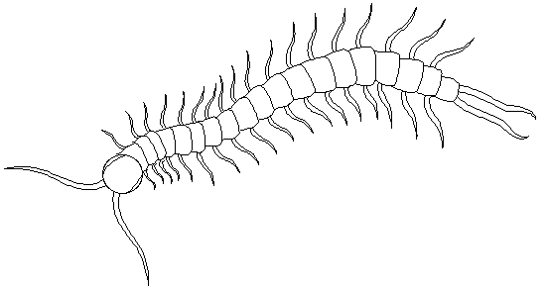 | 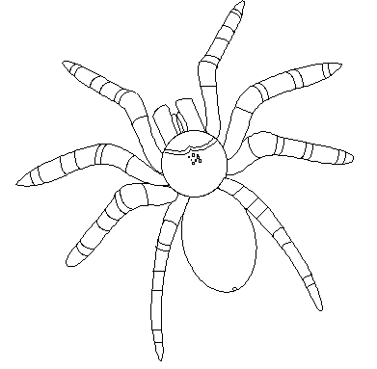

3 Point out and name the main parts of an insect.
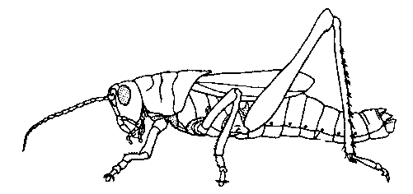
4. Describe the characteristics that distinguish the principal families and orders of insects.
5. Do the following:
a. Observe 20 different live species of insects in their habitat. In your observations, include at least four orders of insects.
 | Species | Order |  | Species | Order
1. |  |  | 11.
2. |  |  | 12.
3. |  |  | 13.
4. |  |  | 14.
5. |  |  | 15.
6. |  |  | 16.
7. |  |  | 17.
8. |  |  | 18.
9. |  |  | 19.
10 |  |  | 20
b. Make a scrapbook of the 20 insects you observe in 4a (sic – this should be “5a”). Include photographs, sketches, illustrations, and articles. Label each insect with its common and scientific names, where possible. Share your scrapbook with your merit badge counselor.

6. Do the following:
a. From your scrapbook collection, identify three species of insects and five species of insects harmful to humans.
Helpful to humans:
1.
2.
3.
Harmful to humans:
1.
2.
3.
4.
5.
b. Discuss the use of integrated pest management vs. chemical methods of insect control.
What are the advantages and disadvantages of each?

7. Explain the symbiotic relationship between bees and humankind.
Explain what colony collapse disorder (CCD) is and some of the possible causes.
Discuss how CCD affects our food supply.

8. Compare the life histories of a butterfly and a grasshopper.
Butterfly
Grasshopper:
Tell how they are different.
9. Raise an insect through the complete metamorphosis from its larval stage to its adult stage (e.g. raise a butterfly or moth from a caterpillar.)*
*Some insects are endangered species and are protected by federal or state law. Every species is found only in its own special type of habitat. Be sure to check natural resources authorities in advance to be sure that you will not be collecting any species that is known to be protected or endangered, or in any habitat where collecting is prohibited. In most cases, all specimens should be returned at the location of capture after the requirement is met. Check with your merit badge counselor for those instances where the return of these specimens would not be appropriate.
10 Do ONE of the following:
a. Observe an ant colony in a formicarium (ant farm). Find the queen and worker ants. Explain to your counselor the different chambers found within an ant colony.
b. Study a hive of bees. Remove the combs and find the queen. Estimate the amount of brood and count the number of queen cells. Explain how to determine the amount of honey in the hive.
11. Tell the things that make social insects different from solitary insects.
12. Tell how insects fit in the food chains of other insects, fish, birds, and mammals.
13. Find out about three career opportunities in insect study.
1.
2.
3.
Pick one and find out about the education, training, and experience required for this profession.
Career:
Education:
Training:
Experience:
Discuss this with your counselor, and explain why this profession might interest you.

When working on merit badges, Scouts and Scouters should be aware of some vital information in the current edition of the Guide to Advancement (BSA publication 33088). Important excerpts from that publication can be downloaded from http://usscouts.org/advance/docs/GTA-Excerpts-meritbadges.pdf.
You can download a complete copy of the Guide to Advancement from http://www.scouting.org/filestore/pdf/33088.pdf.

