COMMISSIONER'S CORNER

The summer is not over yet! Let's have "S'More" summer fun in the outdoors this month. The weather is hot, but the fun is cool as the Cub Scouts do all they can before school starts in the Fall. Is a picnic, softball game, or hike through the forest part of your pack's plans??
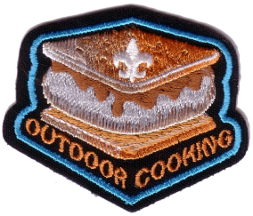
The is last issue of 22nd year of Baloo's Bugle. With the next issue for August RTs and September activities we start our 23rd year~ (only my 14th). I wonder if Chris realizes what she started??

THE 2016 – 2017 CS RT PLANNING GUIDE IS ISSUED
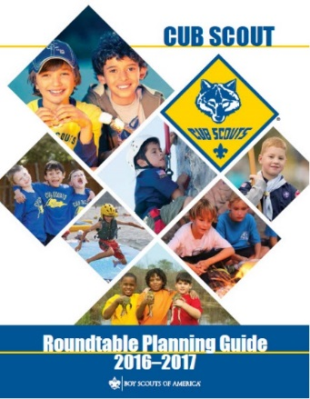
Download it at - http://www.scouting.org/scoutsource/Commissioners/roundtable.aspx

Judy and Dave need could still use help. If you would do one item for Baloo each month, it would help us greatly –
Biography – write a one page +/- biography of a person that exemplifies that month's emphasized point of the Scout Law.
Advancement – Choose a rank. Write a few hints and ideas for the Adventure to be discussed that month at the Roundtable. And, also, any that have a Character Compass pointing to that months point of the Scout Law
Have another idea? Let us know how you feel you could help us to make Baloo's Bugle more of what RT Commissioners, Cubmasters, and Den Leaders want.
Write us through the "Send Your Ideas to Baloo" link or directly – davethecommish@gmail.com and judyjohnsonbsa@yahoo.com

TABLE OF CONTENTS
COMMISSIONER'S CORNER 1
TABLE OF CONTENTS 2
CORE VALUES 4
COURTEOUS QUOTES 4
THOUGHTFUL ITEMS 6
DISCOVERY QUOTATIONS 7
BIOGRAPHY 8
DALE CARNEGIE 8
CUB SCOUT LEARNING LIBRARY 10
Den Leader 10
ADVENTURE PLAN TRACKERS 13
CUB SCOUT LEADER TRAINING 13
IN-PERSON TRAINING 13
ON-LINE TRAINING 13
CUB SCOUT IDEAS 14
School Night for Scouting Agenda 14
Tips for a Successful Fall Recruitment And Join 15
Invitation Methods for Cub Scouting 18
ROUNDTABLE HINTS 25
2016 – 2017 CS RT PLANNING GUIDE 25
DEN MEETING TOPICS 26
CHARACTER COMPASS 27
THEME RELATED STUFF 27
S'MORE CS FUN RELATED ADVENTURES 27
PACK MEETING THEMES AND PLANS 28
PACK MEETING THEMES 29
UPCOMING MONTHS 29
BE UP TO DATE 30
www.scouting.org/programupdates 30
CUBMASTER THOUGHTS 31
Lions and Leadership 31
The Chief Scout Executive on Lions 33
MORE LION INFORMATION 33
WEBELOS 35
Year Round Growth Plan 35
Webelos-to-Scout Planning Calendar 35
Crazy Holidays 38
Learning Opportunities at Philmont Training Center 40
SPECIAL OPPORTUNITIES 41
Historic Trails Award 41
Cyber Chip Award 43
Scout Law Cybersafety/Bullying 44
Internet Scout Patch 44
TRAINING TOPICS 45
Hail Den Leaders! 45
I Am a Den Leader. 46
Seven Things I Learned 47
FUN STUFF 48
Fun Facts about the Coast Guard 48
Fun Facts About Summer 49
THEME PACK AND DEN ACTIVITIES 50
August – A Month for Honesty 51
SUMMER THINGS 54
THEME & PACK MEETING IDEAS 58
GATHERING ACTIVITIES 58
OPENING CEREMONIES 61
AUDIENCE PARTICIPATIONS 63
ADVANCEMENT CEREMONIES 65
LEADER RECOGNITION 68
The ABCs of Leaders 68
SONGS 68
STUNTS AND APPLAUSES 70
APPLAUSES & CHEERS 70
RUN-ONS 71
JOKES & RIDDLES 71
SKITS 72
CLOSING CEREMONIES 73
CUBMASTER’S MINUTES 74
CUB GRUB 75
S'MORES 75
GAMES 81
BSA Social Media 83
You Tube Channels 83
BSA Facebook 84
My.Scouting – your self-updating Pack membership 84
Telling the Scouting Story with Social Media 85
“Bryan on Scouting” 86
Tiger Adventure: Tiger Bites 91
The Fast Food Song 91
Build Your Own Food Pyramid 92
Nutrition Game – Food Pyramid Go Fish Game 92
Self Serve Healthy Kid Snacks 92
Linen Table Manners Napkins 93
Fruit and Vegetable Relay Games 94
Top 10 Patient Information Dental Infographics 94
Tiger Elective Adventure: Tiger: Safe and Smart 94
Learning Your Address and Phone Number 95
911 Safety Quiz 95
Stop, drop and roll 96
Wolf Adventure: Call of the Wild 97
Start a Fire with a Lemon 97
Camping Checklist for Scouts 97
Square Knot Song and Overhand Knot Song 97
Call of the Wild: Campout 97
Call of the Wild: Safety 97
Call of the Wild: Outdoor Skills 97
Cub Scout Outdoor Ethics Awareness Award 98
Wolf Adventure Requirements: Call of the Wild 98
Fire Safety with Cub Scouts 98
The Twelve Days of Camping Song 98
The Outdoor Code 98
Leave No Trace Frontcountry Guidelines 98
Camping Packing List 98
Animal Identification (Requirement 99
Camping Charades Game 99
Camping Gear 99
DISC GAMES (GATHERING) 100
Animal Identification 100
Camping Gear 100
Safety Check (Requirements 4 and 5) 101
Knot Tying/Knot Relay Game 101
Campfire Show Planning 101
Animal Identification (Requirement 3) 102
Human Chain Race 102
Perform Skit or Song (Requirement 6) 102
Ideas for Adventure Requirements: 102
Taco Salad In A Bag! –for camping and kids! 103
Wolf Adventure: Collections and Hobbies 104
Re-Purposed Cereal Boxes 104
Penny Collection 105
10 Most Expensive Collectible Stamps 106
Bear Adventure: Paws for Action 109
Infographic: How to Retire the American Flag 109
Bear Adventure: Paws for Action 109
Simple Indoor Opening Flag Ceremony 109
Displaying the US Flag with Other Flags 109
Making a Plaster Print Mold 110
How to Fold the US Flag 110
A Simple Flag Retirement Ceremony 110
Emergency Phone Number List 110
Raising and Lowering the US Flag 110
Emergency preparedness candle kits 110
Bear Elective Adventure: Beat of the Drum 111
Tabletop Tipi Model 111
Native American Prayer 111
Hubbub – A Native American Dice Game 112
What Is the Order of the Arrow? 112
Why Opossum Has a Bare Tail 112
Pahsahëman – A Native American Field Game 112
Picaria – A Native American Game 112
Mini Tin Can Drums Earth Day Craft 112
DIY DRUMS FOR KIDS 113
Webelos Adventure: First Responder 114
Emergency Preparedness BSA – Cub Scout 115
Webelos Adventure: First Responder 115
How To Treat a Knife Cut 115
Kims Game Items for a Home First Aid Kit 115
Fake Wounds for First Aid Demonstrations 115
First Aid for Tick Bites 115
First Aid Demonstration for Cuts 115
First Aid Baseball Game for Webelos 115
DIY Ready-For-Anything Kit For Your Car 116
Webelos/AOL Elective Adventure: Maestro! 117
Completing Elective Adventures 118
Cub Scout Song Book 118
Webelos/AOL Elective Adventure: Maestro! 118
ONE LAST THING 118
UP - An Interesting Word! 118

CORE VALUES
The Cub Scout Core Values are the
12 Points of the Scout Law.
A Scout is COURTEOUS. The theme S'MORE SUMMER FUN is used to help Cubs understand being COURTEOUS.
A SCOUT IS COURTEOUS
A Scout is courteous. A Scout is polite to everyone regardless of age or position. He knows that using good manners makes it easier for people to get along.
HOW DOES “S'MORE SUMMER FUN” RELATE TO THIS SCOUT LAW POINT?
Summertime is a great time to get outside and to have S’more Cub Scout Fun! This month, enjoy one of the last summer evenings at a pack campfire. Cub Scouts can experience fun activities before the campfire, a campfire full of songs, skits, awards and great memories. At the campfire, the Cub Scouts will treat each other with politeness because they know that is how they want to be treated.
Per our Founder, Lord Baden-Powell
the definition (or meaning) of the Scout Law point highlighted this month is:
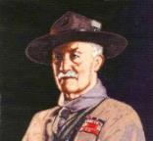
Note – The original Scout Law published in 1908 had nine points. In 1910, the BSA added Brave, Clean, and Reverent. In 1911 B-P added Clean to his original list.
A SCOUT IS COURTEOUS
Baden Powell said -
A SCOUT IS COURTEOUS: That is, he is polite to all—but especially to women and children and old people and invalids, cripples, etc. And he must not take any reward for being helpful or courteous..
(Scouting For Boys, 1908)
It is better to have too much COURTESY than too little, provided you are not equally courteous to all, for that would be injustice.
Baltasar Gracian
 In this video, the “Believe It Live It” team profiles Gene Fackler, and explains why being courteous is essential in his job as a Southwest Airlines skycap. Go to URL: http://boyslife.org/about-scouts/scoutlaw/4191/a-scout-is-courteous/

COURTEOUS QUOTES
Quotations contain the wisdom of the ages, and are a great source of inspiration for Cubmaster’s minutes, material for an advancement ceremony or an insightful addition to a Pack Meeting program cover.
“Really big people are, above everything else, COURTEOUS, considerate and generous - not just to some people in some circumstances - but to everyone all the time.”
Thomas J. Watson, 1874 - 1956, Founder of IBM.
BSA President, 1964-1968
Be courteous to all, but intimate with few, and let those few be well tried before you give them your confidence. George Washington
Finally, be ye all of one mind, having compassion one of another, love as brethren, be pitiful (compassionate in NIV), be COURTEOUS: - I Peter 3:8 (KJV)
Karate begins and ends with COURTESY.' This means respect others, refrain from violent behavior, practice fairness in the spirit of good sportsmanship.
― Takahashi Miyagi
COURTESY costs nothing, but buys everything.”
― Hazrat Ali Ibn Abu-Talib A.S
Politeness (COURTESY) is the art of choosing among your thoughts.
― Anne Louise Germaine de Staël-Holstein
As we are, so we do; and as we do, so is it done to us; we are the builders of our fortunes.
― Ralph Waldo Emerson
Fools show their annoyance at once, but the prudent overlook an insult. - Proverbs 12:18 (NIV)
A tree is known by its fruit; a man by his deeds. A good deed is never lost; he who sows courtesy reaps friendship, and he who plants kindness gathers love. – St. Basil

No one is too big to be COURTEOUS, but some are too little – Anonymous
No one is more insufferable than he who lacks basic COURTESY. ― Bryant McGill
If a man be gracious and COURTEOUS to strangers, it shows he is a citizen of the world. –
Sir Francis Bacon
Do not worry; eat three square meals a day; say your prayers; be COURTEOUS to your creditors; keep your digestion good; exercise; go slow and easy. Maybe there are other things your special case requires to make you happy; but, my friend, these I recommend. – Abraham Lincoln
COURTEOUS men learn courtesy from the discourteous. Persian Proverb
Teach children to be polite and COURTEOUS in the home, and, when he grows up, he will never be able to edge his car onto a freeway Anonymous (This is meant tongue in cheek, not seriously)
A large nose is the mark of a witty, courteous, affable, generous and liberal man. - Cyrano de Bergerac
As youngsters, my mother taught her children that while we might not be the smartest people around, we could be COURTEOUS, polite and considerate of others. Zig Ziglar
Courteous treatment will make a customer a walking advertisement. James Cash (JC) Penney
Many men fail because they do not see the importance of being kind and courteous to the men under them. Kindness to everybody always pays for itself. And, besides, it is a pleasure to be kind. Charles M. Schwab

A brave heart and a COURTEOUS tongue. They shall carry thee far
through the jungle, manling. -
Rudyard Kipling
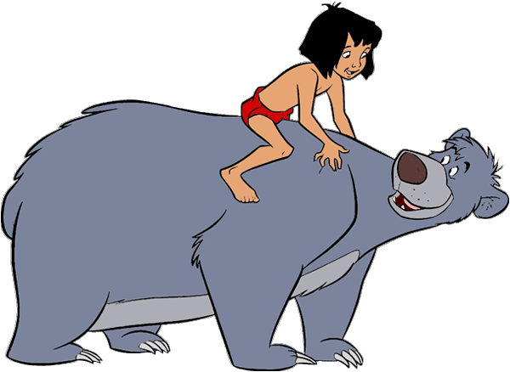


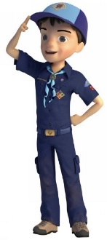

THOUGHTFUL ITEMS
July Prayers
S'more Thanks
CS Roundtable Planning Guide
As we bask in the warm rays of the summer sun, we thank the Creator for the things that make life enjoyable. May we always remember to appreciate the people who care for us. And as we explore our world, let us be safe from harm. AMEN
Go Discover America
Scouter Jim, Bountiful UT
In thinking about “S’more Cub Scout Fun” I had difficulty coming up with an appropriate subject for this month’s thought. I started to look for important dates and holidays during August. I found that Hawaii became our fiftieth State on August 21, 1959, adding the fiftieth star to our American flag.
After that, I started to look at birthdays for the month and found the following list, among many, many, others:
1 Aug 1770 – William Clark
18 Aug 1774 – Meriwether Lewis
1 Aug 1779 – Francis Scott Key
17 Aug 1786 – Davy Crockett
5 Aug 1930 – Neil Armstrong
As you look at the list, what pattern do you see? The first thing I noticed was William Clark and Meriwether Lewis of the Corps of Discovery. Then I noticed Davy Crockett and Neil Armstrong. Finally I noticed the birthday of Francis Scott Key. The common thread of the first four men mentioned above is the spirit of discovery. Davy Crockett helped open up the western frontiers and Lewis and Clark extended it to the limits of the Pacific Ocean. Neil Armstrong extended the frontier to the surface of the moon. Each of these four men carried the American Flag to a new and then distant frontier.
Francis Scott Key’s was a contemporary of all the other men, except Neil Armstrong. He is most famous for his authorship of “The Star Spangled Banner,” our national anthem. With his words he has helped lead others to follow our nation’s flag to new, and in some cases, distant journeys of discovery.
In 1803 Captain Meriwether Lewis and Lieutenant William Clark helped form the “Corps of Discovery.” The Corps of Discovery brought back invaluable geographic and scientific data, including 178 new species of plants and 122 previously unknown species of animals. Lewis and Clark succeeded in mapping a route beyond the Mississippi River to the West Coast. For two years they served both as explorers and ambassadors for the rest of America. Not only were they on a mission of discovery, but they were developing relationships with the native peoples who lived on the land they were exploring.
Davy Crockett explored the western frontier and served his nation as a member of Congress and a soldier, losing his life in battle at the Alamo in Texas.
Neil Armstrong was an aeronautical engineer and Navy Pilot (and an Eagle Scout). He became a test pilot and astronaut and was the Commander of Apollo 11 and the first man to step foot on the moon, uttering the phrase, “That's one small step for man; one giant leap for mankind.”
August is a great time for Cub Scouts to go on their own journey of discovery and proudly represent the nation and the Boy Scouts of America. It can be a time for them to learn new things, meet new people as did Lewis and Clark, and seek the sense of adventure that led Neil Armstrong to be a test pilot and walk on the moon.
Let’s lead our Cub Scouts outdoors, and have “S’more Summer Fun” as we explore America with a new sense of adventure.
Wow, I now feel honored to have my birthday in
the same month as these great men. Especially
Davy Crockett who is my personal favorite
hero. I was just the right age when Walt Disney brought out Davy Crockett with Fess Parker and
have loved Davy Crockett ever since. CD
And speaking of birthdays -
As Bill smith would say -
The best gift for a Cub Scout.......
......get his parents involved!
May we recognize all these everyday heroes and give them our thanks. AMEN

DISCOVERY QUOTATIONS
Quotations contain the wisdom of the ages, and are a great source of inspiration for Cubmaster’s minutes, material for an advancement ceremony or an insightful addition to a Pack Meeting program cover
A discovery is said to be an accident meeting a prepared mind. Albert Szent-Gyorgyi (1893 - 1986)
One doesn't discover new lands without consenting to lose sight of the shore for a very long time.
Andre Gide (1869 - 1951)
The beginning of knowledge is the discovery of something we do not understand.
Frank Herbert (1920 - 1986)
No pessimist ever discovered the secret of the stars or sailed an uncharted land, or opened a new doorway for the human spirit. Helen Keller (1880 - 1968)
I do not know what I may appear to the world; but to myself I seem to have been only like a boy playing on the seashore, and diverting myself in now and then finding a smoother pebble or a prettier shell than ordinary, whilst the great ocean of truth lay all undiscovered before me.
Isaac Newton (1642 - 1727),
From Brewster, Memoirs of Newton (1855)
If I have ever made any valuable discoveries, it has been owing more to patient attention, than to any other talent. Isaac Newton (1642 - 1727)
Mistakes are the portals of discovery.
James Joyce (1882 - 1941)
A perfect summer day is when the sun is shining, the breeze is blowing, the birds are singing, and the lawn mower is broken. James Dent
Ah, summer, what power you have to make us suffer and like it. Russel Baker
August creates as she slumbers, replete and satisfied.
Joseph Wood Krutch
Celebrate Summer - Sun drenched days and starlit nights... Gooseberry Patch
Heat, ma'am! It was so dreadful here, that I found there was nothing left for it but to take off my flesh and sit in my bones. Sydney Smith
I know that if odour were visible, as colour is, I'd see the summer garden in rainbow clouds. Robert Bridges
I question not if thrushes sing,
If roses load the air;
Beyond my heart I need not reach
When all is summer there.
John Vance Cheney
In summer, the song sings itself.
William Carlos Williams
Knowing trees, I understand the meaning of patience. Knowing grass, I can appreciate persistence.
Hal Borland
Oh, bring again my heart's content,
Thou Spirit of the Summer-time!
William Allingham
Oh, the summer night
Has a smile of light
And she sits on a sapphire throne.
Barry Cornwall
Rest is not idleness, and to lie sometimes on the grass on a summer day listening to the murmur of water, or watching the clouds float across the sky, is hardly a waste of time. John Lubbock
Someone's sitting in the shade today because someone planted a tree a long time ago. Warren Buffett
Summer afternoon - summer afternoon; to me those have always been the two most beautiful words in the English language. Henry James
The dandelions and buttercups gild all the lawn: the drowsy bee stumbles among the clover tops, and summer sweetens all to me. James Russell Lowell
The summer night is like a perfection of thought.
Wallace Stevens
You can never appreciate the shade of a tree unless you sweat in the sun. Author Unknown
Sam Houston Area Council
“We do not inherit the earth from our ancestors; we borrow it from our children.” –
Native American Proverb
“The whole secret of the study of nature lies in learning how to use one's eyes.” – George Sand
“A weed is no more than a flower in disguise.” –
James Russell Lowell
“Fire is the best of servants; but what a master!” – Thomas Carlyle
“How is it that one careless match can start a forest fire, but it takes a whole box to start a campfire?” – Author Unknown
“It always rains on tents. Rainstorms will travel thousands of miles, against prevailing winds for the opportunity to rain on a tent.” – Dave Barry

BIOGRAPHY

DALE CARNEGIE
Being COURTEOUS is a key to his principles in "How to Win Friends and Influence People."
Note: Commissioner Dave is a graduate of Dale Carnegie Training and I have served as a Graduate Assistant several times. The Training has proved invaluable to me. When I was looking for a person to highlight for COURTEOUS, I thought of Dale Carnegie. Then I looked at his 30 Principles of "How to Win Friends and Influence People," and I believe at least 19 of them involve being COURTEOUS. So read on, then look at the list f principles and see if you agree.
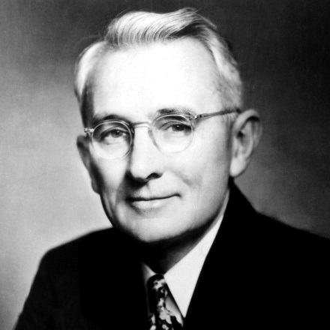
Dale Carnegie is the author of "How to Win Friends and Influence People", one of the bestselling self-help books of all time.

Dale Carnegie was born November 24, 1888, in Missouri. Born poor, he worked as a traveling salesman before teaching public speaking at a YMCA. He was soon lecturing to packed houses and collected his lectures into books. "How to Win Friends and Influence People" won him a national following and the Dale Carnegie Institute became established throughout the country. He died in 1955.
Early Life
His parents were impoverished farmers. Carnegie was unskilled in athletics but learned he could make friends and earn respect because he had a way with words. (He probably was COURTEOUS and a most other Scout Law points) In high school, he attended Chautauqua assemblies. These events brought speakers, musicians, entertainers and preachers to rural communities. He was so inspired that he joined the debate team and became a skillful orator.
After high school, Carnegie attended Warrensburg State Teachers College. His family was too poor to afford the $1 a day cost for room and board, so he lived at home and rode a horse to and from school. He took advantage of the rides to practice speeches and fine-tuning his oratory style. Carnegie frequently entered intercollegiate public speaking competitions and won the majority of the contests. His prowess as a public speaker was such that other students offered to pay him to train them. After graduating from college in 1908, Carnegie succeeded at sales jobs until he saved up enough to quit, move to New York City and try to make it as an actor.
Carnegie briefly studied at the American Academy of Dramatic Arts and tried acting. He quickly decided that a life in the theater was not for him. Later, Carnegie enlisted in the United States Army for World War I. After discharge, he was hired for a traveling lecture course taught by Lowell Thomas.
Public Speaking Classes
At the conclusion of the Lowell Thomas tour, Carnegie returned to New York and considered what to do next. He recalled how students had offered to pay him money to teach them public speaking and realized that his skill was what helped him succeed as a salesman, so Carnegie had the idea to teach public speaking to adults. He convinced the YMCA, to provide him space to begin night classes in return for a part of the profits.
The classes proved an immediate success. Focused on the everyday needs of businesspeople, Carnegie taught his students how to interview well, make persuasive presentations and forge positive relationships. (And be COURTEOUS CD) His students often came to class with stories of how they had put the skills learned the previous week to successful use in their work. The courses were so popular that Carnegie soon moved them out of the YMCA and founded the Dale Carnegie Institute. In 1913, he published his first book and used it as the textbook for his courses.
Over the next two decades, Carnegie gradually refined his courses to better meet the needs of his professional students. He perceived the most successful business people in any given industry were not those with the most technical know-how, but rather those with the best people skills. (Including being COURTEOUS CD) His students needed to learn more than effective public speaking techniques; they needed to learn the social and communication skills that distinguished the leaders of all industries. As he set out to teach his students these crucial skills, Carnegie realized that no textbook existed on the subject. In 1931, after years of intense research that included reading hundreds biographies to learn how the world's greatest leaders achieved their success, Carnegie published just such a book: How to Win Friends and Influence People. The book became a mammoth bestseller. Carnegie's book, like his classes, struck a chord with a population hungry for self-improvement, selling nearly 5 million copies during his lifetime.
Impact on Adult Education and Self-Improvement
Propelled by the success of "How to Win Friends and Influence People," the Dale Carnegie Institute exploded in popularity. In 1953, Carnegie moved the institute's headquarters into a warehouse in Manhattan. Carnegie also wrote biographies, motivated by his belief that the best way to learn the secrets of success was to read up on successful people. In 1932, Carnegie published a biography of Abraham Lincoln, Lincoln the Unknown, and he later published several compilations of brief biographical sketches: He published another self-improvement book, How to Stop Worrying and Start Living, in 1945.
Carnegie died of Hodgkin's disease on November 1, 1955, at the age of 66.
A pioneer in the fields of adult education and self-improvement, Carnegie's books and courses inspired millions. It is still relevant and useful decades after its initial publishing.
Although he wrote thousands of pages of books and gave hours upon hours of lectures, Carnegie's essential message on how to live a successful life can be summed up by his two most fundamental maxims:
"Forget yourself; do things for others"
"Cooperate with the inevitable."

For more info on Dale Carnegie and his training:

http://www.dalecarnegie.com/
PRINCIPLES FROM “HOW TO WIN FRIENDS AND INFLUENCE PEOPLE.”
by Dale Carnegie, founder of the Carnegie Course)
Principles in BOLD, I considered to be examples of being COURTEOUS. CD
BECOME A FRIENDLIER PERSON
- Don't criticize, condemn or complain.
- Give honest, sincere appreciation.
- Arouse in the other person an eager want.
- Become genuinely interested in other people.
- Smile.
- Remember that a person's name is to that person the most important sound in any language.
- Be a good listener. Encourage others to talk about themselves.
- Talk in terms of the other person's interest.
- Make the other person feel important - and do so sincerely.
- The only way to get the best of an argument is to avoid it.
WIN PEOPLE TO YOUR WAY OF THINKING
- Show respect for the other person's opinions. Never say, "You're wrong."
- If you are wrong, admit it quickly and emphatically.
- Begin in a friendly way.
- Get the other person saying, "Yes, yes" immediately.
- Let the other person do a great deal of the talking.
- Let the other person feel that the idea is his or hers
- Try honestly to see things from the other person's point of view.
- Be sympathetic with the other person's ideas and desires.
- Appeal to the nobler motives.
- Dramatize your ideas.
BE A LEADER
- Throw down a challenge.
- Begin with praise and honest appreciation.
- Call attention to people's mistakes indirectly.
- Talk about your own mistakes before criticizing the other person.
- Ask questions instead of giving direct orders.
- Let the other person save face.
- Praise the slightest and every improvement. Be "lavish in your praise."
- Give the other person a fine reputation to live up to
- Use encouragement. Make the fault seem easy to correct.
- Make the other person happy about doing the thing you suggest.

CUB SCOUT LEARNING LIBRARY
The NEW https://cubscouts.org/ !!!

This is the Cub Scout Learning Library –
Everything you could want to know for Cub Scouts is or will be here. And all within a click or 3 of the home page. National heard the message that although things were at www.scouting.org they were often buried too deep to be found.
This site has admin stuff and practical stuff. The new Den Leader Resource Books are here. You can download some of the pages for each Adventure for FREE
This website is a great resource. There are still parts under construction but what is there is GREAT!!

Yes, https://cubscouts.org runs on a phone, too!!!

There are 3 tabs on top of the home page –

- Learning Library
- Cub Hub Blog
- Join Scouting

The tabs for Pinewood Derby and Cub Day camp were removed this month!!
- Learning Library takes you where you can learn about your position and pick up hints. Besides specifics for dens of each rank, other clickable links include –
KEY
- All or most of material was placed on site this past month
- All or most of material was in place and listed as such in last month's Baloo's Bugle.
- Site / pages under construction

Den Leader
Den Meeting Basics
- Your First Den Meeting
- Planning Den Outings
- The Parts of a Den Meeting
- Getting Started
Three of the Core Adventures for the selected rank are listed here. Click on them and you will see / can download all the Leader's Guide pages for these three Adventures.
- Additional Required Adventures
The remaining Core Adventures for the selected rank are listed here. When you click them you get an intro to the Adventure but do not get the Meeting Plans and Resources. You see this note:
To get you started in delivering fun and engaging meetings, complete Den Meeting Plans are available here on the Learning Library for the Backyard Jungle and Games Tigers Play adventures. To obtain Den Meeting Plans for all other adventures, Den Leader Guides are available at your local Scout Shop, online at scoutstuff.org, or as an eBook through Amazon.
- Elective Adventures
All the Elective Adventures for the selected rank are listed here. When you click them you get an intro to the Adventure but do not get the Meeting Plans and Resources. You see the same note (above).
- Building Strong Dens
The Basics of Cub Scouts
- Advancement
- BSA Mission and Vision Statements
- Cub Scout Ages and Ranks
- Cub Scout Uniforming
- Den Flags
- Den Yells
- Leader Survival Kit
- Methods of Cub Scouting
- Purpose of Cub Scouting
- Roles and Responsibilities
- Scout Oath and Law
- What Is Cub Scouting?
- Training
- The Role of Training
- Youth Protection
- Den Planning And Administration
- Advancement Basics
- Advancement Requirements
- Annual Planning For Your Den
- Coordinating Your Den Plan with Pack
- Tracking and Recognizing Advancement
- Youth Protection Training
- Positive Youth Development and Working with Boys
- Developmental Differences Boys 7-11
- Behavior and Discipline
- Positive Youth Development
- Working With Special Needs Cub Scouts (Advice is specific to each Special Need. Lots of research was done to prep these pages.)
- Parents’ Prejoining Conference
- Leadership Techniques
- Working With Specific Disabilities and Needs
- The other positions are still under development:
- Cubmaster
- Committee Chair/Member
- Chartered Org Rep
- Parent / Adult Partner
- Cub Hub Blog takes you to a Cub Scout specific Blog similar to Bryan's Blog. The most recent topics discussed are listed here. There are more at www.cubscouts.org:
There were 4 new posts this month. One about Day Camp!! CD
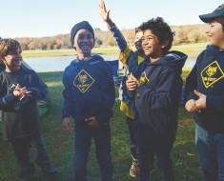4 Quizzes to Test Your Outdoor Knowledge It’s summer time and the living is, well…not always easy. Especially if that “living” is in the…
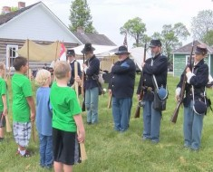Exploring Civil War History with Cub Scouts History is Alive and Well Wherever you live, that place has an inescapable history. Tapping into that…
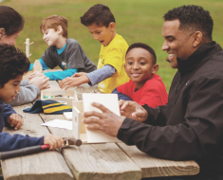Father’s Day Gift Ideas for Sons to Make Their Dads Heartfelt and Handmade Gift Ideas for Dad Fathers’ Day is right around the corner, and nothing says…
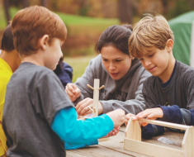10 Ways to Balance Fun and Advancement at Day Camp Let’s start with a question “At summer camp, what’s more important for Scouts, advancement or fun?” That’s…

Cub Hub Blog Lion Posts
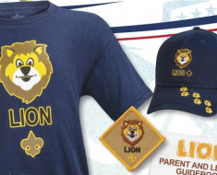A Look at the Lion Uniform and Gear Lion uniform, shirts and hats! In case you’ve missed the Lion uniform images floating around the Digital Pack…
Will Lions Join Tigers and Bears? Oh My! — A Lions FAQ Lions: Answers to your top questions. We have seen a lot of great feedback, comments and questions from…
 5 Questions (and Answers) for the New Lion Program More Information on the New Lion Program As we mentioned earlier on the Cub Hub, Select councils will…
Lion Program will bring Scouting to Kindergarten Boys Something Roaring in the Jungle There is an exciting new Scouting program called “Lion” for Kindergarten-aged boys…
- Join Scouting takes you to
www.beascout.org
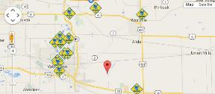

Also, on the home page –
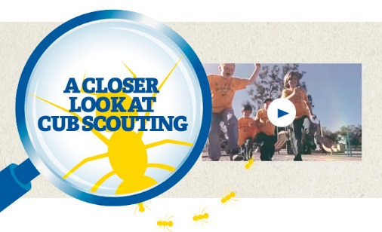
Click for a YouTube Video on Cub Scouting.
https://www.youtube.com/watch?feature=player_embedded&v=dqKFgk8SJlE
AND 6 picture links -

These Six Links take you to:
www.scoutstuff.org – The Supply Division site where you can locate your nearest National Scout Shop or buy your Scout supplies
http://scoutingwire.org/ - Where you can get the latest Scouting News from around the country. You can sign up to get notifications when things are posted here...
https://cubscouts.org/pinewood-derby-2016-photo-contest Takes you to a page that says promotion has ended. Pictures of entries that were received have been removed.
https://www.scoutbook.com/ Where you can get the Scoutbook APP to track your son's Scouting Experience from Tiger to Eagle Scout.
www.boyslife.org – Go directly to the on-line edition of Boys 'Life
http://scoutingwire.org/marketing-membership/ Get resources and materials to strengthen your unit at BSA's marketing and membership site. Learn the best practices and tips employed by the most successful units.

ADVENTURE PLAN TRACKERS
The website links have been updated.
I found out things had been moved!! CD
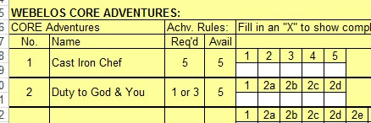
- Tracking Spreadsheets are posted on the USScouts Advancement webpage (http://usscouts.org/advance/cubscout/intro.asp). The spreadsheets were tested by a software developer who said they are so good he sees no reason to develop his own!!
- Utah National Parks Council, also, has Excel spreadsheets posted for all the new Adventure Plan requirements on their Akela's Council BlogSpot.
http://akelascouncil.blogspot.com/search/label/Tracking%20Sheet (The page starts with Arrow of Light scroll down for other ranks)
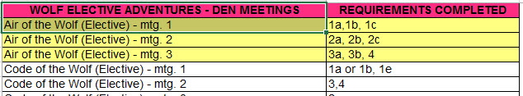
- A spreadsheet that correlates Meetings to Adventure requirements is available on the Utah National Parks' Akela's Council Blogspot at https://www.dropbox.com/s/yb8fweg7etnhqrt/WOLF%20BEAR%20WEBELOS%20REQUIREMENTS%20-%20MTGS.xlsx?dl=0 . It has all the Wolf, Bear, Webelos and AOL Adventure requirements.
These Advancement Spreadsheet workbooks are FREE for Scouters. But be COURTEOUS and observe the following -
PLEASE do not download the files from either site to email or send them digitally to others. They are for your personal / pack use only. If you would like to share these files with others, please copy / send the link to them and send them to the site so they can print off their own. They would love everyone that wants a copy to get their own copy absolutely free. Both USScouts and Utah National Parks receive Ad money based on the number of people visiting the site. That ad money helps keep their websites open. Please help them (us) by encouraging others to visit to obtain files.

CUB SCOUT
LEADER TRAINING

IN-PERSON TRAINING
Position-Specific In-Person Training Guides Available Now! The training guides for
- Den Leader (http://www.scouting.org/filestore/training/pdf/515-215.pdf ),
- Cubmaster/Assistant Cubmaster (http://www.scouting.org/filestore/training/pdf/511-503_WB.pdf ), and
- Pack Committee (http://www.scouting.org/filestore/training/pdf/511-504_WB.pdf )

Are available on Scouting University. You can access them at http://www.scouting.org/training/adult.aspx .
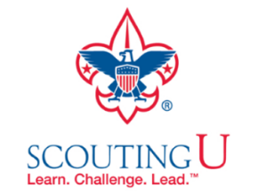

ON-LINE TRAINING
On-Line Training for all Cub Scout positions has been available since October 25, 2015
The online training for Den Leaders, Cubmasters, Committee Chairs and members, and Chartered Organization Representatives is totally updated with help from volunteers from around the country. The new training is divided into shorter, more targeted modules so leaders can get the training they need, in the order they want, any time they need it. It is organized around the learning needed prior to the first meeting, in the first 30 days, and to be position-specific trained. This training was developed to be implemented in conjunction with the BSA’s new learning management system. Keep an eye on
my. Scouting Tools (log in at https://My.Scouting.org) for more information.
Go to the BSA Volunteer Training Team Facebook page (Link above) and.
Then you automatically receive the latest news!!

If you are having difficulties with
the training or system call
Member Care at 972-580-2489,
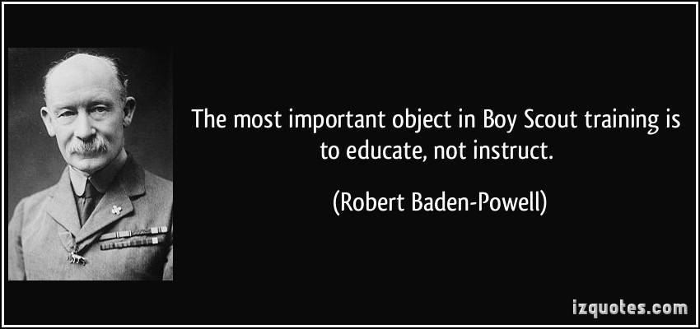
A Typical Learning Plan has several parts –
There is no need to complete more than one section at a time. Do what you have time to do.
Here you can see the three parts of the CM Course -


Each of these three parts is broken down into "bite sized" chunks:
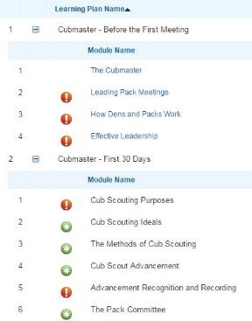
Go check it out and get your
people trained!!!

CUB SCOUT IDEAS

School Night for Scouting Agenda
Adapted from Twin Valley Council, BSA
http://www.twinvalleybsa.org/
You may choose to make a School Night for Scouting flip chart based on the following agenda to ease your presentation
PRE-OPENING
Have the following ready –
- Attendance cards,
- Scouting literature,
- Ceremony equipment,
- American flag and unit flag
EXHIBITS AND DISPLAYS
- Direct boys and parents to visit exhibit & display areas.
- Set up sign with unit number, sponsor, and time and place of meetings.
- At least two Cub Scouts in uniform.
- Pictures of activities, especially Day Camp.
- Sign to direct K'garteners to special Lion room.
- Sign to direct 1st Graders to special Tiger room.
- Other display items might include Pinewood Derby cars, projects from past Scout Shows, etc.
REGISTRATION
Have boys and parents fill out a name tag.
Have parents fill out attendance card for boy.
Split out Lions and Tigers (5 and 6 year old boys and their parents to different locations.)
OPENING CEREMONY
- Teach "When the Sign Goes Up".
  - Here is a simple way to get order for announcements or the next order of business. Explain that whenever you raise your hand in the Scout sign, the group is to become attentive and stop talking.
  - Have everyone practice it a few times until the proper reaction becomes automatic. This method of getting order saves your voice and nerves. Explain to the boys "when the sign goes up, everyone is to listen".
- Flag ceremony--Cub Scout Den
  - Form two lines facing each other. The flag is marched up between the lines with all personnel saluting. The flag is halted at the head of the lines and turned about face, whereupon all assembled give the Pledge of Allegiance.
WELCOME - STATEMENT OF PURPOSE
- Briefly state purpose of meeting.
  - Tell prospective members and their parents about Scouting's opportunities in the neighborhood and inform them as to how they may participate.
- Tell how Cub Scouting does business.
  - Creates a partnership with an institution such as PTA, church, or civic group to use the Cub Scout program with their youth.
  - The unit is owned by the chartered partner (school, civic club, etc.)
  - The chartered partner provides unit meeting place and leadership.
  - The (name your local council) provides program literature and tools, training for leaders, volunteer and professional guidance and a major activity schedule, including provision of camp facilities. Let everyone know when the next scheduled training session is.
  - Cub Scouting is for boys in grades 1-5.
  - Cub Scouts join a Pack. The Pack meets once a month and it's a family meeting (Mom, Dad, brothers & sisters). The boy is assigned to a den which has 6-8 members and meets once a week.
  - Talk about benefits of Boys' Life.
- Introduce Unit Leaders
UNIT SPECIFICS
- Parent participation.
Place great emphasis on each parent joining
Scouting with their son.
  - Parents who have boys of Scouting age are the major source of leadership. Cub Scouting is volunteer led.
  - Full support and cooperation of every parent is essential to a successful Cub Scout program.
  - Parents can help carry their share by serving as unit leaders or den leaders, unit committee members or auxiliaries, or by cooperating on transportation for Cub Scout outings.
  - Parents need to keep informed.
  - Parents should encourage their boy in his advancement.
- Unit Information
  - Leadership Meeting place and time
  - Registration fee
  - BOYS' LIFE SUBSCRIPTION –
  - Policies and procedures (if appropriate).
- Review unit program for the coming year.
  - Leader should distribute a "hand out" describing the Unit's planned program for the next 12 months.
- Distribute and review applications for membership.
- Work on organization of new dens as required.
- Process applications for membership... Cub and adult. Fill out applications and collect fees for new enrollments. Adult applications need to be signed by a representative of the unit's chartering organization.
- Our next meeting will be _________
ADJOURN
  - Mention Boys Life magazine again
  - Have inspirational Cubmaster’s Minute (Closing Thought)
  - Tell everyone Pack parents will remain t answer questions
  - Dismiss Boys and Parents
COMPLETE YOUR SCHOOL NIGHT FOR SCOUTING' REPORT
- Turn in Report along with all the registration forms to your District Coordinator.
  - It does nobody any good for you to keep those applications on your refrigerator until charter renewal, you “get them all together,” “I get a chance to look them over again”, … (or any of the myriad other excuses I have heard over the years)
  - Until you file that application –
- The new Cub does not have BSA insurance
- Will not begin receiving Boys’ Life, which is usually three months after registration anyway
- Your council may refuse to process awards for him as he is not registered (Mine does – CD)
- Straighten up meeting room facilities - remove displays - thank custodian.

Tips for a Successful Fall Recruitment
And Join Scout Night
https://monmouthbsa.org
IMPORTANT NOTES:
New Scout Applications must be completed and turned in to council quickly. The scout (and your unit) is not covered by insurance until the form is filed by council.
Fees are Pro-rated for new scouts. They pay only from registration until charter renewal date.
Youth Protection Training Certificates should be turned in with all Adult Applications. Some councils will not be process adult apps without them.
BEFORE YOU START
Update your Unit Information at www.BeAScout.org
  - Update BeAScout Profile information, website, meeting dates/times/contacts
  - Forgot password? Go to MyScouting.Org and click on “forgot password”
  - Only leaders who had access before to BeAScout can make changes.
  - Three people from each unit can have access
  - Don’t forget to manage your leads – status update
  - BeAScout – new resources for parents/leaders House Cleaning 101
  - Unit leaders – If leaders have changed you must submit a new application to council.
  - Make sure Council knows of all changes in contact phone/email/ websites/addresses
  - Check your Charters/Unit Rosters to make sure that everyone you think is registered really is.
  - Boys NOT registered are NOT scouts, NOT insured and can NOT advance in rank. DON’T WAIT TO RE-CHARTER!
  - Back-to-School Night vs. Fall Round-Up Recruitment Night
Back-to-School Nights are NOT meant to be recruitment nights, but they ARE:
  - A way to increase the visibility of Scouting in your school.
  - A chance for your scouts to help your school by conducting a flag ceremony to open the event
  - A chance to say a “few words” to the audience (if school allows) announcing who you are and inviting them to visit the table and come to your recruitment night. (60 second max).
  - A place to set up a table to display information about your unit
  - A chance for parents to sign-up for more information
  - A way to hand out flyers announcing your “Recruitment Night.”
Fall Round-Up Recruitment Night IS the time to “SELL” your program.
  - Set a date a week or a few days before your first Pack meeting just to meet with prospective scouts. OR, Hold the program an hour before your Pack meeting.
  - Try not to hold a recruitment meeting during a Pack meeting, it can be too overwhelming for parents (we all know how chaotic those first two meetings can be), especially those with very young children.
  - Insist that parents SIGN-IN when they ARRIVE.
  - Have parents fill out registration BEFORE they leave.
  - Encourage Lion and Tiger Parents to fill out an Adult Application – Get them involved from the beginning.
FLYERS and Advertising
With many schools only using electronic formats for flyers it is even more critical to get the message out to prospective parents.
  - Press release (if possible) – advertise your recruitment information night in the local paper. Chances of getting it in are better if you join with other packs in your area and do “ONE” press release for all the packs.
  - Put it on your Facebook page and post on the walls of your friends in other groups like soccer, football, little league etc. Encourage all your [parents to SHARE the announcement so that all their Friends can see it, too.
  - Hand out flyers at local sports games
  - Ask “kid friendly” businesses like pizza places or Game-stop if you can put up a Poster in the window or leave Flyers to announce your recruitment night. **Take it down afterwards**
  - Religious Organizations – See if your church/religious institution will allow you to hand out flyers either before or after a sermon, maybe even have an information table one week before your recruitment night.
  - Boy Talks - Ask your school if you can conduct a 6 minute “Boy Talk.”
Flyers
  - Fill out a Flyer Request form to get copies from your Council. Ensure you give them enough lead time before the event.
  - Obtain approval by the School Superintendent’s office
  - Pick up flyers and distribute to your schools
Yard Signs
  - They are designed to be left up without dates so that people can re-use.
  - If you decide to write on the, make sure to include the Date, Time and location of your event.
  - Check town ordinances for time frames to put up and take down signs.
  - Get permission from local businesses to place signs on their lawns
  - Don’t put up too soon or people will ignore them.
  - Learn how many your council will provide you.
How to Organize a Successful Recruitment Night:
1. Welcome: It is important that every parent AND child be greeted when they arrive. Have a volunteer/parent greet everyone at the door and direct them to the meeting room.
2. Sign-In: See example of sign-in sheet. Everyone should sign-in. Make sure to get clearly printed e-mails so you can follow-up afterwards.
3. Display: Make your room visually appealing, have information about the program, and show how much fun scouting is.
- Photo Album/ Poster board displays
- Copies of the Scout Handbook for each rank
- Derby Cars, rockets, or other items build by scouts
- Pack/Den banners and flags
- Tent and camping equipment
- Mini Boys’ Life Magazines
4. Den Leaders: Have one from each rank or den available to speak with the parents/boys about the program for their specific rank.
5. Activities: Games, hands-on crafts/activities such as egg/spoon races, rain gutter regatta track, segment of derby track, balloon games, soda bottle bowling, a skits/puppet shows by Webelos, etc.
***Get Webelos and Boy Scouts
involved to run the FUN.***
6. The Presentation: Keep it short and stick to the basics.
**If you have a slide show
that is great way to start.***
- Give a brief description of your pack: We are pack # xxx, we currently serve # boys from x town / school(s).
- Talk about the scouting program: We provide age appropriate scouting programs for boys in Kindergarten through 5th grade. Offers boys a chance to learn new things, develop new skills, work as teams, develop strong friendships
- Family oriented program: All volunteers, encourage family participation, partners with your boys through the program.
- Fun Things your pack does: camping, baseball games, mini-golf, etc..
- Community Service: We give back to our community by doing service projects such as a,b,c.
- How a Pack operates:
What is a Pack, a Den, what the meeting schedules are like, registration fees, how you determine which children go into which dens.
- VOLUNTEERS !!!!!!! the lifeblood of the Pack. No volunteers – No pack, no program. Sign them up – Encourage Lion and Tiger Parents to fill out Adult Application. Give small job/task where they can help. No Prior Experience Necessary.
- Make sure to give the date/time/place of your Next Pack/Den Meeting.
- Q&A – make sure to leave time for this. Then do break-out with den leaders.
- Sign them up!
7. Useful Hand-outs
- Give each family a contact name/number for follow-up questions.
- FAQ Sheet about your pack with contact names, Pack Calendar, etc.
- Flyers about scouting
- Applications
- Copy of your newsletter
- * list of when/where your dens meet (not for distribution but helpful to have since it will be asked)
8. Filling out the Application All applications must be turned into council quickly Without a completed and turned in application – the pack and new Scout are not covered by insurance, are not considered “scouts” and can’t do any advancements. Double (Triple) Check that app is completely and correctly completed. Some councils have checklist to look for common errors.
A. Youth Applications – Make sure parents include email, sign form in correct spot, check off Boy’s Life, check off “active scout parent” or “Tiger adult partner”
B. Adult applications - Sign Background Check section, fill out form completely – SS# is mandatory, All questions on side must be filled out or form will be returned.
NOTE: Youth Protection Training Certificate Some councils require YPT Training Certificate to be attached to the application when you turn it in to council or it will NOT be processed.
9. Follow-up email, phone call, letter
1. Myscouting.org e-mail templates to send out invitations to your scouting night.
2. Thank you: to those who haven’t signed-up letting them know they can still join.
3. Welcome to those who have signed up with the contact email for their assigned Den Leader and next meeting date or pack calendar.



Invitation Methods for Cub Scouting
or ...
"Fifty Ways to Find Tomorrow's Leaders"
Chester County Council, http://www.cccbsa.org/recruiting
Look here for exciting ideas on marketing your Cub Scout pack and inviting new families to join!
Good luck and good recruiting!
A few guidelines for successful implementation
Learn about family resources and talents ...
Throughout Invitation Methods for Cub Scouting, pack leaders are challenged to discover the talents and resources of their parents and families. If we know more about what people con do and what they might enjov, our efforts to involve them will be far more successful. The Family Talent Survey Sheet, published by the Boy Scouts of America is a good place to start. Use it "as is," or create your own form. Either way, do take this important step!
Plan ahead ...
One of the keys to a successful Cub Scouting program is planning ahead. Usually all that separates great activities and those just "so so," is thinking about them in advance. The same thing goes for inviting new families to join Cub Scouting. None of the steps are complicated, but they do require lead-time. Just getting the right people and materials in-place, on-time, requires careful planning. And then add to that, time for creating attractive materials; and for preparing parents, leaders, and Cub Scouts for their roles in the effort. You can see how last minute planning can severely limit results.
Use your council's resources ...
Talk to your district executive, a district committee member, or to a commissioner; and read your council newsletter. Learn what's available. There may be a membership recruiting theme to work with, or pre-printed flyers or "stickers" available. Your DE may also be able to assist in a meeting with your principal or visits with boys at school. You won't know unless you ask.
THE TOP TEN LIST
The most important methods for recruiting. All packs should consider them.
            - Pack information sheet
- Every pack should develop and distribute a Pack Information Sheet that includes meeting dates, times, and places; a pack calendar; a list of leaders' contact information; and other exciting information about events and activities.
- Give copies to your chartered partner, pack families, local schools, churches, and other organizations-then they can answer questions and help people get in touch with you.
- It's your chance to brag on your pack! Make it look smart. Keep a supply on hand.
            - Chartered partner organization visit
- Before school begins, schedule a face-to-face meeting with your chartered partner. This important meeting gives you the opportunity to thank the organization for its support, and to outline ideas and requests for your recruitment effort.
- Take your Pack Information Sheet and perhaps a yearbook-style photo album of activities. Be prepared to explain how Cub Scouting benefits the organization.
            - Meeting with the principal
- Just like a PTA presentation (see item #17), a meeting with the principal will strengthen relationships and may foster support for your recruitment efforts.
- Share exciting news and successes regarding your pack and upcoming events. Be sure to include school and community service projects.
- The pack is a resource and an asset to the school. Explain the benefits for the boys and for the school. Schools should be the sites of many pack service projects. And, Cub Scouting is educational: it has been established that active Scouting programs improve grades and study habits, and lead to better jobs and more successful lives.
- Remember, a principal will appreciate a pack that is a source of school volunteers.
- Take a can of popcorn or other gift to thank the principal for support. Be sure to make the meeting brief. Don't waste this important administrator's valuable time.
            - Flyers
- A pack can produce its own Cub Scouting promotional flyers, but often the local district or council will provide them at no charge.
- Order or produce flyers well in advance, and include the date, time, and place of the recruitment night; along with unit leadership contact information. Many flyer designs also have space for information about your upcoming events.
- Joining nights should be held the first few weeks of school and flyers sent home with all boys. It might help if you offer to count out the flyers by classroom. Counts need not be exact. Ask for an average, divide by two for number of boys, and add a cushion!
- If teachers distribute them, attach a half-sheet with directions for each classroom package of flyers. Your note should also thank the teacher for his or her assistance.
            - Wear the uniform
- What a simple way to market Cub Scouting. The uniform is a walking billboard!
- Ask Cub Scouts to wear their uniforms not only on the days of den and pack meetings, but also on those of joining nights and other school events like back-to-school night.
- At your meetings, provide recognition for every boy who wore his uniform that day.
- Leaders should also consider wearing their uniforms at school events.
- Design a cool pack t-shirt for Cub Scouts to wear on a more regular basis.
            - School visits
- Visits to classrooms, the lunchroom, and even on school busses, are highly effective at getting boys excited about Cub Scouting-a great opportunity to talk up your pack activities and to offer a personal invitation to the recruitment night.
- Be sure to take visual aids, "stickers" (see item #7), display boards, and simple props to make the presentation lively and memorable.
- The visit can be done up to three days before the event. Stress that the boys must take a parent or guardian, or other adult partner with them to the joining night!
- After your visit, be sure to send the school a thank you note.
            - Stickers
- "Stickers" that go on a boy's shirt (think peel-off name-tags printed with joining information) may be more likely to make it home than a flyer.
- Boys can also put the stickers on their lunch boxes, notebooks, or anything else that goes home, and that a parent might see.
- Stickers or wristbands should include date, time, and place for joining night, along with contact information and instructions for a parent or adult partner to also attend.
- Distribute at school visits, back-to-school events, and other such functions.
            - Yard signs
- Before joining night, put signs at school entrances and exits, and high traffic areas.
- Distribute signs to parents to post at their homes and perhaps places of business.
- Use council-provided signs or create your own.
- Include date, time, and place for joining night, plus a phone number and web site address. If you design your own sign use LARGE, DARK print.
            - Picture boards
- Display boards speak louder than words! Get permission to set them up at back-to-school nights, recruitments, church/school activities, and other places families will see them.
- Creating these boards may be a great den activity. Be sure to include contact information, web site address, and any joining night information.
            - Back-to-school nights
- Your pack is part of the fiber of the school, and people need to know it. Being present at back-to-school nights and other school activities is an important way to increase awareness of what we have to offer youth and families.
- Set up a table with flyers, a sign-in sheet, stickers, picture board, and other visuals; and speak with all families attending. Be sure to have a supply of your Pack Information Sheet and pack "business cards" (see item #11).
- Take names and contact information of interested families so you can personally call and remind them to attend the recruitment night.
- All pack leaders should be in uniform for this event.
- Encourage pack leaders and parents to volunteer at back-to-school nights. They can help with set up, take down, and other duties.
Pack Families
The families of the pack are your most important resource. They know people; their sons have friends; and getting everyone-especially parents-involved in marketing your program can be an easy way to introduce the idea of volunteering. Don't be shy! Working together with other adults is fun and many will thank you. Just remind them we're looking for our nation's future leaders.
            - "Business" or "buddy" cards
- Design and print attractive "business cards" for parents and Cub Scouts to distribute
- to friends and other families. The cards also work well as a "takeaway" at school, church, and community functions.
- Perhaps use a child-oriented version-a "buddy card" -for the Cub Scouts to use with their friends.
- Think about creating a special version to pass out with candy on Halloween.
- Include pack meeting date, time, and place; leadership contact information; and perhaps a catchy slogan that alludes to the fun new families will enjoy. Print upcoming activities on the reverse side.
- Use a commercial print shop or a business card template on your home computer.
            - Customized invitation letters
- Produce and email a letter to parents that they can customize as from their family, and then send to friends and acquaintances.
- Include information on the benefits of Cub Scouting, your pack's activities, and why your families are involved.
- It is important that any letters invite families to a specific gathering, indicate how to learn more, and what to do if they cannot attend.
            - Personal phone calls/email invitations
- Ask each family to brainstorm other families they could personally call or email with an invitation to join.
- The pack should provide each family with copies of the Pack Information Sheet, business card, and other items to help spread the excitement of Cub Scouting.
- Pack leadership could also create an email "newsletter" or other promotional copy for families to forward to their brainstormed list.
- Have an incentive for the family inviting the most new members.
            - Promotions through family affiliations
- Most families of course, are affiliated with other organizations and businesses: place of employment; customers or clients; church; musical groups; various clubs; sports; etc. These contacts can also be avenues to spread the word about Cub Scouting.
- The Boy Scouts of America publishes a Family Talent Survey Sheet, or you can create your own "family resource questionnaire." Be sure it asks for information about family affiliations outside of Scouting.
- The Pack Information Sheet and business or buddy cards also come in handy with this invitation method.
            - Halloween Candy
- Halloween represents an opportunity where often parades of children actually stop at the homes of Cub Scouting families. Why not take advantage of the opportunity?
- Provide a sticker or label your pack families can to affix to candy they give to out.
- Sheets of labels with invitations can be printed from your computer.
            - Pack web site and/or Facebook page
- Check with your parents and find talent to set up and maintain your own pack web site and Facebook page. This is getting to be the "norm" these days; most packs seem to have them.
- The sites should be designed for members of your pack; as well as for the community to learn about what we have to offer and that we are developing tomorrow's leaders.
- Limit what the public can see, to information about joining nights and pack activities in general. Provide a link to the National Council, http://www.Scouting.org , for information about Cub Scouting and the Boy Scouts of America.
- Provide password protected access that allows pack families to see the more detailed information about activities and events.
- Think logically about youth protection issues. For example, refer to boys only by their first names. Check with your local council about the rules for a pack web site.
- Check with your council, your school, and other community organizations to see if they will provide links from their sites to yours.
- Include your web site address on all pack promotional materials.
Schools
The greatest potential for Cub Scout membership growth is in the schools. Boys who would benefit from what we have to offer spend more time there than almost anywhere else. Pack leaders should develop strong relationships with principals, teachers, and parent organizations. This will go a Jong way-especially in those areas where the local Scouting council or district has limited access. Don't forget to research and include, local private schools and "home-school" associations.
            - PTA/PTO presentations
- At the beginning of each school year, it is a good idea to schedule a brief presentation to your school's parent teacher organization.
- Share information about the number of families in your pack, recent and planned activities, and the benefits of Cub Scouting for both boys and families.
- Distribute Pack Information Sheets and business cards.
- Take a few cans of popcorn to pass around in thanks for their ongoing support.
- Offer the pack's assistance and involvement in PTA/PTO events and projects.
- It is extremely helpful if several pack leaders and parents are active in the PTA/PTO.
            - Involvement in school activities
- Back-to-school nights, carnivals, fund-raisers, and other school activities represent excellent opportunities for pack parents and leaders to volunteer, and thus pay the school back for its support-or sew good will toward developing it.
- The pack's participation will help the school see the pack as a positive resource and committed ally, for they too are developing future leaders.
- If parents cannot volunteer, they should at least attend and otherwise support school functions, and be on the lookout for prospective new families.
- Be sure especially, to be available for flag ceremonies throughout the year.
            - Intercom announcement
- Obtain permission to use the school's public address system or intercom to make Announcements regarding pack meetings and activities, and to promote joining nights.
- The announcements must be brief, upbeat, and well rehearsed.
- Seek a parent to handle this-one with a strong a "broadcast" voice.
            - Video announcement
- If your school has a closed-circuit television system, ask if one of your articulate, well uniformed Cub Scouts or leaders could read a joining night announcement on-camera.
- Make sure the reader is well rehearsed. You can point to your favorite television anchor as an example for how your "news" should be read.
- Your school may also allow you to show one of the Boy Scouts of America's membership promotional videos, either over their TV system, at an assembly, or in a classroom. Work with your district executive to obtain a copy.
            - Textbook covers
- Create and distribute a text book cover that promotes Cub Scouting and your pack.
- These can be easily created on a computer.
- Perhaps design it as a template that dens and families can personalize.
            - Personal letters of invitation
- Use a formal invitation letter or card to invite all families in the school to your joining night.
- Work with pack families to gather names and addresses, or use a school directory if available.
- Invitations should be mailed two weeks ahead.
            - Display case
- Use a school display case or bulletin board to show the excitement in your pack.
- Include action-pictures to catch attention and motivate boys to attend the joining night.
- Consider purchasing an electronic "picture frame" that loops through a number of photos.
- Include a poster with the date, time, and place of the recruitment night, and with other information that will help families make the decision to join.
- Some schools will let you keep up the display year-round, but do this ONLY if you are able to update it from time to time with upcoming pack activities.
            - Phone calls
- Personally call each family at the school, and any additional prospects you might have listed through discussions with others in the pack. Share a few details about your activities, and invite them to the joining night.
- This is a great opportunity to answer questions and share stories about the program.
- Calls should be made at least one week in advance.
- Ask other pack families to help with the calls.
            - Silicone wristbands
- If ordered in quantities of 100 or more, these debossed promotional wristbands can be purchased for as little as $1.00 each, or even less. Try an Internet search on "promotional wristbands" to check out different sources.
- Customize the wristbands with your pack's web site address, so people can learn more about your activities.
- Distribute to boys at the school or award them to new members and their recruiters.
            - School reader-board
- Ask at your school if you can display a message on their outdoor marquee to promote your recruitment night or other pack activity.
- Give lots of notice and make your message short so it can be read as people drive by.
            - Lunch tray liners
- You've seen them at McDonalds and other places-a promotional piece that fits the food tray! Provide information about your pack and its activities, and how to join.
- Tray liners should include pictures, puzzles, and other exciting visuals in order to attract attention and motivate children to even take them home.
- To make the idea more attractive to the school, you could also coordinate the message to include information about girls' youth organizations.
            - Serving school lunch
- Have uniformed pack leaders volunteer to serve lunch on the day of your joining night.
- Be sure to take a picture board, stickers, and flyers to build interest and attention.
            - After-school promotional activity
- Work with the school administration to set up an activity on school grounds.
- If you have volunteers willing to get food handler permits and meet other regulations, make it a hot dog BBQ! Nothing attracts attention like free food.
- Have uniformed Cub Scouts participating along with other children. Make it co-ed and allow all ages to join in. The younger boys will soon be ready for Tiger Cubs.
- Take the games and activities straight out of Cub Scouting literature.
- Have a picture board, displays, stickers, flyers, and copies of your Pack Information Sheet; and watch for parents stopping to pick up their sons.
            - School service projects
- If the pack supports the school the school is more likely to support the pack.
- Make sure service projects are based on what the school needs.
- Boys and leaders should be in uniform as they work.
- Do projects at times when a maximum of boys and parents will see the action.
- Seek coverage in the school newsletter and the local newspaper (see item #46)
- Ask to have pictures and a description displayed on a bulletin board in a hallway.
            - Follow-up joining nights
- It is highly unlikely that all the boys who want to join will make it to one recruitment night. There is just too much going on these days for both boys and parents. As a result many packs hold two or even more joining nights per year.
- Help families understand that if they missed the first meeting they can still join at a subsequent night, or at any other time of the year!
Churches
There is a reason so many churches serve as Scouting chartered partners. Most appreciate our family values and our stand on duty to God. Contact the local minister, priest, bishop, rabbi, or other pastor, and establish a mutually beneficial relationship!
            - Bulletin inserts, articles, & calendars
- Create an attractive insert, and encourage churches in your pack's drawing area to include it with their weekly bulletin. Handle all the printing, and offer to help with the inserting process as well.
- Submit regular articles for churches to include within the text of their bulletins.
- Include pack leader contact information and details about your joining nights and upcoming activities.
- Make articles brief with no long paragraphs. Bold and underline all contact information and activity dates so they will stand out. Inserts should look like an advertisement that guides the eye to critical information.
- If the church produces a weekly or annual calendar, be sure to get all your pack activities listed in it.
            - Church service projects
- Take a look at item #30, covering school service projects. Same suggestions apply.
- If we support the church in this way, then while our Cub Scouts are learning the valuable lessons of service, the pack will be earning the respect of the church.
            - Sunday school presentations
- Ask to make a brief presentation at local religious education classes ("Sunday school").
- Take a few Cub Scouts with you, and be sure to be in uniform.
- Promote and explain the religious awards program for that faith.
- Participate in Scout Sunday services; wear the uniform; set up an information table.
            - Messages from the pulpit
- Though this is especially appropriate for Scout Sunday, many pastors are willing to promote Cub Scouting at other times as well. Our values are an important factor.
- Schedule a meeting with the pastor and follow the same guidelines indicated in item #3 for a meeting with a principal. Pay special attention to the appropriate Religious Awards Program.
- Ask if he or she would be willing to deliver a message along with the sermon and to preach about the values of Cub Scouting.
- Provide a brief summary of important points that might be covered.
- Investigate the possibility of a pack leader delivering a brief message during the part of a service reserved for announcements; cover the joining night or other pack event.
            - "Welcome to Cub Scouts" table
- Secure permission to set up a display that boys and parents can stop by as they enter or exit the church. Perhaps it will make a "future leader" feel welcome!
- Use some of the same ideas indicated previously for a school display (see item #23): Jots of pictures, the Pack Information Sheet, and so forth.
- Have the table staffed by uniformed pack leaders and Cub Scouts.
- Do this the day messages are delivered from the pulpit, and yes, on Scout Sunday.
            - After-church promotional activity
- This would be just like item #29 covering the after-school promotional activity.
- It could be done in a "fellowship hall" or on church grounds, depending on the weather, facilities, and available space.
Community
The following ideas can help market your pack's program throughout your community. Try not to keep your pack a secret! Build awareness that Cub Scouting is alive, healthy and relevant. You will reach not only additional families, but may well develop general support for Scouting aims and objectives.
            - Community events & parades
- Do some research! The local chambers of commerce are a good place to begin. Make a list of all the local carnivals, parades and other events in the area around your pack. Then contact organizers to learn how you can be part of them.
- Set up a display board or booth at community events such as carnivals and parades. Have uniformed leaders and Cub Scouts there to answer questions, along with plenty of flyers and your Pack Information Sheet to distribute.
- Encourage pack families to volunteer to assist with the set-up, clean up, or activities at community events.
- Look for opportunities for your Cub Scouts to present flag ceremonies-especially for patriotic celebrations and 9/11 remembrances. Get them in their best uniforms, and practice, practice, practice!
- Parades are great fun for the entire Scouting family. Build a float, march, or volunteer to carry banners! Again, have plenty of information available to distribute.
            - Pack special events in the community
- Hold a special event such as a "Kite Day," bike rodeo, or carnival. Invite the entire community. Get the local paper to cover it! Community service projects are good too.
- Negotiate a special price at the zoo and offer "Cub Scouting at the Zoo." Publicize it through newspapers, schools, and churches. A science center or museum works too.
- Secure a partner for the event; perhaps the local fire or police department, a school, or a church. This can lead to increased exposure and credibility.
- Have a schedule of events and activities planned for children of all ages. Consider setting it up for just part of a day so people will leave wanting more.
            - Sporting events & recreation centers
- Sports are a major activity for many families; be on the lookout for their marketing possibilities.
- Work with youth sports associations to set up information tables at games.
- Get permission from local sports venues to hang banners or posters, or to set up information tables during games and tournaments.
- Host an activity at a local recreation center. These are often very popular places where kids of all ages "hang out." An example might be a basketball skills clinic for children.
            - Popcorn & fund-raising opportunities
- Selling popcorn or conducting other fund-raisers represents an opportunity to do more than just generate revenue.
- For each item sold, attach information or give the customer a thank you card that also promotes your pack activities and successes.
            - Community reader-boards
- Use marquees at businesses, churches, and neighborhood or recreation centers to promote joining nights and pack activities.
- Contact organizations well in advance, in order to plan the message and its timing.
- Look especially for "scrolling" signs; the moving message attracts more attention.
- Be sure to thank the organization for its support.
            - Local libraries
- Ask the local library if you can hang posters there and leave a supply of your Pack Information Sheets on the counter for interested patrons.
- Design and print Cub Scouting promotional bookmarks for libraries to distribute.
- Libraries also have events; your pack's involvement could lead to more exposure.
- Encourage pack leaders to volunteer to read (in uniform) for "story time."
            - Promotion through businesses and offices
- Visit local businesses and post offices to seek permission to set up a window or counter-top display, or to leave information about your pack activities.
- Ask groceries or drug stores if they will insert your Pack Information Sheet or business card into each shopping bag.
- Family-friendly businesses are the best bet. And they will be especially interested if the display might bring in or increase business.
- The best time to use these methods may be during the Scout Week celebration.
            - Door hangers
- Create attractive door hangers with pack contact information and joining night details.
- Target specific areas within your community and assign them to dens for distribution of door hangers. Use the same rules that you would for door-to-door sales, with full involvement from accompanying parents and leaders.
- Door hangers work especially well in apartment complexes and subsidized housing, but be sure to first obtain permission from building management.
- Blanket key areas in your community on a specific day. Make this a pack activity and give the Cub Scouts a special participation recognition.
The Media
The media is all about communications and marketing; it's what they do. Every news story about Scouting helps generate support; every public service announcement draws a level of interest. There is always somebody out there watching, listening, or reading. Let's help them see and hear about Cub Scouting!
            - Local newspaper "news stories"
- Community newspapers are always interested in what's going on in their neighborhoods. Usually they are looking for stories to write.
- Every pack meeting or activity represents an opportunity for a story: who earned what, who won the race, what families are involved. They are all of interest.
- Develop a relationship with the publisher and editors. Look for a parent with good writing skills who might be willing to prepare and submit news releases.
- Alert the paper several weeks before any of your major activities. You never know; they might send a reporter/photographer.
- Make sure your pack meetings and activities are included in the community events section or calendar that most papers publish. This is a good method to consider for the larger papers as well.
            - Newspaper or newsletter advertising
- Sometimes it pays to purchase small ads in newspapers and in the newsletters published by schools, churches, and even large business that realize they have employees with families.
- An ad might be a one-time purchase for a joining night or major activity, but some newsletters-especially those from churches-will also print low-cost business card-sized ads that become permanent fixtures on the back page.
            - Community access television
- Most communities and local cable companies have community access channels.
- They may run public service announcements, feature live guests, and cover various community events.
- Become familiar with the station in your community and contact management to learn about the possibilities.
- If you have the talent and interest among pack families, try filming a 30-second spot based on your activities and plans for the coming year. Of course, you might want to check with channel management-just to make sure they will run it.
            - Drive-time radio PSAs
- Make your own public service announcement! To get ideas, listen to advertising on the radio. Then plan what will be said, write it out, and rehearse and record!
- If you can recruit someone with a voice recognized in the community, then all the better!
- Some stations-especially talk radio and sports stations-may have radio hosts or personalities willing to do the recording for you.
            - Sign spinner
- Maybe you've seen them on street corners. They're the latest thing. Instead of someone just standing there wearing a sandwich-board, young people hire out as "sign spinners." They use large-usually cardboard or vinyl-signs that they twirl over and around themselves like a basketball player might show off his ball handling skills. It involves a combination of acrobatics, baton-tossing and martial arts movements to attract the attention of passing motorists.
- Ok, so maybe this one's a long shot, but having a sign spinner spinning a Cub Scouting message would certainly attract attention. You never know, one of your Cub Scout's older siblings may already be skilled in the art!
As S’more Summer Fun may involve some fire building to cook your S'Mores -
REMEMBER FIRE SAFETY
Sam Houston Area Council
Here are some reminders as you take caution:
- Build your fire in the center of a 10-foot circle that is free of flammable materials such as twigs and dry grass.
- Don’t build the fire against a tree or between the roots.
- Don’t use firewood that spits sparks.
- Break burnt matches before throwing them away, be sure that they are “cold out”.
- Never leave a fire unattended.
- Keep a bucket of water, dirt, or sand handy for emergency use.
- When you are through with the fire, put it out. Spread the coals and ashes and sprinkle them with water. Stir and sprinkle until the fire is cold out. This means it feels cold to the touch.
From the Cub Scout Leader Book

ROUNDTABLE HINTS
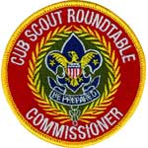

2016 – 2017
CS RT PLANNING GUIDE
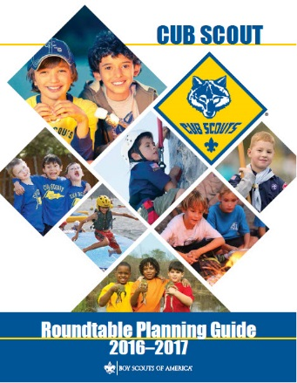
IS ISSUED !!!
You can download a copy at the Roundtable Support page of the Commissioner's part of National's website:
http://www.scouting.org/scoutsource/Commissioners/roundtable.aspx
Page 5 of the 2016-2017 Cub Scout Roundtable Planning Guide (CS RT PG) states –
"There is an exciting new look to the Cub Scout Roundtable this year."
With which I must agree. There have been very exciting changes in the CS RT PG for 2016-2017.
The team that was assembled was on a mission to revitalize CS RTs and increase attendance. They had survey results and front line knowledge of what was happening in Cub Scouting and at Roundtables across the BSA.
Some of their goals were:
- Fresh New Material. No reusing old stuff from previous years.
A wonderful thing to do. When I started on CS RT PG Task Forces in 2003 that was our mantra, too. All material has to be fresh. New songs, skits, discussion material, crafts.
- Roundtable is to be supplemental training where leaders go to learn about new things, new methods, best practices, and network with others. It was never intended to be a session simply to plan a pack and den meetings for the next month.
That statement is true. RTs are Unit Service to the extreme. They are meant to address all aspects of operating a unit not just pack and den meetings. And help them improve. They are meant to deliver everything that the leaders need.
The Interest Topics and discussions in the 2016-2017 CS RT PG cover a greater range of important topics for the leaders than the previous several years. And discussions are sometimes held by position and sometimes everyone all together. Varying the format is another great idea.
And I see that this year's Interest Topics address supplemental training topics for which the leaders have asked.
- The CS RT PG no longer provides pack meeting monthly themes or pack resource sheets. The pack meeting plans found online at Scouting.org are designed to help the Cubmaster plan terrific pack meetings and support den leaders with pack assignments.
The intent of this move is to free up time for more and deeper discussions and training on the Interest Topics and eliminate what was identified as not needed. Since the Pack Meeting plans are very well written and very complete, the task force felt that further review at RTs is unnecessary.
The 16-17 CS RT PG does have this caveat, "You may continue to emphasize the pack meeting plans during your Roundtable as a helpful resource." Let's look at the title of the document, it is a Planning Guide not a syllabus that must be read word for word. It was and still is recognized that each RT is unique. That only the RT Commissioner knows what sells best in his/her district. So the 16-17 CS RT PG allows for discussion of Pack Meeting Plans if the CS RT Commissioner feels that the participants want it.
So, I compliment the team that assembled the 2016-2017 CS RT PG for such a bold step. I have seen the statistics from the surveys and understand the logic and why it was done. And I feel it is a needed change at this time to attract more people to RT. But as with many things, we must carefully watch the long term effect of the change.
- Nothing that can be just downloaded from the internet. The team's goal was material and presentations of that material that would attract new people to RTs. They wanted participants to tell other leaders, "You can't get this just downloading it from the internet."
- What is a Roundtable? Here is a little Commissioner Dave philosophy on RTs in the style of the Athanasian Creed.
- RTs are not solely Training but training is done at RTs. Training provides service to units. Training assists units to provide program.
- RTs are not solely Unit Service but unit service is provided for all attending units at RTs. Unit Service is providing training to units. Unit service assists units to provide program.
- RTs are not solely Program but program is presented at RTs. Program is explained by training. Unit Service helps units deliver program.
- And in this BSA Key 3, none should be before or after another. All three parts are needed to work together.
Every organization in BSA has a Key 3 working together from National (Chief Scout Executive, National Commissioner, National President) down to a local Cub Scout Pack (Chartered Organization Rep, Cubmaster, Committee Chair). RTs are no different.
- What next?
We go forward with our RTs. We use the 2016 - 2017 CS RT PG and advertise RT has changed. We talk up the improvements. We put on exciting RTs using our resources. It will not be easy, it has never been easy. But it will be easier with this CS RT PG.
We take notes and submit comments telling what worked well and with suggestions for changes to make the next issue even better. All things are always under evaluation and all things need constant tweaking.
And we must share that information amongst all groups and work together (Commissioners, Training, and Program) to do what is best for the boys.

DEN MEETING TOPICS
Remember – Boys want to be active!!
See, too, that they earn their awards
(Never say GET. You get sick, you do not get awards – You earn awards. A little CD Philosophy).
Big Rock Ideas – suggestions for Big Rocks that fit Interest Topics or seasonal activity. If years are next to an item (e.g. 13-14) that suggested Big Rock is in that Roundtable Planning guide and on-line at http://www.scouting.org/scoutsource/Commissioners/roundtable.aspx
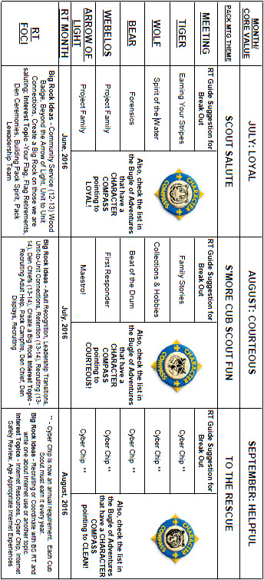

CHARACTER COMPASS
AUGUST -
ADVENTURES with a CHARACTER COMPASS pointing to COURTEOUS:
TIGER –
- Tiger Bites(Core)
- Tigers – Safe & Smart (Elec)
WOLF –
- Call of the Wild (Core)
- Collections and Hobbies (Elec)
BEAR –
- Paws for Actions (Core)
- Beat of the Drum (Elec)
WEBELOS CORE –
- First Responder (Core)
ARROW OF LIGHT CORE –
- None (Core)
WEBELOS & AOL ELECTIVES –
- Maestro (Elec)


SEPTEMBER -
ADVENTURES with a CHARACTER COMPASS pointing to HELPFUL:
TIGER –
- Tiger Bites(Core)
- Curiosity, Intrigue, & Magical Mysteries (Elec)
WOLF –
- Howling at the Moon (Core)
- Paws of Skill (Elec)
BEAR –
- Fellowship & Duty to God (Core)
- Baloo the Builder (Elec)
WEBELOS CORE –
- None (Core)
ARROW OF LIGHT CORE –
- Camper (Core)
WEBELOS & AOL ELECTIVES –
- Fix It (Elec)

THEME RELATED STUFF


S'MORE CS FUN
RELATED ADVENTURES
All Adventures are fun. These involve special Summer or Cub Scout FUN or FOOD –
TIGER –
- Back Yard Jungle – Go on a walk
- Games Tigers Play – Play Games.
- Tiger Bites – 2, 5, & 6 involve eating!
- Tigers in the Wild – Take a Hike, Participate in a Campfire, Visit a Zoo
- Family Stories – Share a favorite snack!
- Floats and Boats – Build and float a boat
- Rolling Tigers – Ride your bike
- Tiger Tag – Play outside active games!
WOLF –
- Call of the Wild – participate in a Campfire
- Howling at the Moon –CAMPFIRE!!
- Paws on the Path – Go on a hike!
- Running with the Pack – Outside fun & games
- Air of the Wolf – Fly a Kite, Shoot a rocket, or race a boat
- Digging in the Past – Dinosaurs!!!
- Finding Your Way – Scavenger Hunt and hike with a compass.
- Paws of Skill – attend a sporting event
- Spirit of the Water – go swimming (safely!)
BEAR –
- Bear Necessities – go camping, be in a campfire, cook food!
- Fur, Feathers, and Ferns – Hike & go to a Zoo
- A Bear Goes Fishing – GO FISHING!!
- Bear Picnic Basket – FOOD!!
- Roaring Laughter – Tell jokes
- Salmon Run – Swim, and row or paddle!
WEBELOS CORE –
- Cast Iron Chef – Cook FOOD!
- Webelos Walkabout – Take a hike!
ARROW OF LIGHT CORE
- Camper – Go CAMPING!
- Scouting Adventure – go outdoors with a Boy Scout Troop!
WEBELOS & ARROW OF LIGHT ELECTIVES –
- Aquanaut – Go Swimming and Paddling
- Castaway – Build a FIRE! Cook without pots!
- Maestro – Attend a live musical performance – Many towns have free outdoor concerts in the summer – go one!!
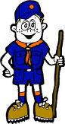

PACK MEETING THEMES
AND PLANS
www.scouting.org
From National's Website for the new plans using the Core Values based on the Scout Law:
Here are a few thoughts to consider around these new pack meeting plans. First, there is a plan for each month that corresponds with a point of the Scout Law. In addition, each plan has a theme to help make the pack meeting even more fun! The plans do not have to be used in a specific order.
Tips for Utilizing the Plans
- Pack meeting plans do not have to be done in any special order, but it is recommended that you include all of the points of the Scout Law each year. The pack planning meeting would be a good time to determine the order.
- There are pack meeting plans for multiple years posted on the website. It is your pack's choice of which one to select from each point of the Scout Law for each year.
- Pack meetings should not last longer than an hour. Adjust the plan to make it fit within the time. Research and experience tells us that Cub Scouts have a hard time sitting still for that long. Keep the meetings fun, active, and engaging.
- If you are comfortable with a costume to fit the theme of the meeting, go for it!
- Importantly, keep it simple and make it fun.
- The following required adventures have a requirement that suggests or requires completion at a pack meeting. Please plan accordingly as part of your annual program planning process. Work with your den leaders to plan when these activities will take place.
Tiger
- Tigers in the Wild, requirement 5. Participate in an outdoor pack meeting or pack campout campfire. Sing a song and act out a skit with your Tiger den as part of the program.
- Games Tigers Play, requirement 3. Make up a new game, and play it with your family or members of your den or pack.
Wolf
- Council Fire, requirement 6c. Create a den project from recyclables for a pack meeting.
Bear
- Grin and Bear It, requirement 2. Working with the members of your den, organize a Cub Scout carnival and lead it at a special event.
- Grin and Bear It, requirement 3. Help younger Cub Scouts take part in one of the events at the Cub Scout carnival.
Webelos
- Stronger, Faster, Higher, requirement 5. With adult guidance, lead younger Scouts in a fitness game or games as a gathering activity for a pack or den meeting.
Arrow of Light
- Building a Better World (if chosen), requirement 10b. Set up an exhibit at a pack meeting to share information about the World Friendship Fund.
As a personal note: I have read most of the plans and they are excellent and just as complete as the new Den Leader Books. The games, and other stuff are right there. Including costuming ideas for that added PIZAZZ!! If you do not use themes and do not add PIZAZZ you are not doing your best for your pack.
GOOD JOB!!! From CD
Check them out at:
http://www.scouting.org/Home/CubScouts/Leaders/CubmasterResources/PackMeetingPlans.aspx


Kim, the chair of the task force, says "I do want to stress that the focus is still the Core Value and the theme is just there as an enhancement. Pack meeting theme plans are specifically crafted to bring out the important points of the Core Value in a fun way."

PACK MEETING THEMES
2015–2016 Pack Meeting Plans
July | Loyal | "Scout Salute"
August | Courteous | "S'more Cub Scout Fun"

2016–2017 Pack Meeting Plans
September | Helpful | "To The Rescue"
October | Kind | "Creepy Crawlers"
November | Courteous | "Cubs In Shining Armor"
December | Cheerful | "Celebrate"
January | Obedient | "Cub Scout City Council"
February | Reverent | "Passport To Other Lands"
March | Loyal | "Our National Treasures"
April | Thrifty | "Power Up!"
May | Clean | "A Picnic With Pizzazz"
June | Brave | "Roaming Reptile Alert"
July | Trustworthy | "Let The Games Begin"
August | Friendly | "#CUBSCOUTS"
If you are using a paper copy the link to all the
Pack Meeting Plans is:
http://www.scouting.org/Home/CubScouts/Leaders/CubmasterResources/PackMeetingPlans.aspx

UPCOMING MONTHS
August's Core Value, COURTEOUS, will use the theme, S'More Cub Scout Fun.
Month | Year | Theme
Potential COURTEOUS Months
December | 1947 | Helps and Gives
December | 1948 | Goodwill
December | 1949 | The Other Fellow
December | 1958 | The Golden Rule
December | 1961 | Follows, Helps, and Gives
December | 1984 | Do a Good Turn
December | 1986 | The Golden Rule
December | 1992 | To Help Other People
December | 1995 | Do a Good Turn
December | 1997 | The Golden Rule
November | 2014 | Give Goodwill
November | 2015 | Cubs In Action
Potential "S'More Summer Fun" Months
June | 1941 | Move into the Backyard
July | 1945 | Outdoor Cubbing
June | 1953 | Summertime Adventure
August | 1954 | Annual Picnic
August | 1955 | Outdoor Fun
August | 1957 | Good Old Summertime
July | 1958 | Outdooring
August | 1961 | Outdoor Festival
July | 1966 | Summertime Adventure
June | 1971 | Outdoor Fun
July | 1975 | Summer Adventure
March | 1977 | Kites-Spring
June | 1980 | Outdoor Fun
July | 1984 | Fun in the Sun
May | 1988 | Outdoor Adventure
July | 1992 | Fun in the Sun
June | 1997 | Outdoor Adventure
June | 2003 | Fun in the Sun
August | 2006 | Scouting It Out
June | 2002 | Critters, Cubs and Campfires
August | 2008 | S'More Summer Fun
June | 2009 | A Camping We Will Go
May | 2015 | Backyard Fun
September's Scout Law point, HELPFUL, will use the theme, To the Rescue.
A Scout is HELPFUL. The theme TO THE RESCUE is used to help Cubs understand being HELPFUL.
A SCOUT IS HELPFUL
- A Scout is helpful. A Scout cares about other people. He willingly volunteers to help others without expecting payment or reward.
HOW DOES “TO THE RESCUE” RELATE TO THIS SCOUT LAW POINT?
- A Scout is concerned about other people. He does things willingly for others without pay or reward. This month, Cub Scouts will explore how to be helpful by avoiding accidents and being prepared for emergencies. Use games and/or mock accidents so Cub Scouts can show they can help by coming “To the Rescue.”

Month | Year | Theme
HELPFUL Months
November | 2015 | Cubs In Action
September | 2016 | To The Rescue
Potential "TO THE RESCUE" Months
September | 1960 | Cub Scout Citizens
October | 1980 | Cub Scout Citizen
July | 1983 | Stars and Stripes
October | 1988 | Cub Scout Citizens
February | 2003 | Uncle Sam Depends on You
November | 2010 | Citizenship
November | 2011 | Citizenship
November | 2013 | Your Vote Counts
December | 2014 | Stars and Stripes
Potential HELPFUL" Months
(Months with Goodwill based theme)
December | 1940 | Good Will - Cub Style
December | 1942 | Good Will
December | 1943 | Good Will Month
December | 1944 | The Other Fellow
December | 1945 | Follows - Helps - Gives
December | 1947 | Helps and Gives
December | 1949 | The Other Fellow
December | 1950 | Helps (for institutions)
December | 1958 | The Golden Rule
December | 1961 | Follows, Helps, and Gives
December | 1972 | Follows, Helps, Gives
December | 1975 | Cub Scout Gives Good Will
December | 1984 | Do a Good Turn
December | 1986 | The Golden Rule
December | 1991 | Follows, Helps, Gives
December | 1992 | To Help Other People
December | 1995 | Do a Good Turn
December | 1996 | Helping Others
December | 1997 | The Golden Rule
December | 2003 | A Cub Scout Gives Good Will
December | 2005 | Faith, Hope & Charity
November | 2008 | Spreading Seeds Of Kindness
March | 2013 | Planting Seeds of Kindness
November | 2014 | Give Goodwill
March | 2015 | Aware and Care
November | 2015 | Cubs In Action



BE UP TO DATE

www.scouting.org/programupdates
The Program Updates page has been regrouped. Since the CS Adventure is in full swing, the emphasis on getting ready for it has been reduced. The downloads are still all there. And great information about three new Cub Leader courses at Philmont Training Center next summer.
There is a lot of information now on etting ready and implementing the changes to the Boy Scout program.
Check it all out – stay current!!

CUBMASTER THOUGHTS
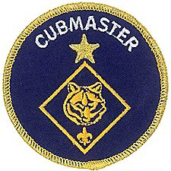

Lions and Leadership
Over the last two issues, we have talked about this new and exciting addition to Cub Scouting,
LIONS.

If your unit has a Lion Program, there is no doubt that you are experiencing a vital jump start in your Scouting membership.
In our pack, all of the Lions in the past two years have become Tigers (20).
To build a successful unit, concentration on membership in the youngest ranks is always a tried and true method.
In the pre Lion Age, Tigers were not always a given. Some years were very good, while others just seemed like pulling teeth to keep the den going.
Part of the problem was (and is) that by First Grade there is a lot of competition out there for a boy's time and his family’s time and attention. Many of the boys became committed to sports and other programs during their Kindergarten year.
The Lion Program has been a great recruitment tool for my unit. I am not sure exactly, but obviously getting the family’s interest earlier is a plus. Getting their attention at the same time or slightly before other organizations helps, too.
But I have found that those little Lions go to school and tell their friends about Lions, and what they experienced as a Lion.
Moms and Dads talk too.
And if they like what they see. (Which our Lion parents obviously have) Word of Mouth is THE number one recruitment tool.

Word of mouth is faster than a speeding bullet and more powerful than a locomotive.
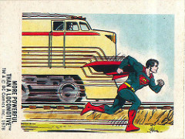
The old saying goes that boys vote with their feet, and to keep those feet marching towards your unit, The Lion Program is a must.
There has been another benefit to come of our two year Lion experience and it is truly exciting.
LEADERS!!!!
It’s like we hit the Scout Leader Lottery.
- In the last two years we have 6 trained uniformed leaders, and two trained Committee members.
- Two are signed up for Wood Badge.
- Another is our Popcorn Kernel.
- All born from the Lion Program.
A Scout is Trustworthy.
This level of volunteerism is exactly what a unit needs to maintain a fresh program and cycle leadership.
There is no secret why we are enjoying such an influx of leadership.
When National developed the Lion Program, they built in development of new leaders. And there is no denying its effectiveness.
The Lion Program is led by a Coordinator, who is responsible for insuring that the program is delivered properly.
There is a lot going there.
"Delivering the program properly" suggests obviously, that the boys will experience The Lion Program as it appears in The Lion Parent and Leader Handbook and that all the activities that the Lions experience will be age appropriate.
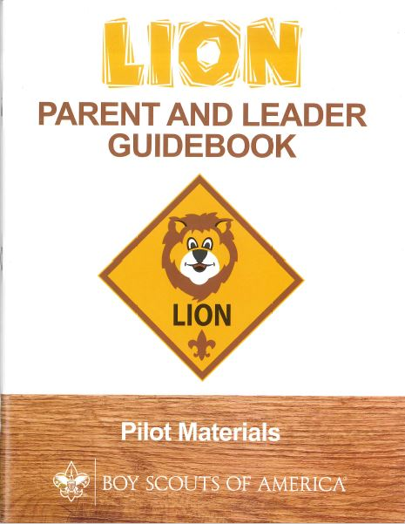
That’s a good start. Here is more -
- Each Lion family takes a turn in hosting a Lion Pride meeting in their home.
- That Host Family works with the Coordinator to plan and execute the program for that particular meeting (Adventure).
- Parents get to see exactly what the Rationale and Take aways are for each Adventure.
- They perform leadership functions.
It is important that The Lion Coordinator be Alive, Awake, and ENTHUSIATIC.
It is even more important that The Coordinator realizes that not only is he or she leading a Pride of Lions, but that he or she is also TRAINING a new crop of potential leaders.
The Cubmaster is a great choice to be The Lion Coordinator. I fulfill both positons in our Pack.
Leading the Lion Pride Meetings with the same level of enthusiasm as a Pack Meeting is CRUCIAL in recruiting and developing leadership candidates from within the Host Families of the Lion Pride.
Lions and their Parents can feel the energy of a well trained, enthusiastic, and experienced Leader.
It becomes clear to the parents relatively quickly that there is a formula for success being delivered not only during the meetings, but at home as the Lions begin to take what is presented in the Lion Pride meetings and put The Aims and Methods of Scouting into action.
It also becomes clear to the parents of these Lions that they too can bring their abilities and skill sets to meetings and begin to affect positive change not only in their sons lives, but in the other boys in the Pride as well.
They realize that leaders are not born, but nurtured and developed.
They realize that they too can lead.
The Coordinator should keep a watchful eye out for those parents within the Pride who begin to ask questions about adventures they have read in the book, or begin to suggest activities that seem to go hand in hand with an Adventure the boys are focused on.
Those who do are your potential new leaders, and you must reach out to as many interested Lion Parents as possible, and begin to plant seeds that they have what it takes to assume the role as Leader, or Assistant Leader.
Asking for an Assistant Leader (or two), is also very effective in tool in grooming parents for leadership in the Pride and in your unit.
The Lion Program is a very successful and well thought out program to peak the interest of a five year old to the wonderful world of Cub Scouting. Like the other levels of Scouting , when the program is delivered as it is intended, it produces fantastic results in the abilities of boys to make moral and ethical choices by instilling in them The Aims and Methods of Scouting.
In other words, it is a HUGE success in helping parents guide their sons to being good contributing members of their society.
Where else can a five year old go to experience the things that Scouting offers?
Nowhere, and now that the Lion Program is becoming offered nationally, the Scouting Movement will begin to enjoy an edge over virtually all other activities offered to this impressionable age group.
Does your unit have a Lions Program yet?
If not, Contact your District Executive and get the ball rolling.
The Lions will be the Pride of your Pack.


The Chief Scout Executive
on Lions
What We Know
According to a 2014 U.S. Census Bureau report, 57 percent of kids ages 6–17 participate in at least one after-school extracurricular activity. This means that by the time they are eligible for Tigers, more than half of them already are engaged in some type of athletic, artistic or other program.
Often, children become attached to lifelong activities at an early age — that is certainly a goal we would have, as we know the long-term benefits of Scouting involvement include strong asset development in the areas of character and leadership. However, we also know that when youth participate in numerous activities at an early age, and miss joining Scouting, they are unlikely to do so at adolescence.
What will be important to learn in the next few years, if the initial entry point works at the kindergarten-age level, is will this cause losses at a different age, or will the program keep the same retention all the way through to Boy Scouting?
What we learn from the pilot Lion format could also help us assess and create a smoother transition from Webelos into Boy Scouting. Too many parents now see a barrier or obstacle, rather than a smoother transition. You will often hear parents say, “We did Cub Scouting, now we’re not sure if we are going to do Boy Scouts.” We do not have a seamless transition into Boy Scouts for a number of reasons. This pilot test will help us think through some of these issues.
We want to be sure that our Lion program delivers the right mix of character and leadership values and that we set the bar high. The program must be sustainable, we must have the right infrastructure to support it, and it needs to address in a meaningful way the needs of parents who want their kids to join Scouting at an earlier age.
You can rest assured that we will carefully evaluate our progress and keep you apprised of the results. Stay tuned for more.
Thanks for reading.
Mike

Reprinted from "The Chief's Corner" on Scoutingwire.org
MORE LION INFORMATION
Rather than reprinting all the related LION info for another month, I am providing you the links to the BSA Sources. CD
Bryan's Blog has written about Lions –
Go to http://blog.scoutingmagazine.org/2016/ and you can look them up

Cub Hub Lion Posts
Go to the Cub Scout Learning Library item in this issue of Baloo's Bugle to see the Cub Hub Blog entries on The Lion Program. Or go to www.cubscouts.org and click on the Cub Hub Blog.
There are slideshows on the web put up
by local councils. Some examples are:
WD Boyce Council has "Lion Cub Pilot Program" at: http://www.wdboyce.org/document/lion-cub-pilot-program/161325
Northern Star Council has a training slide show for District Coordinators and others at: https://www.signup4.net/UPLOAD/NORT26A/LION12E/District%20Lion%20Cub%20Coordinator%20Training.pdf
Councils have put up webpages about what their packs need to know to begin a Lions Program. Examples are:
New Birth of Freedom: http://seb.newbirthoffreedom.org/2016/03/22/were-approved-for-the-lion-scouts-pilot/
WD Boyce: http://www.wdboyce.org/cub-scouts/lion-cub-pilot-program/63360
Garden State (My Council): http://www.gardenstatescouting.org/lion-program-0
Garden State, also, has an FAQ PDF - http://www.gardenstatescouting.org/sites/default/files/Lion%20Program%20FAQ.pdf
And we have created a Facebook page for our units with Lions - https://www.facebook.com/GSCLion/
Selected FAQ's
National has posted a PDF file of FAQs about the LION program at http://www.scouting.org/filestore/pdf/Lion_FAQs.pdf

Organizing for Lions
From – New Birth of Freedom Council
For those packs that are thinking ahead about participating in the Lion Scouts program, having the right volunteers involved in delivering the Lion Scouts program will be important. Research shows that the most important person for a successful Scouting experience is a good leader. There are two new adult leader positions within the pack that are directly engaged in the delivery of the Lion Scouts program – a Lion Coordinator and a Lion Guide. Where do these positions fit into the current pack structure?

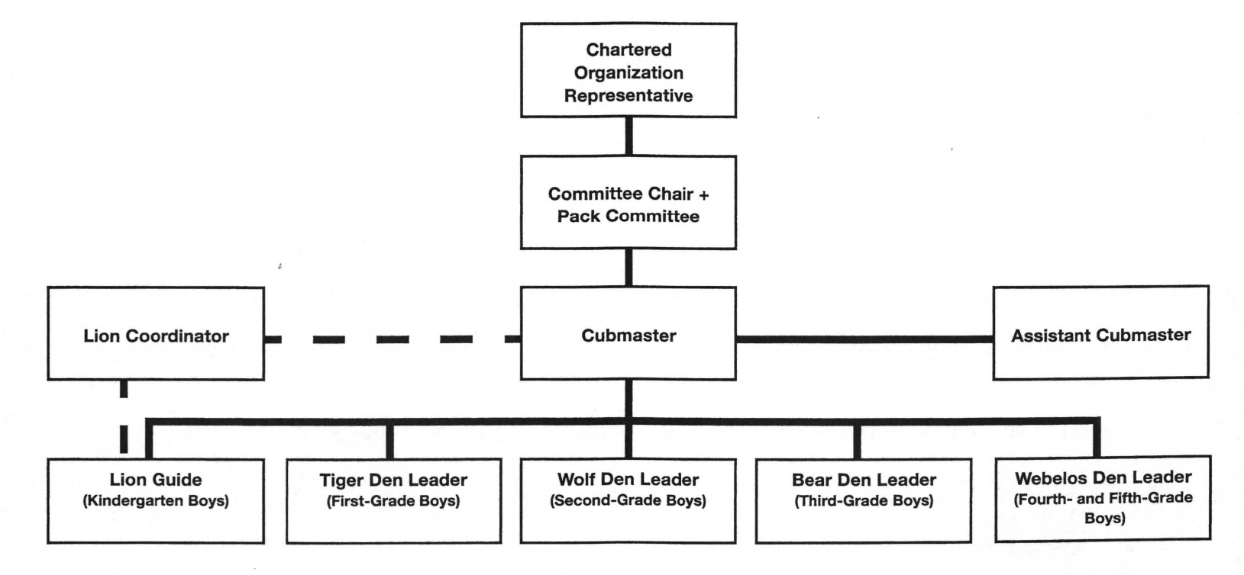

What is the Lion Coordinator’s job description?
- Is an experienced and successful den leader
- Understands den and pack operations within the overall structure of Cub Scouting
- Demonstrates excellent communication and organization skills (and will remain in at least monthly contact with the Lion dens)
- Participates as needed in the unit’s School Night with all new Lions and their parents
- Assists the Lion guide in hosting the first orientation meeting for all the individual Lion dens in their pack
- Serves as a coach and mentor for Lion Guide
The position description for the Lion Guide is as follows:
- Has previous successful experience as den leader
- Works directly with other den and pack leaders to ensure that the den is an active and successful part of the pack
- Plans and prepares for initial Lion den meeting and outings
- Mentors adult partners in the delivery of Lion den meetings
- Attends the pack leaders’ meeting
- Leads the den at the monthly outings and other pack activities
- Ensures the transition of Lion Scouts to Tigers at year-end
- Prepares the Lions for day camp at the end of the Lion year if appropriate
- Coordinates shared leadership among the Lion adult partners in the den
- Ensures that each Lion and his adult partner have the opportunity to be the host team, which plans and executes the den activities, and rotates responsibilities monthly

WEBELOS
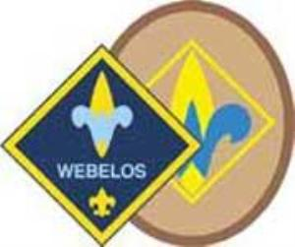
Always an S Webelos always ends with an S whether talking about one Webelos Scout or a den of Webelos. It is an acronym – WE’ll BE LOyal Scouts. As the CS RT Commissioner who mentored me says – "If you don’t have an S at the end – then there is nothing to which to be loyal."

Year Round Growth Plan
http://www.scouting.org/scoutsource/BoyScouts/YearRoundGuide/graduate.aspx
The year-round growth plan is designed to facilitate Scout recruitment and pack-troop relations. To carry out the plan, the troop membership chair will need to remember some important guidelines:
- Work closely with a nearby Cub Scout pack.
- Prepare an effective Webelos-to-Scout plan.
- Make new Scouts and their parents feel welcome.
At the beginning of the recruitment process, the troop should align with a Cub Scout pack in the community. If more than one troop draws its new Boy Scouts from this pack, contact the leadership of the other troops and design a plan to work together with the pack. Offer the use of your troop's equipment and expertise to the Cubmaster and the Webelos den leaders, and work with them to develop an effective Webelos-to-Scout plan, following the year-round calendar provided on this Web site.
Use the Second-Year Webelos Scout Tracking form to collect information on each second-year Webelos Scout. The information will be invaluable as the year-round plan is implemented. The form helps track the Webelos Scouts' progress toward becoming Boy Scouts.
Lastly, ensure that the Scouts and their parents have a smooth transition from the Webelos den to the Boy Scout troop. Make the Scouts and their parents feel welcome and at ease in the new troop environment, and recruit parents of the new Boy Scouts to become assistant Scoutmasters and troop committee members.
The activities recommended in this plan will help stimulate youth interest in the Boy Scout program. Implementing the plan involves the active involvement of adult and youth leaders of the Boy Scout troop as well as the leadership of the Cub Scout pack.
For more information on graduating Webelos Scouts into a troop, see the Webelos-to-Scout Transition DVD and brochure, No. AV-02V012.

Webelos-to-Scout Planning Calendar
Here is a Month by Month Plan for graduating your Webelos into Boy Scouts!

Key Personnel:
- CM 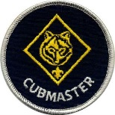-Cubmaster
- PLC  -Patrol Leaders' Council
- SM 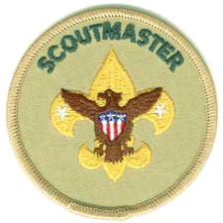 -Scoutmaster
- SPL 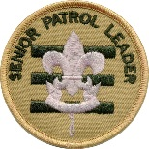 -Senior Patrol Leader
- TCC 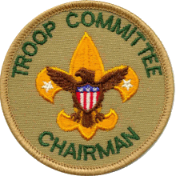 -Troop Committee Chair
- TG 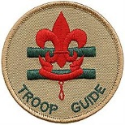 -Troop Guide
- TMC 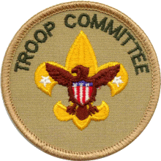 -Troop Membership Chair
- WDL  -Webelos Den Leader

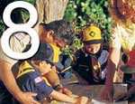 | August |  | Person Responsible
 | 1 | Get names, addresses, and telephone numbers of second-year Webelos Scouts. Record the information on the Webelos Scout Tracking form. | TMC, WDL, CM
 | 2 | Plan a joint Boy Scout troop/Webelos den camping trip for October. | SM, PLC, CM, WDL
 | 3 | Plan a program of upcoming events to present at a Webelos den meeting visit in November. | TMC
 | 4 | Select a den chief for each Webelos den. | SM, SPL, CM
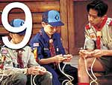 | September |  | Person Responsible
 | 1 | Mail a letter of introduction from the Boy Scout troop to second-year Webelos Scouts to introduce them to the troop. | TMC, SM
 | 2 | Put second-year Webelos Scouts on the mailing list to receive the troop newsletter. | TMC
 | 3 | Continue planning the joint camping trip for October. | SM, PLC, CM, WDL
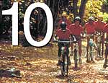 | October |  | Person Responsible
 | 1 | Conduct the joint camping trip with the Webelos den. | SM, TMC, SPL, CM
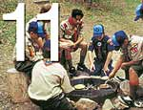 | November |  | Person Responsible
 | 1 | Attend a Webelos den meeting to teach the Webelos Scouts how the Boy Scout troop works. | SM, TMC, SPL
 | 2 | Have den chiefs attend a local council or district training course. | SM
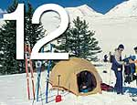 | December |  | Person Responsible
 | 1 | Set a date for Webelos Scouts and their parents to visit a Boy Scout troop meeting in January. | SM, WDL
 | 2 | If desired, send a small holiday gift to each Webelos Scout. | SM, TMC
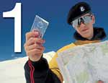 | January |  | Person Responsible
 | 1 | Host Webelos Scouts and their parents at a Boy Scout troop meeting. | SM, SPL
 | 2 | Plan a bridging ceremony for the blue and gold banquet in February to welcome graduating Webelos Scouts to their new troop. | SM, CM, TMC, SPL
 | 3 | Attend a meeting of first-year Webelos Scouts to introduce them to Boy Scouting. | SM, TMC, CM

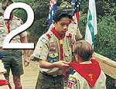 | February |  | Person Responsible
 | 1 | Hold the bridging ceremony at the blue and gold banquet. | SM, CM, SPL, TMC
 | 2 | Get new Scouts actively involved with the troop through troop activities. | TMC, SM, CM
 | 3 | Recruit parents of new Scouts to become assistant Scoutmasters or troop committee members. | TCC, SM
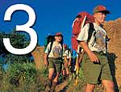 | March |  | Person Responsible
 | 1 | Plan a troop activity for new Scouts to get them involved with their new troop. | PLC, SM, TMC, TG
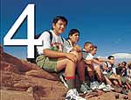 | April |  | Person Responsible
 | 1 | Conduct summer camp orientation to encourage troop involvement. | SM
 | 2 | Attend a meeting of Bear Cub Scouts to introduce them to Boy Scouting. | SM, TMC, CM
 | 3 | Sponsor a troop activity for the new Scouts. | SM, TMC, TG, PLC
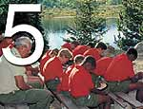 | May |  | Person Responsible
 | 1 | Work closely with new Scouts and parents during their transition to the Boy Scout troop, ensuring their needs are met and that their move has been natural and fun. | TMC
 | 2 | Work on rank advancement with new Scouts. | SM, SPL, TG
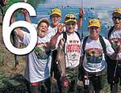 | June |  | Person Responsible
 | 1 | Ensure that all new Scouts attend summer camp. | TMC, SM
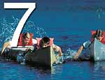 | July |  | Person Responsible
 | 1 | Work closely with new Scouts and parents during their transition to the Boy Scout troop, ensuring their needs are met and that their move has been natural and fun. | TMC
 | 2 | Work on rank advancement with new Scouts. | SM, SPL, TG

Crazy Holidays
Jodi, SNJC Webelos Resident Camp Director Emeritus,
2006-2011. Adapted from http://holidayinsights.com/moreholidays/index.htm
http://www.brownielocks.com/month2.html
August is:
- Admit You're Happy Month
- Happiness Happens Month

- American Adventures Month
- American Artists Appreciation Month
- American Indian Heritage Month
- Black Business Month
- National Breastfeeding Month
- Children's Eye Health & Safety Month
- National Eye Exam Month

Do you know where these
eyes came from?
- Children's Vision & Learning Month
- Family Fun Month
- Get Ready for Kindergarten Month
- Motor Sports Awareness Month
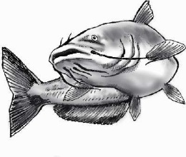
- National Catfish Month
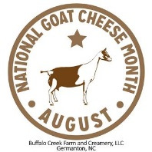
- National Goat Cheese Month
- National Golf Month
- National Immunization Awareness Month

- National Panini Month
- National Picnic Month
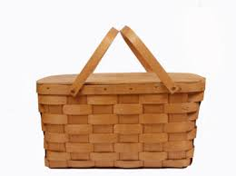
- National Water Quality Month

- National Win With Civility Month
- Peach Month
- What Will Be Your Legacy Month

This dog is a Staffordshire and Bassett mix
- World Mutt-i-grees Rescue Month
Weekly Events:
- International Clown Week: 1-7

- Simplify Your Life Week: 1-7
- National Bargain Hunting Week: 1-5
- Rock for Life Week: 4-7
- National Scrabble Week: 6-10

- Exercise With Your Child Week: 7-13

- Assistance Dog Week: 7-13
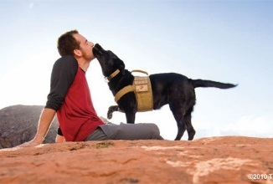
- Knights of Columbus Family Week: 7-13
- Stop on Red Week: 7-13

- Sturgis Rally: 8-14
- Elvis Week: 10-16
- National Smile Week: 11-17
- Feeding Pets of the Homeless Week: 14-20
- National Motorcycle Week: 14-20

- National Aviation Week: 15-21 (Always week of Orville Wright's Birthday on 19th)
- Little League Baseball World Series: 18-28

For schedule of all levels of competition –
http://www.littleleague.org/media/llnewsarchive/2015/September-December/2016-WS-Dates.htm
- Be Kind To Humankind Week: 25-31
- National Safe at Home Week: 23-29
- World Water Week: 8/28-9/2

This the Taughannock Falls' main cataract, a 215-foot drop (66 m), making it 33 feet (10 m) taller than Niagara Falls. It is the tallest single drop waterfall east of the Rocky Mountains. I saw this when I visited my fraternity brother, Bibly, who is recovering from Chemo for cancer in Trumansburg, NY. CD
August, 2013 Daily Holidays, Special
and Wacky Days:
1 National Raspberry Cream Pie Day
2 National Ice Cream Sandwich Day
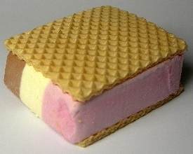
3 National Watermelon Day
4 U.S. Coast Guard Day
5 Summer Olympics begin in Rio
5 Work Like a Dog Day
6 National Mustard Day
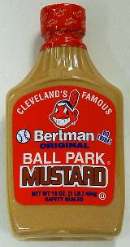
6 Wiggle Your Toes Day
7 National Lighthouse Day
7 Sisters Day - First Sunday in August
7 Friendship Day - First Sunday in August
7 International Forgiveness Day - First Sunday in August
8 Sneak Some Zucchini onto Your Neighbor's Porch Day - now that's nasty!
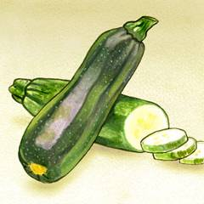
9 Book Lover's Day
9 Chinese Valentine's Day/Daughter's Day - 7th day of 7th Lunar Month
10 Lazy Day
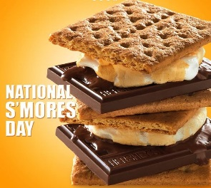
10 National S'mores Day
See recipes in Cub Grub
11 Presidential Joke Day
11 Son and Daughter Day
12 Middle Child's Day
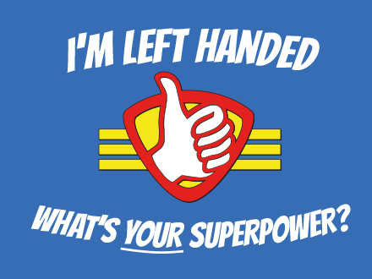
13 Left Hander's Day (For CD's wife)

14 National Creamsicle Day
14/15 V-J Day (Victory over Japan)

15 Relaxation Day - now this one's for me!
16 National Tell a Joke Day
17 National Thriftshop Day
18 Bad Poetry Day
19 Aviation Day
20 National Radio Day

21 Summer Olympics ends in Rio
21 Senior Citizen's Day
22 Be an Angel Day
22 National Tooth Fairy Day
23 Ride the Wind Day
24 Vesuvius Day
25 Kiss and Make Up Day
26 National Dog Day

26 Women's Equality Day
27 Global Forgiveness Day
27 Just Because Day
28 Race Your Mouse Day -but we are not sure what kind of "mouse"
29 More Herbs, Less Salt Day
30 Frankenstein Day
30 Toasted Marshmallow Day
31 National Trail Mix Day
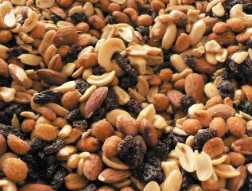

Still time to sign up for

Learning Opportunities at Philmont Training Center

Are you ready to take your Cub Scouting skills to the next level? Check out these learning opportunities available at the Philmont Training Center!
Elevate. to a High-Performing Cub Scout Pack!
Learn what it takes to move your pack to the next level. Take a deep dive into topics such as: effective recruiting practices, growing your pack, supporting Cub Scouts on their advancement journey, converting parents from bystanders to engaged pack volunteers, and leading fun and exciting pack meetings. Move your pack from "great" to "epic" by ensuring you know what it takes to deliver the life-changing experiences only Cub Scouting can provide! Designed for pack committee members, Cubmasters, and unit commissioners.
Philmont Training Center | Registration link
- Week 6: July 10-16, 2016
- Week 9: July 31-August 6, 2016
- Week 11: August 14-20, 2016 (title this week only is "Building Successful Packs")
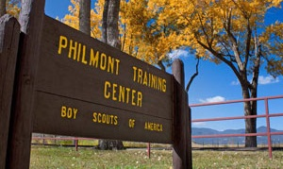
Cub Scouting's Outdoor Skills & Fun!
Put the "outing" back in Scouting … Cub Scouting that is! Learn fun ways to teach boys about the outdoors. Develop new strategies to ensure more of your Cub Scouts experience the outdoors and engage in the "wilderness" around them. Learn how to enhance their outdoor experience with new games, fun, and more! From campfire songs to outdoor award requirements, you'll become an expert in leading Cub Scouting's outdoor skills and fun. Designed for Cubmasters, den leaders, camp committees, and program planners.
Philmont Training Center | Registration link
Week 7: July 17-23, 2016
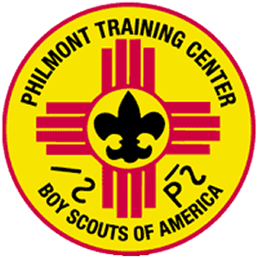
Fun in Dens and Packs!
Do you ever sit through long, boring, and chaotic den or pack meetings? Not in your den or pack, right? Learn ways to keep your great meetings going throughout the next Cub Scouting year! From planning and preparation to meeting sparklers, new songs, skits, and more, you'll develop the knowledge, strategies, and skills to ensure your Cub Scouts are engaged and having fun. You'll learn about the tools and resources available to help you deliver a great Cub Scouting experience! Designed for den leaders, Cubmasters, and pack committees.
Philmont Training Center | Registration link
- Week 8: July 24-30, 2016
- Week 10: August 7-13, 2016
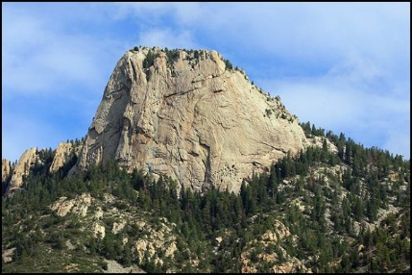

SPECIAL OPPORTUNITIES

Historic Trails Award
Shanae, RT Commissioner, Trapper Trails Council &
www.usscouts.org
The Historic Trails Award recognizes youth and adult leaders who not only explore history but also share it with other people. More than 300 trails have been approved. The BSA recommends that hikers use only the historic trails that have been nationally approved. Contact your local council office or District Executive for a list of local approved trails.
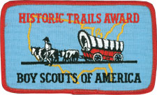
Overview
To bring appreciation to the ideals, principles, and traditions that have made our country strong; emphasis is on cooperation between historic societies and Cub Scout, Boy Scout, Varsity Scout, Venturing, and Sea Scout units. Units should establish a close relationship with a local society early on when planning a historic activity—most communities have such societies.
Background and Planning
The Historic Trails Award requirements emphasize cooperation between historic societies and Cub Scout, Boy Scout, Varsity Scout, Venturing, and Sea Scout units. Scouts should establish a close relationship with a local society as soon as possible when planning a historic activity. Historic societies are generally eager to offer assistance to help your Scouts learn more about local history. Reports from many units indicate that these societies have been eager to offer their cooperation by:
- Suggesting trails or sites that are suitable for unit historic activities and exploration
- Providing units with historic information about the trails or sites
- Offering guidance to units during restoration and marking projects
- Financing the cost of materials used by units for restoration and marking projects
- Staging historic pageants and ceremonies with unit participation
- Directing public attention to unit historic activities through newspapers, television, and radio
Award Requirements
To earn the award, members of your unit must plan and participate in a historic activity. A unit historic activity requires members to
- Locate a historic trail or site and study information relating to it. (The information may be obtained from an adult historic society, public library, or people living near the trail or site. To obtain a trail listing, contact the Outdoor Programs/Properties Department at 972-580-7889.)
There is a 2009 version of National's List of Approved Historic Trails at http://www.coastalcarolinabsa.org/document/historic-trails/133361
- Hike or camp two days and one night along the trail or in the vicinity of the site. Options include an area hotel or the home of other Scouts.
The option for hotel or homes is particularly good for Cub Scouts. If you are working with a local historical society, you could stay at a site already approved by you council for Cub Scout camping.
Whatever your plans, ensure you follow procedure and prepare a Tour and Activity Plan. For more info go to http://www.scouting.org/scoutsource/HealthandSafety/Alerts/TourActivityPlan.aspx
- Cooperate with an adult group such as a historic society to restore and mark all or part of this trail or site. (This may be done during the hike or overnight camp.) Or cooperate with such a group to plan and stage a historic pageant, ceremony, or other public event related to this trail or site—such an event should be large enough to merit coverage by the local press.
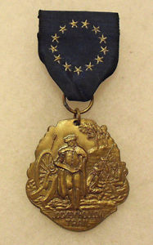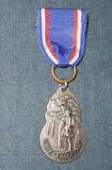
Application for the Award
After completion of the requirements, the unit leader files a Historic Trails Award application with your local council service center. You can download the application form at http://www.scouting.org/filestore/pdf/430-066.pdf.
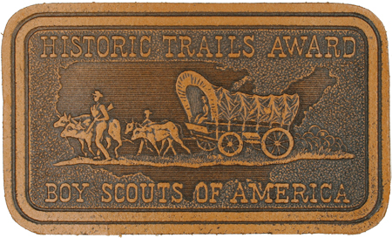
The patch is available embroidered for jackets and blankets or leather for packs and other items. The patch not worn on the uniform.
For more Information:
USScouts.org -
http://usscouts.org/advance/boyscout/historic.asp
(Cub Scouts are eligible to earn the award. Your Den Chief could earn it by helping your Den earn it!!)
National's Website:
- Overview and Eligibility:
http://www.scouting.org/scoutsource/Awards_Central/HistoricTrails.aspx
- Scouting Magazine Article from Mar-Apr 2014 –
http://scoutingmagazine.org/2014/02/need-know-earning-historic-trails-award/
- Award Application, 2015 revision
http://www.scouting.org/filestore/pdf/430-066.pdf
- BSA Historic Trail Specifications:
http://www.scouting.org/filestore/Outdoor%20Program/pdf/430-240(15)_WEB.pdf
This document provides the specifications and application form for a historic trail to be approved for use by Scouting members. A Trail must meet historic trail specifications in five areas:
- Its historical significance
- Its layout
- The responsibility for its upkeep
- Its administration
- The trail's safety considerations
- Renewal of Approved Historic Trails
http://www.scouting.org/scoutsource/Applications/trails.aspx
This site provides the application to renew a currently approved historic trail. Renewal is required every five years. BSA's Outdoor Programs/Properties Department is responsible for approval.


Cyber Chip Award
http://usscouts.org/advance/cyberchip.asp
http://www.scouting.org/cyberchip.aspx
Cyber Chip is now an annual requirement
for all Cub Scouts!!
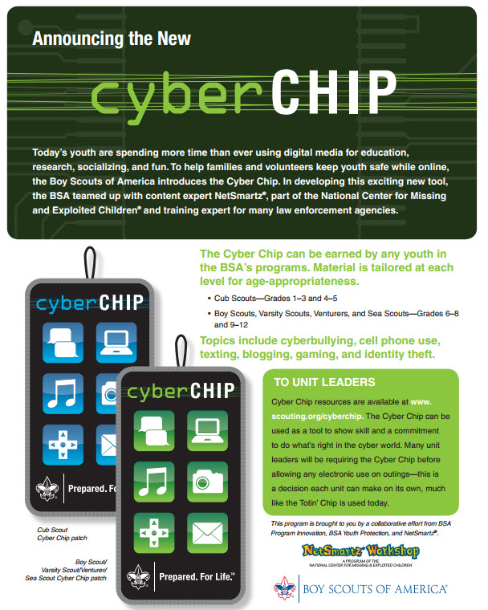
These graphics available on a color hand out PDF at
http://www.scouting.org/filestore/youthprotection/pdf/100-053.pdf
Today's youth are spending more time than ever using digital media for education, research, socializing, and fun. To help families and volunteers keep youth safe while online, the Boy Scouts of America introduces the Cyber Chip. In developing this exciting new tool, the BSA teamed up with content expert NetSmartz®, part of the National Center for Missing and Exploited Children® and training expert for many law enforcement agencies.
Netsmartz® has a Scouting portal showcasing Cyber Chip resources, including videos, for each level. Check it out here. (http://www.netsmartz.org/scouting)
Topics include cyberbullying, cell phone use, texting, blogging, gaming, and identity theft.
Click here to download there brochure - http://www.scouting.org/filestore/youthprotection/pdf/100-053.pdf
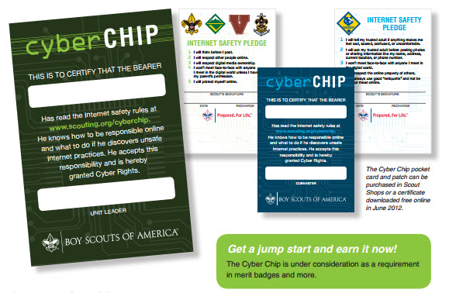
Cyber Chip Requirements
Grades 1-3
- Read, commit to, and sign the Level I Internet Safety Pledge. (BSA Cyber Chip blue card)
- Watch the video “Bad Netiquette Stinks.” (NetSmartz.org/scouting )
- Play the Router’s Birthday Surprise Interactive Adventure, and print the completion certificate to give to your den leader. (NetSmartz.org/scouting )
- Show and tell your family, den leader, den, or pack what you have learned.
Grades 4-5
- Read, commit to, and sign the Level I Internet Safety Pledge. (BSA Cyber Chip blue card)
- Watch the video “The Password Rap” and another video you choose. (NetSmartz.org/scouting )
- As an individual or with your den, use the Teachable Recipes to demonstrate Internet safety rules to your den leader, den, or pack. (NetSmartz.org/scouting )
- Discuss with your unit leader the acceptable standards and practices for using allowed electronic devices, such as phones and games, at your meetings and other Scouting events.
Note: All Cyber Chips will expire annually. Each Scout will need to “recharge” the chip by going back to the Netsmartz Recharge area. This space will hold new information, news, and a place for the Scout to recommit to net safety and netiquette. Then, with the unit leader, the Scout can add the new date to the Cyber Chip card or certificate.
Go to http://www.scouting.org/cyberchip.aspx for available resources and ideas on integrating the Cyber Chip program into your Pack program.

The Scout Law and Cybersafety/Cyberbullying
http://www.scouting.org/filestore/youthprotection/pdf/100-055_WB.pdf
This is available as a PDF form at the site listed above to be signed by Scout, Parent and Leader
Trustworthy. Be truthful with others online, and be very careful of the information you share. Do the right thing when sharing other people’s words or pictures. Make sure you have the owner’s permission before using them.
Loyal. Share information about others only if you have their permission to share it. Uphold appropriate agreements you make with friends when you play games with them.
Helpful. Alert others to scams, cheats, and suspicious sites. Point to reliable and accurate sources of information. Encourage people to report bad behavior online.
Friendly. Reach out to support others who are doing good things, like posting quality creative works. Support those who are bullied.
Courteous. Be polite and respectful. When you use other people’s work, be sure to ask permission when necessary, follow fair use standards, and give credit to the people who created and own the work.
Kind. Treat people with respect when you are on social networks, playing games, talking or texting on a cellphone, or in other digital activities.
Obedient. When using digital devices, follow the rules set by your parents/guardians, teachers, and Scout leaders. Abide by the rules established by sites, services, devices, and games.
Cheerful. Use games, messaging tools, and social forums to build your relationships with others while having fun.
Thrifty. Be a smart consumer. Know your voice, text, and data plans. Use them wisely. Be sure to study digital devices and services you want. Before buying them, make sure you are not overspending on functions and features you won’t need. Be careful not to run up charges on apps and sites.
Brave. Stand up for what is right. Do not participate in mocking and bullying others, even if your friends are doing it. Report suspected abuse to a trusted adult, like your parent or leader; call 911 or call the Cyber Tip line at 1-800-843-5678. If the incident involves any part of the Scouting program, call your Scout executive immediately or email youth.protection@scouting.org.
Clean. Use clean language and discuss only appropriate topics when using digital devices to communicate.
Reverent. Respect the feelings of other people. Do not use digital devices to spread irreverent ideas.
After you earn your Cyber Chip -
Go for USScouts.org's

Internet Scout Patch
This program is open to all youth members in any Scouting program. However, youth may not participate in this program without the consent of a parent or guardian. Ultimately, it is up to a parent to work with his or her child or children on developing a good understanding of the Internet and how to use it safely. Permission from a parent and their support is critical to fostering a dialog that will lead to safer Internet use.

Check it out and download the requirements at
http://usscouts.org/InternetScoutPatch.asp
The U.S. Scouting Service Project is pleased to announce Version 2 of its Internet Scout Patch Program. With the explosive growth of the Internet and the rise of Social Media, it was necessary to re-engineer the program to assure it remained relevant and useful. The new program focuses on fostering a dialog between parent/mentor and Scout that will help prepare Scouts to be aware and alert when using the Internet.
The current version, Version 2.1, of the program includes a new prerequisite. Before Scouts begin work on the Internet Scout Patch, they must now complete the requirements for the BSA Cyber Chip appropriate for their grade level.
The Cyber Chip requirements are available at http://usscouts.org/advance/cyberchip.asp .
The US Scouts Internet Scout Patch is a difficult and challenging program. It will require both the mentor and the participants to work hard. But, it will be worth it! As we continue to become more dependent on the Internet in our daily lives, it is critically important that we develop an understanding of its dangers and how to be prepared, aware, and alert to avoid trouble.
The Patches
Scouts and Mentors can earn the following patches:

Though it should go without saying, the patch is NOT an official award or emblem of the BSA. The patch may be worn by Scouts and Scouters as a temporary emblem to signify their education about the role of the Internet and the World Wide Web in particular as it relates to Scouting. It may also be worn on patch vests or jackets at the personal option of the Scout or Scouter.
Ordering the Patches
The price of each patch is $3.50. We will send one free mentor patch for each order of 10 or more patches. Additional mentor patches are available for $3.50 each. There is no additional charge for shipping.

TRAINING TOPICS

Hail Den Leaders!
Bill Smith, the Roundtable Guy
Many years ago I wrote the following bit about den leaders. I had noticed that pack organization charts always seemed to put den leaders at the very bottom of the hierarchy and I wasn’t sure that was where they belonged.
The program runs on Den Leaders. Do anything to keep them happy and productive. Don't let anyone pile extra duties on them. They are not someone's personal messenger, or delivery boy and especially they are not your wait staff at the Blue and Gold Banquet. Their only job is to lead the dens.
Leading a den is a tough job! It’s a lot tougher than being a Cubmaster, or especially a Scoutmaster. I had those jobs for several years and each was a snap compared to the times I filled in for absent den leaders. Those Tuesday meetings inexorably came around every week and I had to be ready each time with a newly planned program, all sorts of equipment for projects and games and I had to keep track of all the little marks in well-thumbed books or worry about what might be in books that never showed. I’ve never been a Webelos DL but it seems – at least on paper – to be even tougher. I’m not about to get in line for that job either.
As a Cubmaster, I just had to show up at the neighborhood elementary school once a month and try (not very hard) to make an absolute fool of myself. All I had to do was to wear orange gloves and wave my arms a bit and they would all sing Tarzan or Wetspers, and then introduce the dens: Here comes Den Four! They have a new skit for us!
As a Scoutmaster, I would show up every week to watch our cadre of Patrol Leaders and helpers put on their troop meetings. My only part was to recite one or two BP-like homilies at the end of the meetings. Our monthly campouts were even easier. All I ever did was to sit in my sort of comfortable camp chair, drink a never-ending supply of coffee and watch the boys play the wonderful game of Scouting.
I failed to mention all the help I got from the pack and troop committees. They took care of all the finances, the advancement, got the tour permits and booked the meeting places. They were wonderful for me as a CM or SM.
I’m not so sure that den leaders get that much help from their pack committees. Yet, I truly believe that:
In Cub Scouting, you’re either a den leader or your main job is to help den leaders. There is no other choice.
So, who should be helping den leaders?
Pack Leaders
One of the first things I learned as a Cubmaster was that the success of our pack depended a lot more on den leaders than on me. I gradually found ways to help dens and den leaders become successful. We made dens the stars of our pack meetings. We protected the DL corps from having extra jobs thrust on them. For example: let the DLs take care of the product sales or they could serve the food at the Blue and Gold. NO!
Good Pack Trainers, Treasurers and Committee Chairs can do a lot to ensure that den leaders get the training, funding and support they need to make their programs successful.
Someone in the pack structure should be doing their best to line up assistant DLs and Den Chiefs.
Commissioners
Most Unit Commissioners totally ignore dens and den leaders even though the conditions of den programs are better indicators of unit health than most other items on their check lists. District Commissioners, as a rule, are even more oblivious to the concerns of den leaders.
Roundtable
Roundtables can be invaluable to den leaders. Most den leaders require a constant flow of ideas. Den programs consume program items at an alarming rate.
Until now, many RTs have provided all sorts of program help on themes, projects and other activities. It is difficult to foresee how RT staffs will handle the next round of changes but I have seen enough talent at the dozens of Roundtables I have visited to be confident that they will do a great job. I just wish every RT was that good.
District/Council committees
It is difficult to imagine a Quality District without a lot of successful dens in the majority of the Cub Packs. District and even council committees can help by understanding how their calendars affect den leaders. I’ve seen some outstanding workshops and theme fairs over the years that provided den leaders with valuable help. Many DLs have reported that their best help came from Pow Wows or Universities of Scouting.
National programs
The National Council has an excellent track record of providing excellent resources for den leaders. The new Den Leader Guides for the Adevnture Program, the How-To Book and the CS Leader Book are just loaded with useful information. The current Job Specific training is particularly well done. I sincerely hope that they will continue to maintain this quality.
No tribute to den leaders could be complete without this glorious poem by Julie H. Erickson, Lake Bonneville (now Trapper Trails) Council, Ogden, UT.

I Am a Den Leader.
I am a den leader.
I own a hot glue gun, a ring toss game, an American flag, and a 12 passenger van.
I know all about tour permits, permission slips, and registration forms.
I save bits of string, scraps of lumber, old tin cans, and a whole garage full of newspaper.
I am a den leader.
I get excited over paper sack kites that really fly, boys who remember to bring their books, and first aid kits that finally sell.
I laugh at Boy's Life jokes, cheer for my den kick ball teams,
I sing Frankenstein songs at pack meetings, and once wept with a Cub who just found out parents are getting a divorce.
I am a den leader.
I have bribed new Cubs through the Bobcat trail, herded unruly boys along library tours, puffed my way up steep mountain tracks, and panicked when I looked down the other side. I have threatened to quit more than once.
But I am still a den leader
My patch says I'm "trained", but I know I still have a lot to learn from district and council leaders, Cubmasters, other den leaders, and especially my boys.
And I still have one more lesson to teach. I will not give up, especially on any of my boys.
So I am still a den leader.
I like to think there is a special place in heaven reserved for den leaders. Surely, they would have a need for bird feeders and barometers and someone who could love a dirty faced Cub Scout.
I hope when I die there is a hot glue gun plugged in and waiting.
For I am a den leader.
And a heart-felt thank you to every DEN LEADER, past and present! Bill.
******************************************
Read the following carefully, as the Den Leader's role has increased with the new delivery method. Take good care of your Den Leaders. CD

Seven Things I Learned
Bill Smith, the Roundtable Guy
Back in those early days when I was the Cubmaster of Pack 28 in Jackson, NJ, I took every Cub leader training available. I learned a lot about what I was supposed to do but there were some important subjects that were never covered in those training courses or covered so lightly and so quickly that I never really noticed how important they were.
These I learned by experience, sometimes by making mistakes but, more often, by heeding the advice of others, adding those things to my repertoire, and then seeing that their recommendations were valid.
Here is the first and, I think, the most important one.
Protect and Retain Den Leaders.
The program runs on Den Leaders. Very quickly, I discovered that most of the real work in our pack was done in the dens. A lot of the advancement, the communication with parents, the den spirit, the building of self-esteem, and living the ideals of Scouting take place in the den.
Our job running pack meetings and pack activities was mostly to support and encourage the stuff that was going on in the dens and, through the dens, in the homes. Without the work done in the dens and the boys’ homes, we were nothing more than a monthly entertainment show. Only when our show supported and glorified the den achievements, did we became part of Cub Scouting.
Do anything to keep your DL happy and productive. Keeping den leaders is the most important responsibility of all those who support the Cub Scout program. I began to realize this when I was a new Cubmaster but it really struck home when I was given responsibility for membership of a large metropolitan council. When a den or a den leader fails, Scouting stops for those boys.
A good den leader is precious. To keep good den leaders happy and productive, it’s vital that they are, and feel that they are, valuable and successful. Dens and, in reflection their leaders, must shine at pack meetings and pack activities. Den flags, den cheers and den presentations must be the high lights of pack programs.
There are two classes of Cub Scouters: den leaders and those who help them. If you’re not one or the other, you probably aren’t helping the program much.
Get the best DL. Think of your recruiting like the NFL draft or your fantasy ball team. Den leaders should potentially be the stars of your team. Who has the rapport with the boys? Who seems to be imaginative and creative? Who is organized and goal directed? Who might get the cooperation and support of other parents? Who can bring fun and excitement to this den? Choose the best.
Support your DL.. Make sure they get trained. Sit with them through Fast Start and take them to training so you can be there to answer their questions and give encouragement. The Pack Trainer, the Cubmaster and the Pack Chair, all should be responsible for making sure this happens.
Help them getting assistance. Some den leaders like one or more assistant den leaders who are always there and others seem to prefer a continuation of what went on with Tigers and like a rotation of parental help. In any case, those who help at den meetings should at least go through Fast Start and as much other training as is practicable for your pack.
If at all possible, get them Den Chiefs (but more on that in months to come.)
Supply resource material. Your pack budget should cover the costs of at least the Den & Pack Meeting Resource Guide and a copy of the How-To Book for each den. If your leaders have access to the internet, provide them with the URL's of best resources. Build a good back library of Pow Wow books, back issues of Program Helps, other literature and CDs. Above all, get den leaders to your local Roundtable. If you feel your Roundtable needs improvement, rise up and make it better. Remember it’s your boys that benefit.
Don't let anyone pile extra duties on your DL. They are not someone's personal messenger or delivery boy and especially they are not your wait staff at the Blue and Gold Banquet.
When some new opportunity shows up in a Cub Pack that requires some organizing or record keeping it is customary to say, “Oh, the den leaders can do that.” That is courting disaster. There must be someone in every pack who stands firm and protects the dens.
Provide dens with star opportunities. Schedule regular spots at pack meetings for dens to perform. Leading ceremonies, acting out skits, leading songs, doing run-ons should make up a lot of your pack meetings. Expect displays of big projects and reports of special activities and go-see-its.
The opportunity to share the spotlight at the monthly pack extravaganza gives dens the incentive to prepare. Without this, dens often resort to mostly advancement work and den meetings resemble school more than Cub Scouting adventure.
DL’s only job is to lead the den. Leading a den is a long and tough job. Those Tuesday (or whenever) meeting times inexorably roll around every week, ready or not. The DL has to be ready with games, ceremonies, encouragement, materials, and all the other magic in his/her bag of tricks as the gang in blue burst through the door.
There is a strange belief that anyone can lead a den. People who run round-ups are fond of using that myth so they can collect the applications and go home. Yes, it’s easy to run one den meeting for any reasonably able adult who has taken Fast Start and has a copy of Program Helps firmly in hand. I have done it on occasion so I can imagine that most people can. However it’s not just one meeting. It’s years of meetings.
There will be days when thing go badly. There will be the boy who had a bad day at school, the boy being picked by an older sibling, one whose pet gerbil died, or the one whose parent are fighting. There will be times when the big game just doesn’t work and day when the material for that fabulous project is just plain wrong. When boys don’t bring their books; when parents forget their promises. It only takes a few of these –say the four in November – to make a DL question why on earth are we doing this anyway.
Yet, the best den leaders I have met (and I have met hundreds) revel in what they have accomplished. They have indelibly shaped the minds and spirits of each one of that gang in blue. I think that Julie Erickson described it best in her wonderful poem I Am A Den Leader.
I do wish that the only time den leaders quit before their boys cross over to troops is when they have won the lottery jack pot and have retired to Tahiti to bask in the sun and sip cold drinks. They deserve it.
What are YOU going to do now?
The best gift for a Cub Scout.......
......get his parents involved!
The greatest gift you can give your child
..... good self respect!

FUN STUFF

Fun Facts about the
Coast Guard

- The oldest Coast Guard Station still in operation is the one in San Diego, which opened in 1934.
- The Coast Guard was first established in August, 1790, to enforce trade laws and prevent smuggling.
- The Coast Guard seizes over 1,000 pounds of illegal drugs every day.
- In peacetime, the Coast Guard is a unit of Homeland Security. In wartime, it is under the direction of the President.
- The only Coast Guard lighthouse equipped with an elevator is in Charlestown, South Carolina.
- Life saving personnel from the Kill Devil Hills Coast Guard Station helped the Wright brothers during the world’s first heavier than air flight at Kitty Hawk, NC on December 17, 1903.
- Kelly Mogk was the 1st female rescue swimmer in the USCG and 1st female graduate from the Navy’s Rescue Swimmer School in 1986. She earned an Air Medal for her 1st rescue, January, 1989.
- On March 20, 1978, first set of quadruplets to enlist in a U.S. military service took the oath to join the Coast Guard - the Guinnane quads, Gerard, Paul, Vincent and Peter of Detroit.
- Bobby C. Wilks was the first African-American Coast Guard aviator, the first African American to command a Coast Guard air station, and the first African American to reach the rank of Captain.
- On April 6, 1949, a US Coast Guard helicopter flew from Elizabeth, New Jersey to Port Angeles, Washington, a distance of 3,750 miles – the longest unescorted helicopter flight to date, and the first transcontinental flight. The trip took 10.5 days with a total of 57.6 hours in flight.
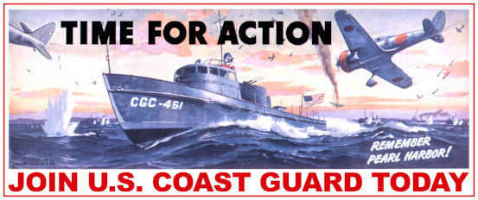
- The Coast Guard is the only military service with two official flags; the first is the Standard, which is used during parades and ceremonies. All 30 battle streamers (the ribbons on the left) are displayed with the standard.

- The second flag is the Coast Guard ensign, which is flown on all vessels as a mark of authority for boardings, examinations and seizures of vessels to enforce the laws of the United States. The American flag is also flown, but the ensign serves as the mark of the Coast Guard service. The ensign is never carried in parades or ceremonies. But there is a lot of symbolism in the standard – there are 13 stars, 13 leaves to the olive branch, and 13 arrows and 13 bars on the shield, a reference to the number of states when the service began. But there are 16 stripes, referring to the number of states when the ensign was adopted. The color red stands for youth and sacrifice; the color blue stands for justice and a covenant against oppression; the color white stands for a desire for light and purity.
- Joshua James is one of the most celebrated lifesavers in Coast Guard history, with 600 lives saved. He earned two gold medals, three silver medals, and other awards, after joining the Coast Guard at age 15. His most famous rescue was in November of 1888. James and his crew saved 29 people from five different vessels during one of the worst storms to hit Hull, Mass.


Fun Facts About Summer
- Americans eat seven billion hot dogs between Memorial Day and Labor Day.
- Strawberries, a favorite summer fruit, are related to the rose – each one has about 200 seeds.
- Watermelons originally came from the Kalahari Desert region in Africa, even though a watermelon is 92% water.
- The word barbecue comes from the Arawak word barbakoa, meaning "frame of sticks."
- Thank the Chinese when you enjoy ice cream during the summer – it was invented there around 2000 BC
- Summer squash is just a name for some varieties of squash that are harvested while still immature and tender and edible. Some are actually available year-round.
- What we call the first day of summer was actually right in the middle of it in the ancient calendar, where summer was the season that surrounded the longest day.
- The North Pole actually gets the most sunshine of any place on earth on June 21st – and for several weeks after!
- When you drink a glass of summer lemonade, think of the wife of President Rutherford B. Hayes wife Lucy – she was called Lemonade Lucy all year long, because she refused to serve liquor in the White House.
- The first person to give tips about how to land a fish in summer was a woman - Dame Juliana Berners, whose “Treatyse of Fysshynge wyth an Angle” was written in 1496 and followed for the next 150 years by English fishermen!
- Although today we eat lots of sliced tomatoes during the summer, they were thought to be poisonous to people until the mid-19th century.
- Americans eat about 140 pounds of potatoes a year, and they are 540 times more likely to eat potato salad on July 4th than on an average day.
- The Sun doesn’t just heat up the earth during the Summer – it also holds the earth and other planets in our solar system in orbit.
- In the Northern Hemisphere where we live, Summer is during June, July and August – but if you live below the equator in the Southern Hemisphere, those are the winter months for you – and the Winter is really Summertime!

THEME PACK AND DEN ACTIVITIES
Alice, Golden Empire Council
- Be sure you start out by reviewing Safety in the Sun and taking the Safe Swim Defense and Safety Afloat training available online from BSA. Remind everyone of the Buddy System and test them often to see if they are with their buddy. Make sure sunscreen, shade and water are available whenever you gather in the Summertime
- This is a great time to review Campfire Safety – and it can be fun and tasty, too, if you use a graham cracker for the dirt, raisins for the fire circle, shredded coconut for the tinder, small pretzel sticks for the kindling, larger pretzel sticks for the fuel, a glass of water for the water you should have nearby a campfire, a spoon for the shovel (to bury the fire), and red hearts for the flame. As you go through the procedure, give out the ingredients – each boy makes a campfire is completed, and then gets to eat it. Older boys can practice making different kinds of fires, such as teepee or log cabin.
- Celebrate Hot August Nights – gather at a wide-open spot for star-gazing. Gather telescopes from pack members, or contact a local Astronomy club – your librarian will have some contact information.
- Another way to get out the heat – have your meeting at night and make and play some of the suggested nighttime games – anything “glow in the dark” will be a hit! Be sure to go over rules and boundaries first, and have adults assigned to keep everyone in the area and out of harm’s way.
- Have the whole den or pack take part in the local library reading program – add to a “bookworm” made of overlapping colored paper circles – each time a book is read, add a new segment. The head of the bookworm can include a set of feelers made of pipe cleaners or black paper, complete with eyes and a big smile. Display the Bookworm at your meeting place. To celebrate completing the project, donate a book to the library from the den or pack.
- Make fruit leather and tea using the power of the sun. Directions under CUB GRUB.
- Celebrate frogs and pond creatures – check out a book about them, read it with the den, then make underwater viewers and visit a local pond. Then enjoy a Sherbert Frog from CUB GRUB.
- Take in an outdoor movie – some communities sponsor family “Movies in the Park” during the summer.
- Make Pinhole cameras and take photos of Summer scenes and happenings
- Have a “What I did on my Summer Vacation” Night – everyone brings pictures and souvenirs from their favorite or most exciting vacation
- Encourage boys to keep a travel journal, or even just a summer journal, with one page for each day. Tell where you went, what you did, what you saw, what you learned, then draw a picture – see Fun Family Education website
- Make sun prints of all kinds of things, such as keys, leaves, etc – but use dark colored construction paper instead of costly blueprint paper.
- Instead of just suffering with summertime humidity, make a record of it with a psychrometer. See directions under THEME RELATED.
- Make a sundial and use it to tell time. Directions in the Dynamic Sun website.
- As a service project, help out a “Get out of the heat” site in your community – or take ice cold water bottles or slices of watermelon to deliver to people out in the heat.
- Invite local seniors to a cool location, such as your Chartered Organization site, and serve cold lemonade or ice tea and popcorn, while showing some old movies.
- Another easy service project would be to take along garbage bags, “grabbers” and gloves when you visit a local park or water site – clean up the area so everyone will enjoy it more.

August – A Month for Honesty
Alice, Golden Empire Council
August is also designated “Water Quality Month” ~ and we all want to feel secure that our water quality is safe. Scouts and their families can help improve and maintain good water quality when we follow the Leave No Trace guidelines, and when we do things that help maintain the quality of the water in our own areas. Some scouts have also helped remind others to keep local waters safe by painting reminders on the curbs. In my area, these reminders say “Drains to the River – Do Not Discard Motor Oil & Trash.” But in other areas, the warning may read “Drains to the Bay – Protect our water.” August would be a great month to take on a conservation project to protect the water in your area!

August 1 – The Birthday of Francis Scott Key
Every schoolchild learns that he wrote the National Anthem – but there is a story of great integrity behind how Francis Scott Key wrote the words we all sing as our country’s national anthem. Here’s the rest of the story:
Francis Scott Key was a respected young lawyer living in Georgetown, just a few miles from Washington, DC when the War of 1812 began. The British had invaded and captured Washington and set fire to the Capitol and the White House by August 24th. A thunderstorm kept the fires from spreading two days in a row, and the British troops returned to their ships in Chesapeake Bay.
Word soon reached Francis Scott Key that the British had carried off an elderly and much loved town physician of Upper Marlboro, Dr. William Beanes, and it was feared he would be hanged. Townsfolk asked Francis Scott Key for his help, and he agreed, and arranged to have Col. John Skinner, an American agent for prisoner exchange, go with him to the British ship Tonnant, where Beanes was being held.
They set sail from Baltimore flying a flag of truce approved by President Madison, and boarded the British ship. At first, the British refused to release Dr. Beanes, but Key and Skinner produced a pouch of letters written by wounded British prisoners praising the care they were receiving from the Americans, including Dr. Beanes. The British officers relented but would not release the three Americans immediately because they had seen and heard too much of the preparations for the attack on Baltimore. They were placed under guard, and forced to wait out the battle behind the British fleet.
At the star-shaped Fort McHenry, the commander, Maj. George Armistead, asked for a flag so big that "the British would have no trouble seeing it from a distance". Mary Young Pickersgill, a "maker of colours," was commisioned to make the flag. Mary and her thirteen year old daughter Caroline, working in an upstairs front bedroom, used 400 yards of best quality wool bunting. They cut 15 stars that measured two feet from point to point. Eight red and seven white stripes, each two feet wide, were cut. The flag measured 30 by 42 feet and cost $405.90 – a lot of money at the time!
At 7 a.m. on the morning of September 13, 1814, the British bombardment began of Fort McHenry began. It continued for 25 hours.The British fired 1,500 bombshells that weighed as much as 220 pounds and carried lighted fuses that would supposedly cause it to explode when it reached its target. But they weren't very dependable and often blew up in mid air. From special small boats the British fired the new Congreve rockets that traced wobbly arcs of red flame across the sky. The Americans had sunk 22 vessels so a close approach by the British was not possible.
At about 1a.m. on the 14th, the British began firing their rockets. Key, Col. Skinner, and Dr. Beanes watched the battle with apprehension. They knew that as long as the shelling continued, Fort McHenry had not surrendered. But, long before daylight there came a sudden and mysterious silence. What the three Americans did not know was that the British land assault and naval assault had been ended.
Waiting in the predawn darkness, Key waited for the sight that would end his anxiety; the joyous sight of the great flag blowing in the breeze. When at last daylight came, the flag was still there!
Being an amateur poet, Key began to write on the back of a letter he had in his pocket. Sailing back to Baltimore he composed more lines and finished the poem. Judge J. H. Nicholson, his brother-in-law, took it to a printer and copies were circulated around Baltimore under the title "Defence of Fort M'Henry". Two of these copies survive. It was printed in a newspaper for the first time in the Baltimore Patriot on September 20th,1814, then in papers as far away as Georgia and New Hampshire. To the verses was added a note "Tune: Anacreon in Heaven." In October a Baltimore actor sang Key's new song in a public performance and called it "The Star-Spangled Banner".
Immediately popular, it was finally adopted as our national anthem on March 3, 1931. But the actual words were not included in the legal documents. Key himself had written several versions with slight variations so discrepancies in the exact wording still occur.
The flag itself went on view for the first time after flying over Fort McHenry, on January 1st,1876 at the Old State House in Philadelphia - for the nations' Centennial celebration. It is now in the Smithsonian’s Museum of American History.
The copy of the poem that Key wrote in his hotel September 14,1814, remained in the Nicholson family for 93 years. In 1907 it was sold to Henry Walters of Baltimore, and eventually to the Maryland Historical Society for $26,400. Another copy that Key made is in the Library of Congress.
August 1 - Picnic Day in Australia - So be an “Aussie” for the day and have a family, den or pack picnic! Be sure and have watermelon (see August 3rd)
August 2 – Ice Cream Sandwich Day - You can make an HONEST – to – goodness ice cream sandwich using the recipe under Cub Grub – or just buy them. Either way, it’s a great treat!
August 3 - National Watermelon Day - Have the treat, add a Watermelon Seed Spitting Contest, or you might even visit a farmer’s market or farm to pick out your watermelon. Check your local area for a certified farmer’s market – some of them offer free tours and special activities for scout groups. Go to: www.ams.usda.gov/farmersmarkets/ In the upper right box, click on Find or Add a Farmer’s Market to find one near you.

August 4 – Coast Guard Day - The Coast Guard was established on this day in 1790! And they are a great example of honesty and integrity. The official statement of the Coast Guard says, “Integrity is our standard. We demonstrate uncompromising ethical conduct and moral behavior in all of our personal actions. We are loyal and accountable to the public trust.

Honesty means being forthright and truthful when we interact with others in the performance of our assigned tasks. We will bring problems forward as soon as they are identified, and not attempt to misrepresent our errors or evade their consequences. We must always own our mistakes as well as our successes, and demonstrate good faith in our efforts to learn from them.” Over and over again, men and women of the Coast Guard have been steadfast in performing their duty even at the cost of their own lives. If you want to check out some true stories about Coast Guard heroes, go to:http://coastguard.dodlive.mil/2010/11/coast-guard-heroes-joseph-napier/ This is a series on the Coast Guard blog, and by clicking on Compass series, you can read stories and see photos of Coast Guard heroes from many times and places, including Katrina.
The motto of the United States Coast Guard is "Semper Paratus" (Always Ready) – and they have served with integrity since President Wilson signed the "Act to Create the Coast Guard“ on January 28, 1915. This act combined the U.S. Life-Saving Service and the Revenue Cutter Service that had been in operation since 1790. Check out the Fun Facts About the Coast Guard.

August 7 – National Lighthouse Day - Many lighthouse and light station keepers have served with honor and integrity, and kept their cool while dealing with people who may forget to be courteous in a crisis. Go to: www.us-lighthouses.com/ for an alphabetical listing; For a listing & photos by region go to: www.pbs.org/legendarylighthouses Another good guide, meant for photographers, includes information about how to access lighthouses. Go to:
www.nicholsonprints.com/Lighthouses.htm

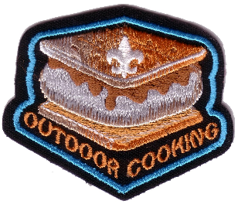
August 10 – S’mores Day - Hey – it’s August – Perfect time for camping, campfires, picnics. Celebrate S’mores Day with S’mores. Can’t go camping right now? Check out the recipes under Cub Grub – make S’mores pie, crumb bars or Indoor Honey Graham Cereal S’Mores!
August 11 – Play in the Sand Day - Spend a fun day or even just a couple of hours, at a nearby beach – play some games, build a sand castle, take lots of pictures - and if it’s allowed, gather materials to do a useful project. See ideas under Den & Pack Activities.
August 12 – Perseid Meteor Showers - Find a good place to view this spectacular annual meteor shower – but check out the tips and information under Den & Pack Activities for more details.
August 17 – Davy Crockett’s Birthday
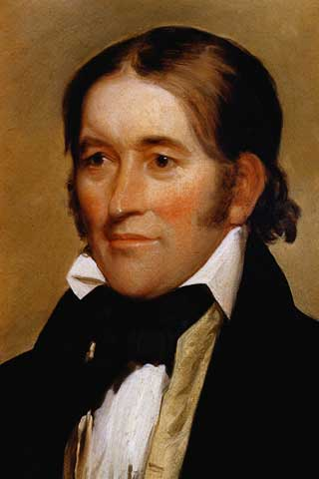
Davy Crockett was born to a large family that lived in the American wilderness where there were no stores, schools, or churches. The family finally settled on the Holston River and opened a tavern where travelers stopped on their way from Virginia to the West. Davy was only 8 when he started working in the tavern – he was excited by the stories visitors told, and wanted to see the world. When Davy was only 12 years old, his father agreed to let him work for a Dutchman driving a herd of cattle over the mountains to Virginia – he offered to let Davy stay, but homesickness brought him home. He was excited to learn that a new school had opened, but on his fourth day, Davy was bullied by another boy, and finally fought the boy and won – but he was afraid the boy and his friends would be waiting for him the next day, so he stayed in the woods till school would have been out and then went home. The schoolmaster sent a note to Davy’s father after a few days, and the angry father headed off with a hickory stick to find Davy. When Davy saw his father coming, he ran away and joined a drover taking cattle hundreds of miles away. For two years, Davy worked at odd jobs, earning about 25 cents a day, but finally his fear of his father faded, and he headed home. There was a great celebration. Davy was bound by customs of the time to stay with his father till he reached 21 – but his father offered to give Davy his freedom early if he would work for six months to earn off a debt his father owed. Davy developed a sense of what it meant to be honest as he worked, and discovered he could earn another $40 if he worked an extra six months. So six months later, he returned home and presented his father with a cancelled note for two debts – a total of almost $80.
Davy was now 16, and knew he should learn how to read and write. He took a job working two days a week for board, and went to school the other four days. He married, built a log cabin, and became an outstanding shot with his musket. He moved several times, settling in Tennessee, and was one of the best riflemen in Andrew Jackson’s army. His skill in hunting kept the troops from starving. He learned to write in order to serve as a magistrate, and became very popular, being a great storyteller. He was asked to run for the legislature, and his jokes and stories, and his wonderful memory helped him get elected.
There was nothing he liked more than a good bear hunt, and his skill was legendary – twice he brought down a bear weighing more than 600 pounds, and he once killed 105 bears in one year. The meat was considered a delicacy, their fur was used for coats, and their skins were used for beds and bedding. In 1827 he was elected to Congress, and introduced himself by saying, “I am …fresh from the backwoods, half horse, half alligator, a little touched with snapping turtle…I can ship my weight in wildcats.” He made quite a stir in Washington, but was always well liked. As a Congressman, Crockett’s service was outstanding – he was honest and conscientious, never took a bribe or voted for something he didn’t believe in – he was called the “Honest Congressman.” He also wrote an autobiography which he called “a plain, honest, homespun account of my life.”
In 1846, Crockett and four of his “Tennessee boys” went to the Alamo to help the Texans in their battle against a far larger Mexican force of 5,000 men. The Texans and Crockett’s men numbered only about 108. But the determined defenders inside the Alamo forced the Mexicans back twice. Out of ammunition, Crockett and the Texans were finally killed as the Mexicans stormed a short wall. On the day he died, Crockett wrote a letter to his daughter telling her not to worry, that he was among friends. His youngest daughter later wrote she remembered him leaving for Texas, “dressed in his hunting suit, wearing a coonskin cap, and carrying a fine rifle presented to him by friends in Philadelphia.”
He was a real-life hero, an honest man who valued his friends,, and became a legend while he was still alive.

August 25 – National Banana Split Day - In honor of this fun holiday, be sure to enjoy a banana split! And if you are having a Raingutter Regatta, save one clean raingutter for a huge, community banana split!

August 31 – Trail Mix Day - Make some trail mix – talk about why different ingredients are needed; why we don’t want too much candy or salt; why we want to include some dried fruit. Now take your trail mix, water and any gear needed for protection or for possible weather conditions – and go on a hike!

SUMMER THINGS
Create a Water Compass
Alice, Golden Empire Council
Materials:
- • Small paper clip, straightened
- • Small piece of styrofoam (packing peanut)
- • Bowl of water
- • Magnet
- • Permanent marker
Directions
- Rub the paper clip with the magnet for several minutes.
- Pierce the paper clip through the “peanut”
- Gently place on the surface of water.
- Allow the needle enough time to align along the magnetic fields of the earth. It will then point north.
- Test this by gently blowing on the needle to push it out of alignment. The same end of the needle should always return to the same direction.
- Mark the north end of the needle with permanent marker.
HOW HOT IS IT?
Alice, Golden Empire Council

Make a Sling Psychrometer to Measure the Humidity – Sometimes it feels a lot hotter than the temperature. That’s because the relative humidity, or moisture in the air, can make it seem much hotter. Our bodies are called by the evaporation of perspiration, and when there’s a lot of water in the air, the evaporation is slowed way down – it can’t go into already “wet” air. Here’s a fun way to measure the relative humidity.
Materials:
- 2 indoor/outdoor wall thermometers (non-mercury)
- Double sided mounting tape
- Small lengths of wire to fasten thru hole in thermometers
- 6 inch circle of fabric
- Rubber band
- 7”x12” piece of poster board or thin duct tape
- Hole punch
- 20 inch length of cotton string
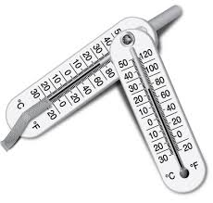
Construction:
- Cut away a 3-1/2 by 3 inch section from the lower right corner of the poster board.
- Tape the two thermometers to the poster board side by side, with the numbers facing up and the liquid filled ends sticking over the edge about 2 inches.
- Use the wire to secure each thermometer to the board through the hole in the top, just to be sure they stay on the board.
- Wrap a piece of duct tape around the top of the poster board about ¾ inch from the top, and punch a hole in the center.
- Thread the cotton string through the hole and tie the ends together to make a loop.

NOTE: If this article confuses you –
NASA has posted an excellent PDF with a structured activity for youth to build and use a sling psychrometer. It has a more complete Relative Humidity chart, too. Check it out at -
https://www.nasa.gov/centers/langley/pdf/245887main_MeteorologyTeacherRes-Ch11.r3.pdf
How to Use the Psychrometer:
- Wet the fabric circle and wrap it around the bottom of the lowest thermometer, using the rubber band. (This is your wet-bulb thermometer)
- Grab the loop of string and swing the psychrometer back and forth waist high in front of you. Take readings about every half minute, until the temperature of the wet-bulb thermometer stops dropping. (About 2-3 minutes)
- Write down the readings for each thermometer.
- Now subtract the wet-bulb temperature from the dry bulb If the air is dry and the water will evaporate quickly from the wet-bulb, so there will be a greater difference between the two thermometers. But if the humidity in the air reaches 100%, there will be no difference between the two, since the water on the wet-bulb has no place to evaporate).
- Look at the table below. Find the dry thermometer temperature in the far left column and FOLLOW it to the right. FIND the difference between the two temperatures on the top, and FOLLOW it down. The number where the row and column intersect is the relative humidity.
Difference between the thermometers:
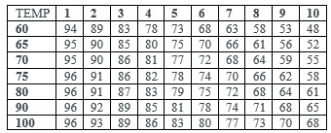
Take your own humidity reading and then check against what the weatherman says the humidity is!!
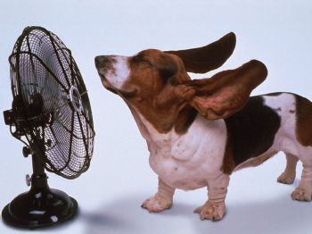
Cricket Chirper
Alice, Golden Empire Council
Crickets make their distinctive sound by rubbing their wings together – make these chirpers and you can add to their music on a Summer evening!
Materials:
- Two 10-inch wooden skewers
- 30 – 1/2 inch wooden beads
- Scissors
- Tacky Glue
Directions:
- Use scissors to cut the pointed tips from the wooden skewers.
- Now thread fifteen beads tightly onto each skewer.
- Secure the end beads to the skewer with tacky glue.
- When the glue is dry, rub the beaded sections against each other to hear your “cricket” chirping!
Create a Box Compass
Alice, Golden Empire Council
Materials:
- Square box with sides no more than 2" high (bottom of a half-gallon milk carton)
- Cardboard circle small enough to lay flat in bottom of box
- 1 1/2" nail with head
- 1 large paper clip, straightened
- Magnet
- Glue or tape
Directions:
- Pierce the center of the box bottom with the 1 1/2" nail from the bottom up into the box.
- Take the straightened paper clip and compare to the diameter of your compass rose. If longer, trim it.
- Rub the paper clip against a magnet for several minutes.
- Glue or tape wire to the cardboard circle, slightly off center.
- On same side, mark center of cardboard circle and pierce halfway through. place cardboard circle on point of nail in box. Let circle settle. It will turn gently until one end of the needle points to north.
- Create a compass rose either by printing an online example or drawing your own. it should be the size of your cardboard circle.
- Glue the compass rose to the cardboard circle with the fleur de lis placed where the needle end points to north.
Sport Stacking
Have you heard of one of the newest sports – Sport Stacking? Founded in 1995 and formally known as cup stacking, this sport can be completed by individuals or as teams. Current world records are set by 13 and 14 year olds.
Participants of sport stacking upstack and downstack cups in pre-determined sequences, competing against the clock or another player. Sequences are usually pyramids of three, six, or ten cups. Proponents of the sport say participants learn teamwork, cooperation, ambidexterity, and hand-eye coordination.
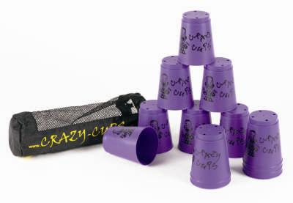
There are four main types of stacks in competition. All stacks can be made from left-to-right or right-to-left (individual preference), but the same direction must be maintained for both "up stacking" (setting the cups into pyramids) and "down stacking" (unstacking the pyramids and returning them to their nested position).
3 - 3 – 3
Uses 9 cups. Cups start in three nested stacks of 3. The stacker must create three pyramids of 3 cups each and then down stack the cups back into nested stacks of 3 in the order that they were upstacked.
3 - 6 – 3
Uses 12 cups. The stacker must create three pyramids made up of three cups on the left, six cups in the center, and three cups on the right (3-6-3), then down stack the cups in the order that they were upstacked into their original position. Also used as the first transition of the Cycle Stack.
6 – 6
Uses 12 cups. The stacker must create pyramids of 6 cups on the left and 6 on the right and then down stack both of them to create one pile of cups. This stack is only used competitively as the second transition in the Cycle Stack.
1 - 10 – 1
Uses 12 cups. The stacker begins with a single downstacked pile. He/she must take two cups off the top, turn one upside-down (stacker's choice), then upstack the remaining ten. The stacker must then tap the opposite sides of the single cups and take down the ten stack into a downstacked 3-6-3. This stack is only used competitively as the third transition of the Cycle Stack
The Cycle Stack
The most complicated stack is called the Cycle Stack. It involves a sequence which includes, in order: a 3-6-3 stack, a 6-6 stack, and a 1-10-1 stack, finishing in a down stacked 3-6-3.
Check out http://en.wikipedia.org/wiki/Sport_stacking
or http://www.worldsportstackingassociation.org/
to learn more about the sport and to watch world record holders compete. You’ll be amazed!

POOL GAMES
Utah National Parks
I figured as it was August some water games would be needed. If you want more water games, see the June 2008 issue of Baloo's Bugle for the July 2008 theme, "H2Ohhhh!!"It is at http://usscouts.org/usscouts/bbugle2007-2008.asp CD
Tug-Of-War
- Play in water that is chest deep for Cub Scouts.
- If playing with adults, divide them equally between the teams.
- Use a sturdy rope, with a colored ribbon tied to the center of the rope.
- Anchor a float or other permanent marker to show the center of the play area.
- Play like standard tug-of-war with the winner being the team that pulls the other team past the center float.
Duck Tag
- This tag game is fun for even the nonswimmers because it does not require special skills and can help them feel comfortable in the water.
- Play in water no higher than waist deep and in an area with a level bottom.
- Play like regular tag, except that a player is safe if he ducks completely under water when “it” tries to tag him.
- A player does not have to stay under water more than two seconds, and then can safely come up without being tagged.
- “It” must go after someone else when his quarry ducks under water.
Dodge Ball
- Play in waist to chest-deep water.
- Divide players into two teams.
- One team forms a large circle, and the other team gets inside.
- The circle players try to hit their opponents with a beach ball or soft foam or rubber ball.
- Score one point for each hit.
- The inside players are allowed to swim in any direction or go under water to avoid being hit, but cannot leave the circle.
- Outside players cannot advance forward to hit a player.
- At the end of a specified time, change places.
Sharks And Whales
- Play in waist to chest-deep water.
- Divide group into two teams, the “sharks” and the “whales.”
- Teams line up facing each other about 10 ft apart.
- Behind each other is its home base – the side of the pool or a rope tied to buoys, or other designated area.
- When the leader calls “sharks” they swim or run after the whales, trying to tag them before they reach their base.
- If a whale is caught, he must join the sharks for the next round.
- Leaders should alternate the calls of “sharks” and “whales”.
- The team with the most players after a specified time is the winner.
Paddlewheel Push
- To play this water game you will need at least one foam or plastic kickboard but more boards will allow more boys to play at the same time.
- Pair off, trying to match basic size and strength of the boys.
- Play in waist deep water.
- Opponents grasp opposite ends of a kickboard.
- On signal, both boys start kicking, trying to force the opponent backward.
- Boys should not stand and shove the board, but should swim and kick legs to move forward.
GET WET!
Utah National Parks
Squirt-Tac-Toe
- Make a tic-tac-toe board on the sidewalk with sticks or chalk.
- Players use a water gun to make the X's and O's.
- Work quickly, because when an X or O dries up, it doesn't count!
- The hotter the day, the quicker you have to be.
Marathon Melt
- Divide into pairs.
- Everyone has to keep one hand behind his back.
- Each pair gets one ice cube.
- See which pair can melt the ice cube first!
Clap and Splat
- Toss a water balloon straight up, and see how many times you can clap before catching it.
- Take turns. If you drop the balloon and it doesn't break, you get to go again.
- If the balloon breaks, you're out.
- The person who can clap the most times and make a successful catch wins.
Soapy Toes
- Fill a kiddy pool with soapy water.
- Dump in a bunch of marbles.
- Set up chairs around the pool and dip in your feet.
- See who can fish out the most marbles with his toes!
Wet Potato
- Pass around a bucket of water while music plays.
- When the music stops, whoever has the bucket dumps it on his head!
Save the Soda
- Each player gets 3 sponges and an empty 2- liter soda bottle.
- Set up the bottles on the ground.
- Each player tries to protect his own bottle while trying to knock down the other players' bottles with the sponges.
- The player with the last standing bottle wins!
Rainy Relay
- Try to pour water from your paper cup into a partner's cup. The trick?
- You both have to hold the cups on your heads!
Balloon Bombs
- Players stand in a circle, an arm's length apart.
- Start passing water balloons quickly around the circle (You may have to toss them).
- If a balloon breaks, the last person who touched it has to sit down, and play continues over his head.
- The last person standing wins.

THEME & PACK MEETING IDEAS

GATHERING ACTIVITIES
Note on Word Searches, Word Games, Mazes and such – In order to make these items fit in the two column format of Baloo’s Bugle they are shrunk to a width of about 3 inches. Your Cubs probably need bigger pictures. You can get these by copying and pasting the picture from the Word version or clipping the picture in the Adobe (.pdf) version and then enlarging to page width. CD
Summer Word Search
Alice, Golden Empire Council
Look for the “Summer” words below in the puzzle. Words may be straight up and down, diagonal or backwards.
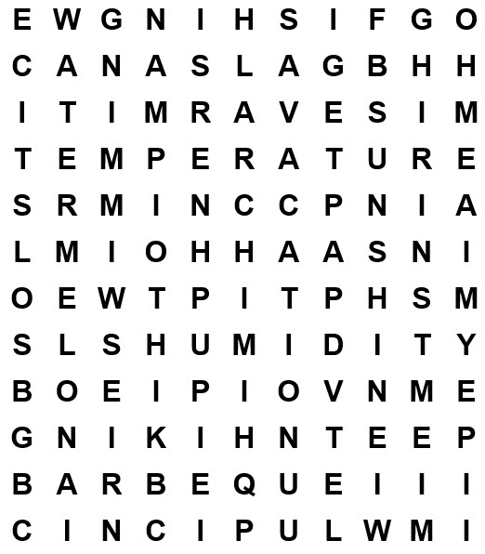
Sunshine Solstice Watermelon
Swimming Humidity Fishing
Picnic Beach Vacation
Temperature Hiking Barbeque
GROUP PUZZLES
Utah National Parks
Cut outdoor, beach or park pictures from magazine illustrations, advertising pictures, postcards, etc. into a number of pieces.
Pass these out as people arrive and ask everyone to complete their puzzle, thereby forming discussion groups.
Assemble School Kits for Kids
Alice, Golden Empire Council
To earn service time for "Journey to Excellence," use the Gathering Time for a summer event to put together School Kits for kids living in shelters, or who have lost homes in recent flooding.
Obtain enough Pencils, notebooks, colored pencils, rulers, scissors, erasers, and other supplies. Determine what will be in each Kit. Then put in sealable plastic bags or backpacks and donated.
Have each Scout write a personal note to the recipient.
Play Capture the Moon
Alice, Golden Empire Council
This is a variation on Flashlight Tag, but using a soccer ball as the “moon” that must be captured.
Equipment:
- Soccer ball
- Flashlight
- Open area and a dark night
How to Play:
- One player is the “astronaut” and stands near the soccer ball “moon,” while other players run and hide when he yells “Blast Off!”
- He counts to 29 (for days in the lunar cycle), then yells “Full Moon” and turns the flashlight on the soccer ball.
- Players try to grab the “moon.”
- The astronaut can turn off the flashlight between tags, and try to sneak up to the hiding players.
- Any player caught in the “light of the moon” (flashlight) is out.
- Winner is either the first to grab the ball without being caught in the flashlight beam, or the last one left. He then becomes the new astronaut.

Grass Blade Whistle
Sam Houston Area Council
Pluck a long, flat blade of grass and hold it between the edges of both thumbs. The blade of grass should be in the middle of the gap between your thumbs. Put your lips against your thumbs and blow hard through the gap. You’ll hear a variety of squeaks and squawks.

Marshmallow Guns
Alice, Golden Empire Council
Have a Marshmallow gun competition between parents and boys. Either build the marshmallow shooters ahead of time. Or have the Scouts, siblings, and parents assemble them when they arrive.
Marshmallow Shooter:
Note: Check Guide to Safe Scouting and other sources. You may be required to have a trained Rangemaster. A good tip for every pack is to get several people trained as BSA Rangemasters.
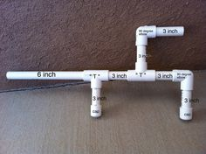
Materials:
- 1/2 “ PVC pipe, cut into: pieces as shown in picture. (If you have trouble seeing picture, go to: https://www.pinterest.com/explore/marshmallow-gun/
- 2- 1/2" PVC elbows
- 2 – 1/2" PVC Tees
- 2 – 1/2" PVC end caps
- PVC cutter
- Miniature Marshmallows
Instructions:
- First cut the pieces.
- Lay out the pieces as shown below and then just connect each piece.
- Sand the mouthpiece end so you won’t get cut – that’s the top piece that is uncapped.
DON’T glue the pieces together!
- (Optional) Decorate your shooter, using colored tape, stickers, acrylic paint or magazine cut-outs and watered down glue – but be sure not to glue the connection points together – in case you have to clean out sticky miniature marshmallows.
Some tips:
- Don't eat your ammo.
- Pick up the marshmallows when you're done - they're very likely bad for animals. If the marshmallows get wet, the sugar makes a big mess.
- If you don’t have a PVC cutter, just get a piece of nylon string about 2 foot long loop it around the pipe and alternately pull each end back and forth the friction and abrasiveness of the string will make a smooth cut, just be careful to keep straight.
- Try shooting various ways – you might even adapt your shooter to shoot two directions at once!
Build a Sub
Alice, Golden Empire Council
A great idea to assemble the food for your summer event (e.g. tailgating for a baseball game)
Order 6 foot long rolls like those used to make Subway sandwiches. As people arrive, form teams (dens, families, random groups) with each team having a roll on a table. Teams have 15 minutes to make an edible creation, using toothpicks, skewers, olives, sliced meats and cheeses, lettuce, condiments, carrot sticks, etc. provided. Also have a knife available for each team, to be used by an adult only. (For example, an alligator, with teeth cut in the front end, propping the mouth open with skewers, eyes of olives, scales of meat cut in triangles)
After judging and taking pictures of each group with their creation, cut up the sandwiches so everyone can dig in! Add drinks, chips and some watermelon for a great feed!
WORD TWINS
Utah National Parks
Provide cards on which have been written one word of common pairs such as “Jack” and “Jill,” “ham” and “egg,” etc. Have as many cards as needed.
Ask everyone to match up his card and introduce himself to the person holding the mate to his card.
Some other combinations are:
Bat and ball, socks and shoes
slide and swing swim shorts and towel
cats and dogs day and night
picnic and ants, sun and moon
bees and honey, sticks and rocks
matches and fire tent and sleeping bag
mosquitoes and bug spray spoon and fork
plates and cups, salt and pepper
hot and cold, clean and dirty
skunks and raccoons wolves and bears, etc.
DOTS PENCIL GAME
Utah National Parks
Draw a square made up of dots like this one on your piece of paper.

Now, without lifting the pencil from the page, draw no more than four straight lines that will cross through all nine dots.
Answer: The answer you will usually find in books is shown here:

MINIATURE SCAVENGER HUNT
Utah National Parks
Needed: - 35 mm film can or similar for each person. (This could be a problem. I still have a supply but most current Cub Scout leaders/ parents probably do not. Substitute something of similar size (e.g. pill container, plastic snack bag (Sandwich bag too big)).
- The object of the game is to gather as many items as you can from other people in the room.
- Each person can only give you one item
- All items must fit inside the container supplied.
- Have the people sign after they give you item so that you know to whom to give it back when the game is done.
- Paper clip
- Bobbi pin
- Penny
- A Different Coin
- Button
- Safety Pin
- Battery
- Patch
- Piece of String
- Thumb Tack
- Key
- Match
- Nail Clipper
- Piece of Paper
- Picture


Have a Sidewalk Art Contest
Alice, Golden Empire Council
Supply plenty of sidewalk chalk and each family, den or individual can have a section of sidewalk to design. You can choose a theme or just let the imagination reign – when time is up, everyone gets to go around and admire the creativity! You could also have “judges” and award each artist or artist group a special award, such as “best use of blue, best use of theme, etc.” Have someone take a photo of each artist or group with their creation. If it’s a hot day, finish up by hosing down the art and restoring the sidewalk or cement to its original condition.
SIDEWALK CHALK,
a book by Jamie Kyle McGillian
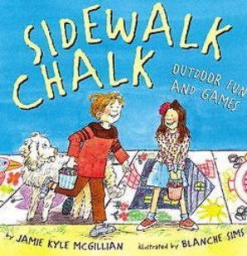
Utah National Parks
This book is great for art related Adventures. It has lots of wonderful ideas for things to draw. Here are a few examples -
- Square Décor – Each square is an open canvas
- Rebus – Create a funny saying using pictures as words
- Creature Features – Each boy take turns drawing parts of a creature
- Alphabet Art (Names) – Draw names, decorate or create an animal or creature using the letters of name
- Shape Art – What can you make using only common shapes?
- Animal Mix-up – Head of a rhino, body of a lion, legs of an ostrich, feet of a duck, etc.
- Make-up anything!
- Mazes – Size just right for chalk line or go BIG and make it Cub Scout size!

OPENING CEREMONIES
August is a great time for Pack Campfires. Get the boys outside. I included some outdoorsy openings in addition to Theme Related openings in case you are doing a campfire. CD
S’More Patriotic Months
Alice, Golden Empire Council

Set up: 7 Cub Scouts and a Narrator (Den Chief or leader). Scouts should have their parts written on the back of their posters. You could modify to have Narrator do all speaking and Scouts just hold signs.
Three large (Poster Size) calendar pages,
- June (with the 14th circled),
- July (with the 4th circled) and
- August (with “Pledge of Allegiance” written across it in large letters.
Large picture of the Flag;
Large picture of July 4th, activities, parades and/or fireworks(or optional demonstration);
Large picture of the Declaration of Independence;
Large picture of the word “Republic” and a large picture of the word “Indivisible.” (The last two words could also be on a large roll of paper, brought out by two scouts and unfolded to show first one word, then both words at the proper time)
Narrator: Summer is perhaps the most patriotic season of all in the United States.
- Enters and posts the June calendar page, with June 14th circled in red - We celebrate June 14th as Flag Day, because Congress adopted the Stars and Stripes as the flag of the United States on June 14, 1777.
- Enters and posts the July calendar page with July 4th circled in red - The second month of Summer is when we celebrate our Independence Day.
- Enters with picture of Declaration of Independence - On July 4, 1776, the Declaration of Independence was adopted, declaring our country independent from Great Britain.
- Enters with a picture of July 4th activities, or several boys can enter demonstrating a parade - Today, we associate our Independence Day, July 4th, with fireworks, parades, barbeques and a day to honor our flag.
Narrator: Many of you may know that our Pledge of Allegiance to the Flag was written by Francis Bellamy, a Baptist minister
- Enters and posts the August Calendar Page, with “The Pledge to Allegiance”written in large letters across it - . But did you know that it was in August of 1892 that he worked out the words of the pledge? So August is also part of our Patriotic Summer.
- Enters with the word “Republic” written in large letters - Bellamy tells us that he began by making an “intense study of the Declaration of Independence…. the Constitution, ….the meaning of the Civil War, and …the aspirations of the people.” He decided that the word “Republic” was the exact word for the one nation which the Civil War was fought to prove…”
- Enters with the word “Indivisible - Bellamy also noted “that we must “specify that it is indivisible, as Webster and Lincoln used to repeat in their great speeches.”
Narrator: As we prepare to honor our Flag with the Pledge of Allegiance, let us remember that it stands for our country, and must remain Indivisible, under God, with Liberty and Justice for All. (Flag Ceremony follows)
Cub Scout Campfire Opening Ceremony
Sam Houston Area Council
Equipment: Real or artificial campfire, seven candles.
Personnel: CM/DL (Narrator) and seven Cub Scouts.
CM: Welcome to our Cub Scout campfire. Akela is among us. Let us draw from this campfire with all its vibrancy and warmth, the secrets of Cub Scouting and the spirit of brotherhood.
- In its light we see new chances to be helpful and to do our best.
- From its warmth we strengthen the bonds of fellowship and learn how to get along with others.
- From the stones that ring the fire and keep its power in check, we learn how we can curb our tempers and become good citizens.
- From the smoke that rises out of the fire, we learn to lift our eyes upward and worship God.
- The spark that started this fire reminds us that little Good Turns can lead to greater deeds.
- Just as the fire needs wood to burn brightly, so do we need the care and love of our parents to burn brightly.
- In its leaping flames, we see the fun of Cub Scouting and the job of life.
S’more Summer Opening Ceremony
Sam Houston Area Council
- Place a picnic basket in the stage area with the den around it.
- Boys open the picnic basket and take out cards that spell SUMMER on one side.
- Cut the cards in the shape of different critters or shapes that represent items that could be found in a picnic basket (hamburgers, hot dogs, watermelon, etc). Words on back in LARGE print.
- As each boy reads his line he takes a step forward.
- S is for summer that we’re glad is here.
- U is for us. Boys who need Scouting all year.
- M is for many outings that Cub Scouting brings us.
- M is for more fun, ‘cause that’s our thing.
- E is for every parent who does his or her share.
- R is for a roaring summer program ‘cause you have planned because you care!
All: Now we just want S’more of great summer fun!
CM Please rise and join in the Pledge of Allegiance
“SOAR”: SAVE OUR AMERICAN RESOURCES
Utah National Parks
Setting: At least four Cub Scouts holding cards with the letters S-O-A-R on the front (maybe with an appropriate picture) and their parts on the back in LARGE print. They come on stage one at a time and read their parts.
- I promise not to break or spoil anything with which I work or play.
- I will not throw paper, candy wrappers, fruit peelings or other trash on sidewalks.
- I will keep my playground clean.
- I will be as careful of other people’s places and things as I would want them to be of mine.
All: Save Our American Resources!
Emcee: Please stand for the presentation of the colors.
FUN OPENING SONG
Utah National Parks
(Tune: Twinkle Twinkle Little Star)
Bring a bag with items inside to throw to the people.
At the end, have a leader (who will not get carried away) walk around with a cooling misting water bottle and point the mist at the audience. (DO NOT DIRECTLY SPRAY OR SOAK PEOPLE (unless this a pool party and all are in swim suits))
It’s so nice to be with you
Here is something you can chew
Gum, gum in the air
Gum, gum everywhere
It’s so nice to be with you
Here is something you can chew
Candy is a lovely treat
Very sweet and very neat.
Candy, candy in the air
Candy, candy everywhere
Candy is a lovely treat
Very sweet and very neat
Some people like health food
Such as nuts they’re good for you
Nuts, nuts in the air
Nuts, nuts everywhere
Some people like health food
Such as nuts they’re good for you
We also brought along some kisses
For the Mr. and the Mrs.
Candy kisses in the air
Candy kisses everywhere
We also brought along some kisses
For the Mr. and the Mrs.
Now it’s time to end our song
Everyone to sing along
Water, water in the air
Water, water everywhere
Now it’s time to end our song
Everyone to sing along
You’re all wet and we are gone!!!
THE OUTDOOR CODE
Utah National Parks
As an American I will do my best to:
Be clean in my outdoor manners;
Be careful with fire;
Be considerate in the outdoors;
and be conservation minded.
Either have Cubmaster say with Cub Scouts repeating and then explain; or involve the Webelos as this is part of their Webelos Badge requirements. They could each state and explain one point and repeat together at the end.
THE MUD PUDDLE
Capital Area Council
PERSONNEL: Den Leader and 6 or 12 Cubs
EQUIPMENT: Sign marked "Mud Puddle", individual props to go with each part such as a plaster casting of an animal track, a blue feather, and elm tree, a large pebble, a blower, a large "worm" etc.
ARRANGEMENT: Sign in center of stage is marked "Mud Puddle.” Boys are gathered around this sign as the opening begins. Cubmaster or Den leader may introduce the opening and verbally "set the stage.”
DEN LEADER:
Did you ever wonder as you pass
A little stretch of mud and grass,
What nature may be hiding there,
Within a spot a few feet square?
Let's gather around and take a look,
And like the pages of a book,
We'll study it with open eyes.
Can soil like this, hold a surprise?
- Here's a freshly patterned animal track where a rabbit hopped across & back.
- I see a stream of busy ants, carrying tidbits as they dance.
- Look, a feather, blue and gray dropped off a passing Blue Jay.
- Here about are sprouting seeds from lofty elms and sprawling weeds.
- A pebble smoothed by action slow, formed about a million years ago.
- In a puddled spot not yet dried out, a water beetle swims about.
Could have 1 - 6 repeat as 7 - 12 or recruit more boys.
- And here an eager plant is set -- an early blooming violet.
- A wiggly worm comes up to twitch; no one knows which end is which.
- The mud itself has food stores vast, form life that grew ages past.
- It's not all Nature reveals, but candy wrappers and toy wheels.
- There's something moving - what's it now? I'll pick it up - a bee - Yow!
- Quick, put some mud upon the spot, to take away the soreness hot.
DEN LEADER:
Our mud will soon dry in the mid-day sun,
But our outdoor adventure has really been fun.
Our opening does not end here by chance,
Please join us now in the Pledge of Allegiance.
OUTDOOR ADVENTURE
Capital Area Council
- America and Cub Scouting are just one big outdoor adventure.
- This is my country. I will use my eyes to see the beauty of this land.
- I will use my mind to think what I can do to make it more beautiful.
- I will use my hands to serve it and care for it.
- And with my heart I will honor it.
- Many immigrants to America had a really big adventure getting here.
- #7: And on their adventure in this country they became loyal Americans.
- Let us be like them, loyal Americans. Please join me in the Pledge of Allegiance.

AUDIENCE PARTICIPATIONS
IN SEARCH OF SUN SCREEN
Utah National Parks
Divide audience into four parts. Assign each part a word and a response. Instruct them they are to say the response whenever they hear the word. Practice as you make assignments.
Vance "I love to swim"
Swim "Splash, splash, splash"
Cub Scouts "Do your best"
Sunscreen "Aaaaaaaaaah, Ooooooooooo"
The day of the summer Pack Meeting was hot and dry. That was good because it was to be a SWIMming party. The CUB SCOUTS and their families were to meet at the Miller's house at noon. VANCE started getting ready at 9 o'clock in the morning. He loved to SWIM. He had just completed SWIMming lessons at the local SWIMming pool and had his card stating that VANCE had passed Advanced Beginners. He knew all his Cub Scout friends would be surprised. It was just last year that VANCE could not SWIM at all.
VANCE found his SWIMming suit and his towel and even his flip-flops without any trouble. But search as he might he could not find his SUNSCREEN. This was terrible. All the CUB SCOUTS had learned at one of the den meetings about the importance of always using SUNSCREEN. VANCE knew that he must protect his skin from the intense Utah sun while he was young so that he would not get skin cancer when he got older. Also, he did not want to get bad sunburn. One of his friends in CUB SCOUTS had fallen asleep in the sun and couldn't sit down or lay in bed comfortably for a week!
"Where are you, SUNSCREEN?" asked VANCE as he started looking through the house again. It was almost time for the SWIMming party. He didn't want to be late. That was when he found it. Way in the back of the bathroom drawer, there was the SUNSCREEN. He grabbed it but to his dismay, the tube felt very light. Oh no! The SUNSCREEN tube was empty. Try as he might, VANCE could not squeeze out even one little drop. What could he do? There was not time to go to the store before meeting the CUB SCOUTS for the SWIMming party. And he knew he should never go SWIMming without his SUNSCREEN.
Just then VANCE’s big brother Weston came bursting through the kitchen door. "What's the matter?" he asked when he saw VANCE sitting dejectedly in the living room. "I'm all out of SUNSCREEN so I can't go SWIMming with the CUB SCOUTS” was the reply. "Here, you can use mine," said Weston, tossing his little brother a new tube of SUNSCREEN. VANCE couldn’t believe it. Just that fast his problem was solved. "Thanks, Wes'", VANCE shouted as he headed out the door to the SWIMming party with the CUB SCOUTS. And for a whole week he didn't say one bad thing about his brother!
A Lesson for the Big Bugs
Capital Area Council
Divide audience into four parts. Assign each part a word and a response. Instruct them they are to say the response whenever they hear the word. Practice as you make assignments.
Bees - Buzz-Buzz
Ants - Hup-2-3-4
Mosquitoes - Bite-e-Bite
Frog - Croak-Croak
Woods - All sounds together
This is a story about Bill and his family and their adventure in the WOODS. One fine spring day, Billy's family decided to go for a picnic in the WOODS, where they could enjoy the outdoors. They packed a nice picnic basket and headed out on their walk.
As soon as they got to where they were going, they found a nice place to set up their picnic. Billy and his brother went to the stream where they looked at a FROG. They heard some BEES over by the wild flowers, and watched some ANTS walking on ground. Being close to the water, they were also being bothered by some MOSQUITOES.
When they went back to the picnic area, they told their parents about the WOODS. How they saw a FROG and how the MOSQUITOES were bothering them. They said that the BEES didn't bother them and that the ANTS were really hard workers. Dad listened closely as he as he unwrapped another sandwich and carelessly threw his paper off to the side. Billy's little sister had just finished a soda and dropped the can by a tree. Mom threw her paper napkin on the ground and jumped up in disgust. "That is it!" she said. "I think the ANTS are taking over the picnic."
Dad stretched out for a nap and had just dozed off when Billy's sister started to scream. She had been stung by a BEE. While Mom took care of her, Dad tried to go back to sleep. But he couldn't because the MOSQUITOES were pestering him. Finally he decided that they had better go home.
Billy protested. "Why do we have to go?” "Well, Billy," Dad replied, we don't seem to be wanted here in the WOODS. We sure haven't been treated very well. The MOSQUITOES are eating me alive. The ANTS took over the picnic. And a BEE stung your sister."
Well," said Billy, "maybe the WOODS are trying to tell us something and the MOSQUITOES, and the ANTS, and the BEES are trying to tell us something.” "What is that?" asked Dad. "Well," said Billy, "just look around us and you'll see we haven't been very nice visitors to the WOODS. Look at all the trash we've thrown around. Seems to me we're the worst bugs of all—litterbugs!"
So the family started cleaning up the mess they'd made and afterwards they felt better. They took a nice walk through the WOODS, listening to the sounds. They actually enjoyed the buzzing of the BEES, the croaking of the FROGS, and the ANTS at work.
When they returned home, they were tired, but happy they had learned an important lesson that day. The worst kind of bug in the WOODS is a litterbug!
Sputo, Sputas, Sputat,
The Sound of Watermelon Seeds
Capital Area Council
Henry had a sweet slice of watermelon. Henry’s sister and brother each had one, too. Henry’s sister took a bite of watermelon and spat out the seeds. SPUTO, SPUTAS, SPUTAT! Henry’s brother took a bite of watermelon and spat out the seeds. SPUTO, SPUTAS, SPUTAT! Henry took a bite of watermelon and spat out the seeds. Dribble, drabble, drop-drop-drop. They fell down to the ground in a sorry little heap by his feet.
“Henry can’t spit watermelon seeds,” Henry’s sister said. She wrinkled up her nose at Henry. “Henry can’t spit watermelon seeds,” Henry’s brother agreed, and he spat one—SPUTO, SPUTAS, SPUTAT! -- that sailed right over Henry’s head.
Henry said, “Sure, you can spit watermelon seeds, but can you hit the metal bucket?” Henry’s sister tried. SPUTO, SPUTAS, SPUTAT! RAT-A-TAT-A-TING! Henry’s brother tried. SPUTO, SPUTAS, SPUTAT! RAT-A-TAT-A-TING! Henry tried. Dribble drabble drop-drop-drop. They fell down to the ground in a sorry little heap at his feet.
Henry said, “Sure, you can hit the bucket, but can you hit the birdbath?” Henry’s sister tried. SPUTO, SPUTAS, SPUTAT! SPLOSH! Henry’s brother tried. SPUTO, SPUTAS, SPUTAT! SPLOSH! Henry tried. Dribble drabble drop-drop-drop. They fell down to the ground in a sorry little heap by his feet.
Henry said, “Sure, you can hit the birdbath, but can you hit an ant hill between your feet? “ Henry’s sister tried. She hit the metal bucket. SPUTO, SPUTAS, SPUTAT! RAT-A-TAT-A-TING! Henry’s brother tried. He hit the birdbath. SPUTO, SPUTAS, SPUTAT! SPLOSH! Henry tried. Dribble drabble drop-drop-drop. The seeds fell down to the ground smack-dab in the middle of an anthill!
And do you know what? Henry got himself another slice of watermelon and smiled the whole time he ate it.

ADVANCEMENT CEREMONIES
S’More Advancement Ceremony
Alice, Golden Empire Council
Materials:
- Campfire, real or artificial (artificial one could be “built” as it is described),
- Marshmallow Sticks for each boy and one for demonstration,
- S'More Set up in a plastic baggy - Marshmallow, 2 Graham Crackers, Square of Chocolate (Additional materials for everyone to make S’mores if the meeting is outside);
- Awards for each boy are attached to a Marshmallow Stick with his name on it.
Set Up:
Cubmaster and other personnel are in front of the audience, with a table holding marshmallow sticks for each boy and the makings for an artificial campfire, OR with all materials near a real campfire.
Give each adult their part in large letters and a prop that fits their part, (in parenthesis) that they can hold up.
If done outside, make sure everyone has a flashlight, if needed.
Cubmaster: One of the things we all look forward to in Summer is making and enjoying S’mores. The boys in our Pack have also been looking forward to receiving awards they have earned. And both S’mores and Advancement have some things in common: Let’s compare the campfire to the Scouting Program –
Chartered Organization Rep: (holds up picture of location provided by them) The campfire needs to be built in a safe location. The Chartered Organization provides that safe place for the Pack.
Committee Chair: (holds up a large stone or a picture of a fire ring) The campfire must be contained in the right area by the stones of the fire ring, just as National, Council and District provide guidelines that assure quality program resources for every unit and every boy.
Unit Commissioner: (holds up a shovel) The water and shovel that we must always have handy for our campfire are like the various rules and safety procedures, like tour permits, that we always use in Scouting.
Cubmaster: (holds up a piece of tinder) Tinder is needed to light the fire – Baden Powell first provided the “tinder” for Scouting when he saw young men in need of guidance and outdoor skills.
Assistant CM: (holds up a piece of kindling) Kindling is provided by small sticks in our campfire, and by the Ideals and Purposes of Scouting in our programs.
Den Leader: (holds up a small log) Fuel, the wood that provides steady warmth in our fire, is like the “fuel” provided by dedicated, trustworthy leaders and volunteers who keep the Scouting program going steadily.
Pack Trainer or Parent: (holds up matches or fire starter) The Spark that lights our campfire can be compared to the Inspiration of ideas and glow of knowledge when dedicated leaders really get to know the Program through Training and the Boys through Experience – then they can really “light a fire” under their Scouts!
Cubmaster: Once our campfire is lighted, we must practice patience and good habits – the fire will be too hot for our S’mores if we aren’t patient, and it could go out if we fail to tend it properly. Like our campfire, the boys who will receive awards here tonight have had to learn patience to wait for their reward, as they tackle new goals and practice new skills – even earning Bobcat takes practice and effort. (If this is an artificial campfire, add red/yellow tissue paper for flames now – or turn on an electric campfire)
Cubmaster: But even with just the right kind of glowing embers to make S’mores, no one would enjoy the treat without the right equipment (holds up the Marshmellow Stick) and the right ingredients. (holds up S’more makings)
Committee Chair: The marshmallow stick is the tool that gets our marshmallow to the fire. Parents and other adults help get the boy to scouting. So we would like to call up our first boys who will receive awards tonight (Calls them by name) along with their parents or other adults who have helped them succeed. Parents, I give you the stick with your son's award attached to represent your part in helping (name of boy) earn his awards. Please remove the “S’mores” fixings, or awards, from the stick and present them to your scout. And just as you have provided scouting tools for your boy to have s'more fun, please give your scout the tool he will need to make his s’more.
(Cubmaster and/or Den Leader reads off the awards as they are handed to each Scout -
They lead a cheer for each Scout or Den or other appropriate grouping.
Be sure to separate rank advancements from other awards so the Scouts can appreciate what they have accomplished.
Be sure to have someone take a picture of each family before they return to their seats
Cubmaster: Now you boys are prepared to enjoy your reward, both your advancements AND your s’mores – but always remember that without kindling, tinder, fuel, and a spark, you couldn’t succeed in Scouting. And always remember to be an example to other boys, to be a friend to each other, and to live the Ideals of Scouting. Congratulations! One more cheer - …
THE PICNIC
Utah National Parks
Equipment: Picnic basket, table, tablecloth, paper plates, napkins, paper cups, plastic forks and spoons, awards to be presented attached to appropriate items.
Setting: Cubmaster enters with a picnic basket. He opens the basket and places the tablecloth on the table.
Cubmaster: We have several Cub Scouts to honor today for the hard work they have done since our last meeting. With these paper plates, we have our Bobcats. (Call boys and parents forward, pull paper plates with Bobcat badges attached to them from the basket, present awards and give congratulations.)
Present other awards in same way:
Tigers - cups
Wolf – napkins,
Bear – knives,
Webelos – spoons,
Activity badges – forks.
Cubmaster: You have seen all of the things that help make a picnic fun, except for the food. These young men and their parents represent the things that make the pack grow and thrive. They are as important to the pack as food is to a picnic. Let’s wish them well as they continue their Scouting trail.
CUB SCOUT MOUNTAIN
Materials:
- Stage steps (at least six steps to the top),
- Cardboard scenery decorated as mountain to fit across side of steps. Place a strip of paper with the appropriate rank on each step, (Bobcat lowest to Arrow of Light.)
- Books and awards to be presented.
Instructions:
- Place steps sideways so audience can see mountain scenery but not steps.
- Each scout will be allowed to ascend to the step marked with the rank he has achieved to receive his award. (You can also include arrow points and activity badges.)
Cubmaster: Has anyone ever been mountain climbing? (response)
Well, the Cub Scouts who have earned awards tonight will demonstrate how to climb a “mountain”. Before you can climb a mountain, you need to have the appropriate equipment. You need ropes, packs, medical supplies, maps, hiking boots and many other things. YOU NEVER GO CLIMBING ALONE!
In Cub Scouting, in order to advance along the Cub Scout Trail, you also need the appropriate equipment. That is your book, uniform, den and pack. You can’t do it alone. You need the help of your den leaders and parents. I have here some supplies for climbing to the top of Cub Scout Mountain. (hold up books).
Call up Scouts receiving Bobcat award and their parents. Bobcat begins your climb up Cub Scout Mountain. So please start your ascent. (Boys go up one step) I now present this Bobcat Badge to your parents to present to you. They have been helpful in assisting your climb. You made this climb look easy, but you worked hard to reach this first step up of Cub Scout Mountain. Do you each have your book for the enxt step? (Answer from boys – Yes). LEAD CHEER. Send them back to seats.
Sample wording for other ranks -
Call up Scouts receiving Tiger award and their parents. Tiger is the next level on your climb up Cub Scout Mountain. So please ascend to the Tiger level. (Boys go up two steps) I now present this Tiger Badge to your parents to present to you. They have been helpful in assisting your climb. You made this climb look easy, but you worked hard to reach this next step up of Cub Scout Mountain.
You need to get prepared to keep on climbing so here is your next book, the Wolf book. It won’t get you to the top of Cub Scout Mountain, for that you will need different equipment. But, we'll see how this helps you climb. LEAD CHEER. Send them back to seats.
(Proceed with other awards in similar manner. Arrow of Light recipients should be recognized with a separate ceremony. But if using this one, have AOL Scouts climb to the top step even if there are more steps than the number of ranks.)
LET THE COMPASS GUIDE YOU
Capital Area Council
There is no Tiger in this ceremony. Not sure how to add it except to say, hopefully you will not have all ranks that night and can drop one and shuffle to add in Tiger after Bobcat. CD
PROPS: You will need a prop compass made of heavy cardboard; placed in front on the advancement table.
CUBMASTER: We look to the compass for our guide.
To the East, we find a Cub ready for his Bobcat Badge. Will (name) and his parents come forward, (Present award) He brings his eagerness like the dawn of a new day. LEAD CHEER
To the South is the Wolf with his spirit of adventure. Will (name) and his parents come forward. (Present awards) LEAD CHEER
To the West is a Bear hunting on the trail of Scouting. Will (name) and his parents come forward. (Present awards) LEAD CHEER
To the North is the Webelos about to realize his boyhood dreams, alive with Scout action. Will (name) and his parents come forward. (Present awards) LEAD CHEER
Let the compass guide all of you on your trails and may you all carry into your adult lives the ideals of Scouting.
MORE ADVANCEMENT IDEAS
Capital Area Council
- Attach awards to small kites. Display on wall. With fluffy clouds, bright sun and/or rainbow. On kite write, "It takes high ideals to earn your . . . "
- Attach awards to a Frisbee or plastic disc, small plastic paratrooper, or paper airplane. Throw for each boy to catch.
- Attach award to airplane tickets. On airplane ticket write, "You are just the ticket. Congratulations on earning you . . ."
- Put awards in balloons with a lightweight paper basket. Write the message, "You soar to great heights in scouting. Congratulations on earning your . . . "
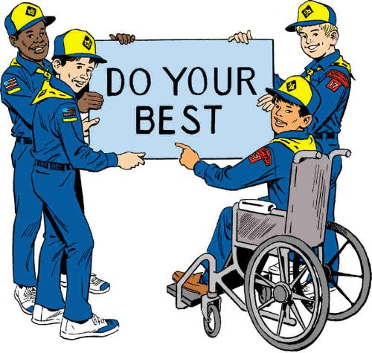

LEADER RECOGNITION
The ABCs of Leaders
Sam Houston Area Council
Start by publishing this list on your Pack Meeting Program. Then read the list aloud at Leader Recognition time when you present the blocks (see below) -
Great Cub Scout Leaders –
- Attend Roundtable
- Believe in the program
- Call to check up if you miss a den meeting
- Discover new ways to involve the Scouts
- Explore all the options
- Find time
- Give unconditionally
- Help whenever asked
- Inspire
- Juggle lots of projects
- Know their knots
- Listen
- Make extra project pieces for siblings
- Notice the wonderful things about their Cub Scouts
- Offer support
- Pray
- Quote Lord Baden-Powell
- Reap the rewards of Cub Scout smiles
- Sing!
- Tell their Scouts – “great job!”
- Understand that life happens
- Value the Aims of Scouting
- Wake up in sleeping bags
- X-amine all material for appropriateness
- Yell cheers during pack meetings
- Have a Zany disposition
Materials – A wooden block letter E mounted on a display board with the wording – "For your exceptional help, many thanks!" and a name, pack # and such.
Cubmaster – There are many parents and leaders here tonight who have helped our pack in a variety of ways. They have contributed their time to the success of our pack meeting and they deserve the Exceptional award for seeing projects and meetings and lots of other things through from A to Z. (Call adults forward and present awards.)

SONGS
More summertime songs here than theme related. Great campfire stuff. Hope you enjoy!! CD
DID YOU EVER SEE A HORSE FLY?
Utah National Parks
(Tune: The More We Get Together)
Did you ever see a horse fly, a horse fly, a horse fly,
Did you ever see a horse fly, a horse fly, fly, fly.
Did you ever see a board walk, a board walk,
a board walk,
Did you ever see a board walk, a board walk, walk, walk.
Other suggestions:
Shoe lace, hair pin, tooth pick, eye drop, neck tie, house fly, moth ball, eye lash, yard stick, hair brush, wrist watch, ear drum.
BABY SHARK
Utah National Parks
Actions - Wrists together, opening and closing hands as a small mouth
Baby shark, do, do, do, do, do, do
Baby shark, do, do, do, do, do, do
Baby shark, do, do, do, do, do, do
Baby shark
Repeat using appropriate actions:
Mama Shark - elbows together, open and close
Papa Shark - use full arms, open and close
Grandma Shark - full arms, closed hands (no teeth)
Surfer Dude - surfing actions
Went for a Swim - swimming actions
Saw a Shark – Hand shading eye, looking
Swam real fast – fast swimming actions
He made it – Wipe brow as if going whew!!
That’s the End - wave good bye
In The Good Old Summertime – Cub Scout Style
Sam Houston Area Council
(Tune: In the Good Old Summertime)
In the good old summertime,
In the good old summertime
Meeting with our Cub Scout Pack
A picnic, family-style.
We’ll play some games
And sing some songs
Scout Leader Pow Wow
With family by our side.
Cub Scouting’s fun the whole year long
But ‘specially in summertime.
BACKYARD ADVENTURE
Utah National Parks
(Tune: Clementine)
Chorus:
In your backyard, in your backyard,
You can have a lot of fun.
If you look at what's around you
You'll have fun 'til day is done.
Did you ever watch an ant work?
Have you listened to the bees?
Have you watched birds build their nests?
And been thankful for the trees?
Chorus
After sunset, watch the stars shine.
Nature's wonders you can see.
Plant a garden, watch the corn grow,
They'll be food for you and me.
Chorus
If you'll just look all around you,
Many new things you will see.
Mother Nature's backyard's endless
Always there for you and me.
The Ants Go Marching
(Great Hiking Song)
Capital Area Council
(Tune: Johnny Comes Marching Home)
The ants go marching one by one, Hurrah, hooray.
The ants go marching one by one, Hurrah, hooray.
The ants go marching one by one,
The little one stopped to SHOOT HIS GUN
And they all go marching...
Down into the ground...to get out of the rain,
BOOM! BOOM! BOOM!
(On succeeding verses change "one by one" to "
two by two,” "three by three,” etc. and use the following lines in place for the underlined above).
Verses:
Two - To tie his shoe
Three - To climb a tree
Four - To shut the door
Five - To take a dive
Six - To pick up sticks
Seven - To look at Heaven
Eight - To shut the gate
Nine - To check the time
Ten - To say the end!
HAPPY WANDERER
Capital Area Council
I love to go a-wandering,
Along the mountain track,
And as I go, I love to sing,
My knap-sack on my back.
Chorus
Val-de ri--Val-de ra-- Val-de ri--
Val-de ra ha ha ha ha ha
Val-de ri,--Val-de ra.
My knap-sack on my back.
I love to wander by the stream
That dances in the sun,
So joyously it calls to me,
"Come! Join my happy song!"
Chorus (Last line - "Come! Join my happy song!")
I wave my hat to all I meet,
And they wave back to me,
And blackbirds call so loud and sweet
From ev'ry green wood tree.
Chorus (Last Line - From ev'ry green wood tree.)
High overhead, the skylarks wing,
They never rest at home
But just like me, they love to sing,
As o'er the world we roam.
Chorus (Last Line - As o'er the world we roam.)
Oh, may I go a-wandering
Until the day I die!
Oh, may I always laugh and sing
Beneath God's clear blue sky!
Chorus (Last Line - Beneath God's clear blue sky!)
Singing in the Rain
Capital Area Council
We're singing in the rain, just singing in the rain.
What a glorious feeling, we're happy again.
Thumbs up! [Group echoes.]
Repeat first two lines, keep thumbs up
Arms Out (Group echoes)
Repeat first two lines, keep thumbs up and arms out
Elbows in (Group echoes)
Keep going adding each of the following, in turn:
Knees Bent,
Knees together,
Toes together,
Butt out,
Chest out,
Head Back
Take Me Out To The Ball Game
Sam Houston Area Council
Take me out to the ball game,
Take me out to the park;
Buy me some peanuts and Cracker Jacks,
I don’t care if I never come back.
For it’s root, root, root for the home team,
If they don’t win it’s a shame;
For it’s one, two, three strikes, “You’re out!”
At the old ball game!
TAKE ME OUT TO THE FOREST
Utah National Parks
(Tune: Take Me Out to the Ball Game)
Take me out to the forest.
Let me hike in the wild.
Show me a skunk and a few bear tracks.
I won't care if I never come back.
But it's look, look, at your compass.
If it rains, then it pours.
And it's ouch, slap, sting and you’re bit
In the great outdoors!
The Twelve Days Of Summer
Sam Houston Area Council
(Tune: The Twelve Days of Christmas)
On the first day of summer, my true love gave to me
A robin in a maple tree.
On the second day of summer, my true love gave to me
Two ducks a-waddling and a robin in a maple tree.
On the third day of summer, my true love gave to me...
Three bees a buzzing, two ducks a-waddling and a robin in a maple tree.
Fourth day... 4 watermelons
Fifth day... 5 picnic baskets
Sixth day... 6 wormy apples
Seventh day... 7 ants a-marching
Eighth day... 8 swimmers swimming
Ninth day... 9 children playing
Tenth day... 10 flowers blooming
Eleventh day... 11 mowers mowing
Twelfth day... 12 gardens growing
Outdoor Adventure
Sam Houston Area Council
(Tune: This Old Man)
Birds and plants, rocks and trees
These are things that I can see
With my backpack, canteen
We are on the run,
Outdoor adventure is so much fun.
Bushes, trains, boats and planes,
Cars are passing, changing lanes,
With our field trips, outings,
We are on the run,
Outdoor adventure is so much fun.

STUNTS AND APPLAUSES

APPLAUSES & CHEERS
Sam Houston Area Council
Home Run Cheer
Simulate swinging a bat at a ball, shade your eyes with your hand and yell, “There she goes!”
Mosquito Cheer
With hand, slap yourself on neck, arms and legs while saying “Ooooo, aaah, eeeee”
Spider Cheer
Walk all four fingers of one hand up the other arm and then scream ‘EEEEEKK!”
Bee Cheer
Put arms out to sides pretending to fly, while saying “Buzz, buzz, buzz.”
Beach Cheer
Divide the audience into three groups. When you point to group one, they yell “Sand!” When you point to group two, they yell, “Surf!” When you point to group three, they yell, “Sun!”
Summer Fun Cheer
Tell the group when you say “summer” or “fun”, they are to say the opposite. Vary the speed you use to see whether they can keep up.
Watermelon Cheer
Capital Area Council
You take a big bite of a watermelon,
Chew it up good and now
You spit out the pits like a machine gun
Utah National Parks
Ocean Cheer
Best done with a large group;
First row sways from side to side;
Second row sways in opposite direction;
Third row same as first, etc.
Then have them add sound effects:
SWOOSH, SWOOSH, SWOOSH!!
Pole Vault Cheer
Hold one arm straight in front.
Stand two fingers of the other hand on the outstretched arm, like legs, and pretend that they “run” down the arm.
When they get to the wrist, make them “leap” into the air. As you bring your hand back down, clap.
Baseball Cheer
Pretend to throw a baseball in the air
Then pretend to hit it with a bat.
After you hit the ball, shout, “Home Run!!”
Bowling Cheer
Pretend to throw a bowling ball down an alley
The yell, “Strike!”
Bicycle Cheer
Say: “Pump, pump, pump!”
Make motions as if using a manual bicycle pump
Bear Hug a Tree Cheer
When lost in the forest, a Cub Scout should “Hug a Tree.”
Put your arms around your own shoulders and
Give yourself a big bear hug just like that tree.
Long Hike Cheer
Stomp your feet loudly three times,
Shuffle your feet softly three times
Ten say “Boy, I’m tired.”
Longer Hike Cheer
Stomp your feet loudly six times,
Shuffle your feet softly six times
Then whine “Are we there yet?”
End of Hike Cheer
Throw hands up in the air and yell “We made it!” and collapse.
Capital Area Council
Big Balloon Cheer
Stick out your thumb and pretend to blow up your hand, keep opening your fingers until your hand opens up really big and yell "BANG!.
Jet Plane Cheer
Move your hand around yelling "Zoom, Zoom"
then add one big clap for the sonic boom.
Lightning Cheer
Shake your finger like jagged lightning yelling "Shhhhh, Shhhh" on each movement.
Throw in a "BOOM" every now and then.

RUN-ONS
Utah National Parks
Some of these are real scout Classics!! CD
Cub 1: (Just standing there.)
Cub 2: (Runs on and yells)
They are after me, they are after me!
Cub 1: What’s wrong?
Cub 2: They are after me!
Cub 1: Who’s after you?
Cub 2: The squirrels are after me, they think I’m nuts! (and runs off)
Cub 1: (Enters during break between skits, poking stick in ground and playing with it.)
Cub 2: (Enters from other side and says)
What you doing?
Cub 1: Just stickin’ around
Cub 1: What did the bug say when it hit the windshield?
Cub 2: I don’t have the guts to do that again.
Cub 1: I wonder what it would be like to be a piece of wood
Cub 2: I’d probably be bored!
Cub 1: You shouldn’t swim on a full stomach.
Cub 2: Okay, I’ll do the backstroke.
Willie: I just found a lost baseball.
Dad: How do you know it was lost?
Willie: Because the kids down the street are looking all over for it.
Cub 1: Why are you crying?
Cub 2: I cleaned the bird cage and the canary disappeared.
Cub 1: How did you clean it?
Cub 2: With the vacuum cleaner.
Camper: Can you pitch a tent?
Beginner: Overhand or Underhand?
Traveler: I’d like to buy a round trip ticket, please.
Agent: To Where?
Traveler: Back to here, of course.
Cub 1: I slept with my head under the pillow last night.
Cub 2: What happened?
Cub 1: The tooth fairy came and took my teeth out.

JOKES & RIDDLES
Utah National Parks
What kind of a dog has no tail?
Hot dog.
What kind of an insect does your uncle like best?
Ants
Why did the hamburger look sad?
It was grounded.
What do spiders eat with their hamburgers?
French Flies.
What do you call an airline that flies backwards?
A receding airline.
Knock, Knocks
Utah National Parks
Knock, knock
Who’s there?
Hutch
Hutch who?
Did you sneeze?
Knock, knock
Who’s there?
Dozen
Dozen who?
Dozen anyone answer the door?
Knock, Knock
Who’s there?
Wooden shoe
Wooden shoe who?
Wooden shoe like to know!

SKITS
FIRE STARTING
Sam Houston Area Council
Characters: Eight boys
Props: See what each boy needs in the skit.
[Have each boy walk on stage with his prop, say his line, and build a fire.]
- (holding wood shavings, pine needles, dry grasses, shredded bark, etc) I’m tinder! I’m quick to burn because I’m small and dry!
- (holding pieces of firewood) I’m kindling! I’m dry dead twigs no thicker than a pencil.
- (holding pieces of firewood) I’m fuel! I’m dry dead wood as thin as your finger and up to as thick as your arm.
- (holding a big cardboard match) I’m a match! I create a spark which will ignite the tinder.
- (holding a poster board picture of a small flame) I’m a flame! I start the kindling burning.
- (holding a poster board picture of a medium fire) I’m a blaze! I burn the fuel and give off heat and light.
- (holding a poster board picture of roaring fire) I’m a bonfire! I’m very dangerous. I can give off enough heat to make this whole pack hot.
- (holding a pail with a small mist bottle of water hidden inside) I’m water. I can put out fires and cool you off. (Takes spray mist bottle out of pail and lightly sprays it into the air.)
THE FIRE
Sam Houston Area Council
You need two players and a behind-the-scenes person to move the fire (an artificial campfire with almost invisible strings attached).
The players sit by the fire, reading, doing a puzzle, etc.
The fire moves slightly. They don’t notice.
It moves again. They don’t notice.
This continues until the fire is pulled off stage.
At that point, one of the players looks at the other and says,
“Looks like the fire’s gone out again!”
HIKING – THE SCOUTING WAY
Sam Houston Area Council
Den Chief: OK, guys. Is everybody ready to go hiking?
[Boys start hiking up their socks and pants or shorts.]
Den Chief: What are you doing? I said hiking! Are you ready to go hiking?
Cub #1: Yes, we’re hiking up our socks and our shorts – you know.
DC: No, no, no. Hiking. Hiking, don’t you know? – hiking!
Cub #2: Oh, OK. [Takes football from behind his back; boys line up to begin play.] Hike one, hike two, hike three.
DC: No, no, no! Hiking! Hiking! Hiking! Come on guys. Get with it!
[Cub #3 walks by with a crown on his head.]
Cub #4: Hi, King!
DC: No, no, no! Hiking, walking, Scouting staff. You know – hiking!
All Cubs: Oh, why didn’t you say so? [Walk offstage hiking with Den Chief.]
CAN YOU DO THIS?
Sam Houston Area Council
Cast: 2 People, campfire blanket
Have one person lie down on his back and the other kneel directly over him.
The top person wears the campfire blanket so as to hide his legs and expose the legs of the person lying down, to create the effect of it being one person sitting down.
Person: Hi there!
Welcome to Don's House of Fine Exercises and Sports Medicine. Today I'm going to ask you about your regular stretching routine.
Can you do this? (He lifts up a leg so that it's parallel with the chest.)
Or this? (Lifts other leg.)
And how about this? (Crosses the legs.)
This is an unusual one. Can you do it? (Brings feet around the neck.)
And let's not forget this one. Can you do it? (Stretches out the legs in spread eagle fashion in the air.) (Elicit a no answer from a volunteer.)
Well, neither can I! (Stands up.)
CLIMB THAT
Sam Houston Area Council
Two Scouts meet, and the first scout begins to brag he can climb anything.
Cub #1: “Can you climb that tree?”
Cub #2 “Sure I've done it lots of times.”
Cub #1 “Can you climb the steep hill over there?”
Cub #2 “No sweat, no problem for me.”
Cub #1 “How about the Empire State Building?”
Cub #2 “Done it. Did it.”
Cub #1 “How about Mount Everest?”
Cub #2 “Boy that was I cold day, I've done that too. I told you I am the world's greatest climber, I can climb anything!”
Cub #1 “I'll bet you ten bucks I can show you something that you can't climb.”
Cub #1 [Pulls out a flashlight and shine the beam up into the sky] “All right climb that!”
Cub #2 "Are you crazy? No Way!”
Cub #1 “I knew you would back out, now pay up!”
Cub #2 “I won't pay because it’s not fair. I know you, I'd start climbing and I'd get half way and you'd turn the flashlight off!”
GOING THE DISTANCE
Utah National Parks
Personnel: Any number of boys
Opening: All start out walking.
1st Cub: (stops) I'm thirsty. (All get a drink.)
(Continue Walking.)
2nd Cub: (stops) I'm hot (All wipe off face.)
(Continue Walking.)
3rd Cub: (stops) I'm hungry (All get something to eat.)
(Continue Walking)
4th Cub: (stops) My shoestring is undone
(All tie shoestrings.) (Continue Walking)
**Make up as many more things as you need so that
every Cub in your den has a part.**
Last Cub (as Cubs approach the end of the stage): This sure has been a long walk how far have we gone?
1st Cub: (Looking back) Across the stage! (Or maybe all the others say this)

CLOSING CEREMONIES
Just a Little More Summer
Alice, Golden Empire Council
Set Up: You need three Cubs of different ages, lined up from older to youngest, and a cardboard sun painted a bright yellow, held by tallest scout (or Den Chief) above the head of boy reading his part.
- Summer is going by fast. There is so much left to do.
- We want to go swimming, hiking, biking, and camping.
- As the sun goes down we want to ask for one more thing.
ALL Just a little MORE SUMMER, please!
God Gives Us the World
Capital Area Council
CM: The founder of Scouting, Lord Baden-Powell, once said, "God has given us a world to live in that is full of beauties and wonders and He has given us not only eyes to see them but minds to understand them, if we only have the sense to look at then in that light." With summer almost over and Autumn approaching, these will be our last months for lots of time in and enjoying the great outdoors. Let us remind ourselves in a true Scouting spirit, to live up to the Outdoor Code:
ALL: As an American, I will do my best to:
- Be clean in my outdoor manners. I will treat the outdoors as a heritage to be improved for our greater enjoyment. I will keep my trash and garbage out of America's waterways, fields, woods, and roadways.
- Be careful with fire. I will build my fire in a safe place and be sure it is dead out before I leave.
- Be considerate in the outdoors. I will treat public and private property with respect. I will remember that use of the outdoors is a privilege I can lose by abuse.
- Be conservation-minded. I will learn to practice good conservation of soil, water, forests, minerals, grasslands, and wildlife. And I will urge others to do the same. I will use sportsman-like methods in all my outdoor activities.
My Backyard
Capital Area Council
- My backyard is a wondrous place
I can stake a claim for a thinking space.
- I can pitch a tent and sleep in the rain,
Or listen to the whistle of a far away train.
- I can throw a ball to Mother of Dad,
Or just be alone when I get mad.
- I can plant a garden or climb a tree,
Or get my dog, Ralph, to chase after me.
- Sometimes we even have den meetings there,
I've finished my Wolf and started my Bear!
- Yeah, the backyard's the place where I run,
When I really want to have some fun.

CUBMASTER’S MINUTES
A Scout is Courteous.
Scoutmaster CG
For more great Scoutmaster Minutes from CG, go to http://scoutmastercg.com/
A Scout is courteous. A Scout is polite to everyone regardless of age or position. He knows that using good manners makes it easier for people to get along.
Bad manners are cool, they always have been. It has always been cool (at least to some people) to rebel against society, to challenge expectations, to be an outsider, a nonconformist. (Funny that nonconformists mostly conform to certain manners of dress and attitude.)
But courtesy is not simply good manners, one may have good manners yet be extraordinarily discourteous. Courtesy is a heartfelt expression of respect and consideration. Respect for the different ways we express ourselves and consideration for our innate desire to be understood, to belong.
A Scout is Courteous.
John Scout 2.0
For more great Scoutmaster Minutes from John Scout 2.0, go to https://johnscout.wordpress.com
“Courteous” isn’t a word we use very much any more. It seems old-fashioned, quaint, out-of-date.
Websters has two definitions of the word. One is
1: Marked by polished manners, gallantry, or ceremonial usage of a court
Yup, pretty old-fashioned there. Good in front of a judge, and nice in front of the ladies. Good manners is, well, good, but doesn’t seem like it should raise to the ranks of “A Scout is Trustworthy” or “A Scout is Brave”. Nobody every saved a life by good manners.
2: Marked by respect for and consideration of others
Respect. Now there’s a term we can relate to. Being “courteous” is about showing people respect, whether it is due or not.
We’ve all heard about guys getting in fights, just because somebody “diss’d” them. Because somebody didn’t show them respect.
See, you can’t demand respect. It can only be given, willingly.
Being courteous is about more than just being kind. It’s about giving the other guy a fair chance. Of following the Golden Rule and treating others like you want to be treated. Be courteous to people and you’ll never go wrong.
A Summer Thought
Alice, Golden Empire Council
The great William Shakespeare once said, “Summer’s lease hath all too short a date.” Like most of us, he thought Summer too short, just like things always do when you’re having a good time. Enjoy every minute! Go out there and have some fun!
Three Important Things
Capital Area Council, TX
To the sailor, three things were essential - a compass, a sextant, and a flag. The compass to tell them where they were heading during the day. The sextant to tell them where they were at night, and the flag to tell them which way the wind is blowing
SUMMER CLOSING
Utah National Parks
May the sun be warm and kind to you,
May the darkest night bring a shining star through.
May the dullest day bring a ray of light to you,
And when you leave here tonight, God’s hand to you.
Good night Scouts!
HAVE YOU EVER WATCHED THE CAMPFIRE?
The Gilwell Camp Fire Book
Via Utah National Parks
Have you ever watched the campfire,
When the wood has fallen low,
And the ashes start to whiten
Round the embers' crimson glow?
With the night sounds all around you
Making silence doubly sweet,
And the full moon high above you
That the spell might be complete?
Tell me - were you ever nearer
To the land of heart's desire
Than when you sat there thinking
With your feet before the fire?
DO YOUR BEST
Utah National Parks
When you give the Cub Scout Promise, the words "Do Your Best" often are lost in all of the other very important words. Let's stop for a minute and carefully consider those words.
- “Do” signifies effort and action.
- "Best" describes effort and action above our usual.
- "Your Best" is just that–the very best.
You are the only person who can possibly know whether or not you have done your best to do certain things.
Think about the meaning of the Promise and decide that you will always do your very best, no matter what the job facing you might be.
SMILE CLOSING
Utah National Parks
A smile costs nothing, but creates much. It happens in a flash, but the memory sometimes lasts forever. It cannot be bought, begged, borrowed or stolen, but it is something that is of no earthly good to anyone unless it is given away. So, if in your hurry and rush you meet someone who is too weary to give you a smile, leave one of yours. No one needs a smile quite as much as a person who has none left to give. What better way to spread good will.
Helpful to Others
Capital Area Council
An excellent way to close a campfire on a
starry night. CD
Lord Baden-Powell, the founder of Scouting said this to scouts everywhere: "I often think that when the sun goes down, the world is hidden by a big blanket from the light of heaven, but the stars are little holes pierced in that blanket by those who have done good deeds in this world. The stars are not all the same size; some are big, some are little, and some men have done small deeds but they have made their hole in the blanket by doing good before they went to heaven. Try and make your hole in the blanket by doing good work while you are on earth. It is something to be good, but it is far better to do good". Think of Baden-Powell's words when you promise "to help other people".
Closing Thought
Capital Area Council
Put me in touch with the heart of a boy—
Let me study his doubts and fears.
Let me show him a way of life
and help him avoid its tears.
For the heart of a boy in its buoyancy
is one that is pure and true.
So, put me in touch with the heart of a boy…
and the heart of a man to be.

CUB GRUB

S'MORES
Want to celebrate
National S’Mores Day
on August 10 with or without going camping or having a real campfire?
Try one of these versions!
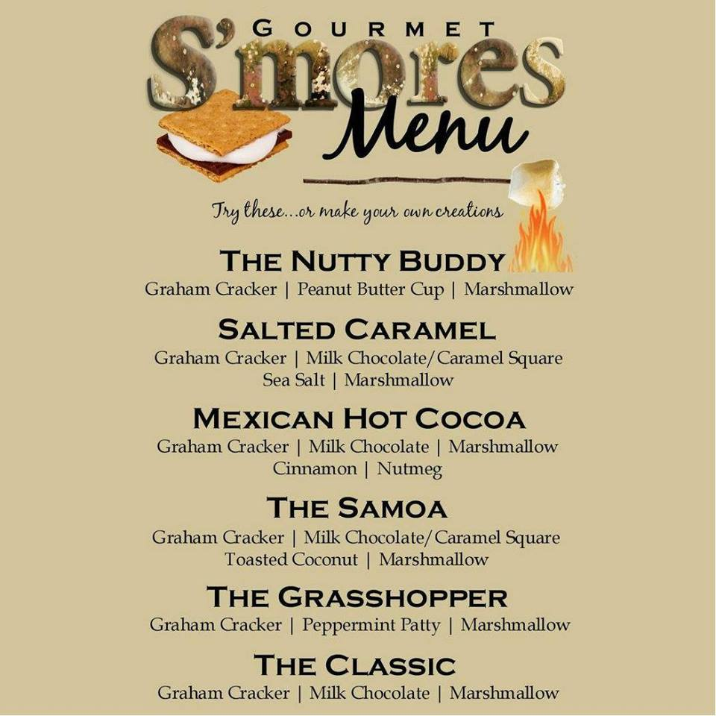S’mores Crumb Bars
Ingredients
3 cups graham cracker crumbs
3/4 cup butter or margarine, melted
1/3 cup sugar
3 cups miniature marshmallows
2 cups semisweet chocolate chips
Directions
- Combine the crumbs, butter and sugar; press half into a greased 13-in. x 9-in. x 2-in. baking pan.
- Sprinkle with marshmallows and chocolate chips.
- Top with remaining crumb mixture; press firmly.
- Bake at 375 degrees F for 10 minutes.
- Remove from the oven and immediately press top firmly with spatula.
- Cool completely.
- Cut into bars.
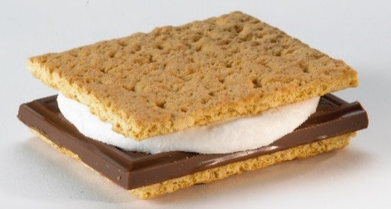
S’Mores Pie
Alice, Golden Empire Council
This can be made as one 9 inch pie,
or in individual mini-pies.
Ingredients
1 - 9 inch graham cracker crust
1 - 7 ounce jar marshmallow crème
1 - 3.9 ounce package instant chocolate pudding mix
1 - cup chocolate shell topping (optional)
Directions
- Spread marshmallow cream in the graham cracker crust.
- Prepare chocolate pudding according to package directions and pour over marshmallow cream.
- Cover top with chocolate shell topping.
- Refrigerate for 1 1/2 hours, then serve.
Indoor S’Mores
Alice, Golden Empire Council
Ingredients
4 cups honey graham cereal
3 tablespoons margarine
6 cups miniature marshmallows
1/4 cup light corn syrup
1 1/2 cups milk chocolate chips
Directions
- Coat a 9x13 inch dish with cooking spray.
- Place cereal into a large bowl; set aside.
- In a medium saucepan over low heat, melt margarine.
- Add marshmallows and corn syrup and stir until melted and smooth.
- Stir in chocolate chips until melted.
- Remove from heat and pour over waiting cereal; stir well to coat.
- Press into prepared pan.
- Cool completely before cutting into squares.
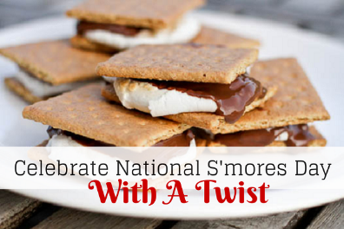
S’mores
Sam Houston Area Council
The word “S’More” means ‘some more’ because that’s what everyone says after they eat one.
Ingredients
3 sections of a Hershey’s chocolate bar,
1 graham cracker rectangle broken into two squares along the dotted line,
a marshmallow,
a marshmallow roasting stick
Ingredients
- Put the chocolate on 1 square of the graham cracker.
- Keep the other cracker piece ready for the top.
- Place the marshmallow on the end of your stick.
- Carefully roast the marshmallow over the fire by holding it about 2 inches above the fire, rotating it until it is golden brown. (Adult supervision needed.)
- With help from an adult or a buddy, grasp the marshmallow between the graham cracker with chocolate and the other cracker piece.
- Gently squish the marshmallow so that the chocolate will melt.
- Be careful – it will be hot. This can be tricky, especially if it’s dark!
- Let it cool before you take a bite.
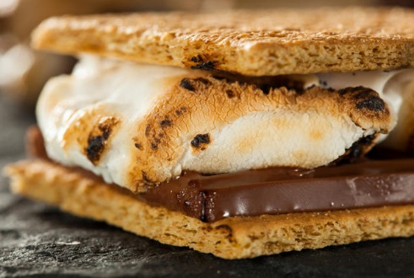
Chocolate Graham Whipped
Cream Sandwiches
Utah National Parks
These are so good!
Ingredients:
Chocolate graham crackers
(not chocolate covered)
Non fat whipped topping
Directions:
- Break graham cracker in half.
- Put 2 Tbs of whipped topping on one half.
- Top with other half.
- Put in freezer to freeze for 2 hours.

S’more Cones
Sam Houston Area Council
Ingredients
Sugar cone,
caramel cube,
15 chocolate chips,
large marshmallow,
drinking glass
Directions
- Place the cone in the drinking glass with the pointy end down.
- Put the caramel and the chocolate chips in the bottom of the cone.
- Microwave on high for 15 seconds.
- Add the marshmallow and microwave another 15 seconds.
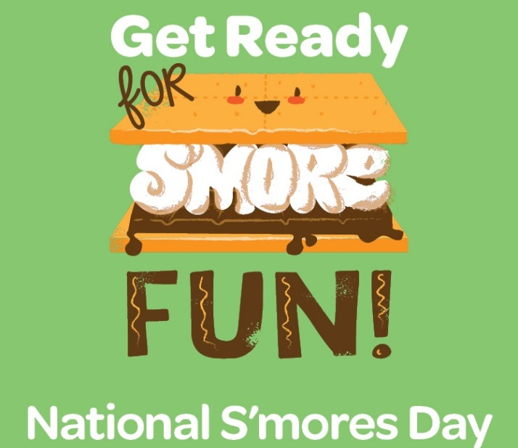
S’more On A Stick
Sam Houston Area Council
Ingredients
3 marshmallows,
popsicle stick,
chocolate – chips or bar,
crushed graham crackers
Directions
- Put three marshmallows on a popsicle stick,
- Place on a plate in the microwave,
- Heat only long enough to soften slightly,
- Let cool for a couple of minutes.
- Melt 2 ½ cups chocolate on the stove or in the microwave in a bowl.
- Roll the marshmallows in the melted chocolate.
- Sprinkle with crushed graham crackers.
- Place on waxed paper and refrigerate for 30 minutes.
Peanut Butter S'mores
San Gabriel Valley, Long Beach, &
Verdugo Hills Councils
Ingredients:
2 pkgs chocolate covered peanut butter cups - 16 ounces
8 graham cracker squares
4 large marshmallows
Directions
- Instructions:
- Place 1 peanut butter cup on each of 4 crackers.
- Spear marshmallows on long fork or clean stick;
- Toast them over campfire coals or over grill on low heat.
- Set a toasted marshmallow on top of each peanut butter cup
- Top each with cracker.
- Press together and hold for a few seconds to melt chocolate.
Roll Up S’Mores
Alice, Golden Empire Council
Ingredients:
Chocolate Chips
Mini Marshmallows
8” flour tortilla
Aluminum Foil
Directions:
- Spoon two Tablespoons of chocolate chips and 12 mini marshmallows onto the center of the flour tortilla.
- Roll up like a burrito, wrap in the foil.
- On campfire coals, heat for 4 minutes, turning halfway.
- On a grill, double the time to 8 minutes total.
- When the foil is cool enough to hold, fold down foil on one end and enjoy!
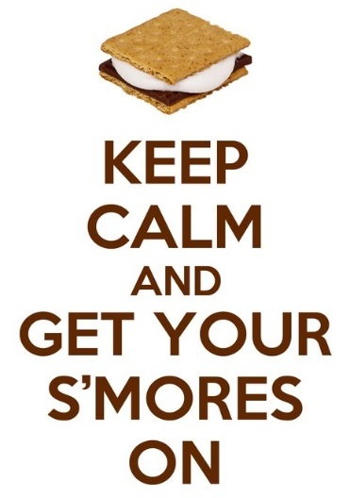
Gooey S'Mores·Bars
Ingredients:
2/3 cup sugar
1/2 cup butter or margarine, softened
1/2 tsp vanilla
1 egg
2 1/3 cups graham cracker crumbs
1/3 cup Gold Medal oil-purpose flour
1/8 tsp salt
1 bag (11.5 ounces) milk chocolate chips (2 cups)
1 jar (7 ounces) marshmallow creme
1 cup miniature marshmallows
Directions:
- 1. Heat oven to 350°,
- Grease bottom and sides of 13x9x2 rectangular pan with shortening or spray with cooking spray.
- Beat sugar. butter. vanilla and egg in large bowl with electric mixer on medium speed, or mix with spoon until light and fluffy.
- Stir in graham cracker crumbs, flour and salt.
- Reserve 2 cups graham cracker mixture. Press remaining mixture in pan.
- Sprinkle chocolate chips over crust; press slightly.
- Drop marshmallow creme by tablespoonfuls over chocolate chips.
- Wet back of tableware spoon and use to lightly spread marshmallow creme.
- Sprinkle with marshmallows.
- Sprinkle with reserved crumb mixture; press lightly.
- Bake 17 to 22 minutes or until marshmallows are puffed and light golden brown.
- Cool at least 30 minutes.
- For bars. cut into 6 rows by 4 rows. Makes 24 bars
Baked S’Mores
Utah National Parks
Ingredients:
1 box favorite brownie mix
1 pkg graham crackers
1 ½ cup mini marshmallows
Directions:
- In a 9x13 baking pan, layer graham crackers.
- Mix brownies according to package directions
- Pour brownie batter over graham cracker layer,
- Bake as directed on package.
- Immediately remove from oven and sprinkle marshmallows over top.
- Place back into warm oven for about one minute or until marshmallows are soft.
S’more Yummy Variations Of S’mores
Sam Houston Area Council
- Stuff your chocolate inside the marshmallow before roasting then squeeze the marshmallow between the two cracker pieces.
- Sliced bananas and a roasted marshmallow between coconut cookies
- Peanut butter, jelly and a roasted marshmallow between graham crackers
- Apple slices, peanut butter, chocolate and a roaster marshmallow between graham crackers
- Strawberry slices and roasted marshmallow between shortbread cookies
- Mint-flavored chocolate and a roasted marshmallow between graham crackers
- A peanut butter cup and a roasted marshmallow between graham crackers
- Put your marshmallow and chocolate between fudge striped cookies rather than graham crackers
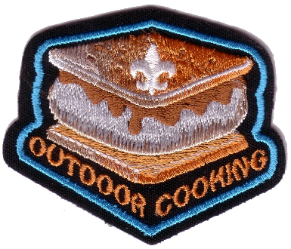
Want more S'Mores
recipes and ideas??
http://www.hersheys.com/puresmores/
Solar Plum Fruit Leather
Alice, Golden Empire Council
Celebrate the Summer sun by using solar power to make fruit leather. Try substituting other fruits such as apricots, but add a little lemon or pineapple juice to keep light colors from going brown.
Ingredients:
- 2 pounds of fresh plums
- 1/4 cup light corn syrup
- Saucepan
- Blender
- Plastic Wrap
Directions:
- Slice the plums thinly; discard pits and place in large saucepan.
- Add the corn syrup and bring to a boil for 3 minutes.
- Pour this mixture into a blender and blend until smooth.
- Set aside to cool.
- Cover cookie sheets with clear plastic wrap and
- Pour the strained puree to 1/4” thickness.
- Let dry in the sun (can take up to 2 days in the sun).
- Your Fruit Leather is done when it pulls off the plastic easily.
Sherbet the Frog
Alice, Golden Empire Council
Ingredients:
- Lime Sherbet
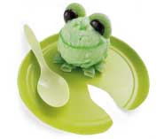
- Green decorating gel (or a strip of green fruit leather or even lime peel)
- Junior mints
- Green Gummy Ring Candy
- Small green plate
Instructions:
- Set a scoop of sherbet (or any green ice cream) on a small green paper plate trimmed to resemble a lily pad.
- Cut one green gummy ring candy into quarters and place under the sherbet to make frog feet.
- Set a Junior Mint and half a gummy ring in place for each eye at the top and back of the sherbet scoop.
- Finally, add a mouth and nostrils with decorator gel or one of the options.
- This would be a great treat after spending time looking for frogs and pond creatures!

Cubcakes
Great Salt Lake Council
Ingredients
1 package (18 oz) chocolate cake, plus ingredients to prepare
1 container (16 oz) chocolate frosting
1 package (5 oz) chocolate nonpareils
72 red cinnamon candies
Chocolate sprinkles
1 tube (0.6 oz) black piping gel
Directions
- Line muffin cups with paper liners.
- Prepare cake mix and bake in muffin cups according to package directions.
- Cool in pans on wire racks 15 minutes.
- Remove cupcakes from pan and cool completely.
- Frost cooled cupcakes with chocolate frosting.
- Use nonpareils for ears and muzzle, red candies for eyes and nose and chocolate sprinkles for fur.
- Use piping gel to place dots on eyes and to create mouth.
All American Dessert
Santa Clara County Council
Ingredients:
1 large Berry blue Jell-O
1 large Red Jell-O, any flavor
4 c Water; boiling
2 c Water; cold
8 oz Cool Whip; thawed
4 c Angel food cake -OR-- pound cake, break in cubes
2 c Strawberries; sliced
1/2 c Blueberries; (optional)
Directions:
- In separate bowls, dissolve each flavor of Jell-O completely in 2 cups of boiling water.
- Stir 1 cup of cold water into each bowl.
- Pour into separate 9x13" pans.
- Refrigerate at least 3 hours until firm.
- Cut into 1/2" cubes.
- Place blue Jell-O cubes in bottom of clear glass trifle bowl.
- Top with 1/3 of the Cool Whip.
- Add cake cubes, then sliced strawberries.
- Top with another 1/3 Cool Whip.
- Add the red Jell-O cubes and then the remaining Cool Whip.
- Sprinkle blueberries over top if desired.
WATERMELON ICE
Utah National Parks
Ingredients:
- 2 cups watermelon
- ½ cup whipped topping
Directions:
- Remove seeds from about 2 cups of watermelon.
- Place watermelon in blender and grind it up.
- Chill. Fold in whipped topping and mix well.
- Tastes sort of like watermelon sherbet.
Colorful Popsicles (Red, White, Blue)
Sam Houston Area Council
Ingredients
- 2 cups blue Powerade, Gatorade or Kool-Aid – something blue
- 12 5 ounce cups
- 1 cup frozen whipped topping
- 1 cup vanilla yogurt
- 12 craft sticks
- 2 cups cran-raspberry juice
Directions
- To begin, divide the blue juice between the twelve cups.
- Place the cups in the freezer until the juice is almost frozen (30-45 minutes).
- Mix together whipped topping and yogurt and then divide this among the twelve cups.
- Return the cups to the freezer for another 45 minutes.
- Use the cran-raspberry juice for the last layer and place them back in the freezer until solid.
- To remove the pops from cups, run warm water over the outside of each cup. Makes twelve popsicles.
Spoon Fudge
Capital Area Council
Serving Size 16
Ingredients:
- 1- Gallon size ZipLoc (tm) plastic bag
- 1 lb. powdered sugar
- 1 cube butter (1/4 lb.)
- 1- 3oz. cube of cream cheese
- 1/2 tsp. vanilla
- 1/4 to 1/2 cup of cocoa
Directions
- Place all the ingredients in the Ziploc bag and squeeze out all the air.
- Squish and smoosh the bag until all the ingredients are well mixed and there is a creamy consistency.
- Add a favorite flavor & stuff ( raisins, peanut butter, etc)
- Take a spoon and enjoy
PACK O’ PUNCH SLUSHEE
Utah National Parks
Ingredients:
- 1 pkg. unsweetened drink mix (any flavor)
- 1 cup sugar
- 1 cup water
- Ice
Directions:
- Get out your blender!
- Add drink mix, sugar and 1/2 cup water.
- Blend well to dissolve sugar.
- Fill blender with ice and remaining water.
- Blend until smooth.
- Try Hawaiian style and add 1 scoop vanilla ice cream in bottom of cup!
ROLL AROUND ICE CREAM
Utah National Parks
Ingredients:
- 1 cup milk
- 1 cup heavy cream
- 1/3 cup sugar
- 1 tsp. vanilla
- 1 clean empty 1 lb. coffee can with lid
- 1 clean empty 3 lb. coffee can with lid
- Ice cubes
- Rock or table salt
Directions:
- Mix the milk, cream, sugar and vanilla.
- Pour into the 1 lb. coffee can and put the lid on.
- Seal with duct tape.
- Place the small can inside the 3 lb. can
- Fill the large can with ice and salt.
- Duct tape the lid.
- Wrap a towel around the can because it will get very cold.
- Give the can to two Scouts and have them roll it back and forth on the floor for at least 20 minutes.
- If the ice melts, unseal the large can and add ice and salt.
- After 20 minutes have passed unseal the small can.
- Inside will be delicious vanilla ice cream!
Ice Cream In A Ziploc Bag
Sam Houston Area Council
Ingredients
- 1 gallon freezer Ziploc bag
- 1 quart freezer Ziploc bag (heavy duty)
- 4 cups ice
- ¼ cup rock salt
- 1 cup whole milk
- 1 teaspoon vanilla extract
- 2 tablespoons sugar
Directions
- Pour the milk, vanilla extract, and sugar into the small Ziploc bag.
- Squeeze as much air out as possible and seal the bag carefully.
- Place the small Ziploc bag down into the large bag.
- Put the ice and salt with the small bag inside of the big bag.
- Seal the large bag tightly.
Seedless Watermelon Ice Cream Cake
Great Salt Lake Council
Ingredients:
- 1/2 to 1 Gallon Lime Sherbet
- 1/2 to 1 Gallon Raspberry or Strawberry Sherbet
- 1 Metal Bowl (amount of Sherbet depends on what size bowl you use)
- Freezer
Directions
- Take the lime sherbet and soften just enough to work with and spread it around the edges of the metal bowl until sides are completely covered about 1/2” thick.
- Freeze for about 45 minutes or until firm.
- When frozen take the pink sherbet and soften just enough to be able to fill in the rest of the bowl.
- Freeze for 45 minutes or until firm.
- When frozen or when you’re ready to serve remove cake by filling sink with just enough hot water so that when you set the bowl in the water it will not go over the sides of the bowl.
- Let sit for about 1 minute and then tip bowl onto a plate. Slice like a watermelon.


GAMES
Swinging Comets
Alice, Golden Empire Council
This is great fun to play in the dark –
it makes use of the way our eyes work –
we actually see a comet “tail” behind the swinging ball. I remember playing with this homemade toy –
it was fun even without glow in the dark paint!
Materials:
- Tennis Ball
- Acrylic paint (optional)
- Glow in the Dark Paint
- Craft Knife (ADULT only)
- Heavy duty string (for added fun, look for Glow in the Dark string at Craft stores)
- Tacky Glue
- A Dark Night and Open Space
Set Up:
- Decorate the ball with acrylic paint and/or cover the dry ball with glow in the dark paint. Let dry.
- Adult cuts a half-inch slit in the ball.
- Take a 30 inch length of string, fold in half and double knot.
- Squeeze the ball so the slit will open up, and insert the knot end of the string into the hole. Add a squirt of tacky glue to secure the string.
How to play:
Hold onto the looped string and swing your “comet” around, or have a contest to see who can toss their comet the farthest. (If the glow fades, just use a flashlight or make a quick trip into the house to renew the glow in the dark)
Moonball
Sam Houston Area Council
Materials: Beach ball
- Players form a circle.
- Toss the ball into the circle and see how long the group can keep the ball in the air (count the number of hits).
- If the ball hits the ground, start again and try to improve your record.
Problem solving – When the ball hits the ground, ask the group what they think will help them do better. Have them try some of their suggestions.
Fox And Geese
Sam Houston Area Council
Fox and Geese games originated in
northern Europe during the Viking Age.
Fox and Geese is a chase game that is played on a circle rather than in one. Eight or more players are needed. One is the fox and the rest are the geese.
To prepare for the game, a circle is drawn (at least 30 feet in diameter) and cut into 8 or 10 equal pieces, like the spokes of a wagon wheel. This can be done in the snow, in the sand or with chalk on a black-top or playground surface.
The player chosen to be the fox begins the game in the center of the circle (his den) and the geese pass along the spokes and rim of the wheel. When a player thinks he has a chance, he can run up the spoke toward the den to tease the fox into chasing him.
At the signal, the fox starts chasing the geese. All the players must stay on the lines at all times. Should two geese meet, they may maneuver carefully around each other but they must not step off the lines. When the fox catches up with a goose, he tags the goose that then joins the fox in hunting the other geese. The last goose left is the winner and becomes the fox for the next round.
Log Rolling
Sam Houston Area Council
- Tape two oatmeal boxes together to make a log or use a large mailing tube.
- Use dowel or yardsticks to roll it.
- Form relay teams and have a relay race pushing the log across the room, around a chair and back to the starting line.
Shadow Stomp Game
Sam Houston Area Council
This game is like a game of tag, but a bit different. In this game,
“It” must stomp on the other players’ shadows instead of tagging him.
The Frog Hop
Sam Houston Area Council
- Draw a finish line about 25’ from the start and line the players up about 3’ apart.
- At “Go” they race by jumping first to the right, then to the left, then straight ahead.
- This procedure is followed until someone crosses the finish line.
What’s In The Picnic Basket?
Sam Houston Area Council
(A quiet game for after all that running around)
Players: 2 or more
Sit in a circle or around a picnic table. The game begins by imagining you have a very large picnic basket. The first player recites the sentence “I’m going on a picnic and I’m bringing _________.” The player must fill in the blank with an appropriate word that begins with the letter A, such as “apples” or “American cheese.”
The second player must repeat the sentence just as the first player said it and add an item that begins with B. For example, “I’m going on a picnic and I’m bringing apples and bread.”
The game continues around and around with each player repeating the complete list of items and then adding something with the next letter of the alphabet.
As the list becomes longer it is more difficult to remember. (If players agree beforehand, the letter X and other difficult letters like Q and Z, can be left off the list or the items for those letters can be chosen by the group.)
If a player makes a mistake, he is “out.” The winner is the last person left, providing he can repeat the whole basketful of items without a mistake.
A simpler version of this game would not require alphabetizing. Instead, kids can pack the picnic basket with any appropriate item. When a player misses an item, the next player starts the list over. Players are out of the game after making three mistakes. The last player remaining is the winner.
MOSQUITO BITES
Utah National Parks
- “IT” pursues the other players and tries to touch one of them.
- When one has been touched, he must keep his hand on the spot where he was touched and pursue the others.
- His hand cannot be freed from this spot until he has tagged someone else.
- The idea is to tag players in inconvenient places - knee, ankle, elbow, etc.
Natures Sounds
Sam Houston Area Council
The group sits quietly in a clearing in the woods. Each person listens, writing down all of the nature sounds he hears - the wind, birds, insects, leaves rustling, etc. (each sound must be specifically identified). After a 5 or 10 minute time limit, each player reads his list. The longest correct list wins the game.

BSA Social Media

You Tube Channels
(Images are hyperlinked to the You Tube Channels)

Scouting Magazine
 | 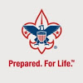
Boys’ Life Magazine | Boy Scouts of America

Summit Bechtel Reserve

Check out the cool stories and interviews on the different channels. (Click on images to view the videos)
Scouting Magazine
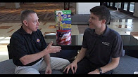
Amplify your fundraiser with Camp Masters


Alaska Airlines CEO Brad Tilden on leadership and Scouting


William Ceva, 2016 NESA STEM Scholarship recipient

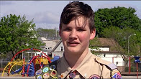
Zachary Blohm, 2016 NESA Eagle Scout Project of the year.


Ben Gallaher, Eagle Scout and country singer, talks music and Scouting.
Boys Life Magazine
Check out the different play lists that are on the Boys Life Magazine YouTube channel.
BL Essentials
Handbook Hacks
How to tie knots
Scouting Around
Uploads

Summit Bechtel Reserve
(Click on images to see video)
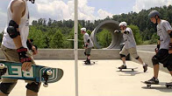
2017 Programs are waiting for you!
Northern Tier
(Click on images to see video)
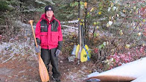
Northern Tier Promotional Video (older video, but still gives you a great idea of what Northern Tier has to offer)
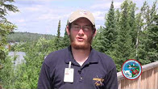
Jobs at Northern Tier
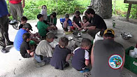
Cub Scout Family Camp
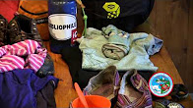
Northern Tier – Packing Personal Gear

BSA Facebook
Police Explorer Finds Way to Help Local Youth with Abandoned Bicycles
Be sure to check out Boy Scouts of America Facebook page for more great articles and Videos regarding Scouting.

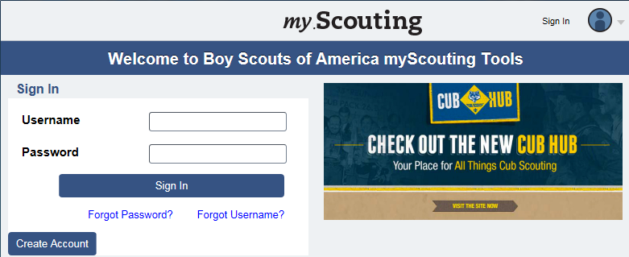

My.Scouting – your self-updating Pack membership database
By Gary Moore

Last month we explored using My.Scouting as a communications tool by using the Calendar and Announcement tools. This is great for providing a consistent “go-to” place where people can come for the latest information. But it is passive in that it relies on people coming to the site. When you need to initiate contact, email and the telephone are the preferred methods to communicate. That makes it critical that your list of phone numbers and email addresses is complete and up to date.
The update process for phone and email information can be time consuming. If someone finds they really only use their cell phone and decides to drop their land line, you often don’t know that until it’s critical that you reach them quickly and have only their now non-existent land line for a phone number. It takes time and effort to track down the correct information.
Rather than having you do all this, the My Dashboard tool in My.Scouting allows members to update their own information. After all, the easiest way to get work done is have someone else do it! Since, as we talked about last month, we’ve ensured that all members have created a login to My.Scouting that is properly associated with their Member ID (we did do that, right?) we now just need to inform them of how to update their information. A video to help with this can be found at https://bit.ly/290X8A5.
Please note that the My Dashboard is available to every member. It lets members look at and maintain only their own information, however.. They can not see or change anyone else’s information.
While it may sound like getting members to update their information is a bother, in the long run, it can save lots of time and trouble. When a member updates their information in My.Scouting, their updates link to their information in ScoutNet, the databased used by Council professionals and National, and updates that as well. When it comes time for your Pack to re-register, your work is cut way down. It also cuts down on manual entry (and the possibility of mistakes) by the Council Registrar. An easy way to ensure people do this is to have a couple of people at your Pack meeting with laptops to help people log in and update their information. Once they’ve seen how easy it is, they will be able to do it themselves in the future.
Now that you’ve had everyone update their contact information, let’s talk about some strategic ways to use that. One of the frustrations about using email to communicate is that while you’re sure it has been sent, you never really know whether it has been opened.
While we know that My.Scouting does not send out email, there are other tools that you can use to help with that.
Two mail programs that I’ve used successfully are Mail Chimp (http://mailchimp.com) and Vertical Response (http://verticalresponse.com.) Both offer free accounts. Mail Chimp allows up to 12,000 total emails a month and up to 2,000 contacts. Vertical Response allows up to 1,200 total emails a month and up to 300 contacts. If you send more email than that, my advice would be to knock it off and spend more time with he boys! Just so you know, I receive nothing from either company – I just want you to be aware of them as resources you may wish to use..
Both programs offer similar features. Both help you create great looking emails easily, let you upload your email lists for easy reuse, report which email bounces, which is opened (meaning that it was read), what links were clicked, and more. They also allow recipients to opt out of the list if they wish. Another advantage is that emails are sent out one email address at a time so every email address in the Pack is not shown which protects the privacy of the recipient.
In most states, this type of email is not spam, as you have an existing relationship with those you’re emailing (your Pack) and you are not selling as the primary purpose of the email. While it is always prudent to check out the laws in your area, I think you’ll find you’re OK. But please do remember to check out BSA’s Social Media guidelines found at: http://bit.ly/294hNDT.
So, now we’ve explored having people update their own information in My.Scouting, but how do you get the information out of My.Scouting in a usable form? Glad you asked! Next month, we’ll look at the Member Manager tool to do just that. The Member Manager tool is available only to the unit Key 3 (and Key 3 Delegates if assigned.) As we start to study this tool, you’ll start to see the power of My.Scouting tools to manage your Pack.
See you next month!

Telling the Scouting Story with Social Media
Robert L. Stocker
Using social media to tell your unit's story is a great way to share all the fun and exciting things that your unit does. Social media also provides you with an awesome tool to recruit new scouting families into your unit.
There is an old saying about a picture being worth a 1,000 words. If that is the case, then if you upload 5 pictures to a social media site, you have just written a 5000-word document telling others how great your unit is.
Of course whenever you publish pictures publically, there are guidelines that need to be followed. Sites like Facebook, Twitter, Instagram, and others, all of guidelines regarding using their sites. Be sure to take the time to read these guidelines and follow them.
The Boy Scouts of America (BSA) has also put together some great guidelines and resources for using social media. In fact, BSA is very pro-active in encouraging units to use the different social media channels and they have created and are still creating lots of helpful information and materials that scouting units, districts, and councils can use in their "Social Marketing Plan." Below are some links and short summary of what information you will find at each link.
http://bsaseabase.org/Home/BrandGuide/Multimedia/SocialMedia.aspx
These are some key considerations you should think about and discuss with your unit before starting to share information on social media.
http://scoutingwire.org/marketing-and-membership-hub/social-media/social-media-guidelines/
This link gives you the BSA's Social Media Guidelines.
http://scoutingwire.org/wp-content/uploads/2015/05/Social_Media_Playbook_050815.pdf
This is the "BSA Social Media Playbook." Here you will find great information to help guide you in using social media to spread the great fun your unit is providing.
With all of these links you will find a lot more links inside them to help you along your social media journey.
Now that you have looked over these guide lines and have a plan on how to use social media; let's take a look at some of these social media channels and the materials' that BSA has put together to help you with your unit's social media usage.
Up this month, FACEBOOK Part 2.
Spreading the word about your unit, district, or council has never been easier than now. Thanks to social media and particularly Facebook, you can let people in your area and the world know about your unit, district, and council. You can share the fun, excitement, and activities that your scouts and family are evolved in with Scouting in ways that were never possible before.
So with all this advertising available to you, literally at your fingertips, what should you be sharing? Fortunately, the Boy Scouts of America (BSA) is leading us by example. With Facebook, the BSA maintains a great Facebook Page that is loaded with examples of what you can be posting about your unit, district, or council.
For example, currently on the BSA Facebook Page there is a post about a Police Explorer who is helping local youth with bicycles that have been abandon.
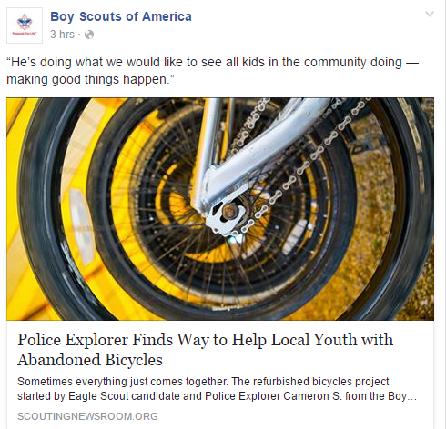
1Screen shot from Boy Scouts of America Facebook page.
There are also several videos on the BSA Facebook Page showing all different kinds of information and activities going on all over the country in scouting.
Following the examples on the BSA Facebook Page, think about what you can post about regarding your unit, district, or council.
Think about all the activities that are going on in your unit each month. Things like meetings, camping, community service projects, high adventure, crafts that the scouts make, awards that scouts are earning, etc.
Everything that is happening in your unit, district, council has the potential to be shared on Facebook, or any other Social Media stream. All of these things can be used to tell the story of scouting and show your community that scouting is alive and well. Oh and don’t forget about EXCITING and FUN!
Something else that you can share on your local Facebook page are articles from other Facebook pages, like the BSA Facebook page. This will help share the stories from around the country, that other scouts are up to.
By looking at these stories from around the county; they may give you ideas about what you could be doing in your local area.
Tune in next month as we continue to look at how we can use social media to tell our story.



“Bryan on Scouting”
is the official blog of Scouting magazine, a Boy Scouts of America publication. Scouting magazine is published five times a year and is received by 1 million registered adult volunteers. Bryan covers many topics every month. He keeps his Blog current and deals with the latest issues.
His articles this past month are listed below (Every title has a hyperlink). The articles in BLUE are of special interest for Cub Scout Leaders.
If the word SPONSORED appears, that BSA received compensation for that blog post.

Documentary sheds new light on Gerald Ford, our only Eagle Scout president

Wood Badge methods inspire executive training program in Rwanda
June 27, 2016 // 0 Comments

Kevin Etter, whose Wood Badge critter is a Bear, has unlocked a way to bring Wood Badge principles beyond Scouting and, indeed, beyond American borders.
MasterChef Junior announces open casting calls for young cooks
June 24, 2016 // 1 Comment

"MasterChef Junior" is hosting open casting calls for Season 6 in New Orleans, Chicago, Los Angeles, New York City, Houston, and Jacksonville, Fla.
Sparks will fly when Cub Scout leader competes in Season 2 of ‘BattleBots’
June 23, 2016 // 2 Comments
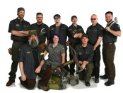
Randy Farmer, an assistant Cubmaster, is a member of Chaos Corps, a team from Atlanta that will appear in tonight's Season 2 premiere of "BattleBots."
Five tips for starting a new Scout unit in an underserved market
June 23, 2016 // 3 Comments

To grow Scouting, consider looking in communities where Scouting hasn't yet flourished. That's a skill this Florida Scouter has perfected.
New Jersey triplets receive Eagle Scout Award — together, of course
June 22, 2016 // 4 Comments
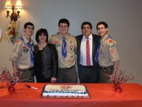
In January, Nicholas, Anthony and Justin Neves — a set of triplets from Troop 46 of Montgomery Township, N.J. — received the Eagle Scout Award.
Eagle Scouts first on scene of rollover accident along Interstate 95
June 21, 2016 // 2 Comments

At the scene of a single-car rollover accident in Georgia, two Eagle Scouts and an assistant Scout executive leapt into action to help the injured driver.
An impressively high number of U.S. senators are Eagle Scouts
June 20, 2016 // 28 Comments
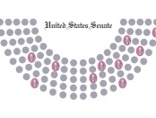
We have the numbers to prove just how many U.S. Senators — some of the country's most powerful politicians — earned Scouting's highest honor in their youth.
A Father’s Day salute to Scouting dads
June 17, 2016 // 6 Comments
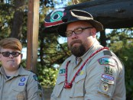
Scouting dads sacrifice time, money and precious vacation days for the betterment of packs, troops, teams, crews, posts and ships across the country.
100th anniversary of BSA charter gets congressional recognition
June 17, 2016 // 0 Comments
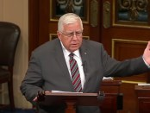
On news sites and in both houses of the U.S. Congress, everyone seems to be talking about the BSA's big anniversary: 100 years since our charter was signed.
Could you earn the Golf merit badge? Take this 18-question quiz to find out
June 16, 2016 // 1 Comment

This 18-question quiz has answers taken straight from the Golf merit badge pamphlet. Be Prepared: Like the game itself, this quiz isn't easy.

‘The Scoutmaster’ turns 60: The story behind the Rockwell classic
June 16, 2016 // 25 Comments
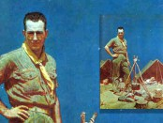
This year marks 60 years since Norman Rockwell created "The Scoutmaster," a tribute to Scoutmasters and adult leaders everywhere.
Accept no substitutes: On June 15, 1916, Woodrow Wilson made the BSA official
June 15, 2016 // 1 Comment

On June 15, 1916, President Woodrow Wilson signed a bill granting federal incorporation to the BSA and protecting the BSA's name and insignia.
Youth Protection and texting with Scouts
June 15, 2016 // 9 Comments

Today's Scouts prefer to text. How does the Youth Protection rule prohibiting one-on-one contact apply to texting with Scouts? We asked the expert.
Extreme Makeovers, Round 16: Eagle Scout project before-and-after photos
June 14, 2016 // 2 Comments
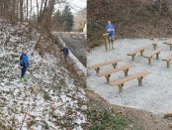
This week's batch of 20 projects includes a concession stand, a blind for viewing wildlife, a shoe drive and 17 more incredible acts of service.
A Boy Scout designed the 50-star American flag
June 14, 2016 // 3 Comments

In 1958, Bob Heft, a high school junior and Boy Scout in Troop 113 of Lancaster, Ohio, designed a 50-star version of the American flag.
Scoutmaster has been developing future leaders in Savannah for 35 years
June 13, 2016 // 3 Comments

For more than three decades, Troop 210 and Scoutmaster Herbert DeLoach Sr. have been developing future leaders in inner-city Savannah, Ga.
Five ways to keep Scouts safe on Snapchat, Facebook and whatever else teens use
June 13, 2016 // 9 Comments

June is Internet Safety Month, so now's the time to get up to speed on online safety with the help of the National Center for Missing & Exploited Children.
Cub Scouts to the rescue in Houston flooding crisis
June 10, 2016 // 2 Comments
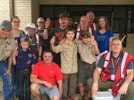
With Houston facing some of the worst flooding in its history, the Scouts of Pack 1292 jumped into action to volunteer at a Red Cross relief site.
The force is strong with this Star Wars-themed blue and gold
June 10, 2016 // 9 Comments

Impressively detailed costumes, a dessert-making contest and "the Scouting Force" made this Star Wars-themed blue and gold an out-of-this-world event.
How to earn the National Den Award
June 9, 2016 // 3 Comments
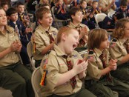
For delivering an outstanding, year-round Cub Scouting experience to your boys, you deserve an award. You deserve the National Den Award.

District serving Manhattan has a rare all-female Key 3
June 9, 2016 // 11 Comments

In a scenario that's rare if not unprecedented, the Big Apple District in the Greater New York Councils now has an all-female Key 3.
Who can sign off on Boy Scout requirements?
June 9, 2016 // 55 Comments

It's a question that every Scout will face: Who can sign off on Boy Scout requirements for merit badges and rank advancement?
How these 2016 National Venturing Leadership Award recipients achieved Greenshirt greatness
June 8, 2016 // 1 Comment
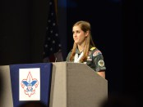
Presented at the council, area, regional and national levels, the Venturing Leadership Award honors Greenshirts who made big contributions to Venturing.
Americans’ three favorite outdoor activities have one thing in common
June 7, 2016 // 0 Comments
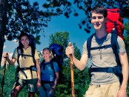
The National Recreation and Park Association asked Americans to select their favorite summer outdoor activities. The top three have one thing in common.
How would you handle a Scout who is consistently late to meetings?
June 7, 2016 // 24 Comments
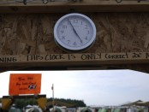
Does your pack, troop, team, post, ship or crew have Scouts who consistently arrive late to meetings? Let's discuss in this latest Tuesday Talkback.
Randall Stephenson, AT&T CEO and BSA president: ‘It’s a new day in Scouting’
June 6, 2016 // 60 Comments

Randall Stephenson, the AT&T CEO who took over as BSA president in May 2016, shares his thoughts on the BSA's bright future.
What are the BSA’s regions and areas?
June 3, 2016 // 22 Comments
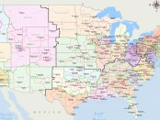
Figuring out the region and area of some Boy Scouts of America councils requires a little bit of guesswork. Or — better yet — a really good map.
Dear Dave, Eagle Scout asks: ‘What does it mean to be American?’
June 2, 2016 // 1 Comment
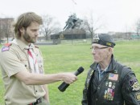
Unsatisfied with the dictionary definition, Eagle Scout "Dear Dave" Jorgenson recently asked: What does it mean to be American?
U.S. Naval Academy’s top graduate is an Eagle Scout, former Venturing officer
June 1, 2016 // 5 Comments

Midshipman Thomas Wester, who was top of his class at the U.S. Naval Academy in 2016, is an Eagle Scout and former Venturing officer.

DEN ADVENTURES


TIGER

Tiger Adventure: Tiger Bites

Identify three good food choices and three foods that would not be good choices.
Show that you know the difference between a fruit and a vegetable. Eat one of each.
With your adult partner, pick a job to help your family at mealtime. Do it every day for one week.
Show you can keep yourself and your personal area clean.
Talk with your adult partner about what foods you can eat with your fingers. Practice your manners when eating them.
With your adult partner, plan and make a good snack choice or other nutritious food to share with your den.
Workbook for use with these requirements: PDF Format DOCX Format

The Fast Food Song

http://scoutermom.com/9838/fast-food-song/
The Fast Food Song is fun for Scouts. It is an action song and would fit in well with a nutrition themed meeting.

The Fast Food Song is fun for Scouts. It is an action song and would fit in well with a nutrition themed meeting. Use the song to introduce the topic of fast food and making healthy choices.
Go through the actions before you sing the song. When you say “Pizza Hut” make a roof over your head with your hands. When you say “Kentucky Fried Chicken”, flap your arms like a chicken. And when you say “McDonalds”, make an M in front of you with your arms.
If you don’t know the tune, here is a very funny You Tube video by The Fast Food Rockers, who wrote the song. This is the whole song. When we do it with scouts, we only sing the refrain.
The Fast Food Song
A Pizza Hut a Pizza Hut
Kentucky Fried Chicken and a Pizza Hut
A Pizza Hut a Pizza Hut
Kentucky Fried Chicken and a Pizza Hut
McDonalds McDonalds
Kentucky Fried Chicken and a Pizza Hut
McDonalds McDonalds
Kentucky Fried Chicken and a Pizza Hut

Build Your Own Food Pyramid
http://scoutermom.com/311/build-your-own-food-pyramid/


Most Scouts are probably familiar with the food pyramid from school. To make the nutrition components of the Scout program more interesting, turn them into a hands-on activity.
Materials
One large piece of poster board – the bigger the better
markers
magazines with pictures of food (or use the cards from the Food Pyramid Go Fish game and pictures of physical activity (walking, running, hiking, exercising , etc.)
scissors
glue
Instructions
Get a large piece of poster board – the bigger the better.
Draw the basic food pyramid on the poster. See the mini poster at mypyramid.gov for an example. It doesn’t need to be elaborate. Just the basic shape will do.
Have the scouts cut pictures of various types of food out of the magazines. Also have them cut out some pictures of people involved in exercise or physical activities.
They should glue the pictures to the appropriate place on the pyramid. Not only should they place the food in the correct stripe, but they should decide if the food goes closer to the bottom (more healthy choices for the food group) or toward the top (less healthy choices).
Place the pictures of the people engaged in activity along the side of the pyramid (where the picture of the person going up the steps is.)
While placing discuss the importance of eating a balanced diet and eating more foods from the bottom of the pyramid than from the top. Also talk about the importance of physical activity.

Cub Scout Nutrition Game – Food Pyramid Go Fish Game
http://scoutermom.com/100/food-pyramid-go-fish-game/
This is basically a go fish game with different types of food. I liked how the kids talked about the different types of food they saw on the cards.
Fitness is an important part of scouting programs. The Tiger, Wolf, Bear and Webelos programs all include some requirement about nutrition. And this continues into Boy Scouts with the requirements for the First Class rank and merit badges. A Cub Scout nutrition game is a way to introduce these concepts to younger Scouts.
About a year ago, I came across this game on the USDA site. Use it with any of the requirements which reference the food pyramid or healthy food choices. I can’t find the link on their site anymore, but I did save a copy of it.
This is basically a go fish game with different types of food. I liked how the kids talked about the different types of food they saw on the cards. There were a couple of scouts who were even talking about if the food on the card should be at the bottom of the pyramid (a more healthy choice for the food group) or at the top (a less healthy choice). Even my den chiefs had some lively discussion about what was shown for the different food groups.
Printable copy of Food Pyramid Go Fish Game (includes instructions)
I wish I could come across the original page on the USDA site with the link to this, because there were some other great materials there also. If anyone finds it, please let me know.

Self Serve Healthy Kid Snacks
http://terrellfamilyfun.com/2013/09/healthy-kid-snacks/

Kid snacks and toddler snacks being handy and at their level is what I’m talking about today. Lennox loves to get her own snack and I always find her digging around the pantry to get something to eat in the morning, after school – all the time it seems. I don’t mind her snacking throughout the day, but she tends to pick out a lot of junk.
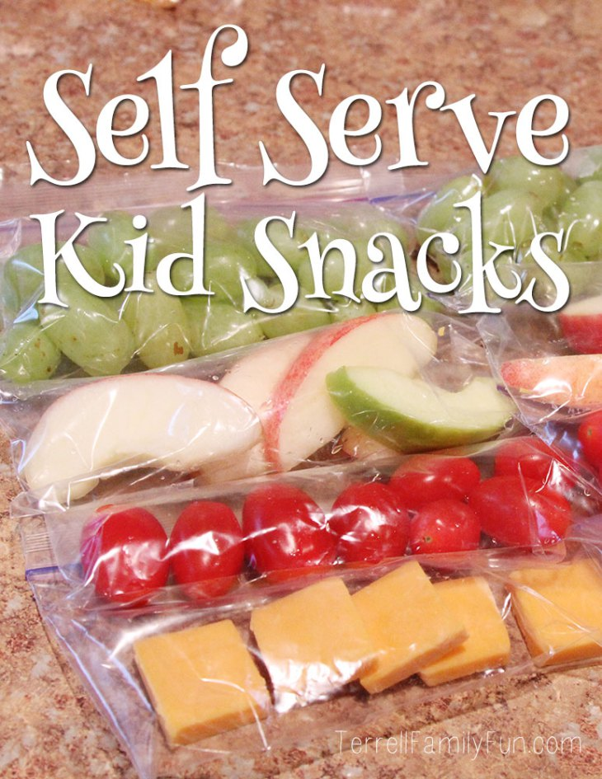So when I went shopping the yesterday, I grabbed our normal fruits and veggies that I usually have in the fridge – but this time I planned on getting them all ready for Lennox before snack time.
I decided to clear out the bottom drawer of our fridge and place all her cold snacks in there. She can open the fridge and get into that drawer on her own. Everything in there will be pretty healthy and individually packaged.
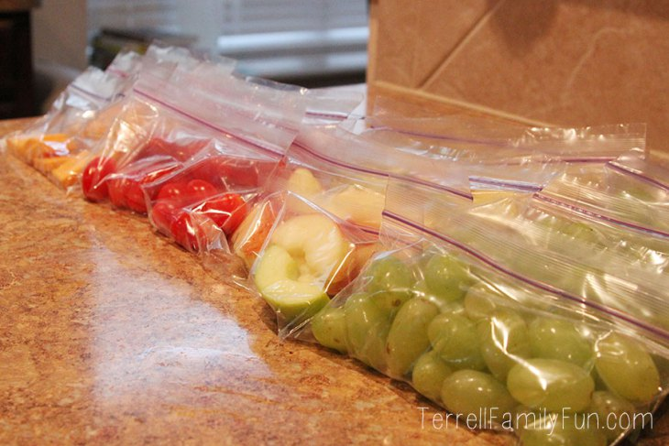I thought about buying all the small packages of everything but really its more economical to just buy it in the regular packages and split it up yourself. I bought Grapes, apple slices, banana cheese, cherry tomatoes (her favorite) and yogurt. Once I got home, I took the snack size ziplock bags (perfect for this, and cheap!) and separated everything out. I got everything into the bottom drawer and showed her.
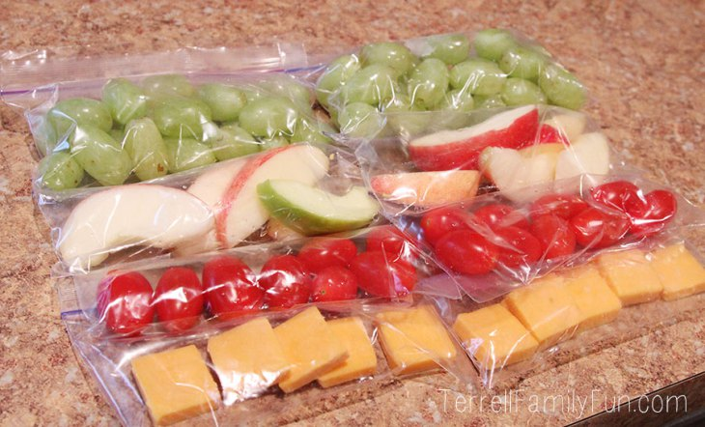This morning, it was a success. She picked out a banana, cheese and grapes to eat in the car on the way to school. No fruit snacks, not cookies, no candy — all which she would find in the pantry!
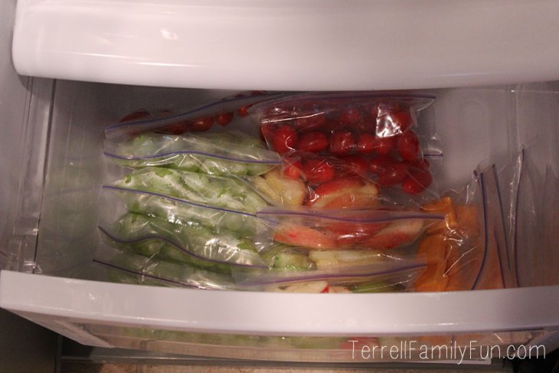My next step will be cleaning out the pantry and making the bottom shelf of the pantry – kid friendly, as well.

Linen Table Manners Napkins
http://kidcrave.com/food/linen-table-manners-napkins/

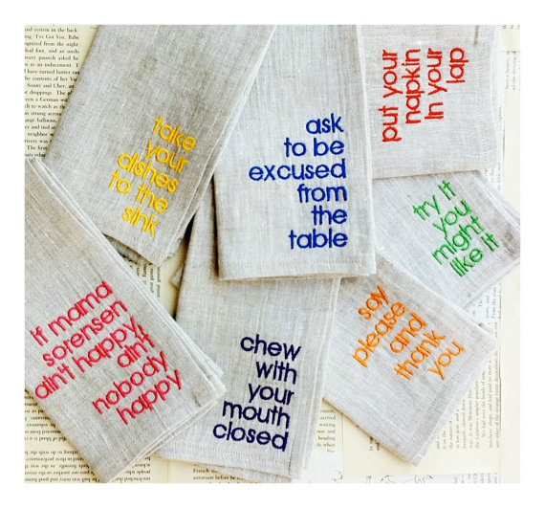
Instead of repeating the same list of do’s and don’t's at the table each night, let a pretty set of napkins do the talking for you. The expertly embroidered Table Manners Dinner Napkins offer up all the instruction they will need. “Chew with your mouth closed!” “Elbows off the table!” and “Use your fork not your fingers!”are covered, among others, in this set of six.

Fruit and Vegetable Relay Games
http://www.foodandfun.org/?p=learn/staff/activities&subject=Fruit+and+Vegetable+Relay+Games&unit=Unit+1:+Fruits+and+Vegetables

Objective
Teams collect and sort as many fruit and vegetable containers as possible.
Preparation and Materials:
Collect, empty, and clean a variety boxes or cans of fruit/vegetables or juice. You could also use pictures/write names of fruits and vegetables to paste on small boxes (like empty milk cartons)
2 large containers (milk crates or paper grocery bags work well) for each team; label one box "fruit" and one box "vegetable"
Instructions
Arrange group in 2 or more teams and have each team line up on opposite sides of a gym/field/large open space.
Place fruit/vegetable containers in the middle of the space, between the teams.
On "Go!" each team member takes turns running to grab a fruit/vegetable container and returning to their team to sort the items. All team members should run in place, stretch, or do jumping jacks when waiting for their turn.
The team with the most items, correctly sorted, wins.
Extension Activities
Search for an item that meets the description called out by the leader. For instance, the leader calls out "orange fruit" and the team members in line run out and find an orange fruit to return to their teams. The next person in line searches for a different item, such as "green vegetable". Other options include: part of plant, how the food is typically served (lunch bag fruit, dried fruit snack, mashed vegetable, etc). For older students who have been introduced to key nutrients, categories may include options like "lots of vitamin C" or "little vitamin C"
As a class, make labels for a few of the fruits and vegetable that are translated into the different languages spoken by the group (Spanish, French, etc). Have children assist with translations. Review the names as a class and then play the game again.
To add variety to the game and encourage family involvement, have children bring in boxes and cans from home.

Top 10 Patient Information Dental Infographics
http://www.dentaltown.com/dentaltown/Blogs.aspx?action=VIEWPOST&b=54&bp=508&v=1
What causes tooth decay? Tooth decay can be stopped if it is caught and treated early.
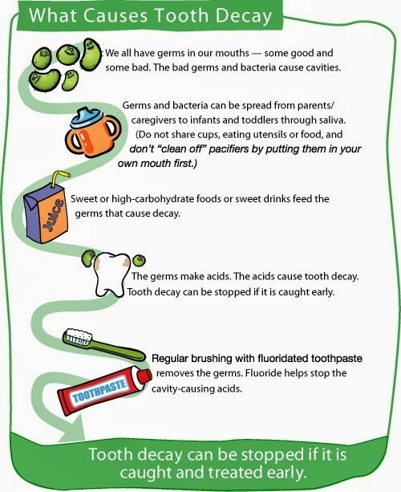

Tiger Elective Adventure: Tiger: Safe and Smart

Tiger Elective Adventure: Tiger: Safe and Smart
1. Do the following:
a. Memorize your address, and say it to your den leader or adult partner.
b. Memorize an emergency contact’s phone number, and say it to your den leader or adult partner.
c. Take the 911 safety quiz.
2. Do the following:
a. Show you can “Stop, Drop, and Roll.”
b. Show you know how to safely roll someone else in a blanket to put out a fire.
3. Make a fire escape map with your adult partner.
4. Explain your fire escape map, and try a practice fire drill at home.
5. Find the smoke detectors in your home. With the help of your adult partner, check the batteries.
6. Visit an emergency responder station, or have an emergency responder visit you.

Workbook for use with these requirements: PDF Format DOCX Format

Learning Your Address and Phone Number
Activity Description
Children will learn their address and phone number to help keep them safe. Memorization strategies include singing, rhyming, and dialing using telephone keypad models for practice.

Why This Is Helpful
To help keep children safe, they should know their address and phone number. If they are lost or in trouble when away from home, they should have their phone number and address memorized so they can tell a safe grown-up how to reach their family. In this activity, children use a variety of motor, literacy, and communication skills as they sing songs, recite rhymes, and practice dialing, in order to memorize their phone numbers and addresses.
This activity was modified from the ReadWriteThink lesson plan “Teaching Language Skills Using the Phone Book."
Get Started
What You Need
Copies of local phone book
An old phone, toy phone, or a telephone keypad or a cellphone keypad on a piece of paper

Here's What To Do
Share a phone book with the children. Look through the pages together and ask children what they see and know about the phone book. What can they find there? How are things organized? What else is included?
Working together, see if you can find your own and the children’s addresses and phone numbers.
Write children’s phone numbers in large numbers on pieces of paper so they can refer to the numbers. Have them read the numbers to you.
Have children practice reading their phone numbers several times a day. You can also make up songs or tunes to sing the phone numbers to.
Get a toy or old phone, or a copy of a telephone keypad or a cellphone keypad on a piece of paper. Using the papers with their phone numbers, have them practice dialing.
After a few times practicing, have children try to remember their phone numbers and dial them without looking at the numbers on their papers.
Once they have practiced several times and are comfortable with dialing, have them call their home numbers from a cell phone or from another phone. If you’re using an old cell phone, you will need to talk about pushing the talk button to complete the call.
To help children learn their addresses, you can use many of the same strategies. Write down their full address for them to read and review. They can also look at the mail to see their addresses.
Make a song or a riddle of children’s addresses to make it easier for them to remember.
Have children look at the numbers on their houses or mailboxes. They can look at street signs as well.

More Ideas To Try
Using poster board, recreate a telephone keypad or a cellphone keypad. Have children use their feet to dial their phone numbers. Ask them to say or sing their phone numbers as they do it.
Let children practice their knowledge by writing their return addresses on envelopes. They could also practice typing them on the computer.
Using a small photo album, make personalized phone books with pictures of the children’s friends and relatives and their phone numbers. Children can also practice dialing these numbers with permission.

911 Safety Quiz
http://www.cityofnewhaven.com/health/pdfs/911%20Safety%20Quiz.pdf

What phone number do you call in an emergency?
A. 411
B. 619
C. 911
Is it a good idea to practice calling 911 on a real telephone?
A. No, never.
B. Yes
Which of these is a good reason to call 911?
A. You see a bad car accident
B. Your friend is being mean to you
C. Your dog is lost
You should call 911 when you need to reach
A. Police
B. Ambulance
C. Fire Department
D. Any of the above
When someone is badly hurt and you don’t know what to do, is it ok to call 911?
A. Yes
B. No

Stop, drop and roll

https://en.wikipedia.org/wiki/Stop,_drop_and_roll
Stop, drop and roll consists of three components.
1.Stop – The fire victim must stop still, ceasing any movement which may fan the flames or hamper those attempting to put the fire out.
2.Drop – The fire victim must drop to the ground, lying down if possible, covering their face with their hands to avoid facial injury.
3.Roll – The fire victim must roll on the ground in an effort to extinguish the fire by depriving it of oxygen. If the victim is on a rug or one is nearby, they can roll the rug around themselves to further extinguish the flame.
The effectiveness of stop, drop and roll may be further enhanced by combining it with other firefighting techniques, including the use of a fire extinguisher, dousing with water, or fire beating one's skin.
Stop, Drop, and Roll!
Tune: Farmer in the Dell
Stop, Drop, and Roll
Stop, Drop, and Roll
If your clothes should catch on fire,
Stop, Drop, and Roll

Stop Drop and Roll
Three Lifesaving Steps If Clothes are Burning
If clothes catch fire they can spread very quickly, engulfing the victim in flames. Certain types of clothing, especially synthetic fabrics, may melt and stick to skin. The best way to reduce injury from the flames is to extinguish the burning fabric as quickly as possible.
To put out burning clothing, take these three steps:
Stop
Don't run or wave your arms. Movement will fan the flames and cause the burns to be more severe.
Drop
Get on the ground quickly and cover your face with your hands.

Roll
Try to smother the flames by rolling over and over. Pay attention to what's burning and focus on putting out that area of your body.
It's helpful to roll up into a rug or thick, nonflammable material (such as tent canvas) to help smother the flames. Don't roll into a thin blanket, sheet or plastic because you may accidentally catch that material on fire also.
Others can help you douse the flames by patting the fire with their hands or other material. Use water or a fire extinguisher to put out the fire if one is available.

As soon as the fire is out, cool the area and treat any burns. Call 911 for any burns that resulted from flaming clothing.



WOLF

Wolf Adventure: Call of the Wild

While a Wolf Scout, attend a pack or family campout. If your chartered organization does not permit Cub Scout camping, you may substitute a family campout or a daylong outdoor activity with your den or pack.
Show how to tie an overhand knot and a square knot.
While on a den or family outing, identify four different types of animals. Explain how you identified them.
With your family or den, make a list of possible weather changes that might happen on your campout according to the time of year you are camping. Tell how you will be prepared for each one.
Show or demonstrate what to do:
When a stranger approaches you, your family, or your belongings.
In case of a natural disaster such as an earthquake or flood.
To keep from spreading your germs.
On the campout, participate with your family or den in a campfire show. Prepare a skit or song, and then present it at the campfire for everyone else.
Do the following:
Recite the Outdoor Code with your leader.
Recite the Leave No Trace Principles for Kids with your leader. Talk about how these principles support the Outdoor Code.
After your campout, list the ways you demonstrated being careful with fire.
Workbook for use with these requirements: PDF Format DOCX Format
http://scoutermom.com/cubscout/wolf-adventure-call-of-the-wild/

Start a Fire with a Lemon
When teaching fire building skills, it can be fun to try some fire starting methods other than matches. This video shows how to start a fire with a lemon, copper brads, zinc nails, wire, and steel wool.



Camping Checklist for Scouts
When preparing for a campout, one of the most common questions from less experienced campers is “What should I bring?” This article from Boy’s Life magazine is a good list of must haves for that campout.


Square Knot Song and Overhand Knot Song
Marianna from Pack 377 in Fort Meade, MD sent in these two songs which she made up to help teach herWolves about square knots and overhand knots.


Wolf Den Outing Plan – Call of the Wild: Campout
Don’t be intimidated by the idea of going camping. If you are a novice, the key is to have some support from somebody who is comfortable “in the wild”.

Wolf Den Meeting Plan – Call of the Wild: Safety
At this Wolf den meeting for the Call of the Wild adventure, Wolves prepare for camping by learning about knots, fire, the Outdoor Code, and Leave No Trace.

Wolf Den Meeting Plan – Call of the Wild: Outdoor Skills
At this Wolf den meeting for the Call of the Wild adventure, Wolves prepare for camping by learning about knots, fire, the Outdoor Code, and Leave No Trace.


Cub Scout Outdoor Ethics Awareness Award
Cub Scouts and their leaders can earn the Outdoor Ethics Awareness award to start learning about being responsible citizens while outdoors.

Wolf Adventure Requirements: Call of the Wild
Call of the Wild is one of the Wolf CORE Adventure Requirements. Wolves go camping, learn some Scout skills, think about being prepared for outdoor adventure, and learn about Leave No Trace.


Fire Safety with Cub Scouts
I like to review some fire safety rules with my Webelos before the fire is built. That way they all know the expectations.


The Twelve Days of Camping Song
Heres another silly song for you. This works well at Christmas (because of the tune) or at camp (because of the theme).


The Outdoor Code
Every Scout who is spending time outdoors should be familiar with the Outdoor Code. It is especially important for Webelos, Boy Scouts, and Venturers who are out camping regularly.


Leave No Trace Frontcountry Guidelines
Leave No Trace is an outdoor ethics program which encourages responsible use of outdoor resources. The frontcountry guidelines are the guidelines for day-use areas like parks and trails.


Camping Packing List
One thing new scouts (and new leaders) often ask the first few times they go camping is “What do I need to bring?” Download a suggested list of personal camping gear.
https://cubscouts.org/library/call-of-the-wild/
RATIONALE FOR ADVENTURE
Many boys join Scouting because they want to go camping. This adventure will introduce Wolves to several camping skills—selecting and bringing gear, participating with their families in campfire shows, and being prepared for bad weather. They will also learn about animals they might see, the Leave No Trace Principles for Kids, tying knots, and how to handle potentially harmful situations.
TAKEAWAYS FOR CUB SCOUTS
Outdoor essentials
Identifying animals
Tying square and overhand knots
Taking care of themselves in the wilderness
A Scout is obedient, courteous. [Wolf Character Compass]
ADVENTURE REQUIREMENTS (Wolf Handbook, page 30)
While a Wolf Scout, attend a pack or family campout. If your chartered organization does not permit Cub Scout camping, you may substitute a family campout or a daylong outdoor activity with your den or pack.
Show how to tie an overhand knot and a square knot.
While on a den or family outing, identify four different types of animals. Explain how you identified them.
With your family or den, make a list of possible weather changes that might happen on your campout according to the time of year you are camping. Tell how you will be prepared for each one.
Show or demonstrate what to do:
a. When a stranger approaches you, your family, or your belongings.
b. In case of a natural disaster such as an earthquake or flood.
c. To keep from spreading your germs.
On the campout, participate with your family or den in a campfire show. Prepare a skit or song, and then present it at the campfire for everyone else.
Do the following:
a. Recite the Outdoor Code with your leader.
b. Recite the Leave No Trace Principles for Kids with your leader. Talk about how these principles support the Outdoor Code.
c. After your campout, list the ways you demonstrated being careful with fire.
NOTES TO DEN LEADER
For Meeting 3, Wolf Scouts may participate in a pack campout (requirement 1) or an alternative activity as permitted by their chartered organization. Confirm the campout plan with families, including transportation, all the necessary clothing, and any additional items they need to bring. Make sure a tour and activity plan has been submitted, if required, and activity consent forms are distributed, signed, and collected.
If Scouts will instead be going on family campouts, identify locations that will help them complete the requirements for this adventure.
See the Appendix for optional den meeting activities, including gatherings, openings, and closings.
PREPARATION AND MATERIALS NEEDED
U.S. and den flags
Plans for the upcoming pack campout—location, fees, gear list, food arrangements, etc.
Assorted flying discs and targets for the Gathering activity (see Meeting 1 Resources)
Information about how to identify animals, including photos or illustrations (Activity 1)
Slips of paper for the “Camping Charades” game (Activity 2)
Sample gear items for the campout, including the Cub Scout Six Essentials (Activity 3)
GATHERING
As Scouts arrive, have them practice throwing discs at targets. (See Meeting 1 Resources.)
Have each Scout write his favorite camping activity on a slip of paper, and put all of the papers in a hat, bowl, or other container.
OPENING
Conduct a flag ceremony of your choosing that includes the Pledge of Allegiance and, as appropriate, the Scout Oath and Scout Law.
Recite the Outdoor Code (requirement 7a; see the Wolf Handbook).
Recite the Leave No Trace Principles for Kids (requirement 7b; see the Wolf Handbook).
TALK TIME
Introduce the Call of the Wild adventure to the den. Build interest by describing the goals of the adventure and some of the activities that are planned.
Carry out business items for the den.
Allow time for sharing among Cub Scouts.
Share plans for the pack campout (see above). If some Scouts will be camping out with their families, discuss possible locations with the boys and their parents, and review everything they will need to bring.
ACTIVITIES
Activity 1: Animal Identification (Requirement 3)
Using photos or illustrations, teach the Scouts how to identify four types of wild animals they may be able to see near their homes or on the campout. If possible, include examples of mammals, birds, insects, reptiles, and amphibians. (See Meeting 1 Resources.)
Have them go to requirement 3 in their Wolf Handbooks and write the name of each animal and how to identify it.
Show the boys some additional pictures that look similar, but are clearly not the types of animals that they will see on the campout. Have them pick out the differences.

Activity 2: Camping Charades Game
Have each Scout pick one of the slips of paper they filled out during the Gathering and pretend to be doing that activity while the other boys try to guess what it is. Tell them not to use words or props— only actions—and give them time to plan the charade with help from adult leaders.
Ideas from this game can be worked into the campfire skit or song the Scouts will perform later with the den or their families (requirement 6). Suggest ways they might do this.

Activity 3: Camping Gear
Discuss with the Scouts what gear they should bring on the campout for their own personal care and comfort, based on where and when they are camping. Don’t forget the Cub Scout Six Essentials! (See Meeting 1 Resources.) You should also cover items like tents, sleeping bags, ground cloths, pillows, sleeping pads or mattresses, warm clothes, raincoats, eating utensils, hats or caps, toothpaste, toothbrushes, etc.
CLOSING
The Grand Howl. To recognize their achievements during this meeting, form a circle and have each boy squat, make the Cub Scout sign with both hands, then lean forward and touch the ground between his feet. Then, like young wolves, all the Scouts raise their heads and give a long howl. When this is done, they all jump to their feet, raise their right hands high above their heads, and give the Cub Scout sign again, shouting, “Akela! We’ll—do—our—best!”
AFTER THE MEETING
Serve refreshments, if desired.
Record completion of requirements 3, 7a and 7b.
Work together to clean up the meeting place.
Prepare thank-you notes for the Scouts to sign at the next meeting.

DISC GAMES (GATHERING)
Frisbee–style flying discs can be used for a variety of activities. The basic skill is easy, and the Gathering is a good time for Wolves to refine that skill without the need for much equipment or preparation. Try either of these two games, depending on the time you have available.
Target shooting. Lay out a field of “targets,” making sure to include a mix of shapes and sizes at various distances from the throwing line. Have Scouts try to hit the items by throwing the discs. As their skills increase, add a few challenges by removing the larger targets, moving some of them farther away, or providing ringshaped objects to shoot through (e.g., tires, hula-hoops).
Disc golf. Set up a course over a large field or backyard with markers for “holes.” The players must strike the markers to complete a hole, counting shots along the way. The course may include some obstacles to play around. The player with the lowest shot score wins. As a variation, let teams of two boys alternate taking shots to complete a hole.
ACTIVITIES

Activity 1: Animal Identification
These tracks may be included as an illustration during the activity.
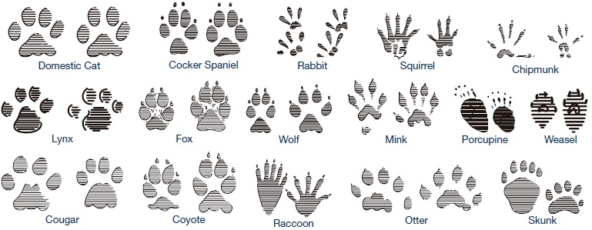

Activity 3: Camping Gear
Cub Scout Six Essentials.
Review these items that each Cub Scout should carry in his personal gear when going on hikes or campouts. Suggest getting a small fanny pack or similar bag to organize the items and make them easy to carry without interfering with normal activities. Emphasize that these items are not intended for play and should be used only when needed.
First-aid kit—adhesive bandages, moleskin, gauze, antibiotic ointment, etc.
Water bottle—filled and large enough to last until it can be filled again
Flashlight—for emergency use only
Trail food—can be made as a den activity prior to hike or campout
Sun protection—sunscreen of SPF 30 or greater and a hat
Whistle—also for emergency use only
RETURN TO TOP
PREPARATION AND MATERIALS NEEDED
U.S. and den flags
Several non-transparent bags, each with a camping item inside for the shape guessing game (Gathering)
Small bottle of soap and a basin or pot filled with water for hand cleaning (Gathering)
Whiteboard and a marker for Talk Time
Examples of gear and clothing needed in case of bad weather (Talk Time)
Ropes for knot tying and the knot relay game—6" length for each Scout (Activity 1)
If needed, invite some Boy Scouts or adult volunteers to help as the Wolves learn to tie knots. Have examples on hand of finished overhand and square knots, so they can compare their work.
GATHERING
Shape guessing. Let each Scout reach into one of the bags prepared for the game and try to guess the camping item inside. Then reveal the contents of each bag.
Hand cleaning. Have each boy demonstrate how he would wash his hands on a campout, using the water basin and liquid soap (requirement 5c).
OPENING
Conduct a flag ceremony of your choosing that includes the Pledge of Allegiance and, as appropriate, the Scout Oath and Scout Law.
TALK TIME
Carry out business items for the den.
Allow time for sharing among Cub Scouts.
Discuss plans for the upcoming pack campout or campouts with families.
Reveal the items that were hidden in bags for the shape guessing game. Discuss hygiene items and gear needed for campouts, making sure to review again the Cub Scout Six Essentials (see Meeting 1 Resources).
Discuss the Leave No Trace principles and how they support the Outdoor Code (requirements 7a and 7b; see the Appendix). Emphasize that Wolves are focusing especially on the Outdoor Code’s call to “Be careful with fire.” Talk about ways the boys will demonstrate this principle during the campout.
ACTIVITIES

Activity 1: Safety Check (Requirements 4 and 5)
Discuss what the boys should do if a stranger approaches them or their family members, and call their attention to the tips in the Wolf Handbook (requirement 5a). Another good resource can be found on the National Crime Prevention Council website: www.ncpc.org/topics/violent-crime-and-personal-safety/strangers/. Use the whiteboard and marker to help as you lead the discussion.
Show the bad weather gear and clothing you collected, and describe how each item might be useful if the weather changes drastically while you are camping.
Talk about what to do in case a natural disaster occurs during a campout, including each type of disaster listed in the handbook (requirement 5b). Have Wolf Scouts write in their handbooks one thing they can do if any one of those disasters strikes. Don’t let the talk get bogged down in hypothetical scenarios—keep it realistic, so the boys can quickly solve the situations. Is your area prone to flooding, earthquakes, wildfires, windstorms, blizzards, or monsoons? Refer to www.ready.gov or other online resources dealing with disaster preparation and recovery.
Activity 2: Knot Tying/Knot Relay Game (Requirement 2)
Show the boys how to tie these two knots, based on the instructions in the Wolf Handbook. Give each boy time to practice and demonstrate what he he has learned. Then, if time permits, play the Knot Relay Game.
Overhand knot. This type is used to prevent a rope from going completely through a pulley or a hole. It can also be a starter for tying shoes or be used to keep the end of a rope from unraveling.

Square knot. Also called a reef knot, this can be used to tie two ropes together or to tie packages, rig sails, or tie the ends of a bandage.

Knot Relay Game. Divide Scouts into two teams, each standing in single- file lines. Lay two ropes on the floor about 20 feet from the start line. The first Scout in each team runs to the rope, ties an overhand knot, shows it to a judge, unties it, and runs back to tag the next boy in his team. Once this relay is finished, you can repeat it using square knots.

Activity 3: Campfire Show Planning
Have Wolf Scouts work together to brainstorm some ideas for a campfire show to perform at the upcoming den outing. Ideas can include simple songs, skits, or other creative acts. Help ensure that each Scout is included and has a role in the show. Scouts will practice for the show as a Do-at-Home Project.
CLOSING
Gather the den in a Friendship Circle. Using their ropes from Activity 2, have each Scout tie his rope to his neighbor’s with a square knot until a rope circle is formed. Standing around the circle, the Scouts hold the rope with their left hands while making the Cub Scout sign with their right. The den leader then recites this quote from Lord Baden-Powell: Every Scout ought to be able to tie a knot. To tie a knot seems a simple thing, and yet there are right and wrong ways of doing it, and Scouts ought to know the right way. Very often it happens that lives depend on a knot being properly tied.
Review details for the upcoming campout or outing in Meeting 3. Make sure all Scouts and their families know the plans.
Do-at-Home Project Reminder:
Wolves should practice a skit or song for the campfire show with their family or the whole den (requirement 6).
AFTER THE MEETING
Serve refreshments, if desired.
Record completion of requirements 2, 4, and 5.
Work together to clean up the meeting place.
Have Scouts sign thank-you notes to give to anyone who helps the den during the pack campout.
RETURN TO TOP
PREPARATION AND MATERIALS NEEDED
Camping gear, including Cub Scout Six Essentials and all items needed from checklist in Wolf Handbook
Food for cooking meals
A skit or song for participating in the campfire show with any props or costumes needed for the presentation
Confirm that a tour and activity plan has been submitted, if required, and that transportation to and from the event is in place. Secure activity consent forms.
Unit den leader should have in possession (if required by local council practices) the tour and activity plan and a copy of the Guide to Safe Scouting.
GATHERING
Remind the Scouts of the slogan, “Take only memories, leave only footprints,” and the adage that Scouts always leave a campsite better than they found it. Wolf Scouts focus on the Outdoor Code principle of “Be careful with fire.” Discuss ways that they can demonstrate this principle when they are at a campsite, using the Wolf Handbook’s guidelines for requirements 7a, b, and c as a resource. Point out to them the things that previous campers may have left behind and remind them that if we leave it here also, other campers will think it was ours. So let’s clean up!
OPENING
Say the Pledge of Allegiance and, as appropriate, the Scout Oath and Scout Law. If the den does not have a United States flag, ask one Scout to display the flag on his uniform for the group.
Go over the activities planned for the outing.
Share the time that the dinner preparation will begin.
Share the time the campfire will begin.
TALK TIME
Carry out business items for the den.
Allow time for sharing among Cub Scouts.
ACTIVITIES
Activity 1: Animal Identification (Requirement 3)
Make sure each Scout identifies four different types of animals during the campout and explains how he identified them. Animals can include birds, insects, and other animals.

Activity 2: Human Chain Race
Have Wolf Scouts line up single file and in two teams. (Have an adult join one of the teams if you have an odd number of boys.) Each player then reaches down between his legs with his right hand and grabs the left hand of the Scout behind him to make one long chain. On the “Go” signal, both teams race forward around an established turning point and back to the finish line. If one of the chains breaks, the team must stop and re-form before continuing.

Activity 3: Perform Skit or Song (Requirement 6)
Have the Scouts perform their skits or songs at the campfire show. Check to make sure any needed props or costumes are ready to go.
CLOSING
The closing for this meeting may be part of the ending of the campfire, or possibly the morning after camping out. It should be inspirational and ideally reference the outdoors.
Have each Scout list in his copy of the Wolf Handbook how he demonstrated the principle of “Be careful with fire” during the campout (requirement 7c).
AFTER THE MEETING
Record completion of requirements 1, 3, 6, and 7c.
Work together to clean up the campsite.
Send thank-you notes to those who helped.
Upon completion of the Call of the Wild adventure, your Wolves will have earned the adventure loop shown here. Make sure they are recognized for their completion by presenting the adventure loops, to be worn on their belts, as soon as possible according to your pack’s tradition.
http://www.boyscouttrail.com/cub-scouts/wolf-call-wild-adventure.php

Ideas for Adventure Requirements:
Ensure everyone is aware and ready to camp by using Campout Checklist to prepare.
Practice your knots so you can help the scouts learn. Overhand Knot (half hitch) Square Knot
A scout doesn't need to actually see an animal. Animals can be identified by sight, sound, tufts of fur, scat, or tracks. I guess a few, such as skunk, could be identified by smell also.
There are many ways to prepare for adverse weather. Rather than a heavy, hot raincoat, an umbrella or light poncho might be a better choice for warm, humid, rainstorms.
A hotter than expected day can be dangerous, too. Having a wide-brimmed hat, umbrella, or shade tarp available could make a big difference.
Read these pages about child safety which is no longer just 'stranger danger' - kidsmartz.org, NCPC.org, free-for-kids.com
Communicate with other den leaders to ensure a variety of entertainment since they will all have similar requirements.
The Outdoor Code is easier to remember if you start with memorizing the Four Cs - Clean, Careful, Considerate, and Conservation-minded.
Den Meeting Ideas for Call of the Wild Adventure:
Use Licorice Knots activity to combine learning and snack.
Play UnRavel game.
The LNT Principles for Kids are listed in the back of the Wolf Handbook. Read details of the principles and implementing them atLNT.org and Outdoor Ethics.
Sing some of the verses of I Met a Bear song.
Perform Panther Tracks skit for the Pack.
Tell Leave a Trace minute to the den.
Conduct a short version of Hole In My Pack activity
Learn more about LNT from Leave No Trace Dude.
Remember to use this Wolf Call of the Wild adventure as a step towards each scout's Outdoor Ethics award.
http://mylitter.com/recipes/taco-salad-in-a-bag-perfect-for-camping-and-kids/

Taco Salad In A Bag! – Perfect for camping and kids!
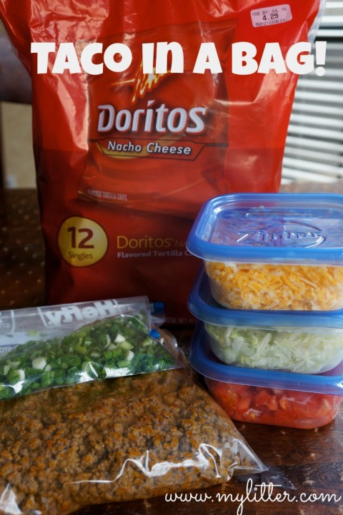This has long been a fun snack/dinner for my kids camping and after school. You can see my Taco Salad recipe HERE for a bigger dish with catalina dressing. Making this for groups, camping or teens is an awesome way to feed a crowd easily.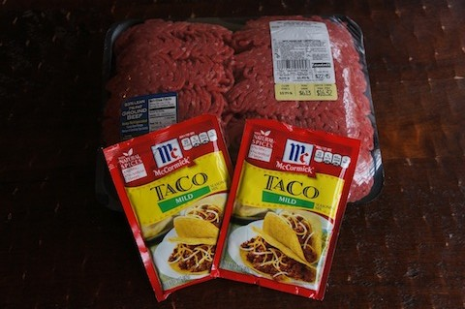First brown some ground beef with taco seasoning. I often have this on hand frozen in my freezer anyway. Next cut up or pull out your toppings, which can include the following:
Onions
Cheese
Sour Cream
Salsa
Lettuce
Tomatos
Whatever you like, and if you are camping can travel easily. My kids like to eat theirs with Doritos, but you can also use Fritos.
Take the bag and break up the chips a bit. Open the bag. Add toppings and meat. Enjoy!

Wolf Elective Adventure: Collections and Hobbies

Begin a collection of at least 10 items that all have something in common. Label the items and title your collection.
Share your collection at a den meeting.
Visit a show or museum that displays different collections or models.
Create an autograph book and get at least 10 autographs. Start with members of your den.
Pick a famous living person, and write him or her a letter. In your letter, ask the person to send you an autographed photo.
Play a game with your den that involves collecting.
Workbook for use with these requirements: PDF Format DOCX Format

Re-Purposed Cereal Boxes
http://simplehomestuff.blogspot.ca/2011/04/re-purposed-cereal-boxes.html?showComment=1303508672044#c2046572190458202849

I don't know about you but my family goes through cereal boxes like crazy! We eat cereal for late night snacks several times a week! So I usually fold the boxes down and keep them for homeschool projects. Here is one way we reuse them.


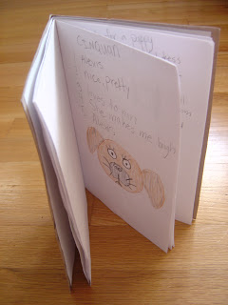



It's Addy's poetry book. I used the fold that was already there to make it easier. I folded a piece of paper in half and lined it up with the crease in the box. Then traced the paper to make my cover outline. I cut out the cover and folded the book and the papers together. Using a thick needle and some thick thread I sewed the book together in the crease. You can also punch holes and use yarn or ribbon.
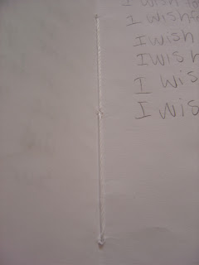
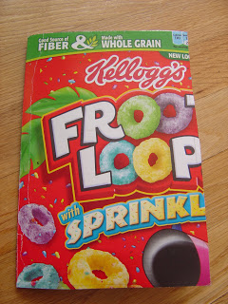
There are countless tutorials online that range from really easy to really difficult.

Penny Collection
http://creativecubscouts.blogspot.com/search/label/Wolf%20Achievement%206

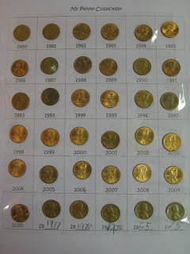
Penny Collection
I have a difficult time planning activities some times. Out of my four boys, three of them have already earned their Wolf rank. Each den meeting I try to work on achievements for the one boy and electives so the three can at least keep getting recognition.

Today we had a highly successful activity. Since the three boys had already done a rock collection, I didn't want to do that. I received an idea from round table about a penny collection.

I created a table, six by six and made "My Penny Collection." I started in the upper left corner and wrote the years in each square. I started with the year 1980 and went through 2010. There were a few blank squares left, so I typed 19___ and let them put pennies they found from earlier years.

At den meeting each boy received a roll of coins to sort through and glue on the appropriate square. They loved it! When my son got home he had to finish searching through our pennies to find the few squares that were left blank after den meeting. Because the pennies kept popping off, I stretched packing tape over them and then put the collection in a sheet protector.

10 Most Expensive Collectible Stamps
http://10awesome.com/10-most-expensive-collectible-stamps/

Let’s take a quick journey in the world of collectible stamps. One of the hobbies we pick up as children and remain truthful to throughout our adult life is stamp collecting. If as youngsters the reasons which push us to arrange such collections can be considered rather naive, such as the importance of the subjects depicted (with a stronger interest for those representing ships, locomotives, planes, animals), as we get older, we tend to be more attentive to those intricate little details such as historical value, geographical aspects, number of prints, etc. All kind of stamps take their place in one’s collection, and whether you’re an an avid collector or not, I’m sure you’ll find interesting getting to know some of the most expensive collectible stamps in the world and the story behind them.
1. Treskilling yellow
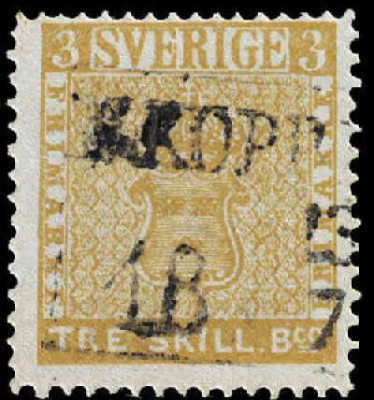
First on our list is a swedish stamp issued in 1855 and most ironically the world’s most expensive is actually a printing error as it should have been printed in green which was indicating its three skilling value instead of yellow which was meant for eight skilling stamps. Because of its rarity this stamp sold in 1996 for no less than 2.5 million swiss francs. Makes you think going in the stamp collection business, isn’t it?
2. Mauritius “Post Office” Stamp
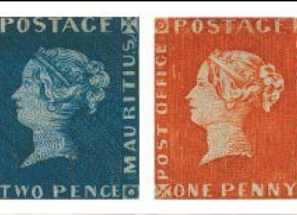
Printed back in 1847 in Mauritius, a British colony at that time, this stamp’s appearance is also marked by an error for instead of “Post paid” as it should have been marked on it, the words “Post office” were engraved. Since there are around 30 stamps remaining, their value is high enough: one of them was sold back in 1993 for around 1,1 million USD.
3. British Guiana
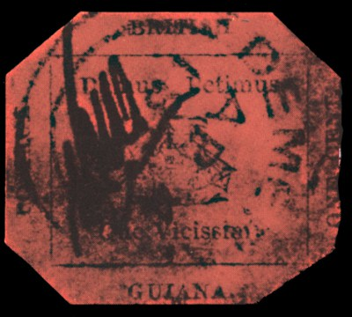
This 1856 one cent black on red stamp was once considered to be the world’s most expensive. Printed in rush because of urgent need, the chosen paper was of poor quality. The stamp depicts a ship and also the latin motto of the colony which says “ we give and we seek in return”. Each of the issued stamps had their corners clipped as well as signed by the post office employees in order to prevent replicas. In 1980 the stamp sold for around 900.000 USD.
4. Hawaii Missionary Stamps
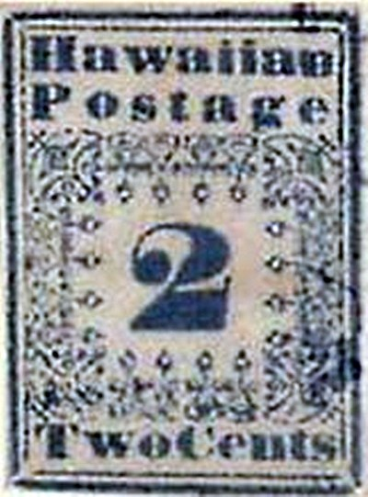
Printed in 1851, its name comes from the fact that missionaries stationed in Hawaii at that time used by them to maintain correspondence with the mainland. There are few of these collectible stamps left now and the reason is the poor quality paper they were printed on. From the whole set the most valued one is actually the 2 cent one which is worth around a quarter million USD.
5. Benjamin Franklin Z-Grill, 1867
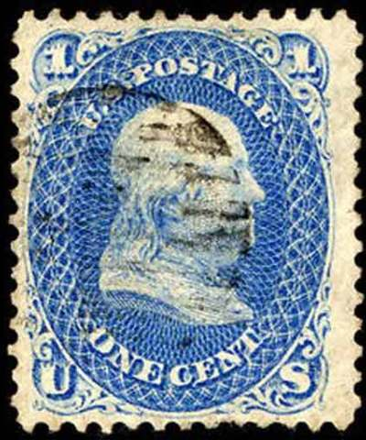
With only 2 stamps existing now, this one is the rarest in the US. It depicts president Benjamin Franklin and in case you’re wondering what z-grill stands for, it actually refers to the tiny indentations on the paper as a method of preventing forgeries. In 1988 one of these two collectible stamps was sold for 930.000 USD.
6. The red lady in the green dress
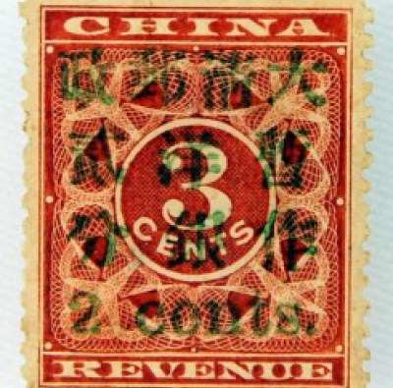
Printed in 1897 and part of a trial printing, there are only 9 examples of what is recognized as the most expensive Chinese stamp. The stamp is valued at nearly 1.3 million USD.
7. The inverted Jenny

Inverted stamps due to erroneous printing are considered rare and thus highly valued. Such an example is this stamp printed in 1918 in the US. It shows a Curtiss Jenny biplane used to shuttle mail and from the initial print there are only about 100 examples which still survive and one stamp was sold in 2007 for 977.500 USD.
8. Double Geneva
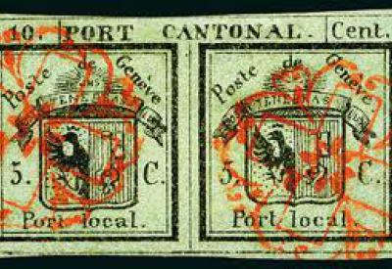
Counted as extremely rare this is the third oldest European stamp and it was printed in 1843. Despite a number of 60.000 doubles printed, only 600 survived the test of time. Printed in black on green paper, at the top it indicates 10 centimes cantonal postage, which was the rate for sending letters to another city and each half had 5 cents inscripted on them, which was the rate for local postage. The estimated value is around 70.000 USD.
9. Baden 9 Kreuzer
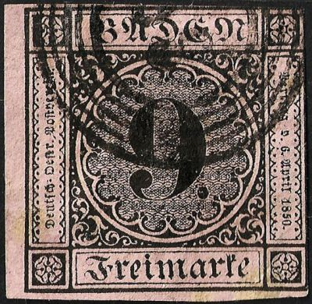
This is Baden’s first postage stamp and was printed in 1851. Sprung out of an error since green paper was intended for the 6 Kreuzer value, there are only 4 examples of this stamp known at the moment which makes it among the rarest collectible stamps in the world. One of them was sold for 1, 3 million euro in 2008.
10. Perot Provisional
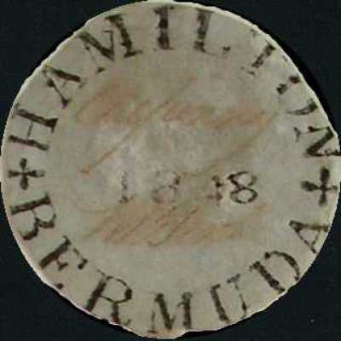
This is the first postage stamp printed in Bermuda in 1848 and along Hamilton which marks the capital city the stamp also bears the signature of William Perot the country’s postmaster, hence the name of this stamp. There are 11 examples of this stamp known today, mostly owned by european royal families and the value of the stamp is around 100.000 USD.

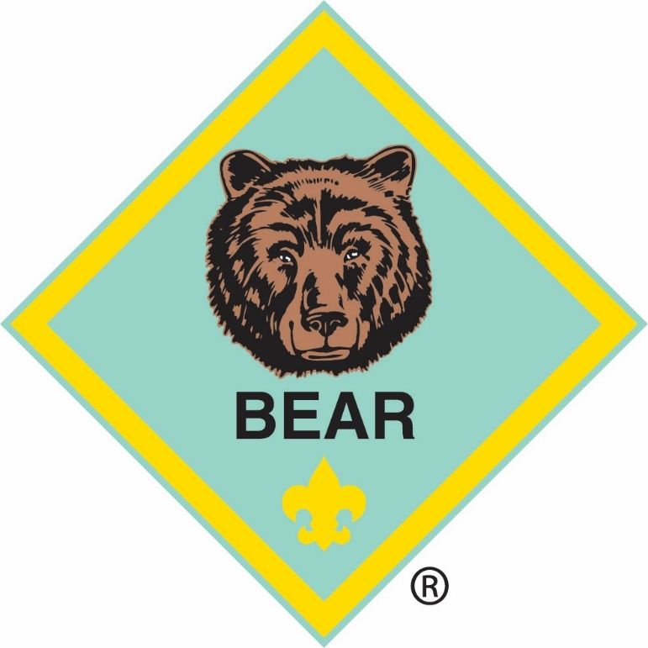

BEAR

Bear Adventure: Paws for Action
Do the following:
Find out about two famous Americans. Share what you learned.
Find out where places of historical interest are located in or near your community, town, or city. Go and visit one of them with your family or den.
Learn about our flag. Display it at home for one month. Say the Pledge of Allegiance and learn its meaning.
Do the following:
Visit a local sheriff's office or police station, or talk with a law enforcement officer visiting your den. During the visit, take turns with your den members asking questions that will help you learn how to stay safe.
During or after your visit with a law enforcement officer, do at least two of the following:
Practice one way police gather evidence by taking fingerprints, taking a shoe print, or taking tire track casts.
Make a list of emergency numbers to post in your home, and keep a copy with you in your backpack or wallet.
With your family, develop a plan to follow in case of an emergency, and practice the plan at least three times. Your family can determine the emergency, or you can develop several plans.
Discuss with your parent or another adult you trust any worries you have about your safety or a friend's safety.
If you have younger brothers and sisters, make sure they know how to call for help in an emergency.
Do the following:
Learn about the energy your family uses and how you can help your family decrease its energy use.
Do a cleanup project that benefits your community.
Workbook for use with these requirements: PDF Format DOCX Format

http://scoutermom.com/cubscout/bear-adventure-paws-for-action/



Infographic: How to Retire the American Flag
This infographic , which will help you explain how to retire a flag, was created by A Stars & Strips Flag corporation .
Continue Reading


Bear Adventure Requirements: Paws for Action
For the Paws for Action adventure, Bears learn about history, law enforcement, and conservation.
Continue Reading


Simple Indoor Opening Flag Ceremony
Many of our kids have not been exposed to flag etiquette before their first flag ceremony, so take the time to give them some basic instruction. This is a very simple flag ceremony for Cub Scouts to use at Den and Pack meetings.
Continue Reading

Displaying the US Flag with Other Flags
The US Flag is the symbol of our country. Scouts should know how to fold it, fly it, and handle it. Flag etiquette is part of many of the Scout requirements. In many cases, the rules are pretty straightforward. But in other cases, you just need to know the rules. For example, it gets more […]
Continue Reading


Making a Plaster Print Mold
Plaster of Paris is messy, which means Scouts will enjoy it. You can use this versatile medium to make plaster molds and casts. This technique can be used to make shoe prints or tire track casts or fossil casts.
Continue Reading

How to Fold the US Flag
The US flag is the symbol of our country and every Scout should know how to handle it. One thing I emphasize when working with Scouts on flag etiquette is that the most important thing is respect. Scouts are going to make mistakes from time to time, but they should always do their best to […]
Continue Reading

A Simple Flag Retirement Ceremony
When retiring a United Stated flag, some people will say that you must do it this way or that way, but according to the Flag Code, it just needs to be done with dignity.
Continue Reading


Emergency Phone Number List
Emergency preparedness is part of every level of Scouting program. For younger Scouts, that primarily means knowing how to get help.
Continue Reading

Raising and Lowering the US Flag
With Memorial Day approaching, it might be time to review how to raise and lower the United States flag. These are some basic rules for raising and lowering the US flag.

Emergency preparedness candle kits
Quite a while ago our ward did Emergency preparedness candle kits but I of course didn’t do them that night I was a big procrastinator and just barely got mine done.
For these kits you need a wide mouthed canning jar (with lid and ring) 4 candles (like the one in the pictures) you can find these at Wilderness survival gear online for .99 cents each but they go down in price if you buy them in bulk. They are 5″ x 1.5″ candles will burn for 8 to 10 hours. I made 5 jars – one for each level of my home then extra’s just in case.
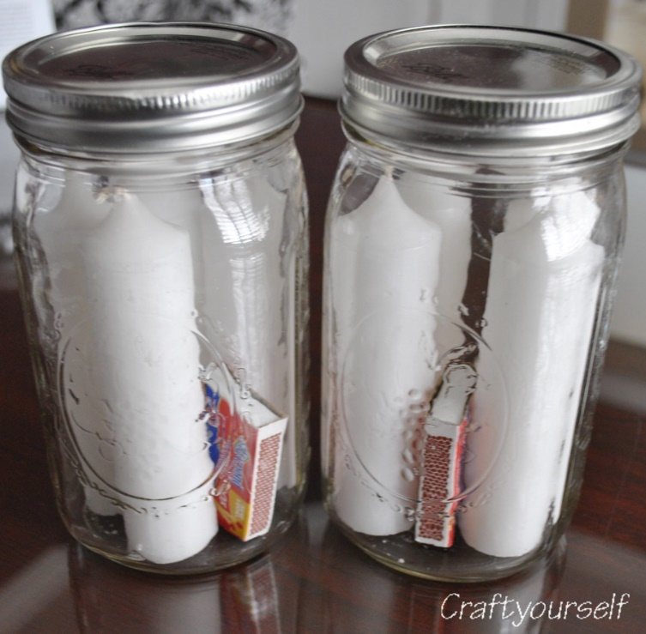
Next you will take a 1.5″ round PVC pipe and cut the sections 1″ tall. (you can use a saw for this and it goes really fast) Take non flammable glue and glue the PVC section onto the bottom of the lid.
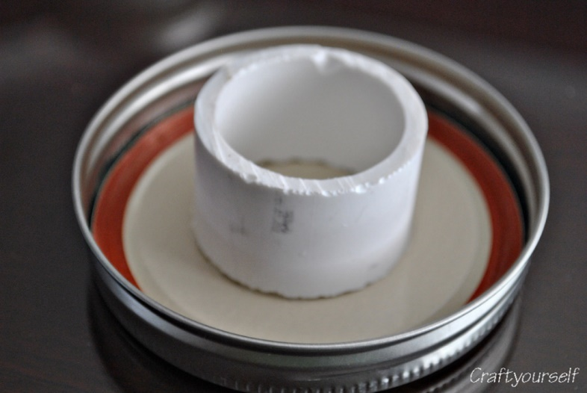
When done drying you can add your small box of matches and close the top. (like in the first picture) If the lights go out and you have no power this is how you can set up the candle (see picture below)
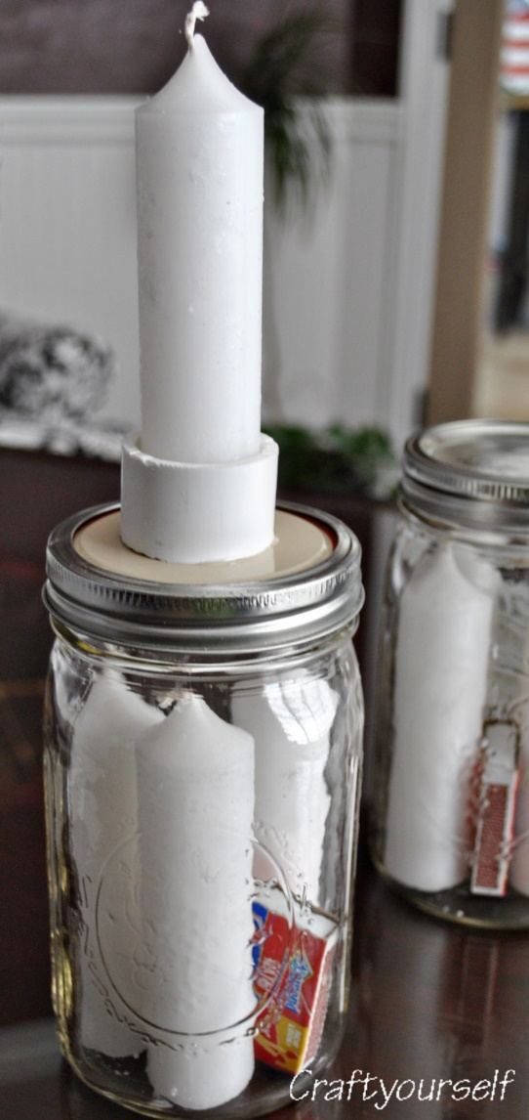
Keep them in a convenient place so when the lights go out you know just where to find them!

Bear Elective Adventure: Beat of the Drum

Learn about the history and culture of American Indians who lived in your area at the time of European colonization.
Write a legend.
Make a dream catcher.
Make a craft.
Make a drum. Once your drum is complete, create a ceremonial song.
Visit an Order of the Arrow dance ceremony or American Indian event within your community.
Learn about ceremonial dances and learn dance steps.
Create a dance.
Workbook for use with these requirements: PDF Format DOCX Format

http://scoutermom.com/cubscout/bear-elective-adventure-beat-of-the-drum/



Tabletop Tipi Model
Scouts who are doing a Native American themed meeting or activity can create a simple tipi model to get the idea of how these versatile dwellings are constructed. We made these at a Cub Scout training session and they were very easy.
Continue Reading


Native American Prayer
Native American lore is an important part of the Boy Scout and Cub Scout programs. This prayer is attributed to Chief Sealth (for whom Seattle is named).
Continue Reading


Hubbub – A Native American Dice Game
This is a traditional Native American game. The scoring systems seem to vary from one reference to another, so the system below is a simplified system which scouts should be able to follow.
Continue Reading


What Is the Order of the Arrow?
Some of you may have Boy Scouts in your families who are in the process of becoming members of the Order of the Arrow. Just when you thought you were getting a grasp on Boy Scouts, they threw something new at you!
Continue Reading

Why Opossum Has a Bare Tail
This is a Native American story which scouts of all ages can enjoy. It is also a cautionary tale for young men who like to build huge campfires.
Continue Reading


Pahsahëman – A Native American Field Game
Pahsahëman is similar to football. It has been played by the Lenape of the American Northeast for many generations. These instructions include tips for adapting this game for use with scouts.
Continue Reading


Picaria – A Native American Game
Picaria is a Native American board game. It is like a cross between tic-tac-toe and checkers. It could be used with Tiger, Wolf, or Bear electives or with a group working on the Indian Lore merit badge.

Mini Tin Can Drums Earth Day Craft
http://www.makeandtakes.com/earth-day-craft-challenge

I love a good challenge, especially a craft challenge! I love to see all the entries and what people are creating. So, happily I’ve joined forces with Steph of Modern Parents Messy Kids (MPMK) to bring you a craft challenge celebrating Earth Day! We’ve partnered up with DecoArt to sponsor our challenge and offer a giveaway of fabulous paint prize packs!
Here is my Earth Day craft idea: Mini Tin Can Drums. We’ve always got a few of tin cans laying around. They inspired our mini drums, along with a balloon and some ribbon.
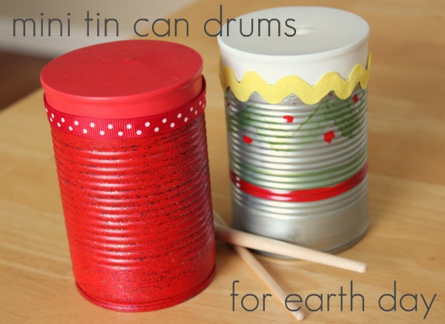
Supplies for Mini Tin Can Drums:
small tin cans
paint and paint brush
20 inch balloons, one per can
scissors
ribbon
craft glue or hot glue is best (adult only)
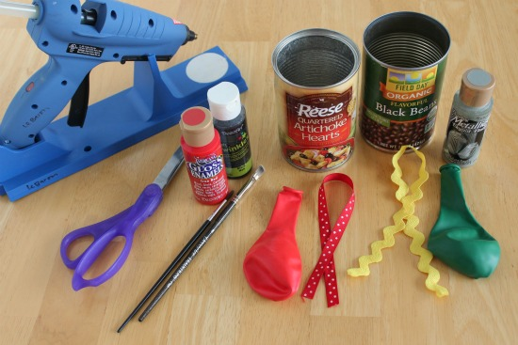
1. Wash and dry your tin cans, removing the label.
2. Now add your paint. This is where you can get really creative. These are your drums, so decorate them any way you’d like. We added some zig-zags, even some black DecoArt Twinkles paint for some extra sparkle! Let the paint dry completely.
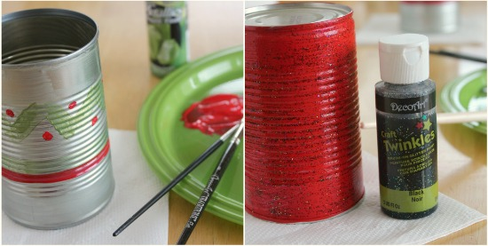
3. With your scissors, cut your balloon. You’ll want to cut farther down than you think, just about where it starts to get big toward the base. You can always cut more, so it’s best to start cutting closer to the top.
4. Stretch your balloon over your tin can. You need to stretch it as much as possible to get the best drum sound. If you’re having trouble with the stretching, you can help it stay in place with tape or glue dots. My balloons were good at sticking to the can and staying in place.
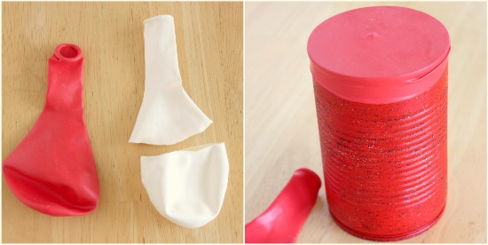
5. With your glue, add your ribbon to the seam of your balloon. This will help glue the balloon in place as well as glue on the ribbon.
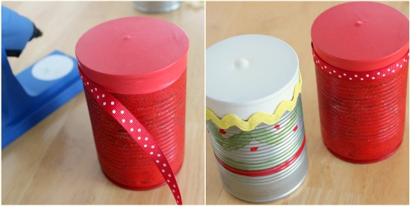
6. Now it’s ready for some drum sticks. We used paper tubes, pencils, and paint brushes, all worked well! We even discovered that the sides of the tin can makes a great sound too, when you rub a pencil down the ribbed side. It’s an all-in-one musical instrument!

DIY DRUMS FOR KIDS
http://jeliaedu.blogspot.gr/2013/02/diy-drums-for-kids.html?m=1

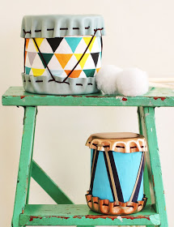

MATERIALS
tin cans
leather
decorative fabric
leather laces
Crop-a-dile
wooden dowel and ball
hot glue gun
cotton
STEPS
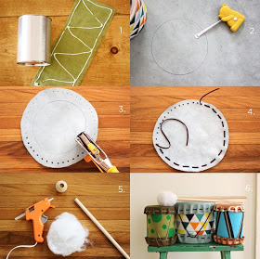
Cut your fabric to fit around your tin can. Use Elmer's Glue to glue it in place.
Lay out your leather and trace around your can. Measure 1 inch around the traced circle and draw another circle.
Use a pen to map out your holes. Use a Crop-a-dile to punch the holes out. If you don't have a Crop-a-dile, you can use a large needle to make your holes.
Run your leather lace through the holes. Cinch tight over the top of the can. Repeat the same steps for the bottom. Run another leather lace diagonally through the top and bottom laces (see picture below for reference).
Insert your wooden dowel into the wooden ball. Glue cotton all over the ball to create your drum sticks.
Enjoy your adorable new gift!
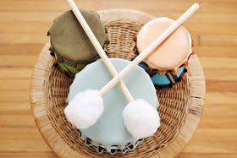
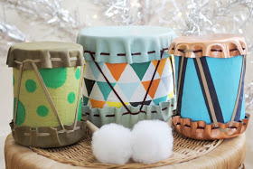



WEBELOS CORE

Webelos Adventure: First Responder

Do all of these:
Explain what first aid is. Tell what you should do after an accident.
Show what to do for the hurry cases of first aid:
Serious bleeding
Heart attack or sudden cardiac arrest
Stopped breathing
Stroke
Poisoning
Show how to help a choking victim.
Show how to treat for shock.
Demonstrate that you know how to treat the following:
Cuts and scratches
Burns and scalds
Sunburn
Blisters on the hand and foot
Tick bites
Bites and stings of other insects
Venomous snakebite
Nosebleed
Frostbite
Put together a simple home first-aid kit. Explain what you included and how to use each item correctly.
Create and practice an emergency readiness plan for your home or den meeting place.
Visit with a first responder.
Workbook for use with these requirements: PDF Format DOCX Format

http://scoutermom.com/cubscout/webelos-adventure-first-responder/

Emergency Preparedness BSA – Cub Scout Requirements
With the updates to the Cub Scout program, many of the requirements for various awards need to be updated also. These are the new requirements for the Emergency Preparedness BSA award for Cub Scouts.
Continue Reading


Webelos Adventure Requirements: First Responder
For the First Responder adventure, Webelos learn some basic first aid and emergency preparedness skills.
Continue Reading
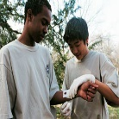

How To Treat a Knife Cut
What is the best way to treat a knife cut? This article from Boy’s Life magazine explains how to stop the bleeding, clean the cut, and dress the wound.
Continue Reading


Kims Game with Items for a Home First Aid Kit
Kim’s game is a traditional Scouting game which was introduced by Sir Robert Baden-Powell. It is based on a game describe by Rudyard Kipling. This version of the game helps Scouts learn what should be in a home first aid kit.
Continue Reading

Fake Wounds for First Aid Demonstrations
If your Webelos or Boy Scouts are working on first aid requirements, you can add in some fun by making a fake wound on a “victim” or two.
Continue Reading

First Aid for Tick Bites
Scouts like to get outdoors, but in many areas that brings the danger of tick bites. While most tick bites won’t cause more than minor irritation, if treated incorrectly complications can occur.
Continue Reading

First Aid Demonstration for Cuts
When you are doing first aid instruction, it is best to demonstrate it as much as possible. Here is a way they showed us at a Pow Wow a few years ago. I did this with my previous Webelos den and they really enjoyed it.
Continue Reading

First Aid Baseball Game for Boy Scouts and Webelos
First aid baseball is a fun way to review first aid skills with Boy Scouts and Webelos. There are instructions for the game and a set of question cards included in the printable file.

DIY Ready-For-Anything Kit For Your Car
http://www.emilyreviews.com/2014/07/diy-car-emergency-preparedness-kit-list.html

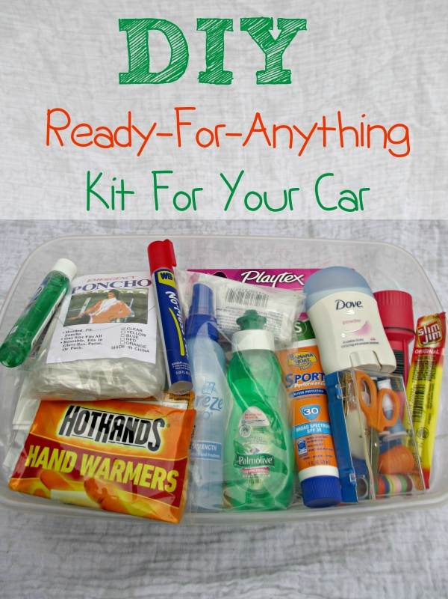
For years I’ve carried around a large purse. On occasion, people have picked up my purse to move it out of their way and been shocked at how heavy it was. I’ve heard “What do you keep in there? Bricks?” on multiple occasions. I like to be prepared, and in the past the best way I knew of to be prepared was to keep too much stuff in my purse. Having emergency items in my purse has helped me out in so many situations. I once had a bra strap break & having a safety-pin in my purse let me repair it until I could get home. When a sinus headache comes on, finding a dose of sinus medication in my purse gave me the ability to move forward with my day instead of laying my head against the table in pain. Having bug spray and sunscreen with me has kept us from getting bit up or burned after making a spontaneous decision to head to a friend’s house, go fishing or head to the lake. Yet, it’s a pain to carry that stuff around all the time in my purse. It recently occurred to me that I could make an emergency preparedness kit to keep in my car. I realized could even include items for a wider range of emergencies because I have so much room to store things in the car than my purse. I decided to make a DIY emergency kit for my car for true emergencies like having the vehicle break down with a dead phone battery to smaller inconveniences like getting to a wedding and realizing you have dog hair on your outfit. I have been working on creating a list of items to put in my DIY emergency kit.
Items For Wardrobe “Emergencies”:
Have a spare outfit for everyone
Febreeze
Lint Roller
Sewing kit
Flip Flops
Stain remover pen or wipes
Bathing Suit
Towels
Items For Weather Emergencies:
Ponchos
Gloves
Hat
Heat reflective survival wrap
Items For Health Emergencies:
Water bottles
Pain relievers
Tampons
Sinus medication
Anti-diarrhea medication
Allergy medication
Anti-itch cream
Foot powder
Sting relief gel
Snacks
Bug spray
Sunscreen
Burn cream
Triple antibiotic ointment
Acid reducer
Thermometer
Bandaids
Cough drops
Eye drops
Gauze
Vaseline
Tissues
Glasses cleaner cloth
Contact solution
Contact holder
Items For Hygiene & Cleanliness “emergencies”
Cleaning wipes
Deodorant
Comb
Razor
Liquid soap
Hand sanitizer
Toilet paper
Baby wipes
Toothpaste
Floss
Gum
Mouth wash
Cotton swabs
Body wash
Lotion
Razor
Lip balm
Tooth brush
Toilet seat protectors
Wash cloth
Hair-ties
Nail clippers
Mirror
Napkins or paper towel
Items for Boredom and Entertainment “emergencies” for kids:
Coloring book
Pack of cards
Books
Travel size games
Sippy cup
Bottle
Pacifier
Diapers
Diaper cream
Environmental Emergencies & Other
Grease
Scissors
Splinter-out
Duct tape
Safety pins
Batteries
Glasses repair kit
Blanket
Rubber bands
Bungee cord
Ziploc bags
Grocery bag
Notepad & pen
Flashlight
Seat belt cutter
Scissors
Power bank (to charge cell phone)
Buying everything in full size to make this kit would be incredibly expensive. So to make my kit, I ordered trial and travel size products from a site called Minimus which sells tons of trial, travel and individual-use size products. The items were incredibly reasonably priced – the comb I ordered was .15, a single use thermometer was .32, an 8 pack of bandaids was $1.32, etc. Plus, all orders of $20 or more ship for free.
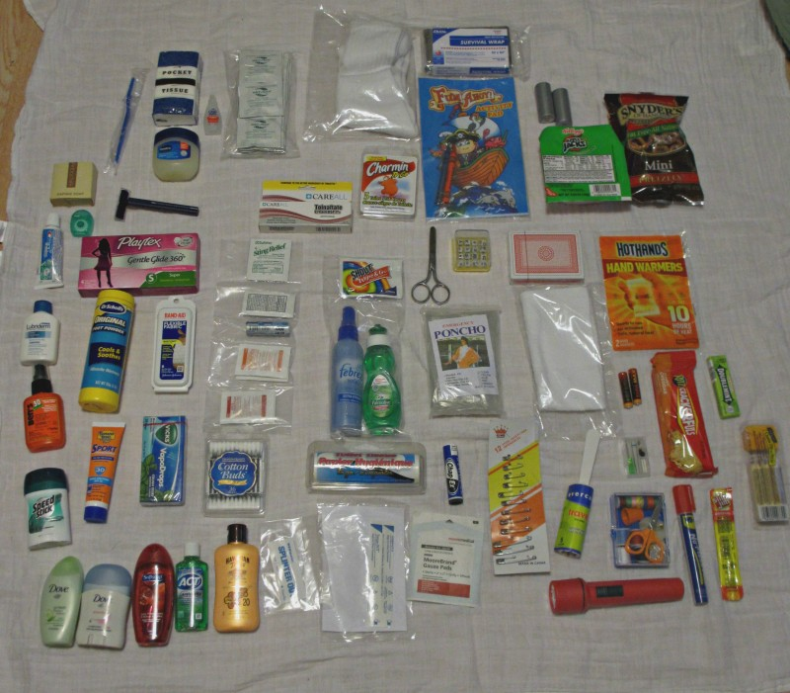
Do you keep an emergency preparedness kit in your car? What items would you add to my list for the kit?



WEBELOS & ARROW OF LIGHT ELECTIVES

Webelos/AOL Elective Adventure: Maestro!

Do all of these:
Do a or b:
Attend a live musical performance.
Visit a facility that uses a sound mixer, and learn how it is used.
Do two of the following:
Make a musical instrument. Play it for your family, den, or pack.
Form a "band" with your den. Each member creates his own homemade musical instrument. Perform for your pack at a pack meeting.
Play two tunes on any band or orchestra instrument.
Do two of the following:
Teach your den the words and melody of a song. Perform the song with your den at your den or pack meeting.
Create original words for a song. Perform it at your den or pack meeting.
Collaborate with your den to compose a den theme song. Perform it at your pack meeting.
Write a song with words and music that expresses your feelings about an issue, a person, something you are learning, a point of the Scout Law, etc. Perform it at your den or pack meeting, alone or with a group.
Perform a musical number by yourself or with your Webelos den in front of an audience.
Workbook for use with these requirements: PDF Format DOCX Format
http://scoutermom.com/cubscout/webelosaol-elective-adventure-maestro/



Completing Elective Adventures
A mother asks ” I understand that I cant do his next advancements until after May graduation BUT can I keep doing electives and getting credit for them?”
Continue Reading


Cub Scout Song Book
Amy wrote me and asked me if I would post a Cub Scout song book she made to fill a ticket for her Woodbadge course. My answer was yes!
Continue Reading


Webelos/AOL Elective Adventure Requirements: Maestro!
For the Maestro! adventure, Webelos learn about music from singing songs to musical instruments.

ONE LAST THING

UP - An Interesting Word!
My Aunt Betty in Florida
Lovers of the English language might enjoy this...How do non- natives ever learn all the nuances of English???
There is a two-letter word that perhaps has more meanings than any other two-letter word, and that word is 'UP.'
It's easy to understand UP, meaning toward the sky or at the top of the list, but when we awaken in the morning, why do we wake UP?
At a meeting, why does a topic come UP? Why do we speak UP and why are the officers UP for election and why is it! UP to the secretary to write UP a report?
We call UP our friends and we use it to brighten UP a room, polish UP the silver, we warm UP the leftovers and clean UP the kitchen. We lock UP the house and some guys fix UP the old car.
At other times the little word has real special meaning. People stir UP trouble, line UP for tickets, work UP an appetite, and think UP excuses.
To be dressed is one thing but to be dressed UP is special.
And this UP is confusing:
A drain must be opened UP because it is stopped UP.
We open UP a store in the morning but we close it UP at night.
We seem to be pretty mixed UP about UP!
To be knowledgeable about the proper uses of UP, look the word UP in the dictionary. In a desk-sized dictionary, it takes UP almost 1/4 of the page and can add UP.
If you are UP to it, you might try building UP a list of the many ways UP is used.
It will take UP a lot of your time, but if you don’t give UP, you may wind UP with a hundred or more.
When it threatens to rain, we say it is clouding UP. When the sun comes out we say it is clearing UP. When it rains, it wets UP the earth.
When it doesn't rain for a while, things dry UP.
One could go on & on, but I'll wrap it UP, for now my time is UP, Sooooo ....Time to shut UP .....!
Oh...one more thing:
What is the first thing you do in the morning & the last thing you do at night? U P


Same is true for Boy Scout Leaders!!

