COMMISSIONER'S CORNER
One loyal friend is worth ten thousand relatives. Euripides
SCOUT SALUTE
2009-2010 Cub Scout Roundtable Leaders’ Guide
Cub Scouts salute those heroes who help keep us safe and secure every day. Can only adults be heroes? Heroes can be ordinary kids who do something out of the ordinary. Do you read Boys' Life? Every issue features Scout heroes. Invite your hometown heroes to a den or pack meeting. Your den can become "silent heroes" by performing service for others without seeking any recognition. Visit a veterans' hospital, fire station, or police station and give a "Cub Scout salute" for their heroism.

THE 2016 – 2017 CS RT PLANNING GUIDE IS ISSUED
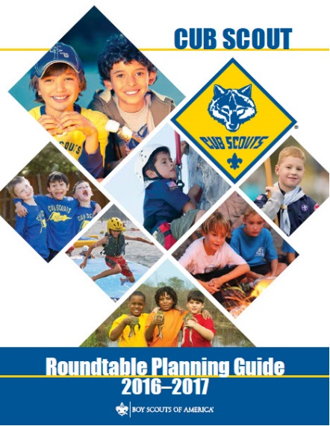
Find it at - http://www.scouting.org/scoutsource/Commissioners/roundtable.aspx

Judy and Dave need could still use help. If you would do one item for Baloo each month, it would help us greatly –
Some ideas for you to consider –
Biography – write a one page +/- biography of a person you select that exemplifies that month's emphasized point of the Scout Law.
Advancement – Choose a rank. Write a few hints and ideas for the Adventure to be discussed that month at the Roundtable. And, also, any that have a Character Compass pointing to that months point of the Scout Law
Point of the Scout Law – Look for items that help get across the meaning of the point of the Scout Law emphasized that month in Roundtable.
Have another idea? Let us know how you feel you could help us to make Baloo's Bugle more of what RT Commissioners, Cubmasters, and Den Leaders want.
Write us through the "Send Your Ideas to Baloo" link or directly – davethecommish@gmail.com and judyjohnsonbsa@yahoo.com

TABLE OF CONTENTS
COMMISSIONER'S CORNER 1
TABLE OF CONTENTS 2
BSA Social Media 3
BRYAN ON SCOUTING 4
My.Scouting - a free, secure and private website for your Pack 8
Telling the Scouting Story with Social Media 9
Up this month, FACEBOOK Part 1. 10
PERSONAL TIMELINES 10
FACEBOOK PAGES/GROUPS 10
CORE VALUES 11
LOYAL QUOTES 11
THOUGHTFUL ITEMS 13
SALUTE QUOTATIONS 13
FLAG QUOTES 14
BIOGRAPHY 14
An Example of Loaylty - My Den Mother (and my Mother) 14
ADVENTURE PLAN TRACKERS 19
BE UP TO DATE 19
www.scouting.org/programupdates 19
CUB SCOUT LEADER TRAINING 19
IN-PERSON TRAINING 19
ON-LINE TRAINING 19
CUB SCOUT IDEAS 20
Recruiting New Leaders 20
ROUNDTABLE HINTS 22
2016 – 2017 CS RT PLANNING GUIDE 23
DEN MEETING TOPICS 24
CHARACTER COMPASS 24
THEME RELATED STUFF 25
SCOUT SALUTE RELATED ADVENTURES 25
Fun Facts About Heroes 25
Honoring American Heroes Veteran’s Administration History 25
Some Great Rules To Follow If You Want To Become A Hero 26
Hero True Or False 26
PACK MEETING THEMES AND PLANS 27
PACK MEETING THEMES 28
UPCOMING MONTHS 28
CUBMASTER THOUGHTS 29
Lions and the Scout Law & Oath 29
The Chief Scout Executive on Lions 31
MORE LION INFORMATION 32
WEBELOS 35
WEBELOS-TO-SCOUT TRANSITION 35
TURNING YOUR WEBELOS INTO BOY SCOUTS 37
KEYS TO CUB SCOUTS CONTINUING IN BOY SCOUTS 38
Crazy Holidays 38
TRAINING TOPICS 41
LEAD A SONG. 41
FUN STUFF 43
Fun Facts About Lollipops 43
Lollipop History 44
THEME PACK AND DEN ACTIVITIES 45
THAT’S FOR THE BIRDS 48
THEME & PACK MEETING IDEAS 49
GATHERING ACTIVITIES 49
OPENING CEREMONIES 52
AUDIENCE PARTICIPATIONS 53
ADVANCEMENT CEREMONIES 55
LEADER RECOGNITION 57
Have I told you lately 57
Because You Said Yes 57
SONGS 58
STUNTS AND APPLAUSES 59
APPLAUSES & CHEERS 59
RUN-ONS 60
JOKES & RIDDLES 60
SKITS 61
CLOSING CEREMONIES 62
CUBMASTER’S MINUTES 63
CUB GRUB 65
GAMES 70
ONE TWO LAST THINGS 72

BSA Social Media
Robert (Bob) L. Stocker
LCRS District Commissioner
Abraham Lincoln Council, BSA
You Tube Channels
(Images are hyperlinked to the You Tube Channels)

Scouting Magazine
 | 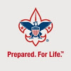
Boys’ Life Magazine | Boy Scouts of America
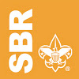
Summit Bechtel Reserve

Check out the cool stories and interviews on the different channels
Scouting Magazine
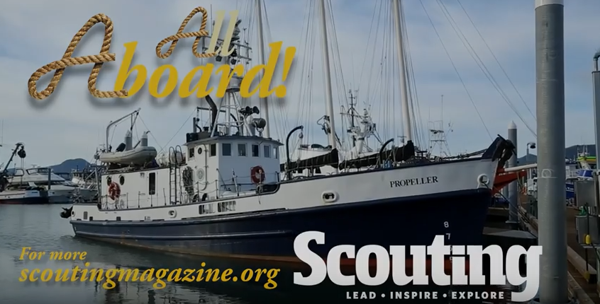
Figure 1 Seattle Sea Scouts set out on 700-mile voyage to Ketchikan, Alaska
Published on May 16, 2016
During their two-week voyage aboard the SSS Propeller, this group of Sea Scouts learn much more than nautical skills — they learn how to get along and work as a team. Watch footage from their voyage in this exclusive video by Scouting magazine's photography director W. Garth Dowling and Tim Lawler, senior media producer at the Boy Scouts of America.

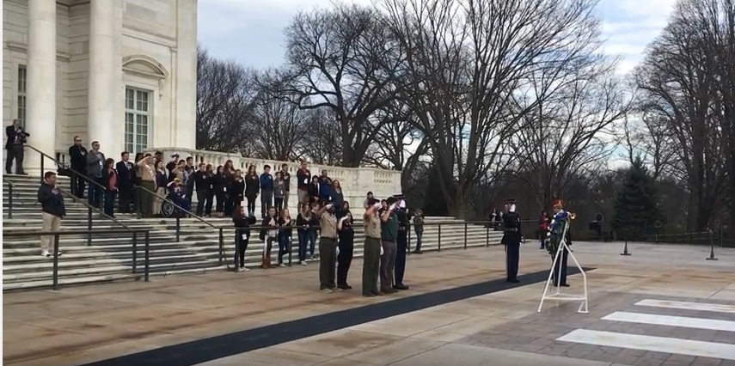
Figure 2 Boy Scouts wreath-laying ceremony at Arlington National Cemetery
Published on Feb 29, 2016
Boy Scouts and a Venturer and Explorer participated in a solemn wreath-laying ceremony at the Tomb of the Unknowns at Arlington National Cemetery on Feb. 29, 2016. The ceremony was part of the BSA's annual Report to the Nation trip.

Boys Life Magazine
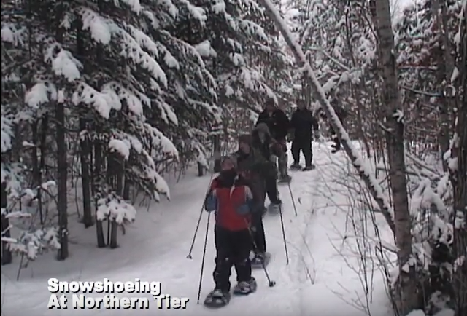
Figure 3 Snow Fun at Northern Tier
Boy Scouts of America
Scouting is for Families Like Mine
Michelle C.
Becky

Summit Bechtel Reserve
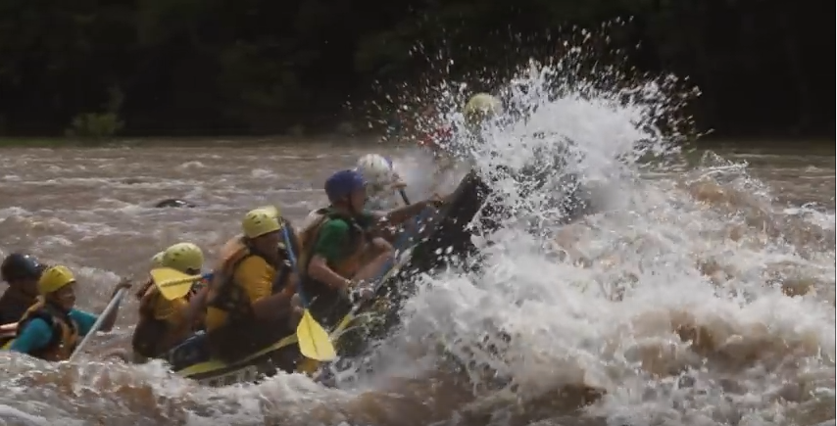
Figure 4 2017 National Jamboree at the Summit Bechtel Reserve

BSA Facebook
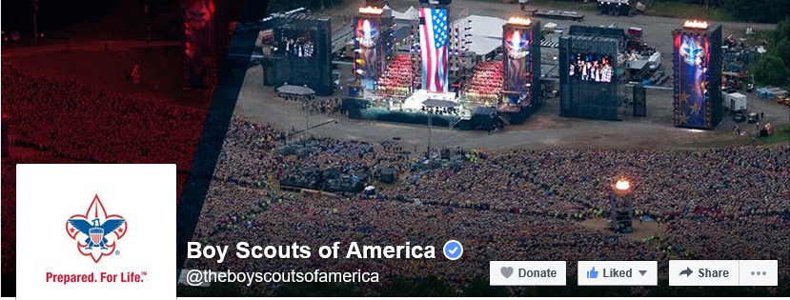
Sign up and get all the latest
as it hits the wires!!!
Cubs have your parents to Sign Up.

BSA Instagram
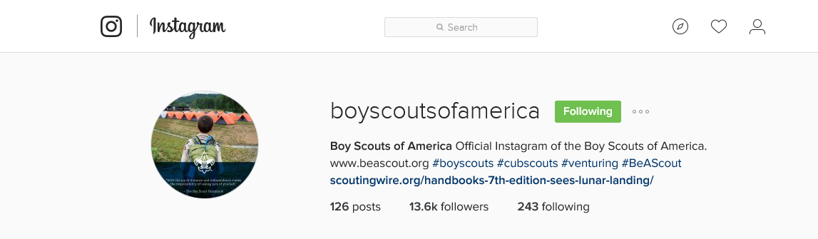
BSA Twitter



BRYAN ON SCOUTING
Robert (Bob) L. Stocker
LCRS District Commissioner
Abraham Lincoln Council, BSA

“Bryan on Scouting” is the official blog of Scouting magazine, a Boy Scouts of America publication. Scouting magazine is published five times a year and is received by 1 million registered adult volunteers. Bryan covers many topics every month. He keeps his Blog current and deals with the latest issues.
His articles this past month are listed below (Every title has a hyperlink). The articles in BLUE are of special interest for Cub Scout Leaders.
If the word SPONSORED appears, that BSA received compensation for that blog post.

Documentary sheds new light on Gerald Ford, our only Eagle Scout president
May 24, 2016 // 0 Comments

A documentary on the National Geographic Channel highlights Gerald R. Ford, the man who is (at least so far) the only Eagle Scout to become U.S. president.
American Legion: We want to help grow Scouting
May 24, 2016 // 6 Comments

The American Legion, the nation’s largest wartime veterans service organization wants to help grow Scouting by chartering new units.
Sea Scout Leadership Award, debuting in 2017, to honor youth and adults
May 24, 2016 // 3 Comments

Now that Sea Scouting is its own program, a new Sea Scout Leadership Award will debut in 2017 to recognize outstanding service to Sea Scouting in 2016.
Take a minute to refresh your drowning-prevention knowledge
May 23, 2016 // 1 Comment

The Boy Scouts of America has plenty of aquatics fun in store for Scouts this summer. It's fun to have fun, but you have to know how to do it safely.
71 years later, lost wallet returned — with Boy Scout card still inside
May 23, 2016 // 6 Comments
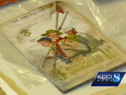
Inside the lost wallet were clues to its age and owner's identity: a 1944 pocket calendar, ration stamps and a Boy Scout membership card.

What’s in this Dallas restaurant’s Scouting-themed Tenderfoot salad?
May 20, 2016 // 3 Comments

Snappy Salads, a Dallas-based salad chain, now has a Scouting-themed salad called the Tenderfoot. So what goes into this salad named for the Boy Scout rank?
My Two Cents: Why it’s OK to wait until age 17 to earn Eagle
May 20, 2016 // 72 Comments

While I commend your fellow Eagle Scouts who earned their badge at 13, 14 or 15, those 16- and 17-year-old Eagle Scouts impress me just as much.
All the DEETs on protecting yourself and your Scouts from mosquitoes
May 19, 2016 // 12 Comments
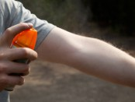
Just in time for mosquito season, let's go over some of the latest recommendations for protecting yourself from those flying menaces.
Vice President Joe Biden, a former Boy Scout, says Scouting teaches ‘valuable life lessons’
May 19, 2016 // 10 Comments

Vice President Joe Biden revealed that he was a Boy Scout and shared his thoughts about Scouting in a congratulatory letter to a new Eagle Scout.

If anyone doubts the power of Scouting, show them this video
May 18, 2016 // 3 Comments
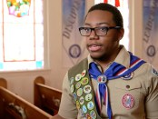
Without Scouts, Justice Boston found himself dwelling on all "the sad things in my life." But with Scouts, "I realized that I could be somebody."

Read what ‘Game of Thrones’ author George R. R. Martin wrote to a new Eagle Scout
May 17, 2016 // 23 Comments
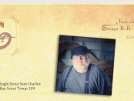
Sam Charles received several congratulatory letters when he became an Eagle Scout last year, but the one from George R. R. Martin was by far his favorite.
What’s the secret to recruiting Boy Scouts?
May 17, 2016 // 13 Comments

What are some proven ways to grow the number of Scouts in your troop? Share your Boy Scout recruiting strategies right here.
Scouts Then and Now, Chapter 4: 73 inspiring sets of photos
May 16, 2016 // 1 Comment
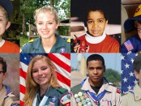
In this chapter of Scouts Then and Now, we share 73 sets of photos that show the same young person in two stages of his or her Scouting life.

Become a better-informed Cub Scout, Boy Scout or Exploring leader while you drive to work
May 13, 2016 // 3 Comments

Commute happy with the Boy Scouts of America's monthly podcasts for Scout leaders: CubCast, ScoutCast and the new ExploringCast
First look: ‘Troop Leader Guidebook’ Vol. 2, designed for experienced Scouters
May 13, 2016 // 9 Comments
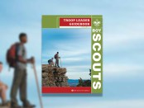
Volume 2 of the Troop Leader Guidebook, the BSA's publication for experienced leaders, addresses topics like self-evaluation, succession planning and more.

Cub Scouters, bring your family to the Philmont Training Center this summer
May 12, 2016 // 3 Comments

Cub Scout conferences at the Philmont Training Center promise a cost-effective family vacation, lifelong Cub Scouting friendships and high-quality training.
Cub Scout’s Richard Petty Pinewood Derby car leads to meeting with The King himself
May 12, 2016 // 20 Comments
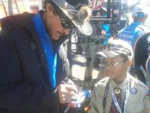
A Pinewood Derby car designed to look like Richard Petty's 1984 red-and-blue Pontiac Grand Prix led to one Cub Scout getting to meet The King.

Mississippi high school has 12 Eagle Scouts in its graduating class
May 11, 2016 // 20 Comments
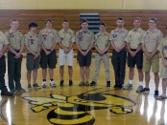
An impressive 12 members of the 2016 Starkville graduating class are Eagle Scouts. These young men excelled in Scouting and will go on to great things.
Utah Eagle Scout wins Hornaday Silver Medal Scholarship, $10,000 for college
May 11, 2016 // 9 Comments
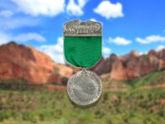
Eagle Scout Porter Bradford of Utah, has received the first William T. Hornaday Silver Medal Scholarship from the BSA and the Camp Fire Conservation Fund.

Why this Sea Scout ship was named best in the country in 2016
May 10, 2016 // 0 Comments
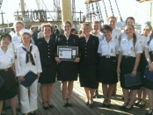
The 2016 National Flagship Award goes to Ship 100, nicknamed the "Viking," which is part of the San Francisco Bay Area Council.

Why oaths, like the Scout Oath, are so important
May 10, 2016 // 22 Comments

More powerful than a promise, an oath — like the Scout Oath — is an unbreakable commitment about one's future behavior.

With your help, 2017 Journey to Excellence will be even better
May 9, 2016 // 33 Comments

2017 Journey to Excellence standards are being created now, and the JTE team wants your help to make them even better than last year's.
10 fascinating facts about Scouting founder Ernest Thompson Seton
May 6, 2016 // 10 Comments
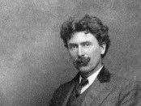
He was the BSA's first Chief Scout and helped write the first Boy Scout Handbook. But there's a lot you probably don't know about Ernest Thompson Seton.

The right way to take your Cub Scouts swimming or boating
May 5, 2016 // 8 Comments

Contrary to past BSA program design, all Cub Scouts may participate in paddle sports as a pack or den. And, of course, they may continue to swim.
The life of a Wood Badge scribe: Great days, late nights
May 4, 2016 // 30 Comments
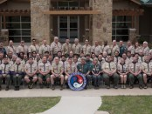
The life of a Wood Badge scribe requires late nights, patience and lots of printer ink. But the memories and the camaraderie are energizing.
Virginia Venturing crew starts Scout unit at orphanage in Haiti
May 3, 2016 // 1 Comment

Thanks to a service-minded Venturing crew in Virginia, the children at one orphanage in Haiti are enjoying all that Scouting has to offer.
Challenge yourself with the May-June 2016 ‘Where Am I?’ contest
May 2, 2016 // 0 Comments

Can you identify this location? Guess right and you could win a $100 Scoutstuff.org gift card. Plus, we reveal the winner of the previous "Where Am I?" contest.

At retirement home, Venturing crew finds much more than a meeting place
May 2, 2016 // 0 Comments
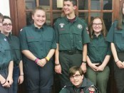
Venturers in Crew 91 build Scouting skills and intergenerational friendships with residents at a local retirement home.

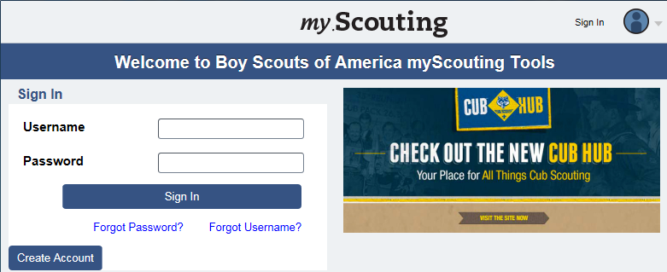

My.Scouting - a free, secure and private website for your Pack.
By Gary Moore
Pine Tree Council Alumni Relations Chair
Executive Board Member

Has your Pack thought of having a website as a communication tool for your Pack? If so, you may have discussed the many hurdles to face in implementing a website: the costs of a domain name, the continuing costs of website hosting, the cost of having someone build the site vs. the expertise, time and work to create a website yourself and the continuing effort needed to keep it up to date with fresh content, and, perhaps most important, the need for security to protect the privacy of the families of your Pack.
Many Packs start with an enthusiastic volunteer putting together an extensive Pack website only to have that volunteer transition to a Troop, drop out of the Pack or move to another community. The website turns from an asset to a liability with parents disappointed by outdated information.
Through the My.Scouting.org website, BSA has now provided Scouting Units with free, easy to use website tools to address the two primary needs of most units: an online calendar and the ability to post and manage announcements. Additionally, this is done in a secure password protected environment.
The My.Scouting Calendar and Announcement tools are the keys to managing content on your Pack's My.Scouting site. So, how do you log into and use these tools? It's really easy, but explaining how in an article like this is hard. I scientifically tested boredom factors between “Reading Written Instructions to use My.Scouting” VS. “Watching Paint Dry”. 100% of my sample (my wife) preferred Watching Paint Dry.
So I've created videos to show how to use many of the tools. The 8 1/2-minute video covering the Calendar and Announcement tools can be found at http://bit.ly/1W9LOmT. In these articles, we'll let the videos cover the mechanics of using the tools, and focus here on the strategy of using the tools.
The most important things about any calendar or announcement source are that it be up to date, accurate and complete. While these tools are quick and easy to use, consistency is key in making them useful. By default, only the Unit Key 3 have access to these tools; but the Organization Security Manager tool can grant any Committee Member Key 3 Delegate permissions to use the tools. If none of your Key 3 qualifies as a willing Geek, it's a great opportunity to bring some aspiring Geek parent on to your Committee as a new volunteer!
A note on the information you post: Consider using the 5W rule. Make sure information includes Who, What, Where (include an address), When and Why. Don’t assume “everybody knows.” That’s really frustrating for new parents.
Once the information is online, the next challenge is to get people to use it. This means that all parents need to create log-in accounts as we discussed last month. Perhaps the resident Geek could set up a laptop at a Pack meeting to help those who need a nudge or help.
Next, promote the use of the site. Have a demonstration at a Pack Meeting. If you have access to a computer projector, consider using the site to review the Calendar and Announcements. Make sure it is consistently referred to through the Pack Newsletter.
These suggestions pertain whether you choose to use the My.Scouting calendar and announcements, Scoutbook or a website. While it takes effort to maintain the information and encourage people to use it, you'll find that your Pack will benefit from having better communication. People will have a place to always find the latest information.
You should also realize, though, that this doesn’t negate the need for a Pack Newsletter. Online information is a consistent resource, but only for the people who come to it. The newsletter is more active in reaching out to everyone. The two together will work better than either alone.
Next month, we'll explore the My Dashboard tool. See you then!
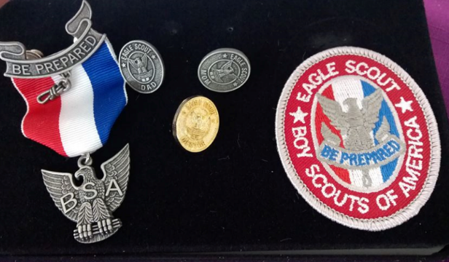

Telling the Scouting Story with Social Media
Robert (Bob) L. Stocker
LCRS District Commissioner
Abraham Lincoln Council, BSA
U
sing social media to tell your unit's story is a great way to share all the fun and exciting things that your unit does. Social media also provides you with an awesome tool to recruit new scouting families into your unit.
There is an old saying about a picture being worth a 1,000 words. If that is the case, then if you upload 5 pictures to Facebook, you have just written a 5000-word document telling others how great your unit is.
Of course whenever you publish pictures publically, there are guidelines that need to be followed. Sites like Facebook, Twitter, Instagram, and others, all of guidelines regarding using their sites. Be sure to take the time to read these guidelines and follow them.

The Boy Scouts of America (BSA) has also put together some great guidelines and resources for using social media. In fact, BSA is very pro-active in encouraging units to use the different social media channels and they have created and are still creating lots of helpful information and materials that scouting units, districts, and councils can use in their "Social Marketing Plan." Below are some links and short summary of what information you will find at each link.
- http://bsaseabase.org/Home/BrandGuide/Multimedia/SocialMedia.aspx
  - These are some key considerations you should think about and discuss with your unit before starting to share information on social media.
- http://scoutingwire.org/marketing-and-membership-hub/social-media/social-media-guidelines/
  - This link gives you the BSA's Social Media Guidelines.
- http://scoutingwire.org/wp-content/uploads/2015/05/Social_Media_Playbook_050815.pdf
  - This is the "BSA Social Media Playbook." Here you will find great information to help guide you in using social media to spread the great fun your unit is providing.
With all of these links you will find a lot more links inside them to help you along your social media journey.
Now that you have looked over these guide lines and have a plan on how to use social media; let's take a look at some of these social media channels and the materials' that BSA has put together to help you with your unit's social media usage.

Up this month, FACEBOOK Part 1.
W
ith Facebook you can post to your own timeline and reach people who are also on Facebook, who have children that are scout age, and who may or may not be in scouting. By posting items on your Facebook timeline about your scout or your unit, you can speak to these people about the fun and excitement that your scout and family is having.
A unit, district, or council, can have a Facebook Page, and/or a Facebook group, where they can share and brag about their scout activities.

PERSONAL TIMELINES
Hopefully the scout families in your unit are already posting pictures of their scout(s)/scout events, like the one above, on their own timelines. However, if they aren't, encourage them to do so. There is nothing better than parents bragging about their scouts. Word of mouth is the best advertising you can ask for.

FACEBOOK PAGES/GROUPS
Facebook pages/groups give your unit a great place to brag about the unit. An important guideline about Facebook pages and groups to remember is “To help ensure that all communication on social media channels remains positive and safe, these channels must be public (emphasis added), and all communication on or through them must be public. This enables administrators to monitor all communication and help ensure there is no inappropriate communication between adult leaders and Scouts or between Scouts themselves. Therefore, no private channels (e.g., private Facebook groups or invite-only YouTube channels) are acceptable in helping to administer the Scouting program. Private channels and private communication put both the youth and you at risk. If you feel the information you seek to share via social media channels should not be shared in public, you should not share that information via social media.” (http://scoutingwire.org/marketing-and-membership-hub/social-media/social-media-guidelines/ paragraph 5)
In addition to sharing what your unit has been up to, you can also “Share” information about scouting that is posted on other Scouting pages that your unit would find helpful and/or useful.
This is a great way to share the scouting adventure with other scouting families, including your own, from other sources besides just your unit.
Remember this is Social Media and Facebook is just one Social Media Channel. By “socializing” on a social media channel with other scout families, units, districts, and councils, you are helping spread the excitement families are having in scouting.
Some great Facebook pages to follow are:
- Boy Scouts of America, National Facebook Page.
- Philmont Scout Ranch
- Boys Life Magazine
- U.S. Scouting Service Project (USSP)-Home of Baloo’s Bugle
Next month we will look at some examples of sharing information on Facebook.

CORE VALUES
The Cub Scout Core Values are the
12 Points of the Scout Law.
The Scout Law point highlighted this month is:
A Scout is LOYAL. The theme SCOUT SALUTE is used to help Cubs understand being LOYAL.
A SCOUT IS LOYAL
A Scout is true to his family, friends, Scout leaders, school, and nation.
HOW DOES “SCOUT SALUTE” RELATE TO THIS POINT OF THE SCOUT LAW?
A Scout is true to his family, friends, Scout leaders, school, and nation. Cub Scouts will show their loyalty during this meeting by participating in several activities such as honoring the American flag, creating a pack banner, and hearing about loyalty from a guest speaker or demonstrating loyalty to a team through a pack game.
Per our Founder, Lord Baden-Powell
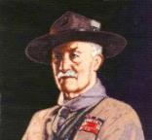
Note – The original Scout Law published in 1908 had nine points. In 1910, the BSA added Brave, Clean, and Reverent. In 1911 B-P added Clean to his original list.
A SCOUT IS LOYAL
Baden Powell said -
A SCOUT IS LOYAL to the King, and to his officers, and to his country, and to his employers. He must stick to them through thick and thin against anyone who is their enemy, or who even talks badly of them.
(Scouting For Boys, 1908)

Loyalty is a feature in a boy’s character that inspires
boundless hope.
– Lord Robert Baden-Powell

 In this video, the "Believe It Live It" team profiles Frank Denius, the UT Longhorns No. 1 fan, and shows how he demonstrated loyalty with his service to his country in World War II. Go to URL: http://boyslife.org/about-scouts/scoutlaw/4108/a-scout-is-loyal/

LOYAL QUOTES
Quotations contain the wisdom of the ages, and are a great source of inspiration for Cubmaster’s minutes, material for an advancement ceremony or an insightful addition to a Pack Meeting program cover.
A boy can learn a lot from a dog: Obedience, LOYALTY and the importance of turning around three times before lying down.
Robert Benchley
Honesty and LOYALTY are key. If two people can be honest with each other about everything, that's probably the biggest key to success. Taylor Lautner
Love is friendship that has caught fire. It is quiet understanding, mutual confidence, sharing and forgiving. It is LOYALTY through good and bad times. It settles for less than perfection and makes allowances for human weaknesses. Ann Landers
The foundation stones for a balanced success are honesty, character, integrity, faith, love and loyalty. Zig Ziglar
You give LOYALTY, you'll get it back. You give love, you'll get it back. Tommy Lasorda
LOYALTY to the country always.
LOYALTY to the government when it deserves it. – Mark Twain

I look for these qualities and characteristics in people. Honesty is number one, respect, and absolutely the third would have to be LOYALTY. – Summer Altice
I’ll take fifty percent efficiency to get one hundred percent LOYALTY. – Samuel Goldwyn
All I want is good, honest,
loyal friends.
Aviv Nevo
I have a LOYALTY that runs in my bloodstream, when I lock into someone or something, you can’t get me away from it because I commit that thoroughly. That’s in friendship, that’s a deal, that’s a commitment. Don’t give me paper – I can get the same lawyer who drew it up to break it. But if you shake my hand, that’s for life. – Jerry Lewis
If put to the pinch, an ounce of LOYALTY is worth a pound of cleverness. – Elbert Hubbard
I place an enormous premium on LOYALTY. If someone betrays me, I can forgive them rationally, but emotionally I have found it impossible to do so.
– Richard E. Grant
All men are LOYAL, but their objects of allegiance are at best approximate. – John Barth
Where the battle rages, there the LOYALTY of the soldier is proved. – Martin Luther
A person who deserves my LOYALTY receives it..
– Joyce Maynard
…it isn’t things and proximity, or even blood that holds us all together. What makes a family is love and LOYALTY. – Genevieve Dewey
LOYALTY and friendship, which is to me the same, created all the wealth that I’ve ever thought I’d have.
– Ernie Banks
LOYALTY cannot be blueprinted. It cannot be produced on an assembly line. In fact, it cannot be manufactured at all, for its origin is the human heart — the center of self-respect and human dignity. It is a force which leaps into being only when conditions are exactly right for it — and it is a force very sensitive to betrayal.– Maurice Franks
You don’t earn LOYALTY in a day. You earn LOYALTY day-by-day. – Jeffrey Gitomer
Honesty and LOYALTY are key. If two people can be honest with each other about everything, that’s probably the biggest key to success. – Taylor Lautner
LOYALTY and devotion lead to bravery. Bravery leads to the spirit of self-sacrifice. The spirit of self-sacrifice creates trust in the power of love. – Morihei Ueshiba
My whole thing is LOYALTY. LOYALTY over royalty; word is bond. – Fetty Wap
Success is the result of perfection, hard work, learning from failure, LOYALTY, and persistence.
Colin Powell
Confidentiality is a virtue of the loyal, as LOYALTY is the virtue of faithfulness. Edwin Louis Cole
LOYAL and efficient work in a great cause, even though it may not be immediately recognized, ultimately bears fruit. Jawaharlal Nehru
Friendship is held to be the severest test of character. It is easy, we think, to be LOYAL to a family and clan, whose blood is in your own veins. Charles Eastman
I love dogs. They live in the moment and don't care about anything except affection and food. They're LOYAL and happy. Humans are just too damn complicated. David Duchovny
I am sustained by the tranquility of an upright and LOYAL heart. Peter Stuyvesant
Where would you be without friends? The people to pick you up when you need lifting? We come from homes far from perfect, so you end up almost parent and sibling to your friends - your own chosen family. There's nothing like a really loyal, dependable, good friend. Nothing. Jennifer Aniston
A man is a better citizen of the United States for being also a LOYAL citizen of his state and of his city; for being LOYAL to his family and to his profession or trade; for being LOYAL to his college or his lodge. Louis D. Brandeis
Horses know how to be loyal but still keep their distance. Sadie Jones
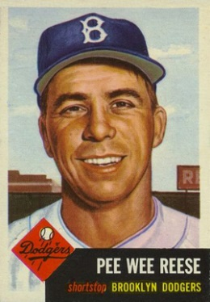
Brooklyn was the most wonderful city a man could play in, and the fans there were the most LOYAL
there were. Pee Wee Reese


THOUGHTFUL ITEMS
July Prayers
Thanks for Everyday Heroes
CS Roundtable Planning Guide
Great Spirit, we give you thanks for the everyday
people who do heroic things-
the firefighters who answer the call for help,
the police who work at keeping our cities safe,
the military personnel who keep our country safe,
and
the Cub Scouts who unselfishly give service to others.
May we recognize all these everyday heroes and give them our thanks. AMEN
Sam Houston Area Council
Thank You for Scouting and for the inspiration You gave our founders. Watch over our meeting and help us to keep Scouting alive forever. Amen.
The First Salute
Scouter Jim, Bountiful UT
If you can't get them to salute when they should salute and wear the clothes you tell them to wear, how are you going to get them to die for their country?
General George S. Patton
A co-worker of mine had a son graduate from the University and the ROTC program. He had two brothers in the military. One, a commissioned officer was able to swear his brother in as a new officer. The other, a Master Sergeant was the first soldier to give the new officer a salute. It was considered a great honor that the first salute he would receive as a Commissioned Officer was from his brother. I know from the culture of the family that the young man was once a Boy Scout and possibly an Eagle Scout. Most likely he was a Cub Scout before that.
That salute was not his first. He had given many salutes in his training no doubt. As a Boy Scout he would have given Salutes during flag ceremonies. But his first salute was no doubt as a Cub Scout. In a blue shirt with his arm proudly held up and two fingers placed to his forehead or against a Blue and Gold hat . This young officer’s first salute as an American in uniform was probably as a Cub Scout proudly wearing a blue shirt.
As leaders, it is well that we remember that our young Cub Scouts giving their first salutes in uniform as Americans with two fingers, will advance in Scouting and start giving three finger salutes as Americans. Some will go on to serve their county and start to give four finger salutes, but their first salutes in uniform will always be as Cub Scouts with two finger against the hat. The Character Connection for November is Respect. There may be no better way to teach respect for the county, the flag, and those who serve in uniform that to teach the importance of that first salute to the flag. Teach boys to wear their uniforms with pride and to be respectful of the flag and to give a crisp proper salute when they honor it.

SALUTE QUOTATIONS
Quotations contain the wisdom of the ages, and are a great source of inspiration for Cubmaster’s minutes, material for an advancement ceremony or an insightful addition to a Pack Meeting program cover
Many have left their families to defend our freedom. We salute their bravery; we express our appreciation and support to their families. And we pray for their safe return. Bob Taft
Ask not what your country can do for you, but what you can do for your country.
John F. Kennedy
Real integrity is doing the right thing, knowing that nobody's going to know whether you did it or not. Oprah Winfrey
Always stand on principle, even if you stand alone.
John Quincy Adams
Integrity has no need of rules. Albert Camus
We must build a new world, a far better world - one in which the eternal dignity of man is respected.
Harry S. Truman
You can only protect your liberties in this world by protecting the other man's freedom. You can only be free if I am free. Clarence S. Darrow
Only those who dare to fail greatly can ever achieve greatly. Robert F. Kennedy
I'm a great believer in luck, and I find the harder I work, the more I have of it. Thomas Jefferson
Heroic service does not come from policy manuals. It comes from people who care - and from a culture that encourages and models that attitude.
Valerie Oberle, VP, Disney University Guest Programs
Do not neglect to do good and to share what you have, for such sacrifices are pleasing to God. Hebrews 13:16
To the world I may be one person,
But to one person I may be the world. Anonymous
Heroes are the people who do what has to be done when it needs to be done, regardless of the consequences. Author unknown

FLAG QUOTES
The whole inspiration of our life as a nation flows out from the waving folds of this banner. Author Unknown
If anyone, then, asks me the meaning of our flag, I say to him - it means just what Concord and Lexington meant; what Bunker Hill meant; which was, in short, the rising up of a valiant young people against an old tyranny to establish the most momentous doctrine that the world had ever known - the right of men to their own selves and to their liberties. Henry Ward Beecher
I swing before your eyes as a bright gleam of color, a symbol of yourself, the pictured suggestion of that big thing which makes this nation. My stars and my stripes are your dream and your labors. They are bright with cheer, brilliant with courage, firm with faith, because you have made them so out of your heart. For you are the makers of the flag and it is well that you glory in the making. Franklin Knight Lane
Cheers for the sailors that fought on the wave for it,
Cheers for the soldiers that always were brave for it,
Tears for the men that went down to the grave for it,
Here comes the flag! Arthur Macy, The Flag
It is the flag just as much of the man who was naturalized yesterday as of the men whose people have been here many generations. Henry Cabot Lodge
That piece of red, white and blue bunting means five thousand years of struggle upwards. It is the full-grown flower of ages of fighting for liberty. It is the century plant of human hope in bloom. Alvin Owsley
We take the stars from heaven, the red from our mother country, separating it by white stripes, thus showing that we have separated from her, and the white stripes shall go down to posterity, representing our liberty.
George Washington, attributed
Our flag means all that our fathers meant in the Revolutionary War. It means all that the Declaration of Independence meant. It means justice. It means liberty. It means happiness.... Every color means liberty. Every thread means liberty. Every star and stripe means liberty.
Henry Ward Beecher
A flag appears 'mid thunderous cheers,
The banner of the Western land.
The emblem of the brave and true
John Philip Sousa
The flag of the United States has not been created by rhetorical sentences in declarations of independence and in bills of rights. It has been created by the experience of a great people, and nothing is written upon it that has not been written by their life. It is the embodiment, not of a sentiment, but of a history. Woodrow Wilson

BIOGRAPHY

An Example of Loaylty -
My Den Mother (and my Mother)
NOTE: I am not writing this boast about my Mom
but to hopefully inspire you to find examples of loayalty in your families and talk about them to
your Cubs. Personal stories are always more
powerful than canned stories. CD
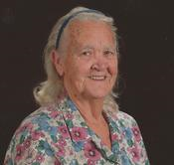
(December 8, 1926 - April 17, 2011)
Ruth H. Lyons, 84, of Middletown, DE and formerly of Washington Township, Bergen County, NJ, passed away on Sunday, April 17, 2011 at Christiana Hospital in Newark, DE. Born on December 8, 1926 in Brooklyn, NY, she was the only child of the late Cord F. and Ottilie (Weiss) Kuhlmann.
Ruth graduated from W.C. Mepham High School in Bellmore, NY, Class of 1944. She enjoyed being a loyal spouse and homemaker and throughout her life loved being loyally involved in her two sons' activities. She was a long time Cub Scout Den Mother, Den Mother Coach, Roundtable Commissioner, and Cub Scout Trainer (I have her 1960's syllabus) with the Boy Scouts and a Little League team mother. She used to amaze my dad that wherever they went, she knew all these men. This was unusual in the 60's. She knew them all from roundtable.
She was loyal to my brother Bill and me, making sure we were confirmed at Zion Lutheran, whose confirmation class was known as "West Point of Lutheran (Mo. Synod) Confirmation classes, earned our Arrow of Light and Eagle Scout awards, and graduated from High School. And that we knew what was right and wrong. And always recognized we were different from each other. The old saying goes, Dave is right-handed and Billy is left-handed. After that, similarities end.
While living in New Jersey, she was an loyal devoted member of Zion Lutheran Church in Westwood, NJ. Following her move to Delaware, she became actively involved with Faith Lutheran Church in Bear, DE. She would manually type the Zion Times, then count spaces and manually justify it. And then retype the whole thing.
She was an active member of the Blue Knights Motorcycle Club New Jersey One with her husband, Bill. Following his death, she remained loayl to the organization continuing to volunteer at their events.
Ruth was an active member of the Jean Birch MOT Senior Center, where she and her husband started the first MOT Senior Center bowling league. As a member of the Senior Center she enjoyed teaching crocheting and in 2009 at the age of 82 was proud to have been the recipient of a blue ribbon at the Delaware State Fair for one of her prize crocheting pieces. She completed poster size crochet pieces of the Lord's Prayer, the 23rd Psalm, and the Last Supper and donated them to her and her sons' churches.
Ruth and her husband were avid travelers and together enjoyed visiting all 50 states and taking a cruise through the Panama Canal. She took pride that at age 67 she received the first motorized trike driver's license issued to a female in Delaware.
They (both parents) were loyal to their family. Bill and I are the only two of our cousins that know all the others. And they were generous with those in need. Helping as they could even though Dad was a police officer and they were not well paid at that time. Ruth completed a family tree of her husband's family starting with his parents and including all 9 of his siblings and their children and grandchildren. After his death, she maintained this and became the honorary matriarch of the family. All the cousins would let her know what changes were occurring. And they would visit when they could. (Being an only child, she had a desire to marry into a large family. She used to kid that any person she dated who had two or less siblings, somehow never got a second date). She attended all the high school and college graduations, Eagle ceremonies, and marriages of her grandchildren and any of the other Lyons family members to which she was invited. Billy and I drove her to many of these.
She is interred with her husband at Delaware Veterans Memorial Cemetery in Bear, DE.
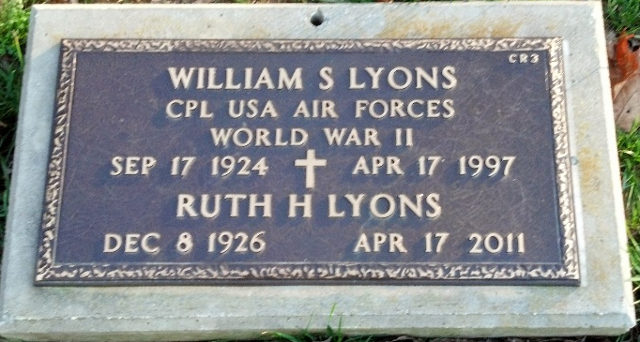
CUB SCOUT LEARNING LIBRARY
The NEW https://cubscouts.org/ !!!

This is the Cub Scout Learning Library –
Everything you could want to know for Cub Scouts is or will be here. And all within a click or 3 of the home page. National heard the message that although things were at www.scouting.org they were often buried too deep to be found.
This site has admin stuff and practical stuff. The new Den Leader Resource Books are here. You can download some of the pages for each Adventure for FREE
This website is a great resource. There are still parts under construction but what is there is GREAT!!

Yes, https://cubscouts.org runs on a phone, too!!!

There are 5 tabs on top of the home page –

- Learning Library
- Cub Hub Blog
- Join Scouting
- Pinewood Derby Photo Contest
- Day Camp
- Learning Library takes you where you can learn about your position and pick up hints. Besides specifics for dens of each rank, other clickable links include –
KEY
- All or most of material was placed on site this past month
- All or most of material was in place and listed as such in last month's Baloo's Bugle.
- Site / pages under construction
- Den Leader
Den Meeting Basics
- Your First Den Meeting
- Planning Den Outings
- The Parts of a Den Meeting
- Getting Started
Three of the Core Adventures for the selected rank are listed here. Click on them and you will see / can download all the Leader's Guide pages for these three Adventures.
- Additional Required Adventures
The remaining Core Adventures for the selected rank are listed here. When you click them you get an intro to the Adventure but do not get the Meeting Plans and Resources. You see this note:
To get you started in delivering fun and engaging meetings, complete Den Meeting Plans are available here on the Learning Library for the Backyard Jungle and Games Tigers Play adventures. To obtain Den Meeting Plans for all other adventures, Den Leader Guides are available at your local Scout Shop, online at scoutstuff.org, or as an eBook through Amazon.
- Elective Adventures
All the Elective Adventures for the selected rank are listed here. When you click them you get an intro to the Adventure but do not get the Meeting Plans and Resources. You see the same note (above).
- Building Strong Dens
The Basics of Cub Scouts
- Advancement
- BSA Mission and Vision Statements
- Cub Scout Ages and Ranks
- Cub Scout Uniforming
- Den Flags
- Den Yells
- Leader Survival Kit
- Methods of Cub Scouting
- Purpose of Cub Scouting
- Roles and Responsibilities
- Scout Oath and Law
- What Is Cub Scouting?
- Training
- The Role of Training
- Youth Protection
- Den Planning And Administration
- Advancement Basics
- Advancement Requirements
- Annual Planning For Your Den
- Coordinating Your Den Plan with Pack
- Tracking and Recognizing Advancement
- Youth Protection Training
- Positive Youth Development and Working with Boys
- Developmental Differences Boys 7-11
- Behavior and Discipline
- Positive Youth Development
- Working With Special Needs Cub Scouts (Advice is specific to each Special Need. Lots of research was done to prep these pages.)
- Parents’ Prejoining Conference
- Leadership Techniques
- Working With Specific Disabilities and Needs
- The other positions are still under development:
- Cubmaster
- Committee Chair/Member
- Chartered Org Rep
- Parent / Adult Partner
- Cub Hub takes you to a Cub Scout specific Blog similar to Bryan's Blog. The most recent topics discussed are listed here. There are more at www.cubscouts.org:
There were 3 new posts this month. One about Lion Cubs!! CD
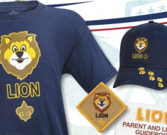A Look at the Lion Uniform and Gear Lion uniform, shirts and hats! In case you’ve missed the Lion uniform images floating around the Digital Pack…
Archery at Day Camp Wins as Most Popular Activity Archery at Day Camp Nails the Bulls Eye! The final votes have been tallied and the consensus…
Announcing the 2016 Pinewood Derby Photo Contest Winners Who Won the Pinewood Derby Photo Contest? In our second year of hosting the Cub Scout Pinewood…

Older Cub Hub Lion Posts
Will Lions Join Tigers and Bears? Oh My! — A Lions FAQ Lions: Answers to your top questions. We have seen a lot of great feedback, comments and questions from…
 5 Questions (and Answers) for the New Lion Program More Information on the New Lion Program As we mentioned earlier on the Cub Hub, Select councils will…
Lion Program will bring Scouting to Kindergarten Boys Something Roaring in the Jungle There is an exciting new Scouting program called “Lion” for Kindergarten-aged boys…
- Join Scouting takes you to www.beascout.org
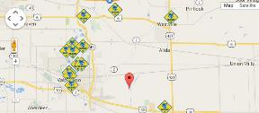

- Pinewood Derby Photo Contest Takes you to pictures of the great entries that were received. See Blog post for winners.
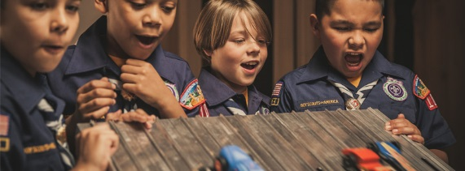
- Day Camp Activity Bracket Challenge
Shows you the completed bracket. See Blog post for winner (ARCHERY!!!)
- Also, on the home page –
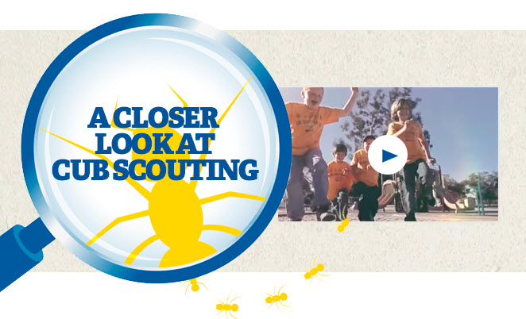
This link takes you to a YouTube Video
on Cub Scouting.
https://www.youtube.com/watch?feature=player_embedded&v=dqKFgk8SJlE
These Six Links take you to:
(From top left across, then down)

www.scoutstuff.org – The Supply Division site where you can find the location of your nearest National Scout Shop or buy all your Scout supplies
http://scoutingwire.org/ - Where you can get the latest Scouting News from around the country. You can sign up to get notifications when things are posted here...
https://cubscouts.org/pinewood-derby-2016-photo-contest - Takes you to pictures of the great entries that were received. See Blog post for winners. (Same as the link on top of homepage).
https://www.scoutbook.com/ Where you can get the Scoutbook APP to track your son's Scouting Experience from Tiger to Eagle Scout.
I just learned that Bob Scott is at it again. Bob led us on the charge to the "CS Adventure Program." Now he is leading the Scoutbook effort. It is sure to be a success!! CD

www.boyslife.org – Go directly to the on-line edition of Boys 'Life
http://scoutingwire.org/marketing-membership/ Get resources and materials to strengthen your unit at BSA's marketing and membership site. Learn the best practices and tips employed by the most successful units.

ADVENTURE PLAN TRACKERS
- Tracking Spreadsheets are posted on the USScouts Advancement webpage (www.usscouts.org). There are be links to them from other places on the site. These spreadsheets are similar in construction and user interface as the existing spreadsheets. The spreadsheets have be tested by the developer of the current spreadsheets and he said they are so good he sees no reason to develop others!!
- Utah National Parks Council has Excel spreadsheets posted for all the new Adventure Plan requirements on their Akela's Council BlogSpot. www.Akelascouncil.blogspot.com .
The Advancement Excel Spreadsheet workbooks are distributed to Scouters for FREE.
PLEASE do not download the files from either site to email or send them digitally to others. They are for your personal / pack use only. If you would like to share these files with others, please copy / send the link to them and send them to the site so they can print off their own. They would love everyone that wants a copy to get their own copy absolutely free. Both USScouts and Utah National Parks receive Ad money based on the number of people visiting the site that helps keep their websites open. Please help us by encouraging others to visit them to obtain the files.



BE UP TO DATE

www.scouting.org/programupdates
The Program Updates page has been regrouped. Since the CS Adventure is in full swing, the emphasis on getting ready for it has been reduced. The downloads are still all there. And great information about three new Cub Leader courses at Philmont Training Center next summer.
There is a lot of information now on etting ready and implementing the changes to the Boy Scout program.
Check it all out – stay current!!

CUB SCOUT
LEADER TRAINING

IN-PERSON TRAINING
Position-Specific In-Person Training Guides Available Now! The training guides for
- Den Leader (http://www.scouting.org/filestore/training/pdf/515-215.pdf ),
- Cubmaster/Assistant Cubmaster (http://www.scouting.org/filestore/training/pdf/511-503_WB.pdf ), and
- Pack Committee (http://www.scouting.org/filestore/training/pdf/511-504_WB.pdf )

Are available on Scouting University. You can access them at http://www.scouting.org/training/adult.aspx .
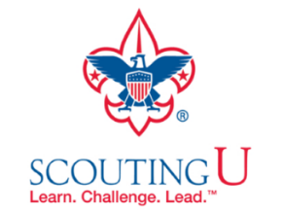

ON-LINE TRAINING
On-Line Training for all Cub Scout positions has been available since October 25, 2015
The online training for Den Leaders, Cubmasters, Committee Chairs and members, and Chartered Organization Representatives is totally updated with help from volunteers from around the country. The new training is divided into shorter, more targeted modules so leaders can get the training they need, in the order they want, any time they need it. It is organized around the learning needed prior to the first meeting, in the first 30 days, and to be position-specific trained. This training was developed to be implemented in conjunction with the BSA’s new learning management system. Keep an eye on
my. Scouting Tools (log in at https://My.Scouting.org) for more information.
Go to the BSA Volunteer Training Team Facebook page (Link above) and.
Then you automatically receive the latest news!!

If you are having difficulties with
the training or system call
Member Care at 972-580-2489,
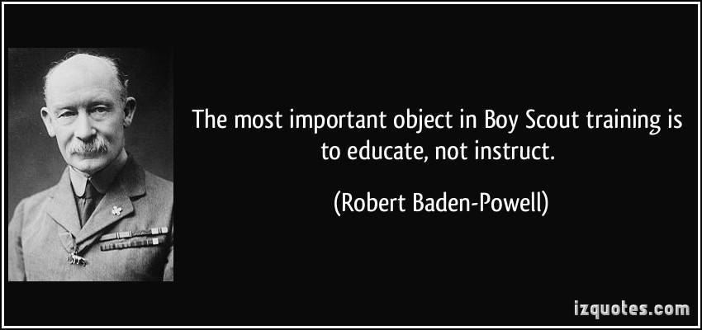
A Typical Learning Plan has several parts –
There is no need to complete more than one section at a time. Do what you have time to do.
Here you can see the three parts of the CM Course -


Each of these three parts is broken down into "bite sized" chunks:
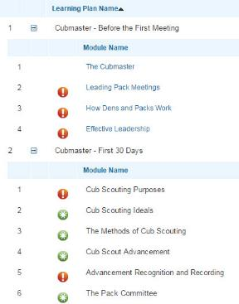
Go check it out and get your
people trained!!!

CUB SCOUT IDEAS

Recruiting New Leaders
Excerpts from “Selecting Cub Scout Leadership,”
Be sure to read the whole pamphlet!!
The Key Three of your pack (The Chartered Organization Representative, the Committee Chair, and the Cubmaster) as well as all the members of the committee should be familiar with the steps of selecting and recruiting quality leaders for your Pack. The key to the process is found on the pamphlet, “Selecting Cub Scout Leadership,” No. 13-500.
The quality of any program, whether it's a Scouting program or any other program, is directly related to the leadership. The stronger the leader, the stronger the program. Selection of leaders is the responsibility of the unit committee and chartered organization. This shown by the requirement to have the Committee Chair and the Chartered Organization Representative sign the new leader's application prior to submission to the local council. The Chartered Organization (as well as the Committee) may seek advice from the BSA local council about the process. Your Unit Commissioner should be actively helping you in this process.
How does a committee or an organization actually go about selecting and recruiting the best person?
Step 1— Gather a Selection Committee
The head of the organization or COR appoints a selection committee. In the case of an existing unit, the unit committee is the logical starting place. However, parents and others may be invited to participate in the process.
Step 2 — List the Qualifications
After a committee is brought together, they then make a list of qualifications the candidate should possess. These traits should be listed on a flip chart for all to see.
Step 3 — List the Candidates
With the qualifications agreed upon, the committee then brainstorms a list of all possible candidates. All candidates mentioned are placed on the list and no committee member may disqualify candidates at this time. With the candidate list developed, the committee then numerically prioritizes the list.
Step 4 — Organization Approval
Since the leadership is the responsibility of the chartering organization, the institution head should provide his approval of the committee's selection.
Step 5 — Call on the Prospect
Now the committee selects a visitation team (usually three people) to visit the number one prospect on the list.
The committee should consist of someone knowledgeable about the Scouting program, someone representing the organization, and someone who has influence with the prospect.
Step 6 — Approach the Prospect
The interview should occur at the prospect's home. After a presentation is made to the prospect, the influential person should ask the prospect to serve. If the prospect is unable to serve, an alternate position should be offered.
If the number one prospect has declined, the number two prospect becomes the top prospect and the process begins again with the institution head.
When the prospect Says Yes; Now What?
Once the prospect has said yes, three things need to occur. First, an application is completed. Second, immediate training should occur. This may be Fast Start or some sort of personal coaching. This needs to occur within 48 hours of his commitment to do the job. Third, an announcement should be made to the organization, other leaders of the unit, and parents as to the prospect's acceptance of the position.
Be sure to get your own copies of Selecting Cub Scout Leaders, No. 13-500; and Selecting Quality Leaders, No. 18-981.
Comment from Commissioner Dave –
My personal Rule #1 – Do NOT beg, you are offering this person a tremendous opportunity to help youth grow to succeed in our world. Approach them on a high plane. Keep the conversation upbeat.
When you say to someone that they are your last hope, you are telling them they were not your first choice. It is not a compliment.
Tell them they will not be alone. There are other leaders. There is an almost infinite amount of literature. Both written on paper and on the web. There is training for new leaders, Cub Scout Position Specific, and continuing training, Roundtables. Also, supplemental, Pow Wow, Danger Zone, Philmont Training Center, and more, there is advanced training, Wood Badge.
And you get to wear a snazzy uniform!!!
Here are few interactive things to help you -
Leader Recruitment Skit
Circle Ten Council
The following is a skit from the 2002 Circle Ten Pow Wow book that can be used very effectively to recruit new leaders. You should modify as needed to better describe your unit and its needs. Commissioner Dave
Who Else…
Set Up: Have all the Cub Scouts and Webelos line up at the front of the room with a spotlight shining on them. Have the adults read the following parts from the back of the room.
Assistant CM: Boys are the nicest things that ever happened to me … those arrogant, self-assured little men-children who assume that all the great big world revolves around them.
Tiger Leader: Who else can carry half a worm, one crushed daisy, a piece of scrap metal, a three-day old apple core and two cents all in one pocket?
Den Leader: Who else can take a bath without getting their shoulders wet, and wash for dinner without turning on the faucet?
Den Leader: Who else can believe that right is right and wrong is wrong, and the good guy always wins in the end?
Webelos Leader: Who else can be a fireman, sword fighter, cowboy, deep-sea diver, all in the space of an hour, and then solemnly hold a funeral, complete with cross and box, for a shell off a turtle lost a month ago?
Webelos Leader: Who else can be a cutter without teeth, meaner without malice, kinder without embarrassment, sillier without foolishness, and clean without neatness?
Committee Chair: The world gains much in leaders and manpower when boys grow up … but it loses something too. That magic feeling that comes with being nine! The feel of dust between bare toes and the ability to lie quietly while time stands still, to watch a minnow in a brook.
Cubmaster: Me … I like Cub Scouts - the boys! They smile when I need a smile; they tease me when I'm somber; they keep me from taking myself too seriously. No, I don't wish that I were nine again. I just hope that somehow God will see to it that I always have someone nine years old in or near my house and heart.
All: Cub Scouting is the nicest thing that ever happened to ME!
At this point you begin your recruitment of new leaders and committee people building off the theme of that the adults enjoy Cub Scouting too.

ROUNDTABLE HINTS
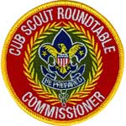
Make Your Roundtable an EPIC Experience for Participants
Jeff McHoul, Assistant Council Commissioner – RTs
Cradle of Liberty Council
Last month, we looked at some methods of "Refocusing your Roundtable " to better serve the needs of the Cub Scout Leaders of your District, this month the focus is on some strategies to continue that process, and can help with your planning for your
2016 - 2017 program year.
As we discussed before, the Cub Scout program has a built in attrition curve of Leaders, which means that each Roundtable may be "the first time" for any single participant of your District Roundtable, and you will only have one opportunity to make a positive first impression.
Leaders who attend Roundtable may all be at different points on the experience curve, but you will still need to be on your game with your program, and your Roundtable Commissioner staff will need to be working together as a high functioning team in order to make an impact.

One approach it to strive to make every Roundtable an EPIC experience:
- E - Exceptional & Experiential
- P - Personally & Program Relevant
- I - Instructional & Inspiring
- C - Concrete

Exceptional & Experiential
You should strive to present an exceptional and experience based program
- know your program level material
- prepare your presentation in advance and rehearse
- make your Roundtable a "hands - on" event - have the Leaders who attend take part in the program by participating in demonstration ceremonies, try any games presented, and work on any project presented
Personally & Program Relevant
Make the presentation personally and program level relevant to the Leaders who attend -
- plan for level specific break-out programs that address the specific needs of Den Leaders as well as Cubmasters and Committee members
- provide program ideas that are simple, directly support the program at every level, and are easy to reproduce and use at every level
Instructional & Inspiring
Structure your program so that it is an instructional experience, providing examples of the method of delivery, that motivates and inspires Leaders
- provide simple directions for games
- example scripts for ceremonies, songs, skits and cheers
- assemble and provide simple kits for each project that you present, and plan for sufficient quantities for all participants and any potential participants
- provide support and coaching to participants while working on projects and tasks to inspire them to take ideas back to their Dens and Packs
Concrete
Bring all of these components together at one place at one time, with a trained and motivated Roundtable team to deliver a concrete experience that provides Cub Scout Leaders with what they need to deliver a successful program at the Den and Pack level .

A Roundtable experience that is relevant to the level and responsibilities of the leaders who participate in your program; incorporating simple, easy to use hands-on instructions, and providing the inspiration to bring ideas back to their Packs and Dens; will provide an EPIC experience that will better serve the Cub Scout Leaders of your District; and ultimately build a stronger Cub Scout program.



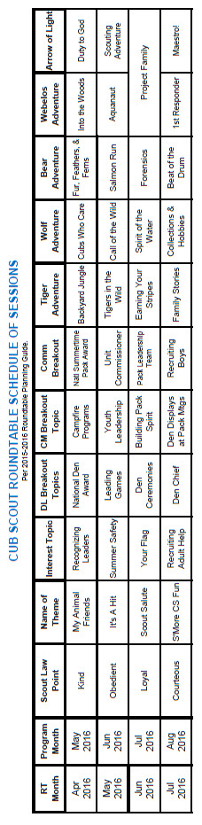

2016 – 2017
CS RT PLANNING GUIDE
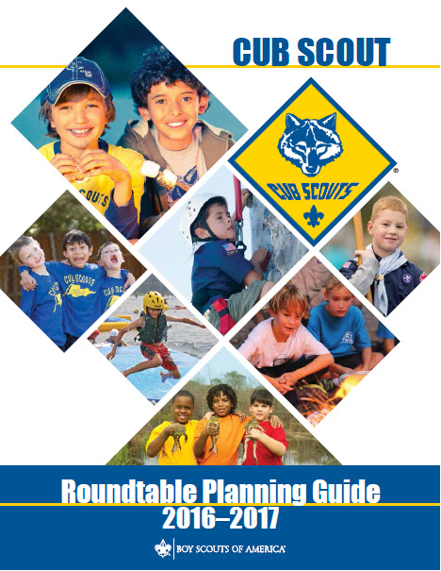
IS ISSUED !!!
You can download a copy at the Roundtable Support page of the Commissioner's part of National's website:
http://www.scouting.org/scoutsource/Commissioners/roundtable.aspx
This year's edition was prepped by the Cub Adventure Team who created the new Adventure Program.
Page 5 of the new Guide states -There is an exciting new look to the Cub Scout Roundtable this year. Some differences you may see in this guide are:
- The Cub Scout Roundtable training plans no longer provide pack meeting monthly themes or pack resource sheets. The pack meeting plans found online at Scouting.org are designed to help the Cubmaster plan terrific pack meetings and support den leaders with den pack assignments. You may continue to emphasize the pack meeting plans during your Roundtable as a helpful resource.
- You will now see Cub Scout interest topics that tie in with points of the Scout Law, and a month is suggested for delivery of each topic. These topics have been integrated into the roundtable program agendas—both the breakout and combined options—to add the element of supplemental training on material that the leaders have asked to learn more about.

DEN MEETING TOPICS
Remember – Boys want to be active!!
See, too, that they earn their awards
(Never say GET. You get sick, you do not get awards – You earn awards. A little CD Philosophy).
Big Rock Ideas – suggestions for Big Rocks that fit Interest Topics or seasonal activity. If years are next to an item (e.g. 13-14) that suggested Big Rock is in that Roundtable Planning guide and on-line at http://www.scouting.org/scoutsource/Commissioners/roundtable.aspx
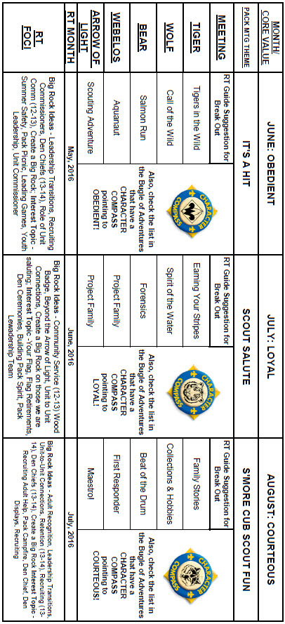

CHARACTER COMPASS
JULY -
ADVENTURES with a CHARACTER COMPASS pointing to LOYAL:
TIGER –
- Team Tiger (Core)
- Earning Your Stripes
WOLF –
- Council Fire (Core)
- Spirit of the Water (Elec)
BEAR –
- Grin and Bear It (Core)
- Forensics (Elec)
WEBELOS CORE –
- None (Core)
ARROW OF LIGHT CORE –
- Scouting Adventure (Core)
WEBELOS & AOL ELECTIVES –
- Project Family (Elec)


JULY -
ADVENTURES with a CHARACTER COMPASS pointing to COURTEOUS:
TIGER –
- Tiger Bites(Core)
- Tigers – Safe & Smart (Elec)
WOLF –
- Call of the Wild (Core)
- Collections and Hobbies (Elec)
BEAR –
- Paws for Actions (Core)
- Beat of the Drum (Elec)
WEBELOS CORE –
- First Responder (Core)
ARROW OF LIGHT CORE –
- None (Core)
WEBELOS & AOL ELECTIVES –
- Maestro (Elec)

THEME RELATED STUFF


SCOUT SALUTE
RELATED ADVENTURES
The following Adventures involve heroes and such –
TIGER –
- Family Stories - Interview one of your grandparents or another family elder – Use this interview to learn about a hero in your heritage.
- Sky is the Limit - #7 – Find out about two astronauts when they were younger …
WOLF –
- Hometown Heroes – the whole adventure
- Council Fire - #5 – Talk with a military veteran, law enforcement officer, …
- Collections and Hobbies - #5 – Write to a famous living person
- Cubs Who care - #1 – Visit a person with a disability, #2g – Learn about someone famous with a disability
BEAR –
- Paws for Adventure, #1 – Famous Americans, #2 – Visit and Talk with Police
- Fellowship and Duty to God - #2b - Identify a person whose faith and duty to God you admire
WEBELOS CORE –
- First Responder - #8 – Visit with a First Responder
ARROW OF LIGHT CORE
- Building a Better World - #4 – Meet with a government leader …
- Duty to god in Action - #2d - Read at least two accounts of people in history who have done their duty to God …
WEBELOS & ARROW OF LIGHT ELECTIVES –
- Build My Own Hero – the whole Adventure
- Aquanaut - #8 - Invite a member or former member of a lifeguard team, rescue squad, the U.S. Coast Guard, U.S. Navy, …
- Adventures in Science - #3i - Read a biography of a scientist. Tell why they are famous.
- Movie Making – Make your movie about a hero.
- Project family – You could use this adventure to discover Heroes in your family history.

Fun Facts About Heroes
Alice, Golden Empire Council
If you need some help remembering heroes, this site lists heroes from various times – click on a specific name and you will be able to see a bio of that person, and click on values of that hero, their defining moments and stories of their failures. This is a Christian website, but with excellent information about the people they feature. The five values they identify as belonging to every hero are: they are fearless, they are applied (very committed), instructed (they have learned as much as they can), they are tireless, and they are humble. I love the fact that there is a link to “warts” - a great way to remind the boys that a true hero is not perfect, and has overcome failures. Lots of stories at: www.heroesofhistory.com .

Honoring American Heroes
Veteran’s Administration History
www.va.gov
1789 – A law was passed to give money to soldiers who fought in the American Revolutionary War ~ many had fought without pay during the war.
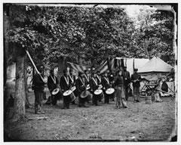
1861 – The Civil War broke out and Union veterans grew from 80,000 to 2 million!
1862 – President Lincoln started national cemeteries to honor the many Union dead from the Civil War.
1865 – President Lincoln gave his second inaugural speech. He asked Congress “to care for him who shall have borne the battle and for his widow, and his orphan.” This became VA’s motto.
1912 – The Sherwood Act gave pensions to veterans of the Mexican and Civil Wars when they turned 62, even if they were not sick or disabled.
1930 – President Hoover signed a bill creating the Veterans Administration (VA).
1940 – Congress created a law to help World War II veterans find jobs when
they came home from war.
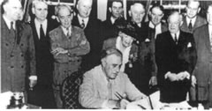
1944 –On June 22, President Roosevelt signed the GI Bill of Rights, which enabled veterans to go to college and buy a home without a down payment.
1946 – More hospitals were built to take care of veterans, including research facilities..
1973 – The Army gave 82 cemeteries to the Veterans Administration, which maintains the gravesites and provides honorable ceremony and maintenance.
1988 – Congress made the Secretary of the VA a cabinet post, allowing access to the President.
1998 – All eligible veterans could now enroll in VA’s health care system.
The Story behind the Motto of the VA
www.va.gov
Lincoln’s words became the VA motto in 1959
with the words, “To care for him who shall have borne the battle and for his widow and orphan.” President Lincoln stated the government’s duty to care for those who are hurt or died defending our Country.
Here is a picture of the VA Seal.

- The eagle represents the United States.
- The circle of 5 stars above the eagle stands for the U.S. Army, Navy, Marine Corps, Air Force, and Coast Guard.
- The flags in the eagle's claws show America's history from 13 colonies to 50 states.
- The gold cord is a symbol for those who died while serving our country. The eagle is holding the cord to keep the memory of those veterans alive.

Some Great Rules To Follow
If You Want To Become A Hero
Alice, Golden Empire Council
- Do your share to make your school, your community, and the world a better place. .
- Take responsibility for what goes on around you.
- Participate in community service.
- Help take care of the environment.
- Be a good neighbor.
- Treat other people with respect and dignity.
- Follow the rules of your family, your school, and your society.
Some Ways to Help at a National Cemetery:
(Contact local National Cemeteries
to arrange activities)
Alice, Golden Empire Council
- Plan ceremonies for Memorial Day or Veteran’s Day
- Donate helpful items such as golf carts used to transport visitors who need assistance in reaching a gravesite
- Recruit volunteers for the cemetery
- Raise and lower cemetery flags on national holidays
- Play taps at burial ceremonies
- Repaint or stain benches
- Help with Welcome Home events.

Hero True Or False
Alice, Golden Empire Council
Tell the boys that you are going to read some statements (Or you could give each boys his own list) If the statement describes a hero, the boys can stand. If the statement does not fit the definition of what makes a hero, boys can remain seated. (Or have the boys circle the number in front of a correct statement) However you use the statements, be sure and discuss them with the boys afterwards – let everyone share their opinion, and make sure that the boys know these are just opinions – and everyone can have their own ideas. See if you can arrive at a definition that everyone agrees to.
- A hero is brave and strong.
- A hero is caring and thoughtful.
- A hero is selfish.
- A hero is never frightened.
- A hero wants to be rewarded for his or her actions.
- A hero makes mistakes.
- A hero is never silly.
- A hero is dishonest.
- A hero puts others before himself or herself.
- A hero stands up for himself or herself.
- A hero never gets angry.
- A hero is always a popular person.
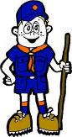

PACK MEETING THEMES
AND PLANS
www.scouting.org
From National's Website for the new plans using the Core Values based on the Scout Law:
Here are a few thoughts to consider around these new pack meeting plans. First, there is a plan for each month that corresponds with a point of the Scout Law. In addition, each plan has a theme to help make the pack meeting even more fun! The plans do not have to be used in a specific order.
Tips for Utilizing the Plans
- Pack meeting plans do not have to be done in any special order, but it is recommended that you include all of the points of the Scout Law each year. The pack planning meeting would be a good time to determine the order.
- There are pack meeting plans for multiple years posted on the website. It is your pack's choice of which one to select from each point of the Scout Law for each year.
- Pack meetings should not last longer than an hour. Adjust the plan to make it fit within the time. Research and experience tells us that Cub Scouts have a hard time sitting still for that long. Keep the meetings fun, active, and engaging.
- If you are comfortable with a costume to fit the theme of the meeting, go for it!
- Importantly, keep it simple and make it fun.
- The following required adventures have a requirement that suggests or requires completion at a pack meeting. Please plan accordingly as part of your annual program planning process. Work with your den leaders to plan when these activities will take place.
Tiger
- Tigers in the Wild, requirement 5. Participate in an outdoor pack meeting or pack campout campfire. Sing a song and act out a skit with your Tiger den as part of the program.
- Games Tigers Play, requirement 3. Make up a new game, and play it with your family or members of your den or pack.
Wolf
- Council Fire, requirement 6c. Create a den project from recyclables for a pack meeting.
Bear
- Grin and Bear It, requirement 2. Working with the members of your den, organize a Cub Scout carnival and lead it at a special event.
- Grin and Bear It, requirement 3. Help younger Cub Scouts take part in one of the events at the Cub Scout carnival.
Webelos
- Stronger, Faster, Higher, requirement 5. With adult guidance, lead younger Scouts in a fitness game or games as a gathering activity for a pack or den meeting.
Arrow of Light
- Building a Better World (if chosen), requirement 10b. Set up an exhibit at a pack meeting to share information about the World Friendship Fund.
As a personal note: I have read some of the plans and they are excellent and just as complete as the new Den Leader Books. The games, and other stuff are right there. Including costuming ideas for that added PIZAZZ!! If you do not use themes and do not add PIZAZZ you are not doing your best for your pack.
GOOD JOB!!! From CD
Check them out at:
http://www.scouting.org/Home/CubScouts/Leaders/CubmasterResources/PackMeetingPlans.aspx


Kim, the chair of the task force, says "I do want to stress that the focus is still the Core Value and the theme is just there as an enhancement. Pack meeting theme plans are specifically crafted to bring out the important points of the Core Value in a fun way."

PACK MEETING THEMES
2015–2016 Pack Meeting Plans
June | Obedient | "It's A Hit"
July | Loyal | "Scout Salute"
August | Courteous | "S'more Cub Scout Fun"

2016–2017 Pack Meeting Plans
September | Helpful | "To The Rescue"
October | Kind | "Creepy Crawlers"
November | Courteous | "Cubs In Shining Armor"
December | Cheerful | "Celebrate"
January | Obedient | "Cub Scout City Council"
February | Reverent | "Passport To Other Lands"
March | Loyal | "Our National Treasures"
April | Thrifty | "Power Up!"
May | Clean | "A Picnic With Pizzazz"
June | Brave | "Roaming Reptile Alert"
July | Trustworthy | "Let The Games Begin"
August | Friendly | "#CUBSCOUTS"
If you are using a paper copy the link to all the
Pack Meeting Plans is:
http://www.scouting.org/Home/CubScouts/Leaders/CubmasterResources/PackMeetingPlans.aspx

UPCOMING MONTHS
July's Core Value, LOYAL, will use the theme, Scout Salute.
Month | Year | Theme
Potential "SCOUT SALUTE" Months
November | 2001 | Hometown Heroes
November | 2009 | Scout Salute
September | 2012 | Hometown Heroes
LOYAL
(Themes for Citizenship, Perseverance)
December | 1986 | The Golden Rule
December | 1997 | The Golden Rule
November | 2010 | Citizenship
November | 2011 | Citizenship
November | 2013 | Your Vote Counts
PATRIOTIC LOYALTY
October | 1951 | Strong for America
February | 1955 | Let Freedom Ring
July | 1964 | Our American Heritage
February | 1966 | Strong for America
February | 1971 | Our American Heritage
December | 1978 | Duty to God & Country
February | 1989 | Strong for America
September | 1989 | Our American Heritage
June | 1994 | Strong for America
July | 2010 | Celebrate Freedom

A Scout is COURTEOUS. The theme S'MORE SUMMER FUN is used to help Cubs understand being COURTEOUS.
A SCOUT IS COURTEOUS
A Scout is courteous. A Scout is polite to everyone regardless of age or position. He knows that using good manners makes it easier for people to get along.
HOW DOES “S'MORE SUMMER FUN” RELATE TO THIS SCOUT LAW POINT?
Summertime is a great time to get outside and to have S’more Cub Scout Fun! This month, enjoy one of the last summer evenings at a pack campfire. Cub Scouts can experience fun activities before the campfire, a campfire full of songs, skits, awards and great memories. At the campfire, the Cub Scouts will treat each other with politeness because they know that is how they want to be treated.
August's Core Value, COURTEOUS, will use the theme, S'More Cub Scout Fun.
Month | Year | Theme
Potential COURTEOUS Months
December | 1947 | Helps and Gives
December | 1948 | Goodwill
December | 1949 | The Other Fellow
December | 1958 | The Golden Rule
December | 1961 | Follows, Helps, and Gives
December | 1971 | Cub Scout Gives Good Will
December | 1984 | Do a Good Turn
December | 1986 | The Golden Rule
December | 1992 | To Help Other People
December | 1995 | Do a Good Turn
December | 1997 | The Golden Rule
November | 2014 | Give Goodwill
November | 2015 | Cubs In Action
Potential "S'More Summer Fun" Months
June | 1941 | Move into the Backyard
July | 1944 | Back Yard Camping
July | 1945 | Outdoor Cubbing
July | 1950 | Outing
June | 1953 | Summertime Adventure
August | 1954 | Annual Picnic
August | 1955 | Outdoor Fun
August | 1957 | Good Old Summertime
July | 1958 | Outdooring
August | 1961 | Outdoor Festival
July | 1966 | Summertime Adventure
June | 1971 | Outdoor Fun
July | 1975 | Summer Adventure
March | 1977 | Kites-Spring
June | 1980 | Outdoor Fun
July | 1984 | Fun in the Sun
May | 1988 | Outdoor Adventure
July | 1992 | Fun in the Sun
June | 1997 | Outdoor Adventure
June | 2003 | Fun in the Sun
August | 2006 | Scouting It Out
June | 2002 | Critters, Cubs and Campfires
August | 2008 | S'More Summer Fun
June | 2009 | A Camping We Will Go
May | 2015 | Backyard Fun

CUBMASTER THOUGHTS
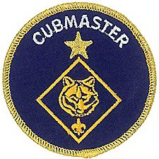

Lions and the
Scout Law & Oath
Mark Diienno, Cubmaster,
Garden State Council
Mark has added Lion Coordinator and Lion Guide to his position as Cubmaster. He has a strong belief that the youngest Scouts and parents need have a great start and learn about Scouting the right way. He is leading his second Lion Pride (Den) this year. 100% of his first one are still active as Tigers!!

Mark Diienno, Cubmaster,
Garden State Council
Mark has added Lion Coordinator and Lion Guide to his position as Cubmaster. He has a strong belief that the youngest Scouts and parents need have a great start and learn about Scouting the right way. He is leading his second Lion Pride (Den) this year. 100% of his first one are still active as Tigers OOpps – WOLFS as of June 1!!
When I first heard of the Lion Program, I wondered how I could relate to a five year old boy. I thought finally the BSA had crossed the line, and I will become a babysitter in a uniform.
And what I thought was more amazing, the “Lion Launch” coincided with the New Program Launch for Cub Scouting, and the Scout Oath and Scout Law would be replacing The Pack Law and Promise.
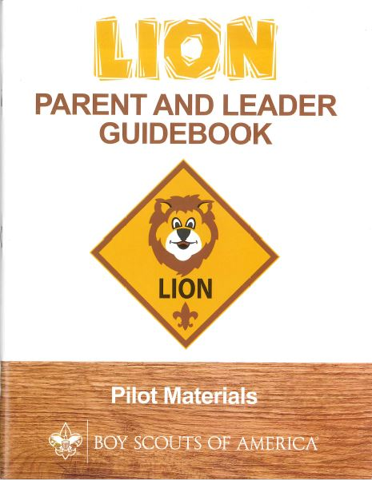
And there it was, page 22, in The Lion Parent and Leader Handbook, The Scout Law and Oath. It took me a while to digest this.
Then I saw the following: “Do not expect Lions to memorize the Scout Oath and Scout Law”
Wow, that was a relief.
I know many an adult Scouter who cannot state the Oath and Law.
So during our first meeting, it was time to give it a try. We practiced how to stand at attention. We practiced The Cub Scout Sign. (This is a very important form of riot control when practiced properly). We practiced The Cub Scout Salute. (This was more out of habit, being the Cub Master, you can’t help but say “Cub Salute!” while you say the Pledge.)
The Lions reacted brilliantly to all of these.

AND THEN A VERY DEEP BREATH

“ON MY HONOR …"
And I recited the Scout Oath.

Blank faces.

ANOTHER DEEP BREATH

“A SCOUT IS..”
And I recite the Scout Law.
I think I heard some grunting from the boys. It was in perfect timing with the rhythm at which I stated the twelve points of the Scout Law.
12 Points - 12 grunts
I’ll take it.
It’s better than the blank looks I got earlier.

And I accepted the challenge.

I would think of ways to make the Oath and Law relevant to a five year old, because they ARE relevant to a five year old.

Our next meeting, I came armed and ready.
I WAS PREPARED

We stood at attention.
We Saluted.
We pledged.
We held up our sign.
I took a deep breath and proclaimed loudly:
REPEAT AFTER ME!
“On My Honor …”
And it was completely different.
I said it slowly, one sentence at a time.
And there they were, participating in those words that define us, and will now begin to define them.
The words and thoughts are easy to understand really. Breaking it down on their level allows them to take ownership.
No blank faces this time.
No, they can't memorize it, but to participate and own the words is a monumental step.
So much for babysitting.
Then I took another deep breath..

REPEAT AFTER ME!
“A Scout is…”
The words came out.
No more grunting.
And these words can be understood by a five year old. Because they are just like us.

They want to be good. To do what is right.
They want to be trustworthy.
They are naturally friendly.
They are always kind.
They work hard on being Obedient.

To further the understanding of the Scout Law we play a game.
We lay the twelve points of the scout law on the floor, and line the Lion Parents on each side forming a human Scout Law ladder.
We roll up our socks, (Yes we are barefoot for this. The Lions (five year old boys) think it is great), and the boys take turns rolling the socks on the floor over the ladder. The parents keep the sock in bounds by kicking it back in if it goes astray.
The sock will land on a point of a Scout Law and the leader discusses it with the Pride in Lion Terms.

For instance -
The sock lands on..
TRUSTWORTHY – Did you really brush your teeth when Mom and Dad told you to do so?

CLEAN – Do you clean up your toys when you are finished with them?

REVERENT – Do you say your prayers every night?

The Scout Law and Oath are relevant, and teachable to ALL Scouts.
We as leaders, cannot forget that all activities should be age appropriate to be effective.
Even the Law and Oath.
There is nothing a five year can't do or learn, if he is led properly.
Stay tuned next month for more talk on the Lion Program
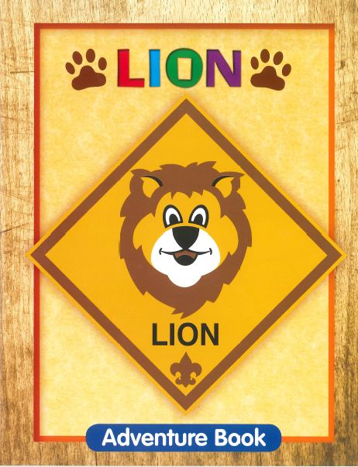

The Chief Scout Executive
on Lions
What We Know
According to a 2014 U.S. Census Bureau report, 57 percent of kids ages 6–17 participate in at least one after-school extracurricular activity. This means that by the time they are eligible for Tigers, more than half of them already are engaged in some type of athletic, artistic or other program.
Often, children become attached to lifelong activities at an early age — that is certainly a goal we would have, as we know the long-term benefits of Scouting involvement include strong asset development in the areas of character and leadership. However, we also know that when youth participate in numerous activities at an early age, and miss joining Scouting, they are unlikely to do so at adolescence.
What will be important to learn in the next few years, if the initial entry point works at the kindergarten-age level, is will this cause losses at a different age, or will the program keep the same retention all the way through to Boy Scouting?
What we learn from the pilot Lion format could also help us assess and create a smoother transition from Webelos into Boy Scouting. Too many parents now see a barrier or obstacle, rather than a smoother transition. You will often hear parents say, “We did Cub Scouting, now we’re not sure if we are going to do Boy Scouts.” We do not have a seamless transition into Boy Scouts for a number of reasons. This pilot test will help us think through some of these issues.
We want to be sure that our Lion program delivers the right mix of character and leadership values and that we set the bar high. The program must be sustainable, we must have the right infrastructure to support it, and it needs to address in a meaningful way the needs of parents who want their kids to join Scouting at an earlier age.
You can rest assured that we will carefully evaluate our progress and keep you apprised of the results. Stay tuned for more.
Thanks for reading.
Mike

Reprinted from "The Chief's Corner" on Scoutingwire.org
MORE LION INFORMATION
Bryan's Blog has written about Lions –
New details released about Lions, the pilot program for kindergarten boys
March 10, 2016 // 38 Comments
 In Lions, the new pilot program for kindergartners, boys wear T-shirts instead of uniforms and earn adventure stickers instead of adventure loops.
Lions, a new pilot program for kindergarten boys, to begin this fall
February 24, 2016 // 109 Comments
 Lions, a new Boy Scouts of America program for kindergarten boys, will begin a pilot in participating councils this fall.
Will Lions be part of the pack? (And answers to your other Lion questions)
April 15, 2016 // 15 Comments
 Will Lions be part of the Cub Scout pack? By adding another year to the program, is the BSA concerned about "burnout"? And why was the Lions name chosen?
Cub Hub Lion Posts
Go to the Cub Scout Learning Library item to see the Cub Hub Blog entries on The Lion Program.
There are slideshows on the web put up
by local councils. Some examples are:
WD Boyce Council has "Lion Cub Pilot Program" at: http://www.wdboyce.org/document/lion-cub-pilot-program/161325
Northern Star Council has a training slide show for District Coordinators and others at: https://www.signup4.net/UPLOAD/NORT26A/LION12E/District%20Lion%20Cub%20Coordinator%20Training.pdf
Councils are putting up webpages about what their packs need to know to begin a Lions Program. Examples are:
New Birth of Freedom: http://seb.newbirthoffreedom.org/2016/03/22/were-approved-for-the-lion-scouts-pilot/
WD Boyce: http://www.wdboyce.org/cub-scouts/lion-cub-pilot-program/63360
Garden State (My Council): http://www.gardenstatescouting.org/lion-program-0
Garden State, also, has an FAQ PDF - http://www.gardenstatescouting.org/sites/default/files/Lion%20Program%20FAQ.pdf
And we have created a Facebook page for our units with Lions - https://www.facebook.com/GSCLion/

Scoutingwire has had a series of
posts on Lions:
New Lion Program Piloting This Fall! http://scoutingwire.org/new-lion-program-piloting-this-fall/
What’s A Lion, Exactly? Here’s The Scoop http://scoutingwire.org/whats-a-lion-exactly-heres-the-scoop/
Answers To Your Lion Program Questions Revealed! http://scoutingwire.org/answers-to-your-lion-program-questions-revealed/
Our Lion Pilot Program Aims To Attract More To Scouting At A Younger Age http://scoutingwire.org/our-lion-pilot-program-aims-to-attract-more-to-scouting-at-a-younger-age/

Organizing for Lions
From – New Birth of Freedom Council
For those packs that are thinking ahead about participating in the Lion Scouts program, having the right volunteers involved in delivering the Lion Scouts program will be important. Research shows that the most important person for a successful Scouting experience is a good leader. There are two new adult leader positions within the pack that are directly engaged in the delivery of the Lion Scouts program – a Lion Coordinator and a Lion Guide. Where do these positions fit into the current pack structure?

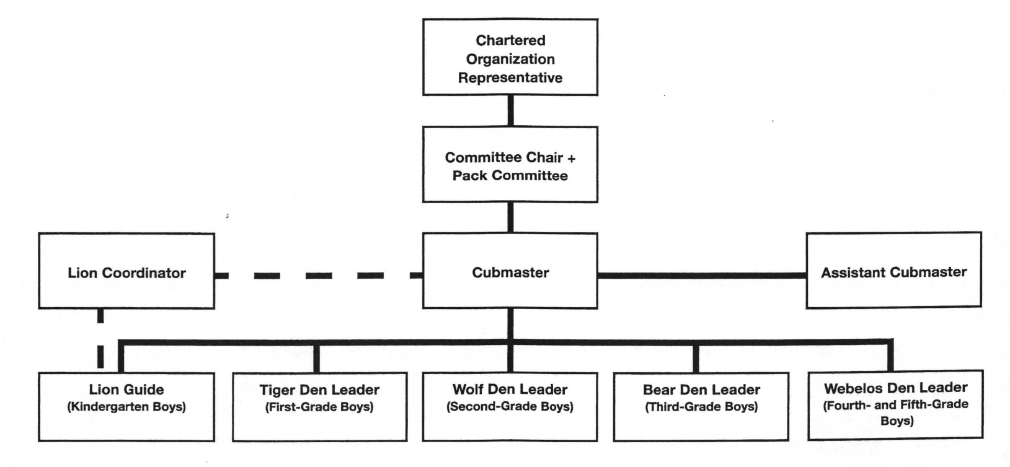

What is the Lion Coordinator’s job description?
- Is an experienced and successful den leader
- Understands den and pack operations within the overall structure of Cub Scouting
- Demonstrates excellent communication and organization skills (and will remain in at least monthly contact with the Lion dens)
- Participates as needed in the unit’s School Night with all new Lions and their parents
- Assists the Lion guide in hosting the first orientation meeting for all the individual Lion dens in their pack
- Serves as a coach and mentor for Lion Guide
The position description for the Lion Guide is as follows:
- Has previous successful experience as den leader
- Works directly with other den and pack leaders to ensure that the den is an active and successful part of the pack
- Plans and prepares for initial Lion den meeting and outings
- Mentors adult partners in the delivery of Lion den meetings
- Attends the pack leaders’ meeting
- Leads the den at the monthly outings and other pack activities
- Ensures the transition of Lion Scouts to Tigers at year-end
- Prepares the Lions for day camp at the end of the Lion year if appropriate
- Coordinates shared leadership among the Lion adult partners in the den
- Ensures that each Lion and his adult partner have the opportunity to be the host team, which plans and executes the den activities, and rotates responsibilities monthly
Selected FAQ's
Our council has run a kindergarten-age program for years. Why is this considered a “new” program now?
Although a few councils have run locally-developed programs in the past, the National Lion Pilot launching now is the only approved BSA program for five-year-old kindergarten-age boys. The curriculum was developed by a team of experts, including representation from the fields of childhood development, education, and child psychology. Locally-developed content was reviewed by that team, and the best pieces woven into the new curriculum. That team worked to ensure that the organization’s high standards were met in delivering effective (age-appropriate) character and leadership programs. A small number of councils have tested the new curriculum over the past two years, and it is now ready to expand as a national pilot.
Why was the “Lion” name selected? I remember a Lion rank in Cub Scouting from years ago. Are you just bringing it back?
Congratulations to all the Scouting historians who caught that! Yes. The Lion name has significance as a rank within Cub Scouting from the 1930’s-1960’s. As names were considered for this new, cutting-edge pilot program, honoring a name from our past made sense. It was a great way to give a nod to the organization’s rich history of delivering fun and exciting Scouting experiences to our nation’s youth. Indeed, it was a fun way to look back at our history while moving forward in a new and exciting way.
Isn’t this just the Tiger program re-branded? Will boys be doing the same activities two years in a row?
No. The Lion pilot program is designed to be an introduction to Cub Scouting. It is filled with fun, age-appropriate activities that will appeal to kindergarten-age boys. Although they share a focus on the traditional Scouting concepts of character development, leadership skills, personal fitness and citizenship, the activities are specific to the Lion program and are not duplicated within Cub Scouting. The activities will be fun and challenging in a way that is separate and apart from what boys will experience as they enter Tigers in 1st grade.
By adding a new rank to Cub Scouting, won’t boys and families “burn out” sooner and drop earlier then they normally would?
Chief Scout Executive, Mike Surbaugh, commented on this in this Chief’s Corner post in March. (Reprinted in this article) He wrote, the Lion pilot is, “designed to develop good, measurable data to determine program quality, parent involvement and its overall fit into the Scouting format.” The pilot will help determine whether a kindergarten program will benefit the development of five-year-old boys, and how it might effect their movement through BSA program areas long-term. As was written by many of you in posts and comments, though, fun and engaging program delivery may be more impactful on retention than a program’s overall length. This pilot will track that type of data and provide key learnings as we move forward.
We’re so excited about this program, when will I know if our council is approved to participate? How will we be told?
Interested councils may apply through their Area Director to become a pilot site. Scout Executives are aware of the application and notification processes. If interested, please contact your council office to inquire. The excitement continues to build!
How will Lions be structured? I’m thinking it might be hard to find volunteers to lead a group of boys that age.
Lions will be organized in dens of six to eight kindergarten-age boys. The dens will be mentored by Lion Guides (experienced Cub Scout adult leaders). Similar to the Tiger rank, each boy will be required to have an adult partner. With the guidance of the Lion Guide, each adult partner will take turns leading den meetings or activities. It is a shared leadership concept.
Will Lions be a part of the pack?
Yes. For units participating in the pilot, Lions are a part of the Cub Scout pack. It is important to note, however, that Lions will only be a part of the pack at an introductory level. The Lion program is designed to introduce five-year-old kindergarten-age boys to the fun and excitement of Scouting, but in ways that maintain appropriate expectations. Because of their age, development level, physical abilities, and stamina, it would be unrealistic to expect Lions to participate fully in pack activities. For example, Lion dens should not participate in pack fundraising, overnight camping or activities such as shooting sports. Those experiences, and others, are more appropriate for older boys as they move through Tiger, Wolf, Bear and beyond. Instead, keep the Lion dens focused on their exciting (and age-appropriate) adventures. Invite them to attend just a few (two to three) pack meetings throughout the year. Be sure to include them in special activities, but only if appropriate for kindergarteners. Remember, the Lion program is an introduction to the world of Scouting. Deliver the curriculum as written and keep it fun!
I can’t help but wonder if this is driven by low recruitment and a desire to get more fees. Is that the case?
Absolutely not! The development of a kindergarten program is driven by the desire to reach more of America’s youth with the purposeful outcomes only Scouting can provide. Oftentimes, families make “joining” decisions at about the kindergarten age. As they enter 1st Grade, schedules are often full and we’ve missed the opportunity. We know from the recent Tufts study that Scouting works! It has a tremendous impact on the lives of young people. The Lion program is a way to reach more of America’s families with the benefits of Scouting.
What are some positive results/outcomes you can share from councils that have already piloted Lions?
Pilot units have been extremely positive about their Lion program experience. A common theme emerging from those units has been their ability to identify engaged families for future leadership roles within the pack. Remember that the Lion program uses a shared leadership concept – introducing parents to the idea of leading just a few meetings or activities throughout the year. This gives the parents a chance to try their hand at leading activities and gives units a way to interact with those parents. In addition, pilot units showed very strong Tiger recruitment the following year. There will be much more data learned this fall as the pilot executes on a broader scale, but these have been early positive outcomes among initial units.

WEBELOS
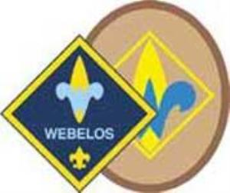
Always an S Webelos always ends with an S whether talking about one Webelos Scout or a den of Webelos. It is an acronym – WE’ll BE LOyal Scouts. As the CS RT Commissioner who mentored me says – "If you don’t have an S at the end – then there is nothing to which to be loyal."

WEBELOS-TO-SCOUT TRANSITION
Margo, Pacific Cascade Council
Transitioning a boy from Webelos Scouts into Boy Scouts is an important part of fulfilling the mission of BSA: preparing young people to make moral and ethical decisions by instilling into them the values of the Scout Oath and Law. Scouting is for the life of the boy. Every graduating Webelos Scout deserves the opportunity to continue his Scouting experience as a member of a Boy Scout troop. How can we make this transition go smoothly?
The purpose of the Webelos-to Scout transition process is to get every Webelos Scout into Boy Scouting by giving every Webelos Scout a sampling of:
Troop programs and events
Troop leadership style
Boy Scout advancement opportunities
The fun and excitement of Boy Scouting
The Role of the Webelos Den Leader.
The leaders of the Webelos dens have a big job. They are responsible for the bulk of the transition into Boy Scouting. Over the course of the boys’ 4th-and-5th-grade years the Webelos leader will carefully guide the Webelos Scouts through the process.
The transition starts with the introduction of the Webelos Scouts to basic elements of Boy Scouting through the requirements of the Webelos rank and the Arrow of Light award. These include learning more about the Scout Oath and Law, as well as other basic elements of Boy Scouting such as the motto, slogan, handshake, and salute. The boys learn about the First Class rank of Boy Scouting and about how their uniform will be different when they are in Boy Scouting.
Conscientious Webelos den leaders who wishes their boys to have a smooth transition into Boy Scouting will enthusiastically describe the adventures to come in Boy Scouting and tell each boy that he is ready for the challenge.
Visit One Troop or Several?
As the boys go through the steps of the Arrow of Light badge, the time will come for the den leader to arrange visits with one or more troops. Let’s talk for a minute about the advantages and disadvantages of transitioning to one troop vs. several.
Transitioning all the boys to one Boy Scout troop is certainly easier for the leaders. Fewer troop visits are needed, and the transition can flow much more smoothly. Visiting with the same troop several times allows the Webelos Scouts to bond with boys in the troop more quickly. However, not every boy will find that he fits well in the troop that was chosen “for” him. And since he will likely be unaware of what other options are out there, if he is not happy in the troop, he will likely drop completely out of Boy Scouts.
In an ideal world, Webelos den leaders will arrange visits with several different troops. This can be difficult and time-consuming. But this method will allow the boys to see that they have options. Each Webelos Scout can choose the troop that he and his family feel is the best fit for him. And if he discovers that he is not happy in his chosen troop, he will know of other troops he could join.
If a Webelos den visits several troops, the Webelos den leader should help the boys compare and contrast the different troops. Each troop will have different strengths and focuses. Some troops love camping, others focus on service, etc. Troops can and should be visited both at regular meetings and at outdoor activities to get a more complete picture of how the troop functions.
The Cross-Over
Another duty of the Webelos den leader is to work with all of the troops involved in the transition, to plan the cross-over ceremony. All of the troops that will be receiving boys from the Webelos den into their troops should have a representative (Scoutmaster or Assistant Scoutmaster) at the cross-over ceremony.
How to Find Troops to Visit
A Webelos leader may wonder how to find troops to visit. Attending Roundtable is one way to meeting Scoutmasters and find troops that are open for visits. Another way would be to ask the unit commissioner for the pack to help find troops that are recruiting new boys into their troop. Other parents in the pack may have contacts with troops in the area.
Another way to learn about several troops at once is to attend events such as Webelos Woods or Webelos-ree, which often have troops run the activities, or a specific transition event, such as one offered in the Sunset Trail District of the Cascade Pacific Council called TAGS (Take a Giant Step).
Family Involvement in the Transition
It is important to involve the families in the transition to Boy Scouts. Webelos den leaders should meet with parents no later than the fall of their 5th-grade year to introduce them to the process that the boys will be undergoing as they earn their Arrow of Light and visit troops. Families should help the boy decide which troop to join. The decision can often be based not just on the “style” of the troop, but also on other more practical factors such as the troop’s meeting time and location, costs involved in the troop’s activities, fundraising activities, etc. Families might be more attracted to a bigger or smaller troop, or one that has a high percentage of Eagle ranks earned, or one that goes camping once a month.
The Role of the Boy Scout Troop
The leaders of a Boy Scout troop also have a role in the transition. Putting an Assistant Scoutmaster in charge of Cub Scout recruitment, including arranging for packs to visit the troop, will make the process more organized and purposeful. The ASM in charge of recruitment could make sure to contact local packs in the summer to arrange troop visits—before everyone is panicking trying to fit visits in! This ASM can also look for opportunities to invite Webelos dens to come camping with the troop, help with Pack or Webelos Den camping, take a contingent of Boy Scouts to Webelos Woods or Webelos-ree, and offer to help with Arrow of Light ceremonies and crossovers. Troops that have an organized and helpful approach to facilitating troop visits will certainly recruit more boys than a troop which recruits only as an afterthought.
Webelos-to-Scout Transition: What Makes It Easy?
- The Scouting Adventure adventure includes a great introduction to Boy Scouting.
- The requirements of the Scout rank are included in the Arrow of Light
- Adventures are set up similarly to merit badges
- Both have outdoor programs
- Cooperation of Scoutmasters and Webelos den leaders
- Possibly same uniform
Webelos-to-Scout Transition: What Makes It Hard?
We want Webelos to flow smoothly into Boy Scouting, yet they are structured as separate programs with very different ways of operating.
- We want Webelos to flow smoothly into Boy Scouting, yet we ask them to move into a new organization (a troop) that they may have no prior connection with.
- We ask them to do this at one of the worst possible times of year – mid-winter - a time that is not a "natural" transition time (like beginning of summer, end of summer, and end of calendar year).
- We make a really big deal out of completing -- finishing -- Cub Scouting and earning the Arrow of Light, essentially inviting Webelos and their families to think about leaving Scouting behind rather than starting up a whole new activity (Boy Scouting) as beginners.
- We ask Den Leaders, who may know nothing at all about Boy Scouting except what is in the Webelos Book, to teach Webelos about Boy Scouting and get them excited about it.
- We ask Den Leaders, who may be burned out after 4 1/2 years, to be excited about starting all over again with Boy Scouting.
- We put the burden on Den Leaders to arrange visits to troops because visits are part of the Arrow of Light requirements.
Results of A Good WTS Transition
Webelos-to-Scout transition can be hard at times, but proper planning and preparation will make the process smoother. A good Webelos-to –Scout transition process will leave the pack with a strong feeling of success, and will leave the boy well-prepared and enthusiastic, ready to start his new adventure in Boy Scouts.



TURNING YOUR WEBELOS INTO BOY SCOUTS
Baltimore Area Council
- Start early with your program for the first year boys to get all of them to Arrow of Light (A.O.L.).
- Do not wait for September to start new Webelos den into active program.
- Get together during the summer months to do some special activities. The Aquanaut Adventure can be completed right away.
- Pull the den together during the summer by doing small and simple service projects for school, church, or community.
- While doing Adventures with boys add those 'joining Boy Scouts' requirements. Get boys into the outdoors soon as they become Webelos.
- Do as many Adventures outside as possible. Plan around a patio, yard, Garage, Park, Pool, a business or any other place.
- Have special Visitors over for den meetings to talk about specific skill activities.
- Spend sufficient time with each Adventure. Usually, two to four weeks.
- Try to get all the boys in the den to the Webelos badge at the same time. Make it special for them at their recognition pack meeting.
- Attend the monthly Roundtable meetings and 'Cub Leader Pow-Wow (or University)' to get ideas for completing Adventures and other help.
- Once into the program start planning ahead, up to six months, those activities you want to do. Work your program into your schedule, the seasons, the weather, the Boy Scout Troop and sudden changes. Always have a back-up plan.
- If a leader feels uncomfortable about doing an activity with the boys, get help: do not pass up the opportunity to learn
- Give boys a sample of the skills, activities, requirements that the Boy Scouts do.
- Start early to get boys ready for camping. Have a backyard Day Camp or overnighter.
- Look for Troops in your area that the boys may go to and visit. Go Camping with them. Have skills demonstrations with them.
- Take boys on meaningful tours and trips (more special than their earlier Cub outings).
- Now is the time to take boys out for hikes - in neighborhood, park, construction site, open fields.
- Know what your boys want and give them all they can take. Every Adventure if they so desire.
- Realize that the second year for Webelos is a short one. Know when to graduate them ahead of time.
- Plan well ahead for the Arrow of Light and get an O.A. (Order of the Arrow) ceremony or other special ceremony scheduled. Contact Troops for ideas and help.
- Be sure to fulfill all the requirements for Arrow of Light and joining Boy Scouts.
- Get parents involved, even more than before, so they will help carry boys into Boy Scouts.
- Visit more than one Troop in your area - early. Have parents go along. Also to get a better understanding of the Boy Scout Program.
- Having a Boy Scout Handbook to work from, refer to, show boys, get ideas from and get them prepared with is a great training aid.
- Know that boys are lost from Boy Scouting during the 1st year if not properly prepared.
- It is very important that boys experience camping before they join the Boy Scouts to make it more comfortable for them.
- Remember that a parent must be with a boy on campouts as Webelos, but let the boys live the experience themselves.
- Having and using a trained 'Den Chief' will add to the program and help leaders, too. The Webelos will enjoy having an older boy there.
- Use as many assistant leaders and parents as possible to help with any and all hands-on skills activities. A good safety factor, too.
- Get outside experienced help to reinforce to the boys the 'Whittling Chit' Requirements.
- Boys should start working towards proper uniforming for the Boy Scouts. Proper insignia placement is important.
- Using a den doodle provides tracking and incentive to get them all into Boy Scouts.
- Work with the Webelos at the beginning of their second year, a little at a time, so that they know the Boy Scout Joining Requirements.
- Have them start working towards the Boy Scout Tenderfoot physical fitness requirements. This is the hardest requirement to fulfill.
- Get boys started in making out duty rosters and menus for campouts soon. They will have to do these on their own as Boy Scouts.
- Get all of your boys to Webelos Summer Camp after their first year. This will be their best Outdoor experience as a Webelos den.
- Games, Skits, Songs, Stories, Competition with each other and a den flag are very important parts of the Webelos Program.
- Letting the boys pick a patrol name, with a patch, instead of a den number will bring the boys closer to the Boy Scout Program.
- The most important part of the Webelos Program is having well trained leaders to pass on all those new skills to the Webelos.

KEYS TO CUB SCOUTS CONTINUING IN BOY SCOUTS
Baltimore Area Council
  - Visit troop before moving up from cub scouts
  - Having friends in the Boy Scout troop
  - Going to summer camp the first summer as a boy scout

Crazy Holidays
Jodi, SNJC Webelos Resident Camp Director Emeritus,
2006-2011. Adapted from http://holidayinsights.com/moreholidays/index.htm
http://www.brownielocks.com/april.html
July is:
- Air-Conditioning Appreciation Days
- Dog Days (7/3 to 8/11)
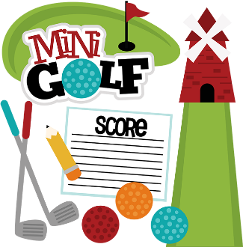
- Family Golf Month
- Independent Retailer Month
- Juvenile Arthritis Awareness Month
- National Anti-Boredom Month
- National Black Family Month
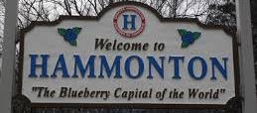
- National Blueberries Month
- National Cell Phone Courtesy Month
- National Cord Blood Awareness Month
- National "Doghouse Repairs" Month
- National Grilling Month
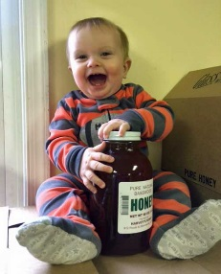
- National Honey Month
- National Make A Difference to Children Month
- National Child Centered Divorce Month
- National Parks and Recreation Month
- National Wheelchair Beautification Month
- Sandwich Generation Month
- Smart Irrigation Month
- Women's Motorcycle Month
- National Horseradish Month
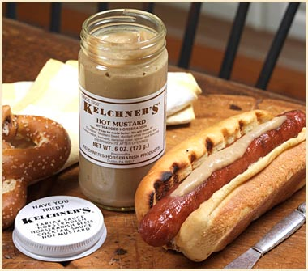
- National Hot Dog Month
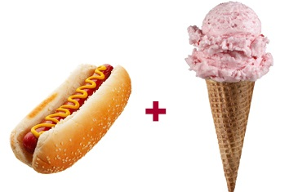
- National Ice Cream Month
Weekly Events:
- National Tom Sawyer Days, Week 1-4
- Freedom Week: 4-10
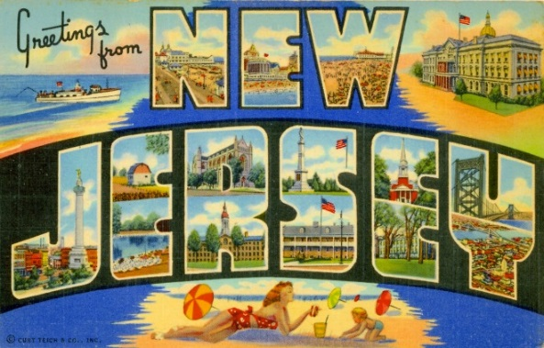
- Be Nice To New Jersey Week: 3-9
- National Farriers Week: 10-16
- Sports Cliché Week: 10-16 (Always Week of Maj. League Baseball All Star Game)
- Rabbit Week: 15-21
(Re: Magician Rabbits The sponsor is Melvin Rabbit up in Canada.)
- National Baby Food Week: 20-23

- National Ventriloquism Week: 13-16
- Comic Con International: 20-24
- Restless Leg Syndrome (RLS) Education & Awareness Week: 18-25 (Note: Different sponsor than the September 23 observance has.)
- National Parenting Gifted Children Week: 17-23
- Captive Nations Week: 17-23
- National Independent Retailers Week: 17-23

- National Zoo Keeper Week: 17-23
- World Lumberjack Championships: 29-31
- Garlic Days: 29-31 (Last Weekend)
Daily:
1 Canada Day
1 Creative Ice Cream Flavors Day
1 International Joke Day
1 ZIP Code Day
2 I Forgot Day

2 Made In The USA Day
2 World UFO Day
3 Roswell UFO Days (July 3-6)
3 Compliment Your Mirror Day
3 International Plastic Bag Free Day
3 Stay out of the Sun Day

4 Independence Day (U.S.)
4 National Country Music Day
4 Sidewalk Egg Frying Day- Hmmmm, I wonder why!?!
5 Work-a-holics Day - even though everyone is on holiday
5 Build A Scarecrow Day - first Sunday in month
6 National Fried Chicken Day
6 International Kissing Day
7 Chocolate Day

7 National Strawberry Sundae Day
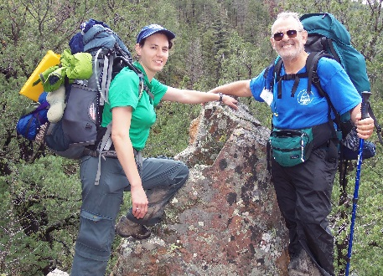
7 Father-Daughter Take A Walk Together Day
8 Collector Car Appreciation day
8 Video Games Day
9 National Sugar Cookie Day
10 Teddy Bear Picnic Day
11 Cheer up the Lonely Day
11 World Population Day

11 Slurpee Day or 7-11's Birthday:
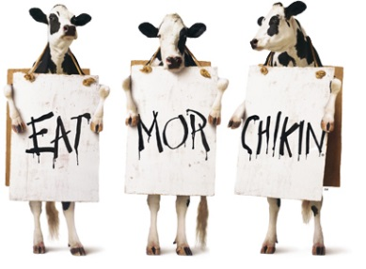
12 Cow Appreciation Day
Get a free Chicken Sandwich at Chik-fil-A
I did not see this year's date on the Chik fil A website
12 Different Colored Eyes Day
12 Pecan Pie Day
13 Barbershop Music Appreciation Day
13 Embrace Your Geekness Day
13 Fool's Paradise Day
14 Bastille Day
14 Pandemonium Day
15 Tapioca Pudding Day
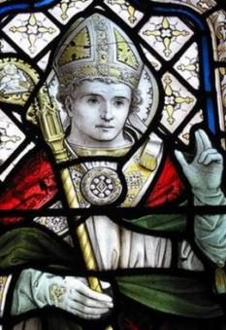
15 Saint Swithins Day
16 Fresh Spinach Day
17 Peach Ice Cream Day
17 Yellow Pig Day
17 National Ice Cream Day (third Sunday of the month)
18 Global Hug Your Kid Day
18 National Caviar Day- something's fishy here
18 Nelson Mandela day
19 National Raspberry Cake Day
20 Moon Day
20 Ugly Truck Day- it's a "guy" thing

20 National Lollipop Day
21 National Junk Food Day
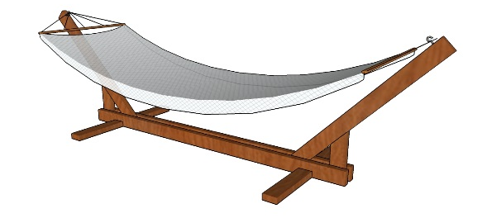
22 Hammock Day
22 Casual Pi Day: 22 (22/7)
22 Ratcatcher's Day
23 National Hot Dog Day

23 Vanilla Ice Cream Day
23 National Day of the Cowboy
24 Church of Latter Day Saints Pioneer Day
24 Tell An Old Joke Day
24 Amelia Earhart Day
24 Cousins Day
25 Parent's Day - fourth Sunday in July
25 Threading the Needle Day

25 Carousel (Merry Go Round) Day
26 All or Nothing Day
26 Aunt and Uncle Day
27 Take Your Pants for a Walk Day
28 Buffalo Soldiers Day
28 National Milk Chocolate Day

29 National Lasagna Day
30 National Cheesecake Day
30 Father-in-Law Day
30 International Day of Friendship

31 National Talk in an Elevator Day
31 Mutt's Day

TRAINING TOPICS

LEAD A SONG.
Bill Smith, the Roundtable Guy
I would guess that there are few things most Cub Scout leaders fear more than having to get up at a pack meeting and……
LEAD A SONG.
Unless you are an experienced choir leader or perhaps the concertmaster of your local symphony orchestra, the thought of standing in front of friends and neighbors and getting them to sing some silly song probably fills you with dread.
Join the club.
I (Bill Smith) had watched in horror at Roundtables and such, when leaders would take us through renditions of B-I-N-G-O or Cub Scout Spirit and I realized that we were expected to do something similar. Not me! I am a cool urbane dude and this just doesn’t fit the image.
It took a trip to Philmont Training Center to change my mind. The staff there convinced me that pack meetings should be fun – as Sean Scott told us:
So start having pack performances instead!
Get rid of the agenda, and get yourself a program! Scrap job titles and positions, and find a cast!
Lose the responsibilities and elements of a meeting and recruit some acts!
(Go to the September 2011 issue of Baloo at http://usscouts.org/bbugle/bb1109P.doc
and read Sean's "Stop Having Pack Meetings" article.)
The cool, urbane image may be OK around the water cooler at work but is not going to make it in a Cub Scout setting. Singing, they emphasized, was a great method for injecting fun and excitement into the program. So I bit the bullet and chose a song for my next pack meeting. We tried Throw it Out the Window. Each den chose a nursery rhyme and we all came in on the choruses. To my utter amazement it worked. The kids, Cubs and siblings, loved it and parents even commented that the pack meetings had improved.
If I could do it, so can you!
If songs are not a regular part of every pack meeting, then you may be missing an important element that could make your meetings more enjoyable and more effective. Songs are the great mood setters. I can’t think a better way to get a bunch of Cub Scouts smiling and clapping than a few verses of Alice the Camel or My Bonnie. Is it possible to have a good campfire without songs? Not in my wildest imagination!
Why Do We Sing?
Most people love to sing, and Cub Scouts are no exception. Singing builds den and pack spirit and enthusiasm. Singing gives boys a chance to let off steam. Singing is fun! Use a song or two to set the mood for your meetings. Have a few songs ready to use as “fillers” during transition times of your meetings. Use songs to get the audience moving and get rid of those wiggles. Use songs to quiet and calm the group when it’s time to go. If you’re not using songs in your program, you’re missing out on the power of music!
How to Get Started
Try leading cheers and audience participation stories. A simple cheer like: I’ll throw the neckerchief up in the air and everyone yell until it comes down. These activities promote an atmosphere where the boys and even the parents become used to following your lead. It then becomes an easy step to try in a simple song like
I Like Bananas, Coconuts and Grapes.
Pick easy songs with lots of repetition and simple tunes. Good Cub Scout songs rarely make much sense. I personally do not like those songs that attempt to introduce the theme with complicated lyrics. They are difficult to teach and they detract from the main purpose of songs in Cub Scouting. Songs should be uproarious fun. As you develop more confidence you can also try the quieter, closing or patriotic songs. These can be great mood setters but it’s usually best to start with the fun, silly songs.
Getting Cubs (or any group) to sing takes mostly enthusiasm and a dose of confidence. Choose a song that you like and feel confident about. Never apologize or dismiss the song or your leadership. Introduce it with enthusiasm -
It’s a great fun song and
we’re going to really blast it out!
It’s important to name the song, make sure they know the tune and the words and tell them that they should sing loud.
You might want to have the words printed out on large poster boards or butcher paper rather than on song sheets. Songs with lots of repetition or familiar words work well. If you have musical accompaniment, like a guitar or piano, that will make it so much the better. I am intrigued by some of these new electronic MP3 gadgets that allow one to download music files and play them back to teach the tunes. I can barely carry a tune so I need all the help I can get.
It helps to have everyone stand for singing. When they are ready, start them off with your version of a downbeat and keep a lively time by waving your arms. Enthusiasm beats musical ability here so have lots of fun while you’re doing it. Ed Hesser, one of my Wood Badge instructors, taught us to wear orange gloves to lead songs. It works.
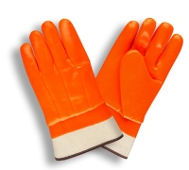 Still afraid?
Wear a pair of brightly colored gloves (e.g. orange). (Or give a pair to a new (afraid) song leader. This will reduce your/their anxiety. Tell the audience to follow the gloves. This takes the focus off the song leader. I have done this many times with new song leaders. It works great and pretty soon they forget the gloves!!
How to Lead a Song
- Choose It. As the leader you must choose the song that the group will sing. You want to be certain that all songs chosen support the values and ideals of Cub Scouting. You will also want to choose a song that fits the program. Fast action songs get the program off to a brisk start. Patriotic songs add a note of dignity to the program. At the end of the program, slower closing songs can leave every one calm and thoughtful.
- Know It. The song leader should know the song—both words and tune—before leading it. Learn the song, then practice before the meeting by teaching the song to your family or to the pack committee members at the monthly pack planning meeting.
- Teach It. Start by telling your audience the name of the song. Unless you are certain that everyone in the group knows the song, you need to teach both the words and the tune. You may wish to provide copies of the words. Use songbooks, reproduced song sheets, or words on a large sheet of paper or overhead projector.
- Sing It. Sing the song through once, either alone or with a small group who already know it. Let the singers try a verse at a time, slowly at first. When they master it, pick up speed.
- Pitch It. Set the pitch by singing the first word of the song loudly so that everyone starts out on the same key. Musical accompaniment helps—a keyboard, piano, accordion, guitar, or harmonica are all good because they can play harmony not just single melody notes.
- Lead It. Be active in your song leading. Use simple arm motions to lead the song so that everyone is singing together.
- Start the singing with a slight upward motion and then a decisive downward motion (a downbeat). Begin singing yourself on the downbeat. Don’t worry if some don’t start with the first note—they’ll join in quickly.
- Beat time with a simple up-and-down motion of the arm, but make it definite and brisk. You’re in command.
- Control volume by raising your hands for loudness and lowering them for softness.
- Move around a little. Inject a little pep and personality. Keep smiling.
- Smile at your group. Relax. Radiate confidence and enthusiasm, even if you don’t feel particularly confident or enthusiastic. Morale catches.
- Stop It. When the group has sung it a time or two, stop—don’t make it a music lesson. If the song isn’t going well, or it was pitched wrong at the beginning, stop the song and start over.
The Cub Scout Song Book
The CS Song Book is a great source of songs. I have heard that a new edition is in the works but there is nothing wrong with current book. There are more and more Internet sites with good Scouting songs. Many now have music files as well as the lyrics.
Your boys will undoubtedly come back from camp this summer with some great songs they picked up from the staff there. Use a few of these as regular fare for your pack meetings and campouts.
www.USScouts.org has a large song
collection at –
http://usscouts.org/songs.asp
Here are some other good internet sources:
Denver Area Council Cub Scout Songbook
Scoutsongs.com
Boy Scout Trail - Songs
So lose your inhibitions, brothers and sisters, and join us in the promised land of fun and frolic!
“Never again shall ye meet as a pack--
only through celebration shall fun be achieved!”
[Book of Cub Scouting, 51:50]
Now is the time to act - redefine your Pack Meeting. Make it a Packformance and have fun. CD

FUN STUFF
Fun Facts About Lollipops
Alice, Golden Empire Council
Being served on a stick may be a new thing for some foods like pickles and cake, but for the lollipop it's been that way the beginning.
Here are 10 fabulous facts about the classic candy.
- The world's largest lollipop was made in 2012. The confectioner behind the job was See's Candies of California, and their creation weighed over 7 thousand pounds. It was chocolate-flavored.

- The first high-production machine was invented in 1908. A manufacturer in a Racine, Wisconsin was asked to build something that could make a lot of lollipops in a short time. They came up with one that could push out 40 in a single minute.
- The term lollipop used to mean other things. The first known use was in the mid 1780s. Charles Dickens used it to refer to stick-less candies. At another time it a different place it's what they called sweetmeat on a stick.

- The Chupa Chup label was designed by Salvador Dali. He and the guy who invented the popular candies were friends. It's reported that there was also money involved, which Dali was rumored to not typically turn down.
- Dum Dum's mystery flavor is a pretty simple recipe. They're created as one flavor batch is running out and the next one is beginning, whatever those two may be.

- Some are made for adults. The candy company Lollyphile produces a variety of beer flavored ones. For fans of the grape, they also offer merlot, chardonnay, and cabernet.
- On request they can come laden with viruses. In 2011 it was reported that moms across the country were ordering lollipops that had been licked by kids infected with chicken pox The goal was to introduce the virus to their own children in hopes of building immunity and avoiding vaccinations.
- George Smith was the first to really run with the idea. He saw a West Haven, Connecticut sweets maker put a caramel and chocolate confection on a stick and an idea came to him. He began to manufacture a hard candy version and named it the Lolly Pop.
- It's easier than ever to sneak a lollipop into class. A team of designers created a pencil/candy hybrid. Instead of a boring, flavorless eraser the writing tool is topped with a delicious twist of candy.
- There's a line specifically for insect lovers. Hotlix, a snack manufacturer that specializes in earthier nibbles, sells a variety of lollipops that contain bugs. Options include scorpions, ants, worms and crickets. Which lollipop flavor is your favorite?
Lollipop History
http://www.candyfavorites.com/shop/catalog-lollipop-history.php
The first incarnation of the lollipop was probably created by cave people thousands of years ago who collected honey from beehives with a stick. Not wanting to waste the sweet nectar, they most likely licked the stick, thus inventing the world’s first lollipop. Good for them and us. Archaeologists believe the ancient Arabs, Chinese, and Egyptians all produced fruit and nut confections that they candied in honey for preservation, and inserted sticks into to make easier to eat.
If the 17th Century English version doesn’t count as the first modern lollipop, you could look to the Civil War era for another early forerunner, when hard candy was put on the tips of pencils for children. The early 20th Century was the era of automation, which is when the birth of the lollipop as we now know it begins in earnest, but there are still discrepancies as to who is the true creator.
In the 17th Century, as sugar became more plentiful, the English enjoyed boiled sugar candy treats and inserted sticks into them to make them easier to eat, too. Linguists say the term ‘lolly pop’ literally means ‘tongue slap’ since the word for ‘tongue’ is ‘lolly’ in Northern England and ‘pop’ means ‘slap.’ London street vendors may have coined this term as they peddled the treat, which was soft rather than hard, but still considered a possible forerunner to the modern lollipop.
As early as 1905, the owner of the McAviney Candy Company may have stumbled upon the lollipop by accident. The company made boiled hard candies that were stirred with a stick, and at day's end, the owner brought the sticks covered with the candy home for his kids to enjoy. It wasn't until 1908 that he began to market these "used candy sticks."
Also in 1908, in Racine, Wisconsin, the first automated lollipop production was brought about by the Racine Confectionary Machine Company that introduced a machine that put hard candy on the end of a stick at the rate of 2,400 sticks per hour. Owners of the company believed that they could produce enough in a single week to supply the nation for an entire year.
In approximately 1912, Russian immigrant Samuel Born invented a machine that inserted sticks into candy. The machine was called the Born Sucker Machine and the City of San Francisco considered it so innovative that they awarded him the keys to the city in 1916. George Smith, owner of a confectionary company called the Bradley Smith Company, took credit for inventing the modern version of the lollipop which he began making in 1908, and in 1931, he trademarked the term ‘lollipop,” borrowing the name from a famous race horse named Lolly Pop, which is when the term lollipop finally connects back to the 17th Century phrase (‘tongue slap,’ remember?).
As you can see, the development of the lollipop took its time and there is some competition for the title “creator of the lollipop,” but regardless, it’s here to stay and it’s currently one of the most popular candies in existence. Modern companies can produce up to 3,000,000 per day, which hardly satisfies the nation's sweet tooth.
Lollipops now come in all shapes and sizes, some companies offer over a 100 varieties. Let's end with:
"When you don’t know what else to do,
put a stick in it."
For more info – go to: http://www.candyfavorites.com/shop/catalog-lollipop-history.php

THEME PACK AND DEN ACTIVITIES
Alice, Golden Empire Council
- Explore different kinds of heroes – include Strategic Air Command, DART, Civil Air Patrol, CERT (Community Emergency Response Team), National Guard, Firemen and Policemen, Regular Military, Teachers, Doctors.
- Have each scout or family make a list of some everyday heroes – make a list of categories and have each person or team fill in a real name that fits the category. Some ideas are: volunteer firefighters, musicians or artists, parents that volunteer at school, people that bake for a benefit sale, people that help the elderly, people that plan celebrations that everyone can enjoy, first responders, people who teach Sunday School, Scout leaders, kids who help younger kids learn something new (like Venturing Scouts or the Den Chief), people who help their neighbors, people who coach sports for kids.
- If you have a school garden or community garden in your area, invite a volunteer to share how it got started, how it helps families in the community. Learn about school gardens in your communities and the “heroes” who keep them going. Go to www.kidsgardening.com/school/searchform.asp for information and stories, as well as links to other great project ideas and garden projects in specific areas.
- Talk to a local librarian – they may need volunteers, can connect you with community organizations, speakers, or sometimes even sponsor programs such as Adult Literacy.
- Check with Habitat for Humanity, Christmas in April, Humanitarian Aid Projects or local Senior Gleaners for service project ideas or to find some wonderful local heroes.
- If there is a teacher’s resource center in your area, volunteer to put together kits for local teachers – they are all heroes!
- Check with your local Volunteer Center – every city or county has one. They can connect you with volunteer opportunities, and sometimes have programs to honor volunteers – an easy way to find someone to honor or come visit your den or pack!
- Ask families in your pack to share stories about everyday heroes – ways that people can help their communities – examples of one-person projects that make a difference. Feature these stories at your pack meeting.
- Challenge every member of your den or pack to Pay it Forward!
- Invite a speaker to talk about Veteran’s Day or heroes – see the VA website information
- To locate a National Cemetery go to: http://www.cem.va.gov.
- Add to the total at BSA Good Turn for America – enter hours of service at www.goodturnforamerica.org
- Check out the “Make a Difference Day” stories from Parade magazine – you might find the perfect one-person or den service project
- Work on the scouting requirements that prepare scouts to be a hero –first aid training, plumbing, fix it, carpentry skills – boys or families can be a “hero” by helping an elderly neighbor or relative who can’t afford regular maintenance – and in the future, as men with these skills, today’s scouts will be a hero to their own families.
- Obtain or print out a map of the local community – (Thomas Bros. maps also show schools, fire stations, community centers) –talk about the places where help is available and where good citizenship is practiced.
- Take a Thomas Bros. map of the local neighborhood, mount on cardboard, laminate, and cut into puzzle pieces to use for a family or den game to learn about community resources.
- Contact a local VFW or local cemeteries to get flags for putting out on graves of Veteran’s – this is only done in the older cemeteries – in most National cemeteries, they instead have a Memorial Avenue of full-size flags donated by families – these flags are ones that were used to cover veteran or military caskets. They are flown on every holiday and whenever there is a funeral for active military. You can arrange to come and raise these flags as a way to honor veterans.
- Check to see if there are Independence Day Parades in your area and register to participate in uniform.
- Visit a museum and look for heroes – people who have done something heroic or started a service project, saved a building from demolition, worked with youth in the community, overcome challenges
- Visit with older people, especially family members, and learn about them, their work, their service, how they spent their time – identify ways that they were heroes, overcame challenges, helped others get educated, or made a difference in their communities
- Choose a service project to honor heroes – one idea is Operation Military Kids, which provides hero packs to children who are sacrificing time with their deployed parents – See web sites
- Invite a CERT (Community Emergency Response Team) member to come and share information with your den or pack families.
- Give local Venturing Scouts the opportunity to teach skills to your scouts – Venturing crews can fulfill their requirements and be a “hero” to your Cubs/Webelos.
- Check out the book The Children’s Book of Heroes by William Bennett and read the story "How the Animals Got Sunlight." Then talk about who the hero is, why and what they did. Or choose one of the other hero stories in the book – you might even use a story as the plot of a skit for the pack meeting!
- Brainstorm with your den about what a hero is - what qualities does a hero have? Encourage boys to think about real people, not just super heroes. Have the boys make special thank you cards for the people they choose as heroes.
- Put out a den or pack “newspaper” with stories about people they have identified as heroes. If any of the boys like to do photography or art, you could add pictures! Print out copies and distribute to pack families and your chartered organization. You might even want to send a note to parents so they can help their sons with the project.
- Suggest that families talk about heroes in their family history – share stories about how ancestors were everyday heroes.
- Choose some everyday heroes that the boys know – such as teachers, police or fire department members, the cubmaster – invite them to come to the pack meeting and give each of them a simple award – perhaps a certificate or even a picture the boys have made to present to them.
- Challenge the boys to use their photography talent to enter the 2009 U.S. and Canada International Photography Contest for Kids – they could choose a subject that shows a hero in action, or even a photo that focuses on being an eco hero by featuring a favorite animal. See details at: http://kids.nationalgeograhic.com/contests/Photos
- Visit a nearby fire or police station, National Guard, Coast Guard or other military installation and see heroes in action. My pack visited a local Coast Guard Station – in land-locked Sacramento – and had a wonderful time touring a plan and watching a video, so check out your local resources! Alice
- As a whole pack, including families, write Letters to the Troops – details under Theme Related. This can also be a great lesson in how to write a caring letter – more details and a template on the website.
“You Are My Hero” Buttons
Great Salt Lake Council
We all have many people in our lives that we admire, dad, mom, teacher, Scout leader etc. This month would be the perfect time to let that person know how much they are appreciated and looked up to. Present them with a “You Are My Hero” button and put a smile on their face!
What you will need:
Wooden badges (craft stores have all shapes and sizes)
Acrylic paint
Sponge and paint brushes
Water to rinse brushes in
Paper plates for palette
Paper towels
Bar pins
Contact cement
Stickers, if desired
Clear varnish (Optional)

Button Instructions:
- Paint button solid color using sponge brush.
- Add small detail with small paint brush. (To make dots, dip blunt end of paint brush in paint. Wipe off end of brush each time you dip to get more even dots.)
- Let dry thoroughly.
- For a shiny finish, use a sponge brush to apply clear varnish. Be careful, if you use some types of pens the varnish will cause them to bleed!
- Apply thin coat of contact cement to the back of the button where the bar pin will be placed.
- Apply thin coat of contact cement to the bar pin.
- Allow contact cement to dry and is touchable.
(Follow directions on label)
- Press bar pin to button.
Kids Can Be Heroes Too!
Alice, Golden Empire Council
If you want proof, go to: www.chinastrategies.com/lithero.htm for true life stories about children who have been heroes!
Active Theme Ideas
Greater St. Louis Area Council
- Invite your local fire department to a Pack meeting. Fire Safety Awareness month is an opportune time for this Pack meeting. Most fire departments have short programs developed, which they will share with your Scouts. Be sure to "salute" them while they are there.
- Invite your local police department to a Den or Pack meeting. The police have many different programs, such as a canine dog demonstration, the rescue helicopter, finger printing demonstration, and “Stay Safe” (self-defense) program. Be sure to "salute" them while they are there.
- Invite your local paramedics and or flight nurse crew to a Pack Meeting. The first aid requirement for all levels of Cub Scouting can be fulfilled. Be sure to "salute" them while they are there.
- Plan an outing for your Den to your local fire or police department. Bring a card or something the Cubs have made as a Thank You and "salute" them while you are there.
- Plan an outing for your Den or Pack to an animal rescue center or humane society because people we salute need not wear uniforms. Bring a card or something the Cubs have made as a Thank You and "salute" them while you are there.
** Remember 2- Deep Adult Leadership!!!
Letters to the Troops
Alice, Golden Empire Council

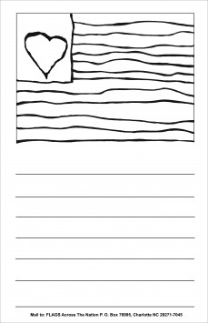

Write letters to our Troops – you can either use the template on http://www.flagsacrossthenation.org/our-projects/letters-to-the-troops/ , or you can make up your own – scouts or siblings can then color in the flag, write a letter below to the troops, put your name and age on the back, and then mail to Flags Across the Nation, 9426 Duckhorn Dr., Charlotte, N.C. 28277.
For younger siblings, or those who don’t feel comfortable writing a letter, click on projects at the website – they have downloadable coloring pages that can be done and also are sent to troops! This is a great project to share with other groups as well!

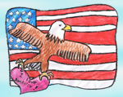
2010 Freedom Art Contest – Challenge the scouts to enter a piece of patriotic art in support of Letters to our Troops. Every child who enters will receive an acknowledgement gift. For details go to: www.flagsacrossthenation.org/about-flags
Stars & Stripes Spinner
Santa Clara County Council
Materials:
Glue
12 Crepe Paper Streamers - 18" Long
3' String
Scissors
Hole Punch

Directions:
- Enlarge to 8 1/4" and make 5 copies of star pattern circle. Each circle is divided into quarters by 3 dotted lines and one solid line. On four of the circles, cut on the solid line to the center of the circle.
- Crease on the dotted lines, folding printed pattern to the inside. First one way, then the other way.
- Form a pocket to catch the wind by folding as shown, overlapping one quarter of the circle onto the next quarter.
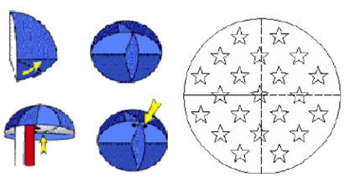
- Glue overlap into place.
- Repeat for the three other slit circles.
- Glue the four pockets together to create a half ball.
- Cut streamers to 18".
- Glue ends around perimeter of the bottom. Glue the 5th circle to the bottom over the streamer ends.
- Use punch to make 2 holes in the top of the ball about 1/2" from the edge.
- Feed string through. Tie ends.
- Hang from tree and watch it spin.

THAT’S FOR THE BIRDS
Suet Recipes
Santa Clara County Council
I am having a Suet-Making party Yes, and
It’s for the Birds
TIP: Use some old cake pans to pack these in until they get hard enough to remove. Also, remember, be very careful having melted suet around the Cubs. Ideally, for this activity, have everyone wear old clothes, and have buckets handy with lots of warm soapy water for clean up. Sometimes you will be only to find suet at a Butcher Shop if you can’t find that, try lard of shortening.
Soft Suet Cakes
Ingredients
4 1/2 cups ground fresh suet
3/4 cup dried and fine ground bakery goods (whole-wheat or cracked-wheat bread or crackers are best)
1/2 cup shelled sunflower seeds
1/4 cup millet
1/4 cup dried and chopped fruit (currants, raisins, or berries)
3/4 cup dried and fine ground meat (optional)
Directions
- Melt suet in a saucepan over low heat.
- Mix the rest of the ingredients together in a large bowl.
- Allow the suet to cool until slightly thickened,
- Stir it into the mixture in the bowl.
- Mix thoroughly.
- Pour or pack into forms or suet feeders; smear onto tree trunks or overhanging limbs and branches; or pack into pine cones.
Hard Suet Cakes
Ingredients
1/2 lb. fresh ground suet
1/3 cup sunflower seed
2/3 cup wild bird seed (mix)
1/8 cup chopped peanuts
1/4 cup raisins
Directions
- Melt suet in a saucepan over low heat.
- Allow it to cool thoroughly, then reheat it.
- Mix the rest of the ingredients together in a large bowl.
- Allow the suet to cool until slightly thickened,
- Then stir it into the mixture in the bowl.
- Mix thoroughly.
- Pour into pie pan or form, or pack into suet feeders.
- Optional or substitute ingredients: millet (or other birdseed), cornmeal, cooked noodles, chopped berries, dried fruit.:
1 part peanut butter
1 part shortening
1 part flour
3 parts cornmeal
1 part cracked corn
black oil sunflower seeds and/or mixed seed
More Treats
1 part Melted Beef Suet
1 part Peanut Butter
6 parts Cornmeal
- Melt Suet then mix in Peanut Butter and Cornmeal. Spoon into paper-lined muffin tins and cool. Store in freezer till needed.
Still More
1 pound Suet in small pieces
1 Cup Yellow Cornmeal
1 Cup Rolled Oats
1 Cup Chunk-style Peanut Butter
1 Cup mixed Wild Bird Seed
1 Cup Sunflower Seed
- Melt suet over low flame. Stir in rest of ingredients to blend. Pour into paper-lined muffin tins. Chill until hardened. These may be frozen also.
And Another
2 Cups Bread Crumbs
1 Handful Nuts (unsalted)
3 Chopped Apples (seeds too!)
2 Handfuls raisins
1 Cup sugar
1/4 Cup Cornmeal
1/2 Pound Ground Suet
1/2 Cup Flour
1 8 0z. Jar Peanut Butter
1 Cup Wild Bird Seed
Directions
- Mix ingredients and
- Add enough bacon drippings to hold it all together.
- Shape into balls or press into pine cones.
- Freeze leftovers.
Suet Feeder
Santa Clara County Council
You may also make a simple Suet Feeder out of a milk carton. Just pour hot ingredients into the carton, let cool then cut the sides out. Other ingredients that you can add or just set out on your feeder are: Ground eggs shells, fine gravel or sand (for grit), cheese, dry cereal, coconut (raw), cornbread, cracker crumbs, dog biscuits (chopped fine), ears of sweet corn. Don't forget the seeds from all of your veggies!

THEME & PACK MEETING IDEAS

GATHERING ACTIVITIES
Note on Word Searches, Word Games, Mazes and such – In order to make these items fit in the two column format of Baloo’s Bugle they are shrunk to a width of about 3 inches. Your Cubs probably need bigger pictures. You can get these by copying and pasting the picture from the Word version or clipping the picture in the Adobe (.pdf) version and then enlarging to page width. CD
Calling for Help Cryptogram
San Gabriel, LB Area, Verdugo Hills Councils
You must discover what number is assigned to each letter, then fill in the blanks to complete the message. Four letters have been identified for you. Have the boys work together to get started. If they have trouble, give them another letter such as L.
Solution at the end of Baloo
Good Turn
Great Salt Lake Council
Have the boys make a list of either the good things they have done for someone else or what has been done for them.
Heroes in Our Community
Alice, Golden Empire Council
Have each boy, den or family bring in a display of a favorite hero – it could be someone from the community or even a family member. Have families talk about their picture with others as they gather.
Cub Scout Salute Word Search
San Gabriel, LB Area, Verdugo Hills Councils
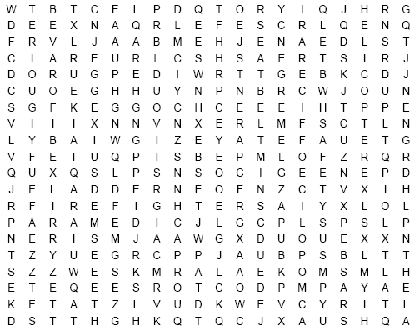
Find words that describe rescue workers, their tools and safety items printed in the word search above. They can be upside down, backwards, forwards or diagonal.
AMBULANCE CAR SEAT CPR
CROSSING GUARD DOCTORS
EMERGENCY EXTINGUISHER FIRE ENGINE
FIREFIGHTERS HELICOPTER HELMET
HELP HOSES HYDRANT
LADDER LIFEGUARD LIFEJACKET
PARAMEDIC PARENTS POLICE OFFICER
RESCUE SAFETY SEATBELT
SIREN SMOKE ALARM TELEPHONE
Hero Bingo
Alice, Golden Empire Council
Print off bingo cards with 9 squares labeled with descriptions such as: Favorite Superhero, Sports Hero, Favorite Teacher Hero, Family Hero, Military Hero, Eco Hero, Community Hero or Project, Hero Quality. Use the center square for “Be A Hero” – and have a space or line inside each square. Give each person or family a bingo card as they come in. They must go around the room and find a different person to fill in each square. You could share some of the entries, or give a prize to the person who has a filled-out card first.
Definitions
Alice, Golden Empire Council
Give each person a strip of colored paper when they arrive and ask them to write one word describing an attribute a hero would have. Post the strips on the wall for everyone to see.
American Hero Word Scramble
Alice, Golden Empire Council
Unscramble the following words to find the words associated with heroes.
- HTEIGRIEFF
- OPIELC
- RAMY
- VNYA
- MIIRTAYL
- OIRAFREC
- SNUER
- COTORD
- MIRAANEC
- EROH
- VEARB
- CUAROEG
Answers – A – Fire Fighter, B – Police, C – Army, D – Navy, E – Military, F – Air Force, G – Nurse, H – Doctor,
I – American, J – Hero, K – Brave, L - Courage
FAMOUS PAIRS
Santa Clara County Council
Make up stickies for people’s backs with names of famous pairs. (e.g – Abbott on one, Costello on another. Or Aldrin on one, Armstrong on another.). As each person enters the room, he has a stickie pinned to his back. The object of the game is to learn the identity of the person on your back and then find his partner. Each player is allowed to ask one or two (or more, you set limit) yes or no question(s) of each other player. At the same time, the two people introduce themselves (their real names) and shake hands. Once you find your identify, find your partner by reading tag.
Hometown Hero Matching Game
Santa Clara County Council
Hang up pictures of famous “hometown Americans” with their names below their pictures. (These can be US heroes, locals, etc.) Have their heroic deeds listed out on a sheet that is handed out to everyone and have folks match the people with the actions.
Veteran’s Day Word Search
Alice, Golden Empire Council
ADMIRATION AIR FORCE AMERICA
ARMY CELEBRATE MARINE
NAVY PARADE PATRIOT
REMEMBER SERVED TRIBUTE

America Hero Word Search
Alice, Golden Empire Council
AMERICAN BLUE BRAVE
COAST GUARD COURAGE COURAGE
FIRE FIGHTER HEROES HONOR
POLICE RED SOLDIERS
WHITE
Hero Match-Up
Great Salt Lake Council
Heroes do many different things for us. Match-up the hero with what they have done to help others
- __ Clara Barton  - __ Martin Luther King Jr.  - __ Benjamin Franklin  - __ George Washington  - __ George Washington Carver  - __ John Glenn  - __ Jackie Robinson  - __ Philo T Farnsworth | A. Astronaut  B. Athlete  C. Civil Rights Advocate  D. Inventor –Peanut Butter  E. Inventor - TV  F. Red Cross  G. US Founding Father  H. US President
Answers: 1F, 2C, 3G, 4H, 5D, 6A, 7B, 8E
WHO’S A SCOUT?
Great Salt Lake Council
Let the boys guess which notable person is a Scout.
Note: All listed below were Scouts.
- Henry “Hank” Aaron (Baseball Player)
- Neil Armstrong (First Man on Moon)
- Philo t. Farnsworth (TV Inventor)
- Gerald Ford (US President)
- JW Marriott J. (Marriott Hotels)
- Steven Spielberg (Movie Director/Producer)
- Walter Cronkite (Journalist)
- Harrison Ford (Actor)
- William Sessions (Former FBI Director)
- Bill Gates (Computer Company CEO)
- John F. Kennedy (US President)
- Sandra Day O’Connor - Associate Justice, US
- Supreme Court
- Jimmy Buffet (Musician)
- Mary Tyler Moore (Actress)
- Richard Gere (Actor) (Richard was born August 31, 1949, same date and year as CD)
WHAT IS THAT SONG?
Santa Clara County Council
- Country Between Canada and Mexico the Good-Looking
- Heavy Iron Hooks Lifted Off the Bottom of the Sea
- Short Fight of Cajun Town
- Higher Being Sanctify United States
- Creator Consecrate Country Begun in 1776
- Majestic Not Born Yesterday Colors
- First Person Singular is Northern Inhabitant Scribble Gentleman
- One of a Few Good Men Prayer Song
- We Leave into Untamed, Sapphire “Out There”
- Celestial Object Glittery Standard
- Other Suns and Streaks Not Ending
- Spigots
- Short Skirmish Chant of the Democracy
- The Wagons with Canons Move Forward on Wheels
- This Area of Ground Belongs to Second Person Singular or Plural
- Secure a Satin Strip of Golden Material With a Knot
- The Time Jack’s Other Nickname Walks Sharply Back to His House
- Heavenly Souls Enter Walking In Straight Lines
Answers
- America the Beautiful;
- Anchors Aweigh;
- Battle of New Orleans;
- God Bless America;
- God Bless the USA;
- Grand Ole Flag;
- I'm a Yankee Doodle Dandy;
- Marine's Hymn;
- Off We Go Into the Wild Blue Yonder;
- Star Spangled Banner;
- Stars and Stripes Forever;
- Taps;
- The Battle Hymn Of The Republic;
- The Caissons Go Rolling Along;
- This Land Is Your Land;
- Tie a Yellow Ribbon;
- When Johnny Comes Marching Home;
- The Saints Go Marching In

OPENING CEREMONIES
We Salute You
Greater St. Louis Area Council
You will need 6 Cub Scouts. Have each Cub make up a card with a picture illustrating what the words on his card say or anything he wants related to the theme. Make sure the words are in LARGE print
- Some who we salute are obvious, local heroes who like a police officer risks life to protect us from violence or the fireman who pulls people out of burning buildings.
- Other we salute are the ambulance drivers, paramedics, doctors and nurses who save lives everyday.
- Some people around us seem like regular people, but they we salute them because they were soldiers in the military and served our country to keep us free.
- A hero is someone who does the right thing even when they are afraid of failure. They do it because it should be done. And we salute them.
- Some who should be saluted are harder to spot, but they are still there. These include blood donors, teachers who spend their time and energy helping kids, and kids who say “No” to drugs.
- Heroes are all around us. Please join in saluting all the heroes of our country, by repeating with me the Pledge of Allegiance to the Flag.

Heroes Flag Ceremony
Great Salt Lake Council
Setting: The Colors advance in the normal manner. A spotlight is shined on the flag while the narrator speaks.
Narrator (Hidden): Heroes, with help from God, have kept me flying in the face of threat and challenge to the democratic way of life I represent. I symbolize all the achievements of a great nation founded for freedom. I am the last hope of peace on earth. I am the American Flag.
Cubmaster: Audience arise and join me in the Pledge of Allegiance to be followed by singing "God Bless America."
Cub Scout Opening
Sam Houston Area Council
Setting – Each letter of C-U-B S-C-O-U-T should be cut out from poster board or printed on large pieces of paper or card stock. Write the lines on the back in LARGE print and line up the Scouts so they can read the lines in order.
- C – is for Comradeship. We learn to get along.
- U – is for Unity. Together we are strong.
- B – is for Boys! Sometimes they’re wild, but mostly they’re nice.
- S – is for Socials! You don’t have to ask twice.
- C – is for Courtesy. Of this we know.
- O – is for Outings. We can’t wait to go!
- U – is for Universal. Scouts are known in every land.
- T – is for Teamwork. We’ll lend you a helping hand.
(All the Scouts say together)
ALL: We Will Do Our Best!!
CM: Will you please rise for the Pledge of Allegiance?
The Circle of Life
Sam Houston Area Council
Setting – Cubmaster (CM) or Narrator , 4 Scouts, 4 posters showing the sun, the moon, the wind, and the earth
Scene – Scouts are in a line.
CM: Everything in life has a cycle, normally represented by a circle, like the circle of life. The power of the world always works in circles and forces try to take a round shape.
- (holding the poster of the sun) The sun is round; it warms all living things and allows us to grow.
- (holding the poster of the moon) The moon is round; it gives us light at night.
- (holding a poster of wind) The winds, in their great power, swirl, giving coolness and strength.
- (holding a poster of the earth) The earth is round; it provides a home and nourishment for all living things.
CM: The life of a person is a circle from childhood to childhood. We teach our children, as they will teach their children. Would you please stand and join me in the Pledge of Allegiance.
Scouting History Opening Ceremony
Great Salt Lake Council
Cubmaster: Robert Baden-Powell, a British hero, started Scouting in England. He developed Scouting as an outdoor program for boys with ideals built in. It was a way of thinking, a way of living, a way of doing things.
Assistant CM: Today, Scouting is still a program filled with fun and adventure. Men who earned badges as Scouts have served on the Supreme Court, in the United States House of Representatives, and in the United States Senate. President John F. Kennedy was the first president who had been a Boy Scout. President Gerald Ford was an Eagle Scout. Many of our astronauts were Scouts. More and more men, trained as Scouts, are taking their places in today’s world.
Cubmaster: Please stand with me and in the Pledge of Allegiance and the Scout Oath.
Stars and Stripes-Our American Heritage
Santa Clara County Council
Setting: Cub Scout (or Den Chief) stands blindfolded, gagged, and bound before the audience.
Cubmaster: This is an American boy.
- The American Revolution won him freedom. (Cubmaster unbinds him,)
- The Constitution guarantees him free speech. (He removes the gag.)
- A free education gives him the ability to see and to understand. (He removes the blindfold.)
- Let us help Scouting teach him to preserve and enjoy his glorious heritage and to become a good citizen.
Turn off lights, spotlight American Flag,
and repeat the Pledge of Allegiance.
I Made A Promise
Santa Clara County Council
Six boys (or 5 and a Leader) are needed for this ceremony. Each should have his part printed on a small card he can conceal in his hand or he should memorize his part.
- I made a promise... I said that whatever I did I would do the best I could.
- I made a promise...to serve my God and my country the best I could.
- I made a promise...to help other people at all times the best I could.
- I made a promise. .to obey the Scout Oath and Law the best I could.
- I have done my best, and I will do my best because I am the best... I am a Cub Scout.
- Will everyone now join us in repeating the Scout Oath.
Heroes All Around Opening
Santa Clara County Council
The past few years have changed America in many ways. One of the most obvious to us now is the fact that we now know heroes are all around us. They are the men and women that run towards danger and disaster when everyone else is running away. They are the ones who risk life and limb to rush to our aid when we dial 911. They are the ones who train year after year to fight for our freedom at anytime and anywhere.
Would everyone who has served in the military or reserves please stand. Would everyone is now or ever has work as a law enforcement officer or a fireman or as a EMT or paramedic please stand also.
Look around, let us all now stand and salute these real American heroes.
Please join in the Pledge of Allegiance.

AUDIENCE PARTICIPATIONS
Clancy To The Rescue
San Gabriel, LB Area, Verdugo Hills Councils
Divide audience up into six groups. Assign each group a response to do whenever their word is spoken in the story. Practice as you assign parts. If your group is small, have everyone react to the last two items. If group is larger, divide into seven groups and assign STEAM. ASLEEP only occurs once at the very end.
CLANCY: Feel your muscles, like a strong man
HORSES: Slap Thighs
YELL: Use your hand over your mouth
FIRE ENGINE: High-pitched siren sound
BELL: Swing arm like a clapper saying,
“Clang, clang, clang!”
HOSE: Shh-sh-sh sound like water from a hose
STEAM: Everyone makes high pitched Sssss sound
ASLEEP: Everyone snores
If you like HORSES, you would have enjoyed living back in the 1800's when they had old-fashioned STEAM type FIRE ENGINES pulled by HORSES. One of the FIRE ENGINES was driven by the greatest hero ever, CLANCY! Yes, Sir! CLANCY was a real hero. Every day when there was no fire, he would take the HORSES out for exercise, trotting them gently up and down the streets. If there were children along the way, CLANCY would always stop and let them pet the HORSES.
Sometimes the alarms were in the daytime, but sometimes they were at night. When the alarm sounded at night, one man would YELL up to the firemen above, and the men would run to the FIRE ENGINE where the STEAM was started up, and away they would go to the fire, clanging the BELL, with CLANCY driving the HORSES.
One night most of the men were in bed and the others were playing checkers when the alarm sounded. Where was the fire? At the mayor's big two-story house! The YELL was given and quick as a flash the firemen were up and on their way. CLANCY stopped the HORSES and YELLED,
"Keep the STEAM up men." They started the fire HOSE and began to squirt water on the fire. CLANCY strained to see upstairs where the mayor's wife was trapped. Flames were everywhere! CLANCY YELLED, "You'll have to jump!" The mayor's wife was afraid, so CLANCY threw her a rope and she came right down into the middle of the net.
The firemen kept fighting the fire. They got the HOSE on it and kept up the STEAM in the FIRE ENGINE. Before long, the fire was out, so they turned off the HOSE, got back on the FIRE ENGINE and went back to the fire house, clanging the BELL. To CLANCY and the other firemen, it was all in a day's work. The tired firemen went back upstairs and soon were sound ASLEEP.
Smokey Bear (A true story)
Santa Clara County Council
Divide the audience into six groups. Assign each group their words for the story. Each time their word is mentioned in the story, the assigned group enthusiastically says the designated sound words. Practice as you make assignments and have a practice session before starting the story.
Big Tree - I am so big!
Middle-Sized Tree - See my pretty leaves
Baby Tree - I'm just a bush
Camper - I love this beautiful forest
Fire - Crackle, crackle
Smokey - Only you can prevent forest fires
Babbling Brook - Assign one person,
they get up and run through the group, babbling
The distribution of the words in this story is not close to even. There are FIRE appears 8 times, Middle Sized Tree and Camper twice. Watch your assignments.
One upon a time in a beautiful lush green forest, there stood three trees, the BIG TREE, the MIDDLE-SIZED TREE and the BABY TREE. A BABBLING BROOK coursed its way through the forest. A CAMPER made a FIRE for his breakfast without clearing the area for 10 feet and then went for a hike without making sure the FIRE was dead out. The FIRE threw some sparks into some dried grass. It started smoldering. The BABBLING BROOK was not close enough to put out the sparks. In a short time, the dry forest was ablaze. The animals heard the sounds of the FIRE. smelled the smoke, and tried to flee. A bear cub couldn't see where his mother had gone so he did what she had taught him when there was danger. He climbed the BIG TREE. The FIRE roared by. It burned up the BABY TREE and MIDDLE-SIZED TREE. It singed the BIG TREE with the bear cub clinging to the top. After the FIRE, a ranger found the bear cub still in the top of the BIG TREE and got him down. He was singed and scared. The ranger healed his burns and raised him. He called him SMOKEY. He became the symbol to remind CAMPERS and hikers to be careful with FIRE and protect the BIG TREES, the MIDDLE-SIZED TREES and the BABY TREES so we can enjoy the forest with the BABBLING BROOKS running through them. Remember, "Only you can prevent forest FIRES!" the one who says that is SMOKEY Bear.
LEFT, RIGHT, WRIGHT
Santa Clara County Council
Divide the audience into LEFT and RIGHT and have them stand up and sit down when they heard their word. You could also divide the audience into LEFT, RIGHT and WRIGHT.
Johnny WRIGHT was very excited as he talked to his parents. "I want to become a Cub Scout," he said. "I am the only boy LEFT in the neighborhood that isn't one. Peter invited me to his Blue & Gold banquet tonight to see if scouting is RIGHT for me. Can we go?"
Mr. WRIGHT called Peter's dad to get directions. When he got off the phone he told everyone, "It's at First Baptist Church. We go south on 125, take a LEFT on Cherry St. then our first LEFT into the parking lot…let's go! Johnny ran RIGHT out and got into the car. At the church they went in and had a great time. The Cub Scouts got great awards, put on skits, sang songs and had a ball. The Cubmaster came over and talked to Johnny. "Why do you want to be a Cub Scout…"Because at school all the kids talk about the fun they have here, and I feel LEFT out, and my friend LEFT his Cub Scout cap at my house, right on my desk so I tried it on, I look cool in it." Johnny replied. One of the leaders looked at Johnny's parents. "Would you like to help out? It's fun and rewarding". Mr. WRIGHT looked at Mrs. WRIGHT they both fidgeted nervously…"We thought parents brought their boys, then LEFT. We didn't know we had to help." "Oh, you don't have to" explained one of the leaders, "but if no one is willing to give of their time, soon there will be no scouting LEFT. The more parents that help…the less work for us all. You could be den leaders and help boys to stay on the RIGHT track, or you could be on the committee and attend a meeting once a month to help make the RIGHT decisions for our Pack. There are many positions with different levels of time commitment, I'm sure we could find one that's just RIGHT for you…I hope I haven't LEFT out any information…so, would you like to help?"
RIGHT on, exclaimed Johnny's folks. Johnny just beamed. He knew he had made the RIGHT decision by coming to the Blue & Gold.

ADVANCEMENT CEREMONIES
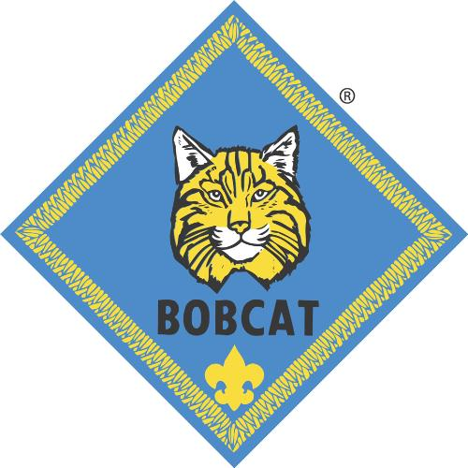
Bobcat Badge Ceremony
Sam Houston Area Council
Setting – 7 Webelos Scouts (WS), all Scouts earning the Bobcat badge; Cubmaster (CM), den leaders (DL).
Scene – Cubmaster invites the Scouts earning their Bobcat badges to stand in front of the group with their parents behind them. Webelos Scouts are standing to the side of the group.
CM: Den leaders, please step forward. For what purpose do these Scouts stand before us tonight?
DL #1: Akela, these Scouts are ready to receive their Bobcat rank.
CM: What leads you to believe they are worthy of this honor?
DL #2: They have completed the requirements for the Bobcat rank by learning the Scout Law, the Scout Oath, the Salute, the Handshake, and the Cub Scout Motto.
CM: Are they ready to show their brothers, the Webelos Scouts?
NOTE: Retesting is not allowed. Once the boy's book is signed he is done. So they can show the Webelos what they have learned. But they cannot be tested by anyone else once the book is signed. The Webelos should be prepped that they are to help if a Bobcat forgets something. They are NOT to criticize. Also, the requirement is to learn the Oath and Law as best as they can and be able to say it, "with help if needed." Rote memorization is not even hinted at in the requirement.
DL #2: Yes, they are.
(Den leaders return to previous spot.)
WS #1: Please, show us the Cub Scout Sign. (Hold the sign until the Cubmaster inspects all the candidates and then returns to the audience and says, “Very Good!”)
WS #2: Please, repeat the Scout Oath (or Promise) with me. Cub Scout Sign! (Raise the sign and say the Promise with the candidates. Then say) Good job!
WS #3: Please, show us the Cub Scout Salute. (Hold the salute as the Cubmaster inspects each candidate. Then say) Two. Well done!
WS #4: Please, repeat the Scout Law with me. Cub Scout Sign! (Raise the sign and say the Law with the candidates. Then say) Good job!
WS #5: Please, show us the Cub Scout Handshake. (Several of the Webelos Scouts perform the handshake with various candidates in the line and return. Say) Well done!
WS #6: What is the Cub Scout Motto? (The candidates say the Motto.) Ok, now let’s hear it with a little spirit! (Candidates say the Motto again.) Great – now louder! (The Bobcats yell the Motto. Then say loudly) That was great!
CM: Webelos Scouts, did they do their best?
WS #1: Yes, they did, Akela.
CM: Then these Scouts are ready to receive their Bobcats badges and to begin work on their next rank?
WS #3: I agree, they have all performed well and are ready, Akela.
CM: Thank you Webelos Scouts. You may be seated.
CM: Congratulations Scouts on completing the rank of Bobcat and showing what you have learned. I’m now going to give you your rank award to your parents to present to you. They have the honor of the presentation as they have done more to help you than I have. The Bobcat badge acknowledges your hard work. Make sure you thank your parents for helping you on this journey. They will journey with you on your adventure through Cub Scouts!
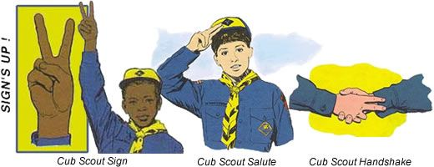
Salute to our Heroes Advancement Ceremony
Sam Houston Area Council
Materials – “Medals of Honor” made from construction paper and attached to loops of crepe streamer to be hung around the Cub Scouts’ necks. Label the medals “HERO.”

Cubmaster: Often we hear of professional athletes being called “sports heroes.” That’s a colorful description, but all they are really doing is playing a game to entertain us. Some of these people really are heroes, but that comes from things they do off the playing field to help their communities.
We salute those heroes that are people who are not afraid to do what they believe is right. They are people who want to make things better for others. They are usually prepared and trained to do the job. And they will do their best even if they are afraid because it is important to them to do what is right.
The following Scouts are the heroes that we salute today. They have chosen to work hard and prepare themselves in life by learning Cub Scouting ideals. They are learning to be independent and successful and happen to have a lot of fun along the way. Please join me in congratulating the heroes who have earned their Bobcat rank (call out names of Scouts and their parents, present rank awards, and place medals around the Scouts’ necks. Continue in a similar manner for each additional rank.)
Hear Ye, Hear Ye
Santa Clara County Council
Props: This can be as simple or as fancy as desired. The setting is at a campaign speech for city mayor.
Characters: The Cubmaster (CM) will need to have four people help with the awards. The candidates as Mr. (or Miss or Mrs.) Tiger, Wolf, and Bear and Mayor Scout.
Cubmaster: Ladies and gentlemen, we have come here tonight to hear the members of our (town council) express their views. Normally, we would salute these upstanding citizens but tonight they wish to salute our Cub Scouts.
Introduce Mr. (or Miss or Mrs.) Tiger, Wolf, and Bear
and Mayor Scout.
Mr. (or Mrs. Or Miss) Tiger: I enjoy talking with the youngest citizens of our fair city. It is great that we can provide so many places for them to go on their Adventures. These Tiger Cubs have earned awards for doing just that – completing Adventures. And I salute you. Would these Tiger Cubs and their Adult Partners please come forward and receive their awards. (Call out boys' names that are receiving their Tiger badges. The Cubmaster assists in presenting the awards to the parents to present to the Tigers.). After presentation CM leads a cheer.
Mr. (or Mrs. Or Miss) Wolf: I would like to talk to the next group of young people about our fair city, to say we need to improve on our quality of life. We have Cub Scouts present who have completed 7 Adventures to improve both their mind and body and their religious beliefs. I salute you for a job well done. Would these Cub Scouts and their parents please come forward and receive their awards. (Call out boys' names that are getting their Wolf Badge. The Cubmaster assists in presenting the awards to the parents to present to the Wolfs.). After presentation CM leads a cheer.
Mr. (or Mrs. Or Miss) Bear: I would like to address the middle-aged group of your fair Pack. You have been working for some time and have achieved much. I salute you and feel honored that I will be helping in the presentation of your Bear award. Would these Cub Scouts and their parents please come forward and receive their awards. (Call out boys' names that are getting their Bear and arrow points. The Cubmaster assists in presenting the awards to the parents to present to the Bears.). After presentation CM leads a cheer.
Mayor Scout: I would like to talk to the old timers of this our golden town. You have each given unselfishly of yourselves and for your loyal support all these years I have a special award that is called the Webelos Badge. Webelos stands for We'll Be Loyal Scouts and I salute you for your continued loyalty to Scouting. Pretty soon you will be moving up to Boy Scouting and I know you will be just as loyal there. Would these Webelos Scouts and their parents please come forward and receive their awards. (Call out boys' names that have completed Adventures and/or earned their Webelos Badges. The Cubmaster assists in presenting the awards to the parents to present to the Webelos.). After presentation CM leads a cheer.
Cubmaster: As sponsor for these campaign speeches I would like to add my personal salute and many thanks for jobs well done.

Badges of Cloth
Greater St. Louis Area Council
This will make a great start to your first advancement ceremony. Although no awards are made during this it does a good job of explaining the advancement program.
You will need six cards each in the shape of a badge, with one letter of the word BADGE on each card, the explanation for each letter on the reverse side.
- B: stands for badges given today. What is a badge? A scrap of colored material is not nearly so important as the job that was done to earn it.
- A: stands for Akela. Your family and leaders who have helped you earn your badge.
- D: stands for Deeds. Good deeds to be done now and in the future for family, friends, and the community. Good deeds done with the knowledge and skills acquired through the badges.
- G: stands for Growth. The Pack helps the Cub Scout grow.
- E: stands for Eagerness and Energy. Both are necessary to earn badges. Badges do not come easily and they should not or their value would be small. Badges present challenges, difficulties, and satisfaction in accomplishment.
- S: stands for Service. Service to others is one of our aims in life. Our badges help up to bring service to others.

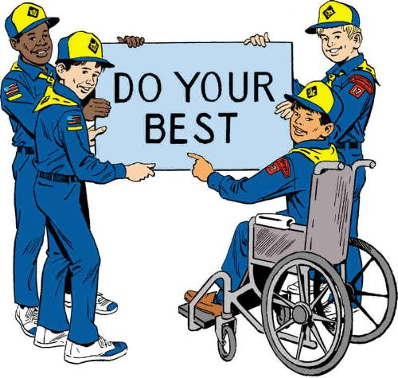

LEADER RECOGNITION
Have I told you lately how much I appreciate all that you do in the
Cub Program?’
Chris Reisel, Former Editor of Baloo’s Bugle
When was the last time you told another scout volunteer the above statement. Have you said thank you for all their help and for volunteering to work in our program? Just two words-----‘thank you’ They are so simple and yet not said enough. We mean to say it, we want to say it, and yet somehow, we manage to forget until it is too late. Something came up, you got distracted and the words never got said. Let me tell you now-----ITS NOT TOO LATE!
“I want to tell you how much I appreciate what you have done to help the program; THANK YOU!”

Because You Said Yes
Sam Houston Area Council
Because you said yes,
- A young man will feel the pride of being someone special as he carefully puts on his uniform for the very first time
- A young man can move to a new town and have "instant friendships" with Scouts he might never have met
- Parents will experience that special pride when they listen to their son say the Cub Scout Promise for the first time
- Bright eyes will become a little brighter with excitement as the kindling finally catches on the first campfire
- The community, and the world will be richer because a young man has learned the importance of caring for his environment, and the warm feeling that comes from giving service to someone less fortunate than himself
- A young man will contact the Boy Scouts one day and say "I had so much fun when I was a Cub Scout, I'd like to try being a leader"
And the circle will continue… because you said yes!
Materials – play gloves or mittens (stuffed), OR latex gloves, OR outline of Scout’s hand on cardstock, mounted on a display with the following sentiments – For Your Helping Hands
Cubmaster – This month there have been some remarkable parents/leaders who have lent their hands at some of our projects. I’d like to call them forward now and present them with the helping hands award. (Call adults forward and present hands.)

SONGS
I Am Proud-
Greater St. Louis Area Council
Tune “Yankee Doodle Dandy”
I am proud to be a Cub Scout
It makes me want to sing and shout
I wear a uniform of blue and gold,
It’s really a sight to behold
You would like to be a Cub Scout
I know without a single doubt
I do my best to do my duty
That’s what Cub Scouting is about.
9-1-1 HELP
Greater St. Louis Area Council
Tune “My Bonnie”
Emergencies they will answer,
They’re always a phone call away
They come when they’re needed most promptly
And for you they will most surely stay
Chorus:
Nine-one-one
Nine-one-one
We call on them when we need HE…LP
Medics are your friends and my friends
They answer their calls so fast
They come when they are needed so greatly
And always will stay to the last.
Chorus:
The firemen too answer calls
A fire is scary to see
But when they come oh so quickly
They put out the fire with glee
Chorus:
We often need a policeman
And 9-1-1 will get one there
Be sure that you know your address
Of this you should always be aware
Chorus:
Pack Meeting
Sam Houston Area Council
to the tune – Clementine
When our Cub Pack is outside at dusk
And our camp fire’s all aglow,
We will form a friendship circle,
As we sing so sweet and low.
We’re brave Tiger Scouts, and Wolf and Bear Scouts,
And trusty Webelos we’ll be.
To our Scout Law and Scout Oath
We will pledge our loyalty.
I’ve Got That Cub Scout Spirit
Great Salt Lake Council
I’ve got that Cub Scout spirit up in my head
(Point to head each time you say it)
Up in my head, Up in my head
I’ve got that Cub Scout spirit up in my head
Up in my head to stay
Repeat verse above and sing in turn:
Deep in my heart (Point to your heart)
Down in my feet (Touch your toes)
All over me (Make big circles with your arms)
Last Verse
I’ve got that Cub Scout spirit
Up in my head (Point to head)
Deep in my heart, (Point to heart)
down in my feet, (Touch your toes)
I’ve got that Cub Scout spirit all over me (Circle arms)
All over me to stay. (Circle arms)
The Yankee Doodle Scout Law
Sam Houston Area Council
to the tune – Yankee Doodle
Trusty Tommy was a Scout
Loyal to his mother
Helpful to the friends about, and
Friendly to his brother
Courteous to all about
Kind unto the rabbits
Obedient to his father, too, and
Cheerful in his habits
Thrifty saving for a need
Brave, and not a faker
Clean in thought and word and deed, and
Reverent to his Maker.
America, My Homeland
Sam Houston Area Council
to the tune – You are my Sunshine
You are my homeland,
You are a great land.
You make me happy,
You make me free.
Your flag I’ll honor,
I’ll pledge allegiance.
The USA is good to me.
I’M A YANKEE DOODLE DANDY
by George M. Cohan
Santa Clara County Council
I'm a Yankee Doodle Dandy
A Yankee Doodle, do or die
A real live nephew of my Uncle Sam
Born on the Fourth of July
I've got a Yankee Doodle sweetheart
She's my Yankee Doodle joy
Yankee Doodle came to London
Just to ride the ponies
I am the Yankee Doodle Boy
TOMMY THE CUB SCOUT
Santa Clara County Council
Tune: Frosty the Snowman
Tommy, the Cub Scout
Was a very happy boy.
With a uniform of blue and gold
And a Den that gave him joy.
Tommy, the Cub Scout
Earned his badges one by one.
He did his best and met the test.
A good citizen he's become.
He helps out other people when
He sees they need a lot.
He does his chores around the house
And feeds his dog (named Spot).
Tommy, the Cub Scout
Does his duty willingly.
Someday he'll join a Boy Scout Troop
And a fine man he will be.

STUNTS AND APPLAUSES

APPLAUSES & CHEERS
Great Salt Lake Council
DYBS yell -
DYBS means “ Do Your Best, Scouts”
It is pronounced ‘dibs’.
Leader raises his fist in the air and brings it down hard each time ‘DYBS’ is yelled.
Number of DYBS given is according to accomplishment. I would set a max (e.g. Three How's is a perfect score on the HOW scale. And thanks to Jamie I can now get to 2 7/8 CD)
The Good Turn Cheer - Stand up and turn around while clapping.
Heart and Soul Cheer - (For people who put their heart and soul into something.)
Pat the palm of your hand on your heart and then on the sole of one shoe.
Santa Clara County Council
Abe Lincoln Cheer: That was great! HONEST!
America: A-M-E-R-I-C-A (3 times), Cub Scouts (or Boy Scouts), Cub Scouts, USA!
Constitution Cheer: We the people, APPROVE!
George Washington Cheer: That was great. I cannot tell a lie.
Presidential Cheer: Salute and say: "Hail to the Chief."
“We Want You” Cheer: Everyone yells “I Want You” and points their finger at the honoree (like in the Uncle Sam posters).
Liberty Bell Yell: Ding, Ding, Ding, Dong! Let freedom ring!
Alice, Golden Empire Council
Superhero Applause - Hold arms out in front and upwards and yell – “Fly Into Action, Superhero!”
Hero Motto
- Divide the audience into two groups.
  - First group puts their hands in front of the eyes as if looking through binoculars and says, “Find a Need!”
  - Second group holds out the left hand as if a bowl, while the right hand “dumps” something in the bowl – while shouting, “And Fill It!”
- Narrator starts by yelling – “What does a hero do?”
- Leader can then point to first group several times, then to the second group, and can also control the sound level with his motions.
Hero Definition Applause
Group yells several times – “Brave and Loyal, Strong and True!” (A “Less Filling’, Tastes Great” type chant. CD)

RUN-ONS
Great Salt Lake Council
- Spell “we” using two letters other than
W or E.
- U and I.
- What can a person wear that is never out of style?
- A smile.
Sam Houston Area Council
Knock-Knock.
Who’s there?
Heaven.
Heaven who?
Heaven the time of my life in Cub Scouts!
Knock-Knock.
Who’s there?
Uniform.
Uniform who?
Uniform a straight line when we say the pledge!
Veteran Heroes
Alice, Golden Empire Council
Down at the Veteran's hospital, a trio of old timers ran out of tales of their own heroic exploits and started bragging about their ancestors. "My great grandfather, at age 13," one declared proudly, "was a drummer boy at Shiloh."
"Mine," boasted another, "went down with Custer at the Battle of Little Big Horn."
"I'm the only soldier in my family," confessed vet number three, "but if my great grandfather was living today he'd be the most famous man in the world."
"What'd he do?" his friends wanted to know.
"Nothing much. But he would be 165 years old."

JOKES & RIDDLES
Santa Clara County Council
- What did the turkey say before he was roasted?
- Wow, I’m stuffed.
Cub #1: What are those holes in the trees?
Cub #2: They’re knotholes.
Cub #1 Really? If they’re not holes, what are they?
Cub #1: I crossed a carrier pigeon with a woodpecker yesterday.
Cub #2: Really, what did you get?
Cub #1: I don’t know, buy when it delivers a message, it knocks.
Cub #1: What is the chemical formula for water?
Cub #2: H, I, H, K, L, M, N, O.
Cub #1: May I ask what that is?
Cub #2 H to O.
Cub #1: (enters pet shop) Sir! I would like 25 cents worth of birdseed.
Man: 25 cents worth of birdseed? How many birds do you have?
Cub #1: I don’t have any birds, I want to grow some.
Who’s the Hero?
Alice, Golden Empire Council
Q: A hero says, "Brothers and sisters, have I none, but that man's father is my father's son." Who is he pointing at?
A: His own son – father’s son has to be himself, since he has no bothers, and since this is the father of the person he is pointing at, he is pointing at his son!
Some Hero Riddles:
Alice, Golden Empire Council
Q: What is light as a feather, but even the strongest hero can’t hold it more than a few seconds?
A: His breath!
Q: What is a policeman's favorite snack?
A: Copcakes (cupcakes).
Q: What kind of food do brave soldiers eat?
A: Hero sandwiches.
Q: When does a police dog not look like a police dog?
A: When it is an undercover agent.
Running from Heroes
Alice, Golden Empire Council
Q: A man left home running. He ran a ways and then turned left, ran the same distance and turned left again, ran the same distance and turned left again. When he got home there were two masked men. Who were they?
A: The catcher and umpire in a baseball game
Calling a Superhero
Alice, Golden Empire Council
Q: Imagine you are in a sinking rowboat surrounded by sharks. Which superhero would you need to survive?
A: You don’t need a superhero at all – Just stop imagining!

A Real Riddle About a Real Hero:
Alice, Golden Empire Council
Q: Why is George Washington's official birthday celebration held on February 22 when he was actually born on February 11?
A: We lost eleven days when we switched from the Julian to the Gregorian calendar during his lifetime. So Washington celebrated his birthday eleven days later to make it a year after his last birthday.

SKITS
Recipe for a Great Cub Scout Den
Sam Houston Area Council
Setting – 3 to 10 Scouts. One Scout “reads” from a cook book; one Scout “stirs” the pot, and the other Scouts add the “ingredients.”
Props - Cover old cans or boxes or plastic containers with paper and label. Fill each can with some streamers so it looks like it’s spilling out when the Scout adds the “ingredient.”
Scene – Scouts are standing around a table with a large pot and the “ingredients” on top of the table.
Cub #1: (stands by the pot and stirs slowly as each ingredient is added)
Cub #2: (reads from the cook book) Here is a recipe for a great Cub Scout den. Hey guys, do we have everything? (He looks around as the other Cubs nod their heads.)
Cub #2: First we need three cups of enthusiasm.
Cub #3: Here it is (pours it in).
Cub #2: Next comes two cups of laughter.
Cub #4: I have that! (pours it in)
Cub #2: Two cups of courtesy are next.
Cub #5: I think this is the courtesy (pours it in).
Cub #2: Now, two cups of helpfulness.
Cub #6: I brought that (pours it in).
Cub #2: Next we need two adults to help.
Cub #7: I found two real good ones! (pours it in)
Cub #1: This is really looking good (peers inside the pot).
Cub #2: We need one cup of ability to follow instructions.
Cub #8: I brought that (pours it in).
Cub #2: Now we need one gallon of patience.
Cub #9: I had to look a long time for that, but I finally found it! (pours it in)
Cub #2: Last we need four cups of friendship.
Cub #10: I got that, and I added a little more than the recipe needed (pours it in).
Cub #2: Well that’s it. Now we need to mix it all together and store it somewhere safe so we can bring some back to every den meeting!
Making A Cub Scout
Great Salt Lake Council
Characters: Child, Two Leaders, Two Parents
Props:
You will need a large table for the child to lie on during the “operation.”
The “doctor” can carry a large cardboard knife.
Props to be “removed” are tacked to the back of the table, out of sight.
Those to be “put in” can be placed nearby. (Props are listed where used.)
Narrator: We are about to instruct you in the method of making a Cub Scout. To complete this project, you will need one small eager boy, two interested parents, one patient den leader, and one courageous Cubmaster.
(Each character enters as his name is spoken. The boy wears his uniform under a large loose-fitting shirt and climbs up on the table. Others don surgical masks. As the narrator continues, the operation proceeds, with the Cubmaster acting as doctor. The den leader and parents hand him the things to be put in and take the things removed. When the boy is hidden under a sheet, he removes his shirt.)
Narrator: Cover him with fun and good times (Hold up posters labeled “FUN” and “GOOD TIMES” and cover boy)
Narrator: We use laughing gas for anesthetic. (Use a tire pump labeled “Laughing Gas.”)
Narrator: Take out hate and put in “Love.” (Hate - lump of paper, so labeled. Love - big paper heart, labeled).
Narrator: Take out selfishness, put in cooperation. (Sign “I,” sign “WE).
Narrator: Take out idle hands, put in busy fingers. (Idle - empty rubber gloves. Busy - glove full of flour.)
Narrator: Take out laziness, put in ambition. (Laziness - rag; Ambition -blown up balloon.)
Narrator: After this pleasant operation, we have a “Cub Scout.”
(Remove the sheet. Boy, in uniform, stands up and gives the Cub Scout sign.)
Blue and Gold Spirit
Sam Houston Area Council
Setting – 7 Scouts. One (Cub #1) is dressed as Lord Baden-Powell (or a den leader, or other Scout leader). Props for the items needed as noted below.
Scene – Lord Baden-Powell stands in front and the Scouts enter one at a time as they are described.
Cub #1: I represent the spirit of Lord Baden-Powell, the founder of Boy Scouting. I am also the spirit of Boy Scouting, past and present. Here is our future – the Cub Scouts of America.
(Cub #2 enters in complete uniform.)
Cub #1: The two colors of the Cub Scout uniform have special meaning. Blue stands for truth and loyalty. Gold stands for good cheer and happiness.
(Cub #3 enters with Wolf book and
Kipling’s Jungle Book.)
Cub #1: Early Cub Scout ceremonies were based on Kipling’s Jungle Tales. When Cub Scouting was organized in America in 1930, Native American themes were used.
(Cub #4 enters with a craft project made from wood.)
Cub #1: Cub Scouting means fun. We have lots of fun. Most Scouts like making things – really good projects – things they can play with that usually follow a monthly theme.
(Cub #5 enters carrying a collection from nature.)
Cub #1: Cub Scouts like to go on hikes and collect things for their nature collections. They like the outdoors.
(Cub #6 enters, carrying a spatula and a bowl.)
Cub #1: Most Cub Scouts like to go on picnics. AND, it’s even more fun when they get to cook their own food.
(Cub #7 enters, carrying the American flag.)
Cub #1: Cub Scouts are proud to be Americans. They are proud of their flag. They are also very proud of their pack flag, because it reminds them they are part of 100 years of Scouting. They are part of both America and the Cub Scouts.
(Pause)
Cub #1: Yes, I represent the past and the present. These young Cub Scouts now are the men of the future. They will be the preservers of our American heritage.
Harvest Celebration
Santa Clara County Council
Boys are standing around talking. They can be attired in Colonial costumes.
- We sure had a great time at the Harvest Celebration. When my Dad said we would have a big party I didn't know it would last for 3 days.
- Yea! We invited 92 Indians, plus all our families. We helped our Moms cook for days. It was fun to play games, have shooting contests and relays during the celebration.
- I liked the food we cooked, boiled eel, lobster, roasted pigeon, stuffed cod, journey cakes, corn meal bread with nuts and succotash.
- The Indians brought food too, turkeys, pumpkins, sweet potatoes, cranberry sauce. And, they brought deer meat, too.
- I liked the popcorn the best...I never ate popcorn before. I heard my Dad say Governor Bradford has decided to have a celebration again next year, in 1622. He wants to call it Thanksgiving Celebration!

CLOSING CEREMONIES
I Will Use
Sam Houston Area Council
Setting – 6 Cub Scouts with verses memorized. (Or they could each have poster with a picture of the body part named on front and the words on back in LARGE print. CD)
- This is my country. I will use my eyes to see the beauty of this land.
- I will use my ears to hear its sounds.
- I will use my mind to think of what I can do to make it more beautiful.
- I will use my hands to serve and care for it.
- And with all my heart, I will honor it.
- Please stand for the retiring of the colors.
A Final Salute
Sam Houston Area Council
Setting – 9 Cub Scouts or 8 Cub Scouts and Cubmaster, the letters of A-T-T-E-N-T-I-O-N on poster board with the appropriate verses on the reverse.
Scene – Scouts in a line. Each holds up his poster as his turn arrives.
- A At tonight’s pack meeting, we
- T Talked about the flag and the importance of honoring it.
- T Tonight we also had some fun as we involved
- E Everyone in our Scouting Spirit.
- N Now it is time for our pack meeting
- T To end. In a few minutes we are going to ask
- I If you would stand and salute the flag
- O One more time as it is retired for this evening. We would
- N Next like you to join us in the Scout Oath.
One Drop Of Blue Closing Ceremony
Great Salt Lake Council
Equipment: One clear gallon glass jar, full of water and blue food coloring.
- The Cubmaster drops one drop of blue food coloring into the gallon of water.
- Watch as one drop of blue becomes a larger and larger circle until it becomes so diluted that it is barely visible. (Hint - Practice and keep your water volume such that a tinge of blue remains)
Cubmaster says:
- The one little drop of blue did its best and succeeded in filling the whole big jar.
- In the same way, one Cub Scout (in blue) can also influence all those around him by his actions and words.
Living Circle Ceremony
Great Salt Lake Council
I remember learning this ceremony at my first Den Meeting at Mrs. Kneale’s house in September 1957. We still teach it to our dens. CD
Based on an Indian custom, the living circle may be used alone or as a part of another ceremony. It reminds a Cub Scout of the fine friendships he is making in Cub Scouting.
Hold out your left hand—palm down, and thumb out.
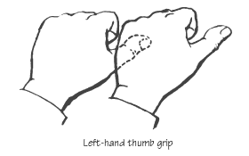
Hold the thumb of the boy on your left and form a connected circle.
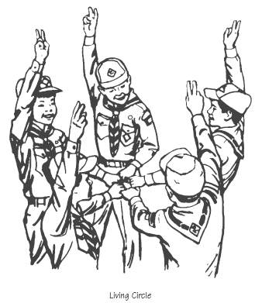
Then say the following as a football team may do after a time out or entering the filed at start of the game.
Action Say
Phonetic spelling of Akela
Raise the circle AH
Lower it KAY
Raise it LA
Lower it WE’LL
Raise it DO
Lower it OUR
Raise it BEST!
Release Hands



CUBMASTER’S MINUTES
A Scout is Loyal
https://johnscout.wordpress.com
Check it out for many other Scoutmaster Minutes!!!
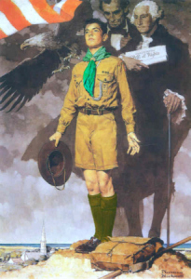
A Scout is Loyal.
A Scout is loyal to those to whom loyalty is due.
When we think of being loyal, we think of standing by our country, and our state. We are loyal to our church and our family. We are loyal to our school.
When we join Cub Scouts, we pledge our loyalty to our Pack and Den. In all Scouting, the Scout Law and Scout Oath guide the Scouts to help the unit (Pack or troop) go and the unit (Pack or Troop) Pack helps the Cub Scout grow.
That’s the key with loyalty. It’s not a one-way street. Your Den and Pack are only as good as you make them.
You get out of Scouts what you put in. You give loyalty to those to whom loyalty is due, and they will return loyalty to you.
A SCOUT IS LOYAL
http://www.macscouter.com/scoutmaste
Scouts, what's the second point of the Scout Law? That's right, "A Scout is loyal. " Our Scout handbook explains that a Scout is loyal to his family, Scout leaders, friends, school and nation.
I'm going to add one more thing to that list - a Scout is loyal to his team. The team might be his patrol or sports team.
Your patrol or soccer team can't be as good as it should be if you goof off a lot or constantly complain about your teammates or your patrol leader or coach. A winning patrol and a winning team, must have a winning attitude. That means that every member must be willing to do his part and not spend time griping because the patrol's plans or the game are not going his way.
That doesn't mean that you have to be close friends with everybody in your patrol or team or even like all of them. But it means that when you join, you commit yourself to the success of the patrol or the team and pledge to give it your best effort.
In Scouting and sports, it's teamwork that makes winners. So whenever you're with your patrol or sports team, remember, "A Scout is loyal".
Scoutmaster Minute - Loyalty
http://voluntoldscouter.blogspot.com/
Two famous generals of the Civil War were Ulysses S. Grant and William T. Sherman. Grant, though the younger of the two, and junior to him at West Point, was Sherman’s Commander. As general of the Union Army, Grant commanded several other generals, but he knew that he could trust Sherman with the most difficult tasks. While some Generals needed line-by-line instructions, Sherman only needed to know the objective. Grant could trust him with the details of getting the job done. Grant knew that the only thing to prevent Sherman’s completing the task was a musket ball with Sherman’s name on it.
That musket ball didn’t exist. Sherman finished his difficult and unpopular task, and Grant accepted Gen Robert E. Lee's surrender at Appomattox Court House in April of 1865, ending the Civil War. These two men remained loyal to each other throughout their lives:
“The friend in my adversity I shall always cherish most. I can better trust those who helped to relieve the gloom of my dark hours than those who are so ready to enjoy with me the sunshine of my prosperity.” – US Grant
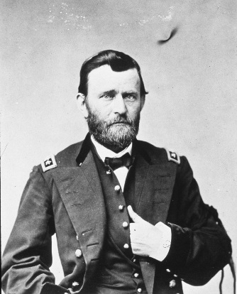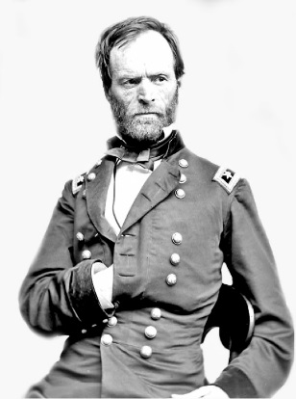
General Ulysses S Grant Gen Wm. T. Sherman
“Grant stood by me when I was crazy, and I stood by him when he was drunk, and now we stand by each other.” – Gen Wm Sherman
I am reminded of another general, in a land far from the battlefields of Tennessee, Virginia and South Carolina, from a time long before. His name was Moroni, and you are all familiar with his struggle against the armies of Lamanites and disloyal Nephites. Like General Grant nearly 2,000 year later, he said, “I seek not for power, but to pull it down. I seek not for honor of the world, but for the glory of my God, and the freedom and welfare of my country.”
Loyalty is a noble characteristic. As you get older, you will confront some serious choices. When you are faced with a difficult choice, ask yourself, “How will this choice demonstrate my loyalty to my friends, my family, my nation, my Church and my God?” Let it be said of you that you chose to be loyal, like Generals Grant, Sherman and Moroni.
Cub Scout Benediction
Santa Clara County Council
And now may the Great Master of all Cub Scouts
Guide and guard our footsteps
For today, for tomorrow,
And for all the tomorrows to come.
The Circle of Life
Sam Houston Area Council
Setting – 4 Scouts holding posters from the Circle of Life opening ceremony
Scene – darkened room if possible, as the Cubmaster speaks
We must stand together – with these four circles. They are powerful forces in our lives, and yet without them, we are unable to sustain life. We must harness the strength and the energy these forces provide for peace in our world. We must find the spiritual power that enables the forces and use it to intensify our own struggle for peace. Each of us carries an energy, and combined with the energies of our friends, our family, our neighbors, our world, we can become one body and one heart striving for peace. And we must continue this path as the sun and the moon and the winds and the earth continue in their paths in the great circle of life.
THE AMERICAN’S CREED
Santa Clara County Council
I believe in the United States of America as a Government of the people, by the people, for the people; whose just powers are derived from the consent of the governed; a democracy in a republic; a sovereign Nation of many sovereign States; a perfect Union, one and inseparable; established upon those principles of freedom, equality, Justice and humanity for which American patriots sacrificed their lives and fortunes. I, therefore; believe it is my duty to my country to love it; respect its flag; and to defend it against all enemies.
GIVE THEM THE CUB SCOUT SALUTE !!!
Great Salt Lake Council
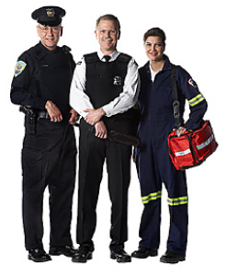
We will find many heroes within the community this month. Some of them will be the adults that we know. Some of them will be Cub Scouts or even the Boy Scouts. We will search throughout the neighborhood to find someone that would be interested in coming to share some of the things that helped them determine their own destiny. We will also look at our young friends that might be the future leaders of tomorrow, those that show leadership qualities that will put them in positions throughout their lives to become the president of a company or even the United States.
We have highlighted some of the heroes that we find in our neighborhood. Our policeman, the firefighters that risk their lives every time they suit up. The mail man is also trained to watch out for the emergencies that might come his way while delivering the mail. The neighbor that would open his door to a young child that might need some help out on the street could be a hero also. We also will be highlighting the women that will be in the lives of the Cub Scouts. They would be the den leaders and perhaps the Cubmaster. Then there is the one special person that is in most every boy’s life, his mother.
We are using the cardboard stand-ups and placing a familiar face by enlarging the photo and attaching it in place of the original. Now we have created the “Super Hero” that we want to present. It, of course, could be any one of many people in your area that you have noticed a silent act of heroism that has not been mentioned before. There are many people that just go about their business daily that often respond at a moment's notice to help out someone in distress.
We often read in the “Boy’s Life” magazine about the young men that have been prepared in a time of need when the call for help arises and what they have done to save a life. We hope that you will be able to search out some of these people and highlight them for the month.
WE GIVE THEM THE CUB SCOUT SALUTE !!!
A Boy
Santa Clara County Council
- He is a person who is going to carry on what you have started. He is to sit right where you are sitting, and attend, when you are gone, to those things you think are so important.
- You may adopt all the policies you please, but how they will be carried out depends on him. Even if you have leagues and treaties, he will have to manage them.
- He will assume control of our cities, states and nation. He is going to move in and take over your churches, schools, universities, and nation.
- All your work is going to be judged and praised or condemned by him. Your reputation and your future are in his hands.
- All your work is for him; and the fate of the nation and of humanity lies in his hands. It is well that we pay him some attention.

CUB GRUB
CUB GRUB
Patriotic Quencher
Sam Houston Area Council
Ingredients –
3 ounces cranberry juice
3 ounces sports drink (blue)
3 ounces sugar free 7-Up (or Sprite)
Ice cubes
Directions –
- Place the ice cubes in the bottom 3rd of a tall 12 ounce clear glass.
- Pour the cranberry juice in to fill the bottom 3rd.
- Place a few more cubes in to the middle and
- Pour in the blue sports drink to fill the glass 2/3 full.
- Place the final 3rd of ice in the glass.
- Pour in the diet 7-Up or diet Sprite.
When poured carefully, this makes a red, white and blue drink. It separates by using the drink with the highest sugar on the bottom, and the least on top.
Hero Sandwich
Santa Clara County Council
- Cut a loaf of French bread in half lengthwise.
- Layer on slices of ham, salami, and cheese.
Or maybe some TURKEY.
- Top with lettuce and sliced tomatoes.
- Add onions, pickles, and hot peppers, if desired.
- Spread on mayonnaise or mustard.
Hot “Hero” Sandwich
San Gabriel, Long Beach Area, Verdugo Hills Councils
Ingredients:
4 crispy fried bacon slices
½ cup mayonnaise or salad dressing
1 cup shredded Cheddar cheese
½ cup dry roasted peanuts
½ teaspoon celery salt
1 teaspoon Worcestershire sauce
2 green onions, chopped
4 English muffins or 8 slices of bread, toasted
Directions
  - Mix mayonnaise, Worcestershire sauce and celery salt in a bowl.
  - Stir in cheese, onions and peanuts. (Watch for allergies)
  - Crumble bacon into mixture. Stir.
  - Fill each sandwich with ½ cup of the cheese mixture.
  - Place one sandwich on a paper napkin and microwave on high 20 to 25 seconds.
  - Makes 4 servings.
Scout Cookies
Great Salt Lake Council
Ingredients
Favorite sugar cookie recipe
2 tbsp cocoa
2 tbsp water
Directions
- Make your favorite sugar cookie recipe.
- Put ¼ cup of dough in small bowl add cocoa and water blend well.
- Drop white dough by rounded teaspoonfuls on greased cookie sheet.
- Grease bottom of glass, dip in sugar, and press quickly to flatten into rounds.
- With a toothpick make eyes, nose, and mouths out of chocolate dough.
- With a spoon make hair out of chocolate dough. If chocolate dough gets too stiff to spread easily, add another drop or two of water.
- Bake 8-10 minutes.
- Makes about 3 dozen cookies
Cinnamon Stars
Great Salt Lake Council
Ingredients
2 tbsp sugar
¾ tsp cinnamon
¾ c butter, softened
2 egg yolks
1 tsp vanilla
1 package French vanilla cake mix
Directions
- Preheat oven to 375 °.
- Combine sugar and cinnamon in small bowl.
- Set aside.
- Combine butter, egg yolks, and vanilla in large bowl.
- Blend in cake mix gradually.
- Roll dough to 1/8 inch thickness on lightly floured surface.
- Cut with 2 ½ inch star cookie cutter.
- Place 2 inches apart on ungreased backing sheet.
- Sprinkle cookies with cinnamon-sugar mixture.
- Bake for 6-8 minutes or until edges are light golden brown.
- Cool 1 minute on baking sheet.
- Remove, cool completely.
- Store in airtight container. Makes 3-3 ½ dozen cookies
People Cookies for Pets
Alice, Golden Empire Council
Take good care of your cat or dog.
You can even make them some People Cookies!
First make sure your pet isn't allergic to the ingredients, then get permission to use the kitchen, and follow this recipe.
Ingredients:
1 cup whole wheat flour
1/2 cup white flour
1/4 cup cornmeal
1/2 cup quick-cooking oatmeal
1/2 cup dry, nonfat milk
1/4 cup grated Parmesan cheese
1/3 cup vegetable shortening
1 raw egg
1/2 cup meat-flavored baby food, warmed in the microwave
Directions:
- In a large bowl, combine the first six ingredients.
- Add the shortening and mix well with a fork.
- Mix in the warm baby food and raw egg.
- Knead the dough with your hands for a few minutes; Sprinkle white flour on hands, rolling pin, and wax paper;
- Then use a rolling pin to roll it out on a wax paper-covered surface.
- Using cookie cutters, cut dough into different shapes and put the pieces on a microwave-safe plate.
- Microwave on low power for two minutes, rotate the plate, and continue microwaving for another minute or two. Check often.
- Let the biscuits cool. Give your pet one or two a day as a treat. Dogs eat them whole, but break treats into smaller pieces for cats.
Cubcakes
Great Salt Lake Council
Ingredients
1 package (18 oz) chocolate cake, plus ingredients to prepare
1 container (16 oz) chocolate frosting
1 package (5 oz) chocolate nonpareils
72 red cinnamon candies
Chocolate sprinkles
1 tube (0.6 oz) black piping gel
Directions
- Line muffin cups with paper liners.
- Prepare cake mix and bake in muffin cups according to package directions.
- Cool in pans on wire racks 15 minutes.
- Remove cupcakes from pan and cool completely.
- Frost cooled cupcakes with chocolate frosting.
- Use nonpareils for ears and muzzle, red candies for eyes and nose and chocolate sprinkles for fur.
- Use piping gel to place dots on eyes and to create mouth.
All American Dessert
Santa Clara County Council
Ingredients:
1 large Berry blue Jell-O
1 large Red Jell-O, any flavor
4 c Water; boiling
2 c Water; cold
8 oz Cool Whip; thawed
4 c Angel food cake -OR-- pound cake, break in cubes
2 c Strawberries; sliced
1/2 c Blueberries; (optional)
Directions:
- In separate bowls, dissolve each flavor of Jell-O completely in 2 cups of boiling water.
- Stir 1 cup of cold water into each bowl.
- Pour into separate 9x13" pans.
- Refrigerate at least 3 hours until firm.
- Cut into 1/2" cubes.
- Place blue Jell-O cubes in bottom of clear glass trifle bowl.
- Top with 1/3 of the Cool Whip.
- Add cake cubes, then sliced strawberries.
- Top with another 1/3 Cool Whip.
- Add the red Jell-O cubes and then the remaining Cool Whip.
- Sprinkle blueberries over top if desired.
Cub Salute Snack
Let each boy make an individual “Salute” snack to enjoy
This is a variation of the Program Helps idea. Alice
Ingredients:
Graham Crackers,
White icing,
Blue sprinkles,
Red rope licorice,
White chocolate chips.
Directions:
- Give each boy a graham cracker and craft stick or small knife to spread white icing on the cracker.
- Have each boy mark off the square for the blue using the edge of a craft stick or knife.
- Have him carefully drop blue sprinkles on the square.
- You (Adult) Cut red licorice into thin strips and short pieces,
- Have each boy add the “stripes” to his flag.
- Use white chocolate chips to make some stars.
While the boys enjoy eating their treat, remind them of the symbolism of the flag:
50 Stars = 50 States;
White = Purity;
Blue = Justice And Fairness;
Red = Courage.
Remind them that these are some of the same qualities that help make a hero.
Alice, Golden Empire Council
Alice, Golden Empire Council
I’m sure you’ve seen this before. Alice
Ingredients:
A sheet cake,
Alternating rows of banana slices and strawberries, and Blueberries in the upper left corner
Directions:
- Cake can be homemade or store bought
- Assemble as above
- Be sure to dip the banana in citric acid or pineapple juice so it doesn’t turn brown!
Pretzel Sparklers
Alice, Golden Empire Council
- Give children long pretzel sticks.
- Have them dip the top part of the stick into melted white chocolate.
- Then, let them add red and blue sprinkles or other miniature candies on top of the melted chocolate.
Fruit Sparklers
Alice, Golden Empire Council
- Alternate blueberries, strawberries, bananas, cherries, and large marshmallows to make a red, white, and blue pattern onto wooden skewers.
- To add a touch of festivity, tie red, white, and blue ribbons to one end of the skewer.
Note: When finished skewering fruit, break off sharp tips to prevent injury.
Transformer Fruit Snacks
Alice, Golden Empire Council
Easiest of all – just pass out Transformer fruit snacks - but be sure you have talked about what is required to “transform” yourself into a hero worthy to be saluted.
Fire Hose
Santa Clara County Council
Ingredients:
1½ cups apple juice
2 envelopes unflavored gelatin
3 oz. package any flavor Jell-O
Ice cubes
Directions
  - Heat half the apple juice to boiling.
  - Add the Jell-O and stir to dissolve.
  - Soften unflavored gelatin in remaining apple juice and add to hot Jell-O.
  - Stir to dissolve.
  - Add ice cubes and stir until melted.
  - Refrigerate 15 minutes.
  - Spoon into a Zip-Loc bag.
  - Cover cookie sheet with plastic wrap.
  - Cut corner off plastic bag and squeeze out small amount of Jell-O in shape of a hose.
  - Chill 2 hours.
  - Eat!!
Firehouse Chili Dog Casserole
San Gabriel, LB Area, Verdugo Hills Councils
“It's like eating a chili dog, but with a fork."
Ingredients:
8 hot dog buns
8 hot dogs
1 (15 ounce) can chili
¼ cup chopped onion
1 tablespoon prepared mustard
2 cups shredded Cheddar cheese
Directions
  - Preheat oven to 350°F (175°C).
  - Lightly grease a 9x13” baking dish.
  - Tear up the hot dog buns and arrange the pieces in the bottom of the dish evenly.
  - Slice the hot dogs into bite size pieces and layer the pieces over the buns.
  - Pour the chili over the hot dogs,
  - Sprinkle with the chopped onion,
  - Then spread some mustard over the chili and the onion.
  - Top off with the cheese.
  - Bake at 350°F (175°C) for 30 minutes.
  - Original recipe yield: 6 to 8 servings
Chili
Get a package of any of the various Alarm Chilis (e.g. 3 Alarm) and mix and serve according to directions
Firefighter Chili Cheese Dip
San Gabriel, Long Beach Area, Verdugo Hills Councils
Ingredients:
1 (8 ounce) package cream cheese, softened
1 (15 ounce) can chili
1 cup shredded Cheddar cheese
Directions
  - In the bottom of a 9” microwave safe round baking dish, spread the cream cheese.
  - Top the cream cheese with an even layer of chili.
  - Sprinkle Cheddar cheese over the chili.
  - Heat in the microwave on high heat 5 minutes, or until the cheese has melted.
  - Serve with your favorite chips or vegetables.
Popcorn Balls
Santa Clara County Council
Ingredients:
3 quarts plain popped corn (about 1/3 cup kernels)
1/4 cup butter
10 oz. bag marshmallows
food coloring (optional)
Directions:
- Put popped corn in a large bowl. Set aside.
- Melt the butter and marshmallows in a stovetop pot, stirring constantly.
- When they are melted, take off the heat and allow the mixture to cool until it can be touched. If you like, stir in a few drops of food coloring.
- Using a wooden spoon, gently stir the melted mixture into the popcorn.
- Next, butter your hands and work quickly to form popcorn balls.
- Place balls on waxed paper to cool.
- After the balls are cool, you may use warm corn syrup to stick gum drops or other candy decorations to the popcorn balls.
- The popcorn balls may be stored in sandwich bags.
- This makes enough for about 15 two-inch balls, but you can make them any size or shape you like!
Making Butter
Santa Clara County Council
- Fill baby food jars half full of whipping cream and screw the lids on tightly.
- Let kids take turns shaking each jar.
- After about 5 minutes the cream will be whipped, and after another minute or so, lumps of yellow butter will form.
- Rinse off the liquid whey and add a little salt, if desired.
- Then spread on home made bread crackers to taste!
Oreo Turkeys
Santa Clara County Council
Ingredients:
Oreo Cookies
Candy Corn
Malted Milk Balls
Icing (Not Whipped)
Directions:
- Open one Oreo and place one part, icing side up (eat the other half).
- Add a bit of icing as glue, and stand another Oreo up on it (this is your turkey body).
- Spread one side half of the standing Oreo with icing, and attach 5-6 pieces of candy corn, fanned out like turkey feathers.
- Add a malted milk ball to the top of the other side, for head. An additional piece of candy corn can be used for a waddle (or a red M&M).
RED, WHITE AND BLUE TWISTS
Santa Clara County Council
- Open enough red (cherry), white (mystery flavor), and blue (raspberry/blueberry?) Airheads to make enough treats for the boys in the den.
- Stack the 3 colors on top of each other on a piece of waxed paper.
- Using a roller pin, meld them together so they’ll stick together when you twist them.
- Cut the stack lengthwise into strips so that they are as wide as they are thick.
- Twist each stick like a barber’s pole to for red-white-blue twists.
APPLE PIE SNACKS
Santa Clara County Council
Aside from baseball and Chevrolet,
what could be more American than Apple Pie?
- Premix and roll out pie dough,
- Cut into circles to fit in individual serving pie tins.
- Premix apple filling (or use a canned variety).
- At the start of the meeting, have the boys put the dough into their own pie tin, add the filling and cover with another piece of dough.
- Let them “carve” their initial into the top pie dough.
- During the meeting, let these bake and cool.
- Serve with ice cream at the end of the meeting.
JELL-O STARS
Santa Clara County Council
Ingredients:
You’ll need red, white and blue colored gelatin.
Jell-o for red and blue
Knox for white
Directions:
- To make the white jell-o, mix a box of Knox gelatin with ½-cup of boiling water and add this to a container of Cool-Whip.
- In a flat pan, pour a ¼-inch layer of blue jell-o and allow it to set.
- Mix the white gelatin and add a ¼-inch layer and allow it to set.
- Finally, add a ¼-inch layer of the red jell-o.
- Once it is all set, use a star-shaped cookie cutter and cut out stars for snack.
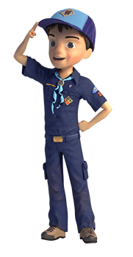

GAMES
Salute to Fitness
Sam Houston Area Council
Set up an obstacle course for the Scouts to move through. Include stations where they must stop and do 5-10 pushups, 10-15 jumping jacks, 10-20 sit ups, and 10-15 toe touches as they move through the course. The Scouts move from one station to the next by using “animal” walks such as a duck walking, a bear walking, a crab walking, a turtle crawling, etc…
Fire, Police, Ambulance Game-
Greater St. Louis Area Council
Three corners of the room are named “Fire Station”, “Police Station”, and “Ambulance”.
The leader calls out a situation in which a boy might find himself and the Cub Scouts have to run to the correct “corner”
The last one home loses a point for his team.
Suggested situations-
- Smoke is seen coming from under the door of a house. (Fire Station.)
- Your window cleaner falls from a ladder while cleaning the upstairs bedroom window (Ambulance.)
- When out fishing you spot some bushes on fire. (Fire Station.)
- You see some older boys cutting the wire to a telephone in a call box (Police Station)
- Your friend falls from his bicycle while you are out for a ride, (Ambulance.)
- You find a transistor radio pavement. (Police Station.)
- Your bicycle is stolen. . (Police Station.)
- An older person who has rescued a small, unconscious girl from a river asks you to telephone for help (Ambulance)
Help Lead me Home
Santa Clara County Council
Supplies: Pencil and paper
- Ask each of the boys to think about the walk from the den meeting place to their home.
- Have them count the number of streetlights, bridges, trees, cross walks, fire hydrant, police stations, fire stations and neighbors houses they pass.
- Have them write down as many as they can remember.
Scout Sign Puzzle
Sam Houston Area Council
- Give each Scout a 3x5 card and instruct him to draw one of these features –
Scout sign,
hair on top of a head,
a pair of eyes,
two ears,
a nose,
a mouth,
a body with one arm down and one arm reaching up,
legs and feet/shoes.
- Place the cards upside down on a table and shuffle them.
- Have each Scout take a turn turning up the cards and putting the Scout together IN THE RIGHT ORDER (start with the Scout sign, then the top of the head, then the eyes, ears, nose, mouth, body, and finally the legs).
- If a Scout turns up a card out of order, it is the next persons’ turn.
- Turn the cards back over for the next Scout.
- The first Scout to turn over the cards in the right order wins.
Mixed Cubs
Great Salt Lake Council
(Musical chairs without music)
- You need enough chairs for everyone in the group except for one person.
- Put the chairs in a circle.
- Then go around the circle and tell each person a Scout name like “Tiger, Wolf, Bear, Webelos.”
- The person in the center can then call out one of the names of the Scouts (Tiger, Wolf, Bear, Webelos) or “Mixed Cubs.”
- The object of the game is to always have a chair.
- When the person in the center calls out a Scout name (e.g. Bear), those people who are representing Bears must get up and find a new chair, and the person in the middle finds a chair.
- Whoever is left without a chair is the new “caller.”
- If “Mixed Cubs” is called, everyone in the game must find a new chair.
- After you are in a new seat, you must make the Cub Scout salute until the new caller shouts out one of the Scout names.
- If you do not make the Cub Scout salute and the caller catches you, then you lose your seat and have to switch places with the caller.
Cub Scout Salute Relay Race
Great Salt Lake Council
- For this relay race, divide the boys up into teams. You can have however many teams you want, but 2 to 4 is probably best.
- Everyone starts at certain point, and each team is lined up in their own line.
- At the go signal, the first person runs to the first station area, makes the Cub Scout sign and repeats the Scout Oath. You may want to have a copy of the Oath posted there for those who do not know it.
On my honor, I will do my best.
To do my duty to God and my country
and to obey the Scout Law;
To help other people at all times;
To keep myself physically strong,
mentally awake and morally straight.
- Then he runs to the next station, gets a licorice rope off the table and ties a square knot. (Show all the boys how to tie square knots before the race begins.)
- He keeps his licorice rope with him to eat later.
- Then he runs to the last station where an American Flag is posted.
- He stops, salutes the flag, and repeats the Pledge of Allegiance.
- Then, he turns around and runs back to his team.
- When he gets there, he must use the Cub Scout handshake with the next boy in line before that boy can start his turn. The first team (make sure the teams are equal in size or have a boy go twice) to have all the boys finish is the winning team.
Potato Roll
Santa Clara County Council
You could do this during Easter time using Styrofoam shaped Easter eggs. Or at Halloween or Thanksgiving with pumpkins. This is a simple race but since potatoes are not nice smooth balls and refuse to roll in nice straight lines, you will need plenty of wandering room.
- You will need two large potatoes and two sturdy sticks. If you need to play inside, use small potatoes.
- The racers line up on the starting line with the potatoes turned on their sides.
- On signal, the racers use the stick to roll the potatoes to the finish line.
- Younger players may want to use their hands instead of the stick..
- Can also be played as a relay race.
Treasure Hunt Game
Santa Clara County Council
Supplies: pencil and paper
Have the boys make a list of things that can be seen in their town. You might help by making suggestions like, large oak trees on Main Street, bridge, library, county office building, historical marker, and City Park. After the boys have made their list take them on a 30 minute walk around town to see the things they listed.
Crossing the Delaware
Santa Clara County Council
Needed: balloons
- Give each player a balloon and have them blow it up and tie it.
- When the contestants are ready, have them stand against the wall.
- At the given signal, they are to cross the room, keeping the balloons in the air by hitting them only with their heads. No hands are allowed.
- The one who succeeds in crossing the room first with his balloon untouched except by his head, wins the game.
Capture the Flag
Santa Clara County Council
Needed: 2 large (at least l foot square) cloth "flags" in different colors, one for each team; a smaller flag for each team's player.
- Pick 2 teams.
- Designate outer boundaries of playing area. Include a line to divide field in half, as well as small areas in each territory for a "jail.”
- Each player receives a small flag in the teams color, which is tucked not tied) into the players belt.
- Each team's large flag is hidden somewhere in the opponent's area.
- The object of the game is to be the first team to bring its flag "home".
- Players must enter the other team's territory to look for their flag.
- While they're looking their opponents can steal their small flags.
- When a players flag is stolen, he goes to "jail" where his small flag is returned.
- A player can free jailed teammates by sneaking into the jail area (without losing his small flag) and calling "jailbreak".
- The game ends when a player finds the large flag and gets it back to his side without losing his small flag.
Hiking Game
Santa Clara County Council
While hiking, the leader stops and says, "I spot a ______________ to naming a familiar object. Everyone who sees the object raises his hand, until everyone sees it.
Hello Neighbor
Santa Clara County Council
- Have boys form a circle, pick some one to be '"it".
- "It" walks counterclockwise around the circle.
- "It" tags someone on the back and starts running.
- The tagged person also starts running but clockwise.
- When the two of them meet while running around the circle, they must stop, shake hands and say "Hello, Neighbor".
- Then they must race to the open spot in the circle that was left open by the player that was tagged.
- The first one to get in the open spot stays in the circle, and the one left out starts to walk counter clockwise and continues the game by tagging another player.
Solution Calling for Help Cryptogram

ONE TWO LAST THINGS
You are blessed
Santa Clara County Council
You are blessed
- If you woke up this morning with more health than illness. You are more blessed than the million who will not survive this week.
- If you have never experienced the danger of battle, the loneliness of imprisonment, the agony of torture, or the pangs of starvation
- You are ahead of 500 million people in the world.
- If you can attend a church meeting without fear of harassment, arrest, torture, or death
- You are more blessed than three billion people in the world.
- If you have food in the refrigerator, clothes on your back, a roof overhead and a place to sleep. You are richer than 75% of this world.
- If you have money in the bank, in your wallet, and spare change in a dish someplace you are among the top 8% of the world's wealthy.
- If your parents are still alive and still married you are very rare, even in the United States.
- If you hold up your head with a smile on your face and are truly thankful you are blessed because the majority can, but most do not.
- If you can hold someone's hand, hug them or even touch them on the shoulder you are blessed because you can offer healing touch.
- If you can read this message, you just received a double blessing in that someone was thinking of you, and furthermore, you are more blessed than over two billion people in the world that cannot read at all.
Have a good day, count your blessings, salute your friends and relatives that make these things possible, and pass this along to remind everyone else how blessed we all are.
Raising a Child
Santa Clara County Council
I have seen repeatedly the breakdown of the cost of raising a child, but this is the first time I have seen the rewards listed this way. It's nice, really nice.
The government recently calculated (This article from 2009) the cost of raising a child from birth to age 18 and came up with $160,140 for a middle-income family. Talk about sticker shock! That doesn't even touch college tuition. For those with kids, that figure leads to wild fantasies about all the money we could have banked if not for (insert your child's name here).
For others, that number might confirm the decision to remain childless. But $160,140 isn't so bad if you break it down. It translates into $8,896.66 a year, $741.38 a month, or $171.08 a week. That's a mere $24.44 a day! Just over a dollar an hour.
Still, you might think the best financial advice says don't have children if you want to be "rich." It is just the opposite.
So, What do you get for your $160,140?
- Naming rights. First, middle, and last!
- Glimpses of God every day.
- Giggles under the covers every night.
- More love than your heart can hold.
- Butterfly kisses and Velcro hugs.
- Endless wonder over rocks, ants, clouds, and warm cookies.
- A hand to hold, usually covered with jam.
- A partner for blowing bubbles, flying kites, building sandcastles, and skipping in the pouring rain.
- Someone to laugh yourself silly with no matter what the boss said or how your stocks did that day.
- For $160,140, you never have to grow up.
- You get to finger-paint, carve pumpkins, play hide-and-seek, catch bugs, and never stop believing in Santa Claus.
- You have an excuse to keep reading the Adventures of Piglet and Pooh, watching Saturday cartoons, going to Disney movies, and wishing on stars.
- You get to frame rainbows, hearts, and flowers under refrigerator magnets and collect spray painted noodle wreaths for Christmas, hand prints set in clay for Mother's Day, and cards with backward letters for Father's Day.
- You get the greatest possible bang for your buck.
- You get to be a hero just for retrieving a Frisbee off the garage roof, taking the training wheels off the bike, removing a splinter, filling the wading pool, coaxing a wad of gum out of bangs, and coaching a baseball team that never wins but always gets treated to ice cream regardless.
- You get a front row seat to history to witness the first step, first word, first bra, first date, and first time behind the wheel.
- You get to be immortal. You get another branch added to your family tree, and if you're lucky, a long list of limbs in your obituary called grandchildren.
- You get education in psychology, nursing, criminal justice, communications, and human sexuality that no college can match.
- In the eyes of a child, you rank right up there with God. You have all the power to heal a boo-boo, scare away the monsters under the bed, patch a broken heart, police a slumber party, ground them forever, and love them without limits, so one day they will, like you, love without counting the cost.


Same is true for Boy Scout Leaders!!

