COMMISSIONER'S CORNER
Every great person has first learned how to Obey, whom to Obey, and when to Obey.
William A. Ward
Welcome Aboard
- Jeff Mchoul - RT Hints
- Robert Stocker - Social Media and how to tell the Scouting story.
- Gary Moore - My Scouting Tools.
- Shanae Ames – Award of the Month – Youth & Adult
- ClaralynSant (A friend of Alice's) A Outdoor Ethics (Leave No Trace) article and Crazy Holidays column.

FILES/ BOOKS/ LINKS TO MATERIALS FROM UNIVERSITIES AND POW WOWs NEEDED –
If your council ran a University or a Pow Wow and published a book or posted files on the web or on a cloud somewhere. Let us know. We are always looking for new material. You can write us at –
davethecommish@gmail.com and
judyjohnsonbsa@yahoo.com


Judy and Dave need could still use help. If you would do one item for Baloo each month, it would help us greatly –
Some ideas for you to consider –
Biography – write a one page +/- biography of a person you select that exemplifies that month's emphasized point of the Scout Law.
Advancement – Choose a rank. Write a few hints and ideas for the Adventure to be discussed that month at the Roundtable. And, also, any that have a Character Compass pointing to that months point of the Scout Law
Point of the Scout Law – Look for items that help get across the meaning of the point of the Scout Law emphasized that month in Roundtable.
Have another idea? Let us know how you feel you could help us to make Baloo's Bugle more of what RT Commissioners, Cubmasters, and Den Leaders want.
Write us through the "Send Your Ideas to Baloo" link or directly – davethecommish@gmail.com and judyjohnsonbsa@yahoo.com
 Boys Life has a series of videos on the Scout Law called "Believe It – Live It." For Obedient a US Army MEDEVAC crew is interviewed and shows why obedience is essential to their mission. Go to URL: http://boyslife.org/about-scouts/scoutlaw/4274/a-scout-is-obedient/

TABLE OF CONTENTS
COMMISSIONER'S CORNER 1
TABLE OF CONTENTS 2
CORE VALUES 5
OBEDIENT QUOTES 5
Sportsmanship Quotes: 6
Welcome to My.Scouting! 7
THOUGHTFUL ITEMS 8
RANK ADVANCEMENT CHARTS 9
BIOGRAPHY 9
Obedient People 9
CUB SCOUT LEARNING LIBRARY 11
ADVENTURE PLAN TRACKERS 15
BE UP TO DATE 15
www.scouting.org/programupdates 15
CUB SCOUT LEADER TRAINING 15
IN-PERSON TRAINING 15
ON-LINE TRAINING 15
CUB SCOUT IDEAS 16
PACK FUNDRAISERS AND FINANCE 16
ROUNDTABLE HINTS 18
Refocusing Your Roundtable 18
DEN MEETING TOPICS 21
CHARACTER COMPASS 21
THEME RELATED STUFF 22
IT'S A HIT RELATED ADVENTURES 22
PACK MEETING THEMES AND PLANS 22
PACK MEETING THEMES 23
UPCOMING MONTHS 24
CUBMASTER THOUGHTS 25
Lions (The Beginning) 25
The Chief Scout Executive on Lions 26
MORE LION INFORMATION 27
WEBELOS 30
WEBELOS HISTORY 30
JUNE 2016 – A MONTH FOR OBEDIENCE 32
Crazy Holidays 33
TRAINING TOPICS 36
Parents 36
The Yardstick 37
Family Induction Ceremony 38
FUN STUFF 39
Fun Facts About Yo-Yo's 39
Build a wooden yo-yo 39
All I Really Need To Know I Learned From Baseball 40
THEME PACK AND DEN ACTIVITIES 42
Bike Rodeo 45
THEME & PACK MEETING IDEAS 49
GATHERING ACTIVITIES 49
OPENING CEREMONIES 51
AUDIENCE PARTICIPATIONS 53
ADVANCEMENT CEREMONIES 54
LEADER RECOGNITION 58
Certificate of the Right to Play 58
SONGS 59
STUNTS AND APPLAUSES 60
APPLAUSES & CHEERS 60
RUN-ONS 60
JOKES & RIDDLES 61
SKITS 62
CLOSING CEREMONIES 63
CUBMASTER’S MINUTES 64
CUB GRUB 65
GAMES 68
Amazing Flying Machine (Bomb Pops) 68
DEN ADVENTURES 71
TIGER 71
Tiger Adventure: Tigers in the Wild 71
Rationale for Adventure 71
Takeaways for Cub Scouts 71
Adventure Requirements (Tiger Handbook, page 92) 71
Animal Tracks Book 73
Tiger Scout Skits 74
Tiger Elective Adventure: Floats and Boats 76
Types of boats 76
How to Make a Floating Toy Boat 76
The Water Safety Chant: 77
Buddy Tag Game 77
Make Sure the Life Jacket is Properly Fastened 77
How to Save an Active Drowning Victim 78
Tiger Elective Adventure: Rolling Tigers 79
Rationale for Adventure 80
Takeaways for Cub Scouts 80
ADVENTURE Requirements (Tiger Handbook, page 174) 80
Summer Family Fun Equals Cub Scout Achievement: Family Bike Rides 81
Bicycle Safety Printable Activities for Cub Scouts 81
Printable Bicycle Safety Playing Cards 82
WOLF 83
Wolf Adventure: Call of the Wild 83
Start a Fire with a Lemon 84
Camping Checklist for Scouts 84
Square Knot Song and Overhand Knot Song 84
Wolf Den Outing Plan – Call of the Wild: Campout 84
Wolf Den Meeting Plan – Call of the Wild: Safety 84
Wolf Den Meeting Plan – Call of the Wild: Outdoor Skills 84
Cub Scout Outdoor Ethics Awareness Award 85
Fire Safety with Cub Scouts 85
The Twelve Days of Camping Song 85
The Outdoor Code 85
Leave No Trace Frontcountry Guidelines 85
Camping Packing List 85
RATIONALE FOR ADVENTURE 85
TAKEAWAYS FOR CUB SCOUTS 85
ADVENTURE REQUIREMENTS (Wolf Handbook, page 30) 85
PREPARATION AND MATERIALS NEEDED 86
GATHERING 86
OPENING 86
TALK TIME 87
ACTIVITIES 87
Activity 1: Animal Identification (Requirement 3) 87
Activity 2: Camping Charades Game 87
Activity 3: Camping Gear 87
CLOSING 87
AFTER THE MEETING 87
DISC GAMES (GATHERING) 88
ACTIVITIES 88
Activity 1: Animal Identification 88
Activity 3: Camping Gear 88
PREPARATION AND MATERIALS NEEDED 88
GATHERING 89
OPENING 89
TALK TIME 89
ACTIVITIES 89
Activity 1: Safety Check 89
Activity 2: Knot Tying/Knot Relay Game 89
(Requirement 2) 90
Activity 3: Campfire Show Planning 90
CLOSING 90
AFTER THE MEETING 90
PREPARATION AND MATERIALS NEEDED 91
GATHERING 91
OPENING 91
TALK TIME 91
ACTIVITIES 91
Activity 1: Animal Identification (Requirement 3) 91
Activity 2: Human Chain Race 91
Activity 3: Perform Skit or Song (Requirement 6) 91
CLOSING 91
AFTER THE MEETING 92
Ideas for Adventure Requirements: 92
Taco Salad In A Bag! – Perfect for camping and kids! 92
Wolf Elective Adventure: Air of the Wolf 94
Product Review: Catapult Cruzers 94
Forces of Flight Game 94
Not your average popsicle stick crafts 95
Popsicle stick bow and arrow 95
What you'll need: 95
What you'll do: 95
Popsicle stick harmonica 96
What you'll need: 96
What you'll do: 96
Popsicle stick knitting loom 96
What you'll need 96
What you'll do: 97
DIY Newspaper Kite 97
How to Make a PVC Trombone 102
Things You'll Need 103
Tips & Warnings 105
Wind Pipe Instrument 105
BEAR 107
Bear Adventure: Bear Claws 107
Bear Elective Adventure: Salmon Run 107
Safety Afloat 108
Coastie the Safety Boat for Cub Scouts 111
Travel Safety Checklist for Cub Scouts 111
BSA Swim Test 112
Requirements 112
Swimmer 112
Beginner 112
Non-Swimmer 112
WEBELOS CORE 112
ARROW OF LIGHT CORE 112
Arrow of Light Adventure: Scouting Adventure 112
Webelos/AOL Elective Adventure: Aquanaut 113
Webelos Aquanaut Ideas 114
Aquanaut Games 114
ONE LAST THING 115
Abbott & Costello: Who’s On First? 115

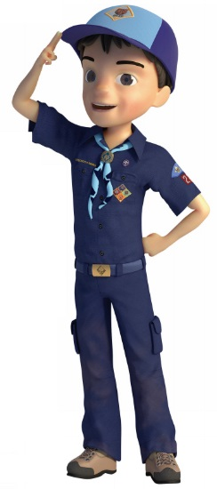

CORE VALUES
The Cub Scout Core Values are the
12 Points of the Scout Law.
The core value highlighted next month is:
June's point of the Scout Law, OBEDIENT, will use the theme, IT'S A HIT.
A SCOUT IS OBEDIENT
A Scout follows the rules of his family, school, and pack. He obeys the laws of his community and country.
HOW DOES “IT'S A HIT” RELATE TO THIS POINT OF THE SCOUT LAW?
It is easy to forget the importance of being honest when you are playing a game and you really want to win. However, a Cub Scout always tells the truth and is a person worthy of trust. This month, we will reinforce how important it is to be honest—notably when playing ball with friends.

Per our Founder, Lord Baden-Powell
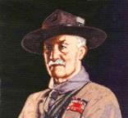
Note – The original Scout Law published in 1908 had nine points. In 1910, the BSA added Brave, Clean, and Reverent. In 1911 B-P added Clean to his original list.
A SCOUT IS OBEDIENT
Baden Powell did not use the word Obedient, he said -
A SCOUT OBEYS ORDERS of his patrol leader, or Scoutmaster without question. Even if he gets an order he does not like, he must do as soldiers and sailors do, he must carry it out all the same because it is his duty; and after he has done it he can come and state any reasons against it: but he must carry out the order at once. That is discipline.
(Scouting For Boys, 1908)

An animal has been made by God,
just as you have been.
He is therefore a fellow-creature.
– Lord Robert Baden-Powell

A SCOUT IS OBEDIENT
Alice Retzinger, Golden Empire Council
While the theme "It’s A Hit" suggests baseball, we should also make sure the boys recognize that Obedience is required in many places – whatever the sport, we should practice good sportsmanship and Follow the Rules. If we decide ahead of time to be obedient to principles and beliefs, we only have to make a one-time decision about that particular thing.
Sometimes, being OBEDIENT is more than just a good thing – it can be a matter of personal safety, even lifesaving. For example, if you have a swim day planned, following Safe Swim and Buddy System rules can literally save a life. Following the rules of the road, even if you are a passenger, or when you are riding a bike or skateboard can keep you safe even if there is an accident.

OBEDIENT QUOTES
Quotations contain the wisdom of the ages, and are a great source of inspiration for Cubmaster’s minutes, material for an advancement ceremony or an insightful addition to a Pack Meeting program cover.
A boy can learn a lot from a dog: Obedience, loyalty, and the importance of turning around three times before lying down.
Robert Benchley
Obey something, and you will have a chance to learn what is best to Obey. But if you begin by Obeying nothing, you will end by Obeying the devil and all his invited friends. John Ruskin
Obedience is better than sacrifice. I Samuel 15:22
It is much safer to Obey, than to govern.
Thomas à Kempis
It is right that what is just should be Obeyed. It is necessary that what is strongest should be Obeyed. Blaise Pascal
The joy of youth is to Disobey; but the trouble is that there are no longer any orders. Jean Cocteau
Obedience of the law is demanded; not asked as a favor. Theodore Roosevelt
Those who know the least Obey the best.
George Farquhar
Every good servant does not (Obey) all commands. William Shakespeare
Unwavering Obedience to the true principals we learn will assure us spiritual survival.
Disobedience, in the eyes of anyone who has read history, is man's original virtue. It is through Disobedience that progress has been made, through Disobedience and through rebellion. Oscar Wilde
The reason why men do not Obey us is because they see the mud at the bottom of our eye.
Ralph Waldo Emerson
There can be a true grandeur in any degree of submissiveness, because it springs from loyalty to the laws and to an oath, and not from baseness of soul. Simone Weil
Every great person has first learned how to Obey, whom to Obey, and when to Obey. William A. Ward
I have thought about it a great deal, and the more I think, the more certain I am that Obedience is the gateway through which knowledge, yes, and love, too, enter the mind of the child. Anne Sullivan
No principal is so noble, as there is none more holy, than that of a true Obedience. Henry Giles
Obedience is a word and concept from which the valiant look for their deliverance. Anonymous
Obedience without faith is possible, but not faith without Obedience. Anonymous
Obey something, and you will have a chance to learn what is best to Obey. But if you begin by Obeying nothing, you will end by Obeying the devil and all his invited friends. John Ruskin
Only he who believes is obedient and only he who is obedient believes. Dietrich Bonhoeffer
The doctrine of blind Obedience and unqualified submission to any human power, whether civil or ecclesiastical, is the doctrine of despotism, and ought to have no place among Republicans and Christians. Angelina Grimke
The ship that will not Obey the helm will have to Obey the rocks. English Proverb
There is no shame in taking orders from those who themselves have learned to Obey.
William Edward Forster
Obedience alone gives the right to command.
Ralph Waldo Emerson
One act of Obedience is better than one hundred sermons. Dietrich Bonhoeffer
A great work is made out of a combination of Obedience and liberty. Nadia Boulanger
The only safe ruler is he who has learned to Obey willingly. Thomas a Kempis
Liberty is Obedience to the law which one has laid down for oneself. Jean-Jacques Rousseau
Obedience is the mother of success and is wedded to safety. Aeschylus
When any one State in the American Union refuses Obedience to the Confederation by which they have bound themselves, the rest have a natural right to compel them to Obedience. Thomas Jefferson
Public opinion is a permeating influence, and it exacts Obedience to itself; it requires us to think other men's thoughts, to speak other men's words, to follow other men's habits. Walter Bagehot
Let thy child's first lesson be Obedience, and the second may be what thou wilt. Benjamin Franklin
True Obedience is true freedom. Henry ward Beecher
Strength was the virtue of paganism; Obedience is the virtue of Christianity. David Hare
We have come out of the time when Obedience, the acceptance of discipline, intelligent courage and resolution were most important, into that more difficult time when it is a person's duty to understand the world rather than simply fight for it. Ernest Hemingway
Obedience keeps the rules. Love knows when to break them. Anthony de Mello
There are two kinds of men who never amount to much: those who cannot do what they are told, and those who can do nothing else.
Cyrus H. Curtis

Sportsmanship Quotes:
Baltimore Area Council
“Games are not so much a way to compare our abilities as a way to CELEBRATE them.” ...Pat Farrington
“How we play the game may turn out to be more important than we imagine. For it signifies nothing less than our way of being in the world.” ...George Leonard
“True games do not divide us into winners and losers, but cause us to EMBRACE each other. They give everyone the chance to experience the feeling of full and even membership in the play community.” ...George Leonard


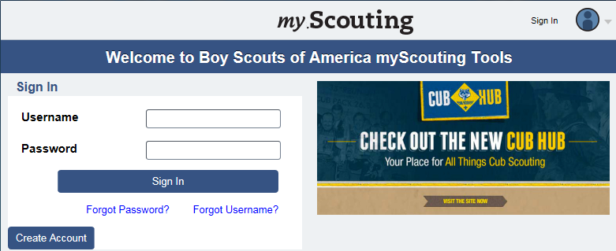

Welcome to My.Scouting!
By Gary Moore
BSA has put a new tool in the hands of Packs, Troops and Crews! The My.Scouting.org website has brought a great source of information and many new tools together to manage membership, member information, training and training records, and communication, both within your unit and with your Unit Commissioner and District Commissioner team.
Up until the introduction of My.Scouting, the only way a Unit could see what was in the “official” Scouting database (called ScoutNet) was to ask for their District Executive (DE) to provide a current Unit Roster. While that would give accurate information, it required time and effort by an already busy DE to access, produce and distribute. Now, though, any of the Key 3 of the Pack, Troop or Crew can quickly go online and get this information themselves. For example, if you turn in a membership application, you can see when that the person was, in fact, registered and added to your unit. When getting ready for re-charter, there are reports detailing Youth Protection records.
In coming months, we’ll go through and look at each of the tools on the website and show how they can be used. And we’ll keep up to date with any new additions.
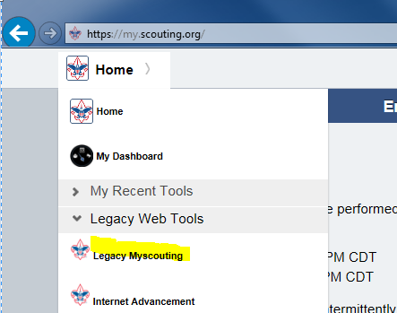
This month, though, we’ll focus on creating an account and logging on to the site. All you need is Internet access and an active email address to validate the account. Currently, my.Scouting Tools is best experienced using the latest version of Google Chrome or Mozilla Firefox. It also works with the latest version of Safari, and Internet Explorer (v11 or better.)
Anyone can create a username and password to log on to the My.Scouting.org website. This allows new adult members to take Youth Protection Training, which is required to be able to register. To create an account, go to http://my.scouting.org and click on the Create Account button. The process is easy, but be aware that you may need to wait up to 30 minutes for everything to set up before signing in.
You’re asked if you are involved with Scouting and for your Member ID. This is to avoid creating multiple accounts and to preserve any training records. It will also save you from having to enter all your personal information as it will be pulled from the ScoutNet database as in the example below. Certain information is not shown to protect personal information.
If you have an email listed in ScoutNet, you can use that to verify your My.Scouting account, or, if you either did not have an email address listed or no longer have access to that account, can specify a new email. In any case, an email will be sent for you to verify the account. If you have any issues, you can call Member Care at (972) 580-2489 M-F 7 AM – 7 PM Central Time or email myscouting@scouting.org for help.
Until your account is linked to a valid BSA Membership ID, you will have no access to any information about a unit or its members, so it’s important that this linkage be correct.
If you did not have a BSA Member ID when signing up, this can be added later by clicking on the menu in the upper left, clicking on Legacy Web Tools and then choosing Legacy Myscouting. Log in using the same username and password used for the My.Scouting.org website, then, from the menu on the left, under My Profile, click on Update My Profile. Scroll to Membership Info section at the bottom, choose your Council from the Council Name: dropdown menu and enter your Member ID in the box then click the Add button. The next time you log in at My.Scouting.org, you’ll have access to the MyScouting tools appropriate to your registered role in Scouting.
So, WOW! You’re connected! What do you do now? Stay tuned for the next exciting episode in next month’s Baloo’s Bugle. We’ll be talking about the Calendar and Announcement tools.

THOUGHTFUL ITEMS
June Theme Prayer
Cub Scout Roundtable Leaders’ Guide
As we learn to play together, let us remember that we need to respect others and to do our best. AMEN
PRAYER OF THE SPORTSMAN
Dear Lord, in the battle that goes on through life,
I ask but a field that is fair:
A chance that is equal with all in the strife,
If I should win, let it be by the code
With my faith and my honor held high,
If I should lose, let me stand by the road
And cheer as the winners go by. —Brayley.
A SPORTSMAN’S PRAYER
Dear God: Help me to be a sport in this little game of life. I don’t ask for any easy place in the lineup, play me anywhere you need me. I only ask for the stuff to give you 100 per cent of what I’ve got. If all the hard drives seem to come my way, I thank you for the compliment. Help me to remember that you won’t ever let anything come my way that you and I can’t handle. And help me take the bad breaks as part of the game. Help me to understand that the game is full of knocks and knots and trouble, and make me thankful for them. Help me to get so that the harder they come, the better I like it.
And, O God, help me always to play on the square. No matter what the others do, help me to come clean. Help me to study the Book so that I will know the rules and to study and think a lot about the greatest player that ever lived and the other great players that are told about in the Book. If they found that the best part of the game was helping other guys who were out of luck, help me to find it too. Help me to be a reg’lar feller with the other players.
Finally, O God, if fate seems to upper-cut me with both hands and I’m laid on the shelf in sickness of old age or something, help me to take that as part of the game too. Help me not to whimper or squeal that the game was a frame-up or that I had a raw deal.
When in the falling dusk I get the final bell, I ask for no lying complimentary stones, I’d only like to know you feel that I’ve been a good, game guy.
—By George H. Brimhall.
What I learned from Officiating Youth Sports
Scouter Jim, Great Salt Lake Council
It is just a game and it is personal. For every little boy and girl playing sports, it is personal. They may look tough on the outside, but they are still tender on the inside. Be positive with the boys you work with, never berate of criticize them. I would always rather hear, “You’ll do better next time,” rather than, “That’s not the way I taught you.” The fragile spirits of the children are crushed by the latter while they are encouraged to try to do better by the earlier.
Winning isn’t everything, sportsmanship is. I once officiated a Pop Warner football game where one team had a special needs player. They asked if they could put him in as a deep safety on defense. While they were playing defense they played with twelve players against eleven. The opposing coach was thrilled to be playing against “such a worthy opponent.” He received the “Good Turn” coin I tried to give away each week to the best sport of the day.
Opponent and enemy isn’t the same thing. Too many times rivalries form and players playing against each other forget that a game is not a war. I once did a softball game where one team did not have a pitcher for a second game. The other team lent them a couple of theirs. The first pitcher hit three of her own players in the first inning with pitched balls. Both coaches keep encouraging her to do her best, even against her own teammates. After the first inning, the opposing team lent them one of their best pitchers to finish the game. At the end of the game, both coaches parted friends.
Character Counts! The most important thing I have learned in my years of officiating youth sports it that character counts. The most important thing coaches, and Scout leaders either for that fact, can teach, is that it is more important to be try your best; be courteous to other players, coaches and officials; and to be a good sport. Sometimes the biggest winners are the ones on the teams with the fewest points when the game is over.
TEN COMMANDMENTS OF SPORTSMANSHIP
- Thou shalt not quit.
- Thou shalt not alibi.
- Thou shalt not gloat over winning.
- Thou shalt not be a rotten loser.
- Thou shalt not take unfair advantage.
- Thou shalt not ask odds thou art unwilling to give.
- Thou shouldst always be ready to give thine opponents the shake.
- Thou shouldst not under-estimate an opponent, or over-estimate thyself.
- Remember that the game is the thing, and that he who thinks otherwise is a mucker and not A true sportsman.
- Honor the game thou playest, for he who playeth the game straight and hard wins even when he loses.
Children have never been very good at listening to their elders, but they have never failed to imitate them James Baldwin
"We cannot hold a torch to light another's path without brightening our own." Ben Sweetmand

RANK ADVANCEMENT CHARTS
Track your Den's completed Adventures and progress to earning their next rank on a wall chart. This worked wonders for us when our son was a Cub Scout. Everyone wanted to have the most completions. And they could see where the goal was.
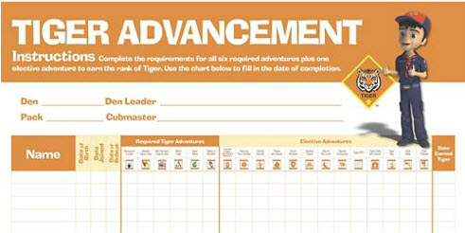
Tiger Advancement Chart, Item: 620578
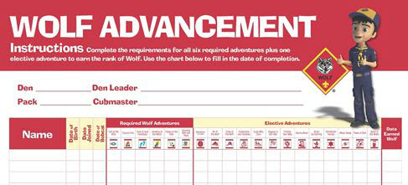
Den Advancement Chart, Item: 620579
(Scoutstuff.org listing says Den Advancement Chart not Wolf)
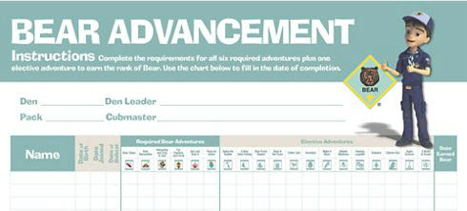
Cub Scout Bear Advancement Chart, Item: 621006
(Not sure why this one says Cub Scout. None of the others do)
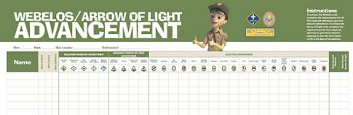
Webelos® Advancement Chart, Item: 620577

BIOGRAPHY

Obedient People

There are many examples of persons being obedient. There are Bible events galore. There are military stories of soldiers following orders. There is the US Constitution. Let's look at a few of these.
Soldiers Obeying Orders
Military personnel must follow orders in order to ensure the success of missions and safety of the team.
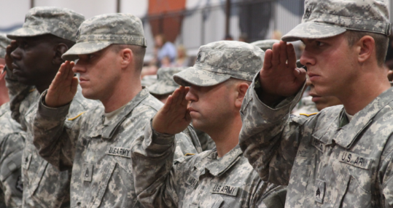
The precision of Seal Team 6 in their successful mission against Osama Bin Laden showed Obedience to the orders and actions. To following the plan exactly. To being quiet.
The obedience of the 1000's of soldiers and marines landing on Normandy on D-Day and on the beach at Iwo Jima during World War preserved our freedom and defeated those who threatened it.
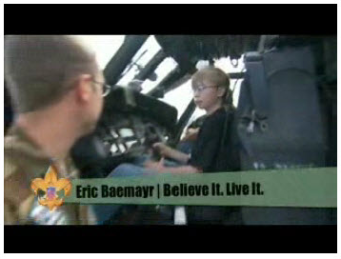
Believe It – Live It
In this video, the “Believe It Live It” team interviews a U.S. Army MEDEVAC crew and shows why obedience is essential to their mission. This video on www.Boyslife.org relates military obedience to the Scout Law http://boyslife.org/about-scouts/scoutlaw/4274/a-scout-is-obedient/
Obedience in the Bible
The ultimate example is Our Savior, Jesus Christ, dying for our sins. He prayed for deliverance from his fate but concluded with "Not my will but thine be done," and he died on the cross for us.

There is Noah building the Ark because God told him to do it. There was no storm or flood yet. The story of Noah is found in Genesis, Chapters 6-8.
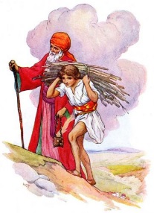
Abraham's obedience to God when he was told to sacrifice his son Isaac in Genesis, Chapter 22. What can you learn from this historic event? First, obedience. Abraham had complete faith in God, believing that Isaac was the son of promise through whom would come many nations. Abraham obeyed God, knowing He could not lie and would keep His promise. Likewise, Isaac, who was 25 at the time, had faith in his earthly father and his heavenly Father. Second—and here is the main point—Isaac strove to always respect and obey his parents. As a direct result of this faith and obedience, we enjoy the blessings promised by God long ago.
Shadrach, Meshach, and Abednego obeying God's commandment to not worship any other God's and winding up in the fiery furnace in Daniel, Chapter 3.
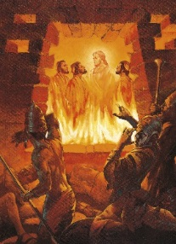
And the many things that Moses did to save his people and bring them to the Promised Land. He did whatever was asked, went to Pharaoh, led his people, presented the Ten Commandments, and parted the Red Sea. There are numerous events recorded in Genesis and Exodus about the journey of the Israelites from Egypt to Israel.
And lots more recorded events that speak of being Obedient to God. Events I learned as a youth that seem to be seldom taught today. But teach us the importance of being Obedient.
The United States Constitution:
Obedience to The Law
For The Common Good
The constitution of our country is the basis of public tranquility, the firmest support of political authority, and a security for the liberty of the citizens. We as Americans are fairly unique in our strict obedient behavior to our Constitution.
We transition our governments, Federal, State, and Local, peacefully. We change our President and Commander in Chief of our military every 4 or 8 years. We have no problems with the process that accomplishes this. We accept the process. We obey the law. No President has ever used his position as Commander in Chief of the military to order a coup and declare himself "President for Life," or a dictator. When Franklin Delano Roosevelt ran for a third term, Americans were incensed and we amended the Constitution to forbid that in the future.
The Constitution grants every one the right to choose their religion or to not believe. We have places of worship for every religion. And we have started a few ourselves. For example, the Church of Jesus Christ and Latter Day Saints was begun by Joseph Smith in New York in the 1820's. We do not tolerate bias against any religious group.
We have a unique system of Checks and Balances to keep each of the three branches of government in line. It is a giant game of rock, paper, and scissors. The Legislative Branch (Congress) enacts laws and passes bills. The Executive branch (President) can reject (veto) the bills that the Legislative Branch passed. The Judicial Branch (Supreme Court) can rule that a bill passed by Congress and signed by the President is unconstitutional and nullify it. And we all obey. When the Supreme Court said Gay Marriage was not prohibited by the Constitution, all the states obeyed. When they said segregation was unconstitutional, actions were taken (and are still in progress) to achieve integration.
Sometimes, after a check is used actions (the balance of checks and balance) can be taken to reverse it. But obedience to the ruling is maintained until during the interim. When the Supreme Court declared income tax unconstitutional, the Congress initiated action to create the 16th Amendment to the constitution that specifically states, "The Congress shall have power to lay and collect taxes on incomes, from whatever source derived, without apportionment among the several States, and without regard to any census or enumeration." After the Amendment was adopted Income Tax was part of the Constitution.
If Congress really wants their bill enacted, they can override the veto of the President with a 2/3rd majority versus a simple majority. The 1st Congressional Override of a Presidential Veto occurred when Congress overrode President Tyler's veto of an appropriations bill. Because of the Viet Nam War, Congress created the War Powers Act of 1973 to limit the President's power as Commander in Chief. Nixon vetoed this bill and it was overridden. President George W Bush vetoed the Medicare Improvements for Patients and Providers Act. It was overridden. None of Barack Obama's vetoes have been overridden. The point for this item is, we do these things peaceably, in accordance with procedure. There may be screaming and shouting and gnashing of teeth, but in the end it is all done properly.
What else can we learn from the Constitution?
The Second Amendment – to Keep and Bear Arms. We are the most well-armed nation in the world. Citizens are entitled to have guns. And many citizens are ready to jump in and defend this right for themselves and fellow citizens.
The Fourth Amendment - prohibits unreasonable search and seizure. We are all familiar with the police shows where they have to delay to get a search warrant. This is our obedience to the 4th Amendment. The police must prove why their search id justified. Often time you read in the newspapers (or on your computer) how a case was thrown out of court because th the evidence was gotten improperly. Similarly, we hear about "Miranda Rights" where a suspect has to be read his rights before being questioned. We are being obedient to our law.
The First Amendment – Freedom of Speech and Freedom of the Press. We can say what we like about our government without fear of reprisal. This has been taken quite literally, as the Supreme Court has said burning of a US Flag in protest is protected by the Freedom of Speech granted in this amendment.

So while we are not perfect – we remain obedient to the Constitution so that we can have a more perfect Union, establish Justice, insure domestic tranquility, provide for the common defense, promote the general welfare, and secure the Blessings of Liberty to ourselves and our Posterity

CUB SCOUT LEARNING LIBRARY
The NEW https://cubscouts.org/ !!!

This is the Cub Scout Learning Library –
Everything you could want to know for Cub Scouts is or will be here. And all within a click or 3 of the home page. National heard the message that although things were at www.scouting.org they were often buried too deep to be found.
This site has admin stuff and practical stuff. The new Den Leader Resource Books are here. You can download some of the pages for each Adventure for FREE
This website is a great resource. There are still parts under construction but what is there is GREAT!!

Yes, https://cubscouts.org runs on a phone, too!!!

There are 4 tabs on top of the home page –

- Learning Library
- Cub Hub Blog
- Join Scouting
- Pinewood Derby Photo Contest
- Day Camp
(NEW THIS MONTH!!)
- Learning Library takes you where you can learn about your position and pick up hints. Besides specifics for dens of each rank, other clickable links include –
KEY
- All or most of material was placed on site this past month
- All or most of material was in place and listed as such in last month's Baloo's Bugle.
- Site / pages under construction
- Den Leader
Den Meeting Basics
- Your First Den Meeting
- Planning Den Outings
- The Parts of a Den Meeting
- Getting Started
Three of the Core Adventures for the selected rank are listed here. Click on them and you will see / can download all the Leader's Guide pages for these three Adventures.
- Additional Required Adventures
The remaining Core Adventures for the selected rank are listed here. When you click them you get an intro to the Adventure but do not get the Meeting Plans and Resources. You see this note:
To get you started in delivering fun and engaging meetings, complete Den Meeting Plans are available here on the Learning Library for the Backyard Jungle and Games Tigers Play adventures. To obtain Den Meeting Plans for all other adventures, Den Leader Guides are available at your local Scout Shop, online at scoutstuff.org, or as an eBook through Amazon.
- Elective Adventures
All the Elective Adventures for the selected rank are listed here. When you click them you get an intro to the Adventure but do not get the Meeting Plans and Resources. You see the same note (above).
- Building Strong Dens
The Basics of Cub Scouts
- Advancement
- BSA Mission and Vision Statements
- Cub Scout Ages and Ranks
- Cub Scout Uniforming
- Den Flags
- Den Yells
- Leader Survival Kit
- Methods of Cub Scouting
- Purpose of Cub Scouting
- Roles and Responsibilities
- Scout Oath and Law
- What Is Cub Scouting?
- Training
- The Role of Training
- Youth Protection
- Den Planning And Administration
- Advancement Basics
- Advancement Requirements
- Annual Planning For Your Den
- Coordinating Your Den Plan with Pack
- Tracking and Recognizing Advancement
- Youth Protection Training
- Positive Youth Development and Working with Boys
- Developmental Differences Boys 7-11
- Behavior and Discipline
- Positive Youth Development
- Working With Special Needs Cub Scouts (Advice is specific to each Special Need. Lots of research was done to prep these pages.)
- Parents’ Prejoining Conference
- Leadership Techniques
- Working With Specific Disabilities and Needs

- Cubmaster
- Committee Chair/Member
- Chartered Org Rep
- Parent / Adult Partner
- Cub Hub takes you to a Cub Scout specific Blog similar to Bryan's Blog. The most recent topics discussed are listed here. There are more at www.cubscouts.org:
There were 6 new posts this month. One about Lion Cubs!! CD
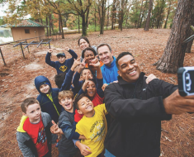 Day Camp or Bust – the Final Round Day Camp Activity Bracket Challenge Update It’s been a couple of weeks, and the Day Camp Activity…
Will Lions Join Tigers and Bears? Oh My! — A Lions FAQ Lions: Answers to your top questions. We have seen a lot of great feedback, comments and questions from…
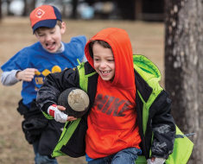Want More Productive Scout Meetings? Add a Little Action Productive Scout Meetings Are Here! No buts about it, Cub Scouts can often be a wiggly bunch.…
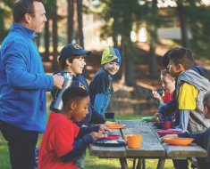 Get Cooking With These Dutch Oven Recipes from Scouting It’s Time to Get Cooking Outdoors When the weather changes and your day dreams turn to spending…
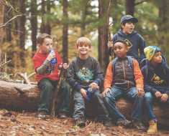 Get in the Game with this Day Camp Activity Bracket Challenge Cub Scout Day Camp Activity Bracket Challenge We had a lot of fun with March Madness this…
 The Adventures of a Well-Traveled Scout Pack The Well-Traveled Scout Pack Look closely and you might recognize the red insignia on the vintage pack.

Older Cub Hub Lion Posts
 5 Questions (and Answers) for the New Lion Program More Information on the New Lion Program As we mentioned earlier on the Cub Hub, Select councils will…
Lion Program will bring Scouting to Kindergarten Boys Something Roaring in the Jungle There is an exciting new Scouting program called “Lion” for Kindergarten-aged boys…
- Join Scouting takes you to www.beascout.org
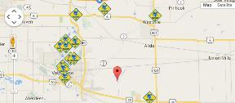

- Pinewood Derby Photo Contest Takes you to an entry form for the Pinewood Derby Photo Contest.
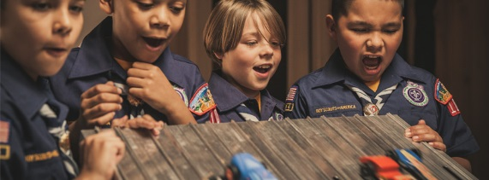
- Day Camp Activity Bracket Challenge
You must be 18 to vote. The bracket started with 16 Day Camp activities. Each activity was paired with another. Then you vote for the one in each pair you (actually, your son) enjoys more. It looks the final round will be Archery vs BB's!!!
- Also, on the home page –
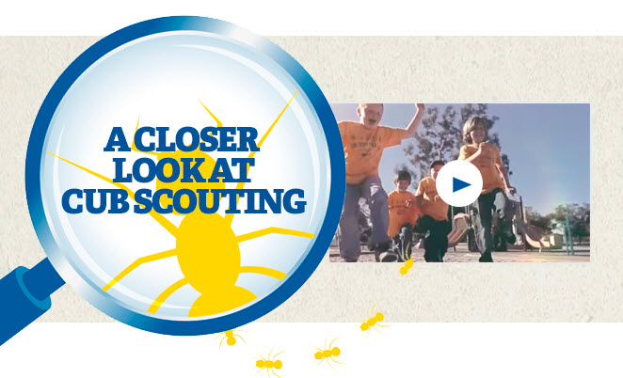
This link takes you to a YouTube Video
on Cub Scouting.
https://www.youtube.com/watch?feature=player_embedded&v=dqKFgk8SJlE
These Six Links take you to:
(From top left across, then down)

www.scoutstuff.org – The Supply Division site where you can find the location of your nearest National Scout Shop or buy all your Scout supplies
http://scoutingwire.org/ - Where you can get the latest Scouting News from around the country. You can sign up to get notifications when things are posted here...
https://cubscouts.org/pinewood-derby-2016-photo-contest - Takes you to the entry form for the Pinewood Derby photo contest (Same as the link on top of homepage).
https://www.scoutbook.com/ Where you can get the Scoutbook APP to track your son's Scouting Experience from Tiger to Eagle Scout.
I just learned that Bob Scott is at it again. Bob led us on the charge to the "CS Adventure Program." Now he is leading the Scoutbook effort. It is sure to be a success!! CD

www.boyslife.org – Go directly to the on-line edition of Boys 'Life
http://scoutingwire.org/marketing-membership/ Get resources and materials to strengthen your unit at BSA's marketing and membership site. Learn the best practices and tips employed by the most successful units.

ADVENTURE PLAN TRACKERS
- Tracking Spreadsheets are posted on the USScouts Advancement webpage (www.usscouts.org). There are be links to them from other places on the site. These spreadsheets are similar in construction and user interface as the existing spreadsheets. The spreadsheets have be tested by the developer of the current spreadsheets and he said they are so good he sees no reason to develop others!!
- Utah National Parks Council has Excel spreadsheets posted for all the new Adventure Plan requirements on their Akela's Council BlogSpot. www.Akelascouncil.blogspot.com .
The Advancement Excel Spreadsheet workbooks are distributed to Scouters for FREE.
PLEASE do not download the files from either site to email or send them digitally to others. They are for your personal / pack use only. If you would like to share these files with others, please copy / send the link to them and send them to the site so they can print off their own. They would love everyone that wants a copy to get their own copy absolutely free. Both USScouts and Utah National Parks receive Ad money based on the number of people visiting the site that helps keep their websites open. Please help us by encouraging others to visit them to obtain the files.



BE UP TO DATE

www.scouting.org/programupdates
The Program Updates page has been regrouped. Since the CS Adventure is in full swing, the emphasis on getting ready for it has been reduced. The downloads are still all there. And great information about three new Cub Leader courses at Philmont Training Center next summer.
There is a lot of information now on etting ready and implementing the changes to the Boy Scout program.
Check it all out – stay current!!

CUB SCOUT
LEADER TRAINING

IN-PERSON TRAINING
Position-Specific In-Person Training Guides Available Now! The training guides for
- Den Leader (http://www.scouting.org/filestore/training/pdf/515-215.pdf ),
- Cubmaster/Assistant Cubmaster (http://www.scouting.org/filestore/training/pdf/511-503_WB.pdf ), and
- Pack Committee (http://www.scouting.org/filestore/training/pdf/511-504_WB.pdf )

Are available on Scouting University. You can access them at http://www.scouting.org/training/adult.aspx .


ON-LINE TRAINING
On-Line Training for all Cub Scout positions has been available since October 25, 2015
The online training for Den Leaders, Cubmasters, Committee Chairs and members, and Chartered Organization Representatives is totally updated with help from volunteers from around the country. The new training is divided into shorter, more targeted modules so leaders can get the training they need, in the order they want, any time they need it. It is organized around the learning needed prior to the first meeting, in the first 30 days, and to be position-specific trained. This training was developed to be implemented in conjunction with the BSA’s new learning management system. Keep an eye on
my. Scouting Tools (log in at https://My.Scouting.org) for more information.
Go to the BSA Volunteer Training Team Facebook page (Link above) and.
Then you automatically receive the latest news!!

If you are having difficulties with
the training or system call
Member Care at 972-580-2489,
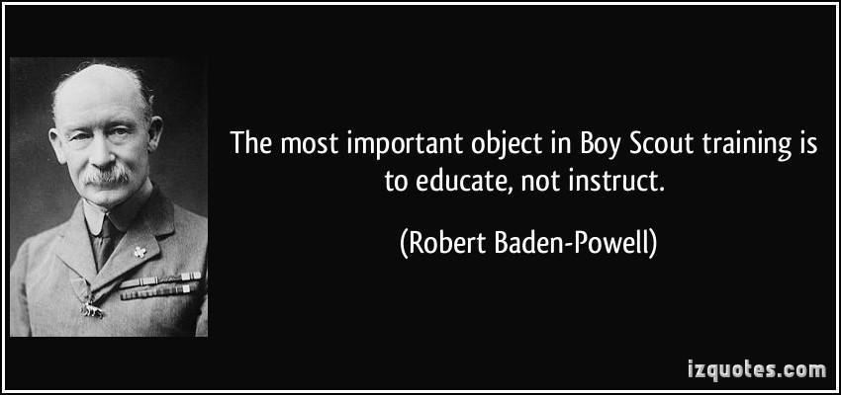
A Typical Learning Plan has several parts –
There is no need to complete more than one section at a time. Do what you have time to do.
Here you can see the three parts of the CM Course -


Each of these three parts is broken down into "bite sized" chunks:
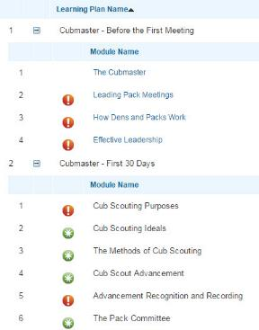
Go check it out and get your
people trained!!!

CUB SCOUT IDEAS
Keeping the Doors Open:

PACK FUNDRAISERS AND FINANCE
Santa Clara County Council
Unit Money-Earning Project Guidelines
The unit leadership in chartered organizations may participate in approved fund-raising projects, provided the Rules and Regulations and guidelines of the Boy Scouts of America are followed to ensure the quality of the product or service, to ensure the safety of all participants, and to avoid the commercialization of the Boy Scouts of America. Every unit conducting such an activity must submit a Unit Money-Earning Application, No.34427, for advance approval by the chartered organization and the local council at least thirty days before the activity.
Whenever your unit is planning a money-earning project, the following checklist can serve as your guide. If you can answer yes to each of the following questions, it is likely that your project will be approved.
- Has your unit committee and chartered organization approved your project, including the dates and the methods?
There should be a real need for earning money based on your unit's program. We should not engage in special money-earning projects merely because someone has offered us an attractive plan. It's important to remember that individual youth members are also expected to earn their own way. The need should be over and above normal budget items covered by dues.
- Does your plan and corresponding dates avoid competition with money-raising efforts and policies of other units, your chartered organization, your local council, and the United Way?
Check with your chartered organization representative to make certain that your chartered organization agrees on the dates. The chartered organization representative can also clear the other dates (e.g. FOS Drive) by calling the council service center.
- Does your plan comply with local ordinances; is it free from any association with gambling; and is it consistent with the ideals and purposes of the Boy Scouts of America Money-raising projects that include the sale of raffle tickets are in violation of this policy.
This includes any activity where value is not guaranteed by purchasing a ticket. (For example, cake raffles would not be allowed, but cake auctions are okay.) This question can be answered only in terms of specific proposals. If there is any question of its suitability, drop the project and find a better one for your unit.
- If a commercial product is to be sold, will it be sold on its own merits and without reference to the needs of Scouting, either directly (during sales presentation) or indirectly?
Teaching youth members to become self-reliant and to earn their own way is an important part of training our youth members. The official uniform is intended to be worn primarily for use in connection with Scouting activities. However, the executive board of the local council may authorize wearing the uniform only in connection with council-sponsored product sales programs.
- If tickets are sold for a function other than a Scouting event, will they be sold by your youth members as individuals without depending on the goodwill of Scouting to make this sale possible?
Youth members in uniform in the name of Scouting may sell tickets for such things as pack shows, troop suppers, circuses, expositions, and similar Scouting events.
- Even when sales are confined to parents and friends, will buyers get their money's worth from any product they purchase, function they attend, or services they receive from your unit?
Here again is the principle of value received - a sale standing on its own merit - so that the recipients are not in any way subsidizing either Scouting or the member. Youth members must learn to pay their own way and to honestly earn the money to do it. You cannot permit anyone to use the good name of Scouting to sell a product.
- If a project is planned for a particular area, do you respect the right of other Scouting units in the same neighborhood?
It's a courtesy to check with neighboring units or the local council service center to coordinate the time of your project and to see that you aren't covering their territory. Your unit commissioner or service team member can help you with this.
- Is it reasonably certain that people who need work or business will not lose it as a result of your unit's plan.
Your unit should neither sell nor offer services that will damage someone's livelihood. If possible, check with the people who could be affected.
- Will your plan protect the name and goodwill of the Boy Scouts of America and prevent it from being capitalized on by promoters of shows, benefits, or sales campaigns?
Because of Scouting's good reputation, customers rarely question the quality or price of a product. Unchecked, the network of Scouting units could become a beehive of commercial interest to the neglect of character building and citizenship training.
- If any contracts are to be signed by your unit, will they be signed by an individual without reference to the Boy Scouts of America, and in no way appear to bind the local council, the Boy Scouts of America, or the chartered organization to any agreement of financial responsibility?
Before any person in your unit signs a contract, he or she must make sure the venture is legitimate and worthy. If a contract is signed, he or she is personally responsible. A contract cannot be signed on behalf of the local council or the Boy Scouts of America, nor may an individual bind the chartered organization without its written authorization. If you are not sure, check with your local council service center for help.
Current Policies of the Boy Scouts of America
Contributions
Bylaws of the Boy Scouts of America, Article XI, Section 1, Clause 2:
Contributions shall be solicited in the name of the Boy Scouts of America only through or by the authority of the Corporation, and shall be limited to the National Council or chartered local councils, in accordance with these Bylaws and Rules and Regulations of the Corporation. Youth members shall not be permitted to serve as solicitors of money for chartered organization units, for the local council, or in support of other organizations. Adult members and youth members shall not be permitted to serve as solicitors of money in support of personal or unit participation in local, national or international events. Youth members, however, are permitted to secure sponsors for council or district activities approved by the executive board. These approved activities may result in financial support for the local council in accordance with the Bylaws and Rules and Regulations of the Corporation.
Use of the Uniform
Rules and Regulations of the Boy Scouts of America, Article X, Section 4, Clause 6:
The official uniforms are intended primarily for use in connection with Scouting activities as defined by the national Executive Board and their use may be approved by local council executive board for council events or activities under conditions consistent with the Rules and Regulations of the Boy Scouts of America.
Gambling
Rules and Regulations of the Boy Scouts of America, Article XI, Section 1, Clause 1:
Gambling. Any fund-raising project designated to benefit chartered organization units, districts, local council, or on a national basis which involves games of chance, lotteries, sale of raffle tickets, bingo, or could be construed as a gambling activity, is not permitted.
Unit Money-Earning Projects
Rules and Regulations of the Boy Scouts of America, article IX, section 2, clause 3:
Units may conduct money-earning projects only when the projects have been approved by the chartered organization and the local council and are consistent with the principles set forth in these Rules and Regulations.
Tax-Exempt Status Of Units and Contributions To Units
The basic issues regarding the tax-exempt status of Cub Scout Packs, Boy Scout Troops, Explorer units, and even Tiger Cub or Cub Scout Dens are addressed in the basic concept of the charter process employed by the Boy Scouts of America reduced to the simplest terms as follows:
- The local council recommends that specific organizations receive a charter from the national office based on specific requirements and guidelines.
- These organizations vary from schools, religious organizations, civic clubs, neighborhood groups, business, industry, and others; each with a different tax status. While some may be tax exempt under IRS Code section 501 (c)(3), others may not be tax-exempt.
Important: The tax-exempt status of the chartered organization determines the tax-exempt status of their units -- pack, troop, post, etc. The national office (National Council) maintains the group exemption status for the local incorporated Boy Scout councils and the local council trust funds conforming to the Model Form Trust Agreement.
Annually, the employer identification numbers of the local council and local council trust funds are forwarded to the Internal Revenue Service in order to maintain the group exemption status of these designated subordinates receiving a charter from the national office.
The chartered organizations with tax-exempt status maintain their status independently from the National Council and local council. Their units' tax-exempt status will be consistent with the tax exempt status of the chartered organization.

ROUNDTABLE HINTS
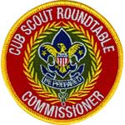

Refocusing Your Roundtable
to better serve Leaders
Jeff Mc Houl, Assistant Council Commissioner – RTs
Cradle of Liberty Council
NOTE: This is Jeff's first column and I think he did a great job!! Looking forward to many more. CD
When we look our Roundtable program, and try to find where we can improve our planning and presentation, how can we truly focus our efforts to achieve the desired results? A good place to start is to take a step back and think about the typical Cub Scout Leader.
Simply by the nature of the Cub Scout program, there is a built in volunteer attrition, which means at any time, the volunteers and leaders who attend Roundtable may all be at different points on the experience curve. The key is to plan and offer a program that appeals to the entire group. Here is a good place to start:
Look at who are the Units who we serve?
- Any youth who is a recipient of the Scouting program
- The volunteer Leaders who deliver the Scouting program
- The parents of the youth who are the recipients of the Scouting program
Redefine your reasons for becoming a Commissioner
- From friend, coach, teacher, mentor, lifesaver to servant – adopt a philosophy of Servant Leadership
- Think of how you can best serve the interests of the units and their Leaders, and deliver that at Roundtable
Focus on Serving the Units
- Tune-in to the ‘personality’ of the individual units that you serve, and the unit Leaders
- Don’t impose your view of a successful unit, but understand the intent of the Leaders you serve
Once you have taken these steps, then you can focus on how to develop your Roundtable program to meet the needs and best serve those leaders, and empower them to succeed in delivering a quality Den and Pack program.
Empower Unit Leader to Succeed
- Empowerment involves sharing knowledge, sharing resources, and providing support as a means of facilitating the development of each individual Leader
- The empowerment of individual unit Leaders is one of the single most important contributions that a Roundtable Commissioner can make to ensure the success of a unit
- That is a hallmark of a quality well planned Roundtable program
Methods of Empowering Unit Leaders
- Help current unit Leaders to understand and develop their vision for their unit
- Help unit Leaders to understand that they are not in this alone
- Help to build an environment of mutual support into your Roundtable delivery
- Help unit Leaders to view the Journey To Excellence as a tool intended to assist Leaders in understanding and becoming part of the greater vision developed by the BSA meant to guide units to success, and not as a “report card”
- Help unit Leaders to understand that regular participation in Roundtable will help them to connect with fellow Leaders
- Help unit Leaders to understand how they can be more successful by involving more Leaders in their own units
Use the available tools to assist unit Leaders in planning a quality program
- Cub Scout Den Meeting Guide and Leader Handbooks
- JTE Scorecard
- Promote and provide direct training for Leaders when needed, and connect Leaders with District Training Team
- Promote attendance of supplemental training opportunities in addition to District Roundtable forums

Once you begin to focus on these key areas, many of the volunteers and leaders who regularly attend your Roundtable will begin to experience success in the delivery of their program to their Dens and Packs. If what you are presenting is relevant and effective, then word will spread that what you are planning and offering works for unit leaders, and is a good program. Once the word gets around, you should see your attendance increase, and participation grow.
Always remember:
- Success at the unit level begins small, and each success must be recognized and congratulated to facilitate continuing success and program momentum which will lead to greater unit retention.
- Use Roundtable as a means of recognizing successes.
And always keep your focus on your vision of a successful Roundtable, and your goals in serving the volunteers and leaders of your District and Council.
Our main focus should always be facilitating the success of units in the quality delivery of the Scouting program and assisting unit level Leaders in making that happen by being wholly committed to meeting the needs of those whom we serve.

The Priorities in Redefining Roundtables to Meet the Needs of Today’s Leaders
- Support Program Planning
- Support Quality Program Delivery
- Get to Know the Individual Needs of the Leaders You Serve
- Build Positive Relationships
- Facilitate Leader Training
- Provide Leader Support thru High Quality Delivery

Best of luck in your efforts, and please share your success.


DEN MEETING TOPICS
Remember – Boys want to be active!!
See, too, that they earn their awards
(Never say GET. You get sick, you do not get awards – You earn awards. A little CD Philosophy).
Big Rock Ideas – suggestions for Big Rocks that fit Interest Topics or seasonal activity. If years are next to an item (e.g. 13-14) that suggested Big Rock is in that Roundtable Planning guide and on-line at http://www.scouting.org/scoutsource/Commissioners/roundtable.aspx
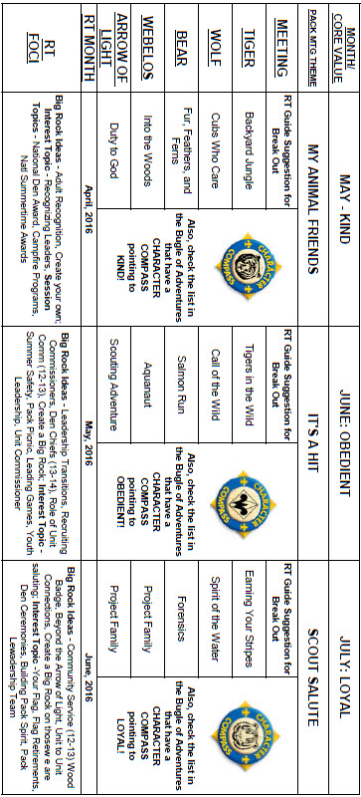

CHARACTER COMPASS
JUNE -
ADVENTURES with a CHARACTER COMPASS pointing to OBEDIENT:
TIGER –
- Tigers in the Wild (Core)
- Floats and Boats (Elec)
- Rolling Tigers (Elec)
WOLF –
- Call of the Wild (Core)
- Air of the Wolf (Elec)
BEAR –
- Bear Claws (Core)
- Salmon Run (Elec)
WEBELOS CORE –
- None (Core)
ARROW OF LIGHT CORE –
- Scouting Adventure (Core)
WEBELOS & AOL ELECTIVES –
- Aquanaut (Elec)


JULY -
ADVENTURES with a CHARACTER COMPASS pointing to LOYAL:
TIGER –
- Team Tiger (Core)
- Earning Your Stripes
WOLF –
- Council Fire (Core)
- Spirit of the Water (Elec)
BEAR –
- Grin and Bear It (Core)
- Forensics (Elec)
WEBELOS CORE –
- None (Core)
ARROW OF LIGHT CORE –
- Scouting Adventure (Core)
WEBELOS & AOL ELECTIVES –
- Project Family (Elec)

THEME RELATED STUFF
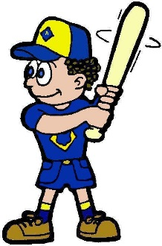


IT'S A HIT
RELATED ADVENTURES
The following Adventures involve sports –
TIGER –
- Games Tigers Play – entire Adventure
- Earning Your Stripes - #5, Play a game …
- Tiger-iffic – several involve games
- Tiger Tag - several involve games
- Tiger Tales - #5, Play a game from the past
WOLF –
- Air of the Wolf (Basketball Science)
- Running with the Pack - several involve games
- Code of the Wolf - #1 involves game
- Paws of Skill – physical fitness activities
BEAR –
- Grin & Bear It - #1, Play a Challenge game …
- Marble Madness – Involves playing games with marbles
WEBELOS CORE –
- Stronger Faster, Higher - #4, involves games
ARROW OF LIGHT CORE
- None
WEBELOS & ARROW OF LIGHT ELECTIVES –
- Sportsman - #2 and #3 involve games


Same is true for Boy Scout Leaders!!
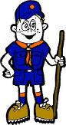

PACK MEETING THEMES
AND PLANS
www.scouting.org
From National's Website for the new plans using the Core Values based on the Scout Law:
Here are a few thoughts to consider around these new pack meeting plans. First, there is a plan for each month that corresponds with a point of the Scout Law. In addition, each plan has a theme to help make the pack meeting even more fun! The plans do not have to be used in a specific order.
Tips for Utilizing the Plans
- Pack meeting plans do not have to be done in any special order, but it is recommended that you include all of the points of the Scout Law each year. The pack planning meeting would be a good time to determine the order.
- There are pack meeting plans for multiple years posted on the website. It is your pack's choice of which one to select from each point of the Scout Law for each year.
- Pack meetings should not last longer than an hour. Adjust the plan to make it fit within the time. Research and experience tells us that Cub Scouts have a hard time sitting still for that long. Keep the meetings fun, active, and engaging.
- If you are comfortable with a costume to fit the theme of the meeting, go for it!
- Importantly, keep it simple and make it fun.
- The following required adventures have a requirement that suggests or requires completion at a pack meeting. Please plan accordingly as part of your annual program planning process. Work with your den leaders to plan when these activities will take place.
Tiger
- Tigers in the Wild, requirement 5. Participate in an outdoor pack meeting or pack campout campfire. Sing a song and act out a skit with your Tiger den as part of the program.
- Games Tigers Play, requirement 3. Make up a new game, and play it with your family or members of your den or pack.
Wolf
- Council Fire, requirement 6c. Create a den project from recyclables for a pack meeting.
Bear
- Grin and Bear It, requirement 2. Working with the members of your den, organize a Cub Scout carnival and lead it at a special event.
- Grin and Bear It, requirement 3. Help younger Cub Scouts take part in one of the events at the Cub Scout carnival.
Webelos
- Stronger, Faster, Higher, requirement 5. With adult guidance, lead younger Scouts in a fitness game or games as a gathering activity for a pack or den meeting.
Arrow of Light
- Building a Better World (if chosen), requirement 10b. Set up an exhibit at a pack meeting to share information about the World Friendship Fund.
As a personal note: I have read some of the plans and they are excellent and just as complete as the new Den Leader Books. The games, and other stuff are right there. Including costuming ideas for that added PIZAZZ!! If you do not use themes and do not add PIZAZZ you are not doing your best for your pack.
GOOD JOB!!! From CD
Check them out at:
http://www.scouting.org/Home/CubScouts/Leaders/CubmasterResources/PackMeetingPlans.aspx


Kim, the chair of the task force, says "I do want to stress that the focus is still the Core Value and the theme is just there as an enhancement. Pack meeting theme plans are specifically crafted to bring out the important points of the Core Value in a fun way."

PACK MEETING THEMES
2015–2016 Pack Meeting Plans
May | Kind | "My Animal Friends"
June | Obedient | "It's A Hit"
July | Loyal | "Scout Salute"
August | Courteous | "S'more Cub Scout Fun"

2016–2017 Pack Meeting Plans
September | Helpful | "To The Rescue"
October | Kind | "Creepy Crawlers"
November | Courteous | "Cubs In Shining Armor"
December | Cheerful | "Celebrate"
January | Obedient | "Cub Scout City Council"
February | Reverent | "Passport To Other Lands"
March | Loyal | "Our National Treasures"
April | Thrifty | "Power Up!"
May | Clean | "A Picnic With Pizzazz"
June | Brave | "Roaming Reptile Alert"
July | Trustworthy | "Let The Games Begin"
August | Friendly | "#CUBSCOUTS"
If you are using a paper copy the link to all the
Pack Meeting Plans is:
http://www.scouting.org/Home/CubScouts/Leaders/CubmasterResources/PackMeetingPlans.aspx

UPCOMING MONTHS
June's Core Value, OBEDIENT, will use the theme, It's A Hit:

Month | Year | Theme
Potential "IT'S A HIT" Months
August | 1945 | Sports
August | 1953 | Sports Carnival
June | 1966 | Sports Carnival
August | 1970 | Cub Scout Field Day
June | 1975 | Sports Carnival
June | 1979 | Learn a Sport
August | 2002 | Sports Extravaganza
July | 2009 | Cub Scout Sports
August | 2015 | Play Ball!
June | 2016 | It's a Hit
OBEDIENT
(Themes for Respect)
May | 1962 | The World Around Us
November | 1967 | Around the World
December | 1973 | Customs of Countries
April | 1978 | The World Around Us
December | 1979 | Customs of Other Lands
April | 1981 | The World Around Us
July | 1988 | The World Around Us
December | 1989 | Customs of Countries
December | 1994 | Customs of Other Lands
February | 2001 | Passports to Other Lands
January | 2007 | Poles Apart
December | 2010 | Respect
December | 2011 | Respect
December | 2013 | Passport to Other Lands
July's Core Value, LOYAL, will use the theme, Scout Salute.
The core value highlighted next month is:
June's point of the Scout Law, LOYAL, will use the theme, SCOUT SALUTE.
A SCOUT IS LOYAL
A Scout is true to his family, friends, Scout leaders, school, and nation.
HOW DOES “SCOUT SALUTE” RELATE TO THIS POINT OF THE SCOUT LAW?
A Scout is true to his family, friends, Scout leaders, school, and nation. Cub Scouts will show their loyalty during this meeting by participating in several activities such as honoring the American flag, creating a pack banner, and hearing about loyalty from a guest speaker or demonstrating loyalty to a team through a pack game.

Month | Year | Theme
Potential "SCOUT SALUTE" Months
November | 2001 | Hometown Heroes
November | 2009 | Scout Salute
September | 2012 | Hometown Heroes
LOYAL
(Themes for Citizenship, Perseverance)
December | 1986 | The Golden Rule
December | 1997 | The Golden Rule
November | 2010 | Citizenship
June | 2011 | Perseverance
November | 2011 | Citizenship
June | 2012 | Perseverance
November | 2013 | Your Vote Counts
PATRIOTIC LOYALTY
October | 1951 | Strong for America
February | 1955 | Let Freedom Ring
July | 1964 | Our American Heritage
February | 1966 | Strong for America
February | 1971 | Our American Heritage
December | 1978 | Duty to God & Country
February | 1989 | Strong for America
September | 1989 | Our American Heritage
June | 1994 | Strong for America
July | 2010 | Celebrate Freedom

CUBMASTER THOUGHTS
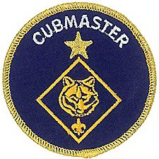

Lions (The Beginning)
Mark Diienno, Cubmaster,
Garden State Council
Mark has added Lion Coordinator and Lion Guide to his position as Cubmaster. He has a strong belief that the youngest Scouts and parents need have a great start and learn about Scouting the right way. He is leading his second Lion Pride (Den) this year. 100% of his first one are still active as Tigers!!

The Lion program is a new level in Cub Scouting. It is not “pretend” Cubs. It is a vibrant, relevant program geared towards boys in kindergarten to begin their journey in The Scouting Program.
They have their own identity, unique program, and Adventures.

The Stakes are very high in offering this program, for you have only one shot to win these boys and their families over to the marvelous world of Scouting.
It is extremely important to start out slowly so as to gain the confidence of the Lion and his parents.
The delicate situation your unit is undertaking becomes obvious at the first gathering, when upon meeting The Lion, you find yourself talking through the legs of one of the parents, as the Lion ducks for cover. It is crucial that in this situation, and every activity moving forward, that the Lion Leader maintain a positive, upbeat, energetic tone. Notice the word “Gathering” is used to describe the first meeting. It is more important to start to form the unity of The Pride (Den), than it is to plunge into the program headfirst.
It is also important to realize that just asking a 5 yr boy to enter a strange house, or meeting place, could be a deal breaker right off the bat. Consider having your first meeting outside, or at least the first part of the meeting outside. Begin with simple games. Bean bag tosses, kicking balls for distance, running around cones, or just letting the Lions play catch with their parents is a great way to begin the team building process.
It is amazing that after only 10-15 minutes of game playing how much easier it is to lead the Lions and have them follow direction.
Keep It Simple, Make It Fun,
As a Leader, it is our job to put our scouts in a position to succeed, so try not to have competitions, for the heart of a 5 yr old is very fragile. Describe it as a display of skill.
As with the Tiger program, The Lion program relies on the scout and the parent to work together in all activities so, directing the parents as to what the goal is will help greatly in obtaining that goal.
The Lion Program is very easy to follow and execute.
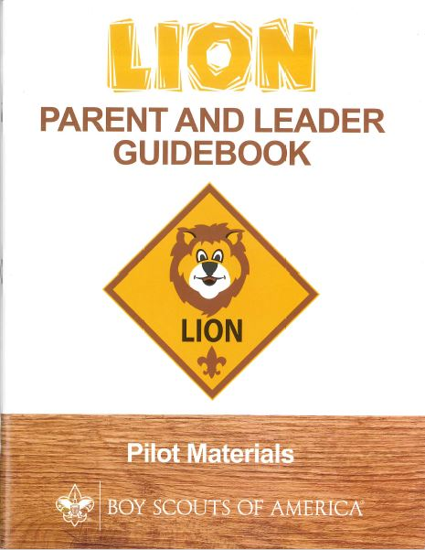
Everything in the Parent/Leader manual is there to aid in delivering the program with little effort, time, resources, and most importantly stress.
Because of the high stakes, it is strongly recommended that the Lion Pride be “Mentored” by a seasoned leader, who can help not only in delivering the program to the Lions , but also begin to groom the parents to become the new crop of leaders in the pack. An experienced Cubmaster would be ideal for this role.
Singing songs, clapping hands, and having fun are the Cubmaster's greatest talents, and these talents are tailor made for the Lion Pride.
The Cub Master’s Leadership experience will also influence these potential new leaders to properly follow the program, seek training, and contribute to the unit for years to come.
Having The Cubmaster involved in the pride will also have a very strong calming effect on the Lions when they attend their first pack meeting and see the familiar face of the Cubmaster running the show.
The Lion Program is the most important thing to hit Scouting since the Blue uniform.
We are in a competition. -
A competition for a family’s time.
There are many activities that begin at this young age and vie for a family's attention.
The Lion Program is Scouting’s answer to help capture our place in this market.
Next month we will look deeper into this amazing program. And yes, The Scout Law and Oath are relevant even at this young age.
Stay tuned…

Mark
Cubmaster OLOPP & Tiger Coordinator
Pack 161, Garden State Council

The Chief Scout Executive
on Lions
What We Know
According to a 2014 U.S. Census Bureau report, 57 percent of kids ages 6–17 participate in at least one after-school extracurricular activity. This means that by the time they are eligible for Tigers, more than half of them already are engaged in some type of athletic, artistic or other program.
Often, children become attached to lifelong activities at an early age — that is certainly a goal we would have, as we know the long-term benefits of Scouting involvement include strong asset development in the areas of character and leadership. However, we also know that when youth participate in numerous activities at an early age, and miss joining Scouting, they are unlikely to do so at adolescence.
What will be important to learn in the next few years, if the initial entry point works at the kindergarten-age level, is will this cause losses at a different age, or will the program keep the same retention all the way through to Boy Scouting?
What we learn from the pilot Lion format could also help us assess and create a smoother transition from Webelos into Boy Scouting. Too many parents now see a barrier or obstacle, rather than a smoother transition. You will often hear parents say, “We did Cub Scouting, now we’re not sure if we are going to do Boy Scouts.” We do not have a seamless transition into Boy Scouts for a number of reasons. This pilot test will help us think through some of these issues.
We want to be sure that our Lion program delivers the right mix of character and leadership values and that we set the bar high. The program must be sustainable, we must have the right infrastructure to support it, and it needs to address in a meaningful way the needs of parents who want their kids to join Scouting at an earlier age.
You can rest assured that we will carefully evaluate our progress and keep you apprised of the results. Stay tuned for more.
Thanks for reading.
Mike

Reprinted from "The Chief's Corner" on Scoutingwire.org
MORE LION INFORMATION
Bryan's Blog has written about Lions –
New details released about Lions, the pilot program for kindergarten boys
March 10, 2016 // 38 Comments
 In Lions, the new pilot program for kindergartners, boys wear T-shirts instead of uniforms and earn adventure stickers instead of adventure loops.
Lions, a new pilot program for kindergarten boys, to begin this fall
February 24, 2016 // 109 Comments
 Lions, a new Boy Scouts of America program for kindergarten boys, will begin a pilot in participating councils this fall.
Will Lions be part of the pack? (And answers to your other Lion questions)
April 15, 2016 // 15 Comments
 Will Lions be part of the Cub Scout pack? By adding another year to the program, is the BSA concerned about "burnout"? And why was the Lions name chosen?
Cub Hub Lion Posts
Go to the Cub Scout Learning Library item to see the Cub Hub Blog entries on The Lion Program.
There are slideshows on the web put up
by local councils. Some examples are:
WD Boyce Council has "Lion Cub Pilot Program" at: http://www.wdboyce.org/document/lion-cub-pilot-program/161325
Northern Star Council has a training slide show for District Coordinators and others at: https://www.signup4.net/UPLOAD/NORT26A/LION12E/District%20Lion%20Cub%20Coordinator%20Training.pdf
Councils are putting up webpages about what their packs need to know to begin a Lions Program. Examples are:
New Birth of Freedom: http://seb.newbirthoffreedom.org/2016/03/22/were-approved-for-the-lion-scouts-pilot/
WD Boyce: http://www.wdboyce.org/cub-scouts/lion-cub-pilot-program/63360
Garden State (My Council): http://www.gardenstatescouting.org/lion-program-0
Garden State, also, has an FAQ PDF - http://www.gardenstatescouting.org/sites/default/files/Lion%20Program%20FAQ.pdf
And we have created a Facebook page for our units with Lions - https://www.facebook.com/GSCLion/

Scoutingwire has had a series of
posts on Lions:
New Lion Program Piloting This Fall! http://scoutingwire.org/new-lion-program-piloting-this-fall/
What’s A Lion, Exactly? Here’s The Scoop http://scoutingwire.org/whats-a-lion-exactly-heres-the-scoop/
Answers To Your Lion Program Questions Revealed! http://scoutingwire.org/answers-to-your-lion-program-questions-revealed/
Our Lion Pilot Program Aims To Attract More To Scouting At A Younger Age http://scoutingwire.org/our-lion-pilot-program-aims-to-attract-more-to-scouting-at-a-younger-age/

Organizing for Lions
From – New Birth of Freedom Council
For those packs that are thinking ahead about participating in the Lion Scouts program, having the right volunteers involved in delivering the Lion Scouts program will be important. Research shows that the most important person for a successful Scouting experience is a good leader. There are two new adult leader positions within the pack that are directly engaged in the delivery of the Lion Scouts program – a Lion Coordinator and a Lion Guide. Where do these positions fit into the current pack structure?

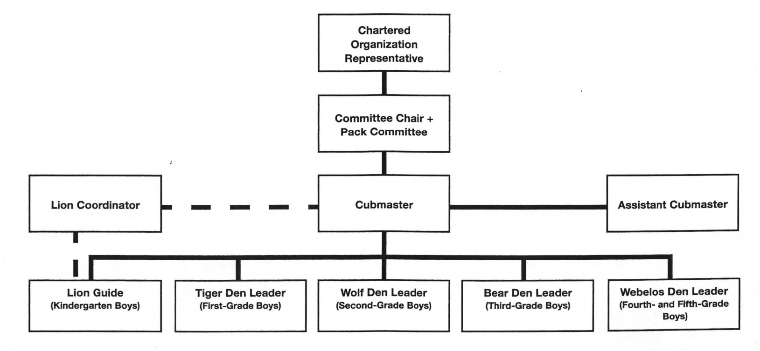

What is the Lion Coordinator’s job description?
- Is an experienced and successful den leader
- Understands den and pack operations within the overall structure of Cub Scouting
- Demonstrates excellent communication and organization skills (and will remain in at least monthly contact with the Lion dens)
- Participates as needed in the unit’s School Night with all new Lions and their parents
- Assists the Lion guide in hosting the first orientation meeting for all the individual Lion dens in their pack
- Serves as a coach and mentor for Lion Guide
The position description for the Lion Guide is as follows:
- Has previous successful experience as den leader
- Works directly with other den and pack leaders to ensure that the den is an active and successful part of the pack
- Plans and prepares for initial Lion den meeting and outings
- Mentors adult partners in the delivery of Lion den meetings
- Attends the pack leaders’ meeting
- Leads the den at the monthly outings and other pack activities
- Ensures the transition of Lion Scouts to Tigers at year-end
- Prepares the Lions for day camp at the end of the Lion year if appropriate
- Coordinates shared leadership among the Lion adult partners in the den
- Ensures that each Lion and his adult partner have the opportunity to be the host team, which plans and executes the den activities, and rotates responsibilities monthly
Selected FAQ's
Our council has run a kindergarten-age program for years. Why is this considered a “new” program now?
Although a few councils have run locally-developed programs in the past, the National Lion Pilot launching now is the only approved BSA program for five-year-old kindergarten-age boys. The curriculum was developed by a team of experts, including representation from the fields of childhood development, education, and child psychology. Locally-developed content was reviewed by that team, and the best pieces woven into the new curriculum. That team worked to ensure that the organization’s high standards were met in delivering effective (age-appropriate) character and leadership programs. A small number of councils have tested the new curriculum over the past two years, and it is now ready to expand as a national pilot.
Why was the “Lion” name selected? I remember a Lion rank in Cub Scouting from years ago. Are you just bringing it back?
Congratulations to all the Scouting historians who caught that! Yes. The Lion name has significance as a rank within Cub Scouting from the 1930’s-1960’s. As names were considered for this new, cutting-edge pilot program, honoring a name from our past made sense. It was a great way to give a nod to the organization’s rich history of delivering fun and exciting Scouting experiences to our nation’s youth. Indeed, it was a fun way to look back at our history while moving forward in a new and exciting way.
Isn’t this just the Tiger program re-branded? Will boys be doing the same activities two years in a row?
No. The Lion pilot program is designed to be an introduction to Cub Scouting. It is filled with fun, age-appropriate activities that will appeal to kindergarten-age boys. Although they share a focus on the traditional Scouting concepts of character development, leadership skills, personal fitness and citizenship, the activities are specific to the Lion program and are not duplicated within Cub Scouting. The activities will be fun and challenging in a way that is separate and apart from what boys will experience as they enter Tigers in 1st grade.
By adding a new rank to Cub Scouting, won’t boys and families “burn out” sooner and drop earlier then they normally would?
Chief Scout Executive, Mike Surbaugh, commented on this in this Chief’s Corner post in March. (Reprinted in this article) He wrote, the Lion pilot is, “designed to develop good, measurable data to determine program quality, parent involvement and its overall fit into the Scouting format.” The pilot will help determine whether a kindergarten program will benefit the development of five-year-old boys, and how it might effect their movement through BSA program areas long-term. As was written by many of you in posts and comments, though, fun and engaging program delivery may be more impactful on retention than a program’s overall length. This pilot will track that type of data and provide key learnings as we move forward.
We’re so excited about this program, when will I know if our council is approved to participate? How will we be told?
Interested councils may apply through their Area Director to become a pilot site. Scout Executives are aware of the application and notification processes. If interested, please contact your council office to inquire. The excitement continues to build!
How will Lions be structured? I’m thinking it might be hard to find volunteers to lead a group of boys that age.
Lions will be organized in dens of six to eight kindergarten-age boys. The dens will be mentored by Lion Guides (experienced Cub Scout adult leaders). Similar to the Tiger rank, each boy will be required to have an adult partner. With the guidance of the Lion Guide, each adult partner will take turns leading den meetings or activities. It is a shared leadership concept.
Will Lions be a part of the pack?
Yes. For units participating in the pilot, Lions are a part of the Cub Scout pack. It is important to note, however, that Lions will only be a part of the pack at an introductory level. The Lion program is designed to introduce five-year-old kindergarten-age boys to the fun and excitement of Scouting, but in ways that maintain appropriate expectations. Because of their age, development level, physical abilities, and stamina, it would be unrealistic to expect Lions to participate fully in pack activities. For example, Lion dens should not participate in pack fundraising, overnight camping or activities such as shooting sports. Those experiences, and others, are more appropriate for older boys as they move through Tiger, Wolf, Bear and beyond. Instead, keep the Lion dens focused on their exciting (and age-appropriate) adventures. Invite them to attend just a few (two to three) pack meetings throughout the year. Be sure to include them in special activities, but only if appropriate for kindergarteners. Remember, the Lion program is an introduction to the world of Scouting. Deliver the curriculum as written and keep it fun!
I can’t help but wonder if this is driven by low recruitment and a desire to get more fees. Is that the case?
Absolutely not! The development of a kindergarten program is driven by the desire to reach more of America’s youth with the purposeful outcomes only Scouting can provide. Oftentimes, families make “joining” decisions at about the kindergarten age. As they enter 1st Grade, schedules are often full and we’ve missed the opportunity. We know from the recent Tufts study that Scouting works! It has a tremendous impact on the lives of young people. The Lion program is a way to reach more of America’s families with the benefits of Scouting.
What are some positive results/outcomes you can share from councils that have already piloted Lions?
Pilot units have been extremely positive about their Lion program experience. A common theme emerging from those units has been their ability to identify engaged families for future leadership roles within the pack. Remember that the Lion program uses a shared leadership concept – introducing parents to the idea of leading just a few meetings or activities throughout the year. This gives the parents a chance to try their hand at leading activities and gives units a way to interact with those parents. In addition, pilot units showed very strong Tiger recruitment the following year. There will be much more data learned this fall as the pilot executes on a broader scale, but these have been early positive outcomes among initial units.

WEBELOS

Always an S Webelos always ends with an S whether talking about one Webelos Scout or a den of Webelos. It is an acronym – WE’ll BE LOyal Scouts. As the CS RT Commissioner who mentored me says – "If you don’t have an S at the end – then there is nothing to which to be loyal."

WEBELOS HISTORY
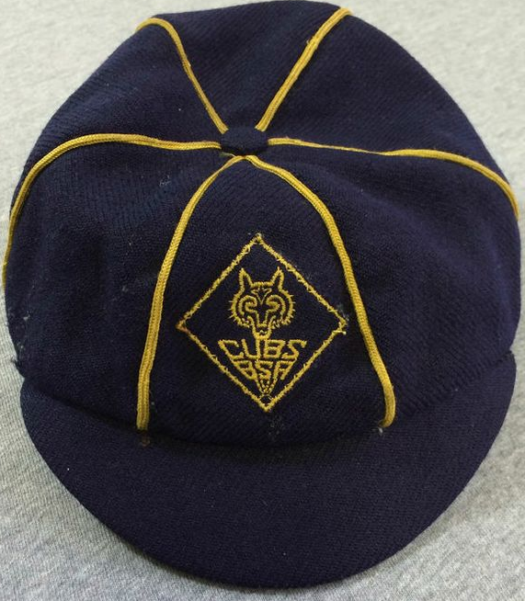
In the Beginning -
Cubbing, as it was first know, started in the United States in 1930. It is interesting to note that in the beginning, each Cub den was led by a Boy Scout Den Chief. It wasn't until 1936 that the position of Den Mother was added as an optional position even though Den Mothers had been helping since 1932. Still, that position was to provide support for the Den Chief. It was not until the late 1940’s to mid 1950’s that the Den Mother assumed full control of the den. Cubbing became Cub Scouts in 1948. And at that time the badges and other items began being changed from Cubs, BSA to Cub Scouts, BSA.
Dens
Dens were formed by age until 1986 when the phase in for grade level began, lasting until 1991. In the beginning, Wolfs were 9 year olds, Bears were 10 years old and Lions were 11 years old. They could enter Boy Scouts when they turned 12. In 1949, the age level was dropped one year for both Cub Scouts and Boy Scouts.
Bobcat
In 1938, the Bob Cat pin was introduced as the entry-level badge for a new Cub. It was only to be worn on civilian clothes. Sometime between 1948 and the 1950's the word BOB CAT on the pin was changed from two words to one word, BOBCAT. In 1959, the Bobcat pin was approved for uniform wear.
Webelos Rank Added
Several changes were made in the early 1940's. In 1941, the Webelos rank was added. It was for a Cub who had completed his Lion badge and had also completed certain requirements for Tenderfoot, the first rank in Boy Scouts. The Webelos badge at that time looked like the Arrow of Light badge we use today. Webelos was defined as an acronym for Wolf-Bear-Lion-Scout. Commissioner Dave graduated from Cub Scouts to Boy Scouts under this program.
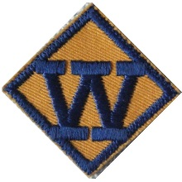Webelos Den Created
In 1954, a Webelos Den was created for boys 10½. The new Webelos Den badge was introduced as a dark blue "W" on a gold or yellow twill background and was worn on the right sleeve in place of the Den Number insignia. This badge often gets confused as a Webelos rank insignia. The size of this den badge is smaller than the rank insignias of the era.
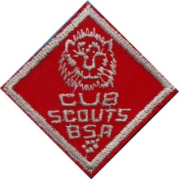Lion Dropped
In 1967 a big change occurred in Cub Scouts, the rank of Lion was dropped, 15 activity badges were created and the last year of Cub scouting became the Webelos program. In 1972 the Webelos rank became the Arrow of Light rank. It is interesting that the same reference states that "Three months before your 11th birthday, you may start to work on requirements for the Webelos Award." I expect that this three months requirement began in 1967. Webelos was redefined as an acronym for WE'll BE LOyal Scouts. Commissioner Dave's Brother Bill (and fellow Eagle Scout) graduated from Cub Scouts to Boy Scouts under this program.
Between 1967 and 1972, Cub Scouts could only wear two diamond shaped patches, Wolf and Bear. They were worn side by side.
Development of Webelos Program (at Philmont)
In the early 1970's about 30 Volunteer Scouters were invited to Philmont to help improve the Webelos program. This is believed to be the first time Volunteers were asked to perform this function. One volunteer, Mel Neiman, recalls "We put together some of the ideas still in use and were given the task to introduce the new ideas to Units in our Councils. At that time as you know there was no official Webelos badge, and we were issued a packet of temporary Webelos badges to be used until the new badges were available."
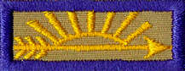Arrow of Light
In 1972, the requirements for the Webelos rank badge were significantly changed and it was renamed the Arrow of Light. The changes meant that Webelos could begin working on their Arrow of Light at the age of 10.
Bobcatand Webelos Cloth Badges Added
In 1972, the Bobcat rank badge was added. In 1977 the diamond Webelos rank badge that can still be used today was developed as a step before the Arrow of Light. With the development of the Bobcat and Webelos badges, Cub Scouts could who earned all the awards would wear a full diamond badge. Bobcat was on the top, Wolf on the Cub Scout's right, Bear on his left and Webelos in the bottom of the diamond.
Two Year Webelos Program
In 1986, the BSA began transitioning from an aged based program to a grade based program and lowered the beginning time for Tiger Cubs to first grade. This changed the Webelos program a two year program (4th and 5th grade vs just 5th grade). Five additional Activity Awards were created making a total of 20.
The two year program quickly became 18 months as the desire for early graduation to Boy Scouts to allow the 5th graders to adjust to the Boy Scout program and attend several camping trips prior to summer camp. This increased the chances that the parents of the new Boy Scouts would allow them to attend summer camp and that the Scouts would have an enjoyable resident camp experience. Commissioner Dave's son, Daniel, and nephew, Shaun, (also Eagle Scouts) graduated from Cub Scouts to Boy Scouts under this program.
 2001 Changes
In 2001, a new oval Webelos badge and a Tiger Cub rank badge were introduced. When a boy has earned his Webelos award, he may wear in place of the rank badge diamond, the oval Webelos badge in the same manner as a Boy Scout rank badge. For packs choosing to use the oval Webelos badge, the new Tiger Cub badge can be worn in place of the old diamond Webelos badge hence retaining a full diamond for boys earning their Bobcat, Tiger Cub, Wolf and Bear.
2015 Changes
On June 1, 2015, the advancement system for all Cub Scouts was replaced by the new Adventure Program. For details on the Adventure Program got to www.scouting.org/programupdates. The impact on Webelos was replacement of the Activity Awards with Adventures and greater emphasis on the outdoors and becoming Boy Scouts. The Webelos colors and pins for completion of Adventures (versus completion of Activity Awards) was maintained.

For a Lesson on Webelos Colors -
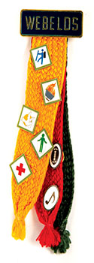
By Mike Walton, www.USScouts.org
Go to the November 2015 Baloo's Bugle issue at
http://usscouts.org/usscouts/bbugle2015-2016.asp

JUNE 2016 – A MONTH FOR OBEDIENCE
Alice Retzinger, Golden Empire Council
June 1: Flip a Coin Day - A day when making decisions is as easy as flipping a coin. This tradition dates back to Julius Caesar. He would flip a coin to make decisions where the right choice was unclear. The correct answer was "heads", which of course carried his image on the coin.
This can be a fun way to choose where to turn when on a hike – but some decisions should be made once and followed – such as moral decisions about how to behave or to be OBEDIENT to a principle or belief you hold.
June 2: National Rocky Road Day - all about eating ice cream specifically Rocky Road ice cream. If you want to make your own, just add nuts, mini marshmallows, and chunks of semisweet chocolate to your favorite recipe. So make and eat some today! But also remember that being OBEDIENT is sometimes a “rocky” road. Others may tease you, or test whether you are really going to follow the rules – but be strong!
6 – National Yo-Yo Day – Learn a new trick - Great way to learn some new rules, gain a new skill, and have some FUN! Go to: http://entertainment.howstuffworks.com/easy-yo-yo-tricks.htm
Here are some fun facts about the Yo-Yo:
- It may have originated in China as early as 500 - 1000 B.C.
- Greeks were probably Yo-Yoing earlier than that!
- In 1992, Jeffrey Hoffman took a Yo-Yo into space aboard the shuttle Atlantis
- Presidents Kennedy, Johnson and Nixon showed off their Yo-Yo expertise while in office!
- The world’s largest Yo-Yo weighs 256 pounds - It’s on display at the National Yo-Yo museum.
- "Walking the Dog" or "Shooting the Moon" are the most popular Yo-Yo tricks
8 – Best Friends Day – Best Friends are dependable– And being with a good friend can help keep you safe, too. Make sure the boys practice the Buddy System – especially if they are going swimming! Remember to always follow the rules when it comes to your safety!
Or celebrate Best Friends Day in the den:
- Have treats that must be shared – one long length of licorice for example. The boys must agree how the treat will be divided, then come to Akela and explain BEFORE they can eat the treat!
- Another great food to share – make a giant sandwich that everyone contributes to, a fruit salad, a soup that everyone brings a veggie for, or, most fun of all, a giant ice cream sundae.
- Make or bring cookies, then divide them into small baggies – give two to each person, but each boy shares one with a buddy.
- Prepare a “community” trail mix – have each person bring an item to add, then mix them all together while you talk about why that item is good to have. Then everyone gets to fill a snack bag with some trail mix and the den can go on a hike. OR Have everyone bring a snack to share on a den hike – two cookies, two boxes of raisins. Let the boys share or mix and match.

14 – Flag Day – Many people have sacrificed to serve our country – and Cub Scouts can honor their service and sacrifice by learning the RULES about how to display the flag with respect. It also takes practice to learn how to do a flag ceremony, raise and lower a flag, or fold the flag properly! You could also have a special outdoor flag ceremony. Local Venturing Scouts or military personnel, or the VFW could come and help!
17 – Eat Your Vegetables Day – Now here’s one thing that your Mother probably would love you to be OBEDIENT about – so try at least a couple of bites of every new vegetable – you might even learn to like it!.
18 - Here are two different third Saturday in June Celebrations - Flip a coin and decide how to spend that third Saturday – or let every den or boy try a different one and report on what they did –
- First, World Juggler’s Day – always held on the Saturday closes to June 17th So check out the rules below and try it!
- Start with scarves if you are brand new.
- Then throw and catch a ball from one hand to the other.
- Now add a second ball – use medium sized soft balls to practice.
- Once you have practiced and can do two balls really well, add a third ball.
- With the hand you write with, hold two balls in that hand and one in the other.
- Throw one of the two balls toward the other hand, and just before you catch it, throw the ball in the other hand.
- Practice over and over till you get really good! In other words, Persevere!
- Second, Go Fishing Day – Fishing is a lot of fun – but it also takes perseverance! Sometimes it takes quite a while to learn how to bait a hook, cast a line without snagging it, or pick a good place and time to catch some fish. And you often have to wait a while for those fish to take the hook! But persevere – fishing can be a great hobby.
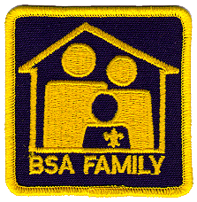
19 – Father’s Day – Make sure to do something special for and with your Dad – Promise to be OBEDIENT – you could even celebrate two holidays this weekend and go fishing on Saturday!
20 – Finally Summer Day - The Summer Solstice, the longest day of the year. On this day, the sun never sets at the North Pole. From now on, each day will be slightly shorter, although you probably won’t notice it. Celebrate by doing some summer activity!
24 – Swim a Lap Day – Like all sports, swimming requires lots of practice, especially if you are afraid of the water. But persevere, and you can always improve your swimming skills! Don’t forget Safe Swim Rules – and never swim alone! This is one case where being OBEDIENT to the rules can be a real lifesaver.
30 – Meteor or Comet Day – AND Superman’s Birthday! Check out the great ideas at NASA’s “The Space Place” – Scouts are listed as “Friends” – and they have all kinds of great ideas that are keyed to Advancement. They actually list the ideas by rank – Core & Elective Adventures!
For Superman’s Birthday on the 30th, encourage pack and den families to watch the Chris Reeve’s – Superman, the Movie -
and challenge the boys to find ways that the Superhero follows the Scout Law. (Families might point out that he does Good Deeds all the time, and CHEERFULLY! He knows that he must be OBEDIENT to laws and beliefs) He saves Lois from a helicopter accident, rescues a cat from a tree, replaces an engine on Air Force One – all of it cheerfully, like a scout! In real life, Christopher Reeve also displayed perseverance after being thrown by a horse and suffering a devastating spinal injury that left him paralyzed. (Be sure to talk about what Perseverance means – that in spite of problems, obstacles and challenges, a boy can keep trying to Do Your Best – even without “Super!”)
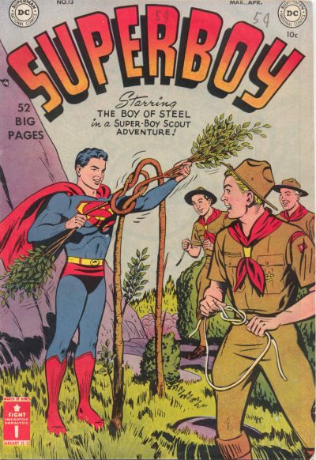
Superboy #13 - The Super-Boy Scout of Smallville! released by DC Comics on April 1, 1951.
http://comicvine.gamespot.com/superboy-13-the-super-boy-scout-of-smallville/4000-120177/

Crazy Holidays
Jodi, SNJC Webelos Resident Camp Director Emeritus,
2006-2011. Adapted from http://holidayinsights.com/moreholidays/index.htm
http://www.brownielocks.com/april.html
June:

- Aquarium Month
- African-American Music Appreciation Month
- Candy Month
- Caribbean-American Heritage Month
- Child Vision Awareness Month
- Children's Awareness Month
- Country Cooking Month
- Dairy Month
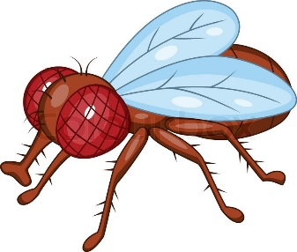
- Fight the Filthy Fly Month
- Great Outdoors Month
- International Childhood Cancer Awareness Month

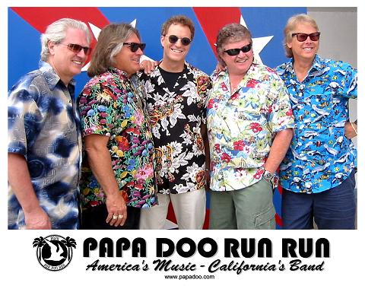
Check them out at - http://www.papadoo.com/
My friend Bo is the drummer. He is the one in the blue shirt on the right side. He was a Life Scout in Troop 227 with me in Bergen County, NJ!!!
• International Surf Music Month
- National Accordion Awareness Month
- National Adopt a Cat Month
- National Candy Month
- National Fruit and Veggies Month

- National Ice Tea Month
- National Fresh Fruit and Vegetables Month
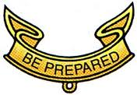
The shape reminds us to be Cheerful and smile!!
- National Smile Month
- National Soul Food Month
- National Camping Month
- Rose Month
- Turkey Lovers Month
Weekly Events:
- Great American Brass Band Week: 2-5
- National Fishing and Boating Week 4-12
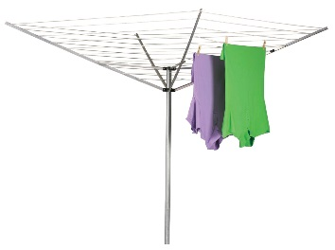
- International Clothesline Week: 4-11
- Pet Appreciation Week, 5-11
- End Mountain Top Removal Week: 5-11
- National Sun Safety Week: 5-11
- Rip Current Awareness Week: 5-11

- Superman Days: 9-12
- Men's Health Week, 12-19
- National Flag Week: 12-18
- Nursing Assistants Week: 12-18
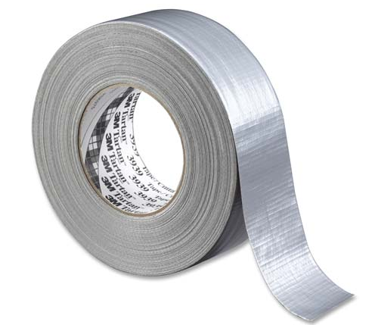
- Duct Tape Days: 17-19
- Old Time Fiddlers Week: 19-25
- Lightning Safety Awareness Week, 19-25
- Watermelon Seed Spitting Week: 23-26
- Water Ski Days: 25-26
Daily:
1 Dare Day
1 Flip a Coin Day
2 National Bubba Day
2 National Rocky Road Day

3 National Doughnut Day
3 Repeat Day (I said "Repeat Day")
4 Applesauce Cake Day
4 National Trails Day
4 Hug Your Cat Day
4 Old Maid's Day
5 World Environment Day
6 National Gardening Exercise Day- Get out and exercise with your plants.
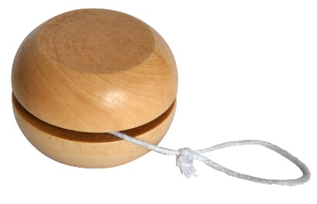
6 National Yo-Yo Day
7 National Chocolate Ice Cream Day
8 Best Friends Day
8 Name Your Poison Day

Donald turns 82 on June 9th this year!!!
9 Donald Duck Day
10 Iced Tea Day
11 National Corn on the Cob Day
12 Red Rose Day
13 Sewing Machine Day
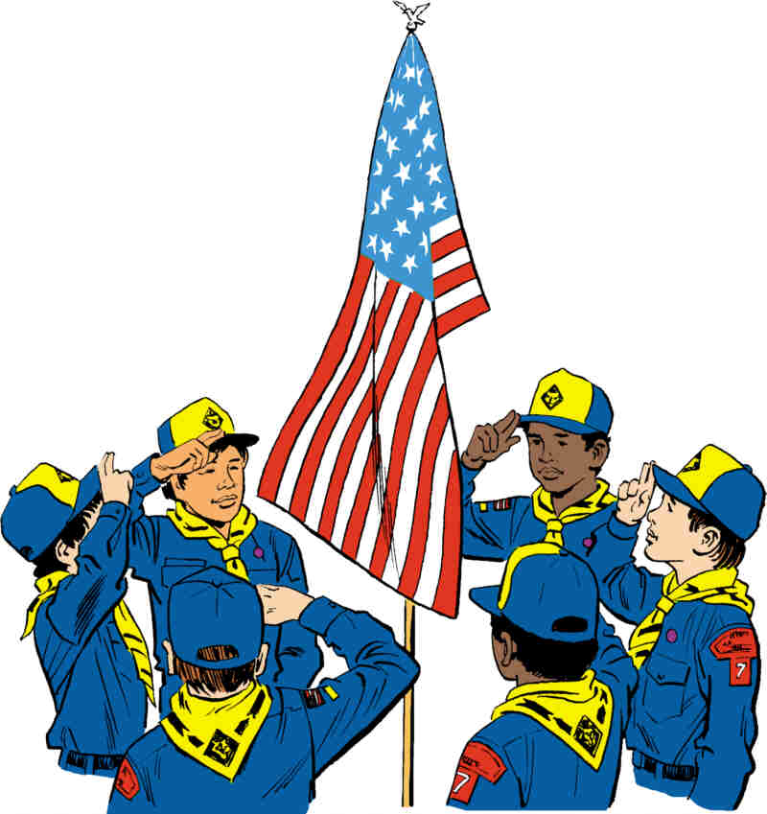
14 Flag Day
14 Monkey Around Day

15 Smile Power Day
16 Fresh Veggies Day
17 Eat Your Vegetables Day
18 World Juggler's Day
18 National Hollerin' Contest Day
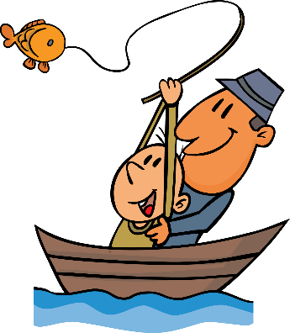
18 Go Fishing Day
18 National Splurge Day - Oh yeah!!

19 Father's Day
19 National Kissing Day
19 World Sauntering Day

20 Ice Cream Soda Day
20 Finally Summer Day- Summer Solstice

21 International Yoga Day
21 Go Skate Day
22 National Chocolate Éclair Day
23 National Columnists Day
23 National Pink Day
24 Swim a Lap Day
24 Take Your Dog to Work Day
25 Log Cabin Day
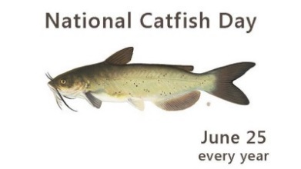
25 National Catfish Day
26 Beautician's Day
26 Forgiveness Day
27 Sun Glasses Day
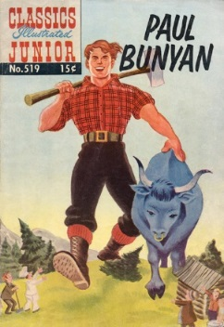
28 Paul Bunyan Day
29 Camera Day
29 International Mud Day
29 Hug Holiday
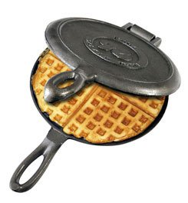
29 Waffle Iron Day
30 Meteor Day

TRAINING TOPICS

Parents
Bill Smith, the Roundtable Guy
The role of parents in Cub Scouting has shifted since this article was initially written. I updated this article to match the new program. Let me know if additional updates are needed. CD
Following this article are three items that I have found helpful I getting parents involved. Be sure to check them out, too!! CD
A Home and Neighborhood Program
The Cub Scout program of the Boy Scouts of America is unique among the various Cub programs in the World Scouting movement. Our method is based on activities a boy could do around his own home or in his immediate neighborhood. While most other Cub organizations conducted a sort of “junior Boy Scout” program with a few leaders in each pack, the BSA opts for something quite different: fun stuff right near home with adult leaders for each den.
The life of a six-to-ten year old is centered on his home. He is just learning how to form close friends and explore new places. He still looks to mom and dad for approval, support and advice. Typically, he doesn’t start reaching out to other adults away from his home until the middle school years. Those Cub Scout years are recognized as an opportunity window for parents to exercise the greatest influence on their sons. Fathers who wait until their sons are in Boy Scouts to become involved are often rudely disappointed – by then, the boys are usually looking elsewhere for guidance and inspiration. Do it now in Cub Scouting!
The Parent Agreement
When families join your pack, each parent should be introduced to the Parent’s Agreement on the second page of the boy’s Application to Join. Each leader should be familiar with this agreement and be prepared to help parents understand its implications and their responsibilities.
Being at Meetings
Younger Cub Scouts, and especially Tigers, are much more comfortable having a parent with them at meetings and activities. Pack meetings are where the boys get a chance to show off – where they are recognized for Doing Their Best, for living up to all those ideals in the Cub Scout Promise and Motto. It’s important those adults who love him are there to share in this recognition and be part of the celebration.
One of the huge benefits of Cub Scouting is that parents are forced to meet and communicate with other neighborhood parents which puts you one good step ahead as your boy enters his teen years. You know and talk to his friends parents.
Working in the Books
The Adventures represent those things a growing boy should be doing as he learns to be a better citizen and a more responsible and capable human being. They give parents and leaders ample opportunities to observe and understand how this boy is growing up: what sort of adult he will be, what kind of husband, what type of father, and what quality of community member he will become. Informed parents and leaders can - and should - make the achievements fun experiences for the boys.
But there is a lot more to it. The electives automatically involve TALKING. The boy and his parent TALK, they listen to each other, they plan; they express their hopes, their concerns, and their jokes. They learn to respect each other's moods, ideas and styles. They create special communication channels that remain vital and valuable for all their lives.
If you, as a leader, shut out the parents by doing too much advancement at den meetings then you deny the parents the opportunity to establish these relationships with their sons.
Helping Leaders
Cub Scouting gives parents opportunities to show their sons examples of leadership and responsibility. It may be a leading a den or pack meeting, or organizing the Blue & Gold banquet or Fourth of July Parade or Friends of Scouting campaign, but every parent should take on a visible job in their son's Cub Scout pack where the Cub Scout can see his role model(s) doing something important.
How to Involve Parents
It takes constant effort, patience
and a sense of humor!!
When the Boy Joins
Ensure that every family is aware of the Parent’s Agreement and understands their obligations when we accept their application to join. The longer we wait the harder it becomes to involve parents. Recruit the parent along with the boy.
Organization and Support
One of the most important tasks a Cub Scout leader does is to convince other parents how important it is for them to get involved in their sons' Cub Scout program and how this helps their families and their boys' development. When they make that a priority and then start working at it, they have a good chance at success.
Never, never do anything that you can possibly get another parent to do.
Being a good Cub Scout leader takes more than just running the meetings - that's the easy part. Interacting with other adults - especially parents - is the essential job quality of Cub Scout leadership.
Each time we take on another job that could be done by a parent who is not performing as a role model for his/her son we are admitting that we have failed. Instead of sharing responsibility we have opted for the easy work around: do it ourselves instead of teaching others that it is better that they do it.
Worse, we have hurt two boys. We have hurt our own sons because the time it takes to do the second (or third and so on) job often comes from the time needed to fulfill our duties as Akela to our own sons, and also, we have deprived another boy the chance to see his parent be a hero - doing something important in his Cub pack.
Parent Agreement
from BSA Youth Application:
I have read the Scout Oath or Promise and Scout Law, and I want my son to join the pack. I will assist him in abiding by the policies of the Boy Scouts of America and of his pack’s chartered organization. I will:
- While he is a Tiger, serve as his adult partner and participate in all meetings and activities and approve his advancement.
- While he is a Cub Scout, help him grow as a Cub Scout and approve his Cub Scout advancement.
- While he is a Tiger, Cub Scout, or Webelos Scout, attend monthly pack meetings and take part in other activities; assist pack leaders as needed.
What are YOU going to do now?
The best gift for a Cub Scout.......
......get his parents involved!
The greatest gift you can give your child
..... good self-respect!
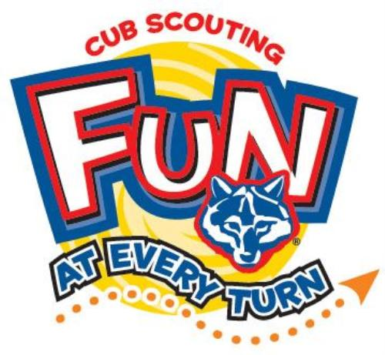

The Yardstick
The importance of the ages 6 - 11,
the Cub Scout years.
Pack 715, Scouter Joe Wollet
Props - You will need a standard yardstick with colored marks at the 3", 5.5", “7”, 9" and 11" distances from one end. These correspond to the ages of 6, 11, 14, 18, 22. Mark both sides.
Dave’s Variation - Prep yardstick by sawing into the yardstick from both sides at the designated marks. Be careful - do not cut all the way through. Leave enough that the stick is still firm. Have a second uncut yardstick to hold up.
Look at this yard stick as your son's life. Each half inch equals 1 year. Thirty six inches - 72 years, the average person's lifespan (when this talk was written. I joke about needing a meter stick now) . At 1/2" (1 year) he is cruising the carpet and furniture, getting into all kinds of things he shouldn't. At 3" he's six and is in first grade, and excited about school. At 5 1/2" he's eleven, and is moving on to Jr. High or Middle School. At 9" he's eighteen and graduating High School. You're busting your buttons with pride for him in his cap and gown. At 11" he's graduating college and has moved on to his own life and family.
Dave's Variation - Go backwards and ask people how much influence and control they will have at that time and snap off the sections as they are discussed – First after college (11 inches to end), essentially none, snap it off. Next, in college (9 -11 inches), also, essentially none. Then during high school (7 - 9 inches), almost none, snap it off. Next middle school (5 ½ - 7 inches) weakening, snap it off, Then tell them that whether they did good or didn’t, the first 6 years are gone and snap off 0 to 3 inches. Now you are left with the piece from 3” to 5 and one half inches.
I'd like to go back to the 2 1/2" between 3 " and 5 1/2" (between 6 and 11 years old). [Hold your fingers at these two marked lines]. These 2 1/2", or 5 years are key years in your son's development. Many of his decision-making skills, ethics and morals will be developed and reinforced during this time. A recent study showed that young people who were close to a caring adult in these early years were less likely to get into trouble with drugs, crime, etc. and were more likely to continue in school.
These five years are the years of the Cub Scout - Tiger Cub through Webelos Scout. [At this point drop the yard stick, but keep your finger spaced the 2 1/2 " apart]. In Cub Scouting we need every family to get involved this much.[refer to the distance between your fingers]. "This much" is different for everybody. Your "This much" might be as a committee member, or a den leader for your son, or for others' it might be organizing an outing, handling the Pack treasury, writing a newsletter, organizing the Blue and Gold banquet. It might be as a Cubmaster.
[Lift the whole yard stick again]. If one person tries to do this much the program will surely fail, but if everyone does "This much" in your son's Scouting career both he and you will have a great experience!
So what are you waiting for? Let us make your son's Scouting Experience something he will remember for a lifetime!
Sign up to help today. Scouting - a family fun experience!

Family Induction Ceremony
Cub Scout Roundtable Planning Guide 2001-2002
Props – Table, one blue, one gold, and one white candle. All should be similar in size and shape. A small white candle for each family.
Cubmaster (or other Leader) – As I look out on this audience, I see many different families. Each is unique in its background and experiences. All of you have come together into this pack to share a very important experience – participating in a program that is designed to give your sons positive growth experiences in his life. By being here, you have shown your son that you support him in these experiences. He advances in this program because of the support and help he receives from the adults in his den and in his home.
Tonight, we want to recognize our new families – Tiger Cubs, Cub Scouts and Webelos Scouts – and welcome them into our pack. As I call your name, please come forward with your son. (Call out names. Families come forward and stand behind the table, facing the audience. Cubmaster lights the white candle first. Then the blue and gold candle from the white are lit as each candle is mentioned.
The blue of this candle, like that of your uniform, stands for truth, loyalty and the blue of the sky. The gold of this candle, like that of the neckerchief, stands for sunlight, good cheer and happiness. Each of these candles has been lit by the white candle, representing your parents here and the important part they play in Cub Scouting. Parents, please light a candle for your son as a symbol of the encouragement and support you will be giving him as he moves along the cub Scout trail. (Parents light their candles from the other candles) Let us now welcome these families to our pack. (Cheer)

The Secret Letters of the
Cub Scout Sign
A Parent Induction Ceremony
Baloo's Archives
On your hand you have five fingers. We use two when we make the Cub Scout sign. These two upright fingers, like the alert ears of a Wolf, stand for the Scout Oath and Law.
The three folded fingers in our Cub Scout sign stand for the three secret letters in Cub Scouting, F-H-G. These letters mean Follows, Helps, Gives. The Cub Scout Follows (Obeys, is obedient to) Akela, Helps other people at all times, and Gives a good impression of Scouting by being Trustworthy, Friendly, Courteous, Kind, Cheerful and Clean. They also mean Fair, Happy, Game. And finally, they can remind us of something each Cub Scout respects, Freedom, Home and God.
All parents and all of our leaders want to do their best to teach Cub Scouts to learn to follow, to help, to give, to be fair and happy whatever the game might be and to respect their freedom, home and God.
Now as part of your induction into the pack as a parent of a Bobcat I ask you to make the Cub Scout sign and repeat after me:
"On my honor, I promise to help my son and all the Cub Scouts in his den and pack to do their best, to do their duty to God and their country, to obey the Scout law, to help other people, and to keep themselves physically strong, mentally awake and morally straight."
As Cubmaster of this pack, I take pleasure in welcoming you into our Scouting family and active participation in Cub Scouting. May your days ahead be happy, game, and fair.

FUN STUFF
Fun Facts About Yo-Yo's
Alice, Golden Empire Council
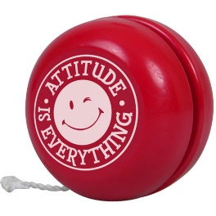
Spin, spin… Can you do tricks on a yo-yo?
- Yo-yos are essentially toys, generally composed of two cylindrical discs connected by an axle, with an attached string.
- It may have originated in China as early as 500 - 1000 B.C.
- Greeks were probably Yo-Yoing earlier than that! Terracotta examples of yo-yos have been found in Ancient Greek art dating between 400 – 500 BC.
- The first modern patent of a yo-yo was in 1866 by James Haven and Charles Hettrich, and it was named a ‘whirligig’ and a ‘bandalore’.
- International yo-yo competitions, where performance is judged, are held all over the world every year, with contestants from many backgrounds.
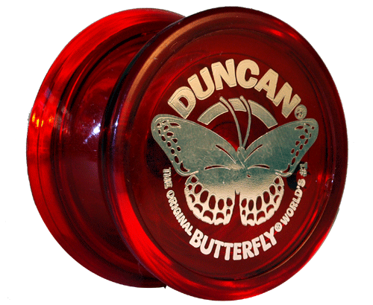
- The term ‘yo-yo’ possibly came from one of the languages spoken in the Philippines, from a word meaning ‘come back’ or ‘spring’, although its origins are uncertain.
- A yo-yo has also been called a ‘bandalore’ (a French term) and a ‘quiz’, and was named a ‘yo-yo’ in 1928 in the United States, by Pedro Flores, who was a Filipino immigrant.
- Japan has some of the best yo-yo masters, most notably world champion Shinji Saito.
- One of the most common yo-yo tricks is ‘walk the dog’, which is when the toy appears to be spinning along the ground in front of your feet.
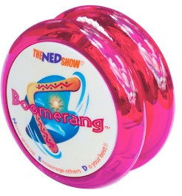
- Cheap yo-yos can spin approximately 10-20 seconds, with a record of nearly 4 minutes, while professional ball bearing yo-yos can spin for 1-4 minutes, with a record of just over 21 minutes.
- In 1992, Jeffrey Hoffman took a Yo-Yo into space aboard the shuttle Atlantis
- Presidents Kennedy, Johnson and Nixon showed off their Yo-Yo expertise while in office!
- The world’s largest Yo-Yo weighs 256 pounds - It’s on display at the National Yo-Yo museum.
- "Walking the Dog" or "Shooting the Moon" are the most popular Yo-Yo tricks
- Yo-yos are generally symmetrical, with weight distributed more on the edges of the discs, although this can vary.
Build a wooden yo-yo
www.Boyslife.org
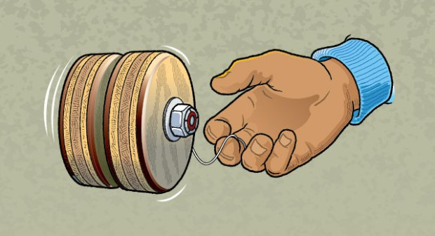
The Boys Life website has complete instructions for building a wooden Yo-Yo. Go to:
http://boyslife.org/hobbies-projects/projects/142533/build-a-wooden-yo-yo/

What You’ll Need:
- 3⁄4″ thick hardwood or plywood board, large enough to cut out two 21⁄2″ disks
- Safety goggles
- Drill
- 21⁄2″ hole saw with 1⁄4″ pilot bit
- Sandpaper
- Tung oil
- 1⁄4″ x 2″ bolt with locking nut
- Two 1⁄4″ washers
- 1⁄4″ x 1⁄4″ x 1⁄2″ nylon spacer (from a hardware store)
- Yo-yo string (available at some hobby stores and online; you can also buy a very cheap yo-yo and use the string from that

All I Really Need To Know I Learned From Baseball

From a Twins Fan in Minnesota -
Back when I was growing up I had a poster that proudly proclaimed “All I really need to know in life I learned from watching Star Trek.” Teachings such as “Remember the Prime Directive” and “Set phasers on stun” resonated with me then and still do today. As I start getting myself psyched up for the coming baseball season, though, I have found myself thinking that in many ways baseball, in addition to entertaining, can also teach us about life. Hence my thoughts on what I can learn about life from baseball.
- Individualism vs teamwork – Yes, following individual statistics is fascinating, but at the end of the day how well an individual pitcher or hitter does is less important than whether the team wins. It is a reminder that success is defined more by what we can do together than by what we can do separately.
It is also a reminder that sometimes the “glory” positions aren’t the ones that make the final difference. Home runs and strikeouts are fun to watch, but sometimes it’s the outfielder throwing to the proper base that decides the game. Everyone has a contribution to make, and everyone’s contribution matters.
- Errors happen – Even the best fielder is going to make a few mistakes over the course of a season. Nobody is perfect. And, yes, sometimes those errors will cost runs or even the game. The question is, will the players let those errors get to them and affect their performance, or are they able to shake them off? That’s what the best players do – they refuse to allow them to fester inside their heads. We are going to make mistakes in life. That’s human nature. We can choose to fixate on our mistakes, or we can learn from them and “play better” in the future.
- Umpires, too, make mistakes – All of us remember the playoff game a few years ago when the outfield umpire completely blew it, calling a ball hit to left foul when it was easily fair. Almost invariably in a game one manager (or both) will rush to the field to protest a call. Just as a matter of practicality, though, how often does the umpire actually change the call? At the end of the day, you have to continue playing the rest of the game – you can’t just take your ball and go home. There will be times when life isn’t fair. That’s just the way it is. The best thing we can do is not let ourselves fixate on that unfairness and allow it to keep us from continue trying and working for what is right. Life isn’t fair – get over it.
- You have to play all nine innings – Unlike other sports, there is no clock in baseball (part of why I like it). At the end of the day, you have to get 27 outs from the other side if you want to win. 26 won’t cut it. In the same way, until you give up that 27th out, you still have a chance (think St. Louis in 2011 World Series). Sometimes we do get to those places in life where it seems like things are hopeless. That’s the time for us to remember that there is still more “game” to go, and as long as we’re alive we have a chance to do it better, to make a difference, to turn things around.
- It’s just a game – I am as passionate (or more so) than most about baseball, yet I always remember that, at the end of the day, this isn’t life. It’s entertainment. The point is to HAVE FUN! In the same way, life, while it is more than just a game, is meant to be enjoyed. Will there be times of pain and sorrow, times of frustration and anger? Absolutely. But I hope I never lose sight of the fact that life is ultimately a gift and a blessing, one that we are meant to treasure and in which we rejoice always. Allow the experience of fresh air and the wind in your face to be pure ecstasy.


From Another Fan
Baseball, when taught properly,
can teach us all we need to know in life.
It is a sport filled with life-lessons, humbling realities, and the innate beauty of the soul. Okay, maybe I get a little carried away when I speak of the sport that I love.
The reality, however, is that baseball can teach us much more than how to hit a round ball with a round bat, how to properly get under a pop-up, and how to keep our glove down on a grounder.
Depend on Others - Baseball teaches us how to count on others. Perhaps no other sport places such a premium on that lesson. It has been called the most individual of team sports, because the main thrust of the action is one-on-one: pitcher versus hitter. But once the ball is thrown, all control rests in the hands of teammates to complete the task.
And for the teammates of the hitter, they have to helplessly look on with zero control of what happens when he is at the plate. They put all their faith and trust in him doing his job. Anyone who has ever worked for a living knows the importance of learning that lesson.
Sacrifice - Baseball also teaches us how to sacrifice for the greater good. Hit the ball to the right to move a runner over, bunt when called upon, take an out on a sac fly to score a run. If you haven't learned the importance of sacrifice in life, God bless your friends and family, because they need you to know that.
Don't Believe Everything You See
Curveballs. Enough said. - If you are older than 10, you probably already know this lesson, but no sport teaches it better than baseball. No matter what your brain tells you, what you see is not always what you get. Sometimes life throws you curveballs. Sometimes, it fools you with changeups. And if you are going through a particularly rough patch, you know that it will fire a 92-mile-per-hour slider at you, seemingly right in your wheelhouse. But when you get ready to swing, it snaps off about 8-inches, nipping the corner, and you're walking back to the dugout.
Never Give Up - Baseball is the only major sport without a time limit. You are never out of a game. You can't get so far behind that the clock makes it mathematically impossible for you to come back. Just like life. You shouldn't give up on life, no matter how old you are, just like you shouldn't give up in baseball. Until you make that last out, you aren't done. I've seen some incredible comebacks in life, and I've seen some incredible comebacks in baseball. Participated in a few in both, too. All you have to do, either in life or in baseball, is get into their bullpen. Once you get into their bullpen, anything can happen.
Finish Strong - Watch the great pitchers past and present, and you will notice the same main trait; they are all stronger at the end of the game than they were at the beginning. It's why Justin Verlander is still throwing 98 in the 9th inning. What a perfect metaphor for life! I've preached to my kids in everything they do (until they are probably sick of hearing it), "Finish strong!" There are going to be times in your life when you have to reach back and find every ounce of strength you've got to close out whatever it is you're doing. FYI, there are no relief pitchers in life. You are going to have to finish what you start, and you better be ready to finish strong.
Don't Try to Strike Everyone Out - I had a pitcher once that you could tell wanted to strike out every batter he faced. A noble goal, no matter how short-sighted. He threw about 94, and he did strike out more than most people. He also walked more than his share. And when a ball was finally put in play, his defense was back on their heels, because they weren't involved in the game. It caused mistakes. It caused complacency.
I told him one time to quit trying to strike everyone out, and he thought I was crazy. He didn't grasp what I was saying. Sometimes, you need a ground ball. Sometimes, you need an infield fly rule. Sometimes, you need other people engaged and invested in what you are doing in order to succeed. Sometimes, you need your teammates.
There are more lessons that could be learned …
So if you want to teach your son about life, get him a bat, a ball, and a glove (and a good coach), and throw him onto a field.


There is a reason baseball
takes place on a diamond.
There is no other jewel quite like it.

THEME PACK AND DEN ACTIVITIES
Alice Retzinger, Golden Empire Council
- Have a display or presentation about the BSA Family Award – Using the family meetings, each family can develop rules about obedience. In the Award materials there are several ideas, including family fire drill. This is one example of when it is vital for everyone to know the rules and obey them! A mock disaster or fire drill gives family members practical experience – what they should do in each area or room of the house, what to do first, how to contact the fire department, and when, and what could happen if each member doesn’t follow the plan.
There are lots of other great activities.
Check out the Family Award at:
- http://councils.scouting.org/scoutsource/CubScouts/Parents/FamilyProgram/index
- http://councils.scouting.org/scoutsource/Awards_Central/BSAFamily
- http://councils.scouting.org/scoutsource/CubScouts/Parents/Literature/33012
- Challenge each family to be responsible for OBEYing the rules for on-line safety – Teach the rules, post them by each computer, and make sure everyone knows how important it is to OBEY these rules!
Make a set of Online Safety Rules and give them to families and boys so they can permanently post these rules near their computer.
Don't tell anyone your password or the password of anyone in your family, class, or school.
Watch out for anyone asking too many personal questions during online discussions--don't answer the questions and get an adult immediately.
Check with an adult in your home/school if someone you don't know sends an "instant message" while you are online.
Never give out your personal information (such as your last name, phone number, or home address) or that of anyone in your family, class, or school.
Avoid anyone or anything online that doesn't feel right--trust your instincts.
Talk to your parents about what rules they want to you follow when you are the computer – including social web sites.
- Take responsibility to OBEY the rules for personal safety in a car, while walking, riding a bike or scooter. Always wear a helmet when on a bike, fasten your seat belt in the car and follow the safety rules found in the Cub Scout manuals. These are rules that you MUST OBEY for personal safety!
- Celebrate Best Friends Day as a Pack – the date is June 8th, but helping all the boys come together with a feeling they belong would be a great theme anytime – and a great time to focus on a very real problem that many kids face – Bullying. Check out these BSA resources:
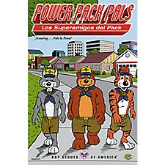
It not only takes adult and peer support, it takes a lot of perseverance to overcome bullying – whether the victim or the bully! Check out the Power Pack Pals comics from BSA at: www.scoutstuff.org
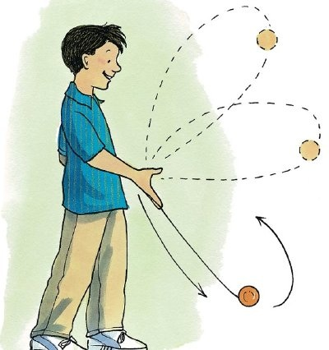
- Have a Yo-Yo clinic – National Yo-Yo Day falls on June 6th, and it is a fun activity that requires practice and perseverance. If there’s a real expert in the pack family or locally, invite them to come to your June Pack activity. There are videos and picture instructions – every boy could learn a trick and practice till he is really good at it – each den could show off at the Pack Meeting! Or – less pressure – take a picture of each boy doing his
- Plan a special activity for Father’s Day – check the ideas under Value Related for two other great “holidays” that Dad might enjoy – Fishing Day and Ice Cream Soda Day. Combine all THREE for a wonderful day with Dad – as a pack activity, you might want to choose the Saturday before Father’s Day. Make sure everyone is included – Grandfathers, uncles or Grandpas for a Day can be invited to fill in.
- Review and practice the Buddy System – Play “Where’s My Buddy?” (See the Games section.) When the weather is warm, and swimming and outdoor activities take over, it’s important that the Buddy System and Safe Swim Defense are second nature!
- Open the Summer Season with a Family Campout for the Pack. Be sure you have a B.A.L.O.O. Trained Adult! And be sure to re-introduce the Buddy System, Swim Safety, and how important it is to ALWAYS follow those important rules!
- Have a Pack Skate Day – it’s a real holiday celebrated on June 21st! And whether it’s ice skating, roller skating, inline skating or skateboarding – it requires perseverance to get really good! But be sure to WEAR A HELMET, and pads or guards that will keep you safe!
Hold a Game / Go to a Game
Commissioner Dave’s Two Cents
What could be better summertime activities for Play Ball than to have a pack Baseball (Softball, Kickball. Wiffle Ball, …) game and to go to a Minor League baseball game.
For your Pack Game there are endless variations – a Parent-Child game. A pack tournament. Challenge another pack. Have boys challenge adults with adults playing with their opposite hand or with one hand tied behind their back or …
And for a real treat, Minor League Baseball can’t be beat. Cost is low. Many have a Scout night with a sleepover. They have family entertainment between innings. You sit real close to the field. The players usually will talk with the fans. I have loved minor league ball ever since my son and I attended a Toledo Mud Hens game in the early 1990’s. And we have had the Wilmington Blue Rocks here for over ten years. This year they switched from Kansas City Royals farm system to the Boston Red Sox farm system. There are also teams nearby in Camden and Trenton and at the Jersey Shore. Check out your local team!!
Sports Wreath
San Gabriel Valley, Long Beach & Verdugo Hills Councils

Materials: printer, paper, glue, scissors and paint or construction paper in your favorite team's colors.
There are two ways to do this craft.
- Trace the child's hand onto paper and cut out the prints.
- Make paint handprints on the paper and cut those out.
Directions:
Make eight handprints (4 of each color).
Cut out the prints and glue to form a wreath.
You can also decorate the wreath with pictures (like basketballs or basketball players). These can be stickers, hand drawn artwork by the children or pictures from coloring books, magazines or fliers.
Bowling Game
San Gabriel Valley, Long Beach & Verdugo Hills Councils
A fun game to make and easy to create.
What You Need:
- Plastic bottles (2 liter or 20 oz.), clean and dry
- Stickers
- Shredded tissue paper, shiny cloth or Easter grass
- Nerf or lightweight rubber ball
How To Make It:
Decorate bottles with stickers and / or fill them using tissue paper (bunched or shredded), shiny cloth or Easter grass. Include an appropriate sized ball (Nerf or light weight rubber).
Line bottles up in Bowling pin arrangement
Go Bowling!!
Sports Cork Board
San Gabriel Valley, Long Beach & Verdugo Hills Councils
Supplies:
- acrylic paint – white, black, orange
- Glue good for cork
- Optional lettering stencils and stamp sponges
- Three 8” circle cork trivets
- Paint brushes – ½” flat, liner
- Black marker, Ruler, Pencil, Masking tape
Note: For best results, please review all instructions on product packaging before beginning any project.
Instructions:
- Paint two cork trivets white. Paint the remaining trivet orange. Let dry.
- Apply a second coat to each trivet as needed. Let dry.
- Using a pencil and referring to the photo, lightly draw
  - A soccer ball pattern on one white trivet,
  - Baseball stitch lines on the other white trivet, and
  - Basketball seam lines on the orange trivet.
- Using orange paint and the liner paint brush, paint the stitch lines on the baseball.
- Using black paint and the flat brush, paint the soccer ball pattern. Let dry.
- Add the lines to the soccer ball and the basketball with the black marker.
- Position the alphabet stencil for the first letter on the basketball; secure with masking tape.
- Dip a stencil sponge into a small puddle of white paint and pat off excess paint.
- Using an up-and-down motion, stencil the first letter.
- Carefully remove the stencil and position for the next letter. Continue stenciling until the wording (ALL STAR) is complete. (or maybe the Cub’s name)
- Glue the balls together, referring to the photo for placement. Let dry completely.
Sports Coasters
Baltimore Area Council
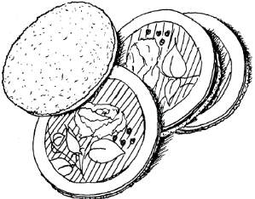
Materials List: Felt, Sports cards, pictures, A pen, Permanent white glue, such as Glue-All, Scissors sharp enough to cut felt, Wide-mouth canning lids (you can find them in the home canning/freezing section of grocery stores.)
Directions: Cut cards or pictures to fit inside circle on lid. Trace around lid onto felt. Cut out one for each lid. Glue cards on inside of the circle. Glue on felt. Let dry overnight.
Fans at the Baseball Field
San Gabriel Valley, Long Beach & Verdugo Hills Councils
These are quick and easy to make. Our Pack went to the ballgame for Scout Night. We made enough for each new Tiger Cub family to have at least one fan. The fans were very popular as we attended the game on a very hot day! Parental supervision is recommended with cutting of the corrugated plastic. Corrugated plastic can be sharp if cut to a point, please be careful. Be sure to round all corners.
What You Need:
- Navy blue corrugated plastic (change this to match your team's colors) Corrugated plastic is often used to make the political campaign and other advertising signs that you see along the roadside.
- Gold "Painters" paint marker
- Extremely sharp scissors
- Popsicle stick
- Pen or pencil
- 5" Circular item to use for a pattern (margarine lid)
- Tacky glue
How To Make It:
  - Use a 5” circular object for a pattern; trace a circle on the navy blue corrugated plastic.
  - Cut out the navy blue circle with the extremely sharp scissors.
  - Using your sharp scissors, cut a small way up on the inside (be sure the "ribs" are vertical) of the navy blue corrugated plastic to make it easier to insert the popsicle stick.
  - Add tacky glue to the end of the stick and push up inside the baseball.
  - Paint "stitching" on the baseball and add your Pack number. Let dry.
  - Take it out to the ballpark, show your Pack spirit, and keep cool!
Notes:
- You can use hot glue if you want the project to dry immediately for the child to use. If using tacky glue, allow to dry overnight.
- You can also use regular cardboard and paint it if you can't get corrugated plastic, but it won't be as durable.
Table Croquet
Baltimore Area Council
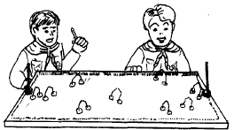
For turf, place carpet scraps or old wash cloths on a table. Or to construct a permanent game, mount on a piece of ¼” plywood cut to size. For mallets, wrap heavy weight aluminum foil around the end of a pencil. For hoops, insert the ends of opened paper clips into balls of clay. For stakes, insert pencils into clay (stakes could also be made of a piece of dowel rod and painted). Use a marble for ball. Set up your course and play.

One Man Ping Pong
Baltimore Area Council
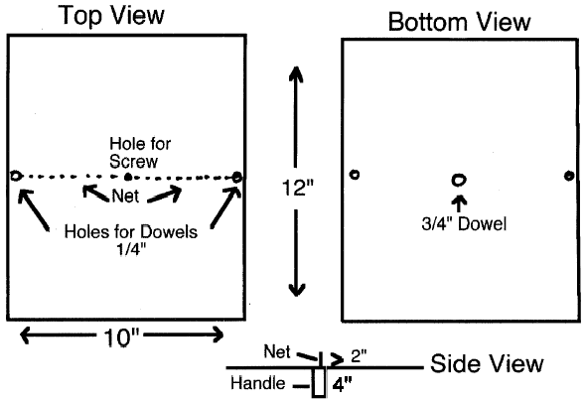
Materials:
1 - #8 or #10 screw 1 - 4” x ¾” dowel
2 - 2” x ¼” dowels 1 - 12” x 10” plywood (¼” or ½”)
1 - piece of netting 1 - ping pong ball
To play:
Bounce ping pong ball back and forth over the net by moving the game board back and forth.
Not up for Ball games and such – How about a –
Bike Rodeo
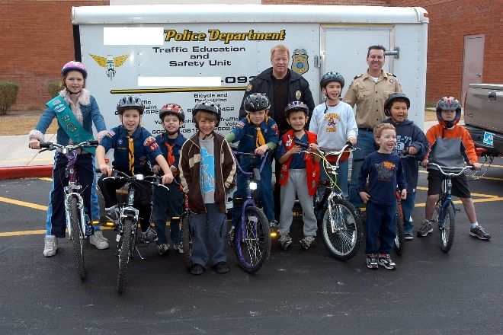
A great pack event is a Bicycle Rodeo. Invite the police to talk about road safety, using helmets, locking their bikes, and even registering their bikes so if their bike is ever stolen it’s one more way of getting it back. You can have your Webelos set up a practice track to test the Scouts knowledge of hand signals, wearing the helmet properly. Let the Webelos Den decide on what they want to help demonstrate or teach then have all the Scouts display what they know.
School parking lots when empty are great places to set up stop signs, yield, (cross over bridge with no steps is a good one to have Scouts cross), hazards to avoid. A large intersecting like an 8 perhaps with one more circle for one more intersection design. You could even have Webelos Scouts or Den Chiefs act as policemen directing traffic in a maze around the lot that intersects each other in a given route. Perhaps have Webelos design cards to give to Scouts (like a drivers license size) saying they passed the knowledge of signals or signs for the road at the end of the track.
For various advancement Scouts can design props, trees and signs along the route. You could have a lemonade/water stand (with parking of course) at one end to keep hydrated. You will want to have an “ambulance” adult or Den Chief Biker for accidents ready with first aide.
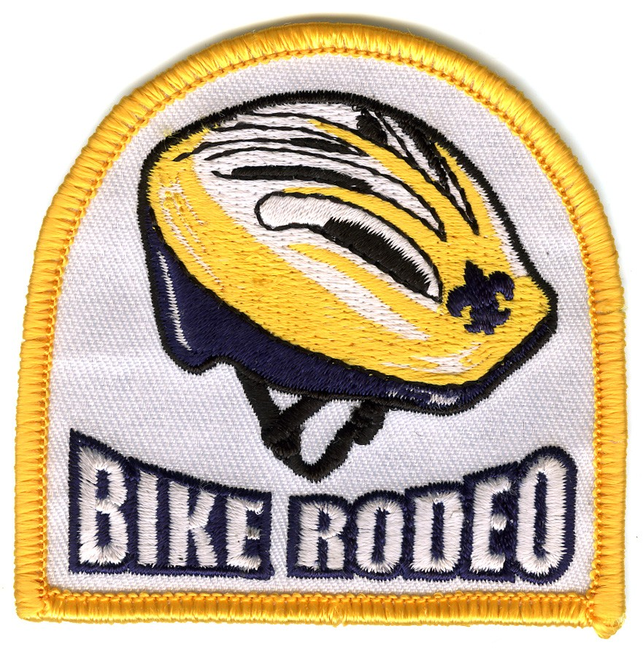
Host a Bike Rodeo – Riding a bike is one area where being OBEDIENT to the rules of safety can literally be a life saver. You could also help make sure each bike is safe and properly adjusted for each person. Check out some great ideas for a Bike Rodeo below.
Bikes & Bike Rodeo Ideas:
(Alice – Golden Empire Council)
Bike Rodeo How To
Riding a bike is one area where it is really important to be OBEDIENT to the rules – and a fun way to learn or reinforce the rules of Bike Safety is to have a bike rodeo. Here are some ideas for you to run a bike rodeo for your Cub Scouts. The boys and their parents need to be involved in this fun activity. Include traffic safety, bike safety, and bike skills in the activities you choose for the event. Your local Police Department, a Cycling Club or the California Automobile Association have information on how to do a Bike Rodeo. Also check some excellent resources on the web.
The rodeo should encourage the safety, bike powers skills and confidence a Cub needs to ride safely. A bicycle is a vehicle with the same rights and responsibilities as other vehicles on the roads. Biking is fun. In order for Cubs to know if their bikes are safe, contact your local police department. Many will send an officer out to do a bike safety checks. Stress the need to of bike safely - not foolishly. Instill good traffic habits from the start with young riders. Once a boy learns to ride a bike, he will never forget. If he learns good riding skills when he is young, they will follow him into adulthood. Bicycling is truly a life-long activity. Make sure your scouts learn the rules of bike safety and understand that to be OBEDIENT to them is essential for their safety.
- Equipment: 50 feet tape or yard stick, Chalk, tape or sting - for lines, Traffic cones or weighted cans, Score sheets and pencils, Clipboards - for volunteers, Stop Sign, Bicycles and helmets
- Organize so there is as little waiting as possible.
- Divide the Cub Scouts and rotate them through the different areas.
Station Ideas
- Station One: Inspection Station – The Cub Scout needs to have his bike checked for safety. See the Bicycle Safety Check list in requirement #5 of the Rolling Tigers Adventure. Have someone available to make needed repairs, or do this inspection ahead of time – Bikes should be correctly adjusted for size and in good repair for the Bike Rodeo.
- Station Two: Helmet and bike check –Check the helmet fit and seat height. Have each boy show how to lock his bike. Safety Gear and how to fit a helmet are discussed in requirement #2 of the Rolling Tigers Adventure. Proper seat height is part of Safety check in Requirement #5 of the Rolling Tigers Adventure.
- Station Three: Ride on the line – Make a wide line and have the Cub Scout ride his bike down the line. The line should be no longer than 12 feet.
- Station Four: Safe Driving - Have the Cub Scouts ride their bikes around traffic cones. The leaders can choose the pattern of the cones.
- Station Five: On the Street - Create an intersection on the parking lot. Have the Cub Scouts demonstrate how to cross an intersection safely.
- Station Six: Steering - Make a circle with the tape. Have the Cub Scouts ride their bike around the circle, staying on the tape as much as possible.
- Station Seven: - Recognition - Cub Scouts receive recognition for rodeo participation and have a snack.
This is just one suggested set of stations. The CAA has a set up that goes over the top five bad habits that cause the most injuries and deaths to children on bikes. See below:
Some Important Facts about
Children & Wheels for Parents:
Children are children, and according to the Bicycle Helmet Safety Institute there are specific reasons why they don’t SEE danger the same way we do while using bikes, scooters, skateboards or skates. Specifically, children:
- Have a narrower field of vision than adults, about 1/3 less.
- Cannot easily judge a car's speed and distance.
- Assume that if THEY can see a car, its driver must be able to see THEM. However, children are easily hidden from view by parked cars and other objects.
- Cannot readily tell the direction a sound is coming from.
- May be impatient and impulsive.
- Concentrate on only one thing at a time. This is likely not to be traffic.
- Have a limited sense of danger.
- Often mix fantasy with reality.
- Imitate the often BAD behavior of others, especially older children and adults
The Top FIVE:
You might be surprised at the Top Five reasons for children’s bike accidents - Authorities urge including these five hazards in your bike rodeo! A booklet from the California Automobile Association included diagrams.
Materials: Several cardboard silhouettes of cars, real or cardboard obstructions such as bushes or fences, Chalk or Tape to mark off street lanes and intersections. Make up a Score Sheet that you can mark off for each participant. Send the scoresheets home with parents so they can see where they need to work on bike safety with their children.
Instructions: Lay out the courses as described. Assign adults to hold the car silhouettes. When the car is “moving” or in play, adult holds it facing the boy doing the course. When not needed, adult turns to the side so the silhouette doesn’t show.
Hazard Number 1: Darting out of driveways or from between parked cars – 30% of all bike accidents, most during Daytime on quiet two-lane streets. Median age is 11!!
- Point out the driveway. Ask how they should ride their bike out, what they need to look for. (cars, trucks, bikes, dogs, cats, pedestrians)
- Tell the rider to go to the end of the driveway, stop, look both ways, and then give a hand signal for a right turn. (Let them practice right hand turn signals)
- Adult volunteer holds a car and randomly has the car “approaching” the driveway. Use a “fence/bush” as a sight obstruction.
- Watch for and note errors: Rider looks only one way; rides out of the driveway with only one hand; doesn’t look for traffic; looks for traffic only one time each way, leaving out the final check; rides on the wrong side of the street, against traffic; doesn’t stay to the right.
Hazard Number Two: Moving to the left without looking, or swerving when looking over the shoulder – 30% of all bike injuries and fatalities – Median age – 13!!
- Mark off a line to the left of a line of cardboard “cars” “parked” on the right side. An optional idea is to have an adult following behind about 10 feet and to the right.
- Each rider is told to listen for their name to be called, then look back around their shoulder to see if there is a car coming. If you have space and cars, you could even park real cars like this. Watch to see if each rider can look over their shoulder without turning the bike into the street.
- Rider is instructed to ride on the line, then to move over and prepare to turn left. Watch to see if the rider looks over his shoulder and can still keep riding straight – the tendency is to swerve to the left as a boy looks over his shoulder. Have them practice several times till they can do it consistently.
Hazard #3 - Failure to Stop at STOP signs – 20% of bike accidents, median age – 12!! Simply place a stop sign at your “intersections and watch to see if the riders follow safe riding and stopping
- Have riders get in line and approach the stop sign, where they stop, look both ways, then proceed, making hand signals as appropriate for left and right turns.
- Two adults hold the cars (car facing means traffic coming; car turned away, traffic is clear). Make sure kids stop at sign then move far enough to see traffic and again look both ways before proceeding.
- Watch for these errors: Rider doesn’t stop, or looks only one way; Rider sees the car and waits, but fails to check again before moving; rider making a turn moves too far to the right or left while waiting; doesn’t put both feet on the ground when stopping.
- Ask what else they should stop for (red lights, yield signs, uncontrolled intersections). See if they know what “yield” means.
Hazard Number 4: Riding against traffic, especially when a car is turning right at the corner. – 30% of all bike accidents – median age 12!!
This is a matter of forming a habit, so have the boys practice several times. Set up a set of intersections and place cars at several locations, with adults randomly turning car silhouettes right at the corner. Make some of your “streets” one way streets to test for understanding by each rider.
Hazard Number 5: NO HELMET!! Riding with the correct helmet will reduce the risk of head injury by 85%!!
(This should be a Mandatory Family, Den and Pack rule – no one is allowed to ride without their helmet! You might have children and parents sign a pledge to ALWAYS WEAR THEIR HELMET) Also, check out the Jello “Brain Without Helmet” in Cub Grub.
Summer Bike Safety
www.helmets.org
Here are some great tips for any parent or den leader to check before bikes come out for the Summer!
I'm going out for my first ride of the summer. Is there anything I need to do with my bicycle before I start?
Yes, and it will only take about ten minutes.
- First, clean the dust off of it. That helps you get back in touch with it, and remember anything you meant to do over the winter. While you are dusting, check for loose parts like saddle or handlebars. If your bike has quick release levers on the wheels, make sure they are snugly closed. Check the tires for wear or dry rot.
- You always need to inflate your tires. Inflate them to the pressure molded into the side wall. Soft tires make the bike harder to pedal, and you'll have more flats.
- Lube the chain. Squeaky chains actually will break from excess internal friction. In the meantime, they rob you of some pedaling energy.
- Adjust your saddle if necessary. Saddle adjustment can be important for comfort and to avoid pressure in the wrong places, particularly on the first rides of summer.
What about equipment? What do I need for safety?
- A helmet, of course.
The helmet is the most important, yes. Make sure it is well adjusted, fits level, and won't slip around too much. In addition to that:
- Gloves protect your hands from chafing, and keep the skin intact if you crash.
- Bike shoes are good because they have rigid soles and spread the pedal pressure evenly. More of your energy gets to the pedal. Running shoes are fine for shorter rides.
- The top that you wear should have a close-fitting neckline. The ones that flop open or hang down are called "bee-catchers."
Anything special to do if I'm taking a child with me?
If you have children, review the basic safety rules with them while you are checking over their bike.
Designer Helmets
Wearing a helmet is a must, but it can be FUN, too! Just use strips of colored plastic tape to create stick on lightning bolts, initials, racing stripes, whatever!
We’re all set to go. Any advice for that first ride?
Ride around the block to be sure your bike is ready. Plan an easy first outing to avoid dragging in to the office on Monday with sore muscles. If the weather is hot, drink plenty of water and take it easy for the first few rides until your body is acclimated to the heat. And use sunscreen to prevent burning.
Summer riding is great fun. It is one of the four best seasons to ride a bicycle!

Cub Scout Rodeo
Tune: Jingle Bells
Alice – Golden Empire Council
Hopping on my bike, and with my helmet on,
Down the street I go, peddling fast not slow,
Waving to my friends - Grab your bikes, let’s go!
Peddle on to have some fun at our Bike Rodeo
OOOOooooh……
Chorus:
Cubs on bikes, Cubs on bikes, riding is such fun
The rodeo for bikes, you know is meant for everyone
Cubs on bikes, Cubs on bikes, riding is such fun
Safety first and practice, too, will make you #1!

THEME & PACK MEETING IDEAS

GATHERING ACTIVITIES
Note on Word Searches, Word Games, Mazes and such – In order to make these items fit in the two column format of Baloo’s Bugle they are shrunk to a width of about 3 inches. Your Cubs probably need bigger pictures. You can get these by copying and pasting the picture from the Word version or clipping the picture in the Adobe (.pdf) version and then enlarging to page width. CD
See also the AMAZING FLYING MACHINE BOMB POPS under the Games Section. Great Fun way to teach the idea that Following the Rules is sometimes essential to getting the right result.
Licorice Discipline
Alice Retzinger, Golden Empire Council

To encourage OBEDIENCE post a length of licorice for each boy at the front of the room – Explain that they will get the licorice at the end of the meeting. Do NOT explain the whole thing Post your Den Rules in the front of the room – or at least go over them. . Then comes the fun – if a boy is loud, or doesn’t do what he’s asked, don’t say anything. Just go to his licorice string and cut off a length. He will of course protest – Just say he’s responsible to figure out WHY for himself and go on with your den meeting. At the end of meeting, give each boy whatever remains of his licorice string. (They will get the point – and anything with food attached is always more memorable!)
Pack Meeting Display
Alice Retzinger, Golden Empire Council
Have a display showing how each den worked on Obedience during the month - Den leaders might focus on a Character Compass pointing to Obedience during the month. There is a list of what Adventures contain a Character Compass pointing to Obedient in this issue of Baloo's Bugle.

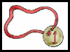
Make homemade “You Can Count On Me” medals – As a Den Activity, let each boy make a medal - BUT …Boys have to earn the right to WEAR the medals – by showing they are responsible enough to follow the rules and be OBEDIENT. Use either cardstock circles or frozen juice lids for the backing. Make a hole in the top center so you can use a ribbon lanyard for your medal. (If you’re really lucky, you have a parent who can design and print your artwork – or who does scrapbooking and can cut out what you need!) If not, you can use stick on lettering, let the boys draw their own design, or get out the markers and have some fun. As a Pack Gathering, you could have the artwork ready, let everyone make a medal, then challenge them to “earn” the medal during the week – Scout’s Honor!
See another idea using the medals -
under Advancement Ceremonies
How Many?
Voyageurs Area Council
Fill a clear container filled with marbles counting as you fill. Everyone makes a guess on a slip a paper (be sure they include their first and last name) as to how many marbles are in the jar. The winner gets the container & marbles.
Who Am I?
Voyageurs Area Council
Make up a "Who Am I" card for each scout. This card has the name of someone who is famous or well-known in Sports. Tape one card on the back of each scout as they arrive (be sure the scout does not see the name). The scouts are allowed to ask each other scout two questions which can only be answered with "Yes" or "No" as they try to guess "Who" they are.
Tumbling Down
Voyageurs Area Council
With a box of baseball cards, have the boys see how high a tower they can build before they all come tumbling down.
Shot Put
Baltimore Area Council
If your July meeting is outdoors, have the boys engage in a shot put competition with a softball or a wooden croquet or bocce ball. The ball must be “put,” not thrown like a baseball.
Sports Ball Word Search
San Gabriel Valley, Long Beach & Verdugo Hills Councils
Find the names of some of our favorite ball sports in the word search below. They can be upside down, backwards, forwards or diagonal.
Soccer Volleyball Ping Pong
Croquet Baseball Rugby
Football Tennis Squash
Polo Basketball Water Polo
Madlibs
Baltimore Area Council
Give every boy a copy of the list below and during Gathering Time have him fill in the types of words required. Parents may help them understand what types of speech are required. Later in the Pack meeting, read the following story. When you reach a number, point to a boy and have him read his answer for that particular number. Have extra copies of the story to hand out to the boys at the end of the evening, so they can see how their whole list of words complete this silly story.
Or you can do this as an audience Participation. Just before reading the story fill in the list by having the audience shout out ideas and you selecting them. Make sure everyone knows your choices. CD
- (name)
- (adjective)
- (name)
- (noun)
- (adjective)
- (past tense verb)
- (clothing)
- (verb ending in -ing)
- (past tense verb)
- (noun)
- (clothing)
- (verb ending in -ing)
- (animal)
- (body part)
- (past tense verb)
- (past tense verb)
- (verb ending in -ing)
- (body part)
- (verb ending in -ing)
- (number)
- (adjective)
- (adverb)
- (adjective)
- (noun)
- (name)
- (adjective)

The Most Embarrassing Day to Play Baseball
Hi, my name is (1)___________, but you may call me
(2) ___________ (3) ___________. That’s what my
(4) ___________ calls me. But anyway, would you promise to keep a (5) ___________ secret? day, at baseball practice as I was trying to catch the ball, it (6) __________ into my (7) _________. I was very embarrassed to take it out because everyone was
(8) ___________ at me. When I (9) ___________ a few times trying to catch the ball, I got a (10) __________ in my (11) __________. Now everyone was (12) ___________ at me really hard. The next time I tried to catch the ball a
(13) ___________ landed on my (14) ___________ and I couldn’t concentrate on catching the ball.
When it was my turn for batting, I (15) ___________ the baseball bat in half! The coach was so
(16) ___________ that he was (17) ___________ on my (18) ___________. I was really embarrassed now, especially since everyone was (19) __________ at me. I also had to pay the coach (20) _________ dollars for a new baseball bat.
The (21) ___________ coach made me leave early since I was doing so (22) ___________. Now people call me (23) ___________ (24) ___________ (25) ___________.
Just remember it’s a (26) ___________ secret!!!!

Name the Signals
Baltimore Area Council
Each Den member gets a piece of paper and a pencil when he arrives. The chart of official sports signals (below) is displayed for everyone to see. (Or you could reproduce them on each boy’s paper.) The object is to have each person list the meanings of the various signals. Answers can be given at the meeting’s end.

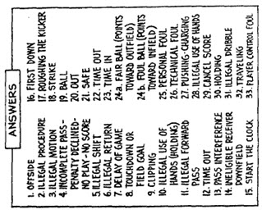

OPENING CEREMONIES
Play Ball
San Gabriel Valley, Long Beach & Verdugo Hills Councils
Have your Cub Scouts help you with this one. Using cardboard or poster board have them cut out 8 different ball shapes. Have them paint or color them to resemble different balls like tennis, football, soccer, baseball, etc. Once dried have them use a stencil to spell out P-L-A-Y-B-A-L-L, one letter on each ball. Then glue or tape to the back of corresponding letter the text the cub is to read. Be sure to use LARGE print. (Need 8 Scouts to read aloud.)
- P is for our Parents who love us and help the Pack.
- L is for our Leaders who help on our scouting path.
- A is for Achievements that help us grow and learn.
- Y is for Yesterday the memories that we share.
- B is for Baloo the Bear who helps us learn to camp.
- A is for Activities because we want to run and play.
- L is for Laughing because Cub Scouts is such fun.
- L is for Learning skills we can use for life.
Sporting Flag Ceremony
San Gabriel Valley, Long Beach & Verdugo Hills Councils
This can be done with one person reading the entire poem or splitting it yup by lines and having different Cub read either each couplet or each line.
- Everywhere we gather I can see your colors wave,
- In churches, schools and stadiums, even in a cave.
- Two foes can meet upon a playing field,
- All are Americans; they will not yield.
- In sportsmanship and honor, some say that is the way,
- To keep our colors flying in every patriotic display.
- The freedom to choose, even if we don’t agree,
- To fight for what’s right, the price to live among the free.
- Please join me in pledging allegiance to our flag.
The Sportsman’s Creed:
Baltimore Area Council
- Have the Scouts repeat after the Leader:
The Player…
…lives clean and plays hard.
He plays for the love of the game.
…wins without boasting, he loses without excuses,
and he never quits.
…respects officials and accepts their decisions without question.
…never forgets that he represents his Den and Pack.
- Have the Cubmaster repeat after the leader
The Coach…
…inspires in the boys a love for the game and the desire to win.
…teaches them that it is better to lose fairly than to win unfairly.
…leads players and spectators to respect others by setting them a good example.
…is the type of adult he wants his boys to be.
- Have the Den Leaders repeat after the Leader:
The official…
…knows the rules.
…is fair and firm in all decisions. (S)He calls them as (s)he sees them.
…treats everyone courteously and demands the same treatment for (her)himself.
…knows the game is for the boys, and lets them have the spotlight.
- Have the Parents repeat after the Leader:
The spectators…
…never boo a player or official
…appreciate a good play, no matter who makes it.
…know the Pack gets the blame or the praise for their conduct.
…recognize the need for more sportsmen and fewer “sports”.
Favorite Song Opening Ceremony
Voyageurs Area Council
- My favorite song is "Take Me Out to the Ballgame." I like it because it reminds me of how excited I feel when my favorite (relative) comes to visit me.
- My favorite song is "Singing In the Rain". I love to run out in the rain, taste the raindrops and splash in the puddles.
- My favorite song is "The Bare Necessities" from "The Jungle Book." I don't like to worry about things I can't change. I am happy with myself and my life.
- My favorite song is "Home on the Range." I love to go camping with my family and enjoy the quiet and peace of the outdoors.
- My favorite song is "God Bless America." I love my country, my flag, and my home.
- What is your favorite song? It tells a lot about you - what is important to you, what you think about, and what you like.
- Please join with us by singing the first verse of your favorite song. Don't mind if someone by you sings something different. We can still make beautiful music together.
Cubmaster: Everyone sing the first verse of your favorite song.
Afraid to try this?? Don’t worry, you can bet that regardless of the sound, everyone will be smiling at the end.
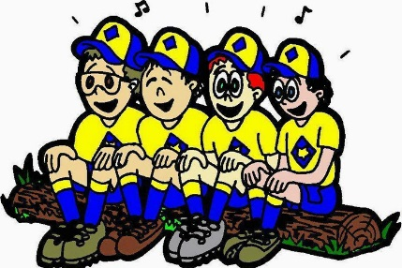
Summer Opening
Baltimore Area Council
Have each boy read his part while holding an item or items that would be used in each of the summer activities. Narrator should, also, be a Cub Scout.
Narrator: What would of happened if our Cubmaster and Den Leaders had decided they didn’t want any Cub Scouting this summer?
(Read only those that apply to your Pack - add activities that you may do that are not listed).
- We wouldn’t have had our Softball League.
- Day Camp would have been just a dream.
- Our families would have missed the fun of our Picnic.
- We wouldn’t have met with other Packs for the Cub Scout Games.
- The fathers probably would not have gone camping with us at the Webelos Overnighter.
- We wouldn’t have marched in our city’s Fourth of July Parade.
Narrator: As you can see, it would have been a pretty dull summer if they had decided to take the summer off. Let’s give a big cheer for our Leaders and parents who have cared enough to give us Cub Scouting during the summer.

AUDIENCE PARTICIPATIONS
A Day at the Ball Game
Baltimore Area Council
Divide audience into four groups. Assign each group a response to say when their word is said in the story. Practice as you assign parts.
Johnny “Cheer, Cheer”
Den Leader ”Happy, Happy”
Umpire ”Blind As A Bat”
Kirby “Our Hero”
One fine day JOHNNY’S DEN LEADER decided to take his Den to a ball game. JOHNNY was so excited because his idol KIRBY was playing that day. The DEN LEADER and some of the parents loaded all the boys into their cars and headed for the ballpark.
On the way to the game, the DEN LEADER pointed to a man in another car and asked, “Why would a person put on such a dark suit on such a warm day?” JOHNNY looked at the man and exclaimed, “He’s an UMPIRE! I wonder if he is going to the game?” Sure enough, when KIRBY and the other players ran onto the field, out strolled the same UMPIRE that JOHNNY and his DEN LEADER saw on the way to the game.
When KIRBY ran out to his fielder’s position, JOHNNY and all the other people cheered for they knew KIRBY was a great player. The UMPIRE called “Play Ball” Everyone was on the edge of their seats as the pitcher took his sign, wound up and delivered his first pitch. “Crack” went the bat and a long fly ball was headed toward KIRBY. Back KIRBY ran, nearer and nearer to the fence, until he was right up against it. At the last minute he made a great leap into the air and the ball thudded into KIRBY'S glove. JOHNNY, his DEN LEADER and everyone cheered as the UMPIRE signaled “He’s Out.” The pitcher then struck out the next two batters with the UMPIRE calling the strikes real loud.
Now it was KIRBY'S teams turn at bat. JOHNNY was hoping KIRBY would hit a home run. First man up, “Crack,” a single. The next batter also singled and now to bat came KIRBY. JOHNNY, his DEN LEADER, and everyone was cheering and hollering for KIRBY to hit a good one. “Strike One”, called the UMPIRE and JOHNNY’s heart came up in his throat. “Strike Two,” called the UMPIRE, and JOHNNY'S heart sank. The pitcher took his sign, checked the runners, wound up, and delivered. “Crack” went the bat and JOHNNY knew KIRBY had hit a long one. Back, back went the fielder, clear to the wall. He leaped, but the ball hit the wall above him. KIRBY was churning his wheels around first, around second, heading for third. In came the ball and KIRBY hit the dirt. “Safe” yelled the UMPIRE. JOHNNY, his DEN LEADER, and everyone cheered.
JOHNNY was real happy because although his idol KIRBY had not hit a home run, he had hit a triple. And that is as close as any idol can come to what is expected of him. Therefore, JOHNNY, his DEN LEADER, and everyone went home happy.
Casey at the Bat
San Gabriel Valley, Long Beach & Verdugo Hills Councils
Divide your group into 3 sections and assign sounds as below.
Or maybe you just want everyone to do all the yells. There are a lot more Caseys than the other two put together - CD
Casey: “That’s me”
Fans (or related words): Cheering sound
Bat or Ball : “It’s a hit”
Now enjoy this famous poem.
Casey at the Bat
by Ernest L. Thayer
The outlook wasn’t brilliant for the Mudville nine that day:
The score stood four to two, with but one inning more to play,
And then when Cooney died at first, and Barrows did the same,
A pall-like silence fell upon the patrons of the game.
A straggling few got up to go in deep despair. The rest
Clung to the hope which springs eternal in the human breast;
They thought, “If only Casey could but get a whack at that—
We’d put up even money now, with Casey at the bat.”
But Flynn preceded Casey, as did also Jimmy Blake,
And the former was a hoodoo, while the latter was a cake;
So upon that stricken multitude grim melancholy sat,
For there seemed but little chance of Casey getting to the bat.
But Flynn let drive a single, to the wonderment of all,
And Blake, the much despised, tore the cover off the ball;
And when the dust had lifted, and men saw what had occurred,
There was Jimmy safe at second and Flynn a-hugging third.
Then from 5000 throats and more there rose a lusty yell;
It rumbled through the valley, it rattled in the dell;
It pounded on the mountain and recoiled upon the flat,
For Casey, mighty Casey, was advancing to the bat.
There was ease in Casey’s manner as he stepped into his place;
There was pride in Casey’s bearing and a smile lit Casey’s face.
And when, responding to the cheers, he lightly doffed his hat,
No stranger in the crowd could doubt ‘twas Casey at the bat.
10,000 eyes were on him as he rubbed his hands with dirt;
Five thousand tongues applauded when he wiped them on his
shirt;
Then while the writhing pitcher ground the ball into his hip,
Defiance flashed in Casey’s eye, a sneer curled Casey’s lip.
And now the leather-covered sphere came hurtling through the
air,
And Casey stood a-watching it in haughty grandeur there.
Close by the sturdy batsman the ball unheeded sped—
“That ain’t my style," said Casey. “Strike one!” the umpire said.
From the benches, black with people, there went up a muffled
roar.
Like the beating of the storm-waves on a stern and distant shore;
“Kill him! Kill the umpire!” shouted someone on the stand;
And it’s likely they’d have killed him had not Casey raised his
hand.
With a smile of Christian charity great Casey’s visage shone;
He stilled the rising tumult; he bade the game go on;
He signaled to the pitcher, and once more the dun sphere flew;
But Casey still ignored it and the umpire said, “Strike two!”
“Fraud!” cried the maddened thousands, and echo answered
“Fraud!”
But one scornful look from Casey and the audience was awed.
They saw his face grow stern and cold, they saw his muscles
strain
And they knew that Casey wouldn’t let that ball go by again.
The sneer is gone from Casey’s lip, his teeth are clenched in hate
He pounds with cruel violence his bat upon the plate;
And now the pitcher holds the ball, and now he lets it go,
And now the air is shattered by the force of Casey’s blow.
Oh, somewhere in this favoured land the sun is shining bright,
The band is playing somewhere, and somewhere hearts are light
And somewhere men are laughing, and somewhere children
shout,
But there is no joy in Mudville—mighty Casey has struck out.
This poem is in the Public Domain

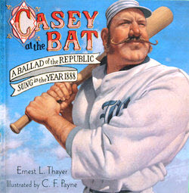

ADVANCEMENT CEREMONIES
Cub Scouting Is Like Playing Baseball
San Gabriel Valley, Long Beach & Verdugo Hills Councils
This ceremony takes you through all the ranks. Badges can be presented at each base as the Scouts walk around the infield. Or they can be held and presented at Home plate by calling everyone in one rank at a time. If you are not doing Arrow of Light, take time to modify that section to use it to inspire Cubs finish their path around the bases.
Participants:
- All Cub Scouts – Tiger, Bobcat, Wolf, Bear, 1st Year Webelos and Graduating (2nd Year) Webelos Scouts
- Den and Webelos Leaders
- Parents of graduating Webelos
- 5 Boy Scouts
- Cubmaster.
Setup: Use a baseball field with bases set about 40 to 60 feet apart (60 feet is Little League standard). Parents stand near third base dugout; Boy Scouts stand near first base dugout; Cubs and Webelos stand near home plate with Den and Webelos Leaders beside their dens. Cubmaster stands at pitcher's mound.
Cubmaster: Cub Scouting is like playing baseball. Each base we go to indicates a certain level of skill obtained.
The Bobcats are in the on-deck circle. (Den Leaders take all new Bobcats to on-deck circle) Call Bobcat parents to on-deck circle. The Bobcat learned the Scout Oath (or Promise) and Law, the Cub Scout Motto, handshake, salute, and sign. And, as all ball players, he got to wear the uniform showing everyone in the stadium what team he was on - in our case the Blue and Gold team. Present awards to parents of Bobcats to present to their sons. Lead Cheer.
When the Cub got up to the plate for the first time, he was a Tiger. Call Tigers and their parents to Home Plate. Say a few words about the awards the Tigers have earned. Present Tiger awards to parents of Tigers to present to their sons. Lead Cheer.
(Den and Webelos Leaders advance
all other Cubs to 1st base and stop.)
The Tiger hit the ball and ran to 1st base - the first leg of the diamond. At this point he learned the basics of the sport - throwing the ball, batting and catching. To the Scout, it was learning what it meant to help other people and to give good will - a time for the Cub to learn the basics with his coaches, mom and dad. The Cub is on his way to manhood. Call Wolf Parents to First base and present Wolf Awards. Lead Cheer.
(Wolf Cubs and Wolf Leader stay at 1st;
the rest go to 2nd base.)
The Cub arrives at the second base, half way around. At this point he learned that through practice and determination one became a better ball handler, better thrower and better batter. The Cub is given choices in the Bear book and begins to learn about camping and how to use a knife safely. The Bear Cub sharpens his skills and begins to enjoy the team aspect of the sport, not just individual achievement. Call Bear Parents to Second base and present Bear Awards. Lead Cheer.
(Bear Cubs and Bear leader stay at 2nd;
the rest go to 3rd base.)
The Cub now arrives at third base. He can see victory! He knows that if he makes it to third, he has a good chance of scoring. As he passes the shortstop he looks at the coach for guidance. This is the year in the Cub's life that changes most dramatically. He becomes a Webelos. It is the acronym for We'll Be Loyal Scouts. To the baseball player, it means that he has mastered the rudiments of the sport and now must rely on his coach to lead him around the bases. The Scout begins to trust others, listen to the coaches, back up his fellow team members and show maturity on the field. The 4th Graders are Webelos. The Webelos go on a few campouts and obtain a taste of adult responsibility. Call Webelos Parents to Third base and present Webelos Awards. Lead Cheer.
(Graduating Webelos go half way to home plate.)
The Cub has gotten the high sign from the coach and he puts on the afterburners as he rounds third base. He's heading for home. The fans are standing, rooting as he approaches home plate. The Arrow of Light Cub is on his last leg of the course. He knows he is going to score. The anticipation is tremendous, as he knows his run could win the ball game.
(Parents of Arrow of Light Cubs and Boy Scouts
go to home plate and wait to give the boys
a "HIGH FIVE" as they cross the plate.)
The Cubs have earned the Arrow of Light, the highest award given to a Cub Scout. He has prepared himself to return home, but this time as an accomplished ball player. He's learned the fundamentals of the sport. He has learned that he should be TRUSTWORTHY, LOYAL, HELPFUL, FRIENDLY, COURTEOUS, KIND, OBEDIENT, CHEERFUL, THRIFTY, BRAVE CLEAN and REVERENT.
He started from the on-deck circle as a Bobcat and will now return home as a young Scout ready to enter the senior league, the Boys Scouts, and be welcomed by his new coach and team mates from Troop ______. He will be greeted by the most influential people in his Cub sporting career - his parents. They helped him every step of the way around the bases. They are so proud of him that they, too, are anxious for him too cross the plate. They were with him as he touched every base and will continue to be with him in the dugout and after the game.
The Arrow of Light is the only badge of rank earned by a Cub Scout that can be worn permanently on the Boy Scout uniform. There are 7 rays of light on the badge to not only signify the 7 days of the week but the 7 virtues of playing the game:
1. WISDOM - Putting to right use the knowledge they have obtained.
2. COURAGE - To meet the opposition head on in spite of one's fear.
3. SELF CONTROL - Controlling one's temper during the game. Being sportsmen.
4. JUSTICE - Justice will prevail, even if you think the umpire made a bad call.
5/6. FAITH and HOPE - Two virtues that all players must have on and off the field.
7. And finally LOVE - Love of family, love of home, love of God, love of fellow members and love of the game.
These are the seven virtues that will make you successful in the games to come. Now would the following Scouts proudly stride into home and receive their Arrow of Light. Lead Cheer.
Cub Scout Baseball
Baltimore Area Council
Equipment: A small baseball diamond on the floor in front, badges to be awarded.
Personnel: Cubmaster, boys to receive awards and their parents.
Note from CD – You may want to add in words here about what the Adventures were that hey completed for each rank.
Will (names), our new Bobcats and their parents please come forward to the “on-deck circle?” As you are standing on the “on-deck circle” you are at the beginning of the “game”. Just as you are at the beginning of the Cub Scout trail. Parents, please accept your son’s badge and present it to him. (Present badges) Lead Cheer
Will (names), our Tiger candidates and their parents please come forward. Stand on home plate. This represents the first stop on your Cub Scout trials. You worked hard on earning your Tiger Rank. So keep up the good work. Parents here are their badges. (Present badges) Lead Cheer
Will (names), our Wolf candidates and their parents please come forward. Stand on first base. This represents the second stop on your Cub Scout trials. You worked hard on earning your Wolf. So keep up the good work. Parents here are their badges. (Present badges) Lead Cheer
Will (names), our Bear candidates and their parents please come forward. Your place on our diamond is at second base. This is the third major stop along the Cub Scout trail. Parents, please accept your son’s badge. (Present badges) Lead Cheer
Will (names), the Webelos and their parents please come forward. Your spot is third. You are almost “home”. Keep up the good work and you will have no problem in finishing your trail. (If appropriate depending on the Webelos badge being presented) You now wear a badge diamond on your shirt to complete that game. OR You now may wear the oval Webelos Badge shaped to have you start thinks of the ranks and adventure awaiting you in Boy Scouts. You need to receive your Arrow of Light. Work hard and you should have no problem. (Present badges) Lead Cheer
(If you have boys earning the Arrow of Light
their spot is home plate.)
Scoreboard Advancement Ceremony
Baltimore Area Council
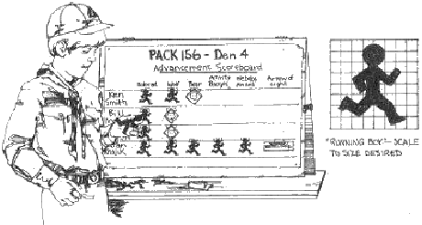
Personnel: Cubmaster, Den Leaders, advancing boys and their parents
Props: Scoreboard and cutouts of running figures, invisible tape, straight pins, badges. Make a scoreboard of poster paper and write in the name of the advancing boys. Use grid methods to draw the figure to size you want; then cut out as many figures as you need.
Call forward advancing Scouts and their parents. Line up the boys on either side of the scoreboard with the parents behind them.
You know, boys, Cub Scouts is a lot like sports. It’s fun, it’s full of physical activities, and you can win – or lose. In Cub Scouting you win by growing strong in mind and body, and by advancing in rank. Or you can lose by not joining in our Den and Pack activities and by not doing your best to pass achievements and electives.
You boys have all been winners this month. You have advanced in rank or earned Adventure Belt Loops, or both. Your coaches have been your Den Leaders and your parents. In Cub Scouting, we could not get along without coaches. So I want to congratulate all of you, boys and parents. Now I’ll ask each boy to show his progress on our scoreboard by putting on the scoreboard a marker for each rank you have earned and have your parents pin on your new rank badge. (In turn, advancing the boy’s tape on a runner for each rank he has earned and removing his new badge for the parents to pin on to his uniform.)
We also have a boy who has earned the Arrow of Light. Cub Scouting’s highest award. (Call him forward with his parents.) __________ has shown that he is ready for Boy Scouting by earning the Arrow of Light. He has met the requirements for this award. He is in the ninth inning of his time in our Pack. We are all proud of him and the way he has progresses in the sport of Cub Scouting. Now ________, will you please fill your ranks on our scoreboard and have you parents pin your Arrow of Light badge on your uniform? (They do so.)
I hope that every member of the Pack gets on the scoreboard in the coming year. It is a good way to be a winner in Cub Scouting.
You Can Count on ME!” Advancement
Alice Retzinger, Golden Empire Council
Materials: You will need a “You Can Count On ME” medal or badge for each boy. (Some ideas are shown under Gathering Activities) If you have access to a Button Maker (or a teacher in your pack) you could make buttons for each boy instead of medals on a lanyard. Assign Den Leaders to come up with an example of how each boy has been Obedient (perhaps by being responsible and completing all his assigned tasks during the month, or have them check with parents for examples of obedience - the examples should be Specific to each boy!
In addition, you should have the advancements for each boy ready and listed so that when he is called up you can recognize that.
Cubmaster: As you probably know, the boys in our Pack have been learning all about Obedience this month – part of being Obedient is being responsible and dependable. And the Den Leaders have told me that they have some wonderful examples of how you boys have been obedient. So tonight, we will have the Den Leaders award a “You Can Count On ME” medal to those boys who have earned it.
First, I would like to call up the Tiger Den Leader.
Tiger Den Leader: Will the following Tiger Scouts come up with their parents? Calls off the names of every Tiger boy – this could be done individually if you want. Parents, I will hand you the medal to present to your son – we know that you are helping him learn to be obedient, responsible, and dependable. As the medal is put around the boy’s neck or pinned to his shirt, the leader tells the audience what that boy did to show he can “Be Counted On.”
Cubmaster: (If a boy has also earned advancement) Tiger Cub name has also shown he is obedient by completing the requirements for whatever has been earned. Parents, will you please present this award to your son? And Tiger scout will you please present this parent’s pin to your mother?
Let’s have a cheer (or special applause) for these Tigers – choose a cheer or applause.
Cubmaster: The Wolf Den Leader(s) also reported that their boys have earned the “You Can Count on ME” medal. They will now present this award.
Wolf Den Leader: Will the following boys come up with their parents? Calls off the names of every Wolf Scout – this could be done individually if you want. Parents, I will hand you the medal to present to your son – we know that you are helping him learn to be obedient, responsible, and dependable.
As the medal is put around the boy’s neck or pinned to his shirt, the leader tells the audience what that boy did to show he can “Be Counted On.”
Cubmaster: (If a boy has also earned advancement) Wolf Cub name has also shown he is obedient by completing the requirements for whatever has been earned. Parents, will you please present this award to your son? And Wolf scout will you please present this parent’s pin to your mother?
Let’s have a cheer (or special applause) for these Wolfs – choose a cheer or applause.
The presentations continue for the Bears, Webelos and Arrow of Light Dens, with a Cheer or Special Applause of Recognition before each group returns to their seat. But if you have an Arrow of Light rank to award, be sure that is a separate ceremony with appropriate recognition!
Alternatively, the “You Can Count on ME” medals could be given out as a separate activity – but be sure to tell what each boy has done – or give out the medals to all at the same time, but have a display showing what each boy has done to earn it.
Cubmaster: As you can see, the boys of our Pack can be counted on to be obedient – but remember that you need to work on this and every point of the Scout Law every day!
B-A-L-L-O-O-N
San Gabriel Valley, Long Beach & Verdugo Hills Councils
You can have fun, meaningful ceremonies that don't take a lot of time. My youngest will never forget his Wolf ceremony (and he's 17 now.) He was called forward with a few of his peers who had also finished and handed a balloon and a small plastic sword (you could give them a safety pin), accompanied by a few meaningful words about the badge. The boys were told to pop the balloons and voila - out popped a Wolf Badge!
That is the ceremony he remembers most - not the more verbose, more serious ceremonies that accompanied some of his other badge presentations.
Set Up –
- Get helium balloons for the number of advancing boys.
- Before blowing them up, insert the cloth badge of rank into them then blow them up.
- Decorate them to be sports balls: White for soccer, baseball or volleyball; orange for basketball; yellow for tennis. Use your imagination. Use the same type of ball for the same rank to help avoid confusion - especially if you have many boys who are advancing.
Write some meaningful words for each rank. Keep the number of words low. The ideas that were originally with this ceremony referenced the old Achievements. Maybe you want short poems. Maybe simple thoughts. Don’t feel limited. Maybe your Cubs would want to write their own lines. They need not rhyme. Send any you write to Judy and I so we can start adapting ideas to the Adventure Program. CD
Spirit of Cub Scouting Induction Ceremony
Voyageurs Area Council
An induction ceremony in June???
I thought to myself this is strange but then I realized that with the emphasis on Spring Recruiting – get those Kindergartners for Tigers now and other Cubs so they can start with day camp – the June Pack Meeting (that is hopefully an outdoor event – Camping Trip or Campfire) may be where these new members do go through an induction ceremony. Not for your pack? Then just file it for use another time. CD
Preparation: Cub Scouts makes a semi-circle with a candle in the middle on a table. Leader lights the candle or turns on an electric candle. Leader leads the new boy(s) to the center behind the candle. He(They) looks at the candle.

- Before you burns a white candle which represents the spirit of Cub Scouting.
- It takes a team to keep that spirit alive; to keep the flame burning.
- You (to the new boy(s)) have been chosen to be a member of our pack.
- Look into the flame. It gives warmth and light.
- As (a) new member(s) of our pack, you must help to keep this flame burning.
- You must learn the Cub Scout Promise and the Law of the Pack and live them.
- You must "Do Your Best" to help keep the flame burning by working as a team.
- As a new member of our pack, we welcome you with the Cub Scout Handshake.
Den Leader, Cubmaster, and boys give the new Cub Scout(s) the Cub Scout Handshake and welcome him (them) into the Pack.
The boy may also be presented with a slide or other item used by the Pack by his leader to complete the induction to the pack.


LEADER RECOGNITION

Certificate of the Right to Play
Sam Houston Area Council
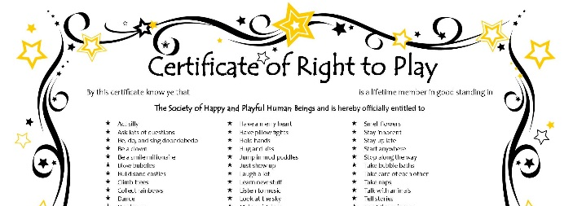
For Certificate above go to www.laughteryogauniverse.com
and click on "Fun Stuff" or Google the title, there are others
By this certificate know ye that THE BEARER IS A LIFETIME MEMBER IN GOOD STANDING IN THE SOCIETY OF CHILDLIKE GROWNUPS AND IS HEREBY ENTITLED TO walk in the rain, jump in mud puddles, collect rainbows, smell flowers, blow bubbles, stop along the way, build sandcastles, watch the moon and stars come out, say hello to everyone, go barefoot, go on adventures, sing in the shower, have a merry heart, read children's books, act silly, take bubble baths, get new sneakers, hold hands & hug & kiss, dance, fly kites, laugh out loud and cry out loud, wander around, wonder about stuff, feel scared & sad & mad & happy, give up worry & guilt &shame, stay innocent, say yes and no and the magic words, ask lots of questions, ride bicycles, draw and paint and color, see things differently, fall down and get up again, talk with animals, look at the sky, trust the universe, stay up late, climb trees, take naps, do nothing, daydream, play with toys, play under the covers, have pillow fights, learn new stuff, get excited about everything, be a clown, enjoy having a body, listen to music, find out how things work, make up new rules, tell stories, save the world, make friends and do anything that brings more happiness, celebration, relaxation, communication, health, love, joy, creativity, pleasure, abundance, grace, self-esteem, courage, balance, spontaneity, passion, peace, beauty, and life energy to all humans and beings of this planet.
FURTHERMORE, the above named member is officially authorized to frequent amusement parks, beaches, meadows, mountaintops, swimming pools, forests, playgrounds, picnic areas, summer areas, summer camps, birthday parties, circuses, bakeries, ice cream parlors, theaters, aquariums, zoos, museums, planetariums, toys stores, festivals and other places where children of all ages gather to play AND is encouraged to always remember the motto of THE SOCIETY OF CHILDLIKE GROWNUPS: IT'S NEVER TOO LATE TO HAVE A HAPPY CHILDHOOD AND MAKE SURE THAT OTHERS DO TOO.

SONGS
Take Me Out To The Ball Game
San Gabriel Valley, Long Beach & Verdugo Hills Councils
by: Jack Norworth and Albert Von Tilzer
This song is in the Public Domain
Take me out to the ball game;
Take me out with the crowd.
Buy me some peanuts and cracker jack;
I don't care if I never get back.
Let me root, root, root for the home team;
If they don't win it's a shame.
For it's one, two, three strikes, you're out
At the old ball game.
You Can Count on Me
Alice Retzinger, Golden Empire Council
(Tune: Row, Row, Row Your Boat)
You can always count on me
I’ll do just what I say
What I SAY is what I DO,
Each and every day!
When I have a chore,
I’ll see that it is DONE,
Do my best in every way,
And try to make it FUN!
I’ll bring my homework home each day,
And work to do my best,
Before I watch TV or play,
I’ll prepare for every test.
And when a scouting project calls,
I’ll be prepared to work
I’ll do my part – and cheerfully,
And I will never shirk!
Repeat First Verse
This is My Baseball
San Gabriel Valley, Long Beach & Verdugo Hills Councils
(Tune: This is My Country)
This is my Baseball
I’ll share it with you.
This is my baseball
Bring your bat and mitt too!
I’m playing with my friends,
I’m gonna hit one home.
Cause this is my baseball
To share and to hold.
Rotten Reeboks
Baltimore Area Council
(tune: Clementine)
Rotten Reeboks, dirty sweat socks,
Generating toxic fumes,
I’ve seen flies dead, struck in mid air
Fatal venture to his room.
In my brother’s bedroom closet
Stinkarooning like refuse
Dwelt a size 10 pair or sneakers
With a smell you couldn’t lose.
Aging tennis, in a corner
Turning the air a bluish green,
Hope the county doesn’t visit
They’d condemn us sight unseen.
I’ve tried bug balm, lemon air scent
Even spray that smells like pine,
Must be something that can cut it,
Something strong, like turpentine.
Even weirdo, crazy mutt dog
Who has breath you can’t adore,
Makes a wide turn, cuz his eyes burn,
Every time he nears the door.
“What’s the big deal?” asks ol’ big foot
None of his friends notice it.
“Proves they’re brain dead,” says my sister,
“Doesn’t surprise me a bit.”
“Not to worry,” says my father
“Could be money after all,
“Pentagon might pay a bundle
“For the secret to it all.”
The Athlete
Baltimore Area Council
(Tune: My Bonnie)
They gave me a suit and a number,
And sent me out on the field.
They gave me a ball called the pigskin,
And shoes with some cleats, toe and heel.
Chorus:
Muscles, and cramps,
wracking my body with pain, with pain,
I stand, wondering,
If ever I’ll do this again !
Next time they gave me a racquet,
Then sent me out on the court
Funny the things you encounter,
While trying to learn a new sport.
Chorus:
The ordeal was finally over,
At least, that’s what I thought.
When they shoved me the soccer equipment,
I fainted dead on the spot !
Chorus:
Cub Scout Sports Song
Baltimore Area Council
(Tune: My Bonnie)
My baseball went over the fence
My arrows are broken to bits
My volleyball been deflated
After riding a horse I can’t sit
Chorus:
Belt loops, belt loops,
I’ll earn Adventures today, today.
Belt loops, belt loops;
My rank badge is not far away
Chorus:
My bicycle has a flat tire
My boomerang just won’t return.
They say that I’ve lost all my marbles
And I still haven’t gotten my turn.
Chorus:
My dog ate my ping pong paddle.
My badminton birdie has flown.
I sprained my right ankle while jogging
And was stranded ten mile’s from home.
Chorus:
They say that Cub Scout sports are fun.
Some day I would like to know.
I’ve been wandering around for an hour
Just waiting for my Den to show.
Bowlin’, Bowlin, Bowlin’
San Gabriel Valley, Long Beach & Verdugo Hills Councils
(Tune: Rawhide)
Bowlin’, Bowlin, Bowlin’
Keep those balls a rollin’
Keep those strikes a rollin’, alright!
We’re laughin’ and a grinnin’
Cause our team is winnin’
Soon we’ll be in first place.
Head ‘em up, roll ‘em down
Roll ‘em down, make a strike
Make a strike, so we win, alright!
Roll ‘em down, knock em off,
Get a mark, make a strike.
We’re gonna win tonight!

STUNTS AND APPLAUSES

APPLAUSES & CHEERS
A Box of Cheer
San Gabriel Valley, Long Beach & Verdugo Hills Councils
- Here is a quite simple and fun way to introduce a cheer.
- Get a small Cheer Box, clean it out, and voila, you have a Cheer Box for all the cheers.
- Take all the cheers and applauses that you have and put each one on a slip of paper, then drop them in your Cheer Box.
- During the pack meeting call up one of your scouts to pick a cheer out of the Cheer Box (No peeking!),
- Then have him lead the cheer.
Baltimore Area Council
The Ball Applause: Hold any kind of ball in your hands. When you are holding the ball, everyone is quiet. When the ball leaves your hands, everyone goes wild and cheers. Try bouncing the ball, faking a throw, or tossing it to another person.
Home Run Applause: Simulate swinging a bat at a ball, shade your eyes with your hand and yell, “Thar she goes:”
San Gabriel Valley, Long Beach & Verdugo Hills Councils
Home Run: Simulate swinging a bat, then shade your eyes with your hands and yell,
"It’s outta here!" or “It’s way back and it’s gone!”
Bouncing Ball: Using a super ball or golf ball (preferably), drop the ball from an outstretched hand over your head or toss it upwards. Have the group yell, “Pow” every time the ball hits the floor.

RUN-ONS
Baltimore Area Council
- You want to hear something funny? My sister thinks a football coach has four wheels.
- Ha! Ha! Ha! Ha! Ha! How many does it have?
Cub 1: Speaking of baseball, I have something here that can run but can’t walk.
Cub 2: What is it?
Cub 1: Water.
- What do baseball players eat on?
- Home plates!
Tiger Cub: What’s the quietest sport in the world?
Den Leader: I don’t know.
Tiger Cub: Bowling. You can hear a pin drop.
Dad 1: I hear your son is on the football team. What position does he play?
Dad 2: I think he’s one of the drawbacks.
Professor: Class, what has eighteen legs and catches flies?
Student: A baseball team?
The Shoe
San Gabriel Valley, Long Beach & Verdugo Hills Councils
Equipment: Two people, one wearing only one tennis shoe.
Preparation: Decide who will wear the one shoe, practice
Action: Cub #1 wearing only one shoe is looking around looking underneath and behind things.
CUB #2: “Did you lose a tennis shoe?”
CUB #1: “No, I found one!”

JOKES & RIDDLES
Sports Riddles In Rhyme
Baltimore Area Council
Say a verse and see who can guess the sport. Answer in parentheses.
Think of a diamond,
Think of a team of nine
Think of a grandstand filled with fans,
Willing to stand in line. (baseball)
Two forwards and a center,
Plus two guards make a team,
To win this fast exciting game
Is every player’s dream. (basketball)
Eleven players on each team.
Two halves in which to play
When a player makes a touchdown.
There’s cheer right away. (football)
San Gabriel Valley, Long Beach & Verdugo Hills Councils
Q: How do baseball players stay cool?
A: They sit next to their fans!
Q: What do cheerleaders drink before they go to a basketball game? A: Root beer!
Q: What do basketball players and babies have in common?
A: They both dribble!
Q: What runs around a soccer field but doesn't move?
A: A fence!
Q: Why did the basketball player go to jail?
A: Because he shot the ball!
Q: Why did the football coach go to the bank?
A: Because he wanted to get his quarter back!
Q: Why did the golfer wear two pairs of pants?
A: In case he got a hole-in-one!
Q: Why don't grasshoppers go to baseball games?
A: They prefer cricket!
Q: Why did the police go to the baseball game?
A: Because someone was stealing a base!
Q: Why did Cinderella get kicked off the soccer team?
A: Because she ran away from the ball!
Q: Why did the cake like to play baseball?
A: Because it was a good batter.
Weather The Weather
www.theweatherprediction.com
I used this when I was the weatherman for a
Wood Badge course in 1996. CD
Whether the weather be fine
Or whether the weather be not,
Whether the weather be cold
Or whether the weather be hot,
We'll weather the weather
Whatever the weather
Whether we like it or not
I guess since I did that one we need –
When I was in Arkansas,
I saw a saw that could out saw any saw I ever saw
So if you are ever in Arkansas,
And see a saw that can out saw the saw I saw
I’d like to see your saw saw
And –
How much wood could a woodchuck chuck
If a wood chuck could chuck wood

SKITS
A New Sport
Baltimore Area Council
Have a Den line up on stage. One Scout steps forward and, acting as a narrator, announces that this is the first exhibition of a new Olympic event. This is the cue for the rest of the Scouts to grin as widely as possible. The narrator announces that this event is called the Standing Broad Grin.
The Football Game
Baltimore Area Council
A group of boys are discussing a football game. Insert the name of your local high schools or favorite pro teams in the blanks.
- I sure hope that the __________ win.
- Well, I’m sure that the _________ will win.
- Why, the _________ will beat ‘em 40 to nothin’.
- I can tell you the score of the game before it starts.
All Others: Oh yeah? How can you? You’re not psychic, are you?
Cub # 4: The score of the game before it starts? It’s nothin’ to nothin’ of course.
(Others chase him off stage.)
Harlem Globetrotters
Baltimore Area Council
Three Scouts are doing laundry. Each is sitting behind a bucket that holds his “laundry”. Two of the buckets really have water and a rag or two. All three work at scrubbing and wringing water from their laundry for a few seconds. One sitting on the end shakes the water from his hands getting his neighbor slightly wet. This provokes the Scout in the middle who retaliates with a splash back, escalate in comedic fashion till the one on the end throws a wet rag at the face of the Scout in the middle who ducks. The rag sails on till it smacks the Scout on the far end (previously not involved in the water fight) in the face. The smack-ee picks up his bucket to dump on the others who take flight into the audience.
The Punch line: When the actors are in the crowd the smack-ee tosses the contents of his bucket in a wide arc over as much of the audience as possible. You can fill the bucket with pieces of newspaper, but in a Scouting setting a bucket full of leaves would work just as well. If the actors have a little talent and practice this can be extremely funny
Sportsmanship Skit
Make large cards with the following letters-S-P-O-R-T-S-M-A-N-S-H-I-P. You’ll need the Cubmaster (cm) and 13 Cub Scouts, each with one letter. As the CM calls a letter the boy with that letter shows his card, reads the words for the letter off the back, and holds it up for the rest of the ceremony.
CM: At the start of a baseball game, the umpire yells, “Play Ball!” Soon, we'll be saying that for the game here at our Pack picnic. But before that, Some Cubs and I would like to remind you of something important. We’ll do it with a little spelling lesson:
- S – is for smiling, even if you hurt inside.
- P – is for pardoning parents who may show poor manners.
- O – is for oozing enthusiasm for your car and your fellow Den members.
- R – is for respecting the feelings of other Cub Scouts.
- T – is for trying your best and (next letter) is for being satisfied with yourself.
- M – is for mastering self-control.
- A – is for anger, which has no place in Cubs.
- N – is for noticing that only one can win.
- S – is for success in doing your best.
- H – is for hushing boastful words.
- I – is for inspiring us to congratulate the winner.
- P – is for playing the game for fun.
CM: Let us remember the word ‘Sportsmanship’ during our game tonight.
Broken Finger
San Gabriel Valley, Long Beach & Verdugo Hills Councils
Personnel: Two Scouts
Preparation: Practice speaking loudly and clearly
CUB #1: Cub #1 approaches Cub #2 "Do you know about first aid? When I press my forehead with my finger, it really hurts. When I do the same to my jaw, it's also painful. When I press on my stomach, I suffer. What can it be?"
CUB #2: Cub #2 listens to Cub #1’s heart, taps on his chest, looks in his ears and declares, "I don't know. You better go to the camp doctor. It looks serious."
CUB #1: “O.K.” Cub #1 leaves for a few minutes and comes back.
CUB #2: "What did the camp doctor say?"
CUB #1: "The doctor said I have a broken finger."
Who's Football?
San Gabriel Valley, Long Beach & Verdugo Hills Councils
Equipment: Something that looks like a T.V. & 2 chairs.
Preparation: Set up the two chairs side by side facing the T.V., Two scouts playing a Father and Son, sit in the chairs.
CUB #1: (The Father) leaps out of his chair saying, “I can’t believe he missed that simple pass! Why do they let that lazy guy play anyway?”
CUB #2: (The Son) looks at father, “Dad, maybe it’s his football!"
Bubble Gum
San Gabriel Valley, Long Beach & Verdugo Hills Councils
Equipment: 1 chair
Preparation: Practice, but there are no lines. But the more the Cubs ham up the action, the better the skit.
This could be introduced as boys waiting outside the Principal’s Office at school. Or waiting to see the doctor.
1st scout walks out to the chair, takes his gum out of his mouth, places it on the back of the chair, and then walks off.
2nd scout walks out to the chair, leans his hand on the back, finds the gum on his hand, and, totally disgusted, wipes it on the seat of the chair and walks off.
3rd scout walks up to the chair and sits down. He realizes with great disgust that the gum is stuck to his bum. Disgusted, he peels it off, throws it to the ground and walks off.
4th scout walks out to the chair, then realizes he's got gum stuck to his shoe. With great disgust he peels it off, sticks it to the back of the chair, and walks off.
1st scout comes back, walks up to the chair, peels it off, sticks it in his mouth and walks on.

CLOSING CEREMONIES
Pump It Up
You need a partially deflated basketball, volleyball, or soccer ball and a hand pump with needle.
The Cubmaster calls forward a Cub Scout and asks him to demonstrate dribbling. Naturally the ball won’t bounce well. Then the Cubmaster calls forward another Cub Scout and asks the two boys to inflate the ball with the pump.
Cubmaster : That’s much better! Now we can play a game after these Cub Scouts have finished their work, There’s a lesson for us here. Your bodies are like that ball. If you are not physically fit and pumped up with energy, you are not ready for anything -- not for play, for school, or for work. Like the ball I had that didn’t have enough air, you don’t have enough strength and energy to do anything.
Let’s all remember to keep our bodies, and our mind, pumped up so that we’re ready for whatever life brings our way.
End by having your song leader lead “I’ve Got That Cub Scout Spirit” from Cub Scout Songbook.
Worn Out Closing
Baltimore Area Council
Set Up - Have four or more boys on stage wearing cardboard feet which have scratches, cuts, band-aids, etc. on them.
- Our Sports Extravaganza meeting has come to an end.
- We now have a message to leave with you, dear friend.
- Our many achievements in life make feet tired and weary.
- But if there was nothing to do, our life would be dreary.
- So forget the knocks and scratches, blisters and aches.
- Do your best at all times, That’s what success takes
As the poem is finished, boys lay down on stage with their cardboard feet facing the audience...each cardboard foot has a letter on it spelling out -
G-O-O-D-N-I-G-H-T
If you have more than enough Cubs, put in Exclamation Points, pictures, or leave blanks

CUBMASTER’S MINUTES
A Scout is Obedient
https://johnscout.wordpress.com/
Check out his blog for many more
Scoutmaster Minutes!!

A Scout is Obedient. A Scout follows the rules of his family, school, and troop. He obeys the laws of his community and country. If he thinks these rules and laws are unfair, he tries to have them changed in an orderly manner rather than disobeying them.
It took me a long time to realize how much this point of the Scout Law has affected me personally. A Scout pays attention to his parents, teachers and Scout leaders. I didn’t always get along with them, and I would challenge them when I thought I was right. But I knew a Good Scout follows the rules.
It’s the second part of this point, however, that we forget about. If you don’t think rules or laws are fair, you don’t just ignore them. You work to change them.
Rules and laws help us all get along—in a family, troop or community. Despite our best intentions, sometimes the rules or laws don’t work quite like they are supposed to. That is when a Good Scout works to change the rules, not just follow them.
A Scout Is Obedient
Troop 56, Indianapolis, IN
http:/t56.org/member/
Click on Scoutmaster Minute tab
A scout is obedient, but how important is it to be obedient? Do rules and laws really hold us back and keep us from enjoying life? The following story illustrates how laws support our lives and make them even better.
A boy and his dad took their kite one windy day, and began to fly it. The wind was strong, and soon the kite soared higher and higher. Within just a short while, they had let out all their line, and the kite was just a small dot in the sky. The boy, caught up in the excitement of flying the kite asked his dad, “isn’t the string holding the kite down? And if we let go of the string, will the kite go even higher?” To this his dad replied, “No, it is just the opposite. It is the string that holds the kite up. If we let go of the string, the kite would fall to the ground and be lost.”
Sometimes we look at laws and rules in the same way. We think they are holding us back, when in truth they are the very things that hold us up. We have a free society because of these rules and laws, and because people respect the laws. Good rules and laws are there to protect people. A great danger is to think disobeying the laws will give us more freedom. Instead, it is through disobedience that innocent people are hurt and suffer.
A Scout Is Obedient
www.macscouter.com
What's the seventh point of the Scout Law? That's right, "A Scout is obedient." Our handbook explains it this way: "A Scout follows the rules of his family, school and troop. He obeys the laws of his community and country. If he thinks these rules and laws are unfair, he tries to have them changed in an orderly manner rather than disobey them.
That tells us that some rules and laws may be unfair, doesn't it? Perhaps some are, but there must be some reason for them. Think about the reason before you try to change them or ignore them.
This month we're using some rules for water safety. The rules are called the Safe Swim Defense, and there is a good reason for all of them. It's to protect your life.
You may think you should be in a different swimming ability group. Well, if you can prove it, you'll be put in a higher group. But until then, stay with your buddy and your group. Obey our swimming supervisors. Our rules have only one purpose, to protect you. Remember that when you're in the water.
What Is a Good Sport?
Baltimore Area Council
A good sport - you hear a lot of talk about being a good sport, but just what does it mean? A good sport learns the rules so he will not break them. He competes with all his heart, striving to outclass his competitors. If he wins, he doesn’t act smug, but instead compliments the losers for the fine job they did. If he loses, he accepts the fact and finds out why. Maybe he can win the next time. A good sport accepts defeat, congratulates the winners, learns how he can improve, and determines to do better the next time.
Sportsmanship
Baltimore Area Council
In 1940, an underdog Dartmouth football team played powerful Cornell, which needed only one more victory for a perfect season and a number-one ranking in the country. Trailing 3-0 Cornell scored a controversial touchdown that the Dartmouth players insisted was made on an extra ‘fifth down.’ However, the referee counted the touchdown, and Cornell won 7-3.
But after the game, Cornell officials watched the game on film and saw that, indeed their team had been allowed and extra play. They immediately sent a telegram to Dartmouth stating that they could not accept the victory. It went into the record book as 3-0 victory for Dartmouth.
That little story tells us what sportsmanship really is. It is the desire to play hard and to win - but to win fairly - and if you lose, to accept defeat with good grace. Let’s remember that during our Cub Scout games and throughout our lives. Also remember, that to be a good sport you have to lose to prove it.
Sport Heroes (Closing Ceremony)
Notes:
- This could be made a ceremony with a different Scout reading each line or couplet (two-line rhyme).
- You might want to update the stars listed (Elway, Marino, Dickinson) to ones current in your area. They are not part of rhyme. Be conscious on number of syllables.
Cubmaster:
Someday a member of our Pack may be a football star
Like Elway, Marino or Dickinson
and known both near and far.
Or maybe we’ll play basketball, or hockey on the ice.
And have our picture in the news
and see our name in lights.
Or maybe we’ll do something else
outside the sporting game.
And though we won’t give autographs,
like those of TV fame,
We hope the people that we know
will think of us and say
That each of us has done his best
while working or at play,
To be the kind of citizen who helps
to make things grow
Like families and neighborhoods
and this old world, you know!
You just don’t have to be a star
(although it would be fine)
To help make this a better world
for your folks and for mine
Just "DO YOUR BEST," our motto says,
in everything you do!
Who could ask for more than that?
Cub Scouts - we’re proud of you!
Good night - have a safe trip home!
A Good Sport
Circle Ten Council
The world is full of people who think it is a calamity if they lose a contest. They lose their temper and act like bad sports. A good sport will do his best, and, if he loses, look to the next game to do better and try to win. In Cub Scouting, we learn to be good sports, and to do our best, whether we win or lose.

CUB GRUB
Cub Grub Cookbook
This is a really great cookbook for Cubs -
http://balboaoaks.bsa-la.org/download/blog/Cub%20Grub%20Cookbook.pdf -
You can save a copy on your PC by selecting
File, Save As... in your web browser's menu bar.
The Jell-O Brain
Alice Retzinger, Golden Empire Council
Only your imagination limits you in the use of the famous Jell-O brain mold, a mold that you fill with gray or pink Jell-O to make a model of the brain. If you search for these on google you will get a lot of hits. I found them from $6.95 to $14.95 before I stopped looking and ordered some. Who could resist. Some sites even have recipes for making brain colored Jell-O!!!
Make one and use it for demonstration about how fragile your brain is. Then have a snack!

Cookie Wheels
Alice Retzinger, Golden Empire Council
Ingredients:
- 1-1/2 cups all purpose flour,
- ½ cup of softened butter or margarine,
- ¼ cup of powdered sugar,
- ½ teaspoon baking powder,
- 1 Tablespoon of milk,
- 1 cup of pie filling or jam (your choice of flavor)
Directions:
- Preheat the oven to 375 degrees.
- Mix the flour, margarine, sugar, baking powder and milk just enough milk to form a dough. If more milk is needed, add it by teaspoonfuls only.
- Divide the dough into 6 equal parts,
- Then shape into balls.
- Place on an ungreased cookie sheet;
flatten slightly.
- Make an indentation 1-3/4 inches across and about ¾ inch deep, in the center of each flattened ball.
- Now fill each indentation with about 2 Tablespoons of filling.
- Bake until edges begin to brown (20-25 minutes). Makes 6 “Wheels”
Soccer Ball Cake
San Gabriel Valley, Long Beach & Verdugo Hills Councils
Ingredients:
- 1 (18.25 ounce) package yellow cake mix
- 1 (16 ounce) container vanilla frosting
- 12 black licorice whips
- ¾ cup white sugar
Directions:
- Heat oven to 350°F (175°C).
- Grease and flour one 2½ to 3 quart oven proof bowl.
- Place sugar in a bowl and stir in black food color until desired color is achieved. Set aside.
- Pour prepared cake batter into the prepared bowl and bake for 1 hour and 15 minutes.
- Let cake cool for 15 minutes in the bowl then invert and let cake cool completely.
- Once cake is completely cool, trim flat side of cake and place on a cake board.
- Trim edges into a ball shape.
- Frost with white frosting.
- Next using a toothpick draw a pentagon in the center top of the cake. Surround the pentagon with five hexagons.
- Repeat to cover entire cake.
- Cover lines with black licorice cut into 1½” pieces.
- Fill the pentagon shapes with black colored white sugar.
Hot Dog Cookies
San Gabriel Valley, Long Beach & Verdugo Hills Councils
These little treasures are great for Pack or Den Meetings or Cub Sports Events.
Ingredients:
- 1 cup butter, softened
- ½ cup confectioners' sugar
- 1 teaspoon vanilla extract
- 2 cups all-purpose flour
- 4 drops red food coloring
- 3 tablespoons flaked coconut
- 2 drops green food coloring
- 1 (4.5 ounce) tube prepared yellow frosting
Directions:
- In a medium bowl, cream together the butter, confectioners' sugar and vanilla until smooth.
- Stir in the flour until dough is smooth.
- Remove 1 cup of dough, then cover and refrigerate remaining dough.
- Knead the red food coloring into 1 cup of dough until the color of a hot dog is achieved.
- Refrigerate all dough for 1 hour.
- Preheat oven to 350°F (175°C).
- Divide the red dough into 16 portions.
- Roll each piece into a 2½” long sausage shape.
- For buns, divide the white dough into 16 portions and shape into 3” logs. Slice them almost in half lengthwise.
- Spread the buns open and place the hot dog doughs inside, leaving buns open.
- Place 2” apart onto ungreased cookie sheets.
- Bake in the oven, for 12 to 15 minutes or until firm.
- Remove from cookie sheets to cool.
- In a small jar or plastic bag, combine coconut and green food coloring. Shake until coconut is evenly colored.
- Sprinkle over hot dog cookies when cool and make a zig zag with the yellow frosting for mustard.
- Yields: 16 cookies
Sports Drink
San Gabriel Valley, Long Beach & Verdugo Hills Councils
Ingredients:
- 2 cups prepared caffeine-free lemon tea
- 2 tablespoons sugar
- 1 pinch salt
- ¼ cup orange juice
Directions:
- Dissolve the sugar and salt in the hot tea.
- Cool.
- Blend the tea and orange juice in a blender or shaker.
- Drink cold for best taste.
Yummy Cheese Ball
San Gabriel Valley, Long Beach & Verdugo Hills Councils
A tasty cheese and bacon cheese ball. Best served with buttery crackers.
Ingredients:
- 1 pound bacon
- 2 (8 ounce) packages cream cheese, softened
- 3 tablespoons mayonnaise
- 1 green onion, chopped
- 1 cup chopped pecans
Directions:
- In a large skillet, fry the bacon. (I would prep the bacon before the meeting and have it ready for the Cubs. CD)
- Remove bacon from the skillet. Drain on paper towels.
- Chop or break the cooled bacon into small pieces.
- In a medium-size mixing bowl, combine cream cheese, bacon, mayonnaise, and green onions.
- When mixed well, form 2 balls out of the mixture.
- Cover and refrigerate 3 to 4 hours, or overnight.
- Roll the cheese balls in the chopped pecans.
- Yield: 20 servings
Chili Wraps
These are great for your favorite sporting events. You can load them with the works or keep them plain for the Cubs. They’re fun and not very messy.
Ingredients:
- ½ pounds ground beef
- 1 (1.25 ounce) package Chili Seasoning
- 1 (14.5 ounce) can diced tomatoes
- 1 (15 ounce) can black beans
- 8 (10”) flour tortillas, warmed
- 1 cup sour cream
- 2 cups shredded Cheddar cheese
- 2 cups shredded lettuce
- sliced green onion, if desired
Directions:
- Brown ground beef in a large skillet; drain fat. (I would have the meet ready for the Cubs. CD)
- Stir in seasoning mix, tomatoes and beans.
- Bring to a boil, reduce heat and simmer 10 minutes.
- Spread ½ cup chili onto center of each tortilla; top each with 2 tablespoons sour cream, ¼ cup cheese and ¼ cup lettuce. Sprinkle with sliced green onion, if desired.
- Fold bottom of each tortilla over chili; fold sides over, overlapping filling.
- For a speedy recipe you could use your favorite canned chili.
- Yield: 8 wraps
Baseball Cookies
Baltimore Area Council
Ingredients
½ C wheat germ
½ C peanut butter
½ C honey
3 C dried milk powder
¾ C graham cracker crumbs
Powdered sugar or shredded coconut
Directions
- Mix together the wheat germ, peanut butter, honey, milk powder and graham cracker crumbs.
- Form into balls the size of large marbles.
- Roll in shredded coconut or powdered sugar.
- Refrigerate.
Grand Slam Bacon Bats
Ingredients
6 bacon strips, halved lengthwise
12 crisp bread sticks (about 5 inches long)
Directions
- Wrap a piece of bacon around each breadstick.
- Place on a rack in a baking pan.
- Bake at 375 degrees for 20-25 minutes, until bacon is crisp. Makes one dozen.
S’mores Crumb Bars
Alice Retzinger, Golden Empire Council
Ingredients
- 3 cups graham cracker crumbs
- 3/4 cup butter or margarine, melted
- 1/3 cup sugar
- 3 cups miniature marshmallows
- 2 cups semisweet chocolate chips
Directions
- Combine the crumbs, butter and sugar;
- Press half into a greased 13-in. x 9-in. x 2-in. baking pan.
- Sprinkle with marshmallows and chocolate chips.
- Top with remaining crumb mixture; press firmly.
- Bake at 375 degrees F for 10 minutes.
- Remove from the oven and immediately press top firmly with spatula. Cool completely. Cut into bars.
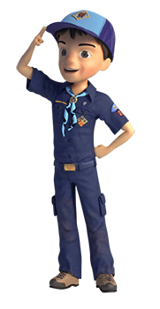
Indoor S’Mores
Alice Retzinger, Golden Empire Council
Ingredients
- 4 cups honey graham cereal
- 3 tablespoons margarine
- 6 cups miniature marshmallows
- 1/4 cup light corn syrup
- 1 1/2 cups milk chocolate chips
Directions
- Coat a 9x13 inch dish with cooking spray.
- Place cereal into a large bowl; set aside.
- In a medium saucepan over low heat, melt margarine.
- Add marshmallows and corn syrup and stir until melted and smooth.
- Stir in chocolate chips until melted.
- Remove from heat and pour over waiting cereal; stir well to coat.
- Press into prepared pan.
- Cool completely before cutting into squares

GAMES
Bomb the Bridges
San Gabriel Valley, Long Beach & Verdugo Hills Councils
Equipment: 2 to 4 tennis balls
The players stand scattered around the hall with their legs about 2 feet apart.
Each player's legs form a “bridge” which may be bombed. To bomb a bridge, a tennis ball must be thrown between the player's legs (hitting a player's legs is not enough).
Once bombed, the player is out and must sit down.
However, he may still take part by continuing to throw the tennis balls to bomb other players.
The last player standing is the winner.
To prevent being bombed, a player may protect himself using his hands to catch or deflect the tennis ball.
Players may not move their feet or crouch to prevent being “hit”.
Balls which are out of reach may be retrieved quickly by the nearest players so that play can continue.
The greater the number of balls the harder and faster the game becomes.
Dribble Ball
San Gabriel Valley, Long Beach & Verdugo Hills Councils
Equipment: A Ball and 3 or more empty 1- to 2-liter bottles per team
Setup: Arrange the bottles in a line, far enough apart so that players can dribble the ball between them.
Standing in teams, each person in turn dribbles the ball down the line of cones slalom fashion, either using their foot or a stick, and then straight back to the next man in their team.
If a bottle is knocked over, the player has to return to the start and begin again.

Amazing Flying Machine
(Bomb Pops)
Alice Retzinger, Golden Empire Council
Materials:
5 Craft sticks
(large ones - tongue depressors work best)
This idea can be used for a Gathering Activity or a Game. It will demonstrate the importance of following directions – and if you can’t follow directions, it will be impossible to be OBEDIENT- or to make your bomb fly!
I did this activity by showing the boys a completed version and challenging them to put together this Flying Bomb using only 5 sticks. Give each boy five craft sticks or tongue depressors – the larger ones work best. Emphasize that they will be able to make a Flying Bomb without any glue IF the follow directions. Either have a large image of the picture or give each boy a half page version.
Directions:
- Weave the 5 sticks together as shown.
Note: The center stick is #3
- Fly like a Frisbee.
- The plane “explodes” on contact with the ground or other surfaces.
- Assemble it again, and have more fun.
Blow-Hard Soccer
Baltimore Area Council
Divide the Den into 2 teams. Mark goal lines at both ends of the room or playing area. Players get on their hands and knees in the center of the room and face their opponents’ goal line. The leader drops a tennis ball into the center, and both teams try to blow it over their opponents’ line. Only blowing is allowed: if the ball touches any part of a player’s body, the other team gets a free blow at the spot of the foul.
Walk the Rope
Alice Retzinger, Golden Empire Council
Lay two 12’ long pieces of rope straight on the floor about six feet apart. Stand a player in his stocking feet at the beginning of each rope. Blindfold the two players. Turn them around twice. At the starting signal, each player feels his way along the rope with his feet. He must keep his feet on the rope all the way or he is out of the race. The first one to reach the end of his rope wins. Variation: Play this also as a relay race with even teams at the beginning of the ropes. Each player must be blindfolded when it is his turn to walk the rope. At the end he removes his blindfold and rushes back to tag the next player on his team.
Australian Circle Game
San Gabriel Valley, Long Beach & Verdugo Hills Councils
Equipment: 2 Tennis balls
A player stands in the center of a circle holding a tennis ball. He tries to throw this ball to someone in the circle who will drop it.
Another ball is also being passed around the circle from one boy to another.
The player in the center may throw his ball to anyone, but he usually throws it to the boy about to receive the ball being passed around the circle.
If either ball is dropped, the one who dropped it changes places with the boy in the center.
Chair Basketball
San Gabriel Valley, Long Beach & Verdugo Hills Councils
Equipment: A ball and 2 chairs
Each team has a boy sitting on a chair at the opposite end of the room.
The object of the game is for the team to score a goal by having their team member catch the ball that is tossed to him while on the chair.
The ball must be dribbled to within throwing distance.
The catcher must catch the ball while on the chair.
It's best to have teams of around 6-8 players.
Crab Soccer
San Gabriel Valley, Long Beach & Verdugo Hills Councils
Equipment: 1 ball and 4 chairs
This is a version of football that can be played indoors using chairs as goal posts.
The rules are much the same as normal football with the exception that players must be in the crab position - that is, on hands and feet with back toward the ground.
You may want to make additional rules to prevent the goalkeeper from throwing the ball too far across the hall. For example, the ball must bounce at least once on their side of the hall.
Relay “Ball” Games
Baltimore Area Council
Ball Pass Relay
Equipment: One ball for each team
Each team stands in file formation with a team leader sitting opposite about twenty feet away. He has the ball in his lap. On signal, the first player in line runs to this leader, picks up the ball, and returns to his place in the file line. He then throws the ball to the leader and goes to the end of the file line and sits down. When the ball returns to the leader’s lap, the next player runs. The first team to finish a rotation wins.
Tennis Ball Pass
Equipment: A tennis ball for each team
Teams stand in a file formation. A tennis ball is passed from chin to chin, using no hands, from one end of the line to the other end. If the ball is dropped, it must be returned to the start of the line. The first team to pass the ball forward and backward wins.
Waddle Relay
Equipment: A small-to-medium ball for each team
On signal, No. 1 players race against each other while carrying the ball between their knees. They must successfully reach the turn-around line, bounce the ball once, and return to their team with the ball once again between their knees and tag Player No. 1. Player No. 2 continues. If the ball is dropped at any time, the player must go back and start over. The first team to have all players “waddle” the ball wins.
Over the Top - Play with a medicine ball or basketball. Boy in line in straddle position. Ball passed overhead from boy to boy. Last boy receiving ball vaults over the line as they stand in stooped position. Others continue until first boy finishes.
Through the Tunnel - Boys in same position. Ball is passed between legs and last boy crawls through, pushing ball ahead with head and hands. Others continue.
In and Out - Ball is passed between legs and overhead. Last boy runs in and out through the line and others continue.
Over and Under - Same formation except the balls are alternatively passed overhead and between the legs. Last boy vaults over one and crawls between legs of next boy. Others continue.
Kangaroo - Ball is passed through line between legs. Last boy tucks ball between knees, jumping on side of line to front, and others continue.
Medicine Ball Roll - Ball is passed between legs, last boy running to front of line. Others continue same.
Cotton Ball Race - Each person has to pick up all the cotton balls with a spatula, keeping it balanced while running to a specified goal and back. If the cotton ball is dropped, the player must start over. When he returns with the cotton ball he places it in a carton.
Barefoot Marble - Divide the Scouts into teams (patrol/Den). First boy runs to a line 15 ft. away. He grasps and carries one marble with the toes of each foot, returns to tag the next Scout.
Arch Bowling
Baltimore Area Council
Set up 10 croquet arches in a row, spaced wide enough to allow a ball to go between them. Set a bowling line at a distance of 15 feet. Increase this distance if the lawn is smooth and well cut. Each player bowls one ball each turn. The ball must go through each arch in order. The first arch must be made before the second, and so on. The player who first completes the sequence of the arches wins.
Bottles And Cans
Baltimore Area Council
Bottles and cans can be used for lots of games. You can invent them or copy them from games in shops. Your games can be a lot more interesting than things that cost a lot of money.
A collection of tall plastic bottles makes bowling pins. Fill them with water or sand so they won’t fall over so easily. A heavy ball you can bowl slowly works best. Try a baseball or a hard orange. Or a small tire!!! CD
Litter Basketball
Baltimore Area Council
Boys always get fussed at for doing this –
Why not make it a game?
Equipment: Lots of crumpled computer or copy paper, trash cans
- Divide Den into two teams and seat them behind a throw line. Place the trash cans about 10 feet away (distance depends on the motor skills of your Den).
- On the signal “GO!” Cubs fire their paper “basketballs” at the trash can goals.
- After a set amount of time stop the game.
- Count the number of “basketballs” in each trash can.
- The team with the most “basketballs” in the cans wins.
Backyard Jugball
Baltimore Area Council
This is a version of lacrosse, Maryland’s official team sport. And I was watching the National Lacrosse Championships this weekend. My son played in High School and now the two of us are hooked. There were over 44,000 fans at the Linc in Philly to watch the semi’s. Finals on Monday!! Great sport if your son or daughter has a chance to play. It is the only team ball sport my Philmont staffer daughter ever really got into. She loves the game, too CD
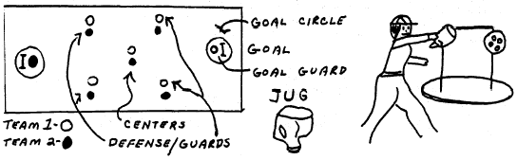
Equipment: Plastic milk jug (Bottom cut off), Wiffle ball, 4 to 12 players.
Rules: Centers face off in center of field; touch ground with scoops on each side of ball raise scoops once over ball touching others scoop then back to ground. Then each boy tries to scoop up the ball and throw it to another team member who must catch it with his scoop then pass it on, or try to make a goal past goalie and between goal posts. Goalie tries to divert ball from goal using scoop or body (no hands). Goal counts one point. If a player touches the ball with his hand the other team gets possession at point of infraction. Players may go anywhere on field except goal circle. Goalie moves freely inside goal circle. Last team to touch out of bounds ball loses possession. Body contact is not allowed and disputes over possession are settled at point of conflict with a face off between the 2 players involved. First team to score 5 points, wins.
Rainy Day Racquetball
Baltimore Area Council
A rousing game of balloon racquetball will brighten up a rainy afternoon - or any afternoon! Make the racquet by bending a wire clothes hanger into a circle. Slip the wire circle into one leg of a pair of pantyhose. Tie off the pantyhose at both ends of the circle. Cut off extra stocking. Flattening the hook of the hanger makes the handle. Cover the handle with masking tape. Make a comfortable grip by building up with strips of cloth or paper, then finish off by wrapping smoothly with tape. After making two rackets, blow up some round balloons, find a partner and have a ball!
Bucketball
Baltimore Area Council
Place two bushel baskets or large metal buckets 50 to 60 feet apart. Establish sidelines 30 to 40 feet apart. Use a basketball or other ball about that size. Play regular basketball rules, but with any number of players on a side. No score is made if the ball bounces out of the bucket or knocks it over.
Button Baseball Game
Baltimore Area Council
Find a box lid that measures about twelve by ten inches. Draw a baseball diamond on top of the lid. Cut out circles as shown so that small nut, cups or paper muffin-pan liners will fit in them. Each player has three buttons for each turn “at bat.” Standing about six feet away, he tosses them at the holes. If he misses all the holes, it is a strike. If the game is played as a team game, “base runners” advance the appropriate number of bases for each hit. If the game is played by individuals, a player scores 1 for a single, 2 for a double, 3 for a triple, and 4 for a home run.

DEN ADVENTURES


TIGER

Tiger Adventure: Tigers in the Wild

- With your adult partner, name and collect the Cub Scout Six Essentials you need for a hike. Tell your den leader what you would need to add to your list if it rains.
- Go for a short hike with your den or family, and carry your own gear. Show you know how to get ready for this hike.
- Do the following:
  - Listen while your leader reads the Outdoor Code. Talk about how you can be clean in your outdoor manners.
  - Listen while your leader reads the Leave No Trace Principles for Kids. Discuss why you should "Trash Your Trash."
  - Apply the Outdoor Code and Leave No Trace Principles for Kids on your Tiger den and pack outings. After one outing, share what you did to demonstrate the principles you discussed.
- While on the hike, find three different kinds of plants, animals, or signs that animals have been on the trail. List what you saw in your Tiger handbook.
- Participate in an outdoor pack meeting or pack campout campfire. Sing a song and act out a skit with your Tiger den as part of the program.
- Find two different trees and two different types of plants that grow in your area. Write their names in your Tiger handbook.
- Visit a nearby nature center, zoo, or another outside place with your family or den. Learn more about two animals, and write down two interesting things about them in your Tiger handbook.
Workbook for use with these requirements: PDF Format DOCX Format
https://cubscouts.org/library/tigers-in-the-wild/

Rationale for Adventure
Tigers will learn how to put the “outing” in Scouting with this outdoor adventure. They will start to develop an understanding of the Outdoor Ethics program as they are introduced to many skills that will be important throughout their Scouting careers.

Takeaways for Cub Scouts
- Cub Scout Six Essentials
- Plant and animal identification
- Outdoor Ethics awareness
- A Scout is obedient, thrifty [Tiger Character Compass]

Adventure Requirements (Tiger Handbook, page 92)
- With your adult partner, name and collect the Cub Scout Six Essentials you need for a hike. Tell your den leader what you would need to add to your list if it rains.
- Go for a short hike with your den or family, and carry your own gear. Show you know how to get ready for this hike.
- Do the following:
a. Listen while your leader reads the Outdoor Code. Talk about how you can be clean in your outdoor manners.
b. Listen while your leader reads the Leave No Trace Principles for Kids. Discuss why you should “Trash your Trash.”
c. Apply the Outdoor Code and Leave No Trace Principles for Kids on your Tiger den and pack outings. After one outing, share what you did to demonstrate the principles you discussed.
- While on the hike, find three different kinds of plants, animals, or signs that animals have been on the trail. List what you saw in your Tiger Handbook.
- Participate in an outdoor pack meeting or pack campout campfire. Sing a song and act out a skit with your Tiger den as part of the program.
- Find two different trees and two different types of plants that grow in your area. Write their names in your Tiger Handbook.
- Visit a nearby nature center, zoo, or another outside place with your family or den. Learn more about two animals, and write down two interesting things about them in your Tiger Handbook.

NOTES TO DEN LEADER
Meeting 3 will be a den outing for a hike and visit to a nature center, zoo, or other outdoor place. In advance of the outing, the leader will need to make arrangements with the outing location and confirm the outing plan with families, including transportation and any additional items they need to bring. Make sure a tour and activity plan has been submitted, if required, and activity consent forms are distributed, signed, and collected.
You will want to record completion of requirement 5 following participation in the campfire or outdoor event. This doesn’t have to be at the same time the den completes this adventure.
See the Appendix for optional den meeting activities, including openings, gatherings, and closings.
To get you started in delivering fun and engaging meetings, complete Den Meeting Plans are available here on the Learning Library for the Backyard Jungle and Games Tigers Play adventures. To obtain Den Meeting Plans for all other adventures, Den Leader Guides are available at your local Scout Shop, online at scoutstuff.org, or as an eBook through Amazon.
http://www.boyscouttrail.com/cub-scouts/tiger-in-wild-adventure.php
Ideas for Adventure Requirements:
- Fill a daypack with the following items and have each scout come to the front and blindly pick out one item. Decide if it should be placed in the 'Useful' or 'Useless' pile of items for a day hike. Some items may depend on time of year or location. Items: water bottle, whistle, flashlight, granola bar, first aid kit, sunscreen, bus spray, sock, glove, bandanna, binoculars, rock, deck of cards, paperback book, dollar, bag of marbles, spoon, towel, Legos, toy car, can of soda, ...
- How long is a "short" hike? 2 miles per hour is a good pace. Stopping to identify plants and animals will slow you down. So, a 1-mile hike is probably long enough.
Most scouts should have a school pack or small fanny pack, but check that everyone does before your hike so no one shows up carrying gear in a plastic bag.
- While on your hike, have each scout think of a way the group is following LNT principles. Things like - stayed on the trail, left a flower, didn't run or yell when other hikers were around, picked up some litter, viewed animals from far away.
- The lead hiker should keep an eye on the dirt trail for signs of animals or they will get trampled. An early morning hike, at a nature area, on a dirt trail, before other visitors arrive, is the best bet for tracks and seeing animals. Birds can typically be viewed all day, and common ones are: robin, duck, goose, blackbird, pigeon, dove, seagull, hawk.
- Work with the Cubmaster to ensure this event gets planned since all dens have similar advancement requirements. Don't forget to practice your song and your skit a few times at a den meeting before going on stage.
- Native trees, rather than planted ornamentals, should be identified. This is easier to do while leafs are still on the trees.
- Tigers could make a game of trying to find the strangest, largest, ugliest, rarest, ... animal to learn about.
Den Meeting Ideas for Tigers In the Wild Adventure:
- The LNT Principles for Kids are listed in the back of the Tiger Handbook. Read details of the principles and implementing them atLNT.org and Outdoor Ethics.
- Use Tree ID to identify a tree from its leaf.
- Use Beneath These Tall Green Trees grace before your snack.
- Tell Tall Trees minute to the den.
- Use some Tree Activities at a den meeting.
- Perform Infantry skit for the Pack.
- Perform I Ain't Lost skit
- Tell Map and Compass minute to the den.
- Learn more about LNT from Leave No Trace Dude.
- Learn more about Hiking from Hiking Dude.
- Remember to use this Tigers In the Wild adventure as a step towards each scout's Outdoor Activity award.
http://www.prekinders.com/animal-tracks-book/

Animal Tracks Book
BY KAREN COX 7 COMMENTS | AFFILIATE DISCLOSURE
I made this Animal Tracks book to go in our Science Center during our Forest Animals theme this month.
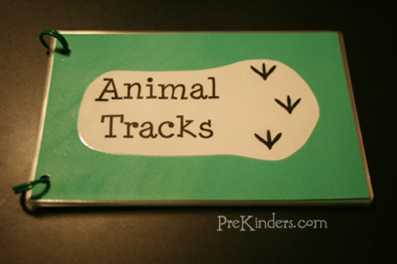
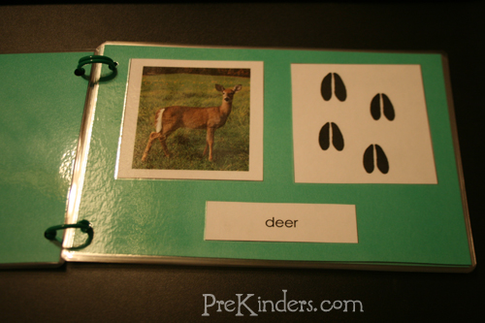
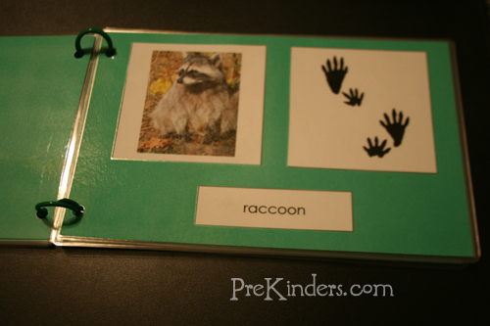
To make the book, I used a free printable from Montessori for Everyone. I printed the Animal Tracks cards and cut them apart. The pages are made with green cardstock paper, cut in half. I glued a picture of the animal and that animal’s tracks side-by-side, and one of the cards with the animal’s name below the picture. I bound the pages with chicken rings.
I also have a set of the cards printed for matching cards, and the kids can use the book as a reference to see which animal tracks match with which animal. This is one of the printables from Montessori for Everyone’s free downloads cultural materials page. Look for “Animal Tracks” under “Zoology”.
http://www.boyscouttrail.com/cub-scouts/tiger-scout-skits.asp

Tiger Scout Skits
Bravest Scout in the World
Emergency Alert System
Enlarging Machine
Guess My Line on the Toilet
Ice Fishing
Invisible Bench - plus Add-Ons
Ole, Champion Tree Climber
One Bright Morning
Short Runway
3 Vs. 1000
38 Over the Cliff
Art or Not
Banana Bandana
Be Prepared
Bear Attack
Big and Strong Like You
Brains for Sale
Brains for Sale - Version 2
Broken Finger
Brownie Pudding
Brushing Teeth
Bubblegum
Burning Schoolhouse
Can of Cola
Can't Work in the Dark
Cancer Operation
Chicken Farmer
Chory of Stinderella or Rindercella
Christmas with the Right Family
Clean Silverware
Clean Socks
Climbing Lightbeam
Clock Inspection
Clothes from Eddie Bauer
Contagious Pregnancy
Dead Body
Depressed Reporter
Did You See That?
Dirty Socks
Dirty Socks - Version 2
Echos in the Woods
Elevator to Bathrooms
Fifth Floor
Fishing Secret
Flea Circus
Follow the Tracks
Fool's Gold
Fred the Flea
Gandhi
George Washington and the Cherry Tree
Good Thing About Christmas
Got Any Duck Food?
Gravity Check
Great Raisins
Grecian Fountains
Hair in my Hamburger
Hare Restorer
History of Cub Scouts
Hunting Thanksgiving Dinner
I Ain't Lost
I Gotta Go Wee
I Saw a Bear
Infantry Is Coming
Is It Time Yet?
Jailhouse Jokes
Jelly Beans Please
Lemonade for Sale
Lighthouse Stairs
Listen!
Lobster Tail
Lost Bubblegum
Lost Green Ball
Lost Quarter
Lucky Boxer
Magic - Mystic Reader
Measuring Leader's Coffin
Meat for Sale
Musical Toilet Seats
My Centipeed
My Royal Papers
My Worm
Need a Big Jerk
Need the Time
New Underwear
Not Enough Parachutes
Nuts, the Elephant
Nutty Fisherman
Oh What a Goose I Am
Olive the Other Reindeer
Olympic Blanket Tossing Team
Operation
Out of Film
Outrun the Bear
Panther Tracks
Pass the Pepper
Penguin Soup
Penny Candy
Plane Engine Trouble
Professor's Address
Pulling and Pushing Rope
Puppy In a Box
Raisin Fly
Raking an Invisible Garden
Run-aways
Sleep Over
Smart Astronaut
Smoke Signals
Soup and Flies
Sponge Butt Prank
Squirrels Think I'm Nuts
Stiff Neck
Taking My Case to Court
Talking Trash
Telling the Time
The Audition
The Psychic
Throwing Little Stones
Toothache
Trained Caterpillar
Turkey Hunt
Two Suckers On a Stick
Ugliest Man in the World
Viper
Walk On Selections
Washing Ears
Water Vending Machine
Water, Water
We Have No Skit
What Kind of Tracks?
World Record Spitter
Worst Breath
Worst Criminal
Scout Soap
Yaputcha
You Don't Say

More Tiger Scout Information to Use:
Tiger Scout Leaders - Responsibilities of the Tiger den leader
Tiger Scout Achievements - Tasks to perform to earn the Tiger recognitions
Tiger Scout Electives - Extra things to do to earn Tiger Track beads
Tiger Scout Activities - great den meeting and pack activity ideas
Tiger Scout Awards - see what awards are available to Tiger scouts
Tiger Scout Ceremonies - a few ceremonies
Cub Scout Games - den or pack games just right for 1st graders
Tiger Scout Graces - fun meal graces
Tiger Scout Jokes - funny, gross, and silly jokes for scouts
Tiger Scout Projects - community or conservation projects for your Tiger den
Tiger Scout Recipes - easy recipes you can make with your tigers for fun snacks or on family campouts
Tiger Scout Skits - skits that Tiger Scouts like to do
Tiger Scout Songs - songs for scouts
Tiger Scout Stories - choose stories that Tiger scouts will enjoy and understand
Tiger Scout Uniform - make sure you put all those badges and patches in the right spots
Cub Scout Academics & Sports - extra recognition opportunities
Tiger Scout Schedule - sample schedule of meetings and activities
These skits for Tiger Cub Scouts will help make your scouting program more successful. Your volunteer time is greatly appreciated and everything you do now to help your boys will make a difference down the road. Please let us know if you have additional skit ideas that we can share with other boy scout volunteers.

Tiger Elective Adventure: Floats and Boats

- Identify five different types of boats.
- Build a boat from recycled materials, and float it on the water.
- With your den, say the SCOUT water safety chant.
- Play the buddy game with your den.
- Show that you can put on and fasten a life jacket the correct way.
- Show how to safely help someone who needs assistance in the water, without having to enter the water yourself.
- Show how to enter the water safely, blow your breath out under the water, and do a prone glide.
Workbook for use with these requirements: PDF Format DOCX Format

Types of boats
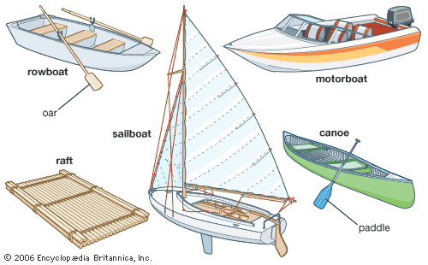
Five common types of boats are the rowboat, the sailboat, the motorboat, the raft, and the canoe.
Encyclopædia Britannica, Inc.

How to Make a Floating Toy Boat
by Chelsea Fitzgerald
http://crafts.creativebug.com/make-floating-toy-boat-1683.html

Making a floating toy boat is an interesting way to recycle products in your home and to create a toy that will delight any small child. Kids love to play with toy boats in bathtubs, mud puddles and any small body of water. The entire family can join in the fun and design fleets of boats to race and perform in friendly competitions. You can even let your dolls or action figures float in the boat and act as a ship captain and crew.

Things You'll Need
- Two empty plastic soda or water bottles with lids
- Permanent markers (optional)
- Large rubber bands
- Colored plastic tape or any tape
- Craft knife
Remove the plastic labels from the soda or water bottles. Wash the bottles to ensure that they are clean. Make sure that the lids are tightly screwed on to each bottle.
Decorate the boat. Use permanent markers to color designs on the boat and give your water craft a name.
Wrap the rubber bands around the two bottles. This is to hold them together temporarily while you wrap them with tape.
Wind colored plastic tape around the two bottles so that they form a boat. You should do this at each end. If you don’t have colored plastic tape, almost any tape will work except for masking or painters tape.
Cut into the top of the plastic bottles by using a craft knife. Create oval openings so that an action figure, doll or other waterproof creature can sit with their legs inside the boat like in a kayak.
Place the action figures into the oval seat openings so that they are sitting with their legs extended. Now your boat is ready to float across the water.
- You can skip cutting out a hole in the plastic bottles and instead glue a sturdy piece of cardboard, plastic or lightweight wood to the top of the boat. It should be approximately 4- by 4- inches. You can add small figures to the raft-like structure to serve as a crew on your boat.
- Always use caution when children play near water.

The Water Safety Chant:
S is “Someone’s Watching” never swim alone!
C is “Check the Rules” know where you can roam!
O is “Only Buddies” should go from the shore
U is “Know what U can do” Don’t do any more!
T is “Tell a grown-up” If someone’s in need!
SCOUT shows safety now you take the lead!

Buddy Tag Game

This Game is meant for Cub Scouts.
Required:
Need at least 12 scouts, the more the better
Instructions:
All players except for two form into buddy pairs and link one arm. Pairs spread out over area. There is one player as 'It' and one player being chased - the 'runner'.
The 'runner' may run up beside any buddy team and link his arm with one free arm of a buddy. This makes 3 scouts together which is not allowed. So, the member of the buddy team that the 'runner' did not link arms with is now the 'runner'.
'It' can tag the 'runner' at any point. As soon as he is tagged, he is 'It' and 'It' is now the 'runner'.
Usually, the tag is made when someone does not realize a 3rd has joined his team. Be careful about one scout being 'It' for too long. Change the game by having 2 Its and Runners at the same time.

Make Sure the Life Jacket is Properly Fastened
Once you choose your life jacket and try it on, make sure it is fastened properly. Some children's life jackets have straps that go underneath the person for added stability. Tighten all straps firmly; they should not be loose.

How to Save an Active Drowning Victim
http://www.wikihow.com/Save-an-Active-Drowning-Victim

Determine whether the person is drowning. Drowning victims may not thrash their arms and splash around in the water; in fact, they tend to be quiet, making the situation all that much more dangerous. Look for the following signs that someone is in need of immediate help:
- The person is not making forward progress, but is bobbing vertically in the water.
- The person's head goes from being submerged in the water to only briefly coming out before going under again.
- The person is unable to call for help. Someone who looks as though they're having trouble, but isn't yelling for help, may not have enough oxygen to call out.
- The person is floating face-down. This would not be considered an active drowning victim, but a passive one; when someone is unconscious, a different rescue method is required. In this case, call emergency services immediately.
Shout for help. No matter your experience or training, having others assist you is a good idea. Yell to others that someone is drowning. If the drowning victim seems to be unconscious, have someone call emergency services immediately. CPR and other drowning first aid may be necessary.
Decide which rescue method to use. Remain calm and figure out how you can best rescue the person in need. This is based on where the person is located and what type of body of water he or she is in.
- Is the victim near the edge of a pool, pier or dock? If a person is close enough to grab an arm, leg, paddle, shirt, or other similar item, perform a reaching assist.
- If you have one available, a shepherd's crook can reach someone beyond the range of a reaching assist in a pool or lake.
- Use a ring buoy or other easy to throw rescue device to reach a victim further away from the shore; this is also used in an ocean rescue.
- Dive into the water and swim to the victim as a last resort, when the victim is out of reach.
Proceed with the rescue. Stay calm and focused. People who panic are more likely to make mistakes and may also stress out the victim. Call to the victim that you're coming to his or her aid.
Lie face down on the edge of the pool or dock. Spread your legs to maintain a stable position. Do not extend yourself beyond a strong position of good balance; if you lean over too far, you'll fall into the water.
- This type of rescue is only helpful if the drowning victim is within reach of the edge of the pool.
- Do not attempt to perform a reaching assist while standing. This puts you in a precarious position, and you'll likely fall into the water.
- Grab an object you can use to extend your reach if the person is a little too far for your arm to reach. Almost anything that can add a few feet to your reach can help; a boat paddle or a rope are also effective if the person is able to grab them.
Reach toward the victim and hold out your hand. Inch as far over the water as you can while maintaining a good hold on the solid edge of the pool or dock. You want to reach out your dominant hand, since you'll by using your strength to pull the victim to safety.
Call to the person to grab your wrist. Repeat yourself until the victim hears you. Since he or she will be panicked, it may take a few moments for your words to register. Make yourself heard by speaking in a voice that is loud and clear.
- Don't scream at the victim or sound too agitated when you call to him or her. This could increase the victim's panic, making it more difficult for the rescue to work effectively.
- Make sure you tell the person to grab your wrist, and not your hand or fingers, since you could accidentally let go of the victim.
Grab the person's wrist and pull him or her to safety. For the strongest possible hold, You should both be grabbing each other's wrists. Pull the person safely out of the water and gently help him or her get onto dry ground.
Locate the shepherd's crook. This is a long metal pole with a hook on the end that can be used either as a handle for the victim to grab, or as a device to wrap around the victim in the event that the victim is unable to hold onto it himself. Many pools and outdoor swimming areas are stocked with this tool.
Tell people to back away. Warn other people on the deck to stand away from the end of the stick in case it hits them. You don't want them to interfere with the rescue.
Stand slightly away from the edge of the deck. Brace your feet in case the victim pulls on the pole. Be sure you're far enough back that you don't risk getting pulled into the water.
Hold the hook where the drowning person can reach it. Call to him or her loudly to grab the hook. If the person is unable to grab it, dip the hooked part further into the water and wrap it around the person's torso, just below his or her armpits. Make sure the hook is not near the person's neck, since this could lead to injury. Aim carefully as it is often difficult to see.
Pull the person to safely. Slowly and carefully pull the victim to the side until he or she is close enough for you to use a reaching assist to pull him to the wall.
Gather the ring buoy (also called a life ring) and the rope. These can be found at lifeguard stations at pools and outdoor swimming areas. Boats are also equipped with ring buoys, so use this rescue if the incident occurs while you're out in the middle of a body of water.
Loosely coil the rope in your non-throwing hand. Step on the end of the rope so that you do not accidentally throw the ring away.
Use an underhand motion to throw the ring. Allowing the rope to uncoil freely from your non-throwing hand.
- Aim near the victim, but try not to strike him directly.
- A good goal is to throw the ring just past the victim, then pull it to him or her with the rope.
Pull the victim to shore once he or she has been reached.
Dive in with a buoy. Do not attempt a swimming rescue without a buoy on hand; a drowning victim's first reaction will be to climb on top of you, so you'll need a flotation device to keep both of you safe and perform the rescue effectively.
- Do not attempt this rescue unless you are a very strong swimmer.
This rescue should be used as a last resort when the victim is drowning in an ocean or lake that is out of reach from the shore.
If you don't have a buoy, go in with a t-shirt or towel that the victim can grab onto.
Swim to the victim. Use the freestyle stroke to quickly get to the drowning person. Use proper ocean swimming techniques to avoid getting tossed back in a wave.
Toss the buoy or rope for the person to grab. Shout to him or her to grab hold. Remember not to swim right up to the victim, since he or she is likely to push you under the water.
Swim back to shore. Move in a straight line back to shore, towing the person behind you. Check back every few paces to make sure he or she is still holding the buoy or rope. Continue swimming until you make it safely back to shore, then exit the water.

Tiger Elective Adventure: Rolling Tigers

- With your den or adult partner, discuss two different types of bicycles and their uses.
- With your den or adult partner, try on safety gear you should use while riding your bike. Show how to wear a bicycle helmet properly.
- With your den or adult partner, learn and demonstrate safety tips to follow when riding your bicycle.
- Learn and demonstrate proper hand signals.
- With your den or adult partner, do a safety check on your bicycle.
- With your den or family, go on a bicycle hike wearing your safety equipment. Follow the bicycling safety and traffic laws.
- Learn about a famous bicycle race or famous cyclist. Share what you learn with your den.
- Visit your local or state police department to learn about bicycle-riding laws.
- Identify two jobs that use bicycles.
Workbook for use with these requirements: PDF Format DOCX Format
https://cubscouts.org/library/rolling-tigers/

Rationale for Adventure
In this adventure, Tigers will learn about their bicycles, safety gear, and how to keep safe and have fun while riding.

Takeaways for Cub Scouts
- Increasing responsibility
- Developing confidence
- Following instructions
- Learning rules
- Learning safety skills
- Being observant
- A Scout is obedient. [Tiger Character Compass]

ADVENTURE Requirements (Tiger Handbook, page 174)
- With your den or adult partner, discuss two different types of bicycles and their uses.
- With your den or adult partner, try on safety gear you should use while riding your bike. Show how to wear a bicycle helmet properly.
- With your den or adult partner, learn and demonstrate safety tips to follow when riding your bicycle.
- Learn and demonstrate proper hand signals.
- With your den or adult partner, do a safety check on your bicycle.
- With your den or family, go on a bicycle hike wearing your safety equipment. Follow the bicycling safety and traffic laws.
- Learn about a famous bicycle race or famous cyclist. Share what you learn with your den.
- Visit your local or state police department to learn about bicycle-riding laws.
- Identify two jobs that use bicycles.

NOTES TO DEN LEADER
Meeting 1 will be an introduction to bicycle gear and safety; Tigers can plan to bring their own bikes to the meeting. Meeting 2 will be a den bike hike. Before the hike, check to make sure all the Tigers and adult partners have bikes and safety gear. If not, look into options for borrowing so everyone will have what they need.
Meeting 3 will be a den outing to a state or local police department. In advance of the outing, the leader will need to make arrangements with the outing location and confirm the outing plan with families, including transportation and any additional items they need to bring. Make sure a tour and activity plan has been submitted, if required, and activity consent forms are distributed, signed, and collected.
Safety Equipment: In addition to bikes, each Cub Scout and adult partner will need the safety equipment spelled out in Meeting 1. Make arrangements in advance with families to supply these items, or develop a plan to borrow them.
See the Appendix for optional den meeting activities, including openings, gatherings, and closings.
To get you started in delivering fun and engaging meetings, complete Den Meeting Plans are available here on the Learning Library for the Backyard Jungle and Games Tigers Play adventures. To obtain Den Meeting Plans for all other adventures, Den Leader Guides are available at your local Scout Shop, online at scoutstuff.org, or as an eBook through Amazon.
http://cubscoutideas.com/1058/summer-family-fun-equals-cub-scout-achievement-family-bike-rides/

Summer Family Fun Equals Cub Scout Achievement: Family Bike Rides
One of the rites of passage for kids is the day they learn to ride their bikes without training wheels. As a parent, there’s a mix of emotions going on. While it is so exciting to cheer on your child, we can’t help but worry about the inevitable skinned knees and elbows. After some practice, our boys are soon proficient bike riders.
With the longer days of summer, we havemore opportunities to get outside and ride bikes with our children. Even if it’s just a 20 minute ride around your neighborhood, the time is well spent–you’ve had a chance to bond with your child, your family has gotten a bit of exercise and your son has earned some Cub Scout credit.
If you want to talk about bike safety before you hit the road, check out this article. It has links to some great information from the National Highway Traffic Safety Administration.
http://cubscoutideas.com/211/bike-safety-printable-activities/

Bicycle Safety Printable Activities for Cub Scouts
Bikes and boys just go together, and as parents, we want our boys outside exercising as much as possible. But it’s important that we and our Cub Scouts both know the bicycle safety rules for kids.
One of the Tiger electives in the new Cub Scout program, Rolling Tigers, is all about bicycle safety.
The Tiger rank is the only one that includes learning about bike safety for kids, but all of our boys need to be reminded about the bicycle safety rules for kids. One way to do this is by having a bike rodeo at one of your pack meetings. You can also hold a community-wide bike rodeo as your joining event or round up activity.

Whether you’re working on Rolling Tigers or planning a Cub Scout bike rodeo, you’ll want to use this great source of information from the National Highway Traffic Safety Administration. The Bicycle Safety Activity Kit is a site with fun activities for kids. They’re split by age group. One section is for the 4 to 7 year olds and one for the 8 to 11 year olds. The site also has information for parents and den leaders.
The printable activities include a safety basics page, a word find, a crossword puzzle and aword scramble among others. These will make learning bike safety rules for kids fun and easy!
http://deceptivelyeducational.blogspot.com/2013/07/printable-bicycle-safety-playing-cards.html

Printable Bicycle Safety Playing Cards

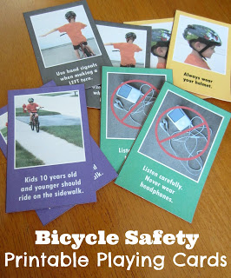We got our oldest son a new bicycle two weeks ago. Now that he's feeling more confident on his bike, I want to make sure he's being safe.

Rather than rattle off a litany of rules, which I know he'll forget, I made him a set of playing cards.

I come from a bicycling family, so I was able to seek the expertise of my dad for some help. He provides instruction (and free helmets) to kids a few times a year as a member of my hometown's bicycle club. As an avid cyclist, he takes bicycle safety seriously, and as you can imagine, shares my goal of keeping our boys safe on their bikes.

You can download your own set of bicycle safety printable playing cards here.
To make the cards, print the 3-page PDF on white cardstock. If you're concerned the paper is see-through, spray glue some thin colored paper to the back before cutting out.

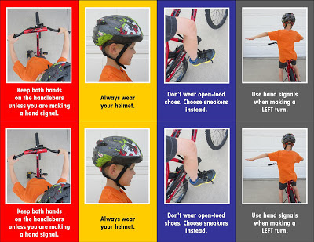

Before we played with our bike safety deck of cards, we read Ride Right by Jill Urban Donahue. This simple books features loads of safety tips - wearing a helmet, only ride during daylight, use hand signals, and be alert (just to name a few)!
Go Bicycling!
With the book done, we shuffled the cards (I printed two sets for our first game). It was time to play "Go Fish" with the two sets of cards. Deal five cards to each player and mix the rest up in the middle between players. Any matches should be removed from players' hands.
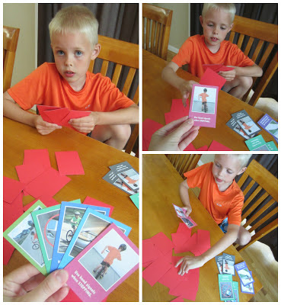

Players can either make a match with two cards or, to make it more challenging, a match can have four like cards. Play alternates between players, with each asking each other for the cards they need to make a match.

"Do you have 'Use hand signals when STOPPING'?"

"No. Go bicycling."

At which time the player who asked, draws a card from the pile. If the opponent has the card in question, it is surrendered. With the match in hand, the player gets another turn until there are no more requested cards to hand over.
The player with the most matches wins.

Bicycle Safety Memory
With one set of cards (24 cards), players shuffle and lay each out in a grid face down. Players take turns turning over two cards at a time. Like in the Go Bicycling game, when they make a match, pairing two like cards, they get another turn. Cards that are not a match, are flipped back over for the opponent's next turn.

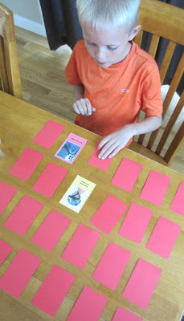

The player to make the most matches wins.
Safe bicycling, everyone!



WOLF

Wolf Adventure: Call of the Wild

- While a Wolf Scout, attend a pack or family campout. If your chartered organization does not permit Cub Scout camping, you may substitute a family campout or a daylong outdoor activity with your den or pack.
- Show how to tie an overhand knot and a square knot.
- While on a den or family outing, identify four different types of animals. Explain how you identified them.
- With your family or den, make a list of possible weather changes that might happen on your campout according to the time of year you are camping. Tell how you will be prepared for each one.
- Show or demonstrate what to do:
  - When a stranger approaches you, your family, or your belongings.
  - In case of a natural disaster such as an earthquake or flood.
  - To keep from spreading your germs.
- On the campout, participate with your family or den in a campfire show. Prepare a skit or song, and then present it at the campfire for everyone else.
- Do the following:
  - Recite the Outdoor Code with your leader.
  - Recite the Leave No Trace Principles for Kids with your leader. Talk about how these principles support the Outdoor Code.
  - After your campout, list the ways you demonstrated being careful with fire.
Workbook for use with these requirements: PDF Format DOCX Format
http://scoutermom.com/cubscout/wolf-adventure-call-of-the-wild/

Start a Fire with a Lemon
When teaching fire building skills, it can be fun to try some fire starting methods other than matches. This video shows how to start a fire with a lemon, copper brads, zinc nails, wire, and steel wool.



Camping Checklist for Scouts
When preparing for a campout, one of the most common questions from less experienced campers is “What should I bring?” This article from Boy’s Life magazine is a good list of must haves for that campout.


Square Knot Song and Overhand Knot Song
Marianna from Pack 377 in Fort Meade, MD sent in these two songs which she made up to help teach herWolves about square knots and overhand knots.


Wolf Den Outing Plan – Call of the Wild: Campout
Don’t be intimidated by the idea of going camping. If you are a novice, the key is to have some support from somebody who is comfortable “in the wild”.

Wolf Den Meeting Plan – Call of the Wild: Safety
At this Wolf den meeting for the Call of the Wild adventure, Wolves prepare for camping by learning about knots, fire, the Outdoor Code, and Leave No Trace.

Wolf Den Meeting Plan – Call of the Wild: Outdoor Skills
At this Wolf den meeting for the Call of the Wild adventure, Wolves prepare for camping by learning about knots, fire, the Outdoor Code, and Leave No Trace.


Cub Scout Outdoor Ethics Awareness Award
Cub Scouts and their leaders can earn the Outdoor Ethics Awareness award to start learning about being responsible citizens while outdoors.


Fire Safety with Cub Scouts
I like to review some fire safety rules with my Webelos before the fire is built. That way they all know the expectations.


The Twelve Days of Camping Song
Heres another silly song for you. This works well at Christmas (because of the tune) or at camp (because of the theme).


The Outdoor Code
Every Scout who is spending time outdoors should be familiar with the Outdoor Code. It is especially important for Webelos, Boy Scouts, and Venturers who are out camping regularly.


Leave No Trace Frontcountry Guidelines
Leave No Trace is an outdoor ethics program which encourages responsible use of outdoor resources. The frontcountry guidelines are the guidelines for day-use areas like parks and trails.


Camping Packing List
One thing new scouts (and new leaders) often ask the first few times they go camping is “What do I need to bring?” Download a suggested list of personal camping gear.
https://cubscouts.org/library/call-of-the-wild/

RATIONALE FOR ADVENTURE
Many boys join Scouting because they want to go camping. This adventure will introduce Wolves to several camping skills—selecting and bringing gear, participating with their families in campfire shows, and being prepared for bad weather. They will also learn about animals they might see, the Leave No Trace Principles for Kids, tying knots, and how to handle potentially harmful situations.

TAKEAWAYS FOR CUB SCOUTS
- Outdoor essentials
- Identifying animals
- Tying square and overhand knots
- Taking care of themselves in the wilderness
- A Scout is obedient, courteous. [Wolf Character Compass]

ADVENTURE REQUIREMENTS (Wolf Handbook, page 30)
- While a Wolf Scout, attend a pack or family campout. If your chartered organization does not permit Cub Scout camping, you may substitute a family campout or a daylong outdoor activity with your den or pack.
- Show how to tie an overhand knot and a square knot.
- While on a den or family outing, identify four different types of animals. Explain how you identified them.
- With your family or den, make a list of possible weather changes that might happen on your campout according to the time of year you are camping. Tell how you will be prepared for each one.
- Show or demonstrate what to do:
a. When a stranger approaches you, your family, or your belongings.
b. In case of a natural disaster such as an earthquake or flood.
c. To keep from spreading your germs.
- On the campout, participate with your family or den in a campfire show. Prepare a skit or song, and then present it at the campfire for everyone else.
- Do the following:
a. Recite the Outdoor Code with your leader.
b. Recite the Leave No Trace Principles for Kids with your leader. Talk about how these principles support the Outdoor Code.
c. After your campout, list the ways you demonstrated being careful with fire.

NOTES TO DEN LEADER
For Meeting 3, Wolf Scouts may participate in a pack campout (requirement 1) or an alternative activity as permitted by their chartered organization. Confirm the campout plan with families, including transportation, all the necessary clothing, and any additional items they need to bring. Make sure a tour and activity plan has been submitted, if required, and activity consent forms are distributed, signed, and collected.
If Scouts will instead be going on family campouts, identify locations that will help them complete the requirements for this adventure.
See the Appendix for optional den meeting activities, including gatherings, openings, and closings.

PREPARATION AND MATERIALS NEEDED
- U.S. and den flags
- Plans for the upcoming pack campout—location, fees, gear list, food arrangements, etc.
- Assorted flying discs and targets for the Gathering activity (see Meeting 1 Resources)
- Information about how to identify animals, including photos or illustrations (Activity 1)
- Slips of paper for the “Camping Charades” game (Activity 2)
- Sample gear items for the campout, including the Cub Scout Six Essentials (Activity 3)

GATHERING
- As Scouts arrive, have them practice throwing discs at targets. (See Meeting 1 Resources.)
- Have each Scout write his favorite camping activity on a slip of paper, and put all of the papers in a hat, bowl, or other container.

OPENING
- Conduct a flag ceremony of your choosing that includes the Pledge of Allegiance and, as appropriate, the Scout Oath and Scout Law.
- Recite the Outdoor Code (requirement 7a; see the Wolf Handbook).
- Recite the Leave No Trace Principles for Kids (requirement 7b; see the Wolf Handbook).

TALK TIME
- Introduce the Call of the Wild adventure to the den. Build interest by describing the goals of the adventure and some of the activities that are planned.
- Carry out business items for the den.
- Allow time for sharing among Cub Scouts.
- Share plans for the pack campout (see above). If some Scouts will be camping out with their families, discuss possible locations with the boys and their parents, and review everything they will need to bring.

ACTIVITIES

Activity 1: Animal Identification (Requirement 3)
- Using photos or illustrations, teach the Scouts how to identify four types of wild animals they may be able to see near their homes or on the campout. If possible, include examples of mammals, birds, insects, reptiles, and amphibians. (See Meeting 1 Resources.)
- Have them go to requirement 3 in their Wolf Handbooks and write the name of each animal and how to identify it.
- Show the boys some additional pictures that look similar, but are clearly not the types of animals that they will see on the campout. Have them pick out the differences.

Activity 2: Camping Charades Game
- Have each Scout pick one of the slips of paper they filled out during the Gathering and pretend to be doing that activity while the other boys try to guess what it is. Tell them not to use words or props— only actions—and give them time to plan the charade with help from adult leaders.
- Ideas from this game can be worked into the campfire skit or song the Scouts will perform later with the den or their families (requirement 6). Suggest ways they might do this.

Activity 3: Camping Gear
- Discuss with the Scouts what gear they should bring on the campout for their own personal care and comfort, based on where and when they are camping. Don’t forget the Cub Scout Six Essentials! (See Meeting 1 Resources.) You should also cover items like tents, sleeping bags, ground cloths, pillows, sleeping pads or mattresses, warm clothes, raincoats, eating utensils, hats or caps, toothpaste, toothbrushes, etc.

CLOSING
- The Grand Howl. To recognize their achievements during this meeting, form a circle and have each boy squat, make the Cub Scout sign with both hands, then lean forward and touch the ground between his feet. Then, like young wolves, all the Scouts raise their heads and give a long howl. When this is done, they all jump to their feet, raise their right hands high above their heads, and give the Cub Scout sign again, shouting, “Akela! We’ll—do—our—best!”

AFTER THE MEETING
- Serve refreshments, if desired.
- Record completion of requirements 3, 7a and 7b.
- Work together to clean up the meeting place.
- Prepare thank-you notes for the Scouts to sign at the next meeting.

DISC GAMES (GATHERING)
Frisbee–style flying discs can be used for a variety of activities. The basic skill is easy, and the Gathering is a good time for Wolves to refine that skill without the need for much equipment or preparation. Try either of these two games, depending on the time you have available.
Target shooting. Lay out a field of “targets,” making sure to include a mix of shapes and sizes at various distances from the throwing line. Have Scouts try to hit the items by throwing the discs. As their skills increase, add a few challenges by removing the larger targets, moving some of them farther away, or providing ringshaped objects to shoot through (e.g., tires, hula-hoops).
Disc golf. Set up a course over a large field or backyard with markers for “holes.” The players must strike the markers to complete a hole, counting shots along the way. The course may include some obstacles to play around. The player with the lowest shot score wins. As a variation, let teams of two boys alternate taking shots to complete a hole.

ACTIVITIES

Activity 1: Animal Identification
These tracks may be included as an illustration during the activity.
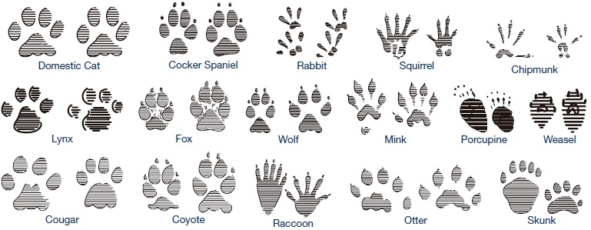

Activity 3: Camping Gear
Cub Scout Six Essentials.
Review these items that each Cub Scout should carry in his personal gear when going on hikes or campouts. Suggest getting a small fanny pack or similar bag to organize the items and make them easy to carry without interfering with normal activities. Emphasize that these items are not intended for play and should be used only when needed.
- First-aid kit—adhesive bandages, moleskin, gauze, antibiotic ointment, etc.
- Water bottle—filled and large enough to last until it can be filled again
- Flashlight—for emergency use only
- Trail food—can be made as a den activity prior to hike or campout
- Sun protection—sunscreen of SPF 30 or greater and a hat
- Whistle—also for emergency use only
RETURN TO TOP

PREPARATION AND MATERIALS NEEDED
- U.S. and den flags
- Several non-transparent bags, each with a camping item inside for the shape guessing game (Gathering)
- Small bottle of soap and a basin or pot filled with water for hand cleaning (Gathering)
- Whiteboard and a marker for Talk Time
- Examples of gear and clothing needed in case of bad weather (Talk Time)
- Ropes for knot tying and the knot relay game—6" length for each Scout (Activity 1)
- If needed, invite some Boy Scouts or adult volunteers to help as the Wolves learn to tie knots. Have examples on hand of finished overhand and square knots, so they can compare their work.

GATHERING
- Shape guessing. Let each Scout reach into one of the bags prepared for the game and try to guess the camping item inside. Then reveal the contents of each bag.
- Hand cleaning. Have each boy demonstrate how he would wash his hands on a campout, using the water basin and liquid soap (requirement 5c).

OPENING
- Conduct a flag ceremony of your choosing that includes the Pledge of Allegiance and, as appropriate, the Scout Oath and Scout Law.

TALK TIME
- Carry out business items for the den.
- Allow time for sharing among Cub Scouts.
- Discuss plans for the upcoming pack campout or campouts with families.
- Reveal the items that were hidden in bags for the shape guessing game. Discuss hygiene items and gear needed for campouts, making sure to review again the Cub Scout Six Essentials (see Meeting 1 Resources).
- Discuss the Leave No Trace principles and how they support the Outdoor Code (requirements 7a and 7b; see the Appendix). Emphasize that Wolves are focusing especially on the Outdoor Code’s call to “Be careful with fire.” Talk about ways the boys will demonstrate this principle during the campout.

ACTIVITIES

Activity 1: Safety Check
(Requirements 4 and 5)
- Discuss what the boys should do if a stranger approaches them or their family members, and call their attention to the tips in the Wolf Handbook (requirement 5a). Another good resource can be found on the National Crime Prevention Council website: www.ncpc.org/topics/violent-crime-and-personal-safety/strangers/. Use the whiteboard and marker to help as you lead the discussion.
- Show the bad weather gear and clothing you collected, and describe how each item might be useful if the weather changes drastically while you are camping.
- Talk about what to do in case a natural disaster occurs during a campout, including each type of disaster listed in the handbook (requirement 5b). Have Wolf Scouts write in their handbooks one thing they can do if any one of those disasters strikes. Don’t let the talk get bogged down in hypothetical scenarios—keep it realistic, so the boys can quickly solve the situations. Is your area prone to flooding, earthquakes, wildfires, windstorms, blizzards, or monsoons? Refer to www.ready.gov or other online resources dealing with disaster preparation and recovery.

Activity 2: Knot Tying/Knot Relay Game

(Requirement 2)
Show the boys how to tie these two knots, based on the instructions in the Wolf Handbook. Give each boy time to practice and demonstrate what he he has learned. Then, if time permits, play the Knot Relay Game.
- Overhand knot. This type is used to prevent a rope from going completely through a pulley or a hole. It can also be a starter for tying shoes or be used to keep the end of a rope from unraveling.

- Square knot. Also called a reef knot, this can be used to tie two ropes together or to tie packages, rig sails, or tie the ends of a bandage.
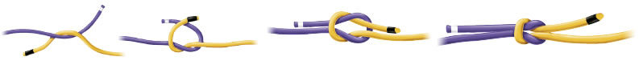
- Knot Relay Game. Divide Scouts into two teams, each standing in single- file lines. Lay two ropes on the floor about 20 feet from the start line. The first Scout in each team runs to the rope, ties an overhand knot, shows it to a judge, unties it, and runs back to tag the next boy in his team. Once this relay is finished, you can repeat it using square knots.

Activity 3: Campfire Show Planning
- Have Wolf Scouts work together to brainstorm some ideas for a campfire show to perform at the upcoming den outing. Ideas can include simple songs, skits, or other creative acts. Help ensure that each Scout is included and has a role in the show. Scouts will practice for the show as a Do-at-Home Project.

CLOSING
- Gather the den in a Friendship Circle. Using their ropes from Activity 2, have each Scout tie his rope to his neighbor’s with a square knot until a rope circle is formed. Standing around the circle, the Scouts hold the rope with their left hands while making the Cub Scout sign with their right. The den leader then recites this quote from Lord Baden-Powell: Every Scout ought to be able to tie a knot. To tie a knot seems a simple thing, and yet there are right and wrong ways of doing it, and Scouts ought to know the right way. Very often it happens that lives depend on a knot being properly tied.
- Review details for the upcoming campout or outing in Meeting 3. Make sure all Scouts and their families know the plans.
Do-at-Home Project Reminder:
Wolves should practice a skit or song for the campfire show with their family or the whole den (requirement 6).

AFTER THE MEETING
- Serve refreshments, if desired.
- Record completion of requirements 2, 4, and 5.
- Work together to clean up the meeting place.
- Have Scouts sign thank-you notes to give to anyone who helps the den during the pack campout.
RETURN TO TOP

PREPARATION AND MATERIALS NEEDED
- Camping gear, including Cub Scout Six Essentials and all items needed from checklist in Wolf Handbook
- Food for cooking meals
- A skit or song for participating in the campfire show with any props or costumes needed for the presentation
- Confirm that a tour and activity plan has been submitted, if required, and that transportation to and from the event is in place. Secure activity consent forms.
- Unit den leader should have in possession (if required by local council practices) the tour and activity plan and a copy of the Guide to Safe Scouting.

GATHERING
Remind the Scouts of the slogan, “Take only memories, leave only footprints,” and the adage that Scouts always leave a campsite better than they found it. Wolf Scouts focus on the Outdoor Code principle of “Be careful with fire.” Discuss ways that they can demonstrate this principle when they are at a campsite, using the Wolf Handbook’s guidelines for requirements 7a, b, and c as a resource. Point out to them the things that previous campers may have left behind and remind them that if we leave it here also, other campers will think it was ours. So let’s clean up!

OPENING
- Say the Pledge of Allegiance and, as appropriate, the Scout Oath and Scout Law. If the den does not have a United States flag, ask one Scout to display the flag on his uniform for the group.
- Go over the activities planned for the outing.
- Share the time that the dinner preparation will begin.
- Share the time the campfire will begin.

TALK TIME
- Carry out business items for the den.
- Allow time for sharing among Cub Scouts.

ACTIVITIES

Activity 1: Animal Identification (Requirement 3)
Make sure each Scout identifies four different types of animals during the campout and explains how he identified them. Animals can include birds, insects, and other animals.

Activity 2: Human Chain Race
- Have Wolf Scouts line up single file and in two teams. (Have an adult join one of the teams if you have an odd number of boys.) Each player then reaches down between his legs with his right hand and grabs the left hand of the Scout behind him to make one long chain. On the “Go” signal, both teams race forward around an established turning point and back to the finish line. If one of the chains breaks, the team must stop and re-form before continuing.

Activity 3: Perform Skit or Song (Requirement 6)
Have the Scouts perform their skits or songs at the campfire show. Check to make sure any needed props or costumes are ready to go.

CLOSING
- The closing for this meeting may be part of the ending of the campfire, or possibly the morning after camping out. It should be inspirational and ideally reference the outdoors.
- Have each Scout list in his copy of the Wolf Handbook how he demonstrated the principle of “Be careful with fire” during the campout (requirement 7c).

AFTER THE MEETING
- Record completion of requirements 1, 3, 6, and 7c.
- Work together to clean up the campsite.
- Send thank-you notes to those who helped.
Upon completion of the Call of the Wild adventure, your Wolves will have earned the adventure loop shown here. Make sure they are recognized for their completion by presenting the adventure loops, to be worn on their belts, as soon as possible according to your pack’s tradition.
http://www.boyscouttrail.com/cub-scouts/wolf-call-wild-adventure.php

Ideas for Adventure Requirements:
- Ensure everyone is aware and ready to camp by using Campout Checklist to prepare.
- Practice your knots so you can help the scouts learn. Overhand Knot (half hitch) Square Knot
- A scout doesn't need to actually see an animal. Animals can be identified by sight, sound, tufts of fur, scat, or tracks. I guess a few, such as skunk, could be identified by smell also.
- There are many ways to prepare for adverse weather. Rather than a heavy, hot raincoat, an umbrella or light poncho might be a better choice for warm, humid, rainstorms.
A hotter than expected day can be dangerous, too. Having a wide-brimmed hat, umbrella, or shade tarp available could make a big difference.
- Read these pages about child safety which is no longer just 'stranger danger' - kidsmartz.org, NCPC.org, free-for-kids.com
- Communicate with other den leaders to ensure a variety of entertainment since they will all have similar requirements.
- The Outdoor Code is easier to remember if you start with memorizing the Four Cs - Clean, Careful, Considerate, and Conservation-minded.
Den Meeting Ideas for Call of the Wild Adventure:
- Use Licorice Knots activity to combine learning and snack.
- Play UnRavel game.
- The LNT Principles for Kids are listed in the back of the Wolf Handbook. Read details of the principles and implementing them atLNT.org and Outdoor Ethics.
- Sing some of the verses of I Met a Bear song.
- Perform Panther Tracks skit for the Pack.
- Tell Leave a Trace minute to the den.
- Conduct a short version of Hole In My Pack activity
- Learn more about LNT from Leave No Trace Dude.
- Remember to use this Wolf Call of the Wild adventure as a step towards each scout's Outdoor Ethics award.
http://mylitter.com/recipes/taco-salad-in-a-bag-perfect-for-camping-and-kids/

Taco Salad In A Bag! – Perfect for camping and kids!
MAY 29, 2015 BY TIFFANY 20 COMMENTS
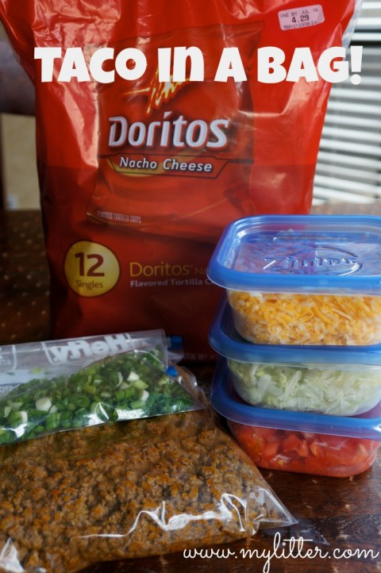This has long been a fun snack/dinner for my kids camping and after school. You can see my Taco Salad recipe HERE for a bigger dish with catalina dressing. Making this for groups, camping or teens is an awesome way to feed a crowd easily.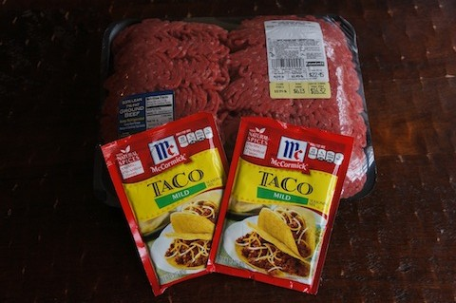First brown some ground beef with taco seasoning. I often have this on hand frozen in my freezer anyway. Next cut up or pull out your toppings, which can include the following:
- Onions
- Cheese
- Sour Cream
- Salsa
- Lettuce
- Tomatos
Whatever you like, and if you are camping can travel easily. My kids like to eat theirs with Doritos, but you can also use Fritos.
Take the bag and break up the chips a bit. Open the bag. Add toppings and meat. Enjoy!

Wolf Elective Adventure: Air of the Wolf

- Do the following investigations:
  - Conduct an investigation about the weight of air.
  - Conduct an investigation about air temperature.
  - Conduct at least one of the following investigations to see how air affects different objects:
    - Make a paper airplane and fly it five times. Make a change to its shape to help it fly farther. Try it at least five times.
    - Make a balloon-powered sled or a balloon-powered boat. Test your sled or boat with larger and smaller balloons.
    - Bounce a basketball that doesn't have enough air in it. Then bounce it when it has the right amount of air in it. Do each one 10 times. Describe how the ball bounces differently when the amount of air changes.
    - Roll a tire or ball that doesn't have enough air in it, and then roll it again with the right amount of air. Describe differences in how they move.
- Do the following:
  - With other members of your den, go outside and record the sounds you hear. Identify which of these sounds is the result of moving air.
  - Create a musical wind instrument, and play it as part of a den band.
  - With an adult, conduct an investigation on how speed can affect sound.
- Do the following:
  - Explain the rules for safely flying kites.
  - Make a kite using household materials.
- With your family, den, or pack, participate in a kite derby, space derby or rain-gutter regatta. Explain how air helps the vehicle move.
Workbook for use with these requirements: PDF Format DOCX Format

http://scoutermom.com/cubscout/wolf-elective-adventure-air-of-the-wolf/


Product Review: Catapult Cruzers
Catapult Cruzers recently sent me a couple of samples to review. Catapult Cruzers are toy airplanes which you put together and launch. These planes would be great for Scouts of any age. See the article for information about a free giveaway.


Forces of Flight Game
The Forces of Flight game would make a fun addition to a pack meeting for the Soaring the Skies Cub Scout theme. Use this game when the Cub Scouts have been sitting for too long and need to get up and move around.
http://www.sheknows.com/parenting/articles/1004063/popsicle-stick-crafts-for-kids
Popsicle stick crafts you haven't seen before!
Jul 02, 2013

by Amy Vowles
Print

Not your average popsicle stick crafts
Popsicle stick crafts don't have to be boring. These creative popsicle stick craft ideas are fun to make and functional too!

Popsicle stick bow and arrow
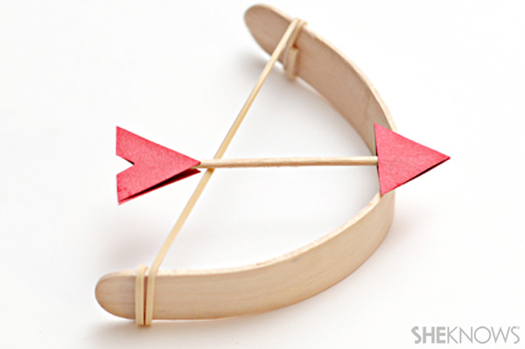
Your kids will love taking aim with this cool bow and arrow.

What you'll need:
- wide popsicle stick
- a pot
- a drinking glass
- rubber band
- scissors
- glue
- toothpicks
- card stock

What you'll do:
- Bring a pot of water to a boil on the stove. Put the popsicle stick in the water and boil it for 30 minutes.
- Carefully remove the popsicle stick from the water and set it aside until it is cool enough to handle.
- Once the popsicle stick has cooled off, gently bend the stick into an arch, then place the bent stick inside a drinking glass so that it will hold its shape while it dries.
- Let the stick dry overnight, then remove it from the glass.
- Cut a rubber band in half and glue the ends of the rubber band to the inside ends of the popsicle stick.
- Once the glue is dry, wrap the rubber band around the ends of the stick until there is no more slack in the band.
- Make arrows by cutting two small triangles out of the card stock. Glue a toothpick between the two triangles.
- Cut two chevron shapes out of the card stock and glue them to the opposite end of the toothpick.
- Once the glue is dry, your arrows are ready to launch!

Popsicle stick harmonica
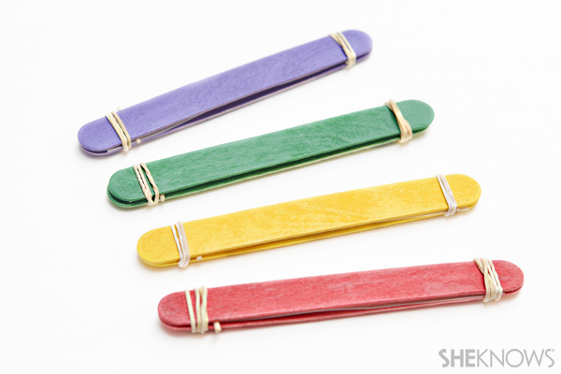
Your little ones can strike up a band with a few of these easy-to-make harmonicas.

What you'll need:
- Popsicle sticks
- paint
- paintbrush
- rubber bands
- toothpicks
- card stock
- scissors

What you'll do:
- Paint all sides of two popsicle sticks and let them dry.
- Cut a piece of card stock that is the same size as the popsicle stick.
- Sandwich the card stock piece between two popsicle sticks.
- Bind the popsicle sticks together by wrapping a rubber band around each end.
- Slide two toothpicks between the popsicle sticks next to the rubber bands. Cut off any part of the toothpick that sticks out.
- Blow through the two popsicle sticks just as you would with a harmonica. Try squeezing the popsicle sticks closer together to see what sounds you can make!

Popsicle stick knitting loom
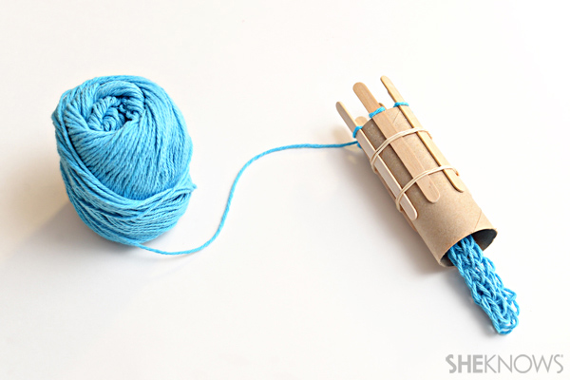
Teach your daughter to knit friendship bracelets and much more using this handmade knitting loom.

What you'll need
- popsicle sticks
- toilet paper tube
- glue
- rubber bands
- yarn
- scissors

What you'll do:
- Glue the popsicle sticks around the toilet paper tube, leaving about 1/2 inch of space between each stick.
- Wrap two rubber bands around the tube to hold the sticks in place while the glue dries, and to give a little extra stability while you knit.
- Begin wrapping yarn around the knitting loom. For specific instructions on how to use a knitting loom, check out this Instructable. You can use the knitting loom to make friendship bracelets, headbands, or anything else you can imagine!

http://www.livingwellspendingless.com/2014/06/23/diy-newspaper-kites/#bYr7BQTRQvtCjUL2.32

DIY Newspaper Kite
June 23 By Ruth Soukup
Hi there! I’m Kelly and I blog at View Along the Way, sharing tips and tutorials to beautify your home on a teensy little budget. My husband Andy and I have two deliciously crazy and sweet kiddos, so like you, we’re always trying to find fun activities that keep them busy without breaking the bank.
I love this little activity, because it’s the perfect combo of craft and physical exercise. It’s educational and artsy, but then you get to run and play with it! You can buy kites at the dollar store, so while this is pretty much a free craft, it’s not something you’re doing to save money necessarily: it teaches the kiddos a little bit about physics and lets them make something that’s fun and actually works.
My kiddos did this craft with my mom, who used to make these kites when she was growing up as one of ten kids with no extra money for toys and crafts! (So that’s who you’ll see throughout these photos helping the kids make theirs.)
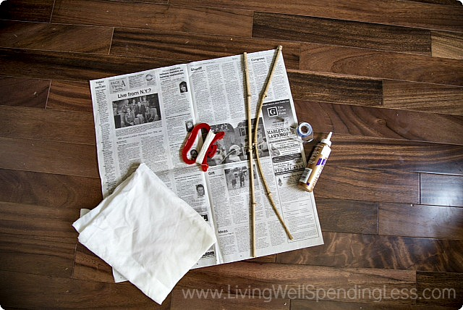
Here is what you need:
One sheet of newspaper (Make sure you get a large, full-size sheet. )
Kite string
Thin strips of an old sheet or scrap fabric
Two thin sticks of bamboo.
Clear packing tape or scotch tape
Elmer’s glue or craft glue


Step 1: Choose and prep your bamboo sticks. You’ll want one stick that’s pretty stiff that runs the width of your newspaper sheet, and one stick that’s a little more bendy that’s as the same length as your newspaper sheet. Part of the fun of this activity was taking my littles to the little bamboo forest to harvest our own!
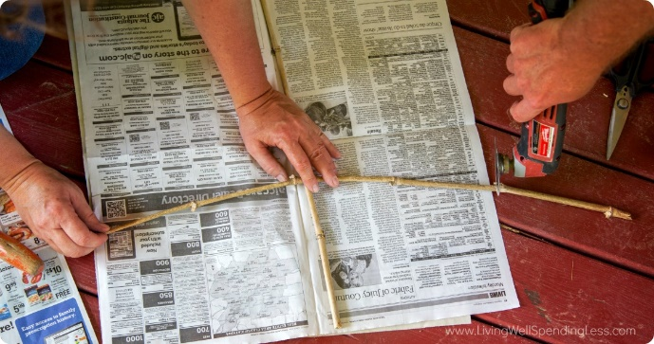
Step 2: Cut your stiffest piece to the length of the newspaper. And your bendiest (real word!) stick to the width of the newspaper. My kiddos did the craft with their grandparents this time, and my dad owns ALL THE POWER TOOLS, so he pulled out an actual power tool to do the cutting here, but plain garden shears will probably work just as well if you’re not the kind of person who looks for every opportunity to wield a powerful saw.
Then use some of your kite string to wrap the two sticks together at the center, making a “t” shape.
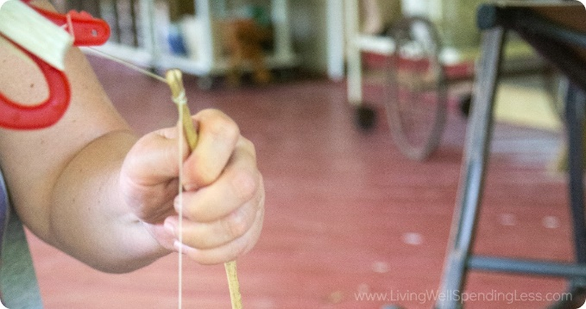
Step 3: Use a knife to cut a small slit in both ends of both sticks of bamboo. (The kite string will slide right in that little slot.) (This, I promise, is the hardest part, and it sounds so much more complicated than it is!) Insert the end of the kite string in that little slot on one side of the shorter, bendy stick, wrap it around the end of the stick a bunch of times, and knot it so it’s attached to the end of the stick pretty sturdily. Then pull the string tight across the stick, making the stick bend a little bit, and slide the string through the slot on the other end of the stick. Tie it off and cut the string.
Woohoo! Almost done!
Now you just need one more piece of string that goes around the outside of the kite, from one end of the bamboo stick to the other, so it looks like this:
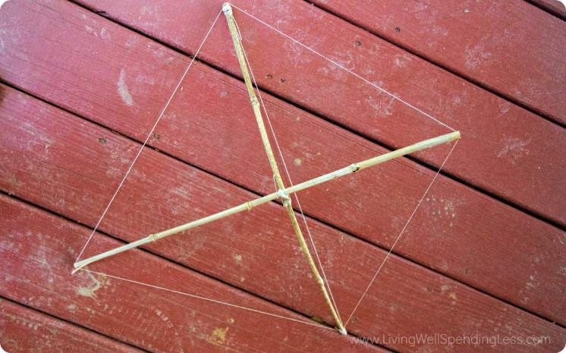
So starting on one end of one piece of bamboo, insert the string in the slot, wrap it around so it’s sturdy, then wrap the string around to the next end, and all the way around the other ends of bamboo, then tie it off again.

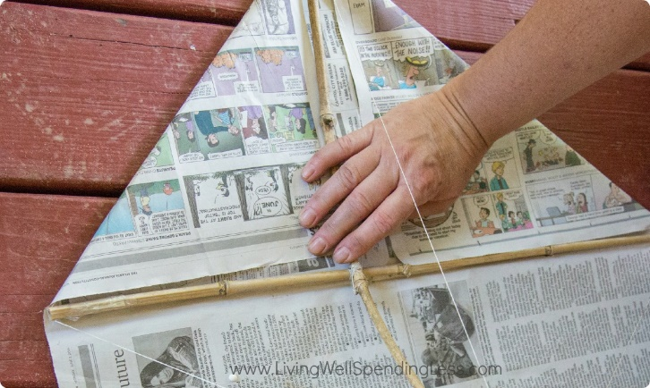
Step 4: Put your little kite skeleton on top of the newspaper, wrap the corners of the newspaper over the string and glue it to itself. It looks like a kite now, hooray! Look at you! You are rocking this parenting gig! *Totally optional, but you can whip out the finger paints right now and let your kids decorate the newspaper before you attach it now. Just one more way to keep ’em entertained!
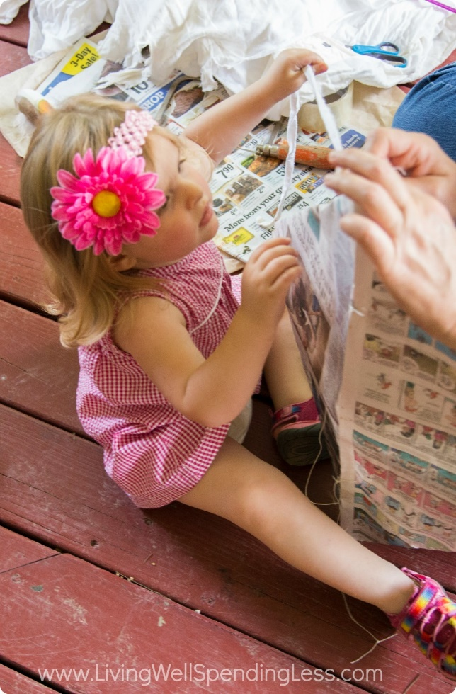
Step 5: Tear an old sheet into long thin strips and tie the strip to the bamboo at the bottom of the kite for a tail. Warning: toddlers come out of the woodwork when they see you tearing fabric! My littlest loved “helping” with this part!
Now add the string so this baby can fly! Turn the kite over so you can’t see the bamboo anymore. You’ll need to make two holes in the newspaper to thread the kite string onto the bamboo stick behind it, but just to be safe, put two small pieces of clear tape on the newspaper to reinforce it so it doesn’t tear. You’re going to make one hole in the center of the kite about one-third of the way down, and another about two-thirds of the way down. Use a pair of scissors to poke a hole in the newspaper where you added the tape.
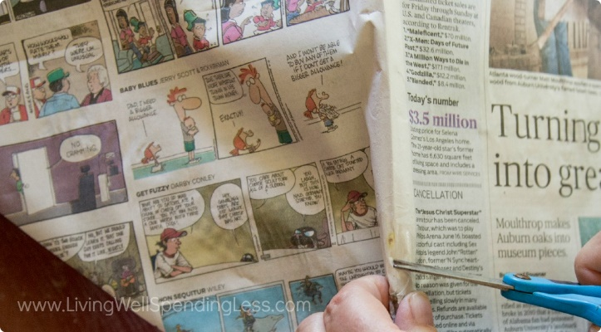
Now poke the string through that hole on the front, loop it around the bamboo stick behind it and knot it, then cut the end of the string so it’s about 2 feet long, poke the other end of the string through the other hole you made, loop it around the bamboo stick there and tie it in a knot. Now tie the end of your whole spool of kite string to the center of that 2-foot loop. It should look like this. See the string coming out of the front like that?

And you’re done!

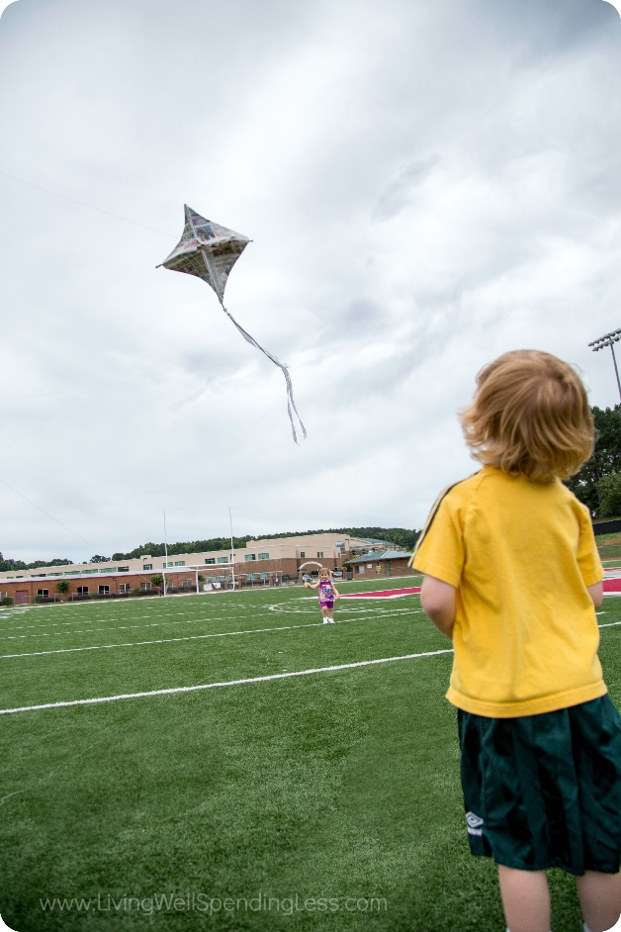
Step 6: Pick a windy day, pack a picnic and make an afternoon of it! We headed to our local high school football field and had lots of fun running around flying the kite, playing, and getting ALL THAT ENERGY OUT before nap-time. (Can I get an amen, mamas?!)

A few tips for best success:
- Use the largest sheet of newspaper you can find so your whole kite is as large as possible. Ours was a little on the small side, so it flew but it didn’t SOAR like it could’ve otherwise.
- Our kite was a little bit square, and you’d probably do better to make yours more of a diamond.
- On kite-flying day, make sure you bring extra fabric for the tail. If your kite isn’t staying upright when you try to fly it, you can just add on another tail or a longer tail. The weight of the tail keeps the kite right-side-up.
- Bring a few extra materials in case your toddler tears the newspaper when you’re just getting started. (Ask me how I know!).
This is definitely a one-time use kite, but in my experience, so are the ones you buy at the dollar store, and half the fun is making something anyway! When we flew ours, it was lightly sprinkling, so the kite even got a little damp and still flew like a champ.
But best of all: the kids thought it was super fun! You can use this project to teach older kids about physics and weather — or just use it to keep ’em entertained and running around for an afternoon!

http://www.ehow.com/how_7358283_make-pvc-trombone.html#page=1

How to Make a PVC Trombone
By Scott Knickelbine
eHow Contributor
There are lots of musical instruments you can make from PVC pipe, and most of them are wind instruments -- flutes, pan pipes and so on. One of the more unique plastic instrument projects is the PVC trombone. Many designs for PVC trombones require you to build jigs for bending the pipe, but you can avoid all that by using pairs of sweep 90 degree elbows connected by a short length of pipe to make the two U-bends you'll need. With the right parts you'll be annoying your friends and neighbors in no time!
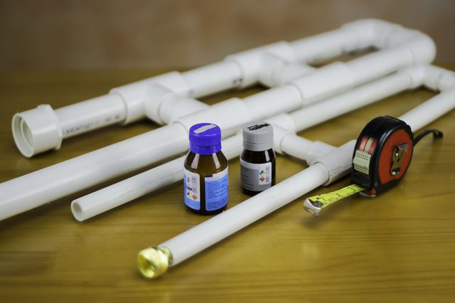(Robinson Cartagena Lopez/Demand Media)

Things You'll Need
- 2 20-inch lengths of 1/2-inch PVC pipe
- 2 20-inch length of 1-inch PVC pipe
- 2 3-inch lengths of 1-inch PVC pipe
- 1 3-inch length of 1/2-inch PVC pipe
- 1 30-inch length of 1-inch PVC pipe
- 1 1-inch length of 1/2-inch PVC pipe
- 1 2-inch length of 1-inch PVC pipe
- 2 PVC 90-degree sweep elbows, 1/2 inch inch
- 2 PVC 90-degree sweep elbows, 1 inch
- 4 PVC slip Ts, 1 inch
- 2 PVC slip Ts, 1/2 inch
- PVC 1.5 inch by 1 inch reducing bell
- 1 garden hose connector fitting
- PVC glue
Step 1
Make a 1-inch U-bend by connecting 2 90-degree sweep elbows with a 1-inch length of PVC pipe. Make sure the open ends of the elbows are aligned and facing the same direction. Glue the connecting pipe into the elbows. Repeat this with the two 1/2-inch elbows. You now have two U-bends, one of them 1-inch and one of them 1/2 inch.
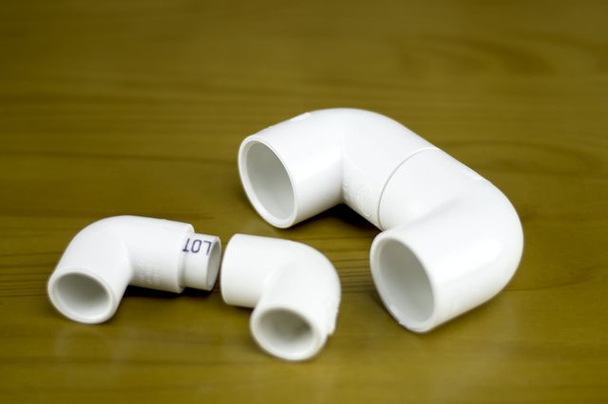Robinson Cartagena Lopez/Demand Media
Step 2
Glue the two 20-inch lengths of 1/2-inch pipe into both openings of the 1/2-inch U-bend.
Robinson Cartagena Lopez/Demand Media
Step 3
Slide the 2 1/2-inch slip Ts onto the open sides of the 1/2-inch PVC pipes, one on each pipe, so that the slip Ts are about 10 inches from the ends of the pipes, and the stems are facing each other. Glue them into position. Connect the two stems with a 3-inch length of 1/2-inch PVC pipe, glued into position. This completes the “slide” for the trombone.
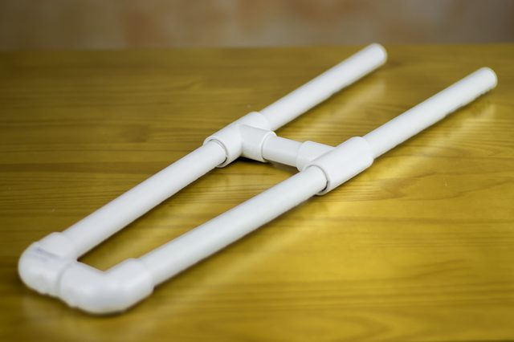Robinson Cartagena Lopez/Demand Media
Step 4
Glue the 30 inch length of 1-inch pipe into one of the open ends of the 1-inch U bend, and one of the 20-inch lengths of 1-inch pipe into the other end.
Robinson Cartagena Lopez/Demand Media
Step 5
Slide a 1-inch slip T each onto the 30-inch length and the 20-inch length of 1-inch pipe connected to the U bend. Position them so that the are each about 8 inches from the U bend, with the stems of the Ts facing each other. Connect these stems with a 3-inch length of 1-inch pipe, glued into position.
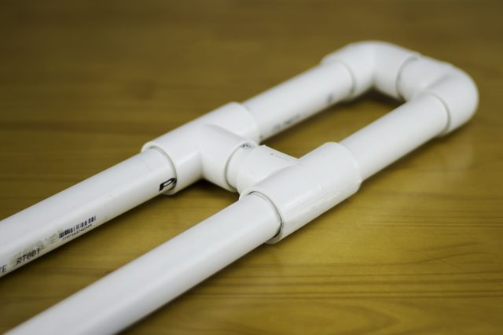Robinson Cartagena Lopez/Demand Media
Step 6
Align one end of the remaining 20-inch length of 1-inch pipe with the open end of the 30-inch length. Slide slip Ts onto each of these pipes, so that they are in alignment and the T on the 30-inch length is about 18 inches from the open end. This should put the T on the 20-inch length about six inches from the end. Glue these Ts into position, and connect them with a 3-inch length of 1-inch pipe, glued into position.
Robinson Cartagena Lopez/Demand Media
Step 7
Glue the 1-inch side of the reducing bell onto the open end of the 20-inch length of 1-inch pipe that is connected to the U bend. This is the bell of your horn.
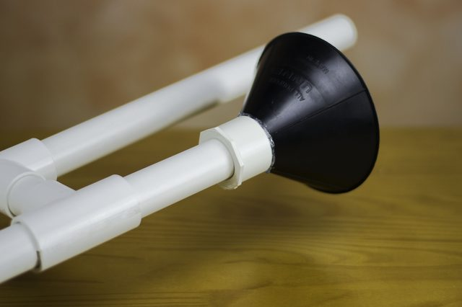Robinson Cartagena Lopez/Demand Media
Step 8
Insert the garden hose fitting into the other 20-inch length of 1-inch pipe, on the side closest to the slip Ts. This is your mouthpiece
Robinson Cartagena Lopez/Demand Media
Step 9
To assemble the trombone, insert one of the open ends of the slide into the pipe with the mouthpiece, and the other end into the 30-inch length of 1-inch pipe.
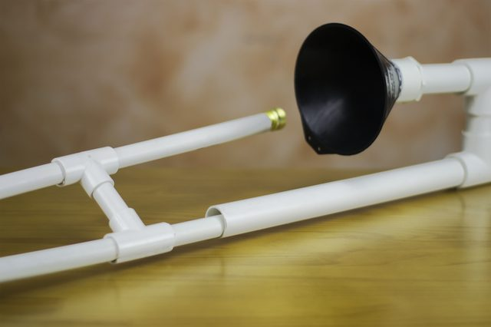Robinson Cartagena Lopez/Demand Media

Tips & Warnings
- To play this horn, grasp it by the handle close to the mouthpiece and the handle on the slide. Buzz your lips into the mouthpiece. By sliding the slide away from you, you get a lower note, and by sliding it close to you, you get a higher note.
- The 1/2 inch pipe should just fit into the 1-inch pipe. It should be loose enough to move, but not so loose that air escapes from the connections. If the fit is too tight, try lubricating the 1/2 inch pipe with some mineral oil. If the fit is too loose, try putting a wrap of electrician's tape around the 1/2 inch pipe, close to the open ends.
- Always use adequate ventilation when using PVC glue.
- Always test fit your parts before gluing them. PVC glue hardens very quickly, and it will be very difficult to free glued PVC joints once the glue has set.
http://laughingkidslearn.com/wind-pipe-instrument

Wind Pipe Instrument
January 14, 2013 by Kate
Children love to play instruments and there are many you can make at home.
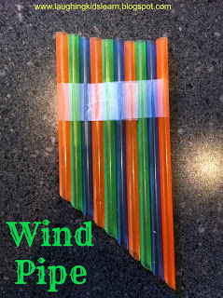
This is a simple wind pipe that children can make in just a few minutes.
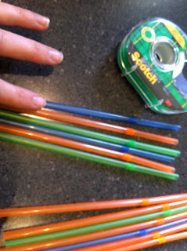
With the straws we had there was an opportunity to discuss patterns and order.
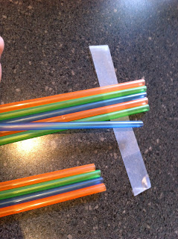
Simply lay out a line of sticky take with the sticky part facing UP.
Lay each of the straws on the sticky tape.
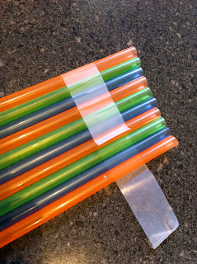
Fasten the straws with the tape.
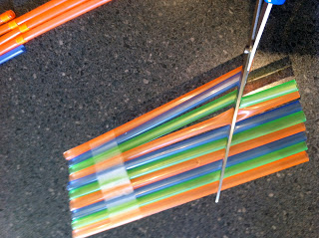
Cut one end of the straws on a diagonal.
This will give the straws various lengths.
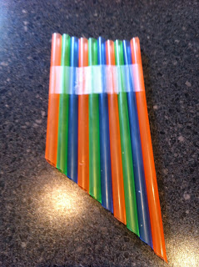
And there you have your wind pipe instrument.
Children can clearly hear their breath change as it passes through each straw.
______________________
Hope you enjoy this. Feel free to comment. I love hearing from you.
Kate



BEAR

Bear Adventure: Bear Claws
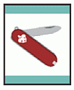
- Learn about three common designs of pocketknives.
- Learn knife safety and earn your Whittling Chip.*
- Using a pocketknife, carve two items.
*One of the items carved for requirement 3 may be used to fulfill Whittling Chip requirement 3.
Workbook for use with these requirements: PDF Format DOCX Format

Bear Elective Adventure: Salmon Run

- Explain the safety rules that you need to follow before participating in boating.
- Identify the equipment needed when going boating.
- Demonstrate correct rowing or paddling form. Explain how rowing and canoeing are good exercise.
- Explain the importance of response personnel or lifeguards in a swimming area.
- Show how to do both a reach rescue and a throw rescue.
- Visit a local pool or swimming area with your den or family, and go swimming.
- Demonstrate the front crawl swim stroke to your den or family.
- Name the three swimming ability groups for the Boy Scouts of America.
- Attempt to earn the BSA beginner swimmer classification.
Workbook for use with these requirements: PDF Format DOCX Format
Meeting Plans can be found here:
https://cubscouts.org/wp-content/uploads/2015/05/Salmon-Run.pdf

Safety Afloat
http://www.scouting.org/scoutsource/HealthandSafety/Aquatics/safety-afloat.aspx


BSA groups shall use Safety Afloat for all boating activities. Adult leaders supervising activities afloat must have completed Safety Afloat training within the previous two years. Cub Scout activities afloat are limited to council or district events that do not include moving water or float trips (expeditions). Safety Afloat standards apply to the use of canoes, kayaks, rowboats, rafts, floating tubes, sailboats, motorboats (including waterskiing), and other small craft, but do not apply to transportation on large commercial vessels such as ferries and cruise ships. Parasailing (being towed airborne behind a boat using a parachute), kitesurfing (using a wakeboard towed by a kite), and recreational use of personal watercraft (small sit-on-top motorboats propelled by water jets) are not authorized BSA activities.
Safety Afloat training may be obtained from MyScouting.org, at council summer camps, and at other council and district training events. Confirmation of training is required on tour and activity plans for trips that involve boating. Additional guidance on appropriate skill levels and training resources is provided in the Aquatics Supervision guide available from council service centers.
- Qualified Supervision
All activity afloat must be supervised by a mature and conscientious adult age 21 or older who understands and knowingly accepts responsibility for the wellbeing and safety of those in his or her care and who is trained in and committed to compliance with the nine points of BSA Safety Afloat. That supervisor must be skilled in the safe operation of the craft for the specific activity, knowledgeable in accident prevention, and prepared for emergency situations. If the adult with Safety Afloat training lacks the necessary boat operating and safety skills, then he or she may serve as the supervisor only if assisted by other adults, camp staff personnel, or professional tour guides who have the appropriate skills. Additional leadership is provided in ratios of one trained adult, staff member, or guide per 10 participants. For Cub Scouts, the leadership ratio is one trained adult, staff member, or guide per five participants. At least one leader must be trained in first aid including CPR. Any swimming done in conjunction with the activity afloat must be supervised in accordance with BSA Safe Swim Defense standards. It is strongly recommended that all units have at least one adult or older youth member currently trained in BSA Aquatics Supervision: Paddle Craft Safety to assist in the planning and conduct of all activities afloat.
- Personal Health Review
A complete health history is required of all participants as evidence of fitness for boating activities. Forms for minors must be signed by a parent or legal guardian. Participants should be asked to relate any recent incidents of illness or injury just prior to the activity. Supervision and protection should be adjusted to anticipate any potential risks associated with individual health conditions. For significant health conditions, the adult supervisor should require an examination by a physician and consult with parent, guardian, or caregiver for appropriate precautions.
- Swimming Ability
Operation of any boat on a float trip is limited to youth and adults who have completed the BSA swimmer classification test. Swimmers must complete the following test, which must be administered annually.
Jump feetfirst into water over the head in depth. Level off and swim 75 yards in a strong manner using one or more of the following strokes: sidestroke, breaststroke, trudgen, or crawl; then swim 25 yards using an easy, resting backstroke. The 100 yards must be completed in one swim without stops and must include at least one sharp turn. After completing the swim, rest by floating.
For activity afloat, those not classified as a swimmer are limited to multiperson craft during outings or float trips on calm water with little likelihood of capsizing or falling overboard. They may operate a fixed-seat rowboat or pedal boat accompanied by a buddy who is a swimmer. They may ride in a canoe or other paddle craft with an adult swimmer skilled in that craft as a buddy. They may ride as part of a group on a motorboat or sailboat operated by a skilled adult.
- Life Jackets
Properly fitted U.S. Coast Guard–approved life jackets must be worn by all persons engaged in boating activity (rowing, canoeing, sailing, boardsailing, motorboating, waterskiing, rafting, tubing, and kayaking). Type III life jackets are recommended for general recreational use.
For vessels over 20 feet in length, life jackets need not be worn when participants are below deck or on deck when the qualified supervisor aboard the vessel determines that it is prudent to abide by less-restrictive state and federal regulations concerning the use and storage of life jackets, for example, when a cruising vessel with safety rails is at anchor. All participants not classified as swimmers must wear a life jacket when on deck underway.
Life jackets need not be worn when an activity falls under Safe Swim Defense guidelines—for example, when an inflated raft is used in a pool or when snorkeling from an anchored craft.
- Buddy System
All participants in an activity afloat are paired as buddies who are always aware of each other’s situation and prepared to sound an alarm and lend assistance immediately when needed. When several craft are used on a float trip, each boat on the water should have a “buddy boat.” All buddy pairs must be accounted for at regular intervals during the activity and checked off the water by the qualified supervisor at the conclusion of the activity. Buddies either ride in the same boat or stay near each other in single-person craft.
- Skill Proficiency
Everyone in an activity afloat must have sufficient knowledge and skill to participate safely. Passengers should know how their movement affects boat stability and have a basic understanding of self-rescue. Boat operators must meet government requirements, be able to maintain control of their craft, know how changes in the environment influence that control, and undertake activities only that are within their personal and group capabilities.
Content of training exercises should be appropriate for the age, size, and experience of the participants, and should cover basic skills on calm water of limited extent before proceeding to advanced skills involving current, waves, high winds, or extended distance. At a minimum, instructors for canoes and kayaks should be able to demonstrate the handling and rescue skills required for BSA Aquatics Supervision: Paddle Craft Safety. All instructors must have at least one assistant who can recognize and respond appropriately if the instructor’s safety is compromised.
Anyone engaged in recreational boating using humanpowered craft on flatwater ponds or controlled lake areas free of conflicting activities should be instructed in basic safety procedures prior to launch, and allowed to proceed after they have demonstrated the ability to control the boat adequately to return to shore at will.
For recreational sailing, at least one person aboard should be able to demonstrate basic sailing proficiency (tacking, reaching, and running) sufficient to return the boat to the launch point. Extended cruising on a large sailboat requires either a professional captain or an adult with sufficient experience to qualify as a bareboat skipper.
Motorboats may be operated by youth, subject to state requirements, only when accompanied in the boat by an experienced leader or camp staff member who meets state requirements for motorboat operation. Extended cruising on a large power boat requires either a professional captain or an adult with similar qualifications.
Before a unit using human-powered craft controlled by youth embarks on a float trip or excursion that covers an extended distance or lasts longer than four hours, each participant should either receive a minimum of three hours training and supervised practice, or demonstrate proficiency in maneuvering the craft effectively over a 100-yard course and recovering from a capsize.
Unit trips on whitewater above Class II must be done either with a professional guide in each craft or after all participants have received American Canoe Association or equivalent training for the class of water and type of craft involved.
- Planning
Proper planning is necessary to ensure a safe, enjoyable exercise afloat. All plans should include a scheduled itinerary, notification of appropriate parties, communication arrangements, contingencies in case of foul weather or equipment failure, and emergency response options.
Preparation. Any boating activity requires access to the proper equipment and transportation of gear and participants to the site. Determine what state and local regulations are applicable. Get permission to use or cross private property. Determine whether personal resources will be used or whether outfitters will supply equipment, food, and shuttle services. Lists of group and personal equipment and supplies must be compiled and checked. Even short trips require selecting a route, checking water levels, and determining alternative pull-out locations. Changes in water level, especially on moving water, may pose significant, variable safety concerns. Obtain current charts and information about the waterway and consult those who have traveled the route recently.
Float Plan. Complete the preparation by writing a detailed itinerary, or float plan, noting put-in and pullout locations and waypoints, along with the approximate time the group should arrive at each. Travel time should be estimated generously.
Notification. File the float plan with parents, the local council office if traveling on running water, and local authorities if appropriate. Assign a member of the unit committee to alert authorities if prearranged check-ins are overdue. Make sure everyone is promptly notified when the trip is concluded.
Weather. Check the weather forecast just before setting out, and keep an alert weather eye. Anticipate changes and bring all craft ashore when rough weather threatens. Wait at least 30 minutes before resuming activities after the last incidence of thunder or lightning.
Contingencies. Planning must identify possible emergencies and other circumstances that could force a change of plans. Develop alternative plans for each situation. Identify local emergency resources such as EMS systems, sheriff’s departments, or ranger stations. Check your primary communication system, and identify backups, such as the nearest residence to a campsite. Cell phones and radios may lose coverage, run out of power, or suffer water damage.
- Equipment
All craft must be suitable for the activity, be seaworthy, and float if capsized. All craft and equipment must meet regulatory standards, be properly sized, and be in good repair. Spares, repair materials, and emergency gear must be carried as appropriate. Life jackets and paddles must be sized to the participants. Properly designed and fitted helmets must be worn when running rapids rated above Class II. Emergency equipment such as throw bags, signal devices, flashlights, heat sources, first-aid kits, radios, and maps must be ready for use. Spare equipment, repair materials, extra food and water, and dry clothes should be appropriate for the activity. All gear should be stowed to prevent loss and water damage. For float trips with multiple craft, the number of craft should be sufficient to carry the party if a boat is disabled, and critical supplies should be divided among the craft.
- Discipline
Rules are effective only when followed. All participants should know, understand, and respect the rules and procedures for safe boating activities provided by Safety Afloat guidelines. Applicable rules should be discussed prior to the outing and reviewed for all participants near the boarding area just before the activity afloat begins. People are more likely to follow directions when they know the reasons for rules and procedures. Consistent, impartially applied rules supported by skill and good judgment provide steppingstones to a safe, enjoyable outing.

Coastie the Safety Boat for Cub Scouts
http://auxbdeptwiki.cgaux.org/index.php/Coastie_the_Safety_Boat_for_Cub_Scouts
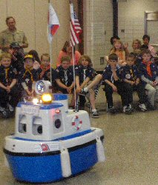

Coastie is a robotic cartoon character used by the Coast Guard Auxiliary to assist with teaching recreational boating safety to younger audiences. As such he is a natural for helping the local Auxiliary Flotilla engage Cub Scouts in a fun discussion of boating safety.

- Organize this event through the right leader, the Cubmaster. To get the best participation, you need a full Pack meeting with Cubs from all of the Dens. The Cubmaster's name and contact information is readily available from the local District Executive. Call the local council office and ask to speak to the "D.E." (District Executive) for your town.
- Whenever possible, bring together two Packs into a special, combined Pack meeting and have one of the Packs host the event. Most Packs have about 30 Cub Scouts. We got twice the number of scouts with combined meetings.
- It takes time to put on a Coastie event. The more scouts you can present him to at once, the better. For a 45 minute to an hour presentation, it takes about 4~5 hours for each Auxiliarist with travel, setup, actual event, breakdown, and return travel.

Travel Safety Checklist for Cub Scouts
http://scoutermom.com/4682/travel-safety-checklist-cub-scouts/

When traveling by car
- Always wear a seatbelt. There should be one seatbelt for each person. Never buckle two people in with one belt.
- Never ever ride in the cargo area of a van, station wagon, or pickup truck.
- Don’t distract the driver. Take some toys or games to keep yourself occupied so the driver can focus on driving.
- Don’t travel in a car which is not in good repair.
- Be aware of what is going on around you, especially when you are entering and exiting the car.
- When exiting a car parked on a road, always exit on the side next to the sidewalk or the shoulder of the road. Never exit on the side which has traffic driving past.
When traveling by public transportation (plane, train, bus, boat, etc.)
- Always stay with your group. Pay special attention to this when boarding and leaving.
- If you need to use the restroom, take an adult with you.
- Have a designated place to meet, just in case you do become separated.
- Have your parents point out the people who can help you, like security officers or attendants.
- Keep your parent’s contact information in your pocket.
- Only talk to other passengers if your parents are with you. Don’t give other passengers personal information about yourself (last name, phone number, etc) when you are talking to them.
- Keep your luggage stowed where it belongs. Make sure anything valuable is stored out of sight.
- Never take anything which resembles a weapon on public transportation. If you have your pocketknife with you, it should be packed in your luggage and never taken out.
- Be aware of what is going on around you. Pay attention to any rules which are explained by the attendants.

BSA Swim Test
http://meritbadge.org/wiki/index.php/BSA_Swim_Test

Requirements

Swimmer
- Jump feet first into water over the head, level off, and begin swimming.
- Swim 75 yards in a strong manner using one or more of the following strokes: side, breast, trudgen, or crawl. Swim 25 yards using an easy, resting backstroke.
- The 100 yards must be completed without stops and must include at least one sharp turn.
- Rest by floating…Long enough to demonstrate ability to rest when exhausted.

Beginner
- Jump feet first into water over the head, level off, and begin swimming.
- Swim 25 feet on the surface.
- Stop, turn, and resume swimming back to the starting place.

Non-Swimmer
- Did not complete either of the swimming tests.



WEBELOS CORE



ARROW OF LIGHT CORE

Arrow of Light Adventure: Scouting Adventure

Do all of these:
- Prepare yourself to become a Boy Scout by completing all of the items below:
  - Repeat from memory the Scout Oath, Scout Law, Scout motto, and Scout slogan. In your own words, explain their meanings to your den leader, parent, or guardian.
  - Explain what Scout spirit is. Describe for your den leader, parent, or guardian some ways you have shown Scout spirit by practicing the Scout Oath, Scout Law, Scout motto, and Scout slogan.
  - Give the Boy Scout sign, salute, and handshake. Explain when they should be used.
  - Describe the First Class Scout badge, and tell what each part stands for. Explain the significance of the First Class Scout badge.
  - Repeat from memory the Outdoor Code. In your own words, explain what the Outdoor Code means to you.
- Visit a Boy Scout troop meeting with your den members, leaders, and parent or guardian. After the meeting, do the following:
  - Describe how the Scouts in the troop provide its leadership.
  - Describe the four steps of Boy Scout advancement.
  - Describe ranks in Boy Scouting and how they are earned.
  - Describe what merit badges are and how they are earned.
- Practice the patrol method in your den for one month by doing the following:
  - Explain the patrol method. Describe the types of patrols that might be part of a Boy Scout troop.
  - Hold an election to choose the patrol leader.
  - Develop a patrol name and emblem (if your den does not already have one), as well as a patrol flag and yell. Explain how a patrol name, emblem, flag, and yell create patrol spirit.
  - As a patrol, make plans with a troop to participate in a Boy Scout troop's campout or other outdoor activity.
- With your Webelos den leader, parent, or guardian, participate in a Boy Scout troop's campout or other outdoor activity. Use the patrol method while on the outing.
- Do the following:
  - Show how to tie a square knot, two half hitches, and a taut-line hitch. Explain how each knot is used.
  - Show the proper care of a rope by learning how to whip and fuse the ends of different kinds of rope.
- Demonstrate your knowledge of the pocketknife safety rules and the pocketknife pledge. If you have not already done so, earn your Whittling Chip card.
Workbook for use with these requirements: PDF Format DOCX Format

Webelos/AOL Elective Adventure: Aquanaut

Complete 1–5 and any two from 6–10.
- State the safety precautions you need to take before doing any water activity.
- Recognize the purpose and the three classifications of swimming ability groups in Scouting.
- Discuss the importance of learning the skills you need to know before going boating.
- Explain the meaning of "order of rescue" and demonstrate the reach and throw rescue techniques from land.
- Attempt the BSA swimmer test.
- Demonstrate the precautions you must take before attempting to dive headfirst into the water, and attempt a front surface dive.
- Learn and demonstrate two of the following strokes: crawl, sidestroke, breaststroke, or elementary backstroke.
- Invite a member or former member of a lifeguard team, rescue squad, the U.S. Coast Guard, U.S. Navy, or other armed forces branch who has had swimming and rescue training to your den meeting. Find out what training and other experiences this person has had.
- Demonstrate how to correctly fasten a life jacket that is the right size for you. Jump into water over your head. Show how the life jacket keeps your head above water by swimming 25 feet. Get out of the water, remove the life jacket and hang it where it will dry.
- If you are a qualified swimmer, select a paddle of the proper size and paddle a canoe with an adult's supervision.
Workbook for use with these requirements: PDF Format DOCX Format

Webelos Aquanaut Ideas

Den Activities
- Discuss the importance of the buddy swimming system.
- Have a demonstration of mask, fins, and snorkel by an expert.
- Take the den swimming. Let them try to pass the 100-foot requirements, and surface dive and snorkel optional requirements.
- If a rowboat is available, have boat safety methods and rowing techniques demonstrated by an expert. Give boys a chance to practice the methods. Invite parents to come along.
- Teach the four basic rescue methods. Let boys’ practice reaching and throwing a lifeline for rescue.
- Practice rescue breathing on dummy.
- Go to a swim meet or diving exhibition.
- Go to a canoe or sailboat race.
- Invite an expert to explain how to handle emergencies in the water. (Contact a swim instructor, the YMCA or Coast Guard)
- Visit a boat yard.
- Have a quiz on boat safety rules.
- Study the safe swim defense plan.
- Learn about water pollutants in lakes and rivers in the area. How do they affect water consumption and recreation?
- At the end of the month, have a family splash party where Webelos Scouts can demonstrate proficiency in swimming, snorkeling, boating, and water rescue. Include games that the whole family will enjoy playing.
- Have a pack meeting at a local pool.
- Have a splash party for your Webelos and allow them to bring their friends (a good recruiting idea). Alternately, have a parent and scout swim coupled with swim tests and instruction in fins, mask and snorkel.
- Know the rules of small-boat safety and practice at a local body of water. Watch the sun set from offshore.
- Invite a scuba diving expert to a den meeting to tell about his equipment and activities.
- Ask Boy Scouts to demonstrate and teach water rescue techniques.
- Use squirt guns to put out candle flames.
- Try to drive a nail into a piece of wood underwater in a washtub.
- Have a water sponge fight. A big bucket of water and everyone gets two sponges to throw. Less messy to cleanup than balloons.
- Have a bottle cap war. Give each scout a bottle cap. Set out a bucket with a large circle around it to denote the free zone. Scouts fill their bottle caps and go splash others outside the circle.

Aquanaut Games

Aqua Hunt
Scatter diving rings all over the pool bottom. On signal, players put on masks, fins, and snorkels and begin search. The one who retrieves the most rings wins.
Flapping Fins Race
On signal, players put on fins (no masks or snorkels) and race to the other side of the pool and back.
Table Waiter Race
Each swimmer carries a paper plate with a cork on it. He starts in the water and goes toward the finish line with the plate held at shoulder level with one hand. He may replace the cork if it falls off.
Guess the Rule On separate slips of paper, write the 8 Sae Swim Defense rules - See Guide to Safe Scout page. Put the slips in a bag and ask the first scout to pick one. He reads his directions silently and pantomimes the action. The player who first guesses what he is doing becomes the next performer.
Nuts And Bolts
Materials: 1-inch diameter bolt and nut for each team. 4 foot string and balloon for each team. Also, a judge in the water for each team is helpful.
Blow up the balloon but not too full. Tie the balloon to one end of the string and the head of the bolt to the other. Thread the nut all the way onto the bolt. Toss the bolt for each team out into the water at about 3 feet deep and spaced well apart.
On GO signal, first scout from each team runs into the water if playing in a lake, or jumps in if in a swimming pool.
Scout goes to bolt, goes underwater to unthread the nut, and brings it up.
When the judge gives him the go-ahead signal, he goes back underwater and threads the nut all the way onto the bolt and brings it up.
When the judge gives him the go-ahead signal, he drops the bolt and tags the next scout.
Find The Number
About twenty large, flat rocks are plainly marked on both sides with numbers ranging from one to five. Drop the rocks into water from two to six feet deep, depending on the swimming ability of your group. On GO signal, everyone brings back as many numbered rocks as possible to his position on shore. Only one rock may be carried at a time.
The player who collects the highest total when the numbers on his rocks are added up is the winner.
Alternative: Add a letter to one side of each rock when painting them. Have every scout retrieve 3 or 4 rocks. Then, randomly choose a letter from a bag and the scout with that letter wins a prize.
Life Preserver Throw
Throw a weight attached to a rope. Award points for distance and accuracy.
Pool Volleyball
Stretch a rope across the pool and play volleyball using a large b beach ball.

ONE LAST THING

Abbott & Costello: Who’s On First?
Baltimore Area Council
Many are not aware that Abbott & Costello are the first non-baseball-playing celebrities ever to be inducted into the Hall of Fame! This would be very hard for the Cub Scouts to do, but a couple of adult leaders could have fun with it.
Abbott: Well Costello, I’m going to New York with you. The Yankee’s manager gave me a job as coach for as long as you are on the team.
Costello: Look Abbott, if your the coach, you must know all the players.
Abbott: I certainly do.
Costello: Well you know I’ve never met the guys. So you’ll have to tell me their names, and then I’ll know who’s playing on the team.
Abbott: Oh, I’ll tell you their names, but you know it seems to me they give these ball players now-a-days very peculiar names.
Costello: You mean funny names?
Abbott: Strange names, pet names...like Dizzy Dean...
Costello: His brother Daffy
Abbott: Daffy Dean...
Costello: And their French cousin.
Abbott: French?
Costello: Goofé (pronounced – Goo – fay)
Abbott: Goofé Dean. Well, let’s see, we have on the bags, Who’s on first, What’s on second, I Don’t Know is on third...
Costello: That’s what I want to find out.
Abbott: I say Who’s on first, What’s on second,
I Don’t Know’s on third.
Costello: Are you the manager?
Abbott: Yes.
Costello: You gonna be the coach too?
Abbott: Yes.
Costello: And you don’t know the fellows’ names.
Abbott: Well I should.
Costello: Well then who’s on first?
Abbott: Yes.
Costello: I mean the fellow’s name.
Abbott: Who.
Costello: The guy on first.
Abbott: Who.
Costello: The first baseman.
Abbott: Who.
Costello: The guy playing...
Abbott: Who is on first!
Costello: I’m asking you who’s on first.
Abbott: That’s the man’s name.
Costello: That’s who’s name?
Abbott: Yes.
Costello: Well go ahead and tell me.
Abbott: That’s it.
Costello: That’s who?
Abbott: Yes. (Pause)
Costello: Look, you gotta first baseman?
Abbott: Certainly.
Costello: Who’s playing first?
Abbott: That’s right.
Costello: When you pay off the first baseman every month, who gets the money?
Abbott: Every dollar of it.
Costello: All I’m trying to find out is the fellow’s name on first base.
Abbott: Who.
Costello: The guy that gets...
Abbott: That’s it.
Costello: Who gets the money...
Abbott: He does, every dollar of it. Sometimes his wife comes down and collects it.
Costello: Who’s wife?
Abbott: Yes. (Pause)
Abbott: What’s wrong with that?
Costello: Look, all I wanna know is when you sign up the first baseman, how does he sign his name?
Abbott: Who.
Costello: The guy.
Abbott: Who.
Costello: How does he sign...
Abbott: That’s how he signs it.
Costello: Who?
Abbott: Yes. (Pause)
Costello: All I’m trying to find out is what’s the guys name on first base?
Abbott: No. What is on second base.
Costello: I’m not asking you who’s on second.
Abbott: Who’s on first.
Costello: One base at a time!
Abbott: Well, don’t change the players around.
Costello: I’m not changing nobody!
Abbott: Take it easy, buddy.
Costello: I’m only asking you, who’s the guy on first base?
Abbott: That’s right.
Costello: Ok.
Abbott: All right. (Pause)
Costello: What’s the guy’s name on first base?
Abbott: No. What is on second.
Costello: I’m not asking you who’s on second.
Abbott: Who’s on first.
Costello: I don’t know.
Abbott: He’s on third, we’re not talking about him.
Costello: Now how did I get on third base?
Abbott: Why you mentioned his name.
Costello: If I mentioned the third baseman’s name, who did I say is playing third?
Abbott: No. Who’s playing first.
Costello: What’s on base?
Abbott: What’s on second.
Costello: I don’t know.
Abbott: He’s on third.
Costello: There I go, back on third again! (Pause)
Costello: Would you just stay on third base and don’t go off it.
Abbott: All right, what do you want to know?
Costello: Now who’s playing third base?
Abbott: Why do you insist on putting Who on third base?
Costello: What am I putting on third.
Abbott: No. What is on second.
Costello: You don’t want who on second?
Abbott: Who is on first.
Costello: I don’t know.
Together: Third base! (Pause)
Costello: Look, you gotta outfield?
Abbott: Sure.
Costello: The left fielder’s name?
Abbott: Why.
Costello: I just thought I’d ask you.
Abbott: Well, I just thought I’d tell ya.
Costello: Then tell me who’s playing left field.
Abbott: Who’s playing first.
Costello: I’m not...stay out of the infield!!! I want to know what’s the guy’s name in left field?
Abbott: No, What is on second.
Costello: I’m not asking you who’s on second.
Abbott: Who’s on first!
Costello: I don’t know.
Together: Third base! (Pause)
Costello: The left fielder’s name?
Abbott: Why.
Costello: Because!
Abbott: Oh, he’s center field. (Pause)
Costello: Look, You gotta pitcher on this team?
Abbott: Sure.
Costello: The pitcher’s name?
Abbott: Tomorrow.
Costello: You don’t want to tell me today?
Abbott: I’m telling you now.
Costello: Then go ahead.
Abbott: Tomorrow!
Costello: What time?
Abbott: What time what?
Costello: What time tomorrow are you gonna tell me who’s pitching?
Abbott: Now listen. Who is not pitching.
Costello: I’ll break your arm if you say who’s on first!!! I want to know what’s the pitcher’s name?
Abbott: What’s on second.
Costello: I don’t know.
Together: Third base! (Pause)
Costello: Gotta catcher?
Abbott: Certainly.
Costello: The catcher’s name?
Abbott: Today.
Costello: Today, and tomorrow’s pitching.
Abbott: Now you’ve got it.
Costello: All we got is a couple of days on the team. (Pause)
Costello: You know I’m a catcher too.
Abbott: So they tell me.
Costello: I get behind the plate to do some fancy catching, Tomorrow’s pitching on my team and a heavy hitter gets up. Now the heavy hitter bunts the ball. When he bunts the ball, me, being a good catcher, I’m gonna throw the guy out at first. So I pick up the ball and throw it to who?
Abbott: Now that’s the first thing you’ve said right.
Costello: I don’t even know what I’m talking about! (Pause)
Abbott: That’s all you have to do.
Costello: Is to throw the ball to first base.
Abbott: Yes!
Costello: Now who’s got it?
Abbott: Naturally. (Pause)
Costello: Look, if I throw the ball to first base, somebody’s gotta get it. Now who has it?
Abbott: Naturally.
Costello: Who?
Abbott: Naturally.
Costello: Naturally?
Abbott: Naturally.
Costello: So I pick up the ball and I throw it to Naturally.
Abbott: No you don’t you throw the ball to Who.
Costello: Naturally.
Abbott: That’s different.
Costello: That’s what I said.
Abbott: Your not saying it...
Costello: I throw the ball to Naturally.
Abbott: You throw it to Who.
Costello: Naturally.
Abbott: That’s it.
Costello: That’s what I said!
Abbott: You ask me.
Costello: I throw the ball to who?
Abbott: Naturally.
Costello: Now you ask me.
Abbott: You throw the ball to Who?
Costello: Naturally.
Abbott: That’s it.
Costello: Same as you! Same as YOU!!! I throw the ball to who. Whoever it is drops the ball and the guy runs to second. Who picks up the ball and throws it to What. What throws it to I Don’t Know. I Don’t Know throws it back to Tomorrow, Triple play. Another guy gets up and hits a long fly ball to Because. Why? I don’t know! He’s on third and I don’t give a darn!
Abbott: What?
Costello: I said I don’t give a darn!
Abbott: Oh, that’s our shortstop.

