COMMISSIONER'S CORNER
Music Prayer
From 2005-2006 CS Roundtable Planning Guide
“Music brings joys to our lives. May we take the joy that it brings to us and spread it to the people whom we meet. Amen.”

Three new contributors this month –
Alice from Golden Empire Council (Sacramento, CA) has returned. Look for her great stuff throughout Baloo's Bugle.
Mark, A Cubmaster from Garden State Council with a great Lion Program is passing on some of his hints for Cubmasters. Mark and I traveled our council's RT circuit several times promoting the new Cub Adventure program and answering leaders' questions. Look for his items under Cubmasters.
Bob from Illinois who is a District Commissioner and has been CS and BS RT Commissioner, Tiger Leader, Cubmaster, and many more! He going to handle all our Social Media items.


We are still looking for a "Few Good Volunteers." How about an Assitant Council Commissioner – Roundtables who wants to write acolumn each month to help out RT Commissioners all around the BSA??
We still really need help.
And it is not too late – check out the list on page 2!!!

Four Reasons to Sing Loud
If God gave you a good voice, sing loud,
He deserves to hear it.
If God gave you a good voice, sing loud,
We deserve to hear it.
If God didn't bless you with a beautiful singing voice,
Sing loud, who is a man to judge what God, has given you?
If God didn't give you a beautiful singing voice,
Sing loud, sing out strong…
God deserves to hear it. He's got no one to blame but himself!


FILES/ BOOKS/ LINKS TO MATERIALS FROM UNIVERSITIES AND POW WOWs NEEDED –
If your council ran a University or a Pow Wow and published a book or posted files on the web or on a cloud somewhere. Let us know. We are always looking for new material. You can write us at –
davethecommish@gmail.com and
judyjohnsonbsa@yahoo.com
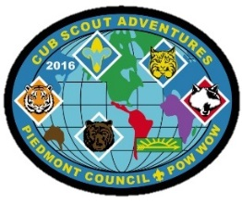

www.scouting.org/programupdates
The Program Updates page has been regrouped. Since the CS Adventure is in full swing, the emphasis on getting ready for it has been reduced. The downloads are still all there. And great information about three new Cub Leader courses at Philmont Training Center next summer.
There is a lot of information now on etting ready and implementing the changes to the Boy Scout program.
Check it all out – stay current!!




Judy and Dave need some help. If you would do one item for Baloo each month, it would help us greatly –
Some ideas for you to consider –
Biography – write a one page +/- biography of a person you select that exemplifies that month's emphasized point of the Scout Law.
Advancement – Choose a rank. Write a few hints and ideas for the Adventure to be discussed that month at the Roundtable. And, also, any that have a Character Compass pointing to that months point of the Scout Law
Roundtable Hints – Prep some hints and ideas for your fellow Roundtable Commissioners each month. This would be easy for someone from a council like Sam Houston where they have an annual RT day where they review all 12 months in advance.
Crazy Holidays – Jodi actually retired from that position a few years ago. We can supply you files for each month. You only need to check for updates and additions. Feel free to use more websites if you have a favorite.
Point of the Scout Law – Look for items that help get across the meaning of the point of the Scout Law emphasized that month in Roundtable.
Special Opportunities – write a brief article each month about one youth and one adult award other than rank advancement.
Have another idea? Let us know how you feel you could help us to make Baloo's Bugle more of what RT Commissioners, Cubmasters, and Den Leaders want.
Write us through the "Send Your Ideas to Baloo" link or directly – davethecommish@gmail.com and judyjohnsonbsa@yahoo.com

TABLE OF CONTENTS

CUB SCOUT LEARNING LIBRARY 17
TELLING OUR STORY 20
ADVENTURE PLAN TRACKERS 22
CUB SCOUT LEADER TRAINING 22
IN-PERSON TRAINING 22
ON-LINE TRAINING 22
SIGNS OF SCOUTING 23
ROUNDTABLE HINTS 25
GET OFF TO A GREAT START 25
DEN MEETING TOPICS 29
CHARACTER COMPASS 29
PACK MEETING THEMES AND PLANS 30
PACK MEETING THEMES 31
UPCOMING MONTHS 31
CUBMASTER THOUGHTS 32
AFTER THE BLUE AND GOLD 32
WEBELOS 33
CHOOSING A PATROL NAME 33
APRIL 2016: A MONTH TO BE CHEERFUL 35
APRIL CRAZY HOLIDAYS 37
TRAINING TOPICS 40
DEN DISCIPLINE 40
USING THE CUB SCOUT SIGN – 41
POSITIVE DEN DISCIPLINE 43
SPECIAL OPPORTUNITIES 44
WORLD CREST 44
THE BSA 1910 RING 45
THE MESSENGERS OF PEACE RING 45
INTERNATIONAL SPIRIT AWARD 46
BSA OUTDOOR ETHICS AWARDS 47
THEME RELATED STUFF 48
STRIKE UP THE BAND (MUSIC) RELATED ADVENTURES 48
FUN STUFF 48
ACTIVITY – MAKE A BAND 49
THEME & PACK MEETING IDEAS 56
GATHERING ACTIVITIES 56
OPENING CEREMONIES 59
AUDIENCE PARTICIPATIONS 62
ADVANCEMENT CEREMONIES 63
LEADER RECOGNITION 67
DEN LEADER SURVIVAL KIT 67
DEN CHIEF INDUCTION 67
COMPASS DEN CHIEF RECOGNITION 67
SONGS 68
STUNTS AND APPLAUSES 71
APPLAUSES & CHEERS 71
RUN-ONS 72
JOKES & RIDDLES 72
SKITS 73
CLOSING CEREMONIES 75
CUBMASTER’S MINUTES 78
CUB GRUB 79
GAMES 81
DEN ADVENTURES 83
TIGER 83
Tiger Adventure: Tigers in the Wild 83
Rationale for Adventure 84
Takeaways for Cub Scouts 84
Ideas for Adventure Requirements: 84
Den Meeting Ideas for Tigers In the Wild Adventure: 85
Animal Tracks Book 85
Tiger Elective Adventure: Tiger Tag 86
Rationale for Adventure 86
Takeaways for Cub Scouts 86
Flip the Bird Tag 87
Tiger Elective Adventure Requirements: Tiger Tag 87
What is Good Sportsmanship? 87
Steal the Bacon 87
Capture the Flag 87
Kick the Can 87
Red Light Green Light 87
Light the Candle Game for Cub Scouts 88
Pirate Pick Up Game 88
Hail Storm Game 88
Clothesline Relay Game 88
WOLF 88
Wolf Adventure: Howling at the Moon 88
RATIONALE FOR ADVENTURE 88
TAKEAWAYS FOR CUB SCOUTS 89
Ideas for Adventure Requirements: 89
Den Meeting Ideas for Howling at the Moon Adventure: 89
The Viper is Coming! 89
Got Any Duck Food? 89
Invisible Bench Skit 90
Can't Work in the Dark Skit 90
Emergency Broadcast System Skit 90
'We Have No Skit' Skit 90
Wolf Scout Skits 90
Wolf Elective Adventure: Code of the Wolf 93
Block Cipher 94
5 SECRET CODES FOR KIDS TO WRITE A CODED LETTER 94
WRITE A CODED LETTER 95
CODE ACTIVITY FOR KIDS: MAKE A SPY DECODER 95
The Thomas Jefferson Cipher Wheel 98
BEAR 99
Bear Adventure: Bear Necessities 99
Bear Elective Adventure: Roaring Laughter 99
WEBELOS CORE 100
Webelos Adventure: Webelos Walkabout 100
ARROW OF LIGHT CORE 100
Webelos/AOL Elective Adventure: Adventures in Science 100
Mini First Aid Kit 101
Make Your Own First Aid Kit 102
First Aid Kit Neckerchief Slide 102
Make personal First Aid Kits 102
Outdoor Code Responsive Reading Ceremony 103
The Outdoor Code Opening 103
Outdoor Code Closing 103
THE OUTDOOR CODE 104
Leave No Trace Awareness Award 104
Cub Scout Leave No Trace Pledge 104
Tiger Cub Scout Requirements 104
Wolf Cub Scout Requirements 104
Bear Cub Scout Requirements 105
Webelos Scout Requirements 105
Cub Scout Leader Requirements 105
LEAVE NO TRACE 105
Focus on “Leave No Trace” 105
Cub Scout Leave No Trace Pledge 106
ONE LAST THING 107
It Is Your Choice 107

There is no personal charm so great as the charm of a cheerful temperament. Henry Van Dyke

CORE VALUES
The Cub Scout Core Values are now the
12 Points of the Scout Law.
The core value highlighted this month is:
April's point of the Scout Law, CHEERFUL, will use the theme, STRIKE UP THE BAND.
A SCOUT IS CHEERFUL
A Scout looks for the bright side of life. He cheerfully does tasks that come his way. He tries to make others happy.
HOW DOES “STRIKE UP THE BAND” RELATE TO THIS POINT OF THE SCOUT LAW?
Music can make us feel many things; one of the best things it makes us feel is cheerful. As we “STRIKE UP THE BAND” this month, we will explore ways to make people happy using music.
Per our Founder, Lord Baden-Powell
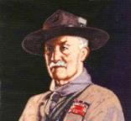
Note – The original Scout Law published in 1908 had nine points. In 1910, the BSA added Brave, Clean, and Reverent. In 1911 B-P added Clean to his original list.
A SCOUT IS CHEERFUL
Baden Powell did not use the word Cheerful, he said -
A SCOUT SMILES AND WHISTLES under all circumstances. When he gets an order he should obey it cheerily and readily, not in a slow, hang-dog sort of way. Scouts never grouse at hardships, nor whine at each other, nor swear when put out. When you just miss a train, or someone treads on your favourite corn---not that a scout ought to have such things as corns--- or under any annoying circumstances, you should force yourself to smile at once, and then whistle a tune, and you will be all right. A scout goes about with a smile on and whistling. It cheers him and cheers other people, especially in time of danger, for he keeps it up then all the same. The punishment for swearing or bad language is for each offence a mug of cold water to be poured down the offender's sleeve by the other scouts. (Scouting For Boys, 1908)

CHEERFUL QUOTES
The most certain sign of wisdom is CHEERFULNESS. Michel de Montaigne
I am CHEERFUL. I don't know if I'm happy. There is a difference, you know. Tom Robbins
A merry heart maketh a CHEERFUL countenance.
King Solomon, Proverbs 15:13
CHEERFULNESS is the best promoter of health and is as friendly to the mind as to the body. Joseph Addison
Never hurry. Take plenty of exercise. Always be CHEERFUL. Take all the sleep you need. You may expect to be well. James Freeman Clarke
CHEERFULNESS, sir, is the principle ingredient in the composition of health. Arthur Murphy
To keep the heart unwrinkled, to be hopeful, KINDLY, CHEERFUL, REVERENT - that is to triumph over old age. Thomas Bailey Aldrich
An ounce of CHEERFULNESS is worth a pound of sadness to serve God with. Thomas Fuller
Wondrous is the strength of CHEERFULNESS, and its power of endurance - the CHEERFUL man will do more in the same time, will do it; better, will preserve it longer, than the sad or sullen. Thomas Carlyle
You find yourself refreshed in the presence of CHEERFUL people. Why not make an honest effort to confer that pleasure on others? Half the battle is gained if you never allow yourself to say anything gloomy. Lydia M. Child
I am determined to be CHEERFUL and happy in whatever situation I may find myself. For I have learned that the greater part of our misery or unhappiness is determined not by our circumstance but by our disposition. Martha Washington
I think that the point of being an architect is to help raise the experience of everyday living, even a little. Putting a window where people would really like one. Making sure a shaving mirror in a hotel bathroom is at the right angle. Making bureaucratic buildings that are somehow CHEERFUL. David Chipperfield
Suffering becomes beautiful when anyone bears great calamities with CHEERFULNESS, not through insensibility but through greatness of mind. Aristotle
Being forced to work, and forced to do your best, will breed in you temperance and self-control, diligence and strength of will, CHEERFULNESS and content, and a hundred virtues which the idle will never know. Charles Kingsley
Early morning CHEERFULNESS can be extremely obnoxious. William Feather

BIOGRAPHY

WILL ROGERS
A CHEERFUL Person
I joked about every prominent man of my time, but
I never met a man I didn't like.
William Penn Adair Rogers
(4 November 1879 – 15 August 1935)
an American humorist and entertainer;
known primarily as
Will Rogers.
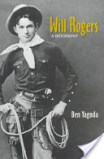
The youngest of eight children, William Penn Adair Rogers was born on November 4, 1879 in Oologah, Indian Territory (what is now Oklahoma). His parents, were part Cherokee. Growing up, Will learned to ride and lasso. He grew so talented with a rope, that he was placed in the Guinness Book of World Records for throwing three lassos at once. One went around the horse's neck, another circled around the rider, and the third flew under the horse.
Will attended school during his childhood. He dropped out to become a cowboy. Will traveled in South Africa, Australia and New Zealand. He appeared at World's Fairs. He toured the vaudeville circuits in America, Canada and Europe. In 1908, Will married Betty Blake, with whom he had four children (Will Jr., Mary, Jim and Fred).
During his years in vaudeville and the Ziegfeld Follies, Will's act evolved. He enjoyed talking and reading. These were the basis for his humor, which focused on intelligent and amusing observations about people, life, the country and the government in simple language that his audience could understand. Audiences hankered for Will's cheerful humor more than roping feats.
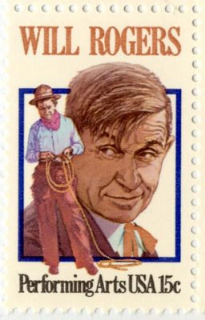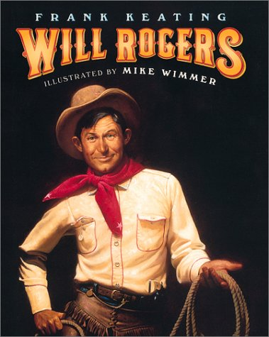
He starred in 71 movies and wrote 4,000 syndicated columns and six books, became a prominent radio broadcaster and political commentator. He called politics "the best show in the world" and described Congress as the "national joke factory." His cheerful folksy humor and honest, intelligent observations about the government and America earned the respect of the nation. Because he was a nationally beloved figure and powerful political pundit, Will was known to US and world leaders. When planning the American Adventure pavilion at EPCOT, the Walt Disney Company initially considered having an audio animatronic Will Rogers emcee along with Ben Franklin and Mark Twain. Will was to represent the 20th Century (1900's) as Ben Franklin does the 18th (1700's) and Mark Twain the 19th (1800's).
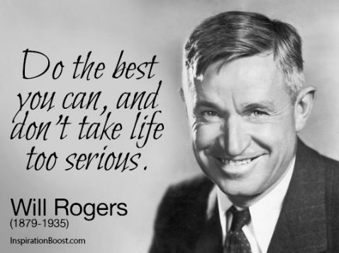
Will's life was cut short on vacation with aviator Wiley Post, This flight ended the life of America's most beloved celebrity on August 15, 1935 when Will and Wiley's flight crashed near Point Barrow, Alaska.
Will Rogers' political writings and sayings continue to remain relevant to politics today, and his cheerful wit and humor continue to endear him to audiences everywhere. To find out more about Will Rogers, fans can visit the Will Rogers Memorial Museum in Claremore, Oklahoma and the Will Rogers Dog Iron Ranch & Birthplace Home in Oologah, Oklahoma.
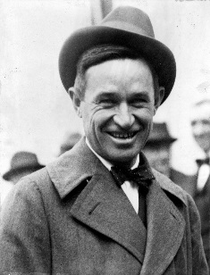
If you want to be successful, it's just this simple. Know what you are doing. Love what you are doing. And believe in what you are doing. Will Rogers
Thinking about the quote above - It is no wonder Baden-Powell was successful in starting Scouting. And that Scouting is most successful where those leading it believe in it and love it!!
Believe me, the Boys can tell if you don't!!
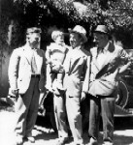
Will Rogers, Wiley Post, and Waite Phillips at the
Villa Philmonte shortly before the fatal flight.
Will and Waite were good friends!!

WILL ROGERS QUOTES
Never miss a good chance to shut up.
A remark generally hurts in proportion to its truth.
Good judgment comes from experience, and a lot of that comes from bad judgment.
The quickest way to double your money is to fold it and put it back into your pocket.
There are three kinds of men: The ones that learn by reading. The few who learn by observation. The rest of them have to pee on the electric fence and find out for themselves.
Always drink upstream from the herd.
Chaotic action is preferable to orderly inaction.
If you find yourself in a hole, stop digging.
A man only learns in two ways, one by reading, and the other by association with smarter people.
After eating an entire bull, a mountain lion felt so good he started roaring. He kept it up until a hunter came along and shot him. The moral: When you’re full of bull, keep your mouth shut.
Diplomacy is the art of saying "Nice doggie" until you can find a rock.
Don't let yesterday use up too much of today.
Everything is funny, as long as it's happening to somebody else.
Get someone else to blow your horn and the sound will carry twice as far.
If you want to be successful, it's just this simple. Know what you are doing. Love what you are doing. And believe in what you are doing.
So let's be honest with ourselves and not take ourselves too serious, and never condemn the other fellow for doing what we are doing every day, only in a different way.
The fellow that can only see a week ahead is always the popular fellow, for he is looking with the crowd. But the one that can see years ahead, he has a telescope but he can't make anybody believe that he has it.
The more that learn to read the less learn how to make a living. That's one thing about a little education. It spoils you for actual work. The more you know the more you think somebody owes you a living.
Live in such a way that you would not be ashamed to sell your parrot to the town gossip.
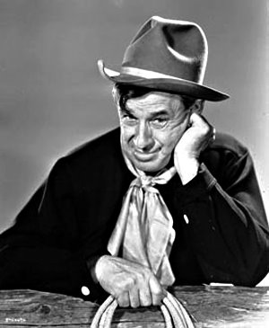
Will Rogers is still relevant today -
Today we talk about the 1% or the 0.1% beings o rich -
Here is what Will Rogers had to say about the rich –
Ten men in the country could buy the world
and ten million can’t buy enough to eat.
Or how about –
"There is (sic) two things that can disrupt business in this country. One is war and the other is a meeting of the Federal Reserve (Board)."
"The day of the guy working for himself is past. We are living in an age of Mergers. When your business is not doing good you combine with something and sell more stock. The poor little fellow, he can't combine with anything but the Sheriff in case he is going broke, which he generally is. But Big Business merges with another that's not going good and both do nothing together. But it's one of the mental weaknesses of the American people that if two things go together they think it must be great. They don't know how it will be financially, but they know that the stock will go up, and that's all they think about, never mind the dividends.
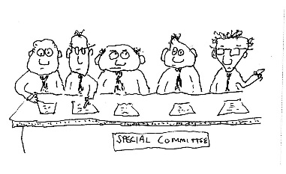
"Outside of traffic, there is nothing that has held this country back as much as committees."

POSITIVE HABITS OF
CHEERFUL PEOPLE
Note – By the Tom Robbins, American Author, quote listed above being CHEERFUL and being happy are not the same thing. However, I think if you live in the positive manner having these habits will create, you will be both CHEERFUL and happy. CD
This list with slight variations in items, differences in explanations, and introductory paragraphs appears on at least a dozen websites with varying by lines. To find more information about the topic, how to improve your health and life, or simply learn more, I recommend Googling "22 Habits of Happy People," and doing your own research. This brief article is intended to stir curiosity and personal research. CD
There are two types of people in the world: those who choose to be happy, and those who choose to be unhappy. Contrary to popular belief, happiness doesn’t come from external things - fame, fortune, other people, or material possessions. Rather, it comes from within. The richest person in the world could be miserable while a person living in the slums of a third world country could be happy and content. I have spent plenty of time amongst both groups to have seen it first-hand. Happy people are happy because they make themselves happy. They maintain a positive outlook on life and remain at peace with themselves.
The question is: how do they do that?
It’s quite simple. Happy (CHEERFUL) people have good habits that enhance their lives. They do things differently. Ask any happy person, and they will tell you that they …
- Don’t hold grudges. Happy people understand that it’s better to forgive and forget than to let their negative feelings crowd out their positive feelings. Holding a grudge has a lot of detrimental effects on your wellbeing, including increased depression, anxiety, and stress. Why let anyone who has wronged you have power over you? If you let go of all your grudges, you’ll gain a clear conscience and enough energy to enjoy the good things in life.
- Treat everyone with kindness. Did you know that it has been scientifically proven that being kind makes you happier? Every time you perform a selfless act, your brain produces serotonin, a hormone that eases tension and lifts your spirits. Not only that, but treating people with love, dignity, and respect also allows you to build stronger relationships.
- See problems as challenges. The word “problem” is never part of a happy person’s vocabulary. A problem is viewed as a drawback, a struggle, or an unstable situation while a challenge is viewed as something positive like an opportunity, a task, or a dare. Whenever you face an obstacle, try looking at it as a challenge.
- Express gratitude for what they already have. There’s a popular saying that goes something like this: “The happiest people don’t have the best of everything; they just make the best of everything they have.” You will have a deeper sense of contentment if you count your blessings instead of yearning for what you don’t have.
- Dream big. People who get into the habit of dreaming big are more likely to accomplish their goals than those who don’t. If you dare to dream big, your mind will put itself in a focused and positive state.
- Don’t sweat the small stuff. Happy people ask themselves, “Will this problem matter a year from now?” They understand that life’s too short to get worked up over trivial situations. Letting things roll off your back will definitely put you at ease to enjoy the more important things in life.
- Speak well of others. Being nice feels better than being mean. As fun as gossiping is, it usually leaves you feeling guilty and resentful. Saying nice things about other people encourages you to think positive, non-judgmental thoughts.
- Never make excuses. Benjamin Franklin once said, “He that is good for making excuses is seldom good for anything else.” Happy people don’t make excuses or blame others for their own failures in life. Instead, they own up to their mistakes and, by doing so, they proactively try to change for the better.
- Get absorbed into the present. Happy people don’t dwell on the past or worry about the future. They savor the present. They let themselves get immersed in whatever they’re doing at the moment. Stop and smell the roses.
- Wake up at the same time every morning. Have you noticed that a lot of successful people tend to be early risers? Waking up at the same time every morning stabilizes your circadian rhythm, increases productivity, and puts you in a calm and centered state.
- Avoid social comparison. Everyone works at his own pace, so why compare yourself to others? If you think you’re better than someone else, you gain an unhealthy sense of superiority. If you think someone else is better than you, you end up feeling bad about yourself. You’ll be happier if you focus on your own progress and praise others on theirs.
- Choose friends wisely. Misery loves company. That’s why it’s important to surround yourself with optimistic people who will encourage you to achieve your goals. The more positive energy you have around you, the better you will feel about yourself.
- Never seek approval from others. Happy people don’t care what others think of them. They follow their own hearts without letting naysayers discourage them. They understand that it’s impossible to please everyone. Listen to what people have to say, but never seek anyone’s approval but your own.
- Take the time to listen. Talk less; listen more. Listening keeps your mind open to others’ wisdoms and outlooks on the world. The more intensely you listen, the quieter your mind gets, and the more content you feel.
- Nurture social relationships. A lonely person is a miserable person. Happy people understand how important it is to have strong, healthy relationships. Always take the time to see and talk to your family, friends, or significant other.
- Meditate. Meditating silences your mind and helps you find inner peace. You don’t have to be a zen master to pull it off. Happy people know how to silence their minds anywhere and anytime they need to calm their nerves.
- Eat well. Junk food makes you sluggish, and it’s difficult to be happy when you’re in that kind of state. Everything you eat directly affects your body’s ability to produce hormones, which will dictate your moods, energy, and mental focus. Be sure to eat foods that will keep your mind and body in good shape.
- Exercise. Studies have shown that exercise raises happiness levels just as much as Zoloft does. Exercising also boosts your self-esteem and gives you a higher sense of self-accomplishment.
- Live minimally. Happy people rarely keep clutter around the house because they know that extra belongings weigh them down and make them feel overwhelmed and stressed out. Some studies have concluded that Europeans are a lot happier than Americans are, which is interesting because they live in smaller homes, drive simpler cars, and own fewer items.
- Tell the truth. 21 Days to Greater Success! Get the book that will help you add these habits to your life! Lying stresses you out, corrodes your self-esteem, and makes you unlikeable. The truth will set you free. Being honest improves your mental health and builds others’ trust in you. Always be truthful, and never apologize for it.
- Establish personal control. Happy people have the ability to choose their own destinies. They don’t let others tell them how they should live their lives. Being in complete control of one’s own life brings positive feelings and a great sense of self-worth.
- Accept what cannot be changed. Once you accept the fact that life is not fair, you’ll be more at peace with yourself. Instead of obsessing over how unfair life is, just focus on what you can control and change it for the better.


You may have noticed that some of the habits of happy people are one in the same with those that are essential for leading a healthy lifestyle – exercising and eating right, for example.
And, if you look back at the quotes column, there are several health-related CHEERFUL quotes boxed together.
Healthy habits will help keep your mood elevated (CHEERFUL, Happy) naturally even in the midst of stress.
Cheerful people tend to be healthy people, and vice versa. Just as it takes three things to have a successful Cub Scout program – boys, parents, and leaders, it takes three things to create emotional wellness (being CHEERFUL and Happy) - healthy food, exercise, and a positive lifestyle.

BSA Social Media

You Tube Channels
(Images are hyperlinked to the You Tube Channels)

Scouting Magazine
 | 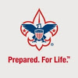
Boys’ Life Magazine | Boy Scouts of America
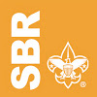
Summit Bechtel Reserve

Check out the cool stories and interviews on the different channels

Scouting Magazine

Cool Camp Series
- Camp Tahosa
- Camp Cedars
- Swamp Base
- Emerald Bay
- Camp Steiner
- Ransburg Scout Reservation
Be sure to check out other “Cool Camp” Videos.

Scouting’s Coolest Sport
- Ice Climbing

Awesome Interviews
- Eagle Scout Iditarod Racer Matthew Filor
- Mike Rowe

Boys Life Magazine
- Basic First Aid Kit
- Display and Fold the American Flag
- Venturing Crew 310 Climbing at Mount Hood
- Star Wars BB-8

Boy Scouts of America

Scouting is for Families Like Mine
- Michelle C.
- Becky

Build an Adventure
- Checklist
- Rocket man
- Construction Zone

Summit Bechtel Reserve
- 2017 National Jamboree
- Mountaineer Weekend

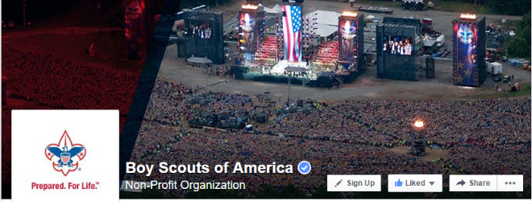
BSA Facebook
Sign up and get all the latest
as it hits the wires!!!
Cubs have your parents to Sign Up.
Read on the BSA Facebook page about one cub scouts “…true spirit of sportsmanship.”

https://cubscouts.org/sportsmanship-is-the-real-winner-at-pinewood-derby/

Cubcast

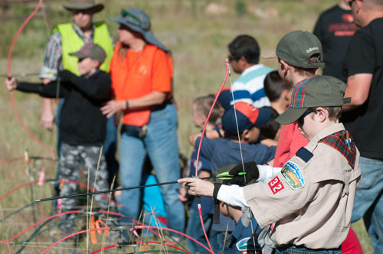
Cub Scouts and Shooting Sports
As CubCast co-host Aaron Derr says, “There’s nothing like the first time you take your son to the shooting range, and after you hear them say, ‘Always point the gun toward the target,’ your kid is the first one who spins around and the gun spins around with him and everybody has to duck.” So we thought it might be a good idea to have Dennis Kampa, author of the BALOO training, join us to explain how shooting sports can teach Cub Scouts valuable life lessons incorporating the Scout Oath and Law.
Listen

Scoutcast
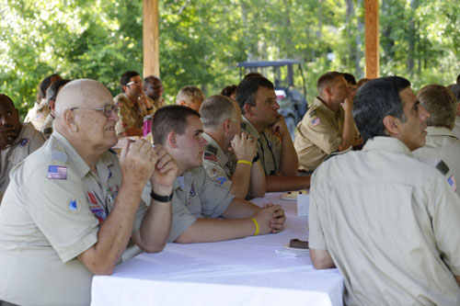
The Scoutmaster’s Minute
The Scoutmaster’s Minute is a brief inspirational message, usually given at the end of a meeting or at the end of an activity in which you bring the whole group back together. But what makes a good Scoutmaster’s Minute? Does it have to be at the end of the meeting? And does it have to be a minute? We asked these questions to John Duncan, Council Commissioner with the Northeast Illinois Council, who gave us a lot of food for thought.
Listen
Be sure to look over the archived Cubcast and Scoutcast recordings. These archives are listed on the left navigation are of the web site.
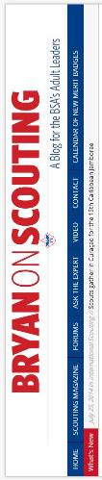
February 2016

Bryan’s Blog
“Bryan on Scouting” is the official blog of Scouting magazine, a Boy Scouts of America publication. Scouting magazine is published five times a year and is received by 1 million registered adult volunteers. Bryan covers many topics every month. He keeps his Blog current and deals with the latest issues.
His articles this past month are listed below (Every title has a hyperlink). The articles in BLUE are of special interest for Cub Scout Leaders.
If the word SPONSORED appears, that BSA received compensation for that blog post.

What’s new in the March-April 2016 edition of Scouting
February 19, 2016 // 0 Comments
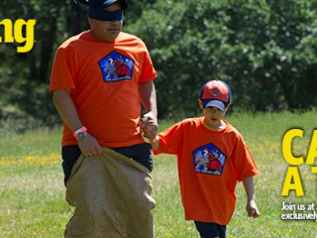
The March-April issue of Scouting will be reaching mailboxes this month. Here's a sneak peek at the stories you'll find inside!

This video could be the greatest Scout recruiting tool yet
February 19, 2016 // 13 Comments
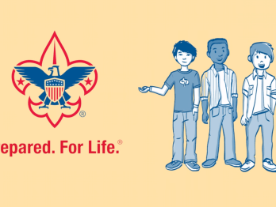
Does Scouting work? A new, highly shareable Scout recruiting video answers that question with a resounding "yes."

BSA names its National Alumnus of the Year for 2016
February 18, 2016 // 0 Comments
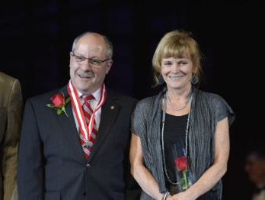
The Scouting Alumni Association has named Ray Capp, Distinguished Eagle Scout and chairman of the Order the Arrow, as its 2016 National Alumnus of the Year.

Five groups who benefit from the BSA’s superb STEM programs
February 18, 2016 // 29 Comments

Any young person who experiences STEM in Scouting or STEM Scouts will benefit. But we found five specific groups who seem primed to enjoy STEM.

Eagle Scout one of 12 students in the world to ace AP Calculus test
February 17, 2016 // 4 Comments
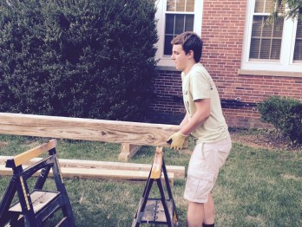
Eagle Scout Landon Labuskes is one of just 12 students in the world to get a perfect score on the Advanced Placement Calculus exam.

Before he served on the Supreme Court, Antonin Scalia was a Boy Scout
February 16, 2016 // 10 Comments
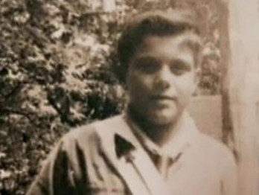
Antonin Scalia, the U.S. Supreme Court justice who died Saturday, was a Cub Scout, Boy Scout and a member of the Order of the Arrow.

Kids to Parks Day 2016: ‘Explore outdoors, the parks are yours!’
February 16, 2016 // 3 Comments
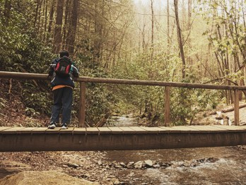
Kids to Parks Day 2016 is May 21. The day offers a terrific opportunity to get outside and explore parks and public lands — either with your Scouting family or your actual family.

A parent helped build that Pinewood Derby car? Yes, that’s the point
February 12, 2016 // 61 Comments
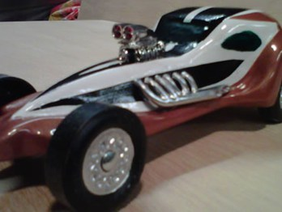
It was the most beautiful Pinewood Derby car the pack had ever seen. And it was clear that a parent helped build it. But isn't that the point?

In Michigan and beyond, Scouts stepping up to help Flint
February 12, 2016 // 6 Comments

Scouts in the Michigan Crossroads Council will collect and donate bottled water in an effort to help those affected by the water crisis in Flint, Mich.

This letter from LeBron James to a new Eagle Scout is a slam dunk
February 12, 2016 // 4 Comments

You can imagine Eagle Scout Joseph's surprise when he opened an envelope to reveal a letter from NBA superstar LeBron James.

Let’s celebrate 10 black leaders who got their start in Scouting
February 11, 2016 // 13 Comments

In celebration of Black History Month, we wanted to share a list of 10 prominent African-American leaders who got their start in Scouting.

Sea Scouts becomes its own program within the BSA
February 10, 2016 // 16 Comments

Sea Scouting, the 104-year-old nautical arm of the Boy Scouts of America, will become its own independent program within the BSA, effective immediately.

The four elements behind every great Scoutmaster’s minute
February 10, 2016 // 1 Comment
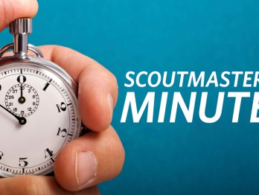
In those 60 seconds (or a little longer), a Scoutmaster's minute helps inspire Scouts with a story, a parable or an anecdote.

Jamboree Performance Troupe seeks dancers, singers, comedians
February 10, 2016 // 5 Comments
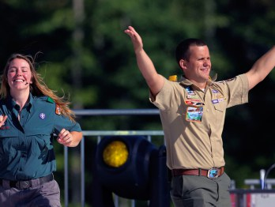
The BSA's jamboree planners are looking for a few Scouts and Venturers to take their talents to West Virginia and join the Jamboree Performance Troupe.

These two Eagle Scouts are now Super Bowl champions
February 10, 2016 // 4 Comments

Denver Broncos players Matt Paradis and Aaron Brewer, both Eagle Scouts, now own another impressive title: Super Bowl champions.

There’s now a fourth way to earn the Snow Sports merit badge
February 10, 2016 // 12 Comments

Beginning Jan. 1, 2016, there's a fourth way to earn the Snow Sports merit badge. Snowshoeing joins downhill skiing, cross-country skiing and snowboarding as options for earning this elective merit badge.

How shooting sports help Cub Scouts grow
February 9, 2016 // 12 Comments
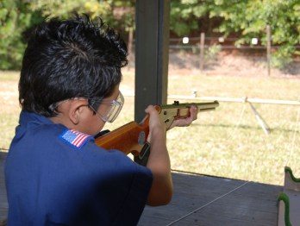
Fortunately, the strength of the BSA's shooting sports program — which starts in Cub Scouts — is in its emphasis on safety above all else.
How long should pack meetings last? What about troop and crew meetings?
February 9, 2016 // 17 Comments

How long should pack meetings last? How long should troop meetings last? And how long should crew meetings last?

Virginia Scouts share emergency action plan used to clear snow after winter storm Jonas
February 9, 2016 // 10 Comments
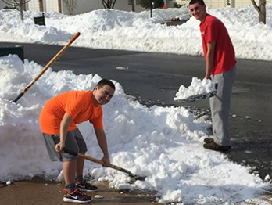
After winter storm Jonas blanketed the northeast in more than two to three feet of snow, Virginia Troop 581 used an emergency action plan to mobilize more than 100 Scouts to clear snow.
North Carolina camp recognized for sustainable forest management
February 8, 2016 // 0 Comments
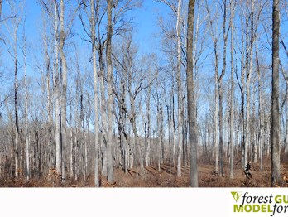
Cherokee Scout Reservation's sustainable forestry practices not only generate revenue for the council, but accolades, too. The property is the only Boy Scout camp named a "Model Forest" by the Forest Guild.

Jeep Super Bowl commercial puts Scouting on the world’s biggest stage
February 8, 2016 // 34 Comments
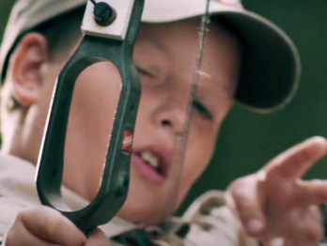
A Jeep Super Bowl commercial included a reference to Scouting. It makes sense, seeing as both Scouting and Jeep are part of America's identity.

On BSA’s 106th birthday, one volunteer asks: Is Scouting still relevant?
February 8, 2016 // 47 Comments

In honor of the BSA's 106th birthday, read an essay from national Order of the Arrow chairman Ray Capp. The essay: "Is Scouting still relevant?"

Denver Broncos have two Eagle Scouts on their roster
February 5, 2016 // 0 Comments
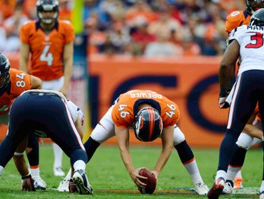
Earlier this week we told you about one Eagle Scout on the Denver Broncos lineup. Turns out there is another.

Venturer learns to appreciate Scouting’s global reach
February 4, 2016 // 4 Comments

Many American Scouts and Venturers know little about Scouting in other countries. But Pratik Vaidya recently learned to appreciate Scouting's global reach.

Read Stephen Colbert’s hilariously awesome letter to a new Eagle Scout
February 4, 2016 // 22 Comments

Stephen Colbert, host of The Late Show on CBS, wrote an awesome congratulatory letter to an Eagle Scout. In it, he hints at his thoughts about Scouting.

Scouts, Explorers ring Opening Bell on New York Stock Exchange
February 3, 2016 // 1 Comment

A group of New York Scouts and Explorers can count themselves among the ranks of celebrities who have rung the Opening Bell on the New York Stock Exchange.

Get to the Summit Bechtel Reserve this summer for VenturingFest 2016
February 3, 2016 // 11 Comments
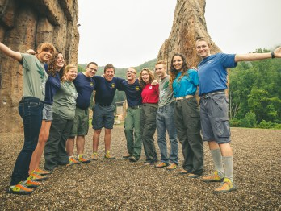
Billed as a "Scouting experience unlike any other," VenturingFest 2016 is a national gathering of Venturers, held at one of the coolest spots in Scouting.

How the BSA benefits every time you hear ‘God Bless America’
February 3, 2016 // 18 Comments

Every time "God Bless America" is performed, a portion of the song's royalties go to benefit Scouts in the BSA's Greater New York Councils.

Carolina Panthers coach Ron Rivera helps grow Scouting in Charlotte
February 2, 2016 // 0 Comments
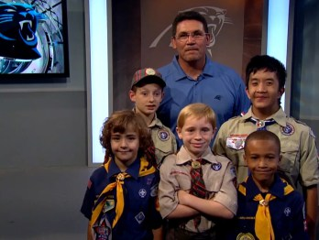
Carolina Panthers coach Ron Rivera, a former Boy Scout, serves as the honorary Round-Up Chairman for the Mecklenburg County Council.

Eagle-required Cooking merit badge’s 2016 requirements now in effect
February 2, 2016 // 27 Comments

Requirements for the Eagle-required Cooking merit badge have been revised for 2016, with better organization, fewer redundancies and a focused approach.

There’s an Eagle Scout playing in Super Bowl 50
February 1, 2016 // 12 Comments
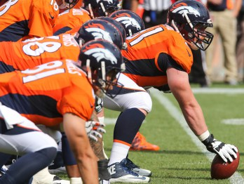
When the Denver Broncos and Carolina Panthers kick off Super Bowl 50 on Feb. 7, 2016, an Eagle Scout will be among the starters.

Blog Contributors
Bryan Wendell, an Eagle Scout, is senior editor of Scouting and Eagles' Call magazines.

Gretchen Sparling is associate editor of Scouting and Eagles' Call magazines.

Get Email Updates
To sign up to receive Bryan’s Blog in your E-mail –
Click the link that appears in every article. Bryan and Gretchen promise never to sell or otherwise exploit your email address. Join 6,852 other subscribers

CUB SCOUT LEARNING LIBRARY
The NEW https://cubscouts.org/ !!!

This is the Cub Scout Learning Library –
Everything you could want to know for Cub Scouts is or will be here. And all within a click or 3 of the home page. National heard the message that although things were at www.scouting.org they were often buried too deep to be found.
This site has admin stuff and practical stuff. The new Den Leader Resource Books are here. You can download some of the pages for each Adventure for FREE
This website is a great resource. There are still parts under construction but what is there is GREAT!!

BSA seems to be working off the same plans that www.USScouts.org and other "unofficial" Scouting websites use. They have seen what you the volunteers want and are delivering it. I hope they are successful and some of us old guys (I have my Medicare card) can retire from our web duties.
Yes, https://cubscouts.org runs on a phone, too!!!

There are 4 tabs on top of the home page –

- Learning Library
- Cub Hub Blog
- Join Scouting
- Pinewood Derby Photo Contest (NEW THIS MONTH!!)
- Learning Library takes you where you can learn about your position and pick up hints. Besides specifics for dens of each rank, other clickable links include –
KEY
- All or most of material was placed on site this past month
- All or most of material was in place and listed as such in last month's Baloo's Bugle.
- Site / pages under construction
- Den Leader
Den Meeting Basics
- Your First Den Meeting
- Planning Den Outings
- The Parts of a Den Meeting
- Getting Started
Three of the Core Adventures for the selected rank are listed here. Click on them and you will see / can download all the Leader's Guide pages for these three Adventures.
- Additional Required Adventures
The remaining Core Adventures for the selected rank are listed here. When you click them you get an intro to the Adventure but do not get the Meeting Plans and Resources. You see this note:
To get you started in delivering fun and engaging meetings, complete Den Meeting Plans are available here on the Learning Library for the Backyard Jungle and Games Tigers Play adventures. To obtain Den Meeting Plans for all other adventures, Den Leader Guides are available at your local Scout Shop, online at scoutstuff.org, or as an eBook through Amazon.
- Elective Adventures
All the Elective Adventures for the selected rank are listed here. When you click them you get an intro to the Adventure but do not get the Meeting Plans and Resources. You see the same note (above).
- Building Strong Dens
The Basics of Cub Scouts
- Advancement
- BSA Mission and Vision Statements
- Cub Scout Ages and Ranks
- Cub Scout Uniforming
- Den Flags
- Den Yells
- Leader Survival Kit
- Methods of Cub Scouting
- Purpose of Cub Scouting
- Roles and Responsibilities
- Scout Oath and Law
- What Is Cub Scouting?
- Training
- The Role of Training
- Youth Protection
- Den Planning And Administration
- Advancement Basics
- Advancement Requirements
- Annual Planning For Your Den
- Coordinating Your Den Plan with Pack
- Tracking and Recognizing Advancement
- Youth Protection Training
- Positive Youth Development and Working with Boys
- Developmental Differences Boys 7-11
- Behavior and Discipline
- Positive Youth Development
- Working With Special Needs Cub Scouts (Advice is specific to each Special Need. Lots of research was done to prep these pages.)
- Parents’ Prejoining Conference
- Leadership Techniques
- Working With Specific Disabilities and Needs

- Cubmaster
- Committee Chair/Member
- Chartered Org Rep
- Parent / Adult Partner
- Cub Hub takes you to a Cub Scout specific Blog similar to Bryan's Blog. The most recent topics discussed are listed here. There are more at www.cubscouts.org:
There were 5 new posts this month. Four have Pinewood Derby information. CD
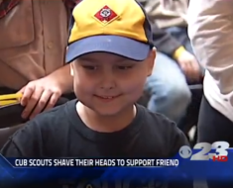 A Cub Scout With Cancer Finds Solidarity in Shaved Heads Scouting is Like a Family Some say a Cub Scout pack is like a family. Maybe that’s because…
 Cub Scouts and Conservation: Making a Safe Turtle Crossing Why did the Turtle Cross the Road? You’ve probably heard about a million reasons why the chicken crossed…
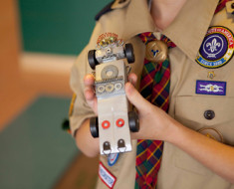 Introducing the 2016 Pinewood Derby Photo Contest Pinewood Derby Photo Contest 2016. Here it is, back by popular demand! We all had so much…
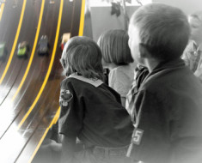 Sportsmanship is the Real Winner at Pinewood Derby In some ways, Pinewood Derby can be disappointing for young, hopeful minds and hearts, especially considering the…
 10 Ways to Involve Everyone at Pinewood Derby For Cub Scouts all over the country, Pinewood Derby is a fun and social event that is…
- Join Scouting takes you to www.beascout.org
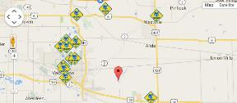

- Pinewood Derby Photo Contest Takes you to an entry form for the Pinewood Derby Photo Contest.
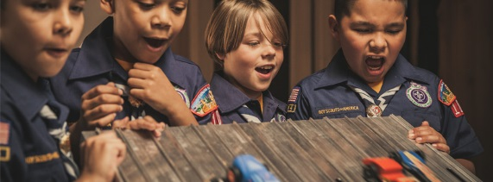
- Also, on the home page –
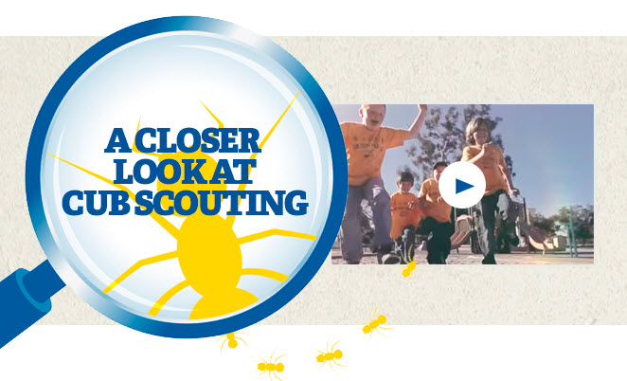
This link takes you to a YouTube Video
on Cub Scouting.
https://www.youtube.com/watch?feature=player_embedded&v=dqKFgk8SJlE
These Six Links take you to:
(From top left across, then down)

www.scoutstuff.org – The Supply Division site where you can find the location of your nearest National Scout Shop or buy all your Scout supplies
http://scoutingwire.org/ - Where you can get the latest Scouting News from around the country. You can sign up to get notifications when things are posted here...
www.scouting.org/programupdates - The great site where all the news about all the changes to Cub Scouting, Boy Scouting, and Venturing can be found.
https://www.scoutbook.com/ Where you can get the Scoutbook APP to track your son's Scouting Experience from Tiger to Eagle Scout.
I just learned that Bob Scott is at it again. Bob led us on the charge to the "CS Adventure Program." Now he is leading the Scoutbook effort. It is sure to be a success!! CD

www.boyslife.org – Go directly to the on-line edition of Boys 'Life
http://scoutingwire.org/marketing-membership/ Get resources and materials to strengthen your unit at BSA's marketing and membership site. Learn the best practices and tips employed by the most successful units.

TELLING OUR STORY
Robert Stocker
W
ELCOME to “Telling Our Story.” A new column in Baloo’s Bugle. Here we are going to learn and discuss how to use Social Media and traditional media, to tell our unit’s story and how this can be used to aid in recruitment.
What is the Boy Scout Moto? Be Prepared. We need to “Be Prepared” in order to use social and traditional media for telling our story, and is what this first article in this column is all about.

In May of 2014, Dr. Robert Gates, National President of the Boy Scouts of America, commented on how “…our marketing needs to be focused on local media – whether traditional local television and newspapers or social media” (Gates, Robert M., May 23, 2014, pg. 11). Dr. Gates went on to comment on how the National Office “…ought to think about how to engage local volunteer leaders in reaching out to local media with stories about our scouts doing great things for that community” (Gates, Robert M., May 23, 2014, pg. 12-13). If you did not hear Dr. Gates’s speech in 2014, here is a link to that speech.
With Dr. Gates’s words in mind from that speech, this new column is designed to share how units can use media to “Tell Our Story.”. We will be looking at guidelines, branding, examples of units sharing their stories, and how to best use the different media outlets that are available to scout leaders, scouts, and scout families.
Before we begin any type of media campaign, we need to realize there is more to using media in telling our story then simply sending pictures into our local paper for publication or creating a Facebook page and posting pictures.
Because we are representing Boy Scouts of America (BSA) we need to be aware of the guidelines and branding standards that the BSA has created for use of media. In addition, we have to remember that we do not automatically have the right to post a picture of a scout who is not our own, and we need to keep in mind Youth Protection Training (YPT) standards.
PERMISSION

You must have signed permission from each person in your unit to share their image. For scouts under 18 you will need to get signed permission from their parent. There is a form that can be used from the Scouting.org web site (Click on the image to the right).
GUIDELINES

On the National BSA web site you can find the guidelines for social media (click the image). Be sure to go over these guidelines before you begin utilizing social media.
BRANDING

Another place that you should look over is the “Brand Identity Guide.” Here you will find lots of information regarding the BSA Brand and how you can and cannot use it. For example, one of my favorite images to use in flyers was the gold fleur-de-lis. As you can tell from this copied image, there is an “X” over it. The reason is because the gold fleur-de-lis has been retired and is not to be used, according to BSA Branding. I still have some flyer templates that use this image; so guess what I will be doing now? Yep, removing this image from my templates.
I actually did not know this until doing research for this column. This goes to show how important it is to periodically check the Branding Identity Guide for changes.
MARKETING
In addition to the guide lines, there are lots of great marketing tools available to units, districts, and councils. For example here are some Cub Scout Assets that can used.
If you have not looked at all the social media places that the Boy Scouts of America are on, check out this link.
PUT IT INTO ACTION
So now you have looked at all of this information and you have a massive headache from information overload. All you want to do is take some pictures of the scouts doing fun activities; and share them with friends in different ways, awesome! Do not let this information overload scare you off.
It really boils down to a few things and hopefully you are already doing them.
- Have the permission slips signed by the parents of your scouts and by each adult leader for themselves.
- Add a caption to the photo of who is in the picture along with the date and location.
Really, you only have one more decision to make and it is a simple one. Where are you going to share your photographs at? It cannot be that hard to choose… RIGHT!
Facebook, Facebook Groups, Facebook Pages, Instagram, Snap Chat, Twitter, Google+, Flickr, and Pinterest are just a few places you can share your images.
FINAL THOUGHTS FOR THIS MONTH
One last thing you may want to consider and that is to assign a media person/team. This person/team would oversee the media information that your unit shares on social media. You might have a parent that has their own blog, or a parent that is really into social media, a Subject Matter Expert (SME). It could be that you have a parent that is works in or is interested in marketing.
Next month we will begin our deep dive into the different social media channels. We will start with Facebook.
 Start, Stop, Continue feedback always welcome.
NEXT MONTH’S TELL OUR STORY TOPIC
Facebook, Facebook Groups, Facebook Pages.

ADVENTURE PLAN TRACKERS
- Tracking Spreadsheets are posted on the USScouts Advancement webpage (www.usscouts.org). There are be links to them from other places on the site. These spreadsheets are similar in construction and user interface as the existing spreadsheets. The spreadsheets have be tested by the developer of the current spreadsheets and he said they are so good he sees no reason to develop others!!
- Utah National Parks Council has Excel spreadsheets posted for all the new Adventure Plan requirements on their Akelas Council Blogspot. www.Akelascouncil.blogspot.com .
The Advancement Excel Spreadsheet workbooks are distributed to Scouters for FREE.
PLEASE do not download the files from either site to email or send them digitally to others. They are for your personal / pack use only. If you would like to share these files with others, please copy / send the link to them and send them to the site so they can print off their own. They would love everyone that wants a copy to get their own copy absolutely free. Both USScouts and Utah National Parks receive Ad money based on the number of people visiting the site that helps keep their websites open. Please help us by encouraging others to visit them to obtain the files.

CUB SCOUT
LEADER TRAINING

IN-PERSON TRAINING
Position-Specific In-Person Training Guides Available Now! The training guides for
- Den Leader (http://www.scouting.org/filestore/training/pdf/515-215.pdf ),
- Cubmaster/Assistant Cubmaster (http://www.scouting.org/filestore/training/pdf/511-503_WB.pdf ), and
- Pack Committee (http://www.scouting.org/filestore/training/pdf/511-504_WB.pdf )

Are available on Scouting University. You can access them at http://www.scouting.org/training/adult.aspx .


ON-LINE TRAINING
On-Line Training for all Cub Scout positions has been available since October 25, 2015
The online training for Den Leaders, Cubmasters, Committee Chairs and members, and Chartered Organization Representatives is totally updated with help from volunteers from around the country. The new training is divided into shorter, more targeted modules so leaders can get the training they need, in the order they want, any time they need it. It is organized around the learning needed prior to the first meeting, in the first 30 days, and to be position-specific trained. This training was developed to be implemented in conjunction with the BSA’s new learning management system. Keep an eye on
my. Scouting Tools (log in at https://My.Scouting.org ) for more information.
Go to the BSA Volunteer Training Team Facebook page (Link above) and.
Then you automatically receive the latest news!!

If you are having difficulties with
the training or system call
Member Care at 972-580-2489,
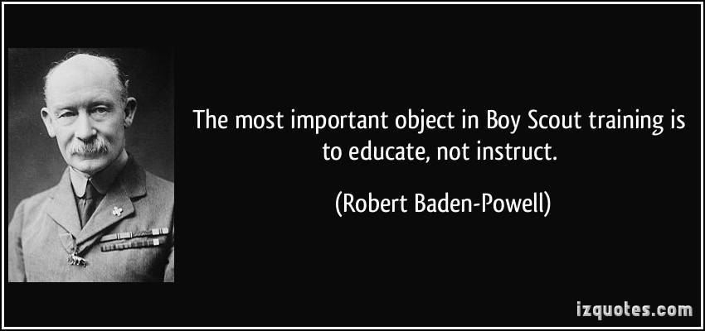
A Typical Learning Plan has several parts –
There is no need to complete more than one section at a time. Do what you have time to do.
Here you can see the three parts of the CM Course -


Each of these three parts is broken down into "bite sized" chunks:
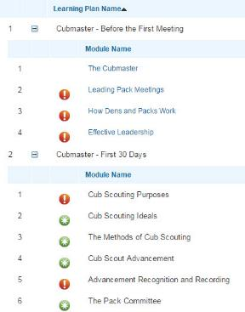
Go check it out and get your
people trained!!!

SIGNS OF SCOUTING
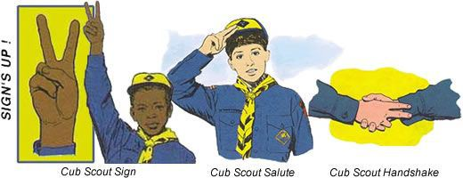
Although none of the signs changed, some of
the meanings changed because of moving to
the Scout Oath and Scout Law.
The Cub Scout Sign
The Cub Scout sign is made with the right arm held high and straight up above the shoulder, with the index and middle fingers forming a V. The other fingers are held down by the thumb. It’s the sign of Cub Scouts in many countries around the world.
The two extended fingers stand for the Scout Oath and Scout Law. They also represent the ears of an alert wolf ready to listen to Akela! They remind boys to be attentive.
Cub Scout Leaders and Cub Scouts should make the Cub Scout sign when repeating the Scout Oath and Scout Law. The sign is also used in the Living Circle and other ceremonies.
Leaders can use the sign to get the boys’ attention or to remind them to be quiet in meetings. When a leader raises the sign, the boys should become quiet and make the sign themselves—and activities cease until each boy has responded appropriately. Reinforce this use of the sign by complimenting the first Cub Scout who reacts. Avoid saying “signs up” to get their attention; let the sign do the work. See additional discussion in "Den Discipline" item on this use of the Cub Scout Sign.

The Boy Scout Sign
The Boy Scout sign is made with the right arm held straight out from the shoulder in a horizontal position, the elbow bent 90 degrees, with the hand in an upraised vertical position, the three middle fingers relatively straight (not spread wide apart), with the thumb holding down the pinky.
In 1907 in Scouting for Boys, Robert Baden-Powell chose the three-finger salute for Scouts to represent the three aspects of the Scout Oath or Promise:
- Honor God and Country
- Help Others
- Obey the Scout Law
BSA has expanded this a little. In the BSA, the three parts of the Scout Oath are:
Duty to God and Country - The core of your being is your relationship with God. Your duty to your country is being a good citizen, obeying the laws, working to make it a stronger nation, and defending it and its principals.
Duty to Other People - Doing your Good Turn each day, looking for people that could use a hand, and providing aid for community services are all ways to help others. We are obligated to help those that cannot help themselves and helping with a CHEERFUL spirit builds our own character.
Duty to Self - Caring for yourself physically, mentally, and morally will result in a more rewarding life. This includes Obeying the Scout Law as well as the ending of the Scout Oath.
The thumb and little finger together represents the bond (brotherhood) between all Scouts
The Boy Scout sign has the same uses as the Cub Scout sign (above) when saying the Scout Oath and Scout Law, in ceremonies, and for quiet.
The Cub Scout Salute
The Cub Scout salute is made by joining the index and middle fingers of the right hand while holding the other fingers with the thumb and touching them to the cap visor or forehead above the right eyebrow. The hand is held the same as for the Cub Scout sign, except the index and middle fingers are together. (The meaning (reason) for the two fingers used is the same as for the Cub Scout sign.)
The salute is used to salute the flag when in uniform—otherwise hold your right hand over your heart—and to show respect to Cub Scout leaders. It may also be used when greeting other Scouts.
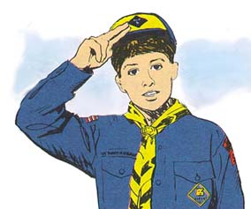
The Cub Scout Handshake
The Cub Scout handshake is made by putting the index and middle fingers of the right hand against the other person’s wrist when shaking hands. It signifies that you will help each to remember and obey the Scout Oath and Scout Law.
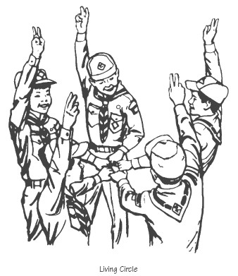
The Living Circle
Note from Commissioner Dave – I remember learning this ceremony at my first Den Meeting at Mrs. Kneale’s in September 1957. We still teach it to dens today.
The Living Circle is a ceremony that may be used as an opening or closing at a Cub Scout meeting. It reminds boys of the friendships they are making that link them together with other Cub Scouts.
To form a Living Circle, Cub Scouts and leaders stand in a close circle, facing inward and slightly to the right. With their right hands, they make the Cub Scout sign.
With their left hands, they reach into the center of the circle. Each thumb is pointed to the right, and each person grasps the thumb of the person on his left, making a complete Living Circle handclasp. The Scout Oath, Scout Law, Cub Scout motto, or other Scouting related phrase can then be repeated.
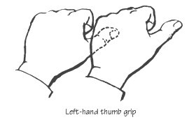
The Living Circle can also be used by moving all the left hands up and down in a pumping motion while the members say, “A-ke-la! We-e-e-ll do-o-o ou-r-r best,” snapping into a circle of individual salutes (with right hands) at the word “best.” (I like having my Webelos Den yell the meaning of Webelos (We'll Be Loyal Scouts) in a chant as a team does before a game or after a time out. CD)
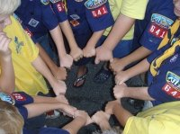

ROUNDTABLE HINTS
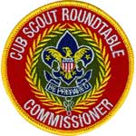

GET OFF TO A GREAT START
GATHERING TIME

You never get a second chance to make a first impression. The origin of this bit of wit is unclear. The quote has been attributed to poet, playwright and novelist Oscar Wilde. It is thought by some to have been authored by American humorist Will Rogers and is even engraved on a plaque at his memorial. Others give creative credit to the great Mark Twain. Madison Avenue, the American launch pad of many memorable advertising campaigns, also lays claim to the slogan.
A lively debate centers on the quote's originator, but not the meaning. There is nothing worse than a faux pas made when greeting a new Scout Leader at his or her first Roundtable. Neither party forgets it quickly. Most fathers-in-law can remember a young man's sweaty-palmed handshake given years before the minister proclaimed a couple husband and wife.
How do you greet and welcome Scouters to your Roundtable? Do you just say," Hi! Seating is over there." And let then go fend for themselves until the Opening Ceremony?
Do you have an assistant RT Commissioner (We no longer say Staff) assigned to greet people and welcome them? Perhaps to introduce them to some of your regular participants?? Maybe to show them around?
Do you take their name(s) so you can recognize newcomers later with a special memento?
Are there handouts and agendas for the evening? Or if you post all your info on "the cloud," do you have a card with the link on it?
Do you have mailboxes for units where you place all the handouts and flyers? Do you show new people what they are and where they are?
Is Wi Fi available at your RT? Do you have the needed info posted or readily available for participants to sign onto the network?
Is there something for them to do?? Something to look at and/or read?? If you don’t keep them busy, they may be bored already before the Opening Ceremony starts and you will never get them back.
Let's look at what the RT Planning Guide says:
PREOPENING
The preopening is a definite part of the program, not just a time filler for early arrivals. Make your gathering time interesting and active. It’s a way to get people to the meeting on time, and it sets the tone for the roundtable that follows.
Organize an interactive, easy-to-join opener such as a get-acquainted game. Ideas for these activities may be found in Group Meeting Sparklers and Troop Program Resources.
Displays and Information Tables
Parking Lot — There will be time later in the roundtable to answer any questions your participants may have. Make it easy for them to share their thoughts by creating a “parking lot”—a container, a bulletin board, or any method of collecting written suggestions or questions. Be sure to have plenty of blank cards or sticky notes and pens available.
Information Table — The majority of interesting materials on district or council events and announcements are available here. Have copies of all relevant resources on hand, and if possible invite the appropriate persons representing that activity to discuss and share with your roundtable participants. When done properly, this should relieve the rest of the roundtable from the need for lengthy announcements.
Other Displays — If the resources are available, set out displays that give leaders ideas for their meetings. Encourage leaders to use similar displays at parents’ nights or special pack events. The possibilities are endless.
Displays might include:
- Craft/activity ideas
- Outing destinations with pictures of boys having fun
- BSA programs such as World Friendship Fund, Messengers of Peace, Nova, Adopt-a-School, and religious emblems
- Local events such as details on camporees, day camps, council camp programs, district activities, and local service opportunities
- Neckerchief slide ideas
- Games that can be made and shared
RT Planning Guide (continued)
Supplies—Keep a supply of commonly used forms and literature on hand. These could include recruiting fliers, handbooks, leader guides, registration forms, etc.
Registration
A roundtable team member should be assigned to greet participants individually as they arrive, help them sign in at the registration table, give them a name tag, and get them involved in the gathering activity. Getting detailed contact information from attendees is important to following up and extending invitations to future roundtables.
Pay particular attention to newcomers. Perhaps you can identify them with a special name tag. Explain the format of your roundtable, including the use of the “parking lot,” and make them feel comfortable and welcomed.
Let's take a closer look at some of these items.
- Organize an interactive, easy-to-join opener such as a get-acquainted game.
This will keep people moving and not sitting playing on their devices until the Opening Ceremony. Get Acquainted games are great, but not every month or they lose their effect. Consider making these activities appropriate for Cub Scout Leaders and Boy Scout Leaders.
A craft or easy project based on the theme will give you an extra learning session for your participants. Neckerchief slides are usually good here.
A game where they reach inside ten bags (or boxes) and identify what is inside works well. If you choose nature items, the Boy Scout leaders may want to join in, too.
Having people find a specified group or identify whose name is on their back. Maybe do Famous Scouters Eagle Scouts, or Presidents in January's RT for February.
Set up a station to practice a Scouting Skill. Have some ropes and ask everyone to tie a Square Knot. The Boy Scout Leaders may come over and try to impress with all the knots they know. Find out what Troop Program Feature the Boy Scout RT is discussing that month. Look it over and find something (a Scout skill, a game, an activity) that could be adopted for Preopening. Work with the Boy Scout RT Commissioner on setting this up.
Where can you get more ideas? On the Monthly Pack Resource Sheet in the RT Planning Guide there is always at least one preopening activity for the Pack Meeting theme. Baloo's Bugle always has pre-opening activities in the Pack Meeting section. The How To Book and Group Meeting Sparklers, also, have numerous ideas. And don't forget the Boy Scout Troop Program Features. The Boy Scout RT Commissioner may be willing to set something up based on a Troop Program Feature.
- Information Table
Have all those who want "Announcement Time" to arrive early and set up a display. Tell them to stand there and talk with the arriving participants. They can get their info out more easily and completely. Then when announcements come they can just stand up and say, "Hi! I am Erich Weiss and I am leading the Magic Show for Scouts of all ages. This year we are demonstrating sensational escape tricks. Most of you saw my display. I have flyers there and in your mailboxes and on-line. Stop by and I can tell you all about it."
Have your next Wood Badge Scoutmaster (or another staff member) at a table recruiting for the course.
Since RTs set the example for units – as you greet your participants and get them moving, suggest that they could have information tables at their Pack Meetings.
- Displays
I am not really sure what the diff is between an Information Table and a Display.
Craft/Activity Ideas – Have Den Leaders and Assistant RT Commissioners (ARCs) bring in completed projected for different Adventures for others to see what the final projects could look like. Maybe provide a handout about how they made it.
Outing destinations – Set up a rotation so that each month a pack brings in pictures and information about a place where they went and had fun and learned. (Aquarium, Museum, Park …)
Encourage outside vendors promoting Scouting events (e.g. Amusement parks, Museum or Ball Park sleepovers) to set up displays talking about their events for Scouts.
BSA Programs – Have an ARC choose a different BSA program each month and set up a display on it to inform the participants. This responsibility could easily be shared with the Boy Scout RT side. The ARC could even delegate it out to a council committee (e.g. The Religious Relationships Committee do the religious Awards months).
Local Events - Have your Camporee Chair set up a table with info about the next camporee. And with pictures from the last one (Hopefully, with everyone smiling)
Or the University of Scouting Dean. Or Council / District Dinner Chair.
How about the FOS Chair having a display about why council needs the support?
Games – Pictures and info on games for Scouts. Perhaps a person there running a game.
Book of the Month Cub – Have an ARC pick a different BSA Book every month to feature at a display. Perhaps you can make a heavy cardboard Ethan poster to hold the book. Choose books both Boy Scout and Cub Scout Leaders would want to use. Example – for December's theme, have the How To Book open to "The house Where Santa Lives." Can't make the cardboard stand – put the book and info on a display table. (Thanks to Pat & Steve Leth for this idea)
- Registration –
Ensure your Registration Staff is warm and welcoming. They dress neatly and like to talk. They need to tell people what is going on before the Opening and get them interested in trying some of what is happening. They are your true "First Impression." They should keep an eye on the District Key 3 that are there in case someone shows up with a problem and is looking to talk about it RIGHT NOW! The Registrars can get the leader with a problem immediately to someone who can help. If there is an ARC Greeter, the Registrars should make sure any new participants meet the greeter and get shown around by him/her.
Have beads (or other attendance incentives) right there at Registration to reward people as soon as they sign in. Have special recognition items for new people ready to go, also.
Now, you probably cannot do all this every month. But certainly you can do some every month. Start with what you know will grab everyone's attention. Add in what you know they need. Work with the BS RT Commissioner to begin coordinating the Preopening with items that all leaders will enjoy. Advertise the Preopening to attract people to come earlier.



DEN MEETING TOPICS
Remember – Boys want to be active!!
See, too, that they earn their awards
(Never say GET. You get sick, you do not get awards – You earn awards. A little CD Philosophy).
Big Rock Ideas – suggestions for Big Rocks that fit Interest Topics or seasonal activity. If years are next to an item (e.g. 13-14) that suggested Big Rock is in that Roundtable Planning guide and on-line at http://www.scouting.org/scoutsource/Commissioners/roundtable.aspx
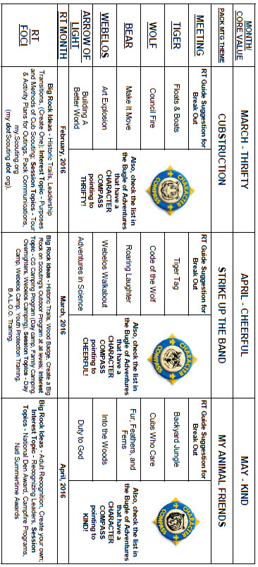

CHARACTER COMPASS
APRIL -
ADVENTURES with a CHARACTER COMPASS pointing to CHEERFUL:
TIGER –
- Tigers in the Wild (Core)
- Tiger Tag (Elec)
WOLF –
- Howling at the Moon (Core)
- Code of the Wolf (Elec)
BEAR –
- Bear Necessities (Core)
- Roaring Laughter (Elec)
WEBELOS CORE –
- Webelos Walkabout (Core)
ARROW OF LIGHT CORE –
- None (Core)
WEBELOS & AOL ELECTIVES –
- Adventures in Science (Elec)
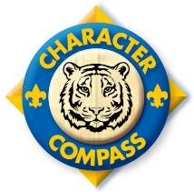
MAY -
ADVENTURES with a CHARACTER COMPASS pointing to KIND:
TIGER –
- Backyard Jungle (Core)
- Tiger-iffic (Elec)
WOLF –
- Duty to God Footsteps (Core)
- Cubs Who Care (Elec)
BEAR –
- Fur, Feathers, and Ferns (Core)
- Critter Care (Elec)
WEBELOS CORE –
- Webelos Walkabout (Core)
ARROW OF LIGHT CORE –
- Duty to God In Action (Core)
WEBELOS & AOL ELECTIVES –
- Into the Wild (Elec)

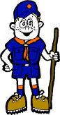

PACK MEETING THEMES
AND PLANS
www.scouting.org
From National's Website for the new plans using the Core Values based on the Scout Law:
Here are a few thoughts to consider around these new pack meeting plans. First, there is a plan for each month that corresponds with a point of the Scout Law. In addition, each plan has a theme to help make the pack meeting even more fun! The plans do not have to be used in a specific order.
Tips for Utilizing the Plans
- Pack meeting plans do not have to be done in any special order, but it is recommended that you include all of the points of the Scout Law each year. The pack planning meeting would be a good time to determine the order.
- There are pack meeting plans for multiple years posted on the website. It is your pack's choice of which one to select from each point of the Scout Law for each year.
- Pack meetings should not last longer than an hour. Adjust the plan to make it fit within the time. Research and experience tells us that Cub Scouts have a hard time sitting still for that long. Keep the meetings fun, active, and engaging.
- If you are comfortable with a costume to fit the theme of the meeting, go for it!
- Importantly, keep it simple and make it fun.
- The following required adventures have a requirement that suggests or requires completion at a pack meeting. Please plan accordingly as part of your annual program planning process. Work with your den leaders to plan when these activities will take place.
Tiger
- Tigers in the Wild, requirement 5. Participate in an outdoor pack meeting or pack campout campfire. Sing a song and act out a skit with your Tiger den as part of the program.
- Games Tigers Play, requirement 3. Make up a new game, and play it with your family or members of your den or pack.
Wolf
- Council Fire, requirement 6c. Create a den project from recyclables for a pack meeting.
Bear
- Grin and Bear It, requirement 2. Working with the members of your den, organize a Cub Scout carnival and lead it at a special event.
- Grin and Bear It, requirement 3. Help younger Cub Scouts take part in one of the events at the Cub Scout carnival.
Webelos
- Stronger, Faster, Higher, requirement 5. With adult guidance, lead younger Scouts in a fitness game or games as a gathering activity for a pack or den meeting.
Arrow of Light
- Building a Better World (if chosen), requirement 10b. Set up an exhibit at a pack meeting to share information about the World Friendship Fund.
As a personal note: I have read some of the plans and they are excellent and just as complete as the new Den Leader Books. The games, and other stuff are right there. Including costuming ideas for that added PIZAZZ!! If you do not use themes and do not add PIZAZZ you are not doing your best for your pack.
GOOD JOB!!! From CD
Check them out at:
http://www.scouting.org/Home/CubScouts/Leaders/CubmasterResources/PackMeetingPlans.aspx


Kim, the chair of the task force, says "I do want to stress that the focus is still the Core Value and the theme is just there as an enhancement. Pack meeting theme plans are specifically crafted to bring out the important points of the Core Value in a fun way."

PACK MEETING THEMES
2015–2016 Pack Meeting Plans
February | Friendly | "Friends Near And Far"
March | Thrifty | "Cubstruction"
April | Cheerful | "Strike Up The Band"
May | Kind | "My Animal Friends"
June | Obedient | "It's A Hit"
July | Loyal | "Scout Salute"
August | Courteous | "S'more Cub Scout Fun"

2016–2017 Pack Meeting Plans
September | Helpful | "To The Rescue"
October | Kind | "Creepy Crawlers"
November | Courteous | "Cubs In Shining Armor"
December | Cheerful | "Celebrate"
January | Obedient | "Cub Scout City Council"
February | Reverent | "Passport To Other Lands"
March | Loyal | "Our National Treasures"
April | Thrifty | "Power Up!"
May | Clean | "A Picnic With Pizzazz"
June | Brave | "Roaming Reptile Alert"
July | Trustworthy | "Let The Games Begin"
August | Friendly | "#CUBSCOUTS"
If you are using a paper copy the link to all the
Pack Meeting Plans is:
http://www.scouting.org/Home/CubScouts/Leaders/CubmasterResources/PackMeetingPlans.aspx

UPCOMING MONTHS
April's Core Value, Cheerful, will use the theme, Strike Up the Band:
Month | Year | Theme
CHEERFUL
(Themes for Cooperation & Positive Attitude)
January | 2009 | A-MAZE-ing Games
September | 2010 | Cooperation
January | 2011 | Positive Attitude
September | 2011 | Cooperation
January | 2012 | Positive Attitude
September | 2012 | Hometown Heroes
January | 2013 | Abracadabra
September | 2013 | Amazing Games
January | 2014 | Lights, Camera, Action
September | 2014 | Under the Big Top
January | 2015 | Yes, I Can
Potential "STRIKE UP THE BAND" Months
January | 1941 | Music and Minstrels
January | 1945 | Cub Made Music
January | 1949 | Music and Minstrels
October | 1954 | Musical Hoe-down
July | 1957 | Homemade Opera
May | 1959 | Musical Hoedown
January | 1973 | Music Makers
April | 1980 | Let's make Music
August | 2001 | Summer Songfest
January | 2003 | Strike Up the Band
January | 2006 | Music Magic

The core value highlighted next month is:
May's point of the Scout Law, KIND, will use the theme, MY ANIMAL FRIENDS.
A SCOUT IS KIND
A Scout treats others as he wants to be treated. He never harms or kills any living thing without good reason.
HOW DOES “MY ANIMAL FRIENDS” RELATE TO THIS POINT OF THE SCOUT LAW?
A Scout knows there is strength in being gentle. It is important to be kind to all creatures great and small. This month we will explore ways to be kind to our animal friends.

Month | Year | Theme
KIND
(Themes for Compassion)
December | 1940 | Good Will - Cub Style
December | 1941 | Giving Good Will
December | 1942 | Good Will
December | 1943 | Good Will Month
December | 1945 | Follows - Helps - Gives
December | 1947 | Helps and Gives
December | 1948 | Goodwill
December | 1961 | Follows, Helps, and Gives
December | 1969 | Cub Scout Gives Good Will
December | 1971 | Cub Scout Gives Good Will
December | 1972 | Follows, Helps, Gives
December | 1975 | Cub Scout Gives Good Will
December | 1985 | Follows, Helps, Gives
December | 1991 | Follows, Helps, Gives
July | 2002 | Inside Out and Backwards
December | 2003 | Cub Scout Gives Good Will
March | 2004 | Walk In My Shoesa
November | 2008 | Spreading Seeds Of Kindness
March | 2011 | Compassion
March | 2012 | Compassion
March | 2013 | Planting Seeds of Kindness
March | 2015 | Aware and Care
Potential "MY ANIMAL FRIENDS" Months
April | 1940 | Pet Show
April | 1943 | Animals and Pets
August | 1949 | Animals and Pets
June | 1962 | Inside Noah's Ark
October | 1964 | Animals in Stories
June | 1986 | Inside Noah's Ark
August | 1992 | Inside Noah's Ark
March | 1996 | Inside Noah's Ark
March | 2001 | Man's Best Friend
May | 2005 | Cub Pet Pals
September | 2006 | Zoo Adventures
March | 2014 | Pet Pals

CUBMASTER THOUGHTS
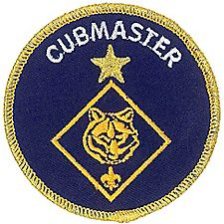

AFTER THE BLUE AND GOLD
Mark Diienno, Cubmaster,
Garden State Council
What an amazing feeling it is firing off an unforgettable Blue and Gold program. All the planning and hard work by you, the Pack Committee, Leaders and parental volunteers came together to form a beautiful memory for all, especially the Scouts.
They just witnessed the Arrow of Light Den(s) cross over into their next level of Scouting, Boy Scouting. (Most have, although some units do their crossover later, to insure the AOL Scout’s readiness for their next adventure)
All is right with the world, and as Cubmaster you can put your proverbial feet up and relax…
Not a chance!
Spring is just around the corner Cubmasters, and that smell in the air is opportunity.
As Cubmasters, we need to focus on the hole in the pack caused by the AOL scouts leaving to join a Boy Scout Troop and begin the next chapter in their lives.
So let's focus on –
SPRING RECRUITMENT.
Now is the time to start working with your Committee, Chartered Org, District and Council resources, to come up with a battle plan to replace those who have crossed over.
Your Council office is probably having a spring recruitment event. Climb aboard and use the tools made available to units, like printing flyers and discussing recruitment strategies with your Unit Commissioner and Chartered Org Rep.
Your Program is your best selling point, and tying spring recruitment to an event is a time tested strategy to win young boys who have never seen scouting before.
And see it they will at your pack's Family Camp!
Now is, also, the time to start planning for a weekend in the outdoors with the Pack!!
Have you decided on where you will be Camping?
Keep it close and use your Councils camps.
Haven’t secured your site yet?
There is still time but you should have it as quickly as possible!
Tying together Spring Recruitment and Family Camp is a can’t miss for units needing to replace Cub Scouts who crossed over to Boy Scouts.
Family Camp is a great opportunity to have fun, teach your boys skills, set up tents, and just make a weekend magical for your unit.
A round robin of events makes for a great program for Family Camp. Knots, Fishing, Hiking, Games, and Service at camp, are just a few ideas to build your day around.
A pack oriented activity like, rain gutter regatta, is a great way to tie the day together.
One of the “stations” can focus on building your regatta out of recycled soda bottles.
The possibilities are endless…
So -
Imagine a new recruit, on the fence, not sure if scouting is right for him.
And you tell him, "Have I told you about a little something called Family Camp?"
Any boy and his family that isn't sure if Scouting is for him (them), who attend a well planned family camp, will soon be placing Blue and Gold around his body.
And you thought you were putting your feet up…..
This is Mark's first column. We welcome him to the staff of the Bugle. I have worked with Mark on several projects. We traveled the RT circuit together for the last 24 months or so telling everyone who would listen why the new Adventure Program is GREAT!! His Pack has over 100 boys and a fantastic LION program. Hopefully, he will be writing about the LIONS program soon!! CD

WEBELOS
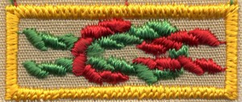
Always an S
Webelos always ends with an S whether talking about one Webelos Scout or a den of Webelos. It is an acronym – WE’ll BE LOyal Scouts. As the CS RT Commissioner who mentored me says – "If you don’t have an S at the end – then there is nothing to which to be loyal." (She is now a Wood Badge Scoutmaster!!)

CHOOSING A PATROL NAME
The Webelos and Arrow of Light Dens are encouraged to pick Patrol Names. Some groups rush into this and pick the first cool sounding name that they hear. When a Scoutmaster I had a rash of sports team names – (Suns, Gators). This lead to not Scouting discussions and dissatisfied members who did not like the team for whom the Patrol was named. The PLC took action and said no more Sports teams patrol names. With that my older boy patrol chose Patriots. They told me I would not see or hear any sports stuff. They said were all patriotic and that Patriots was a very good Scouting name. I could not argue. And they did not infer any sports connection but their flag looked a lot like New England's logo.
Most Dens start with the suggestions in the Boy Scout Handbook, picture sof Patrol Emblems in catalogs from BSA Supply and authorized vendors. Maybe a list from the Den Chief and suggestions of the names their patrols had from Dads who had been Scouts. Most groups don’t think much about what should go into choosing a good Patrol name; they just go with whatever sounds coolest to them.
If there are six scouts in the Den, you will probably get a6 way tie when first voting for the name. This could eventually whittle itself down to one. But it may be a long, bitter battle and create hard feelings.
Your Den has been told they should pick a good name, and you are going to do it right now, right? Actually, no. You see, you want their (It is not yours) Patrol name to really mean something to the Den members. If they pick a name just because it sounds cool, that’s about all it’ll be worth. Instead, have them wait a little bit before trying to pick a name. As they do Scout stuff together - go on camping trips; have meetings; complete Adventures, and do service projects together something is bound to happen.
Have the Den members keep an eye out for any good ideas. For example, on Scoutmaster tells about how as a youth while hiking on one camping trip with his Patrol at a national wildlife refuge, They came around a bend in the trail and saw an enormous buffalo standing about 15 feet in front of us! They startled the buffalo just as much as he startled them. The buffalo took off into the woods. They then wanted to be the Buffalo patrol!!
And feel free to add an adjective – the Roaming Buffaloes – they were out roaming the wilderness when they saw him. They wanted to continue to roam (hike) in the woods. It was their thing.
The Roaming Buffaloes name was it tied to a vivid memory we could talk about for a long time afterward, and captured the spirit of our Patrol.
Have the Den make it theirs. They should own it! The Patrol name should be the number one thing that defines the Patrol. It will build their spirit and draw them together as a better team.
Bryan of Bryan's Blog had a column on Patrol Names (http://blog.scoutingmagazine.org/2014/04/29/tuesday-talkback-how-to-pick-an-unforgettable-patrol-name/ )
Here is some of his advice –
Consider something that unites the patrol
- Maybe the patrol with a bunch of strong swimmers calls themselves the Sharks. The guys into scary movies could be the Zombies or Vampires.
- And those Scouts with a seemingly endless supply of snacks could become the Corn Chips patrol, Rice patrol or Spicy Taco patrol.
- Again, there’s no limit to a Scout’s creativity here.
Add an adjective to a “standard” patrol name
- Patrol emblems sold directly from the BSA at Scout Shops and at ScoutStuff.org include a mix of critters and historic characters.
- You can add a dash of spice to those names by including an adjective before the standard name. Use alliteration to help make the new names really soar.
- Instead of the Dragons, why not the Daring Dragons? The Scorpions could add Stupefying to their name. And the Owls? Well they’re simply Outstanding. (But then again, I used to be one.)
Check out what BSA licensees offer
- At least two official BSA licensees offer officially licensed patrol patches that expand the emblem selection.

- Check out what ClassB and Advantage Emblem offer for hundreds more ideas. The designs are unique, fun and can help foster patrol spirit.
- Shown below: Tiki, Basset Hound, Ninja Monkey, Burnt Toast, Bacon, Pedro, Carabiner, Abominable Snowman
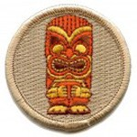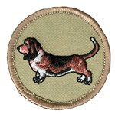
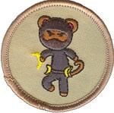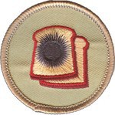
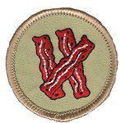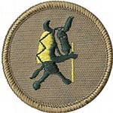
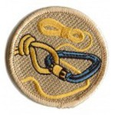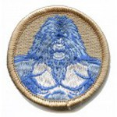
Let Scouts have the final say
- While you might not be the biggest fan of a patrol’s chosen name, as long as it’s Scout-appropriate and not in use by another patrol I can think of no legitimate reason to veto one.
- Even if the name is extremely silly and seemingly unsustainable, wouldn’t it be better to let them use the name and tire of it themselves? If they decide to change it later, they’ve learned an important lesson the proper way.
My 1964 Jamboree patrol was the Mustangs!!!
(That was the year the Mustang debuted)
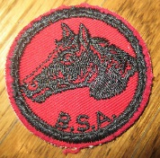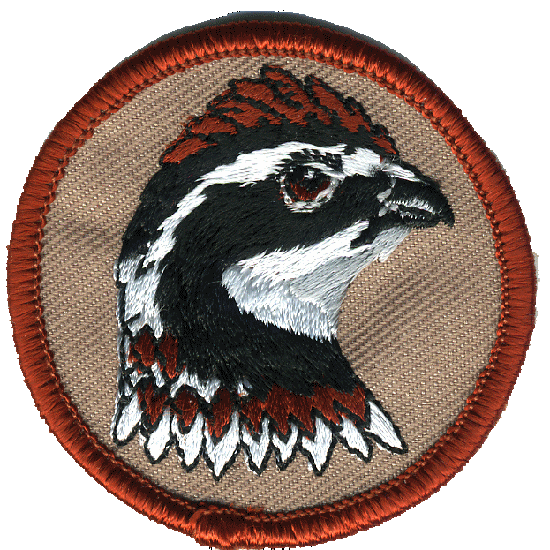
And now I used to be a Bob White. CD

APRIL 2016: A MONTH TO BE CHEERFUL
Alice Retzinger, Golden Empire Council
Not only Scouts recognize April as a month to be Cheerful - National Humor Month and International Guitar Month are celebrated this month. And since our theme is "Strike Up the Band," invite anyone who plays an instrument, including of course, the Guitar, to share their talents with your Pack family this month!
April 1 – April Fool’s Day - Traditionally, April Fool's Day is an opportunity for playing jokes or tricks on one another. The stranger and the more absurd the better. The challenge is to carry out a trick that is believable, if only for a little while. Tricks are most successful if played earlier in the day before a person is wise to what is going on. Important: Jokes and gags must be harmless and fun. They must not be dangerous or hurt anyone's feelings. Give your jokes and gags some thought before carrying them out. Then, have fun! Check out some FUN Food under Cub Grub – sure to leave you feeling Cheerful!
April 1st is also Fun At Work Day - Try having everyone bring out their Slinky for some real fun during break time. Please Note: If you do fun things today that is counter-productive, or takes you away from the job, make sure you get your boss' permission first. Better still, get him or her involved.
April 2 - National Peanut Butter and Jelly Day celebrates the "PB and J" sandwich. Its the favorite lunchtime sandwich of American kids, and many adults, too. Some kids practically live on Peanut Butter and Jelly sandwiches. Just be sure to check for allergies before you share this favorite treat today!
April 3, 1860 - In the American West, the Pony Express service began as the first rider departed St. Joseph, Missouri. For $5 an ounce, letters were delivered 2,000 miles to California within ten days. The famed Pony Express riders each rode from 75 to 100 miles before handing the letters off to the next rider. A total of 190 way stations were located about 15 miles apart. The service lasted less than two years, ending upon the completion of the overland telegraph. Send a cheerful letter or postcard to someone you know and admire….but you may not be able to deliver it by horseback!
American writer Washington Irving (1783-1859) was born in New York City on this day. His works include; Rip Van Winkle, The Legend of Sleepy Hollow and historical biographies such as the Life of Washington. Many a scout or scouter has been made cheerful by the Rip Van Winkle story!
April 5 - African American educator Booker T. Washington (1856-1915) was born a slave in Franklin County, Virginia. Freed by the Civil War, he taught himself the alphabet and eventually graduated from an agricultural institute. In June of 1881, he was asked to become the principal of a new training school for blacks at Tuskegee, Alabama. The Tuskegee Institute began in single building with 30 students but through his efforts grew into a modern university. Webelos and Arrow of Light scouts will want to learn about his great Adventures in Science!
April 7 - Caramel Popcorn Day is an opportunity to enjoy the combination of two great treats - Caramel and Popcorn. This tasty, chewy treat is hard to beat. Caramel popcorn is readily found in popcorn tins and specialty shops and of course, SCOUTS SELL POPCORN - with a Cheerful Outlook! While other flavors of popcorn are fine any other day, today it must be caramel popcorn.
April 8 - Among Buddhists, celebrated as the birthday of Buddha (563-483 B.C.). An estimated 350 million people currently profess the Buddhist faith.
April 11 - Apollo 13 was launched from Cape Kennedy at 2:13 p.m. on this day in 1970. Fifty-six hours into the flight an oxygen tank exploded in the service module. Astronaut John L. Swigert saw a warning light that accompanied the bang and said, "Houston, we've had a problem here." Swigert, James A. Lovell and Fred W. Haise then transferred into the lunar module, using it as a "lifeboat" and began a perilous return trip to Earth, splashing down safely on April 17th. Two ways to remember this day: Watch the movie! OR Do some research into how many astronauts have been scouts! Share what you learn with your pack family!

April 16 - Film comedian Charlie Chaplin (1889-1977) was born in London. He made people feel very cheerful, beginning in vaudeville. He was discovered by American film producer Mack Sennett. He then went to Hollywood to make silent movies, developing the funny 'Little Tramp' film character. Chaplin's classics include The Kid, The Gold Rush, City Lights and Modern Times. In 1940, he made The Great Dictator poking fun at Adolf Hitler, who bore a resemblance to Chaplin. In his later years, Chaplin had a falling out with Americans, but returned in 1972 to receive a special Academy Award. In 1975, he was knighted by Queen Elizabeth II. His antics still bring a smile to people today – so find one of his famous shorts and enjoy it with a bowl of popcorn!
April 17 – Celebrate Bats Day - No, we are not going batty. We just think that bats deserve a little respect. Many scout groups have helped by building bat houses. Check to see if that’s a project available in your area.
Some Fun Facts About Bats:
- There are over 1000 different bat species.
- They may fly, but they are mammals, not birds.
- Bats are nocturnal (active at night).
- Bats ‘see’ in the dark using a special skill called echolocation. Bats make noises and wait for the sound waves to bounce back off objects (an echo), if it doesn’t bounce back then they can safely fly forward. They can tell the distance of various objects by how quickly the sound waves bounce back to them.
- An individual bat eats thousands of insects each night – without bats, we would be up to our eyeballs in bugs!
- Most bats feed on insects, while others eat fruit, fish or even blood!
- Some bats live by themselves while others live in caves with thousands of other bats.
- Bats can live for over 20 years. Some are as small as your thumb. So, let's use today to better understand, and appreciate our friends the bat!
April 18 - In 1775, the Midnight Ride of Paul Revere and William Dawes occurred as the two men rode out of Boston about 10 p.m. to warn patriots at Lexington and Concord of the approaching British.
The San Francisco Earthquake struck at 5:13 a.m. on this day in 1906, followed by a massive fire from overturned wood stoves and broken gas pipes. The fire raged uncontrollably for three days resulting in the destruction of over 10,000 acres of property and 4,000 lives lost.
April 20 – Volunteer Recognition Day – Encourage your scouts to show their appreciation for the volunteers that make scouting possible: Send a Cheerful Thanks, Give a special fun award, Make a banner to say Thanks!
April 22 - "In God We Trust" was included on all newly minted U.S. coins by an Act of Congress on this day in 1864.
April 23- William Shakespeare (1564-1616) was born at Stratford-on-Avon, England. Renowned as the most influential writer in the English language, he created 36 plays and 154 sonnets, including Romeo and Juliet, Hamlet and The Merchant of Venice.
April 25 - Radio inventor Guglielmo Marconi (1874-1937) was born in Bologna, Italy. He pioneered the use of wireless telegraphy in the 1890's. By 1921, Marconi's invention had been developed into wireless telephony (voice radio).
April 26 - Multiracial elections were held for the first time in the history of South Africa. With approximately 18 million blacks voting, Nelson Mandela was elected president and F.W. de Klerk vice president.
Two famous Americans were born on this day: American artist and naturalist John J. Audubon (1785-1851) was born in Haiti. He drew life-like illustrations of the birds of North America. Did you know that Baden-Powell was also an artist? And he taught his scouts to always be observant – he expected them to draw what they saw and look for details in every part of nature. So draw a picture of your favorite Nature subject today!
Landscape architect Frederick Law Olmsted (1822-1903) was born in Hertfors, Connecticut. He helped design some of the most famous parks in America including Central Park in New York, the Emerald Necklace series of connecting parks in Boston, and Yosemite National Park.
April 27 - Telegraph inventor Samuel F.B. Morse (1791-1872) was born in Charlestown, Massachusetts. He developed the idea of an electromagnetic telegraph in the 1830's and tapped out his first message "What hath God wrought?" in 1844 on the first telegraph line, running from Washington, D.C., to Baltimore. The construction of the first telegraph line was funded by Congress ($30,000) after Morse failed to get any other financial backing. After Western Union was founded in 1856, telegraph lines were quickly strung from coast to coast in America.
Civil War General and 18th U.S. President Ulysses S. Grant (1822-1885) was born in Point Pleasant, Ohio. During the war, he earned the nickname "Unconditional Surrender" Grant and was given command of the Union armies. He served as President from 1869 to 1877 in an administration plagued by scandal. He then went on to write his memoirs and died in 1885, just days after its completion.
April 30 - George Washington became the first U.S. President as he was administered the oath of office on the balcony of Federal Hall at the corner of Wall and Broad Streets in New York City.

APRIL CRAZY HOLIDAYS
Jodi, SNJC Webelos Resident Camp Director Emeritus,
2006-2011. Adapted from http://holidayinsights.com/moreholidays/index.htm
http://www.brownielocks.com/month2.html
April 2016 is:

- Adopt A Greyhound Month
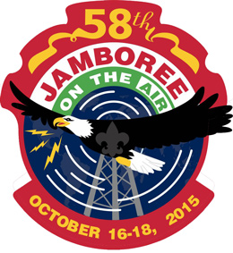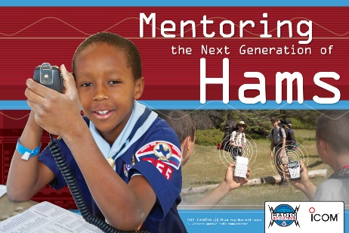
(Logo for JOTA JOTI 2016 is not issued yet)
- Amateur Radio Month
- Arab American Heritage Month

- ASPCA Month
- Autism Awareness Month
- Car Care Month
- Celebrate Diversity Month
- Community Spirit Month
- Couple Appreciation Month

- Distracted Driving Awareness Month
- Global Child Nutrition Month
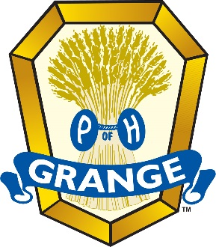
- Grange Month
- Holy Humor Month
- Jazz Appreciation Month
- Keep America Beautiful Month
- Lawn and Garden Month

- Math Awareness Month
- National Card and Letter Writing Month
- National Decorating Month
- National Garden Month
- National Grilled Cheese Sandwich Month

- National (and International) Guitar Month
- National Humor Month

- National Kite Month
- National Knuckles Down Month
- National Landscape Architecture Month
- National Poetry Month
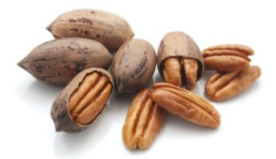
- National Pecan Month

- National Pet Month
- National Poetry Month
- National Safe Digging Month
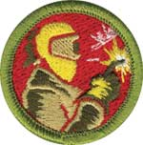
- National Welding Month
- Records and Information Management Month
- Straw Hat Month
- Stress Awareness Month
- World Habitat Awareness Month
April Weekly Celebrations:
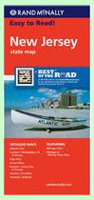

- Read a Road Map Week: 3-9

- American Crossword Puzzle Weekend: 1-3

- Tree Climbing Championship, 1-3
- The APAWS Pooper Scooper Week: 1-7
- Explore Your Career Options: 4-10

- Golden Rule Week: 1-7
- Laugh at Work Week: 1-7
- Medication Safety Week: 1-7
- Bat Appreciation Week: 3-9
- National Volunteer Week: 12-18
- Week of The Young Child: 12-18
- Explore Your Career Options Week: 5-11
- American Indian Awareness Week: 6-12

- The Masters Tournament: 1-10
- Global Youth Service Days: 17-19
- International Wildlife Film Week: 18-25
- Animal Control Officer Appreciation Week: 10-16
- National Environmental Education Wk: 19-25

- National Robotics Week: 2-10
- National Library Week: 10-16
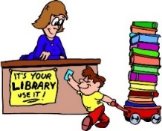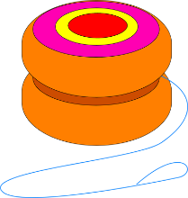
- YoYo and Skill Toy Week 9-17
- National Public Safety Telecommunicators
(911 Operators) Week: 10-16
- Pan American Week: 10-16
- Cleaning For A Reason Week: 18-24
- Consumer Awareness Week: 18-23
- National Occupational Health Nursing Week: 18-22
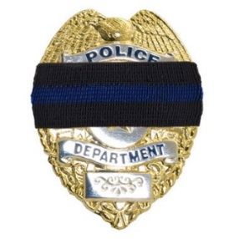
- Police Officers Who Gave Their Lives In The Line of Duty Week: 18-23

- National Park Week: 16-24
- Administrative Professionals Week: 24-30
- National Karaoke Week: 17-23
- National Pet ID Week: 17-23
- National Toddler Immunization Week: 16-23
- Safe Kids Week: 18-23
- Gathering of the Nations Powwow: 29-30
- National Pie Championships: 29-30
April, 2014 Daily Holidays,
Special and Wacky Days:
1 April Fool's Day
1 International Fun at Work Day
1 International Tatting Day
2 Children's Book Day
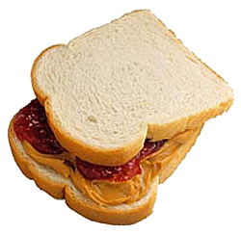
2 National Peanut Butter and Jelly Day
2 Reconciliation Day
3 Don't Go to Work Unless it's Fun Day - we know your decision
3 Tweed Day
4 Hug a Newsman Day
4 Walk Around Things Day
4 School Librarian Day
4 Tell a Lie Day
5 Go for Broke Day
6 Sorry Charlie Day
7 No Housework Day
7 World Health Day
8 All is Ours Day
8 Draw a Picture of a Bird Day
9 Name Yourself Day

9 Winston Churchill Day
10 Golfer's Day
10 National Siblings Day
11 Eight Track Tape Day - do you remember those?
11 Barbershop Quartet Day
11 National Submarine Day
12 Big Wind Day - this day blows me away!
12 Russian Cosmonaut Day
13 Scrabble Day
14 International Moment of Laughter Day
14 Look up at the Sky Day - don't you have anything better to do?
14 National Pecan Day
14 Reach as High as You Can Day
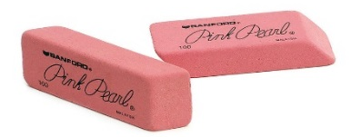
15 Rubber Eraser Day
15 Titanic Remembrance Day
16 National Eggs Benedict Day
16 National Librarian Day
16 National Stress Awareness Day
17 Blah, Blah, Blah Day
17 Bat Appreciation Day
17 National Cheeseball Day
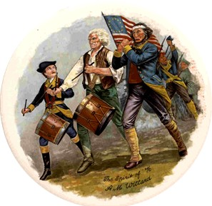
18 Patriot's Day
18 International Juggler's Day - also applies to multi tasking office workers
18 Newspaper Columnists Day
19 National Garlic Day
20 Look Alike Day
20 Volunteer Recognition Day
21 National High Five Day third Thursday
21 Kindergarten Day

22 National Jelly Bean Day
23 Lover's Day
23 National Zucchini Bread Day - they hold this at a time when you are not sick of all that zucchini.
23 Take a Chance Day
23 World Laboratory Day
24 Pig in a Blanket Day
25 East meets West Day
25 World Penguin Day
26 Hug an Australian Day
26 National Pretzel Day
26 Richter Scale Day
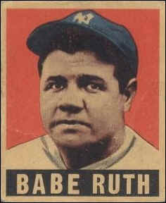
27 Babe Ruth Day
27 National Prime Rib Day
27 Tell a Story Day
27 Administrative Professional's Day
28 International Astronomy Day
28 Great Poetry Reading Day
28 Kiss Your Mate Day - guys, do not forget this one. Kiss her, then read her some poetry.
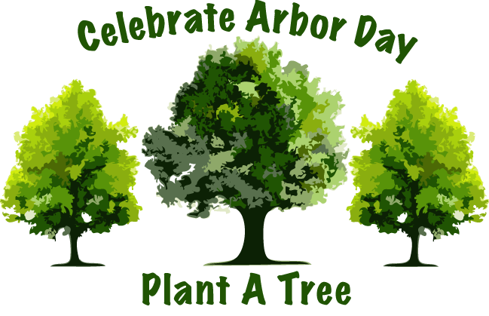
29 Arbor Day
29 Greenery Day
29 National Shrimp Scampi Day
30 Hairstyle Appreciation Day
30 National Honesty Day

TRAINING TOPICS

DEN DISCIPLINE
Utah National Parks Council
Overview - Does the idea of very energetic boys jumping on your couch, bouncing off your walls, painting the cat and causing mayhem just make you want to pull your hair out? Don’t worry – every Cub Scout leader has felt like that at one time or another.
For the sake of your sanity, not to mention your house or your cat, you will need to come up with guidelines of behavior for the den. This is den discipline. Remember that discipline is not punishment. Discipline is making the Cub Scout responsible for his own behavior – telling him that if he chooses a certain course of action, what the specific consequences of that action will be. Discipline is training given to a child to mold or correct his behavior. As a den leader, you need to spell out for the boys what is acceptable behavior and what is not. Also, let them know the consequences for acceptable and unacceptable behavior.
Den Code of Conduct - A den code of conduct (or den rules) should be established by the boys in discussion. Some of their ideas may be silly to you, but don’t judge too harshly. Many of their ideas that relate to safety, respect for property and relationships with others mirror yours. You may make suggestions for things the boys don’t bring up. And they’ll be delighted if you decide to throw out a rule or two. You should also discuss the consequences of breaking the den code of conduct. What should be in your den code? Things that are important to you and your boys. Since every den is different, every den code will be different. Here are some suggestions to help you get started.
- No put-downs, name calling, or crude language.
- No physical aggression.
- You are a guest in this house, please act like one. (Try to be on your best behavior.)
- Be on time.
- Wear your uniform.
- Bring your book.
- One person speaks at a time and everyone listens.
- No running inside.
- Share, take turns.
- Leave the cat (or dog or hamster or fish) alone.
A few rules are enough to start, but more may need to be added as you go along. Cub Scouts may want to write out their den rules and sign on a line at the end of the list. This is a way of sharing with parents the expectations of their sons. A large poster can also be placed at the den meeting site to remind boys of the code.
Now that the rules have been established, stick to them. Be fair. Don’t let one boy get away with doing something you would discipline another boy for doing. Be consistent. Don’t warn and threaten but take action quickly. Don’t send a boy home unless he oversteps the disciplinary bounds you have drawn. If you do send a boy home, call his parents immediately and tell them why.
Here are a few ideas to keep your den meetings running smoothly:
- Use the CUB SCOUT SIGN as a signal for quiet. When boys see this symbol, they should stop what they’re doing, be quiet and raise their own arm in the sign. See section in this item on using the sign.
- Keep den meetings going at a FAST PACE, with lots of variety and fun things to do. Plan more than you think you will need. Get assistants and den chiefs involved.
- Treat boys IMPARTIALLY. Boys expect fair treatment and your example becomes their model. If you make promises, keep them.
- DON’T CRITICIZE a boy in front of the den. Wait until you can talk to him alone.
- Give boys opportunities to make CHOICES as often as possible. Involve them in planning.
- Take some time to EVALUATE your den meetings. What went well? What didn’t go so well? How can I do this differently next time?
- Focus on the POSITIVE. Catch boys being good, helping others, keeping the den code of conduct. Baden-Powell said “A pat on the back is a stronger stimulus than a prick with a pin Expect a great deal of your boys and you will generally get it.”
When asked what tricks, programs or guidelines were used in their den to promote discipline, one leader said “Well, we have our good days and our bad days. Sometimes we just have to remember they are little boys that need to use their bodies. So, we always try to have at least one activity each den meeting that gets them moving! Normally, den meetings are full of various activities, so the boys have a good chance to work off that energy.
“Most of the years we have taught, the boys got along fine. But we had one year when that was not so. The first time we had two boys collide physically, we let them know it would not be tolerated. We told them we are like brother wolves in a den and we support each other. I said if it ever happened again the parents would be informed and they would possibly attend our future meetings. No more problems!”
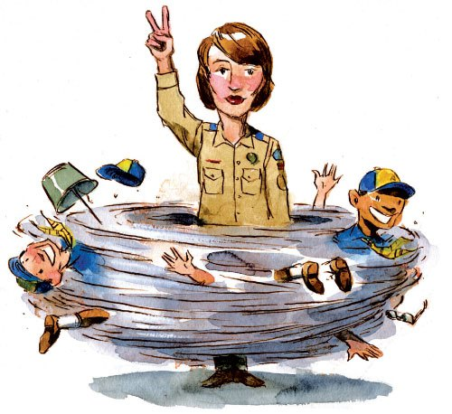

USING THE CUB SCOUT SIGN –
Every book will tell to teach the boys that when Akela (the leader) puts up the Cub Scout sign everyone is to stop what they are dong, get quiet and listen for information (direction, announcement, the winner of the contest is …). But very few give you advice for implementation, so here are a few hints from Commissioner Dave.
- NEVER, NEVER, NEVER say "Sign's Up!" Once you do this there is no difference between the sign and an exasperated teacher trying to get order in a classroom. If you do this, the boys will not react to the sign, they will wait for you to tell them.
- Do not talk while you have the sign up. I have seen too many leaders put the sign up and then leave it up while they do announcements. The Cub Scout Sign applies to all people, including the person who raised it. If someone comes up to you while you have the sign up and asks you a question, you should do one of two things – Either, point to the sign to show them you are calling for quiet. Or quickly, put the sign down and answer the question and then raise the sign again. (I usually only do this if someone comes up to me a little child and asks, "Where is the bathroom?") Maybe, quietly enlist your assistant to continue the quest for quiet while you have the sign down.
- Do not use the sign as threat. "Be quiet or I will have to put the sign up again." This, like saying "Sign's Up!," reduces the use of the sign to a typical adult way to get kids quiet. (And did I say, "NEVER, NEVER, NEVER say "Sign's Up.")
- Remember the purpose of using the sign. A purpose is to have the boys use peer pressure in a good way to get each other quiet. Then it becomes they who have become quiet. They are not just listening to an adult. They realize they have a responsibility. This leads to personal growth.
- Don't give up. I have stood for many minutes with the sign up waiting for quiet. I do not speak. I do not move. I only point to the sign when people look at me. In a September Pack Meeting I usually have to hold it for a "long" time. By December, response is usually pretty quick. And I tell parents, do not tell your son the sign is up, just point to me or your sign since you should put it up, too. Parental buy in is critical.
Physical Reminders –
Some den leaders use little “pats on the back” to help with den discipline and reward boys who are doing well. Here are a few things that have worked.
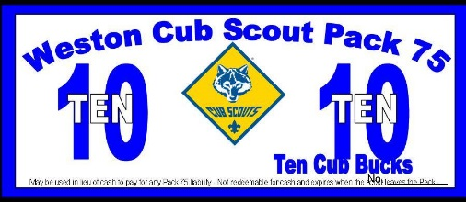
Scout Bucks - Print up “SCOUT BUCKS.” These can be anything from a fancy piece of paper with cool graphics that looks like money to a slip of paper that says “Scout Bucks” on it. Distribute these to the boys when you catch them doing something good. You can also give them out for being on time, wearing their uniform and bringing their book. At the end of den meeting (or the end of the month or another time you designate), boys can go to the den store and buy something. This store can be a box that you have filled with small toys, candies, gift certificates or coupons for free goodies, scout paraphernalia, etc.
Bear Stumps - Each boy is given a block of wood that doubles as a stool at den meeting. He earns nails that will be hammered into the stump if he meets the following requirements:
- Red: He must attend den meeting.
- Blue: He must wear his Scout uniform.
- Green: He must bring his book to den meeting.
- Yellow: He must be represented by at least one member of his family at pack meeting.
- White: He must meet the requirements of a “Bear Necessities.” challenge. This challenge, a charge to do something to make the world just a little bit better, is written down and sent home with the boy.
- Silver: He must do three good deeds for the week, without being asked. (Chores do not count.)
- Gold: He must have done one good deed, that includes a sacrifice of at least one hour, with no expectation of reward.
The den leader hands out the nails before the meeting begins, and the Bear Cubs can only hammer before the meeting and after the closing prayer. If hammer or nails are misused, the Bear loses his nails for that week. The boys are challenged to see how creatively they can decorate their stump. This can be adapted for Wolf dens and Webelos dens too.

Give each boy a whole piece of SHOESTRING LICORICE at the beginning of the meeting. Every time you need to discipline the boy, cut off two inches. He gets whatever is left at the end of meeting time for a treat. A variation of this method would be to give each boy a small cup and three or four M&M’s when he arrives. When you catch him doing good (waiting his turn, helping someone else, volunteering to do something, etc.) reward him with a few more M&Ms to keep in his cup. When the meeting is over, he gets to keep the goodies in the cup.
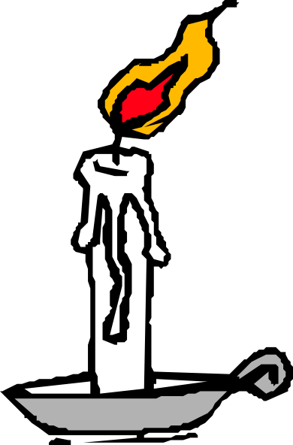
The GOOD CONDUCT CANDLE is an oldie but goodie. A candle is lit as the meeting begins. If the boys misbehave, the candle is extinguished. Use your den code of conduct as a basis of when to keep the candle lit and when to blow it out. You determine if the behavior is suitably changed so that the candle can be lit again. When the candle is burned down to a certain level, a reward is given. It can be a pizza party, a day at the park or pool, or a day of games. Help the boys decide what the reward will be, then they will work for it. This method has several disadvantages. Most schools and some churches do not allow open flames. Open flame is dangerous around any group of young kids. Then, what do you do for discipline once the candle is blown out?
Use carnival or homemade TICKETS. Give each boy three tickets at the beginning of the meeting. Have him sign his name on the ticket. When he breaks a rule, he has to give up a ticket. Tickets left at the end of the meeting can be placed in a bank. At the end of the month, add up who has the most tickets, and he gets a special treat.

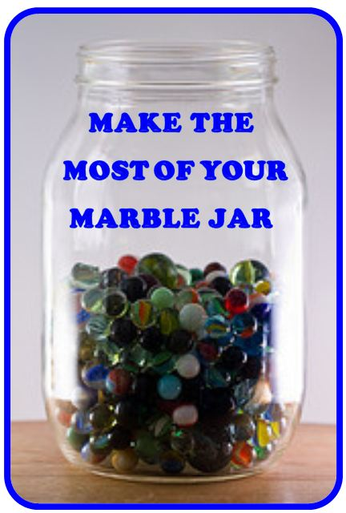
Use a MARBLE JAR. Give each boy three marbles at the beginning of the meeting. When he breaks a rule, he gives up a marble. The marbles left at the end of the meeting go into a jar with a line drawn around it at a height determined by the leader. When the marbles go over the line, the den gets a special treat. Adjust the size of the jar to make this happen every two months or so.
Use a POINT SYSTEM. Award points for every part of the uniform worn by the boy (shirt, neckerchief, slide, belt, pants, socks, tucking in shirt), a point for coming, bringing their book and anything they passed off at home. Additional points can be awarded as you see fit (pack meeting attendance, helping without being asked, performing a service project etc.). When the boy earns a set amount of points, he can choose a gift from the Scout bag. The bag contains different items from the Scout Shop, Wal-Mart, Harbor Freight, dollar store, etc. When a boy earns his Arrow of Light, he is allowed to pick his own party (within reason - no Disneyland!)
An Indian COUP and beads can be used in conjunction with any of the above methods. The boys can make their own coups out of leather or vinyl. They can be worn on their belts, around their necks, or displayed on a board. he boys can earn beads for:
- Attending den meeting
- Earning of Adventures
- Advancement
- Denner service
- Coming in uniform
- Bringing his book
- Attending pack meeting
- Bringing a snack
- Almost anything else – beads are cheap!
The real keys to your discipline system are:
- HAVE ONE. Don’t wait to see if you need one, you do! If you wait until you need it, it’s too late!
- Make sure everyone (Cubs and parents) KNOWS what it is. Explain it at the parents’ meeting, in a note sent home with the boys, and at your first den meeting. Remind when necessary.
- STICK TO IT. Plan on the boys (and maybe the parents) testing you to see if you mean it. Be ready for it. They expect you to do what you say you will do. You lose all credibility if you don’t.

POSITIVE DEN DISCIPLINE
Alice, Golden Empire Council
Focus on the POSITIVE. “Catch” the boys being good, helping others, keeping the den code of conduct. Baden-Powell said “A pat on the back is a stronger stimulus than a prick with a pin. Expect a great deal of your boys and you will generally get it.” Set a goal to say at least one good thing about each boy at every den meeting. But don’t give undeserved compliments – boys know when the praise is genuine! Remember,
“It’s better to build boys than repair men.”
DON’T CRITICIZE a boy in front of the den. Wait until you can talk to him alone. You might want to have a signal so that your assistant can ask a boy to come with her – make sure this is done without sounding angry or as if punishment is in store. Often, removing a boy from the action will defuse the situation. The other adult can simply take the boy to another location and have him help set up for another activity or discuss what happened in the den meeting.
USE POSITIVE WORDS –
- Be specific about what a boy does right – “Thank you for remembering to pick up your mess!” rather than just “Good Job”
- Be sincere and don’t exaggerate – “I really like the colors you used in that drawing” rather than “That’s the best drawing I’ve ever seen”
- Be Immediate with praise so you can reinforce good behavior.
- Share the Praise – while criticism should be done in private, praise is GREAT to SHARE. Share it by saying “I like the way John is putting the cap back on his markers”
You can also Share Praise by adding stickers or beads to a Den Doodle or Individual Boy’s Coup Stick.
And don’t forget to Share with Parents – send an email to let them know when their son is doing a good job or being a good example!
COUPONS – Enlarge and photocopy the coupons below, consisting of a front and back cover and six pages of various coupons. Use as an award for the Cub Scouts. As a boy achieves goals of good behavior, he is awarded “coupons,” which are compiled by the Den Leader. At the end of the month, (or whatever time you have decided) he receives the assembled coupon book. Coupons can be redeemed for treats, tokens to “purchase” incentive items, special privileges, such as helping make a den treat. Assemble the cut out pages, fastening with a staple and threading yarn through punched holes.
Note from Alice: I think a really good way to use these coupons would be to fill them in as a note to send home to parents – Parents need to know when their son has shown a Positive Attitude!
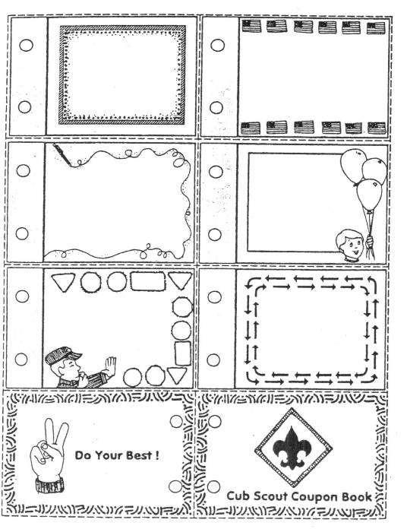

SPECIAL OPPORTUNITIES
With the start of the Cub Scout Adventure Program, the requirements for awards that say things like, "Complete Wolf Achievement 7," needed to be revised to send you to the new Adventures. This was done. The changes were highlighted in Baloo's Bugle in May, June, and July 2015.
To see the revised requirements incorporating the Adventure Program, you can go to
http://usscouts.org/advancementTOC.asp#cub
and get the changes for a specific award.
Or go to
http://www.scouting.org/scoutsource/programupdates.aspx to get a complete summary of all the changes.
All Special Opps discussed this month are for Scouts and Scouters. No Knot of the Month in this issue.

WORLD CREST

An emblem of the World Organization of the Scout Movement, WOSM, (www.scout.org). The World Crest may be worn by all registered youth members and adult leaders as a symbol of their membership in a worldwide Scouting brotherhood. A small amount from the sale of each emblem is sent to the World Scout Foundation to help extend Scouting in developing nations throughout the world. This adds an opportunity for each Scout to personally share indirectly in the activities of brother Scouts in other lands.
Over the years, each member national Scout organization has made use of the badge in a different manner. In 1988 the World Organization of the Scout Movement requested that every national Scout association authorize this emblem to be worn by all members to signify membership in a worldwide movement.
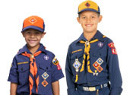
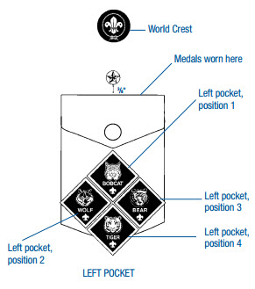
Sew the World Crest halfway between top of left pocket and left shoulder seam
The emblem is worn as a permanent patch centered horizontally over the left pocket and centered vertically between the left shoulder seam and the top of the pocket.
FAQ - If the World Crest may be worn by all youth and adults in the BSA, why isn’t the World Crest pre-sewn on BSA uniforms? In summary, Bryan's Blog's (http://blog.scoutingmagazine.org/) answer to the question said: The fee paid by the BSA to WOSM for use of the emblem is based on the cost of the item sold. By selling the patches separately, the fee is a based on the cost of the patch. If it were pre sewn on a shirt, the fee would be a percentage of the cost of the shirt. Doing that would essentially double the cost of the patch to Scouts and Scouters.
The BSA has authorized two rings that may be worn around the World Crest emblem. Only one ring may be worn at a time.

THE BSA 1910 RING
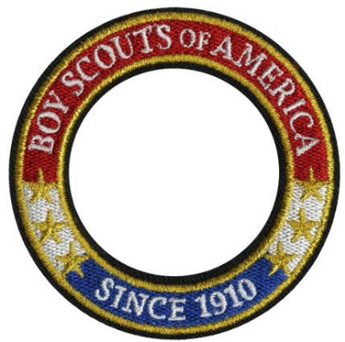
This may be placed around the World Crest emblem by any Scout or Scouter. It was issued for the 100th Anniversary of the BSA in 2010. There are no requirements to wear this ring.

THE MESSENGERS OF PEACE RING
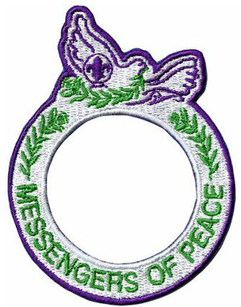
This ring is earned by participating in a Messengers of Peace (MOP) Service Project.
FAQ's
What is Messengers of Peace? - Messengers of Peace is a World Scout Committee initiative designed to promote and recognize service projects that contribute to world peace. Launched in September 2011, Messengers of Peace is a global initiative designed to inspire millions of young men and women in more than 220 countries and territories to work toward peace. Using state-of-the-art social media, the initiative lets Scouts from around the world share what they’ve done and inspire fellow Scouts to undertake similar efforts in their own communities. The initiative is inspired by the World Scout Committee, administered by the World Scout Bureau, and driven by youth volunteers worldwide. For more information –
- BSA Website - http://www.scouting.org/Home/International/messengersofpeace.aspx. There is a lot more information here and many more FAQs.
- World Organization of the Scout Movement (WOSM) Website - https://www.scout.org/messengersofpeace
How do I submit a project? MOP service projects should be reported by the individual in each unit designated to report Journey to Excellence service projects. To designate a Messengers of Peace project, simply select Messengers of Peace as the partner organization when entering a service project through the Journey to Excellence website (www.scouting.org/Awards/JourneyToExcellence ).
What recognition items are available? A participating unit (pack, troop, …) will receive a unit certificate. Each Scout or Scouter who participates in a qualifying project is eligible to wear a Messengers of Peace ring patch around the World Crest on his or her uniform. A unit representative can purchase these ring patches at a local Scout shop, council service center, or Scoutstuff.org

INTERNATIONAL SPIRIT AWARD

www.usscouts.org/awards/
For youth and adult leaders, the International Spirit Award emblem is worn as a temporary patch centered on the right uniform pocket. The award seeks to broaden knowledge of international Scouting and increase appreciation and awareness of different cultures and countries.
This award replaced the former International Activity Award and the International Youth Exchange Award, which are no longer available.
The Award application may be obtained at http://www.scouting.org/filestore/international/pdf/130-044_WB.pdf
Requirements
Cub Scout
- Earn the Cub Scout World Conservation Award.
- Learn 10 words that are in a different language than your own.
- Play two games that originated in another country or culture.
- Participate in Jamboree-on-the-Air or Jamboree-on-the-Internet.
- Organize a World Friendship Fund collection at a unit meeting or district roundtable.
- Complete two of the 10 Experience Requirements.
Boy Scout/Varsity/Venturer
- Earn the Boy Scout or Venturing World Conservation Award.
- Earn the Citizenship in the World Merit Badge. (Alternative for Venturers: Complete the “Understanding Other Cultures” requirement of the TRUST Award.)
- Participate in Jamboree-on-the-Air or Jamboree-on-the-Internet.
- Organize a World Friendship Fund collection at a unit meeting or district roundtable.
- Complete three of the 10 Experience Requirements.
Scouter (Adult)
- Learn about the World Organization of the Scout Movement (www.scout.org). Explain to your unit or at a district roundtable what this organization is and at least three ways that the WOSM website can be used to promote participation in international Scouting.
- Read the most current International Department newsletter (www.scouting.org/international/newsletter) and promote at least two items from the newsletter within your unit or at a district roundtable.
- Help organize or participate in two Jamboree-on-the-Air or Jamboree-on-the-Internet events.
- Organize a World Friendship Fund collection at a unit meeting or district roundtable.
- Complete four of the 10 Experience Requirements.
Experience Requirements
- Host an international Scout or unit and plan activities to help you learn about Scouting in their country.
- Learn about another country and prepare a dinner traditionally served there. Explain what you learned to friends or family over the meal.
- Participate in a World Scout Jamboree, international camporee, or another international Scouting event. Share the experience with your unit or at a district roundtable.
- Take a trip to another country as an individual or with your family or Scouting unit. Make sure to visit a Scouting event or unit in that country. When you return home,share your experience with another unit.
- Organize and participate in a Messengers of Peace project. Share the experience with your unit or at a district roundtable, making sure to explain which dimensions of the program your project promoted.
- Earn the interpreter strip.
- Research Scouting in another country. Make a presentation at a unit meeting or district roundtable.
- Contact your local council’s international representative and assist them with at least two items they need help with promoting.
- Research the process of obtaining a U.S. passport. Create a fact sheet for your unit or district to assist them with requirements for traveling internationally.
- Research a region of the World Organization of the Scout Movement. Make a presentation at a unit meeting or district roundtable.

BSA OUTDOOR ETHICS AWARDS
Robert Stocker
OVERVIEW
Are you looking for something to deepen your unit’s appreciation for the outdoors? Do you or your unit have a love for the outdoors and interested in building skills to extend your commitment on leaving no trace on the land? Well then, the Outdoor Ethics Awareness and Action Award just might be for you and/or your unit.
ABOUT
These awards are built upon The Outdoor Code and The Leave No Trace Seven Principles
The Outdoor Code:
As an American, I will do my best to
Be clean in my outdoor manners.
Be careful with fire.
Be considerate in the outdoors.
Be conservation minded.
The Leave No Trace Seven Principles
- Plan Ahead and Prepare
- Travel and Camp on Durable Surfaces
- Dispose of Waste Properly
- Leave What You Find
- Minimize Campfire Impacts
- Respect Wildlife
- Be Considerate of Other Visitors
REQUIREMENTS
Each Scout level has its own requirements for the Ethics awards. Below are links to each scout level requirement and the requirements for the scout leaders. You will also find a link listed below each scout group to an excellent brochure talking about the Ethics awards for each scout group. This brochure can be downloaded as a PDF and printed out to hand out to interested scouts and scouters.

Cub Scout and Scouter
Cub Scout Outdoor Ethics Program Brochure
Boy Scout and Scouter
Boy Scout Outdoor Ethics Program Brochure
Varsity Scout and Scouter
Varsity Scout Outdoor Ethics Program Brochure
Venturer and Scouter
Venturer Outdoor Ethics Program Brochure
AWARDS
The Outdoor Ethics Awareness Award is a patch that can be worn on the right shirt pocket as a temporary patch.

Temporary patches are worn on the right shirt pocket and only one temporary patch can be worn at a time.

The Outdoor Ethics Action Award is a name tag that can be personalized with the scout or scouters name.
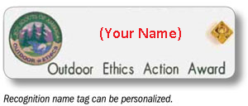
For more in depth information about the BSA Outdoor Ethics program, be sure to check out the link below to the Home page for the Outdoor Ethics Programs. This web site is loaded with all the information; along with changes that have come about because of the changes made to the scouting programs.
Outdoor Ethics – Boy Scouts of America
The BSA's Outdoor Ethics Task Force provides this website as a resource to everyone who is teaching, learning and promoting Outdoor Ethics in Scouting.

THEME RELATED STUFF

STRIKE UP THE BAND (MUSIC) RELATED ADVENTURES
The following Adventures involve "Cubstruction" of something solid –
TIGER –
- Tigers in the Wild - #5 – Sing a song or …
- Tiger Tales - #6 – Sing two Folk Songs
WOLF –
- Duty to God Footsteps - #2c - Learn and sing a song that could be sung in reverence
- Germs Alive - #1 - … while singing the "Germ Song."
- Air of the Wolf - #2b - Create a musical wind instrument …
- Call of the Wild - #6 – Song for a campfire
BEAR –
- Bear Necessities - #2 – Song for a campfire
- Beat of the Drum - #5 – Make a drum.
WEBELOS & ARROW OF LIGHT CORE –
- Camper - #4 – Song for a campfire
WEBELOS & ARROW OF LIGHT ELECTIVES –
- Maestro! - #2a - This whole Adventure is Musical!!!

FUN STUFF
Fun Facts About A Fun Spring – The Slinky
Alice, Golden Empire Council
National Slinky Day is August 30th! This year the Slinky will be 70 years old!!
Mark your calendars. #SlinkyDay70
- The Slinky is still manufactured in the USA at the company's Hollidaysburg, PA facility.
- During the Vietnam War, soldiers used Slinkys as mobile shortwave radio antennas.
- A Slinky dog was a character in the 1995 movie “Toy Story” – His spring was both helpful and a problem!
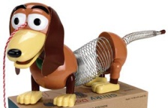
- Slinkys were also featured in the Jim Carrey film “Ace Ventura: When Nature Calls” and John Waters’ “Hairspray.”
- The Slinky is used as a percussion instrument by the Christian band Lost and Found, and in their song called “Lions” fans shout Slinky as the “instrument” is played.
- The Slinky, or a group of them, can be used to demonstrate almost anything to do with the science of earthquakes and seismology.
- The Slinky started as an accident, when a tension spring being tested in the development of a meter to monitor horsepower on US Naval ships fell from a desk. It kept wiggling, and the idea for a toy was born!
- The Slinky is the Official State Toy of Pennsylvania!
- Eddie Murphy opened some of his stand up performances by singing the Slinky Jingle.
- The Slinky was invented in 1943 by a shipyard mechanical engineer in Philadelphia, Richard James.
- He brought home some of the springs for his six children to play with, and then told his wife “I think I can make a toy out of this!”
- It took Richard James two years to figure out which gauge steel and coil to use for the new toy
- Tom Servo from Mystery Science Theatre 3000 has arms made from mini Slinkys.
- The James Spring & Wire Company that made the Slinky was started with just $500.

- In 1999, the United States Postal Service issued a Slinky postage stamp.
- Each slinky uses 80 feet of wire.
- The Slinky toy has a 90% recognition rate in the USA.
- Over a quarter billion have been sold worldwide.
The co-creator of the Slinky, Betty James, was inducted into the Toy Hall of Fame in 2001.

ACTIVITY – MAKE A BAND
This would be a great month to create a band!! There are instructions for homemade instruments in the Cub Scout How-To Book, one of my favorite resources.
Also, I received a recommendation for the “The Kids Can Press Jumbo Book of Music,” by Kids Can Press (duh!). www.kidscanpress.com I bought one and it has a fantastic collection of homemade instruments and music to play on them. There are some freebie samples from the book on the webpage, too. Or maybe you want to hold a …
Talent Show
San Gabriel Valley, Long Beach, &
Verdugo Hills Councils
Why not put together a talent night for your den or pack? I’m sure there is plenty of talent to show off in your group. Boys can play an instrument or sing. Others might want to perform magic tricks. A few boys may want to team up and together do a song or skit. Make a big deal out of it. Instead of looking for the best performer, give each participant some type of recognition – at minimum a certificate or a badge made in the form of a star.
Silly Song writing
Southern NJ Council
Have the boys write new words to an old, well-known tune. The theme should be suggested to them, perhaps a song about camp life, or about their city, town, or province. Of course, it goes without saying that the boys will be expected to present their song at the first opportunity, preferably the next pack meeting.
Pipe Chimes
Steve from North Carolina who taught the Strictly for Cubmasters course I attended at Philmont
Steve had us play the Philmont Hymn for the closing at PTC this summer. We did great with only a little practice. Your Cubs will love playing these things. CD
Materials:
20 feet of single wire electrical conduit
(approximately $2.50 for 10’ stick)
Tubing Cutter - highly recommended for accurate, clean cuts
Time estimate - 1.5 Hours of assembly
Instructions:
Big Picture – You are going to create 20 different pieces of pipe each of a specific length to produce a given note. There will be as string tied onto each pipe for the musician to hold as he taps the pipe with a spoon held in the other hand.
Carefully measure & cut lengths.
Accuracy is important.
Tubing cutter is recommended.
Saws are not recommended. Saws leave burrs.
A miter box is better than a loose hand saw.
Drill 1/8th inch diameter holes in one end of each chime. Pull string through holes and tie.
Label chime (Sharpie Marks A lot).
Chime Dimensions: (1/4 wavelength)
Length of Pipe Note Chime #
13 5/8 A 0
13 3/8 B flat 1
13 B 2
12 5/8 C 3
12 ¼ C sharp 4
11 7/8 D 5
11 ½ E flat 6
11 ¼ E 7
10 7/8 F sharp 8
10 5/8 F 9
10 ¼ G 10
9 7/8 A flat 11
9 5/8 A 12
9 3/8 B flat 13
9 1/8 B 14
8 7/8 C 15
8 5/8 C sharp 16
8 3/8 D 17
8 1/8 E flat 18
7 7/8 E 19
7 5/8 F 20

Over The River
Chimes Needed: - 3, 5, 7, 8, 10, 12, 14, 15
10 10 10 10 7 8 10 10 10 10 15 15 15 14 12 10
10 8 8 8 8 8 7 7 7 7 7 7 5 5 5 7 5 10
10 10 10 10 7 8 10 10 10 10 15 15 14 12 10
10 15 15 14 12 10 7 3 5 7 10 8 7 5 3
America
Chimes Needed - 3, 5, 7, 8, 10, 12, 13, 15, 17
8 8 10 7 8 10 12 12 13 12 10 8 10 8 7 8
3 3 5 3 5 7 8 8 10 8 7 5 3 3 3
15 15 15 15 13 12 13 13 13 13 12 10
12 12 12 12 10 8 10 10 10 10 8 7
11 13 12 10 8 12 13 15 17 13 12 10 8
8 8 8 8 7 8 8 10 8 7
America the Beautiful
Chimes Needed: - 2,3,4,5,7,8,9,10,12,14,15,17,19
10 10 7 7 10 10 5 5 7 8 10 12 14 10 4 5
7 7 3 3 7 5 2 2 2 5 5 8 8 7
3 3 3 2 2 2 5 5 3
10 10 7 7 10 10 5 5 17 16 17 19 12 17 9 8
7 7 3 3 7 5 2 2 14 14 14 12 9 14
2 3 3 2 10 10 10 9 10
10 19 19 17 15 15 10 10 10 12 15 10 17 15 8
15 15 14 10 12 10 10 10 14 10 8 8 10
10 10 10 7 8 7 10 7
5 15 12 12 15 15 10 10 10 10 12 15 10 17 15
10 12 8 8 12 10 7 7 14 10
7 8 8 7 8 7
Cub Scout Spirit
Chimes Needed - 7, 8, 9, 10, 12, 14, 15, 16, 17, 19
10 12 14 15 14 12 10 19 19 17 15
10 10 10 7 15 15 14 10
7 7 7 10 10 8 7
16 17 15 14 19 19 17 15
14 14 12 10 15 15 14 10
8 8 8 8 10 10 8 7
9 12 14 15 14 12 10 19 19 17 15
10 10 10 7 15 15 14 10
7 7 7 10 10 8 7
17 17 15 14 17 15
14 14 12 10 14 10
8 8 8 8 8 7
Goofy for Cub Scouts
(Cub Scout Tuba, Bagpipe or Digeroo)
Darby, my daughter, who learned this from a PTC faculty member. Directions enhanced by Steve from North Carolina who taught the Strictly for Cubmasters course I attended at Philmont. CD
Materials:
- A long, fairly stiff, hollow tube (Paper, plastic, or most any material will work for the tube. Larger diameters make for deeper musical notes.) I like the plastic tubes in the center of the 36 inch paper used on the plotter where I used to work but a real stiff tube from any paper roll will work or make one by rolling a piece of poster board. I have one made from a carpet roll, too!!
- A latex glove
- A straw
- Tape (Electrical tape, duct tape, etc. Masking tape may tear easily.)
Construction Instructions:
- Cut a few inches of the straw
- Put a pinhole in the end of the thumb of the glove (My daughter and Steve say use the thumb. Reason becomes evident, below.)
- Push the straw part way through the hole and tape where the straw and glove intersect
- Take the wrist opening of the glove and stretch it over one end of the tube.
- Tape the wrist end of the glove to the tube by wrapping tape around the glove's wrist and the tube.
- Grab the fingers of the glove and stretch the palm/ back of hand of the glove taut across the tube, sort of sealing the entire circumference of the tube with the palm / back of hand of the glove. . (The glove palm/back will make a “drum” over one end of the tube. This “drum” will be the vibrating membrane, which makes the noise.)
- Holding the glove taut across over the opening, pull the four loose fingers up the side of the tube.
- After you have successfully produced music, if you wish, use tape to secure the four fingers to the side of the tube to evenly tighten your “drum” / your tympanic membrane.)
Playing:
- Resting the top (open end) of the tube on your shoulder
- Blow into the straw; you should get a tuba like sound
HINT - If you get nothing -
Try readjusting the glove across the opening or change angle on the tube
Pencil Xylophone
Baltimore Area Council
A pencil xylophone doesn’t sound like a piano or guitar but it sure sounds like fun!!

If you like music but don’t have a musical instrument of your own, you can make this pencil xylophone that really works! You’ll need eight wooden pencils, a pencil sharpener, corrugated cardboard, glue or tape, and an ice cream stick (two ice cream sticks if you’re real good).
For the xylophone support, cut two pieces of corrugated cardboard, about 4” X 10½.”
Poke eight holes, evenly spaced, along one long side of each cardboard, about l/2” from the edge. Put the ice cream stick into each hole, and twirl the stick around in the hole, which will make it slightly larger than a pencil. Make eight more holes on the other piece of cardboard, so that the holes from each cardboard line up together.
Remove the metal and eraser at the end of each pencil so you’ll be able to sharpen the pencil at both ends. With an open scissors, make a ridge on the pencil at the base of the metal. Run the scissors back and forth around the pencil until it makes a groove in the pencil. Then break the eraser and metal off the pencil at this place.
Sharpen one pencil to each of the following lengths, sharpening at both ends and measuring from tip to tip; 6½”, 6¼”, 6”, 5¾”, 5½”, 5¼”, 5”, and 4½”. These are approximate measurements for the pencils. You’ll probably have to vary them somewhat.
Insert each pencil through a set of matched holes. Start with the longest pencil and end with the shortest pencil. Number the pencils, from “1” to “8”, making the longest pencil ‘1”.
Arrange the cardboard at a slight angle, as pictured, so that it looks like the ends would meet if the cardboard were a bit longer. There should be 4¼” between the sides at the wide end of the xylophone and 2” at the short end.
Cut a piece of corrugated cardboard to fit the open space at end of the support, and tape or glue these pieces to the support, making the -xylophone look more like a finished musical instrument. The ends of the pencils extend over the edge of the support, about
1” on each side, as pictured,
You’ll want your pencil xylophone to play the scale just right. Using a file, nail file, or the sharp edge of folded sandpaper, file a notch into the center of the pencil if you need to lower the pitch, Sharpen the pencil some more to raise the pitch. Play the xylophone by tapping pencils with ice cream stick or another pencil sharpened at both ends.
Try these melodies or write your Pencil Xylophone
Jingle Bells
3-3-3,/2”3-3-3, 3-5-1 -2-3,
4-4-4, 4-3-3, 3-2-2-3-2,5,
3-3-3, 3-3-3, 3-5-1-2-3,
4-4-4, 4-3-3, 5-5-3-2-1.
Farmer in the Dell
1-1-1-1-1-1,2,
3-3-3-3.3,
5-5-6-5-3-1,
2-3-3-2-2-1 .
Mary Had a Little Lamb
3-2-1-2-3-3-3, 2-2-2, 3-5-5,
3-2-1 -2-3-3-3,
2-2-3-2-1 .
Row Your Boat
1-1-1-2-3, 3-2-3-4-5,
7-7-7, 5-5-5, 3-3-3, 1-1-1,
5-4-3-2-1 .
Banjo
Baltimore Area Council
To make this banjo, use aluminum foil pans and cut tabs in the opposite sides of each pan. For a better tone, cut about a 2” hole in the bottom of one pan. Use this pan for the top of your banjo.

For the neck, place a strip of wood, about 2” wide, between the two pans (rims together). Attach tabs to the wood strips by hammering in tacks. At bottom of wood strip, hammer tacks in only half way for stringing wire.
Drill four holes at the end of the neck for golf tee pegs, File slits near tops of tees to keep strings from slipping.
Use wire, ukulele strings, or rubber bands for strings. Fasten one end of each string to tacks. Knot other end of string so it won’t slip out of slit in tee. Twist tee to tighten string. Vary the pitch of each string by tightening or loosening tee.
Rubber Band Banjo
Southern NJ Council
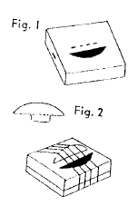
Materials:
Box measuring approximately 4" square & 1" deep
Cardboard piece for bridge
Tape or gummed paper
Rubber bands of various sizes
Toothpick
Directions
- Cut a hole and a slot to insert tab of bridge into in the cover. (Fig. 1).
- Fashion a bridge from cardboard. (Fig 2). Make certain the bridge fits securely into the narrow slot and that the bridge stands upright. Return cover to box and fasten with scotch tape or gummed paper.
- Stretch rubber bands of various sizes over the entire box passing them over the bridge. The smaller bands that are stretched more tightly over the bridge will produce the highest tones.
- To play pick the banjo with your fingers or a toothpick. Select simple tunes with which to begin your playing of the banjo; then go to work on the more difficult ones.
Bass Viola
Baltimore Area Council

Cut tabs at wide and narrow ends of a ham can. Bend tabs out and nail them onto a strip of wood, about 2” wide, to form the neck. String, as for the banjo.
Humming Machine
Baltimore Area Council

Cut a circle of wax paper 2” larger all around than the top of a foil pie pan.
Place the circle on top of the pan and press excess paper down over the sides of the pan.
Tape the paper onto the bottom of the pan at two opposite points only.
To play, place your slightly parted lips lightly against the hummer. Hum a tune. The paper vibrates to amplify your humming.
Tambourine
Baltimore Area Council

With a hammer and a nail, punch a hole in about 20 bottle caps. String caps through holes punched a- round a foil pie pan. Substitute bells for bottle caps, if you like,
Musical Package
Baltimore Area Council
A small package is wrapped in masses of paper and string. Players are seated in circle and package is passed as music is played. When music stops, boy holding the package tries to unwrap it. No tearing or ripping is allowed. When music starts again, boy holding package must pass package on around circle. Game continues until one player is able to completely unwrap the package. Small prize in the package is for winner.
Musical Handkerchief
Baltimore Area Council
Each player takes the name of a musical instrument. The leader throws his handkerchief high into the air, each player being instructed to make the sounds of his instrument while the handkerchief is in the air, but to stop the instant it touches the ground. Anyone who fails to stop that instant must sit out. Then the game continues. Last one in is the winner.
Orchestra
Baltimore Area Council
The boys sit in a circle and each one chooses the name of a musical instrument. It is better to choose the names of instruments, which require distinctive motions to play, such as: bass drum, trap drum, violin, bass viola, piano, cornet, and others. The leader starts the game by imitating the motion of one playing his instrument. For example, if the leader’s instrument is the bass drum, he imitates one beating a bass drum. Each other player must then imitate the motions that go with the playing of his instrument.
Whenever the leader desires, he may change his motions and start imitating the motions of any other player. While he is doing this, all other players except the one imitated must switch to the instrument that the leader was formerly playing. The one whose instrument is imitated must stop his motions and place his hands over his ears.
Whenever the leader switches back to his original instrument, each player in turn must switch back to his. Anyone who plays his instrument while it is being imitated, or fails to switch to the leader’s instrument when he switches to another, or anyone who fails to switch back to his own instrument when the leader switches back to his, must pay a forfeit. Another version of this game is to have a player who has made a mistake become the leader.
Whistling Contest
Baltimore Area Council
The players are formed in a circle with a pile of folded sheets of paper in the center. On each slip of paper is the name of a song. The leader starts by taking one slip of paper. The leader must whistle the song until the name of the song is guessed. The player who guessed is next to pick a slip of paper.
Musical Advance
Baltimore Area Council
The group is divided into two equal teams, which stand in vertical lines both facing the front. At the signal to begin, the last player runs to the front of the line, claps his hands over his head three times and sings the first word of the song named by the leader (both teams will sing the same song). The next player in line sings the second word, on down the line of players. The last player runs to the head of the line, claps his hands over his head three times and sings the next word of the song. The team finishing the song first wins.
Maracas
San Gabriel Valley, Long Beach, &
Verdugo Hills Councils
There are a lot of sounds that come from homemade maracas. Here are a few suggestions to get you started for all those sounds:
Containers:
- Paper cups taped together at the rim
- Empty water bottles
- Empty milk bottles
- Film canisters
Fillers:
- Rice;
- Beads;
- Sand;
- Pebbles;
- Dried peas.
Instrument Slide
San Gabriel Valley, Long Beach, &
Verdugo Hills Councils
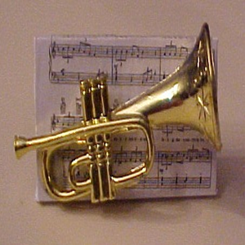
Materials:
- Plastic musical instrument, approximately 1½”
- 1¼” wooden square
- Sheet music
- ¾” PVC ring, 1” long
Equipment:
- Craft glue
- Hot glue/gun
Directions:
Using a good copier machine, copy some music sheets down to “really small size.” (If you can copy the sheets cleanly so that the whole sheet is about 1/8 normal size that would be good.)
Cut the sheet music to cover the top of the wooden square; glue in place with craft glue. Using hot glue, mount the instrument onto the sheet music. Mount the PVC ring to the back of the wooden square.
Household Band
Southern NJ Council
Your house is a house full of band instruments just waiting to be found for next month’s performance at the pack meeting. Right now those instruments may look like ordinary pans, bottles, and tools, but a little work can turn them into music makers.
Some brown wrapping paper, a large bottle of white household glue, string, plastic tape, and rubber bands are needed to begin. Next, collect a large wastepaper basket, the biggest ice cream carton, shortening can, or coffee can that can be found; an empty aluminum foil box, some hammers of different sizes, a few half gallon plastic bottles, some aluminum pie tins, some pan lids, soda bottles, and small frozen juice cans.
When put together according to directions, lots of unusual rhythm sounds will be found in the band. If a Cub in the den plays a real musical instrument, he can carry the tune. Otherwise, assign a couple of the best singers to the Funnyface Trumpets described here.
Funnyface Trumpets
Southern NJ Council
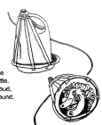
- Cut the bottom out of round half-gallon plastic bottles, the ones with handles.
- Wash them out carefully.
- Fasten thin aluminum pie plates over the cut out section with strips of tape, as shown,
- Paint bold grinning faces on the pie plates.
- Play by humming strongly into the neck of the bottle.
- They make a loud, rattly, kazoo sound.
Drums
Southern NJ Council
Drums of any size and sound can be made by covering old wastebaskets, cartons, or large cans with two pieces of heavy wrapping paper glued together with white glue. Stretch this “skin” tightly over the basket or can and tie tightly in place. Now paint the whole thing with another coat of white glue, and let the drum dry overnight. Long pencils or dowels may be used for drumsticks.
Rattles
Southern NJ Council
Use the same method as for the drums. Cover one end of a frozen—juice can and let it dry. Add a handful of small gravel, dried beans, or beads. Cover the second end and allow it to dry. To play, just shake the can.
Ratchet
Southern NJ Council
- Tear the top off the empty aluminum foil box.
- Cover the box with colored construction paper.
- To play, scrape the saw-toothed foil-cutter with a heavy metal cooking spoon.
- They’re loud, and only one is needed.
Seashell Wind Chimes
San Gabriel Valley, Long Beach, &
Verdugo Hills Councils
The Seashell wind chime will make a lovely sound when the wind blows through it. Materials:
- 8 seashells (from the beach or craft supply stores)
- 1 plastic coffee can lid
- Yarn scraps
- White glue
- Sharp pencil/paper punch
Instructions:
  - Glue each shell to the end of a short piece of yarn. Use liquid white glue.
  - Let dry overnight.
  - Punch eight holes equally spaced on the top of a plastic coffee-can lid. Use a sharp pencil or a paper punch.
  - Hold the lid with the rim facing up. Push the eight pieces of yarn through the eight holes of the underside of the lid.
  - Tie the end of each piece of yarn in a large knot. Make the knot bigger than the hole so the yarn will not slip through.
  - Punch two more holes on opposite edges of the lid.
  - Push one end of a large piece of yarn from the top of the lid through one hole. It should come out on the underside of the chime.
  - Tie a large knot.
  - Push the other end of the yarn through the other hole and knot it.
  - Hang the chime on the branch of a tree or in your window.
Tuba
San Gabriel Valley, Long Beach, &
Verdugo Hills Councils
Materials:
- Three feet of clear flexible tubing 5/8” to 3/4” inside diameter
- 8” funnel
- Tape
Instructions:
Push one end of the funnel into the piece of tubing and secure with tape. With lips together, place free end of tubing to your mouth. Force air between lips to make a buzzing sound. Be sure to clean thoroughly after each music session.
Silly Kazoos
San Gabriel Valley, Long Beach, &
Verdugo Hills Councils
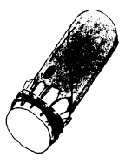
Materials:
- Paper tube roll (use paper towel roll cut in half)
- Rubber band
- Waxed paper
- Pencil
Instructions:
- Cut a piece of waxed paper a few inches larger than the tube roll opening.
- With a rubber band, secure the waxed paper over one end of the tube.
- Using a pencil or pen, punch a hole about 1” from the covered end.
- Hold the open end of the kazoo around the outside of your mouth and hum your favorite tune.
- Decorate your Kazoo with paint or construction paper.
Bass Fiddle
San Gabriel Valley, Long Beach, &
Verdugo Hills Councils
Materials:
- Coffee can
- Mop or broom handle
- String
- Heavy tape
Instructions:
Punch a hole in the bottom of the can. Thread string through hole and secure on the inside. Tie other end of string to end of broomstick and secure with tape so it does not slide down.
To play it, put one foot on the can to hold it in place. Rest the end of the broomstick without the string on the coffee can or on the floor. Tilt dowel back until the string is tight. Then pluck it.
Jingle Bell Gloves
San Gabriel Valley, Long Beach, &
Verdugo Hills Councils
Materials: Stretchy kind of children’s glove and five small jingle bells.
Instructions: Take stretchy glove and sew a jingle bell to end of each finger.
Drum
San Gabriel Valley, Long Beach, & Verdugo Hills Councils
- Get a plastic bleach container (rinse well).
- Saw it off just below the handle.
- Use the bottom for the drumhead.
- Drum using fingers or dowel stick.
- Variation: Use an oatmeal box.
Bottle Xylophone
San Gabriel Valley, Long Beach, &
Verdugo Hills Councils
Materials:
- Eight soft drink bottles:
- Five 12 ounce size
- Two 16 ounce size
- One 10-ounce size.
Instructions:
- Make a hanging stand.
- Hang bottles by their necks
- Tune by pouring water into them.
- After tuning the bottles, mark the water level for easy refilling.
- Use a knife handle for playing.
Homespun Band
San Gabriel Valley, Long Beach, &
Verdugo Hills Councils
Have each boy bring a tool (screwdriver, saw or hammer, kitchen pan or utensil). Divide into dens and give them each a song (one verse and chorus). Give each den about ten minutes to “practice” with their instruments. They need to use each item that was brought as a part of their band.
Attend A Local Band/Music Performance
York Adams Area Council
With the many local music groups, concert halls, schools, etc., in our area, there is always an opportunity to take the boys for an evening of educational entertainment. One place to go for upcoming events in the area is WITF’s website for its monthly magazine, “Central PA.” Go to: http://www.centralpa.org/events.html.
Marching Band/Instruments Demonstration
York Adams Area Council
Call up one of the local high schools and see if the band leader can arrange for several of the band members to visit and put on a demonstration. If you can get the times to work out, they can also be there to help start or end the Pack Meeting.
Create A Pack Marching Band
York Adams Area Council
I bet I am one of a very few people who attended a high school that has never had a real marching band. But just because it didn’t have a “real” one, that doesn’t mean we didn’t have a pseudo marching band—our kazoo and pots ‘n pans marching band. Soooo, why not get the boys together, have them bring in their own combs, pots, pans, etc. and you supply the waxed paper
Be creative – invent your own INSTRUMENTS!!

THEME & PACK MEETING IDEAS

GATHERING ACTIVITIES
Note on Word Searches, Word Games, Mazes and such – In order to make these items fit in the two column format of Baloo’s Bugle they are shrunk to a width of about 3 inches. Your Cubs probably need bigger pictures. You can get these by copying and pasting the picture from the Word version or clipping the picture in the Adobe (.pdf) version and then enlarging to page width. CD
Name the Instrument
Baltimore Area Council
Give everyone a piece of paper with the word “ORCHESTRA” written on it in a vertical line. At the starting signal, everyone must write in a musical instrument beside each letter. The first person to complete the list, or the person having the most instruments listed wins and is awarded a prize.
Musical Mixers
Baltimore Area Council
Have several sets of small cards with song titles on them. Choose songs from the Cub Scout Songbook, or pick Pack favorites. Give each Cub and parent a card and ask him to find others with the same song title and rehearse the first verse of that song with them. Have plenty of copies of the complete songs for the groups to use. Have the groups sing the first verses of their songs, in turn, during the meeting.
String Maze
Baltimore Area Council
You will need for each player (or Team):
- A different colored ball of sting or yarn
- A pencil
- A prize
Preparation:
- Tie the prize to the end of the string
- Hide the prize somewhere in the room
- Unwind the ball of string completely, passing over, under, and around table legs, furniture, and other objects in the room.
- Tie a pencil on the remaining end of the string.
- Repeat this with each ball of string, don't worry about crossing the strings; this will add to the fun.
To play:
- Give each boy (or team - could be a den) a pencil and tell him there is a prize at the end of the string.
- Have them wind the string around the pencil as they work their way around the room to find the prize.
Musical Get to Know You
San Gabriel Valley, Long Beach, &
Verdugo Hills Councils
Find someone who:
Plays a musical instrument
Knows the first verse of the national anthem
Sings in a choir
Knows what an octave is
Knows what the first action is in Hokey Pokey
Can describe and draw a whole note
Can pronounce and tell what a glockenspiel is
Can sing the first verse of ANY song
Can explain and draw a treble clef
Knows the term for singing without musical accompaniment
Likes the same kind of music that I do
Knows who wrote Star Spangled Banner
Can name the four sections of an orchestra
Plays with a band or orchestra
Can give a brief history of God Bless America

Just One Word Trick
Southern NJ Council
You'll really have them at a loss for words with this one! Cut out the following letters from magazine or newspaper headlines (or draw black letters on paper and cut them out,)
J N O O R S T U W E D
Place the letters in any order on the floor or table (or any flat surface), Ask the players to rearrange the letters to spell "just one word.” If they give up, rearrange the letters to spell the three words, "Just One Word."
Getting To Know You - Mixer
Baltimore Area Council
Copy the statements below and give one to each person as they arrive at the meeting. During the meeting, award those who have largest number of spaces filled with small prizes.
Find people who can complete the following sentences. The person’s name can only appear once on the quiz (you can’t put your name). For more fun, arrange the categories in a BINGO board!
was born in the same state as I was.
knows how to play a musical instrument.
has the same middle initial as I do.
sings in a choir.
has a birthday in the same month as I do.
Can sing “America the Beautiful.”
wears the same size shoe as I do.
can whistle.
likes the same sports as I do.
has a harmonica.
has the same favorite color as I do.
takes piano/key board lessons.
has the same hair color as I do.
knows the Cub Scout motto as I do.
likes the same kind of music as I do.
Strike Up The Band
York Adams Area Council
How many different words can anyone find in the theme phrase “Strike Up The Band”? Hand out sheets of paper with the phrase at the top. Ask each den to work together to see how many words it can make from the letters in the phrase.
Impromptu Kazoo Zoo
York Adams Area Council
Have supplies (combs and waxed paper pieces) for the boys to use when they come in. Set aside a band practice area and have one of the parents or the Den Chief act as a conductor for the practice session. Make sure the conductor encourages and makes it lots of goofy fun so the boys don’t lose interest.
Instrument Word Search
San Gabriel Valley, Long Beach, &
Verdugo Hills Councils
Find words that describe a musical instrument in the word search below. They can be upside down, backwards, forwards or diagonal.
Words to Find:
Base Bassoon Cello
Clarinet Flute French Horn
Glockenspiel Guitar Hand bells
Harp Kettledrum Oboe
Organ Percussion Piano
Piccolo Saxophone Strings
Tambourine Timpani Trombone
Trumpet Tuba Ukulele
Violin Vocals Wind
Xylophone
Name That Tune
York Adams Area Council
Borrow as many sound reproducing players (MP3 players, I-pods, I-pads, tablets, I- phones, Androids, PCs, Macbooks, I-Macs, boom boxes, cassette players, 8 Track players, Reel to Reel players, phonographs, gramophones, whatever) (Note 1) as you can and set up each device to play a short (preferably wordless) piece of a different song. Label the players 1 through ?? and make a key listing what song is on each player. Have people walk from one player to another to listen to the different “wordless” pieces to see how many songs they can identify.
Note 1 – The 14 year old item From which I was copying said "Borrow as many cassette recorders as you can.". I updated and backdated the list.
Signs of Spring Word Search
Alice, Golden Empire Council
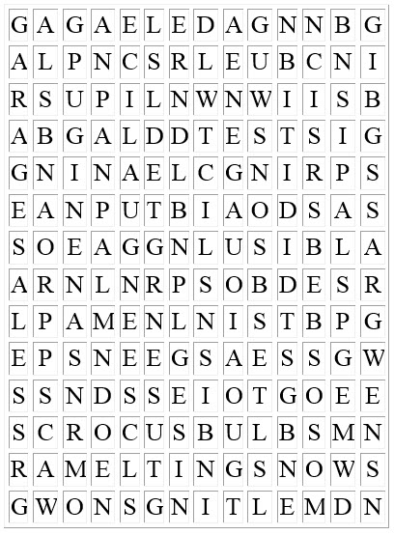
Find these two words phrases:
Apple Blossoms Bird Songs New Grass
Crocus Bulbs Garage Sales Nest Building
Spring Cleaning
What Instrument Is It
York Adams Area Council
Have lettered or numbered pictures of different band instruments on display and give the boys papers with the names of the different instruments that are pictured. (You might even throw in a couple names for which there aren’t pictures.) Have them work together, using their collective knowledge, to figure out what all of the instruments are. Make sure to include some no-brainers and well as some challenges.
Name That Tone
York Adams Area Council
Similar to the pictures, but certainly more challenging, come up with recorded samples from different instruments. If you have internet access, you can find websites with midi files of different instruments’ sounds. Have the boys work together and discuss which instrument plays has sound. (You can also try using an electronic keyboard that synthesizes different instruments, although they’re fidelity is usually not great.) Again have sheets listing the different instruments and have them identify which instrument plays “Sound A,” Sound B,” etc.

OPENING CEREMONIES
Music Magic (Opening Ceremony)
Setup: Have each Scout hold up a sign with the letter itself or a picture representing each letter on the front. Have their text on the back in BIG letters:
- M is for the Many instruments in our band and Pack.
- U is for Unison, we play our music together for the most fun.
- S is for Special and Sound – each instrument makes a special sound.
- I is for Instrument – We each have our own Instrument to play.
- C is for Cubmaster – our Cubmaster leads our band.
- M is for the Melody we hope you will enjoy.
- A is for Adults; we wouldn’t be here without the help of the Adults.
- G is for the Great music we will make together.
- I is for Imagine. Imagine you see beautiful visions when we play our music.
- C is for Concert – let’s begin our Concert by playing America the Beautiful.
America the Beautiful
(Use with above opening or by itself)
O beautiful for spacious skies,
For amber waves of grain,
For purple mountain majesties
Above the fruited plain! America! America!
God shed His grace on Thee,
And crown thy good with brotherhood
From sea to shining sea!
O beautiful for patriot dream
That sees beyond the years
Thine alabaster cities gleam
Undimmed by human tears!
America! America! God shed His grace on Thee,
And crown thy good with brotherhood
From sea to shining sea!
God Bless America
Set Up: Use with an Opening Ceremony or as an opening ceremony. If sing as an Opening Ceremony, you may wish to introduce it with the following text. If using the text you may have one leader or several read it or have a Den have each member say a few words. -
- For our Strike Up the Band Pack Meeting Opening tonight we are going to sing, “God Bless America,” by Irving Berlin. He lived from 1888 to 1989. He immigrated to New York City from Russia with his family when he was five years old. Young Irving sang songs on the street for money to help his family. Soon he was writing songs with a piano player friend. Irving wrote the lyrics, and his friend wrote the melodies. Later Berlin got a job as a "song plugger.”
- “God Bless America,” America’s unofficial national anthem, was composed during the summer of 1918 at Camp Upton, located in Yaphank, Long Island, for Berlin’s Ziegfeld-style revue, “Yip, Yip, Yaphank.” "Make her victorious on land and foam, God Bless America..." ran the original lyric. However, Berlin decided that the solemn tone of "God Bless America" was somewhat out of keeping with the more comedic elements of the show and the song was laid aside.
- In the fall of 1938, as war was again threatening Europe, Berlin decided to write a "peace" song. He recalled his "God Bless America" from twenty years earlier and made some alterations to reflect the different state of the world. Singer Kate Smith introduced the revised "God Bless America" during her radio broadcast on Armistice Day, 1938. The song was an immediate sensation; the sheet music was in great demand. Berlin soon established the God Bless America Fund, dedicating the royalties to the Boy and Girl Scouts of America.
While the storm clouds gather far across the sea,
Let us swear allegiance to a land that's free,
Let us all be grateful for a land so fair,
As we raise our voices in a solemn prayer.
God Bless America,
Land that I love.
Stand beside her, and guide her
Thru the night with a light from above.
From the mountains, to the prairies,
To the oceans, white with foam
God bless America, My home sweet home
Our Cub Scout Band
York Adams Area Council
Set Up: A Leader (Cubmaster or Den Leader, or other) and Five Cub Scouts with placards with a band pictures on front and their words on back in LARGE print. Their parts are rhyming couplets. Try to get them to say them that way.
Leader: With tonight’s theme we’re going to be hearing a lot of noise—music they call it. Noise that comes with having a great time as we “Strike Up the Band.” Let’s hear from some experts, though, on just what makes up a Cub Scout Band…
- B is for Boys who are joined in this group,
They call themselves Cub Scouts—they’re a Pack, not a Troop.
- A is for Allegiance, that all Cub Scouts know,
For their Country they’ll trust and follow.
- N is for Never, will they do any less,
Than working their hardest and doing their best.
- D is for Dynamic, the Cub Scouts you’ll hear,
Are full of real energy, fun, and good cheer.
- So join with us now as we strike up the band,
We’re set to have the best times, throughout all the land.
Leader: To get things started with tonight’s bandstand of fun, let’s join together in singing a song that was written by one of the most well known musicians in America.
Stars and Stripes Forever
York Adams Are Council
Setup: You might want to play “Stars and Stripes Forever” in the background as the color guard brings forward the flags. Also, you can have some of the boys in the Den begin reciting the lyrics to the march before the color guard advances. The lyrics are provided below. You will want to time this so that it all works together (“in concert” as they say!). (In practicing it, I was able to say the words in a shorter time than the music plays.)
Leader/Narrator: Welcome to a night of sound and wonder! Tonight we celebrate music and to begin our program, we will hear the sounds and words of The Official March of the United States of America, “Stars and Stripes Forever, written by John Philip Sousa, American composer, conductor and patriot. Please stand for the presentation of the colors.
(Begin music and reciting the lyrics.)
Stars and Stripes Forever
by John Philip Sousa
Let martial note in triumph float
And liberty extend its mighty hand
A flag appears 'mid thunderous cheers,
The banner of the Western land.
The emblem of the brave and true
Its folds protect no tyrant crew;
The red and white and starry blue
Is freedom's shield and hope.
Other nations may deem their flags the best
And cheer them with fervid elation
But the flag of the North and South and West
Is the flag of flags, the flag of Freedom's nation.
Hurrah for the flag of the free!
May it wave as our standard forever,
The gem of the land and the sea,
The banner of the right.
Let despots remember the day
When our fathers with mighty endeavor
Proclaimed as they marched to the fray
That by their might and by their right
It waves forever.
Let eagle shriek from lofty peak
The never-ending watchword of our land;
Let summer breeze waft through the trees
The echo of the chorus grand.
Sing out for liberty and light,
Sing out for freedom and the right.
Sing out for Union and its might,
O patriotic sons.
Other nations may deem their flags the best
And cheer them with fervid elation,
But the flag of the North and South and West
Is the flag of flags, the flag of Freedom's nation.
Hurrah for the flag of the free.
May it wave as our standard forever
The gem of the land and the sea,
The banner of the right.
Let despots remember the day
When our fathers with might endeavor
Proclaimed as they marched to the fray,
That by their might and by their right
It waves forever.
Making Magic
Southern NJ Council
PERSONNEL: Cubmaster, Bobcat, Wolf, Bear, Webelos.
EQUIPMENT: Magic rings, a sack, black and white scarves, hold-up signs for each speaker.
Cubmaster: "Color guard advance the colors."
- "I am a Bobcat. I know the magic of Scouting, 'Do Your Best'."
- "I am a Wolf. I know the secret of Scouting, I follow Akela."
- "I am a Bear. I know the secret of Scouting, 'Help Other People'."
- "I am a Webelos. I know the secret of Scouting. I can perform magic feats of skill. (Holds up two scarves) In my two hands I have a black and white scarf. I shall put the black and white scarves in the sack. I shall say the magic words. Hokus, pokus, eenie, beenie, jelly beenie..... (Pulls white scarf out 1st) See, the black scarf has changed to the white and the white has changed to the black."
Cubmaster: Boys, the magic to Cub scouting in our Pack is the three rings I have in my hands. You see them linked together as the Scout Oath and Law link us. But with magic the links can become individual circles as each of you are individual links in our Pack. Without all the links working together magic cannot be present."
Color guard present the flags of our Pack and Nation.
Salute
Pledge of Allegiance.
Magic Candle
Southern NJ Council
On head table are arranged magic candles, which should be lit as ceremony begins
Narrator: Our candle stands tall, straight, and white. It burns and gives forth inspiring light. As its light shines forth, you will see our colors blue and gold are regal as can be. As the blue appears, thing of truth and loyalty, the sky so blue, steadfastness and spirituality. When the gold shines forth, be of good cheer and think of happiness and sunlight so clear. As our candle's flame reaches toward the sky so blue, let us ask (our God) to give us wisdom to lead each boy straight and true. Mold each of us to be like our candles, straight and tall, and be inspired to give to God and our country our all.
To make "magic candles"
Use tall white candles. Drill 1/4" diameter holes every two inches down opposite sides of the candle. Place scraping of blue and gold crayons in the holes. Melt paraffin and whip with eggbeater. Cover candle with whipped paraffin using a fork to give the candle a rough decoration. As the white candle burns it will drip blue and gold wax decoratively down the side of the candle.)
Not Just Pieces of Colored Cloth
Baltimore Area Council
Props: Pieces of red, white, and blue cloth or paper (large enough so the audience can see what boys have in their hands), A large box with another smaller box inside it, An American flag in the smaller box, 3 to 5 Cub Scouts.
Paint the larger cardboard box all one color (it looks better). Inside that box place the smaller box. Inside the smaller box place the folded American flag, with the corners up so that the flag can be picked up easily. The box can be on the floor, on a chair or on a table.
Have one den member walk up to the box and drop BLUE colored strips into it.
The Cubmaster says: “The color blue is from the sky of America, the blue of loyalty and truth in American hearts.”
The second Cub walks up to the box and drops in the WHITE strips.
Cubmaster says: “The color white is for purity of heart and service to America.”
Now the third Cub Scout walks up to the box and drops the RED strips into it.
Cubmaster says: “The red is for the blood shed during America’s history and the proud glory of our flag.
Now two Cubs walk up to the box and slowly lift up the flag, while the Cubmaster says: “Together these bright colors and the things for which they stand, combine to make the pride of our hearts, the Flag of the United States of America.”
FYI: Any suitable dialogue is proper. Remember, when you have your opening ceremony you are NOT locked into having the flag brought up from the back of the room, saluting the flag and reciting the Pledge of Allegiance. To fit with the theme sing “America the Beautiful” or “God Bless America.” Use your imagination.

AUDIENCE PARTICIPATIONS
The Wonderful Cellar Band
San Gabriel Valley, Long Beach, &
Verdugo Hills Councils
Divide the group into five smaller groups and assign each group one of the words listed below. Practice as you assign parts. Read the story. After each of the words is read, pause for the group to make the appropriate response.
DUSTY OLD CELLAR: Cree-eek, Ah-Choo
JUG: Boop, Boop
TRASH CAN: Crash-Bam
SAW: Whaang, Whaang
HAT BOX: Rat-a-tat-tat
Once upon a time, as many stories begin, in a DUSTY OLD CELLAR there lived a group of very good, very old, and very out-dated friends. There was an empty glass JUG, a rusty SAW, two beat-up TRASH CANS and a faded old HAT BOX. Now these old friends had been in the DUSTY OLD CELLAR for a very long time, and except for being moved about from time to time, they were left alone to rust or turn to dust. Needless to say, they were very lonely.
One day, the empty glass JUG, in a deep low voice said, "It's too quiet here. I wish something would happen." “ Now really, JUG," said the rusty SAW, "What could possibly happen here?" "Why," said the faded old HAT BOX, "I've been sitting on this DUSTY OLD CELLAR shelf for 20 years and all I've seen are two mice and a Daddy- Long-Legs spider." This empty glass JUG is just getting older and emptier," said the beat-up TRASH CANS. "Don't pay him any mind."
Suddenly there was the sound of footsteps on the DUSTY OLD CELLAR stairs. Four young boys, all dressed alike, came cautiously down the DUSTY OLD CELLAR steps. They were talking in hushed voices. "Are they twins?" asked the faded old HAT BOX.
"I think they're pygmies!" said the rusty SAW in a lofty voice. "Nonsense," said the empty glass JUG. "They're Cub Scouts," said the beat-up TRASH CANS. By now, the old friends were very curious and excited. They listened as the boys talked.
"Boy, it's spooky down here in this DUSTY OLD CELLAR," said Jim. "Don't be a fraidy cat," said Mike. "Aw heck, let's go," said Jack. "No, wait," said Bill. "I've got an idea. We have to do a stunt for our Den Meeting, don't we?"
"Yeah, that's right," the other three chorused. "Well," said Bill, "Let's have a band ... a DUSTY OLD CELLAR band!" "A band!" they yelped. "Sure," said Bill. "I'll play that rusty SAW. Jim, you take that empty glass JUG. Mike that faded old HAT BOX will make a neat drum. And Jack, those beat-up TRASH CAN lids will be swell cymbals. Well, of course, you know the rest. Den Three made new friends with old friends, right there in the DUSTY OLD CELLAR, with an empty glass JUG, a rusty SAW, a faded old HAT BOX and two beat-up TRASH CANS, and for all we know, they may be playing together still!

Down by the Old Mill Stream - (Vaudeville Style)
Baltimore Area Council
INSTRUCTIONS: Sing the song through once with no action. Sing a second time with action. Boys could make musical instruments for washboard band.
Words Actions
Down by the OLD MILL STREAM
OLD- stroke chin for beard
MILL- hands go around like mill wheel
STREAM- small, wavy motion
Where I FIRST met YOU,
FIRST- hold up 1 finger
YOU- point to another person
With your EYES so BLUE
EYES- point to eyes
BLUE- point to CUB uniform
Dressed in GINGHAM, TOO
. GINGHAM- point to WEBELOS scarf
TOO- hold up 2 fingers
It was THERE I KNEW
THERE- point far away
KNEW- point to head and look inspired
That you LOVED me TRUE.
LOVED- put hand over heart
TRUE- put up 2 fingers in CUB salute
You were SIXTEEN
SIXTEEN- flash fingers to show 16
My village QUEEN
QUEEN- put hands to head, fingers up for crown
Down by the OLD MILL STREAM.
(as OLD, MILL, and STREAM above)
Down by the Old Mill Stream - (Another Version))
Baltimore Area Council
For adventurous groups, try the following version:
Down by the OLD (not the NEW, but the OLD)
MILL STREAM (not the River, but the STREAM)
Where I FIRST (not SECOND, but FIRST)
met YOU (not HIM, but YOU).
With your EYES (not your EARS, but your EYES)
so BLUE (not GREEN, but BLUE),
Dressed in GINGHAM (not SILK, but GINGHAM),
TOO (not THREE, but TOO).
It was THERE (not HERE, but THERE)
I KNEW (not THOUGHT, but KNEW)
That I LOVED (not HATED, but LOVED)
you TRUE (not FALSE, but TRUE).
You were SIXTEEN (not FIFTEEN, but SIXTEEN),
My village QUEEN (not the KING, but the QUEEN)
Down by the OLD (not the NEW, but the OLD)
MILL STREAM (not the RIVER, but the STREAM).
Actions
NEW- rock baby in arms
RIVER- large wavy motion
SECOND- hold up 2 fingers
HIM- point to a HIM
EARS- point to ears
GREEN- point to CUBMASTER's green uniform
SILK- point to American flag
THREE- hold up 3 fingers
HERE- point to ground by feet
THOUGHT- put hand like fist and strike pose like Rodin's "Thinker"
HATED- scowl & clench fists
FALSE- clasp hand over mouth, horrified
FIFTEEN- flash fingers to 15
KING- hands to head, fingers down

And another way to do it –
Baltimore Area Council
If you're really brave, reverse the words, i.e. Down by the New (not the Old, but the New) MILL RIVER (not the STREAM but the RIVER), etc.

ADVANCEMENT CEREMONIES
Band of Advancement
York Adams Area Council
SETUP: You could copy pictures for each of the musical instruments to which the ceremony refers and have these pictures posted in the front of the room. I offer my apologies to the real musicians of the world. I am trying to write a ceremony here, not create the most harmonious band—anyway, is that what you’d want from a group of 1st to 5th graders? I think it is better that they’re able to just make lots of noise for now—too soon they’ll have to rein in their enthusiasm one way or another!
BAND CONDUCTOR (maybe in top hat and tails or with one of those big batons): Have you ever seen a marching band? The drum major leading the group? The trumpets and tubas; clarinets and flutes; drums and trombones. A band has many instruments—all of them combining together to make for some great music. It works the same way with Cub Scouting. Let’s put together our Cub Scout Band…
What kind of a band would it be without the wonderful, mellow sounds from our first section, the Bobcats. These are our own band’s Clarinets. Like the clarinet, the Bobcat brings a special sound to the band. The clarinet is a woodwind instrument, as you might know—and that definitely puts me in mind of our Bobcats—they are so full of energy like the wind. Just as Mozart was the first composer to use the clarinet in a symphony, the following boys have achieved the rank of Bobcat.
[Call up the Bobcat recipients and their parents to receive the badges.]
Present badges to parents to award to their sons. Lead a cheer for the Bobcats. Let them return to their seats.
Next, it is our Tiger section. They are our piccolos. Theirs is usually a high-pitched sound of fun and excitement. Why just this past month the sounds of laughter and squeals of good times were heard as they worked on their latest Tiger activities. Let’s see what all the noise was about.
[Call up the Tiger recipients and their parents to receive the badges.]
Present badges to parents to award to their sons. Lead a cheer for the Tigers. Let them return to their seats.
BAND CONDUCTOR: Our band’s next instrument is as fitting as the others for the level to which it’s applied. For what instrument can be at moment quiet, mellow, and pensive, while in the next be blaring with joy and excitement. I refer to, of course both the trumpet and the Wolf Cub.
[Call up the Wolf recipients and their parents to receive the badges.]
Present badges to parents to award to their sons. Lead a cheer for the Wolfs. Let them return to their seats.
BAND CONDUCTOR: A little more “toned down” and “older,” our next band group can still be just as fun and free flowing as the Wolves’ trumpets. These are our Bear Cubs—the trombones of our band. You can just picture the light flashing off the brass of the trombones as the slide moves back and forth And, yes, it also might just sound a little more brassy than the trumpet, too—these guys are getting older and are starting to reach out a little more than their Wolf Cub brothers.
[Call up the Bear recipients and their parents to receive the badges.]
Present badges to parents to award to their sons. Lead a cheer for the Bears. Let them return to their seats.
BAND CONDUCTOR: The band continues to grow as we add our next instrument, the saxophone. Now here’s an instrument with some sound. And just as the sax brings a certain amount of pizzazz to the band, so do our Webelos Scouts bring that same kind of pizzazz to the Pack—they do us proud for working so diligently to complete their Adventures.
[Call up the Webelos recipients and their parents to receive the badges.]
Present badges to parents to award to their sons. Lead a cheer for the Wolfs. Let them return to their seats.
BAND CONDUCTOR: As our band nears completion, we notice a certain lack of pounding rhythm—wonder what it’s missing? The drums of course—that solid resounding pum-pum-pum that comes from the excitement of doing something special. Tonight we add a little bit of bass and rhythm to our band as we recognize the Scouts who have earned (name the Special Opportunity Award the Cubs have earned – Summertime Award, Outdoor Award, International Spirit Award, Recruiter, …).
[Call up the award recipients and their parents to receive the badges.]
Present awards to parents to award to their sons. Lead a cheer for them. Let them return to their seats.
BAND CONDUCTOR: There is no sound that spells “finale” quite like the clash of the symbols. They may not sound off too often, but when they do, everyone stands up and takes note. And that’s how it is with our Arrow of Light Scouts who complete the requirements for the most honored and highest award in Cub Scouting—the Arrow of Light Award. Let's give the Scouts in our Arrow of Light Den encouragement to finish with the Cymbal Cheer.
To close out our awards ceremony, we will listen to a short piece written to honor all of our band “pieces.” This piece is for you. [At this point, play a short selection of a Sousa march.]
Cymbals Cheer
Raise your arms up as if holding two cymbals. Move your hands up and down twice (four cymbal hits) pretending to play the cymbals. Go clang or crash or make a noise that replicates cymbals crashing to you.
American Achievement (Music) Awards
Baltimore Area Council
NOTE: The use of the word Achievement is for achieving something. Not for the former advancement system. CD
Advancement Preparation:
- Make “American Music Awards” for the Badges by spray-painting sauce or ketchup bottles (ones with long skinny necks) with gold paint. Staple just the Wolf, Bear, etc cloth badge on blue or yellow 1” wide ribbon and hang on the award like the picture.
- Make up envelopes that contain the cards and pins for the boys who are to receive Badges and seal them with a gold seal. Have an Assistant Cubmaster help you or have special presenters for the envelopes and the awards.
The script for this Awards Show Pack Meeting is written for the Cubmaster. Feel free to divide up the speaking part if you wish. Other needed personnel will be mentioned as the script goes on at the time they are needed.
To help it go over big – Use a lot of enthusiasm.
Ceremony:
Welcome to the First Annual Pack XYZ Cub Scout Achievement Award Show. Our show tonight is brought to you in living color and is sponsored by (charter organization). I am your host for tonight, Cubmaster __________. We have quite a few categories to cover tonight, so on with the show.
The first category of Achievement is the Bobcat. We have several Cub Scouts who are eligible for the Bobcat and have been nominated for this award. The nominees are: (list all the boys who are to receive their badge). And the winners are: (If there are more than one, announce a tie). Now before you receive your award, please lead the Cub Scouts in the pack in the Scout Oath. All Cub Scouts and Webelos Scouts please: rise and give the Cub Scout Sign, while the winners lead you in the Scout Oath. You parents have been helping in the wings. Each parent, please present your son with his badge.
Note: (In between the awards, have a song or some other musical entertainment)
Our next category is for the Achievement of the Tiger. We have several Cub Scouts who have worked very hard to be nominated for this award. They have completed seven Adventures and some have done even more. The nominees are: (List all the boys just as you did for the Bobcat). And the winners are: (or announce a tie). You have worked very hard to earn this award. You parents have helped your sons to accomplish this award. Please do the honors by presenting the badge and the pin to your son. (Treat the Wolf, Bear, and Webelos Badges like the Tiger Badge). Lead a cheer for the boys in each rank.

Musical Notes
San Gabriel Valley, Long Beach, &
Verdugo Hills Councils
Props: White poster board, with lines for musical score (no notes, just lines and a treble clef), propped up; black paper notes with double sided tape or loops of tape on the back. Have the Cub Scouts’ names in bright colors on the face of each (Gold or silver marker works well).
Cubmaster: There are many beautiful songs in the world. When you are happy, you can’t help but burst out in a song.
The most beautiful music to me is the sound of a happy child when he is proud of his accomplishments. Please join me in singing the praises of the following young men. (Calls out names of first group of boys to earn rank.)
These boys have earned their (Bobcat, Tiger, Wolf, Bear, Webelos) rank. Their hard work and endeavor leaves a song in my heart. This patch is for their uniform to show the world what they have accomplished. The pin is for the parents, to show how much their support means to him. (Gives patches to the parents to present to their sons, pins to the Scouts to present to their parents.)
Boys, as you receive your badge, please add your note to our musical score. (Boys stick their musical notes on the board.)
Cubmaster repeats as necessary varying dialog for each rank.
Star Advancement Ceremony
San Gabriel Valley, Long Beach, &
Verdugo Hills Councils
Set up: Similar to musical awards show with handmade “trophies” using homemade statuettes or star shaped certificates. You may want to even have special envelopes containing the boys’ patches/pins.
Announcer: (Use your best TV Emcee voice) Good evening and welcome to our star studded awards show. Tonight we congratulate all the boys for their accomplishments. First, we have the Bobcat award to be given to the boys with a fantastic first performance in a den. These boys are well on their Cub Scouting trail. The winners are: (Names of boys getting the Bobcat award.) Will these outstanding performers and their agents/parents please come forward?
Next, we have a group of Tigers who have worked hard on their 7 Adventures. Will the following who have earned the Tiger Award and their agents please come forward? (Names of boys) Let’s give a big hand to these winners!
Next, we have a group of Wolves who have worked hard on their 7 Adventures. Will the following who have earned the Wolf Award and their agents please come forward? (Names of boys) Let’s give a big hand to these winners!
Moving right along, we have the band of Bears who have also completed their 7 Adventures and continue to grow in Scouting. The winners are: (Names of boys)
And now, we have our stellar Webelos: They have worked diligently over the years and have completed the 4 Core and 3 Elective Adventures thanks to their agents and directors – their leaders. We are proud to award them the Webelos Award: (Give names of boys.) Will they please come up along with their agents to receive their award? Aren’t these boys all stars for their advancements? They will continue practicing for only one more award, that prestigious Arrow of Light award.
Good luck to all our boys in pursuing their shining careers in Scouting!
Musical Notes
San Gabriel Valley, Long Beach, &
Verdugo Hills Councils
Props: White poster board, with lines for musical score (no notes, just lines and a treble clef), propped up; black paper notes with double sided tape or loops of tape on the back. Have the Cub Scouts’ names in bright colors on the face of each (Gold or silver marker works well).
Cubmaster: There are many beautiful songs in the world. When you are happy, you can’t help but burst out in a song.
The most beautiful music to me is the sound of a happy child when he is proud of his accomplishments. Please join me in singing the praises of the following young men. (Calls out names of first group of boys to earn rank.)
These boys have earned their (Bobcat, Tiger, Wolf, Bear, Webelos) rank. Their hard work and endeavor leaves a song in my heart. This patch is for their uniform to show the world what they have accomplished. The pin is for the parents, to show how much their support means to him. (Gives patches to the parents to present to their sons, pins to the Scouts to present to their parents.)
Boys, as you receive your badge, please add your note to our musical score. (Boys stick their musical notes on the board.)
Cubmaster repeats as necessary varying dialog for each rank.
The Great Spirit
Southern NJ Council
Personnel: Cubmaster, Akela, Great Spirit
Equipment: Artificial campfire, tom-tom
Setting: Curtain opens showing Akela sitting by campfire. Tom-tom is beating softly.
Cubmaster: Chief Akela of the Webelos Tribe, I have before me (number) Cub Scouts who have lived by the Cub Scout motto, kept the Scout Law and followed the Scout Oath. They have each completed the Adventures requirements for their respective ranks. I now present and recommend each for his advancement.
Great Spirit: Tonight we honor those Cub Scouts who have grown in knowledge and have achieved a higher rank in Cub Scouting. How have they grown in knowledge? In much the same manner as Akela. Akela was the big chief of the Webelos - tall, stalwart, straight as an arrow, swift as an antelope, brave as a lion. His father was the son of the great yellow sun. He was called the ‘Arrow of Light’. His mother, from whom he learned all those wondrous things that mothers know, was called ‘Kind Eyes’. When Akela was a young boy, he was taken on short trips into the forest among the great trees and the streams. Here from the Wolf he learned the language of the ground, the tracks, the fields, and the ways of food. From the Bear he learned the secret names of the trees, the calls of the birds and the language of the air. Just like Akela, you have learned much along your trail to advancement.
Akela: Cub Scouts, you have lived by the Cub Scout motto, kept the Scout Law and followed the Scout Oath. I am happy to see you come before this pack to receive your badges.
(Curtain closes)
Cubmaster: Just as Akela’s parents helped him as he grew, so have your parents helped you achieve your new rank. I know that they will be proud to share this honor with you. Will these boys and their parents come forward? (Call names, present badge to mother) Now I will ask that you boys give the Cub Scout sign and repeat after me:
“We boys now promise
To go back to our dens
And to do our very best
To work on more Adventures
And to keep advancing regularly.”
Thank you and congratulations!
LEAD CHEER for each rank.
Advancement Song Advancement
Baltimore Area Council
Have the Leaders form an arch (London Bridge style) and each time you call a den up for its advancements you have the leaders sing the “Cub Scout Advancement Song. This song should be practiced.
Advancement Song
Santa Clara County Council
Tune “When Johnny Comes Marching Home”
When the Cub Scouts all achieve a rank,
Hoorah! Hoorah!
When the Cub Scouts all achieve a rank,
Hoorah! Hoorah!
The moms will cheer (moms cheer)
And the dads will shout (dads shout)
The leaders all will turn about
(Leaders turn around in a circle)
And we’ll clap our hands (all clap)
When the Cub Scouts achieve a rank!
This song could be sung before the Advancement Ceremony any month. Maybe, make it like the Announcement Song that is sung when the Cubmaster says the word Announcements. Have this sung when the Cubmaster announces Advancements. CD

LEADER RECOGNITION

DEN LEADER SURVIVAL KIT
Ellie Matrow, Western Massachusetts Council
Den Leaders and Assistants, Cubmasters, and Committee Members are critical to successful Packs.
But sometimes they need a little survival help, too.
Assemble Survival Kits containing the following to present to them as a Thanks Yous and Recognitions:
A MARBLE - for those days when you lose yours.
A PENNY - so you will never be completely broke.
A PAPER CLIP - to keep everything together.
A STRING - to put it all back together when it all seems to be falling apart.
An ELASTIC - to help you stretch beyond your limits.
A KISS - to remind you that someone cares about you.
LIFESAVERS - to remind you how important you are to your staff and your staff is to you.
SMARTEES - to remind you of how much knowledge you have to share with Commissioners, Scouters, and Scouts.
A CANDLE - to help you keep alive the Spirit of Scouting.
A SHARPENER - for when you have to get right to the point.
A NOISEMAKER - for when you have to toot your own horn
A LEASH CLIP - to help you hold on tight when the going gets rough.

DEN CHIEF INDUCTION
2010 - 2011 CS RT Planning Guide
Materials: Den Chief cords (or Webelos Den Chief cords, as needed), one for each Den Chief being honored
Personnel: Cubmaster (CM), Den Leaders (DL)
CM: Tonight we would like to recognize some very special new leaders in our pack. Will the following Scouts please come forward? (Call the names of den chiefs. Den chiefs come to the front and line up facing the audience.)
CA: These young men have been selected to serve as den chiefs for Pack ___ this year. They have been selected because they have shown leadership skills.
DL: They will help the dens they work with by setting a good example in attitude and uniform, being a friend to the boys in the den and helping them achieve the purposes of Cub Scouting. (Face the den chiefs.)
CC: We, the leaders and families of Pack___, welcome you to our leadership corps. Your troop has presented you the badge of office. We would now like to present you the den chief cord, which is worn on your left shoulder. Den leaders, please place the cord on the den chief who is working with your den. We thank you for the service, enthusiasm, and the fun you will bring to your dens.
CM: Let us honor these Scouts with a cher. (CM leads one of his favorite cheers)

COMPASS DEN CHIEF RECOGNITION
2010 - 2011 CS RT Planning Guide
Materials: Certificate of appreciation, compass, one flashlight for each Cub Scout in the den
Personnel: : Cubmaster (CM), Den Leaders (DL), Den Chief, Cub Scout Den
Set Up:
- Turn down the room lights and ask everyone to stand.
- Have the Cub Scouts form two lines facing each other.
- Cub Scouts shine their flashlights at an angle on the floor so the beams cross.
CM: Call the den chief forward to walk the lighted pathway.
Den Chief comes forward
DL: It is my honor and pleasure to present this certificate to you along with this compass. The boys chose a compass because of the direction you gave them while guiding them in their den and on their Cub Scouting trail.
The boys of your den would now like to do their den yell for you.
Boys do their den yell.
CM: Thank you for your dedication, enthusiasm, and leadership! (CM leads one of his favorite cheers)

SONGS
HHMMmm – how do you pick songs for a Music Theme – well here are some classics and some classics with new words. Some FUN, some thoughtful, some with actions, some without. Maybe you can have each den pick a song and lead it or perform it at your Pack Meeting. Want even more?? Don’t forget the Cub Scout Songbook that now comes with a recording so you can hear the songs, too. Whatever you do – Have FUN. CD
If You're Happy and You Know It
Baloo's Archives
If you're happy and you know it,
clap your hands (clap clap)
If you're happy and you know it,
clap your hands (clap clap)
If you're happy and you know it,
then your face will surely show it
If you're happy and you know it,
clap your hands. (clap clap)
- If you're happy and you know it,
stomp your feet (stomp stomp)
- If you're happy and you know it,
shout "Hurray!" (hoo-ray!)
- If you're happy and you know it,
do all three (clap-clap, stomp-stomp, hoo-ray!)
S-M-I-L-E
Baltimore Area Council
Tune: John Brown’s Body
It isn’t any trouble just to S-M-I-LE
It isn’t any trouble just to S-M-I-L-E
There isn’t any trouble that won’t vanish like a bubble,
If you only take the trouble just to S-M-I-L-E.
- It isn’t any trouble just to G-R-I-N, grin.
- It isn’t any trouble just to L-A-U-G-H
- It isn’t any trouble just to HA! HA! HA! HA! HA!
I've Got That Scouting Spirit
Southern NJ Council
I've got that Scouting spirit up in my head,
Up in my head, up in my head.
I've got that Scouting spirit up in my head,
Up in my head to stay.
2. I've got that Scouting spirit deep in my heart.
3. I've got that Scouting spirit down in my feet.
4. I've got that Scouting spirit all over me
I’d Like To Teach The World To Sing
San Gabriel Valley, Long Beach, &
Verdugo Hills Councils
This one may make a good Opening – CD
I’d like to build the world a home
And furnish it with love
Grow apple trees and honey bees
And snow-white turtle doves
I’d like to teach the world to sing
In perfect harmony
I’d like to hold it in my arms
and keep it company
I’d like to see the world for once
All standing hand in hand
And hear them echo through the hills
For peace throughout the land
That’s the song I hear
Let the world sing today
A song of peace that echoes on
And never goes away
I’d like to teach the world to sing
In perfect harmony
I’d like to hold it in my arms
And keep it company
I’d like to see the world for once
All standing hand in hand
And hear them echo through the hills
For peace throughout the land
That’s the song I hear
Let the world sing today
A song of peace that echoes on
And never goes away
A song of peace that echoes on
And n-e-v-e-r g-o-e-s a-w-a-y
Cub Scout Harmony
Baltimore Area Council
Tune: I’d Like To Teach The World To Sing
I’d like to teach the world to sing
In Cub Scout harmony.
The Blue and Gold would be the thing
That everyone would see.
Each Wolf and Bear and Webelos
Is doing all he can
To “Do His Best” with all the rest
Of Cub Scouts in the land.
Chorus:
We’re the real thing (Cub Scouts)
Why not join us, you’ll see (Cub Scouts)
What fun really can be (Oh, yeah!)
We’re the real thing (We’re Cub Scouts, oh, yeah!)
That’s Why We’re in Cub Scouting
Baltimore Area Council
Tune: Deep In The Heart Of Texas
The fun things in life, Our family’s delight!
(clap hands four times)
That’s why we’re in Cub Scouting.
We do our best, To pass each test
(clap hands four times)
That’s why we’re in Cub Scouting.
Just me and my son, Work, play, and have fun,
(clap hands four times)
That’s why we’re in Cub Scouting.
We think our pack’s great, We keep it first-rate;
(clap hands four times)
That’s why we’re in Cub Scouting!
The Nothing Song
Baltimore Area Council
Tune: Reuben, Reuben, I’ve Been Thinking
Nothing, nothing, nothing, nothing,
Nothing, nothing all day long.
Absolutely nothing, nothing
That’s the name of the Nothing song?
Call out –
Second verse, same as the first
A little bit louder and a little bit worse
Or whatever the next verse number is)
You can have as many verses as you wish!!
Whew-w-w
Baltimore Area Council
Tune: Jingle Bells
Clap your hands, stomp your feet,
Let's all stand up please.
Face to the left, face to the right
Now hands on your knees.
Sit down now, stand back up.
Clap your hands two beats.
Now we'll all wipe our brows,
And collapse in our seat.
Round Time
San Gabriel Valley, Long Beach, &
Verdugo Hills Councils
Divide the room into three separate groups.
All of these songs can be found in the Cub Scout Songbook. Have one group start and then start the other groups,
go through the songs two or three times.
The first group can sing Row Row Row Your Boat
The second group will sing Down by the Station
The third group will sing Are You Sleeping
Commercial Confusion
San Gabriel Valley, Long Beach, &
Verdugo Hills Councils
Tune: The Farmer in the Dell
Last night I watched TV
I saw my favorite show
I heard a strange commercial,
I can’t believe it’s so.
Feed your dog Chiffon.
Comet cures a cold.
Use SOS pads on your face,
to keep from looking old.
For headaches take some Certs.
Use Tide to clean your face
And do shampoo with Tacky Glue,
It holds your hair in place.
Perhaps I am confused.
I might not have it right.
But one thing I am certain of,
I’ll watch TV tonight!
Scouting In The US of A
San Gabriel Valley, Long Beach, &
Verdugo Hills Councils
Tune: YMCA
Young Cub, welcome to Cub Scouts
I said young Cub, this is what it’s about
I said young Cub, you’ll learn to cast that line out
You’ll learn to cook and to camp out
Young Cub, are you ready to start
I said young Cub, be a Tiger and Wolf,
I said young Cub, to be Bear and Webelos,
These are things to help you grow
It’s fun to scout in the US of A
It’s fun to scout in the US of A
You’ll learn most everything to prepare you for life
Without any strife,
It’s fun to scout in the US of A.
Every Year
Southern NJ Council
(Tune: Old MacDonald Had A Farm)
Every year we bake some pies,
Yum, yum, yum, yum, yum.
Coconut and lemon pies,
Yum, yum, yum, yum, yum.
With a big slice now and a glass of milk.
Extra slices if I may.
Every year we bake some pies,
Yum, yum, yum, yum, yum.
Every year we go see Grandma,
Ho, ho, ho, ho, ho.
She always lets us trim the tree.
Ho, ho, ho, ho, ho.
Up go the lights, and up goes the tinsel.
Everyone helps as we decorate it.
Every year we go see Grandma,
Ho, ho, ho, ho, ho.
Baden Powell Had Many Scouts
Southern NJ Council
Tune: Father Abraham
To hear the tune go to http://www.niehs.nih.gov/kids/lyrics/manyscouts.htm
For actions, simply move indicated part of the body named
After the first verse, start swinging right arm;
Swing both arms after second verse;
Swing both arms and right leg after third verse and so on.
Robert Baden-Powell had many scouts
Many scouts had Robert Baden-Powell.
I am one of them, and so are you.
Let me tell you what to do...
Right arm.
Robert Baden-Powell had many scouts
Many scouts had Robert Baden-Powell.
I am one of them, and so are you.
Let me tell you what to do...
Right arm, left arm.
Continue, adding:
- Right leg,
- Left leg,
- Nod your head,
- Stick out your tongue,
- Turn around, sit down.
Little Red Caboose
Taught to me by Diane from South Dakota at the Philmont RT Class a few years ago.
Little red caboose, chug chug chug
Little red caboose, chug chug chug
Little red caboose behind the train, train, train, train
Smokestack on his back, back, back, back
Coming down the track, track, track, track
Little red caboose behind the train
Whoo-Whoo!
Scout Vespers
Southern NJ Council.
Tune: Oh, Christmas Tree
Softly falls the light of day,
While our campfire fades away.
Silently each Scout should ask:
“Have I done my daily task?
Have I kept my honor bright?
Can I guiltless sleep tonight?
Have I done and have I dared.
Everything to be prepared?”
Scout Wetspers
Southern NJ Council
Tune: Oh, Christmas Tree
Softly falls the rain today
As our campsite floats away
Silently each Scout should ask
Did I bring my SCUBA mask?
Have I tied my tent flaps down?
Learned to swim, so I won't drown?
Have I done and will I try
Everything to keep me dry??
The Scout Who Never Returned
Southern NJ Council
Tune: Charlie On The MTA
Let me tell you of a story of a Scout named ____
On that tragic and fateful day;
Put his Scout knife in his pocket;
Kissed his dog and family;
When to hike in the woods far away.
Well, did he ever return?
No, he never returned.
And his fate is still unlearned:
He may roam forever in the woods and mountains,
He's the Scout who never returned.
Now you citizens of [town name],
Don't you think it's a scandal
How ol' [Scout's name] got lost that day?
Take the right equipment;
TAKE ALONG A BUDDY,
When you hike in the hills that way.
Or else you'll never return,
No, you'll never return.
And your fate will be unlearned: just like [Scout's name])
You may roam forever in the woods and mountains,
Like the Scout who never returned.
Take Me Out to the Forest
Southern NJ Council
(Tune: Take Me Out to the Ball Game)
Take me out to the forest.
Let me hike in the wild.
Show me a skunk and a few bear tracks.
I won't care if I never come back.
But it's look, look, at your compass.
If it rains, then it pours.
And it's ouch, slap, sting and your bit
In the great outdoors!
The Grand Old Duke of York
Southern NJ Council
Tune: "A-Hunting We Will Go"
The Grand old Duke of York,
He had ten thousand men.
He marched them up the hill,
Everyone stands up
And marched them down again.
Everyone sits down
And when you're up, you're up;
Everyone stands up
And when you're down, you're down.
Everyone sits down
And when you're only halfway up,
Everyone half-way up
You're neither up nor down!
The Grand Old Captain Kirk
Southern NJ Council
Tune: "A-Hunting We Will Go"
The Grand Old Captain Kirk
He Had A Thousand Men,
He Beamed 'em Up To The Enterprise
Everyone stands up
And Beamed 'em Down Again.
Everyone sits down
And When You're Up Your Up,
Everyone stands up
And When You're Down Your Down,
Everyone sits down
And When You're Only Half Way Up,
Everyone roll your atoms
Your atoms roll around

STUNTS AND APPLAUSES

APPLAUSES & CHEERS
York Adams Area Council
Trumpet: da-da-da-da-dada-da-da-CHARGE!
Band Practice Cheer: Tell everyone that on the count of 3 they are to play their own band instrument until the conductor gives the “stop playing” signal. Give examples, such as drum, bugle, trumpet, flute, trombone, etc. Count to 3 and conduct the band for a few seconds.
Baton Throwing Cheer: Have everyone hold their invisible batons in their hands and on your signal toss them into the air and then try to catch them.
Marching Band Cheer: Use the Band Practice Cheer, but have everyone march in place while playing.
Drum: On legs make a rat-a-tat sound 3 or 4 times, then hit the stomach two times and say "Boom, Boom".
Flute: Pretend to be playing the flute and give two big toots.
Violin Applause: Hold left hand extended as if holding violin, with head tipped a little as if holding instrument under chin. With right hand make the bow go across the strings as you say in a loud scratchy voice, "Squeek-eek-eek, Squawk-awk-awk", "Squeek-eek-eek, Squawk-awk-awk"
Guitar Applause: Hold left hand to side as.if holding neck of a guitar, cup right hand with thumb extended up and move it up and down as if on the strings while moving the fingers on the left hand as if changing keys while saying in a musical voice Wtrum-um-um, Strum-urn-urn, Strum-urn-a
Harp Applause: Hold both hands extended in front of you and move the fingers on both hands while you pull them toward yourself and say,, in a soft musical voice "Pluck-uck-uck, Pluck-uck-uck" (3 times)
Triangle Applause: Hold left hand in front of you as if holding the triangle, while holding.the right hand as if you're holding the small rod. Then make motion as if striking it while saying in a high ringing voice, "Ring-ing-ing, Ring-ing-ing"
Orchestra Applause: This one can be a lot of fun because it is a combination of all the above four. Divide your group into four groups with each group doing a different instrument as described above. When you, the orchestra director gives the signal they all do their sounds at once.
Southern NJ Council
Great Job – Group stands and says “Great Job! Great Job! Great Job!. Get louder each time.
Grand Salute-
Slap your knees 5 times and loudly count 1 2 3 4 5
Stamp your feet five times and loudly count,
Clap your hands five times and loudly count,
Then stand up and salute.
One Note – Have group sing and hold one note as long as possible.
Musical: Announce the name of a well-known song such as "Yankee Doodle" or "Dixie" and ask everyone to clap to its rhythm.
For a different finish, tell everyone to miss the last note. Someone is sure to forget.
Tuba Applause:
Group repeats "Ooom-pah-pah, Ooom-pah-pah."
Try this like the chip - chop cheer by dividing the group into two parts –
the Ooom’s and the pah-pah’s
Trumpet Applause:
Place hands to your mouth as if playing a trumpet and shout out "Ta, da, da, da."

RUN-ONS
Singing Backward
Baltimore Area Council
Who can sing "America, the Beautiful," backward?
(Turn your back to the audience and sing)
Commissioner Dave’s Archives
One of the reasons I am always breaking into song is that I can never find he key
Southern NJ Council
Little Brother
Scout 1: Whatcha doing?
Scout 2: Writing a letter to my little brother.
Scout 1: Why are you writing so slowly?
Scout 2: Because my little brother can't read very fast!
Bee Sting
Scout 1: "OOOOOUCH, OOOOOCH, OOOUCH."
Scout 2: "What's the matter with you?"
Scout 1: "A bee's stung my thumb."
Scout 2: "Try putting some cream on it then."
Scout 1: "But the bee will be miles away by this time."
Knock, Knocks
Southern NJ Council
Knock, Knock Knock, Knock.
Who’s there? Who’s there?
Yodel-lay-he. Leaf.
Yodel-lay-he-who? Leaf Who?
I didn’t know you could yodel Leaf me alone.

JOKES & RIDDLES
A Ninth Of Beethoven
Southern NJ Council
Maestro Patrick Casey was conducting a special performance Beethoven's Ninth Symphony with the local symphony and things were getting a bit crazy. In the fourth movement, the lead violin player got some string and tied the conductor's music to the stand. Two Cellists were asleep. Meanwhile, the bass players had been sneaking shots of whiskey through the entire performance. And were completely plastered by this point. The bass trombone player looks up from his latest issue of Field and Stream to ask his neighbor what in the world was going on. The guy turns to him and says "Well, it's the bottom of the ninth, there are two out, the basses are loaded, the score is tied and Casey’s up."

Musical Riddles
Southern NJ Council & Baltimore Area Council
Riddles are a lot of fun for Cub Scouts to try and figure our and a lot of fun to laugh at. They can be used in the den meetings for gathering time, activity fun or for fillers in the Pack meeting. Give a copy of these to your Den Chief or Asst. Cubmaster and he/she can keep the boys busy guessing for a gathering time activity.
- The choice of which two musical keys might be given to a man walking a tightrope?
C sharp or B flat.
- What's the one thing in the world that can't be beat? A broken drum.
- What tune is music to anybody's ear? For-tune.
- What is the difference between an escaped convict and an orchestra conductor?
One beats the time and the other times the beat.
- Which musical instrument would a doctor transplant? An Organ.
- What musical word does your teacher send home to your parents? Notes
- What instrument sounds like calling twin boys by the same name? Tom-tom
- Which musical word and which instrument are always negative? Notes and Piano.
- What word could make you ill if it's not in harmony? Music (sick)
- Which instrument could you tie something up with? Accordian.
- What musical instrument has a creepy crawly thing in it? Bugle.
- Which musical instrument should belong to an Indian? Oboe (bow).
- Which instruments could be helpful in fishing?
Castanets (Cast-a-nets).
- Why is a slippery pavement like music?
If you don’t C sharp, you’ll B flat.
- Why are pianos hard to open?
The keys are inside
- What does an alligator sing? Scales
- What do you call a broken phonograph record?
A smash hit.
- What do you call a nervous violin? High-strung.

Dances With Cucumbers
Southern NJ Council
May 5, 1863 -- Here on the frontier, I sometimes wonder if the ancients were right. With no other friendly face within 150 miles, it seems as if I have fallen off the edge of the Earth.
I spend my time now reading what books I have and cultivating my patch of cucumbers (which I brought back from the Holy Land, cf. Prince of Thieves). The purpose of this fort, to hold back the Indians, has fallen away with my civilized veneer.
May 7, 1863 -- This morning I had an interesting and silent encounter. One of the tribe of Indians nearby watched me perform my morning tasks and then left without a word. I am excited by the prospect of contact with the natives of the area.
May 20, 1863 -- I have finally convinced the Indians to parlay with me. I taught them the word for "fort,” feeling that it would be simple enough for them to learn. They in turn taught me the Indian word "titonka,” apparently a small but tough, powerfully merchandised horseless carriage of metal construction. I envy these people their simplicity.
June 7, 1863 -- Today I visited the Indians' village. It is on one of the many flat-topped plateaus in the area. As the decline of the buffalo proceeds, so too does this Indian tribe face decline. I will try to teach them agriculture. They have also told me their name for themselves. It is "Anasazi"... which apparently means, "people called Anasazi" in their language. I am called by them "Stinchapecsal" which means "he who should bathe more regularly.”
July 8, 1863 -- A rude awakening. The Indians are fully aware of agriculture and in fact have nothing to do with the buffalo (what kind of nomadic tribe would build a village on a _mesa_?); unfortunately, they are suffering a drought.
Knowing a remedy, I have told them to dig a ditch from the nearby stream up the mountainside to their mesa-top fields. In the meantime, I am pickling my cucumbers.
July 20, 1863 -- The drought is desperate, but the ditch is finished and my pickles are ready. I am lining the ditch with pickles. The Anasazi are doubtful, but I have promised them results in the morning.
July 21, 1863 -- Success! The stream has been diverted and now flows up the mountainside to the Anasazi fields. Amazed by this seeming magic, I told them that it was simply a well-known fact in my world. After all, everyone knows that "dill waters run steep.”

SKITS
Balloon Orchestra
York Adams Area Council
The players in the orchestra each hold a balloon. They blow up their balloons in unison, then let out the air in a squeak at a time to the rhythm of some easily recognized rhythm such as “Blue Danube” or “Jingle Bells”. To end the skit all fill their balloons with air and let go at the director's signal.
Musical Genius
York Adams Area Council
Baltimore Area Council
The announcer makes a flowery introduction about how fortunate the audience is to have this opportunity to hear the splendid musical abilities of the group about to perform. After the introduction the group (at least six) marches on stage and lines up across the front. The announcer states that their first number will be the appealing ballad “The Little Lost Sheep”
Following some throat clearing and changing places, singers open their mouths and produce a long, loud “Baa-a-a”
The announcer comes forward and tells the audience they were just kidding, “All in our group have musical hobbies, - they are just full of music. Just listen.”
At this point the six or more members line up across the stage and get clown on hands and knees, facing audience. Each has been assigned a note of the scale - do, re - mi- fa- so- la- etc. The announcer dramatically plays “Twinkle, Twinkle, Little Star” or other tune that has a range of only six notes, by tapping on head of proper player with soft mallet. Each sings his note at the proper time, when tapped.
All stand and bow together (Curtain Closes)
Howling Dogs
York Adams Area Council
Setting: “Father” is sitting in his easy chair, relaxing, and reading the evening paper. “Son” is setting up his music to begin practicing his musical instrument (doesn’t matter what one). The pet “dogs” are lying about relaxing.
Players: One “father, one “son,” and several pet “dogs.”
Son: Listen to this new piece I learned today, Dad. (Begins playing and the sound is horrific. The dogs begin howling to the awful noise.)
Father: (Grimaces at the clatter and howling.) That fine son, just fine. Are there any other pieces you know?
Son: Sure, Dad. (Plays another piece with the same noisy reaction.)
Father: (Grimacing all the more at the noise.) Just lovely, Son. Why not practice that piece you learned last week?
Son: Okay, Dad. (Again the noise and the howling. This can continue for several iterations, with the father trying to find something the son plays well enough that the dogs don’t go bonkers.)
Father: (Slams down the paper and stands up irritably.) Son, can’t you play a song that the dogs don’t know?!
Musical Merriment
Baltimore Area Council
The success of this stunt depends upon lively music & players. The audience will probably enjoy singing along with the boys and should be encouraged to do so.
Setting:
- Four or five boys are seated in the center of the stage. They are wearing garden gloves, white ties, and large ovals of paper pasted on their foreheads. These articles have been painted with phosphorescent paint to enable them to glow in the dark.
- Two or three boys stand at each side of the seated group. They wear straw hats (bands of paper taped to cardboard brims) tennis shoes, and garden gloves painted with phosphorescent paint.
- Curtains are closed to conceal players.
At a signal, all lights go out, the curtain opens, to the audience, hats, shoes and gloves seem to be moving in space.
Off stage play “Cantina Band” from Star Wars or a fast-paced Dixieland record or similar
The seated boys pretend to play instruments, moving their gloved hands and heads around to match the beat of the music. The boys who are standing tip their hats, shuffle their feet (soft-shoe style), and clap their hands to the music.
During the music, 2 or 3 of the boys will put their hands behind their backs, change hats, or place black paper over their eyes, so that the painted items are concealed.
The Sound
San Gabriel Valley, Long Beach, &
Verdugo Hills Councils
Props:
- Bells, whistles, drums, etc. – give one to each Scout
- Triangle/dinner bell
Action:
(Scout 1 comes on stage)
CUB #1: I’ve just got to find THE SOUND.
I’ve got to!
CUB #2 comes on stage, carrying his noisemaker
CUB #1: Have you got THE SOUND ?
CUB #2: Sure. (He makes his sound)
CUB #1: No, that’s not THE SOUND.
That’s not it at all.
- Action Continues –
- Each Scout comes on stage and is asked by
CUB #1 about his sound.
- Each one makes his sound.
- CUB #1 rejects all sounds.
- Suddenly, there is the sound of a triangle or dinner bell being rung offstage, or a boy wearing a cook’s hat enters ringing the triangle/bell.
CUB #1: (excitedly) That’s it!
That’s THE SOUND.
ALL: What is it? What is THE SOUND?
CUB #1: Why, it’s the sound that calls me to dinner – what’s a better sound than that?

Musical Routine
Southern NJ Council
This can be done with as few as 2 Cubs or as many as you wish depending on how you break up the gags. Or maybe a series of run-ons throughout the meeting
- My brother has been playing the guitar for ten years now.
- He must be pretty good.
Cub # 1: Not really it took him nine years to figure out you don’t blow through it
- You should sing solo.
- Do really think so?
Cub # 3: Yes, so low that I can’t hear you, and you should sing tenor.
Cub # 4: Really?
Cub # 3: Absolutely, Ten or so miles away.
- What did you get for your birthday?
- A harmonica. It’s the best present I ever received.
Cub # 5: Why?
Cub # 6: My mom gives me a five dollars a week not to play it.
- Great news! I’ve saved enough money to go to Disneyland.
- That’s great! When are you going?
Cub # 7: As soon as I save enough to get back.
Show Box Band
San Gabriel Valley, Long Beach, &
Verdugo Hills Councils
Actors: 8 Scouts preparing their den to play at a pack meeting
Props: Homemade instruments
Action:
- I’m sure glad we got here early. We really need to get in shape for this song.
- I can’t understand why our Den Leader wanted us to do this song.
- Maybe it’s because we play so well.
- I hope my Mother and Dad won’t mind.
- It seems to me that the audience would get tired of hearing it.
- Well, it is patriotic.
- It’s almost time…here, everyone get in line…
- Well, here goes. It sure will be long…
(Pause as Den Leader enters and Scouts take their places around the microphone.)
Den Ldr: Den ___ will now play… “God Bless America”!

CLOSING CEREMONIES
Closing Ideas
Baltimore Area Council
- CUBMASTER:
We’ve had a lot of fun today,
With families together in fun and play,
And now before we each go our way,
Let’s have each family take part in
‘Our closing for the day’.
Leader then instructs all families to stand in a family Brotherhood Circle with hands on each other’s shoulders as all in unison say, “As a family, we pledge to do our best!”
Leader then says Goodnight.
- The families could all stand in their own family brotherhood circle while a music player plays some appropriate song such as taps, vespers, etc. All join in if desired
- A good singer or a group could be recorded ahead of time singing a Family Vesper song which could be played while families stand in brotherhood circles making a very impressive closing. Or have a good singer practice the vesper ahead of time and sing it live.
Family Vesper Closing
Baltimore Area Council
The following closing can either be sung to the tune of “Tannenbaum” (Oh, Christmas Tree) or
read by Cub Scouts.
Quietly we join as one,
Thanking God for family fun,
May we now go on our way,
Thankful for another day.
May we always love and share,
Living in peace beyond compare,
As a family may we find,
Friendships true with all mankind.
Closing Ceremonies
Southern NJ Council
Use a song for the closing such as “This Land is Your Land” or “America the Beautiful”.
This Land is your Land
by Woody Guthrie
To hear the tune go to:
http://www.niehs.nih.gov/kids/lyrics/thisland.htm
To learn more about the song go to:
http://woodyguthrie.org/Lyrics/This_Land.htm
CHORUS –
This land is your land, This land is my land,
From California, to the New York island,
From the Redwood Forest, to the Gulf stream waters,
This land was made for you and me.
As I was walking that ribbon of highway,
I saw above me that endless skyway,
I saw below me that golden valley.
This land was made for you and me.
CHORUS
I’ve roamed and rambled and I’ve followed my footsteps
To the sparkling sands of her diamond deserts
And all around me a voice was sounding
This land was made for you and me
CHORUS
The sun comes shining as I was strolling
The wheat fields waving and the dust clouds rolling
The fog was lifting a voice come chanting
This land was made for you and me
CHORUS
As I was walkin' - I saw a sign there
And that sign said - no tress passin'
But on the other side .... it didn't say nothin!
Now that side was made for you and me!
CHORUS
Nobody living can ever stop me,
As I go walking that freedom highway;
Nobody living can ever make me turn back
This land was made for you and me.
America the Beautiful
To hear the tune go to:
http://www.niehs.nih.gov/kids/lyrics/america.htm
The lyrics to this beautiful song were written by Katharine Lee Bates, an instructor at Wellesley College, Massachusetts, after an inspiring trip to the top of Pikes Peak, Colorado, in 1893. Her poem, America the Beautiful first appeared in print in The Congregationalist, a weekly journal, on July 4, 1895. Ms. Bates revised the lyrics in 1904 and in 1913. It is notable that the poem was not always sung to the tune we all know, "Materna," composed by Samuel A. Ward in 1882, nearly a decade before the poem was written. In fact, for two years after it was written it was sung to just about any popular or folk tune that would fit with the lyrics, with "Auld Lang Syne" being the most notable of those. The words were not published together with "Materna" until 1910.
Here is a note from Katharine Lee Bates:
"One day some of the other teachers and I decided to go on a trip to 14,000-foot Pikes Peak. We hired a prairie wagon. Near the top we had to leave the wagon and go the rest of the way on mules. I was very tired. But when I saw the view, I felt great joy. All the wonder of America seemed displayed there, with the sea-like expanse."
O beautiful for spacious skies,
For amber waves of grain,
For purple mountain majesties
Above the fruited plain!
America! America!
God shed His grace on thee,
And crown thy good with brotherhood
From sea to shining sea!
O beautiful for pilgrim feet
Whose stern impassion’d stress
A thorough fare for freedom beat
Across the wilderness.
America! America!
God mend thine ev’ry flaw,
Confirm thy soul in self-control,
Thy liberty in law.
O beautiful for heroes prov’d
In liberating strife,
Who more than self their country loved,
And mercy more than life.
America! America!
May God thy gold refine
Till all success be nobleness,
And ev’ry gain divine.
O beautiful for patriot dream
That sees beyond the years
Thine alabaster cities gleam
Undimmed by human tears.
America! America!
God shed his grace on thee,
And crown thy good with brotherhood
From sea to shining sea.
Outdoor Closing
San Gabriel Valley, Long Beach, &
Verdugo Hills Councils
Let’s remember the food we’ve shared,
The games we’ve played, the songs we’ve sung,
Let’s remember all of these things.
Let’s remember the skits we’ve performed,
The hikes we’ve hiked, the problems we’ve shared,
Let’s remember all of these things.
Let’s remember the games we’ve played,
The friends we’ve made, the fires we’ve burned,
Let’s remember these things.
Yes, let’s remember all of these things,
I now declare this council fire closed,
Its memories stored forever in our hearts and minds.
Or you could divide this up into four parts and have four Cubs each read one part CD
A Cheerful Sign of Spring (A Special Spring)
Alice, Golden Empire Council
Set Up: Cubmaster (CM) and Narrator (NAR) Could be Den Leader, Parent, Assistant CM, Committee person, od CM. and Six Cub Scouts. (You could involve more boys by having one or more boys post the letters on the wall after the first boy shows the letter and reads the words written on the back in Large letters)
If possible, get six Slinkys and have the boys practice so they can demonstrate playing with a slinky at the end as they sing the Slinky jingle.
Cubs should each have a poster with their letter on front and their words to say on back in LARGE letters.
CM: This month, the boys have been seeking to be Cheerful – and they have the awards and advancements to prove it! But they have also learned some important lessons from a famous toy and the story of how it came to be. You will recognize this toy because everyone feels more Cheerful as they play with it. Here’s the story:
NAR: In 1943, an engineer named Richard James had a goal to develop a new meter to monitor horsepower on Naval ships. One of the springs he was using fell from his desk and “walked” down a stack of books. He took what had been an accident and turned it into a new goal – to develop a toy from a spring.
- (With a Letter “S”) “Seek out solutions -turn your Stumbling Blocks into Building Blocks”
NAR: Richard James made lots of springs, tested all kinds of materials, used all different gauges of steel and types of springs to see which ones worked best and which ones would keep moving.
- Cub #2 – (With a Letter L)” Learn all you can about whatever you want to do”
NAR: The children in the James family tested out the new “toy” – and proved it would be fun for children everywhere! Betty James came up with a name for the toy when she discovered in the dictionary that the word “Slinky” is a Swedish word meaning traespiral – sleek or sinuous.
- Cub #3 – (With a Letter I) “Involve your family to help you succeed.”
NAR: It took two years to find the best gauge of steel and type of coil to make a reliable toy, but Richard James kept trying!
- Cub #4 – (With a Letter N) “Never Give Up”
NAR: Richard and Betty James had only $500 to start their company – Richard made several hundred of the new toys, then got permission to do a demonstration at Gimbel’s Department Store during the 1946 Christmas season. He was so nervous that he asked his friend to be in the audience and buy the first one. In 90 minutes, he sold 400 of the toys at $1 each!
- Cub #5 – (With a Letter K) Keep a positive attitude
NAR: After her husband died, Betty James kept the company going. She introduced new kinds of slinky toys – Slinky Jr, Slinky Dog, Crazy Eyes, Neon Slinky. She tried new colors, new materials and all kinds of clever advertising. Now almost 70 years later all Slinkys are still manufactured in the USA at the 40-person Hollidaysburg, PA. (Some toys are assembled elsewhere)
- (With a Letter Y) “You can always learn something NEW … It can make anyone feel cheerful!
NAR: (pointing to letters on the wall) And what do we have?
ALL: (playing with Slinky or Slinky toys as they sing) All the boys sing the Slinky Jingle.

Slinky Jingle
To hear the tune go to:
http://m.tvadsongs.com/player.php?song=Slinky_-_Original
Or watch an old ad on You Tube -
https://www.youtube.com/watch?v=CM_sMM_tvX8
It walks down stairs, alone or in pairs -
And makes a slinkity sound.
A spring, a spring, a marvelous thing.
Everyone knows it's slinky.
It's Slinky, It's Slinky
For fun it's a wonderful toy.
It's Slinky It's Slinky.
It's fun for a girl or a boy!

CUBMASTER’S MINUTES
Six Kinds Of Peace
San Gabriel Valley, Long Beach, &
Verdugo Hills Councils
It has been said that there are six kinds of peace and that a person who is given all of these will never want for anything else - neither for health nor wealth, for love, for happiness, for beauty.
The six kinds of peace are:
- The peace that comes from goodwill among nations;
- The peace that comes when neighbors help each other;
- The peace that a man draws from nature;
- The peace that exists within his family;
- The peace between himself and God; and finally,
- The peace that he finds within himself.
To all you many friends may such peace be yours throughout the coming year, with an added measure of joy to make this holiday season the brightest and happiest ever!
Magic Of The World
Southern NJ Council
As parents, we want to show our sons the wonders of the world. In the eyes of a child, there are not just eight wonders of the world but eight million. We want him to be able to look at the stars, sunrise, sunset, and feel their beauty.
We want them to see a world of love, laughter, and compassion.
We want them to build strength within themselves of strong character and a sensitivity to the needs of others.
We want them to be the best they can be.
Unfortunately, no one can wave a magic wand so that they will receive these things. We as leaders and parents must set the example to show the guidance so they may see the way to accomplish all of these things. This is the magic; Our example and guidance.
So as we leave, let's be aware of our actions and how loudly they speak to our youth.

Quotations for Cubmaster's Minutes
Santa Clara Council Pow Wow Book
Quotations contain the wisdom of the ages, and are a great source of inspiration for Cubmaster’s minutes, material for an advancement ceremony or an insightful addition to a Pack Meeting program cover.
“Most of us go to our grave with our music still inside of us.” - Unknown
“Without music, life is a journey through a desert.” -
Pat Conroy
“There is always music amongst the trees in the garden, but our hearts must be very quiet to hear it.” - M. Aumonier
“Words make you think a thought. Music makes you feel a feeling. A song makes you feel a thought.” -
E.Y. Harburg (Edgar Yipsel) (1898 - 1981)
It is only by introducing the young to great literature, drama and music, and to the excitement of great science that we open to them the possibilities that lie within the human spirit -- enable them to see visions and dream dreams.
Eric Anderson
“It's easy to play any musical instrument: all you have to do is touch the right key at the right time and the instrument will play itself.” - J.S. Bach
“There are two means of refuge from the miseries of life: music and cats.” - Albert Schweitzer (01/14/1875-1965)
“All of us contain Music & Truth, but most of us can't get it out.” – “Mark Twain
“Music melts all the separate parts of our bodies together.” - Anais Nin
“Music expresses that which cannot be put into words and that which cannot remain silent.” - Victor Hugo
“Where words fail, music speaks.” -
Hans Christian Andersen
“Music was my refuge. I could crawl into the space between the notes and curl my back to loneliness.” - Maya Angelou
“All the sounds of the earth are like music.” -
Oscar Hammerstein
“It had never occurred to me before that music and thinking are so much alike. In fact you could say music is another way of thinking, or maybe thinking is another kind of music.” - Ursula K. Le Guin
“ In music one must think with the heart and feel with the brain.” - George Szell
“You are the music while the music lasts.” - T. S. Eliot

CUB GRUB
Cub Grub Cookbook
This is a really great cookbook for Cubs -
http://balboaoaks.bsa-la.org/download/blog/Cub%20Grub%20Cookbook.pdf -
You can save a copy on your PC by selecting
File, Save As... in your web browser's menu bar.
Cashew Chicken for April Fool’s Day
Alice, Golden Empire Council
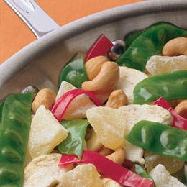
When you serve this main dish,
it will taste surprisingly sweet!
Ingredients:
- 2-3 green fruit roll-ups and 2 red fruit roll-up
- 1-1/2 teaspoon hulled sunflower seeds
- 1-1/2 c. dried apple rings
- 3/4 c. dried pineapple chunks
- 1/2 c. cashews
Directions:
- Make a bunch of pea pods by cutting a 2-1/4 inch square from green fruit roll-up, then arranging 5 or 6 sunflower seeds on the strip in a row, just off center. Fold the strip in half over the seeds, then press the edges together to seal them. Use kitchen scissors to trim the sealed edges into a rounded pea-pod shape.
- Cut the red fruit roll into thin pepper strips and the apple rings into bite-size “chicken” pieces.
- For the full effect, combine the pea pods, pepper strips, chicken pieces, pineapple chunks and cashews in a frying pan, or serve them on plates with chopsticks
- Makes three cups.
Alice gives us two great recipes for April Fool's Day – Neither is what it looks like!!!
April Fools “Cupcakes”
Alice, Golden Empire Council
I’ve made this recipe several times as a cake, just like you make Shepherd’s Pie – if you make it in a larger version, adjust the cooking time – and you might want to use a cake decorating tube to make the frosting look especially realistic. This version is neat, since you have individual servings.

Ingredients: (Makes 12 “cupcakes”)
“Meat Loaf” –
- 1/2 lb. lean ground beef,
- 1/2 cup seasoned bread crumbs,
- 1 cup grated Monterey Jack cheese,
- 3 T. ketchup,
- 1 egg,
- 1/2 teaspoon celery salt,
- 1/4 teaspoon pepper
“Frosting” –
- 3 cups mashed potatoes,
- Food coloring or beet juice
Directions:
- Heat oven to 375 degrees. Line 12 muffin tins cups with foil baking cups
- In a large bowl, mix together meat loaf ingredients and divide evenly among cups.
- Bake for about 15 minutes or until cooked through, with the filled muffin tins on cookie sheets.
- If you want different colors of “frosting” divide the potatoes and add food coloring. Spread a generous amount on each cupcake.
Spaghetti & Meatballs –
Alice, Golden Empire Council
This was a lot of fun one year –
- Make a yellow cake,
- Then make regular buttercream vanilla frosting – but tint it just slightly yellow. You’re going to squeeze it out to look like spaghetti – I didn’t have a decorating tube, but a sealable freezer bag with a hole in one corner worked just fine – remember to do your spaghetti haphazardly, twisting on top itself so it looks realistic.
- The Meatballs are those great Ferrero Rocher chocolate candies (although chocolate malt balls work, too).
- I rolled them in some cocoa powder to make them look more realistic.
- Then just cover with “sauce” made from strawberry preserves and top with grated white chocolate for parmesan cheese.
Licorice Pan Flutes
San Gabriel Valley, Long Beach, &
Verdugo Hills Councils
Cut hollow licorice tubes to different lengths (only cutting one end) and attach them together by heating the edges and sticking them together with scotch tape. Show the boys how to blow into them to make sounds. Have the boys work together to make “beautiful music.” Then they can eat their instruments.
Zip-Loc Fudge
Baltimore Area Council
Ingredients
- Zip-Loc Sandwich bag (For active hands, better use a quart freezer bag)
- 4 Tablespoons powdered sugar
- 1 Tablespoon butter (1/8 stick)
- 2 teaspoons cream cheese
- Few dashes of vanilla
- 1/2 to 1 Tablespoon cocoa
Directions
- Put all ingredients in the bag,
- Squeeze out air and zip bag
- “Smoosh” ingredients together until well blended.
- If desired, add mini M&M’s, raisins, peanut butter, etc.
- This is a single serving recipe.
Zip-Loc Ice Cream
Baltimore Area Council
Ingredients
- 1/2 cup milk or cream
- 1 Tablespoon sugar
- 1/4 teaspoon vanilla
Directions
- Place all ingredients in a quart Zip-Loc freezer bag:
- Seal bag.
- Place the bag inside a gallon Zip-Loc freezer bag with 2 handfuls of ice and 6 Tablespoons rock salt
- Shake, rattle, and squeeze for about 5 minutes.
- Dig in!!
If desired, you can add other flavorings like chocolate syrup, frozen or fresh strawberries, or slices of canned peaches.
Camp Cobbler Delight
San Gabriel Valley, Long Beach, &
Verdugo Hills Councils
Ingredients:
- 1 can sliced peaches, large
- 1 can fruit cocktail, large
- 1 can crushed pineapple, small
- ½ cup instant tapioca
- ¼ lb. margarine
- 1 cup brown sugar
- 1 package cake mix
Instructions:
- In 12” foil-lined Dutch Oven, combine fruit and tapioca.
- Sprinkle cake mix evenly over top of fruit.
- Sprinkle brown sugar over cake mix.
- Dab butter all over top of brown sugar.
- Place lid on oven.
- Bake 45 minutes to 1 hour.
- Use 6 to 8 coals on bottom and 14 to 16 on top.
- Cake is done when top is brown and cake has absorbed juices and is no longer dry.
Peanut Butter S'mores
San Gabriel Valley, Long Beach, &
Verdugo Hills Councils
Ingredients:
- 2 pkgs chocolate covered peanut butter cups - 16 ounces
- 8 graham cracker squares
- 4 large marshmallows
Instructions:
- Place 1 peanut butter cup on each of 4 crackers.
- Spear marshmallows on long fork or clean stick;
- Toast them over campfire coals or over grill on low heat.
- Set a toasted marshmallow on top of each peanut butter cup
- Top each with cracker.
- Press together and hold for a few seconds to melt chocolate.
Homemade Energy Bars
San Gabriel Valley, Long Beach, &
Verdugo Hills Councils
These granola bars are chock-full of goodies and will sustain even the most tired hiker through the trip home. Wrap them individually and make extras for tucking into school backpacks.
Ingredients:
- 1 egg
- ½ cup brown sugar
- 1 tsp. vanilla extract
- 1 cup granola
- ½ cup raisins (or any chopped dried fruit)
- ½ cup chopped hazelnuts (or your favorite nut)
- 1 1.69 oz. pkg. M&Ms chocolate candies
Instructions:
- Preheat the oven to 350°F.
- Generously butter or oil an 8 x 8” square pan (preferably nonstick).
- Crack the egg into a medium-sized bowl.
- Add the sugar and vanilla extract and mix thoroughly.
- Stir in the granola, raisins, hazelnuts, and M&Ms and mix until combined.
- Transfer to the pan and distribute evenly over the bottom, pressing firmly with your hands.
- Bake for 25 minutes.
- Cool and cut into bars or squares.
- Serves 8 to 12.

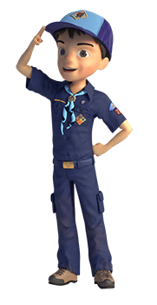

GAMES
NAME THAT TUNE CHARADES
York Adams Area Council
Have titles of songs that the boys should know printed on separate slips of paper all in a paper bag or hat. The first player pulls a slip out without showing it to anyone else and tries to either hum the song or act it out using charades. The first person in the group to guess the song goes next. This continues until they’re all hummed out or until they’ve gone through all of the songs. To help you get the song titles list going, here are some really common, familiar ones:
- Alouette
- Amazing Grace
- Animal Fair
- Announcements! Announcements! Announcements!
- Auld Lang Syne
- Aunt Rhody
- Bananas, Coconuts and Grapes
- BINGO
- Camptown Races
- Christmas Time (Jingle Bells)
- Clementine
- Down in the Valley
- Edelweiss
- Five-hundred Miles
- Froggie Went A-courting
- Battle Hymn of the Republic
- God Bless America
- Frere Jacques
- Goodnight Ladies
- Head, Shoulders, Knees and Toes
- He's Got The Whole world In His Hands
- Hole In My Bucket
- Home on the Range
- How Much Is That Doggie in the Window?
- If I Had a hammer
- If You're Happy and you Know It
- I Love the Mountains
- Inch Worm
- It's a Small World
- I've Been Working On The Railroad
- John Browns Body
- Kum Ba Yah [Come By Here]
- Michael Row the Boat
- My Bonnie Lies Over the Ocean
- My Hat It Has Three Corners
- Oh Shenandoah
- Oh! Susanna
- Old MacDonald
- On Top of Old Smoky
- Rudolph The Red-Nosed Reindeer
- Row, Row, Row
- She'll Be Comin' 'Round the Mountain
- Skip to My Lou
- Swing Low Sweet Chariot
- Take Me Out to the Ball Game
- Taps
- The Ants Go Marching
- The Bear Went Over the Mountain
- The Grand Old Duke of York
- The More We Get Together
- The Saints Go Marching In
- This Old Man
- Three Blind Mice
- Yankee Doodle
- You are My Sunshine
NAME THAT INSTRUMENT
York Adams Area Council
Assign each boy a number so that they go in the numbered order. Have each boy decide what instrument he is and then each, in turn, acts out the instrument. Point out that it’s okay to repeat an instrument type.
Non-Elimination Musical Chairs
San Gabriel Valley, Long Beach, &
Verdugo Hills Councils
The object of the game is to keep everyone in the game even though chairs are systematically removed. The music is played and more and more chairs are removed each time the music stops. In this version, however, more and more boys team up together, sitting on parts of chairs or on each other to keep everyone in the game. At the end, boys are perched on one chair rather than there being only one winner on one chair.
Music Pictionary
San Gabriel Valley, Long Beach, &
Verdugo Hills Councils
This game is based on the TV version. You will need large sheets of paper or a dry erase board, some markers and a timer. The boys are divided into two teams. The game leader has a coin toss to see which team goes first. One boy for the team steps up to the drawing board and is shown a musical term, name of a song, instrument etc. to draw. The team has 30 seconds to guess what character is being drawn. Use of sounds or letters and words is not allowed. If the team doing the drawing does not guess the correct word in 30 seconds, the other team gets one try to guess. The team with the most correct guesses wins!
Sound Effects
Southern NJ Council
You will need: - A music player and sounds that you have recorded
This is another game that is good at the start of a meeting if not all the children have arrived. Borrow some recorded sound effects from your local library. Drama clubs and filmmakers use them. Record different sounds leaving short breaks between each sound. Put in some easy ones such as a dog barking and chickens clucking, but put in some hard ones as well, such as submarine noises and music boxes. Tell the children, that you are going to play them sounds from the television and the cinema. The first person with their hand up will get the prize if they can say what the sound is. Tell them not to put their hand up until they are certain what the sound is. Any age group can play this game. A variation on this is to use the first few notes of popular songs.
Name That Tune
San Gabriel Valley, Long Beach, &
Verdugo Hills Councils
Choose one boy to be the disc jockey and divide everyone else into two teams. Place a bell in front of each team. The disc jockey plays a few bars of a familiar song and then stops it. The team that knows the name of the tune rings the bell and gives the answer. If it is correct, that team gets a point. The first team to score 10 points wins the game.
Musical Charades
San Gabriel Valley, Long Beach, &
Verdugo Hills Councils
Prepare eight to ten slips of paper with names of popular songs. Place them in a bowl. Boys take turns pulling a song from the bowl and then must act out the title, as in the game of Charades, until someone guesses the song title. The player who guesses the title correctly then becomes the next boy to act out a song title. A variation could be having the boys play in teams.
Musical Hoops
San Gabriel Valley, Long Beach, &
Verdugo Hills Councils
This game is similar to Non-Elimination Musical Chairs, except it is played with hula- hoops. You will need a hula-hoop for each player except one. Spread the hula-hoops out onto the floor. If there are eight players, you will need seven hoops. Have each boy stand in a hula-hoop, then start the music and remove one hoop. When the music stops the boys must all find a hoop in which to stand. Continue removing a hoop each time. At the end, everyone will be trying to fit into one hoop.
Sing Down Your Neighbor
San Gabriel Valley, Long Beach, &
Verdugo Hills Councils
The first person sings the first line of a popular song then points to another boy. The second boy must sing the second line of the song and choose another boy to sing the third line. Anyone who fails to sing the correct line drops out of the game. The last surviving singer wins!
Musical Parcel
San Gabriel Valley, Long Beach, &
Verdugo Hills Councils
Before the den meeting, choose a small prize, such as a candy bar or small toy. Wrap it in many different layers of paper. The parcel is passed around from boy to boy while the music is playing. Each time the music stops, whoever is holding the parcel takes off one of the layers of wrapping paper. The lucky player who takes off the last wrapping gets to keep the prize.
Musical Water Balloons
San Gabriel Valley, Long Beach, &
Verdugo Hills Councils
Appoint someone to be the “music” with his back to the players as he sings. Each boy needs a water balloon. The players stand in a circle. When the music starts, each player throws his balloon to the boy on his left, while trying to catch the balloon from the boy on his right. If the balloon falls to the ground, it can be picked up and used as long as it isn’t broken. If it breaks, the game goes on with the remaining balloons. When the music stops, the player without a balloon is eliminated. The last boy to have a water balloon is the winner!
Lip Synch Magic
San Gabriel Valley, Long Beach, &
Verdugo Hills Councils
Have each boy take a turn at lip-synching the words to a song. Have the group vote on who is the most convincing “singer.”

DEN ADVENTURES


TIGER

Tiger Adventure: Tigers in the Wild


- With your adult partner, name and collect the Cub Scout Six Essentials you need for a hike. Tell your den leader what you would need to add to your list if it rains.
- Go for a short hike with your den or family, and carry your own gear. Show you know how to get ready for this hike.
- Do the following:
  - Listen while your leader reads the Outdoor Code. Talk about how you can be clean in your outdoor manners.
  - Listen while your leader reads the Leave No Trace Principles for Kids. Discuss why you should "Trash Your Trash."
  - Apply the Outdoor Code and Leave No Trace Principles for Kids on your Tiger den and pack outings. After one outing, share what you did to demonstrate the principles you discussed.
- While on the hike, find three different kinds of plants, animals, or signs that animals have been on the trail. List what you saw in your Tiger handbook.
- Participate in an outdoor pack meeting or pack campout campfire. Sing a song and act out a skit with your Tiger den as part of the program.
- Find two different trees and two different types of plants that grow in your area. Write their names in your Tiger handbook.
- Visit a nearby nature center, zoo, or another outside place with your family or den. Learn more about two animals, and write down two interesting things about them in your Tiger handbook.
Workbook for use with these requirements: PDF Format DOCX Format

Rationale for Adventure
Tigers will learn how to put the “outing” in Scouting with this outdoor adventure. They will start to develop an understanding of the Outdoor Ethics program as they are introduced to many skills that will be important throughout their Scouting careers.

Takeaways for Cub Scouts
- Cub Scout Six Essentials
- Plant and animal identification
- Outdoor Ethics awareness
- A Scout is obedient, thrifty [Tiger Character Compass]

NOTES TO DEN LEADER
Meeting 3 will be a den outing for a hike and visit to a nature center, zoo, or other outdoor place. In advance of the outing, the leader will need to make arrangements with the outing location and confirm the outing plan with families, including transportation and any additional items they need to bring. Make sure a tour and activity plan has been submitted, if required, and activity consent forms are distributed, signed, and collected.
You will want to record completion of requirement 5 following participation in the campfire or outdoor event. This doesn’t have to be at the same time the den completes this adventure.

Ideas for Adventure Requirements:
http://www.boyscouttrail.com/cub-scouts/tiger-in-wild-adventure.php

- Fill a daypack with the following items and have each scout come to the front and blindly pick out one item. Decide if it should be placed in the 'Useful' or 'Useless' pile of items for a day hike. Some items may depend on time of year or location. Items: water bottle, whistle, flashlight, granola bar, first aid kit, sunscreen, bus spray, sock, glove, bandanna, binoculars, rock, deck of cards, paperback book, dollar, bag of marbles, spoon, towel, Legos, toy car, can of soda, ...
- How long is a "short" hike? 2 miles per hour is a good pace. Stopping to identify plants and animals will slow you down. So, a 1-mile hike is probably long enough.
Most scouts should have a school pack or small fanny pack, but check that everyone does before your hike so no one shows up carrying gear in a plastic bag.
- While on your hike, have each scout think of a way the group is following LNT principles. Things like - stayed on the trail, left a flower, didn't run or yell when other hikers were around, picked up some litter, viewed animals from far away.
- The lead hiker should keep an eye on the dirt trail for signs of animals or they will get trampled. An early morning hike, at a nature area, on a dirt trail, before other visitors arrive, is the best bet for tracks and seeing animals. Birds can typically be viewed all day, and common ones are: robin, duck, goose, blackbird, pigeon, dove, seagull, hawk.
- Work with the Cubmaster to ensure this event gets planned since all dens have similar advancement requirements. Don't forget to practice your song and your skit a few times at a den meeting before going on stage.
- Native trees, rather than planted ornamentals, should be identified. This is easier to do while leafs are still on the trees.
- Tigers could make a game of trying to find the strangest, largest, ugliest, rarest, ... animal to learn about.

Den Meeting Ideas for Tigers In the Wild Adventure:
http://www.boyscouttrail.com/cub-scouts/tiger-in-wild-adventure.php

- The LNT Principles for Kids are listed in the back of the Tiger Handbook. Read details of the principles and implementing them atLNT.org and Outdoor Ethics.
- Use Tree ID to identify a tree from its leaf.
- Use Beneath These Tall Green Trees grace before your snack.
- Tell Tall Trees minute to the den.
- Use some Tree Activities at a den meeting.
- Perform Infantry skit for the Pack.
- Perform I Ain't Lost skit
- Tell Map and Compass minute to the den.
- Learn more about LNT from Leave No Trace Dude.
- Learn more about Hiking from Hiking Dude.
- Remember to use this Tigers In the Wild adventure as a step towards each scout's Outdoor Activity award.

Animal Tracks Book
http://www.prekinders.com/animal-tracks-book/

I made this Animal Tracks book to go in our Science Center during our Forest Animals theme this month.
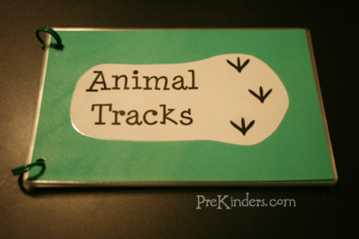
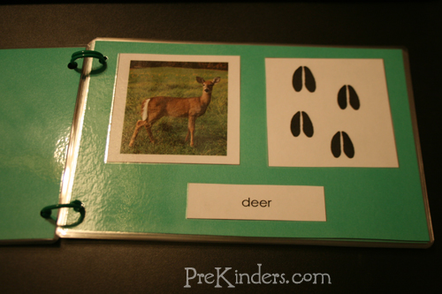
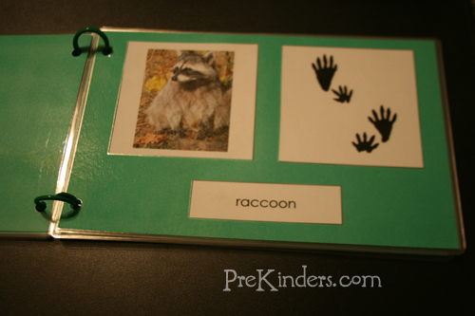
To make the book, I used a free printable from Montessori for Everyone. I printed the Animal Tracks cards and cut them apart. The pages are made with green cardstock paper, cut in half. I glued a picture of the animal and that animal’s tracks side-by-side, and one of the cards with the animal’s name below the picture. I bound the pages with chicken rings.
I also have a set of the cards printed for matching cards, and the kids can use the book as a reference to see which animal tracks match with which animal. This is one of the printables from Montessori for Everyone’s free downloads cultural materials page. Look for “Animal Tracks” under “Zoology”.

Tiger Elective Adventure: Tiger Tag


- Choose one active game you like, and tell your den about it.
- Do the following:
  - Play two relay games with your den and your adult partner.
  - Tell your partner or the other Tigers what you liked best about each game.
  - Have your den choose a relay game that everyone would like to play, and play it several times.
- With your adult partner, select an active outside game that you could play with the members of your den. Talk about your game at the den meeting. With your den, decide on a game to play.
- Play the game that your den has chosen. After the game, discuss with your den leader the meaning of being a good sport.
Workbook for use with these requirements: PDF Format DOCX Format

Rationale for Adventure
This adventure will engage the boys in some active games with their adult partners and establish an appreciation for activity and its role in maintaining one’s health and mental abilities.

Takeaways for Cub Scouts
- Practicing skills
- Experiencing winning and losing
- Learning about sportsmanship
- Developing team spirit
- Having fun outdoors
- A Scout is cheerful. [Tiger Character Compass]

NOTES TO DEN LEADER
Prior to Meeting 1, have Tigers tell their adult partners about an active game they like. For requirement 1, Tigers should come prepared to share the game with their den. The game does not need to be one that the den can play, and Tigers do not need to bring equipment.
For Meeting 2, Tigers should be prepared to tell the den about an active game they would like to play as a den. If equipment is involved, Tigers should bring that equipment to the meeting. The den will choose a game to play.
This adventure does not include plans for a den outing. If an outing is desired, the leader could choose to hold Meeting 2 at a park location where Tigers will have appropriate space for playing games. All outing and transportation information would need to be planned in advance.

http://scoutermom.com/cubscout/tiger-elective-adventure-tiger-tag/



Flip the Bird Tag
Flip the Bird tag is an active game which is a combination of tag and keep away. In it, a players work together to keep their friends from being tagged.


Tiger Elective Adventure Requirements: Tiger Tag
For the Tiger Tag adventure, Tiger Cubs and their adult partners play some active games and think about what it means to be a good sport.


What is Good Sportsmanship?
Scouting and sports go together. Many recognitions require that the Scout discuss sportsmanship. So what does good sportsmanship mean?

Steal the Bacon
Here is another game for a large group of Scouts. This is fun for all age levels – from Cub Scouts to Boy Scouts to Venturers. Your older Scouts might try to employ some strategy when playing this game.

Capture the Flag
Capture the Flag is a great game for a large group. Our Boy Scout troop plays it often as an interpatrol activity during meetings. Cub Scouts can play it also. We had a joint Pack/Troop flag retirement ceremony at a local park in the spring. When the ceremony was over, the Boy Scouts organized a […]

Kick the Can
Kick the can is a classic game which combines tag and hide and go seek. This is a great wide area game for a large group. Use it as an activity at a pack campout or to add some physical activity to a pack meeting.


Red Light Green Light
When working with Cub Scouts, remember KISMIF – Keep It Simple. Make It Fun. Sometimes we come up with elaborite or complicated plans when our young Scouts would really be just as happy with something simple. Red Light Green Light is a great example of this. It is simple and requires no preparation or materials. […]

Light the Candle Game for Cub Scouts
This is a simple game which works in well with a holiday themed meeting. It only requires a few materials and not much preparation, which makes it ideal in my mind. And it works indoors.


Pirate Pick Up Game
Ahoy there me hearties! Today is International Talk Like a Pirate Day. So in honor of the occasion, I have a pirate game.
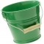

Hail Storm Game
This game doesn’t take much space, so it can be played indoors. If you think ahead and take the materials to camp with you, you can even play it under a fly on a rainy day.

Clothesline Relay Game
In this relay, the Scouts are doing the laundry. They hang out towels on a clothesline and then bring them back in.



WOLF

Wolf Adventure: Howling at the Moon


- Show you can communicate in at least two different ways.
- Work with your den to create an original skit.
- Work together with your den to plan, prepare, and rehearse a campfire program to present to your families at a den meeting.
- Practice and perform your role for a pack campfire program.
Workbook for use with these requirements: PDF Format DOCX Format

RATIONALE FOR ADVENTURE
This adventure will give Cub Scouts an opportunity to become comfortable speaking in front of others. It will also serve as a foundation for organizing and performing a campfire program.

TAKEAWAYS FOR CUB SCOUTS
- Working together to share ideas
- Being part of a team
- Learning to cope with stress, fear, and anxiety
- Participating in a campfire
- A Scout is helpful, cheerful, trustworthy. [Wolf Character Compass]

NOTES TO DEN LEADER
Meeting 3 will be a Wolf den campfire. Make sure that all of the Scouts’ families are invited as soon as the time and location are arranged, and that any needed props are provided or brought by the boys.
Wolf Scouts will also practice and perform their roles at an upcoming pack meeting.

Ideas for Adventure Requirements:
http://www.boyscouttrail.com/cub-scouts/wolf-howling-moon-adventure.php

- Different ways to communicate include: facial expressions, writing, drawing, touching, sign language, speaking, braille, morse code
- A short skit with simple lines usually works much better. Ensure every scout gets to be on stage.
- Presenting to a small, friendly audience is a great way to get more comfortable performing. Consider inviting parents and siblings to arrive 15 minutes before the end of a regular den meeting just for the short program, so an extra meeting is not needed.
- Communicate with other den leaders to ensure a variety of entertainment since they will all have similar requirements.

Den Meeting Ideas for Howling at the Moon Adventure:
- Play some Communication games.
- View Kid's Health communication info.
- Use the Campfire Program Planner.
- There are many ideas for Wolf skits, songs, stories, and jokesavailable.
list of 6 skits that can be done without props and with little practice.
http://cubscoutideas.com/3985/cub-scout-skits-for-campfires/

The Viper is Coming!
This works best with at least 5 boys.
Cub Scout 1: Runs in “The viper is coming! Run!” Runs out
Cub Scout 2: Runs in “The viper is coming! Hide!” Runs out
#3: Runs in “The viper is coming! Call for help!” Runs out
#4: Runs in “The viper is coming! Save yourselves!” Runs out
Viper: Walks in holding a napkin or rag “Hallo! I’m de Viper! Vere’s de Vindows?”

Got Any Duck Food?
You need 2 boys for this skit–a store owner and a customer.
The store owner stands behind a table or chair as if they’re behind a store counter.
Customer: Walks in and faces store owner “Got any duck food?”
Owner: “No, this is a hardware store. We don’t sell duck food.”
Customer leaves and walks back in.
Customer: “Got any duck food?”
Owner: “I told you yesterday that we don’t sell duck food.”
Customer leaves and walks back in.
Customer: “Got any duck food?”
Owner: “No! This is a haaaaardwaaaaaaaare store. We….do….not….sell….duck….food.”
Customer leaves and walks back in.
Customer: “Got any duck food?”
Owner: “No! No! No! Like I told you yesterday, we have no duck food! And, if you ask me again, I’m gonna nail your feet to the floor!”
Customer leaves and walks back in.
Customer: “Got any nails?”
Owner: “No.”
Customer: “Got any duck food?”

Invisible Bench Skit
This skit is best with 4 to 8 scouts.
Cub Scout 1 walks onstage and squats down as if he is sitting on a bench that is invisible.
Cub Scout 2 walks up to Cub Scout 1.
Cub Scout 2: “Whatcha doing?”
Cub Scout 1: “Just sitting on this invisible bench.”
Cub Scout 2: “Can I join you?”
Cub Scout 1: “Sure!”
Cub Scout 2 squats down to sit next to Cub Scout 1. Cub Scout 3 walks up to Cub Scouts 1 & 2.
Cub Scout 3: “Hey, what are you guys doing?”
Cub Scouts 1 & 2: “Just sitting on this invisible bench.”
Cub Scout 3: “Do you mind if I join you?”
Cub Scouts 1 & 2: “Not at all! Have a seat.”
Continue the dialog with each Cub Scout coming up to ask what the boys are doing and if he can join them until you get to the last Cub Scout.
Last Cub Scout: “What are y’all doing?”
All Cub Scouts: “Just sitting here on this invisible bench.”
Last Cub Scout: “No you aren’t. I moved that bench over there yesterday.” Cub Scout points.
All Cub Scouts who are sitting fall down.

Can't Work in the Dark Skit
You need 4 or more scouts for this skit.
All scouts are pretending to rake leaves or dig with shovels. One scout just stands there with his arm raised straight as if he were holding a torch in his hand.
Boss walks in. He walks up to the Cub Scout who has his arm raised.
Boss: “I’m paying you to work, not to just stand around. Why aren’t you working?”
Cub Scout with arm raised: “I’m a lightbulb!”
Boss: “Get to work! When I come back, if you aren’t working, you’re fired!”
Boss leaves, and Cub Scouts continue to work. Boss returns and sees the “lightbulb” Scout still standing with his arm raised.
Boss: “That’s it! You’re fired! Get out!”
Scout drops his arm and dejectedly leaves. As soon as he drops his arm, the rest look around, stop working and start to leave.
Boss: “Hey, why are you guys leaving? Get back to work!”
Cub Scouts: “How? We can’t work in the dark!”

Emergency Broadcast System Skit
One Cub Scout or leader stands to the side or in front. All other Scouts stand in line.
Leader: “For the next ten seconds, we will conduct a test of the emergency broadcast system.”
Cub Scouts: “Beeeeeeeeeeeppppp” for 10 seconds until Leader raises his hand.
Leader: “Thank you. This concludes the test of the emergency broadcast system. Had this been an actual emergency, you would have heard…”
Cub Scouts scream in panic and run around waving their hands.

'We Have No Skit' Skit
You can use as many Cub Scouts as you would like for this skit.
Cub Scout 1 walks up and slaps his forehead.
Cub Scout 1: “Oh, no!”
Cub Scout 2 walks up.
Cub Scout 2: “What’s wrong?”
Cub Scout 1 whispers into Cub Scout 2’s ear.
Cub Scout 2: “Oh, no!”
Repeat this for each Cub Scout only one Cub Scout is left. He runs up to the group.
Last Cub Scout: “What’s wrong?”
All Cub Scouts: “We have no skit!!!”

Wolf Scout Skits
http://www.boyscouttrail.com/cub-scouts/wolf-scout-skits.asp

Bravest Scout in the World
Emergency Alert System
Enlarging Machine
Guess My Line on the Toilet
Ice Fishing
Invisible Bench - plus Add-Ons
Ole, Champion Tree Climber
One Bright Morning
Short Runway
3 Vs. 1000
38 Over the Cliff
Art or Not
Banana Bandana
Be Prepared
Bear Attack
Big and Strong Like You
Brains for Sale
Brains for Sale - Version 2
Broken Finger
Brownie Pudding
Brushing Teeth
Bubblegum
Burning Schoolhouse
Can of Cola
Can't Work in the Dark
Cancer Operation
Chicken Farmer
Chory of Stinderella or Rindercella
Christmas with the Right Family
Clean Silverware
Clean Socks
Climbing Lightbeam
Clock Inspection
Clothes from Eddie Bauer
Contagious Pregnancy
Dead Body
Depressed Reporter
Did You See That?
Dirty Socks
Dirty Socks - Version 2
Echos in the Woods
Elevator to Bathrooms
Fifth Floor
Fishing Secret
Flea Circus
Follow the Tracks
Fool's Gold
Fred the Flea
Gandhi
George Washington and the Cherry Tree
Good Thing About Christmas
Got Any Duck Food?
Gravity Check
Great Raisins
Grecian Fountains
Hair in my Hamburger
Hare Restorer
History of Cub Scouts
Hunting Thanksgiving Dinner
I Ain't Lost
I Gotta Go Wee
I Saw a Bear
Infantry Is Coming
Is It Time Yet?
Jailhouse Jokes
Jelly Beans Please
Lemonade for Sale
Lighthouse Stairs
Listen!
Lobster Tail
Lone Ranger and Tonto
Lost Bubblegum
Lost Green Ball
Lost Quarter
Lucky Boxer
Magic - Mystic Reader
Measuring Leader's Coffin
Meat for Sale
Musical Toilet Seats
My Centipeed
My Royal Papers
My Worm
Need a Big Jerk
Need the Time
New Underwear
Not Enough Parachutes
Nuts, the Elephant
Nutty Fisherman
Oh What a Goose I Am
Olive the Other Reindeer
Olympic Blanket Tossing Team
Operation
Out of Film
Outrun the Bear
Panther Tracks
Pass the Pepper
Penguin Soup
Penny Candy
Plane Engine Trouble
Professor's Address
Pulling and Pushing Rope
Puppy In a Box
Raisin Fly
Raking an Invisible Garden
Run-aways
Sleep Over
Smart Astronaut
Smoke Signals
Soup and Flies
Sponge Butt Prank
Squirrels Think I'm Nuts
Stiff Neck
Taking My Case to Court
Talking Trash
Telling the Time
The Audition
The Good, the Bad, and the Remarkable
The Psychic
Throwing Little Stones
Toothache
Trained Caterpillar
Turkey Hunt
Two Suckers On a Stick
Ugliest Man in the World
Viper
Walk On Selections
Washing Ears
Water Vending Machine
Water, Water
We Have No Skit
What Kind of Tracks?
World Record Spitter
Worst Breath
Worst Criminal
Scout Soap
Yaputcha
You Don't Say

More Wolf Scout Information to Use:
Wolf Scout Achievements - Tasks to perform to earn the Wolf badge
Wolf Scout Electives - Tasks to perform to earn arrow points
Wolf Scout Activities - great den meeting and pack activity ideas
Wolf Scout Awards - see what awards are available to Wolf scouts
Wolf Scout Ceremonies - a few ceremonies
Cub Scout Games - den or pack games just right for 2nd graders
Wolf Scout Graces - fun meal graces
Wolf Scout Jokes - funny, gross, and silly jokes for scouts
Wolf Scout Projects - community or conservation projects for your Wolf den
Wolf Scout Recipes - easy recipes you can make with your scouts for fun snacks or on family campouts
Cub Scout Skits - skits that Wolf Scouts like to do
Cub Scout Songs - songs for Wolfs
Wolf Scout Stories - choose stories that Wolf scouts will enjoy and understand
Wolf Scout Uniform - make sure you put all those badges and patches in the right spots
Cub Scout Academics & Sports - extra recognition opportunities
Wolf Scout Schedule - sample schedule of meetings and activities
Help your den be the hit of the next pack meeting by presenting a great cub scout skit from this collection. Make sure the scouts have time to practice their parts and are ready to perform. As they get better at working together, scouts should get to choose their own cub scout skits to present. Giving them a list of 3 or 4 to choose from might be a good idea.
class="ttext">Let each scout have an opportunity to be the lead onstage. Participating in cub scout skits is a great way to build comfort at being in front of groups. Remember to coach the scouts to perform for the audience rather than just giggle amongst themselves.

Wolf Elective Adventure: Code of the Wolf


- Do one of the following:
  - With the members of your den or family, make a game with simple materials that requires math to keep score.
  - Play a game of “Go Fish for 10s.”
  - Do five activities at home, at school, or in your den that use mathematics, and then explain to your den how you used everyday math.
  - Make a rekenrek with two rows, and show Akela how you would represent the numbers 4, 6, 9, and 14.
  - Make a rain gauge or some other measuring device, and use it.
- Do one of the following:
  - With other members of your den or family, identify three different types of shapes that you see in nature.
  - With other members of your den or family, identify two shapes you can see in the construction of bridges.
  - Select a single shape or figure. Observe the world around you for at least a week, and write down where you see this shape or figure and how it is used.
- Do one of the following:
  - With your den, find something that comes with many small, colored items in one package. Count the number of items of each color in your package. Keep track of each color. Then:
    - Draw a graph showing the number of items of each color.
    - Determine what the most common color is.
    - Compare your results to the other boys'.
    - Predict how many items of each color you will find in one more package.
    - Decide if your prediction was close.
  - With your den or family, measure the height of everyone in the group and see who takes more steps to walk 100 feet.
  - Have each member in your den shoot a basketball. Count the number of shots it takes to make five baskets. Graph the number of shots it takes for each boy using 5, 6–10, 11–15, 16–20, or more than 20.
- Do one of the following:
  - Use a secret code using numbers to send a message to one of your den members or your den leader. Have that person send a message back to you. Be sure you both use the same code numbers.
  - Send a message to another member of your den or your den leader using the pig pen code or another code that changes letters into special shapes.
  - Practice using a code stick to create and decode a message.
Workbook for use with these requirements: PDF Format DOCX Format

Block Cipher
https://sites.google.com/site/codesforscouts/block-cipher

We write the message in a rectangular block, one row at a t time, and then read off the columns.

Example:

To encode the message THIS IS VERY EASY!, write it in a block like this:

THISI
SVERY
EASY!
The coded message is read by looking at the columns, and writing them out like this: TSE HVA IES SRY IY!

To decode it, just write all the code words in a block again, as columns, and then read the message across the rows.

Here's a code for you to solve:

LKU OHR OIT KGH WHE IER DRA ELF ROI LOE OKL OFD

5 SECRET CODES FOR KIDS TO WRITE A CODED LETTER
July 30, 2013 by Rebecca
http://kidsactivitiesblog.com/27282/secret-codes-to-write-a-coded-letter#_a5y_p=825806

1. Reverse the Words
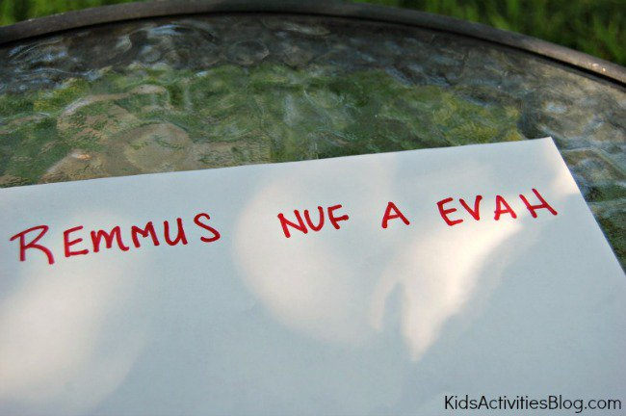
This is a simple code to solve – just read the words backwards! Even though it seems simple once you know the secret, it can be a hard one to figure out when you don’t.
2. Half-Reversed Alphabet
Write out the letters from A to M then write the letters from N to Z directly below them.
3. Block Cipher
Write the message in a rectangular block, one row at a time (we used 5 letters in each row). Then writes down the letters as they appear in the columns.
4. Read Every Second Letter
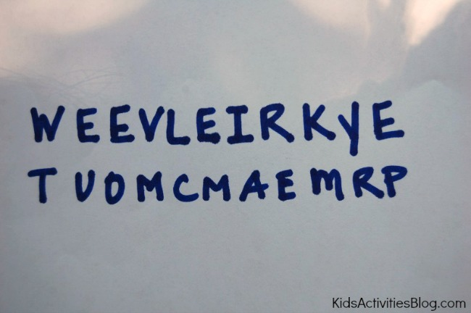
Read every second letter starting at the first letter, and when you finish, start again on the letters you missed.
5. PigPen
The PigPen code is easier than it looks and is my children’s favorite. First, draw out the two grids below and fill in the letters:
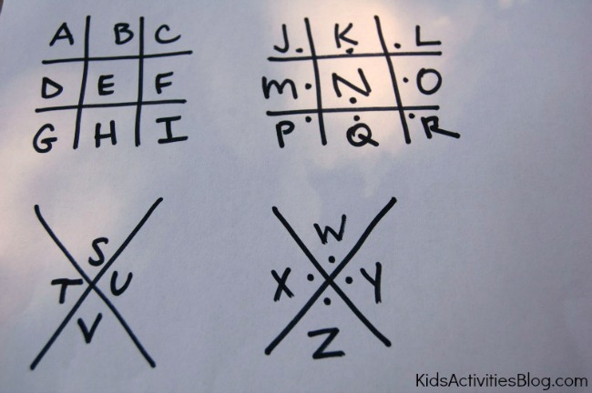
Each letter is represented by the lines around it (or pigpen).
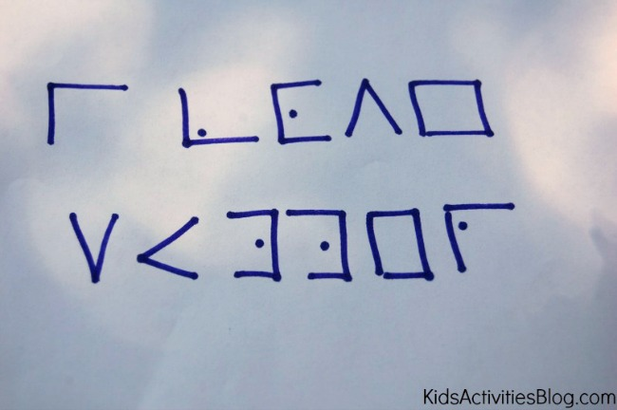

WRITE A CODED LETTER
We practiced writing our names and silly words before moving to coding whole sentences.
The letters and messages you can write can be fun, but make sure you send along a key so the recipient can figure it all out!

CODE ACTIVITY FOR KIDS: MAKE A SPY DECODER
http://frugalfun4boys.com/2014/04/15/code-activity-kids-make-spy-decoder/

April 15, 2014 by Sarah
Aidan (age 10) really enjoys secret codes, and we were thrilled to find this idea on Spoonful for making a spy decoder! The fun part about this decoder is that it provides 27 different codes, making it difficult for someone to crack. If you make two identical decoders, siblings or friends can send encrypted messages to each other.
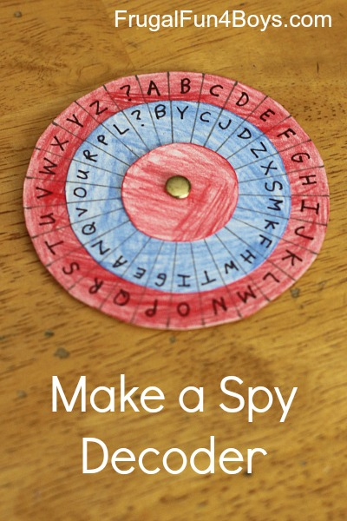
To make a decoder, you will need:
- Posterboard
- Colored pencils
- Scissors
- A compass
- A pencil
- A ruler
- A paper fastener
- A fine tip Sharpie marker
Step 1: Cut out three circles per decoder out of posterboard. You will need one that is 3.25 inches in diameter, one that is 2.5 inches in diameter, and one that is 1.5 inches in diameter.
Note: The size of the circles is very important! If you change the size of the decoder, you will have to change the measurements for marking off the letter sections, which involves higher level math than I felt like using…
Step 2: Color your circles with colored penciles, if desired.
Step 3: On the largest circle, make small pencil marks 3/8″ apart on the outside edge. You should end up with 27 sections.
Detail is important in this step! This was where we got into trouble. We were trying to make three identical decoders. I had 28 sections on my first try, and Aidan had 24. Obviously, those two decoders were not going to be compatible! We figured out what we were doing differently, and we decided that I would make all of the outside pieces so that they would be the same. We had to start over on the large circles, and I made 3 with exactly 27 sections each.
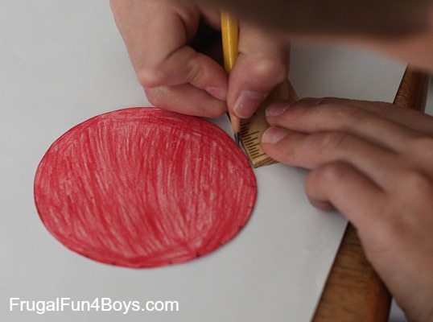
Step 4: Poke a hole through the center of the largest circle and the middle circle. Attach them with the paper fastener. The best way to find the middle of the circle is to use the compass.
Then, use the ruler to draw a straight line from the paper fastener to each edge mark. Again, detail is important. You really want each of the sections to be equal in size, or your decoder will be difficult to use.
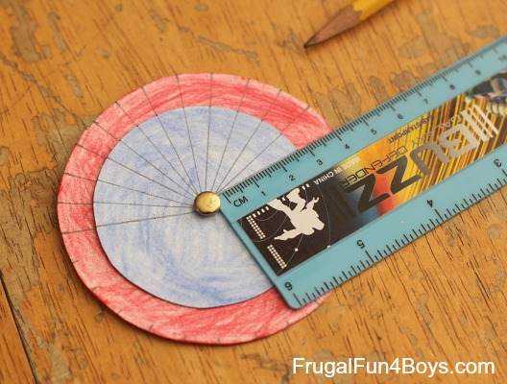
Step 5: Write the alphabet on the outside circle and put a ? in the 27th section. For the middle circle, you can either write the alphabet in order or mix it up. Aidan wanted a random alphabet in the middle circle – I think it made it feel more secret!
Then add the smallest circle to the decoder.
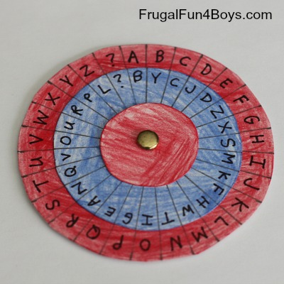
To write a message:
First, set the code. The post on Spoonful suggests setting the decoder where the “A” on the outside circle matches the first letter of the day of the week. Aidan wasn’t wild about that idea. We thought of sending a “code word” along with each message and setting the decoder where “A” on the red circle matches the first letter of the code word. Or, come up with your own system!
To write a message, find the letter you want on the outside (red) circle and write down the corresponding letter on the middle (blue) circle.
To read a message, find the letter on the middle (blue) circle, and write down the corresponding letter from the outside (red) circle.
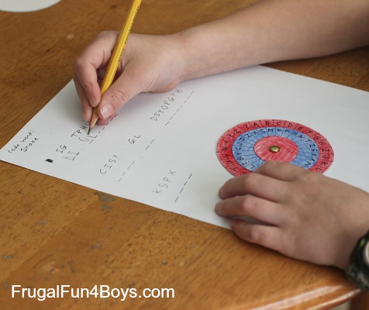

The post on Spoonful has additional directions for making the decoder into something that can be worn around your neck – kind of fun if you want to add that step!
The Thomas Jefferson Cipher Wheel – Here’s an interesting tidbit from history… Thomas Jefferson created a cipher wheel which was used to send encrypted messages in a similar way. The wheel was made from 36 discs on an axle that could be turned to spell out a message. To encrypt the message, the sender would copy down any other row from the cipher wheel other than the intended message (which would appear to be nonsense). The receiver would line up the discs on his (identical) cipher wheel so that they matched the nonsense message and then turn the cipher wheel until they saw a row with the hidden message. Click here to read more about the Jefferson Cipher Wheel – it’s quite interesting! You can also purchase a replica (that really works) from monticello.org.



BEAR

Bear Adventure: Bear Necessities


- While working on your Bear badge, camp overnight with your pack. If your chartered organization does not permit Cub Scout camping, you may substitute a family campout or a daylong outdoor activity with your den or pack.
- Attend a campfire show, and participate by performing a song or skit with your den.
- Make a list of items you should take along on your campout.
- Make a list of equipment that the group should bring along in addition to each Scout's personal gear.
- With your den, plan a cooked lunch or dinner that is nutritious and balanced. Make a shopping list, and help shop for the food. On a campout or at another outdoor event, help cook the meal and help clean up afterward.
- Help your leader or another adult cook a different meal from the one you helped prepare for requirement 5. Cook this meal outdoors.
- Help set up a tent. Pick a good spot for the tent, and explain to your den leader why you picked it.
- Demonstrate how to tie two half hitches and explain what the hitch is used for.
- Learn how to read a thermometer and a barometer. Keep track of the temperature and barometric pressure readings and the actual weather at the same time every day for seven days.
Workbook for use with these requirements: PDF Format DOCX Format

Bear Elective Adventure: Roaring Laughter


- Think about what makes you laugh. Write down three things that make you laugh.
- Practice reading tongue twisters.
- Create your own short story. Remove some nouns, verbs, adjectives, and adverbs from the story, leaving blanks. Without telling the story, have a friend insert his or her own nouns, verbs, adjectives, and adverbs in the story you created.
- With a partner, play a game that makes you laugh.
- Share a few jokes with a couple of friends to make them laugh.
- Practice at least two run-ons with your den, and perform them at a pack meeting or campfire program.
Workbook for use with these requirements: PDF Format DOCX Format



WEBELOS CORE

Webelos Adventure: Webelos Walkabout


Do all of these:
- Create a hike plan
- Assemble a hiking first-aid kit
- Describe and identify from photos any poisonous plants and dangerous animals or insects you might encounter on your hike.
- Before your hike, plan and prepare a nutritious lunch. Enjoy it on your hike, and clean up afterward.
- Recite the Outdoor Code and the Leave No Trace Principles for Kids from memory. Talk about how you can demonstrate them on your Webelos adventures.
- With your Webelos den or with a family member, hike 3 miles (in the country if possible).
- Complete a service project on or near the hike location.
- Perform one of the following leadership roles during your hike: trail leader, first-aid leader, lunch leader, or service project leader.
Workbook for use with these requirements: PDF Format DOCX Format



ARROW OF LIGHT CORE

Webelos/AOL Elective Adventure: Adventures in Science


Do all of these:
- An experiment is a "fair test" to compare possible explanations. Draw a picture of a fair test that shows what you need to do to test a fertilizer's effects on plant growth.
- Visit a museum, a college, a laboratory, an observatory, a zoo, an aquarium, or other facility that employs scientists. Prepare three questions ahead of time, and talk to a scientist about his or her work.
- Complete any four of the following:
  - Carry out the experiment you designed for requirement 1, above. Report what you learned about the effect of fertilizer on the plants that you grew.
  - Carry out the experiment you designed for requirement 1, but change the independent variable. Report what you learned about the effect of changing the variable on the plants that you grew.
  - Build a model solar system. Chart the distances between the planets so that the model is to scale. Use what you learn from this requirement to explain the value of making a model in science.
  - With adult supervision, build and launch a model rocket. Use the rocket to design a fair test to answer a question about force or motion.
  - Create two circuits of three light bulbs and a battery. Construct one as a series circuit and the other as a parallel circuit.
  - Study the night sky. Sketch the appearance of the North Star (Polaris) and the Big Dipper (part of the Ursa Major constellation) over at least six hours. Describe what you observed, and explain the meaning of your observations.
  - With adult assistance, explore safe chemical reactions with household materials. Using two substances, observe what happens when the amounts of the reactants are increased.
  - Explore properties of motion on a playground. Does the weight of a person affect how fast they slide down a slide or how fast a swing moves? Design a fair test to answer one of those questions.
  - Read a biography of a scientist. Tell your den leader or the other members of your den what the scientist was famous for and why his or her work is important.
Workbook for use with these requirements: PDF Format DOCX Format

Mini First Aid Kit
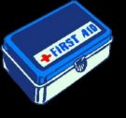
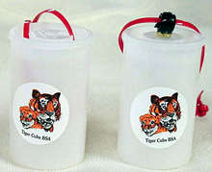
Difficulty: Very Easy
Recycle a film canister and transform it into a handy Mini First Aid Kit for kids to wear on their belt. Great for Tiger Cubs.

What you'll need:
- Fuji film canister
- Scissors
- Orange or black pony bead
- Tiger sticker (from Tiger Cub Family Activity Packet)
- Orange plastic lanyard (Rexlace)
- Midget Tootsie Rolls
- Alcohol swab
- Band-Aid
- Q-tip
- Hot glue or "Glue Dots" (A & W Products)

How to make it:
- Adhere the pony bead to the top of the film canister using either hot glue or Glue Dots.
- Place a Tiger sticker on outside of canister.
- Lace the orange plastic lanyard through lid. Tie a knot. You can also use a hole punch and punch 2 holes in the lid then string the lanyard through. Tie a knot.
- Cut a Q-tip in half.
- Put Tootsie Rolls, alcohol swab, a Band-Aid, 1/2 Q-Tip inside the canister. Secure the lid.
- Put your Mini First Aid Kit on your belt. If you get hurt or lost from the group, clean the spot with the alcohol wipe, put on a Band-Aid, and eat a Tootsie Roll.

Tips:
Note from editor: We found Glue Dots at our local Wal-Mart in the school or business supply area. Although the Glue Dots are a lot more expensive than a hot glue gun, they are SAFER for children to use. Supervise the use as this adhesive is extremely sticky and can be a bit tricky to use at first.

Make Your Own First Aid Kit
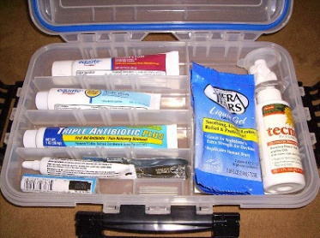
What to Include:
For open wounds, cuts, skinned knees, and scratches
- 1 box 12 adhesive compresses
- 3 sizes sterile bandages
- 3 sterile gauze squares
- A small bottle antiseptic
For blisters
- Adhesive compresses or gauze squares
- Narrow adhesive
For sprains
- 1 triangular bandage
- Small scissors
For burns, sunburn
- Tube burn ointment - 5%
For splinters
- Small tweezers
- Needle
- Matches to sterilize
For fainting
- Small bottle aromatic spirits of ammonia
For bites or stings
- Small box bicarbonate of soda
For toothache
- Small bottle oil of cloves
For plant poisoning
- Small bar yellow soap
Ideas for containers to use:
- A cigar box, a tin cracker or candy box - paint and decorate. Put a list of what-to-do inside the lid.
- Make a cloth case with a strap.
- A cloth kit with pockets. Fold over the top, roll up, and tie.

First Aid Kit Neckerchief Slide
Betsy O, Northwest Texas Council
This slide has been around for a long time. I found it in the 2008-2009 Cub Scout Program Helps.
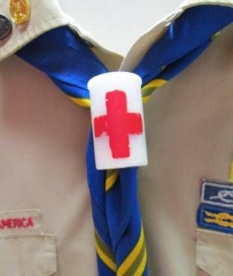
Materials-
Plastic 35 mm film canister with lid
(How much longer will we have these great Craft items with digital cameras abounding?? We need a replacement soon! CD!)
Adhesive Band-Aid
Antiseptic wipe
½ of a chenille stem
Tools-
Red paint pen
Awl
Instructions-
- Have an adult poke two holes, one on either side and near the top of the canister.
- Draw a red cross on the front center of the canister. Let dry.
- Feed the end of the chenille stem through the holes and leave the tails sticking out of both holes.
- Fill the canister with Band-Aids and wipes
- Add your name and date!
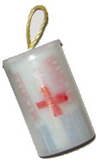

Make personal First Aid Kits
in a zip lock bag. These would include a couple bandaides, cotton ball, safety pen, a sanitize wipe, Q tip, etc) You can also make these in a plastic film canister if you can still find them.
For the Pack Health and Fitness Camp Out you may also want to consider:

Outdoor Code Responsive Reading Ceremony
Equipment: U.S. flag, copy of the Outdoor Code for each participant
The Cubmaster(CM) speaks briefly about the importance to our nation of taking good care of our natural resources and then uses the Outdoor Code as a responsive reading, with boys (and parents, if present, and everyone in the audience) reading the responses.
CM: As an American, I will do my best to be clean in my outdoor manners—
BOYS: I will treat the outdoors as a heritage. I will take care of it for myself and others. I will keep my trash and garbage out of lakes, streams, fields, woods, and roadways.
CM: Be careful with fire—
BOYS: I will prevent wildfire. I will build my fires only where they are appropriate. When I have finished using fire, I will make sure it is cold-out. I will leave a clean fire ring or remove all evidence of my fire.
CM: Be considerate in the outdoors—
BOYS I will treat public and private property with respect. I will use low-impact methods of hiking and camping.
CM: Be conservation-minded—
BOYS: I will learn how to practice good conservation of soil, waters, forests, minerals, grasslands, wildlife, and energy. I will urge others to do the same.
CM: Let us close by singing
“God Bless America.”
(CS How To Book, page 6-13)
You can find a copy of the How-To Book at
http://www.scouting.org/filestore/hispanic/english/33832_WEB.pdf

The Outdoor Code Opening
Sam Houston Area Council
Materials – 4 Cub Scouts, Cubmaster (CM), Assistant CM (CA), the American flag posted on the stage, several potted plants or an artificial tree, a garbage bag filled with trash (rinsed out cans, bottles, crumpled paper, etc.)
Cubmaster enters carrying the garbage bag, and
stands between the flag and the plants.
CM: We are blessed to live in this great land of freedom and beauty. America truly is the home of amber waves of grain and purple mountains majesty. Unfortunately, there are people in this country who abuse their freedom and pollute the land. (He dumps the bag of trash on the ground.) As Cub Scouts, we can learn to be better Americans by living the Outdoor Code.
Cub #1 (enters and stands by Cubmaster) As an American, I will do my best to be clean in my outdoor manners. (He takes empty bag from Cubmaster and begins to pick up trash while Cubmaster speaks.)
CM I will treat the outdoors as a heritage. I will take care of it for myself and others. I will keep my trash and garbage out of lakes, streams, fields, woods, and roadways.
Cub #2 (enters and takes bag from Cub #1. Cub #1 exits.) I will be careful with fire. (Picks up more trash as Cubmaster speaks.)
CM I will prevent wildfire. I will build my fires only where they are appropriate. When I have finished using a fire, I will make sure it is cold out. I will leave a clean fire ring, or remove all evidence of my fire.
Cub #3 (Enters and takes bag from Cub #2. Cub #2 exits.) I will be considerate in the outdoors. (Picks up trash as Cubmaster speaks.)
CM I will treat public and private property with respect. I will use low-impact methods of hiking and camping.
Cub #4 (Enters and takes bag from Cub #3. Cub #3 exits.) I will be conservation-minded. (Picks up remaining trash as Cubmaster speaks.)
CM I will learn how to practice good conservation of soil, waters, forest, minerals, grasslands, wildlife, and energy. I will urge others to do the same. (Cub #4 gives bag back to Cubmaster and exits.) These Cub Scouts have shown they are willing to protect our country's natural beauty and conserve her natural resources.
CA Please stand, salute the flag and join me in singing "America the Beautiful." (Or say the Pledge of Allegiance.)

Outdoor Code Closing
National Capital Area Council

Leader: As a citizen of the United States, I will do my best to be clean in my outdoor manners.
Pack: I will treat the outdoors as a heritage to be improved for our greater
enjoyment. I will keep trash and garbage out of my country's waters,
fields, woods, and roadways.
Leader: Be careful with fire.
Pack: I will prevent wildfire. I will build my fire in a safe place and be sure it is out before I leave.
Leader: Be considerate in the outdoors.
Pack: I will treat public and private property with respect. I will remember that use of the outdoors is a privilege I can lose by abuse.
Leader: Be conservation minded.
Pack: I will learn how to practice good conservation of soil, water, forests, minerals, grasslands, and wilderness, and I will urge others to do the same. I will use sportsmanlike methods in my outdoor activities.

THE OUTDOOR CODE
This is good after a hike, fishing trip, park clean-up, nature hunt (anything outdoors of an educational nature) not just to play.
DEN CHIEF: Let's sit quietly for a few moments. Close your eyes and listen to the sounds of nature. Think of what we have to be thankful for.
Let's now repeat The Outdoor Code.
"As an American, I will do my best --be clean in my outdoor manners, be careful with fire, be considerate in the outdoors, and be conservation-minded.
DEN LEADER: Let's sing God Bless America.

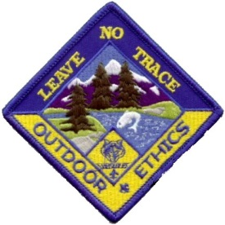

Leave No Trace Awareness Award
The Leave No Trace Awareness Award is worn on the uniform shirt,
centered on the right pocket as a TEMPORARY patch.
Only ONE Temporary patch may be worn at a time.

Cub Scout Leave No Trace Pledge
I promise to practice the Leave No Trace frontcountry guidelines wherever I go:
- Plan ahead.
- Stick to trails.
- Manage your pet.
- Leave what you find.
- Respect other visitors.
- Trash your trash.

Tiger Cub Scout Requirements
- Discuss with your leader or parent/guardian the importance of the Leave No Trace frontcountry guidelines.
- Complete the activities for Achievement 5, Let's Go Outdoors.
- Participate in a Leave No Trace-related service project.
- Promise to practice the Leave No Trace frontcountry guidelines by signing the Cub Scout Leave No Trace Pledge.
- Draw a poster to illustrate the Leave No Trace frontcountry guidelines and display it at a pack meeting.

Wolf Cub Scout Requirements
- Discuss with your leader or parent/guardian the importance of the Leave No Trace frontcountry guidelines.
- On three separate outings, practice the frontcountry guidelines of Leave No Trace.
- Complete Achievement 7, "Your Living World."
- Participate in a Leave No Trace - related service project.
- Promise to practice Leave No Trace frontcountry guidelines by signing the Cub Scout Leave No Trace Pledge.
- Draw a poster to illustrate the Leave No Trace frontcountry guidelines and display it at a pack meeting.

Bear Cub Scout Requirements
- Discuss with your leader or parent/guardian the importance of the Leave No Trace frontcountry guidelines.
- On three separate outings, practice the frontcountry guidelines of Leave No Trace.
- Complete Achievement 12, "Family Outdoor Adventures."
- Participate in a Leave No Trace - related service project.
- Promise to practice Leave No Trace frontcountry guidelines by signing the Cub Scout Leave No Trace Pledge.
- Draw a poster to illustrate the Leave No Trace frontcountry guidelines and display it at a pack meeting.

Webelos Scout Requirements
- Discuss with your leader or parent/guardian the importance of the Leave No Trace frontcountry guidelines.
- On three separate outings, practice the frontcountry guidelines of Leave No Trace.
- Earn the Outdoorsman activity badge.
- Participate in a Leave No Trace - related service project.
- Promise to practice Leave No Trace frontcountry guidelines by signing the Cub Scout Leave No Trace Pledge.
- Draw a poster to illustrate the Leave No Trace frontcountry guidelines and display it at a pack meeting.

Cub Scout Leader Requirements
- Discuss with your den's Cub Scouts or your pack's leaders the importance of the Leave No Trace frontcountry guidelines.
- On three separate outings demonstrate and practice the frontcountry guidelines of Leave No Trace.
- Participate in presenting a den, pack, district, or council awareness session on Leave No Trace frontcountry guidelines.
- Participate in a Leave No Trace-related service project.
- Commit yourself to the Leave No Trace frontcountry guidelines by signing the Cub Scout Leave No Trace Pledge.
Assist at least three boys in earning Cub Scouting's Leave No Trace Awareness Award.

LEAVE NO TRACE
Santa Clara County Council
With Hiking the theme for July a many of Packs and Dens will be out in Camps and Woods and Parks exploring. BSA has published a Cub Scout Version of the Leave No Trace principles. It is available as a bin item, # 13-032. (When requested, Bin items are provided free from BSA National to your local council.) Go ask for your copy.
The brochure describes six Front Country Guidelines for Cub Scouts to follow while hiking, camping and enjoying the outdoors. There is even a Cub Scout Leave No Trace award with a patch for Cub Scouts and leaders to earn.
Making sure our leaders and Cubs are familiar with theses principles should enable our Cubs to be complimented wherever they go and help us recruit even more boys!!

Focus on “Leave No Trace”
Santa Clara County Council
It is never too early to start teaching the concepts and practices of Leave No Trace. We emphasize Leave No Trace in Boy Scouts, but the Cub Scout years are the best place to start learning about it. We can hike and camp as Cub Scout families. If the treasure that is our outdoors is to remain for our children’s children to enjoy, we must all impact nature as little as possible. Teach your Cub Scouts the basic principles of Leave No Trace. An excellent resource can be found on the BSA website at http://www.scouting.org/BoyScouts/TeachingLeaveNoTrace.aspx .
Teach the seven principles of Leave No Trace. Some of these concepts are too advanced for Cub Scouts, but many of them can be understood even by our Tigers.
Plan Ahead and Prepare
- Know the regulations and special concerns for the area you'll visit.
- Prepare for extreme weather, hazards and emergencies.
- Schedule your trip to avoid times of high use.
- Visit in small groups.
Split larger parties into groups of 4 - 6.
- Repackage food to minimize waste.
- Use a map and compass to eliminate use of rock cairns, flagging or marking paint.
Travel and Camp on Durable Surfaces
- Durable surfaces include established trails and campsites, rock, gravel, dry grasses or snow.
- Protect riparian areas by camping at least 200 feet away from lakes, streams
- Good campsites are found, not made. Altering a site is not necessary.
In popular areas
- Walk single file in the middle of the trail, even when wet or muddy.
- Keep campsites small. Focus activity in areas where vegetation is absent.
In pristine areas
- Disperse use to prevent the creation of campsites and trails.
- Avoid places where impacts are just beginning.
Dispose of Waste Properly
- Pack it in, pack it out. Inspect your campsite and rest areas for trash or spilled foods. Pack out all trash, leftover food, and litter.
- Deposit solid human waste in catholes dug 6 to 8 inches deep at least 200 feet from water, camp and trails. Cover and disguise the cathole when finished.
- Pack out toilet paper and hygiene products.
- To wash yourself or your dishes, carry water 200 feet away from streams or lakes and use small amounts of biodegradable soap. Scatter strained dishwater.
Leave What you Find
- Preserve the past, observe but do not touch, cultural or historic structures and artifacts.
- Leave rocks, plants and other natural objects as you find them.
- Avoid introducing or transporting non-native species.
- Do not build structures, furniture, or dig trenches.
Minimize Campfire Impacts
- Campfires can cause lasting impacts to the backcountry. Use a lightweight stove for cooking and enjoy a candle lantern for light.
- Where fires are permitted, use established fire rings, fire pans or mound fires.
- Keep fires small. Only use sticks from the ground that can be broken by hand.
- Burn all wood and coals to ash, put out campfires completely, then scatter cool ashes.
Respect Wildlife
- Observe wildlife from a distance. Do not follow or approach them.
- Never feed animals. Feeding wildlife damages their health, alters natural behaviors, and exposes them to predators and other dangers.
- Protect wildlife and your food by storing rations and trash securely.
- Control pets at all times, or leave them at home.
- Avoid wildlife during sensitive times, mating, nesting, raising young, or winter.
Be Considerate of Other Visitors
- Respect other visitors and protect the quality of their experience.
- Be courteous, yield to other users on the trail.
- Step to the downhill side of the trail when encountering pack stock.
- Take breaks and camp away from trails and other visitors.
- Let nature's sounds prevail. Avoid loud voices and noises.

Cub Scout Leave No Trace Pledge
Oregon Trail Council
Set Up –
Cubmaster (CM) and 6 Cub Scouts (could be all Tiger cubs as this opening is simple)
Props
– Each Cub Scout has a poster with his words and an appropriate picture on front and his part either the words or an explanation of the words in LARGE print on the back.
CM:
I promise to practice the Leave No Trace front country guidelines wherever I go:
Cub #1:
Plan ahead.
Cub #2:
Stick to trails.
Cub #3:
Manage your pet.
Cub #4:
Leave what you find.
Cub #5:
Respect other visitors.
Cub #6:
Trash your trash.
CA:
(Lead the Pledge of Allegiance)

ONE LAST THING

It Is Your Choice
Wayne and Lorraine from Emanuel Lutheran
Michael is the kind of guy you love to hate. He is always in a good mood and always has something positive to say. When someone would ask him how he was doing, he would reply, "If I were any better, I would be twins!"
He was a natural motivator. If an employee was having a bad day, Michael was there telling the employee how to look on the positive side of the situation. Seeing this style really made me curious, so one day I went up to Michael and asked him, "I don't get it! You can't be a positive person all of the time. How do you do it?"
Michael replied, "Each morning I wake up and say to myself, Mike, you have two choices today. You can choose to be CHEERFUL and in a good mood or you can choose to be grumpy and in a bad mood. I choose to be CHEERFUL and in a good mood. Each time something bad happens, I can choose to be a victim or I can choose to learn from it. I choose to learn from it.
Every time someone comes to me complaining, I can choose to accept their complaining or I can point out the positive side of life. I choose the positive side of life."
"Yeah, right, it isn't that easy," I protested.
"Yes, it is," Michael said. "Life is all about choices. When you cut away all the junk, every situation is a choice. You choose how you react to situations. You choose how people will affect your mood. You choose to be in a good mood or bad mood. The bottom line is: It's your choice how you live life."
I reflected on what Michael said. Soon thereafter, I left the Tower Industry to start my own business. We lost touch, but I often thought about him when I made a choice about life instead of reacting to it.
Several years later, I heard that Michael was involved in a serious accident, falling some 60 feet from a communications tower. After 18 hours of surgery and weeks of intensive care, Michael was released from the hospital with rods placed in his back.
I saw Michael about six months after the accident. When I asked him how he was, he replied. "If I were any better, I'd be twins. Wanna see my scars?"
I declined to see his wounds, but did ask him what had gone through his mind as the accident took place.
"The first thing that went through my mind was the well-being of my soon to be born daughter," Michael replied. "Then, as I lay on the ground, I remembered that I had two choices: I could choose to live or I could choose to die. I chose to live."
"Weren't you scared? Did you lose consciousness?" I asked.
Michael continued, "...the paramedics were great. They kept telling me I was going to be fine. But when they wheeled me into the ER and I saw the expressions on the faces of the doctors and nurses, I got really scared. In their eyes, I read 'he's a dead man. I knew I needed to take action."
"What did you do?" I asked.
"Well, there was a big burly nurse shouting questions at me," said Michael. "She asked if I was allergic to anything.
'Yes, I replied."
The doctors and nurses stopped working as they waited for my reply. I took a deep breath and yelled, "Gravity."
Over their laughter, I told them, 'I am choosing to live. Operate on me as if I am alive, not dead'."
Michael lived, thanks to the skill of his doctors, but also because of his amazing attitude. I learned from him that every day we have the choice to live fully.
Attitude, after all,
is everything.

