COMMISSIONER'S CORNER

We have received almost no responses to our Help Wanted Ad the last 2 months. We really need some help.
You will be seeing Alice come back soon to help, and a local Cubmaster by me who has had several great Lion Prides!! Thank you!!
And if you replied and have not heard from us, please write again. Judy and Dave have both had problems with our computers.
And it is not too late – check out the list on page 2!!!
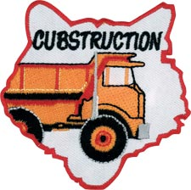

Nothing tells your child you care more than choosing to be with him.
Parent’s Little Book of Wisdom.
When planning projects for this theme remember this from Bill Smith, the Roundtable Guy –
Wood is good.
Bigger is better.
Projects are activities where Cub Scouts make things that are useful: that is, the things fly, make a lot of noise, explode or help the Cubs do other neat things. Do not confuse Projects with Crafts. Crafts are things that are pretty or cute.
Cub Scouts are not into pretty and cute.
So get out and have them do an Adventure this month where they build something worthwhile!! I know Bob Scott and the CAT (Cub Adventure Team) made sure there are some for each rank.
It's not what the boy does to the board that matters, it's what the board does to the boy.
Bud Bennett
I used to teach Electricity Merit badge for Boy Scouts. Each of my students would make an eight (+/-) foot 12 gauge extension cord with heavy duty safety plugs on the end. Sure we could have done something less. Yes, we could have all taken off and put on the same plug. BUT I wanted them to have something worthwhile to take with them from the sessions. I wanted to have something they may keep and someday when they are moving into a new home and looking for an extension cord, find the one they made for Electricity Merit Badge and say, “I made this in Scouts!.” So my challenge to you is to have your Cubs make something this month that will keep for years.


FILES/ BOOKS/ LINKS TO MATERIALS FROM UNIVERSITIES AND POW WOWs NEEDED –
If your council ran a University or a Pow Wow and published a book or posted files on the web or on a cloud somewhere. Let us know. We are always looking for new material. You can write us at –
davethecommish@gmail.com and
judyjohnsonbsa@yahoo.com


www.scouting.org/programupdates
The Program Updates page has been regrouped. Since the CS Adventure is in full swing, the emphasis on getting ready for it has been reduced. The downloads are still all there. And great information about three new Cub Leader courses at Philmont Training Center next summer.
There is a lot of information now on etting ready and implementing the changes to the Boy Scout program.
Check it all out – stay current!!




Judy and Dave need some help. If you would do one item for Baloo each month, it would help us greatly –
Some ideas for you to consider –
Biography – write a one page +/- biography of a person you select that exemplifies that month's emphasized point of the Scout Law.
Advancement – Choose a rank. Write a few hints and ideas for the Adventure to be discussed that month at the Roundtable. And, also, any that have a Character Compass pointing to that months point of the Scout Law
Social Media – check out National's Facebook pages, Bryan's Blog, Cubcast, and Scoutcast and prep the summaries for Baloo.
Roundtable Hints – Prep some hints and ideas for your fellow Roundtable Commissioners each month. This would be easy for someone from a council like Sam Houston where they have an annual RT day where they review all 12 months in advance.
Crazy Holidays – Jodi actually retired from that position a few years ago. We can supply you files for each month. You only need to check for updates and additions. Feel free to use more websites if you have a favorite.
Point of the Scout Law – Look for items that help get across the meaning of the point of the Scout Law emphasized that month in Roundtable.
Special Opportunities – write a brief article each month about one youth and one adult award other than rank advancement.
Have another idea? Let us know how you feel you could help us to make Baloo's Bugle more of what RT Commissioners, Cubmasters, and Den Leaders want.
Write us through the "Send Your Ideas to Baloo" link or directly – davethecommish@gmail.com and judyjohnsonbsa@yahoo.com

TABLE OF CONTENTS
COMMISSIONER'S CORNER 1
www.scouting.org/programupdates 2
TABLE OF CONTENTS 3
CORE VALUES 5
BIOGRAPHY 6
VINCENT KARTHEISER 6
FRUGALITY HALL OF FAME 7
BENJAMIN FRANKLIN 7
CUB SCOUT LEARNING LIBRARY 10
ADVENTURE PLAN TRACKERS 13
CUB SCOUT LEADER TRAINING 14
IN-PERSON TRAINING 14
ON-LINE TRAINING 14
SCOUTING ACRONYMS 15
25 CUB SCOUT TERMS YOU NEED TO KNOW 15
ROUNDTABLE HINTS 16
REBUILDING YOUR ROUNDTABLE © 16
DEN MEETING TOPICS 20
CHARACTER COMPASS 20
PACK MEETING THEMES AND PLANS 21
PACK MEETING THEMES 22
UPCOMING MONTHS 22
WEBELOS 23
WEBELOS TRIVIA 23
MARCH CRAZY HOLIDAYS 25
BSA SOCIAL NETWORKS 28
SCOUTING MAGAZINE ON YOU TUBE 28
BSA FACEBOOK PAGE 28
CUBCAST 29
SCOUTCAST 29
BRYAN'S BLOG, 30
TRAINING TOPICS 32
CUB SCOUTING COMMUNICATION 32
DEN AND PACK NEWSLETTERS 34
GOOD BEHAVIOR MARBLE JAR 35
SPECIAL OPPORTUNITIES 35
INTERPRETERS STRIPS 35
KNOT OF THE MONTH 38
THE INTERNATIONAL SCOUTER AWARD 38
COUNCIL INTERNATIONAL REPRESENTATIVE 39
THEME RELATED STUFF 40
CUBSTRUCTION RELATED ADVENTURES 40
CUBSTRUCTION ACTIVITIES 41
THEME & PACK MEETING IDEAS 46
GATHERING ACTIVITIES 46
OPENING CEREMONIES 49
AUDIENCE PARTICIPATIONS 51
ADVANCEMENT CEREMONIES 52
LEADER RECOGNITION 54
SONGS 55
STUNTS AND APPLAUSES 57
APPLAUSES & CHEERS 57
RUN-ONS 58
JOKES & RIDDLES 58
SKITS 59
CLOSING CEREMONIES 61
CUBMASTER’S MINUTES 62
CUB GRUB 62
GAMES 64
DEN ADVENTURES 67
TIGER 67
Tiger Adventure: Backyard Jungle 67
Ways to Conduct a 1-Foot Hike 67
American Robins 68
House Sparrows 69
10 Steps to Plant a New Tree and Shrubs 69
Flip the Bird Tag 71
Gourd Birdhouse 72
Cub Scouts Birdhouse Plans 73
Tiger Elective Adventure: Floats and Boats 74
Types of boats 74
How to Make a Floating Toy Boat 74
The Water Safety Chant: 75
Buddy Tag Game 75
Make Sure the Life Jacket is Properly Fastened 76
How to Save an Active Drowning Victim 76
WOLF 78
Wolf Adventure: Council Fire 78
Things Change (Requirement 3a) 79
Presentation to Pack Committee 79
Water Field 79
Den Yell 79
Military or Community Service Member Visit 79
Recycled Art Project IMAGEN 79
Perpetual Motion 79
Community Service Proposal Presentation 80
Tug of War 80
Ideas for Adventure Requirements: 80
Den Job Chart 81
Wolf Elective Adventure: Code of the Wolf 81
5 SECRET CODES FOR KIDS 82
WRITE A CODED LETTER 83
MAKE A SPY DECODER 83
HOMEMADE RAIN GAUGE 86
BEAR 88
Bear Adventure: Fur, Feathers, and Ferns 88
Flip the Bird Tag 89
Finding Out About Endangered Species 89
Ideas for Adventure Requirements 90
Bear Elective Adventure: Make It Move 90
Clothespin Button Racer 90
Rube Goldberg Machines for Kids 93
How to Do a Rube Goldberg Project 95
How To Do A Rube Goldberg 95
WEBELOS CORE 97
Webelos Adventure: Cast Iron Chef 97
How to Build a Fire Skit 98
How to Build a Fire 98
Menu Planning with Webelos 99
Edible Campfires Recipe 100
Edible Campfires 100
ARROW OF LIGHT CORE 100
Arrow of Light: Building a Better World 100
Messengers of Peace 101
Ideas for Adventure Requirements 101
Cub Scout Conservation Project Ideas 102
Planting Trees 102
Recycling 103
Walking and Biking 103
Adopt an Endangered Animal 103
Arrow of Light Adventure: Camper 103
Ideas for Adventure Requirements 104
Webelos/AOL Elective: Art Explosion 105
Color Wheel Download 105
DIY 3D HAND DRAWING 105
ONE LAST THING 107
The Parable of the Pencil, parts 2 & 3 107
The Seven Wonders 108

CORE VALUES
The Cub Scout Core Values are now the
12 Points of the Scout Law.
The core value highlighted this month is:
March's point of the Scout Law, THRIFTY, will use the theme, CUBSTRUCTION.
A SCOUT IS THRIFTY
A Scout works to pay his way. He uses time, property, and natural resources wisely.
HOW DOES “CUBSTRUCTION” RELATE TO THIS POINT OF THE SCOUT LAW?
Part of being thrifty is avoiding waste and using resources wisely. It is important to learn how to conserve and repurpose the many items we use every day to help our environment as well as use our resources in an innovative way for fun and adventure.
Per our Founder, Lord Baden-Powell
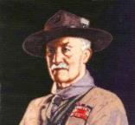
Note – The original Scout Law published in 1908 had nine points. In 1910, the BSA added Brave, Clean, and Reverent. In 1911 B-P added Clean to his original list.
A SCOUT IS THRIFTY
That is, he saves every penny he can, and puts it in the bank, so that he may have money to keep himself when out of work, and thus not make himself a burden to others; or that he may have money to give away to others when they need it. (Scouting For Boys, 1908)

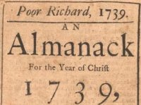
A Penny saved,
is a penny earned
Benjamin Franklin
I'm not cheap, I'm thrifty. ― Kym Whitley
Be thrifty, but not covetous. ― George Herbert
It is thrifty to prepare today for the wants of tomorrow. - Aesop
Good friends, good books, and a sleepy conscience: this is the ideal life. ― Mark Twain
I believe that thrift is essential to well-ordered living.
- John D. Rockefeller
Cannot people realize how large an income is thrift?
- Cicero
Frugality may be termed the daughter of Prudence, the sister of Temperance, and the parent of Liberty.
- Samuel Johnson
Thrift means that you should always have the best you can possibly afford, when the thing has any reference to your physical and mental health, to your growth in efficiency and power. - Orison Swett Marden
He who does not economize will have to agonize.
- Confucius
Frugality is misery in disguise. - Publilius Syrus
Beware of little expenses; a small leak will sink a great ship. - Benjamin Franklin
We are not to judge thrift solely by the test of saving or spending. If one spends what he should prudently save, that certainly is to be deplored. But if one saves what he should prudently spend, that is not necessarily to be commended. A wise balance between the two is the desired end. - Owen Young
Thrift is not an affair of the pocket, but an affair of character. - S.W. Straus
Thrift comes too late when you find it at the bottom of your purse. - Seneca
Thrift was never more necessary in the world's history than it is today. - Francis H. Sisson, "Capital Needs for American Industrial Development," 1920
Whatever thrift is, it is not avarice. Avarice is not generous; and, after all, it is the thrifty people who are generous. - Lord Rosebery
The thrift that does not make a man charitable sours into avarice. - M.W. Harrison
Industry, thrift and self-control are not sought because they create wealth, but because they create character. -- Calvin Coolidge
A bargain ain't a bargain unless it's something you need. - Sidney Carroll, A Big Hand for the Little Lady
By sowing frugality we reap liberty, a golden harvest. - Agesilaus

BIOGRAPHY

VINCENT KARTHEISER
A Thrifty Actor

Kartheiser was born in Minneapolis, Minnesota, in 1979. His Mother ran a nursery, and his Dad sold construction equipment. He is the youngest of six children, he has four sisters and a brother.
Some of Kartheiser’s first acting experiences were on stage of Children's Theatre Company in Minneapolis, including roles in Pippi Longstocking, Our Town, Dr. Seuss’ The 500 Hats of Bartholomew Cubbins, and Rebecca of Sunnybrook Farm. He played various roles on screen from 1993 until present. In 2007, Kartheiser began playing the role of ambitious young ad man Pete Campbell in the AMC television series Mad Men (2007-2015). Along with the rest of the show's cast, Kartheiser twice won the Screen Actors Guild Award for Outstanding Performance by an Ensemble in a Drama Series.
In a 2010 interview with The Observer, Kartheiser revealed that he eschewed the extravagant lifestyle of a Hollywood celebrity in favor of simple living

When the AMC drama Mad Men became an overnight smash, Vincent Kartheiser, soon realized that he craved minimalism in his life after boxes upon boxes of free gifts and swag started showing up at his door. “One day, I looked around and thought ‘I don’t want this stuff, I didn’t ask for it’,” he once told The Guardian. “So I started giving it to friends or charity stores, or if it is still in its box I might sell it for a hundred bucks.”

But he didn’t stop there. He also gave up a car in favor of public transportation to get around Los Angeles, and until a few years ago, he lived in a 603-square-foot home with no television, no mirrors, and for a while - no working bathroom. (Temporary while renovations were in progress, but still.)
While other actors his age are spending money like it’s going out of style, Karthesier, who’s estimated to be worth $1.1 million and growing, knows the fleeting nature of show business, and thinks about the future in all of his purchases. “Mad Men is going to be over at some point and my career will slow down, and I have to be prepared,” he said, “So I have to be a little bit financially conservative when it comes to certain things.”

Although frugality may not be a very high priority for most of the world’s rich, it’s nice to know that fame and fortune doesn’t always affect people negatively. Even with billions of dollars at their disposal, some of the wealthiest people in the world choose to downgrade their possessions and minimize their personal spending in order to provide their families with a bright future, help those less fortunate, and donate to worthy causes. As the old saying goes, “you can’t take it with you.”
FRUGALITY HALL OF FAME
The 14 Most Interesting
Frugal People
While looking for a person to highlight this month for Thrift, I found the site listed above, The Frugality Hall Of Fame – The 14 Most Interesting Frugal People, at http://www.criticalcactus.com/most-interesting-frugal-famous-people/. So if you want someone different. Or just want to see who is listed and why, check it out. I found it very interesting (As Arte Johnson would say on Laugh In.)
The #1 person on the list is Benjamin Franklin. His bio clip follows. I had highlighted him for Thrifty in May of 2015 so did want to use him as the main person again.
The others are –
John D. MacArthur, the founder of Bankers Life.
Hetty Green, a Quaker and the richest woman in American in the 1870s.
Rose Kennedy, the mother of John, Bobby, and Teddy Kennedy.
Ronald Read of Battleboro, Vermont. An unassuming man, Read was the first in his family to finish high school, and worked as a gas station attendant and a janitor until his retirement at age 75. He was so frugal, he drove a second-hand car, gathered his own firewood, and used safety pins to keep his coat closed when the buttons fell off. His appearance and demeanor was so shabby that one time, while having lunch at a local coffee shop, a stranger anonymously paid for his meal, assuming Read was down on his luck and couldn’t afford it. Even his attorney, Laurie Rowell, admitted to the press that the last time she had a meeting with Read, “he parked far away in a spot where there were no meters so he could save the coins.” However, when he died at 92 he was revealed to be a multimillionaire, having amassed more than $8 million by successfully playing the stock market and investing wisely. His own family was unaware of his wealth, stating that their only clue that he was accumulating vast riches was the fact that he read the Wall Street Journal religiously. His stock market savvy and simple spending habits paid off, and upon his death he was generous enough to donate approximately $6 million to his local hospital and library
Carlos Slim Helu, Mexican Entrepreneur
Mark Zuckerberg, Founder of Facebook
David Cheriton, Early investor in Google, technologist, college professor. Named one of "Top Ten Cheapskate Billionaires," by Business Insider.
Michael Bloomberg, former Mayor of New York City and communications mogul.
Zong Quighou, Chinese soft drink company founder
Ingvar Kamprad, IKEA Furniture founder
Warren Buffett, the "Oracle of Omaha." Creator of Berkshire Hathaway Co.
Kiera Knightley, the leading lady in the Pirates of the Caribbean movie franchise.
Vincent Kartheiser, Played Pete Campbell on Mad Men

BENJAMIN FRANKLIN
The First American
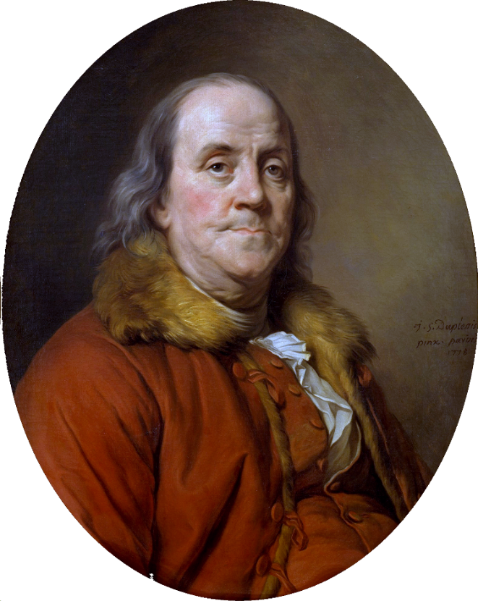
(This article reprinted from May 2015
issue of Baloo's Bugle)
Benjamin Franklin (1706 - 1790) a Founding Father of the United States and a multitalented individual. Franklin was an author, printer, political theorist, politician, postmaster, scientist, inventor, civic activist, statesman, and diplomat. As a scientist, he is known for his work with electricity. As an inventor, he is known for the glass armonica, lightning rod, bifocals, and the Franklin stove, and many more. He facilitated created Philadelphia's fire department and a university.
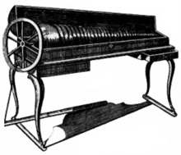
Glass Armonica
Spinning glass bowls on a single shaft are arranged to play music with the lower notes (larger bowls) to the left and higher notes (smaller bowls) to the right.
Franklin earned the title of "The First American" for his early and indefatigable campaigning for colonial unity. He spoke in London and France for the colonies. He exemplified the young American nation. Franklin was foundational in defining the American way of life uniting thrift, hard work, education, community spirit, self-governing institutions, and opposition to political and religious authoritarianism. He was described by Walter Isaacson, as "the most accomplished American of his age and the most influential person in inventing the type of society America would become."
“Having been poor is no shame,
being ashamed of it is.” B. Franklin
Franklin, always proud of his working class roots, became a successful newspaper editor and printer in Philadelphia. He published Poor Richard's Almanack and The Pennsylvania Gazette (which later became The Saturday Evening Post).
He played a major role in establishing the University of Pennsylvania and was elected the first president of the American Philosophical Society. Franklin became a national hero in America when he led the effort to repeal the unpopular Stamp Act. An accomplished diplomat, he was the American minister to Paris and was a major figure in the development of positive Franco-American relations. His efforts to secure support for the American Revolution by shipments of crucial munitions proved vital for the American war effort.
His colorful life and legacy of scientific and political achievement, and status as one of America's most influential Founding Fathers, have seen Franklin honored on many money (e.g. $100 bill); warships; place names (towns; counties); educational institutions; corporations; and, more than two centuries after his death, countless cultural references.
A delegate to the conventions for both the Declaration of Independence and the Constitution and a signer of both, Franklin is considered one of the Founding Fathers of the United States. His pervasive influence in the early history of the nation has led to his being jocularly called "the only President of the United States who was never President of the United States."
I could go one for many pages about his life –
- His inventions - the lightning rod, glass armonica, Franklin stove, bifocal glasses and the flexible urinary catheter.
- His demographic and populations studies.
- His scientific works – ocean currents, electricity, light waves, meteorology, cooling, temperature, oceanography.
- His love and practice of the arts – playing several musical instruments, playing chess, writing
- His public life – Ambassador to France, Diplomat, establishing philosophical societies, hospitals, colleges, postmaster
But let's leave these for others and look at Franklin and Thrift.
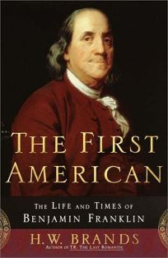
Franklin lived his life to his Thirteen Virtues
Franklin sought to cultivate his character by a plan of 13 virtues, which he developed early in life and practiced the rest of his life. His 13 virtues as:
- Temperance. Eat not to dullness; drink not to elevation.
- Silence. Speak not but what may benefit others or yourself; avoid trifling conversation.
- Order. Let all your things have their places; let each part of your business have its time.
- Resolution. Resolve to perform what you ought; perform without fail what you resolve.
- Frugality. Make no expense but to do good to others or yourself; i.e., waste nothing.
- Industry. Lose no time; be always employed in something useful; cut off all unnecessary actions.
- Sincerity. Use no hurtful deceit; think innocently and justly, and, if you speak, speak accordingly.
- Justice. Wrong none by doing injuries, or omitting the benefits that are your duty.
- Moderation. Avoid extremes; forbear resenting injuries so much as you think they deserve.
- Cleanliness. Tolerate no uncleanliness in body, clothes, or habitation.
- Tranquility. Be not disturbed at trifles, or at accidents common or unavoidable.
- Chastity. Rarely use venery but for health or offspring, never to dullness, weakness, or the injury of your own or another's peace or reputation.
- Humility. Imitate Jesus and Socrates.
You will see a large dose of THRIFTY in these 13 virtues under Resolution, Frugality, and Industry.
Franklin did not try to work on them all at once. Instead, he would work on one and only one each week "leaving all others to their ordinary chance." While Franklin did not live completely by his virtues, and by his own admission he fell short of them many times, he believed the attempt made him a better man contributing greatly to his success and happiness, which is why in his autobiography, he devoted more pages to this plan than to any other single point; in his autobiography Franklin wrote, "I hope, therefore, that some of my descendants may follow the example and reap the benefit." Just as we do not expect our Scouts to keep the Oath and Law perfectly all the time but to do their best and learn from their m, 1739istakes.
Poor Richard's Almanack
Franklin declared 1739 as
The Year of Thrift
Famous Franklin Quotes on Thrift -
- A penny saved is a penny earned.
The lesson: Saving money is the number one key to building wealth and becoming financially successful.
Note from CD – Some Internet sources say this is a misattribution to Franklin. They say it goes back to the 1600's and this form (these words) originated after Franklin.
- An investment in knowledge always pays the best interest.
The lesson: Never stop learning. If you have a chance to take a class, or further your education, go for it. Better yet, study things that interest you on your own time.
- Having been poor is no shame,
being ashamed of it is.
The lesson: Remembering the crushing weight of debt or poverty might be just the motivation you require to sustain your personal frugality and ensure a better future for yourself and your family.
- He that is of the opinion money will do everything may well be suspected of doing everything for money!
The lesson: You should be in charge of your money; it shouldn’t be in charge of you.
- Rather go to bed without dinner than to rise in debt
The lesson: Don’t live beyond your means, and get out of debt as quickly as possible

Cubmaster's Minute Idea –
Talk about Franklin for your minute and start by showing his picture by pulling a $100 bill out of your pocket!! Bet you get everyone's attention!! I don't have one but I know people who do. Or you could print one side from a .jpg on the Internet.

Other THRIFTY Quotes from Benjamin Franklin
- Haste makes waste
- Speak little - do much
- Necessity never made a good bargain
- If you’d know the value of money,
go and borrow some
- Beware of little expenses:
a small leak will sink a great ship
- If you know how to spend less than you get,
you have the philosopher’s stone
- Content makes poor men rich,
Discontent makes Rich men poor
- Avoid dishonest gain:
No price can recompense the pangs of vice
- No gains without pains
- Light Gains, heavy Purses
- He that drinks fast, pays slow
- He that waits upon fortune,
is never sure of a dinner
- Diligence is the mother of good luck
- Don’t judge men’s wealth or piety,
by their Sunday appearances
- Work as if you were to live 100 years,
Pray as if you were to die tomorrow
- Lost time is never found again
- Well done is better than well said
- If Passion drives,
let reason hold the reins
- Wise men learn by others’ harms,
fools by their own



CUB SCOUT LEARNING LIBRARY
The NEW https://cubscouts.org/ !!!

This is the Cub Scout Learning Library –
Everything you could want to know for Cub Scouts is or will be here. And all within a click or 3 of the home page. National heard the message that although things were at www.scouting.org they were often buried too deep to be found.
This site has admin stuff and practical stuff. The new Den Leader Resource Books are here. You can download some of the pages for each Adventure for FREE
This website is a great resource. There are still parts under construction but what is there is GREAT!!

BSA seems to be working off the same plans that www.USScouts.org and other "unofficial" Scouting websites use. They have seen what you the volunteers want and are delivering it. I hope they are successful and some of us old guys (I have my Medicare card) can retire from our web duties.
Yes, https://cubscouts.org runs on a phone, too!!!

There are 3 tabs on top of the home page –

- Learning Library
- Cub Hub
- Join Scouting
- Learning Library takes you where you can learn about your position and pick up hints. Besides specifics for dens of each rank, other clickable links include –
KEY
- All or most of material was placed on site this past month
- All or most of material was in place and listed as such in last month's Baloo's Bugle.
- Site / pages under construction
- Den Leader
Den Meeting Basics
- Your First Den Meeting
- Planning Den Outings
- The Parts of a Den Meeting
- Getting Started
Three of the Core Adventures for the selected rank are listed here. Click on them and you will see / can download all the Leader's Guide pages for these three Adventures.
- Additional Required Adventures
The remaining Core Adventures for the selected rank are listed here. When you click them you get an intro to the Adventure but do not get the Meeting Plans and Resources. You see this note:
To get you started in delivering fun and engaging meetings, complete Den Meeting Plans are available here on the Learning Library for the Backyard Jungle and Games Tigers Play adventures. To obtain Den Meeting Plans for all other adventures, Den Leader Guides are available at your local Scout Shop, online at scoutstuff.org, or as an eBook through Amazon.
- Elective Adventures
All the Elective Adventures for the selected rank are listed here. When you click them you get an intro to the Adventure but do not get the Meeting Plans and Resources. You see the same note (above).
- Building Strong Dens
The Basics of Cub Scouts
- Advancement
- BSA Mission and Vision Statements
- Cub Scout Ages and Ranks
- Cub Scout Uniforming
- Den Flags
- Den Yells
- Leader Survival Kit
- Methods of Cub Scouting
- Purpose of Cub Scouting
- Roles and Responsibilities
- Scout Oath and Law
- What Is Cub Scouting?
- Training
- The Role of Training
- Youth Protection
- Den Planning And Administration
- Advancement Basics
- Advancement Requirements
- Annual Planning For Your Den
- Coordinating Your Den Plan with Pack
- Tracking and Recognizing Advancement
- Youth Protection Training
- Positive Youth Development and Working with Boys
- Developmental Differences Boys 7-11
- Behavior and Discipline
- Positive Youth Development
- Working With Special Needs Cub Scouts (Advice is specific to each Special Need. Lots of research was done to prep these pages.)
- Parents’ Prejoining Conference
- Leadership Techniques
- Working With Specific Disabilities and Needs

- Cubmaster
- Committee Chair/Member
- Chartered Org Rep
- Parent / Adult Partner
- Cub Hub takes you to a Cub Scout specific Blog similar to Bryan's Blog. The most recent topics discussed are listed here. There are more at www.cubscouts.org:

I saw no new posts this month. CD

Three Opportunities to Boost your Cub Scouting Expertise Increase Your Scouting Expertise with these Great Learning Opportunities! You’ve heard the rules of real estate are…READ MORE
Are Scout Jokes Just Dad Jokes in a Uniform? Jokes and Cub Scouts have a long history of being mutually perfect for one another. We’ve blogged…READ MORE
These Halloween Cub Scout Skits are Hilarious Crisp Air and Changing Leaves Autumn is a fun season in your Cub Scouts den and pack. With…
READ MORE
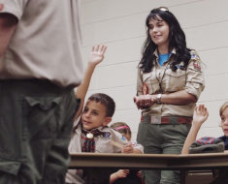 Scouting: Fun for the Whole Family Meet Lydialice. She is a mom whose boy was looking for more outdoor adventure. In her own…
READ MORE
 The “Digital Pack” is Growing, We Just Hit a BIG Milestone Last week saw a big milestone for what we affectionately call the “Digital Pack.” Our Cub Scouts…READ MORE
 Scouting: A Priority for Family Meet Juan. He grew up in Mexico and as a teenager immigrated to the United States. Having…READ MORE
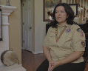 Scouting: An Extension of Family Meet Catherine, or as the Cub Scouts in her den call her, Ms. Cat. She’s a Scout mom,…READ MORE
 Scouting: Not Just a Club, but a Family Meet Becky. Her son just crossed over from Cub Scouts to Boy Scouts, and is about to…READ MORE
 Scouting: Getting the Most out of Family Time Meet Michelle, the proud mother of a Webelos Scout. She knows that life can be busy and…READ MORE
- Join Scouting takes you to www.beascout.org
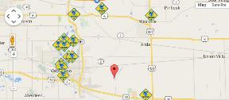

- Also, on the home page –

This link takes you to a YouTube Video
on Cub Scouting.
https://youtu.be/7MmVdjSNVO0
These Six Links take you to:
(From top left across, then down)

www.scoutstuff.org – The Supply Division site where you can find the location of your nearest National Scout Shop or buy all your Scout supplies
http://scoutingwire.org/ - Where you can get the latest Scouting News from around the country. You can sign up to get notifications when things are posted here...
www.scouting.org/programupdates - The great site where all the news about all the changes to Cub Scouting, Boy Scouting, and Venturing can be found.
https://www.scoutbook.com/ Where you can get the Scoutbook APP to track your son's Scouting Experience from Tiger to Eagle Scout.
I just learned that Bob Scott is at it again. Bob led us on the charge to the "CS Adventure Program." Now he is leading the Scoutbook effort. It is sure to be a success!! CD

www.boyslife.org – Go directly to the on-line edition of Boys 'Life
http://scoutingwire.org/marketing-membership/ Get resources and materials to strengthen your unit at BSA's marketing and membership site. Learn the best practices and tips employed by the most successful units.

ADVENTURE PLAN TRACKERS
- Tracking Spreadsheets are posted on the USScouts Advancement webpage (www.usscouts.org). There are be links to them from other places on the site. These spreadsheets are similar in construction and user interface as the existing spreadsheets. The spreadsheets have be tested by the developer of the current spreadsheets and he said they are so good he sees no reason to develop others!!
- Utah National Parks Council has Excel spreadsheets posted for all the new Adventure Plan requirements on their Akelas Council Blogspot. www.Akelascouncil.blogspot.com .
The Advancement Excel Spreadsheet workbooks are distributed to Scouters for FREE.
PLEASE do not download the files from either site to email or send them digitally to others. They are for your personal / pack use only. If you would like to share these files with others, please copy / send the link to them and send them to the site so they can print off their own. They would love everyone that wants a copy to get their own copy absolutely free. Both USScouts and Utah National Parks receive Ad money based on the number of people visiting the site that helps keep their websites open. Please help us by encouraging others to visit them to obtain the files.

CUB SCOUT
LEADER TRAINING

IN-PERSON TRAINING
Position-Specific In-Person Training Guides Available Now! The training guides for
- Den Leader (http://www.scouting.org/filestore/training/pdf/515-215.pdf ),
- Cubmaster/Assistant Cubmaster (http://www.scouting.org/filestore/training/pdf/511-503_WB.pdf ), and
- Pack Committee (http://www.scouting.org/filestore/training/pdf/511-504_WB.pdf )

Are available on Scouting University. You can access them at http://www.scouting.org/training/adult.aspx .


ON-LINE TRAINING
On-Line Training for all Cub Scout positions has been available since October 25, 2015
The online training for Den Leaders, Cubmasters, Committee Chairs and members, and Chartered Organization Representatives is totally updated with help from volunteers from around the country. The new training is divided into shorter, more targeted modules so leaders can get the training they need, in the order they want, any time they need it. It is organized around the learning needed prior to the first meeting, in the first 30 days, and to be position-specific trained. This training was developed to be implemented in conjunction with the BSA’s new learning management system. Keep an eye on
my. Scouting Tools (log in at https://My.Scouting.org ) for more information.
Go to the BSA Volunteer Training Team Facebook page (Link above) and.
Then you automatically receive the latest news!!

If you are having difficulties with
the training or system call
Member Care at 972-580-2489,
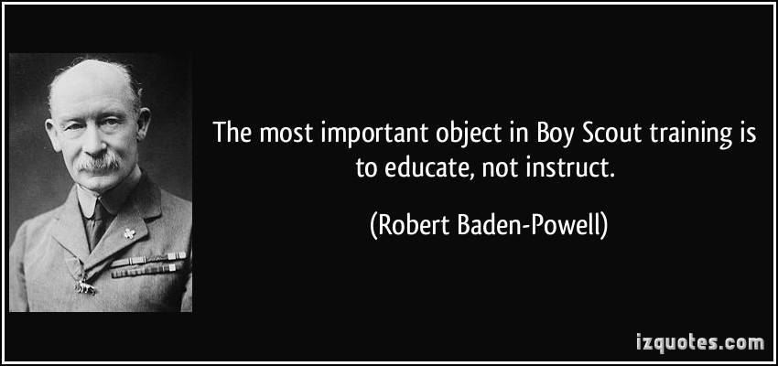
A Typical Learning Plan has several parts –
There is no need to complete more than one section at a time. Do what you have time to do.
Here you can see the three parts of the CM Course -
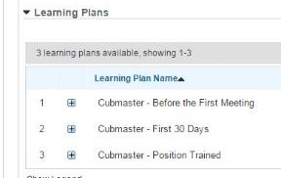

Each of these three parts is broken down into "bite sized" chunks:
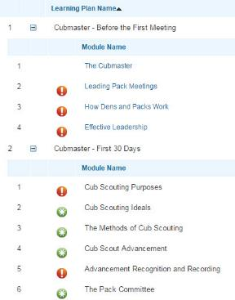
Go check it out and get your
people trained!!!

SCOUTING ACRONYMS
www.usscouts.org
AOL - Arrow of Light (the highest rank in the Cub Scout Program)
ASM - Assistant Scoutmaster
BOR - Board of Review
BS - Boy Scout(s) (also used for the BS Div)
BSA - Boy Scouts of America
CA Assistant Cubmaster
CAC - Council Advancement Committee
CACC - Council Advancement Committee Chair
CC - Committee Chair (for packs, troops, crews, and ships)
CM Cubmaster
CS - Cub Scout(s) (also used for the CS Div)
DAC - District Advancement Committee
DACC - District Advancement Committee Chair
DC Den Chief (A Boy Scout who helps lead a CS Den)
DL - Den Leader
EBOR - Eagle Board of Review
G2SS (or GTSS) Guide to Safe Scouting
GTA - Guide to Advancement
LFL - Learning for Life, the BSA subsidiary that includes career oriented Exploring.
MB - Merit Badge
MBC - Merit Badge Counselor
OA - Order of the Arrow
RT Roundtable (Unit service offered by Commissioners to unit leaders that provides monthly continuing training)
RTC Roundtable Commissioner
SA (or ASM) Assistant Scoutmaster
SM - Scoutmaster
SPL - Senior Patrol Leader (the highest-elected youth leadership position in a Troop)
SS - Sea Scout
UC Unit Commissioner (A representative of the district responsible for helping units)
WDL - Webelos Den Leader

25 CUB SCOUT TERMS YOU NEED TO KNOW
I ran this article a few months ago and forgot to put in the link to the site.
So here it is with the link. Sorry. CD
Are you a new Cub Scout parent? If you are, you've probably already learned thatCub Scouting has its own language.
Our friend (she is a friend to all Cub Scout Leaders) Sherry has posted a list of 25 Common Cub Scout Jargon items (words, phrases, titles) at http://scouting.about.com/od/CubScouts/fl/25-Cub-Scout-Terms-You-Need-to-Know.htm .
These terms can be confusing, so go check out her list, then bookmark her page for easy reference. Print copies of her list for new leaders and parents!!
Here is Letter D for a sample –
Cub Scout Terms - D
District Executive - The District Executive is a paid employee of the local council. His or her role is to support Scouting in the district.
Den - A den is a group of boys who are in the same grade or who are the same age. They work together to advance to the next level of Cub Scouts.
Den Chief - An older Boy Scout who has selected to work with a Cub Scout den. They assist with den activities and serve as a role model (and often friend) to the boys in the den. The den chief position is considered a leadership role by the Boy Scout troop.
Denner - A boy who has been selected (by vote or appointment) to serve in a leadership role in his den. They have specific duties such as taking attendance, leading a flag ceremony, assisting with den activities and conducting a closing ceremony. Serving as a Denner helps develop the Cub Scout's leadership skills.
District - The geographic territory within a council is divided into districts. Districts vary in size. Some may span multiple counties, while others are one county. There may be multiple districts within one county, depending on its size. February is the anniversary month of the Boy Scouts of America, many packs banquets are special events that can include games and entertainment. Cub Scouts often bring their whole families including grandparents.

ROUNDTABLE HINTS
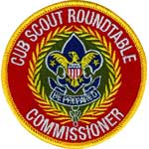

REBUILDING YOUR ROUNDTABLE ©
Hints for the New Cub Roundtable Commissioner
Stan Pope, WD Boyce Council
http://www.stanpope.net
Many thanks to Stan Pope for permission to use this copyrighted article on Rebuilding your Roundtable. CD
First things first:
Is Roundtable attendance low? That's the problem, right? Well, it is "a" problem, but it is the result, not the cause. You must first identify the cause of low attendance. Some possible causes are location, time and content. It is probably "content". We call that "program".
Don't be in a hurry to seek a lot of attendance growth until you have the program under control. If leaders come and don't have a good experience, it will be harder to get them to return after the problems are resolved. Once program is under control, then really start working on the attendance.
Most Cub Roundtables follow the Roundtable Planning Guide format. It has program outlines that sync with the monthly Cub Scout Core Value emphasis. It suggests several break-out sessions, so you need to recruit a leader for each session. (I suggest that you recruit for a 1 year term... easier to get that commitment from them, and easier to break it off if they don't fit your style.) The usual break-outs are Den Leaders, Webelos Leaders, Cubmasters, and Pack Administration.
You as the RT Commissioner should avoid leading a break-out session... you need to be able to wander around and observe the break-out session leaders. (This management technique is called "Management by wandering around.")
As soon as possible, recruit 3 more to work with the first three (2 deep in each position.) It is a good idea to consult with the first 3 regarding people you would recruit to work with them.
As your break-out session leaders come on board, it is time to start seriously working to build attendance.
Reference material:
- (Annual) Cub Scout Roundtable Planning Guide
- Cub Scout Roundtable Commissioner and Staff Basic Training Manual
Training:
Now, to back up a bit... Training is probably a problem for you at this time. You, your "Unit Serving Executive" (District Director or District Executive (DE from now on)), and your new recruits can "self train" using the Cub Scout Roundtable Basic Training Manual or piggy back on another district's training efforts. Perhaps your Council Commissioner has appointed an Assistant Council Commissioner (ACC) for Roundtables who has training plans and an organization already in place.
Sign up for the Train the trainer conferences in/near your council. These include – Train the Trainer (T3) and Trainer's E.D.G.E. These courses incorporate all the latest elements of training espoused by the BSA. So, even if you have done them before, it will be worthwhile for you to do go back and refresh.
If you can swing it, go to "Effective Roundtables" at the Philmont Training Center. Check out the January 2016 issue of Baloo's Bugle, the Philmont Website, http://www.philmontscoutranch.org/ptc.aspx or ask your Unit Serving Executive, District Director or District Executive, for information.
But, what do you do between Now and Then?
Do you and your staff know what a "good" roundtable should look like? Feel like?
Some keys:
- Leaders get ideas for their pack and den programs.
- Leaders feel it is a worthwhile expenditure of their time.
- Leaders get info on "what is going on in the district."
- Leaders have fun.
- Leaders "feel good" about having attended.
Some thoughts about the "general session":
- Not everything that happens there will be of interest to everyone. This means that everything in the general session should be kept short and sweet. If it isn't of interest to some, that's okay, because within a few minutes you will be on to something that will be.
I ran by a "5 minute rule" An item had better be awfully important if it were to take more than 5 minutes to complete that segment of the general session. (This includes the D.E.'s 3 minutes!!! Yup! You're the boss at RT. If you need a "Gong Show hook" to keep the DE in line, then make one! And use it! Just to keep the DE on your side, make sure he/she knows the rules and what to expect.)
- Everything that happens in the "general session" should have the rough spots filed off before it gets "on stage." That is not a time for a staff member to "cold read" a ceremony! You may need to counsel your staff if you feel the attendees were "short changed" because the preparation was inadequate.
- Spread the activities in the general session among the break-out session leaders, and others, if you recruit some for that purpose. Usually, the break-out session leaders will want the additional exposure that comes from having a part in the general session. If you play your cards right, you can greet everyone as they arrive, give the welcome at the start of the meeting, dismiss them to break-outs, and give the CM minute at the end.
Other problems:
From time to time, your DE will have some very important stuff to tell the folks that will take more than the allotted 3 to 5 minutes. That just can't be allowed to happen. Ask that he/she bring hand-outs of the announcements, and keep the oral stuff to a bare minimum.
There may also be other information dispersion activities that take a half hour or so, but is of interest to only a portion of the attendees. Here is how we resolved that problem:
Almost every Cub Roundtable meeting is preceded by what we call "Early Bird." It could be for basic training, popcorn kickoff, District Pinewood Derby rules instruction, Youth Protection Training, Fall Roundup training. Subjects are planned months in advance. Early Bird is optional. It starts 1 hour prior to RT, using one of the break-out session's areas.
From time to time, others will ask to make an announcement during your RT. You get to preview the announcement, even ask for the script of the announcement and, then, permit or decline as you feel appropriate. In any case, keep your "hook" handy, and don't be shy about using it.
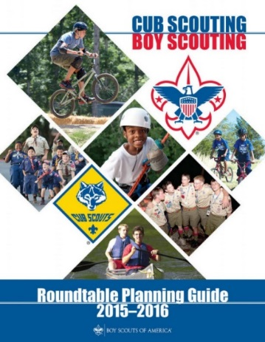
Planning your RT:
A monthly meeting with your staff is the best way to do this. I suggest that you come prepared with a "proposed" agenda for the RT with blanks for "who will do what" with copies for everyone. Allow input, changes, etc. But you make the final decision on content. Parcel out all the work. You can rough plan two months out, and fine tune the next meeting... gather copies of the "hand-outs" for copying. Whether you meet after RT or on a separate day is up to you... usually folks are too keyed up to do any serious planning immediately after RT, so how about the following Sunday evening?
Some ways to build attendance:
- Announcements / Promos at Basic Leader Training. Make sure they have a Map and Invitation.
- Monthly Call-Around. Quick-hit phone calls to one key person from each pack. Perhaps your staff can use the Service Center's WATS lines. Ask your DE.
- Item in your Council / District newsletter. What happened at the last RT. What's coming at the next one.
- Develop an E-mail list of attendees and send out a reminder for each RT listing the planned highlights.
- Invite your district's Unit Commissioners to attend, and ask them to encourage their pack's leaders to attend. (Talk to your District Commissioner about this one.)
Promotion gets them there the first time.
Good program gets them to return.
Financing your RT:
Try to have only one place that attendees are asked to "drop cash." For us, it is the $1 donation asked for the 40 page Monthly Theme Books. For others it is the "Coffee Kitty." If you're lucky, there will be more in the Council/District budget than print 2 copies of the Planning Guide. (That's what our budget is!) Your finance goal is to keep the RT program from being a financial burden on you and your staff and "break even."
Goals:
Before very long, you should start setting some goals. You might talk to your District Commissioner about this. He/She may want some information / statistics from your RT. Typical wants include Number of packs in attendance, Number of leaders in attendance, staffing level, Number of leaders in each break-out session. These are pretty typical measures of growth and success. Your goals may center on these measures, too.
Other considerations:
- Who is your boss? Whom do you have to satisfy to keep your job? What do you have to do to satisfy him/her? In most districts, the Cub Scout RT Commissioner reports directly to the Assistant District Commissioner - Roundtables with a "dotted line" (matrixed relationship) to the Assistant Council Commissioner. This is because the RT Commissioners function is to provide "Unit Service" within the district. Keep your eyes and ears open to learn how the various units are doing. Good, open dialogue with that boss will be valuable to you. He/she may not be able to tell you how to improve your RT, but they may be able to bring resources to bear that you couldn't otherwise get.
- Who are your resources? Besides the Assistant Council and District Commissioners - RTs, District Commissioner, District Executive, and staff you might find someone from years past who would "re-up" for some special assignment.
An example of this is someone to put together a monthly theme book of 30 to 60 pages of theme-related information that can be made available during RT. In our RT, my wife provides that service. She has collected a closet full of POW WOW books and each month she scours through them to flush out ideas that are worth sharing with the leaders in the district. Some other leaders have connections that help with photocopying the theme books.
Another example of this is someone or a group to be responsible for decorations at the RT meetings. This could be old timers, or it could be people who you want to evaluate as potential staff members. Or it could be folks who just can't take on the staff job, but want to help anyway. If you tackle something like this, you might want to have several such groups at work on decorations, so that none are overworked.
- As you RT starts to grow, consider adding more break-out sessions. Some possibilities are:
  - Divide Den Leaders into Wolf Leaders and Bear Leaders.
  - Divide Webelos Leaders into 1st and 2nd year Webelos Leaders.
  - Provide a Break-out session for Tiger Leaders.
  - Provide a Break-out for Den Chiefs (we do this a bit differently... the Den Chiefs meet with the general session for a few minutes, then go off for Den chief Break-out, then they join the Den Leaders break-out, and then back to the general session.
  - Divide Pack Administration into CM/AC and CC/MC groups.
The rationale for dividing is to better meet the needs of the participants... If dividing would not do that, then don't divide. DL often have a lot of hands-on stuff. Large groups can be a problem.
- Your relationship with the DE will be one of the most important in the success of the RT. The DE is your window into most Council functions. A good, open working relationship will be valuable. Keep the needs of RT first. But be as obliging as you can without sacrificing the integrity of the RT. It will make things a little more difficult for the DE, but if he/she understands where you're coming from and why, they will probably work with you. Assess your DE's experience. Some have been around for quite a while. That doesn't mean they know everything, but it does suggest that you hear them out when they have suggestions. Others (we get a lot of these) are new hires, and we get to help train them!
- Who are the other Cub Scout RT Commissioners in your council? How about a visit to their RT meetings? What you would see there isn't necessarily "gospel", but certainly they can provide you with some ideas.
- Assess your present RT meeting location. Does it have enough room for your general session? Can everyone see what is going on at the front? Are there separated areas for the break-out sessions, so that the Pack Admin types can learn to lead songs and make a lot of noise without interfering with an Ethics in Action reflection over in the Webelos Leader's area? Is your location "centrally located" with respect to those who should be attending? This is a big issue in a district like mine where it takes 2 hours to drive across it. Is the parking convenient and safe? Since the meetings are most likely in the evening hours, would a lone female Den Leader feel comfortable coming to the meeting? (I always urge folks to come "like bananas... in bunches!" but that is not a solution for a meeting area in a "high-risk" location.)
Feedback / Email Stan! Or stan@stanpope.net
Comments, positive and negative, are always welcome
Copyright 1997 © by Stan Pope. All rights reserved.


DEN MEETING TOPICS
Remember – Boys want to be active!!
See, too, that they earn their awards
(Never say GET. You get sick, you do not get awards – You earn awards. A little CD Philosophy).
Big Rock Ideas – suggestions for Big Rocks that fit Interest Topics or seasonal activity. If years are next to an item (e.g. 13-14) that suggested Big Rock is in that Roundtable Planning guide and on-line at http://www.scouting.org/scoutsource/Commissioners/roundtable.aspx
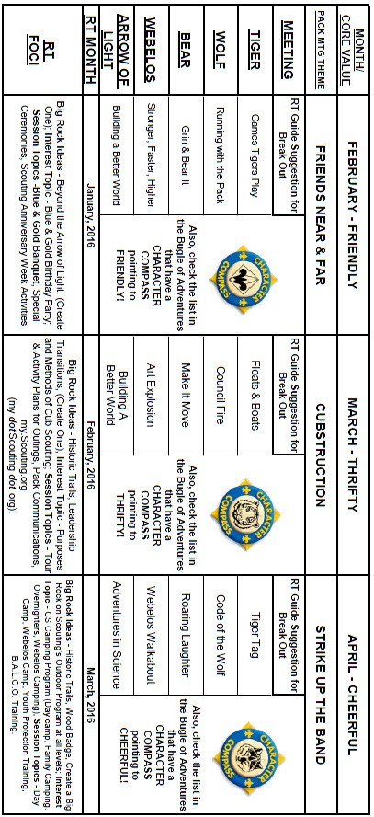

CHARACTER COMPASS
MARCH -
ADVENTURES with a CHARACTER COMPASS pointing to THRIFTY:
TIGER –
- Backyard Jungle (Core)
- Floats and Boats (Elec)
WOLF –
- Council Fire (Core)
- Code of the Wolf (Elec)
BEAR –
- Fur Feathers & Ferns (Core)
- Make It Move (Elec)
WEBELOS CORE –
- Cast Iron Chef (Core)
ARROW OF LIGHT CORE –
- Building a Better World (Core)
- Camper (Core)
WEBELOS & AOL ELECTIVES –
- Art Explosion (Elec)

APRIL -
ADVENTURES with a CHARACTER COMPASS pointing to CHEERFUL:
TIGER –
- Tigers in the Wild (Core)
- Tiger Tag (Elec)
WOLF –
- Howling at the Moon (Core)
- Code of the Wolf (Elec)
BEAR –
- Bear Necessities (Core)
- Roaring Laughter (Elec)
WEBELOS CORE –
- Webelos Walkabout (Core)
ARROW OF LIGHT CORE –
- None (Core)
WEBELOS & AOL ELECTIVES –
- Adventures in Science (Elec)

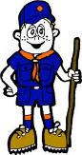

PACK MEETING THEMES
AND PLANS
www.scouting.org
From National's Website for the new plans using the Core Values based on the Scout Law:
Here are a few thoughts to consider around these new pack meeting plans. First, there is a plan for each month that corresponds with a point of the Scout Law. In addition, each plan has a theme to help make the pack meeting even more fun! The plans do not have to be used in a specific order.
Tips for Utilizing the Plans
- Pack meeting plans do not have to be done in any special order, but it is recommended that you include all of the points of the Scout Law each year. The pack planning meeting would be a good time to determine the order.
- There are pack meeting plans for multiple years posted on the website. It is your pack's choice of which one to select from each point of the Scout Law for each year.
- Pack meetings should not last longer than an hour. Adjust the plan to make it fit within the time. Research and experience tells us that Cub Scouts have a hard time sitting still for that long. Keep the meetings fun, active, and engaging.
- If you are comfortable with a costume to fit the theme of the meeting, go for it!
- Importantly, keep it simple and make it fun.
- The following required adventures have a requirement that suggests or requires completion at a pack meeting. Please plan accordingly as part of your annual program planning process. Work with your den leaders to plan when these activities will take place.
Tiger
- Tigers in the Wild, requirement 5. Participate in an outdoor pack meeting or pack campout campfire. Sing a song and act out a skit with your Tiger den as part of the program.
- Games Tigers Play, requirement 3. Make up a new game, and play it with your family or members of your den or pack.
Wolf
- Council Fire, requirement 6c. Create a den project from recyclables for a pack meeting.
Bear
- Grin and Bear It, requirement 2. Working with the members of your den, organize a Cub Scout carnival and lead it at a special event.
- Grin and Bear It, requirement 3. Help younger Cub Scouts take part in one of the events at the Cub Scout carnival.
Webelos
- Stronger, Faster, Higher, requirement 5. With adult guidance, lead younger Scouts in a fitness game or games as a gathering activity for a pack or den meeting.
Arrow of Light
- Building a Better World (if chosen), requirement 10b. Set up an exhibit at a pack meeting to share information about the World Friendship Fund.
As a personal note: I have read some of the plans and they are excellent and just as complete as the new Den Leader Books. The games, and other stuff are right there. Including costuming ideas for that added PIZAZZ!! If you do not use themes and do not add PIZAZZ you are not doing your best for your pack.
GOOD JOB!!! From CD
Check them out at:
http://www.scouting.org/Home/CubScouts/Leaders/CubmasterResources/PackMeetingPlans.aspx


Kim, the chair of the task force, says "I do want to stress that the focus is still the Core Value and the theme is just there as an enhancement. Pack meeting theme plans are specifically crafted to bring out the important points of the Core Value in a fun way."

PACK MEETING THEMES
2015–2016 Pack Meeting Plans
February | Friendly | "Friends Near And Far"
March | Thrifty | "Cubstruction"
April | Cheerful | "Strike Up The Band"
May | Kind | "My Animal Friends"
June | Obedient | "It's A Hit"
July | Loyal | "Scout Salute"
August | Courteous | "S'more Cub Scout Fun"

2016–2017 Pack Meeting Plans
September | Helpful | "To The Rescue"
October | Kind | "Creepy Crawlers"
November | Courteous | "Cubs In Shining Armor"
December | Cheerful | "Celebrate"
January | Obedient | "Cub Scout City Council"
February | Reverent | "Passport To Other Lands"
March | Loyal | "Our National Treasures"
April | Thrifty | "Power Up!"
May | Clean | "A Picnic With Pizzazz"
June | Brave | "Roaming Reptile Alert"
July | Trustworthy | "Let The Games Begin"
August | Friendly | "#CUBSCOUTS"
If you are using a paper copy the link to all the
Pack Meeting Plans is:
http://www.scouting.org/Home/CubScouts/Leaders/CubmasterResources/PackMeetingPlans.aspx

UPCOMING MONTHS
March's Core Value, Thrifty, will use the theme, Cubstruction:
Month | Year | Theme
THRIFTY
(Themes for Resourcefulness & Perseverance)
March | 1944 | When Dad was a Boy
June | 1968 | When Dad was a Boy
February | 2011 | Resourcefulness
June | 2011 | Perseverance
February | 2012 | Resourcefulness
June | 2012 | Perseverance
June | 2013 | Head West Young Man
June | 2014 | Over the Horizon

Potential "CUBSTRUCTION" Months
January | 1999 | Cubstruction
March | 2006 | Cubstruction
September | 1943 | Den Fix-Up Month
March | 1947 | Tools
March | 1948 | Cub Scout Handyman
August | 1959 | Cub Scout Skills
February | 1961 | Genius Night
November | 1964 | Cub Scout Genius
March | 1967 | Cub Scout Handyman
February | 1970 | Genius Night
March | 1970 | Craftsman
November | 1973 | Genius Night
May | 1977 | Genius Night
March | 1981 | Genius Night
September | 1983 | Mr. Fix-It
November | 1983 | Bright Ideas
January | 1985 | Working with Wood
May | 1987 | Genius Night
June | 1988 | Genius Night
April | 1989 | Cub Scout Handyman
January | 1990 | Invention Convention
May | 1991 | Working with Wood
June | 1992 | Genius Night
January | 1995 | Invention Convention
January | 1996 | Working with Wood
May | 1997 | Reinventing the Wheel
January | 1998 | Genius Night
March | 2005 | Invention Convention
February | 2014 | Invention Convention

The core value highlighted next month is:
March's point of the Scout Law, CHEERFUL, will use the theme, STRIKE UP THE BAND.
A SCOUT IS CHEERFUL
A Scout looks for the bright side of life. He cheerfully does tasks that come his way. He tries to make others happy.
HOW DOES “STRIKE UP THE BAND” RELATE TO THIS POINT OF THE SCOUT LAW?
Music can make us feel many things; one of the best things it makes us feel is cheerful. As we “STRIKE UP THE BAND” this month, we will explore ways to make people happy using music.

Month | Year | Theme
CHEERFUL
(Themes for Cooperation & Positive Attitude)
January | 2009 | A-MAZE-ing Games
September | 2010 | Cooperation
January | 2011 | Positive Attitude
September | 2011 | Cooperation
January | 2012 | Positive Attitude
September | 2012 | Hometown Heroes
January | 2013 | Abracadabra
September | 2013 | Amazing Games
January | 2014 | Lights, Camera, Action
September | 2014 | Under the Big Top
January | 2015 | Yes, I Can
Potential "STRIKE UP THE BAND" Months
January | 1941 | Music and Minstrels
January | 1945 | Cub Made Music
January | 1949 | Music and Minstrels
October | 1954 | Musical Hoe-down
July | 1957 | Homemade Opera
May | 1959 | Musical Hoedown
January | 1973 | Music Makers
April | 1980 | Let's make Music
August | 2001 | Summer Songfest
January | 2003 | Strike Up the Band
January | 2006 | Music Magic

WEBELOS
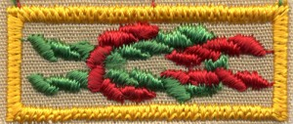

WEBELOS TRIVIA
Always an S
Webelos always ends with an S whether talking about one Webelos Scout or a den of Webelos. It is an acronym – WE’ll BE LOyal Scouts. As the CS RT Commissioner who mentored me says – "If you don’t have an S at the end – then there is nothing to which to be loyal." (She is our next Wood Badge Scoutmaster!!)
Meaning of Webelos
Webelos is an invented term originated by the Boy Scouts of America circa 1954. The Bear Cub Scout Book of 1954 claims that "Webelos" is an American Indian tribe of which Akela is chief, and that the name comes from "Wolf, Bear, Lion, Scout." At that time 10 year old boys spent their first 6 months in a Lion Den to earn their Lion Badge and second 6 months in a Webelos Den to earn the "Webelos Award" (1941-1967), later renamed "Arrow of Light" before graduating to Boy Scouts at age 11.
The program was modified in the early 1960's and Webelos became a 1 year program and the rank of Lion Scout was eliminated. The Webelos acronym was kept. It was redefined to be WE’ll BE LOyal Scouts
Arrow of Light Square Knot
See above. The Arrow of Light Square Knot is an adult only item. This knot is given in recognition of attaining Cub Scouting's highest rank, the Arrow of Light. If you earned the Arrow of light when you were a Cub Scout, you are entitled to wear this knot. It has a red rope forming the standing loop and green rope ends to the left.
Note: prior to 1967, the rank following Bear was Lion, and the Webelos Award was the "getting ready for Boy Scouts" award...similar to the current Arrow of Light. If you earned your Webelos Award prior to 1967, you are also entitled to wear this knot.
For guidance on wearing of BSA Square Knots, see http://blog.scoutingmagazine.org/2012/11/20/in-the-loop-a-guide-to-square-knots-and-how-to-wear-them/
Webelos Emblem
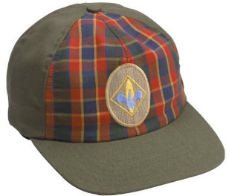
The emblem is made up of a gold Scout badge with a blue 'W,' for Webelos, on it. It shows that you are moving from Cub Scouting to Boy Scouting.
This ceremony combines “Top of the Mountain,” based on a story by Ernest Thompson Seton and “The Seven Virtues” graduation ceremony. Either one alone also makes an impressive Arrow of Light Ceremony
Webelos Scout Uniform
http://www.scouting.org/scoutsource/CubScouts/Uniform/webelos.aspx
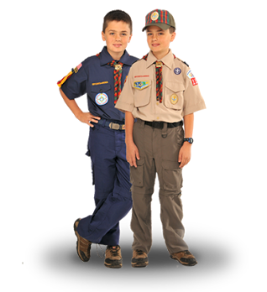
Webelos Scouts may choose to wear either the blue Webelos uniform based on the Cub Scout uniform or the tan/olive uniform similar to the one that Boy Scouts wear. The decision belongs with the Webelos Scout and his family.
For the tan/olive uniform, boys wear the official Boy Scout olive trousers or shorts and official Boy Scout tan long- or short-sleeved shirt with blue shoulder loops. Official blue socks (with gold tops) are worn with the blue uniform, and official olive socks (with red tops) are worn with the tan/olive uniform.
With either uniform, all Webelos Scouts should wear the Webelos neckerchief (plaid with the Webelos emblem), Webelos neckerchief slide (handmade slides are also acceptable), Webelos cap, and Webelos belt buckle.
When to switch from blue to khaki?
The following are personal opinions of Commissioner Dave that are allowed by BSA policy above.
In our pack, we always encouraged the parents to wait until the blue shirt no longer fit their Webelos Scout. The sooner you buy a khaki a shirt, the sooner you will have to replace it. Boys do grow!! We graduated many a Webelos in a blue shirt.
Another good time to switch is when the Webelos Badge is presented if the pack is using the oval Webelos Badge and removal of the Cub Scout Bobcat-Tiger-Wolf-Bear diamond would be required. That is one of the reasons the oval badge was created – to save sewing all the square patches on the khaki shirt.
Webelos Plaid (or Tartan)
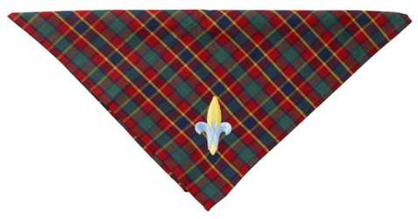
In the September 2015 issue of Baloo's Bugle, the Webelos colors were discussed. The Webelos Plaid contains the same colors for the same reason - The three badge colors represent the three programs in the BSA:
- Yellow - Cub Scouting
- Red - Boy/Varsity Scouting
- Green - "Senior Scouting" (used to be Exploring and now Venturing).
The plaid is registered and recognized as an official tartan in Scotland. The family name is Cub Scouts of America. Go to https://www.tartanregister.gov.uk/tartanDetails.aspx?ref=819 and you can see it.


MARCH CRAZY HOLIDAYS
Jodi, SNJC Webelos Resident Camp Director Emeritus,
2006-2011. Adapted from http://holidayinsights.com/moreholidays/index.htm
http://www.brownielocks.com/month2.html
Did you Know? March was named
for the Roman God "Mars"
March is

- Irish American Month
- Music in Our Schools Month
- National Craft Month
- National Irish American Heritage Month

- National Nutrition Month
- National Peanut Month
- National Women's History Month

- Red Cross Month

- Adopt A Rescued Guinea Pig Month
- Berries and Cherries Month
- Deaf History Month (3/13 to 4/15)
- Exotic Winter Fruit & Leeks and Green Onions Month
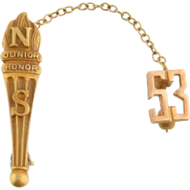
Natl Honoe Society Natl Junior Honor Soc
- Honor Society Awareness Month
- Expanding Girls’ Horizons in Science & Engineering Month
Don't forget about the BSA's new program -

It is Co-ed!!!!
Check it out at - https://stemscouts.org/
- National Athletic Training Month
- National Caffeine Awareness Month
- National Eye Donor Month

- National Frozen Food Month
- National Kidney Month
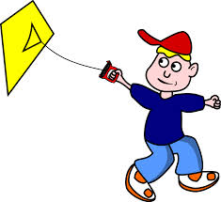
- National Kite Month
- National Multiple Sclerosis Education & Awareness Month
- National Kidney Month
- National Nutrition Month

- National Umbrella Month
- Optimism Month
- Poison Prevention Awareness Month

- Quinoa Month
- Save Your Vision Month
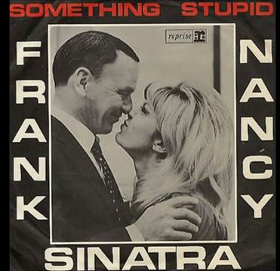
- Sing With Your Child Month
- Spiritual Wellness Month
Week Celebrations:
- National Cheerleading Week: 1-7
- National Pet Sitters Week: 1-7
- National Write A Letter of Appreciation Week: 1-7
- Girl Scout Week: 6-12 (Always the week with March 12)
- Celebrate Your Name Week: 6-
- National Procrastination Week: 6-12

- No More Week: 6-12
- Professional Pet Sitters Week: 6-12

- Read an E-Book Week: 6-12 Link
- Return The Borrowed Books Week: 6-12
- Save Your Vision Week: 6-12
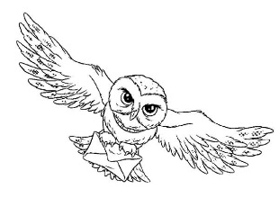
- Festival of Owls Week: 7-11 (First Full Week)
- National School Breakfast Week: 7-11
- Crufts (World's Largest Dog Show): 10-13 Link

- National Rattlesnake Roundup: 11-13
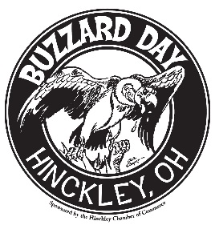
- Turkey Vultures Return: 14-20

- Campfire USA Birthday Week: 13-19 ( 2nd Full Week)
- Consider Christianity Week: 13-19 (Begins two Sundays before Easter)
- National Agriculture Week: 13-19

- International Brain Awareness Week: 14-20
- American Chocolate Week: 20-26 (Always 3rd Full Week)
- Health Information Professionals Week: 20-26
- World Folktales & Fables Week: 20-26
- Act Happy Week: 21-25 (Starts on 3rd Monday)
- National Cleaning Week: 27-4/1 (Last Week)
- National Youth Violence Prevention Week: 27-4/1 Link (Formerly in April)
March, 2013 Daily Holidays, Special and Wacky Days:
1 National Pig Day
1 Peanut Butter Lovers' Day
2 Old Stuff Day
3 I Want You to be Happy Day
3 If Pets Had Thumbs Day
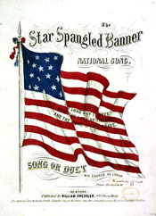
3 National Anthem Day
3 Peach Blossom Day
4 Holy Experiment Day
4 Hug a GI Day
4 Employee Appreciation Day
5 Multiple Personality Day
6 Dentist's Day
6 National Frozen Food Day
7 National Crown Roast of Pork Day
8 Be Nasty Day
8 International (Working) Women's Day
9 Panic Day

10 International Bagpipe Day
10 Middle Name Pride Day
10 Popcorn Lover's Day
11 Johnny Appleseed Day
11 Worship of Tools Day - guys, you can relate
12 Girl Scouts Day
12 Plant a Flower Day
13 Ear Muff Day
13 Jewel Day
14 Learn about Butterflies Day
14 National Potato Chip Day

14 National Pi Day- Why today? Because today is 3.14, the value of Pi.
15 Everything You Think is Wrong Day
15 Ides of March
15 Incredible Kid Day
15 Dumbstruck Day
15 National Agriculture Day
16 Everything You Do is Right Day
16 Freedom of Information Day
17 Submarine Day - the hero sandwich or the boat??
17 Saint Patrick's Day
18 Goddess of Fertility Day
18 Supreme Sacrifice Day
19 National Quilting Day
19 Poultry Day
20 Extraterrestrial Abductions Day
20 Proposal Day

20 Earth Day
21 Credit Card Reduction Day
21 Fragrance Day
22 National Goof Off Day
23 National Chip and Dip Day
23 Near Miss Day
24 National Chocolate Covered Raisin Day

25 Good Friday
25 Pecan Day

25 Waffle Day
26 National Spinach Day
26 Make Up Your Own Holiday Day

27 EASTER
27 National "Joe" Day
28 Something on a Stick Day
29 National Mom and Pop Business Owners Day
29 Smoke and Mirrors Day
30 National Doctor's Day
30 I am in Control Day
30 Take a Walk in the Park Day
31 Bunsen Burner Day
31 National Clam on the Half Shell Day


BSA SOCIAL NETWORKS

SCOUTING MAGAZINE ON YOU TUBE

Scouting magazine You Tube Channel
http://www.youtube.com/user/scoutingmag

Link to Scouting's You Tube Channels
(On-line the pictures are hyperlinked to the channels)


Check out cool stories and interviews -
The latest in the Cool Camps series -
Tahosa Alpine Base (Camp Tahosa),
Denver Area Council
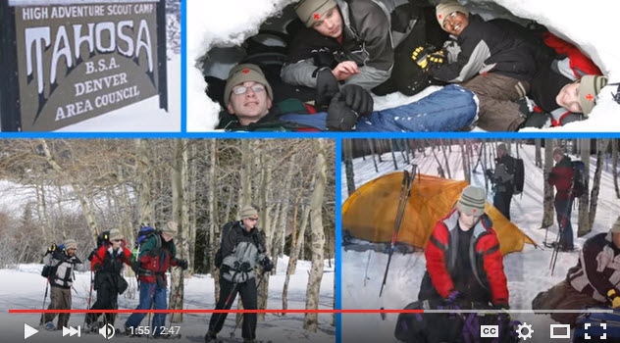
Bryan wants you to check it out at –
https://www.youtube.com/watch?v=clMjninQ658

BSA FACEBOOK PAGE

BSA Facebook page
https://www.facebook.com/pages/Boy-Scouts-of-America/113441755297
Sign up and get all the latest
as it hits the wires!!!
Cubs have your parents to Sign Up.
On the Facebook page you can read about –
The Scouting Connection to the Challenger Space Shuttle
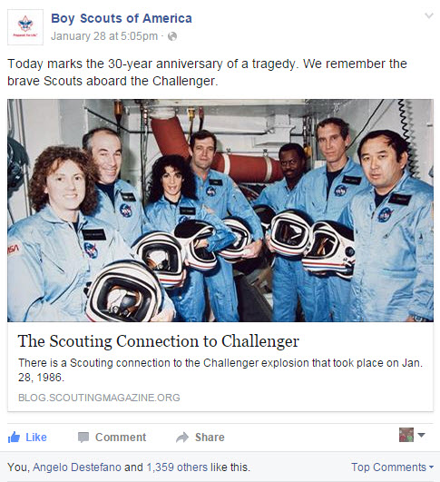
http://blog.scoutingmagazine.org/2016/01/28/four-seven-died-challenger-explosion-scouts/

CUBCAST

http://www.scouting.org/Scoutcast/Cubcast.aspx
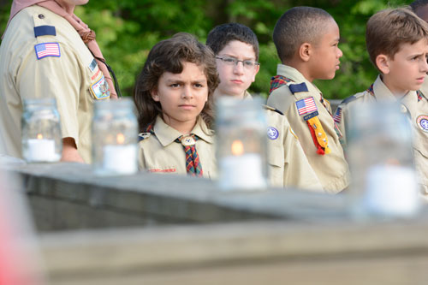
January 2016 -
Preparing for the
Webelos-to-Scout Transition
The Webelos-to-Scout graduation ceremony is the pinnacle of a boys’ journey through the Cub Scout program. But first, as leaders, we need to ‘do our best’ to get him excited about his new adventure as well as work with local Boy Scout troop leaders to ensure a smooth transition. Cub Scout Experience Manager, and Assistant Cubmaster of Pack 910 in Allen, Texas, Darin Kinn shares with us how we can prepare our Webelos to get ready for their transition into the Boy Scout program.

Listen Hear –
http://www.scouting.org/filestore/scoutcast/cubcast/201601_1/CC_JAN_Web2Scout.mp3



Be sure to check out National's website
for the latest on the
Adventure Program Changes -http://www.scouting.org/programupdates.aspx

SCOUTCAST

http://www.scouting.org/Scoutcast/Scoutcast.aspx
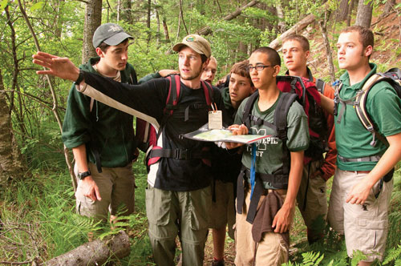
January 2016 -
The Outdoor Ethics Guide
So the way we hear it; the Leave No Trace Trainer is now going to be replaced with the Outdoor Ethics Guide, but Leave No Trace is still being implemented, and oh, Tread Lightly has been added into the mix. Sound confusing? Well, all you need to do is click the download button as Dave O’Leary, the Outdoor Ethics coordinator for the Northeast Region, joins us to explain everything we need to know about this new youth leadership position.

Listen Hear –
http://www.scouting.org/filestore/scoutcast/resources/201512_1/SC_DEC_PlanB.mp3

It is possible that by the time you get Baloo's Bugle and click the link, there may be new Cubcast and/or Scoutcast posted. Do not worry, all previous Cubcasts and Scoutcasts are available from the home page.

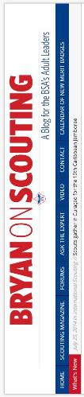
BRYAN'S BLOG,
January 2016
“Bryan on Scouting” is the official blog of Scouting magazine, a Boy Scouts of America publication. Scouting magazine is published five times a year and is received by 1 million registered adult volunteers. Bryan covers many topics every month. He keeps his Blog current and deals with the latest issues.
His articles this past month are listed below (Every title has a hyperlink). The articles in BLUE are of special interest for Cub Scout Leaders.
If the word SPONSORED appears, that BSA received compensation for that blog post.
January 2016
Summer 2016 spaces available at 3 of 4 BSA high-adventure bases
January 27, 2016 // 3 Comments
Philmont, Northern Tier and the Summit Bechtel Reserve each have openings for summer 2016. At Florida Sea Base, the lottery for 2017 spaces is now open.
What makes the best first merit badge for a Boy Scout to earn?
January 26, 2016 // 145 Comments
There's no official recommended order for earning merit badges. So which merit badge makes the best "first merit badge" for Scouts?
BSA merit badge team continues efforts to improve existing badges
January 25, 2016 // 32 Comments
It's the job of the Merit Badge Maintenance Task Force to keep our current library of pamphlets and badge requirements up-to-date, relevant and fun.
On National Handwriting Day, an ode to cursive writing
January 22, 2016 // 19 Comments
Cursive handwriting is a dying art, and with National Handwriting Day on Jan. 23, I asked the expert why cursive handwriting is so important.
Cub Scout gives Carolina Panthers linebacker his Pinewood Derby car
January 21, 2016 // 3 Comments
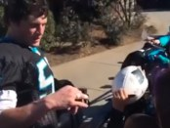A North Carolina Cub Scout gave Luke Kuechly his Pinewood Derby car, but Kuechly didn't have to be told what he was holding. Apparently he was a Cub Scout.
A show of heart: A Valentine’s Day service project Cub Scouts will love
January 21, 2016 // 3 Comments
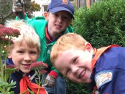Valentine’s Day service project: One Tiger Den in Michigan will create handmade, handwritten valentines to send to our longest-tenured Eagle Scouts.
Scout Sunday 2016 and Scout Sabbath 2016: Your complete guide
January 20, 2016 // 25 Comments
On Scout Sunday 2016 and Scout Sabbath 2016, we set aside time to celebrate a partnership that benefits religious institutions and Scout units alike.
Long before ‘The Revenant,’ Boys’ Life shared the harrowing true story of Hugh Glass
January 19, 2016 // 6 Comments
Twenty-seven years before "The Revenant" dramatized the life of Hugh Glass, Boys' Life shared the terrifyingly true story with its readers.
How Scouters can save money on outdoor gear & more
January 15, 2016 // 12 Comments
Don't let expensive gear deter you and your Scouts from reaching for the next challenge. Here's how to save money on great brands like Coleman.
Parental guidance suggested: What to do when Mom or Dad is too involved?
January 12, 2016 // 70 Comments
We want parents to be involved in their son's pack, troop or crew. Without dedicated parents, Scouting can't function. But how involved is too involved?
20 interactive digital merit badge pamphlets, including every Eagle-required badge, now available
January 11, 2016 // 26 Comments
The future is officially here. There are now 20 different interactive digital merit badge pamphlets available, including every Eagle-required merit badge.
For mystery trip, Scouts trust the adults to plan the location
January 8, 2016 // 29 Comments
The Scouts of Troop 870 of Denver wanted to prove their ability to Be Prepared for anything. So they gave the reins to the adults for a mystery trip.
8 ways Scouting is like ‘Star Wars: The Force Awakens’
January 7, 2016 // 23 Comments
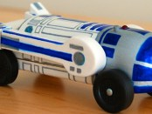Good triumphs over evil, family matters most and all the best action happens outside. These are just a few of the ways Scouting is like Star Wars.
New Boy Scout requirements for 2016 now in effect
January 6, 2016 // 58 Comments
On Jan. 1, 2016, the new Boy Scout requirements I've been blogging about for months became official. Here's your complete guide.
How do you encourage fellow leaders to attend roundtable?
January 5, 2016 // 57 Comments
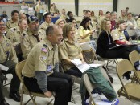How do you encourage a fellow Scouter to attend roundtable? That can be tricky, and it's the subject of our latest Tuesday Talkback.
Dremel Pinewood Derby Days at Lowe’s is where champions are born (or at least have a lot of fun)
January 4, 2016 // 8 Comments SPONSORED
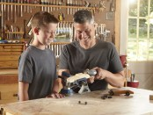This Pinewood Derby season, race to your nearest Lowe's Home Improvement Store for Dremel Pinewood Derby Days.
December 2015
2016 Order of the Arrow national officers elected
December 29, 2015 // 1 Comment
The 2016 Order of the Arrow officers have been elected, and Hunter Jones of the Wa-Hi-Nasa Lodge of Nashville, Tenn., will serve as National Chief.
Dick Douglas, the longest-serving Eagle Scout in history, dies at 103
December 28, 2015 // 5 Comments
Robert Dick Douglas Jr., who won a trip to Africa in a Boys' Life contest, flew with Amelia Earhart and was the longest-serving Eagle Scout ever, has died.

Blog Contributors
Bryan Wendell, an Eagle Scout, is senior editor of Scouting and Eagles' Call magazines.

Gretchen Sparling is associate editor of Scouting and Eagles' Call magazines.

Get Email Updates
To sign up to receive Bryan’s Blog in your E-mail –
Click the link that appears in every article. Bryan and Gretchen promise never to sell or otherwise exploit your email address. Join 6,852 other subscribers

TRAINING TOPICS

CUB SCOUTING COMMUNICATION
Bill Smith, the Roundtable Guy
Note - This column originally appeared June of 2009. Since then some things have improved. And today I am involved with another study by National to keep Roundtables relevant and useful. CD
Cub Scouting Communication
Good communication has always been essential in making the Cub Scout program successful. Our Cubmasters (CM) and Den Leaders (DLs) get a constant flow of program ideas. They are the perpetual consumers of new games, projects, ceremonies, places to go and what to do. Running a pack or a den is not entirely intuitive; one usually needs help. Even if you start with a good supply of wondrous plans, it is amazing just how quickly the well runs dry and you go to Roundtables, Pow Wows and anywhere else you can learn a new skit or magic trick.
Monthly Roundtables continue to be the best venue for communicating program information to CMs and DLs. They provide the most effective media for getting the Cub Scouting program to the packs. When you attend a Roundtable, you employ more of your senses; you hear things, you see things, you do things. You experience the fun of games, the awe of ceremonies, and the satisfaction of acquiring a new skill. And it happens every month in each district so the information is timely and local.
At least that’s the way it should be.
I would guess that many of us have gone to one or more Roundtables where these hardly happened at all. I have sat through some long boring series of announcements, harangues and diatribes by pompous district officials, wondering all the time, if this is the way we are supposed to punish our Cub Scouts.
I have also gone to great Roundtables filled with exciting and informative events where everything I experienced served as a model for how pack and den meetings should be.
Also many – maybe most – good Cub Scout program ideas originate in packs and dens. Somehow these ideas need to reach other leaders. Someone needs to collect them and then communicate them to a central point and then reverse the information flow back to the rest of the Cub Scout universe.
How Does It Really Work?
Many years ago, I served as a member of a national Cub Scouting task force looking into the effectiveness of communication in our program. We looked into how information flows through the various levels, the committees and such, to reach the people who needed it and used it. A lot of our work focused on how DLs and others in Cub Packs got the program. Did they get it from books or other publications or from people? If from people, then how did those folks get it? As best we could, we followed the trail back to its source, usually, but not always, to some national committee.
We learned that good old Program Helps was the most reliable source that pack leaders used. It was a direct channel from National and despite the limited size and long (almost a year) lead time, Cubmasters, Den Leaders, Commissioners, and RT staff cited it as the prime source of program ideas.
We were dismayed to learn that very little of use got to the same people via the official channels of their councils – either from the Scout Exec’s packet or from the Region Offices. A lot of information started that way but much seemed to get lost as it filtered through the various levels of council and district organizations. We also found that there was very little reverse flow unless someone deliberately visited packs to see what good stuff was happening.
Another surprise was that lots of information flowed through a sort of good-old-boy network formed at Cub Scout Wood Badge and at Philmont Training Courses. These friendships spanned council and even regional boundaries. As more and more district Cub Scouters attended these courses, it was amazing to see how few degrees of separation existed between many den leaders and members of national committees. Many unit people could call on a district worker who was part of the network and were themselves in contact with someone on a National group. Telephone communication was rampant. Information flow was quick and surprisingly accurate.
“Sunday's on the phone to Monday,
Tuesday's on the phone to me.” © P. McCartney.
When Wood Badge changed from a regional to a local council affair and Philmont stopped its Cub Scout weeks, this network began to fade. People changed, contacts faded and this process lost its importance.
Enter the Internet
Scouting discovered the internet around 1990. Forums, such as Scouts L, were active and attracted Cub Scouters. Then forums dedicated to Cub Scouting began to appear on AOL, Yahoo and other sites. These quickly replaced the good-old-boy network as resources where leaders could ask a question and quickly get an answer. The forums were often monitored by knowledgeable Scouters from all Scouting levels who helped regulate the tone and accuracy of discussions.
Forums were also efficient at two way communication and have effectively solved the problems of spreading ideas that originate in even the remotest packs or dens.
Large web sites like www.USScouts.org emerged to provide all sorts of great ideas, categorized and sortable to make searching easy, and support to various parts of the program. About the same time, many local councils and units also developed their own web sites. Significant among these was Baloo’s Bugle started by Chris Reisel as a district Cub Scout Roundtable service.
The National organization slowly joined the cyber world, first with Scoutnet and then with a quiet web site offering limited information and little interactive service. In the last few years, this has markedly changed. We now have online training and program resources, podcasts such as Cubcast at http://www.scouting.org/Scoutcast/Cubcast.aspx ,On-line ordering of Scout Gear at www.Scoutstuff.org, on-line advancement, and on-line charter renewals.
As documented elsewhere in this issue of Baloo's Bugle, national now has Facebook pages, Twitter accounts, on-line blogs. And more is coming – e.g. Scoutbook.
But We Still Need Roundtables
No written or online communication can replace Roundtables. Nothing beats getting together with real people, singing real songs, playing real games and having real discussions. Could you possibly imagine online den meetings or pack meetings that exist only on paper?
No, we need face-to-face Roundtables to serve as models for face-to-face Cub Scout meetings.
Roundtables need to be continuously improving. There are reasons why so many Roundtables fail to properly serve our Cub Packs. Here are some things that have been done and ideas for other improvements.
- Local Councils must provide better training for Cub Scout RT Commissioners and staff. The people who put on the shows have to know and buy into the Roundtable mission. This is coming. The Training Manual has been rewritten. A Commissioner's College Bachelor's program for Roundtable Commissioners has been developed. And a Master's Program is under development. If we want pack and den meetings to improve, we must select strong communicators and then train them to put on Roundtables that meet the critical needs of our den and pack leaders.
- District leadership must stop using Roundtables as opportunities to grandstand their own personal agendas. The RT serves the unit leaders: the den leaders and Cubmasters. It’s not there to sell popcorn, promote FOS or conduct other district business. Key3 members are often too lazy to use other available tools and see the RT as a convenient shortcut at the expense of unit leaders’ time and effort. RT Commissioners must stand up and protect their audiences from this type of abuse.
- National needs to continue to beef up its Roundtable support. When I visit roundtables around the country, the magic words are Baloo’s Bugle. Dave and Judy, and Chris before them, have put out this service for about 22 years to the appreciation and delight of many, many RT staffs. National is working to improve its service to Roundtables. The Roundtable Guide is now online. The resource pages have been expanded. Program Volunteers and Commissioners are working hard to provide a great RT Resource. Previous years are maintained on line. The Pack meeting agendas and Den Leader Manuals that replaced Program Helps are available on line. With disc space and bandwidth cheap these days, the expansion of available material is huge. Cub Scouters need games, ceremonies and clip art that they can use. And RT Staffs need to provide them.
National and local councils are making great strides improving communication. I know that it is a tough job with all sorts of complex channels and media to explore. The people who make the decisions and allocate the funding will need lots of cooperation and advice. Not everything they try will work the way they want it to. Yet I’m very optimistic!
On the other hand, I’m growing old and feeble and I’d really like see the day when my own web site is
no more needed nor visited. So let’s start communicating. The only things that can stop us are our own egos.
And we’re not going to let that happen, are we?
Note – A few years ago at age 90 something, following several strokes and a hacking of his site, Bill took down his site and stepped away from active support
What are YOU going to do now?
The best gift for a Cub Scout.......
......get his parents involved!
The greatest gift you can give your child
..... Good self-esteem!

DEN AND PACK NEWSLETTERS
Circle Ten Council
Communication is the complex process of transmitting and receiving signals. Words mean different things to different people. Confidence and poise comes through slow, deliberate talking. Tension sometimes comes from fast-talking. Body language can communicate more than words in some instances. Communications are most likely to succeed when both the sender and receiver assume 100% responsibility of getting the message across.
COMMUNICATION IS THE KEY

Communications between pack leaders and parents is vital. It is important for a person to know to transmit his ideas so that they convey what he intends. Putting yourself in the other person’s shoes…looking at the situation from his point of view…empathy…is always helpful.
There are a variety of techniques that can be used to improve communications with the pack. Some of the methods are considered “one way”, the simple transmitting of ideas. Other methods are “two way”, the exchange of ideas. This list is not exhaustive. Use your imagination and create unique ways to communicate in the pack.
YEARLY CALENDAR: Each year at the annual planning meeting the pack should set the monthly themes for the programs for the next 12 months. Along with the themes, the pack meeting dates, times, and places can be set. This information is vital and should be shared with every family in the pack as soon as it is available.
SURVEY SHEETS: This communication device really falls in the category of information gathering. If each family completes a survey sheet then valuable information is in the hands of the Cubmaster and Den Leaders.
POSTERS: Posters help tell what is going to happen or what has occurred. A den can use posters to tell what activities they have done when the event does not lend itself to display at pack meeting. A poster can also place emphasis on an upcoming event more effectively than the pack newsletter.
SKITS: Communication that takes the form of “one way” does not always have to be in a written format. A skit about next month’s bicycle rodeo or the parent-son cake bake will add more fun and variety to a pack meeting. It can help make others more aware of an upcoming event.

NEWSLETTER: Is there a problem keeping leaders, parents and boys aware of what is going on? If so a pack newsletter can alert everyone to the event that the pack has scheduled and perhaps get volunteers for special events. A newsletter is a one way form of communication. A newsletter can be passed to parents at the monthly pack meeting. If arrangements can be made in the pack budget, the newsletter can be mailed to the home of each Cub Scout. While it will cost, everyone will get a copy of the important information.
Communication is the name of the game-but producing a newsletter is not a game. As games have rules, there are guidelines to clear communication.
ASK YOURSELF
Is there enough information that needs to be given to the pack parents that would warrant having a newsletter?
What do you want to accomplish by publishing a newsletter? The newsletter can serve several functions, such as informing, educating, promoting and entertaining.
Who will be reading the newsletter? Each family should receive a newsletter, as well as the sponsoring organization, hometown newspaper, and prospective Cub Scout families.
Resources- Different types of jobs that need to be accomplished in putting a newsletter together.
- Writing the article
- Editing the written material
- Proofreading
- Typing
- Designing layout
- Drawing. Layout
- Collating/ Stapling & Mailing
ANSWERING OTHER QUESTIONS

Once it has been determined that communication by newsletter is the best method for your pack, there are other questions that need answered. Will the pack finance, or is there a parent who can make copies at their work place? Who will assume which duties to assure that it is out on time? Will it be mailed or distributed at the pack meeting? These questions may need clarification before publication begins.
The editor “gets it all together”. The editor’s duties and responsibilities should be clearly understood by the editor and the pack committee. Get it down in writing to avoid problems and confusion. Remember why you are doing the newsletter.
SOME STORY IDEAS:
- News about membership
- Notices of changes in policies or activities
- Notices of upcoming events
- Recognition of boys & leaders
- Calendar of events
- Make sure stories and articles are clear, concise, and correct
- Friends of Scouting information

GOOD BEHAVIOR MARBLE JAR
Materials:
Empty glass or plastic jar, acrylic glass paints, fine-tipped markers, paintbrush, newspaper to use as a drop cloth.
Preparation:
Start by cleaning and thoroughly drying a jar (select a size appropriate to the size of your den). Paint the jar as you like, leaving at least a one-inch column of the glass clear. Draw three horizontal lines at even intervals up the side of the jar. Label each line with an increasingly valuable reward. Examples of labels could be "candy bar," "ice cream cone “and” pizza party"

How to use the marble jar:
Use the jar as a positive reinforcement tool. Give the boys a marble at the start of each meeting. If he has been well-behaved during the meeting, he gets to put his marble in the jar at the end of the meeting. As the jar fills, rewards are given. Alternately, the whole den might decide how many marbles to put in the jar depending on the behavior of the den as a group. Make sure to choose a jar so that the boys have a reasonable chance of occasionally filling it with marbles.
SPECIAL OPPORTUNITIES
With the start of the Cub Scout Adventure Program, the requirements for awards that say things like, "Complete Wolf Achievement 7," needed to be revised to send you to the new Adventures. This was done. The changes were highlighted in Baloo's Bugle in May, June, and July 2015.
To get a complete summary of all the changes to incorporate the Adventure Program, you can go to http://www.scouting.org/scoutsource/programupdates.aspx.
Or go to http://usscouts.org/advancementTOC.asp#cub
and get the changes for a specific award.

INTERPRETERS STRIPS
Bill James, International Rep, Garden State Council,
Mike Walton, Commissioner Dave and others
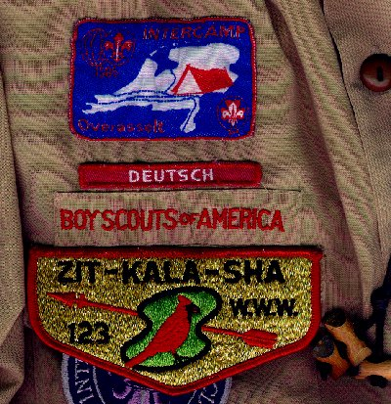
The Scout has a German Interpreter Strip
above the BSA strip. Deutsch is German for German
Overview
To signify that a youth or adult member speaks a foreign language (one other than English)
Who Can Earn the Interpreter Strip?
Any member who speaks a specific foreign language; demonstrate knowledge by carrying on a five-minute conversation in this language, translating a two-minute speech or address, and writing a letter in the language (does not apply for sign language); or, translating 200 words from the written word.
About the Interpreter Strip –
When I (CD) was a Boy Scout, if you chose a certain requirement for the World Brotherhood Merit Badge you could earn an Interpreter’s Strip for a foreign language. I elected this option when earning World Brotherhood (now Citizenship in the World and the foreign language option is no longer there.) I knew of no other way to obtain the strip except while earning the merit badge. But the Interpreter’s Strip still exists. My son earned Signing while a Boy Scout. And my Venturer and Philmont Staff member daughter earned d her Italiano and Signing Strips. (She is an Associate Venturing Advisor having turned 21 over 10 years ago)
In 2003 I participated on a Wood Badge staff and our council’s International Representative was a participant in the course. What occurred was a classic case of student teaching teacher. He explained how any member of the BSA – Cub Scout, Boy Scout, Venturer or Leader could earn Interpreter’s Strips. This was exciting news for me as elementary schools now teach foreign languages to our Cub Scouts and many of our families are bilingual. A Leader earning an Interpreter’s Strip sets a great example for youth in showing that we do respect other peoples. Encouraging the Cubs to earn one helps them learn respect for others. Here is what Bill wrote me when I asked him for more information -

Around the world Cub Scouts are known by many different names. Beavers, Wolves, Joeys are just a few of the different names young Scouts are called in other lands. Although we have many different customs and traditions we have much in common with our Scouting friends in distant countries. For instance, all Cub Scout Associations follow their country's Scout Law and Oath. Our and all other countries' Scout Oath and Law are similar to Baden Powell's original ones and to each other. Additionally every country wears with pride their own distinctive uniform and Scouts worldwide wear the World Crest. On our uniform it’s placed on the left breast just below the blue epaulet loop. We do this in solidarity with our fellow Scouts around the world.
The International Division of Boy Scouts of America and local councils are hopeful that our Cub Scout leaders will do what they can to promote that solidarity and fellowship by wearing the World Crest and the Interpreter's Strip which indicates a leader’s (or Cub’s) ability to reach out and communicate in a foreign language or signing to the hearing impaired. The requirements listed here are demanding yet very doable.
- Carrying on a 5-minute conversation in this language.
- Translating a 2-minute speech or address.
- Writing a letter in the language (Does not apply for sign language)
- Translating 200 words or more from the written word.
More Information –
From http://www.scoutinsignia.com/preter.htm
The unit leader verifies the requirements, after receiving sufficient evidence of the Cub or Boy Scout’s, Venturer’s, or Scouter’s ability to read/write/speak/understand the language. The unit leader or representative should note the personal achievement on the BSA Advancement Report for youth or on the BSA Training Report for adults and submit to the local Council. The unit or qualifying leader may purchase the strip. The strip is worn on the right side of the field uniform above the "Boy Scouts of America" strip.
Most Cub Scouts, Boy/Varsity Scouts and Explorers earn an interpreter's strip in one of three ways: Their parents speak a language in addition to or other than American English; they learn how to speak a language or how to use American or Enhanced Sign Language in school or through Scouting or other agency; or they have lived overseas in a country for several years and had to learn the language on their own. Most adults earn an interpreter's strip by working or living overseas as part of business.
The Interpreter strip is an important communications device for Scouts and Scouters. For many, it represents a closer tie with their family and heritage. For some, it gives an additional form of service at the community, local Council, and National levels, because interpreters are often requested by community service agencies, local Councils and the BSA to work at special events, encampments and programs. It is not a "gimme award" but something each person wearing the strip should be proud of earning.
Of course, when a Scout or Scouter feels that they can no longer understand or speak that language satisfactory, they should remove the strip and save it as a personal memory item. It does nobody any good at all when a person speaking German comes to you and you cannot understand them clearly enough to understand that they need help or require assistance in some way!
Not an Award
The Interpreter Strip is not an award... it is optional insignia, not temporary insignia. Its sole purpose is to serve as an immediate, visual cue to others that you are able to perform as an interpreter, when needed... not to award your ability to converse in another language. (This is also why its placement on your uniform is near your nameplate.)
Two websites for more information –
- http://www.scoutinsignia.com/preter.htm
- http://usscouts.org/usscouts/advance/interpreters.asp
Worksheets
- There is a worksheet to keep track of your progress toward earning an Interpreter Strip at http://worldscouting.homestead.com/files/bsainterpreterworksheet.pdf
- There is an interactive version of the worksheet at http://www.scouting.org/filestore/pdf/512-019_WB.pdf
"How do you get a strip for a language that's not common, like Russian or Croatian"??
The BSA's Supply Group maintains strips on 54 +/- languages. If your local Council does not have a particular language, they can request it from the BSA's Supply Group. Local Councils that have significant numbers of youth representing that ethnic group (e.g. We have a very active Puerto Rico Action Committee here in my town in NJ), or from the Direct Service, which maintains in their office suite within the National Office some 54 or so interpreter strips from languages around the world.
If the language is not available, the Supply Group will authorize a local Council to order it as long as the Scout or Scouter is willing to pay for the strips.

A fun quiz for your Cubs -


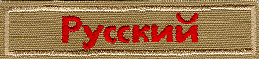


Test your knowledge of different languages. Match the following by drawing a line to the correct interpreters strip
Finnish
Spanish
Russian
Hebrew
Cantonese
The correct order top to bottom is – Cantonese. Hebrew. Finnish, Russian, Spanish
Sample Interpreter Strips
NOTE: The strips shown on this page are a representative sample of some of the languages available. Others can be ordered through the Council Service Center. Older strips were red and white, while newer strips are khaki-tan and red.
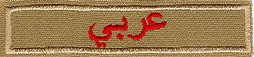 | Arabic
 | Armenian
 | Bengali
 | Cantonese
 | Dutch
 | Finnish
 | French
 | Greek
 | Hebrew
 | Italian
 | Japanese
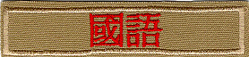 | Mandarin (Traditional)
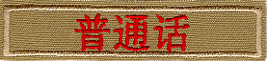 | Mandarin
 | Portuguese
 | Russian
 | Signing
 | Spanish
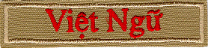 | Vietnamese

KNOT OF THE MONTH
We are going to continue with our International Flavor here with three things Leaders can earn / be.
First, Adults are encouraged to earn an Interpreter Strip to show the youth that it is good to do and needed if we are to be able to communicate with persons around the world.
Second, there is the -

THE INTERNATIONAL SCOUTER AWARD
http://usscouts.org/awards/intl-scouter.asp
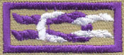
- This award is available from the World Scouting organization. The International Scouter Award encourages Scouters to broaden their involvement in Scouting through participation in world Scouting activities and recognizes Scouters for their contributions to world Scouting.
- It is a bit unusual in that it does not preclude the Scouter from earning more than one knot at a time for the same activity.
- Applicants must be currently registered adult Scouters of the Boy Scouts of America.
- All applicants must receive the approval of their local council's international committee chairperson or international representative and their council Scout executive.
Requirements
Complete any six of the following, from at least three of the following categories:
- Giving leadership to international Scouting:
  - Serve as council international representative, council international committee member, or BSA International Committee member for a minimum of three consecutive years.
  - Serve as a registered adult leader with a Direct Service Cub Scout pack, Boy Scout troop, or Venturing crew.
  - Serve at least one year in any international Scouting position approved by the BSA International Division.
- Giving leadership to international events held in the United States:
  - Host Scouts/Scouters (minimum of three visitors per group) from another country as part of an official national, council, district, or unit activity.
  - Serve on the international staff at a national Scout jamboree.
  - Assist in the organization of your council's participation in the International Camp Staff program. Be responsible for bringing a foreign Scout on staff to the council's summer camp program for two summer camp seasons.
- Giving leadership to international events held in other countries:
  - Serve as an adult leader in a BSA contingent to a world Scout jamboree or Pan-American Scout jamboree.
  - Serve as an adult leader for a group of BSA Scouts participating in an event held by a foreign Scout association recognized by the World Organization of the Scout Movement. The activity may be an exchange program, camp experience, tour activity, or home hospitality function.
  - Serve on the international service staff of a world Scout jamboree.
- Educating self and others:
  - Attend an international Scout conference at the Philmont Training Center. Share what you have learned with others in your council.
  - Promote international Scouting at a district, council, regional, or national event.
  - Participate in organizing or providing leadership for a BSA Scout activity in another country that involves interaction with Scouts from that country, such as an exchange program, camping experience, or tour activity.
- Giving support to international Scouting:
  - Organize a collection for the World Friendship Fund at two district and/or council events.
  - Become or recruit a member of the Order of the Condor for the Interamerican Scout Foundation.
  - Become or recruit a Baden-Powell Fellow for the World Scout Foundation.
For more information, go to
http://usscouts.org/usscouts/awards/intl-scouter.html or
For an application go to
http://www.scouting.org/filestore/pdf/22-721.pdf

Third, you can be

COUNCIL INTERNATIONAL REPRESENTATIVE


Never heard of this??
Want to know if your council has one already,
please click here .
(http://scouting.co1.qualtrics.com/jfe/form/SV_a9jB5EKnXEE3421)
Position Concept
In cooperation with the council leadership, the council international representative sets up a communications and organizational plan that will make it possible to keep the council membership informed of the opportunities for program enrichment in the area of international Scouting.
Position Qualifications
The individual should have, or wish to acquire, an active interest in the program enrichment values of international Scouting as a means of advancing the ideal of world brotherhood and providing extraordinary Scouting activities for Scouts and Venturers. The representative should have sufficient stature within the council structure, preferably membership on the council executive board, to be able to work at the various levels of the council operation involved in unit service. The appointee should be able to attend the international training and information seminars conducted at annual National Council meetings.
Position Duties
- Become familiar with all international program enrichment services available to councils, such as:
- Youth exchange programs
- European Camp Staff Program
- International Camp Staff Program
- Council international Camp-O-Rees
- Twinning projects
- International Scout exhibits at council- wide events
- International training seminars for adults
- World jamborees.
- In coordination with the council leadership, make an effort to see that an international emphasis is included in unit and council programs.
- Promote and communicate to units international program enrichment services.
- Advise and assist unit leaders who are planning international activities.
- Promote and assist council leadership with World Scout Jamboree recruitment.
- Promote and assist with the recruitment of prospective Scouts to the European Camp Staff Program.
- Promote and assist council leadership with the arrival, hosting, and departure of any international Scouts participating in the International Camp Staff Program.
- Promote and conduct World Friendship Fund collections at camps, training courses, general sessions, etc.
- Promote and assist with planning and participation in the Jamboree-on-the-Air (JOTA) and Jamboree-on-the-Internet (JOTI).
- Promote and assist local council with the nomination of quality youth and adults to represent BSA in tours and exchanges with other Scout associations.
For More Information, Contact:
- Your Local Council. Don't know how??
Go to ROUNDTABLE
- International Department, BSA,
1325 West Walnut Hill Lane,
PO Box 152079, Irving, TX 75015-2079
Tel: (972) 580-2401 - Fax: (972) 580-2413 - international@scouting.org
Is there Training available??
YES!!!!!!!!!
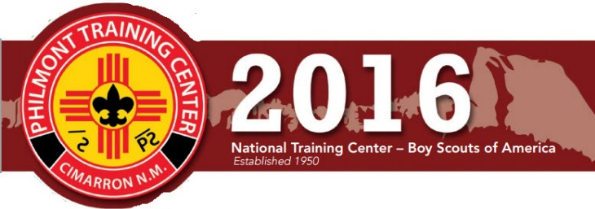
This summer there is a training seminar at the Philmont Training Center just for Council International Representatives. Here is the course description -
International Representatives (by invitation only) – Local council International Representatives (IRs) will gain the tools to enhance their council’s international Scouting experience. This session will motivate IRs to develop their council members’ interest and participation in the international Scouting arena with information about the following: the Council International Committee structure, international tours and exchanges, World Scout Jamborees, the World Friendship Fund, Messengers of Peace and International camp staff programs, to name a few. Your IR toolbox will be full of new information and techniques to bring back home to your packs, troops, teams, ships and crews.
Week 2: June 12-18

THEME RELATED STUFF

CUBSTRUCTION RELATED ADVENTURES
The following Adventures involve "Cubstruction" of something solid –
TIGER –
- Backyard Jungle – Build a Birdhouse.
- Floats & Boats – Build a boat from recycled materials.
- Good Knights – Build a Castle
WOLF –
- Council Fire – Create a project from recyclables
- Air of the Wolf – Make a Kite, Create a musical instrument
- Motor Away – Create Airplane Catapult, Boats, Car
BEAR –
- Baloo the Builder – This whole Adventure is Cubstruction!!!
- A Bear Goes Fishing – Make a Fishing Pole
- Beat of the Drum – Make a drum, a Dream Catcher
- Make It Move – Another great Cubstruction Adventure – Pulleys, Levers and Rube Goldberg stuff.
- Marble Madness – Make a Marble Racetrack
- Robotics – Build a robotic hand, build a robot
WEBELOS & ARROW OF LIGHT ELECTIVES –
- Adventures in Science – Build and launch a model rocket
- Build It - This whole Adventure is Cubstruction!!!
- Engineer – Construct a project from your own plans
- Fix It - - This whole Adventure is Cubstruction!!!

CUBSTRUCTION ACTIVITIES
Greater St. Louis Area Council
Boys love to build things. This month have the dens work on Adventures that involve tools and wood. Learn about different kinds of wood and where it comes from. Make gifts for your family or bird or bat houses for the community. Cubs can work with their family to make repairs around the home. Visit a local hardware store or home- improvement store and see all the different tools. Get permission to visit a local construction site. Since the best gifts are often homemade, make handcrafted awards to present at the pack meeting.
Clothespin Airplane:
Sam Houston Area Council
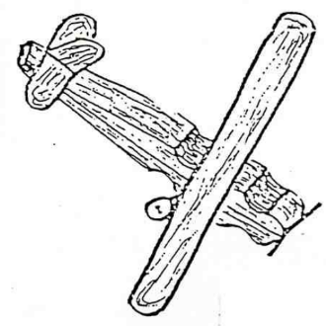
Materials:
Spring type clothespin Ice cream sticks
Toothpicks Buttons
Paints Pipe cleaners (optional)
Tools:
Brushes White glue
Electrical wire cutters Markers
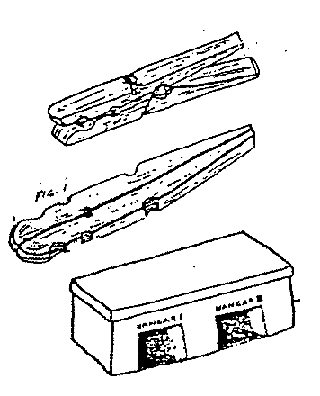
Construction:
- Remove the spring from a spring clothespin.
- Lay the two sticks back to back and glue them together. (Fig. 1).
- Glue on one ice cream stick for the wings as shown below, (or 2 ice cream sticks to make a biplane)
- A short piece of toothpick can be glued into place for the propeller.
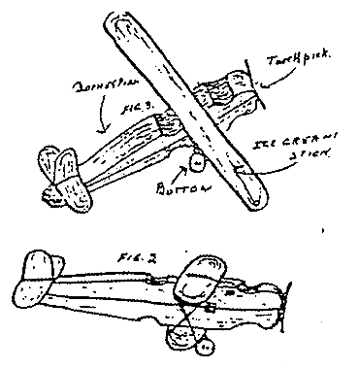
- The tail and rudder are made of pieces of ice cream sticks cut to size with a pocketknife or a pair of wire cutters then glued into place.
- Wheels are buttons mounted on toothpicks that have been bent to shape but not broken.
You may use pipe cleaners instead. (Soak toothpicks in warm water for a few minutes so they bend easily.)
- Finish by painting with markers.
Note Holder I
Baltimore Area Council
Varnish or paint wood scrap. Add ring to back for hanging, Glue on clothespin and add a twig for decoration.
Note Holder II
Great Salt Lake Council
Materials
1 – 3/ 8 in dowel, 6 1/2” long
1 – wood plaque 2 3/ 4” by 1 3/ 4” by 1” thick
spring clothes pin, stain or paint, drill
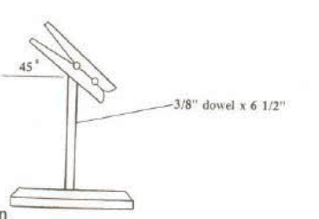
Instructions
- Drill holes 1/ 4” deep for dowel
- Insert dowels
- Glue on clothespin
- Stain or paint
Mini-Shadow Box
Baltimore Area Council
Supplies:
1 wooden yardstick
¼” plywood 10” x 1¾”
Decorative Hanger
glue

Directions:
- Cut stick as follows:
  - 2 - 10” pieces for sides
  - 2 - 2” pieces for top and bottom
  - 3 - 1¾” pieces split lengthwise, to make recessed shelves.
- Glue sides to outside of plywood back ,
- Glue on top and bottom pieces.
- Glue 2 of the narrow pieces to top and bottom, inside of box for added support
- Glue in 4 shelves.
- Let dry and sand rough edges.
- After glue has dried, paint or varnish
- Add ring to top back for hanging.

Constructing Bluebird Boxes
Alapaha Council
Adapted from GA Dept of Natural Resources website
http://www.gadnr.org/
Constructing and erecting the
Perfect Home for Your Bluebirds
See plan sheet next page
Construct boxes using untreated wood. Ideally, boards used in nest box construction should be ¾ inch thick. If smooth lumber is used in nest box construction, roughen the wood on the interior of the box just below the entrance hole; this makes it easier for young birds to climb out of the nesting box. Assemble boxes using screws, aluminum nails or galvanized nails.
Entrance holes should be cut precisely 1 ½ inch in diameter. Larger holes permit European starlings to enter the box. All boxes should be provided with drainage and vent spaces.
The outside of bluebird boxes should be painted a light color. Boxes painted light colors stay cooler than those painted dark colors.
Do not equip a bluebird nesting box with a perch. Bluebirds do not need perches; however, nest competitors such as house wrens and house sparrows will use perches to gain access to a box.
Boxes should be equipped with predator guards. One of the simplest ways to thwart predators from entering boxes is to smear automotive grease on the pole beneath the boxes. An alternative method is to place a sheet metal cone (36 inches in diameter) around the pole beneath the box.
If you have a problem with flying squirrels increasing the size of the entrance holes to your boxes, install metal entrance hole shields around the entrance holes of all of your bluebird boxes. These shields can be obtained from stores specializing in bird-related items.
Remove sparrow nests as soon as they are discovered. While this procedure may have to be repeated several times, eventually the sparrows will nest elsewhere.
Erect boxes 5-6 feet above the ground. Whenever possible, mount bluebird nesting boxes on poles made of metal or sunlight-resistant PVC pipes. Boxes placed on such structures are easier to protect from rat snakes, raccoons and other nest predators. A piece of ¾ inch electrical conduit makes an ideal nesting pole.
If you must mount boxes on trees, leave at least a one-inch space between the nail or lag bolt and the box. This will allow the tree on which the box is mounted to grow without forcing the box off its trunk.
Boxes should be placed in open habitats with sparse trees and low vegetation. Many bluebirds' nest box efforts fail because boxes are erected directly in shrubby and forest conditions.
Position boxes so that they face a tree or shrub located within 100 feet of the box. These woody plants provide safe landing areas for fledglings on their first flight. A young bluebird landing on the ground is vulnerable to cats, dogs and other predators. Bluebirds do not seem to prefer boxes facing in a particular direction.
Boxes should be erected 100 yards or more apart. Nesting bluebirds will often fight with one another when boxes are placed close together.
Monitor boxes once a week during the nesting season. Once hatchlings appear, do not check boxes after the young are 12-14 days old as the young might try to leave their nesting box before they are ready to fly.
Do not take nesting boxes down in the winter season. Boxes make ideal roosting sites for bluebirds on cold winter nights.

Blue Bird Box Plans
Alapaha Council
Adapted from Georgia Department of Natural Resources website, http://www.gadnr.org/
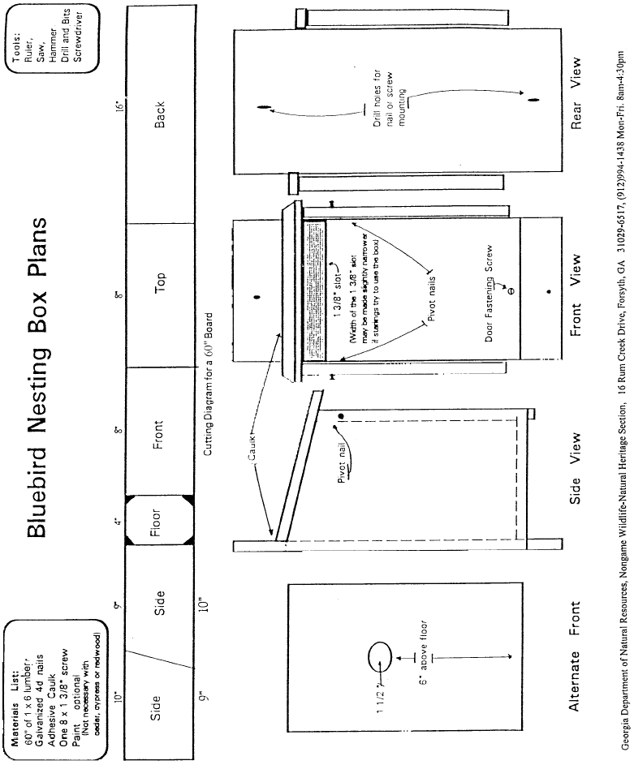

Single Chamber Bat House (Wall Mounted)
Alapaha Council
Many people have discovered the benefits and wonder of attracting backyard bats. We hope you will join them by providing new homes for these fascinating mammals.
Bat Conservation International, Inc. http://www.batcon.org
Materials (makes 1)
1/4 sheet (2' x 4') 1/2" ACX, BCX, or T1-11 (outdoor grade) plywood. DO NOT use pressure treated wood.
One 1" x 2" (3/4" x 1 1/2" finished) x 8' pine furring strip
20-30 exterior grade screws, 1"
One pint dark, water-based stain, exterior grade
One pint water-based primer, exterior grade
One quart flat water-based paint or stain, exterior-grade
One tube paintable latex caulk
1" x 4" x 28" board for roof (optional, highly recommended)
Black asphalt shingles or galvanized metal (optional)
6-10 roofing nails, 7/8" (optional)
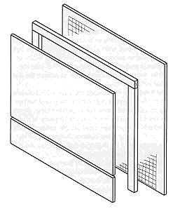
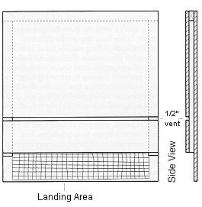
Construction Procedure
- Measure and cut plywood into three pieces:
26 1/2" x 24 16 1/2" x 24" 5" x 24"
- Roughen inside of backboard and landing area by cutting horizontal grooves with sharp object or saw. Space grooves about 1/2" apart, cutting 1/16" to 1/32" deep.
- Apply two coats of dark, water-based stain to interior surfaces. Do not use paint, as it will fill grooves, making them unusable.
- Measure and cut furring into one 24" and two 20 1/2" pieces.
- Attach furring strips to back, caulking first. Start with 24" piece at top. Roosting chamber will be 3/4" wide (front to back).
- Attach front to furring strips, top piece first (don't forget to caulk). Leave 1/2" vent space between top and bottom front pieces.
- Caulk around all outside joints to further seal roosting chamber.
- Attach a 1" x 3" x 28" board to the top as a roof, if desired (optional, but highly recommended).
- Paint or stain exterior three times (use primer for first coat).
- Cover roof with shingles or galvanized metal (optional).
- Mount on building (south or east sides usually best).
Durable plastic mesh can be substituted for roughening to provide footholds for bats. Attach one 20" x 24 1/2" piece to backboard after staining interior, but prior to assembly
RECYCLING FUN!
San Joaquin (CA) Solid Waste Authority
http://www.sjgov.org/solidwaste
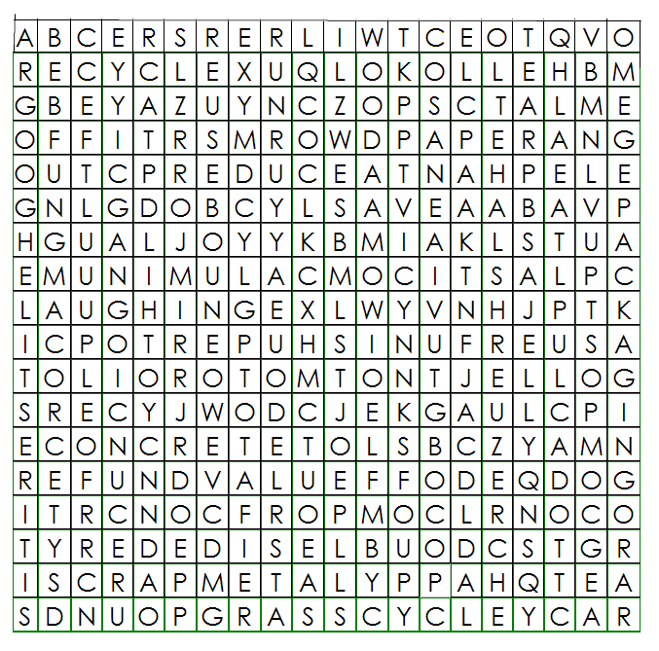
Find the following words in the word search. Words may be vertical, horizontal, or diagonal.
ALUMINUM RECYCLE WORMS
REUSE CLOSE THE LOOP GLASS
SCRAP METAL PAPER CONCRETE
RECYCLING CENTER TIRES
MOTOR OIL COMPOST PLASTIC
REDUCE DOUBLE-SIDED SAVE
GRASSCYCLE WOOD REFUND VALUE
FUN PACKAGING
There are lots of recycling word searches out on the web. Just Google "recycling word search" I chose this one because it was put up by a government group. CD
GENIUS KITS
York Adams-Area Council
I can’t imagine that anyone hasn’t at least heard of the Genius Kit activity, but for those that haven’t heard of or seen this activity, here is my description. And if you have never done a Genius Kit activity, you have missed out on one of the most incredible activities you could imagine. We run these activities every few years because they are always fun and the results are never the same.
What is a Genius Kit?
Well it’s a group of 20 or more odds and ends thrown together into a container and given to a boy to turn into something. (Variations include letting the boys pick their own items from a large open container, but again, the items are odds and ends.)
What is the purpose of the Genius Kit activity?
The object is to let the kids use their imaginations to come up with the most unbelievable creations from the junk they have. You will be amazed at the results!
How do you run a Genius Kit activity?
I have seen them run two different ways. First, as said above, is to give the kids a chance to pick their own items from a general junk bin and then let them work on making their creations. The other way is to give each boy an identical Genius Kit and have each come up with his own creation.
We also apply rules depending on how we are running the event. For example, when we’ve given the boys all the same items, we’ve said no painting and only the materials supplied and clear glue can be used. This keeps them from adding to their creations beyond the “level playing field.”
Finally, this activity doesn’t lend itself to a large group setting. The hot glue and white glue can end up everywhere and might hurt someone. To incorporate it into a Pack Meeting, have the boys work on them at home and bring them in for display and judging. (This is just my opinion.)
How do you judge the Genius Kits?
We try to have enough categories that virtually all of the creations get ribbons. It isn’t easy for the judges, let me tell you. Your best bet is to make sure you have ribbons or certificates for all participants and then you can come up with some Top Prizes.
GENIUS KIT I
Baltimore Area Council
Genius kits are fun for the boys and their families to do together. You will need a paper sack for each boy (or team). Place several different items in the sack. Make sure that you give each boy the same identical items. The more items in the bag the more creative they can be.
Each boy is given their sack and they and their families have a specified time to make something out of the items in the bag. They can only use the items in the bag and the bag itself. Only the tools they think they might need to make something such as: Scissors, screwdriver, glue gun, hammer, etc., may be brought from home. The following is a list of some possible items to use in a kit.:
Different size wood pieces Styrofoam peanuts
Garbage bag ties Nails Toilet paper rolls
2 liter bottles Cotton balls Nuts
Washers Bolts String, rope or yarn
Paper plates Small individual cereal boxes
Tacks Beans’ Macaroni
Dried Peas Fishing line Colored paper
Feather Pinecones Paper Clips
Six-pack pop can holders Juice can lids
Rubber bands Plaster spoons Used spark plugs
Canning lids Egg cartons Paper towel rolls
Paper cups Beans Small cans (e.g. tuna)
Beans Aluminum foil Pop bottle lids Popsicle sticks
Keep your pieces ‘boy things.” Enable them to build something solid. Don’t make it a paper craft.
GENIUS KIT II
Alapaha Council
A genius kit is simply a bag full of odds and ends, any and all scrap materials available in your neighborhood. The contents of each bag should be identical. Include a copy of the rules in each bag.
Some ideas for the contents are:
2 scrap wood blocks 1 jar lid 12 beads
8 peanuts 1 egg carton 2 spools
1 tin can 1 cardboard tube 6 nails
1 wood clothespin 4 straws 6 pipe cleaners
1 coat hanger 4 buttons 1 foot of rope
6 assorted corks 12 tacks 3 leather scraps
3 bottle caps 3 pieces of sponge 4 feet of string
3 pieces of cloth 2 screws 1 board, 1x 6x 10
4 pieces of dowel 3 nuts 1 small tube of glue
Rules for parent/son genius kit project:
- Use only the material supplied;
- You do not have to use all of it.
- Cut them up any way you wish.
- Us any tools you wish.
- Use your imagination and have fun!
- Bring your genius creation to the pack meeting.
Judging prizes could be given for:
Best workmanship Funniest Most ingenious
Most Useful Best invention Most decorative
Best animal Most unusual Best contraption
Smallest Best “what in the world?” Largest
Be creative – invent your own categories!!

THEME & PACK MEETING IDEAS

GATHERING ACTIVITIES
Note on Word Searches, Word Games, Mazes and such – In order to make these items fit in the two column format of Baloo’s Bugle they are shrunk to a width of about 3 inches. Your Cubs probably need bigger pictures. You can get these by copying and pasting the picture from the Word version or clipping the picture in the Adobe (.pdf) version and then enlarging to page width. CD
Wood
Great Salt Lake Council
Lay out a display of wood samples. You can pick these up at most places that sell wood flooring. Label the samples 1, 2, 3 and so on. On a piece of paper to be handed out list the different kinds of wood you have and a space to put the corresponding number. This will give the boys an opportunity to check out the different types of wood, their textures and pattern designs.
Name that Tool
Timucua District, North Florida Council
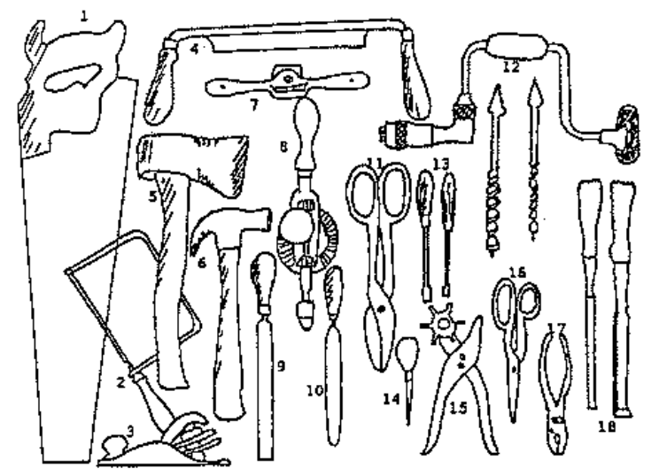
Pictured above are some basic tools Cub Scouts may use when working with wood, leather, or tin. Place the appropriate number next to the named tool.
_____ Awl Ax (hand)_____
_____ Brace & Bits Chisels _____
_____ Coping Saw Drawknife _____
_____ File Half-round File _____
_____ Hammer (claw) Hand Drill _____
_____ Leather Punch Plane _____
_____ Pliers (slip-joint) Saw _____
_____ Screwdrivers Shears _____
_____ Spokeshave Tin Snips _____
Tools
Great Salt Lake Council
Take several different tools and list them on a piece of paper. Then on a table have these tools set out with #’s by them. See how well they can match them up. Just for fun see if you can find a few old-time tools to identify.
Pinewood Derby Logic Puzzle
Great Salt Lake Council
Object: Figure out from the clues the first and last name of each boy, the color of his car, and which race he was in.
Pack 999 had just finished their Pinewood Derby race. It had been a successful night every boy really had had a hand in making his car, no one cried, no Father yelled at the Cubmaster, and very single car made it to the end of the track.
- Bob’s ladybug car raced just before Sam, who raced just before Smith
- Tom and King are BYU fans and so neither one painted his car red.
- Slade had a soccer game and so was late and raced after John
- John and Jones made their cars together and didn’t paint them green.
- Sam used blue spray paint. What a mess he made!!
- The cute yellow taxicab ran in the third race.
Answers at the end of Baloo
Pictionary
Baltimore Area Council
Supplies – Flip chart or large sheets of poster paper, marker
This is a simple game (a commercial version is available in stores but not needed). Boys can join in as they arrive at the den meeting.
One member from the den comes up to the den leader, who whispers a word or phrase to him. The den member then goes back to his den and attempts to draw on a sheet of paper, what the den leader said. They are not allowed to give clues by actions, speech, or writing. The first member of the den to guess correctly wins the point.
This could be played with several dens at once al working on the same word or phrase and seeing which den guesses it first. Each den should have its own paper and marker.
Match Game (or Toothpick Game)
Sam Houston Area Council
There are many match puzzles, but this one is the best. Empty a box of ‘dead’ match sticks (or toothpicks) on to the table and invite everyone present to take eight only. With these eight, challenge them to produce two squares and four triangles. When the time limit is up, show them how easy it is:

LEGO FUN!
Commissioner Dave
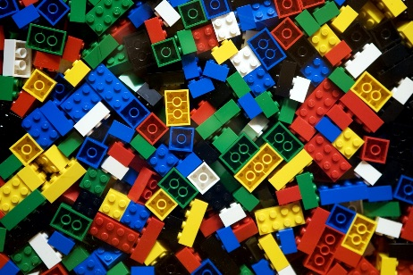
Just put out a pile of Lego Blocks and see what happens as the boys and siblings arrive at the meeting. It will be a blast. Have an adult there to watch and suggest things to build, "Let's see who can build a ????."

Paper Bag Kite
Capital Area Council
- For this kite, use a brown paper grocery bag with rectangular bottom.
- Cut a piece of cardboard the same size as the bottom.
- Cut an oval shape in the center of the cardboard.
- Using the cardboard as a pattern, cut a matching hole in the bottom of the bag.
- Punch a hole in each corner of the cardboard piece.
- Attach a long piece of string to each corner,
- Glue cardboard to bottom of bag, matching the oval openings.
- Take all free ends of the string and tie them together, so that all lengths are even. Tie them to the actual kite string, which is already wound around a piece of wood or other kite string holder. Decorate as desired. Have fun kite flying!
Gumdrop Truss Bridge
Karen, Webelos Leader (and an engineer),
Pack 23, Suffern, NY
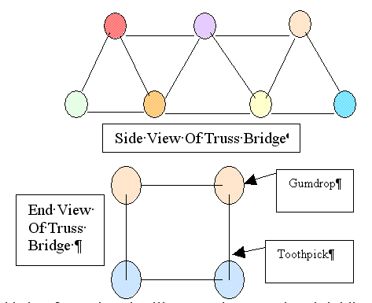
This is a fun project that illustrates the strength and rigidity of a truss bridge. You will need a box of round toothpicks and a couple of bags of inexpensive gumdrops (or spice drops). Scouts can work as pairs or individuals on this project. Each scout should start by assembling a single triangular panel using 3 gumdrops and 3 toothpicks. (It is important to notice the strength of the triangular shape.) From there they can extend the side panel of the truss by adding more toothpicks and gumdrops.
Once the single truss is about 4 panels long, the scouts can begin the second side truss. The two sides are then connected together by adding toothpicks between matching gumdrop node points. This short bridge span, which is about 8 inches long, will be very stiff and strong. Spanning the bridge between two stacks of books, or the like can test the strength. A cup full of pennies can be used to load the truss. After testing the strength, the scouts can extend the bridge length by adding more pieces. A second level of truss may be added for really long spans (2 ft or more). The scouts will enjoy testing out various different bridge configurations.

Cubstruction BINGO
A Commissioner Dave Favorite
Prepare a BINGO card with different things relating to Cubstruction (made a Recipe Holder, used a saw, is an electrician, etc.). Each family, den or individual gets a bingo card and tries to find a person to sign each category. Each person can only sign once, so caution participants to choose carefully.
See sample card on next page!!

CUBSTRUCTION BINGO
THE PURPOSE OF THE GAME IS TO MEET PEOPLE AND LEARN ABOUT THEM
THE OBJECT IS TO COMPLETE THE BINGO BOARD
INTRODUCE YOURSELF TO SOMEONE YOU DON’T KNOW, STRIKE UP A CONVERSATION, AND THEN ASK ‘EM, “SAY YOU LOOK LIKE SOMEONE WHO MIGHT HAVE…”

A PERSON CAN ONLY SIGN ONCE!!!
BUILT A RECIPE HOLDER | MADE A CHALLENGING ITEM OUT OF PLASTIC | MADE A DOOR STOP | CAN DESCRIBE HOW TO TAKE CARE OF PLIERS | BUILT A BIRDHOUSE
CUT METAL WITH A HACKSAW | MADE A PINEWOOD DERBY CAR | MADE A CHALLENGING ITEM OUT OF METAL | MADE A TOOL BOX | OWNS/ OWNED A HAMMER
OWNS A LEVEL | OWNS SAFETY GOGGLES | FREE !!!  SIGN YOUR NAME | PUT PIPE TOGETHER | REPLACED A LIGHT BULB
HAS A NICE SMILE | CAN DESCRIBE A WOOD PLANE | MADE A DISPLAY STAND | BUILT A MODEL | FIXED AN ELECTRIC PLUG
MADE A BENCH FORK | HAS A WHITTLIN’ CHIP CARD | MADE A SET OF BOOKENDS | MADE A RACK FOR CRAFTSMAN | KNOWS THE DIFFERENCE BETWEEN PHILLIPS AND REGULAR SCREWDRIVERS

OPENING CEREMONIES
Purposeful Building Opening Ceremony
Commissioner Dave Original
Decorate ten identical boxes to look like bricks, boards or some other construction material.
Put one purpose of Cub Scouting on each box.**
Character Development Spiritual Growth
Good Citizenship Sportsmanship and Fitness
Family Understanding Respectful Relationships
Personal Achievement Friendly Service
Fun and Adventure Preparation for Boy Scouts
**The ten purposes of Cub Scouting were unchanged by the Adventure Program. You can verify this by googling for them and finding them listed on two different pages on National's Website. They are also listed in the CS BS Roundtable Planning Guide. CD
Recruit ten Cub Scouts to each carry in a block and say something about the purpose listed on their block. I suggest having the words printed on the back of the block (The side the Cub Scout sees but the audience does not).
Cub #1 and Cub #12 do not get blocks. Leaders may perform these parts.
Have each Cub Scout place his block on the stack after reading. Start with 4 on the bottom level, three on the next row, then two and one on top.
- Let us begin our meeting by thinking about the ways we help Cubstruct our Scouts.
- Spiritual growth – Cub Scouting encourages spiritual growth by all members (Places block for first level of pyramid)
- Character Development - Cub Scouting influences the development of positive character traits (Places block for first level of pyramid)
- Good Citizenship – Cub Scouts develop habits of good citizenship (Places block for first level of pyramid)
- Sportsmanship and Fitness – Cub Scouting encourages good sportsmanship and pride in growing strong in mind and body(Places block for first level of pyramid)
- Family Understanding – Cub Scouting improves understanding within the family (Places block for second level of pyramid)
- Respectful Relationships – Cub Scouting strengthens the ability to get along with other boys and respect other people (Places block for second level of pyramid)
- Personal Achievement – Cub Scouting fosters a sense of personal achievement by developing new skills and interests (Places block for second level of pyramid)
- Friendly Service – Cub Scouts learn how to be helpful and do their best (Places block for third level of pyramid)
- Fun and Adventure – Cub Scouting provides fun and exciting new things to do (Places block for third level of pyramid)
- Preparation for Boy Scouts – Cub Scouting prepares them to be Boy Scouts (Places block for top level of pyramid)
- Let us now think about how our nation of fifty states was constructed from 13 original colonies as we take the Pledge of Allegiance.
A Simple Block of Wood
Baltimore Area Council
Baltimore has this listed as a Skit, other books had this for Opening and / or closing. Take your pick. CD
Characters: Each Scout holds a the designated prop in front of him
- A rectangular block of wood.
- Roughed out pinewood derby racer right from the box
- A partially completed racer with a little paint.
- A finished Pinewood Derby Racer
- A finished Pinewood Derby Racer
Setting: Each boy walks on to the stage to read his part- The last scout runs onto the stage shouting his line.
- I’m only a simple block of wood,
Cut from a tree so tall.
Unlike the tree that thundered down,
No noise would I make should I fall.
- But in the hands of a wide eyed boy,
Armed with a knife and a saw.
There are many shapes that I can take,
Some wide, some short, some tall.
- A little paint, a line or two,
Nothing fancy, but not too plain.
No two alike, made with loving hands,
We are all of the tree that remains.
- Like each little boy’s life, starting with form.
Like a block of wood cut from a tree,
The loving hands of leaders like you,
Help us each to be what we shall be.
- And I’m gonna be a racer!
CUBS BUILDING CHARACTER
Sam Houston Area Council
Santa Clara Council
This could also be used as a SKIT!
- (carrying a hammer) In Cub Scouts we learn to build character.
- (carrying a plank) It is not what the boy does to the wood, but rather what the wood does for the boy.
- (carrying a plane) Through Cub Scouting we learn to remove the sharp edges off our personalities.
- (carrying sandpaper) As we grow in Cub Scouting, we become more refined and smooth in our manners.
- (carrying a tool chest) Our talents are gathered together and we get a chance to try them out when our den works on the themes each month.
- (walking with a parent) Our parents help us learn how to use the tools of life when they help us earn our Adventure Loops.
All: Thank you all for helping us grow into well-rounded citizens. Our Cubmaster will now lead us in the Pledge of Allegiance.

BUILDING A BETTER WORLD
OPENING OR CLOSING
Santa Clara County Council, 2001 Pow Wow
Arrangement: Eleven Cub Scouts, each holding a card with a letter on the front and his line on the back. Each speaker holds up his letter as he says his line. Last line is delivered by all (or by their leader).
Note – Most of the lines spoken by the Cub Scouts are couplets (two line rhymes). Make sure they realize this and speak their lines properly.
- Take a B for brotherhood,
boosting for each other’s good.
- Take an E for every land to share
in earth’s riches everywhere.
- Take a T for trustfulness,
trusting more, and fearing less.
- Take a T for teamwork,
for joining hands to get things done.
- Take an E for equal chance
for each person to advance.
- Take an R for real respect
regardless of race, creed or sect.
- Take a W for will to work
for peace with faith and skill.
- Take an O for opportunity
to keep our speech and action free.
- Take an R for reverence
for a guiding Providence.
- Tale an L for love to spread around
when need and bitterness are found.
- Take a D for dignity of man
devoted to a bigger plan.
ALL: There you have it--this is how to build a BETTER WORLD, right now!

Constructing Greatness in America
Great Salt Lake Council
Set Up: 7 Cub Scouts. Each has a poster with a picture of one of the 7 items listed by Cubs #4 and #5 on front and their part in LARGE letters on back. Cubs line up in order with pictures toward the audience. When Cub #4 or Cub #5 names the object on his poster, that Cub raises it high and shows it off. (Cub #4s item should be the first one named by Cub #5. Cub #5's should be the 2nd one he calls)
- Cub Scouts are known for “building something”. The pages of history show how the ingenuity of ordinary men enables them to design and construct great and magnificent works.
- It all starts when young boys such as we Cubs use our imagination and start putting things together.
- This nation displays that ingenuity of man. Our country provides the opportunity for man to surpass his own expectations and provides for us as citizens the enjoyment of such beauty.
- Here are only a few examples of masterpieces Americans have constructed: Georgia’s Stone Mountain Park, the Kennedy Space Center, the St. Louis Gateway Arch,
- The Seattle Space Needle, the Empire State Building, Hoover Dam, Mount Rushmore, and many, many more.
- Please stand and give the proper salute, and together we’ll give thanks for these great constructions and for the men that built them.
- Then in so doing we’ll give thanks to the country that gives us all the same opportunity. Please join with me in the pledge of allegiance.
Many Sides of a Boy
Santa Clara Council
Set Up: One Den Leader (DL), Six Cub Scouts with placards. Each has a picture one side appropriate for the words. His words are on the back in LARGE print.
DL: We will try to show you the many sides to little boys we proudly call son, but remember, these are all one boy.
- I'm the one who lives in his dreams, always off on a cloud, at least that's how it seems!
- I'm the one all full of dirt, so very sure that soap and water will hurt.
- I'm the show-off and athlete; I just can't stand to get beat.
- I'm the pouter, sensitive and shy, but I try to make people think I'm a real tough guy.
- I'm the angel, neat and obedient. Mom wouldn't trade a day with me for all the money in the mint.
- I'm the Cub Scout, the one we boys like best. That's 'cause I'm different from the rest. So everyone, please join us as we say the Scout Oath or Promise that we try to live by every day. (Audience and boys say the Scout Oath or Promise)
DL: They're all these boys and even more. There are lots of surprises for you in store. So love them. Protect them, and try to understand. It's a very hard job growing up to be a man.
Block of Wood
Baltimore Area Council
Equipment: A long table with a cloth covering the top and front and side A block of wood A variety of wood working tools A piece of wood carved and finished.
CM: You see this block of wood (holds up the block of wood, uncarved) which is much like a boy as he enters the Cub Scouting program. It is just a block of wood. It is plain and does not suspect what it can become.
Now, let’s look at a piece of wood (holds up the wood that is carved) that has been lovingly shaped, sanded, stained, and finished in every way to become something useful and beautiful. What makes the difference between the uncut block of wood and this fine piece of wood?
A patient wood worker, using tools that are properly cared for, follows a pattern to shape a block of odd into something of beauty and use. It takes time, it takes patience, it takes a plan. That’s what Cub Scouting is all about. A plan to help shape boys into achieving their potential. And that’s what we’re here to celebrate tonight.

AUDIENCE PARTICIPATIONS
HI MY NAME IS JOE
Sam Houston Area Council
This is a "Do as I do, Do as I Say" audience participation. Audience repeats after the leader and does what the song says Joe does
Stop after ach line and wait for audience to repeat it.
Hi, my name is Joe
And I work in a button factory
I have a house, a wife and a dog
One day my boss says to me, " Joe, are you busy?"
I said NO.
He says, “Press this button with your RIGHT HAND?”
(You start repeatedly pressing a button with your right hand. Keep the movement with your body parts while you lead the next verse)
Hi, my name is Joe
And I work in a button factory
I have a house, a wife and a dog
One day my boss says to me, " Joe, are you busy?"
I said NO.
He says, “Press this button with your LEFT HAND? “
(Continue previous movements, but start repeatedly pressing a button with your left hand. Keep the movement with your body parts while you sing the next verse)
Continue with Optional
Right Leg, Hips
Left Leg, Tongue
Your Head,
Last Verse – done while doing all previously named motions –
Hi, my name is Joe
And I work in a button factory.
I have a house, a wife and a dog
One day my boss says to me, " Joe, are you busy?"
I said YES! (Immediately stop all actions)
This Is the House that I Built
Baltimore Area Council
Have audience repeat the words and actions along with you
This is the house
(Make a roof with arms, touching fingertips together)
That I built. (Point to self)
This is the saw that cut the boards (Make sawing motion)
That went into the house (Make roof with arms)
That I built. (Point to self)
This is the hammer (Make fist with right hand)
That nailed the boards (Pound right fist into left palm)
That I cut with the saw (Sawing motion)
That went into the house (Make roof with arms)
That I built. (Point to self)
These are my hands (Hold out hands and look at them)
That held the hammer (Make fist)
That nailed the boards (Pound right fist in left palm)
That I cut with the saw (Sawing motion)
That went into the house (Make roof with hands)
That I built. (Point to self)
I am sure you can think up more actions to keep
this going and growing!! CD

JOHNNY FIXES IT WELL!
York-Adams Area Council
Here is an Audience Participation skit. Divide audience into six sections. Assign each a word and a response. Tell them that when they hear their word in the story they are to give the response. Practice as you make assignments.
Johnny: I can fix it!
Dad: Be careful, son.
Wrench: Oh Nuts!
Screwdriver: Straight or Phillips?
Bike: Drrrinnngggg, Drrrinnngggg
Pliers: Hold me tight!
JOHNNY had a problem. His BIKE was broken. Now JOHNNY and his dog, Ralph, could not ride to the park to play with his friends. But JOHNNY, being a very smart Cub Scout, knew how to fix the BIKE. However, he needed a box-end WRENCH, a pair of PLIERS, and a SCREWDRIVER. So he asked his DAD if he could borrow a box-end WRENCH, a pair of PLIERS, and a SCREWDRIVER.
His DAD said “Sure, but make sure you take care of the box-end WRENCH, PLIERS, and SCREWDRIVER and return them as soon as you’re finished. “I will DAD,” said JOHNNY. So JOHNNY and Ralph went into the back yard to fix his BIKE with the box-end WRENCH, PLIERS, and SCREWDRIVER. Since JOHNNY knew how to use a box-end WRENCH, a pair of PLIERS, and a SCREWDRIVER, BIKE was soon fixed and ready to ride. Ralph helped all he could. JOHNNY took a quick spin to make sure everything was alright and then he called Ralph to go with him to the park.
“Oh,” said JOHNNY. “I’d better return these tools to DAD before we go.” But when he reached for the tools, the PLIERS and SCREWDRIVER were there but the PLIERS were missing. “Oh no! What would DAD think?” said JOHNNY. He looked all around for the PLIERS. He looked in the bushes, but no PLIERS! He looked all over the yard, but no PLIERS! Finally, he noticed Ralph digging in the garden. JOHNNY went over to Ralph and there were the PLIERS in his bone hole. So the PLIERS were found. And JOHNNY was able to return the box-end WRENCH, the PLIERS, and the SCREWDRIVER to his DAD. Everyone was happy the BIKE was all fixed—except Ralph!

ADVANCEMENT CEREMONIES
Punny Advancement Ceremony
San Francisco Bay Area
Props: Cubmaster dressed in a work smock wearing a carpenter's tool belt. Awards and mother's pins are taped to pieces of wood scraps that are hidden in his tool belt. Be sure to emphasize the "puns" though out the ceremony.
Cubmaster: Tonight, we have some boys who "saw" the opportunity to "nail down" some advancements. At times these boys had to keep "hammering" on some of the tougher requirements, but, they kept on "drilling", "curving" and "sanding" and finally "cut" through. We "wood" like to honor them tonight.
Will Cub Scout please come forward with his parents? has "chiseled" through the requirements for the Wolf badge. (Cubmaster takes the Wolf award from his tool belt and holds it up.) We "wood" like to have his parents present him this award. (Cubmaster hands the award to the parents who present the boy the award.) "wood" you please pin the mother's pin on your mother.
Other "puns" which could be used when making presentations include: "filed", "planed", "sharpened", "glued", "cut", "painted" or any other tool related name or adjective.
Recognition Ceremony Props
San Francisco Bay Area Council
Attach awards to card stock cut in the shape of wood working tools (i.e., saw, hammer, tape measure, etc.) Captions on the awards could match the tool:
- "Way to measure up!"
- "You really hammer down problems!"
- "You saw us through!"
WORKING WITH WOOD
Greater St. Louis Area Council
Boys love to build things. This month have the dens work with tools and wood. Learn about different kinds of wood and where it comes from. Make gifts for your family or bird or bat houses for the community. Work with your family to make repairs around your home. Visit the local hardware store or home- improvement store and see all the different tools. Get permission to visit a local construction site. Since the best gifts are often homemade, make handcrafted awards to present at the pack meeting.
Props: Pocket knife, Saw, Screw driver, Sandpaper and Varnish.
Narrator: Before you are a variety of tools used by carpenters and wood workers to transform plain wood into objects of beauty and usefulness. There are many steps between beginning to work with a piece of wood and completing a project. So it is with Cub Scouting. Tonight we are recognizing significant steps of progress along the Cub Scout trail.
Bobcat Recognition- (Use a pocket knife) Of course a carpenter has to start with a plan. Once he has a plan in mind, the first tools he uses begin to shape the wood. We have young carpenters who have completed the initial step and are here to receive their Bobcat award.
Call up boys and parents. Present badges to parents to present to boys. Lead cheer!!
Tiger Recognition- (Use a saw) Once started on the project, a carpenter has to focus on the major task of shaping this project- whether the finished product is a chair or a bowl. Many, many steps are required to complete this stage of the task. We have several Cub Scouts who have completed the necessary Tiger Adventures and have earned their Tiger Badge.
Call up boys and parents. Present badges to parents to present to boys. Lead cheer!!
Wolf Recognition- (Use screw driver) Once the wood is shaped, it is ready for the assembly process. This stage requires many different types of tools and fasteners and precision in assembly. Much patience is needed. Our Wolf Cub Scouts are learning more and have a tougher set of requirements to fulfill. We have several Cub Scouts who have completed the necessary Wolf Adventures and have earned their Wolf Badge.
Call up boys and parents. Present badges to parents to present to boys. Lead cheer!!
Bear Recognition- (Use sandpaper) After the pieces are assembled, the rough edges must be smoothed out. Sandpaper will smooth out the edges and roughness. Our Bear Cubs are maturing and becoming smoother in their actions and learning more about how to be a leader. We have several Cub Scouts who have completed the Bear necessary Bear Adventures and have earned their Bear Badge.
Call up boys and parents. Present badges to parents to present to boys. Lead cheer!!
Webelos Recognition- (Use varnish) The crowning touch to finishing a fine piece of furniture is what truly makes a piece of wood a masterpiece. Many coats of glass and sanding in between are needed to make wood glow. Drawers and doors without proper hardware are useless. Webelos are learning how to put on the finishing touches. We have several Cub Scouts who have completed the necessary Webelos Adventures and have earned their Webelos Badge.
Call up boys and parents. Present badges to parents to present to boys. Lead cheer!!
Arrow of Light Recognition – Arrow of Light Scouts who earn The Arrow of Light have demonstrated a commitment to becoming master craftsmen and are ready to graduate to Boy Scouts. Our Arrow of Light Den will be ready soon. Let's give them a cheer now to encourage them to keep working toward their goal.
WOODY THE CARPENTER
PROPS:
- A worktable to the side of the awards table.
- All the items the CM requests need to be premade and ready to hand to the CM when requested.
- Candles and rank poster on table.
- Large sign "WOODY THE CARPENTER AT WORK" to be set up to hide what is on table.
- The Cubmaster (CM), Committee Chair (CC) (or other Committee Member), and an Assistant Cubmaster (CA) or other adult in work coveralls carrying a tool box.
CM: Hello, who are you?
CA: Hello, I'm Woody the carpenter. I have skills, but no work.
CM: Well, let's see. I think I can use your help. Here, set up your tools on this worktable.
CA: (sets up sign to hide what he is doing) I'm ready, what do I do first?
CM: I need a Bobcat plaque.
CA (Starts to hammer, saw, etc. hands a rough cut board with Bobcat rank on it.) Will this do?
CM: Woody, this is a fine job. That is just like a Bobcat; it has been roughly cut but there is no question that it's a board not a tree.
A Bobcat has also just been cut. His skills and crafts are rough and just starting to develop. But he has just taken the first step in Cub Scouting. We can see the difference in this board and a tree.
CC: Will the following Cub Trade School Students and their teachers please enter the lumberyard? (Read Names.)
CM: (puts board by Bobcat poster and lights candle) Parents I have the honor of giving this Rank to you so you may present it to your sons.
Lead CHEER!!!
Let's see, I guess we need a Tiger plaque next.
CA: (Starts to saw, hammer, sand etc. hands out a clean square cut board with Tiger rank on it). Will this do?
CM: That certainly will do Woody. A Tiger is very much like this piece of wood. It is clean and square cut, but in need of help just like the Tiger who needs the help of his Adult Partner.
CC: Will the following Apprentices and their parents please come down to the shop? (Read names).
CM: (Places board by Tiger poster and lights candle). Parents I give you the Tiger badge to present to your sons.
Lead CHEER!!!
Let's see, I guess we need a Wolf plaque next.
CA: (Starts to saw, hammer, sand etc. hands out a clean square sanded board with Wolf rank on it). Will this do?
CM: That certainly will do Woody. A Wolf is very much like this piece of wood. He is smooth and clean but still pretty basic with a long way to go.
CC: Will the following Apprentices and their parents please come down to the shop? (Read names).
CM: (Places board by Wolf poster and lights candle). Parents I give you the Wolf badge to present to your sons.
Lead CHEER!!!
What next( pause) I know, Woody, I need a Bear Plaque.
CA: (saws, hammers, etc. hands a board with routed edges and the Bear rank on it) How is this?
CM: Woody, you have done it again! This is just like the Bear Cub Scout, a lot of effort and accomplishment has gone into this, but, it's not quite completed yet. A Bear has accomplished many things on the trail of Cub Scouting, yet he is not at the end and his training is not complete.
CC: Will the following Cub Journeymen and their foremen join us on the job? (reads names)
CM: (Places board by Bear Poster and lights candle) Parents please present the Bear Badge, the third rank of Cub Scouting to your sons.
Lead CHEER!!!
Woody, I know what I need now, the Webelos plaque.
CA: (Saws, Hammers, drills, paints, etc. ) Hands out a finished plaque with Webelos rank on it.
CM: Woody, you certainly have done a fine job. This plaque is just like a Webelos Scout. His skills and crafts are almost completed. His Cub Scout trail has but a few steps left.
CC: Will the following Master Craftsman Cub Scouts and their parents join us? (Read names).
CM: (Place plaque by Webelos poster and lights candle). Parents, you have the honor of presenting the Webelos Rank to your son. Just as a skill and accomplishments were shown on these pieces of wood tonight, the skills and accomplishments were shown on these wooden squares tonight, the accomplishments and skills of these Cub Scouts were evident as they progress along the Cub Scout trail.
Lead CHEER!!!

LEADER RECOGNITION
AND THEN SOME
Sam Houston Area Council
These three little words are the secret to success.
… and then some
They are the difference between average people
and top people in most organizations.
The top people always do what is expected
… and then some.
They are thoughtful of others,
They are considerate and kind
… and then some.
They meet their obligations and responsibilities
Fairly and squarely
… and then some.
They are good friends and helpful neighbors
… and then some.
They can be counted on in an emergency
… and then some.
I am thankful for people like this
for they make the world more livable.
Their spirit is summed up in these three little words
… and then some.
Set Up:
Candle or a small flashlight mounted on a display;
Write on the display – "Thank you for lighting our path."
Presentation Words:
There are some leaders and parents with us tonight who have shared the bright light of their enthusiasm with us all year, and we need to thank them for their time and their dedication to our pack program. They lit our path with the energy they put into this event and did all they could and then some. Would _________, _________, and _______ please come forward so we can show them our appreciation. (Present award and lead cheer.)
CUBSTRUCTION THANK YOU'S
You & Commissioner Dave
Think about the Cubstruction theme and identify small construction items (tools, bricks, models) that could be used as homemade recognition items and reflect the Cubstruction theme.
Some ideas are:
- A miniature tower for the CM who is a Tower of Strength.
- A plaque with a screwdriver on it for the leader that has driven us to be the best
- A ladder (real or toy) for one who has taken us to the next level.
- A model bridge and saying for bridging us over the gap.
Send me your Cubstruction recognition ideas and I can include them next time we have this theme!!!
(davethecommish@gmail.com)

SONGS
Toolbox Song
Baltimore Area Council
San Francisco Bay Area Council
(Tune: I'm a Little Teapot)
I'm a pair of pliers just because
Here is my handle here are my jaws.
Chorus:
Keep me in your toolbox bright and new
Take me out and I'll work for you.
I'm a coping saw that's strung too tight
Pull me then push me to use me right.
Chorus:
I'm a big strong hammer, a mighty tool.
Hit the nails only, that's the rule.
Chorus:
I'm a handy wood plane, give me a try.
I can help you out if your door's too high.
Chorus
Pound the Nail
Greater St. Louis Area Council
Tune: Row, Row, Row Your Boat
Pound, pound, pound the nail,
Pound it right on through!
If you miss and pound your thumb,
Then it will turn true blue!
Wood Working Is Fun
Greater St. Louis Area & Baltimore Area Councils
Tune: Jingle Bells
Saw on wood, Hammer nails,
Wood working is fun!
We’ll get this project done on time
With the setting sun!
Stain the wood, Putty the nails,
Let's give a big hooray!
Now this project is done on time,
Let’s go out and play!
Cubstruction
A CD Original first published in the
2005-2006 CS RT Planning Guide
Tune – Alouette
Use these or make up other motions for the actions:
- Block of wood – draw a square in the air
- Down to size - Saw
- Right size nail – position fingers to show size
- Hammer carefully – swing arm as if hammering
- Big Paintbrush – position hand as if holding brush
- Paint it very nice – pretend to paint with brush
- Name on it – Pretend to sign your name in mid air
- We are done -Pretend to sign your name in mid air
Chorus
Cubstruction, we build with Cubstruction
Cubstruction, it’s how we build our world
First you take a block of wood
Then you cut it down to size
Block of wood – Down to size
OOOooohhh
Chorus
Next you take the right size nail
Then you hammer carefully
Right size nail –Carefully
Block of wood – Down to size
OOOooohhh
Chorus
Now you take a big paintbrush
And you paint it very nice
Big paintbrush – Very nice
Right size nail –Carefully
Block of wood – Down to size
OOOooohhh
Chorus
Last we put our name on it
Then we know that we are done
Name on it – WE ARE DONE!!
(Yell last phrase and stop)
Don’t You Like to Saw
Baltimore Area Council
Tune: I've Been Working on the Railroad
I’ve been sawing on this piece of wood.
All the live long day,
I’ve been sawing on this piece of wood,
Just to pass the time away.
Can’t you see the saw dust flying
Rise up so early in the ‘mom.
Can’t you see our leader shouting,
Not on my wood floor!
Don’t you like to saw,
Don’t you like to saw,
Don’t you like to saw,
More, more, more, more!
Don’t you like to saw,
Don’t you like to saw,
Even if it’s on the floor!
My Cub Scoutmobile
Alapaha Council
Tune: On Top of Old Smokey
One Saturday morning
My granddad and I
Went down to the woodpile
To get some supplies
Some long boards, some short boards,
A few thin ones too
Four wheels and a gear shift
We’re practically through
Some paint and a good seat
Completes our fine car
Now on to the race track
Where the Cub Scouts compete
Zoom! Down the roped off street
Cub Scouts dressed in blue
All had a real great time
We hope you did too!
Pinewood Derby Car
Greater St. Louis Area Council
Tune: I've Been Working on the Railroad
I've been working for the Derby,
Planning my racing car.
All the family's been helping,
My car should be the star!
Can't you hear the crowds a cheering
As we win the prize?
Pinewood Derby time's exciting
For all the Cub Scout guys!
Pinewood Derby Song
Baltimore Area Council
Tune: “Camptown Races”
Cub Scouts all join in the song, Doo-Dah, Doo-dah!
Pine car track is mighty long, Oh, do-dah day!
Chorus: Going to run so fast, going to get ahead,
Root real hard for a blue pine car,
Somebody root for the red.
Red cars, blue cars, green and gray, Doo-Dah, Doo-dah!
Running on the track today. Oh, doo-dah day!
Chorus:
Pine wood cars have lots of class, Doo-dah, doo-dah!
Even though they don’t use gas, Oh, doo-dah day!
Chorus:
They’re the pride of all the lads, doo-dah, doo-dah!
Build by Cub Scouts and their dads, Oh, doo-dah day!
Chorus:
Peanut Butter
Peanut, peanut butter … Jelly!
(wave hands over head, right)
Peanut, peanut butter … Jelly!
(wave hands by hips, left)
First you take the peanuts
And you crunch 'em, you crunch 'em (crush in fists)
you crunch 'em, crunch 'em, crunch 'em,
(repeat)
Chorus - For your peanut, peanut butter…Jelly!
Peanut, peanut butter… Jelly!
Then you take the grapes
And you smash 'em, you smash 'em
(clap palms and squish)
You smash 'em, smash 'em, smash 'em
(repeat)
Chorus
Then you take the bread
And you spread it, you spread it
(spread right palm over left, switch)
You spread it, spread it, spread it
(repeat)
Chorus
Then you take your sandwich
And you eat it, you eat it
(pretend to eat a sandwich)
You eat it, eat it, eat it
(repeat)
Chorus - (Sing final Chorus as if peanut butter
is stuck to the roof of your mouth!)
Whacked My Thumb
Greater St. Louis Area Council
Baltimore Area Council
Tune: Jimmy Crack corn or The Blue Tailed Fly
When I was young I went to play
In father's workshop one fine day
I took a hammer, some wood and nails
And tried to make some kitchen scales.
Chorus :
Whacked my thumb and I don't care
Hurt real bad, but I don't care
Whacked it good, but I don't care
The feelings gone away
I tried to hang a picture frame
Sent to me by Aunt Jane
To hang the picture, I was dumb
I swung the hammer, and smashed my thumb
Chorus
One day I tried to make a boat
Worked real hard so it would float
I nailed my fingers to the bow
I'm bandaged to my elbows now
Chorus
I joined the local Cub Scout pack
I learned to make a neat tie rack
A little skill was all it took
They had instructions in the book
New Chorus :
I missed my thumb, I learned to care
I missed my thumb, I wouldn't dare
I missed my thumb, my thumbnail's bare
The feelings here to stay

STUNTS AND APPLAUSES

APPLAUSES & CHEERS
Cubstruction Cheer
Hammer, saw, nail
Put to the test
You’ll Never Fail
When you do Your Best

Pinewood Derby Hold your right hand over your head and bring it down as if it were a car coming down a track, while saying: “Swoooooosh,” then “Thud” as it hits the bottom of the track.
All Temp-a Cheer 1/3rd of the audience is HOT, 1/3rd is WARM and 1/3rd is COLD, when you point to that part of the crowd, they yell their temperature
Cheers
Denver Area Council
Deep-sea diver cheer: Hold one hand over head, puff out cheeks and say "blub, blub, blub"
Home run Cheer: Simulate swinging a bat at a ball, shade your eyes with your hand and yell (loud) "There She goes!"
Woodcutter’s Applause: Nod your heads, as if asleep, and start cutting the zzz’s.
Plane Applause: Hold imaginary plane in hands and plane the wood to the sound of “zzzziiiiiippp!”
Hammer Applause: Hold nail in one hand and hammer with other hand, saying “Bang, bang, bang, ouch!” (and shake hand that got hit).
Jackhammer Applause: Hold jackhammer with both hands and begin using it. “Bap-bap-bap-bap-bap!”
Great Salt Lake Council
Electric Drill (or Chain saw) – Make Brrrrrr sound for as long as you can
Chip, Chop
Divide audience into two sides.
One says “Chip,” the other “Chop”
After a few iterations, all yell, “Timber.”
Sandpaper – Rub hands together as loud as you can
Glue – Clap hands together and they get stuck, struggle to pull them apart.
Super Glue – Hands get stuck on first clap and can’t be pulled apart. Have pack yell something for help (Home Depot, Lowes, Mr. Fix-It, be original)
Rubber Tree – Pretend to hold axe to chop tree. Every time you swing it bounces back. Make bouncing noise - “Boing, Boing”
Baltimore Area Council
Nail Pounding Cheer Start by pretending to drive a nail with a hammer, then hit your thumb. Make appropriate motions. Words go “Bang, Bang, Bang, Ouch.”
Lumberjack With a partner,
- First person makes a fist with thumb up.
- Second person grasp thumb and makes a fist with thumb up
- First person grasp that thumb and makes fist thumb up.
- Second person repeats.
- With all four hands together, make back and forth sawing motion.

RUN-ONS
Great Salt Lake Council
Cub 1: Knock, knock.
Cub 2: Who's there?
Cub 1: Matthew.
Cub 2: Matthew who?
Cub 1: Matthew has come untied.
Cub 1: Knock, knock.
Cub 2: Who's there?
Cub 1: Hannah.
Cub 2: Hannah who?
Cub 1: Hannah me another potato chip.
Cub 1: Knock, knock.
Cub 2: Who's there?
Cub 1: Dewey.
Cub 2: Dewey who?
Cub 1: Dewey have to keep doing these terrible knock-knock jokes?

Baloo Goes to Court
Sam Houston Area Council
Here are a whole series of run-ons that could be used for a pack meeting or be transformed into a skit
Baloo comes on stage carrying a briefcase
Cubmaster: What are you doing now?
Baloo: I’m taking my case to court.
Baloo returns on stage later in the program. This time he’s carrying a ladder or step stool
Cubmaster: What are you doing now?
Baloo: I’m taking my case to a higher court.
Baloo returns even later with banana peels on top of his briefcase)
Cubmaster: I’m afraid to ask.
Where are you going now?
Baloo: I’m taking my case to a peels court.
Baloo returns with a flashlight and a briefcase)
Cubmaster: Baloo, where are you going?
Baloo: I’m going to night court.
Baloo returns one final time, his briefcase in his hand
Cubmaster: And now where are you going, Baloo?
Baloo: To the Supremes court. (arrange for three female leaders to jump up and sing “Stop in the Name of Love. Before you break my heart, think it o-over.” (Or another Supremes song))
Baloo wanders in with nothing, looks sad, and looks around for something
Cubmaster: is something wrong?
Baloo: I lost my case.

JOKES & RIDDLES
Great Salt Lake Council
What nail should you never hit with a hammer?
A fingernail
What are sleeping trees called? Slumber
What ten letter word starts with gas? Automobile
What do you call a tree in trouble? A birch in a lurch
What do you call a nice looking tree? Fine Pine
How would you be as a piece of wood? Bored
What is the longest furniture in the world?
The Multiplication Table

Brain Teasers
Alapaha Council
Need fillers for your meetings? Have a few of these of these in your pocket to stump your Scouts (Leaders, too)
- Professor Mumbles Professor Mumbles held up a vial of bubbling liquid and said "Class, I have a substance in this bottle that will dissolve any solid it touches. I intend to ..." A student from the back of the room interrupted the Professor and said, "You have the wrong bottle!" How did the student know?
- The Post Office Father asked Jason to go to the post office and buy a dozen one-cent stamps. Jason went to the post office and came home with twelve one-cent stamps. The next day Father asked Jason to go to the post office and buy a dozen two-cent stamps. How many stamps will Jason need to buy this time?
- Good Ewes If you were walking down a country road and there was a sheep in front of two sheep, and a sheep behind two sheep and a sheep between two sheep, how many sheep would you see?
- Mother's in a Jam Mother was making her favorite recipe for peach jam. Just as she was about to put the pot of jam on the stove, she noticed that the recipe called for one lemon for every dozen peaches. The recipe would be ruined if she didn't add lemons, but the peaches were already pureed into a jam mixture. How can Mother find out how many lemons to put into the jam?
- Smoke Screen An electric train is moving at the speed of 60 miles per hour against a very strong head wind of 57 miles per hour. Which direction will the smoke blow, backwards or forwards?
- The Broken Window Becky and Michael were playing in the house and accidentally smashed the picture window. "Oh, Mother will be so angry when she finds out," said Becky. "I know what to do," said Michael. He went outside and found a large rock and put it in the middle of the room.
When Mother came home from shopping the children told her that someone threw a rock from outside and smashed the window. Mother was very angry, not because the window was broken, but because the children lied. How did Mother know the children were not telling the truth?
- Leftovers Mother made twenty-four sandwiches for a picnic. All but seven were eaten. How many were left?
- The Farmer and the Squirrel Farmer Brown had nine ears of corn in his barn. A squirrel went into the farmer's barn and walked out with three ears each day. It took the squirrel nine days to take all the corn from the farmer's barn. Why?
- Mr. Hornbeeper's Dilemma Mr. Hornbeeper was driving in his car and heading west on a straight road. After driving for a mile, Mr. Hornbeeper found himself one mile east of his starting point! How can this be?
- All Wet Ronald and Donald were at the swimming pool. "I can hold my breath for a whole minute," said Ronald. "Watch me." He dove into the pool and sure enough stayed under water for a whole minute. "That's nothing," said Donald. "I can stay under water for five minutes." "That's impossible!" said Ronald. "No one can do that!" "Let's make a bet," said Donald. "I bet I can stay under water for five minutes." "It's a bet," said Ronald. Donald won the bet. How?
Solutions:
- A substance that melts anything it comes in contact with would have melted the bottle.
- Twelve - because a dozen is always a dozen.
- Three sheep.
- Count the peach pits.
- Electric trains don't have any smoke.
- If the window had been broken from the outside, there would have been glass all over the floor.
- If all but seven were eaten, then there were seven left.
- Two of the three ears were on the squirrel's head.
- Mr. Hornbeeper drove in reverse.
- Donald held a glass of water over his head for five minutes.

SKITS
Cubstructing a Cub Scout
2005-2006 CS RT Planning Guide
Props –
    - Hammer with "Do My Best” sign on it
    - Screwdriver with "Do My Duty” sign on it"
    - Pliers with "to God and Country” sign on it"
    - Saw with "Help Other People at all times” sign
on it.
    - Block plane with "Scout Law " sign on it
Setting: Cub Scout is on stage. He is about as scruffy as one can imagine. His shirttails are out, his face is grungy, his hair is a mess, he is slouching, and he has the most forlorn frown on his face. Other Cub Scouts enter and proceed with the repairs…
- Wow! This guy’s in pretty bad shape. We’d better fix him up. I’ll use my "Do My Best" hammer. He “hammers” on the Cub Scout and the Cub tucks in his shirt and begins to stand straight.
- Well, that’s a start! Let me use this "Do My Duty" screwdriver. [He pretends to make adjustments to the lad and the Cub combs his hair and stands a little straighter.
- That’s getting him somewhere! Here, I’ll give these "to God and Country" pliers a try. Again, the Cub gets tweaked a little more and he stands at attention.
- Hey, he’s just about there! Let me work on him with this "Help Other People at all times" saw. Don’t really use it! But as Cub 4 cuts away, the Cub Scout wipes off his face with a wash towel.
- By Golly! I think we’re about done! Just let me give him a little touchup with this "Scout Law" plane. [A little shave here and a little shave there and the Cub Scout responds by changing the frown into a great big smile.
Former Grubby Cub: Gee, thanks, guys! I guess I just needed to get with the program—the Cub Scout program, that is.
The Invisible Bench
Baltimore Area Council
Need: 4 (or more) scouts and a leader .
Have two boys building an invisible bench using invisible tools. They can pretend to hammer and saw, lift pieces and carry the completed bench to a spot on stage. Make sure they make it look heavy!
Cub #1: Boy am I glad we are done building this invisible bench for that Adventure in our Book
Cub #2: Yes, let’s go get Mr./Miss (name of leader) and show him/her.
Two other boys now enter and move the invisible bench to the other side of the stage and leave.
Cub #1 returns and squats as though sitting on the invisible bench where it was originally placed
Cub #1: I’ll just sit here on the bench until (Cub #2’s name) returns with the (leader’s name) to check our work.
Cub #2: (enters with leader) Here it is (Leader’s name) Come try out our bench
Cub #2 and Leader sit in bench. All three discuss how comfortable and well made the bench is.
If you have more den members, have them come in one at a time and ask
Cub X: What are you doing?
Cub 1: I’m sitting on the invisible bench..
Cub X: Can I join you?
Cub 2: Sure, there’s plenty of room.
Each additional boy pretends to sit on the bench.
Go on for as many boys as you want.
After the last boy is sitting,
the two Cubs who moved the bench return.
Cub 3# What are you guys doing?
All: We’re sitting on the invisible bench..
Cub #4: (points) But we moved it over there this morning!”
All: :AAAAHHHHHH!!!! All seated boys fall down.
New Saw
Baltimore Area Council
Greater St. Louis
Announcer This scene takes place in a hardware store in a small north woods lumber town.
Lumberjack (Enters) My old crosscut saw is worn out, and I need something that will let me cut more wood or I’m going to go broke!
Owner: Yes, sir! For only one hundred bucks you can be the proud owner of this chain saw. I guarantee that it will cut twice as much wood in a day as your old crosscut.
Lumberjack: (Handing over money) O.K. great! (Exits)
Announcer: The next day.
Lumberjack: (Enters tiredly) There’s something wrong with this saw. I worked very hard yesterday but only cut half as much wood.
Owner: Well, sir, I have a lot of faith in this product. Here, I’ll put a new chain on it and you give it another try.
Lumberjack: O.K., but if it doesn’t do any better, I’ll be back! (Exits)
Announcer: The next day.
Lumberjack (Enters exhausted) This darned saw is no good. I worked even harder and still it won’t cut half the wood of my old saw! I want my money back!
Owner: Yes, sir! Just let me check it out here. (Pulls starter rope)
Announcer (Makes sound effects of saw running.)
Lumberjack: Oh, My Gosh! What on earth is all that noise?
MEASUREMENT PROBLEM SKIT:
Great Salt Lake Council
Cast: Two Webelos Scouts and one Cub Scout
Set Up: Two Webelos Scouts come on stage carrying a long pole. They prop it up, then stand back and look at it.
Scout 1: Now, there are several ways we can figure out the height of this pole. How do you want to start?
The Scouts unsuccessfully try various methods of estimation to calculate the height of the pole.
The conversation goes something like...
Scout 1: According to my calculations, that pole is about 2 meters high.
Scout 2: There's no way. It has got to be shorter than that. Just look at it.
This kind of exchange repeats several times as the Scouts obviously become more and more exasperated.
A Cub Scout strolls onto the stage.
Cub: Hi! (He watches a bit). What are you guys trying to do?
Scout 2: We are trying to measure the exact height of this pole.
Scout 1: We haven't had too much luck yet, but we will get it.
Cub: Why don't you just lay the pole on the ground and measure its length?
Scout 2: (To the Cub) Didn't you hear right? We want to know how tall the pole is—not how long it is.
Dad's Tools
Greater St. Louis Area Council
Props – tools mentioned throughout the skit
Characters: Narrator, Dad, Mom, Cub Scout
Narrator: As our skit begins, Dad is looking for his hammer...
Dad: Has anyone seen my hammer?
Mom: No dear, did you look in your toolbox?
Dad: It's not there. No one ever puts anything back where it belongs around here.
Cub Look, Dad. I found it. It's over here behind the door where you used it to fix the loose door hinges.
Dad: Now, where is my saw?
Mom: It should be on your workbench.
Dad: Well, it's not there. No one ever puts my tools away.
Cub Dad, don't you remember? You left it out by the garage when you were sawing those boards to build my clubhouse.
Dad: Good grief! Now where is my file?
Cub Oh, that's out in the yard where you used it to sharpen the lawn mower blade.
Dad I can't find my screwdriver now, and I just had it! Did you use it, son?
Cub Yes, Dad. And here it is in the toolbox-right where I put it when I finished with it.
Dad Oh! I never thought of looking for it there!
Wood Project
Greater St. Louis Area Council
Cast: 1 Den Leader (DL) or other adult, 3 Cubs
Den Leader: Wow, boys, we've been working on this wood project for an hour now. I'm really tired!
Cub 1: I've almost finished mine, but my feet are tired.
Cub 2: I've stood here so long I think my feet are stuck to the floor.
Cub 3: Yeah, I agree. Let’s stretch and take off our shoes for a while.
All: Wow, what smells so bad? Is it the wood? Is it a stink bug?
Den Leader: Boys, I hate to tell you this, but I think it's your feet! (All boys pass out)
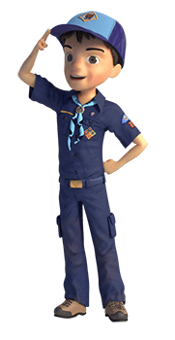

CLOSING CEREMONIES
Tools That Build a Better World Arrangement
Greater St. Louis Area Council
Each boy holds a tool as he speaks - saw, hammer, wrench, ruler, plunger, drill, and pliers. You will need seven Cub Scouts. Maybe hang tags on the tools with their parts in LARGE print
- We are the future builders of America and the world. And this is how we will shape tomorrow.
- (Hammer) I will hammer out injustice.
- (Saw) I will help cut out crime.
- (Drill) I will drill love into every heart.
- (Wrench) I will wrench out discrimination.
- (Plunger) I will plunge out hatred.
- (Pliers) I will pinch out poverty.
Cub Scouting is like Constructing a Tripod
Equipment:
- Three straight tree branches or poles, 4' to 5' long and 3' length of heavy cord OR
- Three lengths of PVC pipe and a 3 way elbow (see picture) fitting that will accept all three pieces.
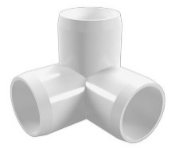
Cubmaster: (Picks up the cord or fitting) Boys and parents, this cord (fitting) represents the pack.
Cubmaster: (Picks up one branch) This pole represents you as a Cub Scout. You are all eager an anxious to be Cub Scout and do many exciting things. (Stand the branch on end and let go. (Insert PVC pipe into fitting) It will fall.):
Cubmaster: HHhhmmm, it doesn’t look like that worked. AAhh, the Cub Scout does not join the pack all alone. (He picks up second pole) He needs leaders!! This pole represents the Pack Leaders (He ties two branches together at the top (inserts second PVC pipe into fitting), stands them on the floor, but does not let go) Will these two branches stand up by themselves? (Cub Scouts reply that they will fall over- Cubmaster lets them fall).
Cubmaster: (Picks up the third branch.) HHhhmmmm. This third pole represents your parents. Let's attach it to the other two." (He does so forming a tripod.) Now it can stand. We can we see that it takes all of us--Cub Scouts, leaders, and parents-working together to make our pack go. Take away the parents, the leaders, or you Cub Scouts, and the pack will fall. Let's remember that and stand tall together!
Taps for Cub Scouts
Tim, Cubmaster, Pack 65, Haddonfield, NJ
Tune: "Taps"
I heard this when I visited Tim’s Pack and had to get the words to share with everyone CD
You can have your pack sing this after the Closing Ceremony or Cubmaster's Minute.
Sun of gold, sky of blue
Both are gone from the sight, day is through.
Do your best, then to rest,
Peace to you.

CUBMASTER’S MINUTES
Cubstruction Cubmaster’s Minute
Sam Houston Area Council
This month’s theme of Cubstruction is about building things. Anything worthwhile building takes some thoughtful planning, so that we know what materials we need, what rules we have to follow and when we need to get it done.
While you’re building something useful, you are also building your skills. So, what you had a tough time doing this time won’t be as hard the next time.
You’re not only building cool stuff, but you’re building your own personal toolbox of skills that you will carry with you for the rest of your life.
Builders
Greater St. Louis Area Council
Isn't it strange that princes and kings,
And clowns that caper in sawdust rings,
And common people like you and me,
Aare all of us builders of eternity.
To each is given a bag of tools,
A shapeless mass and a book of rules,
And each must make, ere this life is flown,
A stumbling block or a stepping stone.
Pocketknife Closing
Baltimore Area Council
Cub Scouts, I hold in my hand a pocketknife. This is a valuable tool because it can be used for many useful things. It is a dependable tool as long as the blade is kept sharp and free from rust and the working parts are in good condition.
But, if it is neglected and becomes dull and rusty, it can be a dangerous tool.
The same principle applies to us. We have a body, which when kept in good condition, will serve us well. But if we fail to take care of ourselves, we can become rusty and dull like a neglected pocketknife. Do your best to keep fit.
Block of Wood I
Baltimore Area Council
Props: Nice wooden object
Show the boys something made of wood. Point out its beauty and fine points.
The wood carver did not learn to do this overnight. It takes patience and hard work to learn how to carve well and make something beautiful. In the same way, you cannot learn to be adults over night. You are learning a little more each day to make you better Cub Scouts, Scouts and adults.
Block of Wood II
Baltimore Area Council
Props: Nice wooden object
As the wood is shaped, assembled, sanded, finished, and adorned with the final details of a fine finished piece of furniture, so our Cub Scouts grow through experiencing the many trails Cub Scouting has to offer. And soon, almost before we know it, the boy has grown and developed until he is ready to advance into the Boy Scouting program. Before our eyes, a boy has turned into a well-adjusted young man.
But a boy doesn’t become a finished product all by himself. He needs challenge and direction. Our den leaders, assistants, and other pack leaders provide this help for our boys. They help to carve and shape the future of young men.
Parents provide vital support to help put the finishing touches on their sons.
Thanks so much to all of you who have reached out to help the boys in our Pack along the way to become all they can be.

CUB GRUB
Cub Grub Cookbook
This is a really great cookbook for Cubs -
http://balboaoaks.bsa-la.org/download/blog/Cub%20Grub%20Cookbook.pdf -
You can save a copy on your PC by selecting
File, Save As... in your web browser's menu bar.
Foundation Snacks
Baltimore Area Council

Ingredients
- Graham Crackers
- Chocolate frosting
- Peanut Butter
- Chocolate chips
- Mini M&Ms
- Chopped Peanuts
Directions
  - Break graham cracker into squares
  - Spread a layer of frosting on one side of a square
  - Spread the other square with peanut butter
  - Sprinkle chocolate chips or nuts top of the peanut butter.
  - Cover with the first cracker,
  - Frosting side down.
  - Gently press together.
House-Wiches
Greater St. Louis Area Council
Cut the top of a slice of bread in a triangle shape to resemble a roof shape.
Spread cream cheese or peanut butter over the bread shape.
Add a cheese slice, cut on the diagonal (triangle), to the roof area of the bread house.
Using more cheese pieces, cucumber slices, thin carrot slices
or whatever food item you can think of, add windows, and doors to the house.
Skiing Snowman
Baltimore Area Council
Ingredients
- 3 lg. Marshmallow
- 2 toothpicks
- 3 pretzels
- Pieces of black licorice lace
- 2 flat carrot Sticks
Directions
- Stack the 3 marshmallows. to form snowman,
- Hold them together with a toothpick.
- Push 1 pretzel through top of middle marshmallow to form arms.
- To make face and buttons press licorice into marshmallows .
- Place snowman on carrot skis.
- Lean remaining pretzel sticks against snowman’s arms for ski poles.
Marshmallow and Pretzel Towers
Ingredients
1 bag large marshmallows,
1 bag small marshmallows,
1 bag thin pretzel sticks,
1 bag large pretzel sticks,
Directions
- Place all 4 ingredients in separate bowls and put them where everyone can reach.
- Write on small slips of paper different things to make out of the pretzels and marshmallows fold them and place them in another bowl. For Example: A triangle, a circle, a square, a bridge, a ladder, a car, a boat, a train and a tower.
- Pull slips out one at a time and let the boys make each item.
Graham cracker Houses
You will need:
1-box graham crackers,
pint size milk carton for each child,
a small square of cardboard covered with tinfoil for each child,
assorted candies for decorating the houses,
royal icing
Royal icing
You will need:
2 egg whites,
3 cups confectioners’ sugar,
1 1/4-teaspoon cream of tartar
Directions for House and Icing
- Beat the egg whites with the sugar and cream of tartar with an electric mixer until creamy and smooth.
- When not using cover with damp cloth to keep it from hardening.
- Frost the bottom of the empty and cleaned milk carton and ‘glue’ to the cardboard.
- Allow drying for about 5 minutes.
- Then frost each side of the carton and put on graham crackers, until all four sides are covered.
- Let stand for another 5 minutes and then break one cracker in half to use for the roof and put onto the base.
- Wait another 5 minutes and then allow the children to decorate their houses the way they would like

GAMES
Pipeline
This is a relay race
Needed for each team –
3 pieces of PVC pipe – don’t make them too long
3 PVC pipe fittings for the pipe
1 hard hat
1 pair safety goggles
1 pair work gloves
1 small ball or marble that will fit in pipe
1 bucket for race not per team
Set up –
- Divide pack into teams.
- Place pipe, fittings, hardhat, goggles, and gloves where teams are to line up
- Place bucket and ball at opposite end (or give to judge to hold)
Play
- First player puts on hardhat, goggles, and gloves. Then he picks up a piece of pipe and runs down to end of course. He places pipe on floor and goes back.
- Second player takes hardhat, gloves, and goggles and puts them on. He takes a pipe fitting and runs down to end of course. He attaches fitting to pipe and returns.
- Thirds player takes hardhat, gloves, and goggles and puts them on. He takes a piece of pipe and runs down to end of course. He attaches pipe to fitting and returns.
- This continues until last piece is placed.
- Then last player calls the team.
- The team goes to opposite end (gets ball and bucket from staff member) rolls the ball through the pipe into bucket
(I had written this originally with pouring water but figured there were too many places where you could not use water. If you use water – add a funnel to list of stuff)
- First team to roll ball through pipe into bucket is winner
Nail Driving Contest I
Baltimore Area Council
Object: To be the first team to drive nail into wood.
Materials: Scrap wood and 10-penny nails.
A hammer for each team.
- Divide the den into teams.
- In front of each boy place a hammer and a piece of scrap wood with a 10-penny nail already started a half-inch into it.
- Boys take turns hammering the nail until the head is flush with the wood.
- This is not a speed contest. Fewest strokes wins.
- If the nail is bent, start over with a new one.
Nail Driving Contest II
Alapaha Council
Divide the den into two teams. Line up the teams for a relay race about 10 feet from the driving area. Provide each team with a piece of two by four about 1 foot long, a hammer, and nails shorter than the thickness of the wood. Each boy runs to the board, drives 2 nails, runs back, and gives the hammer to the next player. The team driving the most straight nails (not the fastest) wins. Variation: Have boys switch hands.
Sawing Contest
Baltimore Area Council
Object: To be the first team to cut a 2x4 in half.
Materials: A 24-inch length of pine 2x4,.
A handsaw for each team.
- Divide the den into two teams.
- Give each team a handsaw and the 2x4.
- In turn, each boy takes one stroke with the saw until the wood is cut through.
- This is not for speed.
Stack the Bricks
Greater St. Louis Area Council
Equipment: Lots of Dixie cups (bricks)
Directions:
- Divide the den into 2 teams.
- At the other end of the hall or room is a pile of cups.
- In turn, each boy runs up and adds one cup to the tower started by the first boy.
- If it falls over the tower has to be rebuilt.
- The team with the tallest, the only, the neatest (you decide – pick one of these or choose one of your own) standing tower is the winner.
Tower of Cups
Greater St. Louis Area Council
Equipment: Lots of flat bottom plastic or foam cups
Directions: Using only one hand; see how many paper or plastic foam cups you can stack top-to- top and bottom- to-bottom before they fall.
Person who stacks the most is the winner.
Tool Box Sort Out
Baltimore Area Council
Use an egg carton for the toolbox. Have an assortment of nuts, bolts, screws, etc., to be sorted. The first boy to sort by size in the proper place wins.
Name The Tools
Baltimore Area Council
Cut different silhouettes of tools from construction paper, such as a hammer, plane, brace, bit, screw driver, etc. Glue these on light weight cardboard and use as flashcards.
Bricklayer's Relay
Greater St. Louis Area Council
Equipment: Per team: 1 hard hat; 1 dustpan; 1 flag; 3 or more 'bricks' - stones, pieces of Styrofoam, or blocks of wood.
Directions:
- Divide the group into teams.
- Have them stand in parallel straight lines at one end of the playing area.
- The leader shouts 'BUILD'.
- The first member of each team dons the hard hat,
- Places a brick in the dustpan and
- Runs down to the other end of the playing area.
- He places the brick on the ground and runs back to the starting line.
- Each team member in turn, races down to build up the wall.
- The race continues until all the bricks on each team are used up .
Long, Short, Round
Baltimore Area Council
Object: To run the relay keeping track of the location of three objects.
Materials: Each team requires two containers.
A long common tool, e.g. a wooden mallet;
a short common tool, e.g. a stubby screwdriver,
and a round object, e.g. a small disk of wood.
This is a good game to sharpen alertness if the leader keeps it moving fast.
- The teams sit down in a single file line with feet extended.
- They count off so that each Cub in the den has a number.
- At the start, the container with the objects is at the front and the empty container is at the back of the team line.
- The leader signals with his arms long or short or round,
- Then calls out a number.
- Scouts with that number race to their can, pick out the object, take it to the other container, and put it in the other container, and return to their places.
- The first Cub Scout back in place wins a point for his team.
- Keeping track of the location of the objects soon becomes a mental challenge.
- If a Cub heads for the incorrect can, he is bound to lose the point.
Log Rolling Contest
Baltimore Area Council
Make logs from 4” cardboard cylinders. This can be a relay, with each boy rolling a log with a dowel or stick to a given point and back to the next person in line.
Human Ladder Crossing:
Sam Houston Area Council
Played with one Den, this is a timed event. With two dens, it’s a relay. Sit the team down in a straight line, with their hips about a foot apart and feet pointing in the same direction. Have them spread their legs, so that their feet touch those of the guy next to them.
Starting at one end of the line, upon command, one boy on each team jumps up and runs to touch the wall and then runs back over the “ladder” made by the legs of his team. He may not step on the boys’ legs and the ladder mustn’t move. After getting across the ladder, he then touches the opposing wall and runs back across the “ladder” to take his original position. Once he sits back down in his spot, the next boy in the ladder jumps up, crosses the ladder in both directions and gets back to his spot (and so on until everyone has had a turn).
This game can be made more interesting by providing simple obstacles around the two outside edges of the hall, e.g. car tires to get through, turned gym benches to walk along, or chairs to go under.
Timber
Alapaha Council
The players form a circle facing inwards and are given a stave or walking stick each to hold upright in front of them on the ground. The leader will call a direction and a number (e.g. 2 to your left.) Each player must let go of his stave (he must not push it, simply let it go in an upright position) and move to grab the appropriate one (e.g. the second one on their left) before it hits the ground. If the stave hits the ground first, he is out. The circle closes up any gaps and continues play. Play continues until only one player is left. Variations: To make a more challenging game, call directions faster and further.
Fumble Fingers
Alapaha Council
Divide the den into two teams. Tell players to untie their shoelaces. Then tell them to put one hand behind their back, or tie one hand to their belt. On signal, each team tries to tie their shoelaces, with each player using only one hand. The first team finished is the winner.
Kick the Can:
Sam Houston Area Council
Materials: One empty #10 metal can, like for coffee or restaurant-sized canned food
This great old-time game can keep boys occupied for hours. One person is chosen to be “It”, by a fair method. He (It) then has to hide his eyes and count aloud to a pre-chosen large number, while the others all find hiding places within earshot of the can. At the end of the count, “It” announces “Ready or not, here I come!” and then tries to find out where the boys are hiding.
If he identifies someone hiding, “It” has to say “I see ‘Johnny’ (or whoever) behind the tree” and then they both run to the can. If “It” picks up the can first, then the boy that was hiding gets captured. If any hiding boy kicks the can before “It” picks up the can (even if “It” didn’t see him), then everyone previously captured goes free. Ideally, “It” stays “It” until he captures everybody.
Since it can be very frustrating to be “It,” be sure to put the can in a large open area, so that he has a better chance. Also, to avoid frustration, perhaps you can change who is “It” after successfully capturing a few boys, otherwise, with a large group it’s nearly impossible to ever capture everyone.
Dice Count
Great Salt Lake Council
Equipment: 1 die, pair of oven mitts, a chocolate bar or other wrapped treat, a hat
To Play:
- Before the game, wrap the chocolate bar in 5-6 layers of paper.
- Have the players sit in a circle and place the bar, the hat, and the mitts in front of one of the players.
- The player directly to the left of the person with the chocolate bar is given the die.
- On a signal, the person with the die starts rolling for a 6, while the other person puts on the oven mitts,
- Then the hat, and then starts to unwrap the chocolate bar.
- Once a 6 is rolled, everything is passed to the left and a new person rolls the die, and
- The previous roller tries to put on the mitts and hat and unwrap the chocolate.
- The player who completely unwraps the candy gets to eat it.
Gates, Bridges & Tunnels
Great Salt Lake Council
Equipment: Rubber chicken
To Play:
- Divide players into groups of three.
- One player in each group is the gate person,
- One is the bridge person, and
- One is the tunnel person.
- All players then form a large circle,
- The players in a group of 3 stand next to each other
- The leader stands in the middle of the circle holding the rubber chicken.
- When “Gates” is called, the gate people leave their spot in their circle and run around the outside of the circle.
- The other two players form a gate by putting their arms together.
- When the gate person gets back to his group, he goes through the gate to the center of the circle and tries to grab the chicken.
- If “Tunnels” is called, the others in the group form a tunnel, which the tunnel person must pass through to get to the center.
- If “Bridges” is called, the others must form a bridge to be crossed to reach the center of the circle.
- The first player to grab the chicken each time becomes the new leader, and the former leader takes the empty place in the circle.
Blindfold The Cook
Great Salt Lake Council
Equipment: Blindfold, wooden spoon, 2 bowls –one full of marshmallows, timer (or watch)
To Play:
- Blindfold the first player, set the bowls and spoon in front of him.
- Time the player for one minute while he tries to scoop as many marshmallows as possible into the empty bowl.
- At the end of the minute, count how many marshmallows were successfully transferred.
- Reset for each player.
- The player with the most is the Champion Scooper! (But everyone gets to eat the marshmallows!)
Crazy Drawing
Great Salt Lake Council
Equipment: Paper and pencil for each player
To Play:
- Each player begins by drawing a single line on his paper.
- It can be any kind of line - straight, jagged, curvy.
- The papers are passed to the person to the left.
- Each player adds a line to the paper that is now in front of him.
- Continue to pass and add lines until the papers have gone around the circle.
- The object is to create something recognizable.
- Once the drawing starts to take shape, each player should continue to develop the picture, one line at a time.
- Annie-Annie Over:
- Sam Houston Area Council
- It is played over a building that you can throw a bouncy ball over and be able to run all the way around it quickly. You call out “Annie-Annie Over” and throw the ball over the building to the kids on the other side. If they catch the ball without it touching the ground, they can sneak around the building and throw the ball at you or catch you and tag you. You have to keep an eye open for them coming and beat them to the other side of the building. If you make it then that is your side but if you are tagged then you are on their side.
- If the ball is not caught then they can wait a moment to try and fool you and then holler out “Annie-Annie Over” and throw the ball back. If the ball doesn't go over the building, the throwers can yell “Pigtail!”, and then try to throw it again. The ball must be caught in order to run around the building after you. When the last kid on a team is tagged then that team wins.
Human Pinball
Alapaha Council
All players except one stand in a circle, facing outwards. Players spread their legs as wide as is comfortable, until their feet are touching their neighbors’ on either side. Everyone bends down and swings his arms between his legs – these are the pinball “flippers.” The one non-flipper enters the circle as the moveable target. The flippers try to hit him by knocking a volleyball or playground ball back and forth in the circle. Whoever hits the target gets to be the new target. The target’s only job is to avoid the ball. The flippers can only hit the ball, not catch and throw it.

DEN ADVENTURES


TIGER

Tiger Adventure: Backyard Jungle

- Take a 1-foot hike. Make a list of the living things you find on your 1-foot hike.
- Point out two different kinds of birds that live in your area.
- Be helpful to plants and animals by planting a tree or other plant in your neighborhood.
- Build and hang a birdhouse.
- With your adult partner, go on a walk, and pick out two sounds you hear in your “jungle.”
Workbook for use with these requirements: PDF Format DOCX Format

Ways to Conduct a 1-Foot Hike
http://cubscoutideas.com/3887/tiger-backyard-jungle-adventure-take-a-1-foot-hike/

There are several ways you can conduct the hike.

1. Make it a Square Foot Hike – Give each boy a 4′ piece of string. Have them pick an area they like and lay out the string to form a square foot. For 10 minutes, they examine their square foot with the magnifying glass. Afterward, they can share what they found with the rest of the group.

2. Play “Do You See What I See?” – For this game, have each boy pick a partner. Partners decide on their one foot area. Have both boys stand behind a line about 10 feet away from the area they’ve chosen. Give the first boy a set amount of time (5 or 7 minutes would probably be best) to examine his area. He makes a list of everything he sees. When the time expires, he and his partner trade places. Give the partner the same amount of time to make his list. Have the boys compare lists and see who found the most things. After they compare, have both of them go back to their area to see if they can find more things working as a team.

3. Complete several 1-foot hikes during a regular hike – Since most of us hike in some kind of wooded area, the boys may be able to find things they wouldn’t if they complete the 1-foot hike in their backyards. Many hiking trails weave through different types of terrain. You may hike through a heavily wooded area, by a body of water or near an open field of wildflowers. By selecting more than one spot to have a 1-foot hike, the boys will be able to see different living things.

To add some excitement, tell the boys that they won’t know when you’ll call out for them to do a 1-foot hike. They need to be ready to quickly find the area they want to examine. Like before, give them a set amount of time to examine the area. Talk about what they found when the time is up. Continue your hike until you find another great spot for a 1-foot hike.

“Leave No Trace”

Since we want to “Leave No Trace” of our hike, the boys shouldn’t dig or disturb the surface of the ground too much. My good friend Betsy gave me several good ideas to help with that. She suggested that we find an area with lots of nooks and crannies to explore without digging. Fallen logs in the woods and grass offer lots of possibilities. Or they can look at a garden with mulch that they can gently push aside.

Betsy also shared these great ideas. We can expand the area beyond just looking at the ground. Go up the plants on your 1- foot space because there is lots to observe on a plant too–the colors, shape of the leaves, texture, bugs or other animals that might be there. The boys might also want to look for shadows. They could look for where the sun is and talk about the path it takes through the sky and how that affects what grows on the opposite sides of trees and rocks.

Recording The Findings

There are a few ways that the boys can record what they found:

Make a simple list.
Draw pictures of what they find.
Make a plot by drawing a large square on their paper and have them indicate where in the square they saw the different living things.

While a 1-foot hike doesn’t sound that exciting at first, your Cub Scouts will be amazed at what they can discover.

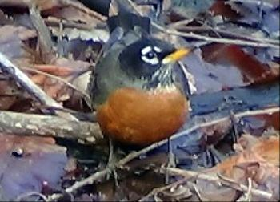

American Robins

The red breasted birds, mark the return of Spring to most folks in the northern states. One of the easiest birds to watch while they go about their nesting and feeding habits since they're in most peoples backyards.
Actually, unknown to a lot of people, these birds spend the winter in much of their breeding range. However, because they spend less time in yards and congregate more in wooded areas you may not see them as often.
During milder winters, it's more common to see them in our backyards.
These birds are often used as the standard to which other birds sizes are compared; one of the most common native birds of the East, and the largest of the Thrush Family.
Hardly a garden in North America has not been visited by this bird. Often referred to as the Red Robin.
Description
American Robins have gray upperparts and the familiar reddish breast, varying from pale rust to a dark brick red. Male and females look nearly identical. The females colors are less vibrant.
Sometimes during nesting season you'll see mud on the breast of a female, since she is the one that lines the nest with mud. The average size of this bird is 9-11 inches long.
Often, you'll see these birds hopping on lawns, meadows, and golf courses looking for earthworms. They also eat insects, fruit, and berries.

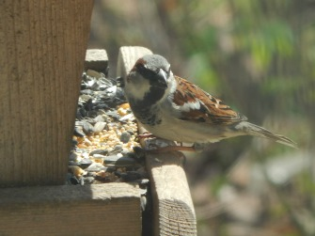

House Sparrows
may or may not be the most loved birds, they certainly are a part of our backyard bird watching experience.

Initially these birds were imported from England. Brought to the US because they were known to eat certain caterpillars that harm shade trees.
One by one, other US cities began importing them for the same purpose. In less than 50 years this small bird has a range that includes the entire U.S. and well into Canada.

Unfortunately, they didn't go after the caterpillars hoped for. While intentions were good, the outcome has been just the opposite. Our native cavity nesters have not evolved fast enough to compete with these highly competitive birds.

Their nesting, feeding, and mating habits can be observed easily due to their long multiple breeding season.

Description
House Sparrows are 5 to 6 inches in length. The male has a gray crown, whitish check, and black throat. The bill and breast are black in summer and in winter the bill is yellow and the breast is gray.
The female has a brown crown and a plain breast with a broad buff line over the eye. Be careful when identifying female House Sparrows because they may look similar to female House Finches. The female House Finch will have a stripped breast.
Although misnamed English Sparrow, and commonly known as the House Sparrow, it is not particularly a native of England and is not a sparrow. It's thought to have its origin in the Mediterranean and actually a member of the Weaver Finch family.

10 Steps to Plant a New Tree and Shrubs
http://www.homedepot.com/c/easy_steps_to_plant_new_tree_HT_PG_OD

Fall is a great time to plant trees and shrubs around your home. By planting in the cooler weather, you're allowing the plants to more easily establish the root growth they will need during the spring growing season and the hot, dry summer. It will also allow the plants to recover from the inevitable stress they experience during transplanting.

Planting a new tree is an investment that can last a lifetime. Position the tree carefully since it will be in place for years. When planting a tree, know its maximum height and spread, information that's usually on the label. Plant it far enough away from houses, outbuildings, power lines, and other permanent structures so that even when mature, the tree won't touch them. Be sure to plant your new tree far enough away from other trees so that it won't grow leaning away from the others, trying to get maximum light.

For tips and helpful information on how to properly fertilize your lawn, visit our Feeding Your Lawn and Overseeding Your Lawn project guides.

Step 1: Things to consider

Here are some things to consider before selecting which trees and shrubs to purchase:

Will the shrubs or trees I have chosen flower?
Do they bear fruit or berries?
Will they attract birds or butterflies?
Are they purely ornamental or will they drop fruit on the ground?
Will this shrub or tree keep its leaves all winter?

Step 2: Tree planting preparation

When selecting the location for your tree, make note of the sun exposure for the area throughout the day. You should also consider the plants, shrubs or trees surrounding the location and try to envision the maximum canopy and height the new tree will eventually reach.

Will it brush up against your house? Are there overhead obstructions such as wires or eaves? What current plants and shrubs will be cast in shade once the tree reaches full height? These are all questions you should ask yourself before heading off to The Home Depot Garden Center. There you will find labeling on the plants and trees indicating their sun needs and expected size at maturity.

This will help you avoid the need to retransplant the tree later because it has outgrown it's space.

Step 3: Location selection

Once you have selected a tree, it’s time to dig the hole. Begin by measuring the tree’s root ball. A common mistake made while planting a tree is to dig the hole too deep and not wide enough.

The hole should be dug at least three times the diameter of the root ball of the tree and no deeper than its root ball. This large diameter of loosened soil will allow the roots to spread and grow more easily.

It’s best to place the soil on a tarp or in a wheelbarrow to avoid killing any surrounding grass and to make back filling the hole easier.

Step 4: Dig the hole

If you’re digging in soil with a high clay content, check the walls and base for glazing. This glazing will form a barrier that blocks water from seeping in. It can also make it more difficult for the roots to spread and grow into the surrounding native soil. Use a gardening tool such as a fork to scratch a few inches deep and break it up.

Dig a slightly deeper ring around the outer edges of the hole, leaving a higher ridge of compacted soil in the center. This will allow the root ball to rest on a pedestal of sorts and keep water from pooling at the base of the root ball.

You want the root ball moist but not soaking in water as this could lead to root rot.

Step 5: Prepare the tree

If the tree you selected comes in a bucket, you’ll need to remove it and gently loosen the root ball with a shovel or by hand. The roots can become pot-bound and will continue to grow in a circular pattern if they aren’t loosened first.

If your tree comes in a burlap wrap, remove any string or twine that may be present. Then cut away the burlap surrounding the roots. If it’s natural burlap, it can be peeled back from the root ball and remain. If it’s a synthetic or plastic burlap it must be removed entirely.

Step 6: Plant the tree

Trees should always be lifted by the root ball, never by the trunk. Lower the tree into the hole and place it on top of the raised center section. Lay the handle of your shovel across the hole to check that the crown of the root ball is level with the surrounding ground.

If the root ball is below the surrounding ground, remove the tree and add more soil. If it’s too high, remove more soil from the hole. It’s best in most regions to not amend the soil. Allow the root system to adjust to the native soil around it and spread.

If your soil is sandy and fast draining, add some peat moss to the excavated soil. Use that mix of native soil and peat to backfill the hole. The peat will act as a sponge and absorb water, keeping it at the level of the root structure.

Step 7: Backfill the hole

Backfill the hole just to the height of the ball or slightly lower to allow for settling. Don’t mound the dirt over the ball and up the trunk, it will prevent air from reaching the roots.

Be careful not to compress the soil too much or it will prevent water from reaching the deeper parts of the root ball. Mound dirt around the tree to form a moat that will help collect water.

Spread two inches of bark or wood chip mulch around the area to help retain water and control weeds. It’s very important that no mulch be touching the trunk of your new tree. Clear mulch back away from the base of the trunk. This will allow enough clear surface area for water, air and light to penetrate the soil.

Step 8: Water and maintain the tree

It’s critical in the early development of the root system to keep the soil moist. Newly planted trees should be watered at the time of planting and you should water it at least once per week during its first growing season. Water it more often during the height of summer as rainfall dictates.

Avoid over watering the tree because it will reduce the oxygen flow to the root system. It’s best to give the tree deep soakings rather than frequent, light waterings. Getting the moisture down deep in the root system will encourage deep root growth.

Soaker hoses work well for deep watering. They release small amounts of water and can be left on for several hours.

Step 9: Planting shrubs

As with tree planting, you should make note of the sun exposure for your planned area. Also note the distance to any surrounding shrubs and flowers. This way, you won’t plant a shrub that will soon crowd out those around it or struggle due to too much or too little sun.

The hole should be dug as deep as the root ball and two or three times as wide. If the roots of the shrub have become pot-bound, loosen the root ball by hand or with a shovel. This will encourage the feeder roots to grow beyond the root ball and help establish the plant sooner.

After digging the hole, place the shrub and again check that the base of the trunk is even with the surrounding ground. Create a moat of soil around the drip line of the plant to allow water to collect around the shrub. The drip line is the distance to the outermost branches. Spread two inches of mulch or pine straw around the shrub, but away from the base of the trunk.

Step 10: Maintaining shrubs

Once planted, give the shrub a long, generous soaking. Repeat the deep watering two or three times per week until the shrub is established.

To help relieve the stress of the transplant, you can apply a plant starter solution to both shrubs and trees immediately after planting. This will help relax the roots and promote growth. Read the product directions for proper application instruction

Flip the Bird Tag
http://scoutermom.com/cubscout/tiger-adventure-backyard-jungle/

This is an active game which is a combination of tag and keep away. In it, a players work together to keep their friends from being tagged. “Flip the Bird” is the traditional name for this game, but if you think it will cause too much of a stir, you can just call it “Bird Tag”.

Materials

You need something to be the “bird”. This can be a rubber chicken, a towel with a knot tied in the middle, a ball, etc. Use your imagination.

Instructions

Choose somebody to be “It”.
Define the boundaries of the play area.
Give the “bird” to somebody who is not it.
“It” tries to tag the other players. “It” can tag anyone except the person currently in possession of the “bird”.
The players work together, throwing the “bird” to the person being chased to prevent “it” from tagging them.
When somebody is tagged, they must sit on the side of the play area.
Last person not to be tagged wins. Hr or she gets to be “It” for the next round

Notes

This game is meant to teach teamwork. However with younger children, some might not want to throw the bird. If this is the case, make the rule that nobody can keep the bird for more than the count of three.

Another option is to have multiple birds and only the people with the birds can be tagged. Know your group and adjust the rules as necessary.

Gourd Birdhouse
http://scoutermom.com/cubscout/tiger-adventure-backyard-jungle/

I dried some gourds we grew, so we can make gourd birdhouses. If you didn’t grow any yourself, you can probably find some in your area at a farmer’s market or even a craft shop.

Because of the number of steps involved and the drying time required between paintings, we will probably start these at a meeting and then they can take them home to paint them. I’m also planning on having them already soaking when the meeting starts. Kids and a 10 percent bleach solution are not a good combination, so they can start at the point where they scrub the gourds with the soapy water.
Gourd Birdhouse

Depending on age and maturity, some of these steps might have to be done by an adult.

Materials:

Dried gourd – “bottle gourd”
bleach solution – one-part bleach and nine parts water
Steel wool
bucket with soapy water
Old towel to dry the gourd
Utility knife
Spoon
Hand drill
Enamel paint or shellac or polyurethane
Paint brush

Directions

Soak the gourd in a bleach solution for 15 minutes. (This might be done by an adult rather than a youth.)
Dry the gourd with the towel.
Immediately clean the outside of the gourd using the steel wool and the soapy water.
Dry the gourd again with the towel.
With the knife, cut a 1 ½ inch diameter hole in the gourd, slightly above the halfway point on the “fat” part of the gourd. (This might also need to be done by an adult.)
Use the spoon to remove any seeds or pith in the gourd.
Drill a few holes in the bottom, for drainage.
Drill two holes at the top of the gourd. Later you will feed the wire through these to make a hanger for the gourd..
Coat the gourd with at least two coats of paint, shellac, or polyurethane, letting it dry 24 hours between applications.
Feed a length of wire through the holes.
Twist the ends of the wire together to form a hanger.
Hang out on a tree and wait for some birds to move in.

Notes

The dried gourds might have some mold spots on them. This happens during the drying process. They can still be used.

You might need to redrill the holes a little after painting.

USE CAUTION WITH THE BLEACH AND THE UTILITY KNIFE!

Cub Scouts Birdhouse Plans
http://cubscoutideas.com/3915/cub-scouts-birdhouse-plans/#more-3915

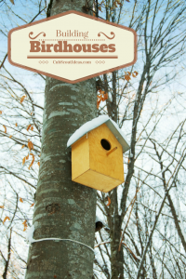
1. Precut a board for each boy following the first diagram.
2. Drill the entrance hole about 2 ½” from the top of the front piece. The hole should be about 1 ½” in diameter. Make sure the hole is centered on the board. Unless you have a manual hand drill and a lot of time for the boys to crank the drill, you’ll probably want to predrill the hole.
3. Attach the front to the sides by using the 1 5/8” deck screws. You might want to predrill holes in the front piece to make it easier for the boys.
4. Attach the back to the sides with the 2” finishing nails. The holes for the nails can also be predrilled.
5. Cut about ½” off each corner of the floor for drainage.
6. Attach the floor about ¼” up from the bottom of the house on the sides and back with the 2” finishing nails. Don’t nail the floor from the front because you won’t be able to open it for cleaning.
7. Attach the roof to the sides with 1-5/8-inch deck screws.
8. Hang your birdhouse outside, and watch for the new occupants to settle in!
Yours in Scouting,
Sherry
DIY Supply List:
5 feet of 1- x 6-inch board cut into the following pieces (see diagram below):
2 – 10” pieces
1 – 7 ¾” pieces
2 – angled pieces 10″ on one side & 8″ on the other
1 – 4” piece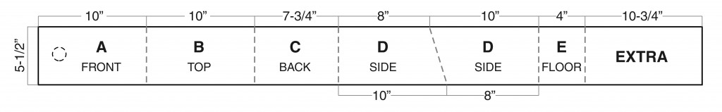 You’ll also need
1 5/8-inch galvanized deck screws
2-inch galvanized finishing nails
Fine sandpaper
Wood glue
Building Instructions:
Assemble the birdhouse as shown in this drawing. Step-by-step instructions are below.
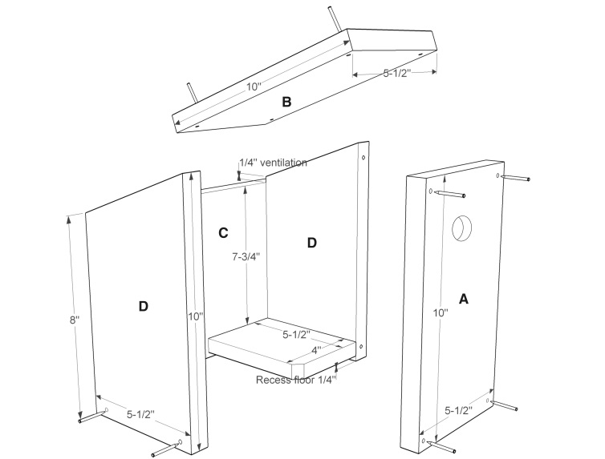
1. Precut a board for each boy following the first diagram.
2. Drill the entrance hole about 2 ½” from the top of the front piece. The hole should be about 1 ½” in diameter. Make sure the hole is centered on the board. Unless you have a manual hand drill and a lot of time for the boys to crank the drill, you’ll probably want to predrill the hole.
3. Attach the front to the sides by using the 1 5/8” deck screws. You might want to predrill holes in the front piece to make it easier for the boys.
4. Attach the back to the sides with the 2” finishing nails. The holes for the nails can also be predrilled.
5. Cut about ½” off each corner of the floor for drainage.
6. Attach the floor about ¼” up from the bottom of the house on the sides and back with the 2” finishing nails. Don’t nail the floor from the front because you won’t be able to open it for cleaning.
7. Attach the roof to the sides with 1-5/8-inch deck screws.
8. Hang your birdhouse outside, and watch for the new occupants to settle in!
Yours in Scouting,
Sherry

Tiger Elective Adventure: Floats and Boats

- Identify five different types of boats.
- Build a boat from recycled materials, and float it on the water.
- With your den, say the SCOUT water safety chant.
- Play the buddy game with your den.
- Show that you can put on and fasten a life jacket the correct way.
- Show how to safely help someone who needs assistance in the water, without having to enter the water yourself.
- Show how to enter the water safely, blow your breath out under the water, and do a prone glide.
Workbook for use with these requirements: PDF Format DOCX Format

Types of boats
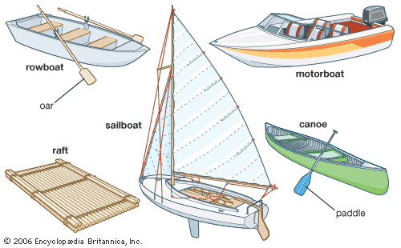
Five common types of boats are the rowboat, the sailboat, the motorboat, the raft, and the canoe.
Encyclopædia Britannica, Inc.

How to Make a Floating Toy Boat
by Chelsea Fitzgerald
http://crafts.creativebug.com/make-floating-toy-boat-1683.html

Making a floating toy boat is an interesting way to recycle products in your home and to create a toy that will delight any small child. Kids love to play with toy boats in bathtubs, mud puddles and any small body of water. The entire family can join in the fun and design fleets of boats to race and perform in friendly competitions. You can even let your dolls or action figures float in the boat and act as a ship captain and crew.

Things You'll Need
- Two empty plastic soda or water bottles with lids
- Permanent markers (optional)
- Large rubber bands
- Colored plastic tape or any tape
- Craft knife
Remove the plastic labels from the soda or water bottles. Wash the bottles to ensure that they are clean. Make sure that the lids are tightly screwed on to each bottle.
Decorate the boat. Use permanent markers to color designs on the boat and give your water craft a name.
Wrap the rubber bands around the two bottles. This is to hold them together temporarily while you wrap them with tape.
Wind colored plastic tape around the two bottles so that they form a boat. You should do this at each end. If you don’t have colored plastic tape, almost any tape will work except for masking or painters tape.
Cut into the top of the plastic bottles by using a craft knife. Create oval openings so that an action figure, doll or other waterproof creature can sit with their legs inside the boat like in a kayak.
Place the action figures into the oval seat openings so that they are sitting with their legs extended. Now your boat is ready to float across the water.
- You can skip cutting out a hole in the plastic bottles and instead glue a sturdy piece of cardboard, plastic or lightweight wood to the top of the boat. It should be approximately 4- by 4- inches. You can add small figures to the raft-like structure to serve as a crew on your boat.
- Always use caution when children play near water.

The Water Safety Chant:
S is “Someone’s Watching” never swim alone!
C is “Check the Rules” know where you can roam!
O is “Only Buddies” should go from the shore
U is “Know what U can do” Don’t do any more!
T is “Tell a grown-up” If someone’s in need!
SCOUT shows safety now you take the lead!

Buddy Tag Game

This Game is meant for Cub Scouts.
Required:
Need at least 12 scouts, the more the better
Instructions:
All players except for two form into buddy pairs and link one arm. Pairs spread out over area. There is one player as 'It' and one player being chased - the 'runner'.
The 'runner' may run up beside any buddy team and link his arm with one free arm of a buddy. This makes 3 scouts together which is not allowed. So, the member of the buddy team that the 'runner' did not link arms with is now the 'runner'.
'It' can tag the 'runner' at any point. As soon as he is tagged, he is 'It' and 'It' is now the 'runner'.
Usually, the tag is made when someone does not realize a 3rd has joined his team. Be careful about one scout being 'It' for too long. Change the game by having 2 Its and Runners at the same time.

Make Sure the Life Jacket is Properly Fastened
Once you choose your life jacket and try it on, make sure it is fastened properly. Some children's life jackets have straps that go underneath the person for added stability. Tighten all straps firmly; they should not be loose.

How to Save an Active Drowning Victim
http://www.wikihow.com/Save-an-Active-Drowning-Victim

Determine whether the person is drowning. Drowning victims may not thrash their arms and splash around in the water; in fact, they tend to be quiet, making the situation all that much more dangerous. Look for the following signs that someone is in need of immediate help:
- The person is not making forward progress, but is bobbing vertically in the water.
- The person's head goes from being submerged in the water to only briefly coming out before going under again.
- The person is unable to call for help. Someone who looks as though they're having trouble, but isn't yelling for help, may not have enough oxygen to call out.
- The person is floating face-down. This would not be considered an active drowning victim, but a passive one; when someone is unconscious, a different rescue method is required. In this case, call emergency services immediately.
Shout for help. No matter your experience or training, having others assist you is a good idea. Yell to others that someone is drowning. If the drowning victim seems to be unconscious, have someone call emergency services immediately. CPR and other drowning first aid may be necessary.
Decide which rescue method to use. Remain calm and figure out how you can best rescue the person in need. This is based on where the person is located and what type of body of water he or she is in.
- Is the victim near the edge of a pool, pier or dock? If a person is close enough to grab an arm, leg, paddle, shirt, or other similar item, perform a reaching assist.
- If you have one available, a shepherd's crook can reach someone beyond the range of a reaching assist in a pool or lake.
- Use a ring buoy or other easy to throw rescue device to reach a victim further away from the shore; this is also used in an ocean rescue.
- Dive into the water and swim to the victim as a last resort, when the victim is out of reach.
Proceed with the rescue. Stay calm and focused. People who panic are more likely to make mistakes and may also stress out the victim. Call to the victim that you're coming to his or her aid.
Lie face down on the edge of the pool or dock. Spread your legs to maintain a stable position. Do not extend yourself beyond a strong position of good balance; if you lean over too far, you'll fall into the water.
- This type of rescue is only helpful if the drowning victim is within reach of the edge of the pool.
- Do not attempt to perform a reaching assist while standing. This puts you in a precarious position, and you'll likely fall into the water.
- Grab an object you can use to extend your reach if the person is a little too far for your arm to reach. Almost anything that can add a few feet to your reach can help; a boat paddle or a rope are also effective if the person is able to grab them.
Reach toward the victim and hold out your hand. Inch as far over the water as you can while maintaining a good hold on the solid edge of the pool or dock. You want to reach out your dominant hand, since you'll by using your strength to pull the victim to safety.
Call to the person to grab your wrist. Repeat yourself until the victim hears you. Since he or she will be panicked, it may take a few moments for your words to register. Make yourself heard by speaking in a voice that is loud and clear.
- Don't scream at the victim or sound too agitated when you call to him or her. This could increase the victim's panic, making it more difficult for the rescue to work effectively.
- Make sure you tell the person to grab your wrist, and not your hand or fingers, since you could accidentally let go of the victim.
Grab the person's wrist and pull him or her to safety. For the strongest possible hold, You should both be grabbing each other's wrists. Pull the person safely out of the water and gently help him or her get onto dry ground.
Locate the shepherd's crook. This is a long metal pole with a hook on the end that can be used either as a handle for the victim to grab, or as a device to wrap around the victim in the event that the victim is unable to hold onto it himself. Many pools and outdoor swimming areas are stocked with this tool.
Tell people to back away. Warn other people on the deck to stand away from the end of the stick in case it hits them. You don't want them to interfere with the rescue.
Stand slightly away from the edge of the deck. Brace your feet in case the victim pulls on the pole. Be sure you're far enough back that you don't risk getting pulled into the water.
Hold the hook where the drowning person can reach it. Call to him or her loudly to grab the hook. If the person is unable to grab it, dip the hooked part further into the water and wrap it around the person's torso, just below his or her armpits. Make sure the hook is not near the person's neck, since this could lead to injury. Aim carefully as it is often difficult to see.
Pull the person to safely. Slowly and carefully pull the victim to the side until he or she is close enough for you to use a reaching assist to pull him to the wall.
Gather the ring buoy (also called a life ring) and the rope. These can be found at lifeguard stations at pools and outdoor swimming areas. Boats are also equipped with ring buoys, so use this rescue if the incident occurs while you're out in the middle of a body of water.
Loosely coil the rope in your non-throwing hand. Step on the end of the rope so that you do not accidentally throw the ring away.
Use an underhand motion to throw the ring. Allowing the rope to uncoil freely from your non-throwing hand.
- Aim near the victim, but try not to strike him directly.
- A good goal is to throw the ring just past the victim, then pull it to him or her with the rope.
Pull the victim to shore once he or she has been reached.
Dive in with a buoy. Do not attempt a swimming rescue without a buoy on hand; a drowning victim's first reaction will be to climb on top of you, so you'll need a flotation device to keep both of you safe and perform the rescue effectively.
- Do not attempt this rescue unless you are a very strong swimmer.
This rescue should be used as a last resort when the victim is drowning in an ocean or lake that is out of reach from the shore.
If you don't have a buoy, go in with a t-shirt or towel that the victim can grab onto.
Swim to the victim. Use the freestyle stroke to quickly get to the drowning person. Use proper ocean swimming techniques to avoid getting tossed back in a wave.
Toss the buoy or rope for the person to grab. Shout to him or her to grab hold. Remember not to swim right up to the victim, since he or she is likely to push you under the water.
Swim back to shore. Move in a straight line back to shore, towing the person behind you. Check back every few paces to make sure he or she is still holding the buoy or rope. Continue swimming until you make it safely back to shore, then exit the water.



WOLF

Wolf Adventure: Council Fire

- Participate in a flag ceremony, and learn how to properly care for and fold the flag.
- Work with your den to develop a den duty chart, and perform these tasks for one month.
- Do the following:
  - Learn about the changes in your community, and create a project to show your den how the community has changed.
  - Select one issue in your community, and present to your den your ideas for a solution to the problem.
- Do the following:
  - Attend the pack committee leaders' meeting. Present ideas to the pack committee regarding your service project.
  - Work together on a community service project.
- Talk to a military veteran, law enforcement officer, member of the fire department, or someone else who works for the community. Talk about his or her service to the community. After you have visited with the individual, write a short thank-you note.
- Do the following:
  - Learn about the three R's of recycling: reduce, reuse, and recycle. Discover a way to do each of these at home, at school, or in your community.
  - Make your own recycling center, or contribute to an existing one.
  - Create a den project from recyclables for a pack meeting.
Workbook for use with these requirements: PDF Format DOCX Format
https://cubscouts.org/library/council-fire/
The outing in this adventure is not a den meeting. Instead, the den will be attending a pack committee leaders’ meeting so the boys can observe the process and present their ideas for a service project.
Alert the committee to include the presentation on their agenda. The committee may also ask the den to conduct either an opening or a closing for the meeting. This should be considered when practicing for the presentation.
Once the committee has approved the project, the den can put it into action. The den will need to make separate arrangements for completion of the project based on the specific type of project selected.
Invite a military veteran, member of the fire department, police officer, or community service worker to talk to the den (requirement 5) during Meeting 2. Also, make arrangements well in advance for shipping the military care packages the Scouts will assemble at that meeting. For assistance, contact a local military base, National Guard station, USO office, or American Legion post. The office you contact may be able to suggest items for the packages.

Things Change (Requirement 3a)
Give each Scout a sheet of poster board and some of the neighborhood photos to build a small collage showing changes in their community through the years.

Presentation to Pack Committee
Practice presenting the service project the den has selected to the pack committee leaders. You could offer a skit written by the boys, a digital slide presentation, or a simple oral proposal.

Water Field
- Play this team-building game. (Remember that Scouting is a safe haven for everybody; no one should be forced to play a game if he doesn’t feel physically or emotionally comfortable with it.)
- Divide the Scouts into two teams. One at a time, a boy from each team walks across a “water field” (water balloons scattered around the backyard or a grassy area) with his eyes closed or wearing a blindfold. The team to get the most players across the field without getting wet wins. Other players can direct their teammates by shouting instructions to avoid the water (e.g., “two steps to the right”). Note: Before playing this game, make sure there are no latex allergies in the den.

Den Yell
Share the three “R’s” of recycling—reduce, reuse, and recycle—and have the boys create a den yell using those three words. Two examples: “We don’t want to lose. So recycle, reduce, reuse!” “Help our earth not get the blues. Recycle, reduce, reuse!”

Military or Community Service Member Visit
- Introduce the visitor to the den.
- Discuss the role of the military in defending our country. Mention each branch of the U.S. services:
— Air Force (protecting our country from the air, usually from bases on land)
— Army (occupational infantry forces that move in after the assault forces)
— Coast Guard (protecting U.S. coasts)
— Marines (mobile assault infantry)
— Navy (protecting our country from the ocean or the air, usually based on ships)
- Guide the Scouts in asking questions related to the ways that community service workers such as your visitor help those in their communities.
- Present the visitor with the prepared thank-you card from the Scouts.

Recycled Art Project IMAGEN
- Have the boys create a project using the items they brought from home. This can be a picture, sculpture, or something that has moving parts. When they finish, they can name the project.
- Make sure that none of the objects brought in by the boys are hazardous or unsanitary, and remind them that the completed project will be displayed at the next pack meeting, so it must be easy to transport.

Perpetual Motion
- Play this team-building game. (Remember that Scouting is a safe haven for everybody; no one should be forced to play a game if he doesn’t feel physically or emotionally comfortable with it.)
- Scouts sit in a circle on a large playing area with a smooth surface. Give each Scout a number, and put a flying disc or pie tin in the center of the circle. The first player walks to the disc, turns it on its edge and spins it like a coin. Returning to sit, he calls out the number of another player who must reach the disc before it stops spinning, give it another spin, and call another player’s number before sitting down. The object of the game is to keep the disc spinning as long as possible.

Community Service Proposal Presentation
- As prepared, have Scouts present ideas and materials in support of their selected community service project to the committee. Scouts should be prepared to answer questions about their choice and how they will carry out the project.

Tug of War
- Play this team-building game. (Remember that Scouting is a safe haven for everybody; no one should be forced to play a game if he doesn’t feel physically or emotionally comfortable with it.)
- Place the long rope in the center of the playing field and divide the boys into two teams, standing single file on either end of the rope. On the “Go” signal, each team tries to pull the other across a center line. After one team wins, have the Scouts play again without looking at each other as they pull. Does this change make a difference in the outcome and how they work together as teams?

Ideas for Adventure Requirements:
http://www.boyscouttrail.com/cub-scouts/wolf-council-fire-adventure.php

- The key concept to get across when handling the flag is to show respect. There are multitudes of ceremonies available, but few 'rules' regarding the U.S. flag.
- Use Wolf Den Job Chart
- Changes can be good or bad. Some changes can use encouragement while others need correction. Each scout should come up with his own project idea, but the entire den should choose a single project to present to the pack committee.
- This project can take a few months from first idea to completion. Communicate with the committee chair to arrange a time for the den to visit and present their project idea. - this may take a couple of months lead time. Then, the actual planning and execution of the project will take even longer.
- Invite a community servant to your den meeting or arrange a den visit to his/her place of work. Other roles include park ranger, government official, paramedic, or food shelf manager.
- At your pack leader meetings, remember to discuss what projects, skits, songs, ... each den plans to bring to upcoming pack meetings so the CUbmaster is aware.
Den Meeting Ideas for Council Fire Adventure:
- Try some of these flag ceremonies: #1, #2, #3, #4.
- Review U.S. flag knowledge with the Flag Test.
- Consider doing a Flag Retirement project.
- Sing Grand Old Flag song.
- Tell Ragged Old Flag minute, or watch the video.
- Sing the litter, trash, and pollution verses of I've Been Working On the Railroad song.
- Find Project Ideas or get ideas from Recent Eagle projects.
- Play some Conservation games.
- If you have a police officer with a good sense of humor visit your den meeting, s/he might enjoy this skit or this one. If it's a firefighter, you might share this joke.
- Tell Disneyland Garbage minute to the den.
- Play Newspaper Basketball game.
- Perform Talking Trash skit

Den Job Chart
http://scoutermom.com/cubscout/wolf-adventure-council-fire/

Cub Scouts love to help out at den meetings! A den job chart will help you spread the jobs around. Ideally each member of your den would have at least one job at every meeting.

Wolf Elective Adventure: Code of the Wolf

- Do one of the following:
  - With the members of your den or family, make a game with simple materials that requires math to keep score.
  - Play a game of “Go Fish for 10s.”
  - Do five activities at home, at school, or in your den that use mathematics, and then explain to your den how you used everyday math.
  - Make a rekenrek with two rows, and show Akela how you would represent the numbers 4, 6, 9, and 14.
  - Make a rain gauge or some other measuring device, and use it.
- Do one of the following:
  - With other members of your den or family, identify three different types of shapes that you see in nature.
  - With other members of your den or family, identify two shapes you can see in the construction of bridges.
  - Select a single shape or figure. Observe the world around you for at least a week, and write down where you see this shape or figure and how it is used.
- Do one of the following:
  - With your den, find something that comes with many small, colored items in one package. Count the number of items of each color in your package. Keep track of each color. Then:
    - Draw a graph showing the number of items of each color.
    - Determine what the most common color is.
    - Compare your results to the other boys'.
    - Predict how many items of each color you will find in one more package.
    - Decide if your prediction was close.
  - With your den or family, measure the height of everyone in the group and see who takes more steps to walk 100 feet.
  - Have each member in your den shoot a basketball. Count the number of shots it takes to make five baskets. Graph the number of shots it takes for each boy using 5, 6–10, 11–15, 16–20, or more than 20.
- Do one of the following:
  - Use a secret code using numbers to send a message to one of your den members or your den leader. Have that person send a message back to you. Be sure you both use the same code numbers.
  - Send a message to another member of your den or your den leader using the pig pen code or another code that changes letters into special shapes.
  - Practice using a code stick to create and decode a message.
Workbook for use with these requirements: PDF Format DOCX Format

5 SECRET CODES FOR KIDS
http://kidsactivitiesblog.com/27282/secret-codes-to-write-a-coded-letter#_a5y_p=825806

1. Reverse the Words
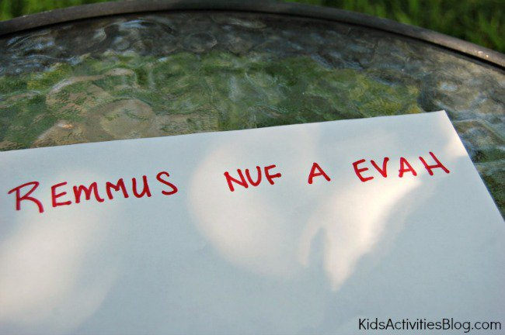
This is a simple code to solve – just read the words backwards! Even though it seems simple once you know the secret, it can be a hard one to figure out when you don’t.
2. Half-Reversed Alphabet
Write out the letters from A to M then write the letters from N to Z directly below them.
3. Block Cipher
Write the message in a rectangular block, one row at a time (we used 5 letters in each row). Then writes down the letters as they appear in the columns.
4. Read Every Second Letter
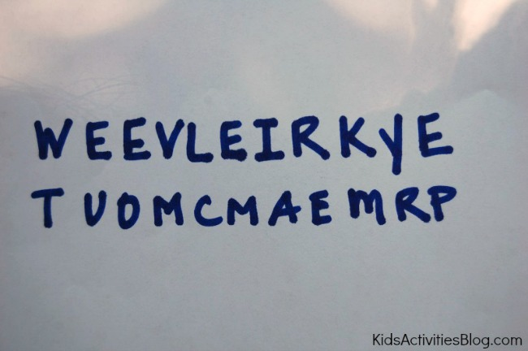
Read every second letter starting at the first letter, and when you finish, start again on the letters you missed.
5. Pig Pen
The Pig Pen code is easier than it looks and is my children’s favorite. First, draw out the two grids below and fill in the letters:
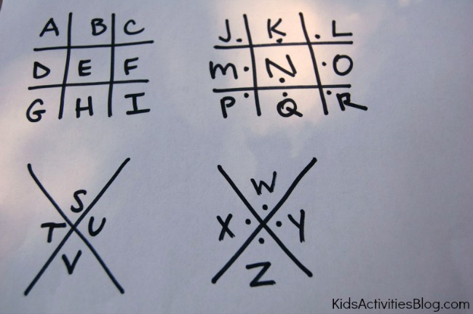
Each letter is represented by the lines around it (or pigpen).
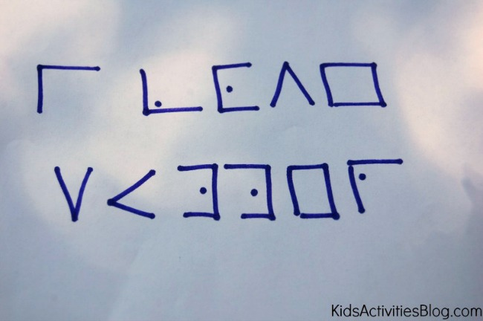

WRITE A CODED LETTER
We practiced writing our names and silly words before moving to coding whole sentences.
The letters and messages you can write can be fun, but make sure you send along a key so the recipient can figure it all out!

MAKE A SPY DECODER
http://frugalfun4boys.com/2014/04/15/code-activity-kids-make-spy-decoder/

Aidan (age 10) really enjoys secret codes, and we were thrilled to find this idea on Spoonful for making a spy decoder! The fun part about this decoder is that it provides 27 different codes, making it difficult for someone to crack. If you make two identical decoders, siblings or friends can send encrypted messages to each other.
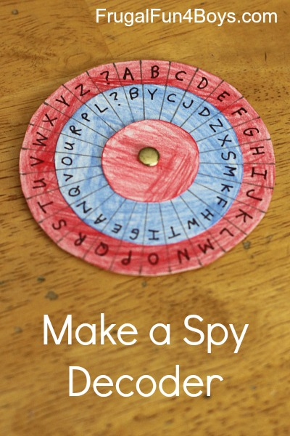
To make a decoder, you will need:
- Posterboard
- Colored pencils
- Scissors
- A compass
- A pencil
- A ruler
- A paper fastener
- A fine tip Sharpie marker
Step 1: Cut out three circles per decoder out of posterboard. You will need one that is 3.25 inches in diameter, one that is 2.5 inches in diameter, and one that is 1.5 inches in diameter.
Note: The size of the circles is very important! If you change the size of the decoder, you will have to change the measurements for marking off the letter sections, which involves higher level math than I felt like using…
Step 2: Color your circles with colored penciles, if desired.
Step 3: On the largest circle, make small pencil marks 3/8″ apart on the outside edge. You should end up with 27 sections.
Detail is important in this step! This was where we got into trouble. We were trying to make three identical decoders. I had 28 sections on my first try, and Aidan had 24. Obviously, those two decoders were not going to be compatible! We figured out what we were doing differently, and we decided that I would make all of the outside pieces so that they would be the same. We had to start over on the large circles, and I made 3 with exactly 27 sections each.
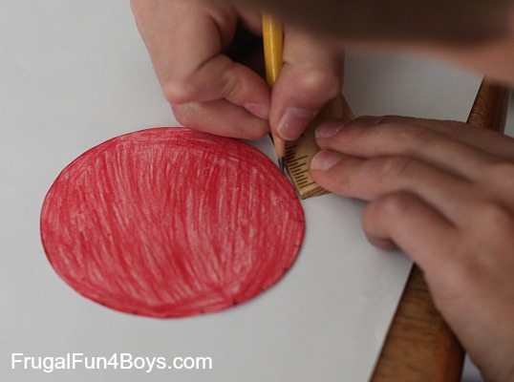
Step 4: Poke a hole through the center of the largest circle and the middle circle. Attach them with the paper fastener. The best way to find the middle of the circle is to use the compass.
Then, use the ruler to draw a straight line from the paper fastener to each edge mark. Again, detail is important. You really want each of the sections to be equal in size, or your decoder will be difficult to use.
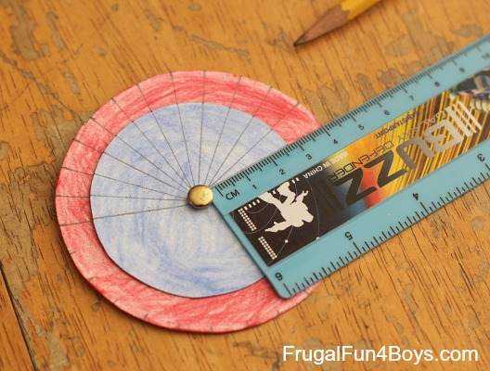
Step 5: Write the alphabet on the outside circle and put a ? in the 27th section. For the middle circle, you can either write the alphabet in order or mix it up. Aidan wanted a random alphabet in the middle circle – I think it made it feel more secret!
Then add the smallest circle to the decoder.
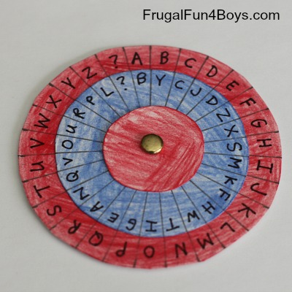
To write a message:
First, set the code. The post on Spoonful suggests setting the decoder where the “A” on the outside circle matches the first letter of the day of the week. Aidan wasn’t wild about that idea. We thought of sending a “code word” along with each message and setting the decoder where “A” on the red circle matches the first letter of the code word. Or, come up with your own system!
To write a message, find the letter you want on the outside (red) circle and write down the corresponding letter on the middle (blue) circle.
To read a message, find the letter on the middle (blue) circle, and write down the corresponding letter from the outside (red) circle.
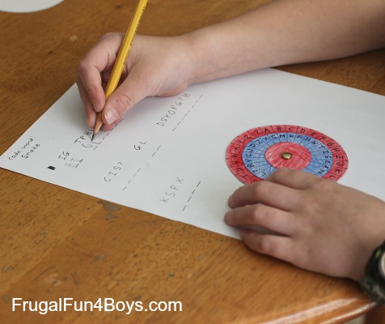

The post on Spoonful has additional directions for making the decoder into something that can be worn around your neck – kind of fun if you want to add that step!
The Thomas Jefferson Cipher Wheel – Here’s an interesting tidbit from history… Thomas Jefferson created a cipher wheel which was used to send encrypted messages in a similar way. The wheel was made from 36 discs on an axle that could be turned to spell out a message. To encrypt the message, the sender would copy down any other row from the cipher wheel other than the intended message (which would appear to be nonsense). The receiver would line up the discs on his (identical) cipher wheel so that they matched the nonsense message and then turn the cipher wheel until they saw a row with the hidden message. Click here to read more about the Jefferson Cipher Wheel – it’s quite interesting! You can also purchase a replica (that really works) from monticello.org.

HOMEMADE RAIN GAUGE
http://theimaginationtree.com/2012/04/homemade-rain-gauge.html

Here’s how to make a really simple rain gauge using recycled materials, for some rainy day fun! There are plenty of opportunities for learning about measuring, number recognition, capacity and weather along the way too!


We have had the most incredible, persistent rainfall for the past 10 days here in the Southern UK, and it has inhibited a lot of our outdoor play ideas. But then I came up with a really easy way to embrace the rain and throw in a bit of playful learning too, by measuring the rainfall!
All you need is an empty plastic bottle, the larger the better!

I cut around the body of the bottle, about 5cm down from the top. We simply turned it upside-down and placed it inside the bottle, making sure it was pushed down and flush with the edges.
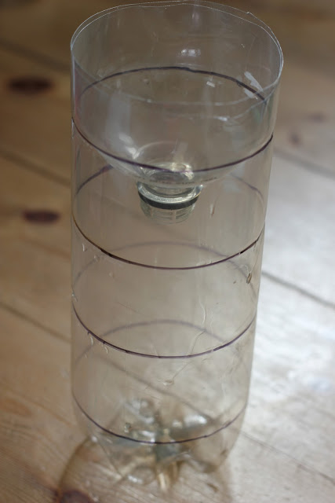
Our bottle had grooves on it already and I just drew around them using a permanent marker. Just make sure your lines are at regular intervals, ready for measuring! Cakie got her ruler and held it up to the lines I had drawn, making a good attempt to read the numbers back. I wrote on the measurements in centimetres.
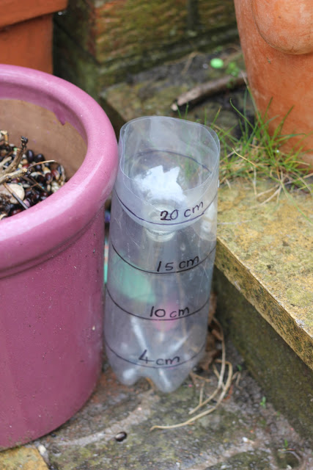
24 hours later, Cakie rushed out to check out the water level in her rain gauge and it was already up to our first marker level of 4cm!!
The rain continues to fall and we are checking every day. The level is rising by at least 2-4cm per day…wow!
With older children I would consider making a line graph to chart the increase in rain and investigate the average monthly rainfall in Britain compared to the rest of the world.



BEAR

Bear Adventure: Fur, Feathers, and Ferns

- While hiking or walking for one mile, identify six signs that any mammals, birds, insects, reptiles, or plants are living nearby the place where you choose to hike.
- Name one animal that has become extinct in the last 100 years and one animal that is currently endangered Explain what caused their declines.
- Visit one of the following: zoo, wildlife refuge, nature center, aviary, game preserve, local conservation area, wildlife rescue group, or fish hatchery. Describe what you learned during your visit.
- Observe wildlife from a distance. Describe what you saw.
- Use a magnifying glass to examine plants more closely. Describe what you saw through the magnifying glass that you could not see without it.
- Learn about composting and how vegetable waste can be turned into fertilizer for plants.
- Plant a vegetable or herb garden.
Workbook for use with these requirements: PDF Format DOCX Format

Flip the Bird Tag
http://scoutermom.com/16586/flip-bird-tag/

This is an active game which is a combination of tag and keep away. In it, a players work together to keep their friends from being tagged. “Flip the Bird” is the traditional name for this game, but if you think it will cause too much of a stir, you can just call it “Bird Tag”.
Materials
You need something to be the “bird”. This can be a rubber chicken, a towel with a knot tied in the middle, a ball, etc. Use your imagination.
Instructions
- Choose somebody to be “It”.
- Define the boundaries of the play area.
- Give the “bird” to somebody who is not it.
- “It” tries to tag the other players. “It” can tag anyone except the person currently in possession of the “bird”.
- The players work together, throwing the “bird” to the person being chased to prevent “it” from tagging them.
- When somebody is tagged, they must sit on the side of the play area.
- Last person not to be tagged wins. Hr or she gets to be “It” for the next round
Notes
This game is meant to teach teamwork. However with younger children, some might not want to throw the bird. If this is the case, make the rule that nobody can keep the bird for more than the count of three.
Another option is to have multiple birds and only the people with the birds can be tagged. Know your group and adjust the rules as necessary.

Finding Out About Endangered Species
http://scoutermom.com/5903/finding-endangered-species-area/
Conservation and Scouting go hand in hand. Since getting outdoors is a big part of the Cub Scout and Boy Scout programs, it makes sense that we should teach Scouts about protecting our natural resources.
The US Fish and Wildlife Service has an Endangered Species Page where you can look up endangered species in your state or even your county. There is also a Weird and Wonderful Wildlife Page on the site where kids can learn about 14 different endagered species and play some games to find out even more.
o if your unit is studying endangered species for requirements or just to learn more about conservation, check out those pages from the US Fish and Wildlife Service.
Ideas for Adventure Requirements:
http://www.boyscouttrail.com/cub-scouts/bear-fur-feathers-ferns-adventure.php
- Requirements 1 through 5 could all be done on one den outing if scouts researched extinct animals beforehand. Signs could be sound, tracks, scat, fur, feathers, or visual sighting.
- Visit IUCN.org and check out the Red List of threatened species (the Photos page would be most interesting).
- At a den meeting, offer as many of these different places as possible in your area and let the scouts choose which sounds most interesting.
- Binoculars and a camera with telephoto lens helps us keep our distance. Staying on the trail and being observant for unusual animal behavior is a good idea.
- Take time to view a fresh, green leaf and a leaf that has begun to decompose. What differences are there? color, disintegrating material, crunchy or soggy.
- Visit EPA.gov Composting for information about composting.
- Have a selection of vegetable seeds on a white sheet of paper and have scouts try to identify them. Help them figure out how long various vegetables will take to grow and how much space they will need. Then, let them choose a few to plant in egg cartons, paper cups, or other personal, portable growing containers.
Den Meeting Ideas for Fur, Feathers, and Ferns Adventure:
http://www.boyscouttrail.com/cub-scouts/bear-fur-feathers-ferns-adventure.php
- Play Group Morph.
- Create Wacky Animals.
- Play Vegetable Olympics.
- Perform Cubmaster In the Wild skit.
- Sing LIttle Green Frog song.
- Sing Tom the Toad song.
- The LNT Principles for Kids are listed in the back of the Bear Handbook. Read details of the principles and implementing them atLNT.org and Outdoor Ethics.
- Learn more about Leave No Trace from Leave No Trace Dude.
- Learn more about Hiking from Hiking Dude.

Bear Elective Adventure: Make It Move

- Create an “exploding” craft stick reaction.
- Make two simple pulleys, and use them to move objects.
- Make a lever by creating a seesaw using a spool and a wooden paint stirrer. Explore the way it balances by placing different objects on each end.
- Do the following:
  - Draw a Rube Goldberg–type machine. Include at least six steps to complete your action.
  - Construct a Rube Goldberg–type machine to complete a task assigned by your den leader. Use at least two simple machines and include at least four steps.
Workbook for use with these requirements: PDF Format DOCX Format

Clothespin Button Racer
http://almostunschoolers.blogspot.com/2010/12/clothespin-button-racer.html

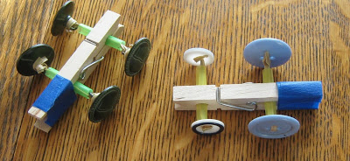
For a easy boredom buster, gather together:
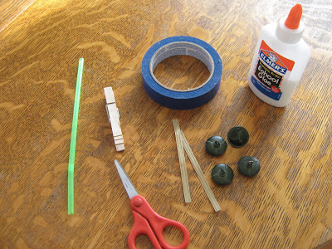

- 1 clothespin (per car)
- 4 buttons, of the same size
- 1 drinking straw
- 2 bread ties
- colored tape
- school glue (optional).

Cut two, one inch, pieces from the straw.
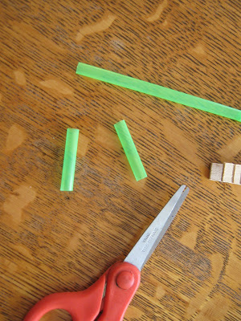
Thread the bread ties through the straws, and secure a button on each side, either looping the bread tie through the back hook, or the holes, depending on the type of buttons you have.
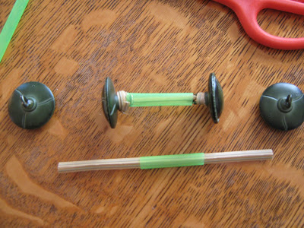
Clip one of the straw axles in the front of the clothespin. You can glue it in place, but that isn't necessary.
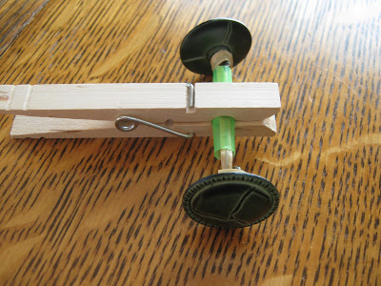
Slide the other straw axle into the back of the clothespin, up against the spring.
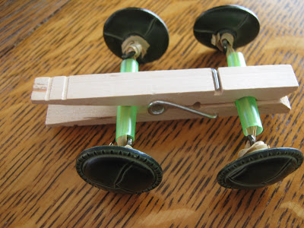
Secure it in place with a piece of tape, as shown.
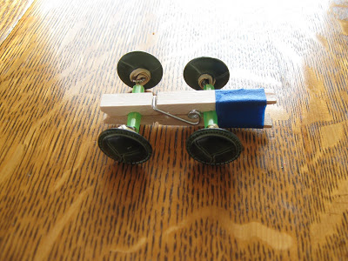
Make more than one...
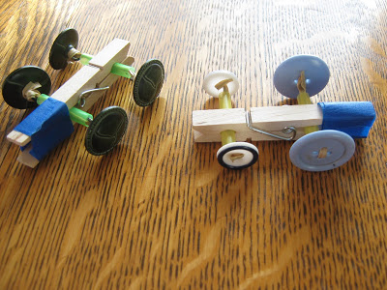
...and let the racing begin.
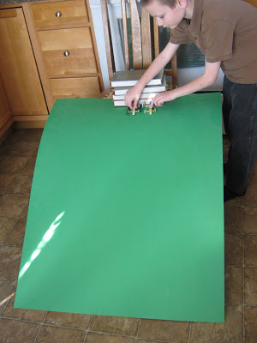
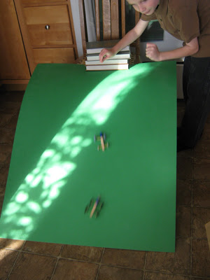
If you don't have a large piece of poster board, you can make a pretty good racing ramp out of an empty cereal box, too.
I found the idea for this toy, in Mary Wallace's excellent, for-kids, toy making book, I Can Make Toys. It's one of those books, where almost every idea looks like fun, and can actually be done by children, on their own.
It's great to be a homeschooler.

Rube Goldberg Machines for Kids
http://onetimethrough.com/rube-goldberg-machines-for-kids-youtube-video/

Today – we’re sharing with you our creation – the “Auto Helicopter Machine!” – along with all our trials and tribulations with the hope that you might try out this amazingly educational and FUN activity with your kids too!
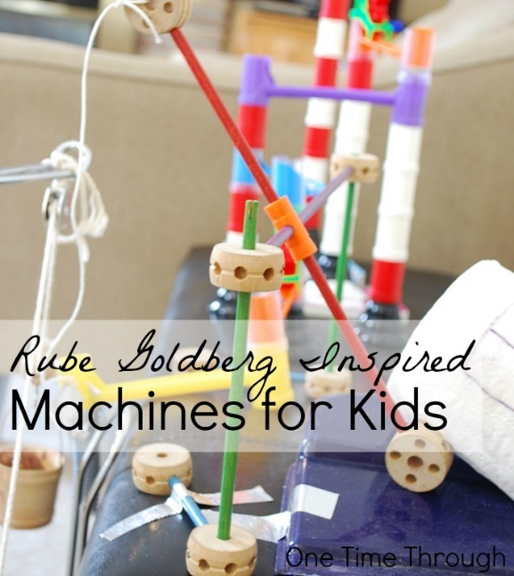
So what is a Rube Goldberg machine anyway? According to the Official Rube Goldberg Machine Contest website it is a “comically involved, complicated invention, laboriously contrived to perform a simple operation.”
It sounds a little daunting at first, I know…but realistically, you can make a machine as complicated as you want (or not) and the best part is – all you need are things from around the house (as you will see in our video below!)
Before I show you our video, I want to mention again that the inspiration for our project came from two posts from the Brain Power Boy blog. Between these 2 posts, you will find everything you need to get started making a Rube Goldberg machine with your child/children – just like we did.
In the post Play and Learn with Rube Goldberg Machines, you will find games, apps, recommended books and toys as well as some links to resources that will help you get started.
In the post Rube Goldberg Videos, you will find 8 videos that will get your child super-inspired to make a machine of their own. Onetime had a blast watching these (as did I!) and wanted to make one of his own right away!
Okay – without further adieu, here is One Time Through’s second official video (now available on our new You Tube channel! Yay!) – or right here for your enjoyment.
Hope you enjoyed watching our fun!
We may have gone a little overboard – after all, our machine filled our entire living room – and it took 2 days of tinkering to complete – but Onetime was right there highly interested the entire time – so why not go with it!?
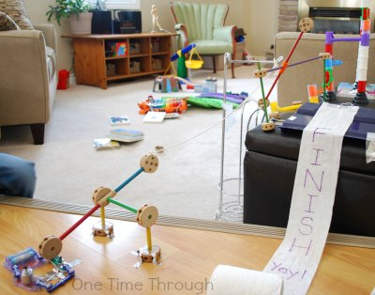And by the way, the perfectionist in me has to just say that every part of our machine did actually work – just not all at the same time – and with a trigger happy kid who kept starting the machine before I got the camera ready or a last part in place – it was never going to get caught on video – and I accepted that! LOL.
Onetime learned a whole lot from setting this whole thing up with me though.
Although I came up with the ideas, he helped me collect the items from around the house, helped build the Tinkertoy parts, the marble run contraption, and the Elenco Electronic Snap Circuits, Jr. Kit component at the end that when disconnected – let the helicopter fly.
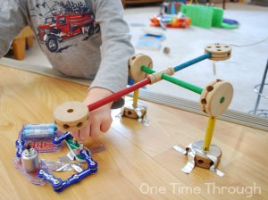
He also got lots of hands-on time investigating our bucket pulley system (which unfortunately got triggered early in our video and so didn’t get caught on tape) – and the levers that when triggered let the toilet paper “flag” roll out – and which tapped the final circuit off.
Our machine probably would not have been quite as fun without the Tinkertoy Super Building Set, marble run (we used the Migoga brand) and Elenco Electronic Snap Circuits, Jr. Kit toy elements, and I highly recommend all 3 (we use them all the time!).

How to Do a Rube Goldberg Project

https://gwynridenhour.wordpress.com/2012/03/14/sum-up-how-to-do-a-rube-goldberg-project-and-not-lose-your-mind/

How To Do A Rube Goldberg
1. Begin with youtube. Just spend a morning searching for Rube Goldberg videos – there are hundreds! And so amazing. Here are a couple of my favorites:
2. Don’t forget to look at the original drawings too! Try Rube Goldberg: Inventions by Maynard Frank Wolfe.
3. Discuss with your students that this is about process as much as the end result. The magic of the Rube is the myriad opportunities it provides for problem solving! Be sure to show them the Mythbusters Christmas special, which shows not only their Rube Goldberg project, but provides a delightful insight to how many times things go wrong in a project like this, even for professionals.
4. Instruct students to decide on themes and an end action. Will the machine tell a story? What is its ultimate goal? Each portion of the machine has to receive an action that converts its potential energy to kinetic energy. It also has to cause the next action to happen. But don’t forget humor – this should be fun! My kids incorporated several of their favorite story lines into their project, including Harry Potter, Munchkin, and Eva’s beloved stuffed animal Kinzy.
5. Consider offering certain parameters. If you’re wanting to study simple machines as a part of this project (which I did), require the students to incorporate them. They’ll do this anyway, because Rube Goldbergs are all about simple machines! But by requiring certain machines, it helps students identify the components they’re using and think about them scientifically. Parameters also help get the kids started. The only machine I required for the kids was a pulley. I also required that the final machine be comprised of at least five components. But the rest was up to them.
6. Have your students draw out ideas for their machines. Or not. Follow your kids’ leads. If they’re list-makers, let them make lists. If they feel the need instead to just get started, then let them. Again, this is all about process.
7. Be prepared to ditch large amounts of work if necessary. If something’s not working, then change it to make the project successful. We had to change everything, including our timeline, materials, and even who would be working on it.
8. Ask discussion-oriented questions when things go wrong and be sure to have kids identify several things. Ask 1) what went wrong, 2) what made it go wrong, and 3) what are the possible solutions. Be sure to have them identify many possible solutions before choosing one. For example, when our broomstick fell too quickly on our falling pendulum, the kids identified all the things that could slow it down. They could increase friction, decrease the broomstick’s weight, or decrease the incline of the pendulum track. We discussed the pros and cons of each avenue before the kids made their choice.
9. Do not be in a hurry. Rube Goldbergs can take a lot of time, depending on how much the kids bring to it. Don’t rush the process.
10. Video, share, and celebrate your successes! Take advantage of youtube, facebook, email, your school website, friends, and family. If you’re into it, do a blooper reel too.
11. And lastly, I offer a prequel suggestion. Rube Goldberg machines are a great way to teach physical science. We did a semester of physics and simple machines before we started the Rube. I used Lego WeDo Education (which was a great concept, but the software was constantly crashing), Forces and Motion Science Fair Projects by Robert Gardner, Zombies and Forces and Motion by Mark Weakland, and a cute albeit dated series of clips I found on youtube by Eureka. You’ll find them by going to youtube and typing “simple machines Eureka.” There are a lot of other great instructional simple machines videos too, so have fun browsing around.
And now for the closeup tour. First, the video once again:
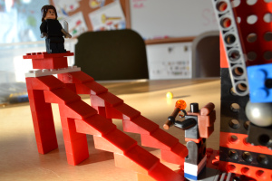
This is component number one, a simple ramp. The kids love the game Munchkin, and in that game there is a card called “Kill the Hireling.”
They think that’s hilarious and chose to use it for the first piece. The hireling (the lego figure at the bottom) ended up having to go without a head, because its head kept getting in the way. But we thought that was funny too.
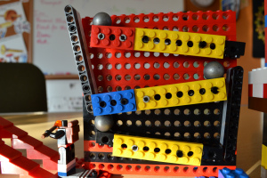
This next component is one that we saw in a lot of other Rube Goldberg machines. The goal is to transfer movement from low to high using ramps, balls, and levers. Each ramp allows the ball to roll down and into a lever; the lever transfers the motion upwards to the next ramp.
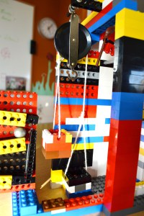
The top ball falls into a bucket that’s attached to a pulley. The pulley system has a counterweight which is offset by the ball’s action.
…
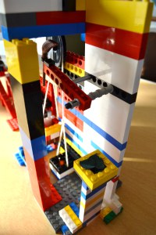
When the pulley system is activated, it pulls a string (I did help with the tying of the string) that’s attached to a stick that props up a flying broomstick (a nod to Harry Potter). Once that stick is pulled away, the broomstick swings on a pendulum.
At the end of the broomstick’s arc is Kinzy’s bowl of eucalyptus. This bowl gets knocked off its pedestal and onto Kinzy’s table. Lunch is served!
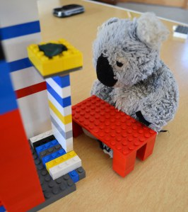



WEBELOS CORE

Webelos Adventure: Cast Iron Chef
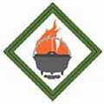
Do all of these:
- At an approved time in an outdoor location and using tinder, kindling, and fuel wood, demonstrate how to build a fire; light the fire, unless prohibited by local fire restrictions. After allowing the flames to burn safely, safely extinguish the flames with minimal impact to the fire site.
- Set personal nutritional goals. Keep a food journal for one week; review your journal to determine if the goals were met.
- Plan a menu for a balanced meal for your den or family. Determine the budget for the meal. Shop for the items on your menu while staying within your budget.
- Prepare a balanced meal for your den or family; utilize one of the methods below for preparation of part of your meal:
  - Camp stove
  - Dutch oven
  - Box oven
  - Solar oven
  - Open campfire or charcoal
- Demonstrate an understanding of food safety practices while preparing the meal.
Workbook for use with these requirements: PDF Format DOCX Format

How to Build a Fire Skit
http://scoutermom.com/9714/years-resolutions-scouts-scouters/

Skits can be a great way to start an instruction program. They get everyone’s attention focused. This is a skit I saw at a camporee, but it would also work as an introduction to a session on fire building.
I don’t remember the exact dialog, but I’ve given you the general idea. I think these guys were doing some improv based on some old Scout jokes.

How to Build a Fire
2 actors are required
Props
- Lawn chair
- Cotton ball
- Various sized sticks and logs
The Skit
Scout 1 is sitting in a lawn chair and Scout 2 is standing next to him.
Scout 1: It’s pretty cold out tonight, so John and I are going to show you how to build a fire. This is an important Scout lesson, so pay attention! First we need some tinder. Belly button lint makes great tinder. John, could we use your belly button lint?
Scout 2 lies down on the ground on his back and pulls up his shirt a little to expose his belly button.
Scout 1: John, I think it would be better if you removed the lint instead!
Scout 2 nods his head, turns around so the audience can’t see, and produces his belly button lint – a big cotton ball.
Scout 1: Wow! That’s a lot of belly button lint. Maybe you should clean that out more often.
Scout 2 shrugs and puts the cotton ball on the ground.
Scout 1: Now we need some small twigs and sticks. John, could you find some for us.
Scout 2 brings in about three good sized logs.
Scout 1: That’s a little larger than I was thinking about. I want some really small twigs and sticks.
Scout 2 puts down the logs and goes out. He returns with a few large sticks – 1 to 2 inches in diameter.
Scout 1 (starting to get exasperated): Still too large. Lots and lots of tiny, tiny sticks!
Scout 2 puts down the large sticks and leaves. He brings in one twig and holds it up.
Scout 1 (getting more angry): We need more than that!
Scout 2 walks out. Scout 1 keeps looking around for him.
Scout 1: I guess if you want something done right you have to do it yourself!
Scout 1 gets out of his chair and storms out in the opposite direction of Scout 2. Scout 2 returns with a good sized load of twigs and small sticks. He proceeds to efficiently make the fire with the other materials he brought in earlier. He lights it (either pretend or for real), and sits in the chair, holding his hands over it to warm them.
Scout 1 returns with a disorganized array of sticks and logs. He sees Scout 2 sitting in his chair, drops his fire building materials, and throws his arms up into the air.
Scout 1: I can’t believe it!

Menu Planning with Webelos
http://scoutermom.com/4722/menu-planning-webelos/
My Webelos den is going to district camporee at the end of the month. So at last night’s Outdoorsman focused meeting, we did some menu planning.
If this were a Boy Scout troop, the youth members would sit down with the grubmaster and do their menu planning without any adult interference. But since these are Webelos and this is only their third campout, I did it with them. I only have four in my den and one was at opening night of a high school play he is in and the other was sick. So with just two – ZM and one of his friends – it went pretty quickly.
Camp is about 90 minutes away, so we decided they would eat before leaving and then we would have a good snack after we setup our campsite. So they pickedWalking Tacos and fruit. We will also toast some Peeps. Breakfast will be sausage and pancakes. For lunch, we will head over to the Boy Scout side of the camporee and the troop will provide lunch for us. Dinner will be Pizza Quesadillas, salad, raw broccoli and carrots with ranch dressing, and more fruit. ZD’s friend is going to bring some brownies. Breakfast on Sunday morning has to be quick, so we are just doing donuts and more fruit.
It was fun to see them discussing all of their options. The two of them both tend to have strong opinions and there was a lot of give and take before they came up with a menu they were both happy with.


Edible Campfires Recipe
http://scoutermom.com/2006/edible-campfires-recipe/
Scouts should know how to build a fire. I am always amazed how many kids don’t understand the concept of using tinder and small sticks. This snack will help introduce the concept.
This would be a good activity for Webelos about to head out on their first camp out.
Troop Instructors could also use this snack to teach fire building skills to newly crossed over Scouts. Demonstrate in the meeting room with this method and then let them go outside and have a try at doing it themselves.
Be creative with the ingredients. I’ve suggested some, but there are lots of other possibilities. Feel free to leave your suggestions in the comments.

Edible Campfires
Ingredients
- Pretzel rods
- Pretzel sticks
- Chow mein noodles
- Shredded wheat, shredded (the full size type works better than the spoon size)
- Candy corn
- Red hots
- Yellow, orange, and red fruit rollups, cut into small strips
- Paper plates
Directions
- Using the pretzel rods as logs, pretzel sticks and chow mein noodles as sticks, and shredded wheat as tinder, arrange the ingredients like you are building a fire on the paper plate.
- “Light” the fire by adding candy corn, red hots, and bits of fruit rollups
- Enjoy!



ARROW OF LIGHT CORE

Arrow of Light: Building a Better World

- Explain the history of the United States flag. Show how to properly display the flag in public, and help lead a flag ceremony.
- Learn about and describe your rights and duties as a citizen, and explain what it means to be loyal to your country.
- Discuss in your Webelos den the term "rule of law," and talk about how it applies to you in your everyday life.
- Meet with a government leader, and learn about his or her role in your community. Discuss with the leader an important issue facing your community.
- Learn about your family's expenses, and help brainstorm ways to save money. Plan and manage a budget.
- Learn about energy use in your community and in other parts of our world.
- Identify one energy problem in your community, and find out what has caused it.
- With the assistance of your den leader or parent, participate in an event that would help lead others in recycling and conserving resources.
- Show that you are an active leader by planning an activity without your den leader's help.
- Do one of these:
  - Learn about Scouting in another part of the world. With the help of your parent or your den leader, pick one country where Scouting exists, and research its Scouting program.
  - Set up an exhibit at a pack meeting to share information about the World Friendship Fund.
  - Find a brother Scout unit in another country.
  - Under the supervision of your parent, guardian, or den leader, connect with a Scout in another country during an event such as Jamboree on the Air or Jamboree on the Internet or by other means.
Workbook for use with these requirements: PDF Format DOCX Format

Messengers of Peace
http://scoutermom.com/14582/messengers-of-peace/
The Messengers of Peace initiative is a program of the World Scout Committee. The Boy Scouts of America joined the Messengers of Peace initiative in 2012. This program encourages Scouts around the world to work for peace by being a positive force in their communities. All types of BSA units can participate in this program.
The program tracks how the efforts of Scouts around the world are making a difference for peace. You can even see a map with pins where Scouts are participating.
Participating is easy. When you submit a service project for Journey to Excellence, just select “Messengers of Peace” as your partner organization.
Scouts and Scouters who participate in a Messengers of Peace service project may wear a Messengers of Peace ring patch around the World Crest on their uniforms.

What type of service project qualifies as a Messengers of Peace project?
You don’t need to travel the world to be a Messenger of Peace. According to the BSA website:
A Messengers of Peace service project is defined as any project that touches on one of these dimensions of peace:
- The personal dimension: harmony, justice, and equality
- The community dimension: peace as opposed to hostility or violent conflict
- Relationships between humankind and its environment: security, social and economic welfare, and relationship with the environment
Many of the service projects your units are doing will qualify. See the Messengers of Peace Service Project Ideas page for lots of examples.

Ideas for Adventure Requirements:
http://boyscouttrail.com/webelos/arrow-of-light-building-better-world-adventure.php
- Basic U.S. Flag information is in the Webelos handbook. Details can be found at usflag.org
- Review the 100 civics questions that U.S. Immigration Services uses for their naturalization test.
- A comparison of the United States and other countries can be found on this interactive map
- Plan this meeting well ahead of time. Meeting at the community leader's work place would be a good den outing. Let the person know what issue you'd like to discuss beforehand.
- Print this budget template for each scout.
- Research your area's energy generation, use, and potential witheia.gov map and energy.gov.
- Common household energy problems can be explored here and energy saving ideas are here.
- Learn about different conservation event ideas at epa.gov.
- Printing this activity plan template for each scout will help them with their planning.
- Use Pen Pals to connect with foreign scout groups.
Den Meeting Ideas for Building a Better World Adventure:
- Use some of these flag ceremonies - Flag Opening ceremony,Flag Closing ceremony,Flag ceremonies,More ceremonies
- Scouts can use these Pledge Intros to lead short flag ceremonies.
- Sing Grand Old Flag song or America the Beautiful song
- Tell I Am Your Flag minute
- Present this Flag skit
- Expand your Flag knowledge at this BSA page or by purchasing theYour Flag book from your local Scout Shop. Then, check your knowledge with this online Flag test. Understand Unit Flag devices.
- Consider working towards the Messengers of Peace award.

Cub Scout Conservation Project Ideas
By Mary Strain
- http://www.ehow.com/info_8242231_cub-scout-conservation-project-ideas.html
Boy Scouts of America, including Cub Scouts, have a long-time history in conservation and environmental work. Conservation ethics and activities have been part of the organization since 1910. Projects that teach Cub Scouts about the value and importance of conservation are educational and offer good reason for the 7- to 10-year-old boys to do something outdoors in this day and age when Scout badges include computer and other indoor projects. They may also help Cub Scouts earn pins and belt loops, including the Wildlife Conservation belt loop.
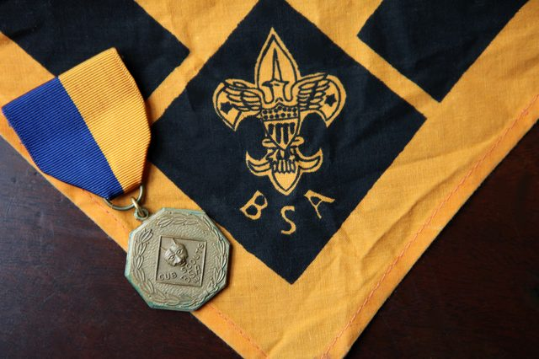(Jeanne Studio/Demand Media)

Planting Trees
One possible Cub Scout conservation project is a tree-planting project. This would be appropriate as part of an Arbor Day or Earth Day celebration. This hands-on project provides teaching opportunities for the leaders: Explain how trees help purify the air. Emphasize planting new trees helps restore forests and beautify areas where trees were lost to logging or construction. Possible sites for a tree-planting might include a park, library, school or retirement facility.
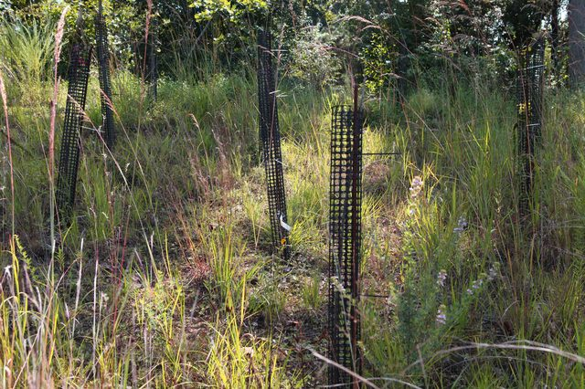Jeanne Studio/Demand Mdia

Recycling
Recycling is an important part of conversation. For a recycling project, plan a field trip the recycling center. Instruct the boys ahead of time to save recyclables for the field trip. If the center requires separating of glass, plastic and so forth, hand out instructions for the boys to take home so they remember how to sort. Talk to the boys about the length of time it takes waste to decompose and why this is a problem. After the field trip to the recycling center, swing by a landfill for a visual of the importance of recycling.
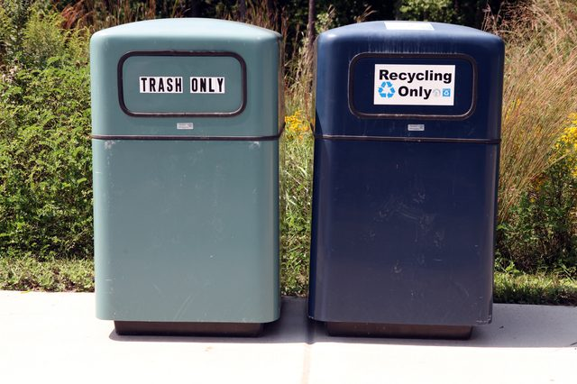Jeanne Studio/Demand Media

Walking and Biking
Taking the Scouts on a biking trip, whether as a day trip or as an overnight camping trip, is a fun way to demonstrate the importance of cutting back on carbon emissions by biking rather than driving, whenever possible. Alternatively, a Scout leader might explain the concept of a "carbon footprint" -- the size of one person's individual contribution to pollution -- by having the boys cut out paper footprints of varying sizes.
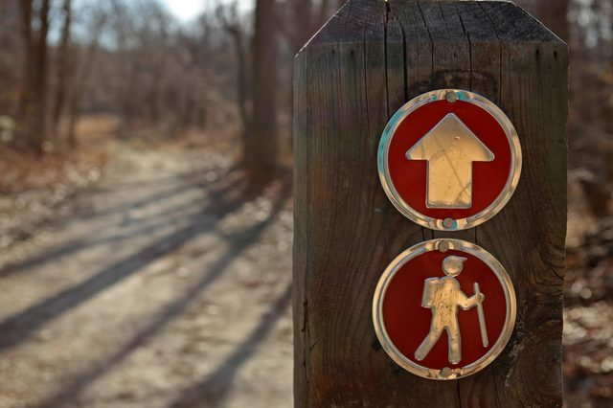Jeanne Studio/Demand Media

Adopt an Endangered Animal
The National Geographic Kids website suggests that children "adopt" an endangered animal as part of a conservation project. The Cub Scout den might choose to adopt an endangered animal at a local zoo or wildlife preserve. Wildlife sanctuaries, which rescue animals and return to the wild when possible, also welcome donations and sometimes provide adoption opportunities for animals that can't be released. To raise money for the adoption, plan a fundraising activity. Car washes are pretty dependable. Or try something that relates to wildlife, such as selling birdhouses or bat houses the boys make.

Arrow of Light Adventure: Camper

Do all of these:
- With the help of your den leader or family, plan and conduct a campout. If your chartered organization does not permit Cub Scout camping, you may substitute a family campout or a daylong outdoor activity with your den or pack.
- On arrival at the campout, with your den and den leader or family, determine where to set up your tent. Demonstrate knowledge of what makes a good tent site and what makes a bad one. Set up your tent without help from an adult.
- Once your tents are set up, discuss with your den what actions you should take in the case of the following extreme weather events which could require you to evacuate:
  - Severe rainstorm causing flooding
  - Severe thunderstorm with lightning or tornadoes
  - Fire, earthquake, or other disaster that will require evacuation. Discuss what you have done to minimize as much danger as possible.
- On a pack campout, work with your den leader or another adult to plan a campfire program with the other dens. Your campfire program should include an impressive opening, songs, skits, a Cubmaster's minute, and an inspirational closing ceremony.
- Show how to tie a bowline. Explain when this knot should be used and why. Teach it to another Scout who is not a Webelos Scout.
- Go on a geocaching adventure with your den or family. Show how you used a GPS unit or a smartphone with a GPS application to locate a geocache.
- Recite the Outdoor Code and the Leave No Trace Principles for Kids from memory. Talk about how you can demonstrate them while you are working on your Arrow of Light. After one outing, list the things you did to follow the Outdoor Code and Leave No Trace.
Workbook for use with these requirements: PDF Format DOCX Format
Ideas for Adventure Requirements:
http://www.boyscouttrail.com/webelos/arrow-of-light-camper-adventure.php
- This Campout Planning Checklist can be used as a guide.
- Ensure all scouts have set up their tents previous, either at home or a den meeting. Read this page about tent tips.
- See Emergency Dude for emergency prep and survival information.
- Coordinate with the other Pack leaders to ensure the campout offers opportunities to all dens. Use this Campfire Planner
- The most common error when learning the bowline is making the initial loop behind, rather than in front of, the standing end of the rope.
- Read Responsible Geocaching and Geocaching Guidelines.
- Visit Leave No Trace Dude for LNT info and teaching aids.
Den Meeting Ideas for Camper Adventure:
- Help scouts choose some good Scout Recipes for their campout.
- Play Going Camping activity.
- Perform Bear Attack skit.
- When practicing tent set-up, try this Anti-gravity Tent Pole activity.
- Read Letter from Scout Camp.
- Play Bowline Flood Rescue.
- Play Bowline Race.
- Consider working towards the Outdoor Ethics award.

Webelos/AOL Elective: Art Explosion

Do all of these:
- Visit an art museum, gallery, or exhibit. Discuss with an adult the art you saw. What did you like?
- Create two self-portraits using two different techniques, such as drawing, painting, printmaking, sculpture, and computer illustration.
- Do two of the following:
  - Draw or paint an original picture outdoors, using the art materials of your choice.
  - Use clay to sculpt a simple form.
  - Create an object using clay that can be fired, baked in the oven, or air dried.
  - Create a freestanding sculpture or mobile using wood, metal, papier-mâché, or found or recycled objects.
  - Make a display of origami or kirigami projects.
  - Use a computer illustration or painting program to create a work of art.
  - Create an original logo or design. Transfer the design onto a T-shirt, hat, or other object.
  - Using a camera or other electronic device, take at least 10 photos of your family, a pet, or scenery. Use photo-editing software to crop, lighten or darken, and change some of the photos.
  - Create a comic strip with original characters. Include at least four panels to tell a story centered on one of the points of the Scout Law. Characters can be hand-drawn or computer-generated.
- Choose one of the following methods to show your artwork:
  - Create a hard-copy or digital portfolio of your projects. Share it with your family and members of your den or pack.
  - Display your artwork in a pack, school, or community art show.
Workbook for use with these requirements: PDF Format DOCX Format

Color Wheel Download
http://artprojectsforkids.org/free-color-wheel-download/

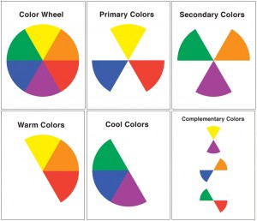
I’ve found that most color wheels are either too complicated (lots of sections and subsections) or too simple (three overlapping balloons) for your average elementary student. My solution was to make my own, and also diagram primary, secondary, warm, cool and complementary colors. Enjoy!
• View and download Color Wheel PDF

DIY 3D HAND DRAWING
http://allfortheboys.com/home/2013/6/21/diy-3d-hand-drawing.html?utm_source=feedly&utm_medium=feed&utm_campaign=Feed:+AllForTheBoys+(All+for+the+Boys)
Tombow sent us a few products to create a project using them. Tombow is celebrating it’s “100 Days of Tombow” program in which they are committing to provide up to $10,000 of Tombow art products to theCouncil for Arts Education, a national nonprofit dedicated to promoting and supporting art education and quality art programs nationwide.
Of course we’d love to have them donate in our name! We wanted to share this super fun (and addictive) 3D hand drawing art project with you.
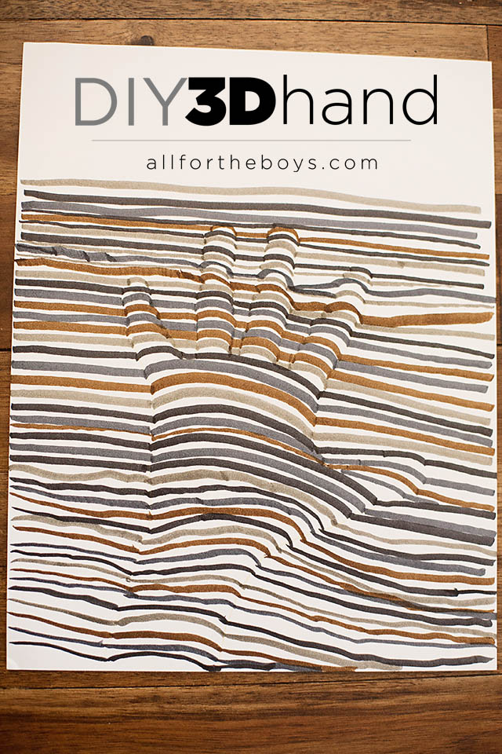
It’s really pretty easy! We used a Tombow colored pencil to trace his hand lightly on a sheet of cardstock.
Next you grab the markers of your choice (we used the Grunge dual brush pen set) and start a pattern with straight lines (we didn’t stick to the pattern 100%). Once you get to the outline of your hand instead of continuing with your straight line you’re going to arch up until the other side of your outline and then continue with your striaght line repeating for any fingers (easier to see in the photos than try to explain) 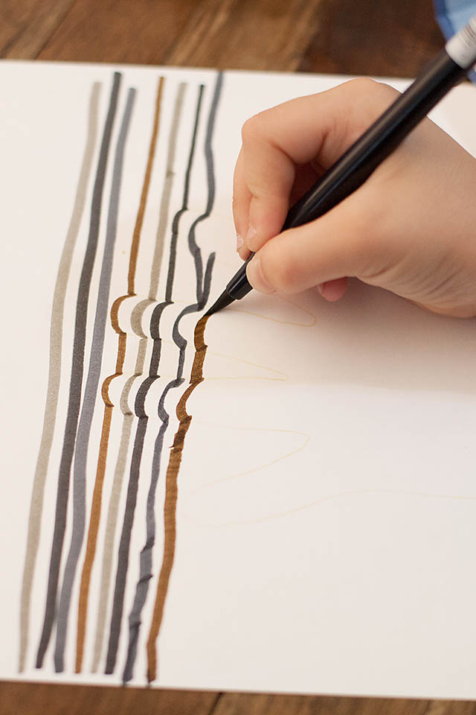
Continue this filling in if needed until you reach the bottom!


ONE LAST THING

The Parable of the Pencil,
parts 2 & 3
Rev Doug Baitinger, Mantua (NJ) UMC
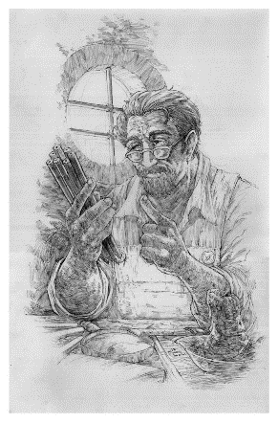
The Parable of the Pencil - Part 1
Review from last month
The five things the pencil maker told the pencil -
- “One: You will be able to do many great things, but only if you allow yourself to be held in Someone’s hand.”
- “Two: You will experience a painful sharpening from time to time, but you’ll need it to become a better pencil.”
- “Three: You will be able to correct any mistakes you might make.”
- “Four: The most important part of you will always be what’s inside.”
- “And Five: On every surface you are used on, you must leave your mark. No matter what the condition, you must continue to write.”

The Parable of the Pencil - Part 2
But now the pencil lay on the dark wood table, feeling insignificant and rather sad. Beside him on the desk was a colorful tin can, filled with every kind of beautiful pen to be had. There were silver fountain pens and a neon felt tip marker. There was also a classy ballpoint whom everyone called Parker.
"What a loser," they said of the pencil, as they observed his wooden frame.
"Don't bother with him, he is nobody," said Parker, "He doesn't even have a name."
Now the world was at war and their owner was a Soldier who was tasked to bring peace to the land. "What we need is a map," the Soldier had said, at the desk across from his Officer the other night. "If someone can fly me over the city unseen, I can draw a map from the sky. The map will tell you where to go and how to win, and soon we'll put an end to this fight." The Officer had agreed and now the Soldier would fly, but first he discussed with his wife. "I'll need something to draw with, something dependable... something that won't fail me mid-flight."
The Soldier looked at his dark wood desk, and observed all the pens in the can. He studied each one, their bodies all shimmering, and he weighed them all in his hand. "This one won't work," he said of a pen, "the ink might blot on the map. This one needs to be refilled every few hours, and this one will dry out without a cap." He looked at each one and always found something wrong or anticipated problems if he used it in the sky. "I need something that would work whatever the conditions, and I need it soon my dear wife."
"Then take this pencil." his wife finally said, handing him the frail and battered yellow thing. "It will write no matter what, it will write on a plane - it's the best writing tool you can bring."
The Soldier smiled, kept the pencil in his pocket, and took it with him on the plane. He finished the map and the map helped bring them peace... and the pencil has never been the same.

The Parable of the Pencil - Part 3
The pencil was now nothing more than a stub; what was left of his lead was now broken. His eraser was gone, his wood frame had split, and some time ago his metal ring had been stolen.
Now he stood before the Pencil Maker, and waited for him to say those 5 words.
"Well done, my faithful pencil," the Pencil Maker said, "You have written what you were meant to write in the world."
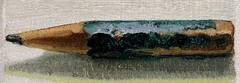
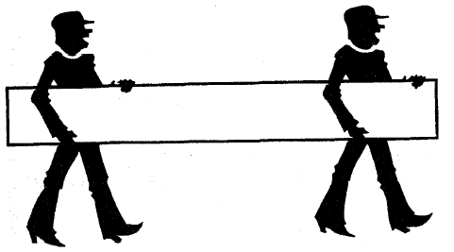

The Seven Wonders
The first grade class assignment was to name the Seven Wonders of the World. Each student had to compile a list, and then share their list, aloud, with the class.
There was ardent interaction as the students called out entries from their lists: the Pyramids, the Empire State Building, the Amazon River, Yellowstone National Park, the Grand Canyon, the Taj Mahal and the list goes on.
The teacher served as the cheer leader, “Class, these are great answers. Well done!”
One girl sits silent. She is asked about her list. She says, “I don’t think I understand the assignment.”
“Why?”
“I don’t have any of the right answers,” she tells the teacher.
“Well, why don’t you tell us what you wrote on your paper, and we’ll help you.” the teacher encourages her.
“Okay,” says the little girl, “I think the Seven Wonders of the World are. . .
To See,
To Hear,
To Touch,
To Smell,
To Feel,
To Love,
To Belong.”
The room was so quiet you could have heard a pin drop. The things we overlook as simple and ordinary and that we take for granted are truly wondrous!! A gentle reminder that the most precious things in life cannot be built by hand or bought by man.
Somewhere along the way, we have buried this little girl’s wisdom.
There are only two ways to live your life.
- One is as though nothing is a miracle.
- The other is to live it as if everything is.

