COMMISSIONER'S CORNER

We have received almost no responses to our Help Wanted Ad the last 2 months. We really need some help.
You will be seeing Alice come back soon to help, and a local Cubmaster by me who has had several great Lion Prides!! Thank you!!
And if you replied and have not heard from us, please write again. Judy and Dave have both had problems with our computers.
And it is not too late – check out the list on page 2!!!

FILES/ BOOKS/ LINKS TO MATERIALS FROM UNIVERSITIES AND POW WOWs NEEDED –
If your council ran a University or a Pow Wow and published a book or posted files on the web or on a cloud somewhere. Let us know. We are always looking for new material. You can write us at –
davethecommish@gmail.com and
judyjohnsonbsa@yahoo.com
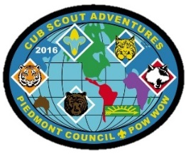

www.scouting.org/programupdates
The Program Updates page has been regrouped. Since the CS Adventure is in full swing, the emphasis on getting ready for it has been reduced. The downloads are still all there. And great information about three new Cub Leader courses at Philmont Training Center next summer.
There is a lot of information now on etting ready and implementing the changes to the Boy Scout program.
Check it all out – stay current!!



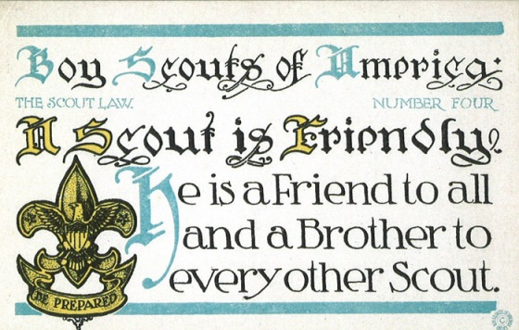
Had it not been for that unknown Scout who was FRIENDLY to W.D. Boyce, the BSA may not exist today. One small acct of FRIENDSHIP, who on Earth knew what would happen. (God surely knew. Only us men were unaware. Since my cancer treatment in 2008, I am a firm believer in Romans 8:28. CD)
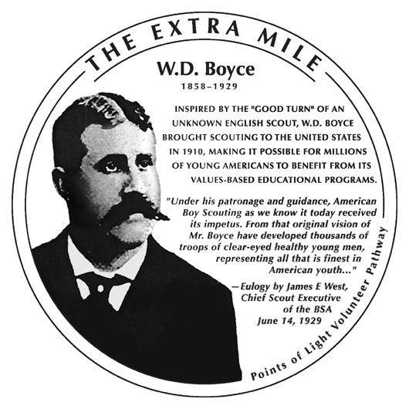
Baloo Editorial Comment –
We probably all heard this story on the news –
Boy Scout leader survives 80-minute bear mauling with help from his troops
And had various reactions – Why? How? The Scouts did great! What went wrong? Did a BSA process fail?
Here is what Patriot's Path, the local council said as reported by the Washington Post -
Commenting on the incident for the Boy Scouts, Dennis Kohl, Patriots Path Council executive, said he had no details of events leading up to the "terrible accident," pointing out that the outing was not an official scout activity.
However, he acknowledged the people involved were "members of our scouting family" and said "they remain in our thoughts and prayers" and "we hope for a speedy recovery."
That is right, it was not a Scout activity. It was a Dad out with his son and two of his son's friends. But thankfully all are Scouts and knew what to do. As stated above, I believe there are no coincidences and all things happen for good per Romans 8:28. But had it been conducted as an official Scout activity, the Dad would not have wound up where he did. CD

Judy and Dave need some help. If you would do one item for Baloo each month, it would help us greatly –
Some ideas for you to consider –
Biography – write a one page +/- biography of a person you select that exemplifies that month's emphasized point of the Scout Law.
Advancement – Choose a rank. Write a few hints and ideas for the Adventure to be discussed that month at the Roundtable. And, also, any that have a Character Compass pointing to that months point of the Scout Law
Social Media – check out National's Facebook pages, Bryan's Blog, Cubcast, and Scoutcast and prep the summaries for Baloo.
Roundtable Hints – Prep some hints and ideas for your fellow Roundtable Commissioners each month. This would be easy for someone from a council like Sam Houston where they have an annual RT day where they review all 12 months in advance.
Crazy Holidays – Jodi actually retired from that position a few years ago. We can supply you files for each month. You only need to check for updates and additions. Feel free to use more websites if you have a favorite.
Point of the Scout Law – Look for items that help get across the meaning of the point of the Scout Law emphasized that month in Roundtable.
Special Opportunities – write a brief article each month about one youth and one adult award other than rank advancement.
Have another idea? Let us know how you feel you could help us to make Baloo's Bugle more of what RT Commissioners, Cubmasters, and Den Leaders want.
Write us through the "Send Your Ideas to Baloo" link or directly – davethecommish@gmail.com and judyjohnsonbsa@yahoo.com

TABLE OF CONTENTS
COMMISSIONER'S CORNER 1
www.scouting.org/programupdates 1
TABLE OF CONTENTS 3
CORE VALUES 4
BIOGRAPHY 5
MR. ROGERS 5
Mr Rogers Quotations 6
OTHER FRIENDLY "PEOPLE" 7
CUB SCOUT LEARNING LIBRARY 8
CUB SCOUT LEADER TRAINING 11
ON-LINE TRAINING 11
IN-PERSON TRAINING 12
ADVENTURE PLAN TRACKERS 12
MEANINGS OF ITEMS COMMONLY USED AT CUB SCOUT CEREMONIES 13
ROUNDTABLE HINTS 13
RTs – The Most Important Part of Unit Service 13
DEN MEETING TOPICS 16
CHARACTER COMPASS 16
PACK MEETING THEMES AND PLANS 17
PACK MEETING THEMES 18
UPCOMING MONTHS 18
WEBELOS 19
ARROW of LIGHT PRESENTATION 19
WEBELOS TO BOY SCOUTS BRIDGING CEREMONY 22
FEBRUARY CRAZY HOLIDAYS 23
BSA SOCIAL NETWORKS 26
SCOUTING MAGAZINE ON YOU TUBE 26
BSA FACEBOOK PAGE 26
CUBCAST 27
SCOUTCAST 28
BRYAN'S BLOG, December 2015 28
TRAINING TOPICS 31
Philmont Training Center 31
Philmont Training Center Info 32
SPECIAL OPPORTUNITIES 36
Service Stars & Attendance Pins 36
Knot of the Month 38
Veterans Recognition 38
THEME RELATED STUFF 39
WORLD BROTHERHOOD OF SCOUTING 39
WORLD CREST 39
BROTHERHOOD 40
THEME & PACK MEETING IDEAS 40
GATHERING ACTIVITIES 40
OPENING CEREMONIES 41
AUDIENCE PARTICIPATIONS 44
ADVANCEMENT CEREMONIES 45
LEADER RECOGNITION 46
SONGS 48
BLUE & GOLD SONGS 49
STUNTS AND APPLAUSES 50
APPLAUSES & CHEERS 50
RUN-ONS 50
JOKES & RIDDLES 50
SKITS 51
Lead Archeologist: Then why did you step in it? 52
CLOSING CEREMONIES 52
CUBMASTER’S MINUTES 54
CUB GRUB 56
GAMES 59
THEME BLUE & GOLD IDEAS 61
PASSPORTS 61
NECKERCHIEF INVITATIONS 62
SCOUTING WORLD INVITATION 62
FRIENDSHIP NUT CUP 64
TABLE CENTERPIECES 64
PLACE MARKERS 65
OTHER BLUE AND GOLD IDEAS 66
OTHER BLUE & GOLD THOUGHTS 68
ONE LAST THING 70
The Parable of the Pencil 70

CORE VALUES
The Cub Scout Core Values are now the
12 Points of the Scout Law.
The core value highlighted this month is:
February's point of the Scout Law, FRIENDLY, will use the theme, FRIENDS NEAR AND FAR.
A SCOUT IS FRIENDLY
A Scout is a friend to everyone, even people who are very different from him..
HOW DOES “FRIENDS NEAR AND FAR” RELATE TO THIS POINT OF THE SCOUT LAW?
A Scout is a friend to all. He is a brother to other Scouts. He offers his friendship to people of all races and nations, and respects the beliefs and customs of others. “Friends Near and Far” reminds us that we are part of something bigger than our own community. By living the Scout Law, we are accepting of the world’s peoples and their values.
Per our Founder, Lord Baden-Powell
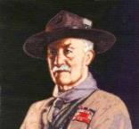
Note – The original Scout Law published in 1908 had nine points. In 1910, the BSA added Brave, Clean, and Reverent. In 1911 B-P added Clean to his original list.
A SCOUT IS A FRIEND TO ALL,
AND A BROTHER TO EVERY OTHER SCOUT, NO MATTER TO WHAT SOCIAL CLASS THE OTHER BELONGS
If a scout meets another scout, even though a stranger to him, he must speak to him, and help him in any way that he can, either to carry out the duty he is then doing, or by giving him food, or, as far as possible, anything that he may be in want of. A scout must never be a SNOB. A snob is one who looks down upon another because he is poorer, or who is poor and resents another because he is rich. A scout accepts the other man as he finds him, and makes the best of him -- "Kim," the boy scout, was called by the Indians "Little friend of all the world," and that is the name which every scout should earn for himself..
(Scouting For Boys, 1908)

To get a hold on boys you must
be their friend.
Lord Robert Baden-Powell
Winnie the Pooh on Friends and Friendship
by A.A. Milne–
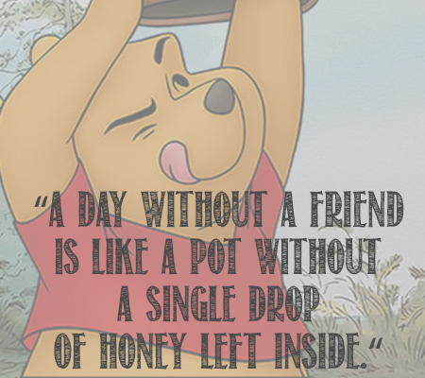
If you live to be a hundred, I want to live to be a hundred minus one day so I never have to live without you.
Promise me you'll always remember: You're braver than you believe, and stronger than you seem, and smarter than you think.
You can't stay in your corner of the Forest waiting for others to come to you. You have to go to them sometimes.
It is more fun to talk with someone who doesn't use long, difficult words but rather short, easy words like "What about lunch?"
Piglet noticed that even though he had a Very Small Heart, it could hold a rather large amount of Gratitude.
“I wonder what Piglet is doing," thought Pooh.
"I wish I were there to be doing it, too.”
Friendship ... is born at the moment when one man says to another "What! You too? I thought that no one but myself . . . ― C.S. Lewis, The Four Loves
Don’t walk in front of me… I may not follow
Don’t walk behind me… I may not lead
Walk beside me… just be my friend”
― Albert Camus
A friend is someone who knows all about you and still loves you. ― Elbert Hubbard
Good friends, good books, and a sleepy conscience: this is the ideal life. ― Mark Twain
It is not a lack of love, but a lack of friendship that makes unhappy marriages. ― Friedrich Nietzsche
There is nothing better than a friend, unless it is a friend with chocolate. ― Linda Grayson
I would rather walk with a friend in the dark, than alone in the light. ― Helen Keller
“Life is an awful, ugly place to not have a best friend. ― Sarah Dessen, Someone Like You
Friendship is unnecessary, like philosophy, like art.... It has no survival value; rather it is one of those things which give value to survival. ― C.S. Lewis, The Four Loves
Why did you do all this for me?' he asked. 'I don't deserve it. I've never done anything for you.' 'You have been my friend,' replied Charlotte. 'That in itself is a tremendous thing.” ― E.B. White, Charlotte's Web
“What is a friend? A single soul dwelling in two bodies.” ― Aristotle
I think if I've learned anything about friendship, it's to hang in, stay connected, fight for them, and let them fight for you. Don't walk away, don't be distracted, don't be too busy or tired, don't take them for granted. Friends are part of the glue that holds life and faith together. Powerful stuff.― Jon Katz
Friendship is the hardest thing in the world to explain. It's not something you learn in school. But if you haven't learned the meaning of friendship, you really haven't learned anything. ― Muhammad Ali
“How many slams in an old screen door? Depends how loud you shut it. How many slices in a bread? Depends how thin you cut it. How much good inside a day? Depends how good you live 'em. How much love inside a friend? Depends how much you give 'em.”
― Shel Silverstein
These four should be understood as warm-hearted friends:
- One who is a helpmate; guarding and protecting, a refuge in danger, giving more than is asked.
- One who is the same in happiness and sorrow; sharing and guarding confidences, remains a friend when things are bad, giving of themselves.
- One who gives good counsel; refrains from evil, encourages us to do good, informs us what is unknown of oneself, who is a good example.
- One who sympathizes; rejoices in prosperity and not misfortune, will not listen to or spread gossip, speaks well of their friend.
Adapted from the Sigalovada Sutta:
The Layman’s Code of Discipline (Digha Nikaya, No. 31)

BIOGRAPHY

MR. ROGERS
A True Friend and a Truly Friendly Person

Anyone who does anything to help a child
in his life is a hero to me.
Fred Rogers
And Mr. Rogers certainly was friendly and a friend to all in his TV audience. Mr. Rogers got into TV because the first time he saw a children's TV show it had “something horrible on it with people throwing pies at one another…” He stated, “I went into television because I hated it so, and I thought there was some way of using this fabulous instrument to be of nurture to those who would watch and listen.” That is to befriend the children. He decide from the beginning, that his show would be unlike most children’s shows. Visually, the presentation of the show would be very simple, and it did not feature the animation or fast pace of other children's shows, which Rogers thought of as "bombardment". He, Mr. Rogers would play himself not just in name, but also in personality and mannerisms, changing nothing about how he acted off camera to how he acted on camera. His reasons for this were that: “One of the greatest gifts you can give anybody is the gift of your honest self. I also believe that kids can spot a phony a mile away.”
Rogers was awarded the Presidential Medal of Freedom in 2002, for his contributions to children's education, justified by President George W. Bush, who said, "Fred Rogers has proven that television can soothe the soul and nurture the spirit and teach the very young".
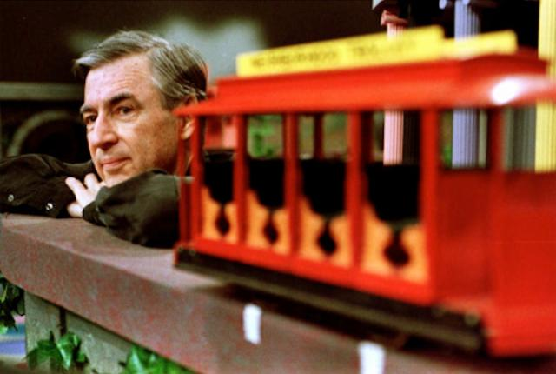
Mister Rogers' Neighborhood won four Emmy awards, and Rogers himself was presented with a Lifetime Achievement Award at the 1997 Daytime Emmys, as described by Esquire's Tom Junod:
Mister Rogers went onstage to accept the award—and there, in front of all the soap opera stars and talk show sinceratrons, in front of all the jutting man-tanned jaws and jutting saltwater bosoms, he made his small bow and said into the microphone, "All of us have special ones who have loved us into being. Would you just take, along with me, ten seconds to think of the people who have helped you become who you are. Ten seconds of silence."
And then he lifted his wrist, looked at the audience, looked at his watch, and said, "I'll watch the time." There was, at first, a small whoop from the crowd, a giddy, strangled hiccup of laughter, as people realized that he wasn't kidding, that Mister Rogers was not some convenient eunuch, but rather a man, an authority figure who actually expected them to do what he asked. And so they did. One second, two seconds, three seconds—and now the jaws clenched, and the bosoms heaved, and the mascara ran, and the tears fell upon the beglittered gathering like rain leaking down a crystal chandelier. And Mister Rogers finally looked up from his watch and said softly "May God be with you," to all his vanquished children.
To see this on You Tube, click the picture –

Link - https://www.youtube.com/watch?v=Upm9LnuCBUM
Mr. Rogers had episodes about friends, friendships, being friendly, such as –
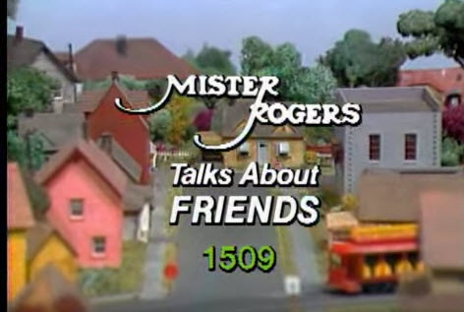
Link - https://www.youtube.com/watch?v=7ZJY6yf0uLY
I, also, found on You Tube -
Mister Rogers' Neighborhood Friends
Mister Rogers' Neighborhood Friends 1509
You are my friend you are special Mr Rogers
Mister Rogers' Neighborhood 22x08 Imaginary Friends part 3
Mr. Rogers "You are my Friend, You are Special"
Mister Rogers - Friends often have hard times
Mister Rogers - It's good to talk with your friends when you are angry
"Mister Rogers' ASL Friends"
And with some more searching I am sure you can find others.
For a deeper look at Fred Rogers, watch the clip of him on the Tonight Show –
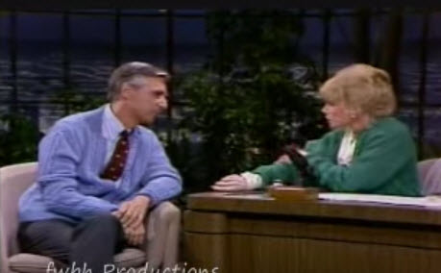
Link - https://www.youtube.com/watch?v=p-Kp5YeqrlE

Mr Rogers Quotations
The greatest gift you ever give
is your honest self.
Forgiveness is a strange thing. It can sometimes be easier to forgive our enemies than our friends. It can be hardest of all to forgive people we love. Like all of life's important coping skills, the ability to forgive and the capacity to let go of resentments most likely take root very early in our lives.
When I say it's you I like, I'm talking about that part of you that knows that life is far more than anything you can ever see or hear or touch. That deep part of you that allows you to stand for those things without which humankind cannot survive. Love that conquers hate, peace that rises triumphant over war, and justice that proves more powerful than greed.
When I say it's you I like, I'm talking about that part of you that knows that life is far more than anything you can ever see or hear or touch. That deep part of you that allows you to stand for those things without which humankind cannot survive. Love that conquers hate, peace that rises triumphant over war, and justice that proves more powerful than greed.
Love isn't a state of perfect caring. It is an active noun like struggle. To love someone is to strive to accept that person exactly the way he or she is, right here and now.
Anything that’s human is mentionable, and anything that is mentionable can be more manageable. When we can talk about our feelings, they become less overwhelming, less upsetting, and less scary. The people we trust with that important talk can help us know that we are not alone.
Mutual caring relationships require kindness and patience, tolerance, optimism, joy in the other's achievements, confidence in oneself, and the ability to give without undue thought of gain.
Whether we're a preschooler or a young teen, a graduating college senior or a retired person, we human beings all want to know that we're acceptable, that our being alive somehow makes a difference in the lives of others.
We need to help people to discover the true meaning of love. Love is generally confused with dependence. Those of us who have grown in true love know that we can love only in proportion to our capacity for independence.
Who we are in the present includes who we were in the past.
The child is in me still and sometimes not so still.

OTHER FRIENDLY "PEOPLE"
I had trouble finding a person a highlight this month for "Friendly." It appears that attribute is not cited too often. My wife suggested,
"Casper, the Friendly Ghost."
And I said maybe, but I prefer a real person. But I did find Casper in "Boo Scout" on line. He is very friendly but when watching remember this video is from 1951 and somethings have changed.

The link - https://www.youtube.com/watch?v=T-ThhkmrMe8 If you Google for Boo Scout it is on You Tube more than once.
I checked for "Friendliest Athletes," and found various lists like – "5 Favorite Good-Guy Pro Athletes," (http://www.yourtango.com/201070181/5-favorite-good-guy-pro-athletes/page/1/ ) by Sara Brady which lists Drew Brees, Scott Fujita, LeBron James, Roger Federer, and Ray Allen. Other lists I found have Venus Williams and lots of other athletes. All great athletes and all donating money to foundations doing good for people. But the word friendly did not appear.
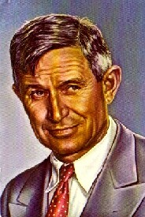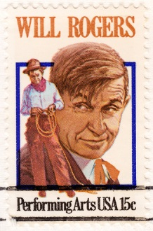
I thought about Will Rogers ("I never met a man I didn't like") but I had featured him in Baloo's Bugle recently. Go to the Positive Attitude issue from 2011-2012 Scouting Year.
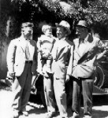

Will Rogers, Wiley Post and Waite Phillips at Villa de Philmonte

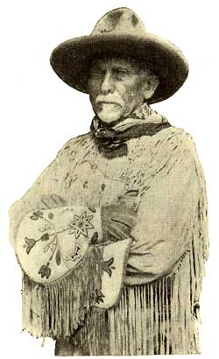
And Daniel Carter Beard (Uncle Dan, the first National Commissioner of the BSA) who was featured in a Boys' Life article titled, "The Friend of Youth." He is the only one of the founding fathers of the BSA (James E West, Ernest Thompson Seton, William D Boyce) usually shone pictured with youth. If you want to read the article, go to http://boyslife.org, and click on the archives, or Wayback Machine, and look up the 1925 article. I will feature him in a future issue.
Then I talked (actually texted) with my daughter and her friend Kelly and they suggested, Mr. Rogers. Whom you already know I chose to feature.

CUB SCOUT LEARNING LIBRARY
The NEW https://cubscouts.org/ !!!

This is the Cub Scout Learning Library –
Everything you could want to know for Cub Scouts is or will be here. And all within a click or 3 of the home page. National heard the message that although things were at www.scouting.org they were often buried too deep to be found.
This site has admin stuff and practical stuff. The new Den Leader Resource Books are here. You can download some of the pages for each Adventure for FREE
This website is a great resource. There are still parts under construction but what is there is GREAT!!

BSA seems to be working off the same plans that www.USScouts.org and other "unofficial" Scouting websites use. They have seen what you the volunteers want and are delivering it. I hope they are successful and some of us old guys (I have my Medicare card) can retire from our web duties.
Yes, https://cubscouts.org runs on a phone, too!!!

There are 3 tabs on top of the home page –

- Learning Library
- Cub Hub
- Join Scouting
- Learning Library takes you where you can learn about your position and pick up hints. Besides specifics for dens of each rank, other clickable links include –
KEY
- All or most of material was placed on site this past month
- All or most of material was in place and listed as such in last month's Baloo's Bugle.
- Site / pages under construction
- Den Leader
Den Meeting Basics
- Your First Den Meeting
- Planning Den Outings
- The Parts of a Den Meeting
- Getting Started
Three of the Core Adventures for the selected rank are listed here. Click on them and you will see / can download all the Leader's Guide pages for these three Adventures.
- Additional Required Adventures
The remaining Core Adventures for the selected rank are listed here. When you click them you get an intro to the Adventure but do not get the Meeting Plans and Resources. You see this note:
To get you started in delivering fun and engaging meetings, complete Den Meeting Plans are available here on the Learning Library for the Backyard Jungle and Games Tigers Play adventures. To obtain Den Meeting Plans for all other adventures, Den Leader Guides are available at your local Scout Shop, online at scoutstuff.org, or as an eBook through Amazon.
- Elective Adventures
All the Elective Adventures for the selected rank are listed here. When you click them you get an intro to the Adventure but do not get the Meeting Plans and Resources. You see the same note (above).
- Building Strong Dens
The Basics of Cub Scouts
- Advancement
- BSA Mission and Vision Statements
- Cub Scout Ages and Ranks
- Cub Scout Uniforming
- Den Flags
- Den Yells
- Leader Survival Kit
- Methods of Cub Scouting
- Purpose of Cub Scouting
- Roles and Responsibilities
- Scout Oath and Law
- What Is Cub Scouting?
- Training
- The Role of Training
- Youth Protection
- Den Planning And Administration
- Advancement Basics
- Advancement Requirements
- Annual Planning For Your Den
- Coordinating Your Den Plan with Pack
- Tracking and Recognizing Advancement
- Youth Protection Training
- Positive Youth Development and Working with Boys
- Developmental Differences Boys 7-11
- Behavior and Discipline
- Positive Youth Development
- Working With Special Needs Cub Scouts (Advice is specific to each Special Need. Lots of research was done to prep these pages.)
- Parents’ Prejoining Conference
- Leadership Techniques
- Working With Specific Disabilities and Needs
- Cubmaster
- Committee Chair/Member
- Chartered Org Rep
- Parent / Adult Partner
- Cub Hub takes you to a Cub Scout specific Blog similar to Bryan's Blog. The topics discussed here through this month were:
Three Opportunities to Boost your Cub Scouting Expertise Increase Your Scouting Expertise with these Great Learning Opportunities! You’ve heard the rules of real estate are…READ MORE
Are Scout Jokes Just Dad Jokes in a Uniform? Jokes and Cub Scouts have a long history of being mutually perfect for one another. We’ve blogged…READ MORE
These Halloween Cub Scout Skits are Hilarious Crisp Air and Changing Leaves Autumn is a fun season in your Cub Scouts den and pack. With…
READ MORE
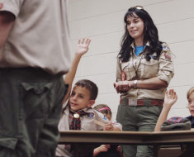 Scouting: Fun for the Whole Family Meet Lydialice. She is a mom whose boy was looking for more outdoor adventure. In her own…
READ MORE
 The “Digital Pack” is Growing, We Just Hit a BIG Milestone Last week saw a big milestone for what we affectionately call the “Digital Pack.” Our Cub Scouts…READ MORE
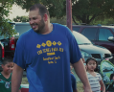 Scouting: A Priority for Family Meet Juan. He grew up in Mexico and as a teenager immigrated to the United States. Having…READ MORE
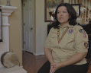 Scouting: An Extension of Family Meet Catherine, or as the Cub Scouts in her den call her, Ms. Cat. She’s a Scout mom,…READ MORE
 Scouting: Not Just a Club, but a Family Meet Becky. Her son just crossed over from Cub Scouts to Boy Scouts, and is about to…READ MORE
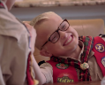 Scouting: Getting the Most out of Family Time Meet Michelle, the proud mother of a Webelos Scout. She knows that life can be busy and…READ MORE
 Scouting: A Way to Invest in Your Family Meet Lester and Apryl who’ve been involved in Scouting for a combined total of 23 years. Together,…READ MORE
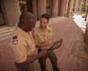 This Scout Dad Makes a Terrific Case to Join Cub Scouting Just outside of Minneapolis is the community of Prior Lake. And its local newspaper, the Prior Lake…READ MORE
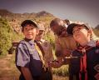 All the Latest Resources for Scouting Recruitment We’ve done it! We brought back the popular #CubChat Twitter chat event for a special conversation on…READ MORE
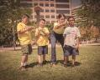 6 Planning Tips for your Cub Scout Calendar When it comes to leading a Cub Scout den or pack, from Blue and Gold to Day… READ MORE
- Join Scouting takes you to www.beascout.org
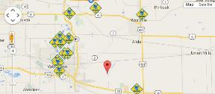

- Also, on the home page –
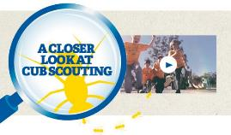
This link takes you to a YouTube Video
on Cub Scouting.
https://www.youtube.com/watch?feature=player_embedded&v=dqKFgk8SJlE
These Six Links take you to:
(From top left across, then down)

www.scoutstuff.org – The Supply Division site where you can find the location of your nearest National Scout Shop or buy all your Scout supplies
http://scoutingwire.org/ - Where you can get the latest Scouting News from around the country. You can sign up to get notifications when things are posted here..
www.scouting.org/programupdates - The great site where all the news about all the changes to Cub Scouting, Boy Scouting, and Venturing can be found.
https://www.scoutbook.com/ Where you can get the Scoutbook APP to track your son's Scouting Experience from Tiger to Eagle Scout.
I just learned that Bob Scott is at it again. Bob led us on the charge to "Cub Scouts 2010" and then to "CS Adventure Program." Now he is leading the Scoutbook effort. It is sure to be a success!! Thank you, Bob - CD


www.boyslife.org – Go directly to the on-line edition of Boys'Life
http://scoutingwire.org/marketing-membership/ Get resources and materials to strengthen your unit at BSA's marketing and membership site. Learn the best practices and tips employed by the most successful units.

CUB SCOUT
LEADER TRAINING

ON-LINE TRAINING
On October 25, 2015, this post appeared on the BSA Volunteer Training Team Facebook Page (https://www.facebook.com/BSAtrainingteam/ )
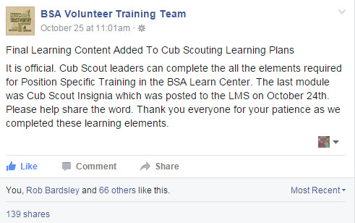
And the comments I read confirm that the system is up, running, and complete!! My Council Training Chair was excited that he could now be qualified for his position in his son's pack!!!
The online training for Den Leaders, Cubmasters, Committee Chairs and members, and Chartered Organization Representatives is totally updated with help from volunteers from around the country. The new training is divided into shorter, more targeted modules so leaders can get the training they need, in the order they want, any time they need it. It is organized around the learning needed prior to the first meeting, in the first 30 days, and to be position-specific trained. This training was developed to be implemented in conjunction with the BSA’s new learning management system. Keep an eye on My.Scouting Tools (log in at https://My.Scouting.org ) for more information.
Go to the BSA Volunteer Training Team Facebook page (Link above) and .
Then you automatically receive the latest news!!
Then on October 28, I saw –
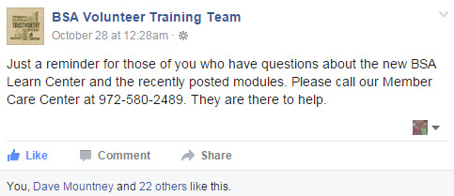
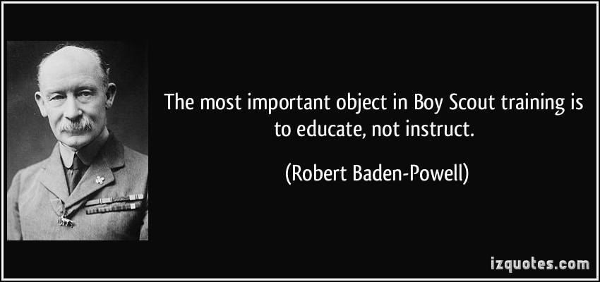
A Typical Learning Plan has several parts –
Here you can see the three parts of the CM Course -


Each of these three parts is broken down into "bite sized" chunks:
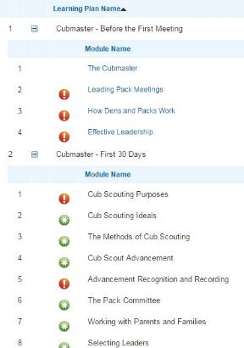
Go check it out and get your
people trained!!!
If you are having difficulties with the training or
system call Member Care at 972-580-2489,

IN-PERSON TRAINING
Position-Specific In-Person Training Guides Available Now! The training guides for
- Den Leader (http://www.scouting.org/filestore/training/pdf/515-215.pdf ),
- Cubmaster/Assistant Cubmaster (http://www.scouting.org/filestore/training/pdf/511-503_WB.pdf ), and
- Pack Committee (http://www.scouting.org/filestore/training/pdf/511-504_WB.pdf )
are available on Scouting University. You can access them at http://www.scouting.org/training/adult.aspx .
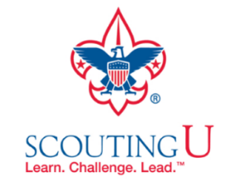

ADVENTURE PLAN TRACKERS
- Tracking Spreadsheets are posted on the USScouts Advancement webpage (www.usscouts.org). There are be links to them from other places on the site. These spreadsheets are similar in construction and user interface as the existing spreadsheets. The spreadsheets have be tested by the developer of the current spreadsheets and he said they are so good he sees no reason to develop others!!
- Utah National Parks Council has Excel spreadsheets posted for all the new Adventure Plan requirements on their Akelas Council Blogspot. www.Akelascouncil.blogspot.com . Check them out.
The Advancement Excel Spreadsheet workbooks are distributed to Scouters for FREE.
PLEASE do not download the files from either site to email or send them digitally to others. They are for your personal / pack use only. If you would like to share these files with others, please copy / send the link to them and send them to the site so they can print off their own. They would love everyone that wants a copy to get their own copy absolutely free. Both USScouts and Utah National Parks receive Ad money based on the number of people visiting the site that helps keep their websites open. Please help us by encouraging others to visit them to obtain the files.

MEANINGS OF ITEMS COMMONLY USED AT CUB SCOUT CEREMONIES
- Cub Scout colors Blue (truth and spirituality, steadfast loyalty, and the sky above) and Gold (warm sunlight, good cheer, and happiness)
- The seven rays of light on the arrow of light represent, in order, wisdom, courage, self-control justice faith hope and love.
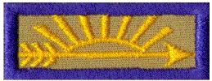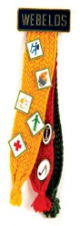
- Webelos colors - The three badge colors represent the three programs in the BSA: Cub Scouting (the yellow/gold), Boy/Varsity Scouting (the red) and "Senior Scouting" (used to be Exploring and now Venturing, the green). These are the same three colors found in the "WEBELOS Tartan", an official tartan (plaid) color combination recognized in Scotland (and is also referred to as the "Boy Scouts of America Tartan", just so you know.
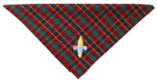
- Webelos neckerchief with 4 colors in it: the Blue & Gold of Cub Scouts and the Red and Green of Boy Scouts. The Green stands for the outdoors and nature, which Scouts are obliged to protect and care for. Red stands for bravery, being prepared to help others, and pride for our country.

Classic Boy Scout
Fleur-di-lis Fleur-di-lis
- The symbol of Scouting is the Fleur de lis, which was used as the north arrow on old sailors' compasses. It will point the youth on the right way in life, just like a compass. The 3 points stand for the 3 points of the Scout Oath. The 2 stars are for truth and knowledge. The eagle is the symbol of the USA. The shield stands for freedom and the readiness to defend that freedom.
- Candle light - stands for the help and encouragement given to Cubs by his leaders, family and friends.
- Red, White and Blue in U.S.A flag stand for, in order – Red - lifeblood of brave men ready to die or worthily live for this; our country. White - purity, cleanliness of purpose; thought and deed. Blue - faith and loyalty, like the eternal blue of the star-filled heavens.

ROUNDTABLE HINTS

RTs – The Most Important Part of Unit Service
BS150, George Costigan, National Capital Area Council,
and a little CD philosophy
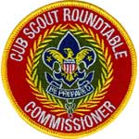
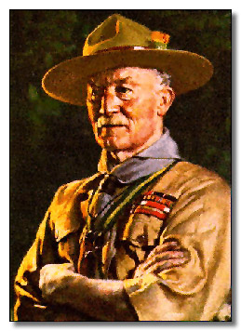
“Roundtable is the single most important event of the district.”
Baden-Powell, 1912
Roundtable is a major element of Unit Service
- The role of Roundtable Commissioners (RTCs) is absolutely critical & serves the District “front line”. The RTC is in direct contact with Unit Leaders every month.
- Units will emulate what they see being demonstrated at the Roundtable, so great Roundtables will help build and sustain great units. (e.g. Uniforming, Respect, Attitude toward Council and National)
- Roundtables are the “group service” tool of unit service. RTs serve many units at once.
- DCs should devote time in monthly commissioner staff meetings to RTCs like they do to any other ADC they have.
- Council Commissioners should also be devoting time in their meetings to making sure Roundtables are effective
RTC's and Assitant Rouuntable Commissioners (Formerly called staff) are like all the other Commissioners except for their specialty – ROUNDTABLES!!!
Note – Assistant RT Commissioners (Those Commissioners runing breakouts, taking attendance, demonstrating skills, leading songs, and more) are indeed COMMISSIONERS!! The Wreath of Service is on their positon patch. They are eligible to earn the Arrowhead Award and the all appropriate Commissioner Training and Honorary Awards. It was to eliminate potential confusion that the title was changed from Staff to Assitant RT Commissioner.
Like Any Other Commissioner,
the RTCs & ARCs Are:
- A friend of the unit
- A representative of BSA
- A unit “doctor”
- A teacher
- A counselor
- An example
- A source of information
RTC's and ARC's
Set the example – in uniforming
The uniform they wear and the way they wear it is the example.
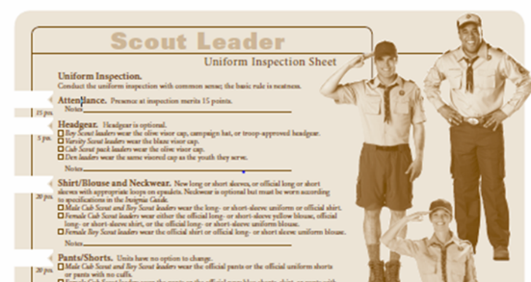
Are a Source of Information
Local Scouters usually expect the RTC and ARCs to know about eeverything being done at Council and District. They need to know what's is up and who is the point of contact.

Are alert for Early Warning Signs of unit trouble.
RTCs hear and see things that are the first signs of
trouble in a unit. A unit that has been regular in RT attendance begins missing RTs. A unit that has not been there shows up with upset leaders.

Roundtable services include:
- Providing a forum where problems can be discussed.
- Fostering the exchange of ideas
- Building trust and comradery
- Mentoring
- Providing supplemental training
Some of these happen just because Scouters are gathered at the RT and begin talking. There is the very imporatnt parking lot or Harrison House (local diner) meeting after RT.

What will Cub Scout RTs be presenting?
They will be presenting ideas for the next (not current month's) program. That is why Baloo's Bugle for January's RTs has info for February's Core Value (Friendly) and theme (Friends Near and Far). Next month, February, Baloo's Bugle and RT will feature March's Core Value and Theme. Got it?? If your RT is not doing the next month (or two months ahead as Alice in Sacramento does), see if they will change!!
Following the January RT a Pack should hold its January Pack Committee Meeting (or Leaders' Meeting or whatever you call it). At that meeting you:
- Verify everyone is ready for January's Pack Meeting. Assignments were made at December's Committee Meeting.
- Plan and make assignments for February
- Take a quick look at March and other months

DEN MEETING TOPICS
Remember – Boys want to be active!!
See, too, that they earn their awards
(Never say GET. You get sick, you do not get awards – You earn awards. A little CD Philosophy).
Big Rock Ideas – suggestions for Big Rocks that fit Interest Topics or seasonal activity. If years are next to an item (e.g. 13-14) that suggested Big Rock is in that Roundtable Planning guide and on-line at http://www.scouting.org/scoutsource/Commissioners/roundtable.aspx
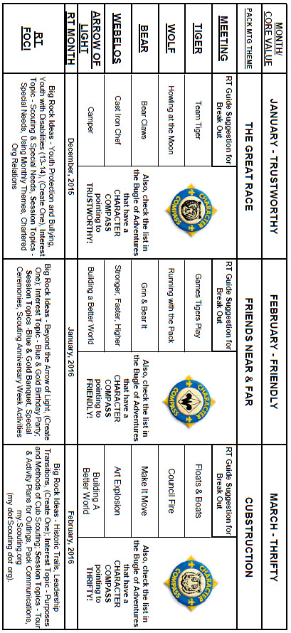

CHARACTER COMPASS
FEBRUARY -
ADVENTURES with a CHARACTER COMPASS pointing to FRIENDLY:
TIGER –
- Games Tigers Play (Core)
- Curiosity, Intrigue, & Magical Mysteries (Elec)
WOLF –
- Running with the Pack (Core)
- Digging in the Past (Elec)
BEAR –
- Grin & Bear It (Core)
- Marble Madness (Elec)
WEBELOS CORE –
- Stronger, Faster, Higher (Core)
ARROW OF LIGHT CORE –
- Building a Better World (Core)
WEBELOS & AOL ELECTIVES –
- Aware & Care (Elec)
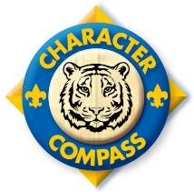
MARCH -
ADVENTURES with a CHARACTER COMPASS pointing to THRIFTY:
TIGER –
- Backyard Jungle (Core)
- Floats and Boats (Elec)
WOLF –
- Council Fire (Core)
- Code of the Wolf (Elec)
BEAR –
- Fur Feathers & Ferns (Core)
- Make It Move (Elec)
WEBELOS CORE –
- Cast Iron Chef (Core)
ARROW OF LIGHT CORE –
- Building a Better World (Core)
- Camper (Core)
WEBELOS & AOL ELECTIVES –
- Art Explosion (Elec)
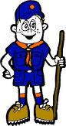

PACK MEETING THEMES
AND PLANS
www.scouting.org
From National's Website for the new plans using the Core Values based on the Scout Law:
Here are a few thoughts to consider around these new pack meeting plans. First, there is a plan for each month that corresponds with a point of the Scout Law. In addition, each plan has a theme to help make the pack meeting even more fun! The plans do not have to be used in a specific order.
Tips for Utilizing the Plans
- Pack meeting plans do not have to be done in any special order, but it is recommended that you include all of the points of the Scout Law each year. The pack planning meeting would be a good time to determine the order.
- There are pack meeting plans for multiple years posted on the website. It is your pack's choice of which one to select from each point of the Scout Law for each year.
- Pack meetings should not last longer than an hour. Adjust the plan to make it fit within the time. Research and experience tells us that Cub Scouts have a hard time sitting still for that long. Keep the meetings fun, active, and engaging.
- If you are comfortable with a costume to fit the theme of the meeting, go for it!
- Importantly, keep it simple and make it fun.
- The following required adventures have a requirement that suggests or requires completion at a pack meeting. Please plan accordingly as part of your annual program planning process. Work with your den leaders to plan when these activities will take place.
Tiger
- Tigers in the Wild, requirement 5. Participate in an outdoor pack meeting or pack campout campfire. Sing a song and act out a skit with your Tiger den as part of the program.
- Games Tigers Play, requirement 3. Make up a new game, and play it with your family or members of your den or pack.
Wolf
- Council Fire, requirement 6c. Create a den project from recyclables for a pack meeting.
Bear
- Grin and Bear It, requirement 2. Working with the members of your den, organize a Cub Scout carnival and lead it at a special event.
- Grin and Bear It, requirement 3. Help younger Cub Scouts take part in one of the events at the Cub Scout carnival.
Webelos
- Stronger, Faster, Higher, requirement 5. With adult guidance, lead younger Scouts in a fitness game or games as a gathering activity for a pack or den meeting.
Arrow of Light
- Building a Better World (if chosen), requirement 10b. Set up an exhibit at a pack meeting to share information about the World Friendship Fund.
As a personal note: I have read some of the plans and they are excellent and just as complete as the new Den Leader Books. The games, and other stuff are right there. Including costuming ideas for that added PIZAZZ!! If you do not use themes and do not add PIZAZZ you are not doing your best for your pack.
GOOD JOB!!! From CD
Check them out at:
http://www.scouting.org/Home/CubScouts/Leaders/CubmasterResources/PackMeetingPlans.aspx


Kim, the chair of the task force, says "I do want to stress that the focus is still the Core Value and the theme is just there as an enhancement. Pack meeting theme plans are specifically crafted to bring out the important points of the Core Value in a fun way."

PACK MEETING THEMES
2015–2016 Pack Meeting Plans
January | Trustworthy | "The Great Race"
February | Friendly | "Friends Near And Far"
March | Thrifty | "Cubstruction"
April | Cheerful | "Strike Up The Band"
May | Kind | "My Animal Friends"
June | Obedient | "It's A Hit"
July | Loyal | "Scout Salute"
August | Courteous | "S'more Cub Scout Fun"

2016–2017 Pack Meeting Plans
September | Helpful | "To The Rescue"
October | Kind | "Creepy Crawlers"
November | Courteous | "Cubs In Shining Armor"
December | Cheerful | "Celebrate"
January | Obedient | "Cub Scout City Council"
February | Reverent | "Passport To Other Lands"
March | Loyal | "Our National Treasures"
April | Thrifty | "Power Up!"
May | Clean | "A Picnic With Pizzazz"
June | Brave | "Roaming Reptile Alert"
July | Trustworthy | "Let The Games Begin"
August | Friendly | "#CUBSCOUTS"
If you are using a paper copy the link to all the
Pack Meeting Plans is:
http://www.scouting.org/Home/CubScouts/Leaders/CubmasterResources/PackMeetingPlans.aspx

UPCOMING MONTHS
- February's Core Value, Friendly, will use the theme, Friends Near and Far:
Month | Year | Theme
Potential "Friends Near and Far" Months
March | 1943 | United Nations Month
January | 1946 | Boys of the World
Novr | 1947 | In Old Mexico
April | 1949 | Life in the Philippines
March | 1959 | Canada, Land of the Mounties
January | 1961 | South America
March | 1962 | Islands of the World
March | 1965 | South of the Border
Decr | 1973 | Customs of Countries
Dec | 1979 | Customs of Other Lands
Dec | 1989 | Customs of Countries
April | 1991 | Canada, Our Neighbor
Dec | 1994 | Customs of Other Lands
March | 1999 | Gateway to the Orient
February | 2001 | Passports to Other Lands
April | 2003 | Land of the Pharaohs
Dec | 2013 | Passport to Other Lands
June | 2014 | Over the Horizon

FRIENDLY
(Themes for former CV's Compassion & Cooperation)
December | 1944 | The Other Fellow
December | 1949 | The Other Fellow
December | 1951 | F-H-G (good followers,  helpers, & givers)
Sept | 1965 | Barn Raising
December | 1984 | Do a Good Turn
December | 1986 | The Golden Rule
December | 1992 | To Help Other People
December | 1995 | Do a Good Turn
December | 1996 | Helping Others
December | 1997 | The Golden Rule
July | 2002 | Inside Out and Backwards
March | 2004 | Walk In My Shoes
January | 2009 | A-MAZE-ing Games

The core value highlighted next month is:
March's point of the Scout Law, THRIFTY, will use the theme, CUBSTRUCTION.
A SCOUT IS THRIFTY
A Scout is a friend to everyone, even people who are very different from him..
HOW DOES “CUBSTRUCTION” RELATE TO THIS POINT OF THE SCOUT LAW?
Part of being thrifty is avoiding waste and using resources wisely. It is important to learn how to conserve and repurpose the many items we use every day to help our environment as well as use our resources in an innovative way for fun and adventure.
March's Core Value, Thrifty, will use the theme, Cubstruction:
Month | Year | Theme
THRIFTY
(Themes for Resourcefulness & Perseverance)
March | 1944 | When Dad was a Boy
June | 1968 | When Dad was a Boy
February | 2011 | Resourcefulness
June | 2011 | Perseverance
February | 2012 | Resourcefulness
June | 2012 | Perseverance
June | 2013 | Head West Young Man
June | 2014 | Over the Horizon

Potential "CUBSTRUCTION" Months
January | 1999 | Cubstruction
March | 2006 | Cubstruction
March | 1949 | Cub Scout Inventors
March | 1970 | Craftsman
November | 1983 | Bright Ideas
January | 1985 | Working with Wood
January | 1990 | Invention Convention
May | 1991 | Working with Wood
June | 1992 | Genius Night
January | 1996 | Working with Wood
May | 1997 | Reinventing the Wheel
January | 1998 | Genius Night
October | 1998 | Imagine That!
March | 2008 | Litter to Glitter
February | 2014 | Invention Convention
February | 2015 | Litter to Glitter

Month | Year | Theme
SELECTED BLUE & GOLD THEMES
February | 1978 | Blue & Gold Traditions
February | 1981 | Great Events of Scouting
February | 1985 | Diamond Jubilee
February | 1988 | Great Events of Scouting
February | 1991 | Blue & Gold Traditions
February | 1994 | Blue & Gold Traditions
February | 1995 | Great Events in Scouting
February | 2000 | Turn Back the Clock
February | 2005 | It's A Scouting Celebration

WEBELOS

ARROW of LIGHT PRESENTATION
This ceremony combines “Top of the Mountain,” based on a story by Ernest Thompson Seton and “The Seven Virtues” graduation ceremony. Either one alone also makes an impressive Arrow of Light Ceremony
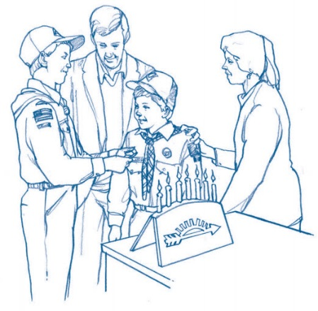
Props:
Pictures or actual or props for
- cactus,
- sagebrush,
- cottonwood spray,
- cedar and
- pine,
"Cub-a-labra" with 7 candles, (See picture above).
Preferably one using the 7 rays of the Arrow of Light as candleholders. If the construction will allow this, definitions of the Seven Virtues in large type could be placed on the back side of the Cub-a-labra (out of sight) so that it looks like the boys have memorized the parts.
Candleholder with four candles – White, Green, Blue, Yellow (All about the same size and shape)
Large white candle to use to light all the others
Personnel –
- Cubmaster (CM)
- Assistant CM (CA)
- Webelos Leaders (WL)
- Committee Chair (CC)
- All Cub Scouts receiving the Arrow of Light
- One Cub Scout from each rank, including Bobcat.
Set Up – station the following Cubs outside of the ceremony area –
- Tiger with cactus
- Bobcat with Sagebrush
- Wolf with cottonwood spray
- Bear with cedar
- Webelos Scout with pine bough
- Arrow of Light Webelos Scout or one receiving it that night
Ceremony -
Cubmaster - Tonight we gather to honor (# of Scouts receiving award) WEBELOS Scouts that have earned the highest award in Cub Scouting: The Arrow of Light. But before I present these awards, let me take a moment to relate an appropriate story and tell you a little about the Arrow of Light.
Afar in our dry southwestern country was an Indian village, behind which a high mountain towered above the desert. It was considered a great feat to climb this mountain, so all the young braves of the village were eager to attempt it.
One day, the chief said, “Now, boys, you may all go today and try to climb the mountain. Start right after breakfast, and go as far as you can. Then when you are tired, come back; but each of you must bring me a twig from the place where you turned.
Away they all went; full of hope, each feeling that he surely could reach the top.
Soon the first boy returned. (Enter Bobcat with sagebrush) He carried a twig of sagebrush. You did not reach the mountain; you did not even cross the desert. I like to think this boy is like a newly inducted Cub Scout; he has just barely started.
An hour later the second boy came slowly back, puffing and sweating. (Enter Tiger with cactus) He stood before the chief, and in his hand he held a piece of cactus. The chief smiled and said, “My boy, you barely got started.” “Well” said the chief, “you reached the foot of the mountain, but you did not start the climb.” This boy is like the Cub Scout who has earned his Tiger badge; he has progressed on his journey but has not really started his climb.
After another hour, the third boy came back. (Enter Wolf with cottonwood spray) He held out a cottonwood spray. “Good” said the chief, “you got as far as the springs.” This might represent the Cub Scout who has reached the first level of his climb and received his Wolf badge.
A while later, another boy came back with some cedar. (Enter Bear with cedar) The chief smiled when he saw it, and spoke, “Well done, my boy, you went halfway up.” This is like the Cub Scout who has progressed halfway up the advancement trail and earned his Bear badge.
Later in the afternoon, the next boy returned carrying a branch of pine. (Enter Webelos Scout with pine bough) To him the chief said, “Good, you went to the third level. You made three - quarters of the climb. Keep on trying. Next year you will undoubtedly reach the top.” The Cub Scout who has earned his WEBELOS badge has reached the three-quarter mark and is in sight of the top.”
The sun was low when the last boy returned. (Enter Arrow of Light Webelos Scout) He was a tall, splendid boy of noble character. He approached the chief and held up his hand. It was empty. But he was radiant as he spoke. “My father, there were no trees where I went. I saw no twigs, no living thing upon the peak. But far and away I saw other mountain peaks, and beyond them the shining sea.” Now the old Chief's face glowed as he said, “I knew it! I knew it when I looked upon your face. You have reached the top. It is written in your eyes and it rings in your voice. My boy, you need no twigs for token, you have seen the glory of the mountain.”
The brave who reached the top is like the Cub Scout who has reached the top - the Arrow of Light Award. But, beyond the top are the peaks of the Boy Scouting program that must be met and climbed to reach the shining sea of adulthood.
Our Scouts like the brave that reached the top of the mountain, have worked very hard to earn this prestigious award, and to demonstrate that they understand the purpose of Scouting.
Webelos Scouts of Akela, are you ready to climb the mountain?
Then climb up on the stage (using the steps) and take your positions at the large Arrow of Light
CM The Arrow of light is the highest Award in Cub Scouting. It is the only Cub Scout badge of rank that a Cub may transfer to his Boy Scout uniform.
Tonight we are privileged to present ___ Arrow of Light Awards.
You see the Pack ### Webelos Class of 20?? assembled at the ceremonial Arrow of Light
CA Webelos Scouts, you have completed all the requirements for the Arrow of Light Award. You have visited a Boy Scout Troop and obtained an application to join. You have begun to see the excitement that lies ahead for you in Boy Scouting.
WL #1 (Lights blue candle) This blue candle represents the sprit of Cub Scouting. That spirit of giving good will and doing your best.
WL #2 (Lights white candle) This white candle represents the spirit of Scouting. If you promise to fulfill the Cub Scout Promise and the Cub Scout Motto, Do Your Best. Please say, “I do”
WEBELOS I DO !!!!!
CC (Lights yellow candle) This yellow candle represents the Arrow of Light Award. Let’s take a moment to look at the Arrow of Light before we go any further.
CM The seven candles before you represent the rays in the Arrow of Light. These seven rays stand for the seven great virtues of life...virtues that WEBELOS Scouts must have if they are to succeed and advance in Scouting and in life. For younger Scouts, living by and using these 7 great virtues will help you achieve much on your trail upward to the Arrow of Light.
All other Webelos scouts please join their brothers on the stage to help in explaining the seven rays on the Arrow of Light.
Webelos #1 A Scout has WISDOM (light candle #1) Having wisdom doesn't mean that a Scout is smarter than others. It means that he uses what he knows to live a better life -- to be a good example for other people, young and old, Scouts and others, family and friends.
Webelos #2 A Scout has COURAGE (light candle #2) Having courage doesn't mean that you're never afraid -- very courageous people are often afraid. However, facing danger despite your fear is the act of a brave, courageous Scout.
Webelos #3 A Scout has SELF-CONTROL (light candle #3) Scouts have to know when to stop. When you can stop yourself when you have had enough or done enough of something -- enough eating, enough playing, or even enough working -- then you have self-control. Know what behavior is correct in each situation, and do it. When you have self-control, you are growing up as a Scout.
Webelos #4 A Scout gives JUSTICE (light candle #4) Justice is part of the Pledge of Allegiance: "with liberty and justice for all." Justice is being fair with others that we go to school with, work and play with. Justice means it doesn't matter who the person is, or what color they are, or what they do...Scouts are fair to everyone.
Webelos #5 A Scout has FAITH (light candle #5) Scouts believe in God. Faith means that we believe in God and other things we cannot see. When you know God exists in your heart, you have faith.
Webelos #6 A Scout has HOPE (light candle #6) Hope means you look forward to good things that you believe will happen. You hope for better things tomorrow, but you work hard today to make those good things happen.
Webelos #7 A Scout has LOVE (light candle #7) Scouts have many kinds of love. Love of family, home, your fellow Scouts, God and country are all a part of Scouting. Every kind of love is important for a full and happy life.
CM Thank you Webelos. You may return to your seats now.
CA You will find that if you live your life by these seven virtues, you will be happy and will make the people around you happy as well.
CC The WEBELOS Scouts before us this evening have proven that they understand their responsibilities as good sons and good Scouts. With the help of their willing parents, they will advance far along the Boy Scout Trail.
Webelos Scouts please extinguish your candles and assemble at the front of the stage.
CA Parents come forward and stand behind your sons
CC Remember that the spirit of Cub Scouting and Boy Scouting are one and the same. The spirit of the entire Scouting movement is one of service, high ideals, and fellowship.
CM To each family I am presenting the Arrow of Light Award and ask you pin it on your boy. This award is worn on your Webelos uniform now and your Boy Scout uniform later.
CA Notice that we left an unlit green candle representing the Boy Scout program. This is to remind you that there is more adventure ahead as you continue in Boy Scouting after your graduation.
CM Congratulations, Scouts. (Lead Cheer)

WEBELOS TO BOY SCOUTS
BRIDGING CEREMONY
Del-Mar-Va Council
I picked this up at a Del-Mar-Va Council Pow Wow a few years ago and it has become my favorite bridging ceremony. The bridge I made for this ceremony generally gets used several times each year as other Packs in my district borrow it for the ceremony. CD
Props –
4 - 5 to 6 foot 4 X 4's (or 2X6’s) for foundation
notched to interlock
5 - 4 foot 2x10's - one plain, one yellow, one blue,
one green, one red
All words are spoken by same person (Narrator, Cubmaster) but you could divide them up amongst several leaders.
Narrative
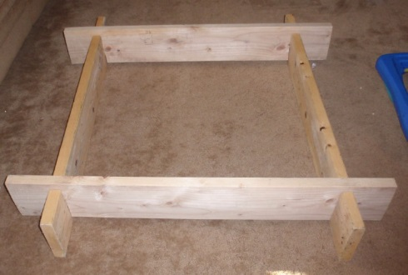
WEBELOS leader, will you please place the first post on the stage in a North/South direction. (WL places post)
WEBELOS Asst. leader, please place the second post on the stage three feet away from the first post in the North/South direction. (WA places post)
These two posts placed here are symbolic of the foundations of Scouting that these WEBELOS leaders have instilled in their WEBELOS Scouts through activities and outings as represented by the natural brown color.
Scoutmaster (name) and Assistant Scoutmaster or Senior Patrol leader), please place your posts in an East/West direction 3 feet apart over the North/South posts that are already in place. (SM and SPL place posts)
As represented by the structure assembly, Boy Scouting will build on the Scouting foundation begun in WEBELOS. These leaders have set the stage for bridging the boys from Cub Scouting into Boy Scouting.
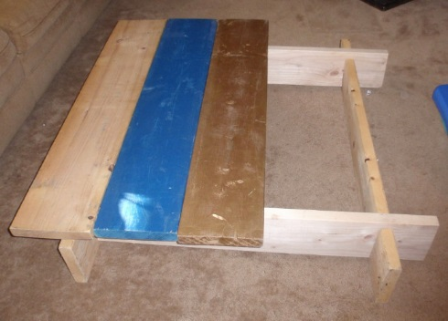
WEBELOS Scout (name), will you and your parents please bring the unfinished plank forward and place it across the east/west posts. (Scout places plank)
This unfinished plank represents the boys as they arrived in Cub Scouting, full of potential but unfinished.
WEBELOS Scout (name), will you and your parents please bring the blue plank forward and place it snuggly against the unfinished plank. (Scout places plank)
This Blue plank represents the Wolf and Bear years of Cub Scouting where with the help of their parents the Scouts became true blue and loyal friends.
WEBELOS Scout (name), will you and your parents please bring the gold plank forward and place it snuggly next to the blue planks. (Scout places plank)
This Gold plank represents their golden years in Cub Scouting as Webelos learning important skills through activity badges and culminating in the Arrow of Light.
WEBELOS Scout (name), will you and your parents please bring the green plank forward and place it next to the gold plank. (Scout places plank)
This green plank represents their new beginning as Boy Scouts, who will soon be green Tenderfoot scouts, anxious to begin the Boy Scout trial toward Eagle.
WEBELOS Scout (name), will you and your parents please place the final plank onto the bridge. (Scout places plank)
This last plank is red the predominant color in the Eagle Scout Badge and represents the fact that as they step off the bridge from Cub Scouting to Boy Scouting they are beginning of their journey to becoming Eagle Scouts.
Webelos entering Troop (number), please assemble with your parents at the unfinished board of the now completed Bridge to Scouting?
As we present you with your Pack graduation Certificate, will each parent please remove your sons Webelos neckerchief and slide.
Scoutmaster invites boys across the bridge, calling each by name and (performing whatever ceremonies are customary for your pack and troop)
After all have crossed - Pack (number) please stand and show your pride to the new Boy scouts from this Pack. (Cheer (Blast Off), Applause)...
We are very proud of you all.

The following could be a Webelos Den’s last salute and thank you to the pack before graduation. CD
Graduation of a Webelos Den to Boy Scouts
Adapted from Alapaha Council Pow Wow Book
All graduating Cub Scouts stand at the front of the room.
Props: 10 candles, 10 cards with verse
Dim lights - candles are lit:
- We’ve played together and worked together.
- Maybe had a fight or two.
- We’ve taken trips and had some slips.
- And seen many projects through.
- That Tiger Badge seems so long ago
- We earned our Wolf and Arrow Points.
- And passed the tests for our Bear degree.
- We earned Activity Awards for Webelos
- And finally those for Arrow of Light
- Now, Boy Scouts we’ll soon be.
Leader: We hope you remember Den (#) with delight!
CM: We salute you Den (#)! Good luck! Happy Scouting!
At this time, the den does its cheer one last time and the Bridging Ceremony to Boy Scouts is begun
Comments welcome. Let me know your opinion -
Davethecommish@gmail.com

FEBRUARY CRAZY HOLIDAYS
Jodi, SNJC Webelos Resident Camp Director Emeritus,
2006-2011. Adapted from http://holidayinsights.com/moreholidays/index.htm
http://www.brownielocks.com/month2.html
February is:
- American Heart Month
- Beans (Dried and Fresh) Month
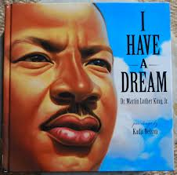
- Black History Month
- National Cherry Month
- Canned Food Month
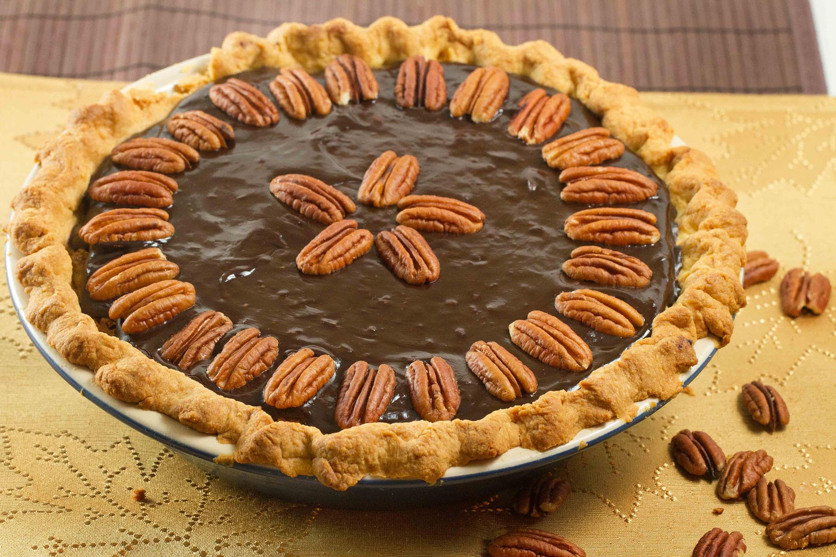
- Great American Pie Month

- Library Lovers Month

- National Children’s Dental Health Month
- National Grapefruit Month
- Adopt A Rescued Rabbit Month

- Barley Month
- Return Shopping Carts to the Market Month
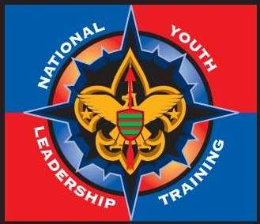
- Youth Leadership Month
Week Celebrations:
- Women's Heart Health Week: Feb 1-7
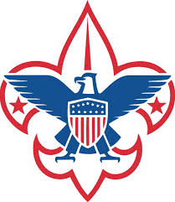
- Boy Scout Anniversary
Week: Feb 7-13
- Burn Awareness Week: Feb 1-7
- Children's Authors & Illustrators Wk: Feb 1-7
- Just Say No to PowerPoint Week: Feb 7-12
(We should hold Wood Badge this week)
- International Friendship Week: 10-14
- Love Makes the World Go Round; But, Laughter Keeps Us From Getting Dizzy Week: Feb 8-14
Victor Borge may have started this!!!!

- Jell-O Week: Feb 7-13 (Second Full Week)
A Must celebration in most Lutheran Churches!!
- National Pancake Week: Feb 21-27
- Great Backyard Bird Count: Feb 12-15
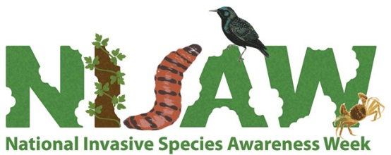
- National Invasive Species Week: Feb 21-27
- Random Acts of Kindness Week: Feb 9-15
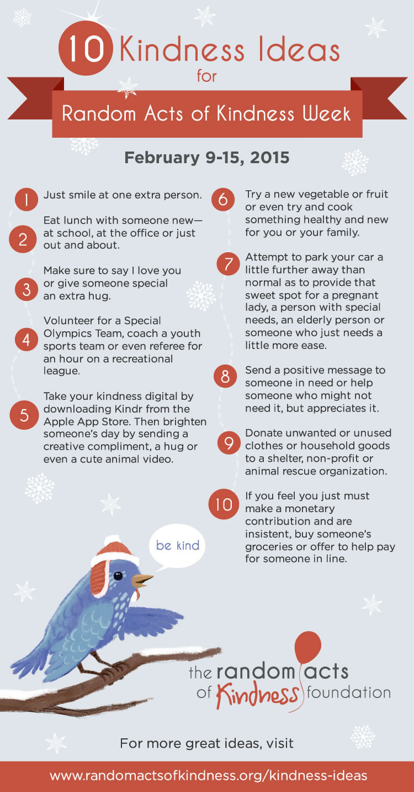
And in honor of George Washington –
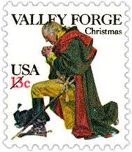
- National FFA Week: Feb 21-27 Link
(Week of Washington's Birthday)
- National Engineers Week: Feb 21-27
(Week including Washington's Birthday).

February 2015 Daily Holidays, Special and Wacky Days:
1 National Freedom Day
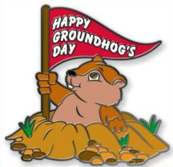
2 Ground Hog Day
2 Candlemas
3 The Day the Music Died - Buddy Holly, Richie Valens and the Big Bopper died in a plane crash in 1959.
4 Create a Vacuum Day
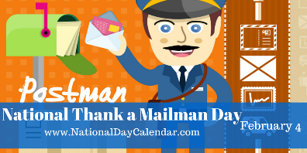
4 Thank a Mail Carrier Day
5 National Weatherman's Day
6 Lame Duck Day
6 Eat Ice Cream for Breakfast Day
7 Wave All you Fingers at Your Neighbor Day
7 Send a Card to a Friend Day - obviously created by a card company
7 Super Bowl Sunday (I don’t know anything about this. I am a Philadelphia Eagles Fan)
8 Boy Scout Day - celebrates the birthday of scouting
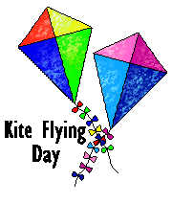
8 Kite Flying Day - in the middle of winter!?!
8 Clean out Your Computer Day
9 Toothache Day
9 Mardi Gras / Fat Tuesday
10 Ash Wednesday
10 Umbrella Day
11 Don't Cry over Spilled Milk Day
11 Make a Friend Day
11 White T-Shirt Day
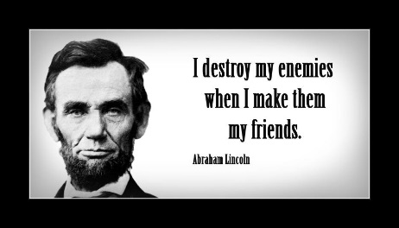
12 Abraham Lincoln's Birthday
12 Plum Pudding Day
13 Get a Different Name Day
14 Ferris Wheel Day
14 National Organ Donor Day
14 Valentine's Day
15 National Gum Drop Day
15 Singles Awareness Day
15 President's Day - third Monday of month
16 Do a Grouch a Favor Day
17 Random Acts of Kindness Day
18 National Battery Day
19 National Chocolate Mint Day

20 Cherry Pie Day
20 Hoodie Hoo Day
20 Love Your Pet Day
21 Card Reading Day
22 George Washington's Birthday
22 Be Humble Day
22 Walking the Dog Day
22 International World Thinking Day
23 International Dog Biscuit Appreciation Day
23 Tennis Day
24 National Tortilla Chip Day
25 Pistol Patent Day
26 Carnival Day

26 National Pistachio Day - it's a nutty day!
26 Tell a Fairy Tale Day
27 Polar Bear Day
27 No Brainer Day - this day is for me!
28 Floral Design Day
28 Public Sleeping Day
28 National Tooth Fairy Day
29 Leap Day – Last time for four years!!

BSA SOCIAL NETWORKS

SCOUTING MAGAZINE ON YOU TUBE

Scouting magazine You Tube Channel
http://www.youtube.com/user/scoutingmag

Check out cool stories and interviews -
The latest in the Cool Camps series -
Tahosa Alpine Base (Camp Tahosa),
Denver Area Council
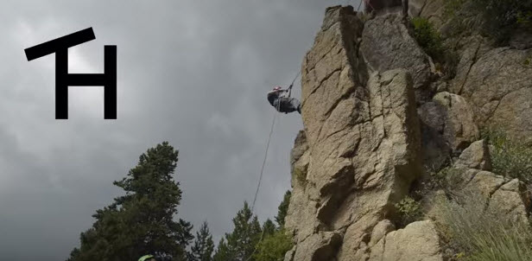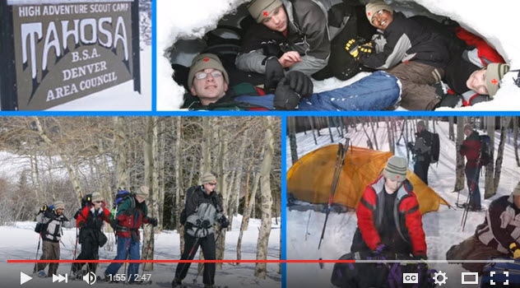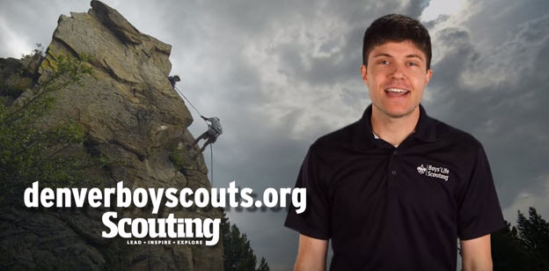
Bryan wants you to check it out at –
https://www.youtube.com/watch?v=clMjninQ658

BSA FACEBOOK PAGE

BSA Facebook page
https://www.facebook.com/pages/Boy-Scouts-of-America/113441755297
Sign up and get all the latest
as it hits the wires!!!
Cubs probably need your parents to Sign Up.
On the Facebook page you can read about –
Learn how to make a fast
pinewood derby car
Want to improve your skill??
Be sure to check out this advice!!
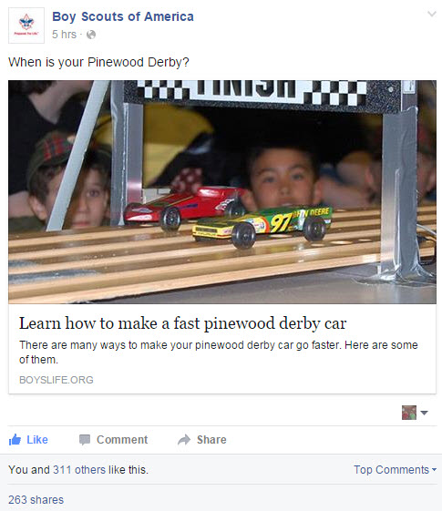
Go To: http://boyslife.org/hobbies-projects/projects/2952/speed-secrets/
Do you know how to do this??
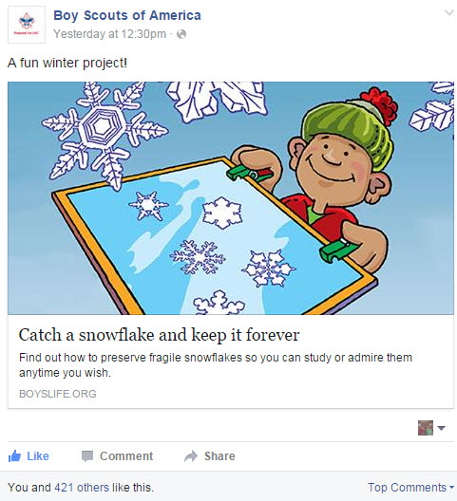
Go To: http://boyslife.org/hobbies-projects/funstuff/3396/snow-job/
How about a trip down
Memory Lane??
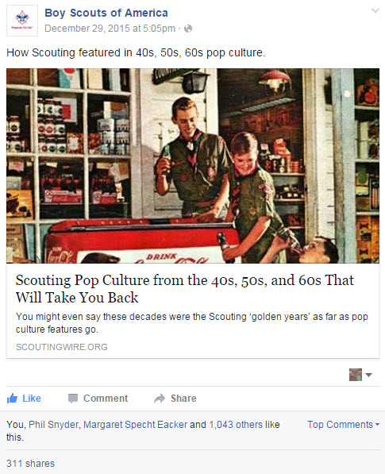
Go To: http://scoutingwire.org/scouting-pop-culture-from-the-40s-to-60s-that-will-take-you-back/

CUBCAST

http://www.scouting.org/Scoutcast/Cubcast.aspx
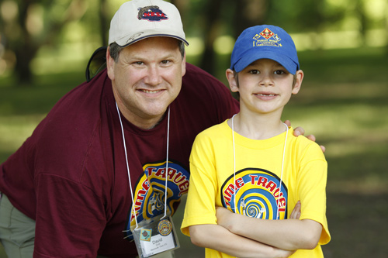
December 2015 -
Are You a Happy Camper?
So you say you’ve never been camping before? Feeling a bit nervous and apprehensive? Don’t worry! The lovely Jennifer Mooney, camping director with the Cascade Pacific Council in Portland, Oregon, joins us to help calm any anxiety you may be feeling about camping … in the woods … with a group of 8-year-old boys. Scout’s Honor. Find out at this month's Cubcast.

Listen Hear –
http://www.scouting.org/filestore/scoutcast/cubcast/201512_1/CC_Dec_HappyCamper.mp3

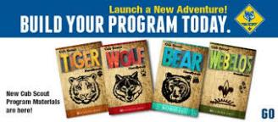

Be sure to check out National's website
for the latest on the
Adventure Program Changes -http://www.scouting.org/programupdates.aspx

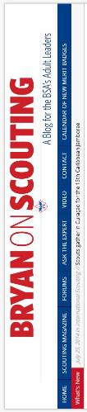
SCOUTCAST

http://www.scouting.org/Scoutcast/Scoutcast.aspx


December 2015 -
Plan B
You’re familiar with Plan B, right? It’s what you have ready as a backup just in case your original plan falls apart. Now the Boy Scouts of America is very good at being prepared should something unforeseen happen during an activity, but what if something goes awry and that activity might not happen at all? Do you just cancel? We here at ScoutCast don’t think you should so we invited Bill Adams, a 30-year Scouting volunteer from the Southern Shores Field Office in Hartland, Michigan, to join us for a discussion on how to get your troop ready for whatever may come its way. Let’s find out together.

Listen Hear –
http://www.scouting.org/filestore/scoutcast/resources/201512_1/SC_DEC_PlanB.mp3

It is possible that by the time you get Baloo's Bugle and click the link, there may be new Cubcast and/or Scoutcast posted. Do not worry, all previous Cubcasts and Scoutcasts are available from the home page.

BRYAN'S BLOG,
December 2015
“Bryan on Scouting” is the official blog of Scouting magazine, a Boy Scouts of America publication. Scouting magazine is published five times a year and is received by 1 million registered adult volunteers. Bryan covers many topics every month. He keeps his Blog current and deals with the latest issues.
His articles this past month are listed below (Every title has a hyperlink). The articles in BLUE are of special interest for Cub Scout Leaders.
If the word SPONSORED appears, that BSA received compensation for that blog post.
December 2015
2016 Order of the Arrow national officers elected
December 29, 2015 // 1 Comment
The 2016 Order of the Arrow officers have been elected, and Hunter Jones of the Wa-Hi-Nasa Lodge of Nashville, Tenn., will serve as National Chief.
Dick Douglas, the longest-serving Eagle Scout in history, dies at 103
December 28, 2015 // 4 Comments
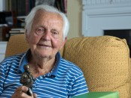Robert Dick Douglas Jr., who won a trip to Africa in a Boys' Life contest, flew with Amelia Earhart and was the longest-serving Eagle Scout ever, has died.
Across the country, Scouts are using ATVs for trail building and conservation
December 22, 2015 // 0 Comments
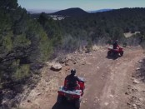Thousands of Scouts have taken ATV training at Scout camps across the country. They're using their new skills as they explore — and build — ATV trails.
The one thing you should include in every public piece of Scouting communication
December 22, 2015 // 19 Comments
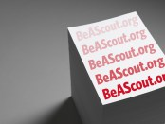One volunteer suggests you turn a positive story into a recruiting message by including this at the end of every piece of unit communication.
Greatest hits: Our 15 most-read posts from 2015
December 21, 2015 // 3 Comments
More than 5 million page views — up from 4 million last year — helped make 2015 the best year ever for Bryan on Scouting. These were the 15 most-read posts.
What’s new in the January-February 2016 edition of Scouting
December 18, 2015 // 1 Comment
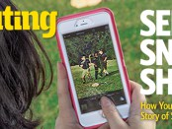The January-February issue of Scouting will be reaching mailboxes this month. Here's a sneak peek at the stories you'll find inside!
Note: Commissioner Dave is the guy behind the
camera when you click on the link to this article.
I took the Visual Storytelling Course in 2013. It was
a blast. Check out Bryan's Post from december 2, 2015, and Training Topics this month for more info on the Philmont Training Center for Cub Leaders!! CD
Crossbow pilot program coming to the Summit Bechtel Reserve
December 18, 2015 // 11 Comments
When Scouts and Venturers descend on the Paul R. Christen National High Adventure Base at SBR, they'll be among the first in the BSA to try crossbows.
When do Scouts start using the new Boy Scout requirements?
December 17, 2015 // 30 Comments
Beginning Jan. 1, 2016, Scouts will use new Boy Scout requirements at every rank. But how does the transition process work?
Harrison Ford once served on Boy Scout summer camp staff
December 16, 2015 // 10 Comments
In 1957, Harrison Ford — before portraying that hero from a galaxy far, far away — played a heroic role much closer to home: Boy Scout summer camp staffer.
10 tips for planning the best Pinewood Derby ever
December 15, 2015 // 16 Comments
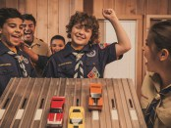Want to make this next Pinewood Derby the best one yet? I've got you covered with these 10 Pinewood Derby planning tips.
Note to Eagle Scout from Skip Yowell, co-founder of JanSport, has advice we can all use
December 14, 2015 // 3 Comments
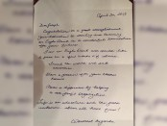When Paul Attwater's son received a congratulatory note from JanSport co-founder (and former Scout) Skip Yowell in 2013, something was memorably different.
Is this the best-ever location for a Wood Badge beading ceremony?
December 11, 2015 // 21 Comments
A special Wood Badge beading ceremony at Philmont this past summer elevated an already meaningful moment into something truly remarkable.
In Scouting, failing to have a plan B is planning to fail
December 10, 2015 // 3 Comments
As Scouters, we're prepared for the unexpected emergency during an event. But what about the possibility the event might not happen at all? Have a plan B.
5 ways to get Cub Scout parents ready to camp
December 10, 2015 // 15 Comments
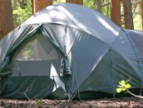Who's more nervous about that first night sleeping in a tent: the Cub Scouts or their moms or dads? In some of our Scouting families, the answer is both.
20 years after I went, Space Camp still has Scouts reaching for the stars (SPONSORED)
December 9, 2015 // 4 Comments
SPONSORED: Space Camp offers an unforgettable week for your Scout-age kids — one that could spark a career in an important field that's actually hiring.
These five friends have been to every high-adventure base
December 9, 2015 // 19 Comments
"It's a story of five boys adventuring together." Friends from Troop 820 of Chapel Hill, N.C., have seen Scouting take them to every high-adventure base.
How do you rein in camp waste on Scout trips?
December 8, 2015 // 44 Comments
An assistant Scoutmaster wonders how using disposable paper and plastic products (camp waste) aligns with the BSA's commitment to environmental stewardship.
Why take Wood Badge? 25 Scouters state their case
December 7, 2015 // 58 Comments
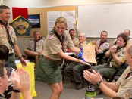Why take Wood Badge? Scouters say it "made me a better leader," "helped me turn my troop around" and is "one of the best training experiences I have had."
The Boys’ Life Warehouse Sale: Great collectibles, everything-must-go prices
December 4, 2015 // 3 Comments
The Boys' Life Warehouse Sale: Limited-edition Boys' Life products for sale at everything-must-go prices.
New Boy Scout requirements put more emphasis on physical fitness
December 3, 2015 // 41 Comments
New Boy Scout rank requirements that take effect on Jan. 1, 2016, put a greater emphasis on Scouts being physically active.
Philmont Training Center: The ultimate destination for Scouting families
December 2, 2015 // 13 Comments
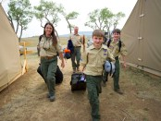With great conferences, terrific volunteers and professionals, and activities for children, Philmont Training Center is the ultimate family destination.
It’s #GivingTuesday, so let’s help invest in the future of Scouting
December 1, 2015 // 2 Comments
On this #GivingTuesday, the Boy Scouts of America is asking you to invest in the future of Scouting by making a tax-deductible gift
November 2015
10 of the craziest places Scouts have camped overnight
November 30, 2015 // 44 Comments
A baseball stadium, an aquarium with sharks swimming above and the camp where Friday the 13th was filmed are among the craziest places Scouts have camped.
Reminder about nontraditional Eagle projects was music to this Scout’s ears
November 25, 2015 // 17 Comments
When I blogged about nontraditional Eagle projects a couple of months back, the post caught the eye of a 15-year-old Eagle Scout from Colorado.
When can adult leaders wear the BSA’s Trained patch?
November 24, 2015 // 45 Comments
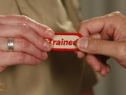The BSA's Trained patch sends a clear message to Scouts, fellow Scouters and parents. It says, "I know what I'm doing." Here's who can wear it.
In ‘Running Toward Danger,’ true tales of Scouts saving lives
November 23, 2015 // 2 Comments
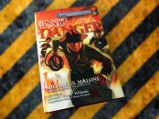"Running Toward Danger," a new book, features 170 of the most exciting rescues in the history of the BSA's heroism awards.
Cub Scout is officially the coolest kid in the carpool lane
November 20, 2015 // 0 Comments
Webelos Scout Jake Nimark will become a legend in the lunchroom thanks to NASCAR driver and BSA supporter Scott Lagasse Jr., who dropped Jake off at school.

Blog Contributors
Bryan Wendell, an Eagle Scout, is senior editor of Scouting and Eagles' Call magazines.

Gretchen Sparling is associate editor of Scouting and Eagles' Call magazines.

Get Email Updates
To sign up to receive Bryan’s Blog in your E-mail –
Click the link that appears in every article. Bryan and Gretchen promise never to sell or otherwise exploit your email address. Join 6,852 other subscribers

TRAINING TOPICS

Philmont Training Center
Are you ready to take your Cub Scouting skills to the next level?
Check out these learning opportunities available at the Philmont Training Center in 2016!!!
Elevate ... to a High-Performing Cub Scout Pack! - Learn what it takes to move your pack to the next level. Take a deep dive into topics such as: effective recruiting practices, growing your pack, supporting Cub Scouts on their advancement journey, converting parents from bystanders to engaged pack volunteers, and leading fun and exciting pack meetings. Move your pack from "great" to "epic" by ensuring you know what it takes to deliver the life-changing experiences only Cub Scouting can provide! Designed for pack committee members, Cubmasters, and unit commissioners.
- Week 3: June 19-25, 2016
- Week 6: July 10-16, 2016
- Week 9: July 31-August 6, 2016
- Week 11: August 14-20, 2016 (title this week - "Building Successful Packs")
Register Now - Philmont Training Center Registration link
(https://reservations.scouting.org/profile/form/index.cfm?PKformID=0x45221c16c )
Cub Scouting's Outdoor Skills & Fun! Put the "outing" back in Scouting … Cub Scouting that is! Learn fun ways to teach boys about the outdoors. Develop new strategies to ensure more of your Cub Scouts experience the outdoors and engage in the "wilderness" around them. Learn how to enhance their outdoor experience with new games, fun, and more! From campfire songs to outdoor award requirements, you'll become an expert in leading Cub Scouting's outdoor skills and fun. Designed for Cubmasters, den leaders, camp committees, and program planners.
Seminar includes a family campout overlooking Mt. Baldy from the newly acquired Cimmaroncita property. Seminar will be led by Dennis Kampa, chief editor of the B.A.L.O.O. Training Syllabus.
- Week 3: June 19-25, 2016
- Week 7: July 17-23, 2016
Register Now - Philmont Training Center Registration link
Fun in Dens and Packs! - Do you ever sit through long, boring, and chaotic den or pack meetings? Not in your den or pack, right? Learn ways to keep your great meetings going throughout the next Cub Scouting year! From planning and preparation to meeting sparklers, new songs, skits, and more, you'll develop the knowledge, strategies, and skills to ensure your Cub Scouts are engaged and having fun. You'll learn about the tools and resources available to help you deliver a great Cub Scouting experience! Designed for den leaders, Cubmasters, and pack committees.
- Week 8: July 24-30, 2016
- Week 10: August 7-13, 2016
Register Now - Philmont Training Center Registration link

Philmont Training Center Info
Philmont Scout Ranch is the Boy Scouts of America's premier high-adventure base. It covers more than 200 square miles of rugged New Mexico wilderness from the Great Plains up into the beautiful Sangre de Cristo Mountains.
Philmont is High Adventure – Much of Philmont is used for backpacking treks, horseback cavalcades and other high adventure challenges for Scouts and Venturers.
Philmont is History – Philmont straddles the mountain branch of the Santa Fe Trail. See the world's only known
T - Rex track and view centuries old Anasazi rock art. There are archeological sites and museums on site. The nearby town of Cimarron boasts several historical buildings from the old “wild” west.
Philmont is a Working Ranch – Horses, cattle and bison are all raised at Philmont. There are real cowboys, wranglers and ranch hands working there.
Philmont is Training - Adults have opportunities of their own at the Philmont Training Center. World-class courses and seminars cover all aspects of Scouting—all amid Philmont's dramatic scenery. If you want the best of Scout leadership training, Philmont is for you and your family!
Philmont Training Center (36°27’30”N, 104°57’W)
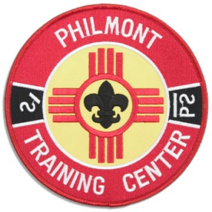
Of particular interest to Cub Scout Leaders, the National Volunteer Training Center of the Boy Scouts of America provides a unique environment for Scouting Conferences each summer and fall. In addition to hosting these Conferences, the Training Center also provides the opportunity for the entire family to be together – Scouts, Scouters, non-BSA Adults and Youth enjoying a wide range of Family Programs. This is what makes the Philmont Training Center experience one of a kind.
Attendance: Attendance is open to all Scouters - All you have to do is apply either on-line or contact your local council or call the Philmont Training Center (575-376-2281) Go to a Roundtable and ask about the Philmont Training Center. Most Cub Scouters who attend training conferences get interested by talking to others who have been there or by asking their DE. Scouters are encouraged to bring immediate family members with them. There is FUN for all!!!
Conferences: Approximately 100 separate weeklong conferences are scheduled each year. Conferences will cover almost every aspect of Scouting-from Cub Scouting and Boy Scouting to Council and District Operations, from Venturing and Professional Development to Scoutreach and Finance.
The Conferences are conducted by divisions and committees of the National Council and are led by a faculty of outstanding volunteer and professional Scouters. Each Conference is designed to discuss specific Scouting issues, share information from all over the B.S.A., and train using the "best methods" that will enhance the Scouting program for youth and adults.
Why Should You Go? Because Philmont training has consistently been the most popular and most effective training for Cub Scouting in the last half century. The best improvements in packs, districts and council Cub Scouting I have seen has come from PTC trained people. Philmont Training is family oriented, program directed and fun. What more could you ask for?
Here is the complete 2016 conference schedule.
- Courses with a flag and in purple are new for 2016.
- Courses with a smiley face and blue highlight Cub Scout leaders will especially enjoy.
Week 1 — June 5-11
- The Council/District Training Committee
- Creating Organizational Excellence
- Games with a Purpose
- Growing Venturing in your Crew and Council
- Philmont Ambassador Seminar
- William T. Hornaday Adviser Training
Week 2 — June 12-18
Commissioner's Week -
Come out and meet Tico!!!
- Advanced Leadership Skills for Administrative Commissioners
- The Council Commissioner
- Delivering Commissioner Service to Changing Communities
- District Commissioner and Assistant District Commissioner Training
- Effective Roundtables
- International Scouting
- Mechanics of Advancement
- Smarter, Strategic, and Sustainable Troops
- The Unit Commissioner
Week 3 — June 19-25 – Southern Region
- Council Key 3
- Cub Scouting’s Outdoor Skills & Fun!
- District Key 3
- District Operations 2
- Elevate!...to a High Performing Cub Scout Pack!
- Multicultural Scouting in Today’s Diverse Communities
- New Units: A Must!
- Order of the Arrow: Developing Youth Leadership Seminar
- Reconnecting & Cultivating Scouting’s Alumni
- National Advanced Youth Leadership Experience (NAYLE)
Week 4 — June 25-July 01
- LDS Scouting Leadership Conference
(by invitation only)
Week 5 — July 2- 8
- LDS Scouting Leadership Conference
(by invitation only)
- NAYLE
Week 6 — July 10-16 – Western Region
- Elevate!...to a High Performing Cub Scout Pack!
- T-Cubed (T3) – Train the Trainer
- Venturing Blast! (by invitation only)
- Western Region: New Strategies to Help Scouting Thrive
- NAYLE
Week 7 — July 17-23 – Central Region
- #Awesome!-STEM Explorations (14-20 age youth)
- Council Key 3
- Cub Scouting’s Outdoor Skills & Fun!
- District Key 3
- District Operations 2
- Planning Programs That Rock
- STEM-Tastic Scouting- Inspiration, Imagination, and Innovation
- Training Effective Unit Leaders
- Venturing Blast! (by invitation only)
- NAYLE
Week 8 — July 24-30 – Northeast Region
Relationships Week - Learn about Duty to God
- Building Successful Youth-Led Units: Training You to Train Your Youth and Adult Leaders
- Chaplaincy Training
- Council Key 3
- District Key 3
- Exploring and Learning for Life Programs: Best Practices and Strategies
- Fun in Dens and Packs!
- Growing Venturing in your Crew and Council
- Scouting in the Catholic Church
- Scouting in the Church of Christ
- Smarter, Strategic, and Sustainable Troops!
- NAYLE
Week 9 — July 31 - August 6
- Advancement Issues and Solutions
- Elevate!...to a High Performing Cub Scout Pack!
- Energize Your Enterprise Risk Management Committee
- Leading Varsity Scouting in LDS Teams
- Planning Programs That Rock
- Training Effective Unit Leaders
- Visual Storytelling Workshop
Check out the story in the Jan-Feb 2016 issue of Scouting Magazine. Great course!!! Commissioner Dave's loved it!!
- Wilderness First Aid Instructor Certification
- Youth Protection Champions
- NAYLE
Week 10 — August 7-13
- The Council/District Training Committee
- Engaging Millennial Parents in Scouting
- Finding Your Way – Night or Day
- Fun in Dens and Packs!
- Growing Venturing in your Crew and Council
- Putting More Outing in Scouting
- Serving More Scouts with Disabilities in Your Local Council
- Becoming a Powerful Program Chair
- Wood Carvers Round Up
- NAYLE
Week 11 — August 14-20
- Applying Outdoor Ethics in Your Unit, District and Council
- Be Prepared for High Adventure
- Building Successful Packs: Training Unit Leaders to Build and Sustain Cub Scout Packs
- Key Concepts of Commissioner Service in Scouting’s Second Century
- Philmont Ambassador Seminar
- Putting More Outing in Scouting
- T-Cubed (T3): Train the Trainer
*Fall Week — September 18-24
Come listen to the Elk bugling
Check out the Thunderbirds!!
- BSA Fishing Train the Trainer
- Climbing Director Certification
- COPE and Climbing Design, Construction, Maintenance, and InspectionAdvancement Issues and Solutions
- COPE & Climbing Program Manager Certification
- COPE Director Certification
- Facilities Management
- Implementing the National Camp accreditation Program
- Philmont Leadership Challenge
- Shooting Sports Director Re-Certification
- Take Aim at Year Round Shooting Sports Programs
- Trek Leader Planning and Advanced Outdoor Leader Skills
- Wilderness First Aid Instructor Certification
For a full schedule of 2016 Conferences with descriptions of each course, go to:
http://www.scouting.org/philmont/
Register Now -
Philmont Training Center Registration link
(https://reservations.scouting.org/profile/form/index.cfm?PKformID=0x45221c16c )
While Conference time is important, ample opportunity for a Scouter to enjoy the majesty of Philmont with his or her family is part of the schedule of most Conferences. There is also plenty of time to meet and socialize with other Scouters from all parts of the country. Making life-long friendships is a regular occurrence at Philmont.
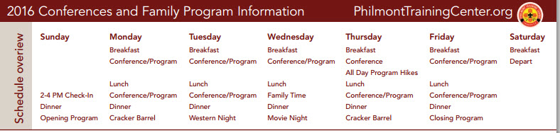
Family Program: One of the great joys of attending a Philmont Conference is that your whole family can share in the experience. You can think of it as a Scouting Family vacation. The schedule is relaxed and the pace is comfortable.
The Philmont Training Center offers a full, organized program for every member of the family-from infants to spouses. Family members are joined by others in their age group and participate in carefully designed, age-appropriate programs under the leadership of trained and experienced Philmont staff.
Family Program Groups
Nursery (2 months to 2 year olds) - A fully equipped nursery is available for the youngest family members. Parents may leave their children during family program times. They may be left for an hour or two, or for the entire morning or afternoon as determined by your group or conference schedule. Care is provided according to your instructions.
Small Fry (3-5 year olds) - The Small Fry Center is located next to the Handicraft Lodge. Philmont staff provides activities, games, pony rides, and supervised play during each program session.
Cowgirls, Cowpokes (6-7 year olds) - These individual groups participate in nature hikes, pony rides, games, songs and skits, crafts, museum tours, and an all day hike.
Ropers, Deputies (8-9 year olds) - Ropers and Deputies individual programs include hiking, Villa and Museum tours, archery and air rifles, pony rides, games, crafts and an all day hike.
Sidewinders (10 year old boys) - Sidewinders enjoy hiking, sports, crafts, archery and air rifles, Villa and Museum tours, and a Sidewinder/Parent overnighter.
Mustangs (11-13 year old girls) - Mustangs have fun enjoying horse rides, archery and air rifles, hiking, handicraft projects, nature activities, outdoor cooking, games, Villa and Museum tours, and an overnight camping trip in Philmont's backcountry.
Trailblazers (11-13 year old boys) - This group participates in day hikes, nature activities and games, horse rides, archery and air rifles, handicrafts, and an overnight camping trip in Philmont's backcountry.
Broncos (14-21 year olds) - The Broncos program is designed to accommodate those teenagers who choose not to participate in the mountain trek program. Broncos will stay at PTC with their families, but enjoy a week of activities built around participation in Philmont's C.O.P.E. course, day hikes, and horse rides.
Mountain Trek (14-20 year olds) - Mountain Men and Mountain Women treks are backpacking expeditions that provide the opportunity to experience the rugged challenges of Philmont's mountains. Mountain Trek crews travel approximately 20-30 miles in Philmont's backcountry.
I have been told that teen-age girls are the most enthusiastic participants at Philmont. Bill
I must concur, my daughter went as a participant three times as a teenager - 2 Mountain Treks and an 11 day trek, and then worked five years on staff. CD
Silverados (spouses and other adults not attending Conference) - Silverados find that a wide-range of exciting activities are available throughout the week. Activities include museum visits, day hikes, a pottery-making demonstration, Villa tours, COPE, horse rides, and trips to nearby resort towns.
Facilities: Tent cities accommodate Training Center participants and their families. Tents are large, two person wall tents with wooden or concrete floors, electric lights, an electrical outlet, wardrobe, and two twin sized beds with mattresses. Each tent city has restrooms and hot showers. Cots and cribs are available for use during the week.
A FANTASTIC recent addition has been the family and handicap restrooms. All restrooms in each Tent City are Family-sized. They are similar to the Family or Companion Assisted Restrooms in the malls and other places. Each room has its own shower, toilet, sink, etc. You can wheel your chair into the shower in the handicapped ones. There are diaper tables in most. Mom and/or Dad can take all the kids into the rest room and have them use the toilet, shower and clean up in privacy. No more dealing with others in the main shower house. No more sneaking sonny into the Ladies Room or daughter into the Men's Room.
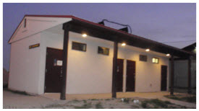
Meals are served in the cafeterias at the Center. Family members who are in camp eat together. Camp meals are provided for those on the trail or in the back country. There is a new (last summer) porch so you can eat and look at the Tooth and gab about your week. They have a fully trained staff to properly serve (No cross contamination) gluten-free, vegetarian, kosher and other specialty meals.
Conferences are conducted in fully equipped conference rooms or at various locations in Philmont's backcountry. Family Program facilities include the Small Fry Center, the Handicraft building, and Pony Ring. However, most of the time family members will be enjoying the best facility of all-Philmont's 137,493 acres of "Scouting Paradise."

I (Bill Smith) have attended four different Conferences at Philmont. At each one, I learned a lot, had a great time, met wonderful people and had my Scouting spirit lifted to new heights.
Every family member who was with me still talks about their experiences in glowing terms. I am continually impressed with the quality of the staff members who run the family programs. They are special people.
I have been at more than a dozen courses and agree most heartily with Bill's statement. I was there three times in 2014 and twice in 2015. I have facilitated and taken courses. In 2013 I took VISUAL STORYTELLING and my picture is in the Scouting Mag story about it. A really great course. CD
Links –
Memories from Scouters who were there:
Star Scout Cody Welch – his experience
Parking, Trading Post, Others
PTC Program for little guys and gals
Philmont Hymn
Troop 227 2006 Photo Gallery
Register Now -
Philmont Training Center
Registration link
SPECIAL OPPORTUNITIES
With the start of the Cub Scout Adventure Program, the requirements for awards that say things like, "Complete Wolf Achievement 7," needed to be revised to send you to the new Adventures. The changes were highlighted in Baloo's Bugle in May, June, and July 2015.
To get a complete summary of all the changes to incorporate the Adventure Program, you can go to http://www.scouting.org/scoutsource/programupdates.aspx.
Or go to http://usscouts.org/advancementTOC.asp#cub
and get the changes for a specific award.

Service Stars & Attendance Pins
www.usscouts.org , www.scouting.org ,Bryan's Blog, BSA Guide to Awards and Insignia, & Baloo's Archives
We all want our Scouts to attend everything. We want them to stay with the program. So don’t forget to recognize them for being there another year and for being at "everything."
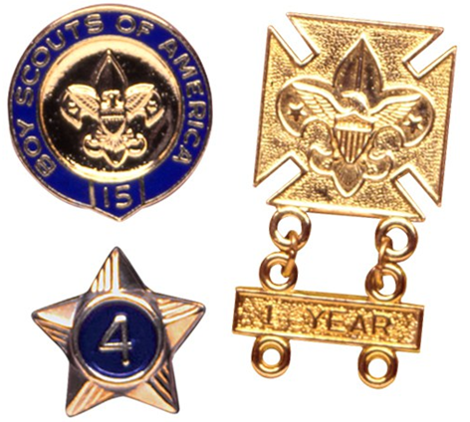
Service Stars
Have you been involved with BSA for a year or more, as a Youth or Adult?? You get a GOLD STAR!!! If you were registered with the BSA as aYouth and now serve as an Adult – be sure to count ALL the years. (I was a Cub Scout for 3 years, a Boy Scout for 7 years, and an Adult Leader for 30+ years. I may wear 1 star or three. See below. CD)

Service stars are Gold metallic numbered stars worn with colored background to indicate years of service in Scouting. The sample above is a two year Service Star. Cub Scouts and Webelos Scouts wear stars with gold background, centered 3/8 inch above the left pocket. Service stars are calculated based on registration information. That's the reason why they are called "service stars". They are not based on "graduation" or "movement" from one program element to another (from Wolf to Bear, for instance) nor from program to program (from Cub Scouting to Boy Scouting, for instance). Each year of service is calculated based on the anniversary of the Scout's date of registration.
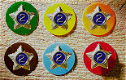
There are 5 Official BSA service star backings:
- Orange for Tiger Cub youth (Discontinued in 2001) If you have one of these, consider adding that year to your Cub Scout star.
- Yellow for Cub Scout youth
- Green for Boy Scout youth
- Brown for Varsity Scout youth
- Red for Exploring/Career Awareness Exploring or Venturing/Sea Scouting youth
- Light Blue for all adult service, Regardless of program
Placement
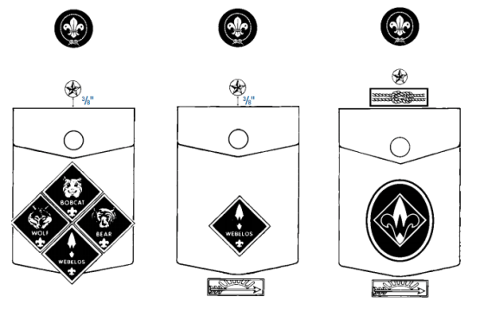
Stars are worn centered above the left pocket. They should be placed 3/8 inch above the top seam of the left pocket flap. Or 1/4 inch above the top Square Knot recognition or other recognition.
The stars must be worn with a colored background. For Scouts, that background represents the phase of Scouting in which the service was rendered.
Only the correct total number of years should be worn. When your son receives his 2nd year Service Star, remove the first and put it in your "Memory Box"
Note for adults on wearing Service Stars
An adult has the option to wear the appropriate color backgrounds for their youth service and blue for their Adult service or they may combine all adult and youth service and wear only the light blue Scouter's service star background.
For example, I could wear my service stars in either option:
Service Stars by program | All service on adult star
- 3 yr - yellow background (Cub Scout youth)  - 7 yr - green background (Boy Scout youth)  - 32 years (30 year and 2 year pins) - light blue background (Adult service) | - 42 years (40 year and 2 year pins) - light blue background (Adult service)
The Pins
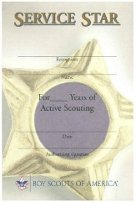
The numbered gold pins include every digit from 1 to 10 and jump by 10s from 20 to 70. Then by 5's: 75, 80, 85, 90. For the last few you’re in pretty rarified air.
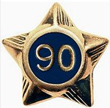
You can. also, present them with the certificate above (Supply No. 34396, 19 cents). Most units pin the star to the certificate and present them together. That helps make sure the star isn’t lost at the meeting before the Cub Scout takes it home.
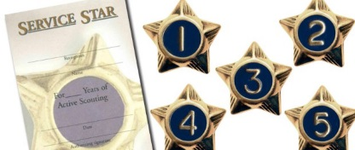
Attendance Pin -
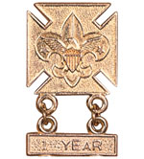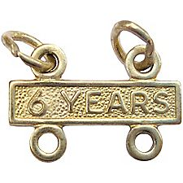
The BSA "Guide to Awards and Insignia," states, "The Attendance Pin worn by youth members in all programs is to encourage regular attendance. Standards are set by unit leader." This is often wrongly called "The Perfect Attendance Award" My Pack always called this the "Good Attendance Award." Every Scout is expected to attend all Den and Pack meetings. However, most Packs recognize that Cub Scouts (Tiger Cubs, Cub Scouts, Webelos Scouts) are involved in other activities and may have scheduling conflicts. Since you know your community best, the Cubmaster with concurrence of the Pack committee sets the requirements for this award. National Council has not established requirements for this award. Make the requirements challenging but doable.
Sample Requirements:
I found several packs on the web with the same list of requirements, whether they all actually decided to do the same thing or simply copied from one another,
I do not know. CD
To earn the attendance award,
A Scout cannot miss more than:
- One regularly scheduled Pack meeting during the program year (September through August).
- Two regularly scheduled Den meetings during the program year (September through August).
A Scout must
- Earn the Summertime Fun Award
- Attend at least one Camping trip (The Pack has two and Webelos have one more)
- Attend a Day Camp or Resident camp
- Attend at least 2/3rd of special Pack activities (trips, picnics, Scouting for Food, ball games, …)
Remember, the Pack sets the requirements.
If you don’t like these, write your own.
Other Information:
- The awards could be presented at the last Pack meeting of the program year or the first of the next year. Presentation at the first gives you awards for the first meeting of the year when you should have lots of new Cubs who will be impressed with seeing what they can earn!!!
- The Official BSA Insignia Guide simply says the award is worn on the official uniform above the left pocket. It does not give a distance above. I would put it about the same height as the Service Star. Let the year bars dangle on the pocket flap.

Knot of the Month

Veterans Recognition
http://usscouts.org/awards/Doc-Commissioner.asp
www.scouting.org
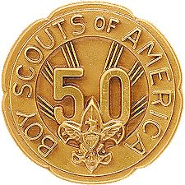
Your Blue & Gold Banquet might be an appropriate time to honor your pack's long term leaders. If they have at least 5 years total as a Youth in Boy Scouting (Cubs, Boy Scouts, Exploring, Venturing) and as an Adult (Leader) they qualify CD
The Veteran Award is an adult recognition. However, tenure earned as a youth may be included in the total number of years registered.
After 5 years of registered service in the Boy Scouts of America, an adult may, upon application, receive the designation of “Veteran,” provided the person agrees to live up to the Scouting obligations; to keep local Scouting authorities in the community in which residing informed as to availability for service; and further, to be as active in the promotion of the cause of Scouting as circumstances and conditions permit. Service in Scouting organizations other than the Boy Scouts of America does not count toward veteran recognition.
To receive an award, an individual must be currently registered with the BSA. An adult designated veteran shall pay the regular registration fee if desiring to continue to retain active connection with the BSA.
Scouters desiring recognition as 5-, 10-, 15-, 20-, 25-, 30-, 35-, 40-, 45-, 50-, 55-, 60-, 65-, 70-, 75-, 80, -85, or 90-year veterans must have maintained an active registered relationship for the required number of years, paying the annual registration fee. The pin is for civilian wear only. Pins from 5 years to 60 years of service are stocked by Scout Stores. Pins from 65 years of service and up may take up to 6 weeks for delivery. The 50 and 75 year pins are special
National and local council records stablish eligibility. The periods of service need not be continuous.
Application should be made to your local council. The form may be obtained on National's Website at: http://www.scouting.org/filestore/membership/pdf/524-701.pdf
This is a great way to recognize long serving members of your unit or district. Most people do not know the Veteran's Award is available.

THEME RELATED STUFF

WORLD BROTHERHOOD OF SCOUTING
The organization of the Scout Movement at the world level, “World Scouting”, is governed by the World Organization of the Scout Movement (WOSM). The WOSM website is www.scout.org.
WOSM is an independent, non-political, non-governmental organization that is made up of 161 National Scout Organizations (NSOs). These NSOs are located in 223 countries and territories around the world. With over 40 million members in some one million local community Scout Groups, WOSM is one of the largest youth movements in the world.
Some seven million members in WOSM are adult volunteers who support local activities. Through peer-to-peer leadership, supported by adults, each local Scout Group embraces the same set of values illustrated in the Scout Promise and Law. Each
SCOUTING OATHS AROUND THE WORLD
Want to see how similar the Scout Oaths from around the world are?? Check it out -
Scouting Oaths from around the World
http://usscouts.org/profbvr/oath_promise/index.html

WORLD CREST

The World Crest is a Scout emblem that has been worn by an estimated 250 million Scouts since the Scouting movement was founded in 1919. It is still worn by 28 million Scouts in 216 countries and territories and is one of the world's best-known symbols.
Scouts and members of the public often ask how the emblem originated. Lord Baden-Powell himself gave the answer: "Our badge we took from the 'North Point' used on maps for orienteering." Lady Baden-Powell said later, "It shows the true way to go." The emblem's symbolism helps to remind Scouts to be as true and reliable as a compass in keeping to their Scouting ideals and showing others the way.
The crest is designed with a center motif encircled by a rope tied with a reef or square knot, which symbolizes the unity and brotherhood of the movement throughout the world. Even as one cannot undo a reef knot no matter how hard one pulls on it, so, as it expands, the movement remains united.
The three tips of the center fleur-de-lis represent the three points of the Scout Promise. In some countries, the two decorative five-pointed stars stand for truth and knowledge.
The crest is white on a royal purple background. These colors are symbolic as well. In heraldry, white represents purity and royal purple denotes leadership and help given to other people.
The World Crest is an emblem of the World Organization of the Scout Movement and is authorized for wear on the uniform of all member associations as a symbol of membership in a world brotherhood. It is authorized by the Boy Scouts of America to be worn by all adult and youth members as a permanent patch centered horizontally over the left pocket and vertically between the left shoulder seam and the top of the pocket.
The BSA donates a small portion of the proceeds from each patch sold to the World Scout Foundation to assist with the development of Scouting's emerging nations.

BROTHERHOOD
Santa Clara County Council, 2001 Pow Wow
by Bob Greer
Last night I watched the sunset
when my day was almost done,
and thought about another boy
whose day had just begun.
I’ll probably never know him,
since we’re half-a-world apart.
How different we must be
if my day ends as his day starts.
On the far side of the sunshine,
on the other end of day,
lives a boy who seems a stranger
in a hundred different ways.
Still I think we might discover
if we look beneath the skin,
that instead of being strangers,
he and I are more like twins.
But listen to his heartbeat.
Oh, just listen to his dreams.
You’ll know that deep inside
we aren’t as different as we seem.
I think I’ll write a message.
I might send it on the wind--
so when he hears it blowing,
he will know he has a friend.
I think that I can touch him,
if I reach out with my heart.
How different can we be
when we’re just half-a-day apart?
On the far side of the sunshine,
on the other end of day,
lives a boy exactly like me
in the most important ways.
Yes, I know we will discover
when we look beneath the skin,
that instead of being strangers,
he and I are really twins.

THEME & PACK MEETING IDEAS

GATHERING ACTIVITIES
Note on Word Searches, Word Games, Mazes and such – In order to make these items fit in the two column format of Baloo’s Bugle they are shrunk to a width of about 3 inches. Your Cubs probably need bigger pictures. You can get these by copying and pasting the picture from the Word version or clipping the picture in the Adobe (.pdf) version and then enlarging to page width. CD
DO YOU KNOW WHERE?
Santa Clara County Council, 2001 Pow Wow
Line up the clue with the correct country
Passport Clue Country
- Boy Scouting originated in this country Japan
- Easiest continent to make ice cubes on Egypt
- Last Summer Olympics were held here China
- Our neighbor to the North England
- They grow lots of coffee here Canada
- Shoes made of wood and lots of tulips India
- Three big pyramids and a sphinx Australia
- Pokemon was invented here Antarctica
- See the Great Wall Holland
- Taj Mahal and lots of curry Colombia
Answers: 1-England; 2-Antarctica; 3-Australia; 4-Canada; 5-Colombia; 6-Holland; 7-Egypt; 8-Japan; 9-China;
10-India
NATION SCRAMBLE
Santa Clara County Council, 2001 Pow Wow
Unscramble the names of these countries. Work with your family or friends.
1. CRFNEA 11. LIFNADN
2. GASDMACAAR 12. RINLDAE
3. EMGARYN 13. CNOLASTD
4. GNAEDNL 14. WRENLZISDTA
5. SARUSI 15. RUALAISAT
6. NRUAHGY 16. IPNELIHPISP
7. NLODAP 17. MERACIA
8. APNJA 18. ZRLIBA
9. EKOAR 19. PISNA
10. EMRKDNA 20. EWN LNDZAAE
Answers: 1-France; 2-Madagascar; 3-Germany; 4-England;
5-Russia; 6-Hungary; 7-Poland; 8-Japan; 9-Korea; 10-Denmark; 11-Finland; 12-Ireland; 13-Scotland; 14-Switzerland; 15-Australia; 16-Philippines; 17-America; 18-Brazil; 19-Spain; 20-New Zealand


GUESS THE NATION
Santa Clara County Council, 2001 Pow Wow
Have small flags representing at least 12 different countries. Number each flag, and have participants try to guess the name of the nation it represents. You may need to give participants a list of country names or hints to help them out a bit.
Country Word Search
Can you find the names of the 18 countries by reading vertically, horizontally, diagonally, backward or forward?
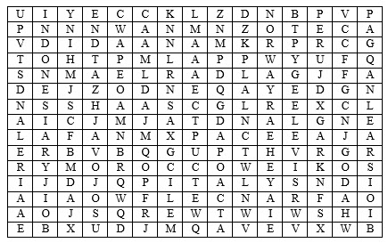
The countries are -
CAMBODIA CANADA CHINA
EGYPT ENGLAND FRANCE
GERMANY HOLLAND INDONESIA
IRELAND ISRAEL ITALY
JAPAN MOROCCO NORWAY
PANAMA PERU UNITED STATES

Friends Around the World
Santa Clara County Council, 2001 Pow Wow
Can you find the names of eleven countries by reading vertically, horizontally, diagonally, backward or forward?
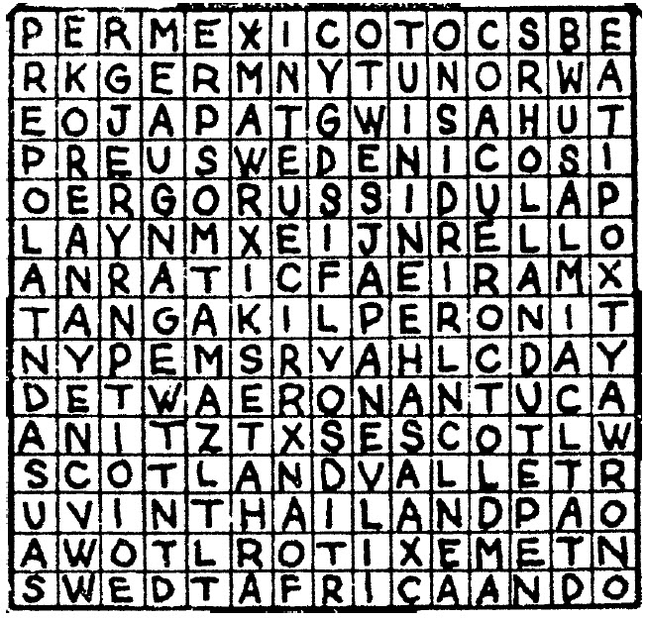
Words:
Africa Germany Holland Japan
Korea Mexico Scotland Sweden
Switzerland Thailand USA
HOW MANY COUNTRIES CAN YOU NAME?
Santa Clara County Council, 2001 Pow Wow
As families arrive, give each family a sheet of paper and ask them to write as many countries as possible.
Family members are encouraged to work together. During the meeting, honor those who knew the most with a cheer.

OPENING CEREMONIES
Hello!
Sam Houston Area Council
Note: See Closing Ceremonies section for companion ceremony
Props:
- Cue cards with the Cubs' lines printed on the back. On the front you could have an outline map of the country whose language the Scout will be saying hello or a picture of that country's Scouting logo.
- You may also wish to post a banner with a map showing all the countries with Scouting or a poster with each country's Scouting organization logo.
Other Thoughts:
- Go to https://www.scout.org/nso to see the list of all 216 countries participating in the World Brotherhood of Scouting.
- If you need more countries or want to use one not listed, feel free to add or delete. If you go to one of the following:
- http://time.com/40910/21-ways-to-say-hello-infographic/
- http://www.athropolis.com/hello2.htm
- http://www.omniglot.com/language/phrases/hello.htm
Announcer: "Welcome to our meeting. There are 216 countries in the World Brotherhood of Scouting, as shown on our map. There are many languages spoken in those countries but you can always hear a Scout greeting you.
- Spanish: Hola (OH-lah)
- French: Bonjour (bohn-ZHOOR)
- German: Guten Tag (GOOT-en Tahg)
- Mandarin: Ni hao (nee-HOW)
- Russian: Zdravstvuite (ZzDrast-vet- yah)
- Mohawk: Sekoh (SEH-goh)
- Swahili: Jambo (JAM-bo)
- Arabic: A1 salaam a'alaykum (AHL sah-LAHM-ah ah-LAY-koom)
- Hindi: Nahmaste (nah-mah-STAY)
- Hebrew: Shalom (Sha-LOHM)
- Hawaiian: Aloha (ah-LOW-ha)
Announcer: "No matter where you go or how you say it, you can count on being greeted cheerfully by a Scout who says 'Hello'."
Scouting Spirit
Heart of America Compass
Personnel: 7 Cubs, with strong voices; and one in charge of lights
Equipment: 8 small candles, 1 large candle, in holders and matches. Cards with each Scout's words on the back in LARGE print. An appropriate picture should be placed on the front (audience) side.
Setting: Lights dim with Scouting spirit candle lit Speakers come forward one at a time, light the small candles from the Scouting spirit candle and read After all small candles are lit, turn off all house lights.
- Cub Scouting is part of family life in more than 60 countries around the world. In all of these countries, on an evening such as this, families are sharing the spirit of Scouting.
- Let us look at the candles’ flame and silently thank God, for the Cub Scout friendships we are privileged to enjoy.
- Thanks to everyone, for your assistance, with the dinner tonight. We would like to share a closing poem with you.
- Boys in uniforms shiny and bright;
With smiling faces to the left and right,
We say thanks for Cub Scouting tonight.
- A Cubmaster who is loyal and true,
Who works with parents and boys in blue;
In hopes that these boys will grow up to be,
Super citizens for the world to see !
- Den leaders who wear their uniforms too,
Teaching Cub Scouts the need to be true,
Working, singing, and playing with them.
Though at times it is total mayhem!
- So all of you Cub Scouters,
in gold and in blue,
The door to Scouting
has been opened to you!
(Lights on)
CM: Thank you Den XX. (Lead a cheer for their good work) Dismiss the meeting.
Destination Cub Land
Capital Area Council
People: 6 Cubs with speaking parts and two Cubs holding the bus
Props: Large cut out cardboard bus with open windows or windows set as flaps from which a Cub can stick out his head
Set Up: Have two Cubs walk onto the stage carrying a cardboard cut out of a bus.
Have the 6 Cubs with speaking parts walking along on the side of the bus away from the audience.
As their turns occur the Cubs stick their heads out of the windows
- Ladies and gentlemen, the destination of this bus is Cub Land. It’s an attraction which offers more than Disneyland, Kings Island, and television combined.
- When you get to Cub Land, you will find fun and crafts projects to make
- You’ll find games and songs.
- Cub Land has great treats such as weekly den meetings and trips.
- Each month there is fun filled pack meetings with awards, skits, and songs.
- Webelos Scouts in Cub Land work on exciting Activity Pins and visit Boy Scout Troops.
(Proceed with a patriotic ceremony).
BUILDING A BETTER WORLD
OPENING OR CLOSING
Santa Clara County Council, 2001 Pow Wow
Arrangement: Eleven Cub Scouts, each holding a card with a letter on the front and his line on the back. Each speaker holds up his letter as he says his line. Last line is delivered by all (or by their leader).
Note – Most of the lines spoken by the Cub Scouts are couplets (two line rhymes). Make sure they realize this and speak their lines properly.
- Take a B for brotherhood,
boosting for each other’s good.
- Take an E for every land to share
in earth’s riches everywhere.
- Take a T for trustfulness,
trusting more, and fearing less.
- Take a T for teamwork,
for joining hands to get things done.
- Take an E for equal chance
for each person to advance.
- Take an R for real respect
regardless of race, creed or sect.
- Take a W for will to work
for peace with faith and skill.
- Take an O for opportunity
to keep our speech and action free.
- Take an R for reverence
for a guiding Providence.
- Tale an L for love to spread around
when need and bitterness are found.
- Take a D for dignity of man
devoted to a bigger plan.
ALL: There you have it--this is how to build a BETTER WORLD, right now!
GIFTS OF SCOUTING
Santa Clara County Council, 2001 Pow Wow
Arrangement: Each Cub Scout has a candle and lights it as he speaks. You may wish to use a Cub-a-Labra and have the candles on a table.
- This is my Scouting light. It is my enthusiasm. As light brings out the sparkle in diamonds, enthusiasm brings out the sparkle in Scouting.
- This is my Scouting light. It represents what I know I can do. And I’ll do my best to do my duty to God and my country.
- This is my Scouting light. As we face each other tonight, let us look at the light and silently thank God for the brotherhood of Scouting we share here tonight.
- This is my Scouting light. I shall pass this way but once so if there is any good that I can do, let me do it now for I shall not pass this way again.
- This is my Scouting light. Let each one of us take time to look back at where we’ve been and have pride in that past. Let us look forward to where we’re going and have hope for that future.
CM: Would you please stand and join us in the Pledge of Allegiance?
SCOUTING FRIENDS NEAR AND FAR OPENING
Santa Clara County Council, 2001 Pow Wow
Arrangement: Cubmaster (cm) and a group of 7 Cub Scouts enter. Cubmaster is holding several travel brochures. Each Cub Scout has one brochure with his lines written inside it. The color guard should be posted just outside the door.
CM: Our pack has been studying all about other countries this month and now we need to plan our pack trip. There are so many neat countries to visit, I just don’t know where to begin. (Looks at brochures in his hands)
- We could go to Mexico--The motto for Cub Scouts there is “Always My Best.”
- Or we could go to Japan--Scouts there start as Beaver Cubs and aim towards Fuji Scout, like climbing their highest mountain.
- It says here that the Egyptian Scout and Guide Federation includes four associations: Air Scouts, Sea Scouts, Boy Scouts and Girl Guides.
- Scotland is part of the Scout Association in the United Kingdom which includes Scotland, England, Ireland, and Wales. Their program is called Scoutreach.
- Here it says that in Canada there are two Scouting organizations--one for the English speaking Scouts and one for French speaking Scouts.
- The program emphasis in the Scout Association of Australia is on adventure, camping, bushcraft, and FUN!
- Scouting was founded in Kenya in 1910. They do community service projects which include planting trees and campaigning for literacy.
CM: Wow--we sure are lucky to belong to such a world-wide organization. We have over three million members in the Boy Scouts of America. Let’s stand as we post the colors of our country.
(Proceed with the flag ceremony)

AUDIENCE PARTICIPATIONS
How The Chinese Zodiac Started
Sam Houston Area Council
Instead of dividing the audience into different groups, have the audience make the sound for each animal. For the word ANIMAL(S) the audience says any animal sound they want.
The New Year was drawing near and 12 ANIMALS were arguing because each wanted the year to be named after him. You can just imagine the commotion as TIGER, DRAGON, SNAKE, HORSE, RAM, MONKEY, OX, ROOSTER, RABBIT, DOG, PIG, and RAT argued and argued.
The DRAGON and the TIGER argued over which one of them was the fiercest. “This should be called the year of the DRAGON because I can create storms,” roared the DRAGON. The HORSE came galloping in. “No, it should be called the year of the HORSE, because I can run fastest.” The proud ROOSTER was preening himself. “No, you are both wrong. It should be called the year of the ROOSTER because I am the most handsome.”
All the ANIMALS disagreed with ROOSTER. There was such a noise of roaring, hissing, neighing, bleating, chattering, barking, grunting and squeaking that the gods were disturbed.
The gods appeared in the sky and demanded to know what all the noise was about. “What are you arguing about?” asked one of the gods. All the ANIMALS tried to answer at once. The noise was deafening. “Be quiet, at once!” ordered the gods. “You all have very bad manners.” The ANIMALS were ashamed of themselves. They politely explained one by one what they had been arguing about. Each ANIMAL explained why he was the most important and why the New Year should be named after him.
The gods thought hard about the problem and decided to involve all the ANIMALS in a race. “Can you see the big river?” asked the gods. “You can all race across the river and the first ANIMAL to get to the other side will have the New Year named after him.”
All the ANIMALS agreed to the race; secretly each one thought he would be the winner. They lined up along the bank. “Ready, steady, go!” shouted the gods. There was an enormous splash as all the ANIMALS leapt into the water.
The race was very close to start with as HORSE, DRAGON, TIGER, and OX swam neck and neck. However OX was the strongest swimmer and he began to take the lead. RAT was not a very strong swimmer but he was very cleaver. As soon as he saw OX take the lead, RAT thought “He’s not going to beat me. I have a plan.” RAT swam as fast as he could and just managed to grab hold of OX’s tail. He carefully climbed onto OX’s back without OX noticing him. OX looked around but did not see RAT on his back. “I’m going to be the winner,” thought OX, “I am well ahead of the other ANIMALS, no one will catch me.” OX slowly and confidently waded the last few meters to the bank but clever RAT leapt over his head and onto the bank first. “I’m the winner, I’m the winner,” squeaked RAT. The OX was so surprised. “Where did you come from?” he asked RAT.
The gods declared clever RAT the winner and named the New Year after him. “Next year will be the year of the OX because OX was second.”
One by one the other ANIMALS reached the bank. TIGER was third, RABBIT was fourth, DRAGON was fifth, HORSE was sixth, SNAKE was seventh, RAM was eighth, MONKEY was ninth, ROOSTER was tenth, DOG was eleventh, and PIG was twelfth and last. “You have all done well,” said the gods. “We will name a year after each one of you, in the same order that you finished the race.”
All the ANIMALS were exhausted but quite happy with this decision because they didn’t need to argue any more.
The Ocean
Heart of America Council
Divide audience into seven sections. Assign each a word and a response. Tell them that when they hear their word in the story they are to give the response. Practice as you make assignments
DOGS: Barking noises
BEARS: Growling noises
FISH: Rub tummy and say raw, raw, yummy
SLED: Slide feet on floor or hands together
SPEARS: Ca Plunk
SNOW: Wave fingers and say flutter, flutter
OCEAN: Clap hands and say sh, sh
The DOGS pulled the SLED over the SNOW they were heading for the OCEAN. One DOG said to the other DOG, how long will it take us to get to the OCEAN? The FISH will sure taste very good, it will give us plenty of energy to work the rest of the day. A BEAR asked where they were going in such a hurry. The DOGS said we are on our way to the OCEAN to get some FISH. The BEAR asked if he could ride along. This was to be the first hitch hike known in Alaska among the animals. So, he hopped on the SLED. But the DOGS soon stopped. They couldn’t pull the SLED through the SNOW. It was getting too heavy. The BEAR was very upset for he was trying to keep his feet warm on the SLED, for he had walked all night in the SNOW. The DOGS soon arrived at the OCEAN and the BEAR how they were going to catch the FISH since they didn’t have a pole or a SPEAR. The DOGS said they didn’t need one, for they were going to the store to buy the FISH. The BEAR asked why then did we come all the way here to the OCEAN. We could have gotten the FISH in town. The DIGS said but they have fresher FISH here at this store. For you see the name of the store was called, “THE OCEAN.”
Jose’s Dilemma
Santa Clara County Council
Split the audience into five groups and assign each group a part -
JOSE: I want to go
MAMA: Take your sombrero
SOMBRERO: It’s too hot
SISTER: Take me, Jose
BURRO: Hee-haw
FIESTA (Everyone): Olé!!
Scene is a small town in Mexico, about 65 years ago.
JOSE was excited. It was almost time for the FIESTA parade. He was going with his MAMA and SISTER. His father had already taken the BURRO and cart with a load of goods for the market. “Hurry, JOSE,” called MAMA, “it’s time to go to the FIESTA. Get your SOMBRERO and meet your SISTER outside.” JOSE looked all over the house but he could not find his SOMBRERO. “SISTER,” he called, “have you seen my SOMBRERO?” JOSE’s SISTER replied that she had not.
JOSE searched some more. He must have his SOMBRERO to attend the FIESTA for the summer sun was very hot. “MAMA,” called JOSE, “have you seen my SOMBRERO?” “Hmmm,” said MAMA, “I think I saw your father put it on our BURRO when he left for market.” “Oh, no,” said JOSE, “the BURRO is wearing my SOMBRERO. I cannot go to the fiesta.” And JOSE sat down, very defeated.
“What’s the matter?” asked his SISTER. “It’s time to go the FIESTA, but the BURRO is in town wearing my SOMBRERO. I cannot go; the sun is too hot.” “I know what to do,” said his SISTER, and off she ran. Soon she returned, and in her hand was the answer to JOSE’s problem. It was yesterday’s newspaper. “Of course,” exclaimed JOSE, “I can make a paper hat just like we did in Cub Scouts last week!”
Soon the hat was made and JOSE, his SISTER, and MAMA left for the FIESTA. But, when JOSE got to town, he was quick to find their BURRO and trade the paper hat for his SOMBRERO, since it was more appropriate for the FIESTA.

ADVANCEMENT CEREMONIES
Around The World
Heart of America Council
Personnel: Cubmaster (CM) and Assistant CM (CA)
Setting: Have yellow tablecloth on awards table, displaying a globe and small flags from other countries
CM: Every minute of every day of every year there are thousands of boys enjoying the fun and excitement of Cub Scouting somewhere in the world. The Cub Scout uniform varies from country to country around the world because each must be suitable and practical for the climate, but they all have one thing in common: They promote Scouting and its goals.
CA: Just as Cub Scouts wear different uniforms in different countries, they also award different badges of rank. In Japan and Korea, Cubs earn the Rabbit, Deer, and Bear Badges. In Australia, the badges are Bronze, Boomerang, Silver Boomerang, and Gold Boomerang. South Africa has the Tenderpad Badge.
CM: As we know, the first badge of rank in the United States is Bobcat. Tonight we honor (name of boys). These cubs have earned this badge which is the start of their Cub Scout trail. They have said Scout Oath and Law. Maybe with a little help but they did their best! Would the Bobcats and their parents please come forward?
Present awards to parents to present to sons. Explain why parents present awards. Lead Cheer!!
CA: The second badge on our Cub Scout trail is Tiger. Tonight we honor (name of boys). These cubs have completed the Backyard Jungle, Games Tigers Play, My Family’s Duty to God, Team Tiger, Tiger Bites, Tigers in the Wild core Adventures and one elective Adventure (Insert name if all did same one) to earn this badge. Would these Tigers and their Parents please come forward?
Present awards to parents to present to sons. Lead Cheer!!
CM: The third badge on our Cub Scout trail is Wolf. Tonight we honor (name of boys). These cubs have completed the Call of the Wild, Council Fire, Duty to God Footsteps, Howling at the Moon, Paws on the Path, and Running With the Pack core Adventures and one elective Adventure (Insert name if all did same one) to earn this badge. Would these Wolves and their Parents please come forward?
Present awards to parents to present to sons. Lead Cheer!!
CA: As the Cubs continue to learn new skills, the next badge they earn is Bear. These cubs have completed the Bear Claws, Bear Necessities, Fellowship and Duty to God, Fur, Feathers, and Ferns, Grin and Bear It, and Paws for Action core Adventures and one elective Adventure (Insert name if all did same one) to earn this badge. Would these Bears and their parents please come forward. (Read names)
Present awards to parents to present to sons. Lead Cheer!!
CM: Our next badge of rank is Webelos. These cubs have completed the Cast Iron Chef, Duty to God and You, First Responder, Stronger, Faster, Higher, and Webelos Walkabout core Adventures and two elective Adventures (Insert names if all did same ones) to earn this badge. Would the following Webelos and their parent please come forward? (Read names)
Present awards to parents to present to sons. Lead Cheer!!
CA: Our oldest Cubs are in the Arrow of Light. They are working on earning that award. The only Cub Scout badge of rank that may be worn on their Boy Scout uniform after they graduate to a Boy Scout Troop.
CM These Cubs like Cub Scouts all around the world, have worked together and developed new interests which make them better citizens of our country and of the world. Let’s give them a final cheer to show how proud we are of them.
Cub Scout Spirit
Heart of America Council
Personnel: Cubmaster (CM), Assistant Cubmaster (CA)
Setting: A world globe on the head table, candles placed around the globe (one for each rank to be presented). Room darkened except for one candle held by the Assistant Cubmaster
CA: We read in the newspaper everyday about wars, nation against nation in all parts of our world. Television shows us daily pictures of bombings, buildings destroyed, people killed, a dark and not very pleasant picture and certainly not what each of us wants for ourselves or our children.
CM: Scouting is one thing that helps to bring people together, because its ideals and goals are the same everywhere. We tend to think of Cub Scouting as just our pack, our dens, and our friends. But, there are Cub Scouts like us in almost every country in the world — we are just a small part of this wonderful organization. Our Assistant Cubmaster, (name) holds a candle representing the Spirit of Cub Scouting. As we present our advancement awards tonight, a Cub Scout will light a candle next to the world globe for each rank
CA: First, we have ____ boys who have passed the requirements for the rank of Bobcat. (Say something about what the Scout did to earn the rank – Did his best to say the Scout Oath and Law, completed 7 Adventures including …)
Will Scout (name) and his parents please come forward? (The rank patches are presented to the parents who give them to the son(s).
The recipient (or one recipient) lights a candle on the table assisted by either the CA.
Then the CM leads a cheer for boys who earned that rank. This is repeated for each rank to be presented.)
CA: Notice how the darkness that surrounded the world (Point to globe) has gone away as the light of the Cub Scout Spirit spread around the globe. If we all continue to work on our Adventures and continue to advance in rank, we can keep the light bright and help our world to be a better place to live for everyone.
CM: Lead a final cheer for all
Note: You can have many variations, such as attaching rank patches on different continents with rubber cement and turn the globe as presentations are made, highlighting Scouting around the world.

LEADER RECOGNITION
FUN WAYS TO SAY THANK YOU
Santa Clara County Council, 2001 Pow Wow

- Chef’s hat, For someone who really cooks with ideas.
- Globe, For someone who is the world’s best __,
or “We think the WORLD of you!”
- Heart, For someone who is all heart or
For someone who shows great heart by __.
- Felt Heart Cutout, You have our heart felt thanks
- Gold Heart, For someone who has a heart of gold.
- Heart and Sole (footprint): “Thanks for putting your heart and soul into our pack.”
- Measuring Spoon or cup, You really measure up.
- Pitcher, Thanks for pitching in.
- Soup can, You did a ‘soup’er job. Thank you!
- Whisk Broom, For someone who is un“beat”able
at “whisking” away our troubles.
- Wooden spoon (painted blue and gold):
For Blue and Gold Banquet chair.
More Fun Ways to Say Thanks
Baloo's Archives
These awards should be simple and fun and can be made with things around the house or found at a craft store.
- For being a lifesaver (package of lifesavers).
- For being totally awesome (box of Total).
- For immeasurable service (ruler).
- For a blooming personality (plastic flower).
- For being the apple of our eye
(plastic or real apple).
- For lighting up the meetings (light bulb).
- For putting your best foot forward (plastic foot).
- For a ducky job (toy duck).
- For an over abundance of energy (size D battery).
- For colorful ideas (box of colors).
- For being tops with us (toy top).
- For being #1 (a birthday candle that is a #1).
- A note of thanks (toy musical instrument).
- Greatest scouting fan (small fan).
- For raisin leaders (box of raisins).
- For adding an extra spark (spark plug).
- For being a sweetie (candy bar).
- For being a joy to be around (almond joy bar).
- For guiding us in the right direction (compass).
- For being a good egg at helping (plastic egg).
- For giving a helping hand when needed
(plastic hand).
- For refreshing ideas (bottle of Listerine).
- For caring enough to give the best (Hallmark card).
- For being the official cheerleader (box of cheer).
- For putting in a lot of time (toy watch).
- For seeing that everyone was trained
(small toy train).
- For keeping everyone informed of changes
(toy telephone).
- For sticking with us (bottle of glue).

PASSPORT LEADER RECOGNITION
Santa Clara County Council, 2001 Pow Wow
A “thank you” at the Blue and Gold time is a nice “mid-term” shot in the arm for den leaders, who at this point are starting to get tired and may be wonde ing if anyone realizes all the hard work they’ve been putting in. Make each den leader a passport award book, with a special thank you note inside. If you choose to give a small token of appreciation, like a Cub Scout bookmark, movie rental coupon, or a free Cub Scout car wash, clip it Inside the passport (coordinate with the den parents). Gifts are not necessary, however. Just show your sincere appreciation of their work.

Cubmaster or Committee Chair:
What is a passport? It’s a document that countries require you to have before you cross their borders. You might say a passport unlocks the mystery and adventure that awaits you, as you explore new lands.
In our pack every boy has a passport. I’ll bet you didn’t know that. But it’s true. Each one of you has a passport. Your passports opens the doors to the fun and adventure and excitement that we have year after year in Cub Scouting.
Our passport to fun and excitement is our den leaders. They are truly the lifeblood of our pack and without them, we could not experience the fun and learning of Cub Scouts. So, let’s take a moment to say thanks to our leaders. We’ve prepared a passport for each leader as a way of showing our appreciation for all the sacrifices you’ve made to make our Cub Scouting experience better.
Den 1 boys and parents, please stand.
Den parent or a Cub Scout:
(Name of the den leader), thanks for being such a great leader, we’d like you to have this passport (gift/certificate) to say thanks for all the things you do to make this den and our pack great.
Cubmaster:
Let’s give our den cheer for (name of the den leader).
(Repeat for each den)

NOTE: This ceremony can easily be adopted for parents' appreciation. Boys can make an appreciation passport for their parents for helping them on their
Cub Scouting Trail.

SONGS
IT’S A CUB WORLD
Santa Clara County Council, 2001 Pow Wow
(Tune: It’s a Small World)
CHORUS
It’s a Cub’s world, after all,
It’s a Cub’s world, after all,
It’s a Cub’s world, after all,
It’s a Cub’s world, after all.
There’s a world of Scouting, a world of fun,
There’s a world of sharing for ev’ryone,
From Tibet to Peru,
Mozambique, Timbuktu,
It’s a Cub’s world after all!
CHORUS
It’s a Cub Scout’s promise to help and care,
In our homes, our country, and ev’rywhere,
In Brazil, Turkey, Spain,
Liechtenstein, the Ukraine,
It’s a Cub’s world after all!
CHORUS
Though Cubs may be diff’rent around the earth,
By the Scout Oath and Law they prove their worth,
Bhutan to Japan, Pakistan, Newfoundland,
It’s a Cub’s world after all!
CHORUS
There are Cubs in England and Italy,
There are Cubs in France and Germany,
When the Cub flag’s unfurled,
All around the world,
It’s a Cub’s world, after all.
CHORUS
CUB SCOUT HARMONY
Santa Clara County Council, 2001 Pow Wow
(Tune: I’d like to Teach the World to Sing)
I’d like to teach the world to sing,
In Cub Scout harmony.
The Blue and Gold would be the thing,
That everyone would see.
Each Tiger, Wolf and Bear ‘n’ Webelos,
Is doing all he can,
To “Do His Best” with all the rest,
Of Cub Scouts in the land.
We’re the Cub Scouts!
Let the whole world see.
They’ll see you and me,
In the Cub Scouts
SCOUTING AROUND THE WORLD
Santa Clara County Council, 2001 Pow Wow
(Tune: Battle Hymn of the Republic)
Around the world as far away
As England or Peru,
Wherever there are kids who
Like to play a game or two,
You’ll find some boys who do their best
In everything they do,
The best in all the world!
CHORUS
Scouts are having fun all over!
Scouts are having fun all over!
Scouts are having fun all over!
The best in all the world!
These boys all hike and fish and camp
Wherever they may be.
They ride their bikes and sing fun songs
The same as you and me.
We’re each a tiny parcel Of the Scouting family
The best in all the world
CHORUS
CUB SCOUT FRIENDSHIP
Santa Clara County Council, 2001 Pow Wow
(Tune: Edelweiss)
Friendships near, friendships far,
Friendships made here in Cub Scouts.
Find a place in your heart,
For the memories you’ve made here.
Think of them and you’ll laugh and smile,
Laugh and smile forever.
Friendships near, friendships far,
Friends and memories of Cub Scouts.
I’m a little piece of tin,
Nobody knows where I have been.
Got four wheels and a running board.
I’m a Ford, oh! I’m a Ford!
Honk, honk, rattle, rattle, crash, beep-beep
Honk, honk, rattle, rattle, crash, beep-beep
Honk, Honk.
SCOUTING GOES ‘ROUND THE WORLD
Santa Clara County Council, 2001 Pow Wow
(Tune: Three Blind Mice)
IDEA - Divide the room into thirds and
sing the following song in the round
Scouting goes, Scouting goes ‘
'Round the world, ‘round the world
Switzerland and India,
Philippines and Austria,
Peru, Japan, America
‘Round the world.
MY AUNT CAME BACK
Action:
Leader chants and adds motions.
Group repeats each line and does motions.
Once an action is started it is continued throughout the “song.”
My aunt came back, from old Japan,
She brought to me, an old silk fan.
(fan with one hand)
My aunt came back, from old Algiers,
She brought to me, a pair of shears.
(cut with fingers of other hand)
My aunt came back, from Holland too,
She brought to me, a wooden shoe.
(stamp one foot repeatedly)
My aunt came back, from old Hong Kong,
She brought to me, the game Ping Pong.
(move head from side to side)
My aunt came back, from the New York Fair,
She brought to me, a rocking chair.
(rock back and forth)
My aunt came back, from Kalamazoo,
She brought to me, some gum to chew.
(chew)
My aunt came back, from Scouting too,
She brought to me. (leader points to group)
Some boys like you!
Pharaoh, Pharaoh|
Tune – Louie, Louie by the Kingsmen
Well the burnin' bush told me just the other day
That I should go to Egypt and say
It’s time to let my people be free
Listen to God if you won’t listen to me
Chorus
Pharaoh, Pharaoh, Whoa baby, Let my people go!
Pharaoh, Pharaoh, Whoa baby, Let my people go!
Well, me and my people goin’ to the Red Sea
With Pharaoh's best army comin' after me
I took my staff, put it in the sand
And all of God's people walked on dry land singin’ …
Chorus
Well Pharaoh's Army was a comin' too
So whattaya think that God did do?
Had me take my staff, and clear my throat
And all of Pharaoh's Army did the "dead man's float
Chorus
Well that’s the story the stubborn goat
Pharaoh should have known that chariots don’t float
The answer is simple, it’d easy to find
When God says, “GO!” you had better mind

BLUE & GOLD SONGS
DEEP IN THE HEART OF CUB SCOUTS
Santa Clara County Council, 2001 Pow Wow
(Tune: Deep in the Heart of Texas)
Where Tigers growl,
And Wolf cubs howl,
Deep in the heart of Cub Scouts.
Where Den Leaders walk,
And Cub masters talk
Deep in the heart of Cub Scouts.
The Blue and Gold
Stands big and bold,
Deep in the heart of Cub Scouts.

THE GRAND OLD BLUE AND GOLD
Santa Clara County Council, 2001 Pow Wow
(Tune: Battle Hymn of the Republic)
There’s one event in Cub Scouts
That we all look forward to
It’s when we get together and
We chew and chew and chew
The food is great and nourishing
And good for young and old
At the grand old Blue and Gold
CHORUS
Gee, it’s great to be in Cub Scouts
This is what it’s all about
Makes you feel so kind and loving
At the Grand old Blue and Gold
The boys are all in uniform
They look so neat and smart
And all the decorations
Play a most important part
You get so darned excited
That you can hardly wait to start
At the grand old Blue and Gold
CHORUS
The master of ceremonies
Is a very upright man
He tells you jokes and makes you laugh
He does the best he can
The boys do skits and sing some songs
And leaders they are grand
At the grand old Blue and Gold
CHORUS

STUNTS AND APPLAUSES

APPLAUSES & CHEERS
BLUE AND GOLD CHEER:
- Divide the room in half.
- As you point, to one side they say “Blue” and
- When you point to the other side they say “Gold.”
- When you point to both sides, they both say “Blue and Gold”
- Vary the speed and direction you point.
CUB SCOUT FAMILY CHEER:
“We are One Big Happy Cub Scout Family!”
- Divide the room into three groups.
- Assign and practice (pointing at different group and varying the order):
  - Group 1--“One”;
  - Group 2--“Big”;
  - Group 3--“Happy”;
  - All--“Cub Scout Family”.
- Then Cubmaster says “We are” and points to Groups 1, 2, 3 and All.
BSA: Divide group into three sections, giving each a letter to yell.
Sam Houston Area Council
Firecracker Cheer
(Remember - firecrackers were invented in China)
Strike a match on the leg, light the firecracker, make noise like fuse “sssss”, then yell loudly “BANG!!”
Trapper’s Trail Council
WORLD BROTHERHOOD CHEER: Divide the room in half. One side will shouts “World” and the other shouts “Brotherhood.” All together “That’s Scouting!”
LEANING TOWER OF PISA CHEER: Have the group stand and on the count of three, lean to the left.
OFFICIAL APPLAUSE AND CHEER:
- Left hand raised, group claps.
- Right hand raised, group cheers.
- Raise both hand, they do both
SPANISH FLAMENCO APPLAUSE: Stand with left hand on hip and right hand held above head in the manner of a flamenco dancer. Simultaneously snap fingers on our right hand and stamp your feet in a fast tempo while turning slowly. Continue until you have made a complete circle. Every quarter turn, yell “Ole!”
HOLLAND WINDMILL APPLAUSE: Hold both arms out straight at shoulder level. Standing on one foot, spin around while rotating arms in circle. Make a loud shoosh sound like the wind.
ITALIAN APPLAUSE: Bravo! Bravo!

RUN-ONS
STRETCHER
Here is great one if everyone needs to stand and move about a bit!! It rhymes so say it with a beat!!
Everyone stand.
Now, hands on your hips, hands on your knees,
Put them behind you, if you please.
Touch your shoulders, touch your nose,
Touch your ears, touch your toes.
Raise your hands high in the air,
At your sides, on your hair,
Above your head as before
While you clap, one-two, three-four.
Now hands upon the empty space,
On your shoulders, on your face.
Then you raise them up so high.
And make your fingers quickly fly.
Then you stretch them out toward me,
And briskly clap them one, two, three.

JOKES & RIDDLES
Ponderers
Alice, Golden Empire Council
What is it that always increases the more Cub Scouts share it? Happiness
What should a Cub Scout keep after he gives it away?
A promise
Why might a Cub Scouts be chubby?
Because Scouting rounds a kid out.

Cub 1 If a waiter were carrying a turkey on a dish and let it fall, what three national calamities would occur?
Cub 2 I don’t have a clue.
Cub 1 The downfall of Turkey, the breakup of China and the overthrow of Greece.

Cub Dad, do you believe in free speech?
Dad: Sure I do. Why?
Cub: Oh, good. I just made a call to Japan.

SKITS
FRIENDS AROUND THE WORLD
Arrangement: Four Cub Scouts dressed in costumes of South America, Japan, Africa and the Netherlands. Each holds a picture or map of his land with narration written on the back. A fifth boy, dressed as Uncle Sam, carries the US flag. In turn boys come on stage and read their parts.
- (South America) I am South America, a big continent known for its exotic foods, rain forests, and minerals. Most of my people speak Spanish or Portuguese. Some of them wear sombreros and serapes. South America! This is my land.
- (Japan) I am Japan. People come from all over the world to see my cherry blossoms and to try to use chopsticks. I am noted for making cars, cameras and video games. Japan! This is my land.
- (Netherlands) I am the Netherlands, but some people call me Holland. I am known for my windmills, my beautiful tulips and delicious cheese. Netherlands! This is my land.
- (Africa) I am Africa, the second largest of the six continents. I am many things--gold, diamonds, oil, exotic animals, deserts and jungles. Africa! This is my land.
- (America) I am the United States of America. People come to me from all over the world to find freedom. My customs are those of every land. I aim to offer equal opportunity to everyone. I am the home of the brave and the land of the free. America! This is our land.

Traveling Around The World
Set Up: This can be done with12 Cub Scouts or any number that you have. Just have boys say more than one pair of lines. (Cub #1 could read 1, 5, and 9, #2 – 2, 6, 10,…) I would make cards with a picture appropriate to the lines on front and the lines on back in BIG print.
- I’m off to Rangoon on a red balloon,
And I hope that I’ll get there before the monsoon.
- I’ve packed my bag with important things,
Marbles and bubble gum, pencils and strings.
- I had to get ready in such a rush
That I almost forgot my comb and my toothbrush.
- I’m off to Rangoon, and I’m taking my kite,
I don’t think I’ll be back before Saturday night!
- I may stop in France, but I really don’t know.
You can’t always tell a balloon where to go.
- As I pass over London, I’ll wave to the Queen,
And I’ll listen for bagpipes above Aberdeen.
- I must stop in Holland to get wooden shoes.
They’d be very handy, no shoestrings to lose.
- I’ll see if the Black Sea really is black,
I’ll tell you about it when I get back.
- I’m off to Rangoon! I’ll have lunch in Japan.
It’s hard to use chopsticks but maybe I can.
- In Egypt I’ll go on a long camel ride,
I’m sure a greased pyramid makes a fine slide!
- In China I’ll sail on a sampan or junk,
In India I’ll measure an elephant’s trunk.
- I’m off to Rangoon, and I’m holding on tight,
And I’m not coming back until Saturday night!
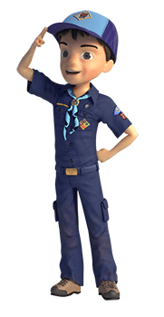
Did You See That?
York Adams Area Council
Players: Anywhere from two to as many Cubs as you want.
Scene: Depending on how many actors you have, you will set this up differently, but the gist of the scene is you have a “lead archeologist” and one or more of his students on a trek through the Sahara to see the great pyramids.
Lead Archeologist: (To entire group) Today we are making a wonderful trip across the Sahara to the land of the Pharaohs. During our trek I expect each and every one of you to keep your senses keen for the things around us. (They begin their trek, maybe back and forth across the stage. Leader stops suddenly and turns to the first student.) Did you feel that?
Student #1: No, I didn’t feel a thing.
Lead Archeologist: It was the change in temperature as we came over that hill overlooking the oasis. You need to be aware of these things, for someday they could save your life. (The trek continues and the leader stops again and addresses the second student.) Did you hear that?
Student #2: No, I didn’t hear anything but the sand swishing around my boots.
Lead Archeologist: It was the sound of the wind blowing across the dunes. It tells you when a sand storm is approaching so you can be prepared for it. You need to be aware of these things, for someday they could save your life. (The trek continues and the leader stops again and addresses the next student.) Did you smell that?
Student #3: No, I don’t smell anything but my sweaty safari shirt.
Lead Archeologist: It was the smell of a campfire of a wandering shepherd. It tells you that someone else is near so that you can be aware that you might have an enemy or a friend nearby. You need to be aware of these things, for someday they could save your life.
(This goes on for as many “students” as you have. Each one, of course, is oblivious to whatever the leader is pointing out. You can vary between the senses, but leave the “seeing” sense for the last student. The trek continues and the leader stops again and addresses the last student.)
Lead Archeologist: Did you see that?
Student #Last: (Haughty and not wanting to seem unaware): Yes, of course I saw it!

Lead Archeologist: Then why did you step in it?

CLOSING CEREMONIES
Be sure to check out BUILDING A BETTER WORLD OPENING OR CLOSING in the Opening Ceremonies section for use as a Closing Ceremony
Good Bye!
Sam Houston Area Council
Note: See Opening Ceremonies section for companion ceremony and link to list of all countries with Scouting
Props:
- Cue cards with the Cubs' lines printed on the back. On the front you could have an outline map of the country whose language the Scout will be saying hello or a picture of that country's Scouting logo.
- You may also wish to post a banner with a map showing all the countries with Scouting or a poster with each country's Scouting organization logo.
Other Thoughts:
- If you need more countries or want to use one not listed, feel free to add or delete. If you go to one of the following:
- http://blog.oxforddictionaries.com/2015/08/goodbye-other-languages/
- http://www.wikihow.com/Sample/Ways-to-Say-Goodbye
- http://www.omniglot.com/language/phrases/goodbye.htm
you can learn how to say and pronounce "Good Bye" in other languages.
Announcer: We close our meeting tonight as we opened it, by visiting the many places around the world which are served by the World Brotherhood of Scouting. We have seen many places, where some things are different and some things are familiar. A scout will always bid you a fond farewell after spending time with you, like this:.
- Spanish: Hola (OH-lah)
- French: Bonjour (bohn-ZHOOR)
- German: Guten Tag (GOOT-en Tahg)
- Mandarin: Ni hao (nee-HOW)
- Russian: Zdravstvuite (ZzDrast-vet- yah)
- Mohawk: Sekoh (SEH-goh)
- Swahili: Jambo (JAM-bo)
- Arabic: A1 salaam a'alaykum (AHL sah-LAHM-ah ah-LAY-koom)
- Hindi: Nahmaste (nah-mah-STAY)
- Hebrew: Shalom (Sha-LOHM)
- Hawaiian: Aloha (ah-LOW-ha)
Announcer: "No matter where you go or how you say it, you can count on a fond farewell by a Scout who says "Goodbye."
Brotherhood Closing
Utah National Parks Council
This was originally written for a Chinese New Year theme. But you can substitute any other country or area of the world.
Preparation:
- Have U.S. and pack flags posted.
- Have a boy hold the Chinese flag or picture of the flag or map of China. (Or any other country or countries that you wish)
- Write each boy's part of the poem in LARGE print on a card for him to read his part in turn.
- Last night I watched the sunset
When my day was almost done,
And thought about another boy
Whose day had just begun.
- I’ll probably never know him,
Since we’re half a world apart.
How different we must be
If my day ends as his day starts.
- On the far side of the sunshine,
On the other end of day,
Lives a boy who seems a stranger
In a hundred different ways.
- Still I think we might discover
If we look beneath the skin,
That instead of being strangers,
He and I are more like twins.
- His skin’s another color,
And he walks another shore.
The flag that he salutes
Is not the flag that I adore.
- But listen to his heartbeat,
Oh, just listen to his dreams.
You’ll know that deep inside
We aren’t as different as we seem.
- I think I’ll write a message.
I might send it on the wind.
So when he hears it blowing
He will know he has a friend.
- I think that I can touch him
If I reach out with my heart.
How different can we be
When we’re just half a day apart?
- On the far side of the sunshine,
On the other end of day,
Lives a boy who exactly like me
In the most important ways.
- Yes, I know we will discover
When we look beneath the skin,
That instead of being strangers,
He and I are really twins!
Thank You Parents
Circle Ten Council
Who got it from Simon Kenton Council
Personnel: 8 Cub Scouts
Equipment: Large poster divided into 8, when put together has a heart on it with the words THANK YOU in it.
Setting: Each boy has a piece of the heart. After all lines have been read, the first four stand in a line and hold their cards while the second four kneel in front and hold up their cards so that the heart is formed.
- Our leaders are grand, the best in the land
- They deserve a thank you, and a big hand, too.
- This celebration's the time and the place, to tell them we think so, right to their face.
- So thanks to the Den Leaders, Committee and Cubmaster, at making Scouting fun, they're truly the masters.
- But there's someone special we don't want to leave out, after all, they're a big part of what Scouting's about.
- We want to say thank you, Mom and Dad, and tell you that we are really glad.
- To have you as parents, yes it's true, because of your help and all that you do.
- To help us through Scouting's achievements and ranks you truly deserve our heartfelt thanks.
Adios
Circle Ten Council
Boys hold cards spelling "ADIOS" which is Spanish for good-bye. Each boy reads one of the parts and after the last one is read, all boys shout "Adios."
- A - We came together and had our fun. It seems as though we'd just begun.
- D - We sang and danced and played some games. And had some fun with Spanish names.
- I - We ate new foods and learned how Spanish children play and shout.
- O- We dressed in ponchos we had made, and took siestas in the shade.
- S - But now the time has come to say, "Adios until another day!" "ADIOS ! "

CUBMASTER’S MINUTES
A Scout Is Friendly 1
http://moorecountyboyscouts.org/
Tonight I'm going to tell you a little story that didn't really happen-at least, I don't think it did. It's about a boy named Brian who had just moved into town and hadn't any friends.
One night Brian happened to come by our meeting place and heard us playing. He hung around a while, listening and looking, but he couldn't get up the nerve to come in. I guess he was just a little bit timid.
Anyway, the next week he was back, hanging around the door. He still couldn't get up his courage to come in and join us.
Brian was waiting around the door when he saw a Scout coming down the street, heading for our troop meeting. That Scout was you.
That's all the story I'm going to tell. You have to finish it. What happened? Did you brush by him or did you invite him to come in?
A Scout Is Friendly 2
Sequoia Council Scoutmaster's Minutes
http://www.seqbsa.org/PDFS/Forms/Scoutmaster_Minutes_Collection.pdf
Probably all of you know some guy who is grouchy all the time. His neighbors try to be nice to him, but he just won't be friendly. Maybe he'll build a great wall around his house to keep people away.
Let me tell you about another kind of neighbor I heard about. There was no wall around his property, and somebody noticed that a strip of grass between his yard and his neighbor's yard was unusually green. How come? He was asked.
"Oh," he laughed, " my neighbor and I are so afraid we'll cheat each other that we always water and fertilize the grass across the line on the other fellows side. That strip of grass down the property line gets twice as much water and fertilizer as the rest of our yards. " Instead of a fence to keep each other away, that man and his neighbor had a vivid green reminder that they were friends.
The point of this story is that if you want to have friends, you can't build walls between yourselves and other people. Instead, cultivate that space between you by being as fair to the other guy as you'd like him to be to you. A Scout is friendly, and the way to have friends - and keep them - is to be friendly yourself.
A Scout Is Friendly 3
Sequoia Council Scoutmaster's Minutes
http://www.seqbsa.org/PDFS/Forms/Scoutmaster_Minutes_Collection.pdf
What's the fourth point of the Scout Law? That's right - "A Scout is friendly. "
Do you have as many friends as you'd like to have? Real friends, I mean? The kind of guys you're glad to see, and who are glad to see you?
Well maybe not. Lots of us would like to make more friends, but somehow it doesn't seem to happen.
Well the secret of making friends is simple - being friendly. If you're a put down artist, or if you're always trying to rip off everybody or get the better of them in some way you're not going to have many friends. Nobody like to be put down or ripped off.
The Bible gives the key to making friends. It's called the Golden Rule - "Do unto others as you would have them do unto you."
That's a great rule to remember in everything you do. And it's a perfect prescription for making friends.
A Smile
Santa Clara County Council, 2001 Pow Wow
We have learned much about other countries this month. People who live in other lands have different customs, different styles of dress and different languages than we do. But there is a universal language understood by everyone in the world. It is a smile.
A smile costs nothing but creates much. It happens in a flash but the memory sometimes lasts forever. It cannot be begged, bought, borrowed, or stolen, but it is something that is of no earthly good unless it is given away. So, if you meet someone who is too weary to give you a smile, leave one of yours. No one needs a smile quite as much as a person who has none left to give.
As you travel through this world, whether you are in a foreign land or your own neighborhood, remember to smile. Remember...”A Cub Scout gives good will.”


World Friendship
Sequoia Council Scoutmaster's Minutes
http://www.seqbsa.org/PDFS/Forms/Scoutmaster_Minutes_Collection.pdf
Before starting this Cubmaster's Minute, give a little background on the World Friendship Fund. Lots of information is available on National's Site –
Brochure –
- http://www.scouting.org/filestore/pdf/wff.pdf
Info Pages –
- http://www.scouting.org/scoutsource/International/InformationSheets/22-329.aspx
- http://www.scouting.org/Home/International/PhilmontConfDocs/WorldFriendshipFund.aspx
Check your Leader's Books and the Boys' Handbooks.
"A Scout is friendly. A Scout is a friend to all. He is a brother to other Scouts. He seeks to understand others. He respects those with ideas and customs other than his own."
That's what your handbooks tell us about the fourth point of the Scout Law. What does it mean? For one thing it reminds us that we have a lot of brothers. Did you know that there are some 40 million Scouts in over 200 countries around the world? Scouting is a lot bigger than our troop, our local council, or even the Boy Scouts of America. It's a worldwide movement of brothers.
Some of those brothers are in poor countries. To help them the Boy Scouts of America has the World friendship Fund, which collects money from American Scouts to buy uniform materials, supplies and equipment, and to train their adult leaders.
Soon (Tonight?), our unit will be making a collection for the World Friendship Fund. You don't have to give a lot. Just contribute some of the money you'd use for candy or video games at the arcade. It will help. Your contribution doesn't have to be a big sacrifice for you to show your friendship for Scouts around the world.
Remember a Scout is friendly
Do Your Best
Santa Clara County Council, 2001 Pow Wow
All over the world, Cub Scouts promise to do their best. Let’s stop for a minute and carefully consider those words. “Best” describes effort and action above our usual performance. “You” are the only person who can possibly know whether or not you have done your best. Every time you repeat the Promise, YOU agree to do your best to do certain things.
“Your Best” is just that--the very best. Think about the meaning of the promise and decide that you will always do your very best, no matter what the job facing you might be. Now please stand, make a Cub Scout sign and repeat the Scout Oath with me.
A Scouting Passport
Scott Thayer, Sequoia Council, California
When people travel to foreign countries, they have to ask their governments to issue them what’s called a passport. A passport is a little booklet with your name and picture in it, along with several blank pages on which foreign border officials stamp the seal of their country when you enter. You can’t go into another country without your passport. But did you know that every Scout already has a passport? It’s not a little booklet, but a small purple patch that we wear on our uniforms, called the World Crest.
The World Crest is a symbol of brotherhood and good will the world over. When you wear the World Crest on your Scout uniform, you remind yourself that you are a part of an organization that includes, but also goes far beyond, your own home nation. The World Crest also reminds us that human beings should be respected and valued regardless of their race, color, creed, or place of origin. You’ll still need a paper passport to visit foreign lands, but the World Crest allows Scouts to think of every person as their neighbor and friend.

All Over The World
Santa Clara County Council, 2001 Pow Wow
Prop: Globe of the world
Cubmaster points at/near the location of the Pack on the globe.
This evening our pack has explore the globe to find friends near and far in other lands. Did you know that all over this world, (spin globe) Cub Scouts just like us are taking part in Scouting activities too?
Well, it’s true. The Scouting movement began in England and now exists in almost every nation. There are Cub Scouts much like us in almost every country. They have the same ideals, the same Promise, and the same brotherhood of service. So let’s think of our brother Cub Scouts around the world as we join in the Scout Oath. (Lead Scout Oath)

Prejudice
Scoutmaster CG
For more – go to http://scoutmastercg.com/
Prejudice is pre-judging an idea, object or person before we have all the facts. Prejudice is usually an attitude toward members of another race, ethnicity, national origin, or system of belief based on second hand information instead of first-hand knowledge. First-hand knowledge comes from freely extending friendship and ignoring our prejudicial thoughts and attitudes.
I may be well spoken, but if I have no friends, my speech is no more than a noisy gong or a clanging bell. I may have the gift of inspired preaching; I may have all knowledge and understand all secrets; I may have all the faith needed to move mountains—but if I have no friends, I am nothing. I may give away everything I have, and even give up my body to be burned —but if I have no friends, this does me no good.
Friends are patient and kind; not jealous or conceited or proud; friends are not ill-mannered or selfish or irritable; friends do not keep a record of wrongs; friends are unhappy with evil, but happy with the truth. Friends never give up; their faith, hope, and patience never fail.
Above adapted from 1 Corinthians 13, NIV -
If I speak in the tongues[a] of men or of angels, but do not have love, I am only a resounding gong or a clanging cymbal. If I have the gift of prophecy and can fathom all mysteries and all knowledge, and if I have a faith that can move mountains, but do not have love, I am nothing. If I give all I possess to the poor and give over my body to hardship that I may boast,[b] but do not have love, I gain nothing.
Love is patient, love is kind. It does not envy, it does not boast, it is not proud. It does not dishonor others, it is not self-seeking, it is not easily angered, it keeps no record of wrongs. Love does not delight in evil but rejoices with the truth. It always protects, always trusts, always hopes, always perseveres.
Love never fails. But where there are prophecies, they will cease; where there are tongues, they will be stilled; where there is knowledge, it will pass away. For we know in part and we prophesy in part, but when completeness comes, what is in part disappears. When I was a child, I talked like a child, I thought like a child, I reasoned like a child. When I became a man, I put the ways of childhood behind me. For now we see only a reflection as in a mirror; then we shall see face to face. Now I know in part; then I shall know fully, even as I am fully known.
And now these three remain: faith, hope and love. But the greatest of these is love.

CUB GRUB
Cub Grub Cookbook
This is a really great cookbook for Cubs -
http://balboaoaks.bsa-la.org/download/blog/Cub%20Grub%20Cookbook.pdf -
You can save a copy on your PC by selecting
File, Save As... in your web browser's menu bar.

FRIENDSHIP TEA
Ingredients:
1 cup orange-flavored instant drink powder
2/3 cup instant tea powder
1 teaspoon ground cinnamon
1/2 cup sugar
1/4 teaspoon ground cloves
Whole stick cinnamon (optional) Lemon slice (optional)
Directions:
Preparation:
- Combine drink powder, tea powder, ground cinnamon, sugar and cloves.
- You can store this up to 4 months in a Zip-Loc bag.
- Stir before using.
- Makes 2 cups, enough for 12 servings.
For each serving:
- Stir 1 rounded tablespoon of mix into 2/3 cup water in a microwave safe mug.
- Heat uncovered on high power for 1 to 2 minutes or until hot.
- If desired, serve with a cinnamon stick and a lemon slice.
GERMAN EGG PANCAKES
Ingredients:
For one serving:
1 teaspoon flour
2 teaspoon milk
2 eggs
1 teaspoon butter
1 teaspoon sugar or jam Lemon wedge (optional)
Directions:
- In a bowl, mix the flour and milk to form a smooth paste.
- Add eggs and beat until the batter is thoroughly mixed.
- Heat butter in a medium sized frying pan over medium heat.
- When the butter starts to bubble, pour in the batter. It should cover the entire pan.
- Cook for four to five minutes, until the top of the batter looks dry. Remove from heat.
- Sprinkle the sugar evenly over the entire pancake and squeeze the lemon slice over the same area.
- Lift half pancake with a spatula and fold it over the other half. Eat hot.
Birds of Egypt Recipes
Southern New Jersey Council
White Chocolate Birds Nests
Needed –
- 2 c. chow mein noodles,
- 2 c. corn flakes,
- crushed white chocolate,
- small gourmet jelly beans
Directions:
- In bowl, mix noodles and cereal.
- Melt white chocolate,
- Pour over cereal and noodles, coating them.
- Put by spoonfuls onto waxed paper.
- Indent to shape like nests.
- When hardened add jelly beans into indentations for eggs.
Owl Snacks
Needed –
- Creamy peanut butter 1 rice or popcorn cake
- 2 banana slices
- 2 raisins for eyeballs
- 6 fruit loops (or other ringed cereal)
- 1 cheese triangle
Directions:
- Spread the peanut butter on the rice or popcorn cake.
- Put the two banana slices on for the owl's eyes.
- Put the raisins, one on each banana slice for eyeballs. Push it in a little so it will stay.
- Add the six loops above the bananas to make eye brows.
- Add the cheese triangle under the banana to form the beak.
- Now you have your owl snack.

Lebanese Cookies
Southern New Jersey Council
Ingredients:
- 1/3 c Cooking oil,
- 1/2 c Butter, softened,
- 1/3 c Sugar,
- 1 TBS Orange juice,
- 1 tsp baking powder,
- 1/2 tsp baking soda,
- 2 C All-purpose flour,
- 3/4 C sugar,
- 1/3 C honey,
- 1/3 C finely chopped walnuts
Directions:
- In mixing bowl, beat cooking oil into butter until blended,
- Beat in sugar.
- Add orange juice, baking powder and baking soda, mix well.
- Add flour, a little at a time, to make a soft dough.
- Shape dough into 2-inch ovals and place onto ungreased baking sheet.
- Bake at 350 degrees for 20 to 25 minutes or until golden.
- Cool cookies on rack.
- Meanwhile, in a saucepan, combine the 3/4 cup sugar, honey and 1/2 cup water, bring to a boil, boil gently, uncovered for 5 minutes.
- Dip cooled cookies into warm syrup.
- Sprinkle immediately with nuts.
- Dry on wire rack.
- Makes 3 dozen
Cactus Cake
Circle Ten Council
Make a cake in the shape of a very large cactus with toothpicks for spines.
Use one 9 x 13 cake, cut in half lengthwise and place one piece above the other to form the center of the cactus. From a second 9 x 13 pan cut 2 arms for the cactus, or use a horseshoe shape pan and cut apart in the center placing one piece on each side of the center cactus for the arms.

Coconut Squares
York Adams Area Council
By Mary Kay Radnich
This sweet and tasty treat is actually Moroccan in origin.
Ingredients:
- 2 c. grated coconut
- 3/4 c. half and half
- 1 1/2 c. sugar
- 3 tablespoons butter
- 3 tablespoons lemon rind
Directions:
- Combine the coconut, the half and half and the sugar in a heavy saucepan.
- Bring to a boil, then turn the heat to low.
- Simmer until a soft ball is formed when a spoonful of the mixture is dropped into cold water.
- Add the butter and lemon rind and mix.
- Let cool to room temperature.
- Transfer to a bowl and with an electric mixer, mix the batter until thick and glossy.
- Pour into a small buttered pan and chill.
- Cut into squares and serve.
Bunuelos (fritters)
Circle Ten Council
Recipe used at Christmas in Mexico
Makes about 3dozen.
Ingredients:
- 2 cups sifted flour
- 2 tbsp. sugar
- 1/2 tsp. baking powder
- 1/2 tsp. salt
- 1/4 tsp. anise seeds, crushed
- 1 tsp. grated lemon rind
- 1 egg, beaten
- 2/3 cup honey
- 1/2 cup oil
Combine flour, sugar, baking powder, salt, anise, and lemon. Stir in honey, egg, and enough milk to create a dough. Roll out to thin rounds 7-8 inches in diameter. Heat oil in a shallow skillet until hot. Quarter each round and drop flat into hot oil, brown lightly about 30 seconds on each side. Remove from skillet and sprinkle to taste with topping mixture of cinnamon and sugar.
Nachos
Circle Ten Council
You will need tortilla chips, shredded cheddar or jack cheese, and your choice of optional items including: ground meat, refried beans, olives, tomatoes, jalapenos, etc.
Spread the tortilla chips evenly on a baking tray. Sprinkle the shredded cheese evenly over the chips, alternating with your other optional items.
Bake in a 350 degree oven for about 5-10 minutes (or until cheese is melted). Serve with salsa and sangria (recipe below!)
Chili Cheese Dip
Santa Clara County Council
Ingredients:
- 1 can chopped tomatoes
- 1 can prepared chili
- 1 lb Velveeta, cubed
Melt ingredients together in double boiler over low heat. Serve with chips when cheese is thoroughly melted. Keep warm in fondue or crock pot.
Mexican Pizza
Santa Clara County Council
Ingredients:
- 1/2 lb. ground burger
- 15 1/2 oz. can chili beans
- 8 oz. can corn, drained
- 2 T. chopped green chilies
- 1 12" boboli crust
- 3 green onions, chopped
- 1 cup shredded cheddar cheese
- 6 olives, sliced
- 2 tomatoes, chopped
Brown burger, drain and combine with beans, corn and chilies.
Place crust on a pizza pan. Spread mixture over crust.
Top with cheese, onions, olives and tomatoes.
Bake 10-12 minutes at 425 degrees, until cheese melts and pizza is heated through.

GAMES
NSIKWI--AFRICA
Santa Clara County Council, 2001 Pow Wow
- You will need a tennis ball and an empty plastic bottle for each player (all the same size).
- Divide the players into two teams.
- Teams sit in lines, facing each other. Make sure there is about ten feet between the teams.
- The players place the empty bottles in front of them
- Each player then tries to knock down the bottle of the player opposite him with the tennis ball. A point is scored for each knockdown.
- After a designated time period, add up the points of the boys on each side.
BIVOE EBUMA (CLAP BALL)--CAMEROON
Santa Clara County Council, 2001 Pow Wow
- Divide den into two teams. The teams line up facing each other about six feet on either side of a center line, and toss a rubber ball back and forth.
- When the ball is caught, the catcher must clap his hands and stamp his feet once. If a player forgets to clap and stamp, a point is scored against his team.
- Keep the ball moving fast.
GREAT BRITAIN
Santa Clara County Council, 2001 Pow Wow
- Dens in relay formation.
- About fifty feet in front of each den, place a judge holding a bag of small objects.
- On signal, the first boy of each line runs to the judge, gets an object, examines it and hands it back to the judge.
- Then he runs back, tells the next in line what he saw.
- The second player runs down, sees a second object, runs back and tells the next in line what he saw and what he was told by the first Cub.
- The next Cub runs down and so on. The last Cub does not go back to the den but writes, on a piece of paper, as much as he can remember of what he has been told.
CHEF MANDA (THE CHIEF ORDERS)--BRAZIL
Santa Clara County Council, 2001 Pow Wow
- Played like Simon Says. The chief stands in front of the group.
- When he says, “The chief orders you to laugh,” all must laugh.
- If he says, “He orders you to laugh,” no one should laugh because all valid orders must start with “The chief...”
- A player who makes a mistake is eliminated or loses one point.
LA PALMA--BOLIVIA
Santa Clara County Council, 2001 Pow Wow
- The Indians of Bolivia used the tailbones of a donkey or llama for this game. You can use a stick. Set the stick up on end in a hole in the ground.
- Draw a straight line away from the stick and at 3’ intervals, drive a peg into the ground; use about 6 pegs.
- You will need a supply of tennis balls.
- Boys then take turns throwing the ball to hit the stick from the first peg. Those who do, move on to the next peg. Those who don’t, stay at peg number one until they hit the stick.
- Boys must throw in their correct order throughout the game.
- The first boy to complete the six throws from the pegs wins. This can also be done on a best time basis.
VARIATIONS: For younger children, make the distance between pegs shorter and allow them an option of rolling the ball. Or use a larger ball.
KABBADI--INDIA
Santa Clara County Council, 2001 Pow Wow
- Divide the group into two teams. Teams face each other behind lines drawn on the ground about six feet apart.
- The game begins when a boy from one team (A) crosses the line to tag a member of the other team (B). If he tags the boy before getting caught and held by the other members of team (B), the victim must join team (A).
- If the chaser is caught and held by team (B) before he makes the tag, he must join that team, (B). The chaser must hold his breath all the time as he runs.
- To prove his is holding breath, he repeats over and over, Kabbadi, kabbadi, kabbadi (pronounced “cubbidy”) without taking in breaths. The teams take turns sending out chasers.
- The team with the most members at the end of the allotted time is the winner.
KAAB--SAUDI ARABIA
Santa Clara County Council, 2001 Pow Wow
- In Saudi Arabia this game is played with the knee bones of sheep. Instead, use washers with identifying colored dots on each. Players should have at least ten washers each. Stones or marbles may also be used.
- To play the game, draw two lines on the ground, about 6 feet apart.
- Each player places one of his “bones” on one line. Standing on the other line, each player now takes turns and attempts to toss one of his remaining “bones” at the ones on the ground.
- If the player hits one of the bones he may pick up that bone. If he misses the “bone,” his remains as a target for the other players. He also loses his next turn. The game is played until all the bones have been hit or all the players have lost their “bone” supply.
NUMBER GAME--SWEDEN
Santa Clara County Council, 2001 Pow Wow
- Choose one player to be “It.” All other players scatter across the playing field and each one draws a circle around himself at about arm’s length, with a stick or chalk.
- Each player stands within the circle he has drawn. “It” gives a different number to each player who stands in a circle.
- “It” calls out two of the numbers he has given. The players with those two numbers must change circles.
- “It” tries to get to one of the circles first. If he fails, he must call out two other numbers. If he succeeds, the players left without a circle becomes “It” for the next game.
- The same procedure is followed for the new game
SEVENTY-ONE YEARS AND COUNTING!
Santa Clara County Council, 2001 Pow Wow
- 2016 marks the 86th anniversary of Cub Scouting in the United States. Let’s start counting!
- Have boys sit in a circle and start counting. When a player comes to “eight” or a number with an 8 in it, he must instead say “blue.”
- When he comes to “six” or a number with six in it, he must say “gold.” So they start out counting with “gold.”
- 64 would be “gold-four” and 28 will be “twenty-blue.” 86 would be “blue-gold.”
WORLD BROTHERHOOD TUG
Santa Clara County Council, 2001 Pow Wow
- This is a teamwork game. Players should be similar in size. Start with a smaller group; gradually increase the size as the boys get used to this game.
- A group of boys sits in a circle holding onto a rope placed inside the circle in front of their feet.
- The ends of the rope are tied together to make a huge loop.
- The object of the game is for everyone to stand up tugging the rope. If everyone pulls at the same time, the entire group should be able to come to a standing position.
PICK-UP STICKS--VIETNAM
Santa Clara County Council, 2001 Pow Wow
- You will need ten chopsticks or popsicle sticks, and small bouncy balls.
- Lay the sticks on the floor in a straight line, one below the other.
- Throw the ball in the air and pick up one stick. Catch the ball in the same hand after you let it bounce once. Keep the stick in your hand and pick another up in the same way.
- Repeat until all of the sticks have been picked up.
- Lay them out again and as the ball is thrown up and allowed to bounce, pick up two sticks at a time.
- Continue with three, then four, and so on until you attempt to pick up all ten at one time.
- This game can be played by two or three players. One player keeps playing as long as he doesn’t drop sticks or misses catching the ball.
- When he makes a mistake, it' the next player’s turn.
AUSTRALIAN CIRCLE GAME
Santa Clara County Council, 2001 Pow Wow
- A player stands in the center of a circle, holding a tennis ball. He tries to throw the ball to someone in the circle who might drop it.
- Another ball is also being passed around the circle from one boy to another. The player in the center may throw his ball to anyone, but he usually throws it to the boy about to receive the ball being passed around the circle.
- If either ball is dropped, the one who dropped it changes places with the boy in the center.
PALITO VERDE (GREEN STICK)--COLUMBIA
Santa Clara County Council, 2001 Pow Wow
- “It” carries green stick or other object. All other players form a large circle, facing inward with their hands behind their backs.
- “It” walks around behind them and suddenly places the green stick in a player’s hands.
- That player chases “It,” who tries to run around the circle and get back to the vacant spot without being tagged.
- If he is touched by the green stick before he reaches safety, he is still “It” for the next round.
- If he reaches the spot safely, the player with the stick becomes the new “It.”

THEME BLUE & GOLD IDEAS

PASSPORTS

Passport can be used as a Blue and Gold decoration, a favor that everyone signs as a memento of the evening, an individual den doodle by stamping the pages when boys do particular things, a place marker, or an invitation. If you have a Country Faire (see Theme Related above), have each country ‘stamp’ the boy’s visa.



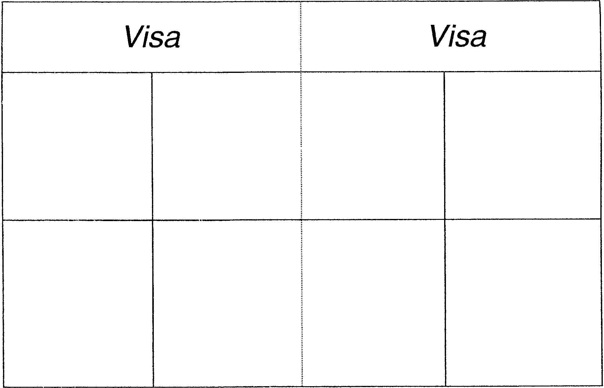

NECKERCHIEF INVITATIONS

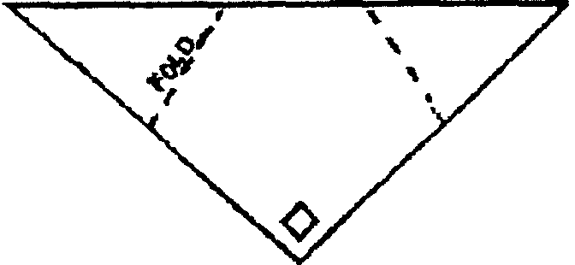
Materials:
- Yellow, blue or red construction paper (the same color as their neckerchief);
- Pens or markers.
Directions:
- Cut paper into triangle shape.
- Draw the plaid or other markings the same as the boy’s neckerchief.
- Fold the invitation as shown.
- On the inside, write the information needed:
    - TIME:
    - PLACE:
    - DATE:
    - RSVP:
    - SPECIAL INFORMATION:

SCOUTING WORLD INVITATION

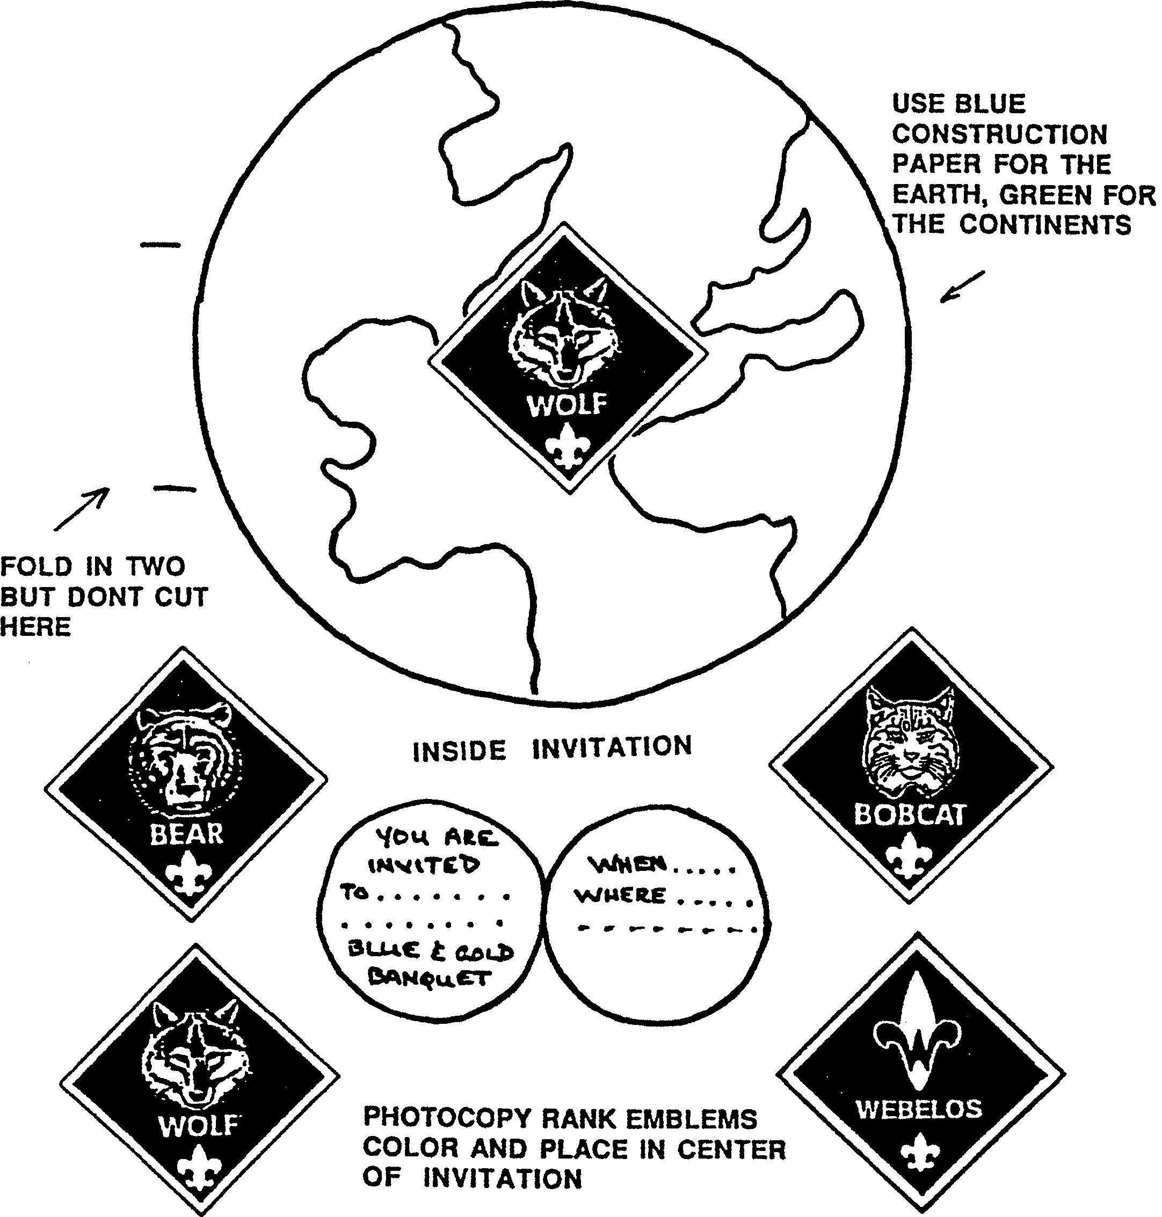

WORLD WISE CUB SCOUT

This may be used as a hanging ornament or a centerpiece--make 2-3 and have them lean against each other.

Trace patterns on white poster board and cut out. With markers or crayons, color the Cub Scout. Trace and color the globe. With paper fasteners, attach the head, arms and legs to the globe at the Xs. For the hanger, cut a 7” piece of string or yarn. Make a loop and glue to back of the head.

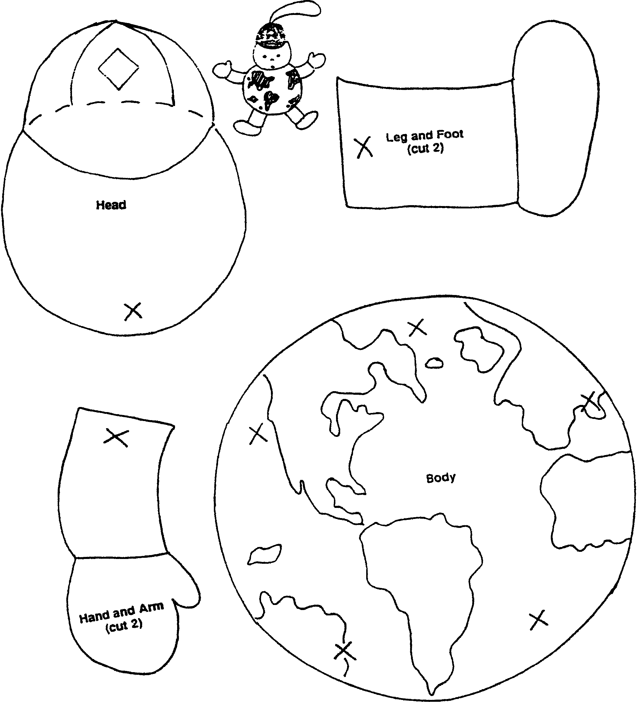

FRIENDSHIP NUT CUP
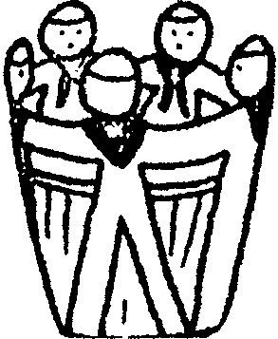
Pleat 2-1/2” strips of blue paper into 1-1/2” pleats.
Cut outline of Cub Scout, leaving arms joined to from a chain.
Open out, add faces and neckerchiefs.
Glue around a yellow nut cup.

NOTES: This Cub Scout cutout pattern may be used for other table decorations as well:
- Paste a few Cub Scouts on a place mat.
- Cut a “string” of 3 or 4, tape hands at both ends together and stand it up as a place marker.
- Make smaller Cub Scouts, two attached. Glue on stiff paper and make a pin for parents or make a neckerchief slide.
- Put these Cubs around another centerpiece.

TABLE CENTERPIECES
FLAG CENTERPIECE
Picture on left below
- Using a large piece of cardboard, have the boys color the flag.
- Write 2 or 3 interesting facts about that country on the back of the flag.
- Make an “easel” for the flag with pieces of cardboard so that it can stand up on the table.
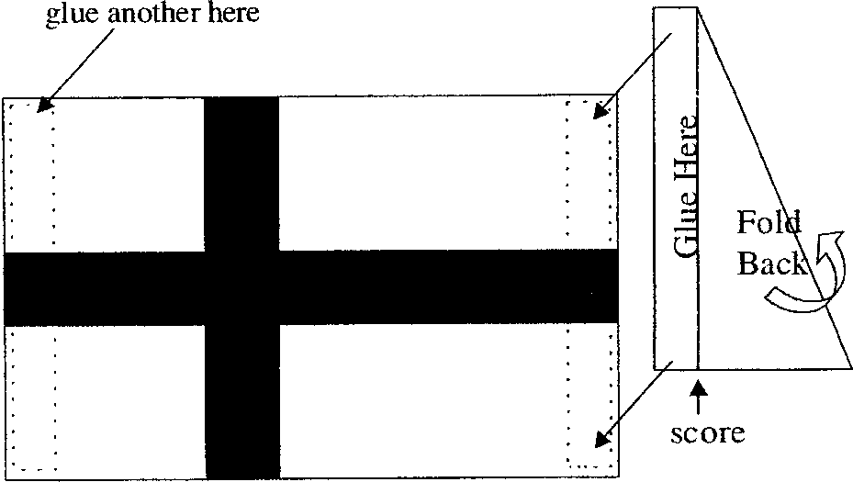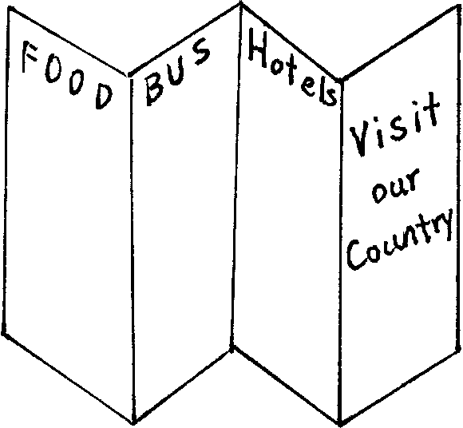
TRAVEL BROCHURE CENTERPIECE
Picture on right above
- Brochure is made with 8 1/2” x 14” paper--use thin but stiff paper like tag board or poster board.
- Fold the paper so that it makes a brochure.
- Choose a country.
- Clip pictures of that country from old magazines.
- Glue the pictures on the brochure, interspersing them between description of the country (library is a great resource for this). Make up some hotel information, airplane and train schedules, restaurant guide, etc.
- Stand the brochure as a centerpiece so everyone can see it.

WORLD SCOUTING FAMILY TREE CENTERPIECE
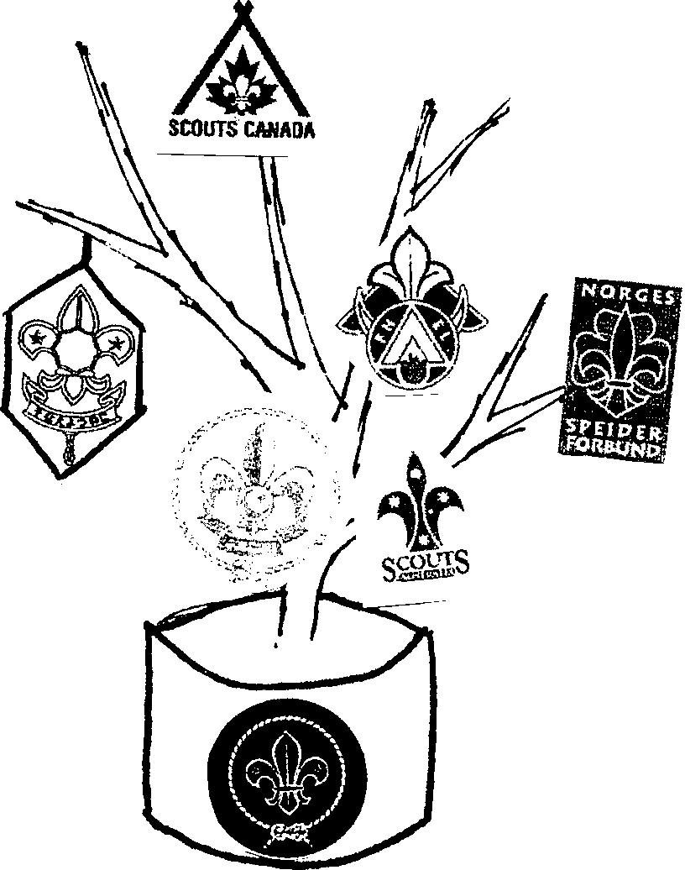
- Fill a can (e.g. Coffee can) with plaster of paris and insert a branch.
- Cover the can with blue or gold paper.
- Obtain copies of several Scouting emblems from different countries. (Assign one of the boys to do this) Don’t forget the BSA emblem.
- Cut out the emblems and paste on card stock that is the dominant color of the nation’s flag.
- Decorate the cardstock backing, if desired, with features from the flag or things that represent the country.
- Tape or glue the emblems on branches.
- Draw the earth or World Brotherhood emblem and glue it on the can.

PLACE MARKERS

- Use large craft stick. Neckerchief is chenille (glue it on the back of the stick). Use pony bead for a slide. Hat is folded, glued paper. If you cut this stick where the neckerchief is attached, it makes a nice slide for the boys.
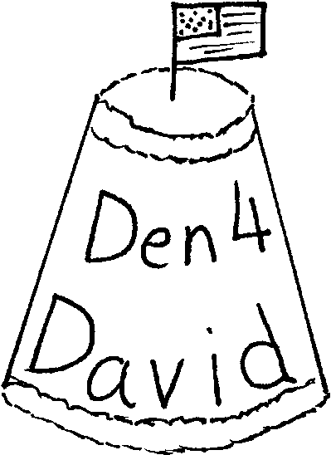
- Cut one paper cup open. Discard the bottom rim and top (this is the pattern for the place markers). Trace this pattern on blue or yellow construction paper. Write name and den number. Glue the construction paper on another paper cup. Glue chenille stems on top and bottom (color of the chenille is opposite of the construction paper). Place a small cocktail flag of the country of your choice on the top (=bottom) of the cup.

PYRAMID PLACE MARKER or DISPLAY PIECE
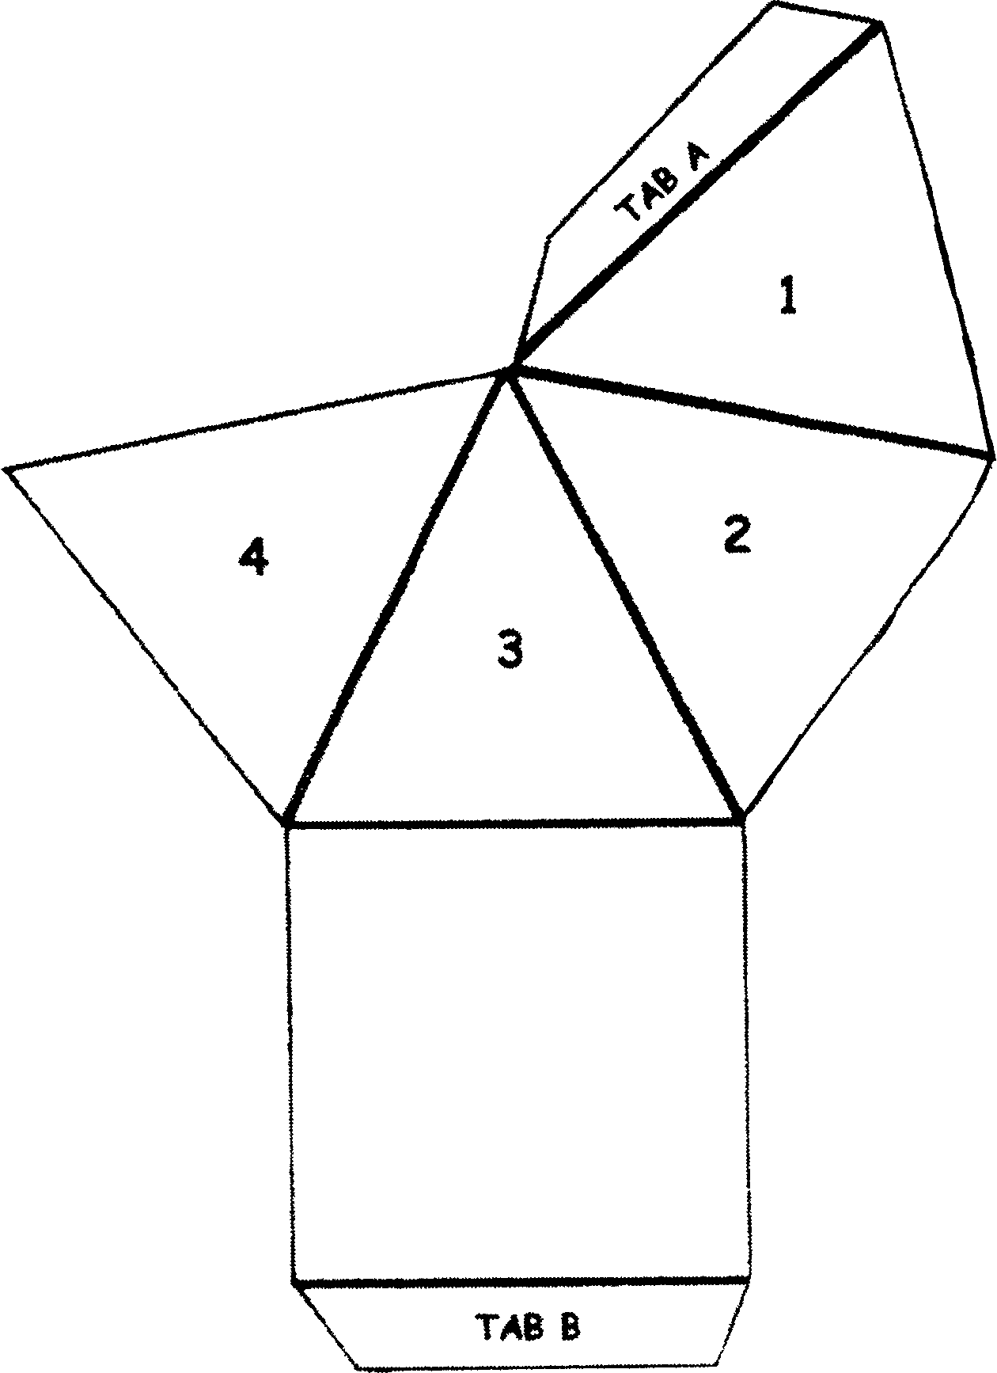
Use this to mark a place at the table. Write the name and Den number on two of the sides, and glue photos on the remaining two sides.

Materials:
- Tag board or cardstock (any color);
- White glue;
- Scissors;
- Photos (of the boy, den meeting etc. School photo works well.)
Directions:
- Copy the pattern on tag board. Enlarge if desired. This pattern is for
2” triangles around a 2” square.
- Cut out the pattern, including the tabs.
- Fold on the lines to make a pyramid.
- Write the name and Den number. Glue photos. Let dry.
- Glue Tab A under section 4 and Tab B under section 1.
- Hold together with a rubber band until dry.

OTHER BLUE AND GOLD IDEAS

NAPKIN RINGS:
- Thread several blue pony beads onto yellow chenille stems. Shape the chenille by wrapping around cardboard tube. Tuck the ends.
- Paint a section of cardboard tube (paper towel, wrapping paper tube) blue. Paint small pebbles gold. Glue the pebbles onto the tube section.
CENTER PIECE
- Wrap a styrofoam ring (any size) entirely with yellow streamer. Cut short section of blue streamer (a little longer than the diameter of the tube of the ring) and wrap them around the ring every 2-3 inches. Stand toothpick flags (cocktail flags) of various countries on the ring.

THE CUB SCOUT GAME
This can be made into a placemat and younger guests and Cubs can entertain themselves while waiting for the "action."
- -Everyone puts a marker on start.
- -Roll a die to see who goes first.
- -First player rolls a die and moves that many spaces and does the requirement.

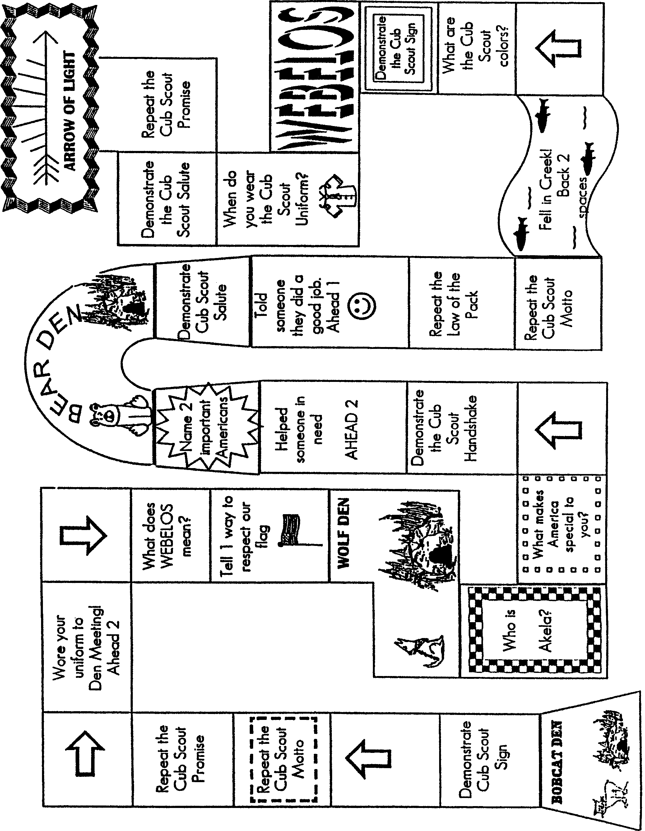

FLAG HOLDER CENTERPIECE
Materials:
- Scrap wood for the base (or 9” section of 1x4);
- Small wooden spools for the stand;
- Paint (blue, yellow); Stiff paper;
- Marker or crayons;
- Stick (diameter of the hole in a spool)
- Note: Replace spools with small wood blocks if desired.
Drill holes in them for the flag poles.
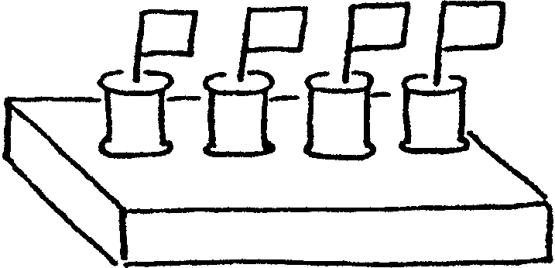
Directions:
- Sand the wood for the base. Paint blue. Let dry.
- Paint the spools yellow. Let dry.
- Glue the spools onto the base, spaced evenly down the middle of the board.
- Make flags of different countries with stiff paper and markers or crayons.
- Attach the flags to sticks. Insert them into the spools.

OTHER BLUE & GOLD THOUGHTS
MAP OF THE WORLD
Have a large world map ready at the pack meeting. As people arrive, give each person star stickers and ask them to mark places they have been or a place where they know someone is living or is from. They may want to include the place where their ancestors came from. During the meeting, comment of the map--how many countries we are connected with, etc.

“ADOPT” A COUNTRY
During the month each den learns about one country. What are the traditional clothes? Is it possible to make something similar to their clothes? If so, wear it at the pack meeting or in a skit. If not, draw or cut out pictures and display them at the pack meeting. Try some of the food. Learn a few phrases in the language. Read one or two traditional children’s stories from that country. Is there any video the den can watch about the country? Learn some games and songs. The library is a great resource for these activities.
- Also, is there a Scouting organization in that country? If so, learn their Cub or Boy Scout Promise. Reproduce their Scouting logo.
- Prepare the Blue and Gold Banquet table decoration using the country’s colors, flags, folk crafts, and writing system. Find pictures of that country in old magazines, cut them out and use them as part of the decorations.
COUNTRY FAIRE
Have several “booths” at the pack meeting featuring the country’s food, games, songs (either learn or listen), and/or crafts. If dens have adopted countries, each den can sponsor a booth. Or have a Country Faire committee to organize this. Posters and maps may be obtained through the country’s Council General, travel information center, or travel agents.

SPECIAL GUESTS
Have a guest from another country. Is anyone in your den from another country?
- Ask the guest to talk about a child’s life in the country he is from. Can he bring some traditional toys from that country?
- Can he teach your den some traditional games?
- Can he teach your den some words in his native language? (Wolf Elective 22) Can he teach the boys to write their names (phonetically) in that language?
(Children are fascinated to see their names written in foreign letters.)
Have a guest who has been to another country or has hosted Scouts or students from another country.
- Ask the guest to bring some souvenirs and photos to show to the boys.
- The guest could tell the boys some of his experiences in a different culture (keep it positive).
Make sure the boys thank the guest.
ACTIVITIES FOR CHILDREN
Often it takes some time for the banquet to get going. Prepare plenty of games and puzzles for younger children to occupy their time. Activity books and crayons for younger children, word search and word unscrambling for older children, mazes of varying degrees of difficulty are some ideas.
THANK YOU’S
It is important to thank leaders, parents, and friends of Scouting who help dens and the pack. The surest way to get support is to express appreciation for their help. And show the appreciation in front of their sons and families. The boys will be proud to see their parents, uncles, aunts or siblings recognized in front of all. Involve the boys in presenting the token of appreciation. Make each presentation short and simple. Remember KISMIF--Keep It Simple, Make It Fun.
AFTER THE BANQUET
After the banquet, be sure to send thank you notes. Do the evaluation and write down suggestions for the next year. Keep all the information, from planning to evaluation in one binder so it can be passed on to next year’s committee.

ONE LAST THING

The Parable of the Pencil
Rev Doug Baitinger, Mantua (NJ) UMC
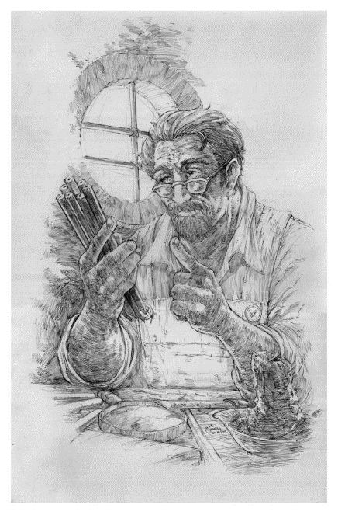
The Pencil Maker took the pencil aside, just before putting him into the box. “There are 5 things you need to know,” he told the pencil, “Before I send you out into the world. Always remember them and never forget, and you will become the best pencil you can be.”
- “One: You will be able to do many great things, but only if you allow yourself to be held in Someone’s hand.”
- “Two: You will experience a painful sharpening from time to time, but you’ll need it to become a better pencil.”
- “Three: You will be able to correct any mistakes you might make.”
- “Four: The most important part of you will always be what’s inside.”
- “And Five: On every surface you are used on, you must leave your mark. No matter what the condition, you must continue to write.”
The pencil understood and promised to remember, and went into the box with purpose in its heart.
Now let’s try replacing the pencil with a Scout! Always remember them and never forget, and you will become the best Scout you can be.
- One: You will be able to do many great things, but only if you allow your leader's hand to hold and lead you. Be it Akela (for Cubs) or the Scoutmaster or others.
- Two: You will experience a painful sharpening from time to time, by earning badges and not taking the easy road. You need to do it to become a stronger person.
- Three: You will be able to correct mistakes you make. You can repitch the tent or apologize to others.
- Four: The most important part of you will always be what’s on the inside. Do your best.
- And Five: On every surface you walk, you must leave your mark by helping others along the Scouting Trail.
Now let’s try replacing the pencil with you and your life!
Always remember them and never forget, and you will become the best person you can be.
- One: You will be able to do many great things, but only if you allow yourself to be held in God’s hand. And allow other human beings to access you for the many gifts you possess.
- Two: You will experience a painful sharpening from time to time, by going through various problems, but you’ll need it to become a stronger person.
- Three: You will be able to correct any mistakes you might make. You will be forgiven.
- Four: The most important part of you will always be what’s on the inside in your heart and soul.
- And Five: On every surface you walk through, you must leave your mark. No matter what the situation, you must continue to do your duties.
How about replacing the pencil with you as a Leader?
By understanding and remembering, let us proceed with our life on this earth having a meaningful purpose in our heart. We all need to be constantly sharpened as leaders:
- One, allow yourself to be guided by mentors, career coaches and trusted friends and colleagues.
- Two and Three, never allow yourself to get discouraged and think that your life is insignificant or can’t be changed. Like the pencil, the most important part of who you are is what is inside of you.
- Four, may this parable encourage you to know that you are a special person with unique talents and abilities.
- And Five, only you can fulfill the purpose which you were born to accomplish.


DEN ADVENTURES


TIGER

Games Tigers Play

Tiger Adventure: Games Tigers Play


- Do the following:
  - Play two initiative or team-building games with the members of your den.
  - Listen carefully to your leader while the rules are being explained, and follow directions when playing.
  - At the end of the game, talk with the leader about what you learned when you played the game. Tell how you helped the den by playing your part.
- Make up a game with the members of your den.
- Make up a new game, and play it with your family or members of your den or pack.
- While at a sporting event, ask a participant why he or she thinks it is important to be active.
- Bring a nutritious snack to a den meeting. Share why you picked it and what makes it a good snack choice.
Workbook for use with these requirements: PDF Format DOCX Format

Cooperative Games, Trust Games, Initiative Activities

Instructor: Miss Michelle Ulmen
Central Washington University
Ellensburg, Washington 98926
e-mail: ulmenm@cwu.edu

Class Overview and Introduction:
The purpose of each of these activities is to help students develop team cooperation, trust, communication skills, and problem solving skills. Throughout the activities the students will be enhancing their personal development and challenged as individuals to face their own perceived limitations. Teamwork is developed by working, playing and accomplishing goals together.
Student Learning Objectives:
These activities are designed to meet the Essential Academic Learning Requirements in Health and Fitness and in Communication

After completing this unit, the student will:
Apply rules and safety procedures, practice sportsmanship and teamwork, and cooperatively participate in a variety of group and individual fitness activities.
Develop fundamental physical skills and progress to complex movement activities as physically able.
Develop the personal skills necessary to comfortably and enjoyably participate in cooperative activities.
Acquire skills to move safely.
Understand concepts of physical fitness.
Recognize patterns of growth and development.
Use listening and observation skills to gain understanding.
Use communication strategies and skills effectively to present ideas to others.
Analyze and reflect of ideas while paying attention and listening in a variety of situations.
Use a variety of effective listening strategies.
Encourage group members to offer ideas and points of view.
Respect that a solution may require honoring and other points of view.

Developmental Analysis

TC = Teamwork, Cooperation CL = Communication, Listening Skills T = Trust
L = Leadership PS = Problem Solving SE = Self Esteem HA = Handicap Awareness

Activity | TC | CL | T | L | PS | SE | HA
Riverboat | X |  | X |  | X
Skywriters | X | X | X |  | X
Toxic Waste Transfer | X |  |  | X | X
Caution: Construction Zone |  | X
Great Communicator |  | X
Arachnophobia | X |  | X | X | X |  | X
Team-A-Pod | X |  | X |  | X |  | X
Grand Canyon II | X |  | X |  | X |  | X
Ship to Shore | X |  | X | X | X
Blind Square | X |  |  |  |  |  | X
Weight Pull | X |  |  | X
Minute Measure |  |  |  |  | X | X
Diminishing Load | X |  | X |  | X
All Aboard | X |  | X |  | X
Whitewater Cascade | X | X | X
Cookie Machine | X | X | X
Slipped Disc | X | X | X
Don't Touch Me | X | X
Radiation Contaminated Material | X | X
Ready Aim Fire | X | X
Line-ups | X | X
Fox and Squirrel |  | X |  |  | X
Body Snatchers |  |  | X
Minefield |  | X
Rope Knots | X | X
Countdown | X | X |  |  | X
Mobil Tee Pee | X |  |  |  | X
Square Form | X | X
The Shrinking Ship | X |  |  | X
Walk-A-Hoop | X | X
Hula Hoop Pass | X | X
Team Across | X | X
Cross the Great Divide | X | X
Ring Cross | X | X
Telephone Number Dance | X | X |  | X
Don't Touch Me | X | X

The Great Communicator
Listening Skills and Practice Communication Skills
Group members need to practice speaking to one another so that they can clearly explain the ideas they wish to put into action. Try having all groups try the Great Communicator at one time. Space is not an issue. Try this challenge early in your team building program. As your groups develop (or struggle to develop), you may wish to repeat this challenge from time to time as a test of communication success.

Task
The group members sit either in a semicircle or randomly in an area assigned only to that group. One member of the group is selected as the Great Communicator.
The Great Communicator attempts to describe a picture in teams that will allow the group members to draw the objects being described. The Great Communicator may not, however, use certain terms describing standard shapes. Terms such as circle, square, rectangle or triangle may not be used. Also, group members may not ask the Great Communicator questions or request further descriptions.
Equipment
Pencil and Piece of Paper for each student
Picture for the Great Communicator to describe
Clipboard for Great Communicator
Possible Solutions
The solutions will vary according to the descriptive skills of the Great Communicator and the listening skills of the group members. As the group displays their drawings and compares them to the Great Communicator's picture, they will get an indication of their success in listening and speaking. As the group practices this challenge a few times, members should see an improvement in their communication efforts and skills.

Caution: Construction Zone
Communication Skills
Group members, using verbal clues and cues, will assist other group members (the construction workers), who will be wearing blindfolds, to assemble a large puzzle. The challenge is not only for the blindfolded group members to complete the puzzle, but also for the sighted group members to communicate in a clear manner so that the construction workers can successfully follow the directions given to them.
Task
Blindfold as many of the group members as you wish. After blindfolding the designated construction workers, the sighted group members mix up the parts of the puzzle. Although there is no end to the types of puzzles you or your students could create, we assume the puzzle you will use will become a square when assembled.
The sighted group member’s five verbal directions to the blindfolded construction workers. The construction workers will need to be guided to the puzzle pieces and then be guided in assembling them. The sighted groups are not allowed to touch the puzzle pieces or the blindfolded group members.
Make sure the working area is completely free of obstructions or other physical structures.
Equipment
1-4 blindfolds per group
Puzzle pieces (made from plywood or tag board)
recommended that they are color coded
see example puzzle

Rules: Only the blindfolded members may touch the puzzle pieces. If sighted members physically touch puzzle pieces, the group must mix up the puzzle again and start from the beginning.

The Riverboat
Team Cooperation, Trust and Problem Solving

Requires a group to transport themselves across a large open space. There is one basic solution to this task, but it usually takes a group the better part of a class period to successfully complete the challenge.
Description
The team will transfer themselves from one area to the other without touching the ground with their bodies. The group may use two folded tumbling mats (or pieces of plywood) to create a riverboat. All members of the team and all equipment must make it to the other side.
Equipment
2 standard tumbling mats or pieces of plywood
two small tires
2 long jump ropes or pieces of rope

Rules
1. If a group member touches the ground with any part of their body, the entire group must go back to the starting position.
2. All equipment must be brought across the river.
3. No one may call a teammate by his or her last name.

Skywriters
Communication, Team Cooperation, Trust and Problem Solving

Group members will attempt to build a series of shapes or patterns on a cargo net using the bodies of all the group members to form each figure. Very physically challenging.
Task: Group members begin by standing under the cargo net. All the members must climb onto the cargo net to form a shape. After the shape is approved, all the group members must get off the cargo net before the next shape is constructed. Using paper and pencils, the group can prepare a plan whereby each person is assigned a specific part of the designated shape.
Equipment: Cargo net, soft surface to crash on to (safety), shapes to be built (square, circle, triangle, +, etc.), paper and pencils

Rules
1. All group members must be on the cargo net and off the floor when the shape is constructed.
2. All group members must be on the same side of the net.
3. All group members must get off the net before the next shape is constructed.

Toxic Waste Transfer

Requires the group to transport objects across an open space without directly touching the objects or their container. The group will manipulate a bucket filled with small objects using ropes attached to the bucket.
Task: After forming a circle around the 5-gallon bucket and holding the ends of the ropes attached to the bucket. The group will transport the bucket from one location to another. When they reach the location, they will be required to transfer some of the contents of the bucket into the other container. If something is spilled (toxic waste) then the team must choose a member of the team to dress in protective clothing, remove the contents, come back, remove the protective clothing, and then the team goes again. Each time there is a spill, a new team member is the toxic waste expert.
Equipment: 5-gallon bucket (attach 10-12 ropes, 8 feet or more in length by drilling holes in the bucket), 5-gallon bucketto transfer material into and protective clothing

Rules
1. If the toxic waster bucket touches the floor, the entire group must start over.
2. Students without protective clothing may not touch the toxic waste.
3. No last names or put-downs may be used.

Team-A-Pod

Members must physically assist and balance one another while traveling across a designated space. The group will creatively sculpt with their bodies a large millipede-like creature that moves with only a limited number of body parts touching the ground.
Task: The team will move themselves across an area (about 30 feet) with collectively only five body parts in contact with the ground. This challenge is set-up for a seven member team. The number of floor contact points can change depending on the number of team members.
Equipment: Cones to mark start and finish points, soft surface to go across (grass will work)

Rules
1. If more than the number of specified contact points touches the floor, the entire team must return to the starting line.
2. No last names or put-downs may be used.

Ship to Shore

A team is stranded on a sinking ship in the ocean. The team members must devise a way to get back to shore before the ship goes down.
Task: Group members will begin to travel with equipment on their stranded ship in the middle of the ocean. All team members must travel from the ship to island 1 and stay on island 1 before advancing to island 2. Teammates must stay at island 2 before traveling to shore.
Equipment: Places designated as shore and ship ways for students to get across ocean

Rules
1. All group members must reach and remain on island 1 before anyone travels to island 2.
2. All group members must reach and remain on island 2 before traveling to shore.
3. Group members may not touch the water with any part of their bodies.
4. If any rule is broken, the person who broke the rule plus a successful member must return to the ship and start over.
Grand Canyon II

Task: The group will transfer its members from cliff 1 to cliff 2. They will attempt to swing across the open space between the cliffs and land safely on the second cliff. Group members will need to assist one another both in swinging as well as safe landing. The placement of the rope in relationship to cliff 1 will determine the difficulty level of this challenge.
Equipment: Climbing rope to swing (if you perform this outside, hang from a very sturdy tree), platforms for the students to swing on to.
To add difficulty: throw out balls for the students to grab while swinging.

Rules
1. If a group member touches the floor, that person and one more successful person must return to cliff 1.
2. If a group member falls off a cliff onto the floor, that person and one successful person must go back to cliff 1.
3. No one may use last names or put-downs.

Arachnophobia
The challenge is for a group to work themselves through a horizontal spider web without touching any part of the web. This is a difficult challenge that requires a great deal of physical help from teammates.

Task: All group members must travel from one end of the web to the other-without touching the web or any supports that hold the web. Group members must travel over each web strand. They are not to travel under the web.
Equipment: 2 high balance beams or other sturdy supports, 20 to 30 yards of elastic string or yarn and an area for the students to fall onto.

Rules
All group members must start at one end of the web.
2. Team members must not touch any part of the web or any part of the supports.
3. Group members must never travel under the web.
4. If a rule is broken, the group must sacrifice the one who made the mistake plus one or more successful members as needed for assistance reentering the web.

Note: All of the challenges mentioned above were taken from More Team Building Challenges.
References
Midura, Daniel W. & Glover, Donald R. (1995). More Team Building Challenges. Champaign, IL: Human Kinetics.
Landy, Joanne M. & Landy, Maxwell J. (1993). Ready-To-Use P. E. Activities for Grades 7 - 9. West Nyack, NY: Parker Publishing Co.
Wuest, Deborah & Lombardo, Bennet. (1994). Curriculum and Instruction: The Secondary School Physical Education Experience. St. Louis, MS: Mosby-Year Book, Inc.
Cooperative Games

COOPERATIVE GAMES/ACTIVITIES

BLIND SQUARE
Equipment: Length of rope, blindfolds for everyone. (Use neckerchiefs.)
Concepts: Handicap awareness, teamwork, cooperation, communication
Objective: To form a geometric shape with a 50 foot loop of rope.
Task: Gather the group into a large circle, Place the loop of rope on the ground inside of the circle at the feet of all of the participants. Tell the group to blindfold themselves, then pick up the rope. When the group is ready tell them to form a perfect square with the rope. When they think they have succeeded, have them remove their blindfolds.
Rules: Each participant must hold onto the rope with at least one hand at all times, blindfolds are to remain in place until they feel they have completed the figure.
Questions: 1. What did the group think the purpose of this activity was?
2. How did being blind make you feel?
3. Ask them to describe what happened, how well did the person perform? Why?
4. How could the activity be improved?

WEIGHT PULL
Equipment: Heavy weight (about 200 pounds), pulley, strong/large diameter rope, timer.
Concepts: Teamwork, cooperation, leadership
Objective: To raise and lower a weight using a rope and pulley as often as possible in a given time.
Task: A weight is attached to a rope running through a pulley or tackle. Each person in the group must hold the rope behind a set point and then raise and lower the weight as many times as possible in two minutes.
Rules: The weight may not be dropped from the top of the pulley, a safety area is drawn on the ground six feet around the weight and no one is allowed to enter it.
Questions: 1. What was the purpose of this activity?
2. Were you doing more or less work than you thought you should?
3. Did the group arrange itself in any particular order?
4. How were they arranged?
5. What was physically hard about this activity?
6. What was mentally hard about this activity?
7. How well did your group do?
8. What could you do to improve?

MINUTE MEASURE
Equipment: A watch with a second hand or a stopwatch.
Concepts: Problem-solving, self-esteem
Objective: To develop an awareness of the duration of a minute and to practice estimating time spans.
Task: Ask the group to find a comfortable spot and sit down. Explain that they are going to estimate three minutes. Have them close their eyes and keep them closed. They begin timing on a signal from the instructor. At the end of one minute, each one should raise their hand with one finger up. At the end of two minutes, they should raise another finger. At the end of three minutes, they should open their eyes and put down their hand. Everyone should remain silent until everyone is finished.
Rules: Everyone keeps their eyes closed until they are finished timing, everyone remains silent until the end of the activity.
Questions: 1. How did you estimate the time?
2. For those who finished first, how did you feel?
3. What did you learn about yourself?
4. Are there other ways we tell time?
5. What are ways people use to estimate time?
6. If you did it again, what would you do differently?
7. Did you care if you were close or not?
8. Would you like to do this again to see if you could improve?
9. Did the time spent waiting seem to take longer?

DIMINISHING LOAD
Equipment: None
Concepts: Problem solving, teamwork, cooperation, trust
Objective: To move a group across an open field as quickly as possible.
Task: Instruct the group that they are to get across an open field as quickly as possible. To get across a person must be carried.
Rules: The first person must return to be carried across, if someone being carried across touches the ground, both must return to be carried across.
Questions: 1.How did the group decide to solve the problem?
2.Did anyone become the leader?
3.How did the leader emerge?
4.What things did you have to think about before you started?
5.How did you feel when things didn't go as well as you wanted?
6.How did you deal with the feelings?

HEIGHT ALIGNMENT
Equipment:
Concepts: Communication, problem solving, handicap awareness
Objective: For the group to align themselves according to height.
Task: Instruct the group to blindfold themselves. When everyone is blindfolded, tell the group to arrange themselves in a line according to height without speaking.
Rules: No one may talk during the activity, blindfolds must remain in place throughout the activity.
Questions: 1. What bothered you about not being able to speak?
2. How did you communicate?
3. Who became a leader?
4. How did you decide to lead or follow?
5. How did you know where to fit into the line?
6. What did you learn from this activity?

ORDER OUT OF CHAOS
Equipment: blindfolds
Concepts: Communication, problem solving, leadership, teamwork
Objective: Develop nonverbal communication in carrying out a task, try with blindfolds.
Task: The group is blindfolded. Each member is assigned a number. Once the numbers are given out, the members must line up in proper numerical order without talking.
Rules: No talking is allowed, blindfolds should remain in place until the task is completed.
Questions: 1. What do you think is the purpose of this activity?
2. What ways did you see to solve the problem?
3. How did you try to communicate this solution?
4. What examples can of not understanding what someone was trying to say?
5. How did you deal with any frustration?
6. What kind of leadership came out of the group?
7. What did you like about how the group made decisions?

REACH FOR THE SKY
Equipment: Two inch masking tape or other marking material.
Concepts: Teamwork, cooperation, communication
Objective: To place a marker as high on an object (tree or wall) as possible.
Task: Break the group into groups of five. The group is then to place a mark as high as possible on an object using resources of the group.
Rules: The group may not use the object for climbing, only for placement.
Questions: 1. What do you think was the purpose of the activity?
2. What was the best part?
3. What was the hardest part?
4. How did the group decide to proceed?
5. How well did you communicate with one another to solve the problem?
6. Did anything hamper communication?
7. When did the group cooperate in completing the activity?
8. How did cooperation lead to success in the activity?

TRAFFIC JAM
Equipment: Space markers
Concepts: Leadership, decision making, communication
Objective: To have two groups, of at least three people each, exchange places on a line of spaces.
Task: Have the two group’s line up facing each other on the spaces. There should be one more space than the number of participants and that space should be in the middle, separating the two groups. The spaces should be one step apart. The groups are now to switch positions on the line. A's should move to the right of the center space and the B's should end up on the left of the center space. They must do this by following these procedures:
1.Stepping off to an adjacent empty square, or
2.Stepping around a person facing the opposite way to an empty space.

Rules: Persons cannot move backwards, persons may not step around someone facing in the same direction, two people may not move at once.
Questions: 1.What was the purpose of this activity?
2.Did a leader emerge and how did he lead?
3.How well did the group do and why?
4.If you disagreed with the group, how did you deal with it?
5.What did you like about this activity?

ALL ABOARD
Equipment: Stable two by two foot platform
Concepts: Problem Solving, teamwork, cooperation, trust.
Objective:. For an entire group to stand on a two by two foot platform without anyone touching the ground.
Task: Everyone in a group must get off the ground and onto the platform. For groups of 10-15, a two by two foot platform is adequate. Use smaller or larger platforms accordingly. In order to be counted as on the platform, each participant must have both feet off the ground for five seconds.
Rules: Everyone must have both feet off the ground, simultaneously, for 5 to 10 seconds.
Questions: 1. What was the purpose of this activity?
2. Did it seem simple at first?
3. How difficult was the activity?
4. What made the activity go well or not?
5. What things involved teamwork?
6. Did everyone want to cooperate?
7. What did you learn from this activity?
8. How did you decide what to do?
ROLL PLAYING
Equipment: 1-3 or 4 balls, any kind and size
Concepts: working together, creating a rhythm
Objective: to move the ball around the circle as quickly as possible, from lap to lap without using the hands.
Task: All sit in a tight circle, touching your neighbor, with the legs extended toward the middle. Place a basketball on the lap of one person in the circle. Move the ball around the circle as quickly as possible, from lap to lap but you can not use your hands. Add a couple of signals like: reverse, go, slow motion. You may add more balls. Add a smaller ball (like a softball or tennis ball and eventually a golf ball or ping pong ball).

FOUR UP
Equipment: none
Concepts:: cooperation, focus on each other
Objective: to have exactly four people standing at all times
Task: Start with everyone sitting down. Anyone can stand up whenever they want to but you cannot remain standing for more than five seconds at a time before you sit down again. Then you can get right up again if you want to. The object is to have exactly four people standing up at all times. This game usually lasts about a minute, but what pandemonium and laughter is generated in that minute!

WHITEWATER CASCADE
Equipment: none
Concepts: trust, cooperation, communication
Objective: move a person along the "river on the laps of the seated people to the end.
Task: Form a long, double line, facing each other. Sit opposite, with feet straight out and next to the side of the other’s hips. Tighten up the total line so everyone is snug. The line can curve. This works better outside and on a gentle slope of a hill. Now, people enter the river by laying flat on their backs, head down river. The lines begin to move the person along the rapids, with hands underneath and with knees raised as necessary to move the person along. Reflect feelings at the end and then join the river at the end

COOKIE MACHINE
Equipment: none
Concepts: Cooperation, trust, communication
Objective: Successfully bring one person from one end of the oven to the other end of the oven.
Task: Form two lines that face each other, all standing shoulder to shoulder with elbows bent and forearm in front, palms up. The forearms should alternate, one player’s arm should each be flanked by the arms of players across from them. Everyone must bunch together very closely, with one foot forward and one foot back for balance. Now, a solidly built oven with a conveyer belt running down the middle has been built. Make sure all watches, rings and anything sharp are removed from the oven and glasses and belts from the cookie. The cookie stands at one end of the oven, announces what kind of cookie they want to be and slides them into the oven. The rest of the class are bakers and chant their cookie choice (Chocolate chip, chocolate chip ) as they bounce them along the conveyor belt, turning them over halfway through, until they pop out the other end, freshly baked. Make sure there are two strong bakers available to ease each cookie out of the oven. After the cookie is done they join the oven.

SLIPPED DISC
Equipment: Frisbee, plastic plate or metal cover
Concepts: cooperation, communication
Objective: Pass the Frisbee around the circle without using hands.
Task: Everyone forms a circle on hands and knees with heads facing inward. A Frisbee is placed in the middle of one person’s back. The object of the game is to pass the object around the circle, from back to back, without using hands. If the object falls, it is picked up by hand and placed on the back of the last person who had it. The game continues until the disc is passed successfully around the entire circle.

FOX AND SQUIRREL
Equipment: 2 balls alike, 1 ball that is different
Concepts: Passing skills, communication, thinking strategies
Objective: for the foxes to catch the squirrel by tagging whoever is holding the squirrel ball with one (or both) of the fox balls.
Task: Everyone stands in a circle and begins passing the fox balls from player to player. You may change directions but may only pass to the person next to you. You may throw the squirrel across the circle. Call out Fox or Squirrel each time you pass one of the balls. You may also pass the squirrel to your neighbor.

GROUP JUGGLING
Equipment: 1 ball per person (5-8 in a group)
Concepts: Cooperation, tossing and catching skills.
Objective: To pass the ball to all participants once, eventually add a ball per person
Have everyone stand in a circle. First a pattern/throwing routine must be established. The first one throws the object to another person (not the one next to him/her). Then that person throws the object to another person. Once the pattern is made you must remember who you throw it to and who throws to you. The next step is to increase a ball with each pattern repetition.

LINE-UPS
Equipment: none
Concepts: cooperation, communication
Objective: line up by the way told, either communicating, non-verbal
Task: 1. Line up by age: non-verbally, verbally
2. Line up by height: non-verbally, time them
3. Do these tasks blindfolded

BODY SNATCHERS
Equipment: none (could use blindfolds)
Concept: Trust
Objective: Avoid being snatched by the Body Snatcher
Task: Choose one player as the evil invader from outer space and the rest go around with their eyes closed. The invading body snatcher gets to keep their eyes open. They creep up to an unsuspecting citizen and make whatever blood-curdling sound they want and that person becomes a new body snatcher. The last one left gets to be the new body snatcher.

MINEFIELD
Equipment: Paper balls, socks, plastic balls or anything that resembles a ball, mousetraps!!!, blindfolds for each pair
Concept: Communication
Objective: Verbally guide the blindfolded person across the minefield in as little time as possible.
Task: Take the boundaries and spread out the mines. Find a partner and go to opposite sides of the minefield. One player is blindfolded and the other verbally tells them how to go through the field. If a mine is blown up (touched) a ten second time penalty is added to their final time. You can do this alone or the whole group together. It makes for better listening!

HAGOO
Equipment: none
Concept: fun
Objective: to travel across a distance without laughing/ to make someone from the other team laugh Hagoo means come here in Tlingit Indians of Alaska.
Task: Two teams face each other, about 3 feet apart. Two players, one for each team, who stand at the opposite ends of the lines are challengers. They step forward and face each other down the length of the gauntlet. With a bow and the invitation Hagoo, they walk towards each other, breaking neither their eye contact nor their reserve. In the middle, they pass and continue to the end, determined to suppress their smile. The rest of the players may engage in any form of facial movements or noises but no touching. If you make it the whole length then you stay with your team. If you smile or laugh you join the other team. You play until everyone has done it or there is only one team.

ROPE KNOTS
Equipment: Length of rope about forty to fifty feet long
Concepts: Communication, cooperation
Objective: For the group to untie the knots without letting go of the rope
Task: Tie three simple slip through knots at about the quarter, half and three-quarter points. Instruct people to take hold of the rope with one hand, making sure that there are 2,3,4 people along each quarter of the rope. The task is then to untie the knots without letting go of the rope.

COUNTDOWN
Equipment: none
Concept: Cooperation
Objective: Collaboratively countdown to 0.
Task: Someone must start at the top of the numbers (if there are 10 in the group then the number is 10) and then someone else (not sitting next to that person) must say the next lower number. You must countdown to 1. Do not sit in a circle and there are no assigned numbers. The leader says countdown and someone starts with the highest number. If two people call the same number at the same time, the leader calls out Cancel the Launch, and they start over. If there is too long a pause in the countdown the leader can cancel the launch.

MOBIL TEE PEE
Equipment: Bell or gong, mats and stop watch
Concept: cooperation
Objective: Form a human tee pee in 120 seconds and move it
Task: Give the ten people 120 seconds to build a human tee pee using all ten people. Next task is for the group to move the human tee pee from one point to another without breaking the tee pee formation. Have spotters.

SQUARE FORM
Equipment: Ball of yarn, blindfolds
Concepts: Communication, cooperation
Objective: To form a circle while holding the yarn and blindfolded
Task: Have the players line up by their birthdays (month and date) starting with January. Put on a blindfold and give them the yarn and ask them to hold it and then as a group form a perfect circle. Take off the blindfolds when you think you have one.

THE SHRINKING SHIP
Equipment: 6-8 foot rope and stop watch
Concept: team building, cooperation
Objective: put everyone’s feet in the circle
Task: Make the perimeter of the circle large enough to guarantee success. Everyone’s feet must be inside of the circle in fifteen seconds. Once they have experienced success from the first round, ask them if they would be willing to make the circle smaller. Continue as long as the group is willing.

HOOP-DE-DOO
Equipment: Hula hoop, rope, ball and weight
Concepts: Tossing and catching skills, cooperation
Objective: toss the ball through the hoop and someone catches it.
Task: Hang a hoop and tie a weight at the bottom to steady it. Divide the group, with half going to opposite sides of the hoop. Have them toss the ball through the hoop and someone catch it on the other side. Do this until everyone has tossed and caught. Now the leader winds up the hoop so that it begins to spin. Begin the tossing and catching again. After a person has done the task they go to the end of the line on the other side of the hoop.

WALK-A-HOOP
Equipment: two hula hoops
Concepts: cooperation, communication
Objective: group to walk across the space without dropping either hoop without using their hands.
Task: Use 6-9 people and divide them into 3 groups. The group at the center places their left leg inside one hula hoop, and right leg inside a second hoop. The side groups then connect to the opposite sides oh the hoops. The leader raises the hoops to knee level and tells them to put tension on it to hold it above the ground. They then have to walk across the assigned space without dropping either hoop. If the group drops the hoop, then have them return to the starting point and start again.

HULA HOOP PASS
Equipment: Hula hoop
Concepts: Cooperation, communication
Objective: Get the hoop around the circle of hand held people without letting go of hands
Task: Form a circle and all join hands. Put the hoop on the grasped hands of two players. See how fast you can pass the hoop around the people in the circle without letting go of hands. You can add another hoop and make it go the other way.

TEAM ACROSS
Equipment: none
Objective: cooperation, communication
Object: Team must move across the field as quickly as possible.
Task: A minimum of one team members’ entire body must be off the ground at all times. The entire group must be connected at all times. No one is allowed to run. If the person or persons being carried touch the ground at all or team members become disconnected then the entire team is disqualified. Works best in large groups of 15-20

CROSS THE GREAT DIVIDE
Equipment: none except boundary lines
Concept: communication, cooperation
Objective: To cross the area without becoming detached.
Task: Players line up with sides of feet touching. Group has an area which everyone must get around or across without feet becoming detached. If their feet become detached, the group must begin again.

RING CROSS
Equipment: Carpet squares for everyone, boundary lines
Concepts: Cooperation, communication
Objective: Line up by birthday and reverse the order by stepping on carpet squares.
Task: Each member gets one square. They may not touch the ground. The squares may not touch each other. Have the group line up by the order of their birthdays. They are to cross the area so they land on the other side in the reverse order. In crossing they may only step on the squares and the squares must not touch each other or they start over again. You may step on someone else’s square.
BODY PARTS MOVING
Equipment: record : Hap Palmer, Movin,
Concepts: Enhance body and spatial awareness, cooperation
Objective: In groups of three move through space attempting to follow challenge’s
Tasks: Move with: three feet touching the ground with hands on ankles Five body parts on the ground Some body parts at a medium level and some parts at a low level, All players on their side and connected to each other One person at a low level and two persons at a high level All players making a round and low shape, Lots of noise without using feet or mouths, All backs touching and very fast, Body parts being used so the group looks like a spider

TAKETAK TIE
Equipment: one hula hoop for each student
Concepts: Cooperation, awareness
Objective: To spin a hoop so it falls on the ground at the same time as our partner’s hoop.
Task: Pairs of students, each with a hoop, try to spin hoops with the same speed and force so the hoops fall on the ground and stop at the same time.

TELEPHONE NUMBER DANCE
Equipment: none
Concepts: Cooperation, communication, creativity
Objective: To create a group dance based on a seven-digit telephone number.
Task: Students are divided into groups of 14 or 7 and given a 7 digit telephone number. Each pair of students within each group receives a telephone number digit and is responsible for creating movement to represent this digit. For example, 3 might be three arm circles. Each pair of students teaches its number movement to the rest of the group. After each group practice performing all seven-movements in sequence, they perform their dance for the rest of the class, and the class tries to guess the telephone number.

KNOTS
Equipment: none
Concept: cooperation
Objective: To form a knot by holding hands in a group and untie it
Task: To form the knot, stand in a circle, shoulder-to-shoulder, and place your hands in the center. Now everybody grab a couple of hands. Do not hold hands of the person standing next to you or the same hands of one person. Now untie it. You may have a leader point to one at a time to do something to untie or just do it as a group.

RED HANDED
Equipment: marble or something equally small
Concept: Cooperation
Objective: Pass the marble without the “it” knowing who has it.
Task: Form a circle and put the “it” in the middle with their eyes closed. Give someone the marble and they start passing it from person to person. The best method of passing is to hold the marble in one fist, palm down, and drop it into the palm-up hand of the next person. Then s/he passes it from one fist to the other and on. The “it” tries to see who has the marble and taps the fist. If wrong they get to guess again. If right that person becomes the new “it”.

WANDS
Equipment: Pair of 12-48inch wooden dowels or wands for each player
Concepts: rhythm, cooperation
Objective: develop a rhythmic pattern of tapping sticks to a chant or music
Task: Stand in a circle holding the stick vertically in front of you. Establish a rhythm and begin adding variations. Maintaining the rhythm, click your two sticks together every few beats. Then, between touching them to the ground, click one or both of them against your partner’s sticks or your neighbors’ on either side. Try various combinations of all these. You may begin tossing sticks through the air to each other in time with the rhythm.

CATERPILLAR
Equipment: none
Concept: Cooperation
Objective: to roll over bodies lying side by side and move as a group to a designated spot
Task: Everyone lies on their stomachs, side-by-side. Make sure you’re packed really closely together. Now have the person on the end roll over onto her/his neighbor and keep rolling down the road of bodies. When s/he gets to the end of the line, s/he lies on her/his stomach, and the next person at the other end starts rolling.
THE REVERSING PYRAMID
Equipment: none
Concepts: Cooperation
Objective: reverse the pyramid by moving only three people
Task: Divide your class into groups of 10 and ask those 10 people to arrange themselves into a 4-3-2-1 standing pyramid, like this Once pyramid ally arranged, ask that symmetrical group of 10 to reverse the apex and base of the pyramid (triangle) by moving only three people.

GIMME A LEG TO STAND ON
Equipment: mats and spotters
Concept: cooperation
Objective: See how many anatomical contact points are necessary to support a group of 10-12 people off the floor.
Task: Get a group of 10-12 people on a mat and tell them to have as few as possible body parts touching the ground.

EVERYBODY UP
Equipment: none
Concept: cooperation
Objective: to gradually keep adding people to the group so that while holding hands, feet touching, starting in a seated position to stand upright together
Task: Start with two people facing one another so that the bottoms of their feet are opposed, knees bent, and grasping each other’s hands. From this position try to pull up to a standing position. Ask someone to join and keep doing it. To be successful you must: have hands grasped, feet in contact, and all buttocks are off the ground at about the same time.

POPSICLE PUSH-UPS
Equipment: none
Concepts: arm strength, cooperation
Objective: Try to get your entire group supported off the ground with only the participant’s hands touching the ground- hands only.
Task: You may just say the above directions or demonstrate having one person lie down on the ground as it to do a push-up. The second person lies face down, perpendicular to the first person, so that the tops of his/her feet are on top of the first person’s lower back. Each person does the same. On a signal, everyone does a push-up and, if done together, there will be four raised bodies, with only eight hands touching the ground.

HULA HOOP PASS
Equipment: Hula hoop attached to stances or poles of some kind or suspended from basketball goal
Concept: Cooperation
Objective: get everyone through the hoop without touching the hoop
Task: Having mats under you for protection, try to get the entire group through the hoop without touching it.

FLYING HOOP JUMP
Equipment: Climbing rope, 5 hoops, box or pile of mats 2-3 feet high
Concept: Cooperation
Objective: for all of the students to get into the hoops without stepping out or falling
Tasks: Have the group stand on a box or mats. A climbing rope is within grasping reach. Five hoops are placed 3-4 feet in front of the mat. The object is for all of the students to get into the hoops without stepping out or falling. Once they accomplish this, remove a hoop.

CONE TOWER
Equipment: Box of ice cream cones, or cardboard cones or cups, ball, ruler
Concept: Cooperation
Objective: Have the team create a tower as high as they can that will still allow a ball to pass underneath
Task: Using the cones or cups build a tower as high as you can but still allow a ball to pass underneath. Measure it with the ruler to see who has the highest.

RIVER CROSSING
Equipment: 2 scooters, rope, 2 rubber rings
Concept: Cooperation
Objective: team to cross the area without touching the floor
Task: Give the students the scooters and rope and rings and have them transport themselves across the river without touching the floor. If they do they have to go back.

CIRCLE SIT
Equipment: none
Concept: Cooperation
Objective: To have everyone sitting on each other’s laps in a circle
Task: Have the students get in a circle all facing one direction. The object is for everyone to sit on the person’s lap behind them without the group falling. It works if everyone sits down at the same time, but that’s the part they need to figure out for themselves. Once they have figured out how to do it, you can see how long they can hold themselves there without falling, each time trying to beat their own time.

HUMAN LADDER
Equipment: one dowel rod for every 2 students. Dowel rods should be approximately 18 long and * -1 in diameter.
Concept: Cooperation
Objective: One will attempt to walk across the ladder held by their teammates
Task: Students should find a partner. Have each partner group hold a dowel rod between them at about waist high level. Each partner group should face each other
and stand shoulder to shoulder with another partner group. You can split the class up into small partner groups (3-5) or group the entire class together. The formation will appear as a ladder with students being the rails, and the dowel rods being the rungs. One student will then attempt to walk across the ladder. The walker should be instructed not to stay on any one rung for a long amount of time, but the walker also should not run. One variation on this is to have the pairs at the beginning of the ladder move to the end of the ladder as soon as their rung has been walked. This will make a never-ending ladder. Use mats and spotters.

TARANTULA CHALLENGE
Equipment: Clothesline, two volleyball standards and wall rings, mats
Concept: Cooperation
Objective: To travel through the web without waking the tarantulas
Task: The 3D spider web is made of clothes line, two volleyball standards and the wall rings attached to the wall. The two standards were approximately 5 feet apart and 6 feet from the wall. Attach the rope to the rings on the wall initially then out to each standard. The web is obviously in a triangular formation which gives it the 3D effect. Place mats on the floor and hang spiders from the web using fishing line. Every member of the group has to travel through a 3 dimensional spider web without waking the sleeping tarantulas. All members must successfully cross through in order to complete the task. If any person wakes the spider, the whole group must start over.

WHITE WATER RAFTING
Equipment: trapezoid (or folded mat), 2 pillow polo sticks (or plungers), 30 white wiffle balls (or any small ball)
Concept: Cooperation
Objective: To travel across the white water without tipping over or touching the floor
Task: The water is rougher than a normal river. Your group has to travel on the raft (mat), using oars (plungers or polo sticks), on the white water (balls) underneath the raft. The key is keeping the balls underneath the raft at all times. As the balls roll out the back, they need to be gathered and passed to the front of the raft.

TUG OF PEACE
Equipment: tug-of-war rope
Concept: Cooperation
Objective: All holding the rope, two teams facing each other, and balanced
Task: Two teams are arranged as if they are going to play tug-of-war, but they try to achieve a static balance with the rope instead. All players try to lean back far enough so that they are out of balance, but the two teams stay balanced.

COMET CHASE
Equipment: Cage ball
Concept: Cooperation and teamwork
Objective: Avoid being touched by the cage ball
Task: The players are divided into two teams with one team having two-thirds of the players. The team with two-thirds of the players evenly spreads apart (5-7 feet) forming a large circle. The team with one-third of the players forms a smaller inner circle spaced approximately 4 feet away from the outer larger circle. The cage ball is approximately 4 feet away from the outer larger circle. The cage ball is placed in the Comet’s Path . A player is selected and placed approximately 8-10 feet in front of the cage ball. On the teacher’s command, the player begins running and the rest of the players start moving the cage ball and try to catch the running player.
SUGGESTIONS: Rotate the players from the inside circle to the outside circle. Rotate runners. Reverse the game by having the runner attempt to catch the cage ball. Have the students try the game in a kneeling position.

SECRET HANDSHAKE
Equipment: A small container with about 20 to 40 cards, each with a body-part word or action written on it, one word or phrase per card (examples: nose,
elbow, twirl, knees, shout, jump, clap, skip, crab walk, karate kick, hip, jog, hands, etc.)
Concept: Cooperation
Objective: Come up with their own personalized Secret Handshake using the three actions or body parts
Task: Have one child in the class reach into the small container containing the different phrases or words. The child pulls out three cards to be included in the Secret Handshake. The activity cards have one body part or motion on them. For instance, one card might say hands, and another crab walk, and another karate kick. The students are then paired up and given a few minutes to come up with their own personalized Secret Handshake using the three actions or body parts-put into any order—which were chosen at the beginning of the activity. The partners should be able to repeat their handshake at least three times with it looking the same each time. At the end of a few minutes, have half of the class show off their handshake to the other half, then repeat so all students have had the chance to show their handshake.

THROW AND GO
Equipment: Hula hoop per set of students, a different throwing object in each hoop (es. Nerf balls, tennis balls, foam dice, deck rings, footballs, bean bags, etc.)
Concept: Cooperation, throwing and catching, teamwork
Objective: Throw and catch with a partner
Task: Line the hula hoops in a straight line with 1 throwing object in each hoop. Have students get back-to-back with a partner, then get on each side of the hoops.
On Go students throw object back and forth to each other until the whistle (or music stops). On the whistle, each set shifts to the left leaving the last set on the left to run to the first hoop which is now empty. If the running set of partners gets to the first hoop and all the throwing objects are in their respective hoop before 10 seconds the class gets a point, if not the teacher gets the point.

DON'T TOUCH ME
Equipment: Eight inch spot for 5-16 people, or a cone for 18-26 people, or a hula hoop for larger groups, stopwatch
Concept: Cooperation and communication
Objective: For everyone to touch the object in the middle and switch places with his partner as fast as possible without touching anyone.
Task: Place the spot, cone, or hoop on the ground in the center of the circle of people. Pick a partner from across the circle. Each person should have his/her own partner. The object of this game is for everyone to touch the spot and switch places with their partner as quickly as possible without touching anyone in the process. While you are in motion, say Don’t touch me! like you mean it until you have reached your partner’s position. Time the overall time it takes the group to accomplish the task. Each time someone touches someone else, one second is added to the group’s overall time.
Variation: round one as in above,.
Round two: each person finds another spot across the circle, once found look down at the floor, repeat the crossing without a touch and without looking up.
Round three: each person finds another spot, they also pick someone standing across from them, this time when they cross they need to walk up to their selected person and greet them, don’t touch anyone else.
Round four: place a hula hoop or small circle on the ground in the center of the circled group. Round four is timed. Each person finds a spot across the circle.
This time on the signal the group must switch sides without touching and each person must step in the hula hoop as they cross. There is a five second penalty for each touch. After the group has tried once, determine their first try time. Allow the group time to problem solve and come up with their plan to better their time.
ANOTHER SUGGESTED ROUND: have the participants pick a spot, put their hands up in front of them for bumpers and then close their eyes. Try to cross without any touches. Allow the group to problem solve and come up with a plan.

KNOT
Equipment: Ten foot rope, 30-50 foot rope which is a different type from the 10 foot rope
Concept: Cooperation
Objective: Team ties an overhand knot at the secured end of a long rope without touching the secured end.
Task: Tie the two ropes securely together to make a longer rope. Tie the other end of the shorter rope to a stationary object such as a column, doorway or post. Start the activity asking, How many people know how to tie a simple overhand knot? Ask everyone in the group to line up and grab the long rope with one hand. No one should be holding the shorter rope that is attached to the longer rope and secured at the end. The goal of the group is to tie a simple overhand knot in the short rope without touching the short rope in the process. The leader should be able to easily identify the knot when you are done. Everyone can slide along the long rope, but cannot let go of it or trade places with anyone in the line. The short rope cannot be touched. The long and short ropes cannot be untied.
One solution strategy: The whole team should slide toward the loose end of the long rope to create some unoccupied space on the long rope. The person closest to the short and long rope connection forms a loop in the excess long rope and steps through the loop. The rest of the group will also have to step through he loop just like the first person. When everyone is through, the team should have a loosely tied overhand knot. The team can maneuver the loose knot toward the short rope and pull it tight in the short rope with a little work. Most teams seem to send the person at the loose end of the long rope around the group to form the knot. That strategy will work, but may be more confusing.

FING FONG FOOEY
Equipment: none
Concept: Math skills
Objective: Creates a way for a group to decide who will do or get something.
Task: The activity starts off like the Rock, Paper, Scissors game except that each person will hold out 1,2,or 3 fingers after the count. With everyone in a circle, count off (fists striding open hands) fing, fong, fooey and end with everyone’s fingers pointing showing their choice of 1,2,or 3. Add the number of fingers exposed. Then, starting with yourself, count each person around the circle until you reach the total number fingers counted. The last person counted is it. For example: You have five people in a group and all together you say fing, fong, fooey. Add the number of fingers showing (let’s say it’s 10) then count each person around the circle until you reach 10. In this case, the person right next to you is it .

GIANT TEXAS LIZARD EGG
Equipment: 1 bowling ball, at least one 3-6 foot rope per participant, milk crate or canvass bag.
Concept: Cooperation
Objective: Move a bowling ball across the floor and into a basket using ropes.
Task: You have found yourselves in the middle of a crisis. An egg from a giant Texas lizard has rolled from its nest and needs to be replaced before the mother returns. Unfortunately, the shell of the lizard egg has properties of the adult lizard’s tail: it emits a sweet odor but is highly toxic. Fortunately for you, a game warden has left some specially treated ropes nearby for just such an incident. The ropes have been treated with radiation to eliminate the possibility of a premature hatching. The radiation is at tolerable levels, however, over-exposure causes instant and terrible side effects such as blindness, muteness, or confusion. Over-exposure occurs when a person touches his own rope with more than one hand. Somehow you must discover a way to move the egg, without breaking it, back into its nest before the mother returns. Be sure not to contact the egg with anything but the treated ropes. Don’t over-expose yourselves…. And don’t even try moving that nest. Giant Texas lizards are especially sensitive to movement of their nests.

RADIATION CONTAMINATED MATERIAL
Equipment: Strings, large elastic band, pin or styrofoam cylinder, crate or box
Concept: Cooperation and communication
Objective: Move the contaminated material to the box without touching it and only using the string and elastic band
Task: Get 8 people and have 4 hold the strings, while facing each other, equally distanced from each other. The stings are attached to and elastic band. The four that are holding the strings should close their eyes or have blindfolds. The other 4 get a partner of the string holders and act as their eyes. The pin is in the middle of the 4 people with the strings. Pull on the strings and the elastic will open so you can put it over the pin and pick it up to bring it to the box. Each non-blindfolded person is telling their partner how much to pull and which way to go.

GUTTERBALL
Equipment: I inexpensive quarter-round sticks (the wooden or plastic trim sticks that are used to cover the edges of wall corners). Any hardware store will have a selection. Buy the cheapest the store has. The simulated wood is best because it bends instead of breaking. A steel ball, or marble and a stop watch.
Concept: Cooperation
Objective: Roll a ball from person to person as quickly as possible without dropping it.
Task: Everyone stands in a circle, and has a gutter. (You can pair up and share a gutter.) Use the gutters you have to transport this ball from the first person to the next all the way around and then back to the first person. Now that you have the feel for the task, try to send the ball through the process as fast as you can, beginning and ending on the first person’s gutter. This time there will be a few constraints for solving the problem. No one’s gutter can be skipped. Gutters cannot touch each other. Gutter per person method-your own pinkies must be touching each other all the time. Gutter per pair method- Each person must choose one end of the gutter to hold and hold it within three inches of the end. People cannot touch the ball as it travels from beginning, through the process and back to the beginning. If the ball falls from a gutter, the process must be restarted.

THE HOUSE
Equipment: one 30-40 foot rope. A retired climbing rope works well.
Concept: Cooperation
Objective: Use a rope to form a house.
Task: Ask the group to pick up the rope. Tell them they can slide their hands along the rope, but they can’t let go and /or trade places in the line. Their task is to form a house or an envelope, whichever they prefer, without the rope doubling back on itself. You may need to provide a sketch of the end product for them to see.
(Page 79, Zircon Gorilla)

PHOTO FINISH
Equipment: rope for start or finish line (optional), Polaroid camera (optional)
Concept: Cooperation
Objective: Everyone on a team crosses a finish line at exactly the same time.
Task: Everyone must start behind he starting line and go toward the finish line and cross the finish line at exactly the same time. If someone finishes before or after anyone else, the whole team tries again from behind the starting line. The team has an unlimited number of tries.

PLASTIC WRAP
Equipment: a roll of very inexpensive plastic wrap cut to four inches wide.
Concept: Cooperation
Objective: A group moves from one side of a room to another as fast as they can as a unit wrapped by plastic wrap.
Task: The group gathers in a tight clump, shoulder to shoulder. Take the four inch wide roll of plastic wrap and begin wrapping it around the whole group at about waist height. Make about 5 rounds while emphasizing to the group that they should not break the band holding them together and they should not take it off the group. Once they are wrapped up, ask them how fast they think they can get from one side of the room and touch the other side of the room. When they have guessed, time their travel and celebrate the effort regardless. Ask them if they could travel the same distance in a shorter time. Yes is almost always immediately the reply. Time them again when they have problem solved enough. Ask everyone to move to the center of the room and back away from the center of the circle until the band breaks or they just can’t move back anymore. When you use good stretchy plastic wrap, the circle often stretches 30 feet in diameter or more and people see that they just had to stretch their boundaries to accomplish their goal.

PORTABLE ZIG-ZAG
Equipment: three portable zigzag boards, at least fourteen 8 * inch rubber or carpet spots. Each of the three zig zag boards consists of a long 2x 4 board, two eight-inch 2x4 boards, two eight inch in diameter circular boards, and a four-inch 2x4 and with a four-inch piece of board from the same type of wood as the circles. All the pieces are fastened together with dry wall screws. Each long 2x4 board is a different length.
Concept: Cooperation
Objective: Team uses the zig-zag boards to travel from point A to point B on the spots without touching the ground.
Task: Place spots on the floor at intervals that will exactly match your beams. A bit of masking tape under each spot will help it stay in place. The spots will be placed in pairs, side-by-side, except for the single spot at the beginning and the end. A pattern of long-short-medium-long-medium-short-medium (14 spots) works well in most spaces and gives the activity a variety of dynamics such as planning, space issues, individualism vs teamwork, etc. Feel free to place the spots around corners to increase the communication difficulty and make the end of the journey a surprise. The team members cannot touch the ground and the teams cannot touch the ground. The spots protect the beam pads from the ground, but the stationery spots cannot be touched by the participants. Spots cannot be moved. The whole team must cross from here to there maintaining physical contact the whole way.
THE STAR
Equipment: 40-50 foot rope tied to itself to form a large circle
Concept: Cooperation
Objective: The whole group creates a five pointed star (the kind that crisscrosses in the middle) with a circle of rope.
Task: Everyone in the group grabs the rope and gets into a circle. Inform everyone that they cannot let go of the rope or trade places with the people next to them to accomplish this challenging task (although they can slide along the rope). The goal of this activity is for the whole group to create a five pointed star with the rope (the kind that crisscrosses in the middle). Once they think the task is complete, ask them to slowly lower the star to the ground and step back to admire their work.

BARN YARD
Equipment: none (blindfolds)
Concept: Cooperation
Objective: The participants are asked to form their animal groups without talking
Task: A great activity to form small groups (stress safety). Each participant is privately assigned an animal, if four groups are needed * of the group would be assigned dog, * of the group cow, * frog and * cat. Once all have been assigned an animal the group is blindfolded or asked to close their eyes, hands up for bumpers. The participants are asked to form their animal groups without talking, they can only make the proper animal noise to locate the others in their group.

DIMINISHING LOAD PROBLEM
Equipment: none
Concept: Cooperation
Objective: To get all participants across this void
Task: A line is drawn as a boundary or start in front of the group. A second line is drawn 15-20 yards away, the finish. Each line goes on for infinity therefore it is impossible to go around the void between the start and finish . The object is to get all participants across this void. Anyone that touches the ground must return to the start. The only person to walk across and stay is the last. Do this in the least amount of trips.

FOUR QUAD (FORK WAD)
Equipment: two ropes (stretch cord works well), enough colored balls so that each participant will have two and the balls will be of four different colors
(colored paper rolled into balls and taped will do), bag, stop watch
Concept: Cooperation, tossing and catching skills
Objective: See how long it takes the group to separate the balls by color into the four grids.
Task: Split the group into four equal subgroups. Each group is assigned a square, the squares are arranged similar to a four square court with no outside boundaries. Four volunteers hold up two ropes tightly separating the four groups approximately chin height. Each participant is asked to take two balls out of a bag without regard for the color.
The problem: on the instructors signal the objective is to see how long it takes the group to separate the balls by color into the four grids. The rules: the balls must be exchanged by a toss over the dividing line, the balls may only be held by the hands (no underarm stuffing), each dropped ball is a five second penalty and remains on the ground for a final count, each touch of the dividing line is a ten second penalty.

READY AIM FIRE
Equipment: two soft balls (nerf balls, rolled paper balls, sock balls) per pair, pins
Concept: Cooperation, communication, tossing
Objective: Knock down all the pins
Task: Have the group get into pairs which ever way you prefer. Designate one partner as the launcher and one as the weapons guidance system. The launcher is equipped with two soft objects. The launcher is also blind folded )or eyes closed). On the signal, the weapons guidance directs their launcher into position to fire on any pin. Once the launcher has been readied and aimed the guidance announces fire and a missile is launched. Once the launcher has fired both missiles the guidance system must direct their launcher to retrieve any discarded missiles and continue to launch.
Rules: each launch must be from the chest out, no over arm throws, the guidance system may not touch the launcher or the missiles. After the allotted time cease fire and compare pins. Switch roles and play again.

NUCLEAR TRANSFER
Equipment: Frisbee or disc with 10-15 eight foot ropes connected around its rim, a 2 liter soda bottle and a start and finish area designated
Concept: Cooperation
Objective: to lift the bottle (nuclear safe area) with the disc using only the ropes and transfer it to the finish area (nuclear safe area).
Task: 8 students hold onto the ends of the ropes and attempt to transfer the bottle to the finish line. If the bottle falls the group starts again.

BIG TURTLE
Equipment: 1 mat per group
Concept: Cooperation
Objective: To walk on hands and knees together with the turtle shell on your backs
Task: A group of about 7 or8 children get on their hands and knees under a large turtle shell and try to make the turtle move in one direction. Younger kids lay down
first and need to be given extra directions about working together. The older ones can try to get the turtle to go over a mountain (bench) or through an obstacle
course without losing the shell.

BIG SNAKE
Equipment: none
Concept: Cooperation
Objective: Get the snake to be connected to everyone in the class, roll over and curl up and sleep
Task: The children start by stretching out on their stomachs and holding the ankles of the person in front of them to make a two-people snake that slithers across the floor on its belly. They soon connect up for a four-people snake, and eight-people snake, and so on, until the whole group is on Big Snake. At various lengths, the children like to see if they can turn the whole snake over on its back without its coming apart. The snake can also go over mountains, through holes, or up trees, or may curl up and go to sleep. I takes a coordinated snake to do these last two feats.

CATERPILLAR OVER THE MOUNTAIN
Equipment: mat, bench
Concept: Cooperation
Objective: To crawl on hands and knees while holding the ankles of those in front of you and crawl over the mountain
Task: First the children work together either to construct a mountain or to move it into place. The mountain can consist of a bench, large play blocks, or anything else that appeals to them. Once the children have helped move the mountain they again work together to put the grass on top of the mountain. A mat draped over the mountain makes good grass. To form the caterpillar, the children line up on their hands and knees, and hold the ankles of the child in front of them. Four children can form one sixteen-legged caterpillar, which moves around the room and over the mountain. Caterpillars can link up with other caterpillars until one giant caterpillar is formed, which crawls over the mountain and slides down the other side. A whole-class caterpillar may need more than one mountain to crawl over. Caterpillars can also coil up or crawl into a cocoon.

THE ROCK
Equipment: 13 inch tire or a heavy-duty box, several mats
Concept: Cooperation
Objective: Get the entire group on the rock (or off the floor) for a slow count of five.
Task: All group members must balance on the rock (or be off the floor) for a slow count of five. The group needs to find a way to help each other maintain balance; that could mean group members will experience close encounters with one another. Place the rock in the middle of the mat away from walls. All group members must be off the floor (mat) and on the rock. All group members do not have to be touching the rock as long as they are off the floor. Once you have been on the rock, touching the floor (or mat) for even an instant means the group must start over with no one on the rock. No last names or put-down may be used.

THE SNAKE
Equipment: a tug-of-war rope
Concept: Cooperation
Objective: The group members create the shape with the rope and they must cover the rope with their bodies.
Task: The group is given a list of shapes such as numbers, letters, names, words, or designs. The challenge is mastered when the group completes the number of shapes assigned. Make the shape using a tug-of-war rope. All group members bust lie on the rope. The tug-of-war rope must be completely covered by group members. The group must have each shape approved by the teacher before beginning another shape. No last names or put-downs. *CJ two sections. You must go back if a rule is broken.

THE POWER LINE
Equipment: Horizontal bar set not higher than the tallest group member. (The bar can be half of an even or uneven parallel bar system or a rope strung between
two standards.) mats, large crash mat for landing, 8-foot two-by-four board.
Concept: Cooperation
Objective: Group members try to cross over a horizontal bar while standing on a board lifted by group members
Task: No group member may touch the Power Line. The board may not touch the Power Line. Group members who have crossed over the Power Line may not touch the floor on the beginning side of the Power Line nor reach under the bar to assist a teammate. All group members must remain on the floor mats except when going over the Power Line. If any rule is broken, the person making the mistake and one who has crossed the bar must return to the starting line

THE ELECTRIC FENCE
Equipment: High balance beam, mats, net and two standards or poles
Concept: Cooperation
Objective: All group members must successfully cross under the fence and stand on the exit ma on the beam.
Task: The students must begin the task by getting on top of the balance beam. The students, may not touch the floor or mats between the entry and exit mats. Group members must go under the net without touching it. The students must get back on the topside of the beam before getting off the beam. Once a student gets off the beam and onto the exit mat s/he may not get back onto the beam. Only people on the beam may help group members hanging under the beam. Any broken rule requires the person making the mistake and one who has crossed the beam to start over.

THE GRAND CANYON
Equipment: Climbing rope, vaulting box (or four folded mats stacked upon one another), and mats placed around for safety
Concept: Cooperation
Objective: All group members cross the Grand Canyon and are standing on the opposite canyon rim.
Task: The Grand Canyon is the area between the starting line and the vaulting box. If any member of the group touches the floor anywhere in the Grand Canyon, a student who has successful crossed the canyon and the person who touched the floor must start over. If a group member falls or jumps off the vaulting box, that person and one other person must start over. The students swing over the Grand Canyon and onto the vaulting box. The group needs to help one another get onto both the rope and the vaulting box.

THE WHOLE WORLD IN THEIR HANDS
Equipment: cage ball, two tires or hula hoops
Concept: Cooperation
Objective: Move the cage ball from one tire to the other without touching it with hands or arms and the ball not touching the floor
Task: Choose an open working space. Group members start by sitting around the cage ball in a crab walk position. The may sit on the floor. During the challenge, they may move to other positions. The cage ball cannot touch the floor. The cage ball cannot touch the hands or arms of any group member. If a rule is broken, the ball must be returned to tire 1 and the group must begin the task again. No last names or put downs.

THE WALL
Equipment: Large folding 12" landing mat standing on end and mats to lay under the12" landing mat.
Concept: Cooperation
Objective: The entire group has to cross over the wall
Task: The12" landing mat may not fall over. Students may not grasp crash pad handles or ropes holding the crash mat together. Students may not step over the line dividing the mats
Healthy Snacks for Cubs



Cheese & Fruit Kabobs
Ingredients:
- Various fruits in season – berries, grapes, sliced bananas, kiwi fruit chunks, pineapple chunks, melon chunks
- Cheese cut into chunks or cut into small shapes with canapé cutters – jack cheese, cheddar, swiss cheese, or this a great way to introduce kids to some different cheeses
- Yogurt – strawberry, vanilla, or any choice that would fit with fruits and cheese
- Wooden skewers
Directions:
- Prepare fruit ahead of time so it is in small pieces ready for the skewer – (for light fruits such as pears or banana, prevent discoloring by slicing into Fruit Fresh or pineapple juice)
- Cut cheese into slices or chunks
- Put ingredients into individual bowls or containers – Let each boy make his own choice of cheese and fruit for the skewers.
- Have yogurt in bowls to use as a dip.

Make Johnny Appleseed Smiles for a snack.
- Make a large apple wedge, then cut a smaller wedge out from the middle of the peel-side (see photo). Take slivered almonds and push them into the apple so they look like teeth and the peel looks like lips.
- Take two apple wedges -smear them with peanut butter – add mini marshmallows for teeth. Food.com adds a dried apricot for a tongue.
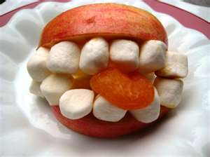

Curiosity, Intrigue, and Magical Mysteries


- Learn a magic trick. Practice your magic trick so you can perform it in front of an audience.
- Create an invitation to a magic show.
- With your den or with your family, put on a magic show for an audience.
- Create a secret code.
- With the other Scouts in your den or with your family, crack a code that you did not create.
- Spell your name using sign language, and spell your name in Braille.
- With the help of your adult partner, conduct a science demonstration that shows how magic works.
- Share what you learned from your science demonstration.
Workbook for use with these requirements: PDF Format DOCX Format

https://cubscouts.org/library/curiosity-intrigue-and-magical-mysteries/

Rationale for Adventure
This adventure helps Tigers explore how things work. Tigers and their adult partners will learn about cracking codes and solving mysteries, as well as discover how science helps us solve problems and understand why things work in certain ways.

Takeaways for Cub Scouts
- Cooperating with others
- Completing simple tasks
- Practicing listening
- Practicing communicating
- Practicing teamwork in games
- A Scout is helpful, friendly. [Tiger Character Compass]

ADVENTURE Requirements (Tiger Handbook, page 108)
- Learn a magic trick. Practice your magic trick so you can perform it in front of an audience.
- Create an invitation to a magic show.
- With your den or with your family, put on a magic show for an audience.
- Create a secret code.
- With the other Scouts in your den or with your family, crack a code that you did not create.
- Spell your name using sign language, and spell your name in Braille.
- With the help of your adult partner, conduct a science demonstration that shows how magic works.
- Share what you learned from your science demonstration.

NOTES TO DEN LEADER
Meeting 3 will be a magic show for Tigers to perform the tricks they have learned and practiced during this adventure. Tigers will prepare invitations during Meeting 1, so the details of the magic show should be in place by that time (date, time, location, etc.). During Meeting 2, find out the number of attendees expected, as well as any audience members’ special needs, in order to plan for seating and refreshments. The magic show may take place in the home of a den member (with additional siblings and family members for an audience), at your regular meeting place, or with any audience that would enjoy viewing a Cub Scout magic show.
https://cubscouts.org/wp-content/uploads/2015/04/Curiosity-Intrigue-MagicalMysteries.pdf
Find a workbook here:
https://meritbadge.org/wiki/images/0/05/Magic.pdf
Spy Games for Kids – How to Break a Secret Code http://funadventureforboys.com/2012/10/24/spy-games-for-kids-how-to-break-a-secret-code/
Code Maker & Breaker
http://www.crayola.com/crafts/code-maker--breaker-craft/
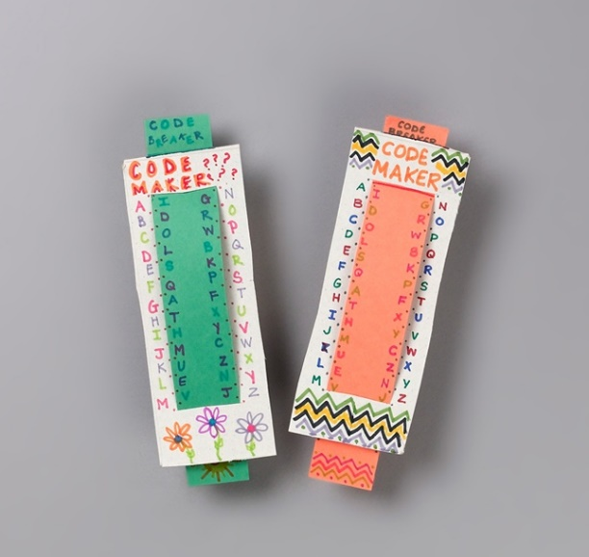
Kids explore alphabet letters, words, and metric measurements with colorful Code Makers and Breakers. Your whole family can create coded messages to decipher.
- 1.
To make the code maker use Crayola® Scissors to cut a rectangle about 7 cm (3 inches) by 19 cm (7 1/2 inches) from recycled cereal box cardboard.
- 2.
Fold the rectangle in half so the long ends meet. Snip into the fold at 3 cm (1 inch) from each end. Unfold. Cut into each snip to make a 4 cm (1 1/2 inches) opening centered and running parallel to each short end.
- 3.
To make the code breaker, cut a 23 cm (9 inches) by 4 cm (1 1/2 inches) piece of construction paper to fit in the code maker's slots. Trim the sides of the code breaker so it will glide easily when you put it into the code maker.
- 4.
Use Crayola Fine Line Markers to mark 1 cm (1/2 inch) spaces to the right and left of the code maker. Write A through M to the left and N through Z to the right in the spaces.
- 5.
Write the code letters on the code breaker strip so they line up with your code maker alphabet. You can make several codes by sliding the code breaker up so each letter is aligned with a different letter. Write the top two letters that disappear in the new spaces at the bottom. Mark lines on the construction paper strip at the top to show how to line up the letters for the particular message you are sending, then be sure to tell the message's recipient at which line to arrange the code breaker.

Book Club for Boys: Navajo Code Talkers and Secret Code Scavenger Hunt
http://www.pragmaticmom.com/2012/02/boy-book-club-unbreakable-code-navajo-code-talkers-making-breaking-code/
My seven-year-old son is in first grade but his closest friends are in second and third grades. It just worked out that way because he missed the cutoff so he’s among the older kids in his class. He can read but he needs help with chapter books and when this book club was formed, I was concerned about bridging the different reading levels.
The solution? Advanced picture books for kids. To prepare for this, I even blogged on it. I love advanced picture books — and my older kids do too! — as a means of visiting new cultures around the world and even back in time.
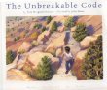
Unbreakable Code by Sara Hoagland Hunter, illustrated by Julia Miner
The Unbreakable Code is close to my heart because it’s the story of the heroic Navajo Code Talkers of WWII, unsung heroes who created a code that the Japanese could not break. Apparently, the war in the Pacific prior to this had gone poorly as the Japanese were ace code breakers and intercepted and read every message from the United States military. And yet the United States had begun a systematic purging of the Navajo culture, forcing young Navajo children to boarding schools where they were punished for speaking their own language. The irony!
Sara Hoagland Hunter depicts this story in a way that small boys can relate to and Julia Miner’s gorgeous illustrations make the book come alive.
I am hosting the first book club so I thought I would have the boys read the book at home. It’s too long to read aloud during the book club. The activity would be to create their own code. Next, they would have to work together to crack a message of code that I create. When they follow the clues (all coded of course!), they will come to a hidden prize.
I think I will also have them make their own messages using invisible ink made from baking soda.
- Mix equal parts water and baking soda.
- Use a cotton swab, toothpick, or paintbrush to write a message onto white paper, using the baking soda solution as ‘ink’.
- Allow the ink to dry.
- One way to read the message is to hold the paper up to a heat source, such as a light bulb. The baking soda will cause the writing in the paper to turn brown.
- A second method to read the message is to paint over the paper with purple grape juice. The message will appear in a different color.
I might also share some links for them to view:
1. This is the official site of the Navajo Code Talkers. You can also donate to them. I might show them the website and see if they want to come up ways to raise money to donate to them.
2. Here’s a great site to make your own Secret Code Wheel. You can print this out on heavy paper. Be sure not to cut off the black triangle. Have the child choose where the black triangle lines up, and then match up the letters in each circle to create the code. The key is to know where the black triangle line up!

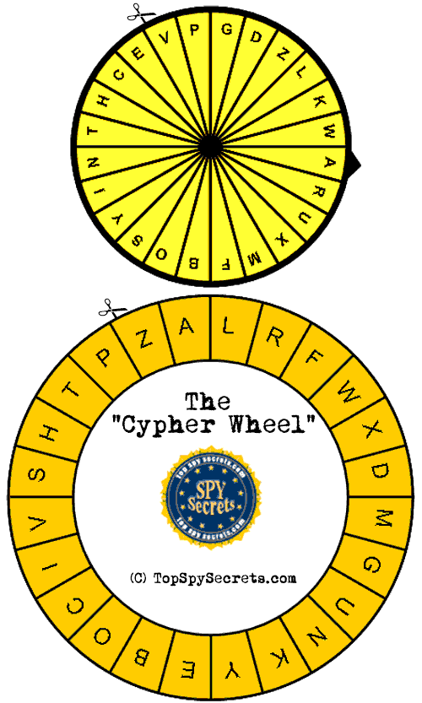
3. For very advanced decoders who can’t get enough AFTER the book club, I’d steer them here to a Cryptography site where there are all kinds of different kinds of secret code strategies.
4. Finally, here’s a link to the Navajo language.

Easy Magic Tricks for Kids, Sawing - Intro
http://magic.about.com/od/libraryofsimpletricks/ss/122406sawing.htm

DISAPPEARING TOOTHPICK TRICK
May 20, 2014 By Allison Waken
http://allfortheboys.com/home/2014/5/20/disappearing-toothpick-trick.html



WOLF

Wolf Adventure: Running With the Pack


- Play catch with someone in your den or family who is standing 10 steps away from you. Play until you can throw and catch successfully at this distance. Take a step back, and see if you can improve your throwing and catching ability.
- Practice balancing as you walk forward, backward, and sideways.
- Practice flexibility and balance by doing a front roll, a back roll, and a frog stand.
- Play a sport or game with your den or family, and show good sportsmanship.
- Do at least two of the following: frog leap, inchworm walk, kangaroo hop, or crab walk.
- Demonstrate what it means to eat a balanced diet by helping to plan a healthy menu for a meal for your family. Make a shopping list of the food used to prepare the meal.
Workbook for use with these requirements: PDF Format DOCX Format
https://cubscouts.org/wp-content/uploads/2015/05/Running-with-the-Pack.pdf

Balance Relay Game
http://www.boyscouttrail.com/content/game/balance_relay-1963.asp

This Game is meant for Cub Scouts.
Required:
paper bag for each team filled with miscellaneous things to balance on your hand
Instructions:
Place one of each item into each paper bag.
Give one bag to each team.
Patrols line up at start line with cone or marker about 40 feet away.
First person of each patrol reaches into his bag and pulls out an item.
He balances this on the back of one hand and races to the end of the play area and back to tag the next scout.
Repeat until all items in the bag are gone.
A player can not touch the item with his other hand.
If the item is dropped, the scout either starts over at the beginning or picks it up where it dropped - you decide beforehand.
Sample items to include:
- feather
- dollar bill
- marble
- egg
- coin
- cotton ball
- balloon
- fist-sized rock
- book
- potato
- dixie cup of water
- playing card
Each patrol could also have a ruler. A scout can choose to balance the item on the ruler rather than his hand for double points.

Palm Push Game
http://www.boyscouttrail.com/content/game/palm_push-916.asp

Instructions:
Pair up scouts of similar sizes, from different patrols if this is a competition.
Opponents face each other with toes about 1 foot apart.
Put up both hands palm-to-palm with opponent.
Push and feint to force your opponent off balance so he moves one of his feet.
One point for each round won. Patrol with most points wins

Rooster Fights Game
http://www.boyscouttrail.com/content/game/rooster_fights-513.asp

Instructions:
Each scout hops on one leg, holding the other foot by the ankle up at his rear. To win, he must force his opponent to lose balance and let go of his ankle, fall down, or step out of the circle.
The only contact allowed is bumping shoulders - no grabbing.

Hunker Down Game
http://www.boyscouttrail.com/content/game/hunker_down-439.asp

Required:
2 low pedestals about 1 foot square (a piece of plywood set on 2 bricks works)
15 foot rope
Preparation:
Place pedestals 6-8 feet apart
Instructions:
One scout stands on each pedestal, holding an end of the rope.
On the leader's signal, each scout tries to cause the other to step off his pedestal or let go of the rope, by pulling or pushing the rope.

Instead of a rope and pedestals, two scouts can stand on a plank laid across the two pedestals. Then, they try to get the other to step off by:
- hold a 2 foot stick or dowel with one hand and twist it around
- hold a short rope with a loop tied in each end
- hold each others right hand, then left hand
- push open palm of right hand against opponent's open palm
- place one hand open flat in the center of opponent's chest
- link pinkie fingers of right hand

Catch 10 Game
http://www.boyscouttrail.com/content/game/catch_10-368.asp

This Game is meant for Boy Scouts.
Required:
a ball
neckerchiefs or ribbons
Preparation:
define the playing field - basketball court size is good.
Divide group into 2 teams.
Put neckerchiefs on 1 team's arm for identification.
Instructions:
One team starts with the ball.
It is thrown to another teammate who yells "One!"
At each successful catch, the next number is yelled.
When a team reaches "Ten!" they receive one point.
The other team tries to intercept the ball or knock it to the ground.
On an interception, the scout yells "One!" and his team is now counting up.
When the ball hits the ground, the team that was last counting loses control and the other team picks it up and starts counting up.
The only physical contact should be incidental while going for the ball.
Set a time limit or first team to a specific score.

Wolf Elective Adventure: Digging in the Past


- Play a game that demonstrates your knowledge of dinosaurs, such as a dinosaur match game.
- Create an imaginary dinosaur. Share with your den its name, what it eats, and where it lives.
- Make a fossil cast.
- Make a dinosaur dig.
- Make edible fossil layers. Explain how this snack is a good model for the formation of fossils.
- Be a paleontologist, and dig through the dinosaur digs made by your den. Show and explain the ways a paleontologist works carefully during a dig.
Workbook for use with these requirements: PDF Format DOCX Format

DIY Dino Dig kits
http://busybugs.co/2012/10/diy-dino-dig-kits.html

by Nicole Carney

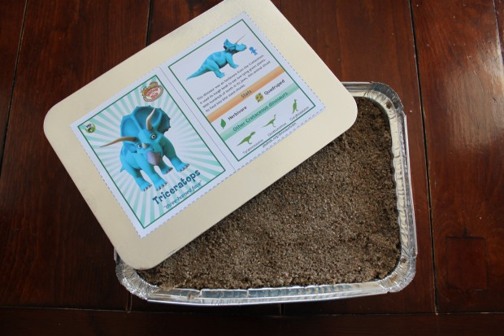
When I asked M what kind of party he wanted for his upcoming 3rd birthday, he enthusiastically exclaimed, ‘DINOSAURS!’ so I’ve been busy brainstorming fun activities for him and his cousins to do for his big dinosaur party.
After looking on the Internet for Dino Dig Kits I found an awesome blog called Mallard Cove Mommy, and immediately became inspired to create individual dig kits for all the kids. For my first practice attempt I made the salt dough recipe for my base, as described on the Mallard Cove Mommy site, but I wanted the dig to be more challenging than just sweeping away some loose sand, so I came up with a way to harden the sand into a nice crusty top. I mixed 2 cups of water with 1 tsp of cornstarch on the stove until it thickened, and added it to 4 cups of sand. Then I spread 2 cups of the sand mixture on top of the dinosaur skeleton and salt dough mold, and baked it in the oven at 180 for 2 hrs. When I took it out, the consistency of the sand was perfect, but as I dug to the bottom I realized what I already knew to be true; the salt dough had become wet and gooey from the sand mixture, which meant I had to come up with a new plan.
I decided to do a base of a more concentrated sand/cornstarch mixture, rather than using salt dough.
I mixed 1/2 cup of cornstarch with 4 cups of water and thickened it on the stove.

Then I added the mixture to 8 cups of sand and mixed it well (I was making 8 kits, and each kit needs 2 cups of the sand mixture for its base, so I made a double batch). Once the ingredients were all incorporated, I pressed 2 cups of the sand mixture into the bottom of a small aluminium pan I had purchased from the dollar store, and pressed the dinosaur fossils into it (I made sure to rock my skeletons back and forth a bit in order to get a good impression so they would fit back into the mold later).
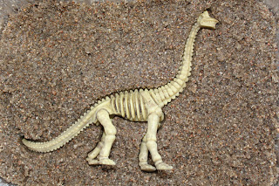
When I was satisfied with the imprints, I took the skeletons out of the pans and baked the sand molds for 2 hrs at 180.
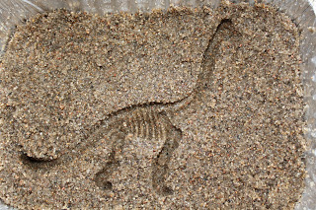
When I took them out of the oven they were as hard as concrete, which is exactly what I wanted! I fitted the Dino skeletons back into their molds and sprinkled some loose sand on top of the fossils.
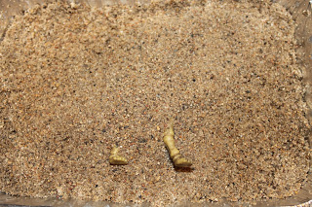
Then I made a more diluted version of the sand mixture for the top that the kids would actually be able to dig through. This time I only added 2 tsp of cornstarch to 4 cups of water, and stirred it while it thickened on the stove. Then I added the cornstarch mixture to another 8 cups of sand (again, I ended up making a double batch for my 8 kits). I shovelled 2 cups of the diluted sand mixture on top of each the dinosaur fossils, and smoothed it out. I baked the kits for another 2 hours at 180.
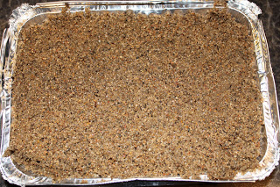
When they came out of the oven, I was really pleased with the consistency of the sand. It wasn’t too hard for the kids to break through on their own with the tools provided, and yet it would give them a bit of a challenge. The only thing I was disappointed with was that the base had absorbed the water from the top layer, and was no longer super hard, which meant that the fossil imprint would be lost as soon as the dinosaurs were excavated. Maybe if I had baked them longer the base would have hardened up again, but seeing that the sand was already at a good, crusty consistency, I decided to leave it as is.
I printed off the corresponding Dinosaur cards from the Dinosaur Train website, as suggested on the Mallard Cove Mommy blog, and glued them onto the insides of the lids.
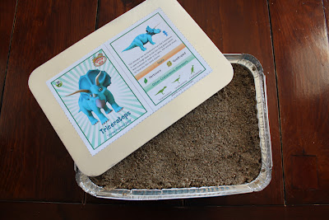
Lastly, I sealed the containers, printed off some labels, and gathered some excavating tools for each of the kids to use (a plastic spoon and knife, a long wooden coffee stir stick, a magnifying glass, and a paint brush), which I purchased from the dollar store.
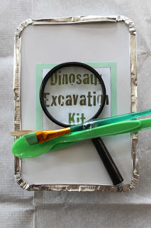
I’ll let you know how the excavation went in my next blog post about M’s Prehistoric Dino Party!

SALT DOUGH DINOSAUR FOSSILS
http://www.loveplayandlearn.com/dinosaur-fossils/

For this activity you’ll need:
- Salt dough (recipe found here)
- Small dinosaur figurines (these are our absolute favorite!)
First prepare your salt dough and then roll it out to about 1/2 inch thick. You can use a cookie cutters or just your hands to make a round shape
Then have your child take the dinosaurs to make prints in the dough
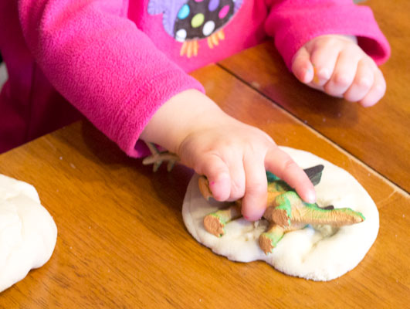
We did some with the whole body
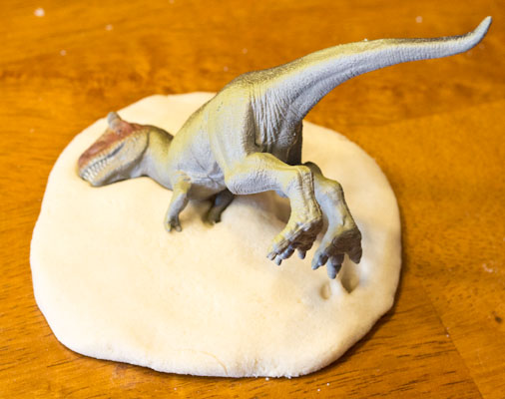

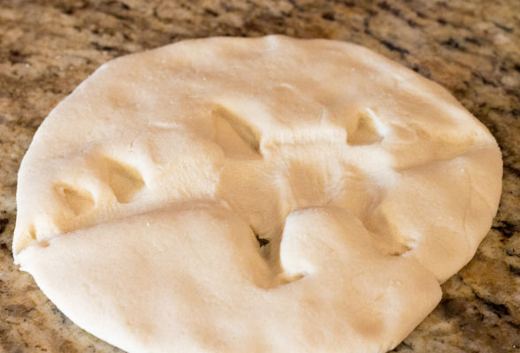
Some of the feet and some of just the head
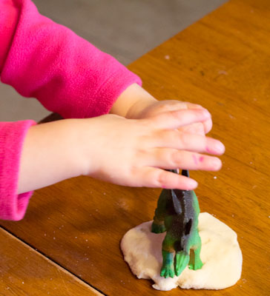

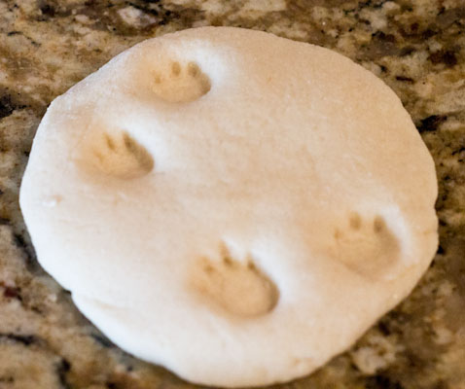
Let them have full range and explore!
When you are done making your prints put them in the oven for about 2-3 hours at 200 degrees F.
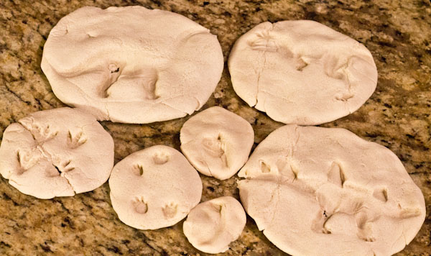

Use these fossils in a Dinosaur Fossil Excavation Activity…with edible dirt!



BEAR

Bear Adventure: Grin and Bear It


- Play a challenge game or initiative game with the members of your den. Take part in a reflection after the game.
- Working with the members of your den, organize a Cub Scout carnival and lead it at a special event.
- Help younger Cub Scouts take part in one of the events at the Cub Scout carnival.
- After the Cub Scout carnival, discuss with the members of your den and your den leader what went well, what could be done better, and how everyone worked together to make the event a success.
- Make and present an award to one of the adults who helped you organize the activities at the Cub Scout carnival.
Workbook for use with these requirements: PDF Format DOCX Format

Count to 10 Activity
http://boyscouttrail.com/content/activity/count_to_10-1466.asp

Instructions:
This may take up to 1 minute for every 3 scouts, so doing it with a group bigger than 15 scouts might get boring.
Everyone gathers in a circle, facing inward.
Leader starts by counting "1" or "1,2".
Next scout counts the next 1 or 2 numbers.
Everyone in sequence must say either 1 or 2 numbers.
Whoever is forced to say "10" is eliminated and the next scout starts counting again at "1".
The last scout is the winner.

All Aboard Game
http://boyscouttrail.com/content/game/all_aboard-329.asp

Required:
2x2 plywood for all to stand on, solidly raised off the ground 6 inches.
Notes:
An initiative game to have a group cooperate to reach a goal.
Instructions:
See how many scouts can stand on the platform with no body parts touching the ground. They must stay on board for 10 seconds.
If an entire patrol can do it, try combining groups to set a record.

Bizz Buzz Game
http://boyscouttrail.com/content/game/bizz_buzz-364.asp

Notes:
Improve mental quickness and concentration.
Good for a filler while sitting around.
Instructions:
Group sits in circle facing in.
In a clock-wise direction, scouts count up from 1.
Instead of 7 and all multiples of 7, and all numbers that contain 7, say 'Buzz'.
For example, 1, 2, 3, 4, 5, 6, Buzz, 8, 9, 10, 11, 12, 13, Buzz, 15, 16, Buzz, 18, ...
If there is a mistake, start over at 1 with the next scout in line.
Once it is going well and the group has reached 50 or so, stop them and add 'Bizz' to the game. Now, substitute 'Bizz' for 5.
For example, 1, 2, 3, 4, Bizz, 6, Buzz, 8, 9, Bizz, 11, 12, 13, Buzz, Bizz, 16, Buzz, 18, 19, Bizz, Buzz, 22, ...
If the number is a multiple of 5 and 7, or has 5 and 7 in it, like 35 or 57 or 70 or 75, say 'BizzBuzz'!
Try for a group record or reaching 100.
Eliminate scouts that make mistakes until only the champion is left.

Can Stack Game
http://boyscouttrail.com/content/game/can_stack-2085.asp

Required:
10 cans per patrol
Instructions:
A pile of 10 cans is set at the start line for each patrol. These can be soda cans, soup cans, tuna cans, but all need to be the same size.
On 'GO', the first scout for each patrol takes one can and runs to the end of the play area. He sets the can on end and returns to tag the next scout.
Each scout in turn takes one can and stacks it onto those currently stacked, creating a stack with no more than 4 cans on the bottom layer.
If at any time the stack falls over, the entire patrol can run to it and return all the cans to their original pile - only one can per scout. Then, they start over moving one can at a time.
First patrol to complete their stack and return to the starting line wins.

Mule Relay Game
http://boyscouttrail.com/content/game/mule_relay-1088.asp

This Game is meant for Boy Scouts.
Required:
An identical set of items for each patrol.
box or backpack, flashlight, sleeping bag, big rock, hat, whistle, pencil, ... anything at all ranging in different sizes and weights.
Just make sure that a person will be able to carry the entire load.
Preparation:
Put all items for each patrol in separate piles on the ground about 40 feet from the start line.
Notes:
It may be beneficial to reflect on how choosing items intelligently may reduce the amount of work required and the ease with which items are transported.
Instructions:
Patrols line up at start line.
On 'GO' signal, patrol leader runs to pile and chooses one item to bring back. He also must choose the name of one item to pass on to the next scout.
When the patrol leader returns, he hands what he has to the next scout and tells him the name of the item he must pick up.
Each scout runs to the pile, picks up the item they were told and adds it to their load. He then picks the name of another item to tell the next scout to pick up.
This continues until a patrol returns with all their items to the starting line.
If an item is dropped, the scout has to return to retrieve it.
A returning scout should not talk to anyone except the next scout in line.

Bear Elective Adventure: Marble Madness


- Discuss with your family and den the history of marbles, such as where and when the game began. Talk about the different sizes of marbles and what they are made of and used for.
- Learn about three different marble games, and learn to play the marble game “ringer.” Learn how to keep score. Learn and follow the rules of the game. Play the game with your family, friends, or your den.
- Learn four or five words that are used when talking about marbles. Tell what each of the words means and how it relates to playing marbles. Share this information with your den.
- With the help of an adult, make a marble bag to hold marbles.
- With your den or family, make a marble obstacle course or marble golf course. Share what you create. Invite everyone to go through your course.
- Create your own game using marbles, and design rules for playing the game. Share the game you created with your den, family, or friends. Explain the rules and how to play the game.
- With your den or family, create a marble race track. Have at least two lanes so you can race your favorite marbles against each other.
- Make a marble maze.
Workbook for use with these requirements: PDF Format DOCX Format
Marble Golf
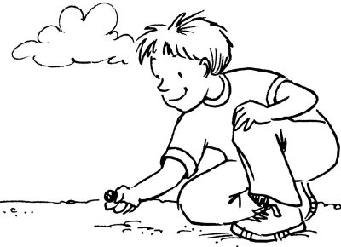

- Set up this game and practice playing it for a future den or pack marbles tournament.

- For holes, bury baby food cans to the brim in the earth.

- Flags are paper triangles glued to craft sticks.

- Add water hazards and sand traps as you wish.

- Shots are taken in the approved knuckles down way for regular marbles.

- Winner is the Webelos who takes the fewest shots to get all the way around.

Marble Ideas
Marble games:
How to play marbles:
http://www.landofmarbles.com/marbles-play.html
Sometimes shooting marbles can be hard for the boys. To make it easier, have the boys aim a short piece of PVC pipe at the target, and roll a marble down the pipe. Experiment with different angels to increase the marble’s speed.

Box Targets:

http://familyfun.go.com/playtime/box-scores-863585/
http://familyfun.go.com/playtime/marble-target-fun-house-708598/


Marble Cliff Hanger: http://familyfun.go.com/playtime/marble-cliff-hanger-708301/

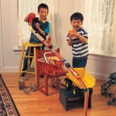
Marble Maze: http://familyfun.go.com/crafts/marble-maze-665946/


Marble Roulette: http://familyfun.go.com/playtime/marble-roulette-708304/
Marble Golf: (from “01 Baloo “Save it for Us” p. 3.)
This 9 hole golf course is laid out around the yard. Small tin cans are sunk into the ground. One to four players start
off and shoot marbles. They count the shots taken to get the marbles into the cans. Hazards may be small brushes, lengths of drain spouts, tubes through which the golfer must shoot, an upright 2 foot long board with a 4 inch hole. For a water hazard, sink a tin pie plate or other suitable container and fill with water. Use flags made from paper triangles glued to popsicle sticks. Golf rules should be observed in playing this game.

Giant Marbles: http://familyfun.go.com/playtime/giant-marbles-919494/
Devil’s Marbles: http://familyfun.go.com/playtime/devils-marbles-707483/
Treats: decorate cupcakes or cookies with gumballs (which look like marbles)



WEBELOS CORE

Webelos Adventure: Stronger, Faster, Higher


Do all of these:
- Understand and explain why you should warm up before exercising and cool down afterward. Demonstrate the proper way to warm up and cool down.
- Do these activities and record your results:
  - 20-yard dash
  - Vertical jump
  - Lifting a 5-pound weight
  - Push-ups
  - Curls
  - Jumping rope
- Make an exercise plan that includes at least three physical activities. Carry out your plan for 30 days, and write down your progress each week.
- With your den, prepare a fitness course or series of games that includes jumping, avoiding obstacles, weight lifting, and running. Time yourself going through the course, and improve your time over a two-week period.
- With adult guidance, lead younger Scouts in a fitness game or games as a gathering activity for a pack or den meeting.
- Try a new sport you have never tried before.
Workbook for use with these requirements: PDF Format DOCX Format

Ankle Fights Game
http://boyscouttrail.com/content/game/ankle_fights-62.asp

This Game is meant for Cub Scouts.
Instructions:
Draw a 6 foot or larger (depending on size of group) diameter ring. Players all stand in ring and grab their own ankles.
On the whistle, try to push your opponent over, or make him let go of his ankles, or step out of the ring. If any of those happen, the scout leaves this round.
Last scout wins the round.

Back Lift Game
http://boyscouttrail.com/content/game/back_lift-803.asp

This Game is meant for Boy Scouts, Bear scouts, Webelos scouts.
Instructions:
Two scouts stand back to back and interlock arms at the elbows.
On signal, each tries to lift the other off the ground.
When both feet are off the ground, a point is awarded.

Crab Scuttle Game
http://boyscouttrail.com/content/game/crab_scuttle-2051.asp

This Game is meant for Cub Scouts.
Preparation:
Mark a start line and end line about 20 or 30 feet away.
Instructions:
Each patrol lines up at the start line. The first scout of the patrol bends over and puts his left hand between his legs to grasp the right hand of the scout behind him. They both run as best they can to the marker at the far end of the play area.
When the reach it, they do not turn, but go backwards until they reach the patrol. The second scout grabs the right hand of the next scout on the patrol with his left hand, and off the three scouts go.
This continues, picking up another scout, until the entire patrol (as one continuous line) runs up and back.

IQ, FQ, MQ Minute
http://www.boyscouttrail.com/content/minute/iq_fq_mq-310.asp

This Minute is meant for Boy Scouts.
Script:
You've all heard of an IQ - that is Intelligence Quotient. There are tests used to determine someone's IQ and then you have a rough idea of how 'intelligent' you are compared to the population.
Did you know we also have an FQ? That would be Fitness Quotient. Sure, when you do your Physical Fitness part of the Tenderfoot requirements or the Personal Fitness merit badge, you test yourself and then try to improve. You have a good idea where you fall on the FQ scale.
Another one that might be useful is the MQ - or Morality Quotient. Some way to measure a person's morals compared to the population. But, I guess that is best left between you and God.
Be sure that you CAN work on improving your intelligence, fitness, and morals, though. There is always room to improve.
With an IQ, FQ, and MQ, we can measure the 3rd part of the Scout Oath - to keep myself physically strong, mentally awake, and morally straight.
It's a good idea to occasionally test yourself to make sure you are still improving.

Fitness Relay Game
http://www.boyscouttrail.com/content/game/fitness_relay-398.asp

Required:
For each team, a paper bag containing cards with one task on each card.
Preparation:
Draw start line and put cone out about 20-40 feet.
Place paper bag with cards at start line.
Notes:
Fitness, teamwork
Instructions:
Patrols line up single file.
On 'Go' signal, patrol leader picks card from bag, reads it and does that task out around the cone and back to tag the next scout.
A scout can not choose a card until he has been tagged.
First patrol to get through all tasks wins.
May demonstrate each of the tasks first so scouts know what they are.
Example Tasks: Hop on left foot, Hop on right foot, Hop with both feet together, Walk backwards, Walk heel-to-toe, Walk blindfolded, Run, Bear walk, Carry a person or have a person carry you, Hold hands between knees, and so on.

Troop Fitness Challenge Activity
http://www.boyscouttrail.com/content/activity/troop_fitness_challenge-1050.asp

This Activity is meant for Boy Scouts.
Required:
Stopwatch.
Tape measure.
600meter distance.
Preparation:
Mark out the 600meter run distance.
Layout a long jump start line.
Mark off a 50meter run distance.
Notes:
Doing this activity twice a year and keeping track of the results can show the overall troop fitness level.
Make sure scouts are aware of the upcoming activity and dress appropriately.
Prep the leaders to make sure only positive encouragement happens.
Instructions:
Every scout performs his best at a set of physical activities. The average for the group is determined.
Event Scoring:
- Sit-ups in 1 minute:
  - <30 - 1 point
  - <40 - 2 points
  - <50 - 3 points
  - >50 - 4 points
- 50 meter Dash
  - >8.5 sec - 1 point
  - <8.5 sec - 2 points
  - <7.8 sec - 3 points
  - <7.3 sec - 4 points
- Pull-ups
  - <3 - 1 point
  - >3 - 2 points
  - >5 - 3 points
  - >7 - 4 points
- Long Jump
  - <5ft - 1 point
  - >5ft - 2 points
  - >6ft - 3 points
  - >7ft - 4 points
- 600 meter Run
  - >2:30 - 1 point
  - <2:30 - 2 points
  - <2:15 - 3 points
  - <2:00 - 4 points
Record the score for each scout, add them up, and find the average for each event.

Physical Fitness Award
http://www.boyscouttrail.com/content/award/physical_fitness-237.asp

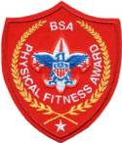
The award's objectives, developed by the Council Services Division of the National Council and the national BSA Health and Safety Committee, are as follows:
- Encourage youth fitness in the BSA by providing positive role models and by enhancing youth awareness and understanding of fitness parameters, health risks, and personal circumstances.
- Encourage physical fitness among Scouters by enhancing their awareness and understanding of fitness parameters, health risks, and personal circumstances.
- Reduce the rate of stress- and fitness-related incidents throughout Scouting.
The award application form is no longer available at its old scouting.org location. The patch is still available on ScoutStuff.org as of 5/12015.
People who earn the recognition can receive a special certificate and can purchase and wear the unique BSA Physical Fitness Award patch. In addition, upon completion of the Fitness Award requirements, Scouts and Scouters may wear a special recognition pin and patch that can be purchased through their local council.
This award is a national program of emphasis designed to heighten fitness awareness and to help change the lifestyles of American youth and adults regarding exercise and a healthy diet to improve the quality of their lives.
This award has been developed to:
- Encourage the development of attitudes, knowledge, and skills that promote fitness and safe conduct.
- Lay a skill, knowledge, and attitude foundation of the seven major components of fitness.
- Improve health, fitness, and quality of life through daily physical activity.

The BSA Physical Fitness Award's core requirements are the following seven major components. They are used to measure an individual's improvement over time, not to establish an arbitrary minimum level of activity.
Posture: Posture is evaluated with a posture-rating chart. The Scout or Scouter is compared to a photo of his or her starting posture, noting 13 different body segments. Each body segment is scored as a five, three, or one, making a possible range of scores from 13 to 65. Higher scores over time reflect improving posture.
Accuracy: The target throw is used to measure accuracy. The Scout or Scouter makes 20 throws with a softball at a circular target and is scored on the number of times the target is hit.
Strength: The sit-up is used to measure strength. The Scout or Scouter lies on his or her back with knees bent and feet on the floor. The arms are crossed on the chest with the hands on the opposite shoulders. The feet are held by a partner to keep them on the floor. Curl to the sitting position until the elbows touch the thighs. Arms must remain on the chest and chin tucked on the chest. Return to the starting position, shoulder blades touching the floor. The score is the number of sit-ups made in a given time.
Agility: The side step is used to measure agility. Starting from a center line, the Scout or Scouter sidesteps alternately left and right between two lines 8 feet apart. He or she is scored on the number of lines crossed in 10 seconds.
Speed: The dash is used to measure speed. The score is the amount of time to the nearest half-second running a set distance that can be increased each year.
Balance: The squat stand is used to measure balance. The Scout or Scouter squats with hands on the floor and elbows against the inner knee. He or she leans forward until the feet are raised off the floor. The score is the number of seconds held in that position.
Endurance: The squat thrust is used to measure endurance. The Scout or Scouter starts from the standing position. He or she performs the usual four-position exercise. The score is the number of completed squat thrusts made in a given time.
Some of these tests measure more than the components they represent. For example, the sit-ups, a measure of strength, also reflect some endurance because of their repetition. The squat stand requires balance, its major component, but also requires strength and endurance to support the weight of the body on the arms.
Requirements:
- Complete a cardiovascular fitness evaluation/consultation with your personal health care provider. (This can be done as part of the examination required by any council-approved class 3 medical evaluation.)
- Using the BSA references listed after the seven major components, give a presentation to a BSA or other community youth group (at least eight youth participants) on cardiovascular fitness, diet, the health benefits of regular aerobic exercise, exercise recommendations for the Scout-age group, and healthy lifestyles.
- Review the BSA guidelines for the Athletics and other physical activity or personal fitness-oriented merit badge and explain steps you have taken to follow each of the guidelines for the fitness goals. Explain precautions to be taken for a physical fitness activity in each of the following: woods, fields, facilities, and waterfront.
- Explain to your mentor the symptoms of dehydration and hypothermia. Explain the special considerations for preventing dehydration and hypothermia.
- Properly outfit for physical activities with proper equipment, clothing, and footwear. Know your own capabilities and limitations. Illustrate how you would prepare for the physical fitness goals included in the award program.
- With supervision from your mentor or other qualified persons, set up a fitness goal-oriented plan using the seven major components of fitness.
- Demonstrate your ability to improve your strength, posture, endurance, agility, speed, accuracy, and balance with your own goal-oriented fitness plan.

Pool Noodle Obstacle Course
http://www.pbs.org/parents/crafts-for-kids/pool-noodle-obstacle-course/
Note: You will need both straight, unaltered pool noodles and pool noodles bent into a circle and taped together. The circular pool noodle is easy to make; just bend the pool noodle until both ends come together and secure them together with duct tape.
  - Stage 1: Ground Crawling: Stick a yard stake in the ground and push 1 end of a pool noodle on it (pool noodles have a hollow middle with holes at both ends). Bend your pool noodle over to make a semi circle and push another yard stake in the ground where the pool noodle ends. Push the other end of the noodle on the stake. Repeat this process until you have the desired number of arcs, placing each pool noodle about 1 foot apart from the next.

  - Stage 2: Agility Rings: Place 1 straight pool noodle horizontally on the ground. Going upwards, put 10 circular pool noodles on the ground, 2 at a time. At the end, place another straight pool noodle. The object of this part is to bounce from ring to ring without disturbing them!

  - Stage 3: Football Toss: Place 1 yard stake in the ground. Push a straight pool noodle onto the yard stake. Grab 2 pool noodle rings and tape them to the top of the straight pool noodle with 1 underneath the other. Repeat with 4 more circular pool noodles. Where the circular pool noodles end, place another yard stake in the ground and push a straight pool noodle onto the yard stake. Tape the circular noodles onto the straight noodle. If you’re having difficulty keeping this obstacle straight, you can also push long sticks into the ground for reinforcement. Tape the sticks to the long and straight pool noodles.

  - Stage 4: Soccer Skills: Stick some yard stakes in the ground in a straight row, each stake about 1 foot apart. Push a pool noodle onto each stake so they are sticking straight up in the air. Leave some soccer balls at this obstacle and watch the kids try to kick/dribble the ball around the noodles.

  - Stage 5: Ring Toss: Push a yard stake into the ground and push a pool noodle onto the yard stake so the pool noodle is standing straight up in the air. Have your kids try and throw a pool noodle ring onto the pole.



ARROW OF LIGHT CORE

Arrow of Light Adventure: Building a Better World


- Explain the history of the United States flag. Show how to properly display the flag in public, and help lead a flag ceremony.
- Learn about and describe your rights and duties as a citizen, and explain what it means to be loyal to your country.
- Discuss in your Webelos den the term "rule of law," and talk about how it applies to you in your everyday life.
- Meet with a government leader, and learn about his or her role in your community. Discuss with the leader an important issue facing your community.
- Learn about your family's expenses, and help brainstorm ways to save money. Plan and manage a budget.
- Learn about energy use in your community and in other parts of our world.
- Identify one energy problem in your community, and find out what has caused it.
- With the assistance of your den leader or parent, participate in an event that would help lead others in recycling and conserving resources.
- Show that you are an active leader by planning an activity without your den leader's help.
- Do one of these:
  - Learn about Scouting in another part of the world. With the help of your parent or your den leader, pick one country where Scouting exists, and research its Scouting program.
  - Set up an exhibit at a pack meeting to share information about the World Friendship Fund.
  - Find a brother Scout unit in another country.
  - Under the supervision of your parent, guardian, or den leader, connect with a Scout in another country during an event such as Jamboree on the Air or Jamboree on the Internet or by other means.
Workbook for use with these requirements: PDF Format DOCX Format
Ideas for Adventure Requirements:
http://boyscouttrail.com/webelos/arrow-of-light-building-better-world-adventure.php

- Basic U.S. Flag information is in the Webelos handbook. Details can be found at usflag.org
- Review the 100 civics questions that U.S. Immigration Services uses for their naturalization test.
- A comparison of the United States and other countries can be found on this interactive map
- Plan this meeting well ahead of time. Meeting at the community leader's work place would be a good den outing. Let the person know what issue you'd like to discuss beforehand.
- Print this budget template for each scout.
- Research your area's energy generation, use, and potential witheia.gov map and energy.gov.
- Common household energy problems can be explored here and energy saving ideas are here.
- Learn about different conservation event ideas at epa.gov.
- Printing this activity plan template for each scout will help them with their planning.
- Use Pen Pals to connect with foreign scout groups.
Den Meeting Ideas for Building a Better World Adventure:
- Use some of these flag ceremonies - Flag Opening ceremony,Flag Closing ceremony,Flag ceremonies,More ceremonies
- Scouts can use these Pledge Intros to lead short flag ceremonies.
- Sing Grand Old Flag song or America the Beautiful song
- Tell I Am Your Flag minute
- Present this Flag skit
- Expand your Flag knowledge at this BSA page or by purchasing theYour Flag book from your local Scout Shop. Then, check your knowledge with this online Flag test. Understand Unit Flag devices.
- Consider working towards the Messengers of Peace award.
http://scoutermom.com/cubscout/arrow-of-light-adventure-building-a-better-world/

- 

Arrow of Light Adventure Requirements: Building a Better World
- In the Building a Better World Arrow of Light adventure, Webelos learn all about citizenship including about the rights and duties of citizens, local government, improving our communities through conservation, and connecting with Scouts in different countries.
- 

Messengers of Peace
- The Boy Scouts of America joined the Messengers of Peace initiative in 2012. This program encourages Scouts around the world to work for peace by being a positive force in their communities.
- 

Simple Indoor Closing Flag Ceremony
- Basic instructions for a very simple closing flag ceremony. This simple closing flag ceremony is appropriate for a den, pack, or other meeting.

Simple Indoor Opening Flag Ceremony
- Many of our kids have not been exposed to flag etiquette before their first flag ceremony, so take the time to give them some basic instruction. This is a very simple flag ceremony for Cub Scouts to use at Den and Pack meetings.

Displaying the US Flag with Other Flags
- The US Flag is the symbol of our country. Scouts should know how to fold it, fly it, and handle it. Flag etiquette is part of many of the Scout requirements. In many cases, the rules are pretty straightforward. But in other cases, you just need to know the rules. For example, it gets more […]

How to Fold the US Flag
- The US flag is the symbol of our country and every Scout should know how to handle it. One thing I emphasize when working with Scouts on flag etiquette is that the most important thing is respect. Scouts are going to make mistakes from time to time, but they should always do their best to […]

A Simple Flag Retirement Ceremony
- When retiring a United Stated flag, some people will say that you must do it this way or that way, but according to the Flag Code, it just needs to be done with dignity.

Citizenship Football Game
- The purpose of the game is to reinforce the ideas which are discussed in the Webelos Citizen activity badge.

Constitution Word Search Puzzle
- In honor of Independance Day, here is a word search with vocabulary related to the United States Constitution.

Raising and Lowering the US Flag
- With Memorial Day approaching, it might be time to review how to raise and lower the United States flag. These are some basic rules for raising and lowering the US flag.

WEBELOS & AOL ELECTIVES –

Webelos/AOL Elective Adventure: Aware and Care


Do all of these:
- Develop an awareness of the challenges of the blind through participation in an activity that simulates blindness.
- Participate in an activity that simulates severe visual impairment, but not blindness.
- Participate in an activity that simulates the challenges of being deaf or hard of hearing.
- Engage in an activity that simulates mobility impairment.
- Take part in an activity that simulates dexterity impairment.
- With your den, participate in an activity that focuses on the acceptance of differences in general.
- Do two of the following:
  - Do a Good Turn for residents at a skilled nursing facility or retirement community.
  - Invite an individual with a disability to visit your den, and discuss what activities he or she currently finds challenging or found challenging in the past.
  - Attend a disabilities event such as a Special Olympics competition, an adaptive sports event, a performance with sign language interpretation, or an activity with service dogs. Tell your den what you thought about the experience.
  - Talk to someone who works with people who have disabilities. Ask what the person does and how he or she helps people with disabilities.
  - Using American Sign Language, sign the Scout Oath.
  - With the help of an adult, contact a service dog organization, and learn the entire process from pup training to assignment to a client.
  - Participate in a service project that focuses on a specific disability.
  - Participate in an activity with an organization whose members are disabled.
Workbook for use with these requirements: PDF Format DOCX Format

http://scoutermom.com/cubscout/webelosaol-elective-adventure-aware-and-care/



Completing Elective Adventures
A mother asks ” I understand that I cant do his next advancements until after May graduation BUT can I keep doing electives and getting credit for them?”


Webelos/AOL Elective Adventure Requirements: Aware and Care
For the Aware and Care adventure, Webelos learn about the challenges faced by people with disabilities.


Guide Me Game for Webelos, Boy Scouts, and Venturers
This game makes a fun break in a meeting. It is appropriate for Webelos, Boy Scouts, or Venturers. The will have to work together to accomplish their goal.


I Can Do That With One Hand Tied Behind My Back Game
The goal of this game is for two Scouts to work together to make a simple lunch. The challenge is that they each have one hand tied behind their back.

Compassion & Disabilities Awareness Pack Meeting Idea
http://cubscoutideas.com/2528/compassion-disabilities-awareness/
Tashia from Sandy Ridge Pack 465 recently held acompassion and disabilities awareness meeting for her pack. She posted about the meeting on the Cub Scout Ideas Facebook page. I was so impressed by what she did that I asked her if I could post about it here on the site. She kindly agreed.
Tashia really put her heart and soul into planning a meeting that would help the boys learn how to have compassion toward everyone. Here’s what she said, “Since the Core Value for March was Compassion, I incorporated it into having feelings, getting in touch with how other people felt with a disability and how the boys could help someone.”
They started their program with five activities the boys had to complete and record on a worksheet.
- Do a good deed for someone.
- Talk about a person who taught them something new. Teach someone else the same activity.
- When you’re with a parent, say “Hello” or “How are you?” to a stranger.
- Do something helpful like hold the door for someone or pick up something they dropped.
- Talk about someone who helps you learn to do good things. Give their name and what they taught you.
- The fun began at her pack meeting! Tashia started by asking if any of the boys knew someone who was disabled. At first only a few boys raised their hands. Then she explained how other conditions are simply overlooked as disabilities. Someone might be disabled and not look like it. They have a few boys who wear glasses, and the boys were surprised to learn that wearing glasses could be considered a disability.
- To illustrate impaired vision to the boys, Pack 465 handed out safety goggles (which were donated by a parent’s workplace) to all the boys. But before they were allowed to put them on, Tashia smeared a thick coat of Vaseline on the glasses. They were each asked how they felt, if they felt any differently and if they felt like they could still do things that they would normally do.
- Next, the pack discussed deafness and hard of hearing. The boys were given cotton balls to put in their ears. If they could still hear without a problem, they were asked to put their fingers over their ears. The leaders asked the same questions to determine if the boys felt differently. They began by yelling the questions then lowered their voices with each question. Tashia said, “They finally experienced what it felt like when the ‘huh?’ and ‘what did you say?’ started.”
- To show the boys what it’s like to have missing or non-functioning limbs, the boys were given paper and markers and asked to write their names. Then they had to write their names with the opposite hand. Tashia wrapped two or three of the boys’ fingers of their dominate hand together with gauze and had them write their name a third time.
- This was the most difficult, and the boys had to take their time and figure out how to hold the marker so that they could do it. Again, the pack discussed their experiences.
- 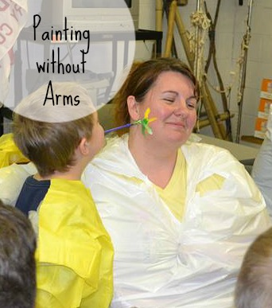For the last activity, the boys were told that they were going to get to face paint two of their brave leaders–Tashia and her co-leader Tony. The boys were so excited as the paintbrushes were passed out! Then Tashia told them that they couldn’t use their hands–only their mouths. She explained that people with missing limbs have to learn how to do things differently.

