COMMISSIONER'S CORNER
We reeceived a few responses to our Help Wanted Ad last month. Thank you. We did lose one person;s E-mail, though. Both Judy and Dave saw it and now neither of them nor the USScouts.org computer Coordinator can find it. A lady had offered to write up ideas for Activities (Adventures?). Please write again. Thank you. You will be seeing Alice come back soon to help, and a local Cubmaster by me who has had several great Lion Prides!! Thank you!!
And it is not too late – check out the list on page 2!!!

Guess what day Commissioner Dave finished his part of this month's Baloo??
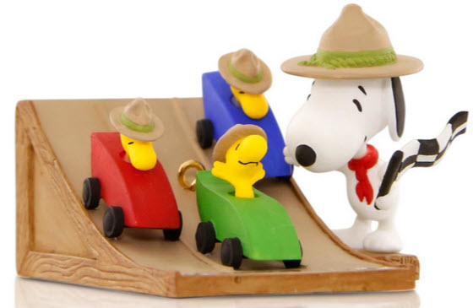
This Christmas ornament available for 2015

PINEWOOD DERBY TIME!!!
It's been a long time since Baloo's Bugle did an issue for Pinewood Derby we wern't sure on the approach to take and did not want anyone to think we are car building experts. The cars Commissioner Dave and his son made always finished but were never in the top 3. So here are some basic guidelines and suggest you google "pinewood derby" and be prepared to be overwhelmed as you search for the way to make the perfect racer. And then watch the movie, "Down and Derby," and go have fun making and racing your cars WITH your sons. I found movie available at Amazon and Netfkix. You can read about the movie at IMDB – go to - http://www.imdb.com/title/tt0398971/
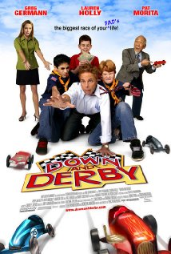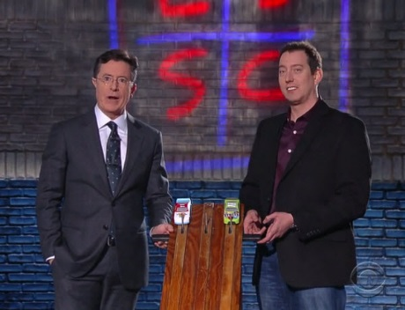
Did you see Stephen Colbert and Kyle bush have a Pinewood Derby on The Late Show?? If not click the pic!! The race is at about minute 5:00 of the show!!!
Or here is the link - http://www.cbs.com/shows/the-late-show-with-stephen-colbert/video/r7xcNwwM7ddGxbj3RrqrYuCNrMYU_WY4/the-late-show-11-23-2015-sylvester-stallone-ted-koppel-my-morning-jacket-/
Pinewood Prayer
CS Roundtable Planning Guide
We give thanks for the fun we have at our pinewood derby. Help us remember to do our best. Help us cope with disappointments if our cars do not go fast. Help us be thoughtful of the feelings of other if our cars should win. Amen
The Pinewood Derby Prayer
Pack 169, Egham, England
Pack 52, Morgantown, West Virginia
Hey God, we ask you to draw near
And bless the boys who gather here.
This is the day they’ve waited for
Their blocks of wood are blocks no more.
Plastic wheels and dime store nails
Become the stuff of sporting tales
Of finishes too close to see!
You’re here for every victory.
You bless the winners in their joy
But there’s another kind of boy
Whose handiwork is blessed by you
Because his hands tried something new.
You smile upon the crooked wheel,
The paint job done with boyish zeal,
The splintered car, the sloppy glue.
You love the work that Your sons do.
But there is one here in this place
Who shows the greatness of Your grace.
He is the boy who hasn’t won
But when he hears the starting gun
He’s there to cheer his fellow scouts
His are the loudest victory shouts.
And when his brothers haven’t won,
He’s just the one to say "well done,
You’ve tried your best and you’ve had fun,
There are more races to be run."
And so, dear God, we hear you say
Upon this happy Derby Day,
"Remember, whether best or worst,
Remember, you are brothers first."


Judy and Dave need some help. If you would do one item for Baloo each month, it would help us greatly –
Some ideas for you to consider –
Biography – write a one page +/- biography of a person you select that exemplifies that month's emphasized point of the Scout Law.
Advancement – Choose a rank. Write a few hints and ideas for the Adventure to be discussed that month at the Roundtable. And, also, any that have a Character Compass pointing to that months point of the Scout Law
Social Media – check out National's Facebook pages, Bryan's Blog, Cubcast, and Scoutcast and prep the summaries for Baloo.
Roundtable Hints – Prep some hints and ideas for your fellow Roundtable Commissioners each month. This would be easy for someone from a council like Sam Houston where they have an annual RT day where they review all 12 months in advance.
Crazy Holidays – Jodi actually retired from that position a few years ago. We can supply you files for each month. You only need to check for updates and additions. Feel free to use more websites if you have a favorite.
Point of the Scout Law – Look for items that help get across the meaning of the point of the Scout Law emphasized that month in Roundtable.
Special Opportunities – write a brief article each month about one youth and one adult award other than rank advancement.
Have another idea? Let us know how you feel you could help us to make Baloo's Bugle more of what RT Commissioners, Cubmasters, and Den Leaders want.
Write us through the "Send Your Ideas to Baloo" link or directly – davethecommish@gmail.com and judyjohnsonbsa@yahoo.com
Table of Contents
COMMISSIONER'S CORNER 1
PINEWOOD DERBY TIME!!! 1
CORE VALUES 4
RACE & CAR QUOTATIONS 4
BIOGRAPHY 5
ABRAHAM LINCOLN 5
CUB SCOUT LEARNING LIBRARY 6
CUB SCOUT LEADER TRAINING 10
ON-LINE TRAINING 10
IN-PERSON TRAINING 11
ADVENTURE PLAN TRACKING SPREADSHEETS 11
25 CUB SCOUT TERMS YOU NEED TO KNOW 11
ROUNDTABLE HINTS 11
TECHNOLOGY AND ROUNDTABLE DELIVERY 12
TEACHING THE SCOUT OATH & LAW TO CUB SCOUTS 15
WHAT THE SCOUT LAW MEANS TO ME 15
DEN MEETING TOPICS 16
CHARACTER COMPASS 16
PACK MEETING THEMES AND PLANS 17
PACK MEETING THEMES 18
UPCOMING MONTHS 18
WEBELOS 19
JANUARY CRAZY HOLIDAYS 21
BSA SOCIAL NETWORKS 24
SCOUTING MAGAZINE ON YOU TUBE 24
BSA FACEBOOK PAGE 24
CUBCAST 25
SCOUTCAST 25
TRAINING TOPIC 29
SCOUTING FOR YOUTH WITH DISABILITIES AND SPECIAL NEEDS 29
SPECIAL OPPORTUNITIES 32
Recruiter Strip 32
ADULT RECOGNITIONS 32
TORCH OF GOLD AWARD 32
WOODS SERVICES AWARD 33
THEME RELATED STUFF 33
PINEWOOD DERBY 36
OTHER GREAT RACES 38
THEMED ACTIVITIES 43
THEME & PACK MEETING IDEAS 45
GATHERING ACTIVITIES 45
OPENING CEREMONIES 46
AUDIENCE PARTICIPATIONS 48
ADVANCEMENT CEREMONIES 51
LEADER RECOGNITION & INSTALLATION 53
SONGS 54
STUNTS AND APPLAUSES 55
APPLAUSES & CHEERS 55
RUN-ONS 56
JOKES & RIDDLES 56
SKITS 57
CLOSING CEREMONIES 59
CUBMASTER’S MINUTES 60
CUB GRUB 61
GAMES 63
ONE LAST THING 68
GILBERT'S PINEWOOD DERBY PRAYER 68

CORE VALUES
The Cub Scout Core Values are now the
12 Points of the Scout Law.
The core value highlighted this month is:
January's point of the Scout Law, TRUSTWORTHY, will use the theme,
THE GREAT RACE.
A SCOUT IS TRUSTWORTHY
A Scout tells the truth. He is honest, and he keeps his promises. People can depend on him.
HOW DOES “THE GREAT RACE” RELATE TO THIS POINT OF THE SCOUT LAW?
Being a member of any type of racing team provides an opportunity to demonstrate trustworthiness. The team members must trust each other to always be prepared and perform their tasks to the best of their abilities. They trust that in the event of a loss, the entire team will demonstrate good sportsmanship toward each other as well as toward the other team..
Per our Founder, Lord Baden-Powell
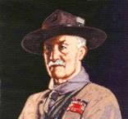
Note – The original Scout Law published in 1908 had 9 points. In 1910, the BSA added Brave, Clean, and Reverent. In 1911 B-P added Clean to his original list.
A SCOUT'S HONOUR IS TO BE TRUSTED
. If a Scout says "On my honour it is so," that means it is so, just as if he had taken a most solemn oath. Similarly, if a Scout officer says to a Scout, "I trust you on your honour to do this," the Scout is bound to carry out the order to the very best of his ability, and to let nothing interfere with his doing so. If a Scout were to break his honour by telling a lie, or by not carrying out an order exactly when trusted on his honour to do so, he would cease to be a Scout, and must hand over his Scout badge and never be allowed to wear it again. (Scouting For Boys, 1908)

Trust should be the basis for all our moral training.
Lord Robert Baden-Powell, Rovering to Success, 1922

RACE & CAR QUOTATIONS
Quotations contain the wisdom of the ages, and are a great source of inspiration for Cubmaster’s minutes, material for an advancement ceremony or an insightful addition to a Pack Meeting program cover
"To finish first, you must first finish." Rick Mears
"Nobody remembers who finished second but the guy who finished second." Bobby Unser
"You drive the car, you don't carry it." Janet Guthrie
Finishing races is important, but racing is more important. Dale Earnhardt
When he was young, I told Dale Jr. that hunting and racing are a lot alike. Holding that steering wheel and holding that rifle both mean you better be responsible. Dale Earnhardt
Natives who beat drums to drive off evil spirits are objects of scorn to smart Americans who blow horns to break up traffic jams. Mary Ellen Kelly
Patience is something you admire in the driver behind you and scorn in the one ahead. Mac McCleary
It takes 8,460 bolts to assemble an automobile, and one nut to scatter it all over the road. Author Unknown
Leave sooner, drive slower, live longer.
Author Unknown
Your grandchildren will likely find it incredible - or even sinful - that you burned up a gallon of gasoline to fetch a pack of cigarettes! Dr. Paul MacCready, Jr.
Any man who can drive safely while kissing a pretty girl is simply not giving the kiss the attention it deserves. Albert Einstein
Hug your kids at home, but belt them in the car. Anon
A tree never hits an automobile except in self defense. American Proverb
Never drive faster than your guardian angel can fly. Anon
When buying a used car, punch the buttons on the radio. If all the stations are rock and roll, there's a good chance the transmission is shot. Larry Lujack (I remember Larry Lujack and his crank letter of the day from WLS in Chicago when I was attending Valparaiso 67 to 71!! Good old Top 40 AM Rock CD)
The one thing that unites all human beings, regardless of age, gender, religion, economic status or ethnic background, is that, deep down inside, we ALL believe that we are above average drivers. Dave Barry, "Things That It Took Me 50 Years to Learn"
The shortest distance between two points is under construction. Noelie Altito
If all the cars in the United States were placed end to end, it would probably be Labor Day Weekend. Doug Larson

BIOGRAPHY

ABRAHAM LINCOLN
Abraham Lincoln's great laws of truth, integrity:
A long career ruled by honesty
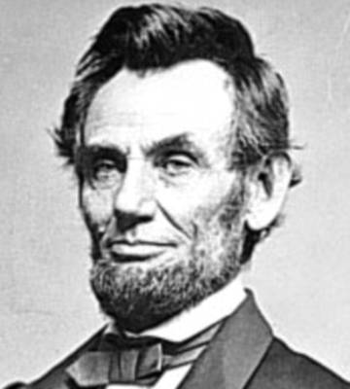
"Mr. Lincoln . . . is almost monomaniac
on the subject of honesty."
Mary Todd Lincoln, letter to a friend
The future president was first called "Honest Abe" when he was working as a young store clerk in New Salem, Ill. According to one story, whenever he realized he had shortchanged a customer by a few pennies, he would close the shop and deliver the correct change-regardless of how far he had to walk.
People recognized his trustworthiness (integrity) and were soon asking him to act as judge or mediator in various contests, fights, and arguments. According to Robert Rutledge of New Salem, "Lincoln's judgment was final in all that region of country. People relied implicitly upon his honesty, integrity, and impartiality."
As a member of the Illinois legislature and later in his law practice, he took advantage of his reputation for trustworthiness and fairness to help broaden his constituency. His good name helped win him four consecutive terms in the legislature.
Lincoln soon moved to Springfield, Ill, and began his law practice, a profession at which he admitted there was a "popular belief that lawyers are necessarily dishonest." His advice to potential lawyers was: "Resolve to be honest at all events; and if in your judgment you cannot be an honest lawyer, resolve to be honest without being a lawyer. Choose some other occupation, rather than one in the choosing of which you do, in advance, consent to be a knave."
According to Judge David Davis, in whose court Lincoln practiced for many years, "The framework for [Lincoln's] mental and moral being was honesty, and a wrong cause was poorly defended by him." Another judge who had worked with Lincoln agreed, saying "Such was the transparent candor and integrity of his nature that he could not well or strongly argue a side or a cause he thought wrong."
Lincoln was trustworthy and ethical not only in his legal dealings with clients, but with his personal relationships.
Always comfortable telling jokes and stories around the men of Springfield, he usually was awkward and self-conscious around women. In Lincoln's early political years, he wrote "I want in all cases to do right, and most particularly so in all cases with women." This was a principle to which he remained true all of his life. Today, historians tell us there is not a single credible story of Lincoln's being unfaithful to his wife.
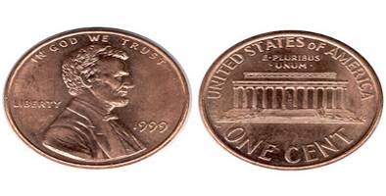
The Reverend Albert Hale of Springfield's First Presbyterian Church said, "Abraham Lincoln has been here all the time, consulting and consulted by all classes, all parties, and on all subjects of political interest, with men of every degree of corruption, and yet I have never heard even an enemy accuse him of intentional dishonesty or corruption."
An example of an "enemy's" respect came in 1858, during Lincoln's Senate race against the powerful incumbent, Stephen A. Douglas. The senator, having competed with Lincoln in the legislature and many Illinois courtrooms, knew his opponent well.
Responding to the news that Lincoln was to be his adversary, Douglas said: "I shall have my hands full. He is the strong man of his party-full of wit, facts, dates-and the best stump speaker, with his droll ways and dry jokes, in the West. He is as honest as he is shrewd, and if I beat him my victory will be hardly won."
Lincoln lost his Senate bid to Douglas. Two years later, however, he found himself running against the same man for the presidency. When Douglas was told of Lincoln's victory, he unselfishly told his informants: "You have nominated a very able and very honest man."
By the time Lincoln was president, statements he had made previously, such as "I have never tried to conceal my opinions, nor tried to deceive anyone in reference to them," and "I am glad of all the support I can get anywhere, if I can get it without practicing any deception to obtain it" had become a source of strength for him as a leader.
Everyone, even his bitterest political opponents, knew exactly where they stood with Lincoln. Because he didn't have to waste time convincing his opponents of his sincerity, he was able to devote his energies to solving political issues and winning the war.
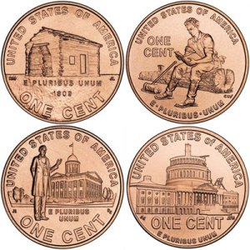Lincoln as commander in chief was honest and straightforward with his generals, always telling them directly what he did and did not appreciate about them. An example of his candor is the following excerpt from a letter to Major General Joseph Hooker in early 1863:
"I have placed you at the head of the Army of the Potomac. Of course I have done this upon what appear to me to be sufficient reasons, and yet I think it best for you to know that there are some things in regard to which I am not quite satisfied with you. I believe you to be a brave and a skillful soldier, which of course I like. I have heard, in such a way as to believe it, of your recently saying that both the army and the government needed a dictator. Of course it was not for this, but in spite of it, that I have given you the command. Only those generals who gain successes can set up dictators. What I now ask of you is military success, and I will risk the dictatorship."
Finally, in search for the reason Lincoln was so adamant about honesty, a quote by one of his closest friends, Leonard Swett, is revealing:
"He believed in the great laws of truth, the right discharge of duty, his accountability to God, the ultimate triumph of the right, and the overthrow of wrong."
For further reading:
http://www.greatamericanhistory.net
Please go to Great American History and check it out. Consider leaving them a donation to thank them for all their hard work on Lincoln and the Civil war and other parts of our history. CD
"Abraham Lincoln: Quotes, Quips, and Speeches"
by Gordon Leidner or
"The Inner World of Abraham Lincoln"
by Michael Burlingame.
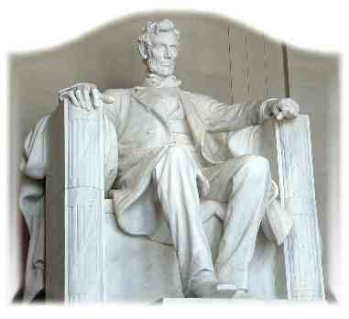

CUB SCOUT LEARNING LIBRARY
The NEW https://cubscouts.org/ !!!

This is the Cub Scout Learning Library –
Everything you could want to know for Cub Scouts is or will be here. And all within a click or 3 of the home page. National heard the message that although things were at www.scouting.org they were often buried too deep to be found.
This site has admin stuff and practical stuff. The new Den Leader Resource Books are here. You can download some of the pages for each Adventure for FREE
This website is a great resource. There are still parts under construction but what is there is GREAT!!

BSA seems to be working off the same plans that www.USScouts.org and other "unofficial" Scouting websites use. They have seen what you the volunteers want and are delivering it. I hope they are successful and some of us old guys (I have my Medicare card) can retire from our web duties.
Yes, https://cubscouts.org runs on a phone, too!!!

There are 3 tabs on top of the home page –

- Learning Library
- Blog
- Join Scouting
- Learning Library takes you where you can learn about your position and pick up hints. Besides specifics for dens of each rank, other clickable links include –
KEY
- All or most of material was placed on site this past month
- All or most of material was in place and listed as such in last month's Baloo's Bugle.
- Site / pages under construction
- Den Leader
Den Meeting Basics
- Your First Den Meeting
- Planning Den Outings
- The Parts of a Den Meeting
- Getting Started
Three of the Core Adventures for the selected rank are listed here. Click on them and you will see / can download all the Leader's Guide pages for these three Adventures.
- Additional Required Adventures
The remaining Core Adventures for the selected rank are listed here. When you click them you get an intro to the Adventure but do not get the Meeting Plans and Resources. You see this note:
To get you started in delivering fun and engaging meetings, complete Den Meeting Plans are available here on the Learning Library for the Backyard Jungle and Games Tigers Play adventures. To obtain Den Meeting Plans for all other adventures, Den Leader Guides are available at your local Scout Shop, online at scoutstuff.org, or as an eBook through Amazon.
- Elective Adventures
All the Elective Adventures for the selected rank are listed here. When you click them you get an intro to the Adventure but do not get the Meeting Plans and Resources. You see the same note (above).
- Building Strong Dens
The Basics of Cub Scouts
- Advancement
- BSA Mission and Vision Statements
- Cub Scout Ages and Ranks
- Cub Scout Uniforming
- Den Flags
- Den Yells
- Leader Survival Kit
- Methods of Cub Scouting
- Purpose of Cub Scouting
- Roles and Responsibilities
- Scout Oath and Law
- What Is Cub Scouting?
- Training
- The Role of Training
- Youth Protection
- Den Planning And Administration
- Advancement Basics
- Advancement Requirements
- Annual Planning For Your Den
- Coordinating Your Den Plan with Pack
- Tracking and Recognizing Advancement
- Youth Protection Training
- Positive Youth Development and Working with Boys
- Developmental Differences Boys 7-11
- Behavior and Discipline
- Positive Youth Development
- Working With Special Needs Cub Scouts (Advice is specific to each Special Need. Lots of research was done to prep these pages.)
- Parents’ Prejoining Conference
- Leadership Techniques
- Working With Specific Disabilities and Needs
- Cubmaster
- Committee Chair/Member
- Chartered Org Rep
- Parent / Adult Partner
- Blog takes you to a Cub Scout specific Blog similar to Bryan's Blog. The topics discussed here in September were:
Are Scout Jokes Just Dad Jokes in a Uniform? Jokes and Cub Scouts have a long history of being mutually perfect for one another. We’ve blogged…READ MORE
These Halloween Cub Scout Skits are Hilarious Crisp Air and Changing Leaves Autumn is a fun season in your Cub Scouts den and pack. With…
READ MORE
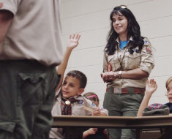 Scouting: Fun for the Whole Family Meet Lydialice. She is a mom whose boy was looking for more outdoor adventure. In her own…
READ MORE
 The “Digital Pack” is Growing, We Just Hit a BIG Milestone Last week saw a big milestone for what we affectionately call the “Digital Pack.” Our Cub Scouts…READ MORE
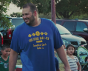 Scouting: A Priority for Family Meet Juan. He grew up in Mexico and as a teenager immigrated to the United States. Having…READ MORE
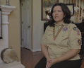 Scouting: An Extension of Family Meet Catherine, or as the Cub Scouts in her den call her, Ms. Cat. She’s a Scout mom,…READ MORE
 Scouting: Not Just a Club, but a Family Meet Becky. Her son just crossed over from Cub Scouts to Boy Scouts, and is about to…READ MORE
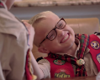 Scouting: Getting the Most out of Family Time Meet Michelle, the proud mother of a Webelos Scout. She knows that life can be busy and…READ MORE
 Scouting: A Way to Invest in Your Family Meet Lester and Apryl who’ve been involved in Scouting for a combined total of 23 years. Together,…
READ MORE
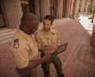 This Scout Dad Makes a Terrific Case to Join Cub Scouting Just outside of Minneapolis is the community of Prior Lake. And its local newspaper, the Prior Lake…READ MORE
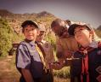 All the Latest Resources for Scouting Recruitment We’ve done it! We brought back the popular #CubChat Twitter chat event for a special conversation on…READ MORE
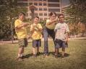 6 Planning Tips for your Cub Scout Calendar When it comes to leading a Cub Scout den or pack, from Blue and Gold to Day… READ MORE
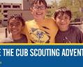 This September, Bring a Friend to Scouting By now, you’ve probably seen the #ShareScouting hashtag and maybe (hopefully!) even used it on your own…READ MORE

- Join Scouting takes you to www.beascout.org
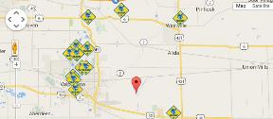

- Also, on the home page –
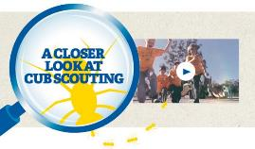
This link takes you to a YouTube Video
on Cub Scouting.
https://www.youtube.com/watch?feature=player_embedded&v=dqKFgk8SJlE
These Six Links take you to:
(From top left across, then down)
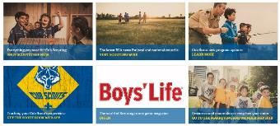
www.scoutstuff.org – The Supply Division site where you can find the location of your nearest National Scout Shop or buy all your Scout supplies
http://scoutingwire.org/ - Where you can get the latest Scouting News from around the country. You can sign up to get notifications when things are posted here..
www.scouting.org/programupdates - The great site where all the news about all the changes to Cub Scouting, Boy Scouting, and Venturing can be found.
https://www.scoutbook.com/ Where you can get the Scoutbook APP to track your son's Scouting Experience from Tiger to Eagle Scout.
I just learned that Bob Scott is at it again. Bob led us on the charge to "Cub Scouts 2010" and then to "CS Adventure Program." Now he is leading the Scoutbook effort. It is sure to be a success!! Thank you, Bob - CD

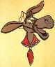
www.boyslife.org – Go directly to the on-line edition of Boys'Life
http://scoutingwire.org/marketing-membership/ Get resources and materials to strengthen your unit at BSA's marketing and membership site. Learn the best practices and tips employed by the most successful units.

CUB SCOUT
LEADER TRAINING

ON-LINE TRAINING
On October 25, 2015, this post appeared on the BSA Volunteer Training Team Facebook Page (https://www.facebook.com/BSAtrainingteam/ )
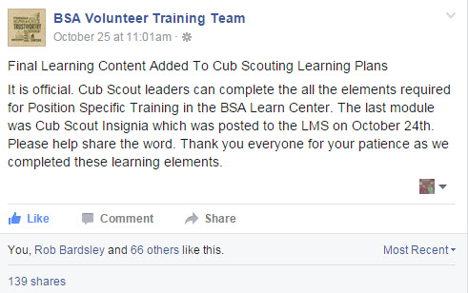
And the comments I read confirm that the system is up, running, and complete!! My Council Training Chair was excited that he could now be qualified for his position in his son's pack!!!
The online training for Den Leaders, Cubmasters, Committee Chairs and members, and Chartered Organization Representatives is totally updated with help from volunteers from around the country. The new training is divided into shorter, more targeted modules so leaders can get the training they need, in the order they want, any time they need it. It is organized around the learning needed prior to the first meeting, in the first 30 days, and to be position-specific trained. This training was developed to be implemented in conjunction with the BSA’s new learning management system. Keep an eye on My.Scouting Tools (log in at https://My.Scouting.org ) for more information.
Go to the BSA Volunteer Training Team Facebook page (Link above) and .
Then you automatically receive the latest news!!
Then on October 28, I saw –
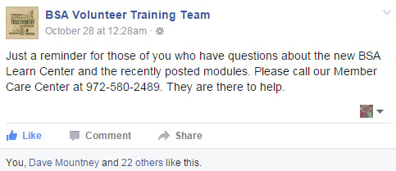
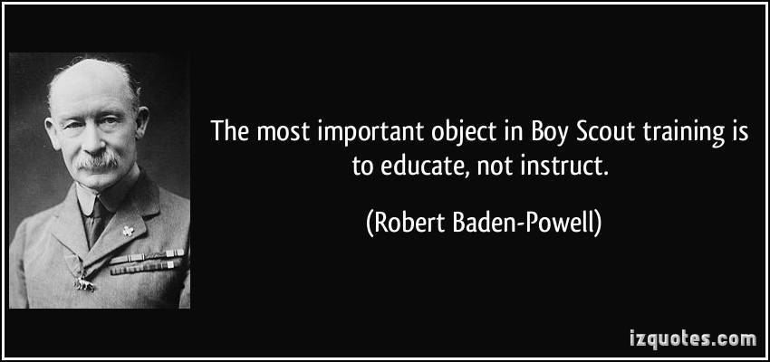
A Typical Learning Plan has several parts –
Here you can see the three parts of the CM Course -
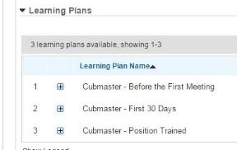

Each of these three parts is broken down into "bite sized" chunks:
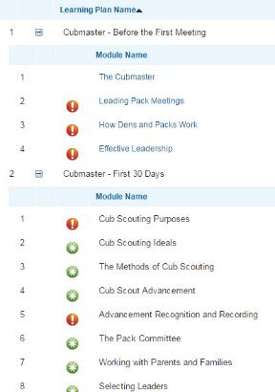
Go check it out and get your
people trained!!!
If you are having difficulties with the training or
system call Member Care at 972-580-2489,

IN-PERSON TRAINING
Position-Specific In-Person Training Guides Available Now! The training guides for
- Den Leader (http://www.scouting.org/filestore/training/pdf/515-215.pdf ),
- Cubmaster/Assistant Cubmaster (http://www.scouting.org/filestore/training/pdf/511-503_WB.pdf ), and
- Pack Committee (http://www.scouting.org/filestore/training/pdf/511-504_WB.pdf )
are available on Scouting University. You can access them at http://www.scouting.org/training/adult.aspx .
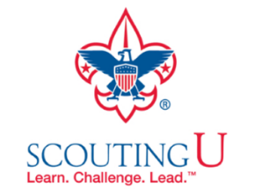

ADVENTURE PLAN TRACKING SPREADSHEETS
- Tracking Spreadsheets are posted on the USScouts Advancement webpage (www.usscouts.org). There are be links to them from other places on the site. These spreadsheets are similar in construction and user interface as the existing spreadsheets. The spreadsheets have be tested by the developer of the current spreadsheets and he said they are so good he sees no reason to develop others!!
- Utah National Parks Council has Excel spreadsheets posted for all the new Adventure Plan requirements on their Akelas Council Blogspot. www.Akelascouncil.blogspot.com . Check them out.
The Advancement Excel Spreadsheet workbooks are distributed to Scouters for FREE.
PLEASE do not download the files from either site to email or send them digitally to others. They are for your personal / pack use only. If you would like to share these files with others, please copy / send the link to them and send them to the site so they can print off their own. They would love everyone that wants a copy to get their own copy absolutely free. Both USScouts and Utah National Parks receive Ad money based on the number of people visiting the site that helps keep their websites open. Please help us by encouraging others to visit them to obtain the files.

25 CUB SCOUT TERMS YOU NEED TO KNOW
Are you a new Cub Scout parent? If you are, you've probably already learned thatCub Scouting has its own language.
Our friend (she is a friend to all Cub Scout Leaders) Sherry has posted a list of 25 Common Cub Scout Jargon items (words, phrases, titles).
These terms can be confusing, so go check out here list, then bookmark her page for easy reference.
Here is Letter B for a sample –
Cub Scout Terms - B
Blue and Gold Banquet - Because February is the anniversary month of the Boy Scouts of America, many packs celebrate with a Blue and Gold banquet. Often, the banquets are special events that can include games and entertainment. Cub Scouts often bring their whole families including grandparents.
Buddy System - The buddy system is used to help Cub Scouts look out for each other. At Cub Scout events, especially outdoor activities, boys should find a partner. The buddies go everywhere together and know where each other is at all times. This helps ensure that the boys always have a partner to help him if he is lost or hurt.

ROUNDTABLE HINTS

TECHNOLOGY AND
ROUNDTABLE DELIVERY
From 2015-2016 RT Planning Guide

When a local district is in a tightly contained geographic area, such as a suburban area of a major city, meeting in person is usually both easy and convenient. But face-to-face roundtable meetings become more difficult when a district includes several counties and many of the roads are rural two-lane roads. The amount of time required to drive to the roundtable site from the farthest reaches of the district may discourage unit leaders from attending in person, especially in poor weather. Roundtable teams for such districts should consider alternative methods to reduce the geographic barriers to roundtable attendance.
One alternative might be a longer roundtable format (up to 180 minutes) that permits attendees to receive more training and better justifies the time required to travel to the roundtable site. This longer format may allow for not meeting every month, but rather on alternate months or even quarterly. Another alternative might be hosting roundtables in two or more locations on a rotating basis. If the district leadership is able to do so, the district could hold more than one roundtable per month, each in a different part of the district. Each of these alternatives has been used successfully in parts of the country.
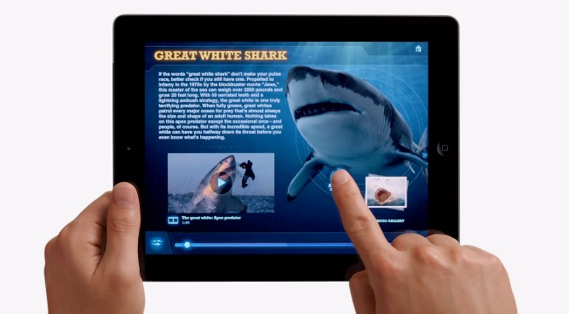
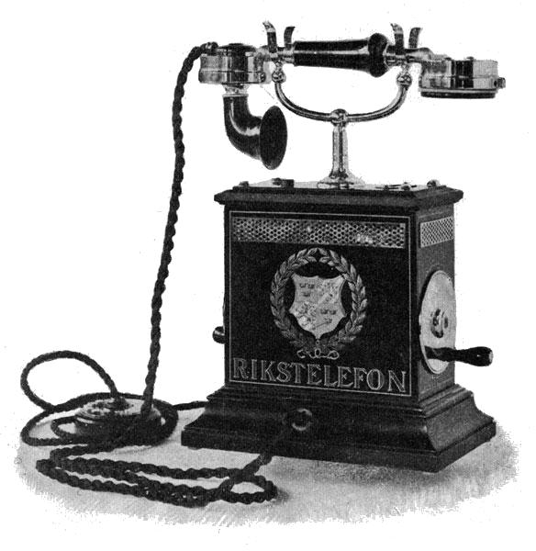
If those alternatives aren’t practical, the leadership of a geographically large district should consider whether it is preferable to deliver at least some portion of the roundtable using one or more of the commercially available telephonic or video services. Some issues to consider and resolve include:
- Availability of telephone jacks in the meeting rooms and/or suitable Internet connectivity at the roundtable site (including Wi-Fi)
- Availability of the equipment necessary to record and transmit a roundtable from the host site, including cameras, quality microphones, and lighting
- Cost of the various telephonic or video services
- Limits imposed by the service provider on the number of simultaneous participants
- Whether to record and broadcast both the joint session and all the breakout sessions, or just the joint session, keeping in mind the need for more equipment if multiple breakout sessions are filmed simultaneously
- Whether to enable two-way communication so remote participants can ask questions and participate in group discussions, or whether the remote participants will only be able to listen to presentations
- Whether the remote participants have access to the necessary technical resources (equipment and bandwidth) to receive a particular type of telephonic or video feed

Another consideration is ensuring a sufficiently large in-person attendance to maintain the camaraderie which is the essence of most successful roundtables. The district leadership should determine whether the in-person attendance can be maintained if the roundtable is broadcast to everyone in the district in real time, or whether it would be better to limit access to recorded roundtables to leaders of selected units. YouTube videos and podcasts can be posted a few days after the actual roundtable to encourage in-person attendance. And it is possible to post “nonpublic” YouTube videos, for which the URL (Web address) is given only to leaders of selected units that are considered to be “sufficiently remote” from the roundtable site.

When the usual roundtable location does not have Wi-Fi or other Internet connections in the meeting room, or when the remote participants don’t have access to high-speed Internet (either cable or wireless), it may not be possible to have an effective video roundtable. In such cases, if the meeting room has either a telephone jack or a high-quality cellular signal, an alternative is for the remote participants to use a conference call service. A high-quality speaker phone, possibly one with multiple microphones, should be used to ensure that remote participants can hear all the participants gathered in the meeting room. Districts should email copies of handouts to the remote participants (or post the handouts on the district website) when using a conference call rather than streaming video.
Many services, both commercial and free, are available. However, most of the free services (such as Skype, Google Voice, Google Chat, and Google Hangout) limit the number of simultaneous remote participants to as few as 10. When a district uses a service that restricts the number of free remote participants, the district should evaluate the possibility of having remote participants gather at satellite locations closer to their homes. Each satellite location can count as one participant, if several leaders use a single speaker phone or video monitor.

Other services (such as GoToMeeting and TeamViewer) support a larger number of remote participants but require the payment of either monthly or per-minute fees. Some services have tiered fees for different numbers of simultaneous participants. FreeConferenceCall.com is an example of a service that does not charge to set up a call, but requires participants to pay for their own telephone service for the call (such as long-distance charges or wireless-to-landline charges). Some councils choose to provide conference call services that are toll-free to remote participants and absorb the cost of the service, whereas other councils require the remote participants to pay for the call.
Some districts may choose to use a blend of in-person roundtables during certain months, real-time remote audio and/or video roundtables during other months, and YouTube videos or podcasts for selected presentations when the primary need is the dissemination of information rather than an interactive discussion. Examples of the latter could include recordings of presentations on Friends of Scouting, Internet Rechartering, or a topic that every new leader should hear as a supplement to available online training. Having these supplemental topics available via podcast or YouTube videos would enable new leaders to hear that information whenever they accept a position for which that information would be useful, without having to repeat basic information at roundtable.
The commissioner newsletter, The Commissioner, has included numerous articles on technology options for roundtable delivery and will continue to do so in the future. The first such article was included in the Fall 2013 edition. The Winter 2014 edition included an article on one district’s use of YouTube videos of roundtable sessions. Current and archived copies of The Commissioner can be found at www.scouting.org/commissioners/.

TEACHING THE SCOUT OATH & LAW TO
CUB SCOUTS

WHAT THE SCOUT LAW MEANS
TO ME
John Wayne
A great American, John Wayne, passed away many years ago. One of his last public appearances was at a dinner. He was riddled with cancer and knew he was close to death. The purpose of the dinner was to benefit a land purchase for a Scout Reservation called John Wayne Outpost Camp.
At this dinner, Wayne recited the Scout Law. Then he did something unusual. He said the twelve points of the Scout Law are "nice words". "Trouble is" he continued, "We learn them so young we sometimes don't get all the understanding that goes with them. I take care of that in my family. As each boy reaches Scout age, I make sure he learns the Scout Law. Then I break it down for him, with a few things I have picked up in more than half a century since I learned it."
Then Wayne proceeded to explain the importance of the Scout Law, breaking it down for the guests at the dinner; much like he would have for his grandson.
TRUSTWORTHY - The badge of honesty. Having it lets you look at any man in the eye. Lacking it, he won't look back. Keep this one at the top of your list.
LOYAL - The very word is life itself; for without loyalty we have no love of person or country
HELPFUL - Part sharing, part caring. By helping each other, we help ourselves; not to mention mankind. Be always full of help -- the dying man's last words.
FRIENDLY - Brotherhood is part of that word. You can take it in a lot of directions - and do - but make sure and start with brotherhood.
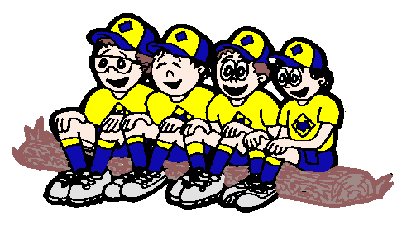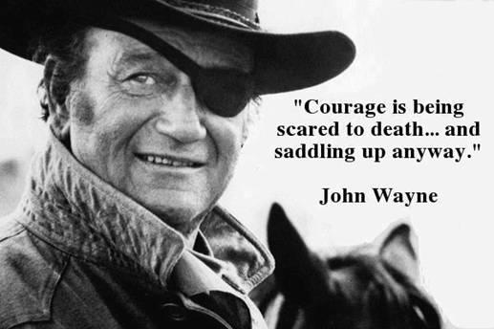
COURTEOUS - Allow each person his human dignity; which means a lot more than saying, "Yes, ma'am" and "Thank you, sir." It reflects an attitude that later in life you wish you had honored more... earlier in life. Save yourself that problem. Do it now.
KIND - This one word would stop wars and erase hatreds. But it's like your bicycle, it's just no good unless you get out and use it.
OBEDIENT - Starts at home. Practice it in your family. Enlarge it in your friends. Share it with humanity.
CHEERFUL - Anyone can put on a happy face when the going is good. The secret is to wear it as a mask for your problems. It might surprise you how many others do the same thing.
THRIFTY - Means a lot more than putting pennies away; and it is the opposite of cheap. Common sense covers it just about as well as anything.
BRAVE - You don't have to fight to be brave. Millions of good, fine, decent folks show more bravery than heavyweight champs just by getting out of bed every morning, going out to do a good day's work, and living the best life they know how against the law of odds. Keep the word handy every day of your life.
CLEAN - Soap and water helps a lot on the outside. But it is the inside that counts, and don't ever forget it.
REVERENT - Believe in anything that you want to believe in, but keep God at the top of it. With Him, life can be a beautiful experience. Without Him, you are just biding time.

DEN MEETING TOPICS
Remember – Boys want to be active!! See, too, that they earn their awards (Never say GET. You get sick, you do not get awards – You earn awards. A little CD Philosophy).
Big Rock Ideas – suggestions for Big Rocks that fit Interest Topics or seasonal activity. If years are next to an item (e.g. 13-14) that suggested Big Rock is in that Roundtable Planning guide and on-line at http://www.scouting.org/scoutsource/Commissioners/roundtable.aspx
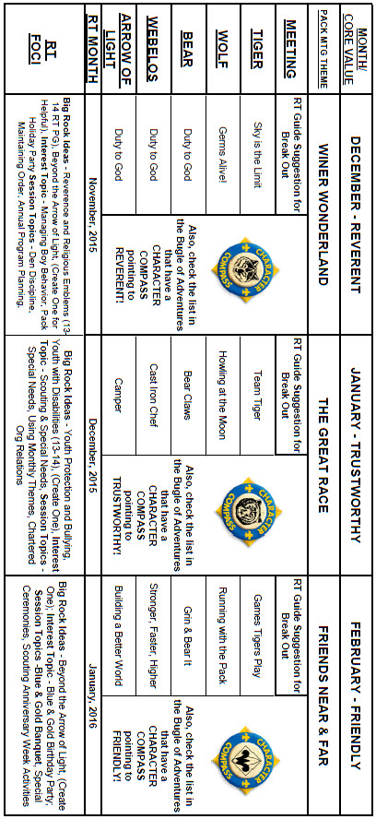

CHARACTER COMPASS
JANUARY -
ADVENTURES with a CHARACTER COMPASS pointing to TRUSTWORTHY:
TIGER –
- Team Tiger (Core)
- Tigers – Safe & Smart (Elec)
WOLF –
- Howling at the Moon (Core)
- Adventures in Coins (Elec)
BEAR –
- Bear Claws (Core)
- Baloo the Builder (Elec)
WEBELOS CORE –
- Cast Iron Chef (Core)
ARROW OF LIGHT CORE –
- Camper (Core)
WEBELOS & AOL ELECTIVES –
- Game Design (Elec)

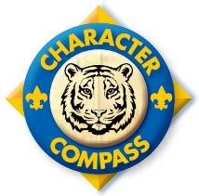

FEBRUARY -
ADVENTURES with a CHARACTER COMPASS pointing to FRIENDLY:
TIGER –
- Games Tigers Play (Core)
- Curiosity, Intrigue, & Magical Mysteries (Elec)
WOLF –
- Running with the Pack (Core)
- Digging in the Past (Elec)
BEAR –
- Grin & Bear It (Core)
- Marble Madness (Elec)
WEBELOS CORE –
- Stronger, Faster, Higher (Core)
ARROW OF LIGHT CORE –
- Building a Better World (Core)
WEBELOS & AOL ELECTIVES –
- Aware & Care (Elec)
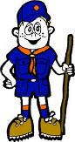

PACK MEETING THEMES
AND PLANS
www.scouting.org
From National's Website for the new plans using the Core Values based on the Scout Law:
Here are a few thoughts to consider around these new pack meeting plans. First, there is a plan for each month that corresponds with a point of the Scout Law. In addition, each plan has a theme to help make the pack meeting even more fun! The plans do not have to be used in a specific order.
Tips for Utilizing the Plans
- Pack meeting plans do not have to be done in any special order, but it is recommended that you include all of the points of the Scout Law each year. The pack planning meeting would be a good time to determine the order.
- There are pack meeting plans for multiple years posted on the website. It is your pack's choice of which one to select from each point of the Scout Law for each year.
- Pack meetings should not last longer than an hour. Adjust the plan to make it fit within the time. Research and experience tells us that Cub Scouts have a hard time sitting still for that long. Keep the meetings fun, active, and engaging.
- If you are comfortable with a costume to fit the theme of the meeting, go for it!
- Importantly, keep it simple and make it fun.
- The following required adventures have a requirement that suggests or requires completion at a pack meeting. Please plan accordingly as part of your annual program planning process. Work with your den leaders to plan when these activities will take place.
Tiger
- Tigers in the Wild, requirement 5. Participate in an outdoor pack meeting or pack campout campfire. Sing a song and act out a skit with your Tiger den as part of the program.
- Games Tigers Play, requirement 3. Make up a new game, and play it with your family or members of your den or pack.
Wolf
- Council Fire, requirement 6c. Create a den project from recyclables for a pack meeting.
Bear
- Grin and Bear It, requirement 2. Working with the members of your den, organize a Cub Scout carnival and lead it at a special event.
- Grin and Bear It, requirement 3. Help younger Cub Scouts take part in one of the events at the Cub Scout carnival.
Webelos
- Stronger, Faster, Higher, requirement 5. With adult guidance, lead younger Scouts in a fitness game or games as a gathering activity for a pack or den meeting.
Arrow of Light
- Building a Better World (if chosen), requirement 10b. Set up an exhibit at a pack meeting to share information about the World Friendship Fund.
As a personal note: I have read some of the plans and they are excellent and just as complete as the new Den Leader Books. The games, and other stuff are right there. Including costuming ideas for that added PIZAZZ!! If you do not use themes and do not add PIZAZZ you are not doing your best for your pack.
GOOD JOB!!! From CD
Check them out at:
http://www.scouting.org/Home/CubScouts/Leaders/CubmasterResources/PackMeetingPlans.aspx


Kim, the chair of the task force, says "I do want to stress that the focus is still the Core Value and the theme is just there as an enhancement. Pack meeting theme plans are specifically crafted to bring out the important points of the Core Value in a fun way."

PACK MEETING THEMES
2015–2016 Pack Meeting Plans
December | Reverent | "Winter Wonderland"
January | Trustworthy | "The Great Race"
February | Friendly | "Friends Near And Far"
March | Thrifty | "Cubstruction"
April | Cheerful | "Strike Up The Band"
May | Kind | "My Animal Friends"
June | Obedient | "It's A Hit"
July | Loyal | "Scout Salute"
August | Courteous | "S'more Cub Scout Fun"

2016–2017 Pack Meeting Plans
September | Helpful | "To The Rescue"
October | Kind | "Creepy Crawlers"
November | Courteous | "Cubs In Shining Armor"
December | Cheerful | "Celebrate"
January | Obedient | "Cub Scout City Council"
February | Reverent | "Passport To Other Lands"
March | Loyal | "Our National Treasures"
April | Thrifty | "Power Up!"
May | Clean | "A Picnic With Pizzazz"
June | Brave | "Roaming Reptile Alert"
July | Trustworthy | "Let The Games Begin"
August | Friendly | "#CUBSCOUTS"
If you are using a paper copy the link to all the
Pack Meeting Plans is:
http://www.scouting.org/Home/CubScouts/Leaders/CubmasterResources/PackMeetingPlans.aspx

UPCOMING MONTHS
- January's Core Value, Trustworthy,
will use the theme, The Great Race
Month | Year | Theme
Potential "The Great Race" Months
DERBIES
July | 1956 | Cub Scout Regatta
August | 1975 | Model-Boat Regatta
January | 1987 | Pinewood Derby
CARS
July | 1965 | Cub Scouts on Wheels
June | 1983 | Fun on Wheels
June | 2007 | Wheel into Summer
January | 2008 | Cub Scout Car Show
SPORTS
August | 1945 | Sports
August | 1953 | Sports Carnival
August | 1956 | Cub Scout Field Day
June | 1966 | Sports Carnival
June | 1970 | Olympics
August | 1970 | Cub Scout Field Day
June | 1975 | Sports Carnival
June | 1979 | Learn a Sport
June | 1990 | Sports Arena
August | 2002 | Sports Extravaganza
July | 2005 | Play Ball!
June | 2008 | Go For The Gold
July | 2009 | Cub Scout Sports
June | 2010 | Hoop-De-Doo

Month | Year | Theme
TRUSTWORTHY
(Themes for former CV's Honesty & Responsibility)
October | 2010 | Responsibility
August | 2011 | Honesty
October | 2011 | Responsibility
August | 2012 | Honesty
October | 2012 | Jungle of Fun
August | 2013 | Kids Against Crime
October | 2013 | Down on the Farm
August | 2014 | Heroes of History
October | 2014 | Dollars and Sense

- Fenruary's Core Value, Friendly, will use the theme, Friends Near and Far

Month | Year | Theme
Potential "Friends Near and Far" Months
March | 1943 | United Nations Month
January | 1946 | Boys of the World
November | 1947 | In Old Mexico
April | 1949 | Life in the Philippines
March | 1959 | Canada, Land of the Mounties
January | 1961 | South America
March | 1962 | Islands of the World
March | 1965 | South of the Border
December | 1973 | Customs of Countries
December | 1979 | Customs of Other Lands
December | 1989 | Customs of Countries
April | 1991 | Canada, Our Neighbor
December | 1994 | Customs of Other Lands
March | 1999 | Gateway to the Orient
February | 2001 | Passports to Other Lands
April | 2003 | Land of the Pharaohs
December | 2013 | Passport to Other Lands
June | 2014 | Over the Horizon

Month | Year | Theme
FRIENDLY
(Themes for former CV's Compassion & Cooperation)
December | 1944 | The Other Fellow
December | 1949 | The Other Fellow
December | 1950 | Helps (for institutions)
December | 1951 | F-H-G (good followers,  helpers, & givers)
September | 1965 | Barn Raising
December | 1984 | Do a Good Turn
December | 1986 | The Golden Rule
December | 1992 | To Help Other People
December | 1995 | Do a Good Turn
December | 1996 | Helping Others
December | 1997 | The Golden Rule
July | 2002 | Inside Out and Backwards
March | 2004 | Walk In My Shoes
January | 2009 | A-MAZE-ing Games

WEBELOS
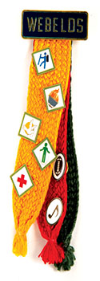
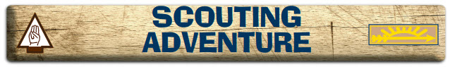
Commissioner Dave with help from - http://usscouts.org/advance/cubscout/aol-core-2015.asp
I love this Adevnture!! -
This Adventure takes all the Boy Scout related requirements that were just a long list of extra things to do in the previous advancement program and combines them into an Adventure. This keeps them from getting overlooked and earns the Scout an award for all his hard work. I know many Webelos Leaders who assumed the Activity Awards were it and there was not much else to do who were very surprised at the extent of Boy Scout related requirements. NOW they are all together and the Webelos Scout earns another Adventure Pin!!
Let's look at the requirements - (http://usscouts.org/advance/cubscout/aol-core-2015.asp )
Do all of these:
- Prepare yourself to become a Boy Scout by completing all of the items below:
  - Repeat from memory the Scout Oath, Scout Law, Scout motto, and Scout slogan. In your own words, explain their meanings to your den leader, parent, or guardian.
NOTE – It says "repeat from memory" not "With help as needed" like the bobcat Award.)
  - Explain what Scout Spirit is. Describe for your den leader, parent, or guardian some ways you have shown Scout Spirit by practicing the Scout Oath, Scout Law, Scout motto, and Scout slogan.
  - Give the Boy Scout sign, salute, and handshake. Explain when they should be used.

Describe the First Class Scout badge, and tell what each part stands for. Explain the significance of the First Class Scout badge.
The Webelos Den Leader Guide has a puzzle you can reproduce for this requirement. I have a wooden replica built on thin plywood that the Scouts take apart and reassemble. Hands On versus simply memorizing is the key!
  - Repeat from memory the Outdoor Code. In your own words, explain what the Outdoor Code means to you.
- Visit a Boy Scout troop meeting with your den members, leaders, and parent or guardian. After the meeting, do the following:
  - Describe how the Scouts in the troop provide its leadership.
  - Describe the four steps of Boy Scout advancement.
  - Describe ranks in Boy Scouting and how they are earned.
  - Describe what merit badges are and how they are earned.
- Practice the patrol method in your den for one month by doing the following:
  - Explain the patrol method. Describe the types of patrols that might be part of a Boy Scout troop.
  - Hold an election to choose the patrol leader.
  - Develop a patrol name and emblem (if your den does not already have one), as well as a patrol flag and yell. Explain how a patrol name, emblem, flag, and yell create patrol spirit.
Not too early to begin using these Boy Scout methods. Choosing a name often immediately boosts morale and spirit. Guide them here though – make sure the name has a positive meaning and the Patrol Leader will be an asset. The Webelos Leader Book has guidance on PL elections.
Need ideas for patrol names & patches? Here are some samples and places to go look.–
From BSA's www.scoutstuff.org -
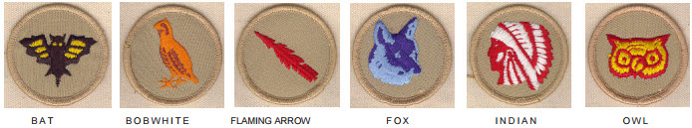
From www.classb.com –
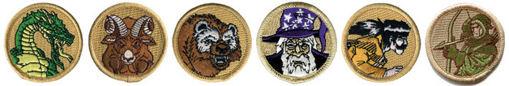
Just Google for "Boy Scout Patrol Patches" and you will find many more!!!
  - As a patrol, make plans with a troop to participate in a Boy Scout troop's campout or other outdoor activity.
- With your Webelos den leader, parent, or guardian, participate in a Boy Scout troop's campout or other outdoor activity. Use the patrol method while on the outing.
- Again not too early – get them started on the correct foot. The Webelos Leader Book has a Duty Roster & other stuff needed for this activity.
- The Scouts will plan their meals for the campout.
- If attending a troop campout at the end of this adventure, make sure the parents/guardians are aware that they are required to have an adult attend the campout with their son.
- Determine a cost per boy and his parent/guardian to cover the purchase of food and any other materials for the campout. Let the boys and their parent/guardian know the
- total cost of the campout in your take-home flier
- Do the following:
  - Show how to tie a square knot, two half hitches, and a taut-line hitch. Explain how each knot is used.
  - Show the proper care of a rope by learning how to whip and fuse the ends of different kinds of rope.
- Demonstrate your knowledge of the pocketknife safety rules and the pocketknife pledge. If you have not already done so, earn your Whittling Chip card.
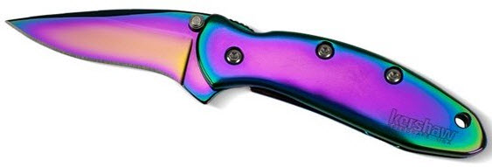
To summarize:
This great Adventure provides an excellent intro to the Webelos Scouts to Boy Scouting. It wraps up a lot of requirements that previously were just a list into a neat package. The Webelos Den Leader guide for this Adventure has excellent information and resources.
Comments welcome. Let me know your opinion -
Davethecommish@gmail.com

JANUARY CRAZY HOLIDAYS
Jodi, SNJC Webelos Resident Camp Director Emeritus,
2006-2011. Adapted from http://holidayinsights.com/moreholidays/index.htm
http://www.brownielocks.com/month2.html
January is:
- National Bath Safety Month
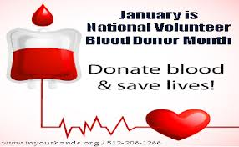
- National Blood Donor Month
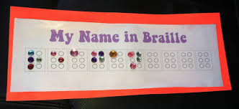
- National Braille Literacy Month
- National Hobby Month
- Learn to Ski and Snowboard Month
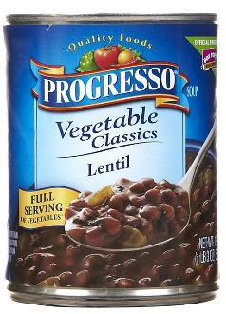
- National Soup Month
- National Glaucoma Awareness Month
- California Dried Plum Month

- National Hot Tea Month
- Be Kind to Food Servers Month
- Birth Defects Month
- Book Blitz Month
- Financial Wellness Month
- International Brain Teaser Month

- International Creativity Month
- National Clean Up Your Computer Month
- National Get Organized Month
- National Radon Action Month
- National Skating Month
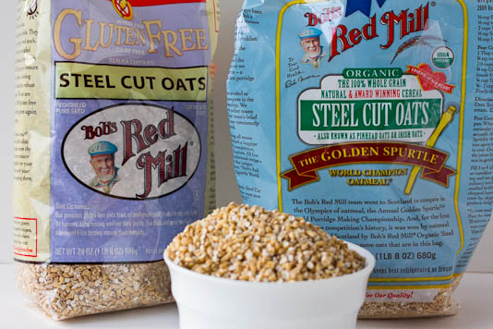
- National Oatmeal Month
- Thyroid Awareness Month
- Celebration of Life Month
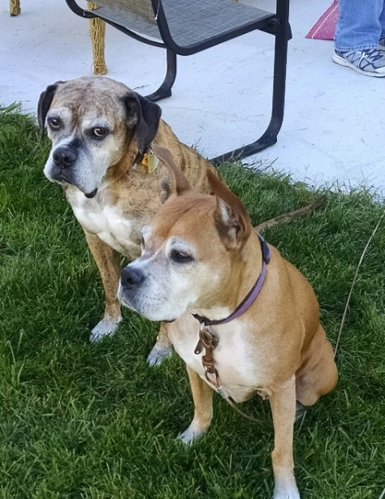
- Walk Your Dog Month
Week Celebrations:
- New Year's Resolutions Week: 1-7
- Celebration of Life Week: 1-7
- Diet Resolution Week: 1-7
- Someday We'll Laugh About This Week: 2-8
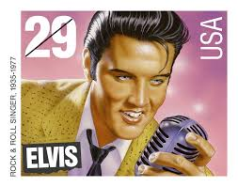
- Elvis' Birthday Celebration Week: 4-8 (This is at Graceland. His birthday is Jan. 8.)
- Home Office Safety and Security Week: 3-9
- National Lose Weight/Feel Great Week: 3-10
- Universal Letter Writing Week: 8-14
- National Vocation Awareness Week: 10-16
- National Soccer Coaches of America Week: 13-17
- National Fresh Squeezed Juice Week: 17-23

- National Bible Week (18-24)
- Week of Christian Unity: 18-25
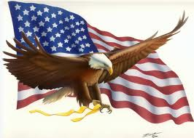
- Bald Eagle Appreciation Days: 16-17
- Clean Out Your Inbox Week: 24-30
- Healthy Weight Week: 18-22
- Hunt For Happiness Week: 18-24
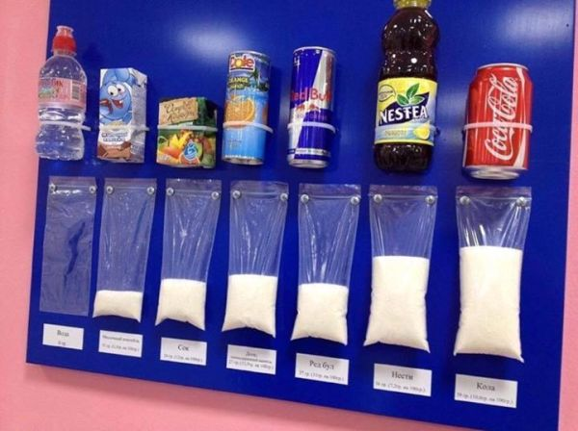
- Sugar Awareness Week 18-22

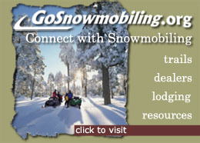
- Snowmobile Safety and Awareness Week: 19-25
- National Nurse Anesthetists Week: 24-30
- National Handwriting Analysis Week: 17-23
- International Printing Week: 21-26
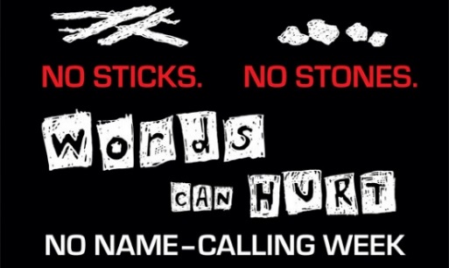
- No Name Calling Week: 18-22

- Catholic Schools Week: 1/31-2/6
- National Cowboy Poetry Gathering Week: 26-31
Holidays, Special and Wacky Days:
1 New Year's Day
2 Run up the Flagpole and See if Anyone Salutes Day
3 Festival of Sleep Day
3 Fruitcake Toss Day
3 Humiliation Day
4 Trivia Day
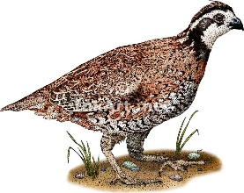
5 National Bird Day
6 Bean Day
6 Cuddle Up Day
7 Old Rock Day
8 Bubble Bath Day
8 Elvis’s Birthday

8 Argyle Day
9 Balloon Ascension Day
9 National Static Electricity Day
10 Houseplant Appreciation Day

Cree bulbs are assembled in the USA
10 National Cut Your Energy Costs Day
11 Step in a Puddle and Splash Your Friend's Day
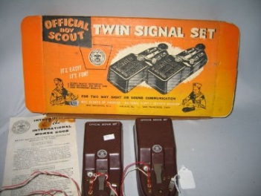
11 Learn Your Name in Morse Code Day
12 Feast of Fabulous Wild Men Day
12 National Pharmacist Day
13 International Skeptics Day
13 Make Your Dream Come True Day
14 Dress Up Your Pet Day
15 National Hat Day
16 National Nothing Day
17 Ditch New Years Resolutions Day
18 Thesaurus Day
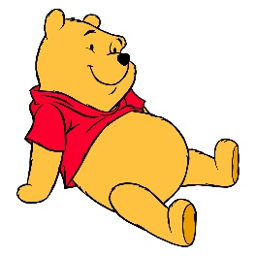
18 Winnie the Pooh Day -The Birthday of Winnie's author A.A. Milne
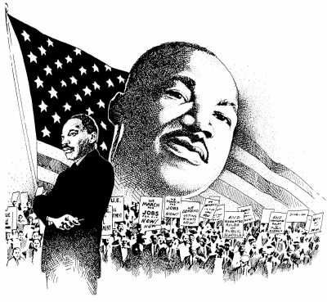
18 Martin Luther King Jr. Birthday , (Actual date – January 15, celebrated on the third Monday)
19 National Popcorn Day
20 National Buttercrunch Day
20 Penguin Awareness Day
20 National Buttercrunch Day
21 National Hugging Day
21 Squirrel Appreciation Day
22 National Blonde Brownie Day
23 National Pie Day
23 National Handwriting Day
23 Measure Your Feet Day- we only ask...."Why!?!"
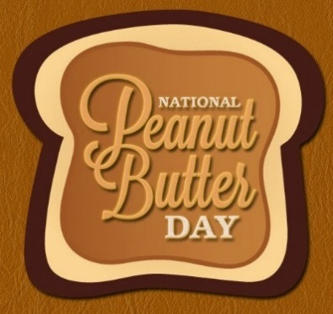
24 National Peanut Butter Day
24 Compliment Day
25 Bubble Wrap Day
25 Opposite Day
26 Spouse's Day
27 Chocolate Cake Day
27 Punch the Clock Day
28 Fun at Work Day
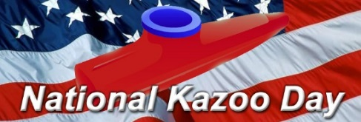
28 National Kazoo Day
29 National Puzzle Day
29 National Cornchip Day
30 National Inane Answering Message Day
31 Backward Day
31 Inspire Your Heart with Art Day

BSA SOCIAL NETWORKS

SCOUTING MAGAZINE ON YOU TUBE
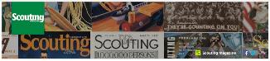
Scouting magazine You Tube Channel
http://www.youtube.com/user/scoutingmag

Check out cool stories and interviews -
Eagle Scout Ken Whisenhunt, Tennessee Titans Head Coach, on coaching and leadership
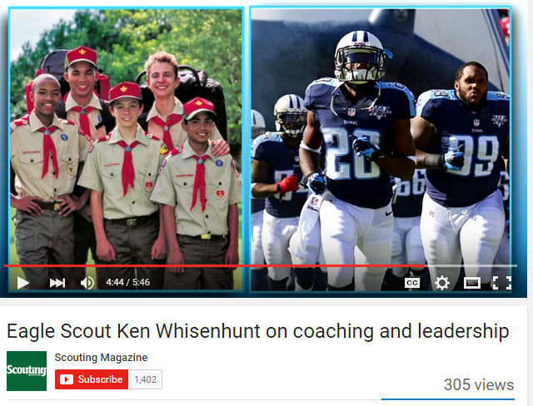
Check it out at –
https://www.youtube.com/watch?v=h1BpX6Q2WG4

BSA FACEBOOK PAGE
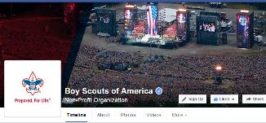
BSA Facebook page
https://www.facebook.com/pages/Boy-Scouts-of-America/113441755297
Sign up and get all the latest as it hits the wires!!!
Cubs probably need your parents to Sign Up.
On the Facebook page you can read about –
A Unique Camporee Held in Florida
I do not want to spoil the surprise – You read about it! (No, it wasn't at Disney!)
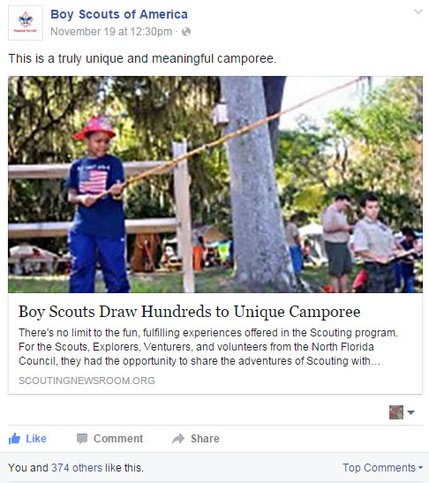
Go To: http://scoutingnewsroom.org/blog/north-florida-council-draws-hundreds-to-special-needs-camporee/
How many of these Top 100 are on your Reading List??
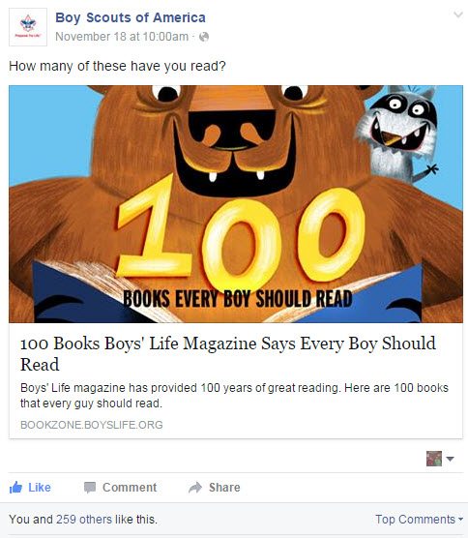
Go To: http://bookzone.boyslife.org/100-books-for-boys/

CUBCAST

http://www.scouting.org/Scoutcast/Cubcast.aspx
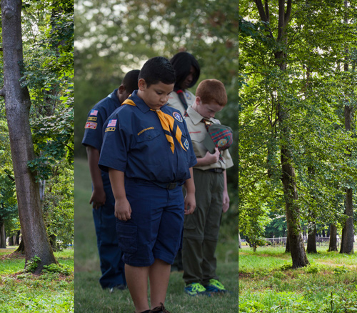
November 2015 -
Duty to God and Cub Scouts
The Scout Oath begins with Duty to God. The Scout Law ends with reverence. So it should be no surprise that Duty to God is such an integral part of Scouting. But what may be an eyebrow raiser is that the Duty to God element of the Cub Scouting program has been updated. Why change it? Fifteen-year Cub Scout volunteer, Kee Ostler tells us it’s, “like tending a garden.” Find out what that means at this month's Cubcast.

Listen Hear –
http://www.scouting.org/filestore/scoutcast/cubcast/201511_1/CC_Nov_DutyToGod.mp3

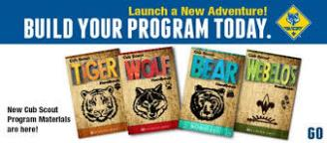

Be sure to check out National's website
for the latest on the
Adventure Program Changes -http://www.scouting.org/programupdates.aspx

SCOUTCAST

http://www.scouting.org/Scoutcast/Scoutcast.aspx

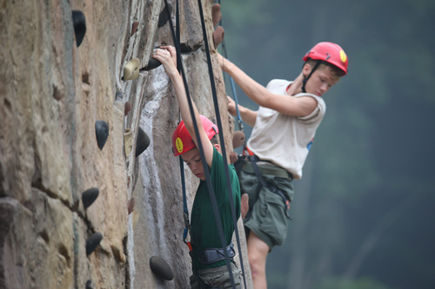
November 2015 -
Scout Safety
Whether you’re new to Scouting or have been with us for a while, you’re probably - and hopefully - very familiar with the Guide to Safe Scouting and the BSA’s rules and regulations regarding safety. You can tell we take safety very seriously. Here to explain the method to the madness of these regulations is our very own Richard Bourlon, team lead of Health and Safety. Let’s find out together.

Listen Hear –
http://www.scouting.org/filestore/scoutcast/resources/201511_1/SC_Nov_Safety.mp3

It is possible that by the time you get Baloo's Bugle and click the link, there may be new Cubcast and/or Scoutcast posted. Do not worry, all previous Cubcasts and Scoutcasts are available from the home page.
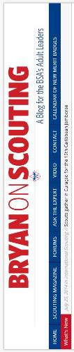
Bryans Blog
November 2015
“Bryan on Scouting” is the official blog of Scouting magazine, a Boy Scouts of America publication. Scouting magazine is published five times a year and is received by 1 million registered adult volunteers.
Bryan covers many topics every month. He keeps his Blog current and deals with the latest issues.
His articles this past month are listed below (Every title has a hyperlink). The articles in BLUE are of special interest for Cub Scout Leaders.

November 2015
Cub Scout is officially the coolest kid in the carpool lane
November 20, 2015 // 0 Comments
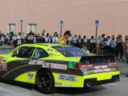Webelos Jake Nimark will become a legend in the lunchroom thanks to NASCAR driver and BSA supporter Scott Lagasse Jr., who dropped Jake off at school.
Philmont crew reunites to re-create photo taken 34 years prior
November 20, 2015 // 4 Comments
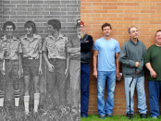A Philmont crew reunited to re-create a photo taken 34 years prior. This is the story behind the most-viral photo in Scouting magazine Facebook history.
Eagle Scout keeping homeless families warm this holiday season
November 20, 2015 // 0 Comments
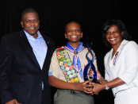In 2009, Nicholas Cobb started Comfort and Joy to provide coats to homeless families. That spawned an Eagle Scout project and much more.
Scouts appear on episode of ‘Barnwood Builders’ on DIY Network
November 19, 2015 // 0 Comments
Troop 248 of Oakdale, Pa., is featured in an episode of "Barnwood Builders," the DIY Network show about salvaging and old-world craftsmanship.
One more reason to become a Pathfinder member of the Scouting Alumni Association
November 19, 2015 // 3 Comments
Join the Scouting Alumni Association between now and Nov. 30 and $4.99 extra gets you a copy of the book "Defiant" by Eagle Scout Alvin Townley.
Venturers do that? Here’s a list of every Venturing crew specialty from 2015
November 19, 2015 // 41 Comments
While the most-popular Venturing crew specialities are "general interest," "high adventure" and "camping/backpacking/hiking," there's more to the list.
Awards recognize individuals and councils who do Venturing right
November 18, 2015 // 4 Comments
Two awards recognize people and councils who do Venturing right: the Venturing Leadership Award and the Council Standards of Venturing Excellence Award.
Three-finger sign in Hunger Games movies isn’t infringement. It’s just cool.
November 18, 2015 // 32 Comments
A Scouter and blog reader saw something familiar in the marketing campaign for "The Hunger Games: Mockingjay, Part 2": a three-finger sign.
Send in a photo of the craziest place you’ve camped
November 17, 2015 // 0 Comments
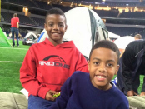Ever bunked on a battleship? Pitched tents next to a pitcher's mound? Camped out somewhere outstanding? Send in photos of the coolest place you've camped.
10 of the coolest Scout meeting places around
November 17, 2015 // 9 Comments
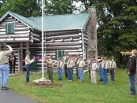Some of these Scout meeting places caught my eye right away, including a troop that meets on a beach. Others make the ordinary extraordinary.
Nominate a Scout or Venturer for the 2016 Outdoor Inspiration Awards
November 16, 2015 // 0 Comments
Know a Scout or Venturer who "shows leadership and passion for the outdoors"? Nominate him or her in the 2016 Outdoor Inspiration Awards.
Number of campouts required for First Class will double in 2016
November 16, 2015 // 93 Comments
In a nod to the BSA's increased emphasis on the outdoors, the number of campouts required for First Class in Boy Scouting will double beginning in 2016.
Philmont offers a physical, emotional retreat for women with breast cancer
November 13, 2015 // 0 Comments
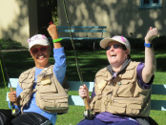Casting for Recovery provides free fly-fishing retreats for women with breast cancer. For the past six years, Philmont has hosted one of those retreats.
Umbrella movie license gives councils expanded options for showing movies
November 13, 2015 // 20 Comments
The BSA has purchased an umbrella movie license that covers all council-owned properties. This move has implications that reach beyond Wood Badge and NYLT.
How does two-deep leadership apply when driving to Scouting events?
November 12, 2015 // 56 Comments
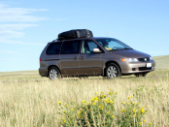Does "two-deep leadership" apply to driving to and from Scouting events? In other words, are two adults required in each car? We asked the expert.
What’s a new Order of the Arrow dad to do when his son isn’t yet elected?
November 12, 2015 // 48 Comments
At a recent camporee, an assistant Scoutmaster was called out to join the Order of the Arrow, Scouting's national honor society. His son was not.
Nominations open for National Alumnus of the Year Award
November 11, 2015 // 1 Comment
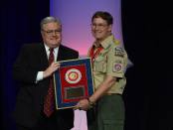Nominations are now being sought for the BSA's National Alumnus of the Year Award, the Scouting Alumni Association's highest recognition.
For Veterans Day, here are 11 Eagle Scout projects that benefited veterans
November 11, 2015 // 10 Comments
Many Eagle Scout candidates choose a project that benefits our nation's veterans and active-duty soldiers. For Veterans Day, here are 11 great examples.
Challenge yourself with the November-December 2015 ‘Where Am I?’ contest
November 10, 2015 // 0 Comments
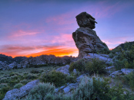Examine the clues, view the photo and submit your guess at this secret location for a chance to win the Where Am I? contest.
Boy Scout service hour requirements to increase beginning next year
November 10, 2015 // 52 Comments
In a nod toward helping other people at all times, Boy Scout service hour requirements that take effect in 2016 will increase the number of hours needed.
Exactly when do you become an Eagle Scout, and when can you wear the patch?
November 9, 2015 // 41 Comments
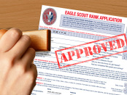Exactly when do you become an Eagle Scout? When is it official that you've earned Scouting's highest rank? We asked the expert.
John Philip Sousa once wrote a ‘Boy Scouts of America’ march
November 6, 2015 // 25 Comments
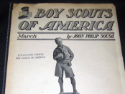In 1916, John Philip Sousa, the American March King who wrote "The Stars and Stripes Forever" and other marches, debuted his "Boy Scouts of America" march.
How to perform CPR
November 6, 2015 // 18 Comments
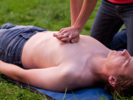You can't learn how to perform CPR from a blog post. Consider the CPR guidelines here to be a jumping-off point before you take more-formal training.
NYLT patch offers a new way for Scouts and Venturers to show they’re trained
November 5, 2015 // 50 Comments
Young men and young women who have completed National Youth Leadership Training are eligible to wear a new NYLT patch in place of their Trained strip.
Keep your camp kitchen clean when cooking with eggs
November 5, 2015 // 34 Comments
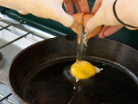Scouting volunteer Larry Green, who has shared his camping tricks before, is back with a tip for keeping your camp kitchen clean when cooking with eggs.
BSA now offers 13 interactive digital merit badge pamphlets
November 4, 2015 // 30 Comments
The BSA released interactive digital merit badge pamphlets for five Eagle-required badges: Camping, Hiking, Cycling, Swimming and Citizenship in the Nation.
Let’s see photos from inside your Scout meeting place
November 3, 2015 // 2 Comments
Please send photos of the inside of your Scout meeting place. Whether you have a permanent location for Scouting or share the space, I want to see it.
Beginning next year, Boy Scouts will tell about their ‘duty to God’ at each rank
November 2, 2015 // 230 Comments
Beginning Jan. 1, 2016, every rank from Tenderfoot to Eagle Scout (plus Eagle Scout palms) will include a "duty to God" requirement.
October 2015
What is Scouting for Food?
October 30, 2015 // 8 Comments
Scouting for Food is the annual food-collection drive run by your local council. It's another reminder to local communities that Scouts do good turns here.
The high-flying sport of ultimate soars into Scouting with new alliance
October 30, 2015 // 12 Comments
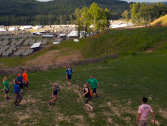The Boy Scouts of American announced a new alliance with USA Ultimate, the national governing body for the sport of ultimate in the United States.
World-class fun awaits at the Summit’s Paul R. Christen High Adventure Base
October 29, 2015 // 5 Comments
The Paul R. Christen High Adventure Base is the newest jewel in the BSA's crown, offering the biggest concentration of high-adventure activities anywhere.
Philmont Photo Archive now goes back to 1981
October 28, 2015 // 0 Comments
The Philmont Photo Archive, a window into Philmont's past through official group photos, has reached a new milestone in its steady journey back in time.
Grant means Amtrak will keep its stop near Philmont
October 28, 2015 // 18 Comments
Amtrak's Southwest Chief will continue service to Raton, N.M., meaning Scouts can enjoy a rugged train adventure before their rugged Philmont adventure.
Philmont Scout Ranch, New Mexico’s hiking paradise, keeps getting better
October 28, 2015 // 4 Comments
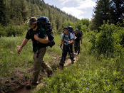Philmont is hiking paradise. More than 1 million Scouts have experienced its rugged trails, breathtaking views and incredible backcountry camps since 1939.
Eagle Scout author back with the second book in his Minecraft trilogy
October 27, 2015 // 1 Comment

The story of an Eagle Scout making waves in the publishing world has reached its second chapter. Book 2 in Sean Fay Wolfe's Minecraft trilogy is out now.
Set sail at Florida Sea Base (no sailing experience required)
October 27, 2015 // 4 Comments
Sea Base, the BSA's sailing oasis in the Florida Keys, the Bahamas and the U.S. Virgin Islands, offers something for anyone who loves the water.
Northern Tier is your gateway to pristine lakes, rivers and forests
October 26, 2015 // 6 Comments
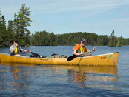Scouts and Venturers who enter Northern Tier's wilderness each summer get to explore a vast series of lakes and rivers during their 6- to 14-day journey.

Blog Contributors
Bryan Wendell, an Eagle Scout, is senior editor of Scouting and Eagles' Call magazines.
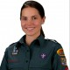
Gretchen Sparling is associate editor of Scouting and Eagles' Call magazines.

Get Email Updates
To sign up to receive Bryan’s Blog in your E-mail –
Click the link that appears in every article. Bryan and Gretchen promise never to sell or otherwise exploit your email address. Join 6,162 other subscribers

TRAINING TOPIC

SCOUTING FOR YOUTH WITH
DISABILITIES AND SPECIAL NEEDS
From National Council's website –
The basic premise of Scouting for youth with disabilities is that every boy wants to participate fully and be respected like every other member of the troop. While there are, by necessity, troops exclusively composed of Scouts with disabilities, experience has shown that Scouting usually succeeds best when every boy is part of a patrol in a regular troop.
(http://www.scouting.org/disabilitiesawareness.aspx)
Flexibility and individuality are key words to remember when adapting Cub Scout Academics and Sports for boys with disabilities. For instance, a fast-moving sport may be difficult for some Cub Scouts with disabilities to participate in. The pace may be too quick, and they may not have enough time to make decisions.
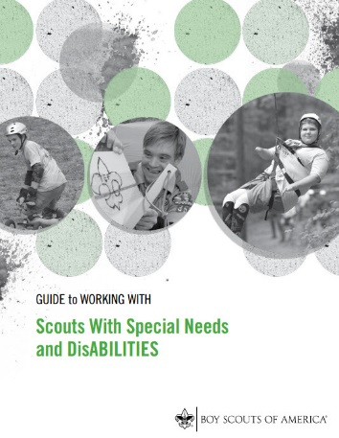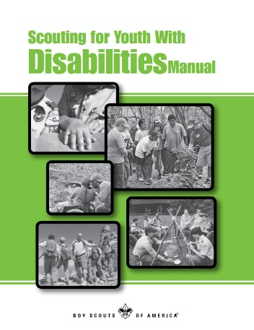
The "Guide to Working with Scouts With Special Needs and Disabilities" (510-071), http://www.scouting.org/filestore/pdf/510-071.pdf ), is an important resources for packs and dens with Cub Scouts having special needs and disabilities. Other resources from BSA include –
- The "Advancement for Members with Special Needs" section of the Advancement Guide at http://www.scouting.org/Home/GuideToAdvancement/SpecialNeeds.aspx
- Scouting for Youth With Disabilities Manual at http://www.scouting.org/filestore/commissioner/pdf/34059.pdf . NOTE: this Manual is presently being revised. Reissue is targeted for late 2015.
- Autism Spectrum Disorders addendum to "Scouting for Youth With Disabilities Manual" at http://www.wwswd.org/downloads/Autism%20Spectrum%20section%20of%20Manual.pdf
- "Scouting With Special Needs and Disabilities," at http://www.scouting.org/filestore/pdf/SpecialNeedsInformationSheet.pdf .
- "Scouts With Disabilities and Special Needs, " at http://www.scouting.org/filestore/pdf/02-508.pdf
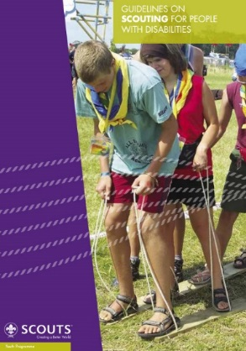
The World Organization of the Scouting Movement (WOSM), the organization that charters each national Scouting organization, has the following publication:
- Guidelines on Scouting for People with Disabilities This pamphlet may be found at: https://www.scout.org/sites/default/files/library_files/Guidelines_SCOUT_Disabled_en.pdf
Here are some general ideas for adapting the program for boys with disabilities.
Adapt the activity, or use mentors, to help a Cub Scout to participate. The boy should be involved to the best of his ability and so that he feels good about his participation.
Involve the boy in a needed, unique role that enhances the activity. For instance, if the activity involves playing a sport, he may be the team manager, the timekeeper, or the person responsible for equipment
Determine alternatives. For instance, miniature golf could be used instead of a full golf course; wheelchair races could be used instead of cycling.
Incorporate special helps into the activity. For instance, during bowling, use ramps with wheelchairs and guide rails for visually impaired youth. During basketball, youth can use a scooter board. During swimming, let youth use artificial aids to help them move across the pool.
Shorten time limits as needed for the mental or physical ability of the Cub Scout.
Include family members when planning a boy's participation in your activity. A knowledgeable parent or guardian is the best resource to help you adapt an Academics or Sports activity.
Pack leaders, with the boy's parent or guardian, may determine different requirements in a specific academic subject or sport to better suit the Cub Scout's ability.
Here are some other helpful hints:
- Soccer, basketball, and volleyball are easy to adapt for wheelchair-bound youth.
- Computers can often be adapted to deal with specific disabilities.
- If baseball is too fast use tee ball or softball.
- In basketball games, adaptations could be minor changes in the rules; for example, don't use the three-second rule, let players cross the centerline, and permit double dribbling.
- Most youth with disabilities participate in physical fitness activities, and Special Olympics are held in the summer and winter. Common sports for youth with disabilities include fishing, horseshoes, gymnastics, aerobics, hiking, and walking.
- Cycling may be possible, but pay attention to potential added dangers on the road to some youth with disabilities.
Sports rating the highest in acceptability for youth with mental disabilities are swimming, softball, soccer, basketball, and physical fitness.

From Scouts With Disabilities And Special Needs
(http://www.scouting.org/filestore/pdf/02-508.pdf)
Since its founding in 1910, the Boy Scouts of America has had fully participating members with physical, mental, and emotional disabilities. Dr. James E. West, the first Chief Scout Executive, was himself disabled. Although most of the BSA's efforts have been directed at keeping such boys in the mainstream of Scouting, it has also recognized the special needs of those with severe disabilities.
The basic premise of Scouting for youth with disabilities and special needs is that they want most to participate like other youth—and Scouting gives them that opportunity. Thus, much of the program for Scouts with disabilities and special needs is directed at (1) helping unit leaders develop an awareness of disabled people among youth without disabilities and (2) encouraging the inclusion of Scouts with disabilities and special needs in Cub Scout packs, Boy Scout troops, Varsity Scout teams, Venturing crews, and Sea Scout ships.
Today, approximately 100,000 Cub Scouts, Boy Scouts, and Venturers with disabilities are registered with the Boy Scouts of America in more than 4,000 units chartered to community organizations.
See the Special Opportunities Section for
Adult Recognitions for working with
Scouts with Disabilities and Special Needs.
Additional Resources:
NOTE: BSA has partnered with Bookshare® -

Through a partnership with Bookshare®, Scouts, unit leaders, and parents with qualified print disabilities can get accessible versions of their Scouting materials all in one place! Bookshare® is an online library of accessible e-books that allows readers with print disabilities to listen to books, see words and hear them read as they are highlighted on a screen, read in Braille, and much more! Bookshare® has more than 100,000 books, including Scout materials, which can be read on desktop computers, laptops, Apple iPads, iPhones, iPod touches, MP3 players, and other assistive technology. Memberships are FREE for U.S. students.
Accessing Scout Materials with Bookshare®
- Helps Scouts, unit leaders, and parents to read
- Provides easy access to Scout publications all in one place
- Helps Scouts keep pace with their peers
- Makes Scouting more accessible and meaningful
Go to http://www.scouting.org/filestore/pdf/BKS-Scout.pdf for more information on Bookshare®
Audio Recordings and Braille Editions of Boys' Life (There is a leader in my district who receives this every month. She has been to my Roundtables and Pack Meetings to show it and talk about blindness CD) as well as Cub Scout and Cub Scout Leader books, manuals, and other printed materials are available through the free library service provided by the National Library Service for the Blind and Physically Handicapped, Library of Congress. Families should also ask their cooperating libraries. For more information, including eligibility requirements and the nearest cooperating library contact the National Library Service of the Library of Congress at:
- Website http://www.loc.gov/nls/
- Call 202-707-5100
- E-mail braille@loc.gov
Braille printings and recordings of some Cub Scout materials are available from other organizations, too. Such as The Lighthouse of Houston, Houston, TX; the National Braille Association, Rochester, NY; and Recordings for the Blind and Dyslexic, Princeton, NJ. Check for local sources near you!!
Training Materials:
Slide Shows:
(These are available in English and Spanish)
Including Scouts With Disabilities - This PowerPoint presentation provides to leaders and parents the basic knowledge needed to implement the advancement plan with Scouts who have disabilities. Topics include: documenting a disability, registration beyond the age of eligibility, alternative advancement requirements, the individual Scout achievement plan, scenarios in working with Scouts who have special needs, and resources available at www.scouting.org. Go to: http://www.scouting.org/Home/BoyScouts/Resources/advancement_presentations.aspx. The location provides presenter's notes and handouts, too.
Essentials in Serving Scouts with Disabilities - This presentation provides leaders and parents with the basic knowledge and skills needed to work with youth who have special needs. Its purpose is to inspire participants to seek more information about specific disabilities they encounter in their Scouts. Go to: http://www.scouting.org/disabilitiesawareness.aspx. The location provides presenter's notes & handout, too.
Commissioner College Courses:
These courses on working with Scouts with Disabilities and Special Needs are filled with excellent material. They may be used by any Scouter for help on this topic. Each course folder includes a power point presentation, teaching notes, handouts and referenced materials. All the courses are located at: http://www.scouting.org/Home/Commissioners/training/college.aspx. The courses are:
- BCS 118 — Serving Scouts with Disabilities
- MCS 322 - Advanced Scouting with Disabilities
- CED 713 - Special Needs Scouting - Advancement
- CED 714 — Special Needs Scouting - ADHD
- CED 715 — Special Needs Scouting - Autism
Other available resources -
A group of Scouters has started an unofficial Scouting website (Remember – www.USScouts.org and Baloo's Bugle are unofficial sites) titled "Working with Scouts and Disabilities." It is at http://www.wwswd.org/. They have amassed a lot of material there.
An article about Franklin Delano Roosevelt that could be a great CM's Minute for a Disabilities program at: http://cubmaster.org/Leaders/Program.Planning/baloo's%20bugle/2013-june/Man%20of%20Courage%20-%20Franklin%20Delano%20Roosevelt%20.asp
This site has games for disabled boys -
http://www.inquiry.net/outdoor/games/disabled/
SPECIAL OPPORTUNITIES
With the start of the Cub Scout Adventure Program, the requirements for awards that say things like, "Complete Wolf Achievement 7," needed to be revised to send you to the new Adventures. The changes were highlighted in Baloo's Bugle in May, June, and July 2015.
To get a complete summary of all the changes to incorporate the Adventure Program, you can go to http://www.scouting.org/scoutsource/programupdates.aspx.
Or go to http://usscouts.org/advancementTOC.asp#cub
and get the changes for a specific award.

Recruiter Strip
http://usscouts.org/advance/recruiter.asp
As the end of the calendar year approaches, many units are going through their annual recharter process. This is a good time to add boys to your roster. The boys themselves are a great recruitment tool among their friends. One incentive that is available to you is to make the boys aware of the Recruiting Strip patch that they can earn.
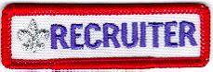
Cub Scouts and Boy Scouts may be awarded, and wear, below the right pocket on their uniforms, the Recruiter Strip shown above
There are NO formal requirements for these strips. Each Unit establishes the procedure for awarding the strip. Usually, a Recruiter Strip is awarded to a Cub Scout or Boy Scout the first time he is successful in getting a friend, relative, classmate, or other acquaintance to join his unit.
Typically, only ONE strip is awarded to a boy while he is a Cub Scout, and another may be awarded while he is a Boy Scout.
Scouts that recruit a new member during special national recruiting drives, can be awarded a special collectible "Scout Recruiter" patch. The design varies from time to time. Some examples are shown below.
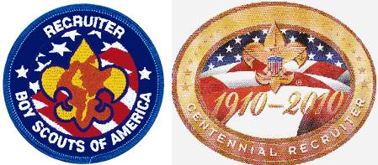
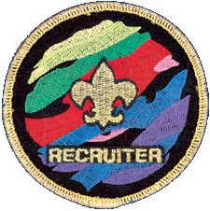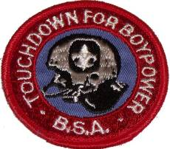

ADULT RECOGNITIONS

TORCH OF GOLD AWARD
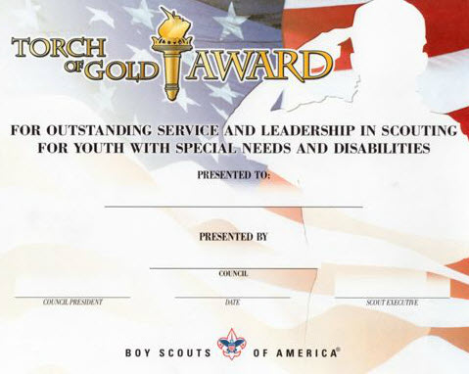
Item: 33733 at www.scoutstuff.org
The Torch of Gold is a council-level distinguished
award of the Boy Scouts of America to recognize
adults for exceptional service and leadership in
working with Scouts who have disabilities.
Guidelines
- Each council may recognize one Scouter per year with the Torch of Gold Award.
- The completed nomination form must be submitted to the council Special Needs or Disabilities Awareness committee or its designee, according to council procedures and deadline. The nomination form is available at http://www.scouting.org/filestore/pdf/512-945.pdf
- The nominee shall:
- Be currently registered with the Boy Scouts of America.
- Have at least three or more years of service in any Scouting leadership capacity related to Cub Scouts, Boy Scouts, and/or Venturers with disabilities, including educating other Scouters about disabilities and working with youth who have disabilities.
- Have completed all activities related to Scouts with disabilities on a strictly volunteer basis.
- This award shall be given only once to an individual, and is not dependent on, or to be influenced by, other awards.
- Presentation should be made at the council annual recognition dinner, district recognition dinner, or other appropriate Scouting event.
- The Scout executive must approve the recipient.
- The Torch of Gold certificate, No. 33733, is the only recognition presented for this award. The certificate is available through the Supply Group.

WOODS SERVICES AWARD
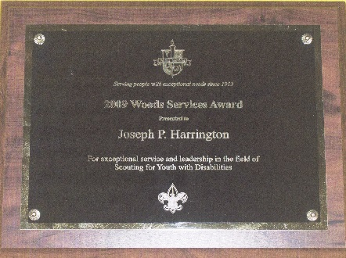
The Woods Services Award was created in 1978 in memory of Luther Wellington Lord, who served as a residential supervisor for more than 23 years at The Woods Schools. During his years of service, he founded and coordinated the BSA program at The Woods Schools. It was under Mr. Lord’s supervision that the first Eagle Scout Award for an individual with disabilities was achieved. Luther Lord was an active member of the National Advisory Committee on Scouting for the Handicapped (the predecessor to the National Disabilities Awareness Committee), and served as the course director for national workshops at Philmont, Schiff Scout Reservation, and numerous regional, area, and local courses. The Boy Scouts of America presents this prestigious award to one adult each year for his or her exceptional service to Scouts with disabilities.
Instructions and Additional Information
- The nomination form should be sent to the National Disabilities Awareness Committee, S272, Boy Scouts of America, by December 31 to be considered for the following year’s selection. One nomination per council, per year, may be submitted.
- A nominee shall
  - Be currently registered as a member of the Boy Scouts of America
  - Have three or more years of service in any Scouting capacity related to Cub Scouts, Boy Scouts, and/or Venturers with disabilities.
  - Have done all Scouting activities related to Scouts with disabilities on a strictly voluntary basis.
- The nomination form must be approved and signed by the nominee’s Scout executive. The nomination form is at: http://www.scouting.org/filestore/pdf/512-258.pdf
- One national award is granted each year.
- The award will be available for presentation by May 1 of each year. It is to be presented at a suitable national or regional meeting, with consideration given to the recipient's availability.
- The award, a handsome, engraved plaque, is provided each year by Woods Services.
- The recipient may wear the Community Organization Award square knot on his or her uniform.
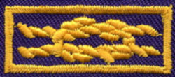

THEME RELATED STUFF
Commissioner Dave's Roundtable Prop for
The Big Race – His 2003 T-Bird!!
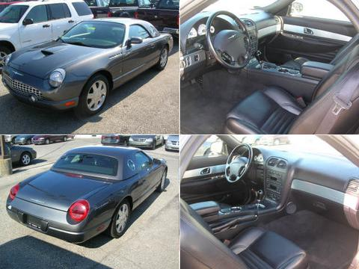
Pinewood Derby
Margaret Holcomb Belljoye
http://usscouts.org/bbugle/bb0001/index.html
This poem first appeared in Baloo's Bugle in January 2000 after Margaret Holcomb Belljoye, contacted USSSP about a Pinewood Derby poem she had written and wanted to share with other Scouters. It is with pleasure and honor that I share it with the readers of Baloo's Bugle again. CD
Each year for Christmas wrapped in shape of a box
This Cub Scout receives a gift and no it's not socks.
It is some axles and wheels, a small piece of pine
You wonder what it is that makes his eyes shine
That Cub Scout, he knows, his mind all in a whirl
These small pieces, more precious than pearls
For in his hands he is holding a dream that is due
To enter a race to be held in month, maybe two
But for this one scout, this race will be his last
For he is a Webelos, his car will have to be fast
As he turns the small piece of pine in his hand
His mind is on shapes and he starts to plan
He gathers pencils, paper and a carbon or two
Traces, erases, discards, and decides on a few
It will continue like this for a few days more
Can't make up his mind, making his brain sore
Finally, picking his pattern his relief is quite great
Then we stand by our action, it is time to create
Out come the tools, a knife ,a saw and a drill
There is nothing like it. it is such a great thrill
To have watched this young grandson we adore
Year after year, build the cars, this will be four
I can now see the wheels turning in his head
Should I design this one or that one instead
Now the pattern is chosen, he traces the shape
With pencil to carbon, then he uses his tape
Making sure the length meets what is set out
In the rules that must be met by all of the scouts
He now turns to the saw, the goggles go on
Safety comes first or rule one will be blown
With his granddad or dad standing close by
He starts the cut and the sawdust does fly
When the dust settles, he fingers the cut wood
Then lifting up his goggles and nothing could
Ever be more prideful than the grin on his face
It is just the start, preparing for one last race
He runs his hands over the shaped piece of pine
I wonder what he's thinking, I'd give a whole dime
Picking up the paper to sand the wood just right
For hours he works with it late into the night
For days and days he leaves it sitting to the side
Thinking of paint and stickers, then eyes open wide
You can see the idea in his head start to form
Man or man this one will be out of the norm
Picking up his scout knife, he carves the first line
Places for the headlights, now this will take time
He has been taught the right way to handle a blade
He carefully finishes it, the groove has been laid
The knife is then closed, so carefully put away
Now on for the fun part, Hurrah! and Hooray!
This car, his last, has been built just for speed
Down deep inside him this hunger this need
For to be Grand Champion the head of the pack
Just one memory to savor, one day looking back
Tell his sons, of long ago times and to talk about
What it was like to learn and live the life of a scout
For now the time has come to just leave it alone
It is just perfect, time to let it stand on it's own
All the work that can be done has been done
He now feels it in his heart that this is the one
His dad and granddad and he all act as one
Packed in a special box, the time has come
To submit it to be judged, then the long wait
He can't touch it again, it's now all up to fate
His car is now checked for weight and design
To see if directions were followed line by line
His weight, length and height are all just right
His car has a number, impounded for the night
None will see the cars till the Derby Day Race
Now preparations for the day pick up the pace
The leaders, parents and scouts volunteers all
Join, to ready the track, they all answer the call
Derby race day is here, he is up with the sun
Trying to remember what he might have done
To build his car so it would have more speed
It is all too late, for he has now done the deed
The large building in which the race is to be run.
Is filled with families of scouts who have done
Each one their best that they could possibly do
“Do Your Best”, is the motto, and each held it true
The excitement builds as all take their places
The anticipation the fever I see in small faces
The ceremony to honor our flag is has begun
The salute to the same all now pledge as one
The first cars now race swiftly down the track
The pace will be kept there will be no slack
Yelling and screaming and cheering, we each
Encourage our own boy a crescendo we reach
The eyes of each boy is now sparkling with zeal
Hoping against hope that he wont lose a wheel
As cars plummet down the track one last time
I look at the scoreboard the moment sublime
He's done it I scream and jump up and down
He'd won the den, the pack, now the last round
Of the District Derby which has been his dream
To be grand champion, again I start to scream
With tears in my eyes and a silly grin on my face
I hug my husband, son, everyone in the place
I turn to face my grandson blow a kiss and sigh
I give him a sign, two fingers in victory held high
It's not the trophies that he has won on this day
The accolades of what others have had to say
It's in his heart and mind that someday will rest
That as a Cub Scout, he tried and did his best.
Belljoye, June 11, 1999
Cub Scout Derbies
Grand Teton Council
Derbies of one kind or another have always been a part of Cub Scouting. As early as 1939, the BSA Supply Division listed kits for model planes, boats, and airplanes. The derbies have been viewed as a way to get parents and sons to cooperate on a project.
An early Cub Leader's Round Table contained instructions for holding a Kite Derby. Competitions included the 100 yard dash, novelty kites, altitude race, artistic kites, kite battle, and the messenger race. The BSA Supply Service offered a pamphlet entitled Kites to teach kite making.
In April of 1937, Scouters were given the directions for making the Cubmobile. The original intention for the Cubmobiles was that they be any contrivance on wheels. According to the How Book of Cubbing, "It may be drawn, pushed, or propelled by Cubs, or may be drawn by a trained animal-in fact, anything goes!" Most ended up patterned after the Soapbox Derby racers,
The first reference to the Pinewood Derby in a Scout publication was in the October, 1954 issue of Boy's Life. The June, 1955 Program Helps listed "Wheels, Wings, and Things" as a theme. The Cub Scout Program Quarterly gave instructions for running the Pack Meeting Derby. The Supply Division's catalogs had kits available for $2.75 for a package of eight. Over 15 million kits were sold during the next 20 years.
Regatta kits arrived in 1958 with kits for eight boats selling for $2.95. The rubber band driven Space Derby kits followed the start of the space race in 1961. Another derby was made available during the seventies; the Rocket Derby. The kits were later dropped from the Supply Division catalog.
Fun Facts about Fantastic Automobiles
Alice, Golden Empire Council
- Bertha Benz was the first woman driver, driving a car designed by her husband, with the first patent for a car, on the first car trip in 1888!
- Leonardo daVinci didn’t invent the first car, but he drew designs that have been built and shown to work utilizing the differential, gear shift and direction changing gears, the jack and the use of ball bearings to move gears smoothly and prevent friction from disabling a mechanical engine. He also understood the value of inter-changeable parts long before Henry Ford!
- Headlights didn’t appear on cars until 1906 – they used kerosene. But that car had no steering wheel! The driver had only a stick or shaft to steer with!
- The first self-propelled road vehicle was a tractor for the French army built in 1769 by Nicolas-Joseph Cugnot. It had three wheels and a top speed of 2.5 miles!
- Most American auto horns beep in the key of F.
- In Singapore a new car costs only $5 to license. As the vehicle gets older, the price goes up, and once the car is 8 years old, it is no longer allowed on the streets. These rules have almost wiped out pollution from cars in that country!
- Speaking of price, between 1968 and 1978, the price of the average American car doubled!
- For every 50 miles driven in an automobile, a person has a 1 in a million chance of being killed.
- In 1905 the Bosco Company of Akron, Ohio, marketed a "collapsible Rubber Automobile Driver." It was intended to scare thieves away. Modern drivers have sometimes used a dummy to access the faster lanes reserved for cars with more passengers – and paid a hefty fine if caught!
- The beloved London taxicabs with their high roofs were originally designed to keep gentlemen from knocking off their top hats as they entered and left the vehicles.
- In 1924 a Ford automobile cost $265!!
- The first automobile race in the U.S. was held in 1895, running from Chicago to Evanston. J. Frank Duryea won at an average speed of 71.5 miles per hour.
- A plumber named David Buick actually build the first General Motors car – he also invented the process where porcelain could adhere to iron, making the white or colored bathtub possible!
- Many people had arms broken by an engine backfire while hand cranking cars to start them before 1917 and the invention of the electric starter!
- On July 11, 1903, the Ford Motor Company sold the first car to Dr. E. Pfenning for $850 cash.
- In 1950 the United States had 70 percent of all the automobiles, buses, and trucks in the entire world – today, China is fast becoming a major car user!
- To manufacture a new car approximately 148,000 liters of water are needed!
- Henry Leland introduced “parts interchangeability” to the auto industry after learning the concept working in firearms factories.
- Brothers Charles and Frank Duryea set up the first American car manufacturing company in 1893.
- By 1908, 485 different companies were building “horseless carriages.”
- Electric cars are nothing new – Robert Anderson introduced an “electric carriage” in 1832 in Scotland.
- American George Selden never manufactured the internal combustion engine he designed in 1876 – but he collected royalties on his patent until 1895.
- In 1913, Henry Ford introduced the world's first moving assembly line, which allowed the same number of workers to build many more cars – and made a car that was cheap enough for the average family to afford – it was also reliable and easy to fix.
Bizarre Driving Laws
Scouter Jim from Bountiful, Utah
Alabama
- It is illegal for a driver to be blindfolded while operating a vehicle.
- It is legal to drive the wrong way down a one-way street as long as a lantern is attached to the front of your car.
- Driving barefoot is illegal.
Alaska
- It is illegal to tie a dog to the roof of your car.
Arkansas
- It is illegal for a person to blare the horn on a vehicle at any place where cold drinks or sandwiches are served after 9 p.m.
California
- Any woman dressed in a housecoat is prohibited from driving a car.
- It is illegal in San Francisco to buff or dry your car with used underwear.
- No unoccupied vehicle may exceed 60 miles per hour.
Florida
- If an elephant is tied to a parking meter, the owner or attendant must deposit money in the meter.
Georgia
- State Assembly members are immune from being ticketed for speeding while the State Assembly is in session.
- In Marietta, Georgia, it is illegal to spit from a moving car or bus, but is okay from a moving truck.
Illinois
- In Evanston, Illinois, it is unlawful to change clothes while inside a car with the curtains drawn, except during a fire.
Kansas
- In Derby, Kansas, it is considered a misdemeanor to screech your tires while driving.
Kentucky
- If you stop for ice cream while driving, be aware that it is considered unlawful to transport an ice cream cone in your back pocket.
Massachusetts
- You will be ticketed if you drive with a gorilla in the backseat of your car.
Michigan
- If you car breaks down in Detroit and you are waiting for assistance, be aware that sitting in the middle of the street to read a newspaper is illegal.
Minnesota
- It is illegal to cross state lines, regardless if you are walking or driving, with a duck on your head. And, if you're crossing into Wisconsin, the law also applies to chickens.
- In Minnetonka, Minnesota, if you drive a truck that leaves mud, dirt, or sticky substances on any road, you will be considered a public nuisance who is harming the peace, safety, and general welfare of the town.
- You cannot ride a motorcycle without a shirt.
Montana
- In Whitehall, Montana, vehicles are prohibited from driving with ice picks attached to the wheels.
Nevada
- It is illegal to drive a camel on the highway.
New Jersey
- Drivers are required to beep their car horns before passing another vehicle.
- If convicted of driving while intoxicated, you permanently lose the option of registering for a vanity license plate.
North Carolina
- In Dunn, North Carolina, it is illegal to drive on a sidewalk.
Ohio
- In Oxford, Ohio, authorities will ticket you if you consecutively drive around the town square more than 100 times.
- Keep in mind that if your car breaks down and you phone for a cab, you will be ticketed if you opt to ride on the cab's roof.
Oklahoma
- It is considered illegal to read a comic book while driving.
Oregon
- You will be ticketed if you leave your car door open longer than is deemed necessary.
- You will be slapped with a Class A traffic violation if you use your car on an Oregon highway to prove your physical endurance.
- It is illegal to pump your own gas.
Pennsylvania
- If you spy a team of approaching horses, you are required by law to pull to the side of the road and cover your car with a blanket or dust cover that has been painted or sewn to blend into the scenery. But, if the horses react skittish to your efforts, you are then required to disassemble your car and hide the parts in the nearby underbrush.
South Carolina
- In Hilton Head, South Carolina, you cannot leave trash in your vehicle out of fear of attracting rats.
Tennessee
- It is illegal to fire a gun at any wild game other than whales from a moving car.
West Virginia
- It is perfectly legal, for road maintenance purposes, to scavenge road kill.

PINEWOOD DERBY
TIPS FOR A SUCCESSFUL PINEWOOD DERBY!
Grand Teton Council
Don't Forget The Purpose Of The Pack Meeting
Make sure you are giving out the regular awards the boys have earned that month. Some Cubmasters think that there isn't enough time on pinewood derby night but the purpose of Pack Meeting still is to recognize the boys. Awards can be done, quickly but still fun. I make a Cubmaster car, which I make slow on purpose. I build it up 2 or 3 months in advance. No one will beat my car, etc. On race day the boys have to race my car to get their award. They love it!!
Give Out The Rules
Make sure everyone knows the rules before you begin. Give out a list of rules that you want them to follow. There are length and weight rules written inside the kits but they are never looked out. Make up your own rule sheet, pass it out to all the parents and then stick to the rules.
Impound The Cars
The weekend before the pinewood derby, have the boys come and impound their car at your house. Make sure each boys car is weighed properly with the same scale. After the car is inspected and weighed in then you will keep the car and bring it to pack night. I had a big box with rags in the bottom so the boy could wrap it and place it in the box. This will eliminate the before race day craziness of weighing the cars, fixing cars, taking weight in or out. It makes it A LOT better on race day to have all that over. At the church, I lay out a big blanket on a banquet table and lay all the cars out.
Awards
I truly believe there is nothing wrong with giving out a 1st, 2nd and 3rd place winners. It is a time for the boys to learn to be a good winner or a good loser. I do believe that each boy should receive the same trophy or certificate. None of this, tiny trophy for the losers and a giant one for the 1st place winner. Make sure each and every boy gets an award. Also, I think it is important to stress good sportsmanship. I give out the best sportsmanship award last of all, as the most important and best award to receive.
Here are some suggestions: Most Attractive, Most creative, Most realistic, Best Paint Job, Most Colorful, Best Workmanship, Most Imaginative, Most Artistic, Most Unusual, Best Quality, Judge's Choice, Simply Marvelous, Best Craftmanship, Most Detailed. Sportiest, Most Original, (Avoid anything that is negative: like Junkyard Special)
Open Class Races
After the official race, I always have an open class race. I encourage the dads to make a pinewood derby car of there own along side their boy. That way hopefully the boy can actually get his hands on his car, if they are building them together step by step. It is also a lot of fun to have the boys race their dads and their moms (I always make a car of my own). You can also have older brothers bring cars from other years and race. It gets the whole family involved.
Special Certificates
Make up certificates like the following for your Pinewood Derby volunteers and attach to OREO cookies, hot wheel cars, or Gold Coin candies
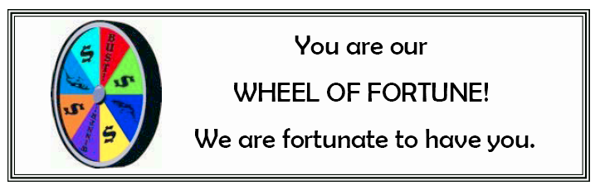
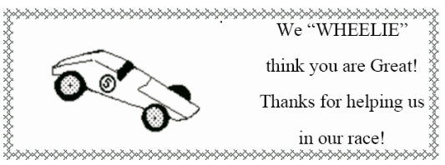
Ideas For Pack and Pack Activities:
Baltimore Area Council
- Have a Boxcar Derby
- Have a Pinewood Derby Race
- Visit a Police or Fire Station
- Show and Tell – models and miniature car collections
- Build a snowman
- Make Pine-Cone treats for the hungry birds
- Go to a local ice skating rink
- Start a collection of model or miniature cars
- Make Race-car neckerchief slides
- Make Pinewood Derby Car Display Stand
Den & Pack Meeting Activities:
Alice, Golden Empire Council
- Invite a policeman or safety expert to come talk to the Den or Pack about how to travel safely in a car.
- Sponsor a safety check with your local police department – checks could be made to assure seat belts, car seats are installed and working properly.
- Invite a mechanic to come and share basics of how a car works or some simple maintenance and safety checks
- Update the First Aid kit used for den activities and field trips – make sure you have current information and supplies that might be needed.
- Invite families to make emergency boxes for their vehicles, including items needed such as: flares, jack, battery cables, emergency air for tires, etc. Also a kit in case of accident or car breakdowns – first aid items, some hard candy, meat sticks, water and cups, blanket, first aid supplies, list of phone numbers, extra diapers or medications, rain ponchos or sweaters, small toys, games or drawing pads to keep kids occupied while they wait. The Red Cross, local government and fire department can provide brochures and information on what to have on hand and how to use it. This would be an excellent service to your pack families as we enter the season where natural disasters can impact family safety.
- Create a list of things to keep in the family car, including insurance information, flashlight and extra batteries, small tools such as screw drivers, battery cables, work gloves, etc.
- Visit a “Safety City” if there is one in your area.
- Visit a local museum devoted to cars old or new.
- Check with local car clubs, racing associations, etc. for large photos or models of cars, racing flags, pennants, to decorate your pack meeting.
ARTFUL CARS
Great Salt Lake Council
Have a car show and race. Have each boy decorate a toy car (Hot Wheel/Matchbox size). You can supply one, or he can use his own. These can be decorated at the activity or prior to it. You may also want them to make a way of displaying it, such as a cardboard platform and backdrop. Let everyone “tour” the show with 3 or 5 anonymous judges choosing cars for different categories. If desired, you can let the boys know there will be judging and what the categories are when you announce the activity. The boys should try to be creative using tacky or hot glue to attach small objects such as beads, feathers, googly eyes, pipe cleaners, sand, sequins and buttons. Remember to keep the wheels movable if racing. There are no limits on size or weight, except original size of car. Be sure to let the glue dry completely before showing, or racing the automobiles.
After the show the cars can be raced down a simple incline. The winner is the car that goes the farthest.

OTHER GREAT RACES
CUB-anapolis 400
Commissioner Dave
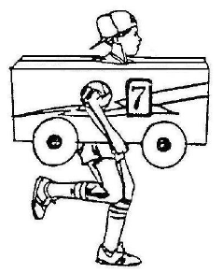
CUB-anapolis is a great fun event. We do it at my Webelos Resident camp and every year it turns out different. There is a great description of how to do it in the Cub Scout "How-To" Book on page 6-18.
The event can be run an individual basis with each Cub and his family making a car and his family being the pit crew or by Dens (how we do it in Webelos Resident Camp) with each Den making a car and the den becoming the pit crew. When done this way, be sure to rotate drivers so every boy gets a chance.
You can hold your race inside in a gym or other large room or outdoors on a field.
Some packs are requiring bicycle helmets. This is probably a good idea for safety and adds to the theme as racers wear safety helmets. And should be easy as anyone with a bicycle has to have a helmet.
A key to success is having fun pit stops.
Some ideas include -
- Clean the windshields - All drivers have goggles on and another Cub washes the goggles with a spray bottle of water (NO Soap or detergent or glass cleaner)
- Rotate tires - Cubs take off shoes and switch their socks to the other foot
- Fuel Up - Have the driver drink a specified amount of water
- Change Drivers - give every one a turn
- What can you think of doing????
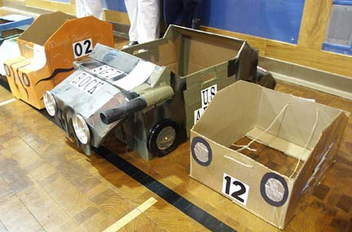
Photos from Pack 813, Dayton
CUB-anapolis 400 Hints
Pack 358, Barrington, NH
http://www.pack358.us
What does a scout need for a CUB-anapolis race?
- A Cub-anapolis Car. Cars should be made from a cardboard box. Make sure the box is not too big for the Scout. Boys need to be able to run while carrying the box.
- A pit crew (at least two people)
- A small towel or washcloth
- A pair of lace-up sneakers with socks (no Velcro or slide on)
What’s a CUB-anapolis???
- The cub carries his box and runs from start line to the finish line.
- A typical race is 3 laps.
- On each lap, the Cub will pull in for a pit stop
- On each stop, your crew will be asked to perform one of the following tasks:
Clean your windshield
Change your tires
Refuel
- After the action is complete - the cub picks up his car again and race back the finish line.
How to Build Your “Cub-anapolis” Car
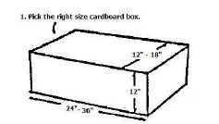
- Pick the right size cardboard box to fit the scout.
Normally a box that is 12”-18” wide, 12” high and 24”-36” long. (A copy paper box is great.)
Body of car must be constructed of cardboard.
Use a box that fits around the boy without being either too snug or too loose.
- No metal or glass materials may be used.
- No items can be hanging or dragging behind a car
- For safety reasons, cars should not have a ‘windshield’
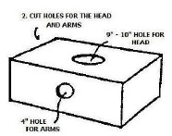
- Cut out the top and the bottom of the box so the scout can stand in the box and pick it up to his waist.
Leave about 2” of the top and bottom at each end to strengthen the box.
Cut 2 holes in the side of the car to use for carrying the car during the race.
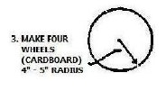
- Make 4 wheels for the car.
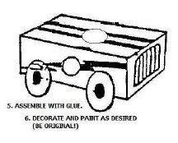
- Assemble car with glue or tape. Please assemble the car in a manner to be safe for the scout
Cut 2 holes in the side of the car to use for carrying the car during the race.
Decorate and paint the car as desired. (Be original)
Tape, tinfoil, paint, construction paper, stickers and paper plates can also be used for decoration.
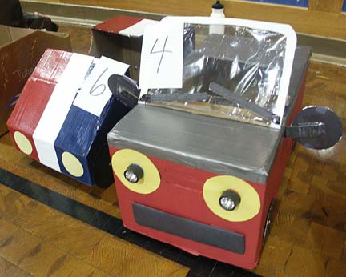
CUB-annapolis
Capital Area Council
Use a cardboard box and straps or suspenders to make a racer, as shown above. The boy provides the “wheels” to make the car go. The whole den works on the vehicle ahead of time with the fastest boy providing the “power” for the vehicle.
Of course, you don’t want to make this too easy, so you add a pit stop (See below for ideas) and GO as well as some areas of tight maneuvers, backing up and fast straight-aways. Change drivers a few times and you have an excellent race for the whole pack.
Add awards for vehicles such as Best Design, Sleekest, Most Excellent, etc.
SCENARIOS
After lap 1 – Windshield wash (wash goggles)
After lap 2 – Tire change (Remove shoes and socks, turn socks inside out, replace socks and shoes
After lap 3 – Refuel (Drink one small bottle of Root Beer)
Dens should ensure that each race car driver has the following accessories:
- Goggles for the car driver (sunglasses, safety glasses, etc) - these must be worn during the race.
- Spray bottle filled with only water (may be shared)!!
- 8 ounce Styrofoam cup and a small jug of water to fill the cup with
The RACETRACK will be laid out with orange cones in whatever pattern the leadership decides to set up...
The race format is as follows:
- START: each racer will run one lap then go to his dens pit stop area.
- 1st pit stop: the pit crew will clean the driver’s windshield (Goggles) with the water spray bottle. Once the goggles are cleaned, they must be dried too.
REMEMBER! DRIVERS ARE ONLY PERMITTED DRIVE THE CAR - They cannot do ANYTHING TO HELP THE PIT CREW!!
- Once the goggles are dried, the driver may get back into the race and complete one more lap, then pit again.
- 2nd Pit stop: The Pit crew must refuel the driver by filling the Styrofoam cup full of water and the driver must drink the ENTIRE cup (without spilling it) before entering the race again.
AGAIN, KEEP IN MIND THE DRIVER CANNOT DO ANYTHING TO HELP THE PIT CREW! THEY MUST HOLD THE CUP WHILE THE DRIVER DRINKS THE WATER!!
- Once the car is re-fueled, they may enter the race and complete another lap - then pit again.
- 3rd pit stop: The Pit crew must change the tires on the car!! To do this, the pit crew must remove the driver’s shoes - then remove his socks - flip the socks inside out – put the socks and shoes back onto the driver (shoes must be tied !!) and only then may the driver enter the race again.
- After completing the third pit stop, make one more lap then return to your pit area!!
- Once every den has completed the required pit stops, we will run the races again if there is anyone who was not afforded the chance to play - or if we just want to run again for the fun of it!!!
- Lastly, there are only winners in this race - participation awards will be given to everyone who plays.

From Capital Area Council
I included this so you can all the directions on one page CD

Bottle Racer
Alice, Golden Empire Council
Boys could build and race bottle racers to explore a simple machine – and an old-time toy!
See directions under Webelos Scientist.
LE MOUSE 500 (Mousetrap Car)
Grand Teton Council
This is a mousetrap on wheels with built-in propulsion. Something so simple and inexpensive that every Cub Scout will want to make one.
The simplicity of this racer tires the imagination. The greatest momentum can be obtained from 2-4" diameter wheels, but the mousetrap needs to be mounted on a board to prevent wobble. Rubber bands or sandpaper can be glued on the rear wheels for traction. Wind the cord the opposite direction and you have front-wheel drive.

Directions
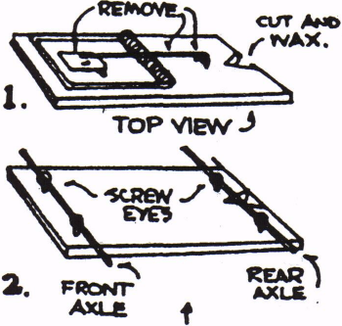
- Remove bait pan and hook arm from the mousetrap.
- Cut a 1/2" deep notch at the rear axle line for easy winding of the string. (This will be at the opposite end of the snapper, and the slot should be rounded slightly and waxed or soaped.)
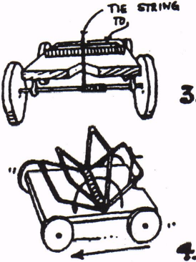
- Carefully measure 1/2" in from each end for eyelets. The wood splits easily, so drill pilot holes and screw in the eyelets carefully.
- Insert wire axles through eyelets. Coat hanger wire may be used. Sand wire if necessary for easy turning in the eyelets. Be sure to roughen the axle where the cord will be wound to give it grip.
- Make wheels from wood -1 1/4” diameter by 3/16" thick. They can be sawed from thin wood, or better, sliced from a dowel. Locate and drill center holes. The more accurate this is, the better the racer will run.
- Knot string onto snapper. Do not tie the string to the axle.
- Pull snapper back to its full extent and hold with thumb.
- Wind string onto the rear axle until tight (Best cord is nylon, as it is springy. Cut with a hot soldering iron to prevent raveling.)
- Set the racer on a rough surface (not a waxed floor) and release.
- Racer should go over 8 feet. Experiment with it and make changes until it does. Try winding the cord backwards for front wheel drive.
- You might want to mark off a board for a race track and let the boys have a race. Do not paint the track, as this will make it too slick.
Build a Clothespin Race Car
Grand Teton Council
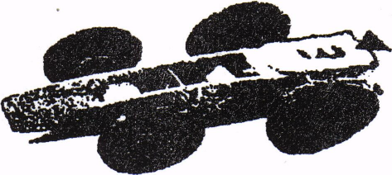
Supplies Needed:
Clothespins ( plastic or wood)
Buttons
White Glue
Twist ties
Colored Tape
Straws
Scissors
Decorations as you like
Directions:
- Thread a long twist tie through the button.
- Twist and put through a piece of straw
- Add second wheel and secure
- Trim the twist tie ends, then make another set of wheels
- Glue the front wheels in place and then the back wheels
- Wrap tape behind the rear wheels for durability
WINDRACER
Grand Teton Council
Supplies Needed:
Coat Hanger Wire, 24" long
Pliers
3 Spools
Large Cork
Thin Dowel
Thin cardboard
Hole punch
Masking Tape
Cotton thread
Directions:
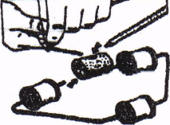
- Take the piece of thin coat hanger-type wire 24 inches long and using pliers, bend the wire as shown in the picture and put on three wood or plastic spools.
- Push the wire end into the bottom edge of a large cork, one end on each side.
- Sharpen an 8-inch thin dowel and push it into the cork so that It angles back.
- Make the sail by drawing an 8-inch-diameter circle on thin colored cardboard and cut out.
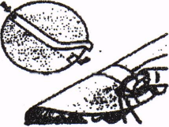
- Run masking tape across the center of the sail continuing to other side of sail. See picture above
- Make a hole 1/2" back from the edge of the card on each end with a paper punch, See picture above
- Slide the sail onto the mast and glue the mast into the hole you made in the cork.
- Secure the sail by looping cotton thread over the top of the mast and running it to the wire, tying it to the wire chassis, See picture below.
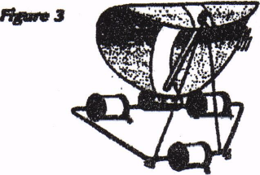
Detergent Bottle Drag Racer
Capital Area Council
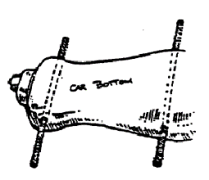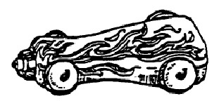
Materials:
plastic dish washing detergent bottle,
nail, hammer,
acrylic paints,
paintbrush,
4 plastic bottle tops (all the same size)
2 pipe cleaners or dowel rods.
Instructions
- First make sure your detergent bottle is washed out and dry. Put the top back on the bottle.
- Where would you like the wheels to be? It doesn’t matter which side of the bottle your use for top or bottom. Carefully punch four holes for wheels into the sides of the bottle with a nail, two on each side. Be sure to make the pairs of holes exactly across from each other.
- Now paint the racer with acrylics. You can make it any color you like and decorate it with flames, stars, racing stripes, etc. Let it dry thoroughly.
- Next use the nail to punch a hole in the center of each plastic bottle top. These will be your wheel! Push a pipe cleaner through each pair of holes, in one side and out the other. Put a bottle top “wheel” on the ends of the pipe cleaners so the wheels stay on.
Spool 4x4
Capital Area Council
You will be surprised at how much power this little “4x4” has. See how steep a hill you can make it climb. All you need to make it is an empty spool, toothpicks or matchsticks, a rubber band and a small piece of soap.
Carefully drill a hole in a small piece of the soap. Make the hole about 1/8” or a little larger, so that the rubber band will pass through it easily even when it is twisted. You must be very careful drilling the hole or you will split the soap. Push one end of the rubber band through the soap and loop it over a toothpick. Push the other end through the hole in the spool and over a small piece of a toothpick. Wind up the 4x4 by turning the long toothpick until the rubber band is tight. Place the 4x4 on the floor and watch it move along. You and your friends can have races.
Gumball Racer
Capital Area Council
Materials:
4 small gumballs
1 plastic straw
2 round toothpicks
1 spring clothespin
2 small gumballs (for chew-glue)
Instructions
- First, pop the two pieces of “chew glue” into your mouth and start chewing
- Cut two pieces of the straw, about 1” long. Using a toothpick, pike a hold all the way through the center of each gumball press slowly and carefully
- To make an axle, push a toothpick through one of the straw pieces. Poke each end through the hole in one of the gumballs and out the other side. (You might have to snip the straw pieces to make them shorter if there isn’t room for wheels)
- Clamp one axle into the front end of the clothespin Tape the other axle under the clothespin near the back
- Wet your fingers and break off a small balls of chewed gum Mold them to the ends of the axles to keep the wheels on.

THEMED ACTIVITIES
Pinewood Car Slide
Trapper Trails
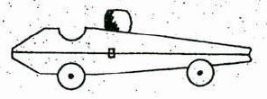
- Take apart a spring type clothespin
- Glue the flat sides together
- Cur two ¼” thick slices off a ½” diameter dowel for wheels
- Glue wheels on side toward front and back
- Glue on a colored round bead for helmeted driver’s head
- Attach ring on back – 1” length of ¾” PVC pipe works well but choice is yours
Candy Race Car
Capital Area Council
Need:
Low temp hot glue gun.
Ribbons or yarn for hanging
1 large package of gum (1 ¼” x 3” x ¾”)
4 round wrapped candies (peppermint or butterscotch)
1 shiny wrapped candy about 1 ¼” long
2 mini chocolate bars (1 ½” x 1” x 3/8”)
Instructions
- Glue the shiny candy to the front of the gum pack as a bumper
- Glue the 4 round candies on as wheels
- Glue the 1 candy bar on the back half of the car, allowing it to stick off the back by a ¼” or so.
- Glue the other candy bar across the back of that candy bar having at least ½ of it extending past the edge of the lower candy bar. Look at the illustration above, and experiment
Racing Flag Slide
Trapper Trails
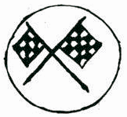
- Find some small (cupcake topper size) racing flags or make some from cardstock and attach to toothpicks
- Cut a tree cookie of appropriate diameter for your flags
- Hot glue the flags in place on the tree cookie
- Attach ring on back – 1” length of ¾” PVC pipe works well but choice is yours
Macaroni Wheel Slide
Trapper Trails
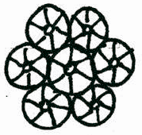
- Using wheel shaped macaroni –
- Glue wheels together to forma bigger wheel
- Spray paint
- Attach ring on back – 1” length of ¾” PVC pipe works well but choice is yours
Crazy Racing Roller
Alice, Golden Empire Council
Materials:
Colored paper
Glue
Small Marble
Scissors
Directions:
Enlarge the design below to the dimensions shown on colored paper. You can also use white paper and have the boys decorate with markers BEFORE folding up their crazy racer-Alice)
Cut out the design.
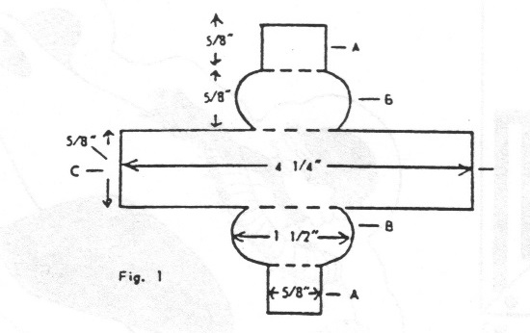
Fold Flaps A & B toward the center strip.
To form the sides, place Flaps A together and glue.
Insert the marble between the sides; then glue the ends C and D together to form a bean-shaped roller with the marble on the inside. (Fig. 2)
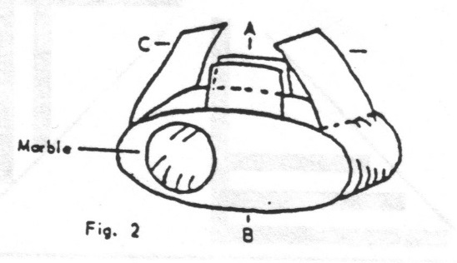
To operate your racer, release it on an inclined flat surface – it will roll down end over end with an erratic motion.
You could also race rollers against each other.
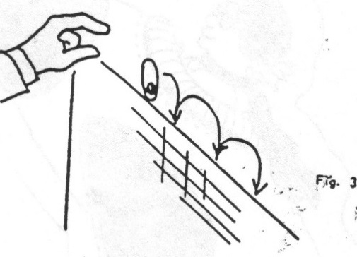
A ramp makes the perfect place to operate your racer.
This project takes about 20 minutes, and younger boys may require some help in folding and gluing.
You could also use larger marbles – just adjust the size of the paper pattern.
Your Emergency Kit on Wheels
Alice, Golden Empire Council
Every family should keep the following supplies either stored in a convenient place known to all family members. A smaller version of the Disaster Supplies kit should be kept in the trunk of the car. Keep items in air tight plastic bags. Change the stored water every six months so it stays fresh (Mark the date on your calendar, perhaps the First of January and the First of July)
Also rotate out food and replace batteries, clothes and shoes for children. Ask your pharmacist about storing prescription medications for your family (and pets)
- Water – a gallon a day per person – in a personal pack, use smaller containers that can be discarded to keep weight down
- Foods that don’t spoil, such as hard candies, meat sticks or jerky, canned juices, milk, meats, fruits and veggies, dried fruits, high energy foods such as granola bars, trail mix, special food supplies for infants, elderly or those on special diets
- First Aid kit – it should include sterile adhesive bandages in various sizes, 2” and 4” gauze pads, triangular bandages, roller bandages, small scissors, tweezers, needle and thread, moistened towelettes, antiseptic in disposable packages, tube of petroleum jelly, safety pins, soap, latex gloves, sunscreen, aspirin or non-aspirin pain reliever, anti-diarrhea medication, antacid, laxative, activated charcoal
- Tools: Mess kit, emergency preparedness manual, battery operated radio and flashlight with extra batteries, cash and change, manual can opener, utility knife, pliers, tape, compass, matches in a waterproof container, aluminum foil, flares, paper, pencil, shut off wrench for household gas and water, WHISTLE, map of area, plastic sheeting or black garbage bags, soap, personal hygiene supplies
- Clothing: Study pair of shoes, rain gear, space blanket, hat and gloves, sunglasses, thermal underwear in cold climates, extra outerwear if needed, change of socks
- Important telephone numbers and family records.
- Also keep special documents in an off-site location such as a safety deposit box or in a water/fire proof container: Insurance policies, deeds, stocks & bonds, passports, social security cards, immunization records, band and credit card numbers, inventory of household goods, important family records, such as birth, marriage, death certificates.

THEME & PACK MEETING IDEAS

GATHERING ACTIVITIES
Note on Word Searches, Word Games, Mazes and such – In order to make these items fit in the two column format of Baloo’s Bugle they are shrunk to a width of about 3 inches. Your Cubs probably need bigger pictures. You can get these by copying and pasting the picture from the Word version or clipping the picture in the Adobe (.pdf) version and then enlarging to page width. CD
Road Sign Game
Grand Teton Council
Road signs like these are important to drivers, Can you think of some games that can be played to help you learn the signs?? Or maybe have your Cubs create a game or three??
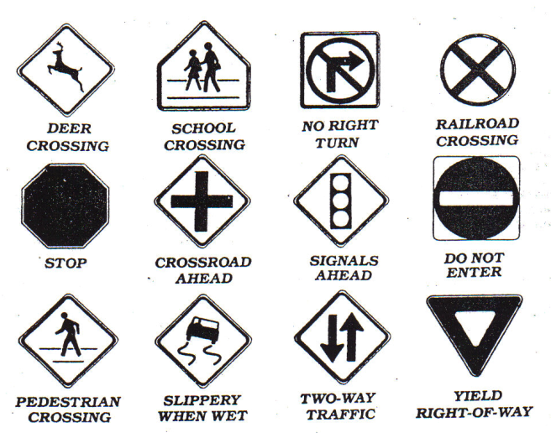
HHHMMmmmmm - this looks like the start of a BINGO board to me Just add in a few more signs and produce some cards with the signs in different orders. CD
How about Road Sign Dominoes for gathering?
Hide the signs around your meeting area and then have the boys find them and mark them off on a card.
What else can you think of creating?? Please send me a note about what you created. Thanks CD
Do You Know Cars?
Grand Teton Council
Each of the definitions below describes a car. Can you name them?
(You may need your parents' help, some of these are no longer manufactured!! CD)
- Our 16th President?
- River in New York?
- First Colony in New England
- Indian Chief
- Theater in which Lincoln was shot
- A spotted horse
- A hawk
- A motherless calf
- A wild horse
- One who travel and finds new things
Answers
1. Lincoln; 2. Hudson; 3. Plymouth; 4. Pontiac; 5. Ford; 6. Pinto; 7. Falcon; 8. Maverick; 9. Mustang; 10. Explorer
Transportation Quiz
Grand Teton Council
- A form a transportation that does not run on wheels is_____.
Skateboard Snow-mobile
Blade skates Tank
- The inventor of the wheel is unknown, but the first record of a wheeled vehicle goes back 5,000 years to ancient ______.
Babylonia Sumer
Egypt Greece
- The wheel is a form of a simple machine called the______.
Pulley Wedge
Screw Lever
- The earliest wheels were made of ______.
Joined wood slabs Bronze
Chiseled stone Iron
- The first important improvement in construction was the ______ wheel.
Wire Disk
Welded Spoked
- A major improvement in the wooden wheel was _______
An iron rim Harder wood
Flat area elimination Axle lubrication
- Starting with the 13th century, a person who made and repaired wheels was called a _________
Wheelwright Wheelie
Wheeler-dealer Wheelsman
- Around 1830, a new kind of wheeled vehicle began to appear, the ________.
Steamboat Stanley steamer
Shaftmobile Steam locomotive
Answers: (1) Snowmobile (2) Sumer (3) Lever (4) Joined wood slabs (5) Spoked (6) An iron rim (7) Wheelwright
(8) Steam locomotive

OPENING CEREMONIES
Car Show
Capital Area Council
Have 7 boys hold up the letters to spell, “CARSHOW.”
The fronts should have the letter and an appropriate picture.
The back (toward the cub) should have his part in LARGE letters.
One at a time, in order, have them read their part.
- C – Cub Scouts
- A – Are
- R – Ready
- S – to Show
- H – How
- O – Our Cars Go!
- W – Welcome. Please join me in the Scout Law.
Destination Cub Land
Capital Area Council
People: 6 Cubs with speaking parts and two Cubs holding the bus
Props: Large cut out cardboard bus with open windows or windows set as flaps from which a Cub can stick out his head
Set Up: Have two Cubs walk onto the stage carrying a cardboard cut out of a bus.
Have the 6 Cubs with speaking parts walking along on the side of the bus away from the audience.
As their turns occur the Cubs stick their heads out of the windows
- Ladies and gentlemen, the destination of this bus is Cub Land. It’s an attraction which offers more than Disneyland, Kings Island, and television combined.
- When you get to Cub Land, you will find fun and crafts projects to make
- You’ll find games and songs.
- Cub Land has great treats such as weekly den meetings and trips.
- Each month there is fun filled pack meetings with awards, skits, and songs.
- Webelos Scouts in Cub Land work on exciting Activity Pins and visit Boy Scout Troops.
(Proceed with a patriotic ceremony).
Pinewood Derby Opening
Capital Area Council
With a little modification, this would be a great Cubmaster's Minute for closing. CD
If you take a moment tonight to contemplate these cars, you will realize that an awful lot of painstaking work went into each one. There is much creativity and ingenuity represented here. I don't know, but I imagine that each car was designed to be the fastest. Of course, not all cars will win. As we begin our pack meeting, keep in mind that in Cub Scouting, as in life, the victors are those who put forth earnest effort. As a great marathon runner from Kenya, a country in Africa, once said "To win is to finish. To finish is to win." Please join me in the Pledge of Allegiance.
A History of Transportation
Capital Area Council
Materials: Narrator and 6 boys with a model or picture of the following: Foot, wheel, boat, engine, airplane and rocket.
- (foot) Man learned to get from place to place, running set a faster pace.
- (wheel) Then he invented the wheel to show how much further he could go.
- (boat) The boat helped us carry more. Now we travel from shore to shore.
- (engine) Engines helped us travel far. Almost everyone owns a car.
- (airplane) On airplanes we travel fast. The jet age has arrived at last.
- (rocket) Rockets fired into space, have taken us past the moon’s face.
Narrator: Transportation has changed our lives and so have the vehicles used. These vehicles play an important part in our lives, either taking us places or bringing us goods and services. Cub Scouting is also a vehicle. It takes us places by inspiring us to look for new adventure outside our homes. And just as cars and engines need fuel to go, so do we. We need new ideas, new incentives, and new opportunities. Trains, planes, buses and ships need crews to keep them going. We do to. We need our parents and leaders to work together to keep the dens and pack going. I’m glad you are on board. We have a wonderful ride in store for you.
Pinewood Derby Opening
Capital Area Council
Have 8 boys hold up the letters to spell, “PINEWOOD.”
The front (toward audience) should have the letter and an appropriate picture.
The back (toward the cub) should have his part in LARGE letters.
One at a time, in order, have them read their part.
- P A Pinewood Derby is fun for all,
But the whole family must answer the call.
- I I will enter the competition real soon
To win or lose or whatever my doom.
- N Neatly I painted my car with dad's expert help,
But please let me run it all by myself.
- E Excitement runs all though the night,
No matter who wins, it will be alright.
- W We would all like to come in first,
But if not, our bubble wouldn't burst.
- O On with the races, don't hesitate,
For this Pinewood Derby can't wait.
- O Open the gates, down the track; then we can rest.
For, being Cub Scouts, we've done our best.
- D Don't mind tonight, where your car places;
Cub Scouting will help you through all life's races.
Things That Go
Grand Teton Council
Cub Scouts line up and hold their posters up as indicated below. On the front (facing audience) is the appropriate picture. On the back in LARGE print is the Cub's part.
- (word "GO") Wheels, wings, and rudders make many things go, All invented by men I'm sure you all know.
- (Model-T Ford) Henry Ford was an important man, for he helped invent n car, He made it in mass production, and made it to go long and far.
- (Spirit of St. Louis plane}"'Lindberg was a man whom we've all read about, He helped build a plane that made the world all shout.
- (Steamship) Robert Fulton did his part in making something that would go, The steamship made him famous, about steam he sure did know.
- (Steam Engine) James Watt, too, became famous, for something that would go, His improvements on the steam engine, year after year did grow.
- (Large wheel with the word "THANKS" for spokes) So you see men such as these, make our country grow, And we're thankful to them, for inventing things that go.
- (U.S. map) So, as we're thinking about the men who have made our nation go, Let us now salute the flag, ever thankful for all that we know.
- Will the audience please rise. Those in uniform, salute. Those not in uniform, place your hand over your heart. Please join me in the Pledge of Allegiance.
Wheels Opening
Grand Teton Council
Props: Each Cub has appropriate clothes or gear to illustrate his line.
Den Chief: There are a lot of ways to have fun with wheels. Let's see a few in action:
- I have fun riding my bicycle.
- I like to go rollerblading.
- Trains are my thing.
- A go-cart is the vehicle for me.
- Riding cross country in a truck is my type of fun.
Den Chief: As you can see there are many ways for Cub Scouts to have fun with things that have wheels. Trains and trucks are more than just fun, though. They are all important in the development of our country. Let's stand and honor their inventors as we say the Pledge of Allegiance.
SPORTSMANSHIP
Baltimore Area Council
Equipment: Cards with letters spelling S-P-O-R-T-S-M-A-N-S-H-I-P on the front and the Cubs' parts on the back in LARGE print.
CUBMASTER: Tonight we will have our Pinewood Derby. Will the boys who were asked to help, please come forward? (Boys hold up letters and explain what each letter stands for.)
- S Smile, even if you hurt inside
- P Plan to have a good time
- O Only use kind words
- R Respect the feelings of other Cub Scouts
- T Try your best
- S Speak positively of others
- M Master the art of self-control
- A Anger has no place in our meeting
- N No pouting
- S Success in “doing your best” is possible for every Cub Scout
- H Hush those words of bragging
- I Inappropriate comments and actions are not welcome
- P Participate in the derby for FUN!
CM: Let’s remember the word SPORTSMANSHIP throughout our Pinewood Derby tonight. Please stand and repeat the Pledge of Allegiance.
Cars & Wheels
Great Salt Lake Council
Welcome to our Pack Meeting. Our theme is Cub Scout Car Show and probably just about all of you arrived on some sort of wheels. Wheels have given us a great freedom to move about our neighborhood, our town, our state, and this great country of ours. However, with that freedom comes an equal responsibility. We have to use our wheels safely. Car wheels, bicycle wheels, scooter wheels, skateboard wheels: all come with different responsibilities and safety rules. Car drivers should obey the speed limit. Bike riders need to obey road regulations when riding, and pedestrian regulations when walking their bikes.
In the same manner, the Declaration of Independence and the Constitution give all citizens certain rights, but with those rights, come responsibilities. Let’s all stand and say the pledge to the flag of our great nation.
PIECE OF WOOD
Baltimore Area Council
Equipment: Piece of wood, item carved out of wood
CUBMASTER: (holding up piece of wood) This is a plain piece of wood, but with imagination we can make many things from it. This is also true of a Cub Scout. From the beginning, you learn many skills in Cub Scouting that will make you a better person.
ASSISTANT CM: (holding up item carved out of wood) This is carved out of a plain piece of wood to become something beautiful. We hope to carve a boy into an adult who is a responsible citizen. You help us to this by learning about citizenship, love of country, and love of God as you advance through each rank.
CUBMASTER: Please stand and say the Pledge of Allegiance with me.

AUDIENCE PARTICIPATIONS
Trouble with the Car
A Mad Libs Reading
Capital Area Council
30 cards with the following words written on them are shuffled then placed face down on the head table. Cubs line up to pick a card and read it as the Narrator reads the story and pauses for an answer. Cards that are used are kept by the leader, not to be used again.
A Den Leader A Cub Scout A Neckerchief
A Roundtable An Adventure A Cubmaster
A Webelos Leader A Year Pin A Pack Meeting
An Elective An Arrow A Patch
A Uniform A Skit A Craft
A Game A Ceremony A Webelos
A Wolf A Bear A KISMIF
A Song A Den A Knot
An Oath An Akela A Banquet
A Pow Wow A Pack A Council
An alternate maybe to randomly assign numbers and have the people read their cards in numerical order.
Once upon a time, my assistant Cub Leader and I decided to drive out of town with our den for a picnic. We loaded a basket with ________, ________, and _______ and other tasty things. Then we drove off with our lunch in an old car that belonged to a friend. The cap on the radiator was decorated with _______ and holes in the roof had been patched with ______ and _____.
As we drive along, my assistant leader pointed to the side of the road. “Oh, look at that bush with _____ and_____ growing on it. Let’s stop here,” she said. We carried the basket to some shade cast by _____ and spread out _____ to sit upon. Nearby, _____ sang gaily in a tree and some low bushes had _____ and _____ growing upon them. Our den was having a wonderful time. “There’s nothing as delicious as _____ with mustard and relish,” said our cubs. “Yes,” I sighed. “However, it is getting late. Maybe we’d best start for home now.”
But our car refused to go. The motor made a noise like _____ and then stopped. “Oh dear,” said our leader, looking under the hood. “I think I see _____ and _____ caught in the gears.” “Impossible,” I said. Are you sure the tank isn’t empty? Are you sure you put in enough ______ before we left home?” “Of course I did,” said our leader. “It must be the wheels. We’ll jack them up with _____ and _____ and then replace them with _____.” Our leader covered her dress with _____ and took _____ to loosen the bolts.
Just then a former drove up and asked if he could help us. “Looks like _____ in the engine,” he said, tightening a bolt with _____. Then he stepped back and the car started. “I just connected _____ to _____, which had rattled loose.” We gave him the rest of our _____ and _____ to show our appreciation and drive happily home again.
The Big Race (Audience Participation)
Grand Teton Council
Narrator reads the following like a radio announcer with a lot of enthusiasm!
Divide audience into four groups. Assign each a word and a response they are to say when that word is read. Practice as you make assignments.
WHITE = Whiz!
RED = Zoom!
YELLOW= Zip!
BLUE = Ca-Chunk!
TIE = ALL STAND
AND CHEER
The cars are ready.
The flag us up.
The race is set to go.
The flag goes down,
The cars are off...
They're running toe to toe!
The WHITE car is ahead.
The RED car goes by.
Here comes the YELLOW car now.
Here comes another one - it's BLUE.
Whew, it sounds bad, wow!!
The last lap now.
The RED car is leading,
The YELLOW car and WHITE car are close behind.
I'm looking hard — I see the BLUE car.
So far back, it's hard to find!
The finish line is just ahead.
That BLUE car is coming up fast,
I can't tell why ...
The crowds on its feet...
They're yelling -
The WHITE car, the RED car,
The YELLOW car, and the BLUE car,
HAVE ALL FINISHED IN A TIE!!
The Big Wheel
Divide the audience into four groups assign each group a word and a response when that word is read. Practice the responses as you make assignments.
Big Wheel= Spin, spin
Canoe= Paddle, paddle
Airplanes= Zooooom
Cars= Rattle, rattle, bang, bang
Caution - There are a lot more Big Wheel(s) in this than the other parts. Maybe you would want to make it that ALL respond when Big Wheel(s) is read. CD
Man has invented may different things which go and have provided him with transportation down through the years. The Indian made his CANOE which took him from place to place and served his purpose well. Men like Henry Ford invented CARS which today are the most popular type of transportation. There were men like the Wright Brothers who pioneered the invention of the AIRPLANE. And then there is a group of people called the BIG WHEELS who really don't go any place or do anything, but they like to feel important.
This story is about one of those BIG WHEELS who just sat and spun his wheels and felt so important while he was doing nothing at all. Everyone around him was working on new and better types of CANOES, designing new and more efficient CARS, and designing and testing new and faster AIRPLANES. But our BIG WHEEL just sat around feeling important, not doing anything to help anybody, while everyone else was doing the work.
Somehow he always seemed to get by and fool people into thinking that he was important because everyone around him was making progress. The BIG WHEELS depended on their brains and energy to make him look good. Finally, one day something happened that changed things overnight for the BIG WHEELS.
Everyone who had been working on the CANOES, the CARS, and the AIRPLANES decided it was time to teach the BIG WHEEL a lesson. They were tired of him doing nothing except acting important. So they all became very busy and didn't pay any attention to him. When something came up, the BIG WHEEL found he couldn't rely on the others to answer questions and make him look important. Finally, the BIG WHEEL realized that he could not accomplish anything without help from others. He realized he was making no contribution to the world at all. He was just sitting there spinning his wheels while the others accomplished a lot of CANOES, CARS, and AIRPLANES. BIG WHEEL felt very bad.
It was a terrible feeling when BIG WHEEL finally realized something he should have known all along. If you're going to get any place in this world, you can't expect other people to do all the work. You must learn to do your part and drive your own CAR, fly your own AIRPLANE, and paddle your own CANOE.
Go-Cart Derby
Santa Clara County Council
Divide audience into three parts. Assign each group a phrase and an action to do when they hear that phrase. Practice as you make assignments.
DOWN THE HILL “Zoo-oo-oo-mmmmmmm”
THE STRAIGHT AWAY “Swooo-oo-sshhh”
AROUND THE CORNER “Zip-zip-zip”
In a small town in the mid-west every year, there was held a big go-cart derby for all the boys in the town. This event was planned for many months in advance and was looked forward to with much anticipation by all the boys. The boys and their parents worked for months on building go-carts that would race DOWN THE HILL coast beautifully on THE STRAIGHT AWAY and go AROUND THE CORNER like winners. Each family worked hard to see if theirs could be the top winner in the derby. All over town, you could see the go-carts being tested DOWN THE HILL, THE STRAIGHT AWAY and AROUND THE CORNER.
One day, as they were making their test runs before the big race, one little boy named Johnny discovered that if he went DOWN THE HILL, AROUND THE CORNER , he would run farther THE STRAIGHT AWAY before his cart came to a stop. He had found the ideal spot for the race. After trying it several times, he hurried to tell some of the parents about this spot, hoping that they would hold the Derby there this year.
Several parents came out and watched Johnny’s go-cart go DOWN THE HILL, AROUND THE CORNER and on THE STRAIGHT AWAY. They agreed that this would be a good spot to hold the race, except that Johnny had overlooked one thing – the go-carts were fine going DOWN THE HILL and AROUND THE CORNER, but it was when they came to a stop on THE STRAIGHT AWAY that they had problems. You see, they came to a stop right in the middle of a drive-in restaurant.
The parents got together and decided to talk to the restaurant owner. As a result, the owner agreed to close his restaurant during the Derby race and the whole town turned out to watch the go-carts race DOWN THE HILL, AROUND THE CORNER and into THE STRAIGHT AWAY. What a spectacular race it was!
After the race was over, everyone decided that, since the restaurant owner had been so generous to close his restaurant during the race that they would all buy their dinner there that night. After all, driving those go-carts DOWN THE HILL, AROUND THE CORNER and into THE STRAIGHT AWAY had made all the boys very hungry, and the shouting and cheering done by the parents had helped them work up a good appetite, too. The restaurant owner was happy because he sold more hamburgers than he had ever sold in one day.
An agreement was made with the restaurant owner that every year they would hold their go-cart derby in that same spot, with the carts racing DOWN THE HILL, AROUND THE CORNER and into THE STRAIGHT AWAY to the drive-in restaurant. They would all celebrate afterwards and buy those delicious hamburgers. So, you see, kindness and consideration to others can make things go better for everyone.
The New Car
Santa Clara County Council
Tonight I’m going to read a little story about a couple that go shopping for a new car. But the story is really rather dull. I’d like you to help me make the story livelier by joining in when I read certain words. Whenever I say these key words, please follow these instructions; it’ll help the story a lot!
- If you have blue eyes, whenever you hear the word BLUE pat the top of your head.
- If you have brown eyes, whenever you hear the word BROWN pat the top of your head.
- If you hear the word LEFT and you’re left-handed, clap your hands.
- If you’re right-handed, clap when you hear RIGHT.
- If you’re under 20, stomp your feet when you hear the word NEW.
- If you’re over 20, stomp your feet when you hear the word OLD.
- If you’re a male, stand up when you hear MAN.
- If you’re a female, stand up when you hear WOMAN.
At this point the Narrator should practice with the audience, calling out the cue words having them respond with the appropriate action. The Narrator begins the story slowly and picks up speed Narrator pauses after each key word.
One day a MAN and a WOMAN went looking for a NEW car. Their OLD one, which was a muddy BROWN was not running well. It LEFT much to be desired in the way of speed and safety, and they wanted another one RIGHT away. They wanted a bright BLUE one.
As they walked into the dealership, the WOMAN noticed a BLUE sports car on the showroom floor. “Darling” she said, “Look at that lovely NEW car RIGHT over there. Wouldn’t it be perfect for us?’
“You may be RIGHT. It’s a lot better looking than our OLD BROWN buggy. Unfortunately there’s one problem. I’ve LEFT all my money at home,” said the MAN.
“You LEFT it at home?” asked the WOMAN.
“Yes, it’s RIGHT in the pocket of my NEW BROWN suit.” said the MAN.
“Your NEW BROWN suit? Why I took that suit to the cleaners just this morning and I didn’t notice any money in any of the pockets,” said the WOMAN.
“But I’m certain I LEFT my money in the inside RIGHT pocket of my NEW BROWN suit,” the MAN said as he scratched his head in wonder.
“Now wait a minute. Are you saying I’m not RIGHT? Are you saying I’m lying about this? MAN, oh MAN, oh MAN! You have a lot of nerve!” shrieked the WOMAN.
“Let’s not argue. We’re here to look at cars, and that BLUE one in the corner is a RIGHT nice model. And just think, if we buy the NEW BLUE car, we’ll never have to worry about our OLD BROWN one again!”
After looking at the price of the NEW BLUE-car, and figuring out what they could get as a trade on their OLD BROWN one, the MAN and the WOMAN decide buying a NEW car would be the RIGHT move for them. But before they LEFT the dealer, they started questioning their decision. Would they be better off with their OLD BROWN car if the NEW BLUE one didn’t run RIGHT? Or what about a NEW BROWN one? How long before they thought of the NEW car as an OLD car? And would they ever feel BLUE about trading in their BROWN auto? BLUE or BROWN, OLD or NEW, what was RIGHT and with which car did they want to be LEFT?
The MAN and the WOMAN were so confused that they decided to sell their car and buy themselves bicycles. And that’s just what they did. And they knew it was RIGHT...LEFT...RIGHT... LEFT (The narrator continues alternating between right and left until the audience realizes they are applauding the end of the story.)

ADVANCEMENT CEREMONIES
Traveling Advancement Ceremony
Grand Teton Council
I modified this a little for more cars and less other things removed arrow points and added in Adventures plus the Tiger and Webelos Ranks that were not here. I am sure with some time and thought you could do better. If you do use this and modify it, drop me a line with how you changed it. Thanks CD
Props: Large pictures/posters of cars that match the descriptions
Cubmaster: The boys in our pack have not just been spinning their wheels and not going any place. We'll see tonight how many of them are reaching their destination.
Our Bobcats have really been "wheeling along" (picture of a small economical car (Volkswagen or similar) and learning the "rules of the road." Will _________ and their parents wheel on up here and receive your Bobcat license that will keep you on the Cub Scout road? Remember to congratulate all Scouts, thank all parents, and lead a cheer
Rolling along with their adult partners (picture of a Minivan) over the open road are our Tigers. Some of them tonight are ready to pull up at the entry to races. (Have boys and their parents "come on up" to the race for their Tiger rank.)
We also have some Tigers who are still rolling along and have earned belt loops for completing Adventures. (Call boys and their parents forward.)
After all Tiger awards are presented, remember to congratulate all Scouts, thank all parents, and lead a cheer
"Chugging along"(picture of a Jeep (SUV) (Not Hummer or Land Rover)) over the mountains and through the woods are our Wolfs. Some of them tonight are ready to pull up at the top of Wolf peak. (Have boys and their parents "come on up" to Wolf peak for their Wolf rank.)
We also have some Wolfs who are still chugging along and have earned belt loops for completing Adventures. (Call boys and their parents forward.)
After all Wolf awards are presented, remember to congratulate all Scouts, thank all parents, and lead a cheer
Not to be outdone, is our Bears who are really "cruising along"(picture of a Police cruiser or luxury automobile) this month. Some have cruised right through their Bear Book and earned their Bear. Will ________ and their parents park their wheels and come up here to receive their license to continue cruising through their BEAR year?
The following boys are still cruising and earned belt loops for completing Adventures. (Call boys and parents forward.)
After all Bear awards are presented, remember to congratulate all Scouts, thank all parents, and lead a cheer
Our Webelos really "zoomed" around this month. (Picture of a sports car (Corvette)). Some have zoomed all the way to the Webelos Rank this month. Will ________ and their parents zoom up here to receive their Webelos rank.
The following Webelos are still zooming around and earned pins for their colors for completing Adventures. (Call Webelos and parents forward.)
After all Webelos awards are presented, remember to congratulate all Scouts, thank all parents, and lead a cheer
And our Arrow of Light Scouts are climbing even harder and higher (Picture of Land Rover or Hummer) and earning their Adventure pins. (Call Arrow of Light Scouts and parents forward.)
The big event that all of you boys are racing toward (Show picture of NASCAR Race Car) has been reached by a few of our Arrow of Light Scouts tonight-----that of the Arrow of Light. This is the farthest and highest that anyone can go in Cub Scouting. (Call boys and their parents forward to receive their Arrow of Light.)
After all arrow of Light awards are presented, remember to congratulate all Scouts, thank all parents, and lead a cheer

Pinewood Derby Advancement
Grand Teton Council
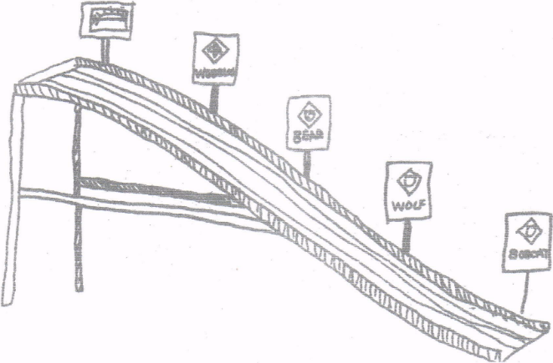
Personnel: Cubmaster, Advancing Cub Scouts and their parents
Equipment: Pinewood Derby Track, Badges of Rank or decals of them and awards to be given to the boys.
Set Up:
- Put decals or actual badges on stiff cardboard and attach to eight-inch-long sticks.
- Tape these on the track or on the side rails of the derby track in ascending order, Bobcat near the bottom, then Tiger, Wolf, Bear, Webelos, and Arrow of Light. If you have a boy graduate into a Scout Troop, have a Scout Badge at the top.
- At appropriate place on the track tape the badges and arrow points to be presented. (Fix everything ahead of time so there won’t be a boring time after the derby and before the awards.)
Cubmaster - We've all had a great time tonight watching the pinewood derby cars race down this track. They really speed downhill don’t they? Well, you can go up hill on this track too. It is a little harder, but it is worth the climb from Bobcat to Tiger to Wolf to Bear to Webelos and to Arrow of Light.
Some of our Cub Scouts have made the climb as far as Bobcat. Will (names) please come forward with your parents. When boys and parents have assembled remove their awards from the track and have the parents pin badges on. Congratulate all, thank parents. Lead cheer.
Some of our Cub Scouts have made the next level – Tiger. Will (names) please come forward with your parents. When boys and parents have assembled remove their awards from the track and have the parents pin badges on. Congratulate all Scouts, thank parents. (If your pack is awarding Belt Loops for completed Adventures at the pack meeting, present the Tiger ones now. Either before or after the rank award). Lead cheer.
Do the same for the Wolf and Bear badges and their Adventures. Congratulate all Scouts, thank parents. (If your pack is awarding Belt Loops for completed Adventures at the pack meeting, present them now. Either before or after the rank award). Lead cheer.
Have Webelos Den Leader take over for the Webelos badge and Adventures. Remember to congratulate all Scouts, thank all parents, and lead a cheer
And the Arrow of Light Den Leader for those awards. Remember to congratulate all Scouts, thank all parents, and lead a cheer
Cubmster resumes if you are graduating a boy into the troop.
Advancement Ides
Grand Teton Council
Trouble - The Cubmaster and the Assistant Cubmaster dress up as a NASCAR pit crew. Announce that they see a Cub Scout car in trouble. Drive over and pick him up and them carry him up front to give him his award. Announce that he is ready to reenter the Cub Scout race.
Remote Control - Have someone hide and drive the awards in with a remote control car. When it time to present an award it is driven on from off stage.
Here it comes! - If you are doing the Pinewood derby this month, attach awards to a Pinewood Derby car and send-it down the track to the recipient.
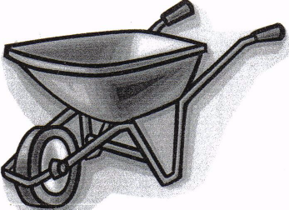
Wheely Proud - Clean out a wheelbarrow. Announce that we are "Wheely proud of our Cub Scouts that have earned awards". Go out into the audience and put them in the wheel barrow and bring them up front to award them.
Checkered Flag
Great Salt Lake Council
Prop: Checkered flag. I made one from a yard of Checkered Print bought for $2 at a material store. Attach to a pole or dowel.
Presentation:
- Cubmaster explains that it is customary and traditional for the winner of a NASCAR race to take a victory lap around the course with the flag waving then to come up to the winners’ circle with those who made it possible for the winner to win. There the winner would be awarded his trophy for the accomplishment.
- Name the first boy to receive his rank advancement.
- Give him the flag and have him run around the outside of the audience with everyone cheering and whistling.
- After he completes the lap have him bring his parents up to the winners circle to receive his award.
- Present the award.
- Lead a cheer
GRAND PRIX ADVANCEMENT CEREMONY
Baltimore Area Council
Personnel:
Cubmaster dressed as a race car driver (e.g., wearing a helmet and gloves and boots), Four adults
Equipment:
Four black-and-white checkered racing flags,
Four 3-ft. dowels,
Toy car,
Stop sign,
Wheel from toy car
Set Up:
- Fasten checkered flags to the dowels.
- Attach awards to the items listed below.
- Create other awards as needed.
- Create a tunnel for boys to walk through to receive awards by having four adults hold flags.
Awards Sayings
- CAR: “You zoomed right into first place when you earned your _____.”
- STOP SIGN: “Way to go for earning your _____. There’s no stopping now!”
- WHEEL: “You’re on a roll now. We’ll (wheel) be proud to award you your ______.”
Car Show Arrow of Light Ceremony
Scouter Jim, Great Salt Lake Council
Props: Review “How-To-Book” on Cubanapolis 400 racing, page 6-18 for instructions on assembling a car from a box. (Or read about it here in this issue of Baloo's Bugle!!)Prepare a color or emblem (meaning) for various parts of the car, such as sides, wheels, headlights and tail lights, door, steering wheel, and key. If there is more than one boy, prepare extra cars and adjust ceremony. Have 4-6 items of information obtained about the Cub(s) ahead of time to surprise them during the ceremony.
Cubmaster - Tonight, we are going to assemble an “Arrow of Light” car. The frame for the car gives it structure and stability. Compare this structure to the requirements needed for the Arrow of Light. The color of the pack “Arrow of Light” car is very important. Give the car some color either the colors/values, emblem, etc. and explain the meaning of the Arrow of Light.
There are lots of things on the inside of a car that helps it to run at high efficiency. I wonder what our “Arrow of Light” car has that helps it run at full throttle? Pull items out of box and display items highlighting the Cub.
Every car has great wheels. Wheels help the car roll down the road. Our Webelos den leader helps our “Arrow of Light” car roll down the road. We would like our den leader to come share with us an activity/service that helps our “Arrow of Light” car. Den Leader can then put on wheels.
Headlights light the way to move forward and tail lights show us where the car is ahead of us. On our “Arrow of Light” car, we would like the parents to share some service/activity that is unique about their son. Parents then put the headlights and tail lights on the car.
We have a door here. It needs to be put on. The only person who can open this “Arrow of Light” car is _____. Will Cub share a favorite experience he did to earn the Arrow of Light award and open the door? Cub then puts on door and states the Scout Oath or Law.
This car is about done. We still need two things, a steering wheel and key. On the Steering wheel have the pin and patch. The Cub then gives the pin to his mom with the “Mother’s Salute,” after which, the Father can present the award with the Cub Scout or Scout handshake. The Cub can start the car with the key by leading everyone in his favorite cheer! The boy can then take his car home.

LEADER RECOGNITION & INSTALLATION
A Den Leader's PayDay
Professor Beaver's Site
http://www.usscouts.org/profbvr/fun_awards/index.html
Write this out putting the candy (or a wrapper from the candy or a picture of the candy) where you see *)
Sometimes we were Butterfingers*

But always a Joy*

We always did Snicker*
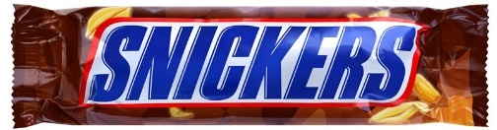
After all, we are boys.

We wanted to give you $100,000 Grand*
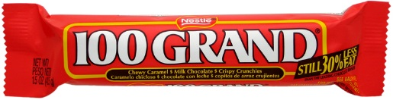
But had Zero* money
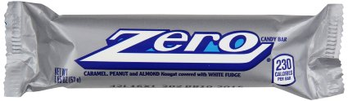
So that idea was canned.

We M & M*ade you this card
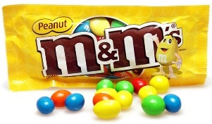
With Mounds* of love and rhyme

To thank you for giving up
so much of your time.
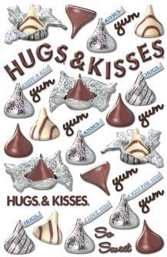
Put in a row of Hershey Hugs and Kisses and have the Cubs sign it. I used poster board for mounting the candy and a calligraphy pen for printing the poem. Prof Beaver
The ABCs of Leaders
Sam Houston Area Council
Great Cub Scout Leaders –
- Attend Roundtable
- Believe in the program
- Call to check up if you miss a den meeting
- Discover new ways to involve the Scouts
- Explore all the options
- Find time
- Give unconditionally
- Help whenever asked
- Inspire
- Juggle lots of projects
- Know their knots
- Listen
- Make extra project pieces for siblings
- Notice wonderful things about their Cub Scouts
- Offer support
- Pray
- Quote Lord Baden-Powell
- Reap the rewards of Cub Scout smiles
- Sing!
- Tell their Scouts – “great job!”
- Understand that life happens
- Value the Aims of Scouting
- Wake up in sleeping bags
- X-amine all material for appropriateness
- Yell cheers during pack meetings
- Have a Zany disposition
Awards from the Heart
Oregon Trail Council
Everyone needs a pat on the back to feel appreciated! These awards are quick and easy. Remember to award den chiefs, pack leaders, and parents, too. Be sure to mention specifically what the person is being recognized for.
Monu-MINT-al Award
Attach a mint to a note or certificate stating that the person has made a monu-mint-al contribution to Scouting.
We Are Not STRETCHING It – We Appreciate You!
Mount rubber bands on foam board or mat board.
You Are Tops
Award a toy top
You Rose to the Occasion!
Award a plastic rose.
What a Catch!
Award a certificate with a fish picture or plastic fish.
You Have Been the Link to Success
Award links of a chain.
There are many lists like this on the internet -
Professor Beaver's site has lighthearted, fun award ideas
http://www.usscouts.org/profbvr/fun_awards/index.html
Try some searches - "101 ways to recognize," scout leader recognition

SONGS
Pinewood Derby Racing Song
Grand Teton Council
Tune "Take Me Out To The Ball Game"
Take me out to the pinewood,
Take me out to the crowd.
Buy me some graphite and a sanding block,
I don't care if I ever get back.
We will root root root for my racer,
If I don't win you can say.
That I cut, sanded and designed it my self
in the Cub Scout Way!
B'gosh their starting the race now,
I see my friend's in the heat
He's standing there biting his fingernails,
But I am sure that he'll never be beat!
For, We'll root root root for my den-mate,
If he doesn't win we can say.
That he cut, sanded, and designed it him self
In the Cub Scout Way!
The Scouts have declared a winner.
And I am proud to say,
My racer, it got to the end of the track.
And my den leader let me bring it back.
For a second heat in consolation.
Was my decision today.
But I cut, sanded, and designed it myself
in the Cub Scout Way!
Pinewood Derby
Grand Teton Council
Tune: I've Been Working On The Railroad
I've been working on the Derby.
Planning my race car,
All the family has been helping.
My car should be the star!
Can't you hear the crowds a cheering.
As we win the prize?
Pinewood Derby time's exciting.
For all the Cub Scout guys,
I’m a Little Piece of Tin
Wood Badge NE-IV-149 Songbook
I’m a little piece of tin,
Nobody knows where I have been.
Got four wheels and a running board.
I’m a Ford, oh! I’m a Ford!
Honk, honk, rattle, rattle, crash, beep-beep
Honk, honk, rattle, rattle, crash, beep-beep
Honk, Honk.
TRANSPORTATION SONG
Grand Teton Council
Tune: Home on the Range
Oh, give me a train, or a boat, or a plane,
that will carry us Cubs far away;
To Paris or Rome- let us wander and roam.
And find new things every day.
Relax on a trail, float over the waves all day.
Or glide through the clouds far over the crowds.
But be home before five every day.
On a broomstick we'll ride,
in a rowboat we'll glide;
Take a trip to the moon in a rocket
And our trip will be fun,
but it soon will be done.
If we happen to hit an air pocket.
Up, up and away, let us orbit the far distant sun.
Or deep on the floor of the sea let's explore.
and as Cub scout we'll wheel into fun.
Pinewood Derby Song
Grand Teton Council
Tune: De Camptown Races
Cub Scouts all join in the song,
Do-da, do-da!
Pine car track is mighty long,
Oh, do-day-day!
CHORUS:
Going to run so fast,
Going to get ahead,
All my work made a blue pine car,
Somebody made a the red.
Black cars, blue cars, green and gray,
Do-da, do-da!
Are running on the track today.
Oh, do-da-day!
CHORUS
Pine cars do have lots of class.
Do-da, Do-dah!
Even though they don't use gas,
Oh, do-da-day!
CHORUS
They're the pride of all the Dens,
Do-da, do-da!
Built by Cub Scouts and their friends,
Oh, do-da-day!
CHORUS
Let’s Go For a Ride
Great Salt Lake Council
Tune: Ten Little Indians
Come everyone lets go for a ride
Start your engines we don’t need a guide.
Just hop in the car of your choice
A Mustang, school bus, or a Rolls Royce.
Gremlin, Vespa, Cadillac
Corvette, Rabbit, horse and tack.
Minivan, Cavalier, ATV
Limousine, Neon, SUV.
A Dodge with a Hemi, ain’t that super?
Or better yet, a Mini Cooper!
Motorcycle, taxi, or Ferrari
Hop into a forklift, you won’t be sorry.
Ambulance, Porsche, El Camino
Convertible, T-bird, or a Pinto.
Big rig, Charger, or a fire truck
Perhaps a crane so you don’t get stuck.
A 1998 Honda Accord
Maybe a Jeep so you don’t get bored.
Station wagon, bicycle, or a Hummer
A caboose is the end, oh what a bummer!
The Old Camp Truck
Great Salt Lake Council
Tune: John Brown’s Body
The old camp truck has a puncture in it’s tire,
The old camp truck has a puncture in it’s tire,
The old camp truck has a puncture in it’s tire,
So we patched it up with chewing gum.
How to do this –
- Sing song through once.
- Second time – replace word truck with the action
- Third – replace truck and puncture
- Fourth – replace truck, puncture, tire
- Fifth – replace truck, puncture, tire, patched
- Final – replace truck, puncture, tire, patched, gum
Motions:
- ‘Truck’ – make a ‘brrrrmmmm’ sound as you pretend to shift into gear.
- ‘Puncture’– make a ‘ptsssss’ sound as you pretend that you are puncturing a tire with your finger
- ‘Tire’ – make a circle in front of you using both arms
- ‘Patched’ – smack your hands
- ‘Gum’ – pretend to have a wad of gum in your mouth and you reach up and pinch it between your thumb and finger and stretch it out in front of you

STUNTS AND APPLAUSES

APPLAUSES & CHEERS
Baltimore Area Council
PINEWOOD DERBY CHEER: Hold your hand over your head and bring it down as if it were a car coming down the track while saying, “Swooooooosh…..” then “Yay!”
Or from Alice, Golden Empire Council
Hold your right hand over your head and bring it down as if it were a car coming down the track, while going “Whoosh,” then “Thud” as it hits the bottom and end of the track.
Also from Alice, Golden Empire Council
Pinewood Derby Winner Cheer:
(To recognize a particular person)
Do as above, but at the end, yell out “_________ is the winner!!! (Repeat three times)
RACE CAR CHEER: Move hand forward like a race car moving down a race track and shout “V-V-R-R-o-o-o-m!”
Or shout "ZZZRRRrrrrrrOOOOOOOOOOOOMMMMMM"
Do it three times (at least!)!!
CHECKERED FLAG: Wave arm in figure 8 motions.
Great Salt Lake Council
CONSTRUCTION FLAGGER – Wave your arms and yell “Slow down!”
TRUCKER – Pretend you are driving a big rig. Reach above your head and pull the horn cord,
make a loud, deep “HONNK! HONNK!”
Trapper Trails
Pinewood Derby cheer –
Cubmaster yells, ‘Start your engines,”
Everyone places their car at the top of the ramp
(they raise their hands up in the air, fingers straight, palms down)
Then the cars go down the ramp
Everyone moves their hands in the shape of the track going “Whooooosh” all the way
It all ends as the car hits the bumper at the end
Everyone gives one big, loud clap
Harley Cheer -
Get on your motorcycle,
Kick start a couple of times saying, Vroom Vroom
Then give it the GAS and drive away.
Pop A Wheelie Cheer -
Pop wheelie leaning way back and saying, “EERRRRTTT!”
Den Yells
Grand Teton Council
Do three times, starting out softly,
and ending up really loud.
We're from Den (#)
Couldn't be prouder.
If you can't hear us,
We'll yell little louder.
Do once, LOUD!
United we stand.
Divided we fall! Den (#)
Is best of all!
Do once, LOUD!
Look out!
Here we come.
Den (#) Is on the run!
Do once, LOUD!
North, South, East or West,
Den (#) Is the best!
(LOUD, with ACTION!)
Clap your hands!
Stomp your feet!
For Den (#)
Can't be beat!

RUN-ONS
Great Salt Lake Council
- Scout 1: What words would you write on an old jalopy’s headstone?
- Scout 2: Rust in Peace!
Grand Teton Council
Joe: I saw you running along side your bike this morning.
Moe: Yes, I was late and didn’t have time to get on.
Knock, Knock.
Who’s there?
Targets.
Targets, who?
Tar gets all over my shoes when I walk down the street.
Teacher: Jimmy, your drawing of a stagecoach is very well done, but it has no wheels. What holds it up?
Jimmy: The bad guys!
A boy walks across stage carrying a car door.
He is asked why he is carrying the car door.
The boy demonstrates as he says, so that he can roll down the window when it gets hot.
- A man whose son had just passed his driving test went home on evening and found that the boy had driven slap bang into the living room.
- (Father)-How did you manage to do that?
- (son)-Quite simple, Dad. I came in through the kitchen and turned left!
- Stop! This a one way street.
- Well, I’m only going one way.
- How many elephants can you get into a small car?
- Four: Two in the front and two in the back..
- How many rhinoceroses can you get into a small car?
- None, it’s full of elephants.
- Stop! This is a one way street.
- Well, I'm only going one way.
Capital Area Council
Cub 1: Did you hear about the wooden car with the wooden wheels and the wooden engine?
Cub 2: No, I didn’t hear. What happened?
Cub 1: It wooden go!
Cub 1: I’ve come to buy a car, but I don’t remember the name. It starts with a “T”.
Cub 2: Sorry, we don’t have any cars that start with tea. All our cars run on gasoline.
Cub 1: Son, here are the keys to my magic car.
Cub 2: Is it really magic?
Cub 1: Yes, one speeding ticket and it will disappear!
Cub 1: This is a ticket for speeding.
Cub 2: Wonderful! When do I get to use it?
Cub 1: What kind of shot do you give a sick car?
Cub 2: A Fuel Injection

JOKES & RIDDLES
Tongue Twisters:
Alice, Golden Empire Council
Red Buick, blue Buick
We're real rear wheels.
Real weird rear wheels
Knife and a fork bottle and a cork
that is the way you spell New York.
Chicken in the car and the car can't go,
that is the way you spell Chicago.
The little red lorry went down Limuru road.
Limuru (Lee-moo-roo) road is a the name of a road in Kenya.
Grand Teton Council
What driver doesn’t have a license?
A screw driver.
What has a head, can’t think, but drives?
A hammer
What happened when the wheel was invented?
It caused a revolution!
What do you call a song played on car horns?
A car tune.
When is a car not a car?
When it turns into a garage.
What do you get when you cross a motorcycle and a funny story? A Yamaha ha ha ha!
Why did the Cub Scout take peanut butter bread with him in the street? He was looking for traffic jam.
Why can’t bicycles go as fast as cars?
Because they are “two” tired.
What did the jack say to the car?
“Can I give you a lift?”
What part of a car is the laziest?
The wheels. They are always tired.
What would happen if everyone bought a pink car?
We would be a pink car nation.
How do you change a duck’s tires?
With a Quacker Jack.
Alice, Golden Empire Council
What kind of car does Mickey Mouse's wife drive?
A minnie van!
Why did the new racing driver make ten pit stops during the race? He was asking for directions!
Cub #1: Our car won’t start, and my mom says there’s water in the carburetor.
Cub #2: How does she know there’s water in the carburetor?
Cub #1: Because the car is in the swimming pool

SKITS
Pinewood Derby Check In
Great Salt Lake Council
Set Up: Cub Scouts are bringing in their derby cars for their Pack meeting.
Cub #1: (to Cub #2) “Hey! That’s a nifty car! Did you make it?”
Cub #2: (to Cub #1) “Nah! My dad did! Did you make yours?”
Cub #1: (to Cub #2) “No Way! My granddad did mine!
(Cub #3 enters)Wow! Look at that one! Hey! Who made yours?”
Cub #3: (to Cubs 1&2) “Oh, Hi! Like it? My mom made mine!”
Cub #2: (Cub #5 enters) “Look at that funny one coming in! I wonder who made his, his Great-Great-Grandpa?” (Cub #4 enters)
Cub #3: (to Cub #4) “Who made your car?”
Cub #4: (to all Cubs) “I did! My dad & mom said I needed to learn to follow instructions and this was a way for me to learn!”
All Cubs: “Oh! Wow! Your car is the best!”
The Human Ford
Capital Area Council
This is one of the most laughable skits imaginable. The Cub Scouts appear on the platform and take their positions. Four of them represent the car occupants, including the driver. They arrange four chairs and seat themselves, two in front and two in back. A young man then assumes a leapfrog position in front of the chairs. He is the engine and radiator. On the top of his head he has tied a baking powder or soda can. Four others group themselves around the chairs as the wheels. They stoop and hold their ankles. An extra tire is on the back. The Ford is not ready to go.
The driver gets out, and taking hold of the extended hand of the “engine” he cranks the machine. The “engine” begins to purr in an engine fashion and then sputters out just as the driver starts to get back into the Ford. He cranks it again and then they start. The riders can inch their chairs along, the rest of the Ford moves with them.
There is hissing sounds and the back tire nearest the audience flattens out. The driver gets out, makes the people in the back seat get up, pretends to get his pump, applies it to the tire and goes through the motions of pumping air into it. The tire rises slowly as if being inflated.
The next mishap is the radiator running out of water. The driver takes off the cap (which is the baking powder/soda can) and pretends to pour in the water. They get started again (after the driver cranks ups the engine again), and shortly after they start along, there is a blow-out. Someone in the car on the side away from the audience has a tightly blown paper bag and he pops this and the front tire next to the audience flattens out. The driver gets out, mops the perspiration from his brow, and after getting imaginary tools, takes the wheel off. It is well to remember here that there are four lugs on a Ford. He then rolls the tire to the rear and gets his extra tire. Then he puts on the extra tire, putting the old one in the place at the rear.
Next a police officer riding an imaginary motorcycle and making all the accompanying noises catches up with the Ford and stops it. He pretends to take the number and the necessary information, the driver pretends to sign something and the officer rides off.
The final mishap is engine trouble. The driver gets out, lifts the hood, (the radiator’s coat) on one side, then on the other. He soon has the trouble fixed, and the Ford must be restarted by cranking the “engine” again.
Remember, each time the car stops, it must be re-started again, by the driver cranking the engine.
This skit is funniest when not a word is said.
Who Am I?
Capital Area Council
Need: 8 actors – one for the narrator and one to deliver each verse. Make a placard for each verse (small for the Cub to read) and with the famous person’s name large enough for the audience to read. (Shown here in parentheses).
After the actor has delivered his verse, and allowed a short time for the audience to guess the subject, the actor turns over the card to reveal the name on the placard.
The Narrator recites the first two verses.
No costumes or scenery are required.
Narrator:
Transportation through the years
Has changed, we are aware.
Because some men had a vision,
And were not afraid to dare.
Although we see the evidence
Of all that they have done,
Let’s see if you can guess their names
Presented, one by one.
- Until I came along and helped,
Fat boats were just a dream.
For I got rid of sails and oars;
I gave the boat its steam!
Who am I? (Robert Fulton)
- I gave o life its “ups and downs”
So many men would say
The elevator makes tall buildings
Possible today!
Who am I? (Elisha Otis)
- As people peddle down the street,
From Grannies to little tykes,
They all owe me a debt of thanks,
‘Cause I invented bikes!
Who am I? (Pierre Lallement)
- As trains crisscross the continents,
My humble head is bowed.
“Father of the locomotive” is
The name of which I’m proud!
Who am I? (George Stephenson)
- As soon as you say “airplane,”
Our names quickly come to mind:
But when we started, pilots were
Quite difficult to find!
Who are we? (Orville and Wilbur Wright)
- ‘Though I did not invent it,
I played a major part
In mass-producing autos. I’d say
I gave the car its start!
Who am I? (Henry Ford)
- I’ll have a fuel-less motor
That will hit the marketplace,
And stop pollution of all kinds
And go faster into space.
Who am I? (YOU?)
Wheels That Go
Grand Teton Council
This is a question and answer skit. Two sets of answers are given and should be used according to whether you wish the skit to be serious or silly. A Cub can read each riddle and another Cub may answer or the audience may be asked to guess the answer.
- I run on boy power. I run on the streets, never on the sidewalks. I have two wheels, spokes, and pedals. What am I?
  - A bicycle.
  - Two unicycles
- I have four wheels. I usually have an air-cooled engine. You can spot me on site. What am I?
  - A dune buggy
  - A Volkswagen that ran off the road in the desert.
- I have two wheels. I have a roll bar. My pedals are as high as the seat. I have a lot of chrome. What am I?
  - A chopper or motorcycle
  - Two souped-up unicycles.
- I have a horn. I have two bright eyes. I have four wheels. I run on the street. What am I?
  - A car.
  - A unicorn on wheels on a highway.
- My horn goes toot-toot. My engine goes choo-choo. I don't always have the same number of parts. What am I?
  - A train.
  - A Cadillac with a problem.

CLOSING CEREMONIES
Pinewood Derby Conclusion
Great Salt Lake Council
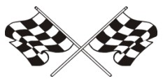
Cubmaster: At the conclusion of our Pinewood Derby, I would like to say that we were all winners here tonight.
- Dad has more respect for his son whether he was a humble winner or a graceful loser.
- Mom was proud of her son whether she gave him a hug of congratulations or comfort.
- The boys gained a better knowledge of competition; how to win, how to lose, how to be happy for a friend, who is taking home the trophy he himself wanted so badly. Cub 4: The leaders, in the pride they felt knowing that each of their boys had done their best.
- Building the car helped bring dad and son closer together.
Cubmaster: Yes, there are only winners here tonight. Thank you all for helping to make the pack go and the Cub Scouts grow. Good night and congratulations to all of us winners.
Car Fun
Grand Teton Council
Personnel: Six Cub Scouts
Equipment: Pictures of the vehicles named by the Cubs
Setting: Boys holding pictures as they recite or read lines.
- I have fun riding in my Dad's convertible on sunny days.
- It is exciting to go back country in our Jeep (or other SUV).
- Riding in our street rod in a parade is my thing.
- Taking our camper (or Recreational Vehicle) out for a week in the woods is our family's favorite vacation.
- Taking the den on a field trip in the minivan lets us watch a movie on the way.
- As you can see, there are many ways to have fun in cars, just as there are many ways to enjoy Cub Scouting.
We Are All Pinewood Derby Winners
Capital Area Council
Have the winners of the various trophies stand and be recognized one more time. Ask the boys who are not yet standing to come forward and lead the Pack in the Scout Law or Scout Oath, as they, too are winners, because they “did their best.”
RACE STEWARD’S CHEER
Baltimore Area Council
Equipment: Solid green flag and black-and-white checkered flag
- In racing this green flag means go.
- And this checkered flag means that the races for today are over. We’d like to lead you in a cheer for all the racers tonight.
- Are you ready?... Get set… Cheer!
Wave the green flag for 5 seconds while everyone cheers; then CUB #2 waves the checkered flag for everyone to stop.
Do this a few times and then wave the checkered flag a final time to indicate that the meeting is over.
CM's FINAL WORDS: Good night, everyone.
Patriotic Closing
Capital Area Council
Equipment: A small American Flag for each Cub Scout, cue cards.
Set Up – Eight Cub Scouts in uniform stand in a straight line, each holding an American Flag and their cards
*Note: make sure each Cub rehearses and knows how to pronounce the words properly.
- I am the symbol of the living America, the badge of its greatness, the emblem of its destiny.
- I am faith. It is I who keep men mindful of their priceless heritage…life, liberty, and the right to pursue happiness.
- I am hope. I represent the land of promise where in, already, man’s loftiest dreams have approached closer to realization than ever before on this earth.
- I am life. Each strand and fiber of my being is a memorial, dedicated to the sacrifices of all those strong men and steadfast women who have lived and died in the nation’s service, that it might live longer.
- I am tolerance. So long as I shall wave, all people under my protection may freely worship, think, write and speak, undaunted by the shadow of fear.
- I am justice, tempered with mercy. For I am friend to the oppressed and downtrodden of every land.
- I am a sign of the future. I wave over schools throughout the nation and in them the nation’s future is molded.
- I am the flag of the United States…the last….the best hope for peace on earth.
Travel Closing
Grand Teton Council
Props: Draw appropriate pictures or use models or photographs of the items mentioned.
- (Train engine) When engineering a project keep on the right track. This way you never will be caught slack.
- (Covered wagon) The covered wagon served folks well in its day. But don't get in a rut, you won't get far that way.
- (Automobile) If spinning your wheels causes a terrible rumble, you may not be moving -just sitting there grumbling.
All Just like the cars in a train
We're joined together as one.
We do our best to help the Pack go
While having Cub Scout fun.
And when it's time to part
and each take a separate trail,
We'll do our best for God and country.
In that we will not fail.

CUBMASTER’S MINUTES
Our Pinewood Derby
Grand Teton Council
At the conclusion of our Pinewood Derby I would like to say that we were all winners here tonight. Dad has more respect for his son whether he was a humble winner or a graceful loser. Mom was proud of her son whether she gave him a hug of congratulations or comfort. The boys gained a better knowledge of competition; how to win, how to lose, how to be happy for a friend, who is taking home the trophy he himself wanted so badly. The leaders, in the pride they felt knowing that each of their boys had done their best. Building the car helped bring dad and son closer together. No, there are only winners here tonight. Thank you all for helping to male the pack go and the Cub Scouts grow. Good night and congratulations to all of us winners.
Pinewood Closing
Grand Teton Council
Set Up - Form a circle around a the derby track
Cubmaster: "Coming together is a beginning. Keeping together is progress. Working together is success." This is a quote from the famous carmaker, Henry Ford. All of the dens come together to form the beginning of our pack. Keeping together at our monthly pack meeting is progress. Working together in Cub Scouting is surely a success story of which you can have a great part. Let's remember this in the coming months.
Please repeat with me the Scout Oath. Thanks for coming out for our Pinewood Derby tonight. We've worked together and made ever boy in Pack a winner!
Henry Ford
Alice, Golden Empire Council
Henry Ford is certainly an example of positive attitude. He built his first vehicle, called the Quadricycle in 1896, and with two other investors founded the Detroit Automobile Company in 1899. But that company folded in 1900. Then in November of 1901, along with five other investors, he started the Henry Ford Motor Company. But after only four months, he left or was forced out of that company. When he left, he took with him his tools and rights to his name. In 1903, he again started the Ford Motor Company. He continued to work on new models and techniques, even visiting other countries to see their methods. In 1909, Henry Ford finally produced the “Model T” - a basic, sturdy, inexpensive car that was reliable and available to the ordinary family. But he kept on looking for even better designs and cheaper, more efficient methods. He introduced the moving assembly line in 1913, and by 1925, his basic car reached the unbelievable low price of only $260. He had set himself the goal to produce a basic, sturdy, reliable vehicle, and in spite of the failure of his first two companies and many design and production challenges, he kept a positive attitude and met his goal. Cub Scouts, too, have goals to reach – some they choose for themselves and some are requirements for advancement. And in spite of challenges, they can learn to keep a positive attitude and keep focused on their goal. Let’s make sure that we as adults also model a positive attitude when we play and work with Cub Scouts – keep focused on your goal!
Tires
Capital Area Council
Hold up a tire advertisement. Cub Scouts, tire manufacturers are constantly working to make a better tire; one that can withstand the pounding and abuse that high-speed driving demands. In other words, a tire that “can take it”. Like the tire, you and I are put to the test every day. When things are going along smoothly, it’s not hard to get along. The real test is how we’ll do when the going gets rough; when things do not turn out the way we want them to. At times like these, the Scout Oath and Law can help you carry on with the right attitude and do your share without grumbling or griping. It will help you meet the test. Can you take it?
Models for the Future
Grand Teton Council
The Cubmaster shows a model of a futuristic car and says: Cub Scouts, here is a great looking car. It is the builder's vision of what cars may look like in the future. We can't be sure that he's right. But we can be sure that the world is going to need good men in the future. And we can be sure that we will all be good men if we remember to follow the Scout Law and Scout Oath. Let's remember that as we stand and repeat the Scout Law (or Scout Oath). (Leads audience in the Scout Law (or Scout Oath).
YOU HAVE A CHIOCE:
Baltimore Area Council
You have a choice.
You can be pleasant or unpleasant.
Which do you choose?
You can be grouchy and grumpy
or you can be happy and cheerful.
Which would you rather be?
It is up to you.
Tonight, we’re all winners.
We had fun and enjoyed each other’s company.
Let’s take that warm feeling of friendship home and keep it close to our hearts until our meeting next month!
Keeping Fit
Grand Teton Council
Cub Scouts, I hold in my hand a pocketknife. This is a valuable tool because it can be used for many useful things. (I used this one to help carve my son's Pinewood Derby car for tonight's race.) It is a dependable tool as long as the blade is kept sharp and free from rust and the working parts are in good condition. But, if it is neglected and becomes dull and rusty, it can be a dangerous tool.
The same principle can be applied to ourselves. We have a body, which when kept in good condition, will serve us well. If we get plenty of exercise, eat the proper foods, and have good health habits, we will be able to enjoy to the fullest the things we do. But if we fail to take care of ourselves, we can become rusty and dull like the neglected knife. Do your best to keep fit!

CUB GRUB
Cub Grub Cookbook
This is a really great cookbook for Cubs -
http://balboaoaks.bsa-la.org/download/blog/Cub%20Grub%20Cookbook.pdf -
You can save a copy on your PC by selecting
File, Save As... in your web browser's menu bar.
Twinkie School Bus
Great Salt Lake Council
Ingredients:
1 Twinkie
4 cookie crisp cereal pieces
1/2 vanilla wafer
2 mini marshmallows
2 red hots
Frosting (for glue)
Directions:
- Place Twinkie in the center of a small paper plate.
- Using the frosting “glue”
  - The cookie crisp cereal pieces to the Twinkie for wheels,
  - The vanilla wafer for the steering wheel,
  - The marshmallows for headlights placing a red hot in the center of each marshmallow to complete to lights.
“Wheelie Cookies”
Alice, Golden Empire Council
Ingredients:
1-1/2 cup all purpose flour
½ cup softened margarine or butter
¼ teaspoon of powdered sugar
½ teaspoon of baking powder
2 Tablespoons of milk
1 cup of pie filling or jam
Directions:
- Pre-heat the oven to 375 degrees.
- Mix flour, butter or margarine, powdered sugar, baking powder and a little milk. (Only enough for the dough to form – if the dough seems dry, mix in 1 teaspoon of milk at a time)
- Divide the dough into six equal parts.
- Shape each part into a ball, place on an ungreased cookie sheet and flatten slightly.
- Make an indentation about 1-3/4” across and ¾” deep in the center of each cookie – I use my finger or thumb.
- Fill each indentation with about 2 Tablespoons of either pie filling or jam.
- Bake until the edges begin to brown, about 20-25 minutes.
- This recipe makes 6 “Wheelies” – easy to double or even triple!
Pinewood Derby Celery Racers
Great Salt Lake Council
Ingredients:
Celery
Canned Cheese
Carrots
Raisins
Toothpicks
Directions:
- Cut celery into 6” lengths.
- Slice carrots in 1/8” thick pieces.
- Pile cheese into center of the celery and
- Top of with a raisin for the drivers head.
- At each end of the celery stick use a toothpick as an axle and wheels.
You can use Peanut Butter instead of Canned Cheese if desired.
Snowball VW Bug Car
Great Salt Lake Council
Using the same method as above using Snowballs instead of Twinkies.
Cookie Wheels
Grand Teton Council
Ingredients:
Cookies (any small kind the size of Oreos)
prepared frosting
colored sprinkles or mini chocolate chips
Directions
- Sandwich two cookies together using frosting as glue.
- Frost the edges of the "wheel" and
- Roll in sprinkles or mini chocolate chips.
Speedy Donuts
Grand Teton Council
These were always a favorite of my troop when we went camping especially if the Webelos were along CD
Ingredients:
1 pkg. ready to bake biscuits
1 c. oil
Sugar & cinnamon mixed in a brown paper bag
Directions
- Separate biscuits and cut a hole in center (or pull apart with fingers to form a ring).
A two liter soda bottle top makes a great hole cutter CD
The following two steps are to be done by adults only
or maybe an older Den Chief
- Drop in hot oil and
- Turn to brown on both sides and remove from oil.
- Toss in the sugar and cinnamon mixture.
- They are ready to eat!!
Homemade Bike Energy Bar
Grand Teton Council
Ingredients:
1/4 cup butter, melted or oil
8 large egg whites, beaten
¾ cup whole-wheat flour
1/4 cup wheat germ
1/2 teaspoon baking powder
1/2 cup nonfat dry milk powder
3/4 cup rolled oats
1 teaspoon salt
3/4 cup brown sugar
2 cups chopped dried fruit
2 1/2 cups nuts, chopped
3/4 cup chocolate chips (optional)
1/4 cup sesame seeds
Directions
- Preheat oven to 350 degrees.
- Grease a 9x13 pan. Beat together eggs and oil.
- Sift together dry ingredients except fruit.
- Add flour to eggs, combine,
- Then stir in fruit, nuts, and chips.
- Spread evenly in pan,
- Bake 30 minutes, they are still soft when done.
- Cool, cut into 24 pieces, wrap in foil and freeze.
Frozen Wheels
Grand Teton Council
Ingredients:
Chocolate chip cookies
Chocolate or vanilla ice cream, softened
Colored sprinkles 01 mini chocolate chips
Directions
- Create a wheel by sandwiching ice cream between two cookies.
- Roll the edges of the "wheel" in colored sprinkles or mini chocolate chips.
- Freeze until ready to eat.

Zesty Appetizer Wheels
Grand Teton Council
Ingredients:
12 slices hard salami
1 (8 ounce) can crescent rolls
1/3 cup tbsps grated parmesan cheese
2 teaspoons Italian seasoning
Directions
- Preheat oven to 3 50°F.
- Open the dough to 2 rectangles,
- Press the perforation to seal.
- Sprinkle each rectangle with 3 tbsp parmesan and 1 tsp Italian seasoning.
- Lay 6 slices salami along the side of the rectangle.
- Roll the dough up and pinch the ends.
- Cut each roll into 8 slices.
- Place on cookie sheet and bake for 13 min or until golden brown.
- You can substitute 24 pepperoni for 12 salami slices.
Ice Cream "Lollipops"
Grand Teton Council
Directions
For each lollipop,
- Use a scoop to shape ice cream into a ball.
- Roll in shredded chocolate, chopped nuts, toasted coconut, or crushed candy or cookies.
- Insert Popsicle stick.
- Store in covered container in freezer.
SUNNY SODA
Grand Teton Council
Ingredients:
orange sherbet or vanilla ice cream
orange soda
Directions
- Scoop orange sherbet or vanilla ice cream into a tall glass.
- Top with orange soda.
Hamburger Surprise
Grand Teton Council
Ingredients:
Vanilla wafers (buns)
Small York Peppermint Patties (burgers)
Green coconut (lettuce)
White frosting, colored yellow and red (ketchup and mustard)
Directions
- Place York Peppermint Patty on vanilla wafer.
- Frost with "mustard," "ketchup," and top with "lettuce."
- Place 2nd wafer on top,
- Squeeze gently for a JUICY hamburger surprise.
Sun-Baked S 'mores
Grand Teton Council
Ingredients:
Graham Crackers,
Large marshmallows,
Chocolate bars
Aluminum foil
Directions
- Put large marshmallow on each of two cracker squares.
- Place & section of chocolate bar on each marshmallow.
- Cover with a second cracker.
- Wrap entire thing in aluminum foil.
- Place in a sunny spot for 1A hour or until melted.
- Unwrap and eat.
Nuts and Bolts
Grand Teton Council
Ingredients:
½ C Margarine
1 ¼ tsp seasoned salt
2 C Corn Chex
2 C Rice Chex
2 C Cheerios
2 C Pretzels
4 ½ tsp Worcestershire sauce
1 C mixed nuts
Directions
- Melt margarine in a large pan in the oven.
- Add seasoned salt and stir.
- Mix in remaining ingredients and stir until coated.
- Bake for 1 hour at 250o. Stir every 15 minutes.
Racing Car Treat
Alice, Golden Empire Council
Each boy can build his own racing car.
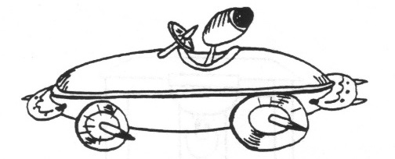
- Begin with a hot dog bun sliced apart, with a slice of cheese in between – this makes racing “stripes” on the side of the “car.”
- You could also add a hot dog, or slice the hot dog horizontally to make another “stripe” down the side of the car.
- Make wheels out of carrot slices and attach with toothpicks.
- Use pimento strips to outline the driver’s seat.
- The “driver” is an olive on a toothpick.
- Pickles can make bumpers and another carrot slice can make the steering wheel

GAMES
Car & Driver
Alice, Golden Empire Council
- Boys work in pairs. One partner is the driver and stands directly behind the other with his hands on his partner’s shoulders.
- They walk through a course that has been set up previously. Use tape on the floor or signs to indicate making a turn, stopping for signals, taking a detour, etc.
- Begin with eyes open, but the “driver” can only direct his “car” by using his hands on the shoulders.
- After doing the course with eyes open, try it with the “car” having a blindfold or closed eyes, directed only by the “driver’s” voice.
- To make it even more challenging, have the vehicles cross over each other’s paths!
Auto Trip Musical Chairs
Alice, Golden Empire Council
Players are seated in a circle and each one is given the name of a part of a car (tires, gas tank, hood, steering wheel, tires, brakes.) One player begins as the storyteller, including various parts as he tells the story of the “trip.” “We went down the road till a Tire went flat…” As a car part is mentioned, the player with that part gets up and runs around his chair, then sits back down. (It helps the storyteller to have the car parts listed on the wall) The story continues, with the storyteller sometimes yelling “Blowout!” Then everyone, including the storyteller must leave their seat, race around the circle and find a different seat. Meanwhile, the den leader pulls one chair out of the circle. Whichever player is left without a seat becomes the new storyteller.
Bulls-Eye Race
Baltimore Area Council
Preparation:
- Make a track out of one 8-foot length of 6" wide x 3/4” thick plywood board.
- Use the traditional strip of wood running the length of the board for the lane.
- Paint 1-inch strips across the board every 6 inches in different colors (Red, yellow, blue, green, etc.) before you attach the center strip.
- Cut a 36x36” piece of butcher paper. Draw a bulls-eye on the paper using 6-inch wide rings.
- Give each ring a point value.
- Tape the bulls-eye flat to the floor.
- Raise the track a few feet off the floor. (The track could be braced on the seat of a chair.)
The Race:
Boys hold their pinewood derby cars at any starting line they wish (e.g., the yellow stripe) and then let it go.
The Object:
- The object is to have the car stop in the bulls-eye.
- If the car stops short, the boy should start his car higher up on the track.
- If the car rolls too far, he should start it on a lower stripe. Each boy gets two trial runs and then a scoring run.
- Points are awarded depending on where the car stops.
Grand Prix Race
Baltimore Area Council
Equipment:
- 2 foot x2-foot piece of cardboard for each team;
- Cones and other objects
Preparation:
Set up cones and objects to create a track.
Divide boys into teams of two.
Each team is given a car (2 x 2 piece of cardboard).
The Race:
- One Cub Scout from each team sits on the cardboard and scoots around a predetermined race track using his feet and hands.
- When he completes the course, the second boy on the team takes his turn.
Box mobile Derby
Baltimore Area Council
This is a fun game where Tiger Cubs in their Box Cars “drive” from pit stop to pit stop trying to accomplish each task. Use your imagination to come up with pit stop ideas!
Some Pit Stop Ideas:
- Staying in Your Lane: Tiger Cubs walk the edge of a wooden board or a taped line on the floor. If a boy strays out of his lane, he has to return to the start and try again.
- Backing Into a Parking Space: Tape a balloon to the wall and have Tiger Cubs back into it until it pops.
- Washing the Windshield: Have a damp washcloth hanging from a string. Tiger Cubs mush wash the windshield (their faces) with using their hands.
- Singing with the Radio: Tiger Cubs stop and sing any song as if they were singing with the radio.
- Gassing Up the Car: Have a small (8-oz. or less) glass of water for each boy to drink as he comes through this pit stop.
- Changing Tires: Have Tiger Cubs take off their old tires (shoes) and put on new (adult sized) tires before racing down a path and back. Then they put their original tires back on.
Transportation Charades
Baltimore Area Council
Before the meeting, write down different modes of transportation on slips of paper.
To play the game, each Cub, (Tigers with the help of their adult partners), acts out one type of transportation while the others guess what it is.
Red Light, Green Light
Baltimore Area Council
Materials: STOP and GO signs and rope for finish line (Signs are easily made by writing the word on construction paper; tape a pencil to the back for stability.)
- Boys line up on one side of the yard; den chief stands at the finish line on the other side.
- When the den chief holds up the GO sign, the boys may move toward the finish line.
- When the Den Chief raises the STOP sign, Cub Scouts must stop in their tracks.
- If they don’t stop, they must go back to the start position.
START YOUR ENGINES
Great Salt Lake Council
- Arrange the Cub Scouts in a circle, with one boy in the center.
- Each boy chooses the name of a car he would like to be.
- It can be the make of a vehicle such as Ford; or it can be a specific model like Explorer.
- The boy in the middle starts the game by saying “I would like to drive a Honda.”
- He can say any car that the boys have chosen.
- Now the “Honda” player needs to answer “I’d rather drive a _______” filling in another name of a car.
- Play continues until a person chooses a car that doesn’t belong, or is his own car.
- He then goes into the center and play starts over.
- You can also change it so that the player that misses is out and play the game elimination style.
READY, AIM, ROLL
Great Salt Lake Council
Materials needed:
Two old rubber tires and
Several tennis or ping pong balls.
Directions:
- Divide the group into two teams.
- Have the teams form two lines about 15 feet from the tires.
- The tires can be standing up or lying flat on the ground.
- Each player gets a chance to throw one or more balls into the tire.
- Remind them about ricochet.
- Each ball that lands in the tire if it is flat, or that goes through the tire standing up earns the team a point.
- The team with the most points wins.
BACK-TO-BACK RELAY
Baltimore Area Council
- Two boys stand back to back with their backs touching.
- They run together from the starting line to the finish line, with one boy facing forward and the other facing backward during the run.
- Then on the return, the one facing forward faces backwards. They must always keep their back touching.
BROKEN DOWN CAR RELAY
Baltimore Area Council
Divide the boys into two or more teams of eight boys.
Line them up single file at a starting point. You can make up other problems and actions for the boys to do.
- The first player one each team represents a flat tire. He hops to the goal and back.
- The second player is a broken radiator. He makes a hissing sound as he runs to the goal and back.
- The third player has water in his tank. He walks forward three steps and backward two steps until he has covered the course.
- The fourth player has a rundown battery, so the 5th Player pushes him.
- The sixth player lost his wheel. He moves on two hands and one foot.
- The seventh player can only move in reverse; so he runs backward.
- And the eighth player is in good shape. He runs fast!
Whirling Wheels
Santa Clara County Council
Equipment: 1 beanbag per Den.
Arrange the Dens like the spokes of a wheel, facing in a clockwise direction with the Denner in the center.
A beanbag lies at the feet of each Denner
When the leader gives the starting signal, The Denner
Picks up his beanbag,
Runs down the line of his Den and
Runs in a clockwise direction around the wheel and
Back to the outside end of the Den.
The beanbag is then passed up the Den to the Cub now at the center.
This continues until all the Cubs have had a turn.
Jet Car
Capital Area Council

Materials:
2” x 2” x 5” box,
9” balloon,
2 straws 1 ½” long,
1 straw 4” long,
2 wooden dowels 3” long and 1/8” in diameter,
4 milk bottle caps or other lightweight wheels,
2 rubber bands,
masking tape,
hammer and small nail.
Construction:
- Tape the two short straws on the bottom of the box to house the dowel axles.
- Make a small hold in the center of each bottle cap wheel with the hammer and nail.
- Force one wheel onto each axle.
- Wheels should fit tightly. Put each axle through a straw on the box bottom and attach the other two wheels.
- Insert the long straw section into the neck of the balloon about ¾”.
- Secure with a rubber band.
- Poke holes in the box so that the straw can mounted at an angle, aiming at the floor.
- Secure with a rubber band.
Use:
- Blow through the straw to inflate the balloon,
- Pinch off the straw to trap the air.
- Set the car on the floor and let it go.
Tire Grand Prix
Capital Area Council
Lay out a course in a safe, open area, and give each player an old tire.
Then have players race, rolling their tires around the course.
At each “pit stop” the driver passes the tire on to a fresh driver.
For added fun, allow player to kick, knock over, or in any way impede the progress of the opposing racers, while still trying to get their best time.
Alert safety guards to watch for unnecessary roughness.
Old tires can be borrowed, which alleviates the disposal problem after the race.
Going on a Trip:
Capital Area Council
Equipment for each team: one suitcase filled with a hat, coat, gloves, and any other desired clothing, one umbrella. (Keep the contents of the suitcases uniform in components and fastenings).
At a signal, first player from each team runs to the goal, opens the suitcase, puts on clothes, closes suitcase, opens umbrella and runs to starting point. There, he takes off all the items and player #2 puts them on. Player #2 races to the suitcase, undresses, repacks the suitcase and returns to the team. # 3 starts the process over, comes back and gives the items to #4, etc. This continues until each player has dressed. First team completed wins.
I Am Part of an Automobile
Capital Area Council
With players seated in a circle, someone starts off by saying, “I am a ______________.” and gives the name of some part of an automobile. The idea is to see how long you can keep going around the circle until you run out of parts. As long as one is able to name a new part, he may remain in the game. Keep going until only one is left in the circle. No part may be named twice.
Stock Car Racing
Capital Area Council
Active, indoors/outdoors - No equipment
The boys line up in lines
Each Cub is given the name of a car and when that car is called, he travels to the end of the area and back in the manner described
Examples are:
- Rolls-Royce – this never goes wrong – the cub runs
- Austin - has a flat tire – the Cub hops
- Morris – stuck in reverse – the Cub runs backwards
- Ford – very old model, can only go slowly, the Cub walks
- Mini – it’s a small car – the Cub runs, crouched down
- Hummer – pulls caravan, the Cub tows his den behind
When “Stock Car” is called – everyone runs
Make up the car names and actions as you wish
Car Tire Games
Santa Clara County Council
Tire Sprint: Racers line up with forward edge of tire at the starting line. On signal, they push tire forward and continue to push it across finish line. If necessary, establish lanes.
Roll for Distance: Each player rolls his tire separately and is entitled to run to gain speed and momentum but must stop at the stopping line while the tire rolls forward by itself.
Roll for Accuracy; Same as above, except tire is rolled at a target of 2 sticks set 3-4 feet apart and approximately 20 feet away.
Moving Target: Players take two turns rolling tire parallel to other players 15 – 20 feet away who try to throw balls or beanbags or broomsticks through the tire as it rolls by.
Tire Wrestling: Place two tires on the ground so they touch each other. One contestant stands in each tire. As the signal, they wrestle to throw or push their opponent out of his tire. The winner is the first to cause the other to fall or step out of his tire, provided he himself remains on his feet in his tire.
Tire Bowling: Bowl, using discarded tires in place of balls, with milk cartons or tin cans for bowling pins. Arrange “alley” on the ground with the bowling line 20 – 30 feet from the pins. Each bowler rolls two tires. Score as in bowling. Or from Capital Area Council -
Use discarded tires in place of a ball and milk cartons, tin cans, or bleach containers for pins. Arrange “alley” on the ground with the bowling line 20 to 30 feet from the “pins”. Each bowler rolls two tires. Score as in bowling.
Tire Rolling Relay: Form teams and give the first player of each team a tire. Place a stake or chair opposite each team on the turning line. At the signal, the first player rolls his tire to the turning line, rolls it around the stake and back to the next player in line.
Through the Tire Relay: Establish a rolling line in front of the lines of dens. The first player of each team goes up to the rolling line with a tire. At signal he rolls his tire forward toward his team by giving it one shove. The players in turn then straddle-jump the tire. If the roller did not steer the tire exactly straight, the line must shift in order to be in line with their tire. If a player knocks the tire down in attempting to jump it, or if it falls over before he can jump it, he must recover the tire and give it to the player in front of him who rolls it for him and the rest of the team. The original roller then takes place at the front of the line. When the last man has jumped the tire, he rolls it to the starting line, and the action is repeated until the original roller has rolled the tire back to the starting line.
Car Games
Grand Teton Council
PLOT YOUR ROUTE
- Give each boy a state map.
- Tell them you are leaving this city (where you live or meet) and going to..........(another city in the state)
- Have them plot the route you will need to take.
GEOGRAPHY GAME
- Players are seated in a circle.
- First player names a geographical term — city, river, country, animal, race, etc.
- Second person must give a geographical word which begins with the last letter of the first player's word.
- Continue thus around the circle.
- The same word is not to be given twice.
YOU'RE GOING TO TAKE A TRIP
- For this game you will need two teams of three or more boys.
- Each boy has blindfold so that they cannot see.
- One boy will be the leader of his team and will have to guide his teammates and pick up small flags along the way. (The Webelos leader has put these markers in the back yard ahead of time so that no one will know where they are.)
- Make two identical trails.
- The team that comes back with the most markers is the winner.
I PACK MY SUITCASE
- One boy starts the game by saying "I pack my suitcase and I put in ......(he says something like my shirt., or my toothbrush).
- The next player says I pack my suitcase and I put in ....repeats the first player's item and then adds his own.
- This continues and each boy who is not able to get all the previous items correctly is out of the game and
- The game continues until all but one boy have missed.
FIND IT ON A MAP
- Give each team a United States map.
- Have the first boy from each team step up to the map and you call out a city.
- The boys all get a predetermined time to find the city and whoever does gets a point (or only the team of the first boy to find the city gets the point.)
- Once the boy has found it, he gets one point for his team and the next boy steps up to the map.
- Call out another city.
- This continues until one team has 11 points.

Car Relay
Santa Clara County Council
- Divide your boys into teams of 6 and have them each select the part of an automobile they will be. Then tell them how they will race.
- Steering – gear is broken – walk zigzag.
- Flat tire –Limp.
- Gas Tank – water in tank two steps forward, one step back.
- Transmission – Can’t go forward – walks backward.
- Battery – Dead – can’t go at all (See Tow)
- Tow – Pushes 5th player by placing both hands on player’s waist.
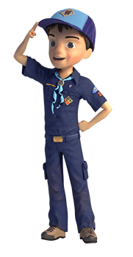



ONE LAST THING

GILBERT'S PINEWOOD DERBY PRAYER
by Peggy Porter
http://usscouts.org/usscouts/pinewood/gilbert.asp
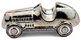
Gilbert was eight years old and had been in Cub Scouts only a short time. During one of his meetings he was handed a sheet of paper, a block of wood and four tires and told to return home and give all to "dad". That was not an easy task for Gilbert to do. Dad was not receptive to doing things with his son. But Gilbert tried.
Dad read the paper and scoffed at the idea of making a pine wood derby car with his young, eager son. The block of wood remained untouched as the weeks passed.
Finally, mom stepped in to see if dad could figure this all out. The project began. Having no carpentry skills, dad decided it would be best if he simply read the directions and let Gilbert do the work. And he did. Dad read aloud the measurements, the rules of what Gilbert could do and what he couldn't do. Within days his block of wood was turning into a pinewood derby car. A little lopsided, but looking great (at least through the eyes of mom).
Gilbert had not seen any of the other kids' cars and was feeling pretty proud of his "Blue Lightning", the pride that comes with knowing you did something on your own. Then the big night came. With his blue pinewood derby in his hand and pride in his heart he headed to the big race.
Once there this little one's pride turned to humility. Gilbert's car was obviously the only car made entirely on his own. All the other cars were a father-son partnership, with cool paint jobs and sleek body styles made for speed.
A few of the boys giggled as they looked at Gilbert's, lopsided, wobbly, unattractive vehicle. To add to the humility Gilbert was the only boy without a man at his side. A couple of the boys who were from single parent homes at least had an uncle or grandfather by their side, Gilbert had "Mom".
As the race began it was done in elimination fashion. You kept racing as long as you were the winner. One by one the cars raced down the finely sanded ramp. Finally it was between Gilbert and the sleekest, fastest looking car there.
As the last race was about to begin, this wide eyed, shy, eight-year-old asked if they could stop the race for a minute, because he wanted to pray. The race stopped, Gilbert hit his knees clutching his funny looking block of wood between his hands. With a wrinkled brow he set to converse with his Father. He prayed in earnest for a very long minute and a half. Then he stood, smile on his face and announced, 'Okay, I am ready."
As the crowd cheered, a boy named Tommy stood with his father as their car sped down the ramp. Gilbert stood with his Father within his heart and watched his block of wood wobble down the ramp with surprisingly great speed and rushed over the finish line a fraction of a second before Tommy's car. Gilbert leaped into the air with a loud "Thank you" as the crowd roared in approval.
The Scoutmaster came up to Gilbert with microphone in hand and asked the obvious question, "So you prayed to win, huh, Gilbert?"
To which this young boy answered, "Oh, no sir. That wouldn't be fair to ask God to help you beat someone else. I just asked Him to make it so I don't cry when I lose."
Children seem to have a wisdom far beyond us. Gilbert didn't ask God to win the race, he didn't ask God to fix the outcome; Gilbert asked God to give him strength in the outcome. When Gilbert first saw the other cars he didn't cry out to God, "No fair, they had a father's help". No, he went to his Father for strength.
Perhaps we spend too much of our prayer time asking God to rig the race, to make us number one, or too much time asking God to remove us from the struggle -- when we should be seeking God's strength to get through the struggle.
Gilbert's simple prayer spoke volumes to those present that night. He never doubted that God would indeed answer his request. He didn't pray to win, thus hurt someone else -- he prayed that God supply the grace to lose with dignity. Gilbert, by his stopping the race to speak to his Father also showed the crowd that he wasn't there without a "dad", but His Father was most definitely there with him. Yes, Gilbert walked away a winner that night, with his Father at his side.
I can do all things through him who strengthens me. Philippians 4:13 (NRSV)

