THE FOUNDER'S PRAYER
Written by Baden-Powell for use in international events.
Father of us all, we meet before Thee here today, numerous in the lands we come from and in the races we represent, but one in our Brotherhood under Thy Divine Fatherhood.
We come before Thee with hearts grateful and gladdened by the many blessings Thou hast granted us and thankful that our Movement has prospered as acceptable in Thy sight. In return we would lay on Thine Altar, as our humble thank-offering, such sacrifice as we can make of self in service to others. We ask that during our communion here together we may, under Thy Divine Inspiration, gain a widened outlook, a clearer vision of all that lies open before us and of our opportunity. Thus we may then go forth with strengthened faith to carry on our mission of heightening the ideals and powers of manhood, and of helping through closer understanding to bring about Thy happier Rule of Peace and Goodwill upon Earth.

COMMISSIONER'S CORNER

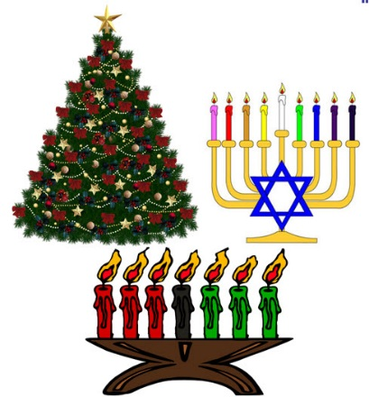
Speaking of Holiday things for Cub Scouts. I did not put the usual Holidays crafts and activities in this issue for December's activities. Not sure what most of the units were doing with the Adventure Program in place. BUT you can go to almost any December Theme issue of Baloo for the last 20 years and find lots of good Holiday activities – Christmas, Hanukah, and Kwanzaa.


Judy and Dave need some help. If you would do one item for Baloo each month, it would help us greatly –
Some ideas for you to consider –
Biography – write a one page +/- biography of a person you select that exemplifies that month's emphasized point of the Scout Law.
Advancement – Choose a rank. Write a few hints and ideas for the Adventure to be discussed that month at the Roundtable. And, also, any that have a Character Compass pointing to that months point of the Scout Law
Social Media – check out National's Facebook pages, Bryan's Blog, Cubcast, and Scoutcast and prep the summaries for Baloo.
Roundtable Hints – Prep some hints and ideas for your fellow Roundtable Commissioners each month. This would be easy for someone from a council like Sam Houston where they have an annual RT day where they review all 12 months in advance.
Crazy Holidays – Jodi actually retired from that position a few years ago. We can supply you files for each month. You only need to check for updates and additions. Feel free to use more websites if you have a favorite.
Point of the Scout Law – Look for items that help get across the meaning of the point of the Scout Law emphasized that month in Roundtable.
Special Opportunities – write a brief article each month about one youth and one adult award other than rank advancement.
Have another idea? Let us know how you feel you could help us to make Baloo's Bugle more of what RT Commissioners, Cubmasters, and Den Leaders want.
Write us through the "Send Your Ideas to Baloo" link or directly – davethecommish@gmail.com and judyjohnsonbsa@yahoo.com
Table of Contents
THE FOUNDER'S PRAYER 1
COMMISSIONER'S CORNER 1
BIOGRAPHY – 5
Native American Spirituality 5
James Earl "Jimmy" Carter, Jr 7
CUB SCOUT LEARNING LIBRARY 8
CUB SCOUT LEADER TRAINING 11
ON-LINE TRAINING 11
IN-PERSON TRAINING 12
ADVENTURE PLAN TRACKING SPREADSHEETS 12
ROUNDTABLE HINTS 13
ROUNDTABLE TEAM MEMBER’S RESPONSIBILITIES 13
TEACHING THE SCOUT OATH & LAW TO CUB SCOUTS 17
CHARACTER COMPASS 18
PACK MEETING THEMES AND PLANS 19
Pack Meeting Themes 20
UPCOMING MONTHS 20
WEBELOS 22
December Crazy Holidays 23
Point of the Scout Law for December - Reverent 25
BSA SOCIAL NETWORKS 27
SCOUTING MAGAZINE ON YOU TUBE 27
BSA FACEBOOK PAGE 27
CUBCAST 28
SCOUTCAST 28
TRAINING TOPIC 33
An Introduction to the Scouts Own 33
SPECIAL OPPORTUNITIES 35
Religious Emblems 35
FAQs about Religious Emblems 35
Adult Religious Recognitions 37
Religious Emblems Coordinators 37
Slides of the Month 38
LEADER RECOGNITION & INSTALLATION 50
The Light of Scouting 50
Here’s to the Scouters’ Spouses 51
Christmas Wreath 51
Scouting is a Candle 51
SONGS 51
STUNTS AND APPLAUSES 53
APPLAUSES & CHEERS 53
RUN-ONS 54
JOKES & RIDDLES 55
SKITS 55
CLOSING CEREMONIES 56
Cubmaster’s Minutes 57
Christmas Spirit & the Gimme Pig 57
CUB GRUB 58
GAMES 62
ONE LAST THING 64

The Cub Scout Core Values are now the
12 Points of the Scout Law.
The core value highlighted this month is:
December's point of the Scout Law, REVERENT, will use the theme, WINTER WONDERLAND
A SCOUT IS REVERENT
A Scout is reverent toward God. He is faithful in his religious duties. He respects the beliefs of others.
HOW DOES “WINTER WONDERLAND” RELATE TO THIS POINT OF THE SCOUT LAW?
As winter comes, it brings with it a wonderland of snow, peace, beauty, and holidays. Many of us come from different backgrounds and celebrate different traditions; each of our traditions gives us an identity, a sense of belonging. When we share our traditions and accept the traditions of others, we expand our circle so that everyone feels that they belong. Whether we celebrate Christmas, Hanukkah, Kwanzaa, or none of these, sharing valued traditions and holding true to what they stand for will help us understand others. But no matter who we are or how we celebrate, everyone in Scouting is part of a great organization that has taught us to show reverence for others and their beliefs.
Per our Founder, Lord Baden-Powell
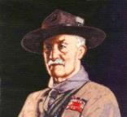
Note – The original Scout Law published in 1908 had 9 points. In 1910, the BSA added Brave, Clean, and Reverent. In 1911 B-P added Clean to his original list.
A SCOUT'S DUTY TO GOD
"No man is much good unless he believes in God and obeys His laws. So every Scout should have a religion....Religion seems a very simple thing: First: Love and Serve God. Second: Love and serve your neighbour." - (Scouting For Boys, 1908)

Be a player on God's team.
Lord Robert Baden-Powell, Rovering to Success, 1922
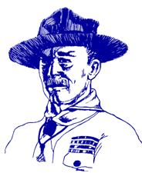
Duty to God Statements by Lord Baden-Powell
- "The Scout, in his promise, undertakes to do his duty to his king and country only in the second place; his first duty is to God. It is with this idea before us and recognizing that God is the one Father of us all, that we Scouts count ourselves a brotherhood despite the difference among us of country, creed, or class. We realize that in addition to the interests of our particular country, there is a higher mission before us, namely the promotion of the Kingdom of God; that is, the rule of Peace and Goodwill on earth. In the Scouts each form of religion is respected and its active practice encouraged and through the spread of our brotherhood in all countries, we have the opportunity in developing the spirit of mutual good will and understanding.
- "There is no religious "side" of the movement. The whole of it is based on religion, that is, on the realization and service of God.
- "Let us, therefore, in training our Scouts, keep the higher aims in the forefront, not let ourselves get too absorbed in the steps. Don't let the technical outweigh the moral. Field efficiency, back woodsmanship, camping, hiking, Good Turns, jamboree comradeship are all means, not the end. The end is CHARACTER with a purpose.
- "The atheists....maintain that a religion that has to be learnt from books written by men cannot be a true one. But they don't seem to see that besides printed books....God has given us as one step the great Book of Nature to read; and they cannot say that there is untruth there - the facts stand before them....I do not suggest Nature Study as a form of worship or as a substitute for religion, but I advocate the understanding of Nature as a step, in certain cases, towards gaining religion." - (Rovering To Success, 1930) day.
- "Our objective in the Scouting movement is to give such help as we can in bringing about God's Kingdom on earth by including among youth the spirit and the daily practice in their lives of unselfish goodwill and cooperation."
More Quotes from Baden-Powell on Faith
Alice, Golden Empire Council
"No man can be really good, if he doesn't believe in God and he doesn't follow His laws. This is why all Scouts must have a religion". (Scouting for Boys, 1908)
"Scouting has been described as "a new religion". It's not, of course, a new religion: it's just the application to religious formation of the principle now accepted in non-religious formation, i.e. to point out a precise aim to the boy and give him the way to learn and practice by himself" [Quoted in Taccuino, a collection of B-P's writings and essays published in Italy. Dated January 1912]
From Aids to Scoutmastership, 1919:
"Love of God, love of your neighbour and respect of oneself as God's servant are the basis for any form of religion"
"Many difficulties may arise while defining religious formation in a Movement such as ours, where many religions coexist; so, the details of the various forms of expressing the duty to God must be left to those responsible of each single association. We insist however on observance and practice of that form of religion the boys profess"
"Nowadays the actions of a large part of youths are guided just in a small part by religious convictions. That can be attributed for the most to the fact that in the boy's religious formation the worry was on teaching instead of educating".
"If you really wish to find the way towards success, i.e. your happiness, you must give a religious base to your life. It's not simply attending church or knowing history or comprehend theology. Many men are sincerely religious almost without knowing it or having studied these things. Religion, briefly explained, means: First: know who God is; Second: use to the best the life He gave us, and do what He expects from us. This means mostly doing something for the others."
From Rovering to Success, 1922
The method of expression of reverence to God varies with every sect and denomination. What sect or denomination a boy belongs to depends, as a rule, on his parents' wishes. It is they who decide. It is our business to respect their wishes and to second their efforts to inculcate reverence, whatever form of religion the boy professes.

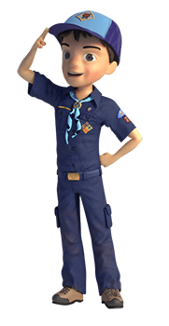


BIOGRAPHY –

Native American Spirituality
An integral part of their cultures -
Living your beliefs 24 - 7
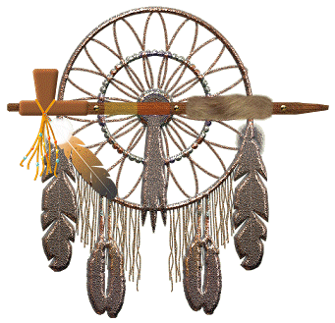
Native Americans saw their beliefs (spirituality, religions) as an integral part of their culture.
In other words - they lived their beliefs every hours of every day. Not just a few hours a week on a perceived Sabbath Day. Most adherents to traditional American Indian ways do not see their spiritual beliefs and practices as a "religion"; rather, they see their whole culture and social structure as infused with 'spirituality' - an integral part of their lives and culture.
Native American religion is very closely connected to the land in which Native Americans dwelt and the supernatural. Native American spirituality is often characterized by a strong emphasis on the importance of personal spirituality and its inter-connectivity with one's own daily life, and a deep connection between the natural and spiritual 'worlds'. Native Americans did not practice religion as we do today. They lived it with spirituality penetrating every aspect of their lives. Most adherents to traditional American Indian ways do not see their spiritual beliefs and practices as a "religion"; rather, they see their whole culture and social structure as infused with 'spirituality' - an integral part of their lives and culture.
Spiritual power, they believed, suffused the world, and sacred spirits could be found in all kinds of living and inanimate things-animals, plants, trees, water, and wind. Through religious ceremonies, they aimed to harness the aid of powerful supernatural forces to serve the interests of man. In some tribes, hunters performed rituals to placate the spirits of animals they had killed.

What were their Basic Beliefs and Practices
While recognizing that there is great diversity in the religious practice of the various Native American religious traditions, we can also see that they do share worldview similarities that allow us to make a few general observations.
- First, in every case, all of creation is seen to be interrelated. These systems all believe that it is the responsibility of humans to oversee and protect the material world.
- Secondly, there is a basic belief that all of life is of equal value. They understand there to be a spark of life in all humans, animals and plants. This life force is considered to be sacred and connects all living things together. All life forms have as much right to existence as human beings, and should not be damaged or destroyed. They believe that plants and animals may be used for food, medicine and to take care of other needs, but there are limitations on that use.
- A third common characteristic relates to a long term concern for life. They are willing to forego short-term expediency in order to assure the long-term viability of the natural world.
- Finally, there is a deep gratitude to the Creator for life and for the things it makes possible. This gratitude is expressed by both public and private worship traditions.
The basic Native American view of deity is dualistic – there is believed to be good and bad in the spiritual world. Most believe in a creator God who was responsible for creating the world. They acknowledge him in their worship practices and pray to him. They also believe that there are other spirits which are able to interact in the material world. These spirits have control over such things as the weather and other circumstances which affect humans.

Native American Prayer
For that solemn moment towards the end of Den or Pack meeting, try this Native American Prayer:
Morning Star wake us, filled with joy.
To new days of growing to man from boy.
Sun, with your power, give us light.
That we can tell wrong and do what is right.
South Wind, we ask, in your gentle way.
Blow us the willingness of obey.
North Wind, we ask, live up to thy name.
Send us the strength to always be game.
East Wind, we ask, with your breath so snappy.
Fill us with knowledge of how to be happy.
West Wind, we ask, blow all that is fair.
To us, that we may always be square.
Moon, that fills the night with red light.
Guard us well while we sleep in the night.
Akela, please guide us in every way.
We'll follow your trail in work or play.
Should not we all strive to live our Faith 24 - 7
as did the Native Americans??

Failure is a reality; we all fail at times, and it's painful when we do. But it's better to fail while striving for something wonderful, challenging, adventurous, and uncertain than to say, I don't want to try because I may not succeed completely. Sources of Strength: Meditations on Scripture for a Living Faith

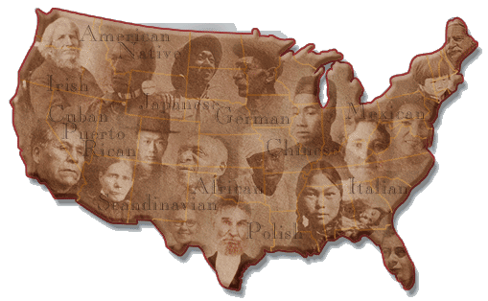
As Mankind becomes more liberal, they will be more apt to allow that all those who conduct themselves as worthy members of the community are equally entitled to the protections of civil government. I hope ever to see America among the foremost nations of justice and liberality." - George Washington

Only when the last tree has died
and the last river has been poisoned
and the last fish has been caught
will we realize we cannot eat money.
Cree Indian Expression
Do you remember the crying Indian commercials??

To see the associated PSA go to http://www.youtube.com/watch?v=j7OHG7tHrNM
or for a later version - https://www.youtube.com/watch?v=DH0U2AsyoWU
or Google "Crying Indian Chief"
The actor is "Iron Eyes" Cody. Although he was not a Native American, he did a lot of good for the Native Americans who readily accepted him.

James Earl "Jimmy" Carter, Jr
39th American President
A REVERENT Man
President Jimmy Carter turned 90 last year and
he is still out their demonstrating his
FAITH and COMPASSION.
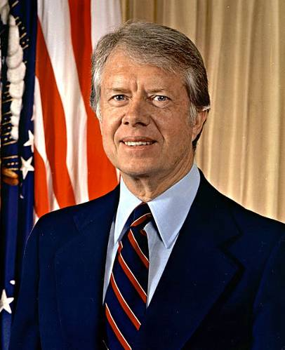
James Earl Carter Jr. was born 1 October 1924 in Plains Georgia. Jimmy Carter was the first United States President born in a hospital. He was the oldest of four children of James Earl Carter and Bessie Lillian Gordy. His father was a prominent business owner and his mother was a nurse. Jimmy Carter was a gifted student and active socially. In High School, he was Secretary of the Plains Future Farmers of America Chapter and a star baseball player.
After High School, Jimmy Carter enrolled in Georgia Southwestern College and applied for the United States Naval Academy. After taking some additional Math courses at Georgia Tech, he was admitted to the Naval Academy in 1943. After graduating 59th in his class of 820 midshipmen, he served on surface ships and on diesel-electric submarines in the Atlantic and Pacific Fleet. As a junior officer he completed the qualifications for command of a diesel-electric submarine. He applied for the US Navy’s new nuclear submarine program run by then Captain Hyman G Rickover. Carter was assigned to Schenectady, New York and worked on developing training materials for the prototype of a new submarine.
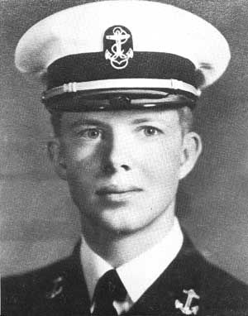
From a young age, Carter showed a deep commitment to Christianity. He served as a Sunday School teacher throughout his life. Even as president, Carter prayed several times a day, and professed that Jesus Christ was the driving force in his life. Carter had been greatly influenced by a sermon he had heard as a young man. It asked, "If you were arrested for being a Christian, would there be enough evidence to convict you?"
Jimmy Carter had intended to make the Navy his career, but the death of his father in July 1953, led him to resign his commission on 9 October 1953 and return to Georgia to run the family business. Though James Earl Carter Sr. died a relatively wealthy man, his forgiveness of debt and division of his estate between his heirs, left little for his oldest son to inherit. Jimmy Carter was forced to move his family into public housing while he struggled to revive the family business. He grew this business from those humble straights to a successful business, with the help of his wife Rosalyn who studied accounting to manage the business funds.
In 1976, Jimmy Carter defeated then President Gerald R. Ford to become the 39th President of the United States. His administration was plagued by the Energy Crisis and the hostage crisis in Iran at the United State Embassy.
Jimmy Carter was defeated for re-election in 1980 by Governor Ronald Regan. He and his vice president Walter Mondale are the longest living post presidential team in American History, now over 32 year out of office. They surpassed second place, President John Adams and Vice President Thomas Jefferson. In 1978 Jimmy Carter was awarded the Silver Buffalo Award by the Boy Scouts of America. In 2002 he received the Nobel Peace Prize for this work after his Presidency.
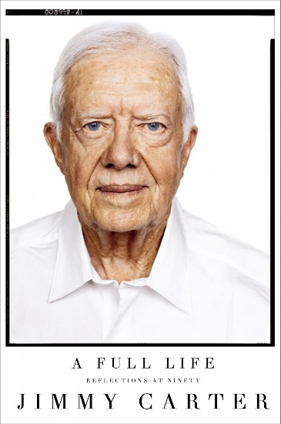
After leaving office he created the Carter Center, a non-profit partnership with Emory University committed to human rights and alleviating human suffering. He and his wife Rosalyn lead the Jimmy and Rosalynn Carter Work Project for Habitat for Humanity International one week each year. Not only do the Carters lead this week of work, they jump in and swing hammers to make it happen. Their first involvement was in 1984 when they helped renovate a six-story building with 19 families, planting the seed for their Work Project. The Carters have truly planted seeds of compassion that have yielded the Fruits of Human Kindness.

CUB SCOUT LEARNING LIBRARY
The NEW https://cubscouts.org/ !!!

This is the Cub Scout Learning Library –
Everything you could want to know for Cub Scouts is or will be here. And all within a click or 3 of the home page. National heard the message that although things were at www.scouting.org they were often buried too deep to be found.
This site has admin stuff and practical stuff. The new Den Leader Resource Books are here. You can download some of the pages for each Adventure for FREE
This website is a great resource. There are still parts under construction but what is there is GREAT!!

BSA seems to be working off the same plans that www.USScouts.org and other "unofficial" Scouting websites use. They have seen what you the volunteers want and are delivering it. I hope they are successful and some of us old guys (I have my Medicare card) can retire from our web duties.
Yes, https://cubscouts.org runs on a phone, too!!!

There are 3 tabs on top of the home page –

- Learning Library
- Blog
- Join Scouting
- Learning Library takes you where you can learn about your position and pick up hints. Besides specifics for dens of each rank, other clickable links include –
KEY
- All or most of material was placed on site this past month
- All or most of material was in place and listed as such in last month's Baloo's Bugle.
- Site / pages under construction
- Den Leader
Den Meeting Basics
- Your First Den Meeting
- Planning Den Outings
- The Parts of a Den Meeting
- Getting Started
Three of the Core Adventures for the selected rank are listed here. Click on them and you will see / can download all the Leader's Guide pages for these three Adventures.
- Additional Required Adventures
The remaining Core Adventures for the selected rank are listed here. When you click them you get an intro to the Adventure but do not get the Meeting Plans and Resources. You see this note:
To get you started in delivering fun and engaging meetings, complete Den Meeting Plans are available here on the Learning Library for the Backyard Jungle and Games Tigers Play adventures. To obtain Den Meeting Plans for all other adventures, Den Leader Guides are available at your local Scout Shop, online at scoutstuff.org, or as an eBook through Amazon.
- Elective Adventures
All the Elective Adventures for the selected rank are listed here. When you click them you get an intro to the Adventure but do not get the Meeting Plans and Resources. You see the same note (above).
- Building Strong Dens
The Basics of Cub Scouts
- Advancement
- BSA Mission and Vision Statements
- Cub Scout Ages and Ranks
- Cub Scout Uniforming
- Den Flags
- Den Yells
- Leader Survival Kit
- Methods of Cub Scouting
- Purpose of Cub Scouting
- Roles and Responsibilities
- Scout Oath and Law
- What Is Cub Scouting?
- Training
- The Role of Training
- Youth Protection
- Den Planning And Administration
- Advancement Basics
- Advancement Requirements
- Annual Planning For Your Den
- Coordinating Your Den Plan with Pack
- Tracking and Recognizing Advancement
- Youth Protection Training
- Positive Youth Development and Working with Boys
- Developmental Differences Boys 7-11
- Behavior and Discipline
- Positive Youth Development
- Working With Special Needs Cub Scouts (Advice is specific to each Special Need. Lots of research was done to prep these pages.)
- Parents’ Prejoining Conference
- Leadership Techniques
- Working With Specific Disabilities and Needs
- Cubmaster
- Committee Chair/Member
- Chartered Org Rep
- Parent / Adult Partner
- Blog takes you to a Cub Scout specific Blog similar to Bryan's Blog. The topics discussed here in September were:
(There were no new entries to the Blog since the list was last published in Baloo's Bugle CD)
 Scouting: A Priority for Family Meet Juan. He grew up in Mexico and as a teenager immigrated to the United States. Having…READ MORE
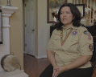 Scouting: An Extension of Family Meet Catherine, or as the Cub Scouts in her den call her, Ms. Cat. She’s a Scout mom,…READ MORE
 Scouting: Not Just a Club, but a Family Meet Becky. Her son just crossed over from Cub Scouts to Boy Scouts, and is about to…READ MORE
 Scouting: Getting the Most out of Family Time Meet Michelle, the proud mother of a Webelos Scout. She knows that life can be busy and…READ MORE
 Scouting: A Way to Invest in Your Family Meet Lester and Apryl who’ve been involved in Scouting for a combined total of 23 years. Together,…
READ MORE
 This Scout Dad Makes a Terrific Case to Join Cub Scouting Just outside of Minneapolis is the community of Prior Lake. And its local newspaper, the Prior Lake…READ MORE
 All the Latest Resources for Scouting Recruitment We’ve done it! We brought back the popular #CubChat Twitter chat event for a special conversation on…READ MORE
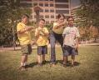 6 Planning Tips for your Cub Scout Calendar When it comes to leading a Cub Scout den or pack, from Blue and Gold to Day… READ MORE
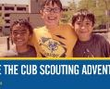 This September, Bring a Friend to Scouting By now, you’ve probably seen the #ShareScouting hashtag and maybe (hopefully!) even used it on your own…READ MORE

- Join Scouting takes you to www.beascout.org
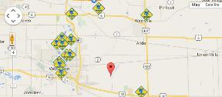

- Also, on the home page –
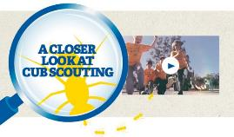
This link takes you to a YouTube Video
on Cub Scouting.
https://www.youtube.com/watch?feature=player_embedded&v=dqKFgk8SJlE
These Six Links take you to:
(From top left across, then down)

www.scoutstuff.org – The Supply Division site where you can find the location of your nearest National Scout Shop or buy all your Scout supplies
http://scoutingwire.org/ - Where you can get the latest Scouting News from around the country. You can sign up to get notifications when things are posted here..
www.scouting.org/programupdates - The great site where all the news about all the changes to Cub Scouting, Boy Scouting, and Venturing can be found.
https://www.scoutbook.com/ Where you can get the Scoutbook APP to track your son's Scouting Experience from Tiger to Eagle Scout.
I just learned that Bob Scott is at it again. Bob led us on the charge to "Cub Scouts 2010" and then to "CS Adventure Program." Now he is leading the Scoutbook effort. It is sure to be a success!! Thank you, Bob - CD


www.boyslife.org – Go directly to the on-line edition of Boys'Life
http://scoutingwire.org/marketing-membership/ Get resources and materials to strengthen your unit at BSA's marketing and membership site. Learn the best practices and tips employed by the most successful units.

CUB SCOUT
LEADER TRAINING
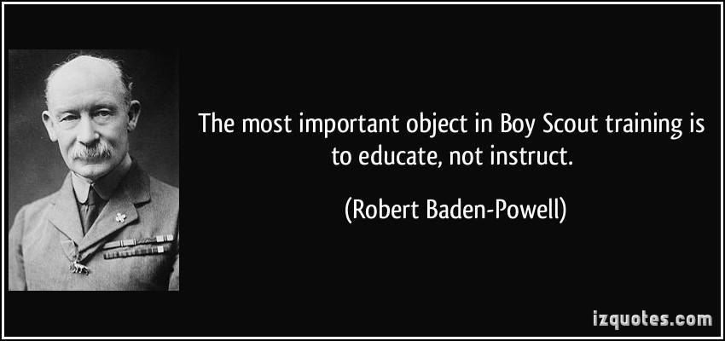

ON-LINE TRAINING
On October 25, 2015, this post appeared on the BSA Volunteer Training Team Facebook Page (https://www.facebook.com/BSAtrainingteam/ )
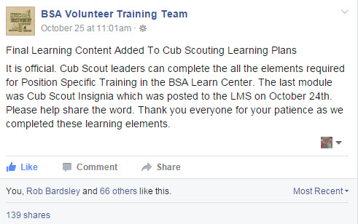
And the comments I read confirm that the system is up, running, and complete!! My Council Training Chair was excited that he could now be qualified for his position in his son's pack!!!
The online training for Den Leaders, Cubmasters, Committee Chairs and members, and Chartered Organization Representatives is totally updated with help from volunteers from around the country. The new training is divided into shorter, more targeted modules so leaders can get the training they need, in the order they want, any time they need it. It is organized around the learning needed prior to the first meeting, in the first 30 days, and to be position-specific trained. This training was developed to be implemented in conjunction with the BSA’s new learning management system. Keep an eye on My.Scouting Tools (log in at https://My.Scouting.org ) for more information.


Go to the BSA Volunteer Training Team Facebook page (Link above) and . Then you receive the latest news!!

A Typical Learning Plan has several parts –
Here you can see the three parts of the CM Course -
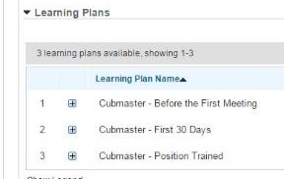

Each of these three parts is broken down into "bite sized" chunks:
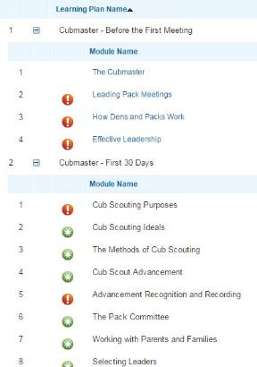
Go check it out and get your
people trained!!!
If you are having difficulties with the training or
system call Member Care at 972-580-2489,

IN-PERSON TRAINING
Position-Specific In-Person Training Guides Available Now! The training guides for
- Den Leader (http://www.scouting.org/filestore/training/pdf/515-215.pdf ),
- Cubmaster/Assistant Cubmaster (http://www.scouting.org/filestore/training/pdf/511-503_WB.pdf ), and
- Pack Committee (http://www.scouting.org/filestore/training/pdf/511-504_WB.pdf )
are available on Scouting University. You can access them at http://www.scouting.org/training/adult.aspx .
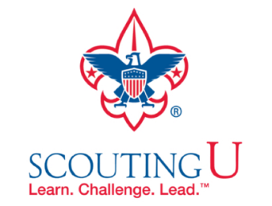

ADVENTURE PLAN TRACKING SPREADSHEETS
- Tracking Spreadsheets are posted on the USScouts Advancement webpage (www.usscouts.org). There are be links to them from other places on the site. These spreadsheets are similar in construction and user interface as the existing spreadsheets. The spreadsheets have be tested by the developer of the current spreadsheets and he said they are so good he sees no reason to develop others!!
- Utah National Parks Council has Excel spreadsheets posted for all the new Adventure Plan requirements on their Akelas Council Blogspot. www.Akelascouncil.blogspot.com . Check them out.
The Advancement Excel Spreadsheet workbooks are distributed to Scouters for FREE.
PLEASE do not download the files from either site to email or send them digitally to others. They are for your personal / pack use only. If you would like to share these files with others, please copy / send the link to them and send them to the site so they can print off their own. They would love everyone that wants a copy to get their own copy absolutely free. Both USScouts and Utah National Parks receive Ad money based on the number of people visiting the site that helps keep their websites open. Please help us by encouraging others to visit them to obtain the files.

ROUNDTABLE HINTS

ROUNDTABLE TEAM MEMBER’S RESPONSIBILITIES
This month we will begin to introduce the members of the RT Team. This material is based on Commissioner College Course #BCS151, The Roundtable Team.
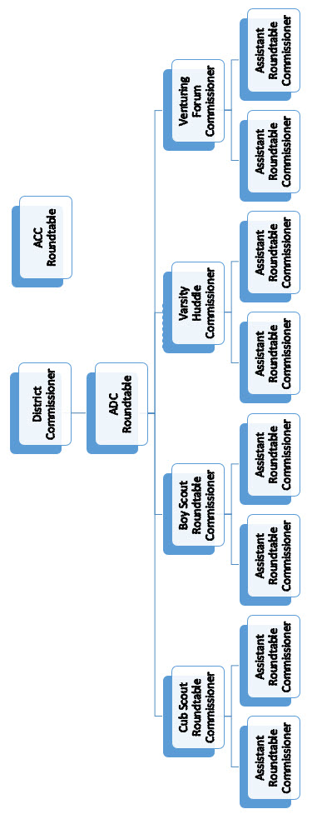
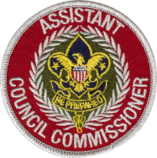
Assistant Council Commissioner for Roundtables.
The coordination of all roundtables held in the council is under the jurisdiction of the assistant council commissioner for roundtable. This person reports to the council commissioner and conducts an annual council wide roundtable-planning meeting followed by a midyear review. This process brings a level of standardization to district roundtable in terms of content by promoting the use of national roundtable guides and other resources while allowing local flexibility for the districts. In some larger councils, there may be multiple assistant council commissioners for roundtable, depending on the local needs.
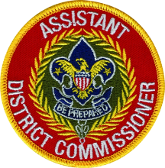
Assistant District Commissioner for Roundtables.
District roundtables fall under the guidance of the assistant district commissioner for roundtable. This individual oversees the district roundtables in all program areas, reports to the district commissioner, and works with the district structure, but also needs to be responsive to and work in cooperation with the assistant council commissioner for roundtable to see that annual planning and midyear review programs are well-attended by the district’s program-specific roundtable commissioners. In addition, this is a perfect position from which to see that national roundtable guide materials are being used so that proper program materials are being given to units. Additional duties include:
Responsibilities of ADC-RTs include:
- Working with the district executive and district commissioner to establish an annual operating budget for the roundtables.
- Attending monthly commissioners’ staff meetings to report on the roundtable activities and to alert unit commissioners to units whose leaders are not attending the roundtable.
- Conducting regular evaluations of the roundtables and team members to determine how they can be improved.
- Attending roundtable in correct uniform.
- Conducting regular self-evaluation.
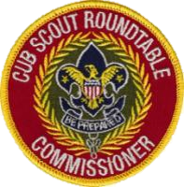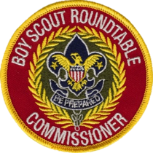
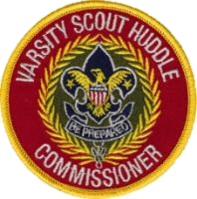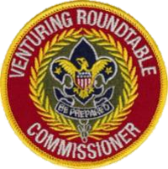
Position-Specific Roundtable Commissioners.
Report to the Assistant District Commissioner for Roundtables and are members of the district commissioner’s staff. Their duties are directly related to the unit service function. Position-Specific Roundtable Commissioners are responsible for seeing that quality roundtables take place; however, he/she needs assistants to be completely effective. The roundtable commissioner is the program team leader. The team approach to roundtable commissioner service is an important key to quality roundtables. A team in which the members share in the decision-making will have a better chance to understand the group’s purposes and goals, to be flexible, and to achieve satisfaction knowing that they have had a part in shaping the team’s spirit. They have an investment in its success!
Responsibilities of Position-Specific Roundtable Commissioners: Cub Scout, Boy Scout, Varsity, and Venturing include:
- Planning and supervising the delivery of program ideas and motivation to unit leaders that will enable units to provide a more effective program to its youth.
- Having knowledge of program-specific literature and how to help leaders use it in support of their program.
- Recruiting and training quality roundtable team members.
- Holding annual, quarterly, and monthly roundtable planning meetings; evaluating the effectiveness of roundtables at each meeting.
- Coordinating the functions conducted by the roundtable assistant commissioners.
- Ensuring that quality roundtables take place as scheduled. (Roundtable commissioners may or may not conduct the roundtable themselves.)
- Coordinating presentations with nationally developed roundtable materials.
- Insuring the ‘‘Big Rocks,’’ presentations are made featuring material relative to the program feature or current Scouting activity (Cub Scout & Boy Scout Roundtable).
- Assisting in the personal Scouting development of each assistant roundtable commissioner; guide assistant roundtable commissioners through Arrowhead Honor and Training Award.
- Supporting district and council operating committees, and seek the support of these committees.
- Providing opportunities for receiving information from unit leaders concerning district, council, and national events and policies.
- Promoting attendance at all roundtables.
- Recognizing units with 100 percent attendance at the end of each year.
- Presiding over the recognition portion of roundtables.
- Gathering information from commissioner staff, professional staff, and other appropriate sources concerning all recognitions to be presented at the roundtable.
- Inviting each person or unit to be recognized to attend the roundtable.
- Following up to remind those who are to be recognized to attend the roundtable.
- Informing the roundtable photographer of all presentations in advance.
- Being alert to other personal recognitions: birthdays, babies, etc.
- Recognizing the units with the best attendance at each roundtable.
- Recognizing team members
- Attending roundtable in correct uniform.
- Conducting regular self-evaluation.
- Recruiting and training assistants as needed.

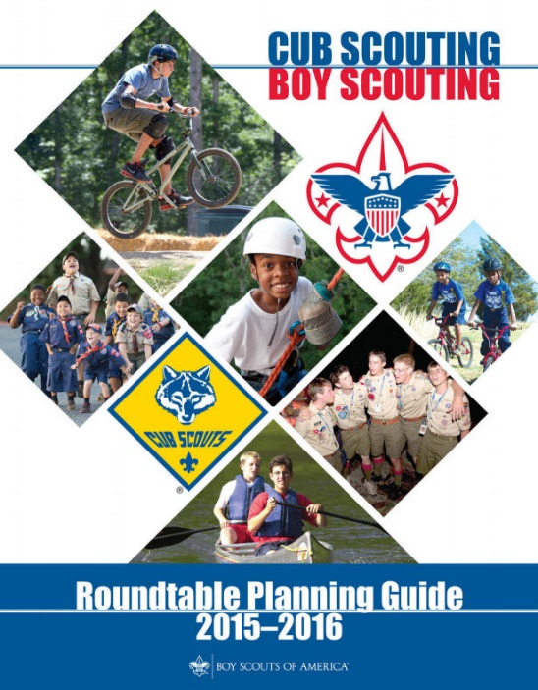
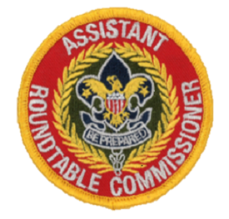
Assistant Position-Specific Roundtable Commissioners.
All who assists with the Roundtable are deemed Assistant Roundtable Commissioners. That negates the need for a staff position on the RT Team. Most importantly, it allows the assistants to pursue the normal Commissioner training and awards. Each program-specific roundtable commissioner may have as many Assistants RT Commissioners as needed; i.e., Cub Scouts may need several to facilitate their program breakouts while others may not need as many. Thus, each could have as many as they deem appropriate based on district size, attendance numbers, and breakout groups formed.
Possible areas of responsibility of Position-Specific Assistant Roundtable Commissioners: Cub Scout, Boy Scout, Varsity, and Venturing include:
- Positions Specific – backs up the CS, BS, Varsity, or Venturing RT Commissioner.
- Break Out Leaders (e.g. CM, DL, CC, and other break outs at Cub RTs)
- Attendance (Registrar)
- Info Center
- RT Feature Coordinator
- Preopening
- Ceremonies
- Refreshments (Cracker Barrel)
- Facilities
- Trading Post & Displays
- Historian (Photographer)
- Camping Coordinator – to track what units are doing and prepare presentations to help them or ask them to share their experiences
- Spotlight Coordinator – what is happening in the district both Scouting and Non-Scouting that can be good for unit programs.
- Media Specialist



TEACHING THE SCOUT OATH & LAW TO
CUB SCOUTS
ROLL TWO FUZZY DICE
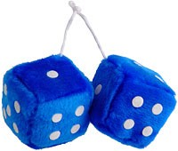
Get a pair of fuzzy dice (Novelty Shop, Oriental Trading). There are 12 numbers same as 12 points of Scout Law. Playing Options –
Option #1 -
Roll one die and either the roller or the whole den in unison recite the points of the Law up to the number. If you roll a one, they should say, “A Scout is trustworthy.” If you roll a five, they should go all the way through courteous. Have all the Cubs primed to help if the reciter stumbles. To make it easier, just roll one die until the boys master the first 6 points. Then roll both.
Option #2 –
A Cub rolls the dice. Either he figures out what part that number is (11 = Clean) or a leader tells him. Then he says a little about what that part means to him.
SING "TRUSTY TOMMY"
TRUSTY TOMMY
USSCOUTS.org
http://usscouts.org/songs/songbk1a.asp
Tune – Yankee Doodle
Trusty Tommy was a Scout
Loyal to his mother,
Helpful to the folks about,
And friendly to his brother.
Courteous to the girls he knew,
Kind unto his rabbit,
Obedient to his father, too,
And cheerful in his habits.
Thrifty saving for a need,
Brave, but not a faker,
Clean in thought and word and deed,
And reverent to his Maker.

Check it out on You Tube -
Real Scouts singing -
https://www.youtube.com/watch?v=Y0y4O5E51_k
Professionals signing -
https://www.youtube.com/watch?v=d_4SaiMC4KQ
CRAFT STICK HANGING
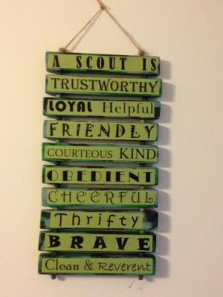
Have the Cubs each take 13 craft sticks. On the first one they write "A Scout Is" Then they put one part of the Scout Law on each of the other 12. You can play a game getting the points in order or they can create a hanging like th eon ein the picture. When you say “go,” the first boy on each team runs to his team’s pile of cards, picks what he thinks is the first point of the Law and sticks it on the wall using masking tape. He then returns to tag the next player, who runs up, chooses the second point, and places it below the first. Continue in this manner until one team has all the points on the wall in the correct order.
TAKE IT A SMALL PART AT A TIME
- Break the Scout Law into sections of three or four words. (e.g. Trustworthy, Loyal, Helpful, then Friendly, Courteous, Kind, then Obedient, Cheerful, Thrifty, and finally Brave, Clean, Reverent). Then work on one group at a time.
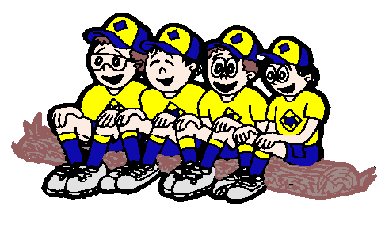
DEN MEETING TOPICS
Remember – Boys want to be active!! See, too, that they earn their awards (Never say GET. You get sick, you do not get awards – You earn awards. A little CD Philosophy).
Big Rock Ideas – suggestions for Big Rocks that fit Interest Topics or seasonal activity. If years are next to an item (e.g. 13-14) that suggested Big Rock is in that Roundtable Planning guide and on-line at http://www.scouting.org/scoutsource/Commissioners/roundtable.aspx
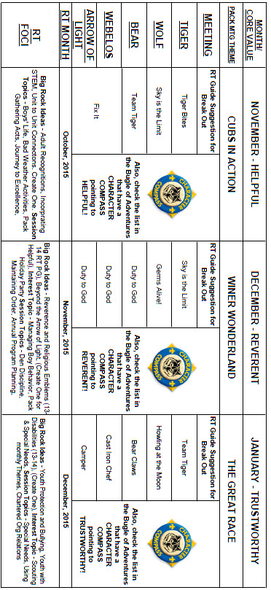

CHARACTER COMPASS
DECEMBER -
ADVENTURES with a CHARACTER COMPASS pointing to REVERENT:
TIGER –
- My Family's Duty to God (Core)
- Sky is the Limit (Elec)
WOLF –
- Duty to God Footsteps (Core)
BEAR –
- Fellowship & Duty to God (Core)
WEBELOS CORE –
- Duty to God & You (Core)
ARROW OF LIGHT CORE –
- Duty to God in Action (Core)
WEBELOS & AOL ELECTIVES –
- Into the Woods (Elec)



JANUARY -
ADVENTURES with a CHARACTER COMPASS pointing to TRUSTWORTHY:
TIGER –
- Games Tigers Play (Core)
- Curiosity, Intrigue, & magical Mysteries (Elec)
WOLF –
- Running with the Pack (Core)
- Digging in the Past (Elec)
BEAR –
- Grin & Bear It (Core)
- Marble Madness (Elec)
WEBELOS CORE –
- Stronger, Faster, Higher (Core)
ARROW OF LIGHT CORE –
- Building a Better World (Core)
WEBELOS & AOL ELECTIVES –
- Aware & Care (Elec)
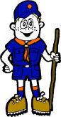

PACK MEETING THEMES
AND PLANS
www.scouting.org
From National's Website for the new plans using the Core Values based on the Scout Law:
Here are a few thoughts to consider around these new pack meeting plans. First, there is a plan for each month that corresponds with a point of the Scout Law. In addition, each plan has a theme to help make the pack meeting even more fun! The plans do not have to be used in a specific order.
Tips for Utilizing the Plans
- Pack meeting plans do not have to be done in any special order, but it is recommended that you include all of the points of the Scout Law each year. The pack planning meeting would be a good time to determine the order.
- There are pack meeting plans for multiple years posted on the website. It is your pack's choice of which one to select from each point of the Scout Law for each year.
- Pack meetings should not last longer than an hour. Adjust the plan to make it fit within the time. Research and experience tells us that Cub Scouts have a hard time sitting still for that long. Keep the meetings fun, active, and engaging.
- If you are comfortable with a costume to fit the theme of the meeting, go for it!
- Importantly, keep it simple and make it fun.
- The following required adventures have a requirement that suggests or requires completion at a pack meeting. Please plan accordingly as part of your annual program planning process. Work with your den leaders to plan when these activities will take place.
Tiger
- Tigers in the Wild, requirement 5. Participate in an outdoor pack meeting or pack campout campfire. Sing a song and act out a skit with your Tiger den as part of the program.
- Games Tigers Play, requirement 3. Make up a new game, and play it with your family or members of your den or pack.
Wolf
- Council Fire, requirement 6c. Create a den project from recyclables for a pack meeting.
Bear
- Grin and Bear It, requirement 2. Working with the members of your den, organize a Cub Scout carnival and lead it at a special event.
- Grin and Bear It, requirement 3. Help younger Cub Scouts take part in one of the events at the Cub Scout carnival.
Webelos
- Stronger, Faster, Higher, requirement 5. With adult guidance, lead younger Scouts in a fitness game or games as a gathering activity for a pack or den meeting.
Arrow of Light
- Building a Better World (if chosen), requirement 10b. Set up an exhibit at a pack meeting to share information about the World Friendship Fund.
As a personal note: I have read some of the plans and they are excellent and just as complete as the new Den Leader Books. The games, and other stuff are right there. Including costuming ideas for that added PIZAZZ!! If you do not use themes and do not add PIZAZZ you are not doing your best for your pack.
GOOD JOB!!! From CD
Check them out at:
http://www.scouting.org/Home/CubScouts/Leaders/CubmasterResources/PackMeetingPlans.aspx


Kim, the chair of the task force, says "I do want to stress that the focus is still the Core Value and the theme is just there as an enhancement. The theme pack meeting plans are specifically crafted to bring out the important points of the Core Value in a fun way."

Pack Meeting Themes
2015–2016 Pack Meeting Plans
November | Helpful | "Cubs In Action"
December | Reverent | "Winter Wonderland"
January | Trustworthy | "The Great Race"
February | Friendly | "Friends Near And Far"
March | Thrifty | "Cubstruction"
April | Cheerful | "Strike Up The Band"
May | Kind | "My Animal Friends"
June | Obedient | "It's A Hit"
July | Loyal | "Scout Salute"
August | Courteous | "S'more Cub Scout Fun"

2016–2017 Pack Meeting Plans
September | Helpful | "To The Rescue"
October | Kind | "Creepy Crawlers"
November | Courteous | "Cubs In Shining Armor"
December | Cheerful | "Celebrate"
January | Obedient | "Cub Scout City Council"
February | Reverent | "Passport To Other Lands"
March | Loyal | "Our National Treasures"
April | Thrifty | "Power Up!"
May | Clean | "A Picnic With Pizzazz"
June | Brave | "Roaming Reptile Alert"
July | Trustworthy | "Let The Games Begin"
August | Friendly | "#CUBSCOUTS"
If you are using a paper copy the link to all the
Pack Meeting Plans is:
http://www.scouting.org/Home/CubScouts/Leaders/CubmasterResources/PackMeetingPlans.aspx

UPCOMING MONTHS
- December's Core Value, Reverent,
will use the theme, Winter Wonderland
Month | Year | Theme
REVERENT
(Themes for former CV Faith are listed here)
November | 1942 | Thanksgiving
November | 1952 | Faith of his Fathers
December | 1960 | Guiding Stars
November | 1974 | Pilgrims
November | 1980 | Thanksgiving-Living & Sharing
November | 1984 | Turkey Day
November | 1992 | Turkey Day
November | 2003 | Pilgrims of Plymouth Rock
December | 2005 | Faith, Hope & Charity
December | 2007 | Celebrations Around the World
April | 2011 | Faith
April | 2012 | Faith
April | 2013 | Cub Scouts Give Thanks
April | 2014 | My Family Tree
April | 2015 | Soaring the Skies

Month | Year | Theme
Potential "Winter Wonderland" Months
December | 1939 | Pack Christmas Party
December | 1946 | Cub Scout Santa Claus
December | 1952 | An Old-Fashioned Christmas
December | 1956 | Christmas In The Americas
December | 1957 | Happy Holiday
December | 1962 | The Magic of Christmas
December | 1963 | Old-Fashioned Christmas
December | 1964 | Winter Festival
December | 1966 | Yuletide Everywhere
December | 1968 | Winter Wonderland
December | 1974 | Old Fashion Christmas
December | 1976 | Winter Festival
December | 1980 | Happy Holidays
December | 1983 | Giving Gifts
December | 1987 | Happy Holidays
December | 1988 | Holiday Magic
December | 1990 | Giving Gifts
December | 1993 | Holiday Magic
December | 1999 | Holiday Magic
December | 2000 | What do … at Holiday Time?
December | 2001 | Works of Art
December | 2002 | Winter Wonderland
December | 2007 | Celebrations Around the World
December | 2008 | Holiday Lights
December | 2009 | Works of Art
December | 2012 | Holiday Lights
- January's Core Value, Trustworthy,
will use the theme, The Great Race
- A SCOUT IS TRUSTWORTHY
A Scout tells the truth and keeps his promises. People can depend on him.
- HOW DOES “THE GREAT RACE” RELATE TO THIS POINT OF THE SCOUT LAW?
Being a member of any type of racing team provides an opportunity to demonstrate trustworthiness. The team members must trust each other to always be prepared and perform their tasks to the best of their abilities. They trust that in the event of a loss, the entire team will demonstrate good sportsmanship toward each other as well as toward the other team.
Month | Year | Theme
Potential "The Great Race" Months
DERBIES
July | 1956 | Cub Scout Regatta
August | 1975 | Model-Boat Regatta
January | 1987 | Pinewood Derby
CARS
July | 1965 | Cub Scouts on Wheels
June | 1983 | Fun on Wheels
June | 2007 | Wheel into Summer
January | 2008 | Cub Scout Car Show
SPORTS
September | 1939 | Cub Olympics
August | 1945 | Sports
August | 1950 | Cub Scout Olympics
August | 1953 | Sports Carnival
August | 1956 | Cub Scout Field Day
June | 1960 | Cub Scout Olympics
June | 1964 | Cub Scout Olympics
June | 1966 | Sports Carnival
July | 1968 | Cub Scout Olympics
June | 1970 | Olympics
August | 1970 | Cub Scout Field Day
July | 1972 | Cub Scout Olympics
June | 1975 | Sports Carnival
June | 1979 | Learn a Sport
June | 1990 | Sports Arena
August | 2002 | Sports Extravaganza
July | 2005 | Play Ball!
June | 2008 | Go For The Gold
July | 2009 | Cub Scout Sports
June | 2010 | Hoop-De-Doo

Month | Year | Theme
TRUSTWORTHY
(Themes for former CV's Honesty & Responsibility)
October | 2010 | Responsibility
August | 2011 | Honesty
October | 2011 | Responsibility
August | 2012 | Honesty
October | 2012 | Jungle of Fun
August | 2013 | Kids Against Crime
October | 2013 | Down on the Farm
August | 2014 | Heroes of History
October | 2014 | Dollars and Sense



WEBELOS
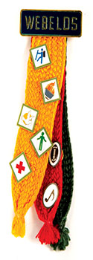
Leadership for Webelos Den Overnighters
Commissioner Dave
in response to a question
I was asked -
"Dave – What are the training requirements for leadership on a Webelos Den overnight camping trip with a local troop?" The questioner went on to explain that their unit is chartered to a Catholic Church and besides BSA's Youth Protection, ALL adults on the trip who are staying overnight (that means ALL parents) must have completed the Catholic Youth Protection training and be fingerprinted. No exceptions. So they were okay with Youth Protection. The question dealt with Webelos Leader Outdoor Training. The Den Leader has not taken the training but one of the Assistants has. However, that assistant may not be on this particular trip.
The Cub Scout Outdoor Program Guidelines (http://www.scouting.org/filestore/pdf/510-631.pdf ), says:
Webelos Den Overnight Camping
Webelos den campouts serve to move the Webelos Scout to the next level of the BSA’s ever-increasing challenge in the outdoors. The boy and his parent or guardian will be introduced to the basics of Boy Scout camping. A Webelos den leader who has completed position-specific training and Outdoor Leader Skills for Webelos Leaders training should conduct these events. In most cases, each youth member will be under the supervision of a parent or guardian. In all cases, each youth participant is responsible to a specific adult. Webelos dens are encouraged to participate in joint den-troop campouts, particularly in the fifth-grade year. These campouts should be conducted with an individual troop for the purpose of strengthening ties between the pack and the troop. BSA health and safety, age-appropriate guidelines for Cub Scout activities, and Youth Protection guidelines apply. When camping with a troop, Cub Scout guidelines still apply for all Cub Scout members. Webelos dens are encouraged to visit Boy Scout camporees and Klondike derbies. The purpose of these visits should be for the boys to look ahead with anticipation to their future as Boy Scouts and observe troops they might join. Webelos Scouts should not compete or participate in activities designed for Boy Scouts. Webelos Scouts should not spend the night at the event if the program is Boy Scout–based. A separate Webelos-only event known as a WebelosRee should be provided by the council or district. To provide leadership for this event, Webelos den leaders should complete the course, Outdoor Leader Skills for Webelos Leaders.
Cub Scout Leader Book
On page 139 of the 2015 printing of the CS Leader Book is a matrix titled, "CS Outdoor program Options," listing all outdoor options for Cub Scouts. Under required Training for Webelos Den Overnight Campouts it, too, says should be trained in Outdoor Leader Skills for Webelos Leaders.
To summarize:
Although BSA rules and guidelines do not require an Outdoor Leader Skills for Webelos Leaders trained Webelos Leader on a Webelos Den Overnight Campout, they make a strong case that the leader should have been so trained.
Another option, may be to see if the sponsoring Troop, has a leader who recently "graduated" to Boy Scouts with his/her Den and has taken Outdoor Leader Skills for Webelos Leaders recently. It could be that person's responsibility to make sure the weekend's program is Webelos oriented versus Boy Scout.
Other Items:
Two-Deep Leadership Required It is the policy of the Boy Scouts of America that trips and outings may never be led by only one adult. Two registered adult leaders, or one registered adult leader and a parent of a participant, one of whom must be 21 years of age or older, are required for all trips and outings. The chartered organization has the responsibility to stress to the unit leaders that sufficient adult leadership must be provided on all trips and outings.
Sleeping Arrangements No youth may sleep in a tent with an adult other than his parent(s).
Comments welcome. Let me know your opinion -
Davethecommish@gmail.com

December Crazy Holidays
Jodi, SNJC Webelos Resident Camp Director Emeritus,
2006-2011. Adapted from http://holidayinsights.com/moreholidays/index.htm
http://www.brownielocks.com/month2.html
December is:
- AIDS Awareness Month
- Bingo (the game) Birthday Month
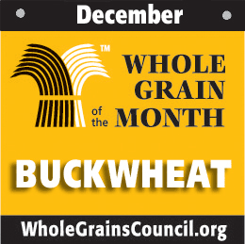
- Buckwheat Month
- National Drunk & Drugged Driving (3D) Prevention Month
- National Write A Business Plan Month
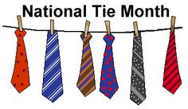
I had to learn to tie a tie (and my shoes) in
order to earn my Wolf Badge in 1957. CD
- National Tie Month

- Operation Santa Paws (1-19)
- Quince and Watermelon Month
- Safe Toys and Gifts Month
- Spiritual Literacy Month
- Take a New Year's Resolution to Stop Smoking (TANYRSS) (12/17 - 2/5)
- Tomato and Winter Squash Month
- Universal Human Rights Month
- Worldwide Food Service Safety Month
- Write a Friend Month
Week Celebrations:
- Tolerance Week: 1-7
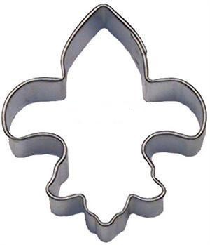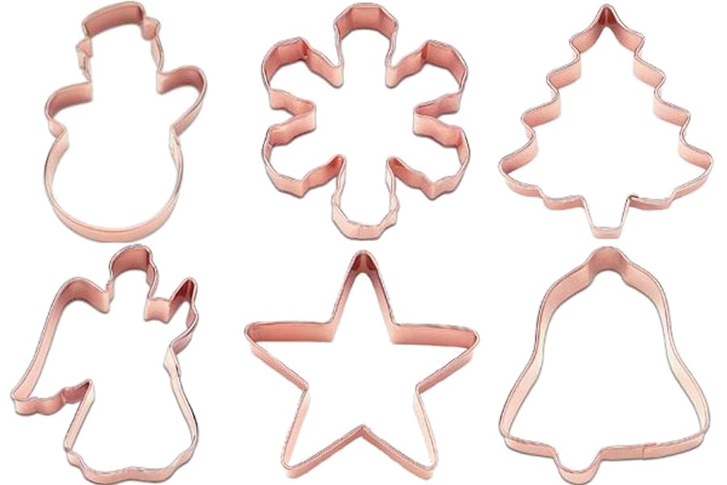
- Cookie Cutter Week: 1-7
- Clerc-Gallaudet Week: 3-10 (First Week)

- National Handwashing Awareness Week: 6-12
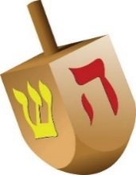
- Hanukkah 7-14
- International Coelenterate Biology Week: 7-11
- Older Driver Safety Awareness Week: 7-11
- Recipe Greetings For The Holidays Week: 7-11
- Computer Science Week 7-13
- Human Rights Week: 10-17
- Gluten-free Baking Week: 13-19 (Week Before Christmas)
- Halcyon Days: 14-28 (Always 7 days before and 7 days after the Winter Solstice)
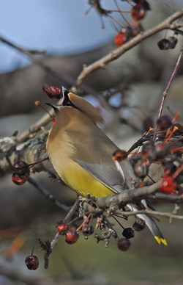
- Christmas Bird Count Week: 12/14-1/5
- Posadas: 16-24
- Saturnalia: 17-23
- It's About Time Week: 25-31
- Kwanzaa: 26-1/1
Each Day of December 2015 has a holiday:
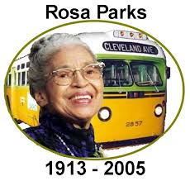
- 1 Rosa Parks Day
- 1 Eat a Red Apple Day
- 1 World Aids Awareness Day
- 2 National Fritters Day
- 3 National Roof over Your Head Day
- 4 Santa’s List Day -
we hope you are on the "Nice" list
- 4 Wear Brown Shoes Day
- 5 Bathtub Party Day
- 5 Repeal Day - The 21st Amendment ends Prohibition
- 6 St. Nicholas Day
- 6 Mitten Tree Day
- 6 Put on your own Shoes Day
- 7 International Civil Aviation Day
- 7 Letter Writing Day
- 7 National Cotton Candy Day -
Would you like some fairy floss?
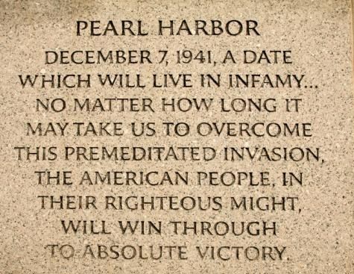
- 7 Pearl Harbor Day

- 8 Pretend To Be A Time Traveler Day
- 8 National Brownie Day
- 8 Take it in the Ear Day
- 9 Christmas Card Day
- 9 National Pastry Day
- 10 Human Rights Day
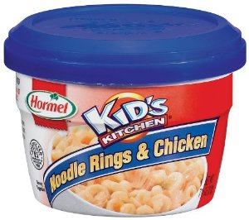
- 11 National Noodle Ring Day
- 12 National Ding-a-Ling Day
- 12 Poinsettia Day
- 13 Ice Cream Day
- 13 Violin Day
- 13 International Children's Day
- 14 Roast Chestnuts Day
- 14 National Bouillabaisse Day
- 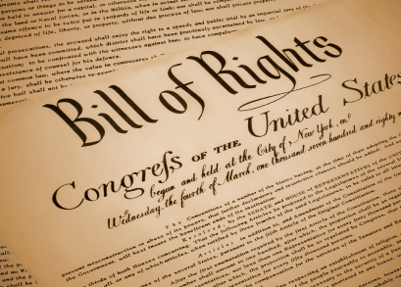
- 15 Bill of Rights Day
- 15 National Lemon Cupcake Day
- 16 National Chocolate Covered Anything Day
- 17 National Maple Syrup Day
- 18 Bake Cookies Day
- 18 National Roast Suckling Pig Day
- 19 Look for an Evergreen Day
- 19 Oatmeal Muffin Day
- 20 Go Caroling Day
- 21 Forefather's Day
- 21 Humbug Day
- 21 National Flashlight Day
- 21 Look on the Bright Side Day
- 22 National Date Nut Bread Day - or September 8!?
- 23 Festivus - for the rest of us
- 23 Roots Day
- 24 National Chocolate Day
- 24 National Egg Nog Day

- 25 Christmas Day
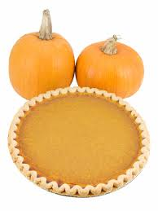
- 25 National Pumpkin Pie Day for recipes see Pumpkin Nook 's Cookbook
- 26 Boxing Day
- 27 Make Cut Out Snowflakes Day
- 27 National Fruitcake Day
- 28 Card Playing Day
- 29 Pepper Pot Day
- 30 National Bicarbonate of Soda Day
- 31 Make Up Your Mind Day
- 31 New Year's Eve
- 31 Unlucky Day

Point of the Scout Law
for December - Reverent
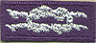

Teachable Moments
- Consider taking a field trip to an historic place of worship. Visit an early church or mission and learn about the history and faith of people who lived in your area earlier.
- As you work on the new Cub Scout Adventures, remind boys that their abilities be they mental for the STEM type badges or physical for sports and athletic badges are all gifts from God. Reinforce in a positive way that they should be thankful for these gifts.
Den Activities
Search for Faith
Alice, Golden Empire Council
Words in this search all pertain to belief in God – words may be in any direction.
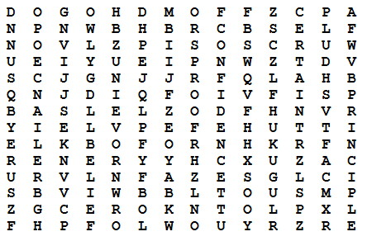
Here are the words:
Belief Principle Certain
Proof Confidence Reliance
Friends Religion God
Self Hope Sure
Loyalty Trust
Song - Cub Scout Garden
Commissioner Dave
Tune: She'll Be Coming Round the Mountain.
It is Fall (and Winter) and harvesting our gardens is either happening or over. Gardening is a great example of reverence and faith in God. I wrote this one a few years ago. It has many more verses. (Too many for Cub Scout attention spans!!)
Be sure to create some really good motions for the verses!
We will plant our Cub Scout Garden in the spring
We will plant our Cub Scout Garden in the spring
We will plant our Cub Scout Garden
We will plant our Cub Scout Garden
We will plant our Cub Scout Garden in the spring
We will pray to God to watch our crop each day
We will pray to God to watch our crop each day
We will pray to God to watch
We will pray to God to watch
We will pray to God to watch our crop each day
We will reap our harvest early in the fall
We will reap our harvest early in the fall
We will reap our harvest early
We will reap our harvest early
We will reap our harvest early in the fall
Then we’ll Thank God for his help with our garden
Then we’ll Thank God for his help with our garden
Then we’ll Thank God for his help
Then we’ll Thank God for his help
Then we’ll Thank God for his help with our garden
Web Resources
Activities for your Den for Reverent
Based on the British Beaver Scout Faith Badge
Commissioner Dave
The December 2009 issue of Beaver Magazine published by the Scouting in England for Leaders of their youngest boys (British Beavers are equivalent to our younger Cub Scouts), has an article on their non-denominational Faith badge with many great activities your dens could do. Multi-cultural activities include Christian, Judaism, and Islam.
http://scouts.org.uk/documents/Magazine/decjan_09/beavdecjan09.pdf
I checked the link is good - CD, October 29, 2015
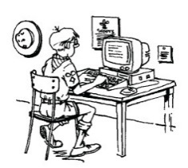
Links to Faith-Based Scouting Groups:
(List is incomplete. Send me others you know about so next year I can have a longer list. Thank you CD)
http://www.nlas.org/
National Lutheran Association on Scouting
(CD is a member of NLAS)
http://www.ldsbsa.org/
Church of Jesus Christ of Latter-day Saints BSA Relations Office
http://www.presbyterianscouters.org/
Presbyterian Church
http://www.jewishboyscouts.com/
Jewish Boy Scouts
http://www.nccs-bsa.org/
National Catholic Committee on Scouting
http://nycatholicscouts.com/
New York Catholic Scouts
http://www.naums.org/
National Association of United Methodist Scouters
http://baptistscouters.org/
Association of Baptists for Scouting
I checked these, too - CD, October 29, 2015
Religious Awards for Cub Scouts
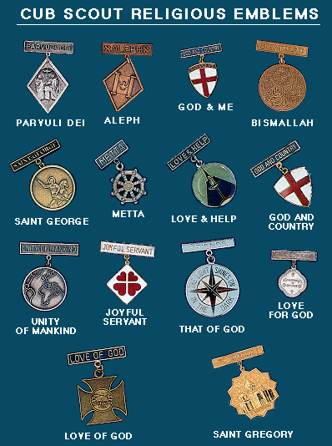
Chart from http://bsa-la.org/index.php?page=cub-religious-emblems
Go to the Special Opportunities section for details on
Cub Scout Religious Awards, Adult Religious Awards,
and Religious Emblem coordinators in your
Council, District, and Unit.

BSA SOCIAL NETWORKS

SCOUTING MAGAZINE ON YOU TUBE

Scouting magazine You Tube Channel
http://www.youtube.com/user/scoutingmag

Check out cool stories and interviews -
Cool camp of the month – Camp Cedars, Nebraska
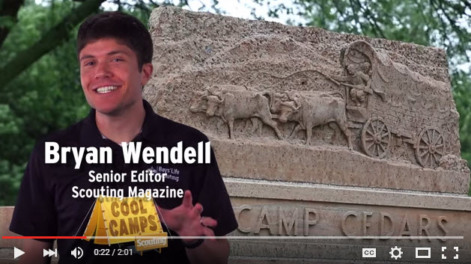
Check it out at –
https://www.youtube.com/watch?v=x0kCUrebtjo

BSA FACEBOOK PAGE
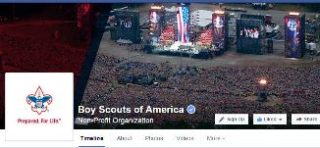
BSA Facebook page
https://www.facebook.com/pages/Boy-Scouts-of-America/113441755297
On the Facebook page you can read about –
Tufts Study Confirms: Scouting Builds Character in Six Critical Areas
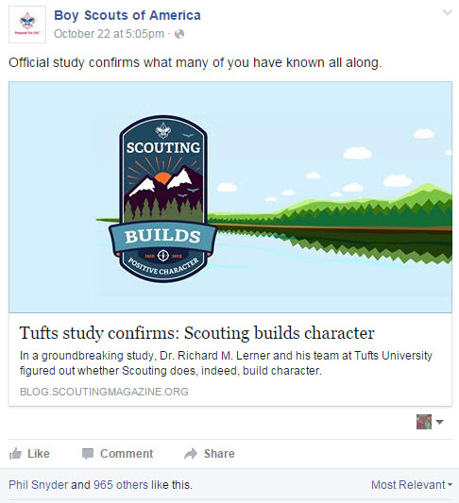
Go To: http://blog.scoutingmagazine.org/2015/10/22/tufts-study-confirms-scouting-builds-character-six-critical-areas/
2019 World Scout Jamboree: Dates, location, theme, logo
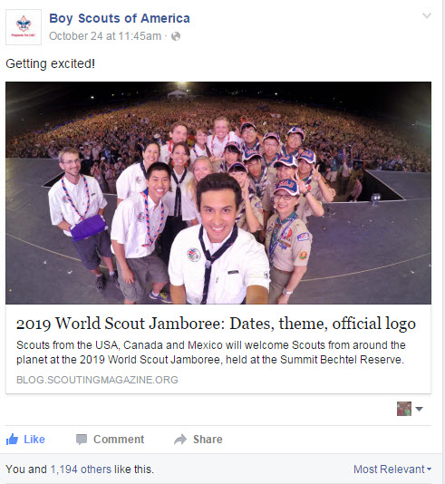
Go To: http://blog.scoutingmagazine.org/2015/08/11/2019-world-scout-jamboree-held-summit-bechtel-reserve-gets-dates-theme-official-logo/

CUBCAST

http://www.scouting.org/Scoutcast/Cubcast.aspx

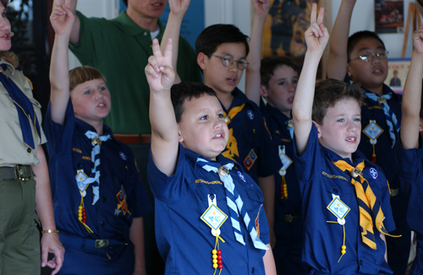
October 2015 -
Putting the Uniform in Uniformity
Robert Baden Powell, the founder of Boy Scouting, said, "The uniform makes for brotherhood, since when universally adopted it covers up all the differences of class and country." But what exactly do we mean by “uniform”? Is it the official blue or maybe the same T-shirt? Northern Star Council Scout Executive, John Andrews joins us for the answers and shares a great tip on how to be sure all the boys in your pack are dressed for success.
Listen Hear –
http://www.scouting.org/filestore/scoutcast/cubcast/201510_1/CC_Oct_Uniformity.mp3



Be sure to check out National's website
for the latest on the
Adventure Program Changes -http://www.scouting.org/programupdates.aspx

SCOUTCAST

http://www.scouting.org/Scoutcast/Scoutcast.aspx

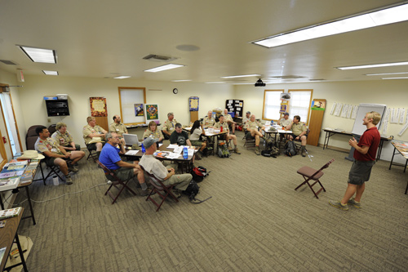
October 2015 -
Advanced Leadership Training: What’s In It for You?
Don Wendell, father of ScoutCast co-host Bryan Wendell and former chair of the National Advanced Leadership Task Force, stops by the ScoutCast studio to tell us all about the various advanced leadership courses that the BSA offers and how those courses will help you become not only a better leader (which makes the program better for the youth), but also a better employee, manager, parent, etc., and have a good time doing so. Take the first step to being a better you and click the Download button to hear more.
Listen Hear –
http://www.scouting.org/filestore/scoutcast/resources/201510_1/SC_OCT_AdvancedTraining.mp3

It is possible that by the time you get Baloo's Bugle and click the link, there may be new Cubcast and/or Scoutcast posted. Do not worry, all previous Cubcasts and Scoutcasts are available from the home page.
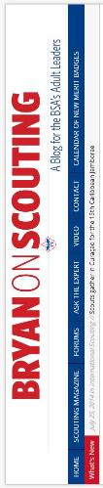
Bryans Blog
October 2015
“Bryan on Scouting” is the official blog of Scouting magazine, a Boy Scouts of America publication. Scouting magazine is published five times a year and is received by 1 million registered adult volunteers.
Bryan covers many topics every month. He keeps his Blog current and deals with the latest issues.
His articles this past month are listed below (Every title has a hyperlink). The articles in BLUE are of special interest for Cub Scout Leaders.

Northern Tier is your gateway to pristine lakes, rivers and forests
October 26, 2015 // 1 Comment
Scouts and Venturers who enter Northern Tier's wilderness each summer get to explore a vast series of lakes and rivers during their 6- to 14-day journey.
SCOUTStrong Be MedWise award encourages responsible use of medicine
October 23, 2015 // 4 Comments
The Boy Scouts of America this week launched the SCOUTStrong Be MedWise award, which encourages young people to learn about the responsible use of medicine.
Meet the first recipient of the Grand Slam of High Adventure Award
October 23, 2015 // 27 Comments
For attending all four bases, Owen Buzan of the National Capital Area Council became the first recipient of the Grand Slam of High Adventure Award.
2016 We the Students Essay Contest will award $2,500 to Scout, $500 to his troop
October 22, 2015 // 6 Comments
One skilled Scout will receive a $2,500 scholarship for himself and $500 for his troop by winning the 2016 We the Students Essay Contest.
Tufts study confirms: Scouting builds character in six critical areas
October 22, 2015 // 25 Comments
In a groundbreaking 2.5-year study, Dr. Richard M. Lerner and his team at Tufts University figured out whether Scouting does, indeed, build character.
When encouraging proper uniforming becomes unkind
October 21, 2015 // 229 Comments
Proper uniforming is a worthy pursuit, but sometimes that pursuit takes a turn with comments that aren't friendly, courteous or kind. Let's discuss.
Does your troop or crew do pack checks before a big hike or trip?
October 20, 2015 // 25 Comments
A., a committee chairperson in Alaska, wonders whether other Boy Scout troops (or Venturing crews) have pack checks before a big trip or hike.
Scout, currently a joining badge, to become its own rank
October 19, 2015 // 81 Comments
Scout, previously a badge a young man received upon joining, will become its own rank — complete with a new patch — beginning Jan. 1, 2016.
What is Friends of Scouting?
October 16, 2015 // 31 Comments
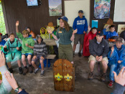Friends of Scouting is your council's annual giving campaign. In most councils, Friends of Scouting (or FOS) represents the council's largest income source.
Can one activity fulfill two (or more) Scout requirements?
October 15, 2015 // 27 Comments
Can something used to meet one Scout requirement count toward the completion of another? Let's look at using one activity for two Scout requirements.
10 Scout fundraising tips to maximize profits and fun
October 14, 2015 // 10 Comments
(SPONSORED)
SPONSORED: Next time you're gearing up for a fundraiser, follow these 10 Scout fundraising tips — served up by See's Candies — to maximize profits and fun.
On Read Across the Globe Day, promote literacy among Scouts
October 14, 2015 // 2 Comments
Helping Scouts and other young people develop a lifelong love of reading by participating in Read Across the Globe Day.
Eagle Scout builds Stan Musial mosaic out of 5,980 Rubik’s Cubes
October 13, 2015 // 2 Comments
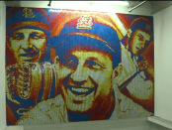St. Louis Eagle Scout Connor Wright used 5,980 Rubik's Cubes to make a 208-square-foot Stan Musial mosaic to honor the St. Louis Cardinals legend.
Grab the Kleenex: ‘Families Like Mine’ videos will inspire you, recruit others
October 13, 2015 // 7 Comments
Watch, download and share one or more of the BSA's new "Families Like Mine" videos. These inspirational videos will help your recruiting and FOS efforts.
Bullying: An affliction as real as it is preventable
October 12, 2015 // 20 Comments
If you have at least four Scouts in your unit, chances are at least one has been a bullying victim. And chances are you wouldn't know anything about it.
101 great Scout service project ideas
October 9, 2015 // 14 Comments
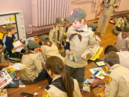These Scout service project ideas should get you started, but anything that fulfills a community need (and follows the Guide to Safe Scouting) can count.
Sliced apples turning brown? Try this camp cooking hack
October 8, 2015 // 12 Comments
Are your sliced apples turning brown before you get the chance to use them? Try this camp cooking hack from a BSA volunteer.
The wait is over: Now’s the time for advanced leadership training
October 7, 2015 // 33 Comments
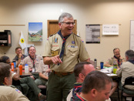The importance of advanced leadership training, that next step after basic training, is the subject of the latest episode of ScoutCast.
Why the Cub Scout uniform matters
October 7, 2015 // 18 Comments
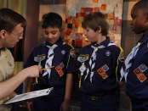The Cub Scout uniform is a tool for recruiting. It's a way for boys to show off their accomplishments. It provides a sense of belonging.
In which month do the most Scouts earn Eagle?
October 6, 2015 // 55 Comments
Turns out there's an Eagle Scout month. Scouts earn the Eagle Scout award all year long, but what might surprise you is that one month stands out.
Extreme Makeovers, Round 13: Eagle Scout project before-and-after photos
October 5, 2015 // 6 Comments
This week's batch of 24 projects includes restored pingpong tables, a refurbished miniature golf course a new entrance sign at a cemetery and many more.
North Carolina man, 103, has been an Eagle Scout for nearly 90 years
October 2, 2015 // 1 Comment
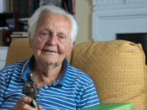Robert Dick Douglas Jr. earned the Eagle Scout award on Dec. 8, 1925. He has been an Eagle Scout longer than anyone else around: 90 years.
Scoutmaster wants to remove a certain four-letter word from Scouting
October 2, 2015 // 161 Comments
New York Scoutmaster Michael Montemarano is on a mission. His goal: eliminate a particularly irksome word from the Scouting vernacular.
How an updated uniform helps with recruiting, retention
(SPONSORED)
October 1, 2015 // 0 Comments
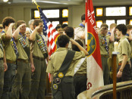 A complete and updated uniform can lead to recruiting and retention. If you think that means more sewing, I know just the thing.
2015 Jamboree-on-the-Air, Jamboree-on-the-Internet dates set
October 1, 2015 // 3 Comments
The 2015 Jamboree-on-the-Air and Jamboree-on-the-Internet, enabling Scouts to communicate with other Scouts from around the world, will be Oct. 16 to 18.
September 2015
Ken Whisenhunt, Tennessee Titans head coach, is an Eagle Scout
September 30, 2015 // 2 Comments
Eagle Scout Ken Whisenhunt, head coach of the Tennessee Titans, sat down with Eagles' Call to share his thoughts on coaching, Scouting and leadership.
Keep your paper towel roll from unraveling with this simple camp hack
September 30, 2015 // 31 Comments
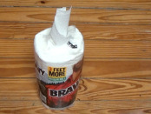A Scouting volunteer came up with a simple, ingenious way to keep your paper towel roll from unraveling when camping in the front country.
Should parents be invited to sit in at troop meetings?
September 29, 2015 // 103 Comments
In one assistant Scoutmaster's troop, there's a "heated difference of opinion" about this: Should parents be invited to sit in during troop meetings?
What are Lone Scouts?
September 28, 2015 // 29 Comments
Certain circumstances make traditional Scouting an imperfect fit for certain young men. That's why Lone Scouts was created.
American Scouter visited Pope Francis in 2014 and brought back the pontiff’s message for Scouts
September 25, 2015 // 1 Comment
Bray Barnes, Distinguished Eagle Scout and world chairman of the International Catholic Conference on Scouting, met Pope Francis at the Vatican in 2014.
Guide to the Grand Slam and Triple Crown of National High Adventure
September 25, 2015 // 25 Comments
Scouts and adults who visit three or four BSA national high-adventure bases can earn the Grand Slam or Triple Crown of National High Adventure awards.
10 things to know about flag etiquette
September 24, 2015 // 61 Comments
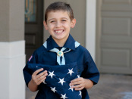A volunteer from Texas cares so much about flag etiquette that he prepared a presentation he'll send to fellow volunteers. Here are 10 things to know.
This is how to earn a merit badge
September 24, 2015 // 34 Comments
Merit badges cover American Business, Woodwork and everything between. Boy Scouts should read these 12 steps to learn how to earn a merit badge.
Meet Country Meats, a family-run business with a fascinating story
September 23, 2015 // 0 Comments
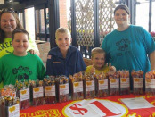Sponsored Post: You can feel good about a Country Meats fundraiser. This family-run business offers snack sticks your Scouts will have no trouble selling.
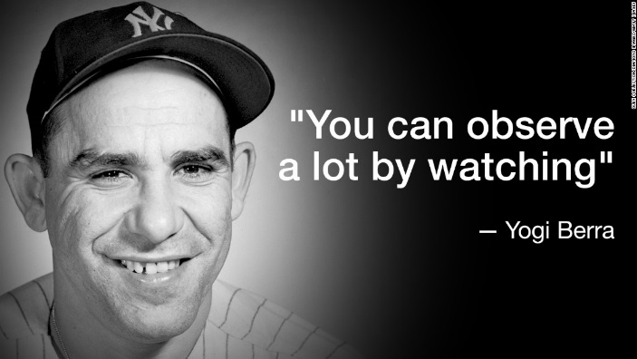
Remembering Yogi Berra, baseball legend who raised more than $1 million for Scouting
September 23, 2015 // 6 Comments
Yogi Berra, the baseball legend whose Scouting service earned him the Silver Buffalo Award, has died. He was 90.
How do you offer financial assistance to pack and troop families?
September 22, 2015 // 25 Comments
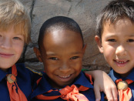No young person should be denied the Scouting experience because of money. Share how you offer financial assistance to pack and troop families.
10 times the BSA changed merit badge emblems for the better
September 22, 2015 // 66 Comments
Maybe it doesn't fully encompass the merit badge, or maybe it looks a little dated. Here are 10 times the BSA changed merit badge emblems for the better.
An Eagle Scout project doesn’t have to be permanent
September 21, 2015 // 34 Comments
Physical, construction-based Eagle Scout projects are great. But an Eagle Scout project doesn't have to be permanent to have a lasting impact.
Extreme Makeovers, Round 12: Eagle Scout project before-and-after photos
September 21, 2015 // 8 Comments
This week's batch of 16 Eagle projects includes shelving for storing hockey gear, a teaching garden at a preschool, a redesigned 4-H Snack Shack and more.

Blog Contributors
Bryan Wendell, an Eagle Scout, is senior editor of Scouting and Eagles' Call magazines.

Gretchen Sparling is associate editor of Scouting and Eagles' Call magazines.

Get Email Updates
To sign up to receive Bryan’s Blog in your E-mail –
Click the link that appears in every article. Bryan and Gretchen promise never to sell or otherwise exploit your email address. Join 6,162 other subscribers

TRAINING TOPIC

An Introduction to the Scouts Own
With Pack Family Camping strongly encouraged and promoted, Packs should be holding a Scout’s Own Service every camping trip, whether it on a traditional day of worship or not. I am sure some are doing very well, some are not, and some are simply ignoring a Scout’s Duty to God and getting home earlier. Here is a brief presentation by Kyna Hendra, “Mrs. MacScouter,” clearing up what is and is not a Scout’s Own Service. Her book that you can see on www.macscouter.com is over a 100 pages of excellent tip s and ideas for building your own Scout’s Own. CD
From the MacScouter’s “A Scout is Reverent” Book
http://www.macscouter.com/ScoutsOwn/index.html
The founder of Scouting, Robert Baden-Powell, believed that Reverence and Duty to God should be an important part of the Scout Movement and of every Scout and Scouter. He originated the notion of Scout's Own ..."a gathering the Scouts for the worship of God and to promote fuller realization of the Scout Law and Oath (or Promise), but supplementary to, and not in substitution for, regular religious observances." (Aids to Scoutmastership, p.38)
Let us first consider what Scouts' Owns are not.
- They are not Church Services, nor are they meant to be a substitute for them.
- They are not a structured liturgy like the Book of Common Order, etc.
- They are not a good opportunity for the Leader to bang home some truths with a little bit of God added for effect.
- They are not necessarily the Chaplains or Leaders' department or duty.
Given those guidelines, let's define what Scouts' Owns are. This is not what they ought to be - this is what they are; and if they do not fulfill one or more of these categories, they are not Scouts' Owns.
- They are an acknowledgment of God and his creation and ourselves as part of it, expressed in a way that all the faiths that Scouting embraces can share together.
- They are a pause in our activity to discover something deeper and more permanent in the things we are trying to achieve or learn or enjoy.
- They are a response to the Creator for the gift of life.
Which means, of course, they can be almost everything from a time of silence through a single sentence right up to a kind of service of worship that might include music and singing and stories and readings and prayers. In other words, although the next few paragraphs and pages suggest some material that could be useful for a Scouts' Own and end with a couple of outlines that might be useful for a colony/pack/troop/unit evening or in camp, there really is no "proper form."
For example, a group of Venture Scouts [older Scouts or high adventure group] may get to the summit of a mountain after a difficult or challenging rock climb and as they stand or sit down to recover and enjoy the view, one of them says, with feeling, "Thank God we made it!" and the others respond "Too right" (in context, another word for "Amen"), conscious or not, they have experienced a Scouts' Own, because they have recognized both their achievement and their growing because of it. The glory of a sunset and the breaking of the dawn; the sky at night, the hills by day and the flickering friendship round a camp-fire are absolutely natural settings for thinking -- sometimes silently, sometimes aloud -- about the power that is the beginning and end of everything and our human place in the complex order of the universe. And that's a Scouts' Own, without the need, even, for a mention of God by name -- only by implication. You see the point? A Scout's Own is really a spiritual experience that happens.
But sometimes, especially at the younger ages, it has to be underlined. So a game or an activity that has demanded effort in body or mind or in tolerance and team-work can, on the spot, be turned into a Scouts' Own with a thought and a "thank-you" for God -- no necessity for hymns or uniforms or readings. Of course, there is a place for a Scouts' Own with songs and readings -- when a time is set aside for God. Then it can be good to tell a story of adventure or challenge, where the people have relied on their faith -- whatever their faith -- in the Creator God to achieve their goal; and sing a campfire song or two about sharing and caring and serving. The song "Allelu, alleluia, praise ye the Lord" can be fun, because, divided into two groups, one does the 'Alleluias' and the other the 'Praise ye the Lord' and whenever they are singing they stand and when not they sit. This is praise that is ordered chaos and fun. Maybe that's a good description of a true Scouts' Own.
And prayers. A lot of young folk today find prayer difficult, yet the best prayers come from them. The young Cub Scout who prays "Thank you God for making me" has hit the nail on the head that's a Scouts' Own in a sentence. So it is far better to let the young people make up their own prayers - maybe creating a Group book of prayers and use it, updating it year by year. As a Leader you will never quite match, for them, the depth of their own thinking.
Finally, having, hopefully, done away with the mystique surrounding and the necessity of formality or a formal structure for Scouts' Owns, we suggest you go and get on with them - and enjoy them!
Some Ideas on Scouts' Owns
By Baden Powell
Printed in "The Scouter", November 1928
For an open Troop, or for Troops in camp, I think the Scouts' Own should be open to all denominations, and carried on in such manner as to offend none. There should not be any special form, but it should abound in the right spirit, and should be conducted not from any ecclesiastical point of view, but from that of the boy. Everything likely to make an artificial atmosphere should be avoided. We do not want a kind of imposed Church Parade, but a voluntary uplifting of their hearts by the boys in thanksgiving for the joys of life, and a desire on their part to seek inspiration and strength for greater love and service for others.
A Scouts' Own should have as big an effect on the boys as any service in Church, if in conducting the Scouts' Own we remember that boys are not grown men, and if we go by the pace of the youngest and most uneducated of those present. Boredom is not reverence, nor will it breed religion.
To interest the boys, the Scouts' Own must be a cheery and varied function. Short hymns (three verses are as a rule quite enough-never more than four); understandable prayers; a good address from a man who really understands boys (a homily "talk" rather than an address), which grips the boys, and in which they may laugh or applaud as the spirit moves them, so that they take a real interest in what is said. If a man cannot make his point to keen boys in ten minutes he ought to be shot! If he has not got them keen, it would be better not to hold a Scouts' Own at all.
Basic Concepts for Planning a Scout's Own (Interfaith Worship) Service
- Choose a setting that lends itself to the occasion and promotes reverence –
    - A grove of trees,
    - A site with a view of a lake, pond, brook, etc.
    - For small groups, sitting in a circle can be a very effective arrangement.
- Everything must be in good taste.
- The service should be planned, timed, and rehearsed.
(Generally 30 minutes maximum.)
- It should go without saying that those attending an interfaith worship service will be courteous, kind, and reverent. They should respect the rights and feelings of others even if their beliefs and religious practices differ from their own.
- Everyone in attendance should have opportunities to participate, if they wish, through responsive readings, silent and group prayer, singing, etc.
Recognizing Diversity in a Scout's Own (Interfaith Worship) Service
- Scouts practice many faiths, and many units are composed of Scouts from a variety of faiths. When this is the case during a Scout outing, ask them to suggest materials, to participate in the planning, and to assist in leading the service. If the group represents a mixture of religions, you may choose to use inspirational passages instead of particular religious materials.
- Because different faiths observe different religious practices and have a variety of holy days, it is not always possible to conduct an interfaith service in a time frame that fully recognizes individual religious obligations. This should be acknowledged and explained. Other time may need to be built into the schedule to allow individuals to meet their obligations.
- "Interfaith" means a service that all Scouts and Scouters may attend. Therefore, much attention must be paid to recognize the universality of beliefs in God and reverence.
- Encourage Scouts and Scouters to participate in religious services. Let them know ahead of time the nature of a service so that those anticipating a multi-faith experience do not find themselves surprised by a service that espouses the beliefs of a particular faith or religious tradition.
SPECIAL OPPORTUNITIES
With the start of the Cub Scout Adventure Program, the requirements for awards that say things like, "Complete Wolf Achievement 7," need to be revised to send you to the new Adventures. We have highlighted these changes here over the last few months.
To get a complete summary of all the changes to incorporate the Adventure Program, you can go to http://www.scouting.org/scoutsource/programupdates.aspx.
Or go to http://usscouts.org/advancementTOC.asp#cub
and get the changes for a specific award.

Religious Emblems
www.USScouts.org
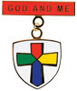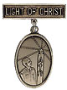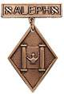
"A Scout is Reverent." All Scouts show this by being faithful in their duty to God. Some go further and give special service. This can qualify them for a religious emblem. Such an emblem is not a Scouting award. It is conferred on a Scout by his religious leader. Each faith has its own requirements for earning the emblem for members of its Faith. Listed at http://usscouts.org/advance/cubscout/religious.asp#Chart on the www.USScouts.org website are the TIGER CUB, CUB SCOUT, AND WEBELOS SCOUT emblems and where to find out about them. Before writing or visiting your local council service center, check with your religious leader. (Unless indicated otherwise below, awards listed may be earned by both Cub Scouts and Webelos Scouts, but not by Tiger Cubs)
These groups (and others) also offer religious emblems for older youth. For information on the awards available to Boy Scouts, Varsity Scouts, Venturers, and/or Explorers, Click here.
Most of the awards consist of bar pins, ribbons, and pendants, and are worn on the uniform above the left pocket on formal occasions. In addition, the Religious Emblem Square knot, shown at the top of this page, may be worn on the uniform over the left pocket by youth or adults who earned any of the religious awards.
One or more miniature devices are affixed to the knot to indicate which level(s) of the award was earned. The youth religious emblem knot may be worn on the uniform by itself or with one or more devices to indicate the program phase(s) where the award was earned. A Scout that earns a sequence of religious emblems wears one youth religious emblem knot and up to four devices, as described below.
- The CUB SCOUT device for the first level (God & Me, Maccabee, etc.) earned as a Tiger Cub or Cub Scout;
- WEBELOS device for the second level (God & Family, Parvuli Dei, Aleph, etc.) earned as a Cub Scout or Webelos Scout;
- BOY SCOUT device for the first level (God & Church, Ad Altare Dei, Ner Tamid, etc.) earned as a Boy Scout;
- VENTURING device for the second level emblem (God & Life, Pope Pius XII, Etz Chaim, etc.) earned as an older Boy Scout, Varsity Scout, Sea Scout, or Venturer. Note that Webelos Scout and Venturing devices are used to designate the second level emblems, even if the youth isn't a Webelos Scout or Venturer when the religious emblem was earned.
For more information on the Youth Religious Emblem square knot patch, go to (http://usscouts.org/awards/religyouth.asp)
For information on the devices which are attached to the knot, go to http://usscouts.org/awards/devices.asp.

FAQs about Religious Emblems
www.scouting.org
What are the religious emblems programs?
The religious emblems programs are programs created by the various religious groups to encourage youth to grow stronger in their faith. The religious groups—not the Boy Scouts of America—have created the religious emblems programs themselves. The Boy Scouts of America has approved of these programs and allows the recognition to be worn on the official uniform, but each religious organization develops and administers its own program.
I have a unit with children of all different faiths. How can I include the religious emblems programs for my unit?
The religious emblems programs should be presented to youth members and their families as an optional program for them to complete through their religious organization. Religious instruction should always come from the religious organization, not from the unit leader. Parents need to be informed of these programs and told where to get the information for their particular faith. Interested in making a presentation on the religious awards? Find sample scripts at www.praypub.org.
Do boys and girls participate in the same program?
It depends on the religion. Some religions have created programs that are used by both boys and girls. Other religions have created programs for members of separate youth agencies (i.e., Boy Scouts of America, Girl Scouts of the U.S.A., and Camp Fire). Please check the specific eligibility requirements for each religious emblems program.
Do the youth have to belong to a religious institution?
It depends on the religion. Please check the eligibility requirements for your particular religious program.
Why doesn't my religious institution know about the religious emblems programs?
Although the religious bodies at the national level created the religious emblems programs, the local religious institution may not be aware of these programs. It may be helpful to write for more information or even obtain a copy of the curriculum to give to your religious leader.
If the religious emblems program for my faith has more than one level (for the different grade levels), may my child earn all of these recognitions?
Yes. Members can earn all levels of their religious emblems program. However, they must be in the appropriate program guidelines when they start and complete each level (they may not go backward and earn younger programs).
How is the emblem presented?
The emblem should be presented in a meaningful ceremony, preferably in the youth member's religious institution. Some emblems come with a sample presentation ceremony.
How long does it take to complete a program?
It depends on the program. Some programs may take three or four months, others longer.
Where is the emblem worn on the uniform?
The universal religious square knot is worn over the left shirt pocket of the Scout uniform. The medallion is pinned over the square knot for full uniform occasions.
How do we get started on these programs?
- Youth members must obtain the specific booklet for their religion. This booklet will contain information on all the lessons and service projects that they will need to complete. Each member needs to have his or her own booklet to document progress. Some religions also provide adult manuals for counselors and mentors. Check with your local council to see if it stocks these booklets in its store, or contact the religious organization directly (addresses and phone numbers are provided at http://www.scouting.org/scoutsource/Awards/ReligiousAwards/~/link.aspx?_id=9D5FA10AEB254061A248D13D459424FE&_z=z).
- Parents must review the specific guidelines for their particular program; age/grade requirements vary from program to program. Some programs require that the youth be an official "member" of the local religious institution, others may not. Each program determines who may serve as counselor (some require clergy, others allow parents or other family members). Be sure to look at specific eligibility guidelines!
- Families should talk to their religious leaders and show them the booklet before beginning any program. Most of the religious emblems programs require that they be completed under the auspices of that religious organization, and many require the signature of the local religious leader. Again, check the specific eligibility requirements for your religious program.
- The member needs to complete the requirements, obtain the proper signatures, and follow the instructions to order the emblem/award. (These emblems are not available in your local council.) The emblem can be presented at any time of the year and should be presented in a meaningful ceremony, preferably in the member's religious institution.
Who may serve as counselor?
It depends on the program. Some programs require clergy to serve as counselor, others allow a parent or family member. Please check the specific guidelines for your religious program.
How do I order the recognition items?
Each religious program has its own emblem. Follow the instructions in your recognition guidelines. These emblems will not be available in your local council!
What is the adult religious recognition program?
An adult religious recognition award is presented by nomination only. The recognition is presented to worthy adults for their outstanding service to youth both through their religious institution and one of the national youth agencies. Recipients of these awards are unaware that they are being nominated. They are nominated to receive an award by submitting the required application, letters of recommendation, and resume. Please check eligibility requirements for specific awards.
Which religious emblem square knot should I wear?
Cloth, silver knot on purple, No. 05007, may be worn by youth or adult members who earned the knot as a youth, above left pocket.
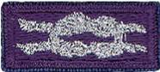
Cloth, purple on silver, No. 05014, may be worn by adult members presented with the adult recognition of a faith, above the left pocket. Adults may wear both knots if they satisfy qualifying criteria. (See the Insignia Guide, No. 33066D.)
NOTE: - Since the programs are similar or the same (as in the case of the PRAY Awards) for girls and boys in Boy Scouting, 4H, Girl Scouting, Campfire, etc., a female Venturer or Adult Leader who earned her religious award as a youth may wear the purple square knot on her uniform even though it was not earned as a member of the BSA. (My Philmont staffer daughter Dr. Darby does this!!)
Per Mike Walton of www.USScouts.org, this applies to BOTH MALES AND FEMALES, youth and adult. If you earned a youth religious emblem as a youth member, whether or not it was earned or received as a BSA member does not matter. The youth religious emblem square knot represents ANY AWARD which youth members earned or received -- period.
So yes, a Girl Scout, 4Her, or Royal Ranger/Missionette who earned a youth religious emblem in one of those programs and then either becomes an adult or youth member of the BSA (to include Venturing/Sea Scouting) may wear that emblem on their BSA field uniform; and informally wear the square knot insignia without device on the uniform shirt.
The 2015 printing of the "Guide to Awards and Insignia," states in the Special regulations section (page 9), "The Boy Scouts of America recognizes the religious emblems programs that belong to each faith group. Anyone (youth or adult) who, as a member of another youth agency (e.g., Girl Scouts of the USA, Camp Fire USA, a Sunday school class, etc.), has earned the religious emblem of their faith is eligible to wear the approved religious emblem on their respective uniform. Individuals would also be eligible to wear the religious square knot, without any device."

Adult Religious Recognitions
Baloo's Archives
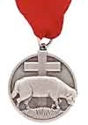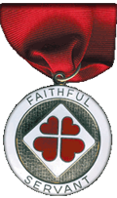
What is the adult religious recognition program?
An adult religious recognition award is presented by nomination only. The recognition is presented to worthy adults for their outstanding service to youth both through their religious institution and one of the national youth agencies. Recipients of these awards are sometimes unaware that they are being nominated. They are nominated to receive an award by submitting the required application, letters of recommendation, and resume. Please check eligibility requirements for specific awards. Self and spousal nominations are usually not allowed.
Essentially every denomination that has Youth Awards has at least one Adult Award. The award on the left is the Lutheran Lamb Award. Presented to acknowledge at least 10 years of distinguished service of a Lutheran adult in fostering the spiritual growth of youth through church and civic youth serving agency programs and to increase the use and quality of the civic agency programs in Lutheran congregations as a part of their ministries with youth. (Commissioner Dave has been presented this honor). The recipient may wear the Adult Religious Emblem Square Knot. The Lutherans also have the Servant of Youth Award to acknowledge distinguished volunteer service by adults in ministry to young people through one or more civic youth agency programs. This award may be presented to a non-Lutheran SM of a troop chartered to a Lutheran Church. (or vice versa – a Lutheran Scoutmaster of a troop at a Baptist (or other) Church)
The award on the right is the Churches of Christ Faithful Servant award. There is a minimum ten year tenure requirement for nomination. The recipient may wear the Adult Religious Emblem Square Knot.
For complete listings of Adult Religious Recognitions for BSA Leaders go to National’s site at http://www.scouting.org/scoutsource/Awards/ReligiousAwards.aspx
or US Scouts site at http://www.usscouts.org/awards/religadult.asp
Many of these awards are coordinated by P.R.A.Y. Check their website for info, too www.praypub.org
Only one Adult Religious Award square knot is worn regardless of how many awards have been received. It is possible, for example, to receive two or three levels of awards in some faiths or to receive awards from more than one faith.
So, if you know someone who is deserving of receiving the Adult Award from his faith – check it out and begin the nomination process.

Confused??
Need help to figure out these awards??

Here is with whom you can talk –

Religious Emblems Coordinators
They support the Duty to God (religious Emblems) Program, Promote Growth, & Retention in Units
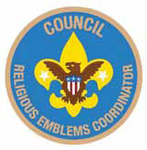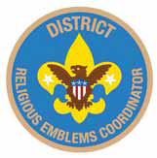
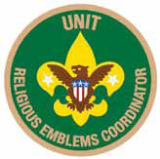
Purpose:
There are three purposes for having Religious Emblems Coordinators at the council, district, and unit levels:
- Encourage all youth to earn the emblem of their faith
- Promote religious emblems usage the way the BSA promotes other youth advancement
- Establish goals and track the number of religious emblems earned each year
Why?
Baden-Powell stated, "Religion seems a very simple thing: First, love and serve God. Second, love and serve your neighbor." (Scouting for Boys, 1908) Here are three reasons to have Religious Emblems Coordinators:
- Reinforce BSA values through religious emblems
- Improve relationships with religious chartered organizations
- Establish relationships with potential religious chartered organizations
Responsibilities -
Unit Religious Emblems Coordinator
- After appointment by the unit committee chair, serves on the unit committee
- Acquaints all youth with the religious emblems program and emblems available for their faith
- Provides Scout families and clergy with an orientation to the religious emblems program and encourages their involvement
- Urges all youth to earn the religious emblem(s) of their faith
- Disseminates information about any district or council religious emblems activities, retreats, camps, or classes
- Promotes religious emblems usage the way the BSA promotes other youth advancement
- Serves as the unit's liaison to the district religious emblems coordinator
District Religious Emblems Coordinator
- After appointment by the district program chair, attends district meetings and with district program chair, sets district goals for religious emblems.
- Encourages every unit to appoint a unit religious emblems coordinator
- Disseminates information to units through charter renewal packets, roundtables, and camporees
- Helps unit religious emblems coordinators recruit presenters to make presentations on religious emblems, including clergy of chartered organizations, unit leaders who promote religious emblems, chaplains, etc.
Council Religious Emblems Coordinator
After appointment by the council vice president of program, works with the Religious Relationships Committee. The religious emblems coordinator focuses specifically on raising awareness of religious emblems and increasing usage. The Religious Relationships Committee works directly with the faith community to recruit chaplains, coordinate the council calendar with religious holidays, sponsor religious emblems retreats, identify religious representatives from the various faith groups, and strengthen ties with local congregations and chartered organizations.
Disseminates information to district religious emblems coordinators.
Provides information for dissemination at Trainings (e.g. Colleges of Commissioner Science, Universities of Scouting, New leader trainings) and summer camp (resident and day) programs. Provides information for dissemination to Professional staff and volunteers.
Learns through the Religious Relationships Committee which faith committees are sponsoring religious emblems retreats and which congregations are offering religious emblems classes.
To learn more:
Go to National's Web Page at http://www.scouting.org/Home/Commissioners/newsletter/spotlight/10_2013_religious.aspx and "read all about it."
Then, go to Roundtable and find out who your District Religious Emblems Coordinator is and call them up for help.

Slides of the Month
Christmas Light Bulb Slide
Inspired from 2008-2009 CS Program Helps
Betsy O Northwest Texas Council
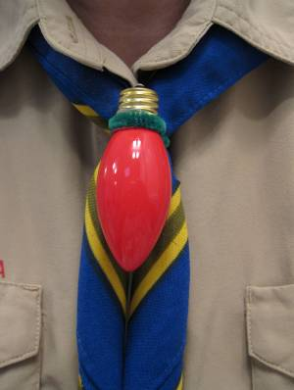
Materials:
8 inches of green chenille stem
1 C9 replacement bulb for Christmas lights
Tools:
Loaded hot glue gun
Sharpie marker
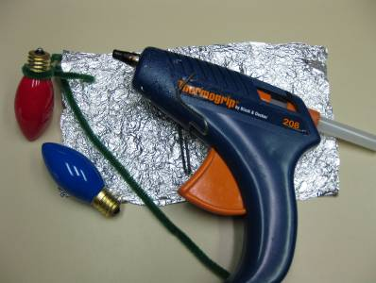
To make the Christmas Light Bulb Slide:
- Make a loop in the middle of the 8 inch chenille stem and form it tightly around the base of the light bulb where the glass meets the metal.
- Remove the stem and apply hot glue around the base of the bulb and quickly replace chenille stem. Be careful! The glue is hot!
- After the glue cools, give the chenille stem a hard twist tight against the bulb and add another drop of glue to the twist to hold it.
- Add your name and date and you are ready to go!
Flickering Candle Slide
Betsy O, Northwest Texas Council
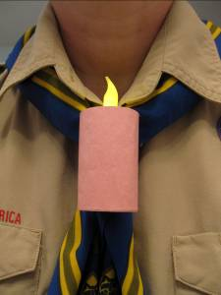
Materials:
Battery operated L.E.D. flickering candle tea light
Paper towel or toilet paper roll cardboard tube
Construction paper- white for a Menorah candle, red, black or green for a Kwanzaa candle or pink or yellow for a birthday candle
1/2 of a chenille stem, preferably the color of your “candle”
Tools:
Scissors
Ruler
Pencil
Exacto Knife or awl
Loaded hot glue gun
White glue
Rubber band
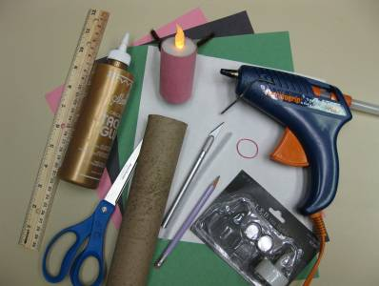
To make the Flickering Candle Slide:
- Mark and cut the cardboard tube 2 ½ inches long. Be careful not to squish your tube. (Any longer and you can’t reach in and turn on your flame)
- Slit the tube lengthwise, from top to bottom. You need to do this so that you can tightly wrap one end of the tube around the base of the candle tea light.
- Run a thin line of hot glue along the inside rim of the cardboard tube at one end and quickly roll tightly around the candle base. Hold until the glue has set. Add more glue to the overlapped cardboard to hold the side together.
- Measure and cut construction paper to wrap around “candle”. Glue and use a rubber band to hold until the glue sets.
- Form the ½ chenille stem into a square bottomed “U” shape. The base should be about 1 inch wide. Glue perpendicular to the back seam of the candle about 1 inch down from the top. Add your name and the date, turn on your candle and voilà!

THEME & PACK MEETING IDEAS

GATHERING ACTIVITIES
Note on Word Searches, Word Games, Mazes and such – In order to make these items fit in the two column format of Baloo’s Bugle they are shrunk to a width of about 3 inches. Your Cubs probably need bigger pictures. You can get these by copying and pasting the picture from the Word version or clipping the picture in the Adobe (.pdf) version and then enlarging to page width. CD
December Number Rhyme
Baltimore Area Council
Fill in the right number at the end of each line. After you have completed one through six, add up the numbers to get the answer for number seven.
- Take the number of letters in SANTA ______
- Count a half dozen candy canes. ______
- Check the number of ears on a panda bear. ______
- Count the wings on two shiny toy planes. ______
- Count the points on a treetop star. ______
- Count the number of kings in a favorite
Christmas carol ______
- They add up to a date in December- -
It’s our merriest day, by far! ______
Answer – 5+6+2+4+5+3=25
Backward and Forward
Baltimore Area Council
Can you fill these blanks with words that are spelled the same backward as forward?
- The night before Christmas. __ __ __
- What you do with a whistle. __ __ __ __
- A little child __ __ __
- Father __ __ __
- Twelve o’clock __ __ __ __
- A chin apron __ __ __
- A live Christmas gift __ __ __
- Silent __ __ __
- A good thing you did __ __ __ __
- What a noisemaker does __ __ __
Answers – eve, toot, tot, dad, noon, bib, pup, mum, deed, pop)
Holiday Theme:
Alice, Golden Empire Council
Assign dens or families to choose a Holiday of Lights to demonstrate and explain. See some ideas under CORE VALUE RELATED: December – A Time for Respect; Also see the Holiday Around the World skit idea for some suggestions.
Invite every family to dress as they would to celebrate “their” holiday, bring a favorite holiday treat to share and display pictures and examples of how they celebrate the Holiday Season. This can be a really interesting Pack meeting, especially if you live in an area with people from many different cultures, religions and parts of the world – not everyone celebrates Christmas. Here’s a chance to learn about other holiday celebrations.
Decorate a Christmas Tree
Utah National Parks Council
Materials: Small Christmas Tree, paper, stickers, markers, glitter, etc. to make decorations
Directions:
As they arrive have the boys and their families make decorations to place on the Christmas Tree to be given to a family in need.
During the Pack Meeting announce and talk about the purpose of the tree. That it is to be donated to a family in need with all your lovely, handmade ornaments adorning it.
Christmas Carol Scramble
Utah National Parks Council
Materials: Choose several well-known Christmas carols. For each selected song, write each line on a separate piece of paper.
Directions: Give a slip of paper to everyone as they come in. Tell them to find the people who have the other lines to their song and arrange them in order. The first song team to find all the right people and sing the song is the winning team.
What Am I?
Pamela, North Florida Council
Materials: Index cards with the names of objects related to the Winter Wonderland or December Holidays written on them, tape.
As Cub Scouts and families arrive, tape a card on each person's back. Make sure the people don't see their own cards. They walk around the room and ask others questions that will help them guess the name of the object. They may ask each person only one question at a time.
Questions must require a "yes" or "no" answer.
Christmas Cheer Song Match
Utah National Parks Council
Directions: Match the phrase with the song title.
Lyrical Phrase
- Was a happy jolly soul
- Are you listening?
- In a one horse open sleigh
- No crib for his bed
- Let Earth receive her King
- As they shouted out with glee
- The lights are brightly shining
- Now you say there’s no such thing as Santa
- Like the ones I used to know
- Bring us some figgie pudding
- Sing, choirs of angels
- All is bright
- She didn’t see me creep
- He knows when you’re awake
- Dancing and prancing in Jingle Bell Square
Song Title
- I saw Mommy Kissing Santa Claus
- Grandma Got Run Over by a Reindeer
- Frosty the Snowman
- Joy to the World
- Jingle Bell Rock
- Santa Claus Is Coming to Town
- Oh Come, All Ye Faithful
- Away in a Manger
- Silent Night
- Jingle Bells
- O Holy Night
- We Wish You a Merry Christmas
- White Christmas
- Winter Wonderland
- Rudolph
Answers: 1-C, 2-N, 3-J, 4-H, 5-D, 6-O, 7-K,
8-B, 9-M, 10-L, 11-G, 12-I, 13-A, 15-F, 15-E
Christmas Card Puzzle
National Capitol Area Council
This game makes a good gathering activity. Cut an old Christmas card into irregular pieces to form a puzzle for each player and place in an envelope. As each boy arrives, give him a puzzle. If playing as a regular game, the first player to put his puzzle together is the winner.
Santa's Bag
National Capitol Area Council
Number 10 brown paper bags from 1 to 10. Put a familiar item in each bag (preferably related to Christmas), fold and staple the bag shut. Each boy is given a pencil and paper with 1 through 10 listed. Then they try to guess what is in each bag by touching and shaking the bag. They write their guess on the paper by number. The Cub with the most correct answers wins.
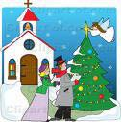
Gift-Wrapping Station
York Adams Area Council
The boys are getting to an age where they can begin to help with the wrapping of gifts (and they probably really want to do it themselves as well). Get one or two parents to set up a gift-wrapping station so that the boys can either bring in gifts they want to wrap or they can use empty containers to practice wrapping. You might want to set this up starting in the beginning of the month and make it available for each December Den Meeting.
Find Your Caroling Partners
York Adams Area Council
Prepare “sets” of cards that each contains a verse of popular carol. Hand these out to people as they arrive, instructing them to find others who have the same song/verse. Tell them they need to practice their song for a special presentation immediately following the opening. After the opening ceremony, have each group of carolers stand and sing its song.

Holiday Maze
Baltimore Area Council
Can you find the way from the bedroom to the Christmas tree?

Answers to gathering Activity Things -
December Number Rhyme: (1) 5, (2) 6, (3) 2, (4) 4, (5) 5, (6) 3, (7) 25
Backward and Forward: (1) eve, (2) toot, (3) tot, (4) dad, (5) noon, (6) bib, (7) pup, (8) mum, (9) deed, (10) pop

OPENING CEREMONIES
Holidays Lights Around The World
Alice, Golden Empire Council
- In India and Thailand, they celebrate the Festival of Lights, With little lamps or lotus boats that float into the night. [Boy carries a Lotus Boat of foil]
- In Sweden, too, they honor Santa Lucia, Queen of Light, The oldest girl will wear a crown with candles warm and bright. [St. Lucia crown or candle and greens.]
- In Mexico, the children gather goodies from the floor, For they’ve broken the piñata filled with candy treats galore! [Piñata]
- In Poland, on the table, under dishes they put straw, And they leave a chair that’s empty for the Holiest child of all. [Hand full of straw or a small chair.]
- In Ireland, each window holds a very special light, A candle that will welcome all who wander in the night, Just as Mary came with Joseph seeking shelter long ago, The candle still will welcome those who wander to and fro. [Artificial battery candle]
- In Holland, children fill their shoes with carrots and with straw ~ In hopes “Black Pete” will substitute a gift for one and all. [Wooden shoes and/or carrots]
- In Israel, the children play with a special top for a special day. [Dreidel]
- In England, children hang a sock - one that doesn’t have a hole! They hope it will hold presents and not a lump of coal! [Christmas stocking]
- Let’s Celebrate! Let’s Celebrate! and learn of special ways that people all around the world celebrate their holidays! [Globe]
Tree Opening
Utah National Parks Council
HINT: Use tree decorating as a Gathering Activity
Directions: Cubmaster uses Cub Scout sign to get everyone's attention, then Assistant Cubmaster lights the Christmas tree.
Cubmaster: “Cub Scouts, isn’t that a beautiful tree? It’s full of Holiday Lights making it bright and colorful, like the joyous seasons we celebrate this month.” (Name seasons celebrated by Pack members, such as Christmas, Hanukkah, Kwanzaa, and any others.)
Assistant Cubmaster: “And we all had a part in making it so beautiful. When all Cub Scouts work together and do their best, the result is always something fine like this tree. Let’s remember that as we repeat the Scout Oath.” (Leads Oath)
Cubmaster: "Now let us repeat the Pledge of Allegiance"
A December Gift Opening Ceremony
Alice, Golden Empire Council
Props: Box wrapped with holiday paper and tied with a bow. In the box are a menorah, small Christmas tree, invitation, Kwanzaa candelabra, and other symbols of December Holidays appropriate for your unit, Instant Recognition patch and beads, small wrapped gift, small felt stocking, and card saying "Do Your Best."
Cubmaster: (Opens box and looks inside.) December is one of the most exciting months of the year, and certainly one of the busiest. This month we have: Christmas (Takes out tree.); Hanukkah (Removes menorah.); Kwanzaa (Removes candle holder.), (Does other symbols), and Holiday parties (Takes out invitation.).
What a great time for all of us! Our pack has had lots of fun this month working on advancements (Takes patch and beads from box.).
One of the best things was our special service project/Good Turn (Takes stocking (or other symbol for the project) from box.)
We've been busy, and all the time we have followed the Cub Scout Motto: (takes paper out of box and shows it while saying motto) "Do Your Best". And we have learned to Respect the traditions of other people from around the world. We are also learning to show Respect for our flag.
Now den ___ will present the colors.
Holiday Pledge of Allegiance
2011-2012 CS RT Planning Guide
Personnel: A Cub Scout (or several Cub Scouts) , den chief, or adult leader reads the lines for narrator (NAR) and the audience (AUD) reads the other lines together. Either print the lines in the Program or Distribute the ceremony beforehand.
NAR: I pledge allegiance
AUD: At this joyous time of the year
NAR: To the flag
AUD: A symbol of unity
NAR: Of the United States of America
AUD: Where we join together in peace
NAR: And to the republic for which it stands
AUD: Where people do their best to help each other
NAR: One nation under God
AUD: Where we have freedom to worship in our own way
NAR: Indivisible
AUD: We will stand strong, giving respect to others.
NAR: With liberty and justice for all.
AUD: Where people of all races and faiths can experience true fairness
NAR: Let us remember all our blessings as we pledge our allegiance to the flag.
Christmas Flag
Baltimore Area Council
A beautiful opening but be sure of your audience before using it, please. CD
Personnel 6 Cub Scouts
Equipment taped music, American Flag
Setting Play "Joy to the World" softly in the background as Cub Scouts recite lines.
- I pledge Allegiance, at this joyous time of year.
- To the flag, a symbol of unity as Christ is a symbol of peace.
- Of the United States of America, a land chosen above all others.
- And to the republic, to the people who care and share for which it stands.
- One nation under God, who shared His Son with us.
- Indivisible, a nation united through love with liberty and justice for all.
- Please stand and repeat the Pledge of Allegiance.
Cub Scout Spirit
Baltimore Area Council
Personnel: 5 Cub Scouts, Den Chief (DC), Den Leader (DL) or Cubmaster (CM)
Equipment: 5 index card with script written on each, US flag, Pack flag
Setting: Flags are already in place in the front and each Cub Scout enters from the side one at a time and reads his script.
- December is a fun time of the year. It is a time for giving and sharing.
- As we gather for the last pack meeting of 2012 let us remember the good times.
- Let us end this year with new determination to keep the Cub Scout Spirit going.
- As we begin our program tonight, let us keep in mind the true holiday spirit.
- Remember, to give of yourself is more important than any gift you can buy.
DC: Please stand for the Pledge of Allegiance.
Holiday Lights
Utah National Parks Council
Personnel: 5 Cubs, Den Leader (DL) and Cubmaster (CM)
(I inserted the DL because of the large amount of text
to be read. DL could stand at podium or elsewhere and
read. If you have a Webelos Den and they are all good
readers, let them do the reading. Or maybe use your
Den Chief. Or have a parent for each boy up front with
them to help with the reading. CD)
Materials: Log candle holder with 3 candles (12")
Multipurpose lighter

- The theme of this month is “Holiday Lights” and we have been busy getting ready for the Holiday season.
- This month there are three major holidays celebrated by a different Religions, Hanukkah, Christmas and Kwanzaa. And each uses light in a special way.
- Hanukkah is the Jewish Feast of Lights or Feast of Dedication. The Hebrew word Hanukkah means dedication. It is a celebration of God's deliverance of the Jews in 165 BC.
DL: The Hanukkah holiday begins on the eve of the 25th day of the Hebrew month of Kislev, and lasts eight days. It usually falls in the month of December and is celebrated by lighting of candles in a special Hanukkah menorah. I light the first candle for Hanukkah. [Lights the first candle]
- Christmas is the celebration of the birth of Jesus Christ. Advent is the season of preparation for Christmas.
DL: In preparing for Christmas, Christians use an Advent wreath with four candles in the wreath and one in the center. They light one candle in the wreath each week and the center, or Christ, candle on Christmas, for Jesus is the Light of the World. The word Christmas is taken from old English, Christes maesse or Christ's Mass. I light the second candle for Christmas. [Lights the second candle]
- Kwanzaa is an African American holiday based on the traditional African festival of the first harvest crops.
DL: The word Kwanzaa comes from the phrase Matunda ya Kwanzaa, which means “first fruits” in Swahili. The holiday was developed in the United States in 1966 by M. Ron Karenga, a professor of Pan African studies and a black cultural leader. It begins on December 26th and lasts for seven days. Each day of Kwanzaa, another candle is lit on the Kinara. The candles stand for the seven principles of black culture developed by Karenga. The principles are: Unity, Self-determination, Collective Work and Responsibility, Cooperative Economics, Purpose, Creativity, and Faith. I light the third candle for Kwanzaa. [Lights the third candle]
- With the spirit of the holiday candles now burning, let us begin our own celebration of our accomplishments this month.
CM: All rise for the Pledge of Allegiance. [Perform proper flag protocols.]
Flag and Candle Ceremony
Utah National Parks Council
Note - The Three Candles closing extinguishes these
candles to close the meeting
Material: American flag, Pack Flag (optional), white candle, blue candle, red candle, white 5-pointed star, and five Cub Scouts.
Set Up: The flags have been posted in their stands before the beginning of the Pack Meeting.
The Cub Scouts walk to the front of the room carrying their unlit candles. (Candle-shaped lamps with batteries may be used in place of wax candles.)
- Practically from the beginning of time, man has used symbols to express hope, ideals, and love of his own nation. Our Flag represents the ideals of science, commerce, and agriculture. It symbolizes the sacrifices made by men and women for the future of America. It stands for your home and everything and everyone you hold dear. I light the red candle, which represents the red in our flag, and stands for hardiness and valor. It reminds us of the lifeblood of brave men and women shed in our defense.
- I light the white candle, which is the symbol of purity and innocence, and which represents the white of our Flag.
- I light the blue candle which symbolizes perseverance and justice. The blue in our Flag directs our view toward the heavens. It reminds us of a power greater than our own.
- The stars in our Flag represent the individual states. They indicate that the height of achievement for our nation is as limitless as the heavens above us.
Each Cub Scout places his candle on a table in the
center of the meeting room, situated between the
American Flag and the Pack Flag. The candles remain
lit until the end of Pack Meeting.
- Will the audience please stand and join me as we pledge our allegiance to the Flag.
With Apologies To Charles Dickens
York Adams Area Council
Reader: This is a special time of year for people all around the world. It is a time of Joy and Light, of Hope and Peace, and of the comforts of Home, Family, and Tradition. It is a time of Spirit in all things, and although there are many different types of Spirit and Spirits among us, tonight we are going to be visited by four of them.
Spirit Of Christmas: "I am the Spirit of Christmas" (Lights Advent candles, using appropriate prayer(s) and a brief statement as to what the candles and the holiday represent.)
Spirit Of Chanukah: "I am the Spirit of Chanukah" (Lights the Chanukah candles using the appropriate prayer(s) and a brief statement as to what the candles and the holiday represent.)
Spirit Of Kwanzaa: "I am the Spirit of Kwanzaa" (Lights the Kwanzaa candles and gives a brief statement as to what the candles and the holiday represent.)
Spirit Of Scouting: "I am the Spirit of Scouting, and here I light the twelve candles which the twelve points of the Scout Law, and three candles which represent the three points of the Scout Oath. I will also light one additional candle of the purest white, which represents not only the Spirit of Scouting, but also all the other Spirits of Goodness which exist throughout this old world of ours no matter what they may be called. Now, I call upon my Fellow Spirits, and all of you here in this room, to join with me in reciting the Scout Oath or Law or both.
All: (Scout Oath or Law or both)
Reader: Thank you all. Please be seated.
All Spirits: "Happy Holidays!"
Winter Wonderland
York Adams Area Council
Setup: Have the boys who are presenting the opening prepare cards that describe what “Winter Wonderland” means to them. They will read these before the Pack, so you will want to review them to make sure they’re sensible and appropriate.
Leader: Tonight we gather to celebrate the theme, Winter Wonderland. What does that mean, Winter Wonderland? To each of us it means something different, but to all of us something special. Let’s close our eyes and think about “Winter Wonderland” and let our thoughts paint pictures of what it means to us. As we do this, let’s hear from the boys in Den ___ who have already given some thought to what this means.
(Boys read off “To me, Winter Wonderland means…”)
Leader: So many different ideas all from the same two words. It’s no different than when we say “United States.” Again, two small words that mean many different things to many different people. But there is one way in which all of us are united—let’s stand and recite the Pledge of Allegiance followed by the Scout Oath — thoughts that bind us all together.
December Opening
National Capitol Area Council
Personnel: 5 Cub Scouts and Cubmaster (CM)
Equipment: 5 Index cards with script written on each, US Flag and Pack Flag. Flags are already in the front and each Cub Scout enters from the side one at a time and reads his script.
- December is a fun time of the year. It is a time for giving and sharing.
- As we gather for the last Pack meeting for 2015, let us remember the good times.
- Let us end this year with new determination to keep the Cub Scout Spirit going.
- As we begin our program tonight, let us keep in mind the true Holiday Spirit.
- Remember, to give of yourself is more important than any gift you can buy.
CM: Please stand for the Pledge of Allegiance.
AUDIENCE PARTICIPATIONS
For December –
The World's Greatest Audience Participation
The House Where Santa Claus Lives
Have everybody stand and do the appropriate motion when the item is called.
- HOUSE: Hands over head in an inverted V.
- SHED: Hands in front of chest in an inverted V.
- SLED: Hands together in a waving motion from left to right.
- REINDEER: Hands on sides of head, palms out.
- PACK: Both hands over a shoulder as if carrying a pack.
- LITTLE GIRLS: Females, young and old, stand.
- LITTLE BOYS: Males, young and old, stand.
- DOLL: Hands with palms together on cheek, with head slightly bent.
- BOX: Both hands outline the three dimensions of a box.
- LION: Extend both hands and give a deep growl.
- SOLDIER: Stand at attention; give the Cub Scout salute.
- TRAIN: Make a figure 8 with a hand.
- SANTA CLAUS: Pat stomach with both hands and say “Ho, Ho, Ho.”
NARRATOR saya the whole thing. This will not work if Narrator must read it. Occasional checks are all right. I usually have a sheet with the objects listed in large print where I can see it to check.
This is the HOUSE where SANTA CLAUS lives.
This is the SHED behind the HOUSE where SANTA CLAUS lives.
This is the SLED that is kept in the SHED behind the HOUSE where SANTA CLAUS lives.
These are the REINDEER that pull the SLED that is kept in the SHED behind the HOUSE where SANTA CLAUS lives.
This is SANTA CLAUS who guides the REINDEER that pull the SLED that’s kept in the SHED behind the HOUSE where SANTA CLAUS lives.
This is the PACK all filled with toys for good LITTLE GIRLS and good LITTLE BOYS that is carried by old SANTA CLAUS who guides the REINDEER that pull the SLED that is kept in the SHED behind the HOUSE where SANTA CLAUS lives.
This is the BOX that is kept in the PACK all filled with toys for good LITTLE GIRLS and good LITTLE BOYS that is carried by SANTA CLAUS who guides the REINDEER that pull the SLED that is kept in the SHED behind the HOUSE where SANTA CLAUS lives.
This is the DOLL that is in the BOX that is in the PACK all filled with toys for good LITTLE GIRLS and good LITTLE BOYS that is carried by SANTA CLAUS who guides the REINDEER that pull the SLED that is kept in the SHED behind the HOUSE where SANTA CLAUS lives.
This is the LION that frightened the DOLL that is in the BOX that is in the PACK all filled with toys for good LITTLE GIRLS and good LITTLE BOYS that is carried by SANTA CLAUS who guides the REINDEER that pull the SLED that is kept in the SHED behind the HOUSE where SANTA CLAUS lives.
This is the SOLDIER that captured the LION that frightened the DOLL that is in the BOX that is in the PACK all filled with toys for good LITTLE GIRLS and good LITTLE BOYS that is carried by SANTA CLAUS who guides the REINDEER that pull the SLED that is kept in the SHED behind the HOUSE where SANTA CLAUS lives.
This is the TRAIN that runs on the track and carries the SOLDIER forward and back, who captured the LION that frightened the DOLL that is in the BOX that is in the PACK all filled with toys for good LITTLE GIRLS and good LITTLE BOYS that is carried by SANTA CLAUS who guides the REINDEER that pull the SLED that is kept in the SHED behind the HOUSE where SANTA CLAUS lives.
Old Fashioned Christmas
Capital Area Council
Divide audience into three parts. Assign each part a word and a response. Instruct them they are to say the response whenever they hear the word. Practice as you make assignments.
Old Fashioned Christmas: "Peace on Earth"
Toys: "Buzz, bang, whiz
Gifts: "From the heart"
Please note when reading this that it is a poem.
What is an Old Fashioned Christmas? a boy said to his parents one day.
They thought for a while before they would venture to say.
After talking it through and pondering a while,
They tried to portray to him the Old Fashioned Christmas style.
You see the holiday season we all know of today,
Often seems a far cry from what this season should portray.
People crowd in the stores buying meaningless Gifts and Toys,
In far too large a quantity for all the girls and boys.
In the Old Fashioned Christmas, things were different you see,
Far fewer Gifts than there seem to be.
So they were all given with love beyond measure,
Making the giving a wonderful treasure.
In the Old Fashioned Christmas the best Gifts of all,
Were those of goodwill or perhaps a token so small.
Toys were not given in excess by the score,
And many Gifts were home made, not bought from a store.
So if an Old Fashioned Christmas you wish now to see,
Remember the quantity of Gifts is immaterial as can be.
For an Old Fashioned Christmas let's all now start,
By remembering, my friend, it begins in the heart!
Through the giving of kindness and goodwill to all mankind,
An Old Fashioned Christmas we certainly can find.
The Gifts with a meaning in this season play a part,
With an Old Fashioned Christmas begun in the heart!
A Great Holiday
Sam Houston Area Council
Divide the audience into 9 groups. Assign each group one of the words listed below. When their item is mentioned in the story, the assigned group should shout the designated saying. Have a practice session before starting the story.
MOM AND DAD: Remember your manners!
I: I’m soooo excited!
SNOW: Sprinkle with fingers and say
‘Flakes, flakes, flakes.”
PRESENTS: Spread arms and
shout “A new bike!”
GREETING CARDS: Hang them on the wall!
HOLIDAY DINNER: Rub stomach and
say “Yum, yum.”
DECORATIONS: Sing “Deck the halls
with boughs of holly.”
LIGHTS: Sparkle, sparkle
HOLIDAYS: All sounds and parts
at the same time.
Note -
There are 11 I's and only 4 or 5 of each of the others. CD
My favorite time of year is winter. MOM AND DAD and I love the HOLIDAYS! I enjoy sending GREETING CARDS and eating a big HOLIDAY DINNER. I enjoy colder weather and the SNOW. But most of all I enjoy seeing all the LIGHTS and exchanging lots of PRESENTS! Our house is filled with DECORATIONS.
My favorite DECORATIONS are the candles and the LIGHTS. I help MOM AND DAD send GREETING CARDS, prepare the HOLIDAY DINNER, shovel SNOW, wrap PRESENTS, put up DECORATIONS and set out the candles and the LIGHTS. After we are finished, I read stories about the HOLIDAYS. There are so many different celebrations around the world!
Our family and friends visit during the HOLIDAYS. We exchange PRESENTS with little GREETING CARDS on them. MOM AND DAD tell me I must be patient and wait to open them. Sometimes our friends bring us new DECORATIONS. We burn the candles and turn on all the special LIGHTS. I look out the window to see if there is SNOW.
Finally, we all sit down to eat our HOLIDAY DINNER. MOM AND DAD say grace and thank our guests for joining us for the HOLIDAYS. We eat our HOLIDAY DINNER while the DECORATIONS and LIGHTS sparkle all over the house.
After dinner we look at the GREETING CARDS one more time. As everyone leaves, we thank them for the PRESENTS. When I open the door and go outside, you’ll never guess what I see. SNOW!
Winter Songs
Capital Area Council
Divide audience into four parts. Assign each part a song and a response. As each part comes along, the group stands and sings the first line of their song. Instruct them as each part comes along, the group stands and sings the first line of their song. Practice as you make assignments.
Winter: "Dashing Through The Snow"
Santa: "Jolly Old Saint Nicholas"
Sleigh: "Sleigh bells ring, are you listening"
Reindeer: "Rudolph the Red Nosed Reindeer
Once upon a tune, on a cold, dark Winter night, Santa sat in his workshop trying to decide what to do. His Sleigh had a broken runner, his elves were behind schedule on toy production, his Reindeer were suffering from lack of exercise and they were weak, and he, Santa, had a cold. With Christmas only days away, and the Winter weather cold, and snowy, Santa was so depressed. Rudolph, his most famous Reindeer, was unable to get his nose recharged, so that it barely glowed at all.
In a practice run, the Sleigh with the broken runner scarcely got off the ground. With the toys to make, the elves were stopping early to watch the Power Rangers. "Goodness me!" cried SANTA. "How will I ever get everything complete by Christmas Eve?"
Out of the cold Winter night, trudged a cold, hungry old man. "Santa," cried the cold, old, hungry man. "If you will give me a hot meal and a warm place to sleep, I'll fix your Sleigh, cure your Reindeer, fix Rudolph's nose and get the elves to work faster." Santa quickly agreed. After they had eaten and a nice night's sleep, the old man went to work.
First, he plugged the nose of Rudolph, the red-nosed Reindeer into the television set. This charged Rudolph's nose so that it glowed more brightly than ever, and it also blew a fuse on the TV set. This enabled the elves to work later, since they couldn't watch the Power Rangers. They quickly caught up to schedule. In the meantime, the old man used parts of the TV set chassis to fix the runner on the Sleigh. The Reindeer, not able to watch TV, began to run in the snow, and quickly regained their strength. Santa slept better and got rid of his cold.
Because an old man knew the true value of the TV, everything was ready and on December 24th Santa hitched his Reindeer to the Sleigh and rode off into the Winter sky!

A Wintry Mix-Up
Utah National Parks Council
Directions: Print the following phrases, one per card. Number the cards. Distribute to the audience. The Narrator reads the story aloud, pausing at each blank space. The person with the next card fills in the blank. You might want to number the cards and your script in case someone is not paying attention. Make sure order is random for maximum fun.
Cards Needed -
A quart of eggnog A Little Lamb A Snowman
A pound of butter A broken TV A pair of dirty socks
A fluffy pillow A dog' s bone Chicken feathers
A snow shovel A Stocking cap An old innertube
14 cookies Lipstick Frozen fingers
Snow boots Furniture Polish Bubble Gum
It was a cold winter night. The icicles on the eaves of the cozy house hung down like _____, and the snowflakes were falling as fast as ______. Inside, Mrs. Woolley sat in her old rocker that creaked like _____. She was knitting a pair of mittens the color of ______.
Story -
"Where can my husband be?" she wondered as she went to the stove. She lifted up the lid and stirred a bubbling pan of stew. The stew smelled delicious, just like ______. Just then, two little children burst into the room. Their frightened faces were the color of ______.
"Mommy, come with us!" they cried. "Something is happening in the garage." Mrs. Woolley tossed her knitting into______ and ran out the door so fast that she almost tripped over ______. With a noise like ______, the three quietly crept to the garage. In the frosty sky overhead, the stars twinkled like ______, and the snow lay on the ground as deep as ______. Through the window of the garage, they could see a figure pulling tools off the shelf and stuffing them into a sack that was as lumpy as ______.
"A robber," Mrs. Woolley whispered to the children. "You grab ______, and you grab ______, and I'll make a noise like______ to scare him away."
But just then, the door opened, and the person inside quietly crept out. "Stop, thief", Mrs. Woolley tried to shout, but she was so frightened, her voice sounded like ______. The figure with the sack stopped short. Then there was a jolly laugh, and a voice said, "What are you doing out here so late?"
It was daddy, himself! He said he was just gathering some tools to fix the broken sled, which had lost ______. Daddy had the day off tomorrow, and wanted the whole family to go sledding. He took each child by the hand. "Your hands are so cold, they feel like ______," he said.
They all hurried into the house for a bowl of stew, which tasted better than ______on that cold night. Then he gathered the family around the fire, which was crackling like ______, and read them all a story about ______. How wonderful it was to be together again.

Holiday Masterpiece
Sam Houston Area Council
Divide the audience into 6 groups. Assign each group one of the words listed below. When their item is mentioned in the story, the assigned group should shout the designated saying. Have a practice session before starting the story.
CANDLE(S): "Flicker, Flicker"
TREE(S): "Standing Tall!"
GIFT(S): "Thank You!"
FAMILY: "I love them!"
FOOD: "Yum, Yum"
HOME: "Home Sweet Home"
DRAW(ING): Everyone says “Work of Art!”
Let’s imagine you are each DRAWING a picture of a holiday scene. Let’s start with your HOME, a place to come in from the cold. Add some TREES outside with a bit of frost on the branches. Because the lights are lit inside your HOME, you can see your FAMILY through the windows. Who will you have in your DRAWING of your FAMILY? And what is your FAMILY doing on this chilly night at HOME? Will you DRAW them playing games together or wrapping GIFTS or sharing their favorite FOOD?
Let’s imagine more.
Add some CANDLES to your drawing. Make them shiny and bright. Are the CANDLES lit for Hanukkah or for Kwanzaa? Or will you draw a Christmas TREE with CANDLE lights for your FAMILY in your HOME?
Draw some GIFTS under the TREE or near a Menorah lit with CANDLES. You might draw some homemade GIFTS made for Kwanzaa. These GIFTS will be for your FAMILY that you drew inside your HOME.
We can’t forget the FOOD in this picture! Preparing and eating FOOD is an important part of a FAMILY’S holiday fun! What kinds of FOOD will you DRAW? The FOOD for Kwanzaa might be corn and fruit and vegetables. You might DRAW a turkey all shiny and brown for Christmas dinner. Or maybe your FOOD will be crispy latkes, with applesauce on top. You can each imagine your favorite FOOD in your DRAWING – something yummy that you can share.
When you finish with all the details, your DRAWING may have CANDLES, it may have TREES, and it may have FOOD and GIFTS and HOME and other things your FAMILY enjoys. Make it your masterpiece.
Now that you’ve imagined your DRAWING and created it in your mind, you might be ready to put your special DRAWING on an actual piece of paper. DRAW the picture that you imagined for your FAMILY. It could even be your GIFT to them for the holidays.
In closing, use this opportunity to send each boy home with “special” piece of drawing paper that he can use to draw his masterpiece for his family at home.

ADVANCEMENT CEREMONIES
Note from Commissioner Dave
Please be careful when doing Advancement ceremonies in December. The awards should never be presented as gifts. The Scouts have earned them. Gifts are often undeserved. Don’t confuse our Scouts. Make sure the Scouts and the audience knows all awards were earned.
Winter Wonderland
Capital Area Council
There is something refreshing about the look of a field or woods after a good snowstorm. It’s the look of a clean, unblemished land. I’m sure it was this picture that was on the person’s mind when the term “Winter Wonderland” was first coined. Even when we think of the words ourselves, I’m sure there’s more than one of us here that thinks of such a picture. Close your eyes for a moment and think about it… Winter Wonderland. Winter Wonderland. Winter Wonderland.
Keeping your eyes closed, I want you to concentrate on the image that comes to mind when I give you another phrase: Cub Scout Wonderland. Cub Scout Wonderland. Cub Scout Wonderland.
I don’t know about the rest of you, but the image that comes to mind for me is one of fun. Kids running around having a good time doing things. But I also see smiles on boys’ faces for having done things really well. I see the look in their eyes that comes from having done something they never even thought they’d be able to do. It’s the look of excitement and wonder. It’s the look of goodness—a healthy, hardy look.
Okay. Now let’s open our eyes and see these same things in real life. Look around and what do you see? I’ll tell you what I see. I see you, Cub Scouts, who are pleased with yourselves for having succeeded beyond measure. I see the parents who are proud of what they sons are doing and glad that they are part of it. I see the brothers and sisters who are having almost as much fun as their Cub Scout brothers are having. It is a sure sign of the success of the Scouting Program and the all of your hard work.
Tonight we will recognize our Tigers, Wolfs, Bears, Webelos, and Arrow of Light Scouts who have worked so hard and achieved so much.
[For each rank, call off the award and/or rank, say a few words about it, the call the boys' names, inviting them forward with their parents to receive their awards.]
Christmas Awards
Baltimore Area Council
CHARACTERS:
SANTA - with long list & empty sack,
HELPER X with green cap,
6 HELPERS with red caps, working tools & toys,
Cubmaster (CM) and Assistant Cubmaster (CA).
SETTING: Santa's workshop, with all 7 helpers busy working on toys & whistling or singing "Jingle Bells". As curtain opens, Santa enters, puzzled, despaired, checking list in hand.
SANTA: Ho, Ho, Ho! This is an unusual list from the Cub Scouts of Pack _____. We're running out of time! Good grief! Sakes alive!
(Sits down with sack opened, looking very sad.)
Helper #1 I've worked on trains, have they run out of brains?
Helper #2 It's clear to see - they don't want trucks from me!
Helper #3 Surely Santa, you know the score! That's no Ho,Ho! Please tell us more.
Helper #4 I know, great red & white one ... they need a change. (Rattles change in pocket.)
Helper #5 That's right, wise leader. Any new ideas in our "goody range"?
Helper #6 Shazam! Methinks the Cubs are tired of toys. How about more "Adventure Loops" for those boys?
Helper X (Runs across stage, carrying a cardboard shield on large sack - Christmas type - with a Cub Scout emblem painted on it.) Sock it to 'em Santa!
(He places shield in Santa's sock.)
Santa then gives awards to Cubmaster to distribute. (Awards were either hidden in "empty" sack, or placed in bag with shield)
CM Thanks Santa for awards then explains to Santa how the awards were earned. That the awards are not gifts but recognition for the things the Cub Scouts have done.
Comment from CD - Be sure to really stress this point. The boys earned the awards. They are not gifts. Don't let boys and parents think we just give out badges without meaning.
CM & CA Present awards to parents to present to their sons. Then, they lead cheers. They make sure every boy receive individual recognition.
Climbing the Tree
Capital Area Council, Utah National Parks Council
Baltimore Area Council
Materials: Have a Christmas tree with various colored lights. (This can be a cardboard tree with holes for the lights.) The bulbs should be unscrewed slightly so that they can be easily turned on at the proper time. You may wish to use yellow lights for the bottom row (BOBCAT), orange lights for the next row (TIGERS), red lights next (WOLF), green lights on the fourth row (BEAR), and blue lights for the top row as well as the top of the tree (WEBELOS).
Personnel: Cubmaster (CM) and Assistant Cubmaster (CA)
CM: As we look at our tree this evening, we see that it is dark, with only one light on. [Screw in top light.] This is the light which represents the Webelos Arrow of Light Award.
Let us see if there are boys here tonight who can help light the way to the top of the tree, to the highest rank in Cub Scouting.
The first step along the Cub Scout trail is the BOBCAT. [Turn on light at the bottom. If there are any Bobcats to be inducted do it here. Call boys and parents forward, present badges to parents to award to sons. Lead cheer.]
Once a boy has achieved this honor, he is ready to climb.
CA: Next is Tiger. Boys complete 6 Core and 1 Elective Adventure to earn their Tiger Rank. The following boys have completed these requirements: [Call boys and parents forward and any boys who have earned any Tiger Track beads, too. Present badges to parents to award to sons. Lead cheer.]
Thank you, boys. We are now able to turn on the light representing the Tiger rank. [Turn on next light.]
CM: There are 6 Core and 1 Elective Adventure to complete for the rank of Wolf. Some of these require knowledge of the United States flag, keeping strong, safety, and being useful to the family. The following boys have completed these requirements: [Call boys and parents, present badges to parents to award to sons. Lead cheer.]
Thank you, boys. We are now able to turn on the light representing the Wolf rank. [Turn on next light.]
CA: As the boy grows older and stronger, he is able to climb higher. But just as it is a little more difficult to climb the upper branches of a tree, so the Adventures are a little more difficult for the Bear rank. [Call boys and parents forward. Present badges to parents to award to sons. Lead cheer.]
Thank you, boys. We are now able to turn on the light representing the Bear rank. [Turn on next light.]
CM: Now the boys have reached 4th grade and have more climbing to do. The next climb will bring them to the Webelos Award. In order to reach the Webelos Award they must earn 4 5 Core and 2 Elective Adventures. The boys who have earned their Webelos badge have begun to learn what Scouting really is. [Call boys and parents forward, present Webelos badges to parents to award to sons. Lead cheer.]
We are now able to turn on the light representing the Webelos rank. [Turn on next light.]
CA: These boys have helped us light our tree, but it is still not quite as bright as it might be. Since they have received help from their parents and leaders, let us turn on a light for the parents, too. [Turn on another light.]
Now the boys have reached the 5th grade and have one more climb to go. This last climb will bring them to the top of the tree and the coveted Arrow of Light.
To encourage them on their way to the Arrow of Light, let us turn on our last light because, as you have learned throughout Cub Scouting, you have helped to make the world brighter. [Turn on another light.]
CM: Now our tree is complete. As you have seen, it has taken boys plus parents and leaders to complete it. With the same effort you have shown before, keep working for the highest rank in Cub Scouting. Congratulations to you and your parents for the fine work you have done.

LEADER RECOGNITION & INSTALLATION

The Light of Scouting
Baltimore Area Council
Setting – You will need candles for every person in the pack. Wrap each candle in foil to create a drip plate.
Scene – Dim the lights in the room. There should be two candles on a table in the front of the room. The pack committee should be near the front with the Cubmaster and the Assistant Cubmaster. The den leaders line up on each side of the room after the pack committee, and the Scouts line up next to their den leaders. Make sure the Cubmaster has a lighter.
(Cubmaster lights one of the candles on the table
and turns to speak to the group.)
This candle represents the spirit of Scouting. All by itself in this big room, it doesn’t seem like much. But then, the spirit of Scouting finds me, as your Cubmaster
(Lights the 2nd candle from the 1st, and continues.)
While this is a little better, it is not nearly enough light. Fortunately, the spirit of Scouting continues to spread from me to the Assistant Cubmaster and to our wonderful Pack Committee
(Cubmaster lights candle of Assistant Cubmaster,
and then they each light one candle of the pack
committee members. Lighting continues from one
candle to another until all the pack committee
candles are lit.)
The spirit of Scouting doesn’t stop there! It continues to spread as more and more folks learn about the riches and treasures found in our program.
(Den leader candles are lit from pack committee members.)
Are you starting to see a pattern? Don’t you think having even more spirit would be better? How do the den leaders spread their Spirit? That’s right! They spread the spirit of Scouting with their dens and all the Tigers, Wolves, Bears, and Webelos Scouts can experience this spirit.
(Den leader lights one candle of the den and
Scouts light one candle from a previous candle
until all Scout candles are lit.)
Wow! Isn’t this better? Let’s consider that this is just one pack. We’re a small part of one district in one council in the United States. The spirit of Scouting burns all over the world! So, when our light combines with all the other lights in all the other packs all over the world, the spirit of Scouting becomes a tremendous beacon to guide Scouts on their journey through life. I hope you carry this spirit of Scouting with you all your life!

Here’s to the Scouters’ Spouses
Utah National Parks Council
Obtain Scouter's Husband awards (#33765) and Scouter's Wife Awards (33766) from National Supply (www.scoutstuff.org) or your local National Shop.
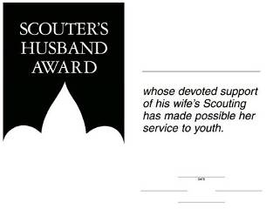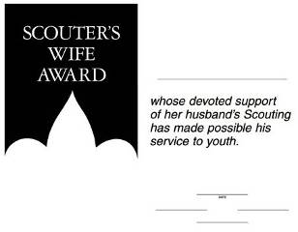
Fill In the information and sign them.
Then at a Pack Meeting (Blue & Gold?) call them forward, read Here’s to the Scouters’ Spouses and present the certificates.
Here’s to the Scouters’ Spouses
By Carol Shaw Lord
You quietly sit
While we threaten to quit
And encourage us to keep on a tryin’.
Without you being strong
We wouldn’t last long
You’re the one’s we always rely on.
You listen (without squawks)
While we practice our talks
While we’re gone you pick up the slack.
You do our share of chores,
And butler the doors,
And help keep us on the right track.
Here’s to our spouses
Who care for our houses,
That’s great help we could never hire.
Why, you hardly even mutter
While the house fills with clutter
As the Scouting stuff piles ever higher.
For all your warm greetings,
When we come from our meetings,
And helping us out in a crunch,
For manning the phone,
And your struggles alone,
We say to you all, thanks a bunch!

Christmas Wreath
Utah National Parks Council
- Have each Scout trace their hand on green construction paper.
- Cut out all the hands and place them together in a circle with the fingers pointing outward, forming a wreath.
- Decorate with red berries using markers or crayons.
- Give to the head of their Chartered Organization as a ‘Thank You' and Christmas Card. (Or Cubmaster. Or each Den for their Den Leader. Or one for each Committee Member. Or ...)

Scouting is a Candle
Sam Houston Area Council
Materials –
Candles - longer tapers, OR small birthday cake candles
Mount each candle on a piece of wood/plywood – write in black marker – thank you for shining your light in our pack.
Have Committee Chair read this poem:
Poem could be read before or after
Cubmaster's presentation, your choice
Scouting is a candle that will light you on your way.
It’s trying on your honor, and helping every day.
Exploring worlds around you and looking wider still.
Pitching tents out in the woods and hiking up a hill.
Music and voices blended under God’s majestic sky,
Helping those around you, kindness in great supply.
The meaning in a moment, in a smile, or in a tear,
Makes you a little taller with each new Scouting year.
A promise to your God and to your country, too,
Makes you a part of your world, and your world a part of you.
It’s something that you carry wherever you may go,
A secret deep inside you that only Scouts would know.
But it’s the kind of secret that you want the world to know,
You can’t hide all the happiness; you can’t hide all the glow.
A candle glows together, it shines externally.
Make it shine on everyone, that’s the way the world should be.
Cubmaster: Tonight we would like to say thank you to some leaders and parents who have lit up our pack meeting with their helping hands. (Call adults forward and give them thanks and the memento.)

SONGS
I'm Playing In The Snow
Baltimore Area Council
(Tune: I’m singing in the Rain)

I’m playing in the snow.
I’m playing in the snow.
What a glorious feeling
It’s snowing again.
Making snowman tonight
For the whole world to see
I’m happy just playing
In the snow
Lights in the Window
Sam Houston Area &Utah National Parks Councils
Tune: Clementine
We see lights outside of houses
Candles in the windows bright
But the thing that make our hearts glow
Is the fire at our campsite.
We like hiking, and adventure
Helping others is our quest.
And we always share Scout spirit
When we try to do our best.
As the lights glow at this time of year
We pause to say a grand thank you
To the leaders who spend time with us
Now and all the whole year through.
Christmas Song
Baltimore Area Council
(tune: Rudolph the Red Nosed Reindeer)
Here's to the Cubs in our den,
As they follow, help and give;
All of the boys in our den,
Know just how a Cub should live.
Now it's time for Christmas,
We've been very helpful boys,
We've gathered lots of old things,
Fixed them up like brand new toys.
Saved our pennies every meeting,
Bought a lovely Christmas Tree;
Trimmed it up to take to
Our Den's adopted family.
Bright and early Christmas morning
When they see our shiny toys;
We'll be happy that we shared our
Christmas joys with other boys.
S-A-N-T-A
Utah National Parks Council
Tune: BINGO
There was a chubby merry man
And Santa was his name-o
S-A-N-T-A, S-A-N-T-A, S-A-N-T-A
And Santa was his name-o
Repeat verse substituting a clap for the letter S,
then S-A, Then S-A-N, ...
The Winter Pokey
Utah National Parks Council
Tune: The Hokey Pokey
You put your right mitten in,
You take your right mitten out
You put your right mitten in,
And you shake it all about.
You do the winter pokey (shiver)
And you turn yourself around.
That's what it's all about!
Continue adding additional verses:
left mitten, right boot, left boot, long scarf, warm cap, snowsuit, etc.
Giving Time
Capital Area Council
(Tune: Jingle Bells-chorus)
Giving time, sharing time
Fun for everyone
Scouters know that Christmas is
The time for deeds well done
Giving time, sharing time
Let us all take part
Join with Cub Scouts all around
And give gifts from the heart
Cub Scout Christmas
Capital Area Council
(Tune: White Christmas)
I’m dreaming of a Cub Scout Christmas
Where Cub Scout pants are given me
Then my eyes will water
Tho’ they hadn’t oughter
When a belt to hold them I will see
I’m dreaming of a shirt to hold badges
With a neckerchief and Cub Scout slide
Or a pocket knife, to last for life
Making my smile a mile wide.
Rudy, The Red-Nosed Cub Scout
Capital Area Council
(Tune: Rudolph, The Red-Nosed Reindeer)
Rudy, the red-nosed Cub Scout,
Had a very runny nose;
And if you ever saw it,
You would probably say, "Oh, Gross!"
All of the other Cub Scouts
Used to laugh and say, "Oh, Ick";
Parents would not go near him
'Cause they thought they might get sick.
Then one winter's Pack Meeting,
Akela said, "Sign's Up!"
Rudy, with your nose so wet,
A box of Kleenex is what you'll get!
Then all the Cub Scouts cheered him,
As he blew and blew and blew;
Rudy, the red-nosed Cub Scout,
We will DO OUR BEST with you!
Oh Christmas Tree
Baltimore Area Council
Tune: 0’ Tannenbaum
(1)
Oh, Christmas tree! Oh Christmas tree!
Your needles falling down on me.
Oh Christmas tree! Oh Christmas tree!
Your needles falling down on me.
"It's freshly cut," the salesman said.
But now you're home, I see you're dead.
Oh Christmas tree! Oh Christmas tree!
Your needles falling down on me.
(2)
Oh Christmas tree! Oh Christmas tree!
You fell over on my TV.
Oh Christmas tree! Oh Christmas tree!
You fell over on my TV.
The cable lines are in a pinch,
I can't watch Snoopy or the Grinch.
Oh Christmas tree! Oh Christmas tree!
You fell over on my TV.
(3)
Oh Christmas tree! Oh Christmas tree!
There's something under you I see.
Oh Christmas tree! Oh Christmas tree!
There's something under you I see.
Is it a present gaily wrapped?
No, it's a blob of gooey sap.
Oh Christmas tree! Oh Christmas tree!
There's something under you I see.
Twelve Scouting Days of Christmas
(Tune: 12 Days of Christmas. Substitute Christmas for Scouting in the leading lines as you wish)
York Adams Area Council
On the first day of Scouting, Akela gave to me
A Den Leader swinging from a tree!
On the second day of Scouting, Akela gave to me
Two Screaming Bobcats,
And a Den Leader swinging from a tree!
OK, you should have the idea by now. Here's the rest of these silly verses:
Third Day - Three Skinny Wolves
Fourth Day - Four Hungry Bears
Fifth Day - Five Webelos
Sixth Day - Six Adventure Pins
Seventh Day - Seven Silly Den Chiefs
Eighth Day -Eight Shouting Scouts
Ninth Day - Nine Warring Eagles
Tenth Day - Ten Derby Cars
Eleventh Day - Eleven Funny Den Skits
Twelfth Day – Twelve Wacky Cheers

STUNTS AND APPLAUSES

APPLAUSES & CHEERS
Capital Area Council
Rudolph Applause Put thumbs to head with fingers pointing up to form antlers. Wrinkle nose and say, "Blink, blink, blink!"
Goodbye Santa Applause Pretend to throw a pack onto your back and say, "Merry Christmas to all and to all a good night."
Frozen Cub: Wrap your arms around yourself, and say, “BRRRRR!”
Salt and pepper: Hold both fists out in front of you and raise up the thumbs. Then you turn them over and shake the shakers.
Milkshake: Shake contents in shaker bottle, slurp the drink.
Baltimore Area Council
Christmas Bells Applause:
- Pretend to hold a bell rope,
- Have the left side of the audience to say "DING" on the down stroke
- Have the right side of the audience to say "DONG" on the up stroke.
- Repeat three times.
Snowball Applause:
- Reach down and pick up some imaginary snow, and
- Pack it into a ball.
- Pull arm back,
- Throw, and yell, "Splaaaatttt!"
Scout Cheers
Utah National Parks Council
- Genius Quiet Clap - Clap hands together four times and then loudly say, “How great I am, how great I am, Genius! Genius!”
- Light Globe - Pretend to screw in a light bulb, while saying, “Bright, bright, bright!”
- Idea - Put finger on side of face and close eyes as if thinking hard, suddenly jump up, open eyes real wide and yell, “That’s the best idea yet!”
- Stamp of Approval - Pound right balled up fist in open palm of left hand.
- Nutty - Say, “This is a nutty applause. Everyone yell ‘Cashew’, three times.” After they do that, you reply, “God, bless you!”
- Okay - Divide into two groups. One group yells, “O!” the other “Kay!”
- Tony the Tiger - Yell, “Greeaaaatttt!”
- Dancer - Have all stand up, link arms, and do the Can-Can.
- Jack in the Box - Squat down and then jump as high as you can and say, “Boing!”
Banana Cheer
Utah National Parks Council
Bananas of the world unite
(place hands together above head),
Peel to the left
(lower left hand to your side)
Peel to the right
(lower right hand to your side)
Peel down the center
(place both hands above head again and lower simultaneously)
And umph take a bite!
(Snap arms back together above head in a giant bite)
GO BANANAS! GO, GO BANANAS!
(while dancing around)
Holiday Lights Cheers
Utah National Parks Council
Snowglobe - Pretend to hold a ball in your hand, shake it up and down and say, “Oooo! Aaah! Oohh!”
Santa - “Ho, ho, ho!” Hold stomach as you laugh
(Optional) Pull on reins & say, "Where's Rudolph?"
Rudolph - Put thumbs to head with fingers pointing up and form antlers; wrinkle nose and say, “Blink, blink, blink.”
Silent Night - Stand up, cup hands around mouth (as if yelling) and silently mouth the words “Great Job!”
Merry Happy - One side yells “Merry Christmas” and the other side answers “Happy New Year.” Repeat three times.
Jingle Bells - Stand and wiggle all over while saying ‘jingle, jingle, jingle.”
Dad’s Gift - Act as if opening a gift and when open say, “Oh, a new tie! Just what I needed.”
Christmas Stocking - Pretend to empty your stocking and then put it on your right foot.
Dasher - Slide hands against each other, making loud swishing noises.
Frosty the Snowman - “Thumpity, thump, thump!” twice.
Mistletoe - Pretend to hold mistletoe over your head and make kissing sounds.

RUN-ONS
Ho, Ho, Ho
Utah National Parks Council
Q: How does Santa Claus water his garden?
A: With his ho, ho, hose
Q: How does Santa Claus keep his legs warm?
A: With his ho, ho, hose
Q: How does Santa Claus weed his garden?
A: With his hoe, hoe, hoe
Q: What does Santa Claus eat for breakfast?
A: His Cheerios, hos, hos
Q: What is Santa Claus’s favorite dessert?
A: Ho Hos
Baltimore Area Council
- So what are you getting mom and dad for Christmas?
- A list of what I want.
- Why did the silly boy take the Christmas tree to a barber?
- Because his mother said that it needed to be trimmed.
Sam Houston Area Council
Knock-Knock.
Who’s there?
Divest.
Divest who?
Divest is yet to come!
Knock-Knock.
Who’s there?
Kendall.
Kendall who?
Kendall in the wind – please close the window!
Baltimore Area Council
Knock, Knock
Who’s There?
Canada
Canada Who?
Canada dog come in the house, it’s cold outside.
Knock, Knock
Who’s There?
Murray
Murray Who?
Murray Christmas to all and to all a Good Night.
Knock Knock
Who’s There?
Pizza
Pizza Who?
Pizza on Earth, Good Will to Man.
Knock Knock
Who’s there?
Donut
Donut who?
Donut open till Christmas!
Knock, Knock
Who’s there?
Avery
Avery who?
Avery Merry Christmas!
Christmas Flowers
Utah National Parks Council
#1: This year we are going to have lots of Christmas flowers.
#2: Why is that?
#1: Last year I planted all the Christmas Bulbs.

JOKES & RIDDLES
On the Beach
Capital Area Council
Cub Scout #1: What do bears and wolves get when they walk along the beach?
Cub Scout #2 I don't know.
Cub Scout #1: Sandy Claws!
Utah National Parks Council
Cub 1: What's red and white, and red and white,
and red and white?
Cub 2: A candy cane?
Cub 1: No, Santa Claus rolling down a hill.
Cub 1: What is red, white, and blue?
Cub 2: Santa Clause with a cold!
Cub 1: No! A sad candy cane.
Cub 1: Why did Santa only take 7 reindeer on his trip?
Cub 2: Comet had to stay home and clean the sink.
Cub 1: What do you have in December that you don't have in any other month?
Cub 2: The letter "D".
Cub 1: What do you call a chicken at the North Pole?
Cub 2: Lost.
Utah National Parks Council
Q: What does a Christmas tree eat with?
A: U-tinsels.
Q: What do you get when you cross a shark and a snowman?
A: Frostbite.
Q: Who is two feet tall and sings “Blue Christmas?”
A: Santa’s Elvis.
Q: What do you get when you cross Frosty the Snowman with a baker?
A: Frosty the Doughman.
Q: Why is Santa like a light switch?
A: He goes up and down a lot during the night.
Q: Why did Comet stay home on Christmas Eve?
A: She was cleaning the kitchen sink.
Q: What do snowmen eat for lunch?
A: Iceburgers.
Q: What did the walrus say to the polar bear?
A: Have an ice day!
Q: What does Santa have for a snack on Christmas Eve?
A: Peanut butter and jolly!
Q: What’s in December that isn’t in any other month?
A: The letter “D”!
Q: How many pieces of candy can you put into an empty stocking?
A: One! After that, it’s not empty!
Q: Which Holiday candles burn longer, reds or greens?
A: Neither all candles always burn shorter!

SKITS
Solving a Christmas Problem
Baltimore Area Council
Personnel: 8 Cub Scouts
Equipment: Christmas tree, chair
Setting: As the scene begins, a Cub Scout (#6) is seated, head in hands by a Christmas tree.
The other Cub Scouts enter and speak to him
- What is really wrong with you, we’ve got a lot of work to do.
- Come on don’t be so down. Your face looks terrible with that frown.
- Tell us why you are so sad. At Christmas time you should be glad.
- Maybe with Christmas so near, he’s worrying about what he’s getting this year.
- Come on and let me help you out. Because helping others is part of being a Cub Scout.
- (Jumps up and with a big smile on his fact and shakes hands and slaps on back on Cub #5)
That’s it! That’s it! Thanks old Buddy, my thinking sure was pretty muddy!
- (All look puzzled at each other) What did he do that made things right? I guess I’m just not too bright.
Cub #6: (speaking with lots of expression) I don’t have money to buy my Mom a gift you see, but now I know I’ll give her just helpful me!
- Boy I’m glad you’ve helped us all remember, the important part of that holiday in December
(All put their arms around each other and
walk off stage in a happy group)
Trimming the Christmas Tree
Baltimore Area Council
Cast: Group of Cubs, Den Leader (DL),
Materials: Scout staff with sprig of evergreen lashed to the top;
Materials to make snipping and sawing sounds (You can prerecord these on a cassette tape.)
Setting: Den Leader (DL) is on stage;
The Cubs are off to the side.
Two Cubs enter.
- Go ask the den leader how this tree is supposed to look.
- Goes to leader, acts out asking question. Leader acts out response. The Cubs run off stage, and audience can hear the sounds of sawing, snipping etc.)
- (Enters, goes to leader.) Like this?
DL: (Looks over at the Cubs who are positioned to let the leader see, but not the audience.) More off of this side. (Gestures Cub runs off stage.) More sawing sounds are heard.
Repeat this several times, with leader pointing and gesturing about different sides of the tree. Everyone is getting more and more tired. Finally after many sounds of sawing and snipping the Cubs all march over to the leader, carrying the staff with the sprig attached to the top, and show it to the leader and the audience. Leader groans and all leave.
The Gift Of Goodwill
York Adams Area Council
Arrangement: A group of 8 Cub Scouts are gathered around, wrapping Christmas gifts. Each boy is wrapping a gift. Den Chief (DC) enters.
DC: Hey guys, let me see what each one of you is wrapping.
- Gloves for my Dad.
- An owl plaque for my mom.
- Oreo cookies for my little brother… maybe he’ll quit eating mine
- A doll for my sister.
- Wind chimes for my mom.
- Ink pens for my big brother… maybe mine will quit disappearing.
- A lamp for my mom.
- A lacy handkerchief for my grandma. She likes to wave them goodbye.
DC: Hey, you guys are really giving Goodwill. (laughs)
All: We hope so. Aren’t we supposed to do that year round?
DC: Yes, but let me show you something that’s quite unusual. (He takes a large piece of poster board and a marking pen. He calls on each boy in order to name the gift he is wrapping, and he writes the first letter on the board. Such as a G for gloves, etc. The result spells out Goodwill, which he holds up for the audience to see.)
Cub #1: Hey, that’s all right! We’re giving Goodwill separately together!
All: (Look at Den Chief.) Figure that one out!

CLOSING CEREMONIES
GIFTS Closing Ceremony
Utah National Parks Council
Set Up: Den Chief (DC) or Den Leader (DL) and 5 Cub Scouts. Be sure boys have learned their parts or create cards with pictures on the audience side and the words on back in LARGE type.
DC/DL: What you are is God's gift to you. What you make of yourself is your gift to God. Make it a good gift.
- Work while you work.
- Pray while you pray.
- One thing at a time. That is the way.
- All that you do, do with all your might.
- Things done halfway are not done right.
All: (Together) Do Your Best!
Goodwill Closing Ceremony
Capital Area Council
Set Up: 8 Cub Scouts each with a sign with one of the letters on front. The words are written on the back in large print. Boys say their parts in turn.
- G - Good Cub Scouts are friends to all.
- O - On their honor to obey the Scout law
- O - Once they show how HELPFUL they are
- D - Doubled friendships will surely be found.
- W - Working together being HELPFUL will make the world a better place.
- I - Including as new friends -- boys from each faith and race.
- L - Leaving behind them a path of good cheer from being HELPFUL.
- L - Let's all practice being HELPFUL now and all through the year.
Three Candles
Utah National Parks Council
Directions: Three Cub Scouts. They walk to the front of the room to extinguish the candles.
- As I put out this white candle, which represents purity, may we be mindful that a Cub Scout is clean. He is clean in body and thought. He stands for clean speech, clean sports, and clean habits. He travels with a clean crowd.
- As I put out this blue candle, which represents loyalty, may we as Cub Scouts be ever mindful to be loyal to whom loyalty is due. We are loyal to our den leader, our home, our parents, our country, and our God.
- As I put out this red candle, which represents courage and sacrifice, may we be mindful of the sacrifices that have been made for us by many others that we may continue to enjoy freedom, liberty and justice in the great nation of the United States of America.
Christmas Spelling
Baltimore Area Council
Arrangement: Nine Cub Scouts come onstage, one by one. Each carrying a large cardboard letter. As he speaks his lines, he holds up his letter, each ultimately spell out the word Christmas. Words are n back of Letters in LARGE PRINT.
- C is for candles, we burn on Christmas night. To gladden weary travelers with their light so bright.
- H is for happiest; the happiest time of year. It's jolly, gay old Christmas tunes with all its mirth & cheer.
- R is for ring; we ring the Christmas bell. All the Christmas gladness, the world to tell.
- I is for the infant who lay in a manger. Little Lord Jesus, a dear little stranger.
- S is for shepherds who kept their flocks by night; And heard the angels singing, and saw a wondrous light.
- T is for tree, all green and gold and red. We see it Christmas morning when we jump out of bed.
- M is for the mistletoe we hang at Christmas time. In merry wreaths, when candles burn and Christmas bells chime.
- A is for all; to all men we wish cheer. Joy and gladness, love and hope, for Christmas time is here.
- S is for the star that shone on Christmas night, Star and candle, bell and wreath, all make our Christmas bright.
Wonderland Of Wonderlands: The U.S.A
York Adams Area Council.
Set Up: Cubmaster (CM) or Den Chief or den Leader and 5 Cub Scouts. Be sure boys have learned their parts or create cards with pictures on the audience side and the words on back in LARGE type.
CM: As we think about tonight’s theme, Winter Wonderland, we should also think about the other wonderlands that we have been blessed to know and experience. Here are some thoughts to ponder…
- If we could shrink the Earth's population to a village of precisely 100 people, with all existing human ratios remaining the same, it would look like this:
- There would be 57 Asians, 21 Europeans,
14 from the Western Hemisphere (North and South) and 8 Africans.
- 51 would be female; 49 would be male.
70 would be non-white; 30 white.
70 would be non-Christian; 30 Christian.
- 50% of the entire world's wealth would be in the hands of only 6 people and all 6 would be citizens of the United States.
- 80 would live in substandard housing.
70 would be unable to read.
50 would suffer from malnutrition.
- 1 would be near death, 1 would be near birth.
- Only 1 would have a college education.
No one would own a computer.
CM: When one considers our world from such an incredibly compressed perspective, the need for both tolerance and understanding becomes glaringly apparent. So look around you and embrace your fellow citizens of the world, all members of a village called humanity, who breathe life into this planet each in a unique manner and for only a miniscule moment in time - then leave their individual legacies to form, molecule by molecule and compound by compound, the history of the human race. We are one. Let's love one another, living and working together in peace and shared prosperity.

Cubmaster’s Minutes

Christmas Spirit &
the Gimme Pig
Ideas and Stories for the Scoutmaster’s Minute, BSA, 1956
I remember my Scoutmaster, Mr. Jack Bullis, Troop 227, North Bergen County Council (#350) of The Township of Washington, Bergen County, NJ, telling us this Scoutmaster's Minute as if it was yesterday. He was standing there in the gym of Washington School as we all stood and listened. The story and his presentation obviously impressed me.
If you deliver it well, maybe someone will be writing about you 60 years from now! Thank you, Mr. Bullis!! CD
There's a strange animal to be found in especially large numbers at this time of the year. It's called a "gimme pig." You can recognize it very easily. It will be saying something like this, "Gimme a bicycle. Gimme an electric train. Gimme a record player, Gimme a motor scooter. Gimme a pony."
(Okay, so it's a little dated - IPod, IPad. You can update it to the popular toys of the current year)
Do you think you have ever seen any of these strange animals?
Surely you haven't seen one in this Scout room!
No Scout could possibly be a gimme pig.
A Scout is pledged to help other people at all times.
He wants to give - that's what he's thinking about.
A real Scout never thinks "gimme."
He thinks about the good he can do, the happiness he can bring to somebody else. Because, as you know, he puts other people ahead of himself.
He is thinking about other people especially at this time of the year.
What will you give this Christmas?
How much service to other people?
How much happiness to your family?
What will you give?
December Lights Closing Ceremony
(Or Opening)
Baltimore Area Council
This is the season of decorations and lights. It is a time when the days are shorter and the nights are long. But, somehow, things seem brighter. Shopping centers are bright with holiday decorations and lights. Thousands of homes have single candles to light the way for the Christ Child. Other thousands have candles burning to commemorate the miracle of the oils of Hanukkah. Even the stars in the winter sky seem brighter. The most brilliant glow comes from the spirit of goodwill that you live all year round in the Scout Oath and Scout Law. Let us all stand and repeat them together.
Starry Night
Capital Area Council
Dim or turn off room lights except
for an electric candle or flashlight
This is the season of lights and stars, when days are short and nights are long with beautiful stars.
Lord Baden-Powell, the founder of Scouting, once said this to his Scouts, “I often think when the sun goes down, and the world is hidden by a big blanket from the light of heaven. But the stars are little holes pierced in that blanket by those who have done good deeds in this world. The stars are not all the same size; some are big, and some are little. So some men have done great deeds, and some men have done small deeds, but they have all made their hole in the blanket by doing good before they went to heaven.”
Let’s remember when we look at the starry sky, to make our own hole in the blanket, by doing good deeds that spread seeds of kindness and help other people.

CUB GRUB
Cub Grub Cookbook
This is a really great cookbook for Cubs -
http://balboaoaks.bsa-la.org/download/blog/Cub%20Grub%20Cookbook.pdf -
You can save a copy on your PC by selecting
File, Save As... in your web browser's menu bar.
Cinnamon Nachos
2011-2012 CS RT Planning Guide
Ingredients:
Corn tortillas
Vegetable oil
Cinnamon
Sugar
Directions:
- Lightly brush both sides of corn tortillas with vegetable oil.
- Cut into six wedges and bake in a 400-degree oven for four to eight minutes.
- Remove from oven, and quickly drop into a paper bag to which you have added a cinnamon-sugar mixture.
- Close the top of the bag and shake gently to coat the nachos with the mixture.
- Serve and enjoy with the hot chocolate.
Caution: The tortilla chips are very hot when taken out of the oven! An adult should do this and put them into the bag.
Note: Be aware of food allergies and diet restrictions.
Cookies to Make for National Cookie Day
December 18:

Thumbprint Cookies
Alice, Golden Empire Council
These were a big hit at RT!!
Ingredients:
1 c. butter
2 c. flour
1 tsp. vanilla
1/2 c. powdered sugar
3/4 c. quick oats
Strawberry or grape jam
1 tsp. vanilla
Directions
- Beat butter, sugar, vanilla until fluffy.
- Add flour, oats, mix well.
- Chill dough.
- Remove from refrigerator, form into 1 inch balls and place on baking sheet.
- Press thumb into center of each ball and fill with jam.
- Bake at 350 for 15 minutes.
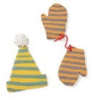Striped Dough:
Alice, Golden Empire Council
This colorful dough is perfect for the Hat & Mittens cookies. Divide the cookie dough in half and tint each a different color. Pat each half into a rectangle, about 5 by 7 inches, wrap in plastic, and refrigerate or freeze until firm. Roll each piece between two sheets of waxed paper to form rectangles that measure 8 by 11 inches and are about 1/4 inch thick.
Stack directly on top of each other. Using a sharp knife, cut the dough into strips about 1/2 inch wide. Turn each strip on its side with the stripes facing up. Place one strip near the end of a large piece of waxed paper. Press the next strip of dough parallel to the first strip, alternating the color. Place a piece of waxed paper on top of the stripes and roll over the top to make them adhere. Remove the top piece of paper and cut out shapes as desired.
Marbleized Dough: Lightly press together any scraps of the striped dough to achieve a marbleized look.
Easy Mexican Bunuelos
Alice, Golden Empire Council
There must be hundreds of recipes for bunuelos – but these are easy ones the boys can make during a den meeting for their snack.
- Use canned biscuits, cut them in half, then drop into hot oil and cook till both sides are golden.
- You can also cut small flour tortillas into quarters, drop them into hot oil and cook till slightly golden.
- Now toss your bunuelos in a paper bag or plastic sealable bag filled part way with cinnamon sugar. Another option is to just drizzle them with maple syrup or honey.
- Eat and enjoy!
Yule Log Cake
Alice, Golden Empire Council
The traditional Buche de Noel or Yule Log cake, is made by baking a cake in a jelly roll pan, frosting it, then carefully rolling it up into a “log.” Usually, a wedge is cut from one end and used to make a “knot” on one side, and the whole thing is frosted. Sometimes, meringue mushrooms are added. You can find recipes for this cake everywhere – but here are two easier versions the boys could help make.
- Make a regular cake mix, but bake in a loaf pan. Remove from pan, let cool thoroughly, then use a knife to round the top edges so you have a log shape. Cut one end at an angle to create a wedge shape – this can be added to one side to make the “knot” where a “branch” would have been. Now frost your cake and decorate with small plastic animals, such as squirrels, or add artificial leaves or berries along the bottom.
- The second version is made like a cheese log – purchase a log or trim cheese to a log shape – then “frost” with cream cheese and add decorations. Serve with crackers for a great snack.
Holly Jolly Dip
Alice, Golden Empire Council
Goes especially well with veggies.
Ingredients: 1 whole roasted red pepper (from a jar), 1 cup crumbled feta, 1 small clove garlic, 2 tablespoons olive oil
Instructions: Combine all the ingredients in a food processor. Pulse for 10 seconds, scrape down the sides, then repeat until combined, about 1 minute. Makes 3/4 cup.
Baggie Fudge
Baltimore Area Council
Ingredients
1/4 oz cream cheese
2 tsp butter
1/3 C powdered sugar
2 tsp Cocoa powder
Directions
- Put all ingredients in a sandwich sized zipper bag.
- Allow Cubs to squish and squeeze it until all the lumps are gone and what is left inside looks like fudge.

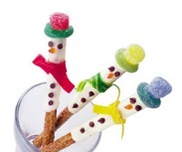Crunchy the Snowmen
Alice, Golden Empire Council
Bag of 8-inch pretzel rods, 1 cup white chocolate chips, mini chocolate chips, orange decorators' gel, fruit leather (various colors), gummy rings, gumdrops
Directions:
- Melt chocolate chips in the top of a double boiler. Dip one end of an 8-inch pretzel rod in the melted chocolate and use a plastic spoon or knife to spread the chocolate two thirds of the way down the rod.
- Set the pretzels on a sheet of waxed paper and press on mini chocolate chips for eyes and buttons. Use orange decorators' gel to add a carrot nose.
- When the chocolate has hardened, stand the pretzels in a mug or glass and tie on strips of fruit leather for scarves. For each hat, stretch a gummy ring over the narrow end of a gumdrop and secure it on the pretzel rod with a dab of melted chocolate.
White Marshmallow Snowflakes
Baltimore Area Council

Ingredients
18 small marshmallows,
1 large marshmallow,
9 toothpicks
Directions
- Break 3 toothpicks in half, leave other whole and
- Assemble snowflake as shown.
Penguin Treat
Utah National Parks Council
Ingredients:
1 1/2 Chocolate sandwich cookies
2 colored candies
3 pieces of candy corn
White frosting
Directions:
- Cut the cookie half in half (for wings).
- Divide the full cookie in half.
- Use the half without the white filling for the head, the half with the white filling for the body.
- Attach the eyes, beak, feet, and wings with the white frosting.
Holly Jolly Fudge
Utah National Parks Council
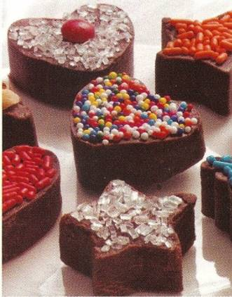
Ingredients:
3 Cups semisweet- or milk-chocolate chips
1 (14-oz) can sweetened condensed milk
1/8 teaspoon salt
1 teaspoon vanilla extract
Assorted sprinkles, sugars and candy decorations
Directions:
- Place the chocolate chips in a 2-quart bowl and microwave for 1 minute, then stir them with a wooden spoon. If the chips are not completely melted, microwave them again for 30 seconds, then stir until they’re smooth.
- Stir in the sweetened condensed milk, salt, and vanilla extract.
- Line a 9-inch square pan with aluminum foil, extending it about 2 inches beyond each side. (This makes it easy to remove the fudge later.) Lightly spray the foil with nonstick cooking spray.
- Spread the mixture evenly in the pan.
- Chill the fudge until firm, about 30 minutes in the freezer or 1 hour in the refrigerator.
- Lift the foil from the pan and place it on a flat work area. Use 1-inch cookie cutters to cut out the fudge, then lightly press decorations onto each piece. Makes about 50 pieces.
Christmas Trees
Utah National Parks Council
Ingredients:
3 Tbsp. butter
3 Cups miniature marshmallows
1/2 tsp. vanilla
1/2 tsp. green food coloring
4 Cups Cheerios
Sliced gumdrops
Toothpicks
Yellow/gold stars
Directions:
- Melt butter and marshmallows; stir often.
- Remove from heat,
- Add vanilla and food coloring.
- Fold in Cheerios.
- Cool.
- While cooling, make stars and slice gumdrops.
- Butter hands and shape 2/3 cup mixture into a tree and place on waxed paper.
- Add gumdrop slices.
- Put star on top with toothpick.
Peanutty Mice
Utah National Parks Council
Ingredients:
1/2 cup butter softened
1/2 cup creamy peanut butter
1/2 cup packed brown sugar
1 large egg
1 teaspoon vanilla extract
1 3/4 cups all-purpose flour
1 teaspoon baking soda
1/2 teaspoon salt
Peanut halves
Mini chocolate chips
Shoestring licorice
Directions:
- Cream the butter, peanut butter, and sugars.
- Beat in the egg and vanilla until fluffy.
- Sift together the flour, baking soda and salt, and stir into the wet mixture just to blend.
- Cover and chill until firm (about 1 hour).
- Shape level tablespoons of dough into balls.
- Pinch one end of the ball to form the pointed mouse nose.
- Then flatten the bottom and pinch sides to create a rounded back.
- Place the mice 2" apart on an ungreased cookie sheet.
- Push in peanut halves for ears and mini chocolate chips for eyes.
- Use a toothpick to make a small rounded hole for the tail.
- Bake in pre-heated 350 degree oven for 8-10 minutes or until firm.
- Cut the licorice into 3" long tails and insert while cookies are still warm.
- Makes 4-5 dozen.
Candy Menorah
Utah National Parks Council
Materials:
Styrofoam pieces for base
9 peppermint sticks
9 candy kisses
Directions:
- Cut a 1" square of foam and glue to center of foam base.
- Push four peppermint sticks into the foam to one side of the center.
- Push four peppermint sticks into the other side.
- Push the central peppermint stick into the center.
- On the first day of Hanukkah, "light" the Shamash and the first "candle" on the right.
To light each candle:
- Dab some frosting onto the top of the candy stick and attach a candy kiss.
- Candles are lit from right to left.
- On the eighth day, the edible parts of the menorah may be eaten in celebration of the holiday.
Reindeer Food—Birch Bark
Utah National Parks Council
Everyone knows that a reindeer’s favorite food is the tender bark of the birch tree in the early spring. So have your boys whip up a batch of birch bark to feed those reindeer on Christmas Eve.
Ingredients:
2 cups white chocolate
3/4 cup sliced, slivered or coarsely chopped almonds
Directions:
- Place 1 cup of white chocolate in a microwave-safe bowl and microwave on high for one minute.
- Remove and stir well.
- As the mixture cools, replace in microwave and turn on high for 30 seconds.
- Remove and stir.
- As the chocolate melts, add a few more pieces of white chocolate and stir.
- Replace in microwave and turn on high for 20 seconds.
- Continue to stir and add white chocolate.
- When smooth, add almonds and spread with spatula on waxed paper.
- Let harden and store in re-sealable bag with a header stapled to it reading: Birch bark. Save and leave out for Santa’s reindeer.
Candy Cane Cocoa
National Capitol Area Council
Prep Time: 5 min, Cook Time: 10 min,
Ingredients: 4 cups milk, 3 ounces semisweet chocolate, chopped, 4 peppermint candy canes, crushed, 4 small peppermint candy canes, 1 cup whipped cream
Directions:
In a saucepan bring the milk to a simmer. Add the chocolate and the crushed peppermint candies and whisk until smooth. Divide hot cocoa between four mugs garnish with whipped cream and serve with a candy cane stirring stick

GAMES
Candy Cane Pass (Relay Race)
Utah National Parks Council
Supplies: 4 candy canes per team (have several extras in case of breakage)
Play:
- The first player of each team holds 4 candy canes, one between each of his fingers on one hand.
- On ‘Go!’ he passes the candy canes to the next teammate in line – no using of the other hand to help!
- The relay continues down the line, teammate to teammate, without dropping the candy canes.
- If any candy canes are dropped, the relay starts over for that team.
- The first team to complete the relay wins.
Christmas Card Match-Up
Utah National Parks Council
Equipment: Several old Christmas cards cut diagonally into two, and divided into two carrier bags with one half of each card in each bag.
Setup:
- Take one bag and spread its cards in various places around the hall.
- Players are divided into two teams.
Game Play:
- Give one half-card to the first player of each team.
- Each player goes off to find the matching half and bring it back to their team.
- The next player is given another half-card.
- Play continues until all cards are matched.
- The team with the most complete pairs collected at the end wins.
Snowball Drop
Utah National Parks Council
Equipment: White Ping Pong ball, table.
Setup:
- Divide the participants into teams of 3-6.
- Each team kneels on opposite sides of a table.
Game Play:
- The object is to blow a “snowball” (ping pong ball) so that it will ‘drop’ off the edge of the table on the opponent's side.
- This scores one point. No one is allowed to touch the snowball or the table in any way.
- First team to score three points wins.
- Repeat play for the other participants, as needed.
Mitten Match Game
A Memory Game
Utah National Parks Council
- Make several copies of mittens and have children color each pair to match each other but be different from the other pairs of mittens.
- Cut them out,
- Then turn all mittens upside down and
Have the children take turns finding the mates. (ala Memory or Concentration)
After You
2011-2012 CS RT Planning Guide
Materials: Dishes of yogurt or dry cereal, spoons, string
- Divide players into pairs. Partners sit facing each other with a small table, chair, lapboard, etc., between them.
- Give each pair two spoons joined together with a length of string so spoons are only six inches apart.
- Place a dish of yogurt or dry cereal in front of each person.
- On signal, everyone starts to eat.
- Each person must eat only from his or her own dish and must not lift the dish off the table.
- The pair finishing their dishes first wins.
- Encourage the players to use good table manners.
Snowball Race
Baltimore Area Council
Materials:
- A container of small marshmallows per team
- A plastic spoon
- An empty container per team
Set Up:
- Players set in lines of equal length; 6 players per line.
- A container of marshmallows is placed in front of each line and an empty container is placed beside the player at the end of the line.
- Each player is given a small plastic spoon.
Action:
- On signal, the first player takes one marshmallow in his spoon and transfers it to his neighbor's spoon and so on down the line.
- The player at the end of the line receives the marshmallow and places it in the empty container and yells "It's a hit!"
- This is the signal for the first player to start the next marshmallow down the line.
- Any marshmallow that is dropped must be replaced on the spoon by the person who dropped it before it can be passed along.
- The team getting all their marshmallows into the container first, wins.
Dreidel Games
Alice, Golden Empire Council
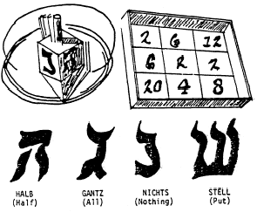
The Dreidel Game is played by making a game board from a large box top which has been squared off with appropriate numbers in each square. Each player spins the dreidel and adds or subtracts his or her score depending upon which side of the dreidel faces up and on which number it rests.
For example, if the dreidel faces up Stell on 20, the player loses 20. First player to accumulate 25 points is the winner.
The Put-Take-Nothing Game begins with each player receiving an equal amount of small candy, raisins or nuts. Each player puts one item into a "pot", or "kitty", and the players spin the dreidel in turn. Scoring is the same as in the Dreidel Game. When a player gets "Gantz", or all, each player puts in another item to make a new "pot". The game ends when one player has accumulated all of the items.
Hide the Dreidle (Hanukkah top) one Cub leaves the room. The others hide the dreidle. The Cub returns. The others yell "hot" and "cold" depending on whether he is near or far. You can use real or paper dreidle.
Pass the Dreidel Cubs sit in circle, start music. Pass the top around the circle. When the music stops, the Cub holding the dreidel drops out. Last Cub is the winner.
Pin The Hanukkah Candle
Baltimore Area Council
What you’ll need:
- A poster-size menorah
- A cardboard candle for each player
Set Up:
- Draw a menorah on a large sheet of cardboard and tape it to the wall.
- From lightweight cardboard, cut out a candle for each player.
- The candle represents the shammes or candle used to light the eight Hanukkah candles.
- Put a pin through the flame of each candle.
Action:
- Blindfold a Cub Scout and turn him around three times.
- He then tries to pin his shammes on any of the menorah's candles.
- The one who comes closest, wins.
Filling Santa's Pack
Baltimore Area Council
What you’ll need:
- A balloon for each player, color-coded for each team
- A large barrel or trash can
Set Up:
- Form two den size groups and line them up on the opposite sides of the room.
- Give one team balloons of one color; give the other team a contrasting color.
- Ask them to blow up their balloons and tie them.
- In the center of the room, have a large container - but not one large enough to hold all the inflated balloons.
Action:
- On signal, have all the boys try to tap their balloons into the barrel with one hand behind their back.
- When the container is full, stop the game.
- The team with the most balloons in the container wins.
Unscramble the String Lights
(AKA Tangle Knot)
Utah National Parks Council
Directions: Everyone stands in a circle. Each Cub Scout reaches in with his right hand and joins hands with someone NOT standing next to him. The repeat with left hands. Do not join both hands with the same person. Working as a group, try to untie the string of lights without breaking any grips. Hands may be rotated but should never lose contact. This can test the flexibility of the players/string. If the group is hopelessly tangled, the leader may break apart one set of hands and join somewhere else. If successful, the group will end up in an untangled circle.
Snow Clothes Relay
Utah National Parks Council
Materials: Two outfits of outside clothing (i.e. coats, mittens, boots, snow pants, scarf, hat, etc.), two paper bags. (Adult sized clothing makes this really funny)
Directions: Place the clothing in two bags. One team member must run across the room put the clothes on in order of receiving them out of the bag. Then run across the room and take it all off, for the next player to put on. First team to have all players finish, wins the game.
Ice Cube Race
Utah National Parks Council
Materials: A bag of ice, two spatulas, four containers
Directions: Place ice in two of the containers. Place the other two containers a fair distance away. Object of the game is to move the ice from one container to the other, by using the spatula. Boys must pick up an ice cube with the spatula and run to the other container and deposit the ice cube. First team to have all the ice in the opposite container wins.
Fumble Fingers Relay
Materials: 2 jars with screw on lids, 10 toothpicks, 2 pair of large mittens
Directions: Each team has a pair of large mittens. At a goal line is a jar, one for each team containing five toothpicks. On signal, the first person from each team races to the goal line, puts on the mittens, removes the lid, empties the jar, picks up the toothpicks and puts them back in the jar and screws on the lid. He takes off the mittens and races back to hand them to the next player, who repeats the action.
Santa Nods
- Santa is in the center of a circle made by the other players.
- Santa points at any player and says, "Santa says yes" or Santa says no".
- That player must quickly nod "yes" or shake his head "no".
- If Santa says only "yes' or "no" without first saying "Santa says", the player must not respond. If he does, he is out of the game.
- Santa should give commands quickly.
- The last person still in the game becomes the new Santa.
What Does The Snowman Say? Nothing
What you’ll need:
A hat, preferably a bowler hat and a scarf
Set Up:
One cub, the Snowman, dressed up in the hat and scarf, stands stiffly facing the group. He must not respond in any way - by giggling, moving or speaking.
Action:
- The object of the game is for the other boys to get a reply to their questions, such as "What's your middle name? Who's your best friend? Do you like ice cream?" or to make the Snowman laugh by making faces. No touching is allowed.
- Establish a short time limit and play several times. Any boy who gets a response from the Snowman becomes the next one.
- Finish up with SNOWMELT: everyone turns into a snowman and at the signal "the sun comes out," the snowmen begin to "melt down" to the floor - the last one to melt completely (stretch out on the floor) is the winner.
- Rule: keep moving at the same time.

ONE LAST THING
Beatitudes are the Cub Scouts
Capital Area Council
Blessed are the Cub Scouts
who are taught to see beauty in all things around them.
For their world will be a place of grace and wonder.
Blessed are the Cub Scouts
who are led with patience and understanding
For they will learn the strength of endurance and gift of tolerance.
Blessed are the Cub Scouts
who are provided a home where family members dwell in harmony and close communion
For they shall become the peacemakers of the world.
Blessed are the Cub Scouts
who are taught the value and power of truth,
For they shall search for knowledge and use it with wisdom and discernment.
Blessed are the Cub Scouts
who are guided by those with faith in a loving God
For they will find Him early and will walk with him through life.
Blessed are the Cub Scouts
who are loved and know that they are loved
For they shall sow seeds of love in the world and reap joy for themselves and others.

Beatitudes for Those Who Care
Sam Houston area Council
Blessed are you who take the time to listen to difficult speech for you help me know that, if I persevere, I can be understood.
Blessed are you who never bid me to "Hurry up," or take my tasks from me and do them for me. For I often need time rather than help.
Blessed are you who stand beside me as I enter new and untried ventures. For my failures will be outweighed by the times I surprise myself and you.
Blessed are you who understand that it is difficult for me to put my thoughts into words
Blessed are you who, with a smile, encourage me to try one more.
Blessed are you who never remind me that today I asked the same question twice.
Blessed are you who respect me and love me just as I am.

The Five Finger Prayer
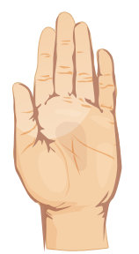
- Your thumb is nearest you. So begin your prayers by praying for those closest to you. They are the easiest to remember To pray for our loved ones is, as C. S. Lewis once said, a "sweet duty."
- The next finger is the pointing finger. Pray for those who teach, instruct and heal. This includes teachers, doctors, and ministers. They need support and wisdom in pointing others in the right direction. Keep them in your prayers.
- The next finger is the tallest finger. It reminds us of our leaders. Pray for the president, leaders in business and industry, and administrators. These people shape our nation and guide public opinion. They need God's guidance.
- The fourth finger is our ring finger. Surprising to many is the fact that this is our weakest finger, as any piano teacher will testify. It should remind us to pray for those who are weak, in trouble or in pain. They need your prayers day and night. You cannot pray too much for them.
- And lastly comes our little finger the smallest finger of all which is where we should place ourselves in relation to God and others. As the Bible says, "The least shall be the greatest among you." Your pinkie should remind you to pray for yourself. By the time you have prayed for the other four groups, your own needs will be put into proper perspective and you will be able to pray for yourself more effectively.

