ADVENTURE TIME!!
Change is the law of life.
And those who look only to the past or present are certain to miss the future.
John F Kennedy

The NEW Cub Scout Adventure Plan!!!
For the BOYS –
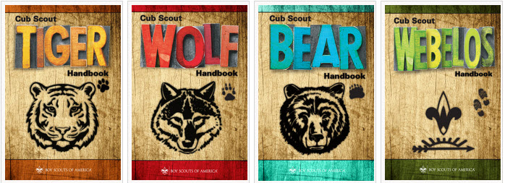
For the DEN LEADERS!!!
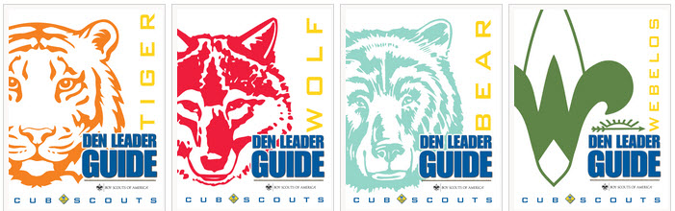
For EVERYONE!!!
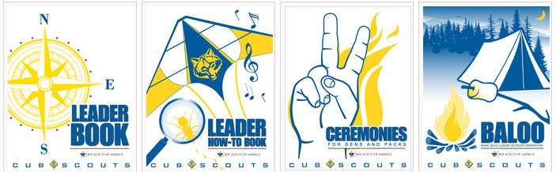

Table of Contents
ADVENTURE TIME!! 1
Table of Contents 1
The Cub Scout Core Values are now the 12 Points of the Scout Law 4
Davy Crockett - Proving He Was Trustworthy 4
The Ballad of Davy Crockett 6
COMMISSIONER’S CORNER 7
Connecting HEALTH & FITNESS with Outdoor Activities 8
DEN MEETING TOPICS 9
ADVENTURES that involve sports & playing ball: 10
PACK MEETING THEMES AND PLANS 10
Pack Meeting Themes 10
UPCOMING MONTHS 11
Crazy Holidays 12
BSA SOCIAL NETWORKS 14
BSA FACEBOOK PAGE 14
SCOUTING MAGAZINE ON YOU TUBE 14
Cool Camp: Camp Merriweather on the Oregon Coast 14
STEM SCOUTS 15
Inside the Vortex, the STEM Scouts Mobile Lab 15
June 2015 - Planning the Cub Scout Year 16
Bryans Blog 17
TRAINING TOPIC 21
Annual Program Planning 24
SPECIAL OPPORTUNITIES 25
National Summertime Pack Awards for Cub Scouts, Dens, and Packs 25
Pack Summertime Award 26
PROGRAM UPDATES 26
TRACKING SPREADSHEETS FOR THE CUB SSCOUT ADVENTURE PLAN 27
THOUGHTFUL ITEMS FOR SCOUTERS 28
June Theme Prayer 28
PRAYER OF THE SPORTSMAN 28
A SPORTSMAN’S PRAYER 28
What I learned from Officiating Youth Sports 28
TEN COMMANDMENTS OF SPORTSMANSHIP 28
A Cub Scout Prayer 29
Sportsmanship Quotes: 29
GATHERING ACTIVITIES 29
How Many? 29
Who Am I? 29
Tumbling Down 29
Shot Put 29
Sports Ball Word Search 29
Madlibs 29
The Most Embarrassing Day to Play Baseball 30
Name the Signals 30
OPENING CEREMONIES 31
Play Ball 31
Sporting Flag Ceremony 31
Our Country’s Birthday 31
The Sportsman’s Creed: 31
Summer Opening 31
Favorite Song Opening Ceremony 32
AUDIENCE PARTICIPATIONS 32
A Day at the Ball Game 32
Casey at the Bat 33
ADVANCEMENT CEREMONIES 34
B-A-L-L-O-O-N 34
Cub Scouting Is Like Playing Baseball 34
Cub Scout Baseball 35
Scoreboard Advancement Ceremony 35
Spirit of Cub Scouting Induction Ceremony 36
LEADER RECOGNITION 36
Certificate of the Right to Play 36
THEME RELATED STUFF 36
TEN COMMANDMENTS OF SPORTSMANSHIP 36
SONGS 37
Rotten Reeboks 37
The Athlete 37
Cub Scout Sports Song 37
Take Me Out To The Ball Game 37
Bowlin’, Bowlin, Bowlin’ 37
This is My Baseball 38
STUNTS AND APPLAUSES 38
A Box of Cheer 38
The Ball Applause 38
Home Run Applause 38
Home Run 38
Bouncing Ball: 38
RUN-ONS 38
The Shoe 38
Weather The Weather 38
Sports Riddles In Rhyme 39
SKITS 39
A New Sport 39
The Football Game 39
Sportsmanship Skit 39
Broken Finger 39
Who's Football? 40
Bubble Gum 40
CLOSING CEREMONIES 40
Pump It Up 40
Worn Out Closing 40
Cubmaster’s Minutes 40
What Is a Good Sport? 40
Sportsmanship 40
Sport Heroes (Closing Ceremony) 41
A Good Sport 41
ONE LAST THING 41
Abbott & Costello: Who’s On First? 41
DEN ADVENTURES 44
TIGER 44
Team Tiger 44
Den Job Chart 44
Tigers – Safe & Smart 44
How to Teach Kids Their Addresses and Phone Numbers 44
911 Safety Quiz 45
Stop, drop and roll 46
WOLF 46
Howling at the Moon 46
Welcome 46
Adventures in Coins 47
Parts of a Coin 47
Obverse 47
Reverse 47
Coin Bowling 47
How to Make a Balance Scale for Kids 48
BEAR 49
Bear Claws 49
Whittling Chip Course 49
Whittling Chip Course 49
Class I 49
Homework 52
Class II 52
After the course 53
Additional Materials 54
Knife Safety Quiz 54
Knife Safety Quiz Answers 54
Baloo the Builder 55
A Basic List of Hand Tools Needed For Kids to Get Started in Woodworking 55
WEBELOS CORE 56
ARROW OF LIGHT CORE 59

The Cub Scout Core Values are now the
12 Points of the Scout Law
The core value highlighted this month is:
Trustworthy -
- A Scout tells the truth. He is honest, and he keeps his promises. People can depend on him.
Why "Play Ball" for Trustworthy?
- It is easy to forget how important it is to be honest when one is playing a game and really wanting to win; however, a Cub Scout is a person who always tells the truth and is worthy of trust (Therefore – Trustworthy). This month we reinforce how important it is to be honest, especially when playing baseball with friends.

Per our Founder, Lord Baden-Powell
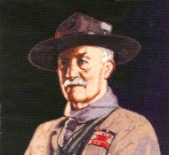
A SCOUT'S HOUOUR IS TO BE TRUSTED. If a scout says "On my honour it is so," that means that it is so, just as if he had taken a most solemn oath. Similarly, if a scout officer says to a scout, "I trust you on your honour to do this," the scout is bound to carry out the order to the very best of his ability, and to let nothing interfere with his doing so. If a scout were to break his honour by telling a lie, or by not carrying out an order exactly when trusted on his honour to do so, he would cease to be a scout, and must hand over his scout badge."

Davy Crockett -
Proving He Was Trustworthy
"Make sure you are right – then go ahead"
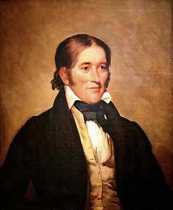
Davy Crockett was born to a large family that lived in the American wilderness where there were no stores, schools, or churches. The family finally settled on the Holston River and opened a tavern where travelers stopped on their way from Virginia to the West. Davy was only 8 when he started working in the tavern – he was excited by the stories visitors told, and wanted to see the world. When Davy was only 12 years old, his father agreed to let him work for a Dutchman driving a herd of cattle over the mountains to Virginia – he offered to let Davy stay, but homesickness brought him home. He was excited to learn that a new school had opened, but on his fourth day, Davy was bullied by another boy, and finally fought the boy and won – but he was afraid the boy and his friends would be waiting for him the next day, so he stayed in the woods till school would have been out and then went home. The schoolmaster sent a note to Davy’s father after a few days, and the angry father headed off with a hickory stick to find Davy. When Davy saw his father coming, he ran away and joined a drover taking cattle hundreds of miles away. For two years, Davy worked at odd jobs, earning about 25 cents a day, but finally his fear of his father faded, and he headed home. There was a great celebration. Davy was bound by customs of the time to stay with his father till he reached 21 – but his father offered to give Davy his freedom early if he would work for six months to earn off a debt his father owed. Davy developed a sense of what it meant to be honest as he worked, and discovered he could earn another $40 if he worked an extra six months. So six months later, he returned home and presented his father with a cancelled note for two debts – a total of almost $80.
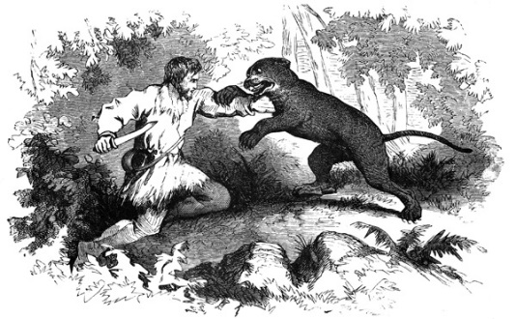
Davy was now 16, and knew he should learn how to read and write. He took a job working two days a week for board, and went to school the other four days. He married, built a log cabin, and became an outstanding shot with his musket. He moved several times, settling in Tennessee, and was one of the best riflemen in Andrew Jackson’s army. His skill in hunting kept the troops from starving. He learned to write in order to serve as a magistrate, and became very popular, being a great storyteller. He was asked to run for the legislature, and his jokes and stories, and his wonderful memory helped him get elected.
There was nothing he liked more than a good bear hunt, and his skill was legendary – twice he brought down a bear weighing more than 600 pounds, and he once killed 105 bears in one year. The meat was considered a delicacy, their fur was used for coats, and their skins were used for beds and bedding. In 1827 he was elected to Congress, and introduced himself by saying, “I am …fresh from the backwoods, half horse, half alligator, a little touched with snapping turtle…I can ship my weight in wildcats.” He made quite a stir in Washington, but was always well liked. As a Congressman, Crockett’s service was outstanding – he was honest and conscientious, never took a bribe or voted for something he didn’t believe in – he was called the “Honest Congressman.” He also wrote an autobiography which he called “a plain, honest, homespun account of my life.”
In 1846, Crockett and his “Tennessee boys” went to the Alamo to help the Texans in their battle against a far larger Mexican force of 5,000 men. The Texans and Crockett’s men numbered only about 108. But the determined defenders inside the Alamo forced the Mexicans back twice. Out of ammunition, Crockett and the Texans were finally killed as the Mexicans stormed a short wall. On the day he died, Crockett wrote a letter to his daughter telling her not to worry, that he was among friends. His youngest daughter later wrote she remembered him leaving for Texas, “dressed in his hunting suit, wearing a coonskin cap, and carrying a fine rifle presented to him by friends in Philadelphia.”
He was a real-life hero, an honest man, and became a legend while he was still alive.
"Let your tongue speak what your heart thinks"
Davy Crockett
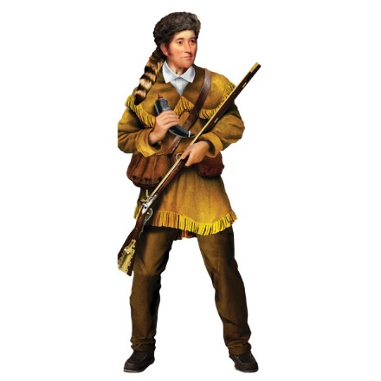
"Fame is like a shaved pig with a greased tail, and it is only after it has slipped through the hands of some thousands, that some fellow, by mere chance, holds on to it!" Davy Crockett
Davy Crockett Quotes
- Let your tongue speak what your heart thinks.
- I am at liberty to vote as my conscience and judgment dictates to be right, without the yoke of any party on me... Look at my arms, you will find no party hand-cuff on them.
- We have the right as individuals to give away as much of our own money as we please in charity; but as members of Congress we have no right to appropriate a dollar of the public money.
- It is better to keep a good conscience with an empty purse, than to get a bad opinion of myself, with a full one.
- Fame is like a shaved pig with a greased tail, and it is only after it has slipped through the hands of some thousands, that some fellow, by mere chance, holds on to it!
- Although our great man at the head of the nation (Andrew Jackson), has changed his course, I will not change mine.
- It was expected of me that I was to bow to the name of Andrew Jackson... even at the expense of my conscience and judgement. such a thing was new to me, and a total stranger to my principles.
- Pop, pop, pop! Boom, boom, boom!
Throughout the day
No time for memorandums now.
Go ahead! Liberty and independence forever.
- I have suffered myself to be politically sacrificed to save my country from ruin and disgrace and if I am never again elected I will have the gratification to know that I have done my duty.
- I would rather be politically dead than hypocritically immortalized.
- I have always supported measures and principles and not men.
- I would rather be beaten and be a man than to be elected and be a little puppy dog.
- The party in power, like Jonah's gourd, grew up quickly, and will quickly fall.

The Ballad of Davy Crockett
Music by George Bruns and
Lyrics by Thomas W. Blackburn.
Born on a mountain top in Tennessee
Greenest state in the Land of the Free
Raised in the woods so's he knew every tree
Kilt him a b'ar when he was only three.
Davy, Davy Crockett, King of the wild frontier!

In eighteen thirteen the Creeks uprose
Addin' redskin arrows to the country's woes
Now, Injun fightin' is somethin' he knows
So he shoulders his rifle an' off he goes.
Davy, Davy Crockett, The man who don't know fear!

Off through the woods he's a marchin' along
Makin' up yarns an' a singin' a song
Itchin' for fightin' and rightin' a wrong
He's ringy as a b'ar and twice as strong.
Davy, Davy Crockett, The buckskin buccaneer!

Andy Jackson is our general's name
His reg'lar soldiers we'll put to shame
Them redskin varmints us volunteers'll tame
'Cause we got the guns with the sure-fire aim.
Davy, Davy Crockett, The champion of us all!

Headed back to war from the ol' home place
But Red Stick was leadin' a merry chase
Fightin' and burnin' at a devil's pace
South to the swamps on the Florida Trace.
Davy, Davy Crockett, Trackin' the redskins down!

Fought single-handed through the Injun War
Till the Creeks was whipped an' peace was in store
And while he was handlin' this risky chore
Made hisself a legend for evermore.
Davy, Davy Crockett, King of the wild frontier!

He give his word and he give his hand
That his Injun friends could keep their land
And the rest of his life he took the stand
That justice was due every redskin band.
Davy, Davy Crockett, Holdin' his promise dear!

Home fer the winter with his family,
Happy as squirrels in the ol' gum tree,
Bein' the father he wanted to be,
Close to his boys as the pod and the pea.
Davy, Davy Crockett, Holdin' his young 'uns dear!
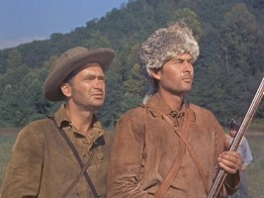
Fess Parker as Davy, and Buddy Ebsen as Georgie in Walt Disney's Production
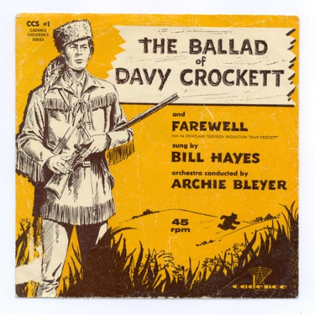
But the ice went out and the warm winds came
And the meltin' snow showed tracks of game
And the flowers of Spring filled the woods with flame
And all of a sudden life got too tame.
Davy, Davy Crockett, Headin' on West again!
Off through the woods we're ridin' along
Makin' up yarns and singin' a song
He's ringy as a b'ar and twice as strong
And knows he's right 'cause he ain't often wrong.
Davy, Davy Crockett, The man who don't know fear!

Lookin' fer a place where the air smells clean
Where the trees is tall and the grass is green
Where the fish is fat in an untouched stream
And the teamin' woods is a hunter's dream.
Davy, Davy Crockett, Lookin' fer Paradise!

Now he'd lost his love an his grief was gall
In his heart he wanted to leave it all
And lose himself in the forests tall
But he answered instead his country's call.
Davy, Davy Crockett, Beginnin' his campaign!

Needin' his help they didn't vote blind
They put in Davy 'cause he was their kind
Sent up to Nashville the best they could find
A fightin' Spirit and a thinkin' mind.
Davy, Davy Crockett, The man who don't know fear!

The votes were counted and he won hands down
So they sent him off to Washin'ton town
With his best dress suit still his buckskins brown
A livin' legend of growin' reknown.
Davy, Davy Crockett, The Canebrake Congressman!

He went off to Congress and served a spell
Fixin' up the Gover'ment and laws as well
Took over Washin'ton so we heared tell
And patched up the crack in the Liberty Bell.
Davy, Davy Crockett, Seein' his duty clear!

Him and his jokes travelled all through the land
And his speeches made him friends to beat the band
His politickin' was their favorite brand
And everyone wanted to shake his hand.
Davy, Davy Crockett, Helpin' his legend grow!

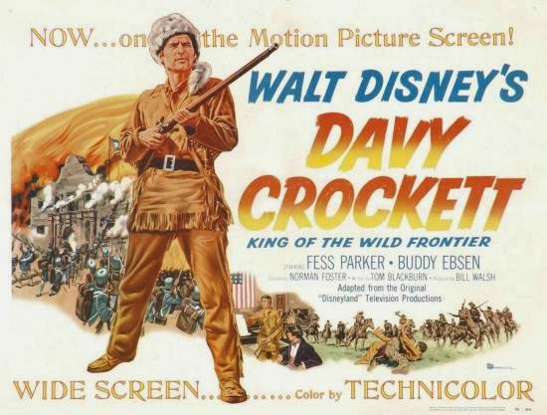

He knew when he spoke he sounded the knell
Of his hopes for White House and fame as well
But he spoke out strong so hist'ry books tell
And patched up the crack In the liberty Bell.
Davy, Davy Crockett, Seein' his duty clear!

When he come home his politickin' done
The western march had just begun
So he packed his gear and his trusty gun
And lit out grinnin' to follow the sun.
Davy, Davy Crockett, Leadin' the pioneer!

He heard of Houston and Austin and so
To the Texas plains he jest had to go
Where freedom was fightin' another foe
And they needed him at the Alamo.
Davy, Davy Crockett, The man who don't know fear!

His land is biggest and his land is best
From grassy plains to the mountain crest
He's ahead of us all meetin' the test
Followin' his legend into the West.
Davy Davy Crockett, King of the wild frontier!

Hear Fess Parker sing it at - https://www.youtube.com/watch?v=txcRQedoEyY

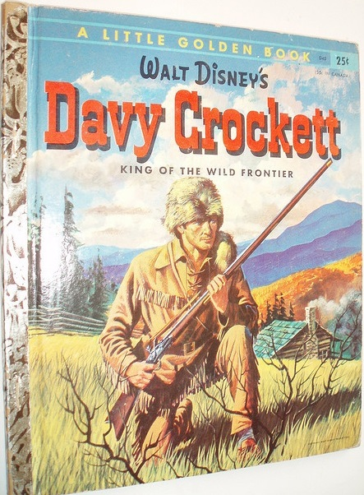

COMMISSIONER’S CORNER
Are you ready for your Pack’s Annual Program Planning Conference?? Have you done all your homework and gathered all your references?? Check out the Training item for lots of good ideas on this important process.
Here is aCommissioner Dave Pet Peeve –
Cub Scouts EARN awards and Awards are PRESENTED. Cub Scouts don’t just get awards. Billy earned his Bear Badge, not Billy got his Bear Badge. We don’t just give awards to Cub Scouts. They are not gifts. The Cubmaster didn’t give Dan his Belt Loop, he presented Dan his Belt Loop. Also, Rank Awards are entirely different from the others – Belt Loops and Pins, Special Awards, Leave No Trace Awards, … I was at a Pack Crossover the other week. Each Cub’s awards were neatly placed in an envelope. The content of the envelope was read and the envelope presented to the Cub (not the parent to present to the boy as we teach in Training). Now you tell me how that boy will know his Bear Badge is different from his Service Star for another year of membership. We need to think about the subliminal messages carried by our actions.
You often hear that the Arrow of light is the only badge a Cub Scout earned that he can wear on his Boy Scout uniform. Well, it is the only Cub Scout badge of rank he can wear permanently on his Boy Scout uniform. But in actuality there are several items a Cub may have earned that he can wear on his Boy Scout uniform - the Arrow of Light, of course, the youth religious award knot and ribbon, year pins denoting his time of service in Cub Scouting, and Special Awards for Lifesaving or Meritorious Service. Also, the new oval Webelos badge may be worn until he earns his Scout badge.


TEACHING THE SCOUT LAW
TO CUB SCOUTS
After last month's suggestions we received a nice note from Jennifer, a Webelos leader suggesting singing the Scout Law to the tune of "Ten Little Indians."
A Scout is
Trustworthy, Loyal,
Helpful, Friendly,
Courteous, Kind,
Obedient, Cheerful,
Thrifty, Brave,
Clean and Reverent
This is the Scout Law.

It took me a few tries but I got it down, and so can you!! Try it.
And a Big Heap How to Jennifer!!

Here is a Karaoke version that show the original words but plays only music
https://www.youtube.com/watch?v=mbVUayytvMY
And a sung version -
https://www.youtube.com/watch?v=k0SkWCCWrF8
I would not try and fit it to this version:
https://www.youtube.com/watch?v=r9-OrJnt1O4
(It is the Beach Boys version!!!!)
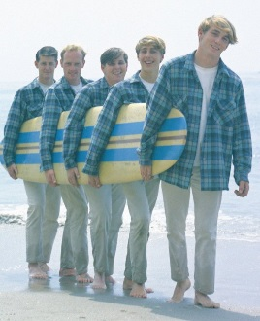
Other new ideas welcome – Just write Judy and I the address shown on Baloo's Bugle's Home Page!!! CD

Connecting
HEALTH & FITNESS
with Outdoor Activities
(Adapted from B.A.L.O.O. Appendix E)
Appendix E of the B.A.L.O.O. syllabus has been completely rewritten and the detailed suggestions for ways to line up the Core Values (now the 12 points of the Scout Law) to activities have been replaced with current information.

There is great information about the Ideals of Cub Scouting (e.g. The Purposes of Cub Scouting, Developing Character, Desired Outcomes, Scout Law and Scout Oath, and their meanings). Check it out!!

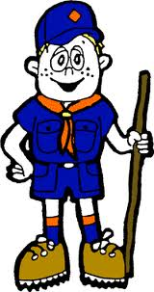

DEN MEETING TOPICS
YOU are now using the CUB SCOUT ADVENTURE PLAN. Look at the books and pick some great Adventures to do this summer. This is a great time to get used to the new Adventure Program and familiarize yourself with the materials. Just remember – Boys want to be outside playing. See, too, what they can earn / complete (Never say GET. You get sick, you do not get awards – You earn awards. A little CD Philosophy) at camp.
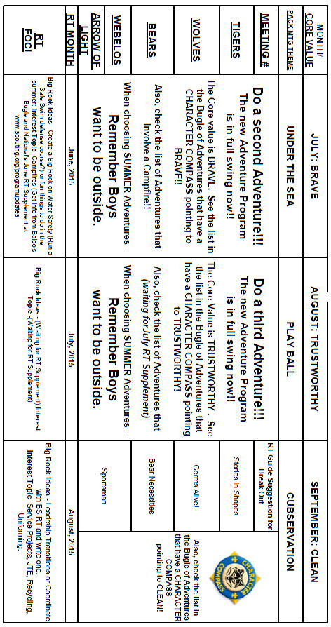

AUGUST -
ADVENTURES with a CHARACTER COMPASS pointing to TRUSTWORTHY:
TIGER –
- Team Tiger
- Tigers – Safe & Smart
WOLF –
- Howling at the Moon
- Adventures in Coins
BEAR –
- Bear Claws
- Baloo the Builder
WEBELOS CORE –
- Cast Iron Chef
ARROW OF LIGHT CORE –
- Camper
WEBELOS & AOL ELECTIVES –
- Game Design



SEPTEMBER -
ADVENTURES with a CHARACTER COMPASS pointing to CLEAN:
TIGER –
- Backyard Jungle (Core)
- Tiger Bites (Core)
- Stories in Shapes (Elec)
WOLF –
- Paws on the Path (Core)
- Germs Alive (Elec)
BEAR –
- Bear Necessities (Core)
- Baloo Picnic Basket (Elec)
WEBELOS CORE –
- Stronger, Faster Higher (Core)
ARROW OF LIGHT CORE –
- (None)
WEBELOS & AOL ELECTIVES –
- Sportsman (Core)
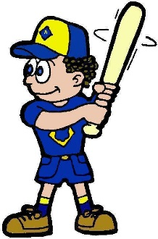


ADVENTURES that involve sports & playing ball:
TIGER –
- Games Tigers Play (Play two Team Building Sports)
WOLF –
- Air of the Wolf (Science Experiment with a Basketball)
- Code of the Wolf (Math exercise using basketball free throw data)
- Paws of Skill (How teams work together)
- Running with the Pack (Play a game or sport)
WEBELOS CORE –
- Stronger, faster, Higher (Try a new sport)
WEBELOS & AOL ELECTIVES –
- Sportsman (Play Two team Sports and more)

PACK MEETING THEMES
AND PLANS
www.scouting.org
From national's Website for the new plans using the Core Values based on the Scout Law:
Here are a few thoughts to consider around these new pack meeting plans. First, there is a plan for each month that corresponds with a point of the Scout Law. In addition, each plan has a theme to help make the pack meeting even more fun! The plans do not have to be used in a specific order.
As a personal note: I have read some of the plans and they are excellent and just as complete as the new Den Leader Books. The games, and other stuff are right there. Including costuming ideas for that added PIZAZZ!! If you do not use themes and add PIZAZZ you are not doing your best for your pack.
GOOD JOB!!! From CD
Check them out at:
http://www.scouting.org/scoutsource/CubScouts/Leaders/DenLeaderResources/DenandPackMeetingResourceGuide/PackMeetingPlans.aspx
Kim, the chair of the task force, says "I do want to stress that the focus is still the Core Value and the theme is just there as an enhancement. The theme pack meeting plans are specifically crafted to bring out the important points of the Core Value in a fun way."

Pack Meeting Themes
2015–2016 Pack Meeting Plans
September | Clean | "Cubservation"
October | Brave | "Super Cub!"
November | Helpful | "Cubs In Action"
December | Reverent | "Winter Wonderland"
January | Trustworthy | "The Great Race"
February | Friendly | "Friends Near And Far"
March | Thrifty | "Cubstruction"
April | Cheerful | "Strike Up The Band"
May | Kind | "My Animal Friends"
June | Obedient | "It's A Hit"
July | Loyal | "Scout Salute"
August | Courteous | "S'more Cub Scout Fun"

2016–2017 Pack Meeting Plans
September | Helpful | "To The Rescue"
October | Kind | "Creepy Crawlers"
November | Courteous | "Cubs In Shining Armor"
December | Cheerful | "Celebrate"
January | Obedient | "Cub Scout City Council"
February | Reverent | "Passport To Other Lands"
March | Loyal | "Our National Treasures"
April | Thrifty | "Power Up!"
May | Clean | "A Picnic With Pizzazz"
June | Brave | "Roaming Reptile Alert"
July | Trustworthy | "Let The Games Begin"
August | Friendly | "#CUBSCOUTS"
If you are using a paper copy the link to all the
Pack Meeting Plans is:
http://www.scouting.org/scoutsource/CubScouts/Leaders/DenLeaderResources/DenandPackMeetingResourceGuide/PackMeetingPlans.aspx

UPCOMING MONTHS
- August's Core Value, Trustworthy,
will use the theme, Play Ball
Based on the theme intent and the write up in the Cub Scout Roundtable Planning Guide – Judy and I substituted TRUSTWORTHY for HONESTY. CD
Previous Month's that have themes that might have material you can us with TRUSTWORTY and "Play Ball" are:

Month | Year | Theme
Trustworthy
January | 1943 | Do Your Bit
December | 1958 | The Golden Rule
November | 2001 | Hometown Heroes
November | 2002 | Kids Against Crime
January | 2004 | Home Alone
November | 2009 | Scout Salute
August | 2011 | Honesty
August | 2012 | Honesty
August | 2013 | Kids Against Crime
August | 2014 | Heroes of History
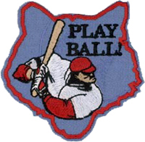
Month | Year | Theme
Play Ball
August | 1945 | Sports
August | 1953 | Sports Carnival
August | 1956 | Cub Scout Field Day
June | 1966 | Sports Carnival
August | 1970 | Cub Scout Field Day
June | 1975 | Sports Carnival
June | 1979 | Learn a Sport
June | 1990 | Sports Arena
August | 2002 | Sports Extravaganza
July | 2005 | Play Ball!
June | 2008 | Go For The Gold
July | 2009 | Cub Scout Sports
June | 2010 | Hoop-De-Doo

- September's Core Value, Clean,
will use the theme, Cubservation
- A SCOUT IS CLEAN
A Scout keeps his body and mind fit. He helps keep his home and community clean.
- HOW DOES “CUBSERVATION” RELATE TO THIS POINT OF THE SCOUT LAW?
Everything we do impacts the world around us.
When a Scout is clean, he is choosing to make sure that the legacy he leaves is a positive one. He makes moral choices and through an active lifestyle he keeps his body healthy. He also is conscious of the impact that he can have on nature and the responsibility he has to keep the world clean for those who come behind him.
Previous Month's that have themes that might have material you can us with CLEAN and "Cubservation" are:

Month | Year | Theme
Cubservation Months
August | 1952 | Conservation
April | 1955 | Cub Scout Foresters
November | 1955 | America Beautiful
April | 1958 | Keep America Beautiful
April | 1968 | Keep America Beautiful
September | 1971 | Conservation
May | 1972 | Beautiful America
May | 1974 | Keep America Beautiful
May | 1976 | SOAR
July | 1987 | America The Beautiful
April | 1999 | Pollution Solution
April | 2001 | Save It For Us
April | 2004 | Cubservation
May | 2009 | Leave Nothing But Footprints
April | 2010 | Spring into Action
Clean
Health & Fitness formerly addressed Clean
October | 1939 | Health and Safety
January | 1982 | Adventure in Good Health
May | 2011 | Health & Fitness
May | 2012 | Health & Fitness
May | 2013 | Cub Café

Crazy Holidays
Jodi, SNJC Webelos Resident Camp Director Emeritus,
2006-2011. Adapted from http://holidayinsights.com/moreholidays/index.htm
http://www.brownielocks.com/month2.html
August is:
- Admit You're Happy Month
- Happiness Happens Month

- American Adventures Month
- American Artists Appreciation Month
- American Indian Heritage Month
- Black Business Month
- Children's Eye Health & Safety Month

Do you know where these
eyes came from?
- Children's Vision & Learning Month
- Family Fun Month
- Get Ready for Kindergarten Month
- Motor Sports Awareness Month
- National Catfish Month
- National Eye Exam Month
- National Goat Cheese Month
- National Golf Month
- National Immunization Awareness Month

- National Panini Month
- National Picnic Month
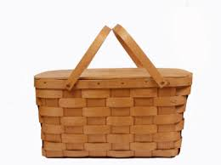
- National Water Quality Month
- National Win With Civility Month
- Peach Month
- What Will Be Your Legacy Month
- Water Quality Month
Weekly Events:
- International Clown Week: 1-7

- National Scrabble Week: 1-5

- Simplify Your Life Week: 1-7
- Assistance Dog Week: 2-8
- Knights of Columbus Family Week: 2-8
- Exercise With Your Child Week: 2-8

- National Bargain Hunting Week: 3-8
- Old Fiddler's Week: 3-8
- Sturgis Rally: 3-9
- Rock for Life Week: 4-7
- Feeding Pets of the Homeless Week: 9-15
- National Motorcycle Week: 9-15
- Elvis Week: 10-16
- National Smile Week: 11-17
- National Aviation Week: 15-21 (Always week of Orville Wright's Birthday on 19th)
- Little League Baseball World Series: 20-30

- Friendship Week 18-24
- Be Kind To Humankind Week: 25-31
- National Safe at Home Week: 23-29
August, 2013 Daily Holidays, Special and Wacky Days:
1 National Raspberry Cream Pie Day
1 National Mustard Day
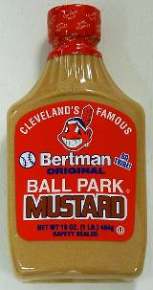
2 National Ice Cream Sandwich Day
2 Sisters Day - First Sunday in August
2 Friendship Day - First Sunday in August
2 International Forgiveness Day - First Sunday in August
3 National Watermelon Day
4 U.S. Coast Guard Day
5 Work Like a Dog Day
6 Wiggle Your Toes Day
7 National Lighthouse Day
8 Sneak Some Zucchini onto Your Neighbor's Porch Day - now that's nasty!
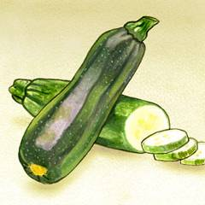
9 Book Lover's Day
10 Lazy Day
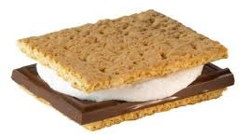
10 National S'mores Day
See recipes in Cub Grub
11 Presidential Joke Day
11 Son and Daughter Day
12 Middle Child's Day
13 Left Hander's Day (For CD's wife)


14 National Creamsicle Day
14/15 V-J Day (Victory over Japan)

15 Relaxation Day - now this one's for me!
16 National Tell a Joke Day
17 National Thriftshop Day
18 Bad Poetry Day
19 Aviation Day
20 National Radio Day
21 Senior Citizen's Day
22 Be an Angel Day
22 National Tooth Fairy Day
23 Ride the Wind Day
24 Vesuvius Day
25 Kiss and Make Up Day
26 National Dog Day
26 Women's Equality Day
27 Global Forgiveness Day
27 Just Because Day
28 Race Your Mouse Day -but we are not sure what kind of "mouse"
29 More Herbs, Less Salt Day
30 Frankenstein Day
30 Toasted Marshmallow Day
31 National Trail Mix Day
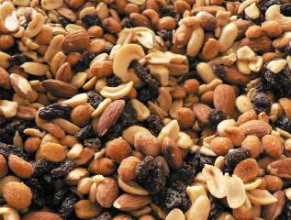

BSA SOCIAL NETWORKS

BSA FACEBOOK PAGE
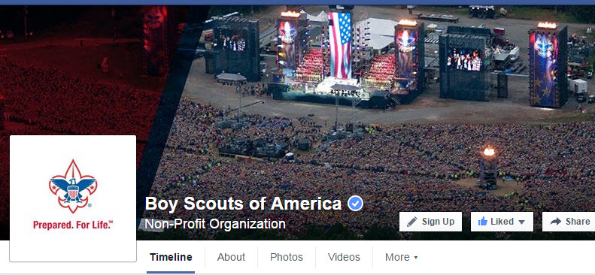
BSA Facebook page
https://www.facebook.com/pages/Boy-Scouts-of-America/113441755297

On the Facebook page you can read about –
How to build a wooden yo-yo!!
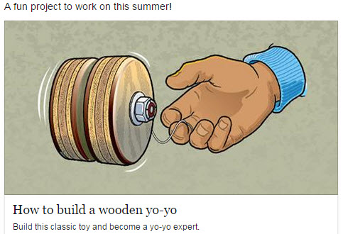
Go To: https://www.facebook.com/pages/Boy-Scouts-of-America/113441755297

SCOUTING MAGAZINE
ON YOU TUBE

Scouting magazine You Tube Channel
http://www.youtube.com/user/scoutingmag

Check out some of the Cool Camp Videos –
For Example –

Cool Camp: Camp Merriweather on the Oregon Coast
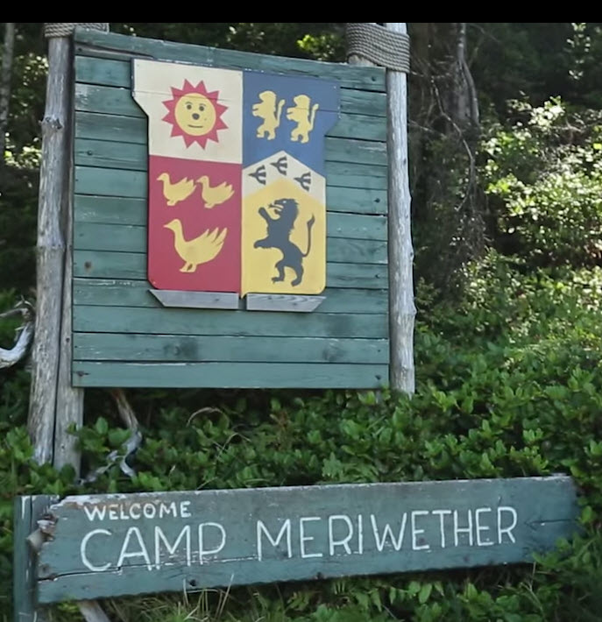
Check it out at -
https://www.youtube.com/watch?v=Sac_KYuZ3hQ&index=3&list=PLuxQzUzGg-5y1ME9ZJqdCzAR6HmYi393y

STEM SCOUTS
What are those?
STEM Scouts are boys and girls in third through 12th grade. They’re split into three divisions:
- Elementary school (third through fifth grade)
- Middle school (sixth through eighth grade)
- High school (ninth through 12th grade)
Instead of packs or troops, STEM Scouts are grouped into “laboratories,” which can be shortened to “labs.”
They meet weekly, after school, for hands-on, fun activities organized into four- to six-week modules that cover a ton of fun STEM topics.
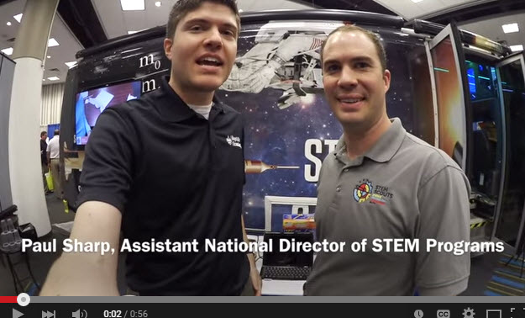

Inside the Vortex,
the STEM Scouts Mobile Lab
https://www.youtube.com/watch?v=0c98k4P94c4

Don't know what STEM Scouts is?
Want to learn more about STEM Scouts??
(STEM = Science-Technology-
Engineering-Mathematics)

STEM Scouts was successfully piloted in East Tennessee for several years. Recently, the BSA’s National Executive Board approved a plan to expand the STEM Scouts pilot to these 12 additional councils. (Pending the councils' boards' approval):
- Capitol Area Council (Austin, TX)
- Catalina Council (Tucson, AZ.)
- Circle Ten Council (Dallas, TX)
- Connecticut Rivers Council (E Hartford, CT)
- Crossroads of America Council (Indianapolis, IN)
- Denver Area Council (Denver, CO)
- Garden State Council (Westampton Township, NJ) (Commisioner Dave's Council!!!)
- Greater St. Louis Area Council (St Louis, MO)
- Middle Tennessee Council (Nashville, TN)
- Pathway to Adventure Council (Chicago, IL)
- Sam Houston Area Council (Houston, TX)
- Samoset Council (Weston, WI)
The success of the East Tennessee pilot confirms the BSA’s hypothesis that young people are excited to experience STEM (science, technology, engineering and math) in a fun setting. The STEM Scouts program blends Scouting’s time-tested character-building traits with hands-on STEM modules that’ll prepare boys and girls for careers in STEM fields.

April McMillan and Trent Nichols (pictured) serve as national directors of STEM programs. On the STEM Scouts site, (https://stemscouts.org/ )they shared their vision for this new BSA program. A few highlights:
- The key for the entire offered curriculum is that it will be fast-paced, thought-provoking and fun. Adult volunteers and STEM professionals will have the opportunity to engage interested girls and boys with hands-on activities in the labs divided by the age divisions. Throughout the year, students will be involved in experiential activities that encourage natural curiosity and insights in STEM fields.
- This new program represents a bit of a paradigm shift for parents from the traditional outdoor-oriented Scouting. The children will receive important character building and learning through field trips and weekly interactions with STEM professionals as well as learning citizenship. This up close and personal insight into how STEM skills are used in business and industry is critical to enable girls and boys to visualize themselves succeeding in STEM fields

More Info on STEM Scouts??
- Go to https://stemscouts.org/
- Go Bryans Blog -(http://blog.scoutingmagazine.org/) and read the following articles
STEM Scouts pilot expanding to 12 more councils
 The BSA's National Executive Board approved a plan to expand STEM Scouts, a new program of the Boy Scouts of America, to 12 additional councils.
STEM Scouts ready for prime time with NASCAR Truck Series debut
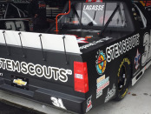 The STEM Scouts logo will feature prominently on Scott Lagasse Jr.'s #31 truck in tonight's Toyota Tundra 250 at Kansas Speedway in Kansas City, KS.
Understanding the difference between STEM in Scouting and STEM Scouts
 Read about the difference between STEM activities in traditional Scout units and STEM Scouts, the new BSA program expanding to 12 councils this fall.
Video: Inside the Vortex, the STEM Scouts mobile lab
 I got to check out the Vortex, the STEM Scouts mobile lab. It's a whole lot of awesomeness on four wheels.

(NOTE from Commissioner Dave – I had a great time with the VORTEX at BSA's National Annual Meeting. And I am very excited Garden State Council was selected for a pilot!!)
.
CUBCAST
http://www.scouting.org/Scoutcast/Cubcast.aspx

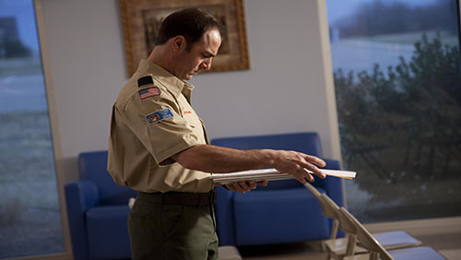

June 2015 -
Planning the Cub Scout Year
Blue and gold banquets, camping trips, field trips, fund raising -the list of all the things your Cub Scouts should be doing seems endless. However, everyone getting together to plan the Cub Scout year makes everything that much easier. But how do you get everyone gathered to put together a Cub Scout calendar, and who is “everyone”? Click the Download button to find out.
Listen Hear -
http://www.scouting.org/filestore/scoutcast/cubcast/201506_1/CC_June_Planning_the_Year.mp3


SCOUTCAST
http://www.scouting.org/Scoutcast/Scoutcast.aspx

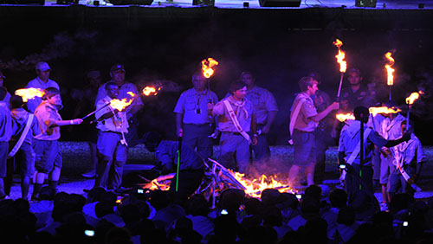
June 2015 -
Just What is the order of the Arrow?
You’ve probably heard of it, maybe even know someone who’s in it. Some people think it has something to do with Indians…(maybe?) Some even suspect it’s a “secret society” within the Boy Scout organization. And why are the members so gosh-darn loyal? National Chief Nick Dannemiller joins us as we explore the mystery that is the Order of the Arrow. You’ll be pleasantly surprised.
Listen Hear -
http://www.scouting.org/filestore/scoutcast/resources/201506_1/SC-June_OA.mp3

It is possible that by the time you get Baloo's Bugle and click the link, there may be new Cubcast and/or Scoutcast posted. Do not worry, all previous Cubcasts and Scoutcasts are available from the home page.
Bryans Blog
May 2015
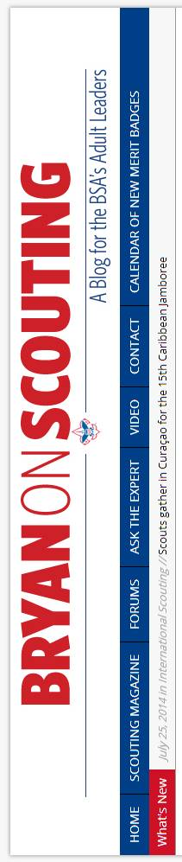
“Bryan on Scouting” is the official blog of Scouting magazine, a Boy Scouts of America publication. Scouting magazine is published five times a year and is received by 1 million registered adult volunteers.
Bryan covers many topics every month. He keeps his Blog current and deals with the latest issues.
His articles this past month are listed below (Every title has a hyperlink). The articles in BLUE are of special interest for Cub Scout Leaders.
Here’s a comic strip about Scouting that only Scouters will understand
June 26, 2015 // 14 Comments
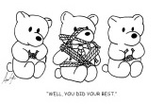
Those funny, heartwarming, only-in-Scouting scenes inspired a Scouter from Nevada to create a comic strip about Scouting.
How to make a camp washing machine using a paint bucket and plunger
June 25, 2015 // 30 Comments
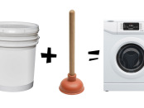
With just five minutes and a couple of items available at your local hardware store, you can make a camp washing machine. Your tentmate will thank you.
Ask the Expert: What is (and what isn’t) a camping
night for the Camping MB?
June 24, 2015 // 158 Comments

Tent, hammock, cabin, retired battleship — all offer great experiences for Scouts, but only some count as camping nights for the Camping merit badge.
What do you do with flag grommets left behind after retirement ceremonies?
June 23, 2015 // 89 Comments

For this edition of Tuesday Talkback, share your thoughts on what a troop should do with the flag grommets left behind from flag retirement ceremonies.
Supersize service: Scouts wash World War II-era B-17 airplane
June 22, 2015 // 4 Comments
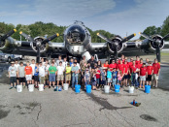
A few dozen Scouts from Erie, Pa., gathered to give a World War II-era Boeing B-17 "Flying Fortresses" a good scrubbing.
Philmont STEM expert will sail aboard the Nautilus this summer
June 19, 2015 // 3 Comments

Sarah Burgess, STEM coordinator at Philmont Scout Ranch, has been hand-picked to sail aboard the Nautilus exploration vessel this summer.
Second edition of ‘Four Percent’ book packs in
even more great stories about Eagle Scouts
June 18, 2015 // 2 Comments

"Four Percent: The Extraordinary Story of Exceptional American Youth" is now available in a new and expanded second edition.
Send me before-and-after Eagle project photos
June 17, 2015 // 5 Comments
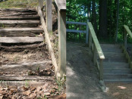
I’m interested in before-and-after Eagle project photos — the same photos each Eagle Scout includes with his final project documentation.
Casting call: BSA seeks Boy Scouts to star in instructional videos
June 16, 2015 // 19 Comments
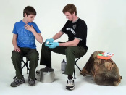
The BSA's production team is looking for troops with skills in camping, hiking, swimming, cycling or lifesaving to star in a series of instructional videos.
10 Eagle Scout cakes that’ll make you say ‘Sweet!’
June 15, 2015 // 14 Comments
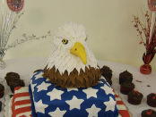
The 10 Eagle Scout cakes here are some of the best-looking I've ever seen, and I think you'll agree. Just, please, no licking the screen.
Henry Repeating Arms salutes BSA with Scouting-themed rifles
June 12, 2015 // 18 Comments

SPONSORED: Two American traditions unite in an impressive way with Scouting-themed rifles from Henry Repeating Arms.
In honor of Flag Day, here are 14 times Scouts honored our flag
June 12, 2015 // 14 Comments

Flag Day is June 14, so I wanted to share 14 times in the past that Cub Scouts and Boy Scouts have honored Old Glory.
Eagle Scout to canoe the length of the Mississippi River
June 11, 2015 // 10 Comments

On July 1, Eagle Scout Jake Tavakoli, 29, and his girlfriend will begin to canoe the length of the Mississippi, the third-longest river in North America
Ask the Expert: Should units carry a balance in their unit accounts?
June 10, 2015 // 74 Comments

Should your unit bank account have a large balance you carry over from year to year? That question about unit accounts is answered in this Ask the Expert.
2015 National Outdoor Conference is a must for
any Scouter involved with outdoor programs
June 9, 2015 // 4 Comments

At the 2015 National Outdoor Conference you'll join volunteers and professionals to learn more about delivering the world's greatest youth outdoor program.
Eagle Scout is biking to every Major League
Baseball stadium this summer
June 8, 2015 // 4 Comments
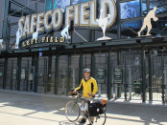
Eagle Scout Matt Stoltz is exactly one-third of the way toward a remarkable goal: Bike to every Major League Baseball stadium in North America this summer.
How to use a Swedish torch to cook your next
camp meal in style
June 5, 2015 // 24 Comments
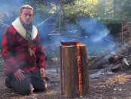
The Swedish torch could be the most effective cooking fire I've ever seen. It's a self-contained fire that functions like a stovetop range.
How to make needle and thread from the
Agave Americana plant
June 5, 2015 // 5 Comments
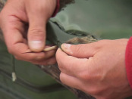
Need to make an impromptu gear repair? Look around you. If you're in Arizona, Texas or somewhere the Agave americana grows, you're in luck.
5 new Cub Scout recruiting tools that will help you grow your pack
June 4, 2015 // 10 Comments
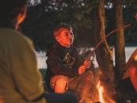
You can find all of these new recruiting tools in the new Marketing & Membership Hub. Go ahead and bookmark it now. You'll want to return again and again.
Meet Edward Campbell, the 2015-2016 National
Sea Scout Boatswain
June 4, 2015 // 6 Comments
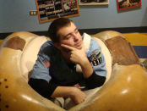
The National Sea Scout Support Committee selected Edward Campbell of Albion, Ind., to be the 2015-2016 National Sea Scout Boatswain.
Eagle Scout wants you to stop texting and driving
June 3, 2015 // 15 Comments

William Bauman, whose Eagle Scout project was a campaign against texting and driving, has an important message for Scout leaders and parents.
10 reasons a week at Scout summer camp beats a week at the office
June 2, 2015 // 33 Comments

While your coworkers wade through email, yawn through another teleconference and fill out the gazillionth Excel spreadsheet, you'll be at Scout summer camp.
Adventures await: The new Cub Scout program is officially here
June 1, 2015 // 15 Comments

The books are hot off the presses, the adventure loops are shiny, and your Cub Scouts are ready. It's June 1, and the new Cub Scout program is here.
Share your money-saving tips with Scouting magazine
June 1, 2015 // 6 Comments

How to you stay on a budget while experiencing Scouting to the fullest? Share your money-saving tips for a future issue of Scouting magazine.
Eagle Scout and survival expert hosts ‘Fat Guys
in the Woods’ on The Weather Channel
June 1, 2015 // 8 Comments

Creek Stewart, Eagle Scout and survival expert, is the host of "Fat Guys in the Woods" on The Weather Channel. Season 2 premieres at 9 p.m. Sunday, June 7.
Cub Scout lesson may have prevented abduction
of two 8-year-old boys
May 30, 2014 // 17 Comments

A Cub Scout lesson on the potential danger of strangers may have saved two boys from abduction.

Blog Contributors
Bryan Wendell, an Eagle Scout, is senior editor of Scouting and Eagles' Call magazines.

Gretchen Sparling is associate editor of Scoutingand Eagles' Call magazines.
Get Email Updates
To sign up to receive Bryan’s Blog in your E-mail –
Click the link that appears in every article. Bryan and Gretchen promise never to sell or otherwise exploit your email address. Join 6,162 other subscribers

TRAINING TOPIC
ANNUAL PROGRAM PLANNING
“A common element of strong units is they all have a good annual program planned a year in advance (and it is) shared with all families in the form of a calendar.”
BSA Annual Program Planning Conference Guide, 2012

One thing that has not changed with the Cub Scout Adventure Program, is the need to hold an Annual Program Planning Conference for your Pack. The results will be different because of the Adventure Program but the need to do it remains unchanged.
The first thing –
Do Your Homework –
A month or two before the scheduled face-to-face conference, the Committee Chair and Cubmaster gather the following information:
- Key school dates
- Community event dates
- Your chartered organization's dates
- Personal dates that may affect your pack's activities such as the Cubmaster's anniversary cruise, the Chair's birthday
- Dates of District and Council events
- Collected Family Talent Survey sheets from all parents
- Last year's pack annual plan if you have one
They, also, get (or consider) the following:
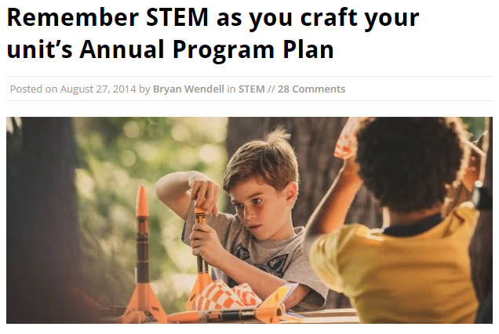
- How can STEM activities be worked into this year's plan. For ideas you can go to Bryan's Blog on STEM and Annual Plan at http://blog.scoutingmagazine.org/2014/08/27/remember-stem-craft-units-annual-program-plan/

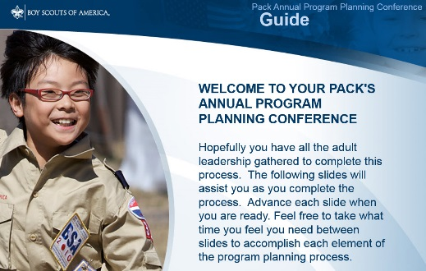
- Download the video on the Pack's Annual Program Planning Conference from http://www.scouting.org/filestore/membership/zip/BSA_Pack_Annual_Program_Planning_Conference_Guide.zip
They should review it and study it to make sure they are ready for the big day/night/event. You can use this power point ( or to be fancy - electronic program planning conference guide) to add some color to the Annual Program Planning Conference process. This narrated PowerPoint presentation, takes will take your pack leaders step-by-step through the planning process

- Review and establish JTE Goals for the Pack. Determine what activities are needed to have the Pack do better than this year. Anticipate changes to the JTE requirements for the next calendar year.
The JTE is a year round program of leading indicators to help you plot your course to a successful program (I hate it when my Cub Scout writing sounds like I am at work but it is true. And it is a GREAT tool!! CD) If you have not set up to monitor your progress on the dashboard go to the spreadsheet on National's website and you will get a great picture of your status. You fill in page 1 by answering questions and it completes your JTE form on page 2 (Kind of like when I do my income tax on Turbo Tax CD) Page 3 is a Unit Budget form, be sure to use that, also. The spreadsheet is at: http://www.scouting.org/scoutsource/Awards/JourneyToExcellence.aspx

- They should obtain the Boys' Life Annual program Planning materials. Some councils supply these, some do not. They are available directly from national at Things to order – http://www.scouting.org/filestore/magazine/pdf/331-057_LR.pdf
Important Material available here include –
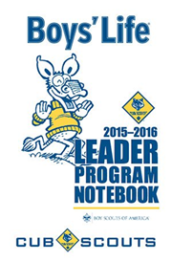
CS Leader Program Notebook (No. 331-014 $1.00)
The pocket-sized 4-inch x 6-inch 2015–2016 BOYS’ LIFE Cub Scout Leader Program Notebook is designed for Cubmasters and den leaders but is useful for all Cub Scout leaders. Its 100 pages include a guide to effective Cub Scout program planning; individual pages for each monthly core value; the pack’s annual PROGRAM PLANNING STEPS; 12 monthly calendars to write in important notes; full-page, fill-in-theblank outlines for each weekly den meeting; planning outlines for the monthly pack leaders’ meeting; the monthly pack meeting; requirements for the National Den Award; and a description of Journey to Excellence. The Cub Scout Leader Program Notebook is a valuable aid for all Cub Scout leaders. You can download the file at http://www.scouting.org/filestore/magazine/pdf/331-014.pdf BUT it is well worth the $1.50 to get the booklet as intended as a pocket notebook!!!
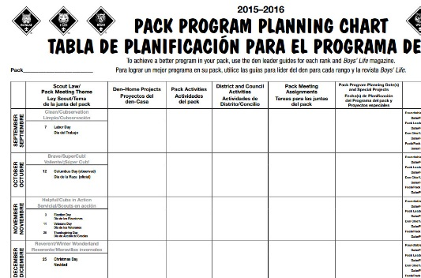
Pack Program Planning Chart (No. 331-017 75¢)
The poster-sized 17-inch x 22-inch BOYS’ LIFE Pack Program Planning Chart (English and Spanish) helps Cub Scout leaders plan the pack’s 2015–2016 annual program. The chart provides information for each month’s recommended Cub Scout core value and Webelos/Arrow of Light activity badges. Space is provided to write in den-home projects, pack program planning dates and special projects, Webelos activities, and dates for monthly meetings (roundtable, pack leader, den chief, and pack). Experienced pack leaders use the Pack Program Planning Chart to effectively plan the pack’s annual program. You can, also, download this chart at http://www.scouting.org/filestore/magazine/pdf/331-017_bilingual.pdf . But you really need at least 17X22 paper. Poster sizes will work even better if you have a source.
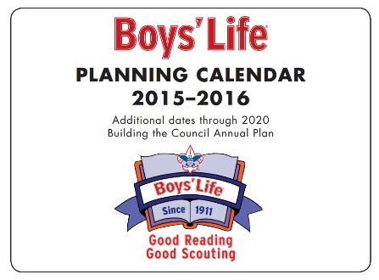
2015–2016 BOYS’ LIFE Council Planning Calendar
(No. 331-011 $1.50) - The popular BOYS’ LIFE Council Planning Calendar measures 8.5 inches x 11 inches. The fill-in-the-box calendar dates begin September 2015 and extend through December 2016. Additional calendar dates noting selected holidays and religious dates run through December 2020! Planning ahead? This is your calendar. You can, aslo, download this calendar at http://www.scouting.org/filestore/magazine/pdf/331-011.pdf
AND it all comes with
Pedro's Seal of Approval!!


Second –
Plan for success by selecting the right people to attend and picking the best possible date.
Inviting all the following:
- All pack committee members
- All den leaders and assistants
- All pack/den aids and den chiefs (optional)
- Chartered organization representative
- Your unit commissioner (optional)
- Anyone else you think might be helpful, (e.g. selected parents).
Selecting a date for the conference.
See when you can have the most people attend. My pack used to do a picnic. The leaders would meet and the parents not in the conference would watch the boys at a pool, or in a park. We could get the local troop to help, too. The more people, the better the result. The less people to complain about what was chosen and what was not chosen.
This is a Unit specific decision.
Sending out your invites early. This should help people keep from booking a date they told you they were available. Make the invite official. Have them know they are part of one of the most important Pack Events of the year.
Prepping your unit calendar with fixed dates – Just take the dates you collected and put them into your pack's master calendar—including den meeting dates, Roundtables, District Cuborees, Webelos Overnights, Your Pack and Committee Meeting nights, Town Celebrations in which you participate, Scouting for Food, everything you have uncovered while doing your homework. The date of Easter varies from year to year and we used to miss that one in our planning – so please make sure you look it up.
This can be done either on a hard copy or by plugging the information into an electronic calendar on a computer.
Third –
Hold your meeting
- Let the power point you down loaded drive the agenda. Or copy it, and go through the steps manually.
- Or, Use the agenda on National's site for a Pack Annual Program Planning Conference. - http://www.scouting.org/scoutsource/CubScouts/Leaders/ProgramPlanning.aspx
- Or, Follow the agenda in the Circle Ten Council article (that follows this one) on Annual Pack Planning Conferences.
- Or write your own using parts from all the above and your experience.
Fourth –
Tell everyone
- A research project done by Eli Lilly in Indianapolis, Indiana, showed that 1 of the 3 common elements of strong packs is (I will share the other two common elements in a bit. You try and guess them, please.):
They all have a good annual pack program planned a year in advance that is then shared with all families in the form of a calendar.
The important result of a shared annual program calendar is that your pack will attract more families, and Cub Scouts will stay for a long time.
- Get it in your newsletter. Don’t have a newsletter?? START ONE, NOW!!! BSA has a template available at http://www.scouting.org/scoutsource/CubScouts/Leaders/newslettertemplate.aspx
- Create a poster. Don’t know what to put on a poster. Try this sample from BSA –
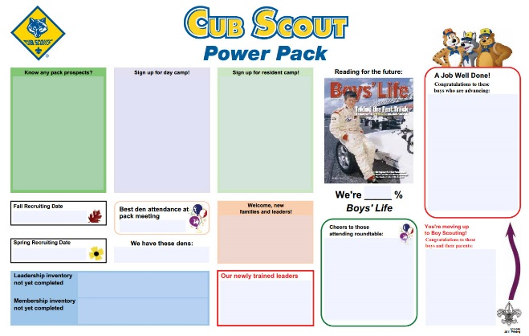
This poster is found at http://www.scouting.org/filestore/pdf/512-045_tab_WB.pdf
Fifth –
Monitor Implantation and Update the Plan as needed
Annual program planning is an ongoing process. Review the plan each month at your pack leaders' meeting to make sure you are still on track, to recruit chairs and other help, you participate in important meetings, or to make assignments or changes as needed.
Quarterly, do a three month look ahead to make sure all your great events will happen!!
Oh, those other two common elements of successful Packs???
- Training
- Having the right person in the position (Not just picking the first warm body)

Annual Program Planning
Circle Ten Council
Year Round Program
THE BASIS OF A SUCCESSFUL PACK
Program planning is a simple but critical part of your pack's success. Throughout the process remember your goal is to deliver a high quality program to each boy and his family. It should be fun, exciting and focused on the purposes of Cub Scouting.
Setting an annual program plan provides direction and sense of satisfaction and a feeling of accomplishment in a job well done. Planning also makes the best possible use of your valuable volunteer time.
Planning Steps:
One of the most important responsibilities of the pack committee is to keep the pack operating with a first-rate, year-round program. The quality of the program will depend largely on the pack committee giving the Cubmaster, the Cub Scout den leaders and Webelos den leaders the help they need.
Cub Scout program planning includes four steps, dependent upon one another, which usually guarantee a strong pack program. The steps are:
Annual Pack Program Planning Conference
Monthly Pack Leader's Meetings
Monthly Den Leader Meetings
Monthly meetings of each den leader with the den chief
Steps to having a great
Annual Program Planning Meeting
SET A DATE TO MEET - Set a date in August with the committee, including the Den Leaders and Webelos Leaders.
CHECK MEETING DATES - Before this time check with your chartering organization and school calendar to find available dates for pack meetings. They should be at the same time and date each month.
REVIEW LAST YEAR'S PROGRAM - Which activities worked and which did not? Decide what activities and special meetings you would like to do again. Also determine whether or not your budget was adequate for them.
REVIEW YOUR JOURNEY TO EXCELLENCE STATUS - The JTE is a year round program of leading indicators to help you plot your course to a successful program (I hate it when my Cub Scout writing sounds like I am at work but it is true. And it is a GREAT tool!! CD) If you have not set up to monitor your progress on the dashboard go to the spreadsheet on National's website and you will get a great picture of your status. You fill in page 1 by answering questions and it completes your JTE form on page 2 (Kind of like when I do my income tax on Turbo Tax CD) Page 3 is a Unit Budget form, be sure to use that, also. The spreadsheet is at:
http://www.scouting.org/scoutsource/Awards/JourneyToExcellence.aspx
SET NEW MEETING DATES - Review the available pack meeting dates with the pack committee and set dates for the coming year. Write pack meeting dates in your council calendar (extra copies are available through the Service Center for your committee members and den leaders). Be careful to avoid holidays and school breaks.
SET COUNCIL AND DISTRICT DATES - Review the council and district calendar and mark dates on your program schedule for district and council activities: Webelos Woods, Pinewood Derby, training sessions, and important meetings like roundtable.
SET SPECIAL PACK DATES - Set the dates for special activities your pack will be doing during the year and put them in your program calendar. These may include:
Pack Fundraiser (Product Sale)
Blue and Gold Banquet
Pinewood Derby
Friends of Scouting
Summertime Activities
Webelos and Tiger Graduation
Since June 1, 2003, adults giving leadership to a pack campout MUST complete the Basic Adult Leader Outdoor Orientation (BALOO). Please check council calendar for upcoming BALOO training sessions. (This is not required for council-run programs)
SCHEDULE YOUR MONTHLY COMMITTEE MEETING - Select dates for and schedule monthly meetings of your committee to meet and plan out the next month's activities and meetings (i.e. in September you should be planning for October). You should have a committee meeting every month.
REVIEW THE MONTHLY CORE VALUES - Choose the Core Value (Scout Law) emphasis for the month from the literature (Best is to use what is being presented at Roundtable) or rearrange them based on your local activities or choose a theme (OOoops, there is that word) of your own. Write them in your annual calendar so everyone knows what the month's Core Value emphasis is for both Cubs and Webelos.
SET A BUDGET - Based on the meetings and activities you have planned for the year, number of boys who are likely to advance, and the number of youth and adult members of the pack, figure out what your approximate yearly expenses will be. You will need to plan enough fund raising activities to cover these expenses. The Budget Planning Worksheet will help you calculate and plan your annual expenses and income to create a budget.
NOTE -
There is an electronic budget planning worksheet
in the Excel spreadsheet on National's website to
help you do this more easily
http://www.scouting.org/scoutsource/Awards/JourneyToExcellence.aspx
DISTRIBUTE THE PLAN - Cub Scouts and their families will better participate in meetings and activities if they have a copy of the calendar. Every family should receive a copy of the annual calendar so they can plan accordingly.
These are the basic steps your committee will need to follow to have a complete annual program plan and calendar. This calendar will help insure that everyone in the pack knows exactly what is happening from month to month during the year. More important, it will help you plan in advance and avoid being caught off guard by rapidly approaching deadlines.
Remember that September brings *** Join Scouting Night*** and the start of a full year of activities. When you go to Join Scouting Night, if you have a well thought-out plan and distribute it to your members, new and old, you will find it is easier to recruit not only boys but also adult leaders.

SPECIAL OPPORTUNITIES
With the start of the Cub Scout Adventure Program, the requirements for awards that say things like, "Complete Wolf Achievement 7," need to be revised to send you to the new Adventures. We will be highlighting these changes here over the next few months.
To get a complete list now, you can go to http://www.scouting.org/scoutsource/programupdates.aspx and download the .PDF of all the changes. Or you could go to www.usscouts.org and get the changes for a specific award.

National Summertime Pack Awards
for Cub Scouts, Dens, and Packs
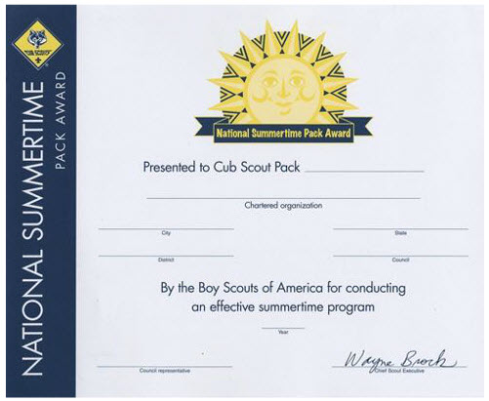
PACK CERTIFICATE
From http://usscouts.org/advancementTOC.asp and www.scouting.org/programupdates
Individual Cub Scout Summertime Award

Boys who participate in three pack events, one each month for June, July, and August, are eligible to receive the National Summertime Pack Award pin, which they can wear on the right pocket flap of their uniform. This is an individual recognition for boys, not adults.
Den Summertime Award
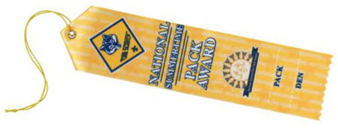
Dens with an average attendance of at least half their members at the three summer pack events are eligible for a colorful den participation ribbon.

Pack Summertime Award
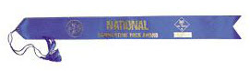
The pack can qualify for the National Summertime Pack Award certificate and streamer by planning and conducting three pack activities—one each in June, July, and August (or during other school vacations if your pack is in a year-round school).
Aoolication for ALL (Cub Scout, Den, and Pack) Summertime Awards
The award application may be found at http://www.scouting.org/filestore/pdf/33748.pdf

NEXT MONTH –

STEM Awards!!!

Need more info?
For additional information and the latest on the changes to these Special Opportunities for Cub Scouts, head to:

The Advancement pages on USScouts (http://usscouts.org/advancementTOC.asp ). Paul has already posted all the new requirements.
Or

On National's Site got to www.scouting.org/programupdates and look for the link to "Updated Requirements for Cub Scout Awards."

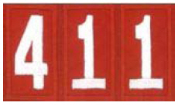
PROGRAM UPDATES

Be sure to check out National's website
for the latest on the
Adventure Program Changes -http://www.scouting.org/programupdates.aspx
What Has Happened / Is Happening -
The Boys' Books and the Den Leaders' Books have been available since before May 1. Get them and read them.
Position-Specific In-Person Training Guides Available Now! The training guides for Den Leader , Cubmaster/Assistant Cubmaster , and Pack Committee (Pack Committee Challenge) are now available on the adult training page of scouting.org.
The online training for Den Leaders, Cubmasters, Committee Chairs and members, and Chartered Organization Representatives has been totally updated with help from volunteers from around the country. The new training is divided into shorter, more targeted modules so leaders can get the training they need, in the order they want, any time they need it. The new training is organized around the learning needed prior to the first meeting, in the first 30 days, and to be position-specific trained. This new training was developed to be implemented in conjunction with the BSA’s new learning management system. The anticipated timing for launching this new tool is June 30, 2015. Keep an eye on MyScouting Tools (logging in through MyScouting.org ) for more information.
Philmont Training Sessions Are Filling, but There Is Still Time to Register Cub Scout leaders have a chance to visit Scouting paradise and learn more about "Leading the New Cub Scout Adventure." Four sessions are offered by the volunteers who designed the program and authored the new handbook and leader training materials. Visit the Philmont Training Center site to learn more about the conference and registration dates.
New Pack Meeting Plans Available Now! Pack meeting plans for the 2015-2016 and 2016-2017 Cub Scouting years are now available! From the Cubmaster’s Minute to resource lists, you’ll find everything you need to lead fun and engaging pack meetings! And they support the new Cub Scouting program, too! Check out the list and links from this issue of Baloo.
Updated Requirements for Cub Scout Awards The requirements for the
- National Den Award,
- National Summertime Pack Award,
- Cub Scout World Conservation Award,
- Cub Scout Outdoor Activity Award
have been revised to reflect the new Cub Scouts program launching June 1, 2015. See Special opportunities section of Baloo.
Supplemental Roundtable Content
To help prepare unit leaders for the new Cub Scouting program launching June 1, supplemental roundtable content has been developed to replace or supplement the current sessions listed as "Cub Scout Interest Topics" for January–July 2015.
Available installments are posted below.
Most packets have presentation materials (e.g. slidshow), Topic Guide, and worksheet or Handout. and
Already on Program Updates page -
- January – Program Support for Den Leaders
- February – Advancement
- March – Program Planning
- April – New Pack Meeting Plans
- May – Aquatic Adventures
- June – Campfire Programs



TRACKING SPREADSHEETS FOR THE CUB SSCOUT ADVENTURE PLAN
- Tracking Spreadsheets will be posted on USScouts webpage (www.usscouts.org) on June 1, 2015. They will be in the Advancement Section. There will be links to them from other places on the site. These spreadsheets are similar in construction and user interface as the existing spreadsheets. The spreadsheets have be tested by the developer of the current spreadsheets and he said they are so good he sees no reason to develop others!!
- Utah National Parks Council has Excel spreadsheets posted for all the new Adventure Plan requirements on their Akelas Council Blogspot. www.Akelascouncil.blogspot.com . Check them out.
The Advancement Excel Spreadsheet workbooks are distributed to Scouters for FREE.
PLEASE do not download the National Park Council files to email or send them digitally to others. They are for your personal / pack use only. If you would like to share these files with others, please copy / send the link to them and send them to our site so they can print off their own. We would love to have everyone that would like a copy to come here to get their own copy absolutely free. Utah National Parks Council receives money to keep our website open where we store all of our documents and PDF files by people visiting our blog. Please don't take money out of our pockets by bypassing our blog.

THOUGHTFUL ITEMS FOR SCOUTERS
Many thanks to Scouter Jim from Bountiful, Utah, who for many years voluntarily prepared this section of Baloo for us each month. He’s another “Regal” Bob White, too. Scouter Jim has retired from the staff Baloo's Bugle and is missed by us all. This column s reprint of the he wrote when Play Ball!! Was the theme in July 2005. CD

June Theme Prayer
Cub Scout Roundtable Leaders’ Guide
As we learn to play together, let us remember that we need to respect others and to do our best. AMEN

PRAYER OF THE SPORTSMAN
Dear Lord, in the battle that goes on through life,
I ask but a field that is fair:
A chance that is equal with all in the strife,
If I should win, let it be by the code
With my faith and my honor held high,
If I should lose, let me stand by the road
And cheer as the winners go by.
—Brayley.

A SPORTSMAN’S PRAYER
Dear God: Help me to be a sport in this little game of life. I don’t ask for any easy place in the lineup, play me anywhere you need me. I only ask for the stuff to give you 100 per cent of what I’ve got. If all the hard drives seem to come my way, I thank you for the compliment. Help me to remember that you won’t ever let anything come my way that you and I can’t handle. And help me take the bad breaks as part of the game. Help me to understand that the game is full of knocks and knots and trouble, and make me thankful for them. Help me to get so that the harder they come, the better I like it.
“And, O God, help me always to play on the square. No matter what the others do, help me to come clean. Help me to study the Book so that I will know the rules and to study and think a lot about the greatest player that ever lived and the other great players that are told about in the Book. If they found that the best part of the game was helping other guys who were out of luck, help me to find it too. Help me to be a reg’lar feller with the other players.
“Finally, O God, if fate seems to upper-cut me with both hands and I’m laid on the shelf in sickness of old age or something, help me to take that as part of the game too. Help me not to whimper or squeal that the game was a frame-up or that I had a raw deal.
“When in the falling dusk I get the final bell, I ask for no lying complimentary stones, I’d only like to know you feel that I’ve been a good, game guy.
—By George H. Brimhall.

What I learned from Officiating Youth Sports
Scouter Jim, Great Salt Lake Council
It is just a game and it is personal. For every little boy and girl playing sports, it is personal. They may look tough on the outside, but they are still tender on the inside. Be positive with the boys you work with, never berate of criticize them. I would always rather hear, “You’ll do better next time,” rather than, “That’s not the way I taught you.” The fragile spirits of the children are crushed by the latter while they are encouraged to try to do better by the earlier.
Winning isn’t everything, sportsmanship is. I once officiated a Pop Warner football game where one team had a special needs player. They asked if they could put him in as a deep safety on defense. While they were playing defense they played with twelve players against eleven. The opposing coach was thrilled to be playing against “such a worthy opponent.” He received the “Good Turn” coin I tried to give away each week to the best sport of the day.
Opponent and enemy isn’t the same thing. Too many times rivalries form and players playing against each other forget that a game is not a war. I once did a softball game where one team did not have a pitcher for a second game. The other team lent them a couple of theirs. The first pitcher hit three of her own players in the first inning with pitched balls. Both coaches keep encouraging her to do her best, even against her own teammates. After the first inning, the opposing team lent them one of their best pitchers to finish the game. At the end of the game, both coaches parted friends.
Character Counts! The most important thing I have learned in my years of officiating youth sports it that character counts. The most important thing coaches, and Scout leaders either for that fact, can teach, is that it is more important to be try your best; be courteous to other players, coaches and officials; and to be a good sport. Sometimes the biggest winners are the ones on the teams with the fewest points when the game is over.

TEN COMMANDMENTS OF SPORTSMANSHIP
- Thou shalt not quit.
- Thou shalt not alibi.
- Thou shalt not gloat over winning.
- Thou shalt not be a rotten loser.
- Thou shalt not take unfair advantage.
- Thou shalt not ask odds thou art unwilling to give.
- Thou shouldst always be ready to give thine opponents the shake.
- Thou shouldst not under-estimate an opponent, or over-estimate thyself.
- Remember that the game is the thing, and that he who thinks otherwise is a mucker and not true sportsman.
- Honor the game thou playest, for he who playeth the game straight and hard wins even when he loses.
Children have never been very good at listening to their elders, but they have never failed to imitate them" James Baldwin
"We cannot hold a torch to light another's path without brightening our own." Ben Sweetmand

A Cub Scout Prayer
Circle Ten Council
Oh Lord that I will do my best, In prayer, I come to thee.
Help me to help others everyday and at all times lead me.
To honor Mother and Father and to obey the Cub Scout Law, too.
This I ask that I may be a loyal Cub Scout true. Amen.

Sportsmanship Quotes:
Baltimore Area Council
“Games are not so much a way to compare our abilities as a way to CELEBRATE them.” ...Pat Farrington
“How we play the game may turn out to be more important than we imagine. For it signifies nothing less than our way of being in the world.” ...George Leonard
“True games do not divide us into winners and losers, but cause us to EMBRACE each other. They give everyone the chance to experience the feeling of full and even membership in the play community.” ...George Leonard

GATHERING ACTIVITIES
Note on Word Searches, Word Games, Mazes and such – In order to make these items fit in the two column format of Baloo’s Bugle they are shrunk to a width of about 3 inches. Your Cubs probably need bigger pictures. You can get these by copying and pasting the picture from the Word version or clipping the picture in the Adobe (.pdf) version and then enlarging to page width. CD

How Many?
Voyageurs Area Council
Fill a clear container filled with marbles counting as you fill. Everyone makes a guess on a slip a paper (be sure they include their first and last name) as to how many marbles are in the jar. The winner gets the container & marbles.

Who Am I?
Voyageurs Area Council
Make up a "Who Am I" card for each scout. This card has the name of someone who is famous or well-known in Sports. Tape one card on the back of each scout as they arrive (be sure the scout does not see the name). The scouts are allowed to ask each other scout two questions which can only be answered with "Yes" or "No" as they try to guess "Who" they are.

Tumbling Down
Voyageurs Area Council
With a box of baseball cards, have the boys see how high a tower they can build before they all come tumbling down.

Shot Put
Baltimore Area Council
If your July meeting is outdoors, have the boys engage in a shot put competition with a softball or a wooden croquet or bocce ball. The ball must be “put,” not thrown like a baseball.

Sports Ball Word Search
San Gabriel Valley, Long Beach & Verdugo Hills Councils
Find the names of some of our favorite ball sports in the word search below. They can be upside down, backwards, forwards or diagonal.
Soccer Volleyball Ping Pong
Croquet Baseball Rugby
Football Tennis Squash
Polo Basketball Water Polo

Madlibs
Baltimore Area Council
Give every boy a copy of the list below and during Gathering Time have him fill in the types of words required. Parents may help them understand what types of speech are required. Later in the Pack meeting, read the following story. When you reach a number, point to a boy and have him read his answer for that particular number. Have extra copies of the story to hand out to the boys at the end of the evening, so they can see how their whole list of words complete this silly story.
Or you can do this as an audience Participation. Just before reading the story fill in the list by having the audience shout out ideas and you selecting them. Make sure everyone knows your choices. CD
- (name)
- (adjective)
- (name)
- (noun)
- (adjective)
- (past tense verb)
- (clothing)
- (verb ending in -ing)
- (past tense verb)
- (noun)
- (clothing)
- (verb ending in -ing)
- (animal)
- (body part)
- (past tense verb)
- (past tense verb)
- (verb ending in -ing)
- (body part)
- (verb ending in -ing)
- (number)
- (adjective)
- (adverb)
- (adjective)
- (noun)
- (name)
- (adjective)

The Most Embarrassing Day to Play Baseball
Hi, my name is (1)___________, but you may call me
(2) ___________ (3) ___________. That’s what my
(4) ___________ calls me. But anyway, would you promise to keep a (5) ___________ secret? day, at baseball practice as I was trying to catch the ball, it (6) __________ into my (7) _________. I was very embarrassed to take it out because everyone was
(8) ___________ at me. When I (9) ___________ a few times trying to catch the ball, I got a (10) __________ in my (11) __________. Now everyone was (12) ___________ at me really hard. The next time I tried to catch the ball a
(13) ___________ landed on my (14) ___________ and I couldn’t concentrate on catching the ball.
When it was my turn for batting, I (15) ___________ the baseball bat in half! The coach was so
(16) ___________ that he was (17) ___________ on my (18) ___________. I was really embarrassed now, especially since everyone was (19) __________ at me. I also had to pay the coach (20) _________ dollars for a new baseball bat.
The (21) ___________ coach made me leave early since I was doing so (22) ___________. Now people call me (23) ___________ (24) ___________ (25) ___________.
Just remember it’s a (26) ___________ secret!!!!

Name the Signals
Baltimore Area Council
Each Den member gets a piece of paper and a pencil when he arrives. The chart of official sports signals (below) is displayed for everyone to see. (Or you could reproduce them on each boy’s paper.) The object is to have each person list the meanings of the various signals. Answers can be given at the meeting’s end.

OPENING CEREMONIES

Play Ball
San Gabriel Valley, Long Beach & Verdugo Hills Councils
Have your Cub Scouts help you with this one. Using cardboard or poster board have them cut out 8 different ball shapes. Have them paint or color them to resemble different balls like tennis, football, soccer, baseball, etc. Once dried have them use a stencil to spell out P-L-A-Y-B-A-L-L, one letter on each ball. Then glue or tape to the back of corresponding letter the text the cub is to read. Be sure to use LARGE print. (Need 8 Scouts to read aloud.)
- P is for our Parents who love us and help the Pack.
- L is for our Leaders who help on our scouting path.
- A is for Achievements that help us grow and learn.
- Y is for Yesterday the memories that we share.
- B is for Baloo the Bear who helps us learn to camp.
- A is for Activities because we want to run and play.
- L is for Laughing because Cub Scouts is such fun.
- L is for Learning skills we can use for life.

Sporting Flag Ceremony
San Gabriel Valley, Long Beach & Verdugo Hills Councils
This can be done with one person reading the entire poem or splitting it yup by lines and having different Cub read either each couplet or each line.
- Everywhere we gather I can see your colors wave,
- In churches, schools and stadiums, even in a cave.
- Two foes can meet upon a playing field,
- All are Americans; they will not yield.
- In sportsmanship and honor, some say that is the way,
- To keep our colors flying in every patriotic display.
- The freedom to choose, even if we don’t agree,
- To fight for what’s right, the price to live among the free.
- Please join me in pledging allegiance to our flag.

Our Country’s Birthday
Baltimore Area Council
Set Up: Stage this ceremony by placing the flag in a stand on the right side of the stage. Play a fan on it for a ripple effect. Soft background patriotic music playing.
(Voice from person hidden off stage) I am Old Glory. I am here to help celebrate the birthday of our country this month. For more than ten score years I have been the banner of hope and freedom. Born amid the first flames of America’s fight for freedom, I am the symbol of a country that has grown from a little group of thirteen colonies to a united nation of fifty sovereign states. Planted firmly on the high pinnacle of American faith, my gently fluttering folds have proved an inspiration to untold millions. Men have followed me into battle with unwavering courage. They have looked upon me as a symbol of national unity. They have prayed that they and their fellow men might continue to enjoy life, liberty and the pursuit of happiness. So long as the principles of ‘truth, justice and charity for all remain deeply rooted in human hearts, I shall continue to be the enduring banner of the United States of America.
Cubmaster: Please rise and repeat the Pledge of Allegiance with me.

The Sportsman’s Creed:
Baltimore Area Council
Have the Scouts repeat after the Leader:
The Player…
…lives clean and plays hard.
He plays for the love of the game.
…wins without boasting, he loses without excuses,
and he never quits.
…respects officials and accepts their decisions without question.
…never forgets that he represents his Den and Pack.
Have the Cubmaster repeat after the leader
The Coach…
…inspires in the boys a love for the game and the desire to win.
…teaches them that it is better to lose fairly than to win unfairly.
…leads players and spectators to respect others by setting them a good example.
…is the type of adult he wants his boys to be.
Have the Den Leaders repeat after the Leader:
The official…
…knows the rules.
…is fair and firm in all decisions. (S)He calls them as (s)he sees them.
…treats everyone courteously and demands the same treatment for (her)himself.
…knows the game is for the boys, and lets them have the spotlight.
Have the Parents repeat after the Leader:
The spectators…
…never boo a player or official
…appreciate a good play, no matter who makes it.
…know the Pack gets the blame or the praise for their conduct.
…recognize the need for more sportsmen and fewer “sports”.

Summer Opening
Baltimore Area Council
Have each boy read his part while holding an item or items that would be used in each of the summer activities. Narrator should, also, be a Cub Scout.
Narrator: What would of happened if our Cubmaster and Den Leaders had decided they didn’t want any Cub Scouting this summer?
(Read only those that apply to your Pack - add activities that you may do that are not listed).
- We wouldn’t have had our Softball League.
- Day Camp would have been just a dream.
- Our families would have missed the fun of our Picnic.
- We wouldn’t have met with other Packs for the Cub Scout Games.
- The fathers probably would not have gone camping with us at the Webelos Overnighter.
- We wouldn’t have marched in our city’s Fourth of July Parade.
Narrator: As you can see, it would have been a pretty dull summer if they had decided to take the summer off. Let’s give a big cheer for our Leaders and parents who have cared enough to give us Cub Scouting during the summer.

Favorite Song Opening Ceremony
Voyageurs Area Council
- My favorite song is "Take Me Out to the Ballgame." I like it because it reminds me of how excited I feel when my favorite (relative) comes to visit me.
- My favorite song is "Singing In the Rain". I love to run out in the rain, taste the raindrops and splash in the puddles.
- My favorite song is "The Bare Necessities" from "The Jungle Book." I don't like to worry about things I can't change. I am happy with myself and my life.
- My favorite song is "Home on the Range." I love to go camping with my family and enjoy the quiet and peace of the outdoors.
- My favorite song is "God Bless America." I love my country, my flag, and my home.
- What is your favorite song? It tells a lot about you - what is important to you, what you think about, and what you like.
- Please join with us by singing the first verse of your favorite song. Don't mind if someone by you sings something different. We can still make beautiful music together.
Cubmaster: Everyone sing the first verse of your favorite song.
Afraid to try this?? Don’t worry, you can bet that regardless of the sound, everyone will be smiling at the end.
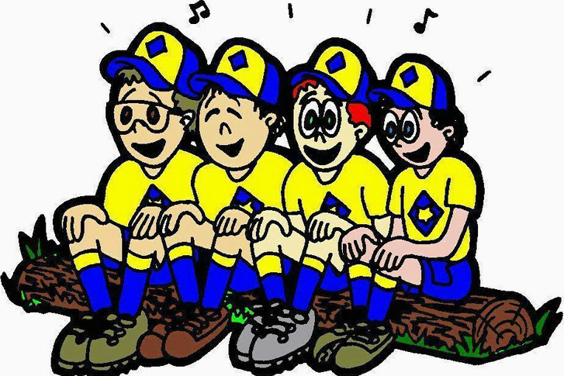

AUDIENCE PARTICIPATIONS

A Day at the Ball Game
Baltimore Area Council
Divide audience into four groups. Assign each group a response to say when their word is said in the story. Practice as you assign parts.
Johnny “Cheer, Cheer”
Den Leader ”Happy, Happy”
Umpire ”Blind As A Bat”
Kirby “Our Hero”
One fine day JOHNNY’S DEN LEADER decided to take his Den to a ball game. JOHNNY was so excited because his idol KIRBY was playing that day. The DEN LEADER and some of the parents loaded all the boys into their cars and headed for the ballpark.
On the way to the game, the DEN LEADER pointed to a man in another car and asked, “Why would a person put on such a dark suit on such a warm day?” JOHNNY looked at the man and exclaimed, “He’s an UMPIRE! I wonder if he is going to the game?” Sure enough, when KIRBY and the other players ran onto the field, out strolled the same UMPIRE that JOHNNY and his DEN LEADER saw on the way to the game.
When KIRBY ran out to his fielder’s position, JOHNNY and all the other people cheered for they knew KIRBY was a great player. The UMPIRE called “Play Ball” Everyone was on the edge of their seats as the pitcher took his sign, wound up and delivered his first pitch. “Crack” went the bat and a long fly ball was headed toward KIRBY. Back KIRBY ran, nearer and nearer to the fence, until he was right up against it. At the last minute he made a great leap into the air and the ball thudded into KIRBY'S glove. JOHNNY, his DEN LEADER and everyone cheered as the UMPIRE signaled “He’s Out.” The pitcher then struck out the next two batters with the UMPIRE calling the strikes real loud.
Now it was KIRBY'S teams turn at bat. JOHNNY was hoping KIRBY would hit a home run. First man up, “Crack,” a single. The next batter also singled and now to bat came KIRBY. JOHNNY, his DEN LEADER, and everyone was cheering and hollering for KIRBY to hit a good one. “Strike One”, called the UMPIRE and JOHNNY’s heart came up in his throat. “Strike Two,” called the UMPIRE, and JOHNNY'S heart sank. The pitcher took his sign, checked the runners, wound up, and delivered. “Crack” went the bat and JOHNNY knew KIRBY had hit a long one. Back, back went the fielder, clear to the wall. He leaped, but the ball hit the wall above him. KIRBY was churning his wheels around first, around second, heading for third. In came the ball and KIRBY hit the dirt. “Safe” yelled the UMPIRE. JOHNNY, his DEN LEADER, and everyone cheered.
JOHNNY was real happy because although his idol KIRBY had not hit a home run, he had hit a triple. And that is as close as any idol can come to what is expected of him. Therefore, JOHNNY, his DEN LEADER, and everyone went home happy.

Casey at the Bat
San Gabriel Valley, Long Beach & Verdugo Hills Councils
Divide your group into 3 sections and assign sounds as below.
Or maybe you just want everyone to do all the yells. There are a lot more Caseys than the other two put together - CD
Casey: “That’s me”
Fans (or related words): Cheering sound
Bat or Ball : “It’s a hit”
Now enjoy this famous poem.
Casey at the Bat
by Ernest L. Thayer
The outlook wasn’t brilliant for the Mudville nine that day:
The score stood four to two, with but one inning more to play,
And then when Cooney died at first, and Barrows did the same,
A pall-like silence fell upon the patrons of the game.
A straggling few got up to go in deep despair. The rest
Clung to the hope which springs eternal in the human breast;
They thought, “If only Casey could but get a whack at that—
We’d put up even money now, with Casey at the bat.”
But Flynn preceded Casey, as did also Jimmy Blake,
And the former was a hoodoo, while the latter was a cake;
So upon that stricken multitude grim melancholy sat,
For there seemed but little chance of Casey getting to the bat.
But Flynn let drive a single, to the wonderment of all,
And Blake, the much despised, tore the cover off the ball;
And when the dust had lifted, and men saw what had occurred,
There was Jimmy safe at second and Flynn a-hugging third.
Then from five thousand throats and more there rose a lusty yell;
It rumbled through the valley, it rattled in the dell;
It pounded on the mountain and recoiled upon the flat,
For Casey, mighty Casey, was advancing to the bat.
There was ease in Casey’s manner as he stepped into his place;
There was pride in Casey’s bearing and a smile lit Casey’s face.
And when, responding to the cheers, he lightly doffed his hat,
No stranger in the crowd could doubt ‘twas Casey at the bat.
Ten thousand eyes were on him as he rubbed his hands with dirt;
Five thousand tongues applauded when he wiped them on his
shirt;
Then while the writhing pitcher ground the ball into his hip,
Defiance flashed in Casey’s eye, a sneer curled Casey’s lip.
And now the leather-covered sphere came hurtling through the
air,
And Casey stood a-watching it in haughty grandeur there.
Close by the sturdy batsman the ball unheeded sped—
“That ain’t my style," said Casey. “Strike one!” the umpire said.
From the benches, black with people, there went up a muffled
roar,
Like the beating of the storm-waves on a stern and distant shore;
“Kill him! Kill the umpire!” shouted someone on the stand;
And it’s likely they’d have killed him had not Casey raised his
hand.
With a smile of Christian charity great Casey’s visage shone;
He stilled the rising tumult; he bade the game go on;
He signaled to the pitcher, and once more the dun sphere flew;
But Casey still ignored it and the umpire said, “Strike two!”
“Fraud!” cried the maddened thousands, and echo answered
“Fraud!”
But one scornful look from Casey and the audience was awed.
They saw his face grow stern and cold, they saw his muscles
strain,
And they knew that Casey wouldn’t let that ball go by again.
The sneer is gone from Casey’s lip, his teeth are clenched in hate,
He pounds with cruel violence his bat upon the plate;
And now the pitcher holds the ball, and now he lets it go,
And now the air is shattered by the force of Casey’s blow.
Oh, somewhere in this favoured land the sun is shining bright,
The band is playing somewhere, and somewhere hearts are light;
And somewhere men are laughing, and somewhere children
shout,
But there is no joy in Mudville—mighty Casey has struck out.
This poem is in the Public Domain

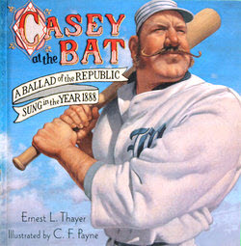

ADVANCEMENT CEREMONIES

B-A-L-L-O-O-N
San Gabriel Valley, Long Beach & Verdugo Hills Councils
You can have fun, meaningful ceremonies that don't take a lot of time. My youngest will never forget his Wolf ceremony (and he's 17 now.) He was called forward with a few of his peers who had also finished and handed a balloon and a small plastic sword (you could give them a safety pin), accompanied by a few meaningful words about the badge. The boys were told to pop the balloons and voila - out popped a Wolf Badge!
That is the ceremony he remembers most - not the more verbose, more serious ceremonies that accompanied some of his other badge presentations.
Set Up –
- Get helium balloons for the number of advancing boys.
- Before blowing them up, insert the cloth badge of rank into them then blow them up.
- Decorate them to be sports balls: White for soccer, baseball or volleyball; orange for basketball; yellow for tennis. Use your imagination. Use the same type of ball for the same rank to help avoid confusion - especially if you have many boys who are advancing.
Write some meaningful words for each rank. Keep the number of words low. The ideas that were originally with this ceremony referenced the old Achievements. Maybe you want short poems. Maybe simple thoughts. Don’t feel limited. Maybe your Cubs would want to write their own lines. They need not rhyme. Send any you write to Judy and I so we can start adapting ideas to the Adventure Program. CD

Cub Scouting Is Like Playing Baseball
San Gabriel Valley, Long Beach & Verdugo Hills Councils
This ceremony takes you through all the ranks. Badges can be presented at each base as the Scouts walk around the infield. Or they can be held and presented at Home plate by calling everyone in one rank at a time. If you are not doing Arrow of Light, take time to modify that section to use it to inspire Cubs finish their path around the bases.
Participants:
- All Cub Scouts – Tiger, Bobcat, Wolf, Bear, 1st Year Webelos and Graduating (2nd Year) Webelos Scouts
- Den and Webelos Leaders
- Parents of graduating Webelos
- 5 Boy Scouts
- Cubmaster.
Setup: Use a baseball field with bases set about 40 to 60 feet apart (60 feet is Little League standard). Parents stand near third base dugout; Boy Scouts stand near first base dugout; Cubs and Webelos stand near home plate with Den and Webelos Leaders beside their dens. Cubmaster stands at pitcher's mound.
Cubmaster: Cub Scouting is like playing baseball. Each base we go to indicates a certain level of skill obtained.
The Bobcats are in the on-deck circle. (Den Leaders take all new Bobcats to on-deck circle) Call Bobcat parents to on-deck circle. The Bobcat learned the Scout Oath (or Promise) and Law, the Cub Scout Motto, handshake, salute, and sign. And, as all ball players, he got to wear the uniform showing everyone in the stadium what team he was on - in our case the Blue and Gold team. Present awards to parents of Bobcats to present to their sons. Lead Cheer.
When the Cub got up to the plate for the first time, he was a Tiger. Call Tigers and their parents to Home Plate. Say a few words about the awards the Tigers have earned. Present Tiger awards to parents of Tigers to present to their sons. Lead Cheer.
(Den and Webelos Leaders advance all other Cubs to 1st base and stop.)
The Tiger hit the ball and ran to 1st base - the first leg of the diamond. At this point he learned the basics of the sport - throwing the ball, batting and catching. To the Scout, it was learning what it meant to help other people and to give good will - a time for the Cub to learn the basics with his coaches, mom and dad. The Cub is on his way to manhood. Call Wolf Parents to First base and present Wolf Awards. Lead Cheer. (Wolf Cubs and Wolf Leader stay at 1st; the rest go to 2nd base.)
The Cub arrives at the second base, half way around. At this point he learned that through practice and determination one became a better ball handler, better thrower and better batter. The Cub is given choices in the Bear book and begins to learn about camping and how to use a knife safely. The Bear Cub sharpens his skills and begins to enjoy the team aspect of the sport, not just individual achievement. Call Bear Parents to Second base and present Bear Awards. Lead Cheer. (Bear Cubs and Bear leader stay at 2nd; the rest go to 3rd base.)
The Cub now arrives at third base. He can see victory! He knows that if he makes it to third, he has a good chance of scoring. As he passes the shortstop he looks at the coach for guidance. This is the year in the Cub's life that changes most dramatically. He becomes a Webelos. It is the acronym for We'll Be Loyal Scouts. To the baseball player, it means that he has mastered the rudiments of the sport and now must rely on his coach to lead him around the bases. The Scout begins to trust others, listen to the coaches, back up his fellow team members and show maturity on the field. The 4th Graders are Webelos. The Webelos go on a few campouts and obtain a taste of adult responsibility. Call Webelos Parents to Third base and present Webelos Awards. Lead Cheer. (Graduating Webelos go half way to home plate.)
The Cub has gotten the high sign from the coach and he puts on the afterburners as he rounds third base. He's heading for home. The fans are standing, rooting as he approaches home plate. The Arrow of Light Cub is on his last leg of the course. He knows he is going to score. The anticipation is tremendous, as he knows his run could win the ball game. (Parents of Arrow of Light Cubs and Boy Scouts go to home plate and wait to give the boys a "HIGH FIVE" as they cross the plate.)
The Cubs have earned the Arrow of Light, the highest award given to a Cub Scout. He has prepared himself to return home, but this time as an accomplished ball player. He's learned the fundamentals of the sport. He has learned that he should be TRUSTWORTHY, LOYAL, HELPFUL, FRIENDLY, COURTEOUS, KIND, OBEDIENT, CHEERFUL, THRIFTY, BRAVE CLEAN and REVERENT.
He started from the on-deck circle as a Bobcat and will now return home as a young Scout ready to enter the senior league, the Boys Scouts, and be welcomed by his new coach and team mates from Troop ______. He will be greeted by the most influential people in his Cub sporting career - his parents. They helped him every step of the way around the bases. They are so proud of him that they, too, are anxious for him too cross the plate. They were with him as he touched every base and will continue to be with him in the dugout and after the game.
The Arrow of Light is the only badge of rank earned by a Cub Scout that can be worn permanently on the Boy Scout uniform. There are 7 rays of light on the badge to not only signify the 7 days of the week but the 7 virtues of playing the game:
1. WISDOM - Putting to right use the knowledge they have obtained.
2. COURAGE - To meet the opposition head on in spite of one's fear.
3. SELF CONTROL - Controlling one's temper during the game. Being sportsmen.
4. JUSTICE - Justice will prevail, even if you think the umpire made a bad call.
5/6. FAITH and HOPE - Two virtues that all players must have on and off the field.
7. And finally LOVE - Love of family, love of home, love of God, love of fellow members and love of the game.
These are the seven virtues that will make you successful in the games to come. Now would the following Scouts proudly stride into home and receive their Arrow of Light. Lead Cheer.

Cub Scout Baseball
Baltimore Area Council
Equipment: A small baseball diamond on the floor in front, badges to be awarded.
Personnel: Cubmaster, boys to receive awards and their parents.
Note from CD – You may want to add in words here about what the Adventures were that hey completed for each rank.
Will (names), our new Bobcats and their parents please come forward to the “on-deck circle?” As you are standing on the “on-deck circle” you are at the beginning of the “game”. Just as you are at the beginning of the Cub Scout trail. Parents, please accept your son’s badge and present it to him. (Present badges) Lead Cheer
Will (names), our Tiger candidates and their parents please come forward. Stand on home plate. This represents the first stop on your Cub Scout trials. You worked hard on earning your Tiger Rank. So keep up the good work. Parents here are their badges. (Present badges) Lead Cheer
Will (names), our Wolf candidates and their parents please come forward. Stand on first base. This represents the second stop on your Cub Scout trials. You worked hard on earning your Wolf. So keep up the good work. Parents here are their badges. (Present badges) Lead Cheer
Will (names), our Bear candidates and their parents please come forward. Your place on our diamond is at second base. This is the third major stop along the Cub Scout trail. Parents, please accept your son’s badge. (Present badges) Lead Cheer
Will (names), the Webelos and their parents please come forward. Your spot is third. You are almost “home”. Keep up the good work and you will have no problem in finishing your trail. (If appropriate depending on the Webelos badge being presented) You now wear a badge diamond on your shirt to complete that game. OR You now may wear the oval Webelos Badge shaped to have you start thinks of the ranks and adventure awaiting you in Boy Scouts. You need to receive your Arrow of Light. Work hard and you should have no problem. (Present badges) Lead Cheer
(If you have boys earning the Arrow of Light their spot is home plate.)

Scoreboard Advancement Ceremony
Baltimore Area Council
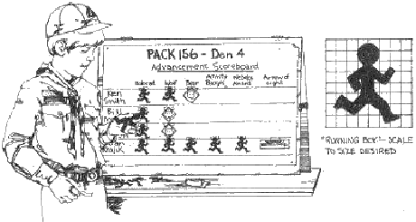
Personnel: Cubmaster, Den Leaders, advancing boys and their parents
Props: Scoreboard and cutouts of running figures, invisible tape, straight pins, badges. Make a scoreboard of poster paper and write in the name of the advancing boys. Use grid methods to draw the figure to size you want; then cut out as many figures as you need.
Call forward advancing Scouts and their parents. Line up the boys on either side of the scoreboard with the parents behind them.
You know, boys, Cub Scouts is a lot like sports. It’s fun, it’s full of physical activities, and you can win – or lose. In Cub Scouting you win by growing strong in mind and body, and by advancing in rank. Or you can lose by not joining in our Den and Pack activities and by not doing your best to pass achievements and electives.
You boys have all been winners this month. You have advanced in rank or earned Adventure Belt Loops, or both. Your coaches have been your Den Leaders and your parents. In Cub Scouting, we could not get along without coaches. So I want to congratulate all of you, boys and parents. Now I’ll ask each boy to show his progress on our scoreboard by putting on the scoreboard a marker for each rank you have earned and have your parents pin on your new rank badge. (In turn, advancing the boy’s tape on a runner for each rank he has earned and removing his new badge for the parents to pin on to his uniform.)
We also have a boy who has earned the Arrow of Light. Cub Scouting’s highest award. (Call him forward with his parents.) __________ has shown that he is ready for Boy Scouting by earning the Arrow of Light. He has met the requirements for this award. He is in the ninth inning of his time in our Pack. We are all proud of him and the way he has progresses in the sport of Cub Scouting. Now ________, will you please fill your ranks on our scoreboard and have you parents pin your Arrow of Light badge on your uniform? (They do so.)
I hope that every member of the Pack gets on the scoreboard in the coming year. It is a good way to be a winner in Cub Scouting.
Spirit of Cub Scouting Induction Ceremony
Voyageurs Area Council
An induction ceremony in July???
I thought to myself this is strange but then I realized that with the emphasis on Spring Recruiting – get those Kindergartners for Tigers now and other Cubs so they can start with day camp – the July Pack Meeting (that is hopefully an outdoor event – Camping Trip or Campfire) may be where these new members do go through an induction ceremony. Not for your pack? Then just file it for use later in the year. CD
Preparation: Cub Scouts makes a semi-circle with a candle in the middle on a table. Leader lights the candle or turns on an electric candle. Leader leads the new boy(s) to the center behind the candle. He(They) looks at the candle.
- Before you burns a white candle which represents the spirit of Cub Scouting.
- It takes a team to keep that spirit alive; to keep the flame burning.
- You (to the new boy(s)) have been chosen to be a member of our pack.
- Look into the flame. It gives warmth and light.
- As (a) new member(s) of our pack, you must help to keep this flame burning.
- You must learn the Cub Scout Promise and the Law of the Pack and live them.
- You must "Do Your Best" to help keep the flame burning by working as a team.
- As a new member of our pack, we welcome you with the Cub Scout Handshake.
Den Leader, Cubmaster, and boys give the new Cub Scout(s) the Cub Scout Handshake and welcome him (them) into the Pack.
The boy may also be presented with a slide or other item used by the Pack by his leader to complete the induction to the pack.

LEADER RECOGNITION

Certificate of the Right to Play
Sam Houston Area Council
By this certificate know ye that THE BEARER IS A LIFETIME MEMBER IN GOOD STANDING IN THE SOCIETY OF CHILDLIKE GROWNUPS AND IS HEREBY ENTITLED TO walk in the rain, jump in mud puddles, collect rainbows, smell flowers, blow bubbles, stop along the way, build sandcastles, watch the moon and stars come out, say hello to everyone, go barefoot, go on adventures, sing in the shower, have a merry heart, read children's books, act silly, take bubble baths, get new sneakers, hold hands & hug & kiss, dance, fly kites, laugh out loud and cry out loud, wander around, wonder about stuff, feel scared & sad & mad & happy, give up worry & guilt &shame, stay innocent, say yes and no and the magic words, ask lots of questions, ride bicycles, draw and paint and color, see things differently, fall down and get up again, talk with animals, look at the sky, trust the universe, stay up late, climb trees, take naps, do nothing, daydream, play with toys, play under the covers, have pillow fights, learn new stuff, get excited about everything, be a clown, enjoy having a body, listen to music, find out how things work, make up new rules, tell stories, save the world, make friends and do anything that brings more happiness, celebration, relaxation, communication, health, love, joy, creativity, pleasure, abundance, grace, self-esteem, courage, balance, spontaneity, passion, peace, beauty, and life energy to all humans and beings of this planet.
FURTHERMORE, the above named member is officially authorized to frequent amusement parks, beaches, meadows, mountaintops, swimming pools, forests, playgrounds, picnic areas, summer areas, summer camps, birthday parties, circuses, bakeries, ice cream parlors, theaters, aquariums, zoos, museums, planetariums, toys stores, festivals and other places where children of all ages gather to play AND is encouraged to always remember the motto of THE SOCIETY OF CHILDLIKE GROWNUPS: IT'S NEVER TOO LATE TO HAVE A HAPPY CHILDHOOD AND MAKE SURE THAT OTHERS DO TOO.

THEME RELATED STUFF

TEN COMMANDMENTS OF SPORTSMANSHIP
Jim Jones, Great Salt Lake Council
- Thou shalt not quit.
- Thou shalt not alibi.
- Thou shalt not gloat over winning.
- Thou shalt not be a rotten loser.
- Thou shalt not take unfair advantage.
- Thou shalt not ask odds thou art unwilling to give.
- Thou shouldst always be ready to give thine opponents the shake.
- Thou shouldst not under-estimate an opponent, or over-estimate thyself.
- Remember that the game is the thing, and that he who thinks otherwise is a mucker and not a true sportsman.
- Honor the game thou playest, for he who playeth the game straight and hard wins even when he loses.

SONGS

Rotten Reeboks
Baltimore Area Council
(tune: Clementine)
Rotten Reeboks, dirty sweat socks,
Generating toxic fumes,
I’ve seen flies dead, struck in mid air
Fatal venture to his room.
In my brother’s bedroom closet
Stinkarooning like refuse
Dwelt a size 10 pair or sneakers
With a smell you couldn’t lose.
Aging tennis, in a corner
Turning the air a bluish green,
Hope the county doesn’t visit
They’d condemn us sight unseen.
I’ve tried bug balm, lemon air scent
Even spray that smells like pine,
Must be something that can cut it,
Something strong, like turpentine.
Even weirdo, crazy mutt dog
Who has breath you can’t adore,
Makes a wide turn, cuz his eyes burn,
Every time he nears the door.
“What’s the big deal?” asks ol’ big foot
None of his friends notice it.
“Proves they’re brain dead,” says my sister,
“Doesn’t surprise me a bit.”
“Not to worry,” says my father
“Could be money after all,
“Pentagon might pay a bundle
“For the secret to it all.”

The Athlete
Baltimore Area Council
(Tune: My Bonnie)
They gave me a suit and a number,
And sent me out on the field.
They gave me a ball called the pigskin,
And shoes with some cleats, toe and heel.
Chorus:
Muscles, and cramps,
wracking my body with pain, with pain,
I stand, wondering,
If ever I’ll do this again !
Next time they gave me a racquet,
Then sent me out on the court
Funny the things you encounter,
While trying to learn a new sport.
Chorus:
The ordeal was finally over,
At least, that’s what I thought.
When they shoved me the soccer equipment,
I fainted dead on the spot !
Chorus:

Cub Scout Sports Song
Baltimore Area Council
(Tune: My Bonnie)
My baseball went over the fence
My arrows are broken to bits
My volleyball been deflated
After riding a horse I can’t sit
Chorus:
Belt loops, belt loops,
I’ll earn Adventures today, today.
Belt loops, belt loops;
My rank badge is not far away
Chorus:
My bicycle has a flat tire
My boomerang just won’t return.
They say that I’ve lost all my marbles
And I still haven’t gotten my turn.
Chorus:
My dog ate my ping pong paddle.
My badminton birdie has flown.
I sprained my right ankle while jogging
And was stranded ten mile’s from home.
Chorus:
They say that Cub Scout sports are fun.
Some day I would like to know.
I’ve been wandering around for an hour
Just waiting for my Den to show.

Take Me Out To The Ball Game
San Gabriel Valley, Long Beach & Verdugo Hills Councils
by: Jack Norworth and Albert Von Tilzer
This song is in the Public Domain
Take me out to the ball game;
Take me out with the crowd.
Buy me some peanuts and cracker jack;
I don't care if I never get back.
Let me root, root, root for the home team;
If they don't win it's a shame.
For it's one, two, three strikes, you're out
At the old ball game.

Bowlin’, Bowlin, Bowlin’
San Gabriel Valley, Long Beach & Verdugo Hills Councils
(Tune: Rawhide)
Bowlin’, Bowlin, Bowlin’
Keep those balls a rollin’
Keep those strikes a rollin’, alright!
We’re laughin’ and a grinnin’
Cause our team is winnin’
Soon we’ll be in first place.
Head ‘em up, roll ‘em down
Roll ‘em down, make a strike
Make a strike, so we win, alright!
Roll ‘em down, knock em off,
Get a mark, make a strike.
We’re gonna win tonight!

This is My Baseball
San Gabriel Valley, Long Beach & Verdugo Hills Councils
(Tune: This is My Country)
This is my Baseball
I’ll share it with you.
This is my baseball
Bring your bat and mitt too!
I’m playing with my friends,
I’m gonna hit one home.
Cause this is my baseball
To share and to hold.

STUNTS AND APPLAUSES
APPLAUSES & CHEERS

A Box of Cheer
San Gabriel Valley, Long Beach & Verdugo Hills Councils
- Here is a quite simple and fun way to introduce a cheer.
- Get a small Cheer Box, clean it out, and voila, you have a Cheer Box for all the cheers.
- Take all the cheers and applauses that you have and put each one on a slip of paper, then drop them in your Cheer Box.
- During the pack meeting call up one of your scouts to pick a cheer out of the Cheer Box (No peeking!),
- Then have him lead the cheer.
Baltimore Area Council
The Ball Applause: Hold any kind of ball in your hands. When you are holding the ball, everyone is quiet. When the ball leaves your hands, everyone goes wild and cheers. Try bouncing the ball, faking a throw, or tossing it to another person.
Home Run Applause: Simulate swinging a bat at a ball, shade your eyes with your hand and yell, “Thar she goes:”
San Gabriel Valley, Long Beach & Verdugo Hills Councils
Home Run: Simulate swinging a bat, then shade your eyes with your hands and yell,
"It’s outta here!" or “It’s way back and it’s gone!”
Bouncing Ball: Using a super ball or golf ball (preferably), drop the ball from an outstretched hand over your head or toss it upwards. Have the group yell, “Pow” every time the ball hits the floor.

RUN-ONS
Baltimore Area Council
- You want to hear something funny? My sister thinks a football coach has four wheels.
- Ha! Ha! Ha! Ha! Ha! How many does it have?
Cub 1: Speaking of baseball, I have something here that can run but can’t walk.
Cub 2: What is it?
Cub 1: Water.
- What do baseball players eat on?
- Home plates!
Tiger Cub: What’s the quietest sport in the world?
Den Leader: I don’t know.
Tiger Cub: Bowling. You can hear a pin drop.
Dad 1: I hear your son is on the football team. What position does he play?
Dad 2: I think he’s one of the drawbacks.
Professor: Class, what has eighteen legs and catches flies?
Student: A baseball team?

The Shoe
San Gabriel Valley, Long Beach & Verdugo Hills Councils
Equipment: Two people, one wearing only one tennis shoe.
Preparation: Decide who will wear the one shoe, practice
Action: Cub #1 wearing only one shoe is looking around looking underneath and behind things.
CUB #2: “Did you lose a tennis shoe?”
CUB #1: “No, I found one!”
JOKES & RIDDLES

Weather The Weather
www.theweatherprediction.com
I used this when I was the weatherman for a Wood Badge course in 1996. CD
Whether the weather be fine
Or whether the weather be not,
Whether the weather be cold
Or whether the weather be hot,
We'll weather the weather
Whatever the weather
Whether we like it or not
I guess since I did that one we need –
When I was in Arkansas,
I saw a saw that could out saw any saw I ever saw
So if you are ever in Arkansas,
And see a saw that can out saw the saw I saw
I’d like to see your saw saw
And –
How much wood could a woodchuck chuck
If a wood chuck could chuck wood
San Gabriel Valley, Long Beach & Verdugo Hills Councils
Q: How do baseball players stay cool?
A: They sit next to their fans!
Q: What do cheerleaders drink before they go to a basketball game? A: Root beer!
Q: What do basketball players and babies have in common?
A: They both dribble!
Q: What runs around a soccer field but doesn't move?
A: A fence!
Q: Why did the basketball player go to jail?
A: Because he shot the ball!
Q: Why did the football coach go to the bank?
A: Because he wanted to get his quarter back!
Q: Why did the golfer wear two pairs of pants?
A: In case he got a hole-in-one!
Q: Why don't grasshoppers go to baseball games?
A: They prefer cricket!
Q: Why did the police go to the baseball game?
A: Because someone was stealing a base!
Q: Why did Cinderella get kicked off the soccer team?
A: Because she ran away from the ball!
Q: Why did the cake like to play baseball?
A: Because it was a good batter.

Sports Riddles In Rhyme
Baltimore Area Council
Say a verse and see who can guess the sport. Answer in parentheses.
Think of a diamond,
Think of a team of nine
Think of a grandstand filled with fans,
Willing to stand in line. (baseball)
Two forwards and a center,
Plus two guards make a team,
To win this fast exciting game
Is every player’s dream. (basketball)
Eleven players on each team.
Two halves in which to play
When a player makes a touchdown.
There’s cheer right away. (football)

SKITS

A New Sport
Baltimore Area Council
Have a Den line up on stage. One Scout steps forward and, acting as a narrator, announces that this is the first exhibition of a new Olympic event. This is the cue for the rest of the Scouts to grin as widely as possible. The narrator announces that this event is called the Standing Broad Grin.

The Football Game
Baltimore Area Council
A group of boys are discussing a football game. Insert the name of your local high schools or favorite pro teams in the blanks.
- I sure hope that the __________ win.
- Well, I’m sure that the _________ will win.
- Why, the _________ will beat ‘em 40 to nothin’.
- I can tell you the score of the game before it starts.
All Others: Oh yeah? How can you? You’re not psychic, are you?
Cub # 4: The score of the game before it starts? It’s nothin’ to nothin’ of course.
(Others chase him off stage.)
Harlem Globetrotters
Baltimore Area Council
Three Scouts are doing laundry. Each is sitting behind a bucket that holds his “laundry”. Two of the buckets really have water and a rag or two. All three work at scrubbing and wringing water from their laundry for a few seconds. One sitting on the end shakes the water from his hands getting his neighbor slightly wet. This provokes the Scout in the middle who retaliates with a splash back, escalate in comedic fashion till the one on the end throws a wet rag at the face of the Scout in the middle who ducks. The rag sails on till it smacks the Scout on the far end (previously not involved in the water fight) in the face. The smack-ee picks up his bucket to dump on the others who take flight into the audience.
The Punch line: When the actors are in the crowd the smack-ee tosses the contents of his bucket in a wide arc over as much of the audience as possible. You can fill the bucket with pieces of newspaper, but in a Scouting setting a bucket full of leaves would work just as well. If the actors have a little talent and practice this can be extremely funny

Sportsmanship Skit
Make large cards with the following letters-S-P-O-R-T-S-M-A-N-S-H-I-P. You’ll need the Cubmaster and 13 Cub Scouts, each with one letter. As the Cubmaster reads the letters the boys show their cards, read the words for their letter off the back, and hold them up for the rest of the ceremony.
CM: At the start of a baseball game, the announcer yells, “Play Ball!” Very soon, we will be saying that for our big game here at our Pack picnic. But before that, 13 Cub Scouts and I would like to remind you of something very important. We’ll do it with a little spelling lesson:
- S – is for smiling, even if you hurt inside.
- P – is for pardoning parents who may show poor manners.
- O – is for oozing enthusiasm for your car and your fellow Den members.
- R – is for respecting the feelings of other Cub Scouts.
- T – is for trying your best and (next letter) is for being satisfied with yourself.
- M – is for mastering self-control.
- A – is for anger, which has no place in our meetings.
- N – is for noticing that only one can win.
- S – is for success in doing your best.
- H – is for hushing boastful words.
- I – is for inspiring us to congratulate the winner.
- P – is for playing the pinewood derby for fun.
CM: Let us remember that word ‘Sportsmanship’ during our derby tonight.

Broken Finger
San Gabriel Valley, Long Beach & Verdugo Hills Councils
Personnel: Two Scouts
Preparation: Practice speaking loudly and clearly
CUB #1: Cub #1 approaches Cub #2 "Do you know about first aid? When I press my forehead with my finger, it really hurts. When I do the same to my jaw, it's also painful. When I press on my stomach, I suffer. What can it be?"
CUB #2: Cub #2 listens to Cub #1’s heart, taps on his chest, looks in his ears and declares, "I don't know. You better go to the camp doctor. It looks serious."
CUB #1: “O.K.” Cub #1 leaves for a few minutes and comes back.
CUB #2: "What did the camp doctor say?"
CUB #1: "The doctor said I have a broken finger."

Who's Football?
San Gabriel Valley, Long Beach & Verdugo Hills Councils
Equipment: Something that looks like a T.V. & 2 chairs.
Preparation: Set up the two chairs side by side facing the T.V., Two scouts playing a Father and Son, sit in the chairs.
CUB #1: (The Father) leaps out of his chair saying, “I can’t believe he missed that simple pass! Why do they let that lazy guy play anyway?”
CUB #2: (The Son) looks at father, “Dad, maybe it’s his football!"

Bubble Gum
San Gabriel Valley, Long Beach & Verdugo Hills Councils
Equipment: 1 chair
Preparation: Practice, but there are no lines. But the more the Cubs ham up the action, the better the skit.
This could be introduced as boys waiting outside the Principal’s Office at school. Or waiting to see the doctor.
1st scout walks out to the chair, takes his gum out of his mouth, places it on the back of the chair, and then walks off.
2nd scout walks out to the chair, leans his hand on the back, finds the gum on his hand, and, totally disgusted, wipes it on the seat of the chair and walks off.
3rd scout walks up to the chair and sits down. He realizes with great disgust that the gum is stuck to his bum. Disgusted, he peels it off, throws it to the ground and walks off.
4th scout walks out to the chair, then realizes he's got gum stuck to his shoe. With great disgust he peels it off, sticks it to the back of the chair, and walks off.
1st scout comes back, walks up to the chair, peels it off, sticks it in his mouth and walks on.

CLOSING CEREMONIES

Pump It Up
You need a partially deflated basketball, volleyball, or soccer ball and a hand pump with needle.
The Cubmaster calls forward a Cub Scout and asks him to demonstrate dribbling. Naturally the ball won’t bounce well. Then the Cubmaster calls forward another Cub Scout and asks the two boys to inflate the ball with the pump.
Cubmaster : That’s much better! Now we can play a game after these Cub Scouts have finished their work, There’s a lesson for us here. Your bodies are like that ball. If you are not physically fit and pumped up with energy, you are not ready for anything -- not for play, for school, or for work. Like the ball I had that didn’t have enough air, you don’t have enough strength and energy to do anything.
Let’s all remember to keep our bodies, and our mind, pumped up so that we’re ready for whatever life brings our way.
End by having your song leader lead “I’ve Got That Cub Scout Spirit” from Cub Scout Songbook.

Worn Out Closing
Baltimore Area Council
Set Up - Have four or more boys on stage wearing cardboard feet which have scratches, cuts, band-aids, etc. on them.
- Our Sports Extravaganza meeting has come to an end.
- We now have a message to leave with you, dear friend.
- Our many achievements in life make feet tired and weary.
- But if there was nothing to do, our life would be dreary.
- So forget the knocks and scratches, blisters and aches.
- Do your best at all times, That’s what success takes
As the poem is finished, boys lay down on stage with their cardboard feet facing the audience...each of the feet has a letter on it spelling out G-O-O-D-N-I-G-H-T)
If you have more than 4 Cubs, put in Exclamation Points, pictures, or leave blanks

Cubmaster’s Minutes

What Is a Good Sport?
Baltimore Area Council
A good sport - you hear a lot of talk about being a good sport, but just what does it mean? A good sport learns the rules so he will not break them. He competes with all his heart, striving to outclass his competitors. If he wins, he doesn’t act smug, but instead compliments the losers for the fine job they did. If he loses, he accepts the fact and finds out why. Maybe he can win the next time. A good sport accepts defeat, congratulates the winners, learns how he can improve, and determines to do better the next time.

Sportsmanship
Baltimore Area Council
In 1940, an underdog Dartmouth football team played powerful Cornell, which needed only one more victory for a perfect season and a number-one ranking in the country. Trailing 3-0 Cornell scored a controversial touchdown that the Dartmouth players insisted was made on an extra ‘fifth down.’ However, the referee counted the touchdown, and Cornell won 7-3.
But after the game, Cornell officials watched the game on film and saw that, indeed their team had been allowed and extra play. They immediately sent a telegram to Dartmouth stating that they could not accept the victory. It went into the record book as 3-0 victory for Dartmouth.
That little story tells us what sportsmanship really is. It is the desire to play hard and to win - but to win fairly - and if you lose, to accept defeat with good grace. Let’s remember that during our Cub Scout games and throughout our lives. Also remember, that to be a good sport you have to lose to prove it.

Sport Heroes (Closing Ceremony)
Cubmaster:
Someday a member of our Pack may be a football star
Like Elway, Marino or Dickinson
and known both near and far.
Or maybe we’ll play basketball, or hockey on the ice.
And have our picture in the news and see our name in lights.
Or maybe we’ll do something else
outside the sporting game.
And though we won’t give autographs,
like those of TV fame,
We hope the people that we know will think of us and say
That each of us has done his best while working or at play,
To be the kind of citizen who helps to make things grow
Like families and neighborhoods
and this old world, you know!
You just don’t have to be a star (although it would be fine)
To help make this a better world for your folks and for mine
Just "DO YOUR BEST," our motto says,
in everything you do!
Who could ask for more than that?
Cub Scouts - we’re proud of you!
Good night - have a safe trip home!

A Good Sport
Circle Ten Council
The world is full of people who think it is a calamity if they lose a contest. They lose their temper and act like bad sports. A good sport will do his best, and, if he loses, look to the next game to do better and try to win. In Cub Scouting, we learn to be good sports, and to do our best, whether we win or lose.

ONE LAST THING

Abbott & Costello: Who’s On First?
Baltimore Area Council
Many are not aware that Abbott & Costello are the first non-baseball-playing celebrities ever to be inducted into the Hall of Fame! This would be very hard for the Cub Scouts to do, but a couple of adult leaders could have fun with it.
Abbott: Well Costello, I’m going to New York with you. The Yankee’s manager gave me a job as coach for as long as your on the team.
Costello: Look Abbott, if your the coach, you must know all the players.
Abbott: I certainly do.
Costello: Well you know I’ve never met the guys. So you’ll have to tell me their names, and then I’ll know who’s playing on the team.
Abbott: Oh, I’ll tell you their names, but you know it seems to me they give these ball players now-a-days very peculiar names.
Costello: You mean funny names?
Abbott: Strange names, pet names...like Dizzy Dean...
Costello: His brother Daffy
Abbott: Daffy Dean...
Costello: And their French cousin.
Abbott: French?
Costello: Goofé
Abbott: Goofé Dean. Well, let’s see, we have on the bags, Who’s on first, What’s on second, I Don’t Know is on third...
Costello: That’s what I want to find out.
Abbott: I say Who’s on first, What’s on second, I Don’t Know’s on third.
Costello: Are you the manager?
Abbott: Yes.
Costello: You gonna be the coach too?
Abbott: Yes.
Costello: And you don’t know the fellows’ names.
Abbott: Well I should.
Costello: Well then who’s on first?
Abbott: Yes.
Costello: I mean the fellow’s name.
Abbott: Who.
Costello: The guy on first.
Abbott: Who.
Costello: The first baseman.
Abbott: Who.
Costello: The guy playing...
Abbott: Who is on first!
Costello: I’m asking you who’s on first.
Abbott: That’s the man’s name.
Costello: That’s who’s name?
Abbott: Yes.
Costello: Well go ahead and tell me.
Abbott: That’s it.
Costello: That’s who?
Abbott: Yes. (Pause)
Costello: Look, you gotta first baseman?
Abbott: Certainly.
Costello: Who’s playing first?
Abbott: That’s right.
Costello: When you pay off the first baseman every month, who gets the money?
Abbott: Every dollar of it.
Costello: All I’m trying to find out is the fellow’s name on first base.
Abbott: Who.
Costello: The guy that gets...
Abbott: That’s it.
Costello: Who gets the money...
Abbott: He does, every dollar of it. Sometimes his wife comes down and collects it.
Costello: Who’s wife?
Abbott: Yes. (Pause)
Abbott: What’s wrong with that?
Costello: Look, all I wanna know is when you sign up the first baseman, how does he sign his name?
Abbott: Who.
Costello: The guy.
Abbott: Who.
Costello: How does he sign...
Abbott: That’s how he signs it.
Costello: Who?
Abbott: Yes. (Pause)
Costello: All I’m trying to find out is what’s the guys name on first base.
Abbott: No. What is on second base.
Costello: I’m not asking you who’s on second.
Abbott: Who’s on first.
Costello: One base at a time!
Abbott: Well, don’t change the players around.
Costello: I’m not changing nobody!
Abbott: Take it easy, buddy.
Costello: I’m only asking you, who’s the guy on first base?
Abbott: That’s right.
Costello: Ok.
Abbott: All right. (Pause)
Costello: What’s the guy’s name on first base?
Abbott: No. What is on second.
Costello: I’m not asking you who’s on second.
Abbott: Who’s on first.
Costello: I don’t know.
Abbott: He’s on third, we’re not talking about him.
Costello: Now how did I get on third base?
Abbott: Why you mentioned his name.
Costello: If I mentioned the third baseman’s name, who did I say is playing third?
Abbott: No. Who’s playing first.
Costello: What’s on base?
Abbott: What’s on second.
Costello: I don’t know.
Abbott: He’s on third.
Costello: There I go, back on third again! (Pause)
Costello: Would you just stay on third base and don’t go off it.
Abbott: All right, what do you want to know?
Costello: Now who’s playing third base?
Abbott: Why do you insist on putting Who on third base?
Costello: What am I putting on third.
Abbott: No. What is on second.
Costello: You don’t want who on second?
Abbott: Who is on first.
Costello: I don’t know.
Together: Third base! (Pause)
Costello: Look, you gotta outfield?
Abbott: Sure.
Costello: The left fielder’s name?
Abbott: Why.
Costello: I just thought I’d ask you.
Abbott: Well, I just thought I’d tell ya.
Costello: Then tell me who’s playing left field.
Abbott: Who’s playing first.
Costello: I’m not...stay out of the infield!!! I want to know what’s the guy’s name in left field?
Abbott: No, What is on second.
Costello: I’m not asking you who’s on second.
Abbott: Who’s on first!
Costello: I don’t know.
Together: Third base! (Pause)
Costello: The left fielder’s name?
Abbott: Why.
Costello: Because!
Abbott: Oh, he’s center field. (Pause)
Costello: Look, You gotta pitcher on this team?
Abbott: Sure.
Costello: The pitcher’s name?
Abbott: Tomorrow.
Costello: You don’t want to tell me today?
Abbott: I’m telling you now.
Costello: Then go ahead.
Abbott: Tomorrow!
Costello: What time?
Abbott: What time what?
Costello: What time tomorrow are you gonna tell me who’s pitching?
Abbott: Now listen. Who is not pitching.
Costello: I’ll break your arm if you say who’s on first!!! I want to know what’s the pitcher’s name?
Abbott: What’s on second.
Costello: I don’t know.
Together: Third base! (Pause)
Costello: Gotta catcher?
Abbott: Certainly.
Costello: The catcher’s name?
Abbott: Today.
Costello: Today, and tomorrow’s pitching.
Abbott: Now you’ve got it.
Costello: All we got is a couple of days on the team. (Pause)
Costello: You know I’m a catcher too.
Abbott: So they tell me.
Costello: I get behind the plate to do some fancy catching, Tomorrow’s pitching on my team and a heavy hitter gets up. Now the heavy hitter bunts the ball. When he bunts the ball, me, being a good catcher, I’m gonna throw the guy out at first. So I pick up the ball and throw it to who?
Abbott: Now that’s the first thing you’ve said right.
Costello: I don’t even know what I’m talking about! (Pause)
Abbott: That’s all you have to do.
Costello: Is to throw the ball to first base.
Abbott: Yes!
Costello: Now who’s got it?
Abbott: Naturally. (Pause)
Costello: Look, if I throw the ball to first base, somebody’s gotta get it. Now who has it?
Abbott: Naturally.
Costello: Who?
Abbott: Naturally.
Costello: Naturally?
Abbott: Naturally.
Costello: So I pick up the ball and I throw it to Naturally.
Abbott: No you don’t you throw the ball to Who.
Costello: Naturally.
Abbott: That’s different.
Costello: That’s what I said.
Abbott: Your not saying it...
Costello: I throw the ball to Naturally.
Abbott: You throw it to Who.
Costello: Naturally.
Abbott: That’s it.
Costello: That’s what I said!
Abbott: You ask me.
Costello: I throw the ball to who?
Abbott: Naturally.
Costello: Now you ask me.
Abbott: You throw the ball to Who?
Costello: Naturally.
Abbott: That’s it.
Costello: Same as you! Same as YOU!!! I throw the ball to who. Whoever it is drops the ball and the guy runs to second. Who picks up the ball and throws it to What. What throws it to I Don’t Know. I Don’t Know throws it back to Tomorrow, Triple play. Another guy gets up and hits a long fly ball to Because. Why? I don’t know! He’s on third and I don’t give a darn!
Abbott: What?
Costello: I said I don’t give a darn!
Abbott: Oh, that’s our shortstop.

DEN ADVENTURES


TIGER

Team Tiger
Tiger Adventure: Team Tiger
1. List the different teams of which you are a part.
2. With your den, make a den job chart that shows everyone doing something to help. As one of the den jobs, lead the Pledge of Allegiance at a den meeting.
3. Pick two chores you will do at home once a week for a month.
4. Make a chart to show three ways that members of your Tiger team are different from each other.
5. Do an activity to help your community or neighborhood team.

Den Job Chart
http://scoutermom.com/16630/den-job-chart/
Cub Scouts love to help out at den meetings! A den job chart will help you spread the jobs around and keep track of which den members have already been assigned specific jobs. Your Cub Scouts will want an opportunity to do each job. Ideally each member of your den would have at least one job at every meeting.
The chart below is an example. Put the meeting date at the top of the column. Then put the name or initials of the Cub Scout who will be doing the job in the appropriate cell. There are some blank lines to add other jobs for your den.
You can also just use this chart as an example. It is easy to create a chart in a spreadsheet program such as Excel.
Color Guard
Color Guard
Lead opening flag ceremony
Lead closing flag ceremony
Bring snack
Bring drink
Meeting helper (help hand out supplies, etc.)
Cheerleader (promote positive attitude during meeting)
Lead oath and law

Tigers – Safe & Smart
Tiger Elective Adventure: Tiger: Safe and Smart
1. Do the following:
a. Memorize your address, and say it to your den leader or adult partner.
b. Memorize an emergency contact’s phone number, and say it to your den leader or adult partner.
c. Take the 911 safety quiz.
2. Do the following:
a. Show you can “Stop, Drop, and Roll.”
b. Show you know how to safely roll someone else in a blanket to put out a fire.
3. Make a fire escape map with your adult partner.
4. Explain your fire escape map, and try a practice fire drill at home.
5. Find the smoke detectors in your home. With the help of your adult partner, check the batteries.
6. Visit an emergency responder station, or have an emergency responder visit you.

How to Teach Kids Their Addresses and Phone Numbers
http://mom.me/parenting/6220-how-teach-kids-their-address-and-phone-number/
Between learning nursery rhymes and names of his preschool or kindergarten classmates, your child’s memory may hit overload at some point. However, one of the most important lessons he should learn is how to memorize his address and phone number.
“The primary reason for children to know their address and phone number is obviously for safety in case the child becomes lost,” says Jennifer Little, 40-year educator and educational psychologist in Milwaukie, Oregon, who has taught from the preschool to graduate level. “Learning information about one’s self is also an introduction to the skills needed in school.”
Make learning about his contact information fun and memorable with games, songs and repetition.
Rhyming
Keep your child entertained while learning his address and phone number. “Young children enjoy rhyming activities, which are readiness skills rarely taught to the extent that children need,” says Little. With your child’s help, create words that rhyme with your street name. Ask your child, “What rhymes with Cross Street?” and make suggestions like "boss" and "moss." Take the activity one step further by choosing words that rhyme with your city and state, too.
Story Time
Making up stories using your street number in correct sequence calls attention to the digits and makes them important, Little says. If your house number is 245, create a tale with 245 silly monsters or 2 cats, 4 dogs and 5 monkeys.
Make the stories physical, too, to keep your little one engaged. “When fingers are involved, it gets more brain pathways involved,” Little says. For example, the adult could say, “Show me 2,” “Show me 2 and now 4,” and then “Show me 2, now 4, now 5” to represent 245 Cross Street.
Working Walks
Working outside of the home and classroom may help your child to learn his address and phone number in a more comfortable atmosphere. Get some fresh air, take a walk and begin an address or phone number scavenger hunt. “Having the child read the street numbers when walking along the street helps the child realize that each one is unique and important,” says Little. Point out numbers on signs and homes to represent those in your telephone number and see if your child can count down the house numbers to find his own.

911 Safety Quiz
http://www.cityofnewhaven.com/health/pdfs/911%20Safety%20Quiz.pdf

What phone number do you call in an emergency?
A. 411
B. 619
C. 911
Is it a good idea to practice calling 911 on a real telephone?
A. No, never.
B. Yes
Which of these is a good reason to call 911?
A. You see a bad car accident
B. Your friend is being mean to you
C. Your dog is lost
You should call 911 when you need to reach
A. Police
B. Ambulance
C. Fire Department
D. Any of the above
When someone is badly hurt and you don’t know what to do, is it ok to call 911?
A. Yes
B. No

Stop, drop and roll

https://en.wikipedia.org/wiki/Stop,_drop_and_roll
Stop, drop and roll consists of three components.
- Stop – The fire victim must stop still, ceasing any movement which may fan the flames or hamper those attempting to put the fire out.
- Drop – The fire victim must drop to the ground, lying down if possible, covering their face with their hands to avoid facial injury.
- Roll – The fire victim must roll on the ground in an effort to extinguish the fire by depriving it of oxygen. If the victim is on a rug or one is nearby, they can roll the rug around themselves to further extinguish the flame.
The effectiveness of stop, drop and roll may be further enhanced by combining it with other firefighting techniques, including the use of a fire extinguisher, dousing with water, or fire beating one's skin.



WOLF
WOLF –

Howling at the Moon
Wolf Adventure: Howling at the Moon
1. Show you can communicate in at least two different ways.
2. Work with your den to create an original skit.
3. Work together with your den to plan, prepare, and rehearse a campfire program to present to your families at a den meeting.
4. Practice and perform your role for a pack campfire program.

Welcome
Southern NJ Council
Equipment: Seven pieces of construction paper each with one letter from the word WELCOME written on it. Cubs arranged to spell out the word their arts in LARGE print on the back of the cards.
Cub # 1: W - We've come here tonight to communicate with you.
Cub # 2: E - Each boy showing and telling what he can do.
Cub # 3: L - Let's all lend an ear for the message.
Cub # 4: C - Come now and direct your attention this way.
Cub # 5: O - Opening this meeting we're doing right here.
Cub # 6: M - Making for you a message soon dear.
Cub # 7: E - Everybody welcome is what we wish to communicate now to you and to tell you this meeting has now started, too!
Go into Flag Ceremony, Promise or Law, and Prayer
Maybe a Patriotic song, too

Adventures in Coins
Wolf Elective Adventure: Adventures in Coins
1. Identify different parts of a coin.
2. Find the mint mark on a coin; identify what mint facility it was made in and what year it was made.
3. Play a coin game.
4. Choose a coin that interests you, and make a coin rubbing. List information next to the coin detailing the pictures on it, the year it was made, and the mint where it was made.
5. Play a game or create a game board with your den or family where you can practice adding and subtracting coins.
6. Create a balance scale.
7. Do a coin-weight investigation.

Parts of a Coin
https://www.money.org/parts-of-a-coin

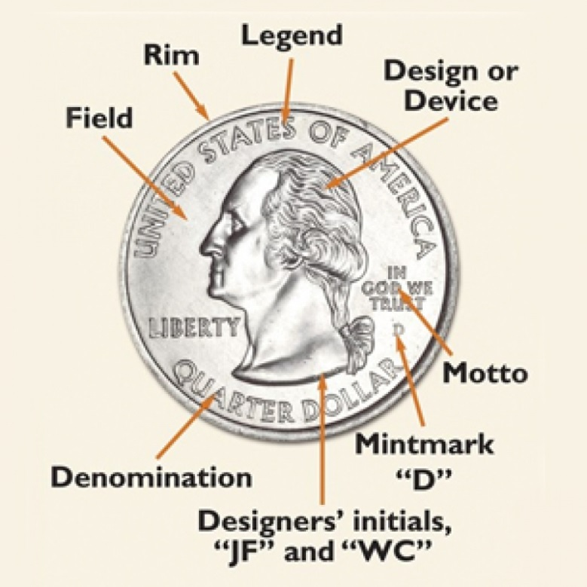

Obverse
Obverse, or “heads” side of a 2000-D Statehood quarter. The obverse side, depicting the familiar portrait of President George Washington, was modified slightly to include some of the wording previously used on the reverse.
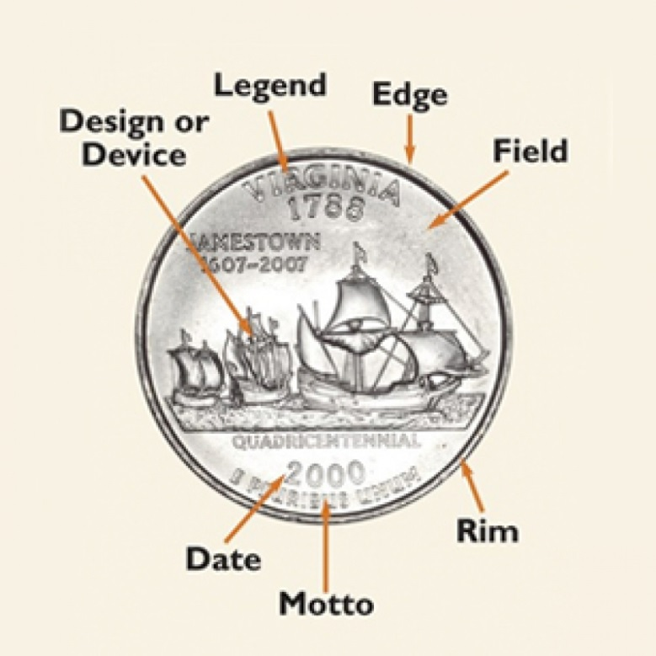

Reverse
Reverse, or “tails” side, of a 2000-D Statehood quarter commemorating the founding of each state. Launched in 1999, the 50 States Quarter program features five new designs per year through 2008. The “D” mint-mark indicates it was made at the Denver Mint.

Coin Bowling
Santa Cara County Council
The object of this game is to be the first person to bowl down a coin that is standing on its edge. You can play this game outside or indoors.
Balance a coin on its edge in the middle of a flat surface (sidewalk or hardwood floor). Quarters, fifty-cent pieces, or dollar coins work well for this. If you have trouble balancing the coin, use a small piece of modeling clay to support it. Players take turns rolling other coins of the same size across the surface, trying to knock down the balanced coin. It is harder than it looks, so players should aim for the flat side of the coin. The first player to know down the coin is the winner. You can also set up several coins as in real bowling and award bonus points for knocking down more than one coin per turn.

How to Make a Balance Scale for Kids
http://www.wikihow.com/Make-a-Balance-Scale-for-Kids
Learning to balance counterweights is a useful skill for young kids. You can start a solid foundation in physics in a single afternoon activity. Gather some household items and watch your children learn to make and use a balance scale.
Find a notched hanger. These are the plastic or wooden hangers with notches cut out of the top section so that you can hang items with straps.
Grab some fishing line or some yarn. Yarn is easier for younger children, while line or twine may be better for older children for its sophisticated look.
Wash out two plastic yogurt cups. They should be at least four oz. containers and have a large lip. Wash them out and dry them thoroughly.
- You can also use plastic drinking cups.
Set the items on a worktable. You will want to grab a hole punch or small pointy awl for punching holes in the plastic. It is best that adults handle this single portion of the project.
Lay out all the items on a worktable. Make sure your child can reach them all.
Explain the project to your child. Hold the hanger up and show how the hanger tips from side to side when there are weights at either end. Show that you will hang items on either side to balance the scale and compare items by their weight.
Measure the circumference of the identical plastic cups. A fabric measuring tape is perfect for this use. Divide the circumference by three, since you will make three equidistant holes in each cup.
- For example, if it is six inches long, you will want to mark a hole every two inches.
- Try to do the sums together with your child. This is a great simple math activity for a school-aged child.
Mark a hole with a permanent marker near the top rim three times, one-third the way around the top. Repeat on the other plastic cup.
Stick an awl or hole punch through each of your marked holes. Do this part of the project yourself. You can also tape the yarn to the cup if you want this to be a child-only activity.
Measure six equal lengths of yarn or fishing line. They should be about one foot long.
Loop one end of the yarn through a hole and tie it securely with a double knot. Repeat with three holes in the yogurt cup and tie the three pieces together at the top. Tie a loop into the top as well, so that you can hang the cups.
- Repeat with the other plastic cup.
Bring the loop in the yarn around the notched portion of the hanger. Repeat with the other cup. Make sure the cups are secure and even before you start to play.
Loop the hanger over a door handle or a curtain rod.
Give your child some dried beans. Place some beans in one end, and then ask them to fill the other section until the weight is even.
Continue the adventure with the child’s toys that are small enough to fit in the cups. Have your child weight figures on either side until they are even.
Decorate the balance scale with your kids. Tell them that every decoration must be exactly the same on each side to ensure it weighs items properly. Discuss a mirror image or symmetrical image to further their learning.



BEAR
BEAR –

Bear Claws
Bear Adventure: Bear Claws
1. Learn about three common designs of pocketknives.
2. Learn knife safety and earn your Whittling Chip.
3. Using a pocketknife, carve two items.

Whittling Chip Course
http://meritbadge.org/wiki/index.php/Whittling_Chip_Course

Whittling Chip Course
This Whittling Chip course is designed to be taught over two classes, lasting approximately 1 hour each. The length of the course may vary depending on how many Scouts are in the Den.
The first class of the course introduces Scouts to knives, knife safety and some basic principles. They will also have an opportunity to whittle a shape out of soap using a butter knife. Between the first and second class the Scouts will work with their parents at home to make a carving. The second course reviews what was learned in the first part of the course and allows Scouts to work with each other. At the end of the second class Scouts (with written permission) will be presented with their Whittling Chip cards. The Whittling Chip patch will be presented at a Pack meeting.

Class I
What is a Knife?
First, a knife is a tool not a toy. It is not something to use during playtime. It is not something to use to threaten other people with. Knives are to help you complete a task.
Knives come in many shapes and sizes. Some have only one blade. Others may many blades and tools. Some are small; some are big. Generally, a good Scouting knife will have blade, a punch, a can opener and a screwdriver blade in a foldable design. The blade is usually a little over 2” long. Such a knife is usually all that a resourceful Cub Scout will need.
Hands On Demonstration:
Display a variety of knives. Explain knife uses and which a Cub Scout can carry. Cub Scouts are only allowed to carry pocketknives on Scout activities. If other knives are needed, kitchen knives for example, they will be brought and used by adults. Display a fixed blade (sheath or hunting) knife. Explain that a pocketknife will do almost anything these knives do. Show how a sheath knife attached to the belt could injure someone by bending over with the sheath pointed against the leg and/or the sheath pointed up toward the stomach. Demonstrate that if someone was to grab the knife from its sheath, the natural reaction is to grab the knife, which could result in severe cuts. Cub Scouts should not need to carry a fixed blade (sheath) knife.
Display a variety of pocketknives. Display straight edge and serrated blades. Show that some have only a few blades and some have many. Explain that many of the extra blades are seldom used or don’t work well. Example: Having fork and spoon blades on the knife would mainly be useful when backpacking, at other times you usually have better silverware available. They should learn the proper way to use each blade on their knife. Display a pair of scissors. Show how these are two knife blades that cut against each other. Explain that they should be treated with the same respect and safety rules as any other knife.
Display various kitchen knives like a table knife, paring knife, bread knife, and a butcher knife. Explain what they are used for. Explain that since they will probably use these in a kitchen in the future, they should be treated with the same respect and safety rules. Display a lock blade knife. Explain that the lock is a safety feature that keeps the blade from accidentally closing on the fingers. These may be better for the boys if they can release the lock easily enough. Some locks are hard to release and could result in an injury if the knife slips while trying to release the lock.
Getting started using a knife
If an accident happens
- Always tell an adult ¬¬especially if someone was injured and is bleeding.
- If the cut is minor, clean and treat it according to First Aid rules. If the cut is serious, get help quick. If you get “stabbed” by more than about ¼” of the knife blade, do not pull it out unless you have too. The knife blade will help keep pressure on the wound and prevent heavy bleeding.
Safe Zone
Before you open or use your knife, you need to be sure that the area around you is safe and secure. Establish a “safe zone” or "blood circle" around you to protect yourself and other people and animals.
Do this:
- Choose a spot with fairly level ground
- Make sure that there are no small children or pets close by, even if they are outside of your safe zone
- Stand up with one arm out by your side, holding your CLOSED knife
- Slowly rotate yourself around
- If you hit something or someone, move until you can do this without interference
- Make sure that nothing or no one is in the imaginary circle that creates
- If you are going to sit, make sure that you have something steady and secure ¬¬the ground works really good for this
- If you are going to stand, make sure that your feet and secure and that the area is not slippery or contains items that may trip you if you move
Once you can do this, you have established your safe zone. At any time after you begin using your knife, the safe zone becomes unsafe, immediately stop and close your knife until it is safe again.
Hands on Demonstration:
Explain to the boys that anytime they are using a knife they should have a “safety zone” around them. Demonstrate holding your arm out as far as possible holding an object like a ruler and turning around. The boys should learn that whenever they are using a knife, they should be the only person in their safety zone. If someone else enters their circle for any reason they should close their knife and lay it down.
Explain to them that they are also responsible for anyone entering the circle, even from behind, so unless they have eyes in the back of their head, suggest that they always work with a wall behind them. Show them how someone could surprise them from behind and if they turn quickly holding a knife, they could hurt someone.
How to safely open a knife
Be sure that you establish your “safe zone” before you open your knife. Hold the knife in one hand, with the blade side facing away from you, and open the blade with your other hand. Most blades have a small semi¬circle cut into the blade near the top to give you better hold on the blade while opening it. You can use your fingernail or grab that edge with your fingers to pull the blade open. Be sure to hold the sides of the knife firmly as you open the blade. It is often easier to open if you pull both the blade and the knife apart at the same time ¬¬use a motion similar to those of bird wings flapping up.
Never sling the knife to “pop open” the blade. Be sure that the blade opens all the way; some will “click” when the blade is fully opened. If necessary, immediately turn the knife so that the point and blade edge face away from you.
Before you use it
Before you use your knife, do a quick inspection. If the knife handle or blade is loose, do not use it until it can be repaired. If the knife blade is cracked, broken or chipped, do not use the knife.
If the knife is too small for your hands or too heavy to easily control, do not use the knife.
How to safely handle a knife
It is important that you learn how to correctly and properly handle a knife.
Do’s •Remember to keep the knife closed when not being used •Remember to keep the knife in your pocket •Always hold the knife in the same hand that you would hold a pencil in •Always keep the blade point and edge away from you ¬¬and anyone else who may be near •Hold the knife tightly, but not so tight that you knuckles turn white •If you have to carry an open knife (or scissors), always walk carefully with the blade pointed away from you and to the side •Always cut or carve by moving the knife blade away from you
Don’ts •When a knife blade is opened, never hold the knife by the blade, but always by the handle •Never run or jump with the knife blade open •Never use a knife to dig in the dirt •Never cut the bark from a live tree •Never carve on anything that does not belong to you •Never throw your knife •Never pry with your knife •Never use the blade as a screwdriver •Never leave your knife lying where a younger child could get it
If you drop a knife
If you accidentally drop an open knife, never try to catch it. Quickly step back and wait until it fails to pick it up. Before you use it again, always inspect the knife and blade for any damage.
Passing a knife
Whenever you need to pass the knife to another person, always close the knife first. Never throw the knife. While holding one end of the knife, allow the person to get hold of the other end of the knife. Do not release your hold on the knife until the person taking it from you says “Thank You”. This indicates that the other person realizes that they are receiving the knife and are ready to accept responsibility for it. After hearing the “Thank You”, say “You’re Welcome” as you release the knife. This indicates that you have released the responsibility for the knife to the other person.
If you must pass a “fixed” or non¬closing knife, firmly hold the dull side of the knife blade while extending the knife handle to the other person. Never throw the knife. Allow that person to grasp the knife blade and say “Thank You” before releasing the blade. The other person should hold the knife steady until you have released your hold on the knife.
Hands on Exercise:
Use a plastic silverware knife. Apply a small amount of bright red lipstick along the cutting edge. Show the boys how to hold the knife by the back (dull) side of the blade and pass it to another person, handle first using the same “thank you – you’re welcome”. After passing the knife around to everyone, including parents, check for lipstick on everyone’s hands. Any lipstick marks indicate that the person could have been cut by a sharp blade.
How to safely close a knife
Wipe the blade clean. Hold the knife handle so that the point and edge of the blade are facing away from you and your fingers are not under the blade. If the blade has a lock, disengage the lock with your other hand. Slowly close the blade with the palm of your hand against the back of the blade. Once closed, place the knife back into your pocket for added safety.
How to cut
Hold the knife in the hand that you use to write with. This is your dominate hand and you will be able to better control the knife with this hand. Grasp the handle with your whole hand. Position the blade at a slant, pointing away from you. To cut, begin the cut then move the blade away from your body. If this is not possible, position yourself to the side of the object you are cutting. If you are cutting completely thru something, be aware of what is under the object you are cutting. Cutting on rock, dirt, metal, some plastics, etc. can dull the knife blade as the cut is made. Always use something that ‘gives’ under the object (such as cardboard or a cutting board).
If you are carving or whittling, always hold the object you are cutting securely in front of you, place the blade against the object and apply slight pressure while moving the blade away from your body. It is better to make several cuts using light pressure than one cut by forcing the blade.
Hands on Exercise:
Let the boys practice carving on soft bar of soap with wooden craft stick knives or plastic tableware knives. This will allow them to start getting the feel of using a knife. Show the boys how to cut long thin shavings by cutting at the proper angle. Also show them how to carve out chips by making the first cut down into the soap and making a second angled cut until it reaches the first cut. Watch to see that they are cutting off the thin shavings and small chips like they should. This will also let you catch some possible safety problems early and with less chance of a serious cut.

Homework
After the Scout has demonstrated good aptitude with the soap carving project, you can let them try their hands at carving and whittling wood. A good choice is balsa as it is lightweight and not too “tough”. It is a good idea to have some simple shapes (such as ice cream cones, cowboy hats or boots, etc) that can be traced onto the wood for a pattern. If you choose to do smaller patterns, you can mount the finished carvings onto a small piece of PVC and make neckerchief slides.
Please work with your Scout at home in making a carving with his pocketknife and bring the carving to Class II to share with his fellow Scouts.

Class II
How to care for a knife
Keep the knife clean and dry. Keeping the knife clean and dry will help prevent rust and keep the knife from getting “tight”. Rust will cause the knife to become dull and can make the blade weak. If a knife has become wet, be sure that it is completely dried. If possible, rub a thin coat of oil on the metal parts to help prevent rust and ensure that the knife opens smoothly. Never clean the knife is a dishwasher, always clean by hand. It is OK to use dish soap on the blade, but be sure that it gets completely rinsed and dried.
If you will be using the blade to cut food, be sure that the knife gets cleaned both before and after use. Knives can become dirty from being carried in your pocket. Also, be sure that the knife is properly cleaned to prevent cross contamination of food items. Keep the knife sharp
Be sure your knife is sharp. A sharp knife is safer to use than a dull knife because it does not require as much force to cut. Using too much force can cause the blade to slip, possibly resulting in an injury. The tip of the blade is often the part that dulls the quickest. This is because it is often in contact with other surface materials as you cut. When sharpening, be sure that you remember to sharpen the tip.
Sharpen the knife using stones usually called whetstones. These stones come in many sizes and “grits”, which describe the size of the stone’s particles. Rougher grits have smaller numbers and mean that their stones are made of large particles. These stones are used for grinding and repairing the edge of the blade, not for fine sharpening. Smoother grits have larger numbers, meaning that the stones are made of smaller particles. The larger the number, the finer the edge the stone will produce. These are the sharpening stones. Whetstones require some type of lubricant. Some use oil and some use water. Water stones are more practical because water is more easily obtained in most places.
Sharpening Steps 1. Place the stones on a level surface. 2. Wet the stone with a little water or oil. 3. Place the blade of the knife flat on the stone, then raise the back edge about the width of the blade itself, keeping the cutting edge on the stone. 4. Draw the knife straight back toward you, or move it straight back and forth putting pressure on it only when you pull it toward you. This is always better than moving it in a circular fashion. 5. Turn the blade over and repeat on the other side an equal number of times. 6. Repeat steps 1 thru 5 on a finer grit stone until the knife has a smooth, sharp edge. 7. If you have some leather available, you can use this to finish the edge by dragging the blade edge along the leather. Repeat the same number of strokes on each side of the blade.
Hands on Practice
Allow the Scouts to “practice” knife sharpening using a home¬made stone and knife. Use a wood block with sandpaper glued to it and sharpen a craft stick into a knife shape. Show the boys how to angle the blade against the stone (or stick against the sanding block) to produce a sharp edge. Explain the importance of sharpening equally on both sides of the blade to prevent an uneven edge.
Cleaning your knife
Cleaning your knife is very important, if you let too much grime, grease, and grit build up, then it will be harder to clean your knife. Keep it as clean as you can while out in the field and do a more thorough job when you get home. Additionally, always keep the hinges of your knife lubricated either with light cooking oil, sewing oil or WD-40. Regularly check your knife for trouble spots. Inspect the blade for areas of rust. As soon as you see any rust spots you should immediately clean them. Inspect the handle. You are looking for any build up of dust, dirt or grime. Especially inspect along the inside of the blade bed as well as around any pivot points.
To clean your knife, unfold all the blades. Using either a cotton swab, corner of a towel or a toothbrush, apply lubricant to the knife. The lubricant helps loosen any gunk or buildup on the knife. Use the toothbrush to scrub any hard-to-get places. Wipe off the excess (now dirty) oil with a towel and apply a drop of clean lubricant to the hinges. Apply a layer of oil to the blades and wipe of the excess oil.
Knife Safety Quiz
As a check to ensure that all Scouts understand the topics discussed as part of this course, have them complete a knife safety quiz. You can choose to have each Scout take the test individually or complete the quiz as a group. If you choose the group option, it may be good to have a completed copy of the quiz to send home with each Scout for later review.
Whittling Chip Pledge
Now that you have completed the knife safety course, you are eligible to be awarded the Whittling Chip. The final requirement in the course is that you agree to abide by the safe knife policy by signing the “Safe Knife Pledge”.

After the course
Now that your Scout has earned his Whittling Chip, he can bring his pocket knife to Scouting functions when the leadership deems it appropriate.
Appropriate
- Campout
Not Appropriate
- It is never appropriate to bring the knife to school for a Pack or Den function.
If you will be buying your Scout a knife, here are a couple of suggestions. Please take the time to find a knife that you feel will be appropriate for your Scout.
- A single blade, lock back knife may be a good knife for your Scout. However, if they are not strong enough to release the lock it may make the knife dangerous.
- Stay away from the Swiss Army style knives, the simpler the better and these large knifes might not properly fit the hand of younger Scouts.
- Serrated knives are harder to sharpen thank non-serrated.
- No fixed blades.
- It is a good idea to purchase a sharpening stone to keep the knife sharp.

Additional Materials

Knife Safety Quiz
Part I: Circle the correct answer
- True / False 1. A knife is NOT a toy.
- True / False 2. A dull knife is safer than a sharp knife.
- True / False 3. Dirt on a knife blade helps keep it sharp.
- True / False 4. Never carve your initials on anything that does NOT belong to you.
- True / False 5. When someone hands you a knife you say “Thank You” to show good manners.
- True / False 6. A knife is handy for cutting bark off trees.
- True / False 7. A pocketknife should always be closed when it is not in use.
- True / False 8. It's okay to keep your knife wet.
- True / False 9. A Cub Scout can take his knife to a pack meeting at the school if school is out.
- True / False 10. You should carry your open knife in your pocket.
- True / False 11. You should close the blade with the palm of your hand
- True / False 12. A Cub Scout should carry a fixed blade knife if it is kept in a sheath.
Part II: Fill in the blank
- Close the blade with the ________________ of your hand.
- A __________________ should never be used on something that will dull or break it.
- People watching you work with your knife should not enter your __________ __________.
- Your knife should always be kept ___________ and _________.
- Scissors should be handled with the same safety rules as a ____________.
- Always ________ when carrying a knife or scissors.
Part III: Circle the correct answer
- Always keep your knife ( dry / wet ) so it will not rust.
- When using a knife, do not make ( big / little ) shavings or chips.
- A ( dull / sharp ) knife is more likely to cut you.
- A Cub Scout ( can / cannot ) take his knife to a den meeting at school if it is held outside.
- A knife should be cleaned ( before / after ) cutting food.
- A fixed blade knife or scissors should be passed to another person ( blade / handle ) first.
The Pocketknife Pledge (fill in the blanks)
- I understand the reason for ________________________________________ rules.
- I will treat my pocketknife with the ______________________________ due a useful tool.
- I will always __________________________ my pocketknife and put it away when not in use.
- I will not use my pocketknife when it might _______________________ someone near me.
- I ______________________________ never to throw my pocketknife for any reason.
- I will use my pocketknife in a safe manner at ________________________times.
Choices: Close Respect Injure Promise All Safety

Knife Safety Quiz Answers
Part I: Circle the correct answer
- True 1. A knife is NOT a toy.
- False 2. A dull knife is safer than a sharp knife.
- False 3. Dirt on a knife blade helps keep it sharp.
- True 4. Never carve your initials on anything that does NOT belong to you.
- False 5. When someone hands you a knife you say “Thank You” to show good manners.
- False 6. A knife is handy for cutting bark off trees.
- True 7. A pocketknife should always be closed when it is not in use.
- False 8. It's okay to keep your knife wet.
- False 9. A Cub Scout can take his knife to a pack meeting at the school if school is out.
- False 10. You should carry your open knife in your pocket.
- True 11. You should close the blade with the palm of your hand
- False 12. A Cub Scout should carry a fixed blade knife if it is kept in a sheath.
Part II: Fill in the blank
- Close the blade with the __PALM__ of your hand.
- A __POCKETKNIFE__ should never be used on something that will dull or break it.
- People watching you work with your knife should not enter your __SAFE__ __ZONE__.
- Your knife should always be kept __CLEAN__ and __DRY__.
- Scissors should be handled with the same safety rules as a __KNIFE__.
- Always __WALK__ when carrying a knife or scissors.
Part III: Circle the correct answer
- Always keep your knife ( dry ) so it will not rust.
- When using a knife, do not make ( big ) shavings or chips.
- A ( sharp ) knife is more likely to cut you.
- A Cub Scout ( cannot ) take his knife to a den meeting at school if it is held outside.
- A knife should be cleaned ( before / after ) cutting food.
- A fixed blade knife or scissors should be passed to another person ( handle ) first.
The Pocketknife Pledge (fill in the blanks)
- I understand the reason for __SAFETY__ rules.
- I will treat my pocketknife with the __RESPECT__ due a useful tool.
- I will always __CLOSE__ my pocketknife and put it away when not in use.
- I will not use my pocketknife when it might __INJURE__ someone near me.
- I __PROMISE__ never to throw my pocketknife for any reason.
- I will use my pocketknife in a safe manner at __ALL__ times.

Baloo the Builder
Bear Elective Adventure: Baloo the Builder
1. Discover which hand tools are the best ones to have in your tool box. Learn the rules for using these tools safely. Practice with at least four of these tools before beginning a project.
2. Select, plan, and define the materials for the projects you will complete in requirement 3.
3. Assemble your materials, and build one useful project and one fun project using wood.
4. Apply a finish to one of your wood projects.

A Basic List of Hand Tools Needed For Kids to Get Started in Woodworking
http://www.WoodworkersResource.com

You can buy the tools that you don't already have as you get to them in the book or you can go ahead and buy them all at once. In the article below I give suggestions as to sizes and styles that can help children get the most out of their use. The advantage in having all your tools ahead of time is that it will save you from having to run around trying to find what you'll need the day before you start a new project just to find out it's sold out. Another advantage is you can often times find all the tools you need online at one site. This can save you time and money.
Here is a list of tools you'll need. Use this to compare what you already have to what you'll need to purchase. You can buy each child their own set (which would be nice since one of the first projects is a tool box) or they can share tools. (But getting kids to do that is an entire book unto itself.)
A. Measuring Tape (12') they make measuring tapes that have the fractions labeled on the tape to make it easier to read especially if your child is just learning about fractions.
B. Ruler (12") wooden ones are easier to read than the clear or colored plastic ones.
C. Hammer (7 - 10oz for smaller children, 16oz for older children with better hand eye coordination)
D. Screwdrivers: flathead and Phillips
E. Nail set
F. Handsaw (western or Japanese style)
G. Coping saw
H. Block plane
I. Brace Drill (Hand drill)
J. Rasp
K. Sandpaper (100, 120, 150, 180 grits)
L. Glue (white or yellow) water proof for outdoor projects
M. Screws and nails (a box each of 1 ¼" and 1 5/8" drywall screws and a box each of 3d, 4d, and 6d finish nails will get you through most projects in this book).
N. Clamps (See the lesson on building the step stool for information on clamps).
O. Safety glasses (it may take some extra effort, but find a pair that fits your child. They will become frustrated quickly if every time they start to swing a hammer they have to push their glasses back up on their noses. Manufactures do make child size glasses it just might take some looking around to find them.)
P. Combination square
Q. Speed square
Again, this isn't a complete list of the hand tools needed to build any project imaginable, but it's a great start.



WEBELOS CORE

Cast Iron Chef
Do all of these:
1. At an approved time in an outdoor location and using tinder, kindling, and fuel wood, demonstrate how to build a fire; light the fire, unless prohibited by local fire restrictions. After allowing the flames to burn safely, safely extinguish the flames
with minimal impact to the fire site.
2. Set personal nutritional goals. Keep a food journal for one week; review your journal to determine if the goals were met.
3. Plan a menu for a balanced meal for your den or family. Determine the budget for the meal. Shop for the items on your menu while staying within your budget.
4. Prepare a balanced meal for your den or family; utilize one of the methods below for preparation of part of your meal:
a. Camp stove
b. Dutch oven
c. Box oven
d. Solar oven
e. Open campfire or charcoal
5. Demonstrate an understanding of food safety practices while preparing the meal.

Edible Fire
http://usscouts.org/bbugle/bb0704/bb_webelos.html
Teach the art of fire building by letting the participants make an edible fire. Make sure you OK the fire before they consume it! Use frosting to assemble one of the following lists into an edible fire:
Plan A
Napkin = base
Small Marshmallows = fire ring
Flaked Coconut = kindling
Red Hots or Raisins = coals
Candy Corn = fire
Pretzel Sticks = logs
Kool-Aid = water to put out fire
Plan B -
Large cookie = base
Peanut M&Ms = rock ring
Potato Sticks = kindling
Pretzel Sticks = logs
Candy Corn = fire
Tootsie Rolls = fuel wood
Granola = dirt Small cup
Small cups = water buckets
Inexpensive Cold Weather Sleeping Mat
Stuff two large heavy-duty plastic garbage bags with crumpled up newspaper balls. Leave room to tie off the bag. Remove excess air and flatten the bag to make an insulated sleeping mat. An extra blanket can be wrapped around it burrito style and pinned if you tend to slide off.
Hands-On Experience
Ask one buddy team to set up a fire lay. Ask a second team to light it. Ask a third team to extinguish it in the proper manner and clean up the area. If wood fires are not permitted, show how to lay and start a charcoal fire in a grill.

Outdoor Cooking
Aluminum Foil Dinner
1/4# hamburger, sliced potatoes, sliced carrots, slice of onion, one or two teaspoons of water, salt and pepper. Use heavy foil. Fold over edges, leaving space for steam. Place directly in hot coals; avoid puncturing package while handling. Use tongs. Turn after 10 minutes, cook for 20 minutes total time. To test to see if it’s cooked, unfold, refold in airtight fold. Eat directly from foil.
Egg and Bacon in a Paper Bag
This requires a green roasting stick, a small brown paper bag with rectangular bottom, a strip of bacon, one egg, salt and pepper.
Place bacon on the stick and broil it slowly over the hot coals. When partially cooked, place bacon in the bottom of bag. Put stick through the two sides of the bag. Hold the bag over hot coals for a short time to get bottom of bag greasy. Break egg into bag. Put over coals again. DO NOT get bag too close to coals or it will go up in flames. Do this slowly. Use the bag as your plate. Toast bread on a stick. BREAKFAST IS READY!
“Coffee Can” Stew
Each Scout brings from home a l lb. Coffee can. Inside the can, all your ingredients for stew, meat and vegetables packed separately (you need to brown the meat). You can also prepare everything at home and just do the simmering on the campout.
Dutch Ovens
Nothing beats Dutch-oven main courses, unless it’s a Dutch-oven dessert. My two favorites are cobbler and pineapple upside-down cake.
Omelets in Zip-Locs
Mix your eggs and other ingredients; place them in a sealed zip-loc bag and drop in almost boiling water. It works great and there’ s no clean-up.
Stuffed Potatoes
Core small potatoes; insert a small precooked sausage or wiener. Wrap in foil and set in hot ashes to bake. Takes 45-90 minutes.
Hobo Popcorn
In center of 18 X 18 inch square of heavy aluminum foil, place one teaspoon cooking oil and one tablespoon popcorn. Bring foil centers together to make a pouch. Seal the edges by folding, but allow room for the popcorn to pop. Tie each pouch to a long stick with a string and hold the pouch over hot coals. Shake constantly until all corn has popped. Season with margarine and salt.
Baked Apples
Core an apple and place it on a square of aluminum foil. Fill the core with raisins, brown sugar and a dash of cinnamon. Or fill with cinnamon candies. Wrap and bake for 10 minutes in hot coals.
Hot Dog Plus
Slit side of wiener, insert wedge of cheese, and wrap with bacon. Broil over coals until cheese melts and bacon is crisp. Serve in a toasted wiener bun.
Fruit Cobbler
Place three cans of fruit pie filling in the bottom of a foil lined Dutch oven. Pour in one box cake mix, distribute evenly but do not stir into fruit. Add some cinnamon and small amount of butter. Place coals under Dutch oven and some on the lid for about 45 minutes until done.

If You’re Lost in the Woods
Fill in the blanks with a word from this list. All words should be used once.
dry fire head hole leaves
nightfall run sheltered signal wander
- Stop, sit down, and try to figure out where you are.
Use your _________, not your legs.
- If caught by night, fog or a storm, stop at once and
make camp in a ______________ spot.
- Build a ____________ in a safe place.
- Gather plenty of ____________ fuel.
- Don’t _______________ about. Travel only downhill.
- If injured, choose a clear spot and
make a _____________ (smoke) fire.
- Don’t ____________, don’t worry and
above all, don’t quit.
- If caught out during ___________, find shelter quickly -
a ledge, a large boulder or a fallen tree.
- Use ___________ and branches as a blanket to
shelter yourself.
- If without a sleeping bag, build a fire in a deep ___________, cover 6 inches of hot coal (wood)
with 6 inches of earth and sleep on the warmed earth.
(Answers: 1-head, 2-sheltered, 3-fire, 4-dry, 5-wander, 6-signal, 7-run, 8-nightfall, 9-hole, 10-leaves)

Franklin Goes Camping Maze
Franklin is loading up for the bus and you can help him. Pick up every piece of camping gear in the puzzle, then head toward the bus. Pick up the gear in order from one to ten. When you enter a box that contains some camping equipment, you must leave through the opposite path -don’t double back. Happy packing!
- canteen
- can opener
- flashlight
- baseball and bat
- net
- bug spray
- pan
- umbrella
- sleeping bag
- lantern
- matches
- football
- fishing rod
- cooler
- first aid kit
- axe
- canoe
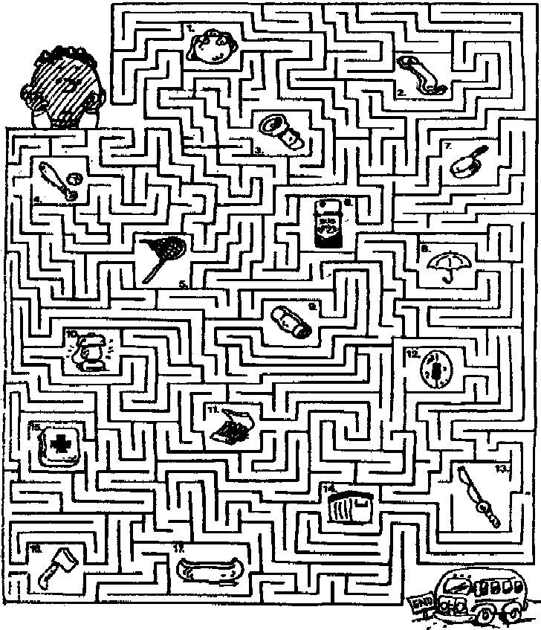



ARROW OF LIGHT CORE

Camper
Arrow of Light Adventure: Camper
Do all of these:
1. With the help of your den leader or family, plan and conduct a campout. If your chartered organization does not permit Cub Scout camping, you may substitute a family campout or a daylong outdoor activity with your den or pack.
2. On arrival at the campout, with your den and den leader or family, determine where to set up your tent. Demonstrate knowledge of what makes a good tent site and what makes a bad one. Set up your tent without help from an adult.
3. Once your tents are set up, discuss with your den what actions you should take in the case of the following extreme weather events which could require you to evacuate:
a. Severe rainstorm causing flooding
b. Severe thunderstorm with lightning or tornadoes
c. Fire, earthquake, or other disaster that will require evacuation. Discuss what you have done to minimize as much danger as possible.
4. On a pack campout, work with your den leader or another adult to plan a campfire program with the other dens. Your campfire program should include an impressive opening, songs, skits, a Cubmaster’s minute, and an inspirational closing ceremony.
5. Show how to tie a bowline. Explain when the knot should be used and why. Teach it to another Scout who is not a Webelos Scout.
6. Go on a geocaching adventure with your den or family. Show how you used a GPS unit or a smartphone with a GPS application to locate a geocache.
7. Recite the Outdoor Code and the Leave No Trace Principles for Kids from memory. Talk about how you can demonstrate them while you are working on your Arrow of Light. After one outing, list the things you did to follow the Outdoor Code and Leave No Trace.

Some Advice on Keeping the Tent Dry

By Tony Wesley
Some tips for the novice. Veterans of camping will have learned these and probably have a few ideas of their own.
-- Examine your camp site carefully before setting up the tent. That nice flat spot, is it a low point? If you camp in a hollow, you may end up camping in a puddle if it starts raining.
-- Is this a new or borrowed tent? If so, put that rain fly on NOW even if the sky is blue. You can take it off, now that you know how to put it on. The tent will breath better with it off. But make sure you remember where it is. I met a couple who learned the hard way just the night before. They didn't know know what the rain fly was, and put it under their tent as ground cover. It rained on them, and that's when they realize something was wrong. Reading the instructions in the middle of the night with the rain pouring down on them, they realized what they had done. So they had to unstake the tent, move it, and place the rain fly over the tent, which was rather soggy by this point.
-- Are you camping under trees? The trees will help break the rainfall, but they will continue to drip after the rain has stopped. You win some, you lose some.
-- A canvas under the tent is a good idea, but watch out. If your canvas extends out further than your rain fly, rain will run off the rain fly and onto the canvas. Depending on the slope, the rainwater may then run *under* your tent.
-- You can improve your tent's rain resistance by applying seam sealer to your tent. Spending a couple dollars and a few minutes ahead of time will help. But don't expect miracles.
-- Condensation will form on the tent's interior walls, unless you keep the tent ventilated.
-- Placing the sleeping bag on a pad or an air mattress is a good idea. It will not only improve your sleep by keeping you warmer and and bed softer, it will keep you up off the tent floor should you get water in the tent.
A little bit of water seems inevitable if you're camping in the rain. But some precautions and some common sense can make the difference between damp and wet. Oh, if you have room, toss that book you've been meaning to read in with your camping gear. If you get stuck in your tent waiting for the rain to pass, it'll be worth its weight in gold.

Planning the Campfire Program
A memorable Campfire requires planning. You can begin your planning process by reading Michael Lee Zwiers excellent article, Campfire Magic. Then, learn how to use the Campfire Planning Worksheet, download it, and put these ideas to work.

Campfire Magic
Michael Lee Zwiers, from The Leader, June/July 1989
http://macscouter.com/campfire/Planning.asp

Campfire Magic! You've experienced it. You chose the songs, practiced skits, and organized everything into a program. Then you brought people together and began.
Everything went without a hitch. Participants sang the songs enthusiastically and laughed uproariously (or groaned painfully) at the skits. From there, the tone and pace of the program slowed until the final prayer was just a memory on the lips and in the ears.
As the dying campfire crumbled into ashes, campers reluctantly drifted off to bed. You stood before the glowing embers, soaking in their fading warmth and knowing that everything was just right. You've been touched by campfire magic.
Campfires like this are special but rare. They need not be. With a little careful thought and preparation, they can become the rule and not the exception. What follows are some hints and ideas from Alberta's campfire leader training courses to help you plan a campfire program, deliver it smoothly, and bring the magic to it.
Planning
The structure of a magic campfire is like the shape of the fire. It builds up slowly from the lighting and opening to a peak, then subsides gradually to the closing as the fire burns down to embers.
The opening includes parading to the formal circle, introductions, the fire lighting, and a short, upbeat opening verse that sets the mood and guidelines for the fire and welcomes people to the magic of the experience. You may deliver it dramatically with arms in the air or holding a hand over the fire. You may involve participants by having them echo a line or, if you are using a "magic start", asking them to concentrate to inspire the fire to light. Perhaps you'll have a number of torch bearers light the fire as you declare it open. Build up from the opening with some well known songs, a few rounds, some fun songs, some action songs, a game and stunt or two and, at the peak of excitement, skits and yells. Bring down things slowly with a few rousing songs, some quieter songs, a story or Scouter's Five, a spiritual song or two, vespers and taps, and a closing verse.
You might include a short Scout silence before the verse or invite participants to pause for a moment to listen to night sounds or reflect and be thankful. Many campfire leaders end the verse with "I now declare this campfire closed" but, as Lewis Carroll once said, "They don't seem to have any rules in particular; at least, if there are, nobody attends to them."
Hints For Success
Before the event, review campfire etiquette with your gang. The campfire circle is sacred and always quiet before and after the fire. Prohibit flashlights from the circle. Make a no-talking rule. If wood needs to be added to the fire during the campfire, only the Keeper of the Flame may do it. Applause takes the form of yells, not clapping.
Choose a magic site (on the lake shore, etc.) and, however you start it, keep the fire a reasonable size. Fires that are too big can take away the magic. To enhance the mystique, you may want to add ashes from your last campfire to this new one. And, if you clean up all the coals and other signs of festivity before the next morning, your campers will always think of the campfire site as a special place.
Keep the program short. If you will offer refreshments later, plan time so that it won't break up a good program. For the greatest success, involve as many people as possible in the campfire as leaders of songs or yells or players in skits or stunts. If you can, audition songs and skits ahead of time to avoid any possible problems, either with difficulty or poor taste. Choose songs you enjoy and know your young members enjoy. Stick to the familiar rather than trying to teach a new song, unless it is something really easy, repetitive, and fun. Be sure you include parents and special guests as well as campers. Avoid song sheets or books, a sure way to destroy atmosphere as participants turn their backs to the fire in hopes of catching some light to read the words.
Look for audience feedback. Are they singing and taking part or looking bored? Keep it alive. If a song is too slow, speed it up. If it is really dragging, simply end it and move into a "no fail" song you have up your sleeve. Set a brisk pace with minimum breaks between songs. Sometimes campers become so caught up in the fun they want to sing every song they've ever heard. You have to be firm, but remind them they can have their own sing song and put in all their favorites at their tent site after the formal campfire is over.
If someone brings along a musical instrument, ensure that it enhances the experience. If it begins to detract by becoming a "solo" act because nobody knows the songs or they are all slow ballads, stop the player firmly but politely.
Announce the next act or song at least one act ahead so that the people involved have time to prepare. If you know who is on next, you can simply whisper in an ear to alert them. Keep a set of quickie yells, stunts, or songs on hand in case a person or group is not ready to perform when the time comes or you need to stop a performance for some reason.
For example if, despite your screening, a group begins a skit or stunt in poor taste, stop it. Indicate simply that it is not appropriate and go on with something else. After the campfire, talk with those involved to explain the reason for your actions.
Once you've eliminated the problem of poor taste, skits or stunts can still go wrong if the players speak too quietly or position themselves badly (e.g. with backs to the audience). That's another good reason for pre-campfire auditions. To work well and safely, a skit needs good light. The Keeper of the Flame can add small sticks to a dim fire. You might also provide pot lights or kerosene lanterns, as long as they aren't so bright they detract from the atmosphere.
Keep a firm rein on proceedings to avoid things like poorly timed announcements that can destroy the magic. If some participants begin to cause a distraction, you can do one of two things. Signal another Scouter to tap them on the shoulder and talk quietly to them, or quickly bring into the program a Scouter's Five related to their behavior. If you stop a campfire to lecture noisemakers, it's an automatic downer.
A campfire may be magic, but there's no trick to it, just good planning and some common sense. At the many campfires in your future, may you often be touched by the magic.
-- Thanks to Scouter Michael Lee Zwiers, Edmonton, Alta.

The Campfire Planning Worksheet
Download the Campfire Planning Worksheet in one of three formats below:
- The Campfire Planning Worksheet in MS Word 6.0 format
- The Campfire Planning Worksheet in RTF format
- The Campfire Planning Worksheet in PDF format for Acrobat
The Campfire Planning Worksheet is printed two-sided. The back side is where you plan the program. The front side is the program agenda, in proper order, used by the Master of Ceremonies.
Have your Dens or Patrols work on skits, songs, stunts, etc. Plan a time when a representative of each Den or Patrol will come to you with the name and type of each item that they will do. Write them on the back side, in the appropriate place, in no particular order. Make sure that if you are not familiar with something they plan to do that you have them perform it for you -- this could avoid an embarrassing situation.
When you have all possible skits, cheers, songs -- even those that the Master of Ceremonies will lead -- written on the planning section, consider how to put them together into a program. As you read above, a Campfire Program should start slowly and quietly, build to a high level, then taper off to a quiet closing. Bracket everything with appropriate opening and closing songs or readings. Mix up the items in the middle for variety. You might consider some stories near the end to wind things down before the closing.

Bowline/Sheet-bend Draw
http://www.macscouter.com/games/V2_MoreTeam.asp

Have the group divide into pairs. Each pair lines up across from each other. Each Scout is given a piece of rope long enough to tie around his/her waist and leave a couple of extra feet. These ropes should be on the ground by the scout's feet.
At the GO signal, each scout picks up his/her rope and ties a bowline around their waist. Then they join the rope with their partners rope using a sheet-bend. They then back up until the ropes become taught, lean back and hold their hands in the air.
As a Patrol competition, the first patrol to have all of their pairs done, wins. As an individual competition, each team competes independently. Check the knots, if they are wrong, have them start over, with time running.

Geocaching with Kids
http://www.rei.com/learn/expert-advice/geocaching-kids.html

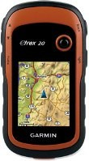
Geocaching (pronounced GEE-o-cash-ing) offers you a family-friendly way to teach your children about the wonders of the outdoors. It's a high-tech treasure hunt that can help engage your kids in the natural world.
This article gives you the basics to get started.
For additional reading about GPS receivers and geocaching, see the REI Expert Advice articles:
GPS Receivers: How to Choose
GPS Receivers: How to Use
What Is Geocaching?
The short, humorous answer: "Using billions of dollars of military hardware to find Tupperware® hidden in the woods."
The more helpful answer: Geocaching uses handheld GPS units to find hidden "caches" in your neighborhood or out on the trails. Caches are containers of all sizes that may be camouflaged to blend into their surroundings. Inside there will be—at a minimum—a logbook to sign, with larger caches also containing various inexpensive trinkets for trade.

How Do I Start Geocaching?
Start by looking up caches in your area. Geocaching.com lists more than 2.1 million active geocaches worldwide, so chances are excellent there will be several near you.
Some caches are easy to find while others may require a long hike, so check the difficulty and terrain ratings on the web page before you go. A "1 star" difficulty and terrain rating are just about right for a young child.
Cache sizes are also given online, so if your child is looking forward to finding and exchanging "treasure," be sure to select a cache that is "regular" size or larger.
What Do I Bring Geocaching?
Treat a geocaching-hunt as you would any hike by dressing your kids comfortably for the outdoors and carrying essential supplies such as water and snacks.
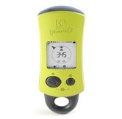
To find a cache, you will need to enter its coordinates in a handheld GPS receiver. A GPS unit with all the bells and whistles for navigation may cost from $300 to $600, but there are also geocaching-specific units available for around $70. Pick one that is simple to use so the kids can lead the way.
Shop REI's selection of handheld GPS receivers.
Family-friendly GPS receivers are pretty easy to use, but instruction is helpful for more advanced models. REI stores regularly offer basic GPS instruction classes, and you can reference the REI Expert Advice articles noted above.
Caches often contain small trade items or trinkets. The rule of geocaching is that if you take something from the cache, you must replace it with something of equal or greater value. So, have the kids pack an assortment of trinkets for trading.
For poking into dark cache-hiding places, bring a trekking pole or hiking stick and a flashlight. Lastly, you will want to sign the logbook in the cache to prove you found it, so don't forget to bring a pen.
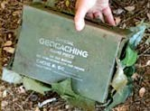
Looking for a Cache
Understanding how a GPS works and what it is telling you will greatly increase your chances of finding a cache. A GPS is a radio receiver and needs a clear view of the sky for best reception, so keep it out of your pocket while hiking.
You may find the compass view, which gives the bearing and distance to the cache, to be the most informative screen. It will point you in the right direction while you are moving but may not be accurate while stopped. Keep an eye on where it is pointing while you are hiking, and you may be able to guess where the cache is hidden from a distance.
Safety tip: Be aware of your surroundings. Take your eyes off of the GPS occasionally so you don't fall down a hill (or worse).
Most GPS units are accurate to within 20 feet, so when you are closer than this to the cache, it really can't tell you much more. At this point you should put it away and start looking.

Tips to locate a cache:
Look for likely places or objects that appear out of place (unnatural piles of sticks, etc.).
Recall the size of the cache (from geocaching.com); use the hint if needed.
Take your time and be patient.
Caches may be hidden in old logs or rock piles that are home to other creatures as well, so teach kids to look first before reaching in. Kids will likely search enthusiastically; just make sure they don't tear up the countryside looking for the cache. If you turn over a rock, replace it as found. Always follow Leave No Trace principles.
Once You Find a Cache
You found it! Congratulations! Now what?
Take something from the cache.
Leave something in the cache.
Write about it in the logbook.
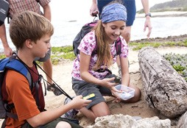
Look through the cache. Take an item and leave an item, and enter your name and experience into the logbook. Some people don't care to trade, and that's OK too. Carefully reseal the cache and hide it as well as you found it. Don't leave markers for the next cacher to find it or place it in a "better" spot.
Now is a good time to practice a little CITO (Cache In, Trash Out). If there is any trash in the area, pick it up and pack it out.
Once back at home, go to geocaching.com and write a log to let the cache "owner" know you found it. Let them know the condition of the cache, your experiences on the trail and any trades you made. This can be a fun creative-writing experience for the kids.
Now off to the next cache… and the next one… and the next one. Hmm, kind of addicting, isn't it? After finding a variety of geocaches in your area, you may be ready to hide some of your own.
Hiding Your First Cache
Some kids will really enjoy creating and hiding geocaches of their own. Follow the guidelines provided by geocaching.com to make sure it is something you would enjoy finding yourself.
Will it be easy to get to? If it is close to roads or high-traffic areas, there's a strong chance someone may stumble on it. Look for a place that will take a bit of time to get to, or create some camouflage to hide it.
Will it be easy to find? If it is too visible, a passerby could spot it. If you make it a challenge, be sure to include some hints!
Will it be on private or public land? If you place it on private land, you must get permission. Caches are not permitted on lands of the National Park Service or in national wildlife refuges. Stay away from archaeological sites and sensitive habitats as well.
Consider the impact searchers will have on the area. If it is difficult to find, will the actions of frustrated searchers do any damage or alarm those who are not aware of the cache?
Would you want to go there? Some caches have been hidden behind dumpsters. Is that really where you would enjoy searching?
Review the guidelines at geocaching.com before placing.
Review the locations of other caches in the area. They must be at least 0.1 mile (528 feet) apart.
You are ultimately responsible for the cache, so make sure you know the rules for the area where it is being placed.
The Bottom Line
Geocaching can be fun for the whole family. Use geocache hunts to introduce your kids to new parks, new activities and/or the natural history of your area. It also can make a fun addition to your next vacation. Look up cache locations along highways and near hotels to make travel time more interesting.

The Outdoor Code
As an American, I will do my best to -
- Be clean in my outdoor manners.
I will treat the outdoors as a heritage.
I will take care of it for myself and others
I will keep my trash and garbage out of lakes, streams, fields, woods, and roadways.
- Be careful with fire.
I will prevent wildfire.
I will build my fires only where they are appropriate.
When I have finished using a fire, I will make sure it is cold out.
I will leave a clean fire ring, or remove all evidence of my fire.
- Be considerate in the outdoors.
I will treat public and private property with respect.
I will use low-impact methods of hiking and camping.
and
- Be conservation minded
I will learn how to practice good conservation of soil, waters, forests, minerals, grasslands, wildlife, and energy.
I will urge others to do the same.

Leave No Trace Principles
http://usscouts.org/advance/leavenotrace.asp
The tremendous rewards of high-adventure treks are drawing more and more people to the backcountry. At the same time, the vast territory suitable for treks is shrinking in size. More people and less land mean we all must be careful not to endanger the wild outdoors we have come to enjoy.
A High-Adventure Ethic
A good way to protect the backcountry is to remember that while you are there, you are a visitor. When you visit a friend you are always careful to leave that person's home just as you found it. You would never think of dropping litter on the carpet, chopping down trees in the yard, putting soap in the drinking water, or marking your name on the living room wall. When you visit the backcountry, the same courtesies apply. Leave everything just as you found it.
Hiking and camping without a trace are signs of an expert outdoorsman, and of a Scout or Scouter who cares for the environment. Travel lightly on the land.
The Principles of "Leave No Trace"
"Leave No Trace" is a nationally recognized outdoor skills and ethics education program. The Boy Scouts of America is committed to this program. The principles of Leave No Trace are not rules; they are guidelines to follow at all times.
The Leave No Trace principles might not seem important at first glance, but their value is apparent when considering the combined effects of millions of outdoor visitors. One poorly located campsite or campfire is of little significance, but thousands of such instances seriously degrade the outdoor experience for all. Leaving no trace is everyone's responsibility.
Plan Ahead and Prepare
Proper trip planning and preparation helps hikers and campers accomplish trip goals safely and enjoyably while minimizing damage to natural and cultural resources. Campers who plan ahead can avoid unexpected situations, and minimize their impact by complying with area regulations such as observing limitations on group size.
Proper planning ensures
- Low-risk adventures because campers obtained information concerning geography and weather and prepared accordingly
- Properly located campsites because campers allotted enough time to reach their destination
- Appropriate campfires and minimal trash because of careful meal planning and food repackaging and proper equipment
- Comfortable and fun camping and hiking experiences because the outing matches the skill level of the participants
Camp and Travel on Durable Surfaces
Damage to land occurs when visitors trample vegetation or communities of organisms beyond recovery. The resulting barren areas develop into undesirable trails, campsites, and soil erosion.
Concentrate Activity, or Spread Out?
- In high-use areas, campers should concentrate their activities where vegetation is already absent. Minimize resource damage by using existing trails and selecting designated or existing campsites.
- In more remote, less-traveled areas, campers should generally spread out. When hiking, take different paths to avoid creating new trails that cause erosion. When camping, disperse tents and cooking activities-and move camp daily to avoid creating permanent-looking campsites. Always choose the most durable surfaces available: rock, gravel, dry grasses, or snow.
These guidelines apply to most alpine settings and may be different for other areas, such as deserts. Learn the Leave No Trace techniques for your crew's specific activity or destination. Check with land managers to be sure of the proper technique.
Pack It In, Pack It Out
This simple yet effective saying motivates backcountry visitors to take their trash home with them. It makes sense to carry out of the backcountry the extra materials taken there by your group or others. Minimize the need to pack out food scraps by carefully planning meals. Accept the challenge of packing out everything you bring.
Sanitation
Backcountry users create body waste and wastewater that require proper disposal.
Wastewater. Help prevent contamination of natural water sources: After straining food particles, properly dispose of dishwater by dispersing at least 200 feet (about 80 to 100 strides for a youth) from springs, streams, and lakes. Use biodegradable soap 200 feet or more from any water source.
Human Waste. Proper human waste disposal helps prevent the spread of disease and exposure to others. Catholes 6 to 8 inches deep and 200 feet from water, trails, and campsites are often the easiest and most practical way to dispose of feces.
Leave What You Find
Allow others a sense of discovery: Leave rocks, plants, animals, archaeological artifacts, and other objects as you find them. It may be illegal to remove artifacts.
Minimize Site Alterations
Do not dig tent trenches or build lean-tos, tables, or chairs. Never hammer nails into trees, hack at trees with hatchets or saws, or damage bark and roots by tying horses to trees for extended periods. Replace surface rocks or twigs that you cleared from the campsite. On high-impact sites, clean the area and dismantle inappropriate user-built facilities such as multiple fire rings and log seats or tables.
Good campsites are found, not made. Avoid altering a site, digging trenches, or building structures.
Minimize Campfire Use
Some people would not think of camping without a campfire. Yet the naturalness of many areas has been degraded by overuse of fires and increasing demand for firewood.
Lightweight camp stoves make low-impact camping possible by encouraging a shift away from fires. Stoves are fast, eliminate the need for firewood, and make cleanup after meals easier. After dinner, enjoy a candle lantern instead of a fire.
If you build a fire, the most important consideration is the potential for resource damage. Whenever possible, use an existing campfire ring in a well-placed campsite. Choose not to have a fire in areas where wood is scarce-at higher elevations, in heavily used areas with a limited wood supply, or in desert settings.
True Leave No Trace fires are small. Use dead and downed wood no larger than an adult's wrist. When possible, burn all wood to ash and remove all unburned trash and food from the fire ring. If a site has two or more fire rings, you may dismantle all but one and scatter the materials in the surrounding area. Be certain all wood and campfire debris is dead out.
Respect Wildlife
Quick movements and loud noises are stressful to animals. Considerate campers practice these safety methods:
- Observe wildlife from afar to avoid disturbing them.
- Give animals a wide berth, especially during breeding, nesting, and birthing seasons.
- Store food securely and keep garbage and food scraps away from animals so they will not acquire bad habits. Help keep wildlife wild.
You are too close if an animal alters its normal activities.
"Leave No Trace" Information
For additional Leave No Trace information, contact your local land manager or local office of the Bureau of Land Management, the Forest Service, the National Park Service, or the Fish and Wildlife Service. Or, contact Leave No Trace at 800-332-4100 or on the Internet at http://www.lnt.org.
For posters, plastic cards listing the Leave No Trace principles, or information on becoming a Leave No Trace sponsor, contact Leave No Trace Inc., P.O. Box 997, Boulder, CO 80306, phone 303-442-8222.
Respect Others
Thoughtful campers
- Travel and camp in small groups (no more than the group size prescribed by land managers).
- Keep the noise down and leave their radios, tape players, and pets at home.
- Select campsites away from other groups to help preserve their solitude.
- Always travel and camp quietly to avoid disturbing other visitors.
- Make sure the colors of their clothing and gear blend with the environment. (NOTE: During Hunting Season, it may be better safe than sorry and wear BRIGHT clothes - especially ORANGE Colors)
- Respect private property and leave gates (open or closed) as found.
Be considerate of other campers and respect their privacy.
Master of Leave No Trace Training Course
Master of Leave No Trace training courses are available from the National Outdoor Leadership School (NOLS) in cooperation with four federal agencies (the Bureau of Land Management, Forest Service, National Park Service, and Fish and Wildlife Service). Approximately 18 courses are taught throughout the country each year in all types of environments from alpine tundra to deserts.
The Master of Leave No Trace course has three components:
- low-impact camping skills,
- wild-land ethics, and
- teaching techniques.
A five-day field course provides students with a comprehensive overview of Leave No Trace techniques through practical application in a field setting comprising a short backcountry trip.
If you are interested in attending a Master of Leave No Trace course, call the Leave No Trace hotline at 800-332-4100 ext. 282. Also call that number for a list of Leave No Trace masters in your area.

Game Design
Webelos/AOL Elective Adventure: Game Design
Do all of these:
1. Decide on the elements for your game.
2. List at least five of the online safety rules that you put into practice while using the Internet on your computer or smartphone. Skip this if your Cyber Chip is current.
3. Create your game.
4. Teach an adult or another Scout how to play your game.

Cyber Chip
http://usscouts.org/advance/cyberchip.asp

NOTE: The BSA Cyber Chip blue card and green card are available from BSA Scout Shops and Trading posts.
Cyber Chip Requirements for Grades 1-3
- Read, commit to, and sign the Level I Internet Safety Pledge. (BSA Cyber Chip blue card)
- Watch the video "Bad Netiquette Stinks." (NetSmartz.org/scouting)
- Play the Router's Birthday Surprise Interactive Adventure, and print the completion certificate to give to your den leader. (NetSmartz.org/scouting)
- Show and tell your family, den leader, den, or pack what you have learned.

Cyber Chip Requirements for Grades 4-5
- Read, commit to, and sign the Level I Internet Safety Pledge. (BSA Cyber Chip blue card)
- Watch the video "The Password Rap" and another video of your choosing. (NetSmartz.org/scouting)
- As an individual or with your den, use the Teachable Recipes to demonstrate Internet safety rules to your den leader, den, or pack. (NetSmartz.org/scouting)
- Discuss with your unit leader the acceptable standards and practices for using allowed electronic devices, such as phones and games, at your meetings and other Scouting events.

Cyber Chip Requirements for Grades 6-8
- Read and sign the Level II Internet Safety Pledge from NetSmartz. (BSA Cyber Chip green card)
- Write and sign a personalized contract with your parent or guardian that outlines rules for using the computer and mobile devices, including what you can download, what you can post, and consequences for inappropriate use.
- Watch the video "Friend or Fake?", along with two additional videos of your choosing, to see how friends can help each other to stay safe online. (NetSmartz.org/scouting)
- As an individual or with your patrol, use the EDGE method and mini lessons to teach Internet safety rules, behavior, and "netiquette" to your troop or another patrol. You are encouraged to use any additional material and information you have researched. Each member of the patrol must have a role and present part of the lesson. (NetSmartz.org/scouting)
- Discuss with your unit leader the acceptable standards and practices for using allowed electronic devices, such as phones and games, at your meetings and other Scouting events.

Cyber Chip Requirements for Grades 9-12
- Read and sign the Level II Internet Safety Pledge. (BSA Cyber Chip green card)
- Write and sign a personalized contract with your parent or guardian that outlines rules for using the computer and mobile devices, including what you can download, what you can post, and consequences for inappropriate use.
- Discuss with your parents the benefits and potential dangers teenagers might experience when using social media. Give examples of each.
- Watch three "Real-Life Story" videos to learn the impact on teens. (NetSmartz.org/scouting)
- As an individual or patrol, use the EDGE method and the Teen Volunteer Kit to teach Internet safety rules, behavior, and "netiquette" to your troop or another patrol. You are encouraged to use any additional material and information you have researched. Each member of the patrol must have a role and present part of the lesson. (NetSmartz.org/scouting)
- Discuss with your unit leader the acceptable standards and practices for using allowed electronic devices such as phones and games at your meetings and other Scouting events.
NOTE: Requirement 3 for Grades 9-12 was revised after publication of the 2014 Boy Scout Requirements booklet. The revised wording is shown above. The original wording of that requirement was: "With your parent's permission, "like" the Boy Scouts of America page on Facebook."

Note: All Cyber Chips will expire annually. Each Scout will need to "recharge" the chip by going back to the NetSmartz Recharge area. This space will hold new information, news, and a place for the Scout to recommit to net safety and netiquette. Then, with the unit leader, the Scout can add the new date to the Cyber Chip card or certificate.
Level I Internet Safety Pledge (for Cub Scouts)  - I will tell my trusted adult if anything makes me feel sad, scared, confused, or uncomfortable.  - I will ask my trusted adult before posting photos or sharing information like my name, address, current locations, or phone number.  - I won't meet face-to-face with anyone I meet in the digital world.  - I will respect the online property of others.  - II will always use good "netiquette" and not be rude or mean online. | Level II Internet Safety Pledge (for Boy Scouts  - I will think before I post  - I will respect other people online  - I will respect digital media ownership  - I won't meet face-to-face with anyone I meet in the digital world unless I have my parent's permission  - I will protect myself online.

