CORE VALUES
Change is the law of life.
And those who look only to the past or present are certain to miss the future.
John F Kennedy

It is finally here –
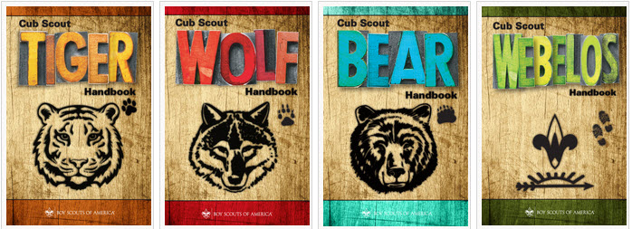
The NEW Cub Scout Adventure Plan!!!

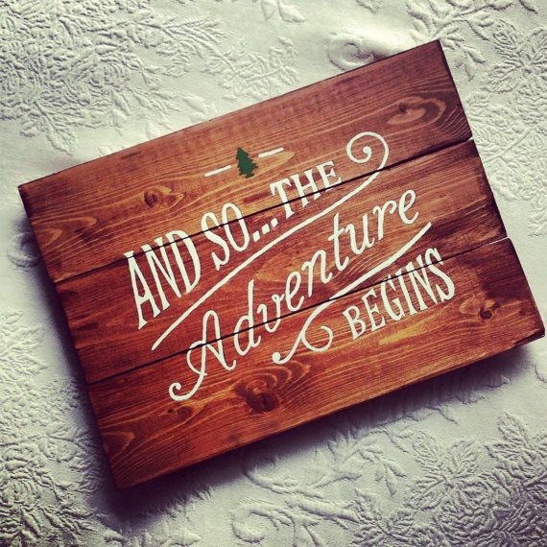
(This sign available at ETSY.com)
The Cub Scout Core Values re now the
12 Points of the Scout Law.
The core value highlighted this month is:
Brave:
- A Scout can face danger although he is afraid. He has the bravery to stand for what he thinks is right even if others laugh at him or threaten him.
Why "Under the Sea" for the Core Value Brave?
- The oceans are the last unexplored frontiers on Earth. One needs to be brave to venture into undiscovered territory. This month let us take our Cub Scouts under the oceans to explore and do what is right in caring for our last earthly frontier.

NOTE: Brave was one of three words added to Baden-Powell's original Scout Law by James E. West and the BSA in 1910. They, also, added Clean and Reverent. In 1911, B-P added Clean to the British Scout Law. (So I do not have a B-P definition of Brave)

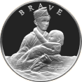
See the original Norman Rockwell painting at
https://encrypted-tbn2.gstatic.com/images?q=tbn:ANd9GcRq2AM3-zvDba--kUmbMnDGIuAJJ7_EXEUR_5vg5NWvVh1F8gWa

Table of Contents
CORE VALUES 1
Table of Contents 2
A Brave Man - Franklin Delano Roosevelt 4
BRAVE Quotes from Benjamin Franklin 5
Here are some Eleanor Roosevelt Brave Quotes 5
Cubmaster's Minute Idea 6
About the FDR Quote on the World War II Memorial– 6
COMMISSIONER’S CORNER 7
Have you seen the new books and other materials?? 7
If not, WHY NOT?? 7
TEACHING THE SCOUT LAW TO CUB SCOUTS 7
DEN MEETING TOPICS 9
PACK MEETING THEMES AND PLANS 10
Pack Meeting Themes 10
UPCOMING MONTHS 11
Connecting HEALTH & FITNESS with Outdoor Activities 12
Crazy Holidays 13
BSA SOCIAL NETWORKS 15
BSA FACEBOOK PAGE 15
SCOUTING MAGAZINE ON YOU TUBE 15
Cool Camp: Goshen Scout Reservation 16
Inside the Vortex, the STEM Scouts Mobile Lab 16
CUBCAST 17
Bryans Blog 18
TRAINING TOPIC 22
CAMPFIRES 22
CAMPFIRES & CUB ADVENTURES 24
PLANNING CAMPFIRES 25
PLANNING A PACK CAMPFIRE 25
Artificial Campfires 25
Outdoor Ceremonies 26
Campfires: “Outing in Scouting” 26
SPECIAL OPPORTUNITIES 26
Cub Scout World Conservation Award 26
National Den Award 27
PROGRAM UPDATES 27
TRACKING SPREADSHEETS FOR THE CUB SSCOUT ADVENTURE PLAN 28
Brave Ideas 29
Bravery Word Search 29
POEM: IT GIVES MY SOUL BRAVERY 29
Bobcat Induction - Inducting The New Family 29
Footprints on the Moon opening ceremony 30
Fitness Game 30
Superhero Cape Gathering 30
Brave Opening Ceremony 30
Opening Prayer 31
Recognition Ceremony 31
Rank advancement Ceremony 31
Hero Cubmaster’s Minute 32
Superhero Skit 32
Cub Scout Superpowers 32
Brave Activities for Packs & Dens 32
Go to a Renaissance Faire 34
Under the Sea Ideas 34
The Hidden Fleet Gathering Activity 34
School of Fish Gathering Activity 35
Scrambled Water Gathering Activity 35
Underwater Words Gathering Activity 35
It’s Raining Cats and Dogs! Gathering Activity 35
Have an H2O Olympics Gathering Activity 35
Build a River Gathering Activity 35
Mink in a Maze Gathering Activity 36
Ocean Objects Word Search Gathering Activity 36
How Many Words Gathering Activity 36
Crossing the Quick Sand Gathering Activity 36
Fishing in the Tropics Gathering Activity 36
The Six “Ships” of Scouting Opening Ceremony 37
WATER 101 OPENING Ceremony 37
Raingutter Regatta Opening Ceremony 37
Safe Swim Opening Ceremony 37
Spirit of Scouting Opening Ceremony 37
OCEAN Opening Ceremony 37
Cub Scout Fish Opening Ceremony 38
Seaside Opening Ceremony 38
Swim Party Opening Ceremony 38
On The Beach Audience Participation 38
Fisherman’s Luck Audience Participation 39
IN SEARCH OF SUN SCREEN Audience Participation 39
Water Audience Participation 39
Robinson Crusoe's Diary Audience Participation 40
Waterways Advancement Ceremony 40
Fishing Trip Advancement Ceremony 41
SEA ADVENTURES Advancement Ceremony 42
Goin' Fishin' Advancement Ceremony 42
SCHOOL OF FISH ADVANCEMENT Ceremony 42
WATER FUN Advancement Ceremony 43
Arrow of Light Advancement Ceremony 43
“Water Adventure” Graduation Ceremony 44
Row, Row, Row Your Boat Song 44
BLOW YOUR BOAT Song 44
Propel Your Craft Song 44
Sailing, Sailing Song 44
Little White Duck Song 44
There’s A Hole In The Bottom Of The Sea Song 44
SuperCalifornianExpertSurferoftheOcean Song 45
Cub Sailors Song 45
Columbus Song 45
Shipwrecked Cub Scouts Song 46
He Waded in the Water Song 46
Lobster Mash Song 46
Give Me A Pond Song 46
Water Sports Song 46
Shipwrecked Cub Scouts Song 47
Skin Diver’s Song 47
Popeye the Sailor Man Song 47
Jaws Song 47
Singing in the Rain Song 47
Scout Wetspers Song 47
Outdoor Fun Song 47
This Sand Is Your Sand Song 48
Buccaneer Applause 48
Deep Sea Diver Applause 48
Water Cheer 48
Clam Clap Applause 48
Motorboat Applause 48
Seal Applause 48
Beach Cheer 48
Water Sprinkler Applause 48
Surfboarders Cheer 48
Diver’s Cheer 48
The Wave Cheer 48
Swimming Applause 48
Big Rain Applause 48
Beach Cheer 48
Clam Clap 48
Water Cheer 48
OCEAN APPLAUSE 48
RAINSTORM APPLAUSE 48
Backyard Pool Cheer 48
RUN-ONS 49
JOKES & RIDDLES 49
“H” TO “O” 49
ALLERGIC 50
THE CANTALOUPE 50
Waterways Skit 50
How Did You Get Here? Skit 50
Who Am I Skit 50
A Ship Like This Skit 51
Man Fishing Skit 51
Facts of Water Skit 51
The Fisherman Skit 51
Fishing Skit 51
THE FISHING TRIP Skit 52
Water Water Skit 52
Beach Party Closing Ceremony 52
Transportation of Smiles Closing Ceremony 52
NET CLOSING Ceremony 53
Conservation Closing Ceremony 53
Water Fun Closing Ceremony 53
Three Important Things Cubmaster Minute 53
Togetherness Closing Thought Cubmaster Minute 53
Captain Of All Scouts Cubmaster Minute 53
Starfish Cubmaster’s Minute 53
Remember to be Grateful Cubmaster Minute 54
LIFE IS LIKE A RIVER Cubmaster Minute 54
“WORK WHILE YOU WORK” Cubmaster Minute 54
MAKE A FEW WAVES Cubmaster Minute 54
WATER Cubmaster Minute 54
Candle Cubmaster Minute 54
Mutiny Cubmaster Minute 54
Water Sayings: 54
Fun Facts About Water: 55
Saving Water in the House: 55
Water Waste Prevention: 55
Saving Water in the Yard 56
Fifteen Steps to Building a Campfire 56
DEN ADVENTURES 56
TIGER 56
Games Tigers Play 56
Tigers – Safe & Smart 57
Tiger Theatre 57
WOLF 57
Paws on the Path 57
Hometown Heroes 57
BEAR 58
Paws for Action 58
Salmon Run 58
WEBELOS CORE 59
First Responder 59
Webelos Walkabout 59
ARROW OF LIGHT CORE 59
WEBELOS & AOL ELECTIVES 59
Build My Own Hero 59

A Brave Man -
Franklin Delano Roosevelt
"The only thing we have to fear is fear itself."
Who is Franklin Delano Roosevelt? FDR was the thirty-second President of the United States. He was the president during the Great Depression, which was a time period where the economy crashed. The Great Depression started with the Stock Market Crash of 1929. During the 1920s, the value of these stocks increased a lot. In 1932 and 1933, the Stock Market decreased rapidly. This decrease affected everyone in the United States. People began to feel as though they were at risk of losing all their savings and, because they were so poor, they did not buy a lot of products. Many people who deposited their money into the banks wanted to withdraw money, but these banks could not give back all of the money that was deposited. One hundred forty billion dollars that was deposited in the banks was lost and disappeared.
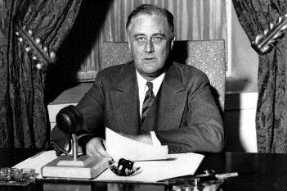
In 1933, Franklin Delano Roosevelt was elected into office. America had a “Bank Holiday,” which was when FDR closed the banks for three days. He created the New Deal, which was meant to help the economy to recover. The Congress made up many groups to help to relieve the economy. Some of these groups were NRA, FDIC, and AAA. This was part of the first phase of the New Deal. The second phase of the New Deal was to help the people of America get jobs. The social security system was established in 1935 for people to have economic security.
Roosevelt had to be BRAVE to want to run this country during such a harsh time. He also was BRAVE because he was suffering from poliomyelitis. In summer 1921, he was diagnosed with this disease. He started to get tired, and he couldn’t move his legs. With this disability, Roosevelt could not do things by himself. He had to have someone help him do everyday things. He swam to try to get more movement into his legs. He spent a lot of money trying to find a cure for poliomyelitis. Jonas Salk made a vaccine to stop poliomyelitis because of Roosevelt’s efforts to find a cure for it. Even with this disability, Roosevelt ran the country through the most devastating time the United States had ever faced.
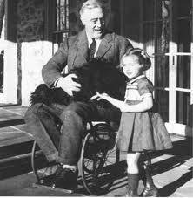
"THE NEW DEAL":
A package of programs introduced by President Roosevelt aimed at ending the Depression by stimulating the economy and putting people back to work. The "New Deal" programs were enacted during the first 100 days of the Roosevelt Administration.
March 9: Emergency Banking Act
March 20: Economy Act
March 31: Civilian Conservation Corps established
April 19: End of the gold standard
May 12: Emergency Farm Mortgage Act
May 18: Tennessee Valley Authority established
May 27: Truth in Securities Act
June 13: Home Owners' Loan Act
June 16: National Industrial Recovery Act and
Farm Credit Act
"I think," his wife, Eleanor (Roosevelt), observed, "probably the thing that took the most BRAVERY (another word for BRAVERY – CD) in his life was his mastery and his meeting of polio. I never heard him complain." And though anyone remembering how athletic and strong he had been as a young man could not fail to realize what a terrific battle must have gone on within him, "he just accepted it as one of those things that was given you as discipline in life." After his struggle with polio, he seemed less arrogant, less smug, less superficial, more focused, more complex, more interesting. "There had been a plowing up of his nature," Frances Perkins commented. "The man emerged completely warm-hearted, with new humility of spirit and a firmer understanding of philosophical concepts." He had always taken great pleasure in people, but now they become what one historian has called "his vital links to life." Far more intensely than before, he reached out to know them, to understand them, to pick up their emotions, to put himself into their shoes. No longer belonging to his old world in the same way, he came to empathize with the poor and the underprivileged, with people to whom fate had dealt a difficult hand.
What is more, Roosevelt had a remarkable capacity to transmit his internal strength to others, to allow, as White House counsel Sam Rosenman observed, the men and women who came to Washington during the New Deal "to begin to feel it and take part in it, to rejoice in it-- and to return it tenfold by their own confidence." Frances Perkins claimed that "his capacity to inspire and enbravery those around him to do tough, confused and practically impossible jobs was without dispute." Like everyone else, she said, she "came away from an interview with the president feeling better not because he had solved any problems," but because he had somehow made her feel more cheerful, more determined, stronger than she had felt when she went into the room. "I have never known a man who gave one a greater sense of security," Eleanor said. "I never heard him say there was a problem that he thought it was impossible for human beings to solve."
Following the attack on Pearl Harbor, FDR made a BRAVE move, demanding we attack the Japanese mainland. And when he was told it was not possible he stood, to show nothing was impossible. And so his BRAVERY lead to the Doolittle Raid and our eventual victory in World War II.
Both my Mom and my Dad were greatly affected by FDR. My Dad and all his brothers were Civilian Conservation Corps (CCC) members and WWII veterans. My Mom's family benefitted from his restoration of the economy keeping the Pennsylvania Railroad busy and my Grandfather employed.
"Bravery is not the absence of fear, but rather the assessment that something else is more important than fear." Franklin D. Roosevelt

BRAVE Quotes from Benjamin Franklin
- When you get to the end of your rope, tie a knot and hang on.
- The only limit to our realization of tomorrow will be our doubts of today.
- First of all, let me assert my firm belief that the only thing we have to fear is fear itself - nameless, unreasoning, unjustified terror which paralyzes needed efforts to convert retreat into advance.
- We defend and we build a way of life, not for America alone, but for all mankind.
- The only limit to our realization of tomorrow will be our doubts of today. Let us move forward with strong and active faith.
- It is common sense to take a method and try it. If it fails, admit it frankly and try another. But above all, try something.
We cannot always build the future for our youth, but we can build our youth for the future.
Franklin Delano Roosevelt
His wife, Eleanor Roosevelt, certainly helped and inspired Franklin Delano Roosevelt to be brave.
Here are some Eleanor Roosevelt Brave Quotes.
- You gain strength, bravery, and confidence by every experience in which you really stop to look fear in the face... Do the thing you thing you cannot do.
- Bravery is exhilarating.
- Do not stop thinking of life as an adventure. You have no security unless you can live bravely, excitingly, imaginatively; unless you can choose a challenge instead of competence.”
- It is a brave thing to have bravery to be an individual; it is also, perhaps, a lonely thing. But it is better than not being an individual, which is to be nobody at all.
- If many of our young people have lost the excitement of the early settlers, who had a country to explore and develop, it is because no one remembers to tell them that the world has never been so challenging, so exciting... Perhaps the older generation is often to blame with its cautious warning: “Take a job that will give you security, not adventure.” But I say to the young: “Do not stop thinking of life as an adventure. You have no security unless you can live bravely, excitingly, and imaginatively; unless you can choose a challenge instead of a competence.
- There is no more liberating, no more exhilarating experience than to determine one's position, state it bravely and then act boldly.
- Bravery is more exhilarating than fear and in the long run it is easier. We do not have to become heroes overnight. Just a step at a time, meeting each thing that comes up, seeing it is not as dreadful as it appeared, discovering we have the strength to stare it down.
Cubmaster's Minute Idea –
Talk about Franklin Delano Roosevelt for your minute. Have people pull a dime out of their pocket and telling you who is on that coin. Or enlarging a picture of a dime and showing his profile.

About the FDR Quote on the World War II Memorial–
This is the plaque at the WWII Memorial -
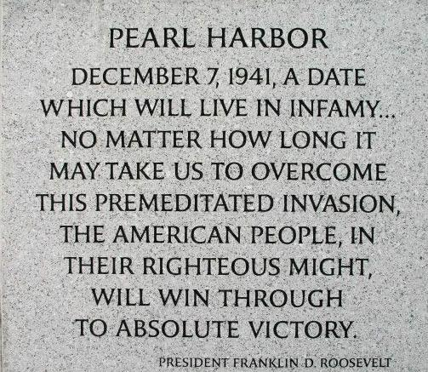
This is the full text of FDR’s Speech -
The red text is what is on the plaque above.
The blue text is where he says “So help us God.”
Yesterday, December 7, 1941 — a date which will live in infamy — the United States of America was suddenly and deliberately attacked by naval and air forces of the Empire of Japan.
The United States was at peace with that nation, and, at the solicitation of Japan, was still in conversation with its government and its Emperor looking toward the maintenance of peace in the Pacific.
Indeed, one hour after Japanese air squadrons had commenced bombing in the American island of Oahu, the Japanese Ambassador to the United States and his colleague delivered to our Secretary of State a formal reply to a recent American message. And, while this reply stated that it seemed useless to continue the existing diplomatic negotiations, it contained no threat or hint of war or of armed attack.
It will be recorded that the distance of Hawaii from Japan makes it obvious that the attack was deliberately planned many days or even weeks ago. During the intervening time the Japanese Government has deliberately sought to deceive the United States by false statements and expressions of hope for continued peace.
The attack yesterday on the Hawaiian Islands has caused severe damage to American naval and military forces. I regret to tell you that very many American lives have been lost. In addition, American ships have been reported torpedoed on the high seas between San Francisco and Honolulu.
Yesterday the Japanese Government also launched an attack against Malaya.
Last night Japanese forces attacked Hong Kong.
Last night Japanese forces attacked Guam.
Last night Japanese forces attacked the Philippine Islands.
Last night the Japanese attacked Wake Island.
And this morning the Japanese attacked Midway Island.
Japan has therefore undertaken a surprise offensive extending throughout the Pacific area. The facts of yesterday and today speak for themselves. The people of the United States have already formed their opinions and well understand the implications to the very life and safety of our nation.
As Commander-in-Chief of the Army and Navy I have directed that all measures be taken for our defense, that always will our whole nation remember the character of the onslaught against us.
No matter how long it may take us to overcome this premeditated invasion, the American people, in their righteous might, will win through to absolute victory.
I believe that I interpret the will of the Congress and of the people when I assert that we will not only defend ourselves to the uttermost but will make it very certain that this form of treachery shall never again endanger us.
Hostilities exist. There is no blinking at the fact that our people, our territory and our interests are in grave danger.
With confidence in our armed forces, with the unbounding determination of our people, we will gain the inevitable triumph, so help us God.
I ask that the Congress declare that since the unprovoked and dastardly attack by Japan on Sunday, December 7, 1941, a state of war has existed between the United States and the Japanese Empire.
- The “infamy” line was chosen because it is famous. By the way, “infamy” was an ad lib from the written text. Go to Snopes to learn more (http://www.snopes.com/politics/military/memorial.asp)
- The other selected passage is the line for which Congress cheered and applauded the loudest and the longest.
So go read the full text on Snopes.com and the next time you receive that E-mail (you know the one) – reply back to all with the link to Snopes and get the true story out.
Read more at http://www.snopes.com/politics/military/memorial.asp

COMMISSIONER’S CORNER
Spoke with a Den Leader who attends my church this AM. I have been getting her information on the New Adventure Program throughout the year.
This morning she was very excited about it. She will be a BEAR Leader next year and she and her co-leader had met to look at the book and plan next year.
She said she was amazed at how much outdoor stuff there was. And the good stuff (e.g Knives) is now a Core (Required) Adventure. They are planning several trips to Lum's Pond, a local state park. Sounds like their Cubs will have a blast!!
So get busy and start planning your year!!!!
You, too, could be amazed at how great the new Adventure Program is.

Have you seen the new books and other materials??
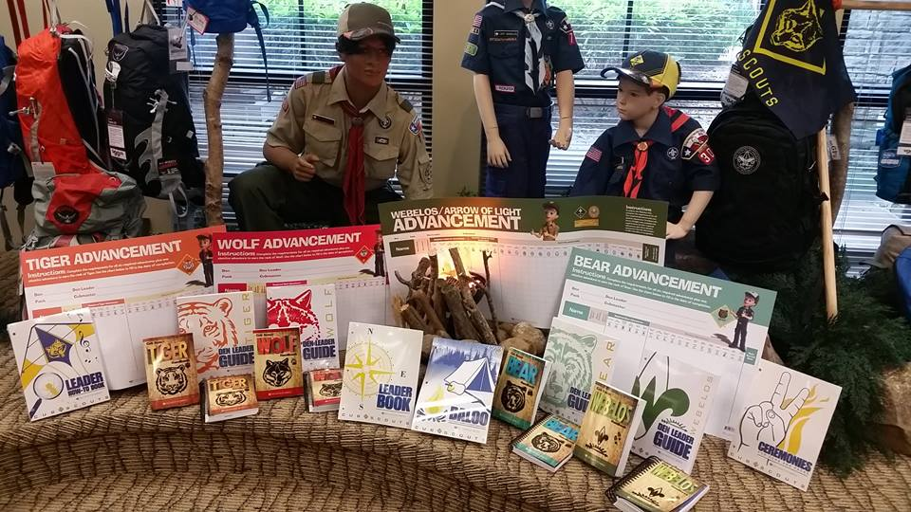
If not, WHY NOT??

TEACHING THE SCOUT LAW
TO CUB SCOUTS
- CLIMB A LADDER
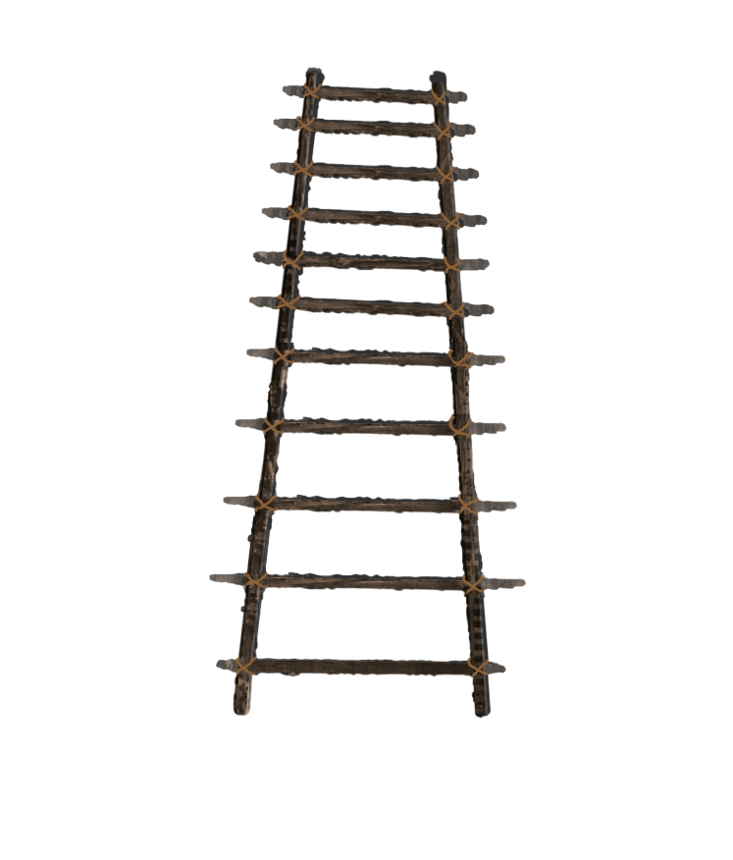
Take (or make) a ladder with 12 sections. Label each section with one of the parts of the Scout Law (Trustworthy, Loyal, Helpful, Friendly, Courteous, Kind, Obedient, Cheerful, Thrifty, Brave, Clean, Reverent). Scouts ( Scouts and Adult Partner for Tigers) sit by the ladder. A Cub rolls/tosses a ball (or tosses a bean bag). The Cub has to explain in his own words the part of the Scout Law where the object landed.
- ROLL TWO FUZZY DICE
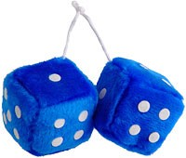
Get a pair of fuzzy dice (Novelty Shop, Oriental Trading). There are 12 numbers same as 12 points of Scout Law. Playing Options –
Option #1 -
Roll one die and either the roller or the whole den in unison recite the points of the Law up to the number. If you roll a one, they should say, “A Scout is trustworthy.” If you roll a five, they should go all the way through courteous. Have all the Cubs primed to help if the reciter stumbles. To make it easier, just roll one die until the boys master the first 6 points. Then roll both.
Option #2 –
A Cub rolls the dice. Either he figures out what part that number is (11 = Clean) or a leader tells him. Then he says a little about what that part means to him.
- SING "TRUSTY TOMMY"
TRUSTY TOMMY
USSCOUTS.org
http://usscouts.org/songs/songbk1a.asp
Tune – Yankee Doodle
Trusty Tommy was a Scout
Loyal to his mother,
Helpful to the folks about,
And friendly to his brother.
Courteous to the girls he knew,
Kind unto his rabbit,
Obedient to his father, too,
And cheerful in his habits.
Thrifty saving for a need,
Brave, but not a faker,
Clean in thought and word and deed,
And reverent to his Maker.

Check it out on You Tube -
Real Scouts singing -
https://www.youtube.com/watch?v=Y0y4O5E51_k
Professionals signing -
https://www.youtube.com/watch?v=d_4SaiMC4KQ
- RELAY RACE
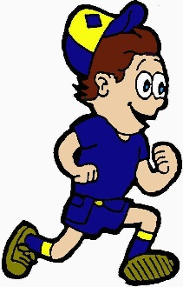
As Baden-Powell says, “A boy is not a sitting-down animal.” By turning the Law into a relay race, you can let Scouts burn off some energy while learning something in the process. Here’s how:
- Make two sets of 12 cards where each card displays one point of the Law.
- Put the cards in each set in random order and place them in two piles at the front of the room.
- Divide the den into two teams and have each team line up facing one pile of cards.
- When you say “go,” the first boy on each team runs to his team’s pile of cards, picks what he thinks is the first point of the Law and sticks it on the wall using masking tape. He then returns to tag the next player, who runs up, chooses the second point, and places it below the first. Continue in this manner until one team has all the points on the wall in the correct order.
- If a team has the points in the wrong order, let them take extra turns, moving one card per turn. The first team with all the points posted in the right order wins.
- CRAFT STICK HANGING
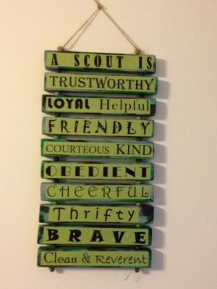
- Have the Cubs each take 13 craft sticks. On the first one they write "A Scout Is" Then they put one part of the Scout Law on each of the other 12. You can play a game getting the points in order or they can create a hanging like th eon ein the picture. When you say “go,” the first boy on each team runs to his team’s pile of cards, picks what he thinks is the first point of the Law and sticks it on the wall using masking tape. He then returns to tag the next player, who runs up, chooses the second point, and places it below the first. Continue in this manner until one team has all the points on the wall in the correct order.
- TAKE IT A SMALL PART AT A TIME
- Break the Scout Law into sections of three or four words. (e.g. Trustworthy, Loyal, Helpful, then Friendly, Courteous, Kind, then Obedient, Cheerful, Thrifty, and finally Brave, Clean, Reverent). Then work on one group at a time.

DEN MEETING TOPICS
YOU are now using the CUB SCOUT ADVENTURE PLAN. Look at the books and pick some great Adventures to do this summer. This is a great time to get used to the new Adventure Program and familiarize yourself with the materials. Just remember – Boys want to be outside playing. See, too, what they can earn / complete (Never say GET. You get sick, you do not get awards – You earn awards. A little CD Philosophy) at camp.

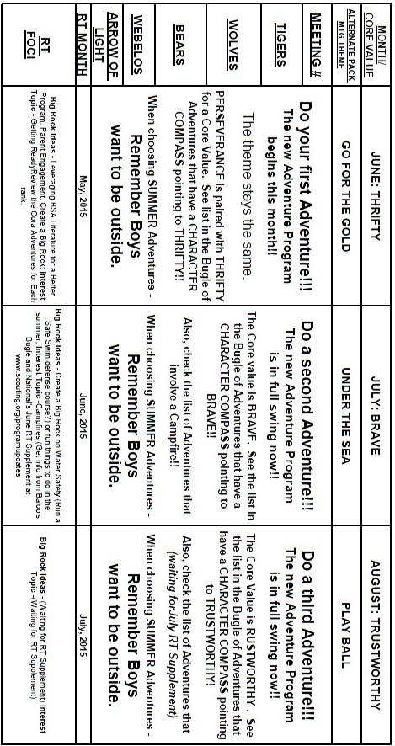

JULY -
ADVENTURES with a CHARACTER COMPASS pointing to BRAVE:
TIGER –
- Games Tigers Play
- Tigers – Safe & Smart
- Tiger Theatre
WOLF –
- Paws on the Path
- Hometown Heroes
BEAR –
- Paws for Action
- Salmon Run
WEBELOS CORE –
- First Responder
- Webelos Walkabout
ARROW OF LIGHT CORE –
- None
WEBELOS & AOL ELECTIVES –
- Build My Own Hero



AUGUST -
ADVENTURES with a CHARACTER COMPASS pointing to TRUSTWORTHY:
TIGER –
- Team Tiger
- Tigers – Safe & Smart
WOLF –
- Howling at the Moon
- Adventures in Coins
BEAR –
- Bear Claws
- Baloo the Builder
WEBELOS CORE –
- Cast Iron Chef
ARROW OF LIGHT CORE –
- Camper
WEBELOS & AOL ELECTIVES –
- Game Design

PACK MEETING THEMES
AND PLANS
www.scouting.org
2015–2016 Pack Meeting Plans
Here is the remaining theme to be featured for
2014-2015 in the CS RT PG -
Month Core Value Supplemental Theme
- August Trustworthy** Play Ball

** - Scout Law based Core Values are Judy and Dave's best guess based on theme and what current Core Value was assigned. The three summer months are transition. Pick Adventures from the list and let us know how you did!!!

From national's Website for the new plans using the Core Values based on the Scout Law:
Here are a few thoughts to consider around these new pack meeting plans. First, there is a plan for each month that corresponds with a point of the Scout Law. In addition, each plan has a theme to help make the pack meeting even more fun! The plans do not have to be used in a specific order, but some do have reminders to include activities from the required adventures to help the Scouts earn their rank.

As a personal note: I have read some of the plans and they are excellent and just as complete as the new Den Leader Books. The games, and other stuff are right there. Including costuming ideas for that added PIZAZZ!! If you do not use themes and add PIZAZZ you are not doing your best for your pack.
GOOD JOB!!! From CD

Check them out at:
http://www.scouting.org/scoutsource/CubScouts/Leaders/DenLeaderResources/DenandPackMeetingResourceGuide/PackMeetingPlans.aspx

Kim, the chair of the task force, says "I do want to stress that the focus is still the Core Value and the theme is just there as an enhancement. The theme pack meeting plans are specifically crafted to bring out the important points of the Core Value in a fun way."

Pack Meeting Themes
2015–2016 Pack Meeting Plans
September | Clean | "Cubservation"
October | Brave | "Super Cub!"
November | Helpful | "Cubs In Action"
December | Reverent | "Winter Wonderland"
January | Trustworthy | "The Great Race"
February | Friendly | "Friends Near And Far"
March | Thrifty | "Cubstruction"
April | Cheerful | "Strike Up The Band"
May | Kind | "My Animal Friends"
June | Obedient | "It's A Hit"
July | Loyal | "Scout Salute"
August | Courteous | "S'more Cub Scout Fun"

2016–2017 Pack Meeting Plans
September | Helpful | "To The Rescue"
October | Kind | "Creepy Crawlers"
November | Courteous | "Cubs In Shining Armor"
December | Cheerful | "Celebrate"
January | Obedient | "Cub Scout City Council"
February | Reverent | "Passport To Other Lands"
March | Loyal | "Our National Treasures"
April | Thrifty | "Power Up!"
May | Clean | "A Picnic With Pizzazz"
June | Brave | "Roaming Reptile Alert"
July | Trustworthy | "Let The Games Begin"
August | Friendly | "#CUBSCOUTS"
If you are using a paper copy the link to all the
Pack Meeting Plans is:
http://www.scouting.org/scoutsource/CubScouts/Leaders/DenLeaderResources/DenandPackMeetingResourceGuide/PackMeetingPlans.aspx

UPCOMING MONTHS
- July's Core Value, Brave, will use the theme
Under the Sea
Based on the theme intent and the write up in the Cub Scout Roundtable Planning Guide – I substituted BRAVE for BRAVERY. CD
Month's that have themes that might help you with BRAVE and "Under the Sea " are:

- Months with WATER ideas for
Under the Sea –
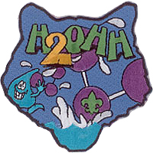
Month | Year | Theme
Water Themes
July | 1967 | Cub Scout Water Fun
July | 1970 | Old Swimming Hole
August | 1971 | Cub Scout Water Fun
July | 1974 | Water Fun
August | 1977 | Water Fun
August | 1994 | Water Fun
July | 1995 | Water Carnival
July | 1996 | Water Fun
July | 2004 | Fin Fun
July | 2008 | H2 OHhhhhh!
August | 2010 | Waves of Fun
- Months with CAMPFIRE Ideas –
(National's RT Supplement suggests doing campfires in RT and possibly doing a Campfire for your Pack Meeting)
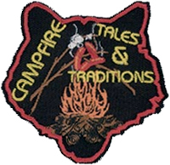
Month | Year | Theme
Campfire Themes
August | 1984 | Campfire Yarns
August | 1993 | Campfire Yarns
August | 2001 | Summer Songfest
August | 2005 | Campfire Tales and Traditions

- Here are months with Summertime ideas –
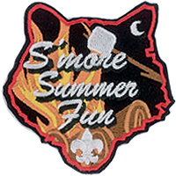
Month | Year | Theme
Summertime Ideas
July | 1943 | Back Yard Month
May | 1944 | Gardening
July | 1944 | Back Yard Camping
July | 1950 | Outing
May | 1953 | Mother Nature's Backyard
June | 1953 | Summertime Adventure
July | 1954 | Treasure Hunters
August | 1954 | Annual Picnic
August | 1955 | Outdoor Fun
August | 1957 | Good Old Summertime
June | 1959 | Summer Safari
August | 1961 | Outdoor Festival
June | 1965 | Backyard Adventure

Month | Year | Theme
More Summertime Ideas
August | 1970 | Cub Scout Field Day
June | 1972 | Backyard Adventure
July | 1975 | Summer Adventure
August | 1975 | Model-Boat Regatta
July | 1976 | July 4th Picnic
March | 1977 | Kites-Spring
July | 1984 | Fun in the Sun
June | 1985 | Backyard Fun
August | 1989 | Outdoor Festival
June | 1991 | Backyard Fun
July | 1992 | Fun in the Sun
June | 1996 | Backyard Fun
July | 2006 | Red, White and Baloo
August | 2008 | S'More Summer Fun
May | 2015 | Backyard Fun

- August's Core Value, Trustworthy,
will use the theme, Play Ball
- Trustworthy - A Scout tells the truth. He is honest, and he keeps his promises. People can depend on him.
- Why "Play Ball" for Honesty?
It is easy to forget how important it is to be honest when one is playing a game and really wanting to win; however, a Cub Scout is a person who always tells the truth and is worthy of trust. This month we reinforce how important it is to be honest, especially when playing baseball with friends.
Based on the theme intent and the write up in the Cub Scout Roundtable Planning Guide – I substituted TRUSTWORTHY for HONESTY. CD
Month's that have themes that might help you with TRUSTWORTY and "Play Ball" are:

Month | Year | Theme
Trustworthy
January | 1943 | Do Your Bit
December | 1958 | The Golden Rule
November | 2001 | Hometown Heroes
November | 2002 | Kids Against Crime
January | 2004 | Home Alone
November | 2009 | Scout Salute
August | 2011 | Honesty
August | 2012 | Honesty
August | 2013 | Kids Against Crime
August | 2014 | Heroes of History


Month | Year | Theme
Play Ball
Sept | 1939 | Cub Olympics (Note 1)
August | 1945 | Sports
August | 1950 | Cub Scout Olympics
August | 1953 | Sports Carnival
August | 1956 | Cub Scout Field Day
June | 1960 | Cub Scout Olympics
June | 1964 | Cub Scout Olympics
June | 1966 | Sports Carnival
July | 1968 | Cub Scout Olympics
June | 1970 | Olympics
August | 1970 | Cub Scout Field Day
July | 1972 | Cub Scout Olympics
June | 1975 | Sports Carnival
June | 1979 | Learn a Sport
June | 1990 | Sports Arena
August | 2002 | Sports Extravaganza
July | 2005 | Play Ball!
June | 2008 | Go For The Gold
July | 2009 | Cub Scout Sports
June | 2010 | Hoop-De-Doo
(Note 1 – September 1939 – The very first month that Cub Scouts used a Theme!!)

Connecting
HEALTH & FITNESS
with Outdoor Activities
(Adapted from B.A.L.O.O. Appendix E)
Appendix E of the B.A.L.O.O. syllabus has been completely rewritten and the detailed suggestions for ways to line up the Core Values (now the 12 points of the Scout Law) to activities have been replaced with current information.

There is great information about the Ideals of Cub Scouting (e.g. The Purposes of Cub Scouting, Developing Character, Desired Outcomes, Scout Law and Scout Oath, and their meanings). Check it out!!

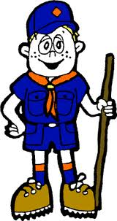

Crazy Holidays
Jodi, SNJC Webelos Resident Camp Director Emeritus,
2006-2011. Adapted from http://holidayinsights.com/moreholidays/index.htm
http://www.brownielocks.com/month2.html
July is:
- Air-Conditioning Appreciation Days
- Dog Days (7/3 to 8/11)
- Eggplant and Lettuce Month

- Family Golf Month
- Family Reunion Month
- Juvenile Arthritis Awareness Month
- Mango and Melon Month
- National Anti-Boredom Month
- National Black Family Month
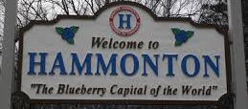
- National Blueberries Month
- National Cell Phone Courtesy Month
- National Cord Blood Awareness Month
- National "Doghouse Repairs" Month
- National Grilling Month
- National Horseradish Month
- National Hot Dog Month
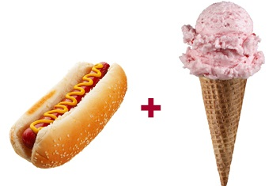
- National Ice Cream Month
- National Independent Retailers Month
- National Make A Difference to Children Month
- National Parks and Recreation Month
- National Share A Sunset With Your Lover Month
- National Wheelchair Beautification Month
- Nectarine and Garlic Month
- Sandwich Generation Month
- Smart Irrigation Month
- Women's Motorcycle Month
Weekly Events:
- Beans and Bacon Days: 1-5
- Freedom Week: 4-10
- National Tom Sawyer Days, Week 2-5
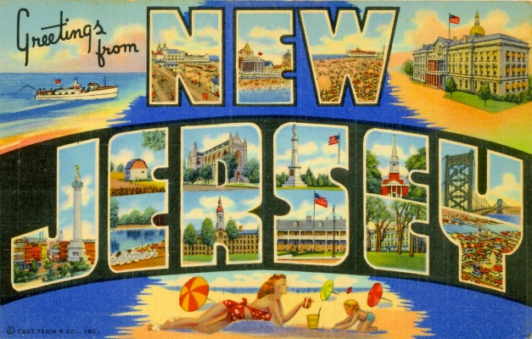
- Be Nice To New Jersey Week: 5-11
- National Farriers Week: 5-11
- Sports Cliché Week: 12-16 (Always Week of Maj. League Baseball All Star Game)
- Rabbit Week: 15-21 (Re: Magician Rabbits The sponsor is Melvin Rabbit up in Canada.)
- National Baby Food Week: 15-18
- National Ventriloquism Week: 15-18
- Comic Con International: 9-12
- Restless Leg Syndrome (RLS) Education & Awareness Week: 18-25 (Note: Different sponsor than the September 23 observance has.)
- National Parenting Gifted Children Week: 19-26
- Captive Nations Week: 19-25
- National Independent Retailers Week: 19-25
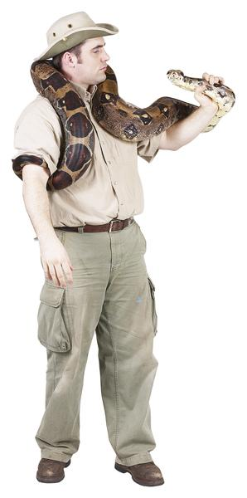
- National Zoo Keeper Week: 19-25
- World Lumberjack Championships: 23-25
- Garlic Days: 24-26 (Last Weekend)
Daily:
1 Canada Day
1 Creative Ice Cream Flavors Day
1 International Joke Day
1 ZIP Code Day
2 I Forgot Day

2 Made In The USA Day
2 World UFO Day
3 Roswell UFO Days (July 3-6)
3 Compliment Your Mirror Day
3 International Plastic Bag Free Day
3 Stay out of the Sun Day

4 Independence Day (U.S.)
4 National Country Music Day
4 Sidewalk Egg Frying Day- Hmmmm, I wonder why!?!
5 Work-a-holics Day - even though everyone is on holiday
5 Build A Scarecrow Day - first Sunday in month
6 National Fried Chicken Day
7 Chocolate Day
7 Father-Daughter Take A Walk Together Day
7 National Strawberry Sundae Day
8 Video Games Day
9 National Sugar Cookie Day
10 Collector Car Appreciation day
10 Teddy Bear Picnic Day
11 Cheer up the Lonely Day
11 World Population Day

11 Slurpee Day or 7-11's Birthday:
12 Different Colored Eyes Day
12 Pecan Pie Day
13 Barbershop Music Appreciation Day
13 Embrace Your Geekness Day
13 Fool's Paradise Day
14 Bastille Day
14 Pandemonium Day
14 Cow Appreciation Day
Get a free Chicken Sandwich at Chik-fil-A
15 Tapioca Pudding Day
15 Global Hug Your Kid Day
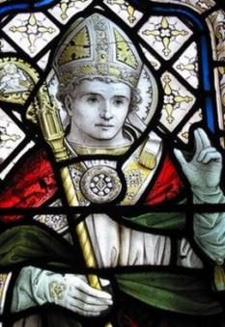
15 Saint Swithins Day
16 Fresh Spinach Day
17 Peach Ice Cream Day
17 Yellow Pig Day
18 National Caviar Day- something's fishy here
18 Nelson Mandela day
19 National Ice Cream Day (third Sunday of the month)
19 National Raspberry Cake Day
20 Moon Day
20 Ugly Truck Day- it's a "guy" thing
21 National Junk Food Day
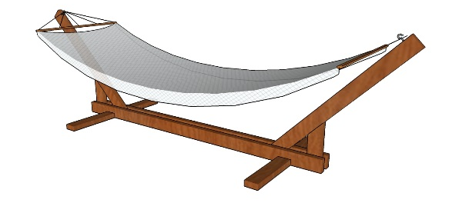
22 Hammock Day
22 Casual Pi Day: 22 (22/7)
22 Ratcatcher's Day
23 National Hot Dog Day

23 Vanilla Ice Cream Day
24 Church of Latter Day Saints Pioneer Day
24 Tell An Old Joke Day
24 Amelia Earhart Day
24 Cousins Day
25 Threading the Needle Day
26 Parent's Day - fourth Sunday in July
26 All or Nothing Day
26 Aunt and Uncle Day
27 Take Your Pants for a Walk Day
28 Buffalo Soldiers Day
28 National Milk Chocolate Day

29 National Lasagna Day
30 National Cheesecake Day
30 Father-in-Law Day
31 National Talk in An Elevator Day
31 Mutt's Day

BSA SOCIAL NETWORKS

BSA FACEBOOK PAGE
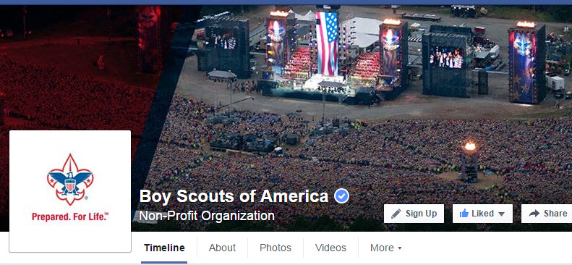
BSA Facebook page
https://www.facebook.com/pages/Boy-Scouts-of-America/113441755297

On the Facebook page you can read about –
How the BSA Honored One of the Oldest Eagle Scouts (He is 103)
Go To: http://scoutingnewsroom.org/blog/how-the-bsa-honored-one-of-the-oldest-eagle-scouts/

SCOUTING MAGAZINE
ON YOU TUBE

Scouting magazine You Tube Channel
http://www.youtube.com/user/scoutingmag

Check out some of the Cool Camp Videos –
For Example –

Cool Camp: Goshen Scout Reservation
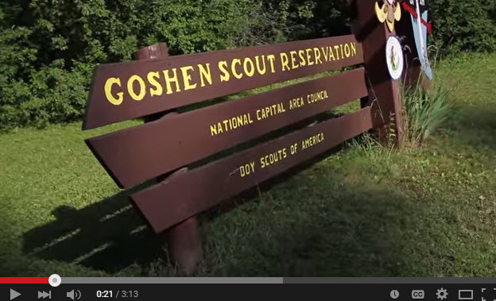
Check it out at -
https://www.youtube.com/watch?v=CrIizmhRYP0
They have lots of videos check out the one on STEM Scouts –
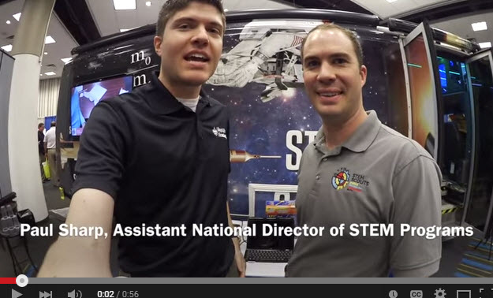

Inside the Vortex,
the STEM Scouts Mobile Lab
https://www.youtube.com/watch?v=0c98k4P94c4

Don't know what STEM Scouts is?
Want to learn more abot STEM Scouts??
(STEM = Science-Technology-
Engineering-Mathematics)

STEM Scouts was successfully piloted in East Tennessee for several years. Recently, the BSA’s National Executive Board approved a plan to expand the STEM Scouts pilot to these 12 additional councils. (Pending the councils' boards' approval):
- Capitol Area Council (Austin, TX)
- Catalina Council (Tucson, AZ.)
- Circle Ten Council (Dallas, TX)
- Connecticut Rivers Council (E Hartford, CT)
- Crossroads of America Council (Indianapolis, IN)
- Denver Area Council (Denver, CO)
- Garden State Council (Westampton Township, NJ) (Commisioner Dave's Council!!!)
- Greater St. Louis Area Council (St Louis, MO)
- Middle Tennessee Council (Nashville, TN)
- Pathway to Adventure Council (Chicago, IL)
- Sam Houston Area Council (Houston, TX)
- Samoset Council (Weston, WI)
The success of the East Tennessee pilot confirms the BSA’s hypothesis that young people are excited to experience STEM (science, technology, engineering and math) in a fun setting. The STEM Scouts program blends Scouting’s time-tested character-building traits with hands-on STEM modules that’ll prepare boys and girls for careers in STEM fields.
STEM Scouts are boys and girls in third through 12th grade. They’re split into three divisions:
- Elementary school (third through fifth grade)
- Middle school (sixth through eighth grade)
- High school (ninth through 12th grade)
Instead of packs or troops, STEM Scouts are grouped into “laboratories,” which can be shortened to “labs.”
They meet weekly, after school, for hands-on, fun activities organized into four- to six-week modules that cover a ton of fun STEM topics.

April McMillan and Trent Nichols (pictured) serve as national directors of STEM programs. On the STEM Scouts site, (https://stemscouts.org/ )they shared their vision for this new BSA program. A few highlights:
- The key for the entire offered curriculum is that it will be fast-paced, thought-provoking and fun. Adult volunteers and STEM professionals will have the opportunity to engage interested girls and boys with hands-on activities in the labs divided by the age divisions. Throughout the year, students will be involved in experiential activities that enbravery natural curiosity and insights in STEM fields.
- This new program represents a bit of a paradigm shift for parents from the traditional outdoor-oriented Scouting. The children will receive important character building and learning through field trips and weekly interactions with STEM professionals as well as learning citizenship. This up close and personal insight into how STEM skills are used in business and industry is critical to enable girls and boys to visualize themselves succeeding in STEM fields
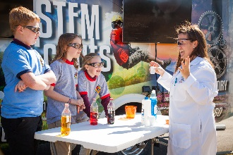
More Info on STEM Scouts??
- Go to https://stemscouts.org/
- Go Bryans Blog -(http://blog.scoutingmagazine.org/) and read the following articles
STEM Scouts pilot expanding to 12 more councils
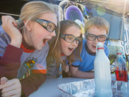 The BSA's National Executive Board approved a plan to expand STEM Scouts, a new program of the Boy Scouts of America, to 12 additional councils.
STEM Scouts ready for prime time with NASCAR Truck Series debut
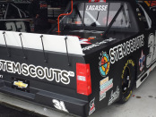 The STEM Scouts logo will feature prominently on Scott Lagasse Jr.'s #31 truck in tonight's Toyota Tundra 250 at Kansas Speedway in Kansas City, KS.
Understanding the difference between STEM in Scouting and STEM Scouts
 Read about the difference between STEM activities in traditional Scout units and STEM Scouts, the new BSA program expanding to 12 councils this fall.
Video: Inside the Vortex, the STEM Scouts mobile lab
 I got to check out the Vortex, the STEM Scouts mobile lab. It's a whole lot of awesomeness on four wheels.

(NOTE from Commissioner Dave – I had a great time with the VORTEX at BSA's National Annual Meeting. And I am very excited Garden State Council was selected for a pilot!!)
CUBCAST

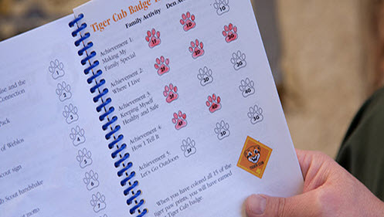
May 2015 -
The New Cub Scouting Materials and How to Use Them
If you’re a regular CubCast listener, as you should be, you know we’ve had quite a few episodes about getting ready for the new Cub Scouting program. In those shows, we mentioned the materials that were created for the new program and now we’ve invited Cub Scout online training task force member Nancy Farrell to have an in-depth discussion with us about those materials and how they’ll make your life as a Cub Scout leader so much easier.
Listen Hear -
http://www.scouting.org/filestore/scoutcast/cubcast/201505_1/CC_New_CSA_Materials_May.mp3

SCOUTCAST

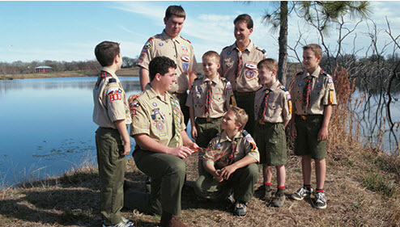

May 2015 -
How the New Cub Scouting Program Affects Your Troop

With the new Cub Scouting program, Webelos are going to be a whole lot better prepared than they used to be to join your troop. What do you, as a Scout leader, need to do to get ready? Join ScoutCast hosts Lee Shaw and Bryan on Scouting blogger Bryan Wendell as they discuss all the details with Dennis Kampa, author of the BALOO Training Guide and Cub Scout Adventures task force member. His answer may surprise you.

Listen Hear -
http://www.scouting.org/filestore/scoutcast/resources/201505_1/SC_May_How_New_CS_Adv_Effect_Your_Troop.mp3

It is possible that by the time you get Baloo's Bugle and click the link, there may be new Cubcast and/or Scoutcast posted. Do not worry, all previous Cubcasts and Scoutcasts are available from the home page.
Bryans Blog
May 2015
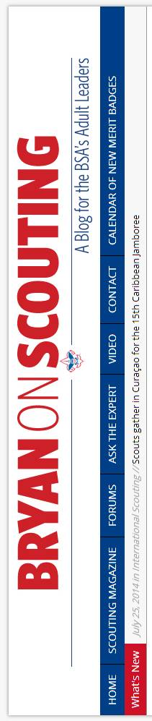
“Bryan on Scouting” is the official blog of Scouting magazine, a Boy Scouts of America publication. Scouting magazine is published five times a year and is received by 1 million registered adult volunteers.
Bryan covers many topics every month. He keeps his Blog current and deals with the latest issues.
His articles this past month are listed below (Every title has a hyperlink). The articles in BLUE are of special interest for Cub Scout Leaders.
National President Dr. Robert M. Gates addresses BSA National Annual Meeting
May 21, 2015 // 185 Comments

National President Dr. Robert M. Gates enbraveryd the Scouting family to reflect in the days and months ahead on the challenges facing the BSA.
Did Ferris Bueller’s dad earn the Silver Beaver award?
May 29, 2015 // 35 Comments

It's the question on everyone's mind since the film "Ferris Bueller's Day Off" debuted in 1986: Did Ferris Bueller's dad earn the Silver Beaver award?
Meet three of the creators of the new Animation merit badge
May 29, 2015 // 2 Comments
The talented team tasked with creating the new Animation merit badge includes experts in the fields of animation and digital media. Meet three of them here.
2017 National Jamboree registration now open for staff and attendees
May 28, 2015 // 42 Comments
2017 National Jamboree registration is now open. Get ready, because 2017 will be here before you can say "Live Scouting's Adventure."
Scoutbook creator Shawn Jackson sits down for a quick chat
May 27, 2015 // 59 Comments
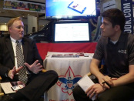
Scoutbook creator Shawn Jackson says having his game-changing web app acquired by the BSA is the best thing that could've happened to it.
Tuesday Talkback: How do you keep siblings entertained at Scout meetings?
May 26, 2015 // 29 Comments

Virginia Scouter Rob H. doesn't want the younger siblings of Scouts or Venturers sitting around feeling bored for an hour or two. What do you think?
Step by step: How to buy interactive digital merit badge pamphlets
May 23, 2015 // 17 Comments
Here's the simple, step-by-step guide to purchasing and downloading the BSA's new interactive digital merit badge pamphlets.
Rollout of interactive digital merit badge pamphlets begins
May 23, 2015 // 43 Comments
Starting now, Boy Scouts (and troop leaders and merit badge counselors) can download interactive digital merit badge pamphlets for four merit badges.
Meet your 2015 Silver Buffalo Award class
May 22, 2015 // 8 Comments

The 2015 Silver Buffalo class consists of 13 Scouting volunteers who have given tireless service and dedication to Scouting on a national level.
Video: What is the Order of the Arrow’s ArrowTour?
May 22, 2015 // 12 Comments

ArrowTour will bring all of the excitement surrounding the Order of the Arrow's 100th anniversary this year to council camps across the country.
Here are the outstanding young men who won 2015’s top NESA scholarships
May 22, 2015 // 4 Comments
Shane Uribe, Frank Nash and Trevor Case received the three top NESA scholarships for 2015. These are their stories.
Video: Scott Lagasse gives us a tour of his NASCAR truck
May 20, 2015 // 0 Comments
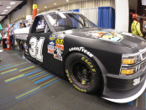
Scott Lagasse and Team SLR brought the actual truck Scotty raced in Kansas a couple weeks back. He gives us a quick tour in this video.
Video: Inside the Vortex, the STEM Scouts mobile lab
May 20, 2015 // 26 Comments
I got to check out the Vortex, the STEM Scouts mobile lab. It's a whole lot of awesomeness on four wheels.
Sea Scout Ship 1000 of Texas wins 2015 National Flagship award
May 20, 2015 // 4 Comments
Sea Scouts, BSA has named Ship 1000 — also known as the Enterprise — the recipient of its 2015 National Flagship award.
Thermacell lantern makes your campsite a no-fly zone for pests
May 19, 2015 // 38 Comments
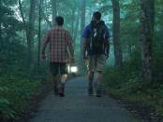
The $60 lantern packs plenty of light and creates a 15-foot force field against mosquitoes, black flies and no-see-ums.

Animation merit badge requirements released
May 19, 2015 // 24 Comments
The Animation merit badge requirements were released this week, officially making it the BSA's 136th current merit badge.
Eagle Scout to compete on NBC’s ‘American Ninja Warrior’ on May 25
May 18, 2015 // 11 Comments

Jackson Meyer, an Eagle Scout from Seaside, Ore., will compete in the May 25 episode of "American Ninja Warrior" on NBC.
Stuff You Should Know podcast tells listeners “How Pinewood Derbies Work”
May 18, 2015 // 1 Comment
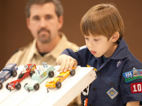
Cub Scout leaders, listen up! The most recent episode of the popular Stuff You Should Know podcast is all about the pinewood derby.
Ask the Expert: Are OA life memberships a thing?
May 18, 2015 // 17 Comments
When inducted into the OA (Scouting's honor society) you get a sense of brotherhood that stays with you for life. But can you be a life member of the OA?
On Armed Forces Day, 8 ways to salute those who served
May 15, 2015 // 10 Comments

Armed Forces Day — Saturday, May 16, 2015 — is a critical time for us to thank our military members for their patriotic service in support of our country.
Nat Geo wants you and your Scouts to step up to the plate to fight food waste
(This post was sponsored by National Geo)
May 15, 2015 // 21 Comments

This is about more than just finishing all that you scoop onto your plate at the dining hall. This is about stepping up to the plate to fight food waste.
2015 Guide to Safe Scouting now available — here’s what’s new
May 14, 2015 // 21 Comments
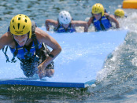
The 2015 Guide to Safe Scouting is now available, including updates to the Safety Afloat, COPE/Climbing and transportation sections.
BSA names Michael Surbaugh its 13th Chief Scout Executive
May 13, 2015 // 26 Comments

The BSA today named Michael Surbaugh its 13th Chief Scout Executive. He'll serve as the BSA’s top professional during an exciting time for Scouting.
Hot dog! Boys’ Life cover wins national recognition as Readers’ Choice
May 13, 2015 // 4 Comments

The "aww"-inspiring September 2014 Boys' Life cover that just won a Readers' Choice Award from the American Society of Magazine Editors.
Eagle Scout Davis Dawson recognized with Prudential Spirit of Community Award
May 13, 2015 // 4 Comments
Davis Dawson used his Eagle Scout Service Project as an opportunity to build a new home for a family in need — earning him national recognition as one of North Carolina's top volunteers.

Here’s your chance to help make Journey to Excellence (JTE) even better
May 12, 2015 // 51 Comments

Units want to improve their JTE scores annually. Similarly, the Journey to Excellence standards themselves are constantly tweaked. Here's how to help.
Understanding the difference between STEM in Scouting and STEM Scouts
May 11, 2015 // 57 Comments
Read about the difference between STEM activities in traditional Scout units and STEM Scouts, the new BSA program expanding to 12 more councils this fall.
STEM Scouts ready for prime time with NASCAR Truck Series debut
May 8, 2015 // 5 Comments
The STEM Scouts logo will feature prominently on Scott Lagasse Jr.'s No. 31 truck in tonight's Toyota Tundra 250 at Kansas Speedway in Kansas City, Kan.
Tell your Scouts about ROCS and TCT, two of Philmont’s best-kept secrets
May 8, 2015 // 0 Comments
Roving Outdoor Conservation School (ROCS) and Trail Crew Trek (TCT) have spaces open this summer at Philmont Scout Ranch. Tell your Scouts and Venturers.
A clarification on the wood being used in the OA Centennial Fire at NOAC
May 7, 2015 // 8 Comments
At the 2015 National Order of the Arrow Conference, a Centennial Fire will burn with wood from every OA lodge. But what type of wood will be used?
‘Neatness makes the difference!’ Check out this 1950s uniform inspection sheet
May 7, 2015 // 27 Comments
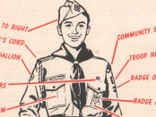
Perfect uniform? Check. Scouts in the 1950s had their uniforms checked using this uniform inspection sheet. A score of 100 out of 100 was the goal.
Water guns OK for target shooting, not for firing at other Scouts
May 6, 2015 // 500 Comments

Water guns are OK for Scouts to shoot at targets only. They shouldn't be aimed or fired at one another, according to BSA policies.
11 percent of the males in this high school graduating class are Eagle Scouts
May 5, 2015 // 10 Comments
Better than 1 out of every 10 young men in the graduating class of South Fayette High School in McDonald, Pa., are Eagle Scouts.
Eagle Scout organizes relief trip to area destroyed by Nepal earthquake
May 4, 2015 // 4 Comments

After surviving a deadly earthquake at Mount Everest's base camp, Matt Moniz is organizing relief efforts to a remote Nepal villages.
This troop’s excellent technology policy is based on the Scout Law
May 4, 2015 // 92 Comments
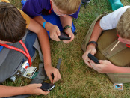
Our youngest Boy Scouts were 3 years old when the first iPhone came out. It might be time to rethink your troop's technology policy.

May 2015 ScoutCast, CubCast get you ready for the new Cub Scout program

May 1, 2015 // 16 Comments


We are exactly one month away from the launch of the new Cub Scout program. The May 2015 episodes of CubCast and ScoutCast will help you get ready.

Which merit badges would each of the Avengers be most qualified to counsel?

May 1, 2015 // 26 Comments


It turns out each of the Avengers — Captain America, Iron Man, Thor, Hawkeye and the rest — would be pretty great at counseling certain merit badges.

Blog Contributors
Bryan Wendell, an Eagle Scout, is senior editor of Scouting and Eagles' Call magazines.

Gretchen Sparling is associate editor of Scoutingand Eagles' Call magazines.
Get Email Updates
To sign up to receive Bryan’s Blog in your E-mail –
Click the link that appears in every article. Bryan and Gretchen promise never to sell or otherwise exploit your email address. Join 6,162 other subscribers

TRAINING TOPIC

CAMPFIRES
National has some great material on0line this month for CAMPFIRES. Just go to www.scouting.org/programupdates and look for the material for the June Roundtables. Materials in clude:
- A great power point
- A leader's guide for the Power Point
- A copy of the Campfire Planner
Be sure to check it out –
Commissioner Dave's Campfire Hints

Advice from a Campfire
- Bring people together
- Spark new ideas
- Kindle strong friendships
- Radiate warmth
- No smoking
- Be a good storyteller
- Don’t go to bed fired up!
For more Advise from Nature go to –
https://www.yourtruenature.com/
Commissioner Dave has the Tee Shirt!! And Jodi the hat!!
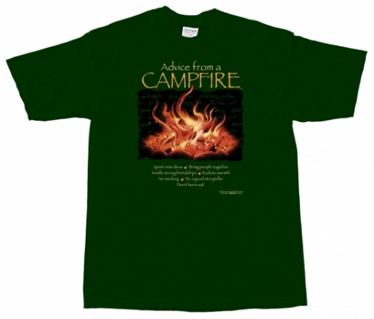
Besides Campfire Advise they have tree, apple, barn, bat, bear, bison, bluebeery, and titles for 14 other letters. They have over 40 "Advise from" categories.

- A Time for Memories at the end of the day. A campfire is a great way to finish a great day of Cub Scouting outdoors! And you don't even need a fire and it doesn’t have to be dark! Any gathering of Cubs, leaders, family members, and/or others gathered for some fun and fellowship can be a Campfire..
- It is about the Scouts. A campfire should be about the Scouts not Adults. Why not have a Webelos or Cub Emcee. Sure he may need some coaching and other help but why not?? The key is in planning properly to fit it all together. The Scout Campfire Planning sheet makes that easier. Just think of the OPPRTUNITIES -
- Share fellowship as you all gather around!
- Scouts can practice public speaking skills!
- Scouts can showcase or learn performance skills!
- Scouts can show their creativity!
- ALL present can participate!
(Notice the word “Scouts”, not “adults”)
Want to know one reason why Scouts do Skits and stuff? Why it is part of the program?? Think about the following quote from Jerry Seinfeld –
“According to most studies, people's number one fear is public speaking. Number two is death. Death is number two. Does that sound right? This means to the average person, if you go to a funeral, you're better off in the casket than doing the eulogy.”
― Jerry Seinfeld
Hopefully, by having the Scouts do the skits and lead songs, and other stuff, they will not be afraid to stand in front of a group and talk to them. They will not be afraid to lead.
- A campfire has many elements –
  - Fun – singing songs, performing skits, hearing stories – all great fun!
  - Action – Action songs – hand clapping, exciting stories and group participation stunts all bring the action in to your program!
  - Entertainment – let’s have a great show!
  - Training – as leaders, we can include training features – such as “How to Behave at a Campfire”, without making it seem like school, and by making it part of the fun!
  - Adventure – nothing like an exciting group participation stunt, or a great story to get everyone on the edge of their seats!
  - Fellowship – Gathering everyone together in a shared experience contributes to the success of your pack – and it’s a lot of fun as well!
  - Inspiration – be sure to have a good “Cubmaster’s Minute” to wrap it all up before you send them on their way!
- The Four S's of Campfire Success – (These are a staple of almost every BSA training course that discusses Campfires)
  - Songs – all kinds of songs! And lead them with enthusiasm. Wave your arms. Have action. Start with a familiar song to get everyone involved. Maybe teach one later in the campfire. Close with a serious song as the fire fades away.
  - Stunts – audience participation, hand clapping, flashlight stunt. Cheers for every skit and act in the campfire!! Run Ons between the acts.
  - Stories – don’t skip this part – it gets easier every time you do it! Be careful of Ghost Stories – or be ready to have a bunch of Scouts waking you up at 3 AM and telling you they are afraid.
  - Showmanship – an exciting fire lighting to get things started and everyone in the mood. Then Follow the Flames. Cubs have limited attention spans. Keep their 45 to 60 minutes in duration. Build your fire so that you will not have to add any more wood. Have a theme, put the Emcee in costume.
- Follow the Flames - Start familiar and slowly. Build tempo quickly as the fire builds. Build to a peak as the fire goes higher. Begin to taper off as the fires begins to fade away. Close with a serious song and Leader's Minute as the fire is almost out. When the flames are high, the fire is bright – do you high energy, action parts loud, noisy, songs with actions – great Then as the fire burns down, the mood should come down – quieter songs, more reflective, maybe a story to quiet the group down… When you’re down to the coals, it’s time for a quiet story, a final slow song, and a Cubmaster Minute PLANNING is the Key!
- Use THE CAMPFIRE PROGRAM PLANNER – (You can get a plain one at http://www.scouting.org/filestore/pdf/33696.pdf or a Fillable PDF Form at http://www.scouting.org/filestore/program_update/pdf/2015_06_Topic_Worksheet.pdf ) You place all the acts, cheers, stunts, songs, everythin on side 1. Then on side 2 you put everything in the desired order remembering to Follow the Flames.
- No Surprises / Positive Values – The Adult responsible for the Campfire must know everything that is planned to happen at the Campfire. And I mean EVERTHING - “spontaneous” run-ons, cheers, everything, etc The Adult Leader shall have reviewed and approved them all. And if a group starts to do something different, they shall be stopped and removed from the stage. If their skit or a spontaneous gag becomes grey – stop them and get them off stage. There are polite ways to do this (Ask in your area for what others do. We like doing a "Tree Count.") The standards of the B.S.A must be maintained!
In the B.A.L.O.O. Training syllabus, Appendix C, Positive Values, there is a great discussion of "Guidelines for Scouting Appropriate Activities" and how to reinforce the values of Scouting. When teaching about this (Grey Areas, as they used to be called) try to use positive examples (Do this …) not bad examples (Don’t do this …).
Campfire activities shall NOT include:
  - Embarrassing an audience member
  - Racial or cultural putdowns
  - Violent behavior
  - Bathroom humor
  - Water skits (Where someone gets wet as part of the gag)
  - Sexual overtones
  - Material that is not consistent with BSA Standards
If you are still unsure, ask yourself the following - Would you do this skit if your saintly grandmother was in the front row?
- A Few Last Pointers:
  - Tell them – let the Leaders know in advance if possible, what is expected at the campfire. You can discuss this when you review their skit. Or maybe at a Leaders' Meeting the day of the campfire.
  - The Opening sets the expectations – set everyone's expectation for a great campfire with an impressive fire lighting and a well-planned opening ceremony
  - Use the Sign – if things get out of hand, bring the group back with the Cub Scout sign – make sure your Master of Ceremonies is aware of this as well! Just put up the sign, and wait – it’ll happen! Saying "Signs UP" defeats the purpose of the sign. You have just become another adult yelling for quiet. I have stood for long periods of time waiting (often with other adults yelling signs up – that just delays the process). Eventually the Cubs understand that nothing will happen while I have the sign up until they are quiet. Sometimes it takes the parents longer to understand than the Cubs. And every time after the first, they get quiet more quickly.
Keep Control, the best campfires run smoothly along from one thing to the next, with minimal interruptions, and everyone has a great time!
  - Well-Planned, well-paced – Prepare a list of approved skits from which they can choose. It will make the process go smoothly with leaders who have never done this before or those who did not get it all together before they left home. And make you the campfire guru able to help everyone out. I have a "canned" list of 25 skits. I can teach any one of them to a den in 4 minutes or less. I, also, carry a list of 25 cheers, 10 songs, and 5 audience participations so I never have to repeat an activity during a campfire. I then supplement this list with theme related activities if the campfire has a specific theme (e.g. knights of the White Horse)
Tell all your groups when they will be on stage. Perhaps give them a copy of the Planner. An "on deck" system works well, getting the next group ready to run on as soon as they are called avoiding a 10 minute gap of people moving about. Be ready to explain to the last groups why – I usually pick the more serious skits for last. People will remember the first skit, their son's skit, and the last skit. Send them off on a very positive note. Following your prepared Campfire Program Planner, there won’t be any time for shenanigans, it‘ll all flow together!
  - Stop if not approved – if a group starts in with something that is not on your approved plan, just stand up, use the sign to restore order, thank them, and move on to the next group/event.
  - Keep Control – the best campfires run smoothly along from one thing to the next, with minimal interruptions, and everyone has a great time!

CAMPFIRES & CUB ADVENTURES
- Tiger -
Tigers in the Wild (Core Adventure)

Requirement 5, Participate in an outdoor pack meeting or pack campout campfire. Sing a song and act out a skit with your Tiger den as part of the program.
- Wolf
Call of the Wild (Core Adventure) -
Requirement 6, On the campout, participate with your family or den in a campfire show. Prepare a skit or song, and then present it at the campfire for everyone else

Howling at the Moon (Core Adventure)
Requirement 3, Work together with your den to plan, prepare, and rehearse a campfire program to present to your families at a den meeting.
Requirement 4, Practice and perform your role for a pack campfire program.
- Bear
Bear Necessities (Core Adventure)
Requirement 2, Attend a campfire show, and participate by performing a song or skit with your den.
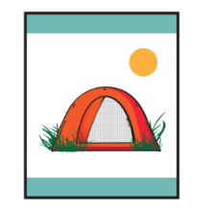
Roaring Laughter (Elective Adventure)
Requirement 6, Practice at least two run-ons with your den, and perform them at a pack meeting or campfire program.
- Arrow of Light
Camper (Core Adventure)

Requirement 4, On a pack campout, work with your den leader or another adult to plan a campfire program with the other dens. Your campfire program should include an impressive opening, songs, skits, a Cubmaster’s minute, and an inspirational closing ceremony

PLANNING CAMPFIRES
There are lots of great books out there for planning campfire. Just check out the books for sale from vendors that support www.usscouts.org or Google the topic.
My favorites are:
- Creative Campfires, By Douglas R Bowen
It has all the bases covered with many songs, skits, stories, yells, run-ons, cheers and more
- The Canyon Campfire Companion (Volumes 1 & 2) .

PLANNING A PACK CAMPFIRE
Catalina Council
If the fire regulations at your outdoor activity prohibits live fire, or if you’re holding your meeting at an indoor location, use an artificial campfire. See the directions later in this section.
- This would be a good time to have the parents form groups and put on presentations at the campfire.
- After the main campfire program, the cooling embers will be an enticement for special food treats – see the recipes for s’mores in the Cub Scout Program Helps for this month’s theme.
- Print a copy of the BSA’s Campfire Planner to plan your campfire program. The Campfire Planner is available on line from many, many sites. Here is one link: http://macscouter.com/Campfire/Planning.asp
The form has two sides. On one side you list all the skits, songs, cheers, stories, gags and other stuff you plan to do. On the other side you put them in the order you plan to do them. Start fast, build up the pace and enthusiasm as the fire builds, then slow things down as the fire wanes.

Artificial Campfires
Don’t let bad weather or lack of a location keep you from having a pack campfire. A little imagination can bring the atmosphere of a real campfire indoors. Here are some methods you can use to create an artificial campfire.
- Place a candle in a large glass bowl lined with red foil. Make a rock ring around the bowl.
- Place a candle in a large can with holes punched in the sides.
- The two below are a little more elaborate, but well worth the effort

Outdoor Ceremonies
Catalina Council
Ceremonies are important, even in the outdoors. Outdoor pack activities usually call for an opening and closing ceremony (or closing campfire). Any outdoor pack activity which takes the place of a regular pack meeting should also include advancement ceremonies so awards can be presented promptly.
Remember these things when planning outdoor ceremonies:
- Weather – it is difficult to keep candles lit in winds or light rain. Have a backup plan with some type of protection.
- Acoustics – the wind sometimes carries voices in the wrong direction. Make sure the speaker can be heard.
- Natural surroundings – make the most of surroundings to furnish background. Lakefront or open areas in the woods make good ceremony sites.
- Length – make ceremonies short, especially if the audience is standing.
- Flag – be certain the U.S. flag is secure. A normal flag holder will not be adequate in winds. Insist on respect for the flag, indoors or outdoors.
- If you’re having a real fire, make sure you have complied with local fire ordinances and have provided a safety area so people are not too close to the fire. ♦ Do not use the fire as a backdrop for speakers, skits, etc, for it is very hard for the audience to see sometimes. Stand slightly to one side for best effects. (Good idea is to have portable lights shining low on speakers)

Campfires: “Outing in Scouting”
Cub Scout Program Helps 2008-2009, 2 JUN 09
Creating a memorable campfire takes planning. Here are a few hints to ensure that your campfire is a pleasant experience for all:
- Approve all elements of the campfire that the dens will do (skits, songs, stunts, run-ons, applauses, and cheers) to make sure they follow the positive values of Scouting.
- Follow the flames: Start the campfire with an exciting song/skit that gets everyone involved. As the fire diminishes, the activities become calmer.
- Use the Campfire Planner that is in the Cub Scout Leader Book appendix. Vary active and quieter contributions to ensure a fast-moving campfire.

SPECIAL OPPORTUNITIES
With the start of the Cub Scout Adventure Program, the requirements for awards that say things like, "Complete Wolf Achievement 7," need to be revised to send you to the new Adventures. We will be highlighting these changes here over the next few months.
To get acomplete list now, you can go to http://www.scouting.org/scoutsource/programupdates.aspx and download the .PDF of all the changes. Or you could go to www.usscouts.org and get the changes for a specific award.

Cub Scout World Conservation Award

From http://usscouts.org/advancementTOC.asp and www.scouting.org/programupdates
The World Conservation Award is worn on the
uniform shirt, centered on the right pocket
as a TEMPORARY patch.
Only ONE Temporary patch may be worn
at a time.
Cub Scout World Conservation Award
The World Conservation Award provides an opportunity for individual Wolf Scouts, Bear Scouts, Webelos Scouts, Boy Scouts, Varsity Scouts, and Venturers to "think globally" and "act locally" to preserve and improve our environment. This program is designed to make youth members aware that all nations are closely related through natural resources, and that we and our world environment are interdependent.
Requirements
Wolf Scouts
You may earn the World Conservation Award by doing the following:
- Earn the Paws on the Path adventure.
- Earn the Grow Something adventure.
- Complete requirements 1 and 2 from the Spirit of the Water adventure.
- Participate in a den or pack conservation project in addition to the above.

Bear Scouts
You may earn the World Conservation Award by doing the following:
- Earn the Fur, Feathers, and Ferns adventure.
- Earn either the Bear Goes Fishing or Critter Care adventure.
- Complete requirement 3 from the Baloo the Builder adventure by constructing a bird feeder or a bird house as one of the options.
- Participate in a den or pack conservation project in addition to the above.
Webelos and Arrow of Light Scouts
You may earn the World Conservation Award by doing the following:
- Earn the Building a Better World adventure.
- Earn the Into the Wild adventure.
- Earn the Into the Woods adventure.
- Earn the Earth Rocks adventure.
- Complete requirements 1, 3a, and 3b in the Adventures in Science adventure.
- Participate in a den or pack conservation project in addition to the above.
Need more info?
For additional information and the latest on the changes to these Special Opportunities for Cub Scouts, head to:
The Advancement pages on USScouts (http://usscouts.org/advancementTOC.asp ). Paul has already posted all the new requirements.
Or
On National's Site got to www.scouting.org/programupdates and look for the link to "Updated Requirements for Cub Scout Awards."

National Den Award
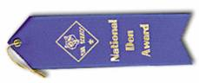
From the revised Cub Scout Leader Book, page 43,
and www.scouting.org/programupdates
The National Den Award recognizes dens that conduct a quality, year-round program. It can be earned only once in any 12 months. The 12-month period (charter year, calendar year, etc.) is determined by the pack committee.
Service projects, field trips, character development, and Cub Scout camping are areas that are emphasized. Dens earn the award as a team, not as individual den members.
The recognition is a ribbon for the den flag or den doodle.
Requirements
- Have at least 50 percent of the den’s Tigers, Cub Scouts, or Webelos Scouts attend two den meetings and one pack meeting or activity each month of the year.
- Complete six of the following during the year:
- Use the denner system within the den.
- In a Tiger den, use shared leadership and rotate the boy/adult host team.
- Have 50 percent of the den go on three field trips per year. A field trip may be used in place of a den meeting.
- As a den, attend a Cub Scout day camp, Cub Scout or Webelos Scout resident camp, or a council family camping event with at least 50 percent of the den membership.
- Conduct three den projects or activities leading to a discussion of the Scout Law.
- Have 50 percent of the den earn at least three elective adventure loops or adventure pins.
- Have 50 percent of the den participate in a patriotic ceremony or parade.
- Have 50 percent of the den participate in a den conservation/resource project.
- Have 50 percent of the den participate in at least one den service project.

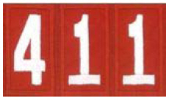

PROGRAM UPDATES

Be sure to check out National's website
for the latest on the
Adventure Program Changes -http://www.scouting.org/programupdates.aspx
What Has Happened / Is Happening -
Cubcast – see description of Cubcast and Scoutcast (Scoutcast is also dedicated to the Cub changes this month) articles and links in this edition of Baloo
The Boys' Books and the Den Leaders' Books are in the stores. I got mine a week early. Get them and read them. Electronic copies coming very soon!!!
Position-Specific In-Person Training Guides Available Now! The training guides for Den Leader , Cubmaster/Assistant Cubmaster , and Pack Committee (Pack Committee Challenge) are now available on the adult training page of scouting.org.
The online training for den leaders, Cubmasters, committee chairs and members, and chartered organization representatives has been totally updated with help from volunteers from around the country. The new training will be divided into shorter, more targeted modules so leaders can get the training they need, in the order they want, any time they need it. The new training is organized around the learning needed prior to the first meeting, in the first 30 days, and to be position-specific trained. This new training was developed to be implemented in conjunction with the BSA’s new learning management system. The anticipated timing for launching this new tool is June 30, 2015. Keep an eye on MyScouting Tools (logging in through MyScouting.org ) for more information.
Philmont Training Sessions Are Filling, but There Is Still Time to Register Cub Scout leaders have a chance to visit Scouting paradise and learn more about "Leading the New Cub Scout Adventure." Four sessions are offered by the volunteers who designed the program and authored the new handbook and leader training materials. Visit the Philmont Training Center site to learn more about the conference and registration dates.
New Pack Meeting Plans Available Now! Pack meeting plans for the 2015-2016 and 2016-2017 Cub Scouting years are now available! From the Cubmaster’s Minute to resource lists, you’ll find everything you need to lead fun and engaging pack meetings! And they support the new Cub Scouting program, too! Check out the list and links from this issue of Baloo.
Updated Requirements for Cub Scout Awards The requirements for the
- National Den Award,
- National Summertime Pack Award,
- Cub Scout World Conservation Award,
- Cub Scout Outdoor Activity Award
have been revised to reflect the new Cub Scouts program launching June 1, 2015. See Special opportunities section of Baloo.
Supplemental Roundtable Content
To help prepare unit leaders for the new Cub Scouting program launching June 1, supplemental roundtable content has been developed to replace or supplement the current sessions listed as "Cub Scout Interest Topics" for January–July 2015.
Available installments are posted below.
Most packets have presentation materials (e.g. slidshow), Topic Guide, and worksheet or Handout. and
Already on Program Updates page -
- January – Program Support for Den Leaders
- February – Advancement
- March – Program Planning
- April – New Pack Meeting Plans
- May – Aquatic Adventures
Additional content to be posted the last week of month before the RT month as follows:
- June – Campfire Programs
- July – Resources for Packs and Den Leaders
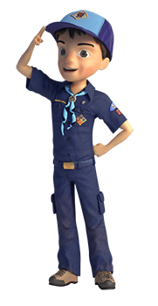


TRACKING SPREADSHEETS FOR THE CUB SSCOUT ADVENTURE PLAN
- Tracking Spreadsheets will be posted on USScouts webpage (www.usscouts.org) on June 1, 2015. They will be in the Advancement Section. There will be links to them from other places on the site. These spreadsheets are similar in construction and user interface as the existing spreadsheets. The spreadsheets have be tested by the developer of the current spreadsheets and he said they are so good he sees no reason to develop others!!
- Utah national Parks Council has Excel spreadsheets posted for all the new Adventure Plan requirements on their Akelas Council Blogspot. www.Akelascouncil.blogspot.com . Check them out.
The Advancement Excel Spreadsheet workbooks are distributed to Scouters for FREE.
PLEASE do not download the National Park Council files to email or send them digitally to others. They are for your personal / pack use only. If you would like to share these files with others, please copy / send the link to them and send them to our site so they can print off their own. We would love to have everyone that would like a copy to come here to get their own copy absolutely free. Utah National Parks Council receives money to keep our website open where we store all of our documents and PDF files by people visiting our blog. Please don't take money out of our pockets by bypassing our blog.

Brave Ideas

Bravery Word Search
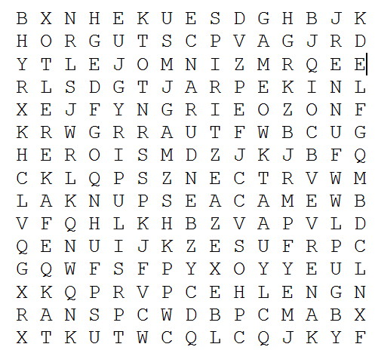
Find these synonyms for BRAVERY in the word search:
BACKBONE GUTS BOLD
HEROISM BRAVE NERVE
DARING POWER ENDURANCE
SPIRIT FACE DANGER SPUNK
GAME VALOR
POEM: IT GIVES MY SOUL BRAVERY
it gives my soul bravery
to know
the impossible
is achievable
and i need
neither to be the strongest
nor the wisest
i need
only to be the best i can be
By lungelo mbatha

Bobcat Induction - Inducting The New Family
Heart of America Council
Equipment: Wolf, Bear, Webelos and Boy Scout Handbooks; Bible, two blue, two yellow and one white candle; Bobcat badges and membership certificates.
Cubmaster: Friends, we welcome you to our ceremony for new Cub Scout families. Before you burn five candles, two are blue, two are gold, and the center one is white. In front of the colored candles are the letters "C", "U", "B", "S". These four letters spell "Cubs," but each letter by itself stands for something special.
Use off stage Den Chiefs, Den Leaders or Committeemen for voices.
Voice 1 The "C" stands for Courtesy. A Cub Scout is courteous. He is courteous to old folks, his friends, his teachers, and especially his parents. He is courteous in all that he says and does.
Voice 2 The "U" stands for unity. When a boy joins a Pack, his parents join too. He does not work alone but with other boys. He learns to get along with others.
Voice 3 The "B" stands for Bravery. The Cub Scout is braveryous enough to stand up for the things that he thinks are right - honesty, equality, fair-play, thereby making the world a better place in which to live.
Voice 4 The "S" stands far Service. A boy not only does service to himself while he is a Cub Scout but he at so serves others. He strives to help spread good will in every way he can.
Cubmaster: Cub Scouts, you see before you four books: the Wolf book, the Bear book, the Webelos book, and the Boy Scout handbook. They stand for the steps that a boy climbs as he goes higher and higher in Cub Scouting and finally reaches the very top as a Boy Scout. Also, before you lies a Bible open to these words: "Remember now, thy Creator, in the days of thy youth" –Ecclesiastes 12:1. That means that each boy should remember God, his Maker, in all that he says, does and thinks. The great white candle in the center stands for God, just as God should stand in the center of our lives.
You have come here tonight seeking admission to the friendship and fun of Cub Scouting. You have attended a meeting of the Den you expect to join. You have learned, along with your parents who are here with you, those things necessary to become a Bobcat.

Then present badges with usual rituals of your Pack

Footprints on the Moon opening ceremony

As curtain opens a den of Cub Scouts dressed as astronauts are lined up across the stage. There are large astronaut footprints cut out of black paper and taped on to stage floor. These footprints lead from off stage to center of stage where there is a flag stand. A Cub Scout astronaut enters from side of stage following line of footprints and puts the flag in the stand and narrator at microphone at side of stage reads following:
The United States has much to be proud of. One of those many things is the fact that the United States was first on the moon where Old Glory was placed as evidence of this eventful day. This, indeed, is something for all of us to be proud of, and as we all join together in the Pledge of Allegiance to our flag, let us be thankful for the braveryous astronauts of our country who helped make it possible for our flag to be erected on the moon, so that some day some of our own Cub Scouts may be able to leave their mark on society by leaving their footprint on the moon, too! Please rise now and join me in the Pledge of Allegiance.
Advancement Ceremony
Setup: Enough chairs to
seat the boys receiving
awards are arranged in a semicircle around either
side of a central table.
CUBMASTER: Lords and ladies, noble members of
the pack, we bid you welcome to the Court of Pack
[number] . We come this day to recognize those
knights who, by their diligent effort, cheerful spirit,
knowledge, and willingness to do their best, have
earned a seat at the Roundtable. They have proved
themselves to be worthy of this honor. Knights of
the Order of the Bobcat, come forward. Sir [boy’s
first name] of [boy’s last name].(Each boy comes
forward with his parents as his name is called, and
his rank is presented.)
CUBMASTER (after all boys have received their
rank): Will you uphold the honor of the Order of
the Bobcat?
CUB SCOUTS: I will.
CUBMASTER: Then take your place at the
Roundtable. (Parents return
to their seats, and each
boy takes a chair in the ci
rcle.) (Repeat
with each
rank until all boys earning recognition have been
seated in the circle.)
CUBMASTER: Knights of the Roundtable of old
were men of great bravery, honesty, humility,
loyalty, and strength.
These young knights today
have, by their hard work, shown that the spirit of
the Roundtable lives still. Lords and ladies, Cub
Scouts, and honored knights of the Roundtable,
please rise and repeat with me the Cub Scout
Promise.
Medieval Tournaments are a great idea for Pack
meetings!

Fitness Game
Cub Scout Roundtable Helps 2015
The Webelos den leads the gathering activity by leading a fitness game or games.

Superhero Cape Gathering
Cub Scout Roundtable Helps 2015

Have each Cub Scout and his family make a superhero cape with an emblem to represent the Scout’s superpower. They will get one rectangle of plastic and some permanent markers to make the capes.
Make sure to cover the table with newspaper, butcher paper, bulletin board paper, or some sort of covering to protect the table from the pens. Have the Scouts try on the capes before drawing to see where to place the emblem. They will then spread the cape out on a table to draw the emblem. Once they have finished their capes, have the Scouts discuss with each other their superpowers and how the emblem represents this power.

Brave Opening Ceremony
Cub Scout Roundtable Helps 2015

The preassigned den presents the flags and leads the pack in the Pledge of Allegiance.
Scout Law Opening Ceremony
Use 12 Scouts or provide two signs per Scout.
Cub Scout 1: (Holding up a sign printed with “Trustworthy”) “Trustworthy—You can count on me!”
Cub Scout 2: (Holding up a sign printed with “Loyal”) “Loyal—I will stick by you.”
Cub Scout 3: (Holding up a sign printed with “Helpful”) “Helpful—I will volunteer to help you without
expecting a reward.”
Cub Scout 4: (Holding up a sign printed with “Friendly”) “Friendly—I offer friendship to everyone, no
matter how different they are.”
Cub Scout 5: (Holding up a sign printed with “Courteous”) “Courteous—I am polite and use
good manners.”
Cub Scout 6: (Holding up a sign printed with “Kind”) “Kind—I treat others as I want to be treated.”
Cub Scout 7: (Holding up a sign printed with “Obedient”) “Obedient—I obey rules and laws.”
Cub Scout 8: (Holding up a sign printed with “Cheerful”) “Cheerful—I look for the bright side of life.”
Cub Scout 9: (Holding up a sign printed with “Thrifty”) “Thrifty—I use time and resources carefully.”
Cub Scout 10: (Holding up a sign printed with “Brave”) “Brave—I stand up for what is right even if
others don’t.”
Cub Scout 11: (Holding up a sign printed with “Clean”) “Clean—I keep my home and community clean.”
Cub Scout 12: (Holding up a sign printed with “Reverent”) “Reverent—I respect my own beliefs and the
beliefs of others.”
All: “I am a Super Cub!”
Cubmaster: “All of our Cub Scouts are Super Cubs! Their superpower is the Scout Oath and Law. Let’s
recite the Scout Oath and Law together as a reminder of how super our Scouts are.

Opening Prayer
Cub Scout Roundtable Helps 2015

“Help us realize the power we each have inside of us to make the world a better place by remembering
to do our best each and every day.”

Recognition Ceremony
Cub Scout Roundtable Helps 2015

Adventure Loops and Pins:
(Note: Adventure loops and pins can be presented at a meeting or as immediate recognition in the den.)
By den, call the names of those Cub Scouts who have completed the month’s adventure to
come forward.
• Have the den leader pass out the awards to the boys as they receive a Cub Scout handshake from
the Cubmaster.
• If time allows, invite the den leader or den chief of the den to speak about the adventure work done
for that month and have the den stand and be recognized.
• Use a positive cheer to recognize their accomplishments.
Other options:
• Have the den stand and be recognized or come forward to receive certificates for the adventure they
have completed. This option would be appropriate for a den that has already received the adventure
loop or pin.
• Adapt the advancement ceremony for the month’s theme into an adventure loop presentation if no
rank badges are being presented.

Rank advancement Ceremony
Cub Scout Roundtable Helps 2015

Cubmaster: “Tonight we recognize all those brave Scouts who have used their superpowers to achieve
their rank this month.
Bobcat: “Will the following Scouts who have earned the Bobcat badge please come up with their
parents or guardians? (The Cubmaster calls the name of each Scout to receive the Bobcat badge.)
These Scouts have learned their first Cub Scout power—the basics of Cub Scouting—to help them on
their next adventure.”
Tiger: “Will the following Scouts who have earned the Tiger rank this month please come up with their
parents or guardians? (The Cubmaster calls the name of each Scout to receive the Tiger badge.) These
Scouts have used their powers to earn their rank, and now are ready to continue their adventures in Cub
Scouting.”
Continue similarly for Scouts who have earned the ranks of Wolf, Bear, Webelos, and Arrow of Light.

Hero Cubmaster’s Minute
Cub Scout Roundtable Helps 2015

“A hero is a person who is admired for his character, his achievements, and his example to others. Let
us honor all the real heroes in our world today and our own Super Cub heroes, who are growing into the
heroes of our future.”

Superhero Skit
Scene: A group of boys stand together, talking and wearing T-shirts instead of uniform shirts.
Boy 1: “I hear a superhero is coming!”
Boy 2: “Have you seen him?”
Boy 3: “No, I wonder who it is?”
Boy 4: “I hear he helps people. Maybe it’s Superman. I hope there isn’t any kryptonite around here.”
Boy 5: “I hear he is trustworthy, maybe it’s Thor and he’ll shoot lightning!”
Boy 6: “I hear he is patriotic, so it might be Captain America!”
4 Cub Scout
Boy 7: “I hear he is brave and wears a special uniform. Maybe it’s Ironman!”
Boy 8: “I hear he is kind. Maybe it’s Batman.”
All: (As den chief or other Scout in uniform enters) “Here he comes!” (Den chief or Scout walks
across stage, flexing his muscles and grinning. All Scouts cheer him on.)

Cub Scout Superpowers
Cub Scout Roundtable Helps 2015

Trustworthy Always answers the call
Loyal Defends the earth from evil forces
Helpful Rushes to the rescue
Friendly Turns evildoers good
Courteous Protects old and young alike
Kind Balances his strength with being gentle
Obedient Enforces right over wrong
Cheerful Laughs in the face of danger
Thrifty Saves time by moving faster than an arrow
Brave Overcomes fear when threatened
Clean Repels evil influences over mind and body
Reverent Has the power to believe

Brave Activities for Packs & Dens
Alice, Golden Empire Council
Keep an eye out for little acts of bravery – give boys a little party favor “medal” for sharing examples of bravery.

Ask boys and parents to help collect stories of bravery – Print them out so everyone can have stories to share in their families or dens.

Brainstorm with your den about what bravery is – does a person have to be a hero to show bravery? Enbravery boys to think about real people, not just super heroes. Have the boys make special thank you cards for the people they choose as braveryous.

Work on the scouting requirements that prepare scouts to be a hero –first aid training, plumbing, fix it, carpentry skills – boys or families can be a “hero” by helping an elderly neighbor or relative who can’t afford regular maintenance – and in the future, as men with these skills, today’s scouts will be a hero to their own families.

Learn more about how bravery was shown by the knights of old – Study the Knight’s Code and Rules of Chivalry and compare them to the Cub Scout motto and Law of the Pack & Scout Law.

Visit a local Renaissance Faire or Knights of the Roundtable Restaurant – Most states now have at least one event based on the Middle Ages and Knights of Yore – Just Google it! Of course, you can also just host your own event at the Pack Meeting!

Have each boy create his own shield – Boys can choose their own color, shape and symbols, or you can share the meaning of colors, decorations and symbols used on real shields used by knights; check out the traditional examples:

Shield or Heraldic Shapes



The shapes above are traditional shapes used by a knight, with some examples showing how they might use color and designs as well. The shapes are:
“Heater” style used by both French and English knights; Modern French style; Oval; Lozenge (sometimes used by a heiress to a family crest); Square; Italian; Swiss; Tudor Arch; German or English; Polish; Traditional Iberian

Traditional Colors
Yellow or gold - Generosity and elevation of the mind
White or silver Peach & Sincerity
Blue - Loyalty & Truth Loyalty and truth
Red - Military fortitude; Bravery
Black Dependable; Mourning a fallen comrade Constancy or grief
Green - Hope & Joy
Purple - Royal majesty, justice
Orange - Worthy ambition
Maroon - Patient in battle; victorious
Traditional Symbols
Cross or Chevron - Protection
Crescent – Honored by the king
Lion or panther – Great bravery
Tiger - Great fierceness and valor
Bear - Ferocity in the protection of family
Wolf – Valiant leader
Leopard - Valiant and hardy warrior
Horse - Readiness for all employments for king and country.
Lamb - Gentleness and patience under suffering
Ram - Authority
Dog - Bravery, vigilance, loyalty, and fidelity
Camel - Patience and perseverance
Tortoise - Invulnerability to attack
Heart - Charity, sincerity
Pen - Emblematic of the liberal art of writing and of
learned employments.
Eagle or Double Eagle -Signifies a man of action,
ever more occupied in high and weighty affairs, and one of lofty spirit, ingenious, speedy in apprehension and judicious in matters of ambiquity.

Play one of the Bravery Games in this Baloo – and discuss the outcome!

Set up an obstacle course based on the adventures of Lewis & Clark – Check out ideas on the website as shown in Theme Related. Let the boys use tables, chairs, safety cones, hula hoops, pool noodles, boxes – whatever is available – to include some of the obstacles the Corp of Discovery faced. If you do it outside, add in some water obstacles – after all, much of the Lewis & Clark journey was on or in the water!

Visit a museum and look for examples of Bravery – people who have done something heroic or started a service project, saved a building from demolition, worked with youth in the community, overcome challenges

Suggest that families talk about examples of bravery in their family history – share stories about how ancestors were everyday heroes.

Learn or review the steps for Hug A Tree and Survive – then you can be prepared to act with bravery if you ever do become lost.

Choose some everyday heroes that the boys know – such as teachers, police or fire department members, the cubmaster – invite them to come to the pack meeting and give each of them a simple award – perhaps a certificate or even a picture the boys have made to present to them.

Choose a service project to honor military people who have shown bravery – one idea is Operation Military Kids, which provides hero packs to children who are sacrificing time with their deployed parents; another it Call to Action, directed by Tom Whittaker.

In honor of Lewis & Clark, earn the Map & Compass Belt Loop – Learn more about the expedition of the Corp of Discovery.

Have each scout or family make a list of some examples of bravery – make a list of categories and have each person or team fill in a real name that fits the category. Some ideas are: volunteer firefighters, musicians or artists, parents that volunteer at school, people that bake for a benefit sale, people that help the elderly, people that plan celebrations that everyone can enjoy, first responders, people who teach Sunday School, Scout leaders, kids who help younger kids learn something new (like Venturing Scouts or the Den Chief), people who help their neighbors, people who coach sports for kids.

Visit with older people, especially family members, and learn about them, their work, their service, how they spent their time – identify ways that they showed bravery, overcame challenges, helped others get educated, or made a difference in their communities

If you haven’t worked on Hug A Tree and Survive, check out these excellent ideas for what to do if lost – Details at: www.nasar.org Also check out the Hug A Tree game ideas under GAMES.

Obtain or print out a map of the local community – (Thomas Bros. maps also show schools, fire stations, community centers) –talk about the places where help is available and where bravery is needed.

Invite a CERT (Community Emergency Response Team) member to come and share information with your den or pack families.

Explore different kinds of people who display bravery – include Strategic Air Command, DART, Civil Air Patrol, CERT (Community Emergency Response Team), National Guard, Firemen and Policemen, Regular Military, Teachers, Doctors.

Check out the book The Children’s Book of Heroes by William Bennett and read a story about bravery -– you might even use a story as the plot of a skit for the pack meeting!

Go to a Renaissance Faire
Commissioner Dave
Renaissance Faires are where many people come in costume and spend the day reliving the time of chivalry and knights. My family and I regularly attend the Pennsylvania Renaissance Faire (See website below). We see Shakespearean plays snippets, eat turkey legs, participate in old time games and dancing, listen to folk music from the era and much more as we walk around and look at knights in armor, the ladies in their fancy dresses, wenches and pirates.. One year we witnessed the rivalry between Queen Elizabeth and Mary, Queen of Scots through jousts, human chess games, sword fights and other events. This year there were two noblemen courting Queen Victoria who were competing (in strangely enough) the exact same events.. We were there on Pirates Weekend and there was a boat race people were paying to play – It was a Cub Scout Raingutter Regatta. The boats were unmistakable even though they were painted to be pirate ships.
So I went looking and found some websites for Renaissance Faires -
Texas Renaissance Festival, Plantersville, TX
http://www.texrenfest.com/main.htm
(There are at least four other Ren Faires in Texas)
Pennsylvania Renaissance Festival
http://www.parenfaire.com/
Maryland Renaissance Festival
http://www.rennfest.com
Then I found these sites that have lists of Renaissance Faires from all around the country. Some are one weekend events, some are like the Pennsylvania Faire that are every weekend for 10 weeks or so.
http://www.verymerryseamstress.com/renaissancefaires.htm
http://www.faires.com/
http://www.faire.net/SCRIBE/WebScribe.htm
http://www.renaissance-faire.com
http://www.renaissanceinfo.com
the periodical Renaissance Magazine
So if you are not holding your own event, maybe you can go and see one of these.

Under the Sea Ideas
GATHERING ACTIVITIES

Note on Word Searches, Word Games, Mazes and such – In order to make these items fit in the two column format of Baloo’s Bugle they are shrunk to a width of about 3 inches. Your Cubs probably need bigger pictures. You can get these by copying and pasting the picture from the Word version or clipping the picture in the Adobe (.pdf) version and then enlarging to page width. CD

The Hidden Fleet Gathering Activity
Baltimore Area Council
Go Forward, Backward or Diagonally to find the names of the fourteen different kinds of ships below:
(We've done the first one, to show you how)
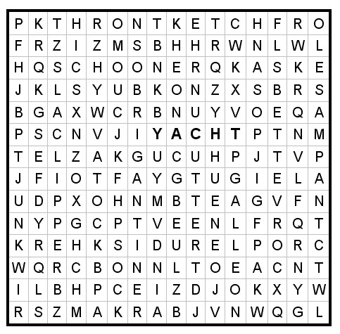
YACHT SLOOP CUTTER
KETCH GALLEON BARK
SCHOONER CLIPPER JUNK
TUG CANOE BRIGANTINE
CORVETTE SAMPAN.

School of Fish Gathering Activity
Voyageur Council
Pin pictures of fish on people as they arrive. Have cutouts of swordfish, tuna, trout, catfish, etc. On a signal, they are to see which “school of fish” can assemble first.

Scrambled Water Gathering Activity
Longhorn Council
When you unscramble the following words, you will know eight kinds of bodies of water.
KEAL NECOA YOUBA
DROJF FULG GOANOL
NOPD VERIR
Answers: lake, ocean, bayou, fjord, gulf, lagoon, pond, river

Underwater Words Gathering Activity
Longhorn Council
How many words can you make from the letters in the word UNDERWATER? Who can make most words? How about the longest? (At least 80 are possible! Probably even more.)

It’s Raining Cats and Dogs! Gathering Activity
Alice, Golden Empire Council
Using the list of Water Proverbs under Theme Related, you can:
- Put half of a water saying on one person’s back and they must locate the person with the other half of their saying by asking only questions that can be answered with “yes” or “no”.
- Have individuals, families or dens pick a water saying out of a bag – they then act out their saying as Charades. Winning person or team gets the most correct answers and has first chance at the refreshment table.
- Have each team (den, family, or boy and parent) pulls a phrase out of a bag and explain the meaning of the phrase – give an extra point for a good example.

Have an H2O Olympics Gathering Activity
Alice, Golden Empire Council
Use teams made up of dens or families. Have the following “events” set up around the room, and have a “judge” keep track of each team’s scores:
- Pole Vaulting – Over the Top – Fill a clear plastic cup with water to the brim. Add pennies one at a time till the water spills over the top.
- Balance Beam – Using an eyedropper, add drops of water to a penny’s surface. Continue till the water spills over or the drop collapses.
- Sculling Contest: Bubble Power – Cut out two boat shapes from a piece of cardboard (see pattern); Cut a small notch in the center rear of each boat and place a soap chip there. Boat shape can be altered by the team with scissors. Put boats in a tray filled with water and on signal, each team lets their boat go to see which one goes fastest.
- Backstroke Competition – See which team can suspend the most paper clips on the surface of the water. (Hint: Lay the paper clip on the tines of a fork and lower clip into the water) Use a magnifying glass to get a better idea of what’s happening on the surface of the water.
These would also make great den games!

Build a River Gathering Activity
Alice, Golden Empire Council
The object of this activity is to put together all the components of a river (or ocean, or stream, or lake – whatever is most common in your area)
- Make up sets of cards with things that make up a river (or whatever body of water you are using) written on them – For a river you may have - water, riverbank, rapids, waterfalls, sand, mud, various kinds of fish, turtles, birds, insects, various kinds of plants, bushes, flowers, trees, pebbles, boulders, bridges, beaches, swimming hole, beaver dam, marshy area, snag in water, sand bar, man-made dam, etc. Make enough sets for each den, family or assigned group to have one.
- Each completed “river” is made by people holding cards or taping them to the wall.
- Once the “river” is completed, the group chooses a name for their “river,” as well as characteristics for their river.
- They should also come up with a conservation project to maintain or improve their river’s health.
- Each group gets to share their project with the whole pack.

Mink in a Maze Gathering Activity
Voyageur Council
Every wild animal must live in its chosen habitat. The mink prefers a riparian habitat. Can you help it find its way to the pond at the center of the maze?
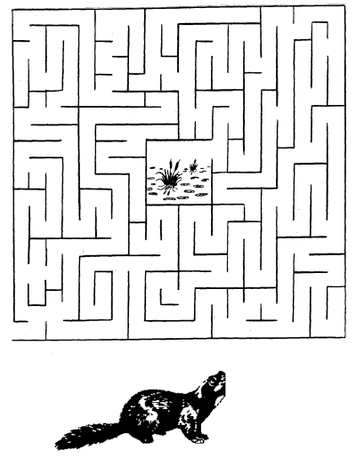

Ocean Objects Word Search Gathering Activity
Voyageur Council
Find these things that can be found in or on the ocean. Look up, down, across, backwards and diagonally:
BOAT OCTOPUS BREEZE
PELICAN CORAL SALT
CRAB SAND EEL
SEA FISH SHARK
FLOTSAM SHIP FOG
STORMS GULL SUB
ICEBERG WAVES LIGHTHOUSE
WHALES
The remaining 13 letters, in order, spell the name of a beautiful sea.
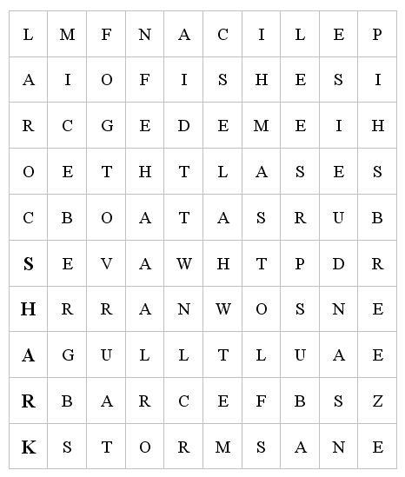

How Many Words Gathering Activity
Baltimore Area Council
- Give each boy a pencil and a piece of paper.
- See how many words they can make out of the letters in the word “RIVERBOAT.”
- Each letter may be used only once (except “R” which may be used twice since there are two of them).
- “RIVER” and “BOAT” do not count.

Crossing the Quick Sand Gathering Activity
Circle Ten Council
Place small pieces of masking tape on the floor to from a twisty line of stepping-stones with some close together and others far apart.
Each Cub in turn tries the course while balancing a tennis ball on a flat board.

Fishing in the Tropics Gathering Activity
Place a dishpan with many plastic or rubber items in the bottom, on the floor in the middle of the room.
Provide a fishing pole consisting of a stick about two feet long, on one end of which is fastened a string with a hook. Velcro works great. Be sure you put Velcro on the items in the sea.
As they arrive, give each Cub Scout three minutes to snag as many “fish” as he can, and award a small prize when finished.
Float the Needle
Have bowl of water and a needle and challenge boys to try to make the needle float.
After they have tried and failed, place a small piece of tissue on water and the needle on top of that. As the tissue gets wet, it will sink to the bottom. The surface tension of the water will allow the needle to remain afloat.
OPENING CEREMONIES

The Six “Ships” of Scouting Opening Ceremony
Baltimore Area Council
A True Scouting Classic! CD
Arrangement: 6 Cub Scouts hold large cardboard cutouts of ships, on which have been printed the following words; SCHOLAR-SHIP; FELLOW-SHIP; FRIEND-SHIP; SPORTSMAN-SHIP; WORKMAN-SHIP; STATESMAN-SHIP on the front and their parts on the back in LARGE print.
Cubmaster: Tonight, Den __ would like to tell you about the Six Ships of Scouting. These are ships that were launched to sail the Waterways of the USA – strong and mighty... ships that will last forever.
- SCHOLAR-SHIP. This ship is very important on the Sea of Education. On her deck stand such officers as Ambition, Determination, Intelligence and Application. Her flag bears symbols of the letter “A” and the plus sign.
- FELLOW-SHIP. This ship stands for good spirit, fine cooperation and never-failing unity. Its flag floats high - the flag of Scouting.
- FRIEND-SHIP. This is the most handsome ship of all. It is true blue and its flag is golden - since friendship itself is golden.
- SPORTSMAN-SHIP. This is the ship that’s fair and square. It never veers from its course. Its flag is never at half-mast.
- WORKMAN-SHIP. This ship’s every line, every part, every mast, represents the best that a person can give. Its flag wears a laurel wreath.
- STATESMAN-SHIP. This ship represents wise guidance, constant counsel, unselfish interest and sincere endeavor. Its flag is white for purity.
Cubmaster: And there you have six strong and sturdy ships to brave the Waterways of the USA. Three cheers for the Scouting ships!

WATER 101 OPENING Ceremony
Santa Clara County Council
Arrangement: Cubmaster is dressed in a long laboratory coat and slacks that are easy to remove, holding a clipboard, and carrying a briefcase. (He is wearing beach clothes underneath the slacks)
Cubmaster: (Very seriously): Welcome to our Water 101 college pack meeting. I am Professor Cubmaster and I hope that you are all prepared to listen closely and take notes. We are here today to learn about a very important substance--H₂O, otherwise known as water. Now the first thing we will study is the molecular structure...
Pack Committee Chair: (Runs in to interrupt Cubmaster) Excuse me, Professor, but today’s pack meeting is Fin Fun. We are supposed to have fun with water, not lecture in Water 101.
Cubmaster: Oh, but I’m sure my secretary told me about a Water 101 lecture I was to give today. (Consults pocket calendar.) How embarrassing. That’s next week. Luckily, every good Scouter comes prepared for nearly everything. Excuse me a moment. (Cubmaster goes away and comes back in beach-going clothes. He opens his briefcase, pulls out sandals, a beach towel, snorkel and fins. He also takes out a small water squirter and squirts the committee chair.) Today we are going to have water activities. It’s going to be fun! Who’s ready to join me??

Raingutter Regatta Opening Ceremony
Baltimore Area Council
Set Up - Have the boatswain (a good whistler) give a long, drawn-out note, dropping to a lower tone near the end, to welcome the Skipper (Cubmaster) aboard. Cubmaster then calls for each ship’s crew section (Den) to give its Den yell. The entire crew (Pack) then stands, pledges allegiance to the flag and sings “Row, Row, Row Your Boat” as a round.

Safe Swim Opening Ceremony
Voyageur Council
Arrangement: Make card for each letter. Write the line for each boy in LARGE print on the back. The boys can carry water activity toys such as inner tubes, balls or snorkeling equipment.
- S S is for Scouts, we have fun.
- A A is for Activities, out in the sun.
- F F is for Friends, your buddies in the pool.
- E E is for Excitement, but keep your cool.
- S S is for Safety. That must come first.
- W W is for Water, not only for thirst.
- I I is for Instructions we follow with care.
- M M is for Merriment we all love to share.
ALL Putting them all together and we have SAFE SWIM. Let’s be safe and we will all win.

Spirit of Scouting Opening Ceremony
Setting: Before the opening ceremony, place a candle at one side of the stage or room but in view of everybody. When the time for the opening ceremony, the Cubmaster make the following statement.
Cubmaster: (light candle) This candle represents the spirit of Cub Scouting. It is going to burn throughout our meeting, representing the fun and friendship we have enjoyed together here. Let’s all stand and give the Pledge of Allegiance to the Flag.

OCEAN Opening Ceremony
Circle Ten Council
Have large cards with the letters O C E A N on them for the Cubs to hold and read from.
- O – O is for Old Glory that we wave with pride.
- C – C is for colors we see each night with joy.
- E – E is for evenings that give us pleasant thoughts.
- A – A is for awareness of the beauties of the sea.
- N – N is for Neptune, the mythical God of the sea, who rules his kingdom with love.
Leader: Put it all together, it is OCEAN; it borders our land and gives us much to be thankful for.

Cub Scout Fish Opening Ceremony
Voyageur Council
Arrangement: 8 Cub Scouts holding cardboard pieces, which make a fish when put together. Each part is lettered, so that all together they spell CUB SCOUT, C being the head of the fish and T the tail. Each boy’s lines are written on the back of his card in LARGE print.
(Boys enter one at a time and repeat their lines in order.)
- (Head of Fish) C is the part we build on. It stands for COURTESY in Cub Scouting and all through life.
- U is next. This part stands for UNITY, because united we are strong.
- B is the next added. That stands for BRAVERY in all our thoughts and all our deeds.
- S is next and that stands for SAFETY. We learn it and use it.
- C adds some more and it stands for CHURCH--the one of your choice.
- O is building it stronger, and it stands for OUTDOOR life, which is full of fun and adventure.
- U is near the finish and it stands for UNDERSTANDING, something that all our families have.
- (Tail of Fish) T is the tail that guides us. It stands for TRUTH in all things.
All: Will everyone rise and please join us in the Pledge of Allegiance?

Seaside Opening Ceremony
Capital Area Council, TX
Personnel: Cub Scouts
Equipment: A beach bucket and shovel with empty squirt guns for each Cub and Den Leader
Set Up: The Cubs come in and line up carrying their buckets and shovels. The squirt guns are inside the buckets out of view of the audience. It would also add to the effect if the Cubs rolled up their pants legs (or wear shorts) and have bare feet. They could also pantomime actions.
- Here at the beach there is so much to see! Look on the ocean is a sailboat!
- Yeah! They're great. But the waves are really fun. I love to run into the water and let the waves push over me.
- Do you know what I like? I think the seagulls are cool! They attack when you sit down to have lunch.
- Yeah! But have you ever been able to find a starfish at the edge of the water. That's really cool!
- Do you know what else is fun! Hunting for clams. They bury themselves in the sand and when you get close to getting them--they squirt!!
(Cubs reach in their buckets and
use their squirt guns to *squirt* the audience.

Swim Party Opening Ceremony
Capital Area Council, TX
This opening is for use if you are having your pack event at a swimming facility.
Have all the boys stand around the edge of the shallow end of the pool or the side of the beach.
On signal, they are to jump or wade into the water and make a circle in the pool.
CM Now that we are all together, please repeat the following pledge after me:
"As a Cub Scout:
I promise to be careful in the water
I will observe water safety rules at all times,
When I am with a group around water I will enbravery others to do the same.
CA Please join us in the Pledge of Allegiance.
AUDIENCE PARTICIPATIONS

On The Beach Audience Participation
(a MadLibs)
Baltimore Area Council
Create a list ahead of time of the types of words needed for the story, and ask the audience to provide the words to fill in the blanks in the story. The narrator reads the story. Filling in the blanks with the words provided by the audience.
Plural Noun
Body Part
Verb
Body Part
Noun
Noun
Plural Noun
Adjective
Verb
Plural Noun
Exclamation
Person in Room
Noun

If you want to en_{j}oy yourself at the beach, you should bring your _plural noun_. Before exposing your skin to the sun, you should put suntan oil on your _body part_ . Rub it on your face; then smear it all over. Be sure that it's rubbed in thoroughly. Then go into the salt water and _verb _. When you come out of the water, don't dry your _body part_. Lie down on a(an) _noun_ and soak up the rays. It's fun if you bring a(an) _noun_ to play with at the beach, l like to build _plural noun_ with sand. You see all sorts of bodies at the beach. Some are _adjective_ like your own. You can _verb_ on the beach. Some beaches allow you to sunbathe without your _plural noun_, _exclamation_ ! My friend, _person in room_ went to a beach without his/her _noun_ and got so sunburned that he/she had to walk home.

Fisherman’s Luck Audience Participation
Circle Ten Council
In this audience participation, the audience will be divided into the necessary number of groups and each group will say the following lines when their name is called:
Fisherman Great day for fishing
Fish Bubble, Bubble
Worm Wiggle, Wiggle
Reel Everyone pretends to reel in a fish
Once there was a FISHERMAN who went FISHing on a sunny April day. He was hoping to catch a big FISH. He found a nice spot and stopped along the river.
The FISHERMAN put the REEL on his rod, and a worm on his hook and started to FISH. He patiently waited and waited, but no FISH came to eat the WORM on the hook. The FISHERMAN decided to leave his hook and WORM in the water and take a little nap. He was awakened by the screeching sound of his REEL; sure enough he had hooked into a great big FISH.
The FISHERMAN wounded in the REEL and to his surprise he found a stick on the end of his hook. The WORM was gone. So the FISHERMAN put another WORM on his hook and tossed his line into the water. Again he was awakened by the sound of the REEL, this time he found a tin can on his hook. “This is getting frustrating” he said, “I really want to catch a FISH before I run out of WORMs”.
One last time the FISHERMAN threw this line into the water and set his rod and REEL beside him. The sound of the REEL woke him once again. This time however he could not REEL in his FISH he knew for sure that his WORM was ling gone. He REELed and REELed until finally a large black fin rose out of the water. The FISHERMAN has caught a submarine. Riiinnnng . . . . went the alarm clock the FISHERMAN rolled over and said “six thirty in the morning”. The whole trip had only been a dream.

IN SEARCH OF SUN SCREEN Audience Participation
Sam Houston Area Council
Divide the audience into four groups. Assign a part to each group and have them practice. As narrator, read the story, they respond to the appropriate word.
Timmy: “I love to swim”.
Cub Scouts: “Do your best”.
Swim/Swimming: “Splash, splash, splash”.
Sun Screen: “Aaaaaaaaa-Oooooooo”.
The day of the summer Pack meeting was hot and dry. That was good because it was to be a SWIMMING party. The CUB SCOUTS and their families were to meet at the Miller’s house at noon. TIMMY started getting ready at 9 O’clock in the morning. He loved to SWIM. He had just completed SWIMMING lessons at the local SWIMMING pool and had his card stating that TIMMY had passed Advanced Beginners. He knew all his CUB SCOUT friends would be surprised. It was just last year that TIMMY could not SWIM at all.
TIMMY found his SWIMMING suit and towel and even his thongs without any trouble. But search as he might he could not find his SUN SCREEN. This was terrible. All the CUB SCOUTS had learned the importance of always using SUN SCREEN at one of the Den meetings. TIMMY knew that he must protect his skin from the intense summer sun while he was young so that he would not get skin cancer when he got older. Also, he did not want to get a bad sunburn. One of his friends in CUB SCOUTS had fallen asleep in the sun and couldn’t sit down or lay in bed comfortably for a week!
“Where are you, SUN SCREEN?” asked TIMMY as he started looking through the house again. It was almost time for the SWIMMING party. He didn’t want to be late. That was when he found it. Way in the back of a bathroom drawer, there was the SUN SCREEN. He grabbed it but to his dismay, the tube felt very light. Oh, no! The SUN SCREEN tube was empty. TIMMY could not squeeze out even one little drop. What could he do? There was no time to go to the store before meeting the CUB SCOUTS for the SWIMMING party. And he knew he should never go SWIMMING without his SUN SCREEN.
Just then, TIMMY’s big brother Weston came bursting through the kitchen door. “What’s the matter”, he asked when he saw TIMMY sitting dejectedly in the living room? I’m all out of SUN SCREEN. I can’t go SWIMMING with the CUB SCOUTS, was the reply. “Here, you can use mine”, said Weston, tossing his little brother a new tube of SUN SCREEN. TIMMY couldn’t believe it. Just that fast was his problem solved. “Thanks, Wes!” TIMMY shouted as he headed out the door to the SWIMMING party with the CUB SCOUTS. And for a whole week he didn’t say anything bad about his brother!

Water Audience Participation
Capital Area Council, TX
Narrator reads story. When audience hears a "water" word, they do a wave, like at sporting events.
One upon a time, there lived a poor merchant from Botany Bay. He sailed across the Seas to distant lands. He traveled with his dog, Bruno. During Ocean voyages, he missed his family.
On one of these Sea journeys, the poor merchant traveled to the island of Catomania. He heard a loud caterwaul as he entered the Bay. The island had a terrible problem. Too many cats! The king begged him to help. The poor merchant let loose his trusty Bruno. Bruno chased the cats on board the ship in the Bay.
The poor merchant quickly set sail for the high Seas, with a shipload of cats. At the next port, the island of Micea, he found another island with a problem. They had never seen a cat before. The island was run over with Sea gulls. There was practically not a place to land his ship because the gulls covered the Water's edge. He was able to sell all of the cats to the inhabitants of Micea. The cats who were hungry after the long Ocean journey, gobbled up all of the gulls but two who flew to the top mast of the poor merchant's ship in the BAY.
The merchant sailed for many days in the Ocean. When he reached America, he brought out his caravan of camels. They pulled his ship right to the Rio Grande River in Albuquerque. He found the pioneers wrestling with a plague of locusts. The quick-thinking merchant threw a stone at the giant gulls. They swooped down and hungrily devoured the locusts. The pioneers who were still settling in, didn't have much to trade, so he let his camels have a drink from the River and was on his way again.
The next stop was an island called Waterworld. There was so much Water, the islanders had a hard time eating, sleeping, working or playing. The camels smelled the Water as soon as they made port and stampeded. Soon, the excess Water was gone. The islanders thanked the merchant by presenting him with a cargo hold full of umbrellas. They wouldn't he needing them anymore.
When the merchant arrived home, his family Rained tears of joy. The tears poured for days and days. The wise merchant who knew it never Rains but it pours, sold the cargo hold of umbrellas to the good citizens, and became the now rich merchant from Botany Bay.

Robinson Crusoe's Diary Audience Participation
Capital Area Council, TX
This is a nonsense game that never fails to crack them up - the sillier, the better! Names of objects are written on slips of paper and dropped into a container. As "Mr. Crusoe" reads his diary, each "sailor" takes turns drawing from the container to fill in the blanks.
Copy these phrases on slips of paper:
A ship | A dove | A bonfire
A big tree | Dandelions | A wild goat
30 cannibals | A loud noise | Some gunpowder
My tent | A strong fence | A chest of gold
A goatskin | A pile of straw | A piece of canvas
My fieldglasses | All my belongings | A table and chair
A cup of goat's milk | The top of the hill
"This morning I woke up early and ate my breakfast, which consisted of and . Afterward, I took my saw and hammer and built . Since I was shipwrecked and alone, I had to go hunting in the woods to see what I might have for lunch. I forgot my gun, so I had to capture with my bare hands. I also tried to catch to but could not run fast enough. I went home to my cave, sat down in and ate my lunch. Since my clothes were all lost as sea, I decided to make myself something to wear. I made a pretty neat hat from and a coat out of . I decided to wrap my feet in . Suddenly, I heard a and rushed out and climbed into . I looked through just in case I might see . I didn't but there on the beach I saw dancing in wild glee around . Running up the trail toward my hideout was crying out and looking very frightened. I hid the poor thing behind . I then found my gun, loaded it with and stood guard over . When it seemed safe, I got busy and built all around . Then I finally lay down in my comfortable bed, mad of , and slept soundly.
ADVANCEMENT CEREMONIES

Waterways Advancement Ceremony
Jim Jones, Great Salt Lake Council
Set Up – All parts are read by same person, or it could be broken up amongst Den Leaders, Assistant CM(s) and others. No props are required but pictures illustrating the various waterways would add to the ceremony (and the words could be placed on the back of the picture). If you want to get really creative, have the CM and an Assistant dress up as Lewis and Clark and modify the text to have them telling the story of their journey.
In 1804 Meriwether Lewis and William Clark began a journey at the request of President Thomas Jefferson to explore the west in search of a water route to the Pacific Ocean. Much of their journey was traveled on the great waterways and rivers of North America.
Tonight we honor others on their own journey of discovery. Will the following Cub Scouts and their parents please come forward? (Call forward all the Cub Scouts receiving their Bobcat Award.) These Cub Scouts represent the trickles of water from melting snow and ice that are the headwaters of America’s rivers and waterways. These Cub Scouts have earned the Bobcat Badge. (Present Bobcat Badges)
As these trickles of water come together they form small rivulets. As Bobcats grow they may come together in the Tiger Den. Would the following Cub Scouts please come forward with their parents? (Call those Cub Scouts forward that are receiving their Tiger Badges.) These boys represent those rivulets. Each of these Cub Scouts has earned his Tiger Cub Badge. (Present Tiger Cub Badges.)
As these rivulets grow and move forward in their flow, they become streams. Would the following Cub Scouts please come forward with their parents. (Call those boys forward that are receiving their Wolf Badges.) These boys have grown and progressed in their Scouting journey of discovery and earned the Wolf Badge. (Present Wolf Badges.)
The streams grow and join becoming the rivers that are the tributaries of the great American Waterways. The Bear Den represents those tributaries. Would the following Cub Scouts please come forward with their parents. (Call forward the Cub Scouts receiving the Bear Badge.) These boys represent those tributaries in their own journey of discovery. They have earned the Bear Badge. (Present Bear Badges)
When those tributaries come together to form the great American Waterways, the journey is almost complete. Would the following Cub Scouts please come forward with their parents? (Call forward Cub Scouts receiving the Webelos Badge.) These boys represent Lewis and Clark’s Mississippi River. Each of these Cub Scouts has earned the Webelos Badge. (Present the Webelos Badge.)
Would the following Cub Scouts please come forward with their parents? (Call forward the Cub Scouts that are receiving the Arrow of Light.) The greatest Waterway in America is the Mississippi River. This is the beginning and ending point of Lewis and Clark’s journey of discovery. As great as the Mississippi River is, it eventually empties into the Gulf of Mexico ending its journey. Tonight these Cub Scouts are ending their journey of discovery in Cub Scouting and receiving their Arrow of Light, Cub Scouting’s highest honor. (Start your Pack’s traditional Arrow of Light Ceremony here)

Fishing Trip Advancement Ceremony
Baltimore Area Council
Setting: The Cubmaster, or whoever is going to lead the advancement ceremony, is starting down memory lane of a recent fishing trip that he made. He starts to relate it to Cub Scouting.
Props: Cubmaster will need clothing for fishing, a pole that is hooked up with a magnetic hook. Cub Lake (some type of tub container to be the fishing hole). Advancements on fish as described below.
Cubmaster: Well, before I tell you who is getting awards tonight, I want to tell you about my latest fishing trip. You all know that any good fisherman will get up before dawn to prepare himself to go fishing. That is when this day started for me. There are seven things I have to do to get ready for a fishing trip, and as I was doing these things, I remembered the seven requirements that my son had to do to get his Bobcat Badge. Just like I prepared to go fishing, my son had to prepare himself to be a Cub Scout.
Call up Cub Scouts and their parents who are getting their Bobcat Badges.
Scouts, here at Pack ____, we are really proud of your accomplishment of completing the requirements for the Bobcat Badge. And just like I have to have a license to go fishing, you have to become a Bobcat to go on in Scouting. Scouts, tonight I'm presenting your parents with your Bobcat Badge. When they give it to you, I want you to always remember how you prepared yourself for Scouting.
Present badges on pretend fishing licenses to the parents
Well, let me continue on with my fishing trip. You won't believe the trouble that I had! Before I even got to the lake, I got lost, and had to look at a map. I then had to make a phone call because I forgot to leave a note to let my family know where I was going to be. Then, once I was at the lake, things didn't get any better. I dropped my bait bucket, I cut my finger. I got knots in my fishing line, I even had to go back to the car for the lunch that I had packed. But you know, some nice things did happen to me too. The day was beautiful, birds were out singing in the trees, and the trail to the lake was clean. I saw some really neat plants growing alongside of the path, and I found a really great rock for my son's collection.
Oh, yes you are probably wondering what all of this has to do with Scouting. Well, as I was having all of these problems I remembered that the Tiger Cubs had to look at a map and go Outdoors.
And I thought of the 7 Adventures that Cubs have to do to get their Wolf and Bear badges. And you know, some of the things that they had to learn I needed that day. The first aid for my cut finger, the knots in my line, and the lunch I did remember to pack. In Cub Scouts, boys get a really good understanding of nature and how to take care of the land around them. That path was so clean I bet some fisherman who had been in Cub Scouting had come before me.
So I did go fishing, and caught (insert number of Tiger, Wolf and Bear advancements that you have) really nice fish. Here let me show you.
Cast your line into Cub Lake and catch fish for the Tiger Badge(s), Wolf badge(s), and the Bear Badge(s)
Call up the Cubs with their Parents. If a large number, You may wish to separate by rank. Be sure every boy receives individual recognition.
Scouts, you are receiving your Tiger Badge tonight, and, along with your parents, your Pack is really proud of you and the work you have done. Congratulations.
Scouts, you are receiving your Wolf Badge tonight, and, along with your parents, your Pack is really proud of you and the work you have done. Congratulations.
Scouts, you are receiving your Bear Badge tonight and you have shown us that you take your Cub Scouting seriously. Congratulations.
Well, my fishing trip continued on for a few more hours and I continued to think about Cub Scouting. I thought about how each of the Webelos Scouts complete more difficult Adventures to earn their rank, the Adventures give the Scout a taste of what Boy Scouting will be like. They just sort of cover what a Scout that is in 4th and 5th grade needs to know.
Will our Webelos leader please come up here tonight. I'm going to go fishing and see if I can find any Webelos Activity Badges down here. Yes, there do appear to be a few.
Have Webelos Leader give out the badges to the boys
I want to thank each one of you tonight for coming along with me on this trip, Scouting and fishing sure do have a lot in common, don't you agree?

SEA ADVENTURES Advancement Ceremony
Circle Ten Council
Cubmaster (CM): When a boy wanted to be a sailor, he would hire himself on as a cabin boy. There he learned the terminology of the ship. He learned his knots and the rigging.
Assistant Cubmaster (CA): When a boy wants to become a Cub Scout, he must learn the basics of Scouting. When he learns the Scout Law, the Scout Oath, the sign, the salute, and the handshake, and the motto, a boy then becomes a Bobcat. Will the Bobcat recipients please come forward with their parents?
(Present awards to parents to pin on their son)
CM: A sailor quickly learned to use maps and charts so he could see where they are and where they are going. So too, does a Tiger Cub Scout grow. He learns about his town by looking at a map and going places in the town. After he finishes this and the other six other Adventures, he is recognized as a Tiger. Would our Tiger Cubs and their parents please come forward?
(Present awards to parents to pin on their son)
CA: A sailor boy’s knowledge of the sea did not end there. As he traveled about the world, he saw many different types of ships and their uses. His world would become larger. So too, does a Cub Scout grow. He completes seven Adventures learning about many other things. It is then that he is recognized as a Wolf. Would our Wolf Cubs and their parents please come forward?
(Present awards to parents to pin on their son)
CM: A sailor even today has to know the methods of ship communication, whether it be flags or radio. He needs to know about radar. A Bear needs to do his Duty to God, learn more about wildlife and the environment, more about family life and more about strengthening his body. Will our Bear rank recipients and their parents please come forward?
(Present awards to parents to pin on their son)
Webelos Leader 1(WL 1): A sailor soon learns about tides and the sea currents. He learns to use these to travel. A Webelos Scout must earn seven different Adventures to help prepare him for the future. Will our Webelos and their parents please come forward?
(Cubmaster presents awards to parents to pin on their son)
WL 2: Finally, a sailor has a destination, a goal; he must know where he is and how to get where he is going. He uses the constellations and the North Star to guide him. He uses a compass and a sextant to chart his course. So, too, does a Webelos Scout. He has to earn seven more Adventures to give him skills for the future. He has visited Boy Scout troops, as he plots is course. He has filled out a Boy Scout application form. He is deciding on his goal, maybe even an Eagle Scout. Will our Arrow of Light recipients and their parents come forward?
(Cubmaster presents awards to parents to pin on their son)

Goin' Fishin' Advancement Ceremony
Baltimore Area Council
This ceremony can he used indoors or at the waterfront.
If you are indoors,
Pin the badges that were earned to a cardboard fish.
Make a fishing pole out of a dowel, string, and a paperclip hook.
Put paperclips bent into circles into mouths of the fish.
Make the fish different colors according to the badge pinned to it and tell each boy who earned an advancement to go fishing for a (color) fish. (e.g. red fish for Wolf)
Make a statement about the boys’ accomplishments and have the parents help the boy if needed.
If you are at the water, you could use the same process or you could use the water instead of a bucket to put the fish in. Simply wrap the badges tightly in aluminum foil and have the one who swims best in the water with the badges. When the boy casts his line out, the swimmer can attach the proper badge to the hook and give it a tug.

SCHOOL OF FISH ADVANCEMENT Ceremony
Circle Ten Council
Equipment: A poster board or a sheet colored blue imitating water gradually getting deeper, five different size fish made of cardboard, awards.
Setting: Cubmaster is in front of room with water behind him.
Cubmaster: The small fish starts out in shallow water (Place smallest fish in shallow water) and the first step is to learn how to maneuver in the water, just as our beginning Scout is becoming familiar with Cub Scouting. The first part of becoming a Cub Scout is that of a Bobcat. Would the following boys please come forward with their parents? (Award badges)
Tiger Leader: As our small fish grows (place the next fish further out in the water) he moves a little further into the water finding new adventures and discovering new areas. Just as our fish is developing so is our Cub Scout. The next step is that of a Tiger. Would the following boys please come forward with their parents? (Cubmaster awards badges and/or arrows)
Wolf Leader: As our small fish becomes stronger and larger (place the next fish further out in the water) he moves further into the water finding new adventures and discovering new areas. Just as our fish is developing so is our Cub Scout. The next step is that of a Wolf. Would the following boys please come forward with their parents? (Cubmaster awards badges and/or arrows)
Bear Leader: Our fish has grown into a larger fish (place 3rd fish further out in the water) and has moved out further into the water becoming more acquainted with the other fish and is learning to maneuver faster in the water. Just like the fish, the Cub Scout is learning and meeting more challenges and is becoming more acquainted with the pack. The next step is that of the Bear. Would the following boys please come forward with their parents? (Cubmaster awards badges and/or arrows)
Webelos Leader Our fish has finally reached the stage where he can go into the deepest water (place largest fish in the deepest water) and has learned quite a lot about the water and what lies in it. This stage of growth is like that of the Webelos. The Webelos has matured and learned much about the pack and is ready to move on into Boy Scouting. Would the following boys please come forward with their parents? (Cubmaster awards Webelos badge and/or activity pins)
Assistant Cubmaster Just as the fish has developed and has gone out into deeper water, we know our Cub Scouts have learned and developed as we send them on into Boy Scouting and beyond.

WATER FUN Advancement Ceremony
Circle Ten Council
Props: Various items used in the water: (e.g. mask, snorkel, fins, ski tube, skis, etc.) and leaders wearing them
Cubmaster needs to have a fishing hat and vest available.
Have a fish tank or fish bowl and enough dowel rods with strings attached to badges in plastic sealed bags. These are the awards for the boys.
Cubmaster: Water fun is something that is enjoyed by nearly everyone. We have some special people here tonight to show you ways to have fun in the water.
- Mask man The person who does not want to get water on his face, or the person who does not want to be seen.
- Snorkeler The next person thinks he/she is a shark. They think they are a part of the great white shark family. In fact, _______ is a card-holding member of the JAWS fan club.
- Finner This person only walks on the beach and leaves big prints in the sand. He’s hoping you think that Bigfoot has reappeared.
- Tuber This person is someone who has always wanted to drive on water, but has not yet figured out how.
- Etc. (make up your own to fit the props)
These are just a few of the items that can be used to have fun in the water. Fishing is also very popular. (Put on fishing hat and vest.) In this fish tank I have caught some badges for Cub Scouts who have advanced in rank. (Pull badges out one by one and call boy forward with his parents.)

Arrow of Light Advancement Ceremony
Baltimore Area Council
PERSONNEL: Webelos Leader or Cubmaster; Webelos Scout(s); parents.
EQUIPMENT: Ceremony board (see illustration)
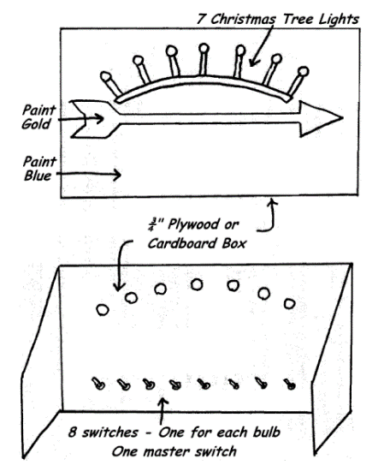
ARRANGEMENT: Room is in darkness. Leader introduces Webelos Scout(s) who are receiving Arrow of Light, and explains they have met the requirements to receive the highest award in Cub Scouting.
LEADER: The purpose of Cub Scouting is to light the way to Boy Scouting.
The first rank in Cub Scouting is Bobcat a Cub Scout learns the Scout Law, the Scout Oath, the Cub Scout sign, handshake; motto and salute. (Turn on first light)
The rank for first grade is Tiger. (Turn on first light) A First Grade Cub Scout must complete 7 Adventures to earn this rank.
The rank for second grade (eight year old) Cub Scouts is Wolf. (Turn on third light) 7 Adventures are required to earn the Wolf badge. Then he works on elective adventures until he is in third grade (nine years old). He can earn as many elective adventures as time and ambition will allow.
Seven Adventures are required for the Bear badge. (Turn on fourth light) You can see that as a boy progresses in Cub Scouting, his way becomes lighter. After receiving his Bear badge, he works on elective adventures until he is in fourth grade (10 years old)
Now he becomes a Webelos Scout. (Turn on fifth light) They wear the Webelos tri-colors on their sleeve and work on Adventures to pin to the Tri-colors. To earn the Webelos badge, he must earn 7 Adventures. Webelos stands for “We’ll Be Loyal Scouts” and it is the name of the Indian tribe of which Akela is chief. The Webelos Scout is older. He can do more for himself. His parents no longer sign for his advancement; his Webelos Leader does this.
When he is in fifth grade, he works on the Arrow of Light Award. (Turn on sixth light) To receive this award, he must earn 7 Adventures. By now he really knows the Scout Oath, the Scout Law, the Scout Motto, Slogan, Sign, Salute and Handclasp. He learns the parts of the Scout badge. He understands and supports the Outdoor Code. He plans and leads a flag ceremony at a Pack meeting. Now he has earned the Arrow of Light award, the highest award a Cub Scout can earn. (Turn on seventh light) His path to Boy Scouting is now fully lit.
Let’s review his path to Scouting. (Turn out all lights) This is what his path looked like before he entered Cub Scouting. (Turn on all lights) This is what his path is like now that he has progressed through the ranks of Cub Scouting to the Arrow of Light.
Goodbye Cub Scout… Hello Boy Scout.

“Water Adventure” Graduation Ceremony
Baltimore Area Council
Note: This may be adapted to be an advancement for any Cub Scout rank advancement
Setting:
- Side view of a ship (USS WEBELOS) is cut from cardboard. Cubmaster, Webelos Leaders and Bear Leaders dressed as Ships Officers.
- Bear Dens are standing to the side of the ship.
- The Cubmaster and new Webelos Leader/s are standing behind the ship.
Cubmaster: (blows whistle). Bear First Mate, is your crew assembled and ready to board?
Bear Leader: Aye, aye, Sir!
Cubmaster: Webelos First Mate, are you ready to receive your new crew?
Webelos Leader: Aye, aye, Sir!
Cubmaster to Bears: Bears, are you prepared to board the Webelos Ship and continue along the trail that will lead to the USS Arrow of Light? (Prompt boys to say “Aye, aye, Sir!”) Before boarding the Webelos Ship, would you all raise your right hands in the Cub Scout Sign and recite the Cub Scout Promise? (CM leads boys in the promise)
Welcome aboard! (Motion the Bears toward the ship) Webelos First Mates, meet the new crew of the USS WEBELOS .
(Suggestion: Cubmaster can present the new Webelos with their neckerchiefs; the Webelos Leader with his/her badge of office, or the Den flag.)
SONGS

Row, Row, Row Your Boat Song
Baltimore Area Council
Row, row, row your boat
Gently down the stream.
Merrily, merrily, merrily, merrily,
Life is but a dream.
Blub blub blub your sub
Gently ‘neath the stream
Ha ha fooled you all
I’m a submarine
Propel Propel Propel your craft
Passively down the liquid solution
Ecstatic ecstatic ecstatic ecstatic
Existence is but an optical illusion

BLOW YOUR BOAT Song
Circle Ten Council
Tune: Row, Row, Row your Boat
Blow, Blow, Blow your boat,
Fast along the waves.
Do your best, do your best,
We're the Cub Scout braves.
Blow, Blow, Blow your sail,
Passing others by
Do your best, do your best,
Aye-Aye-Aye

Propel Your Craft Song
Baltimore Area Council
Tune: Row, Row, Row Your Boat
Propel, propel. propel your craft
Smoothly through the liquidy solution,
Ecstatically, ecstatically. ecstatically, ecstatically
Existence is but an illusion,

Sailing, Sailing Song
Baltimore Area Council
Sailing, sailing over the bounding main
Where many a stormy wind shall blow
‘Ere Jack comes home again
Sailing, sailing over the bounding main
Where many a stormy wind shall blow
‘Ere Jack comes home again

Little White Duck Song
Baltimore Area Council & Circle Ten Council
There’s a little white duck sittin’ in the water,
A little white duck, doin’ what he oughter.
He took a bite of a lily pad, flapped his wings
And he said I’m glad that I’m a little white duck
Sittin’ in the water, quack, quack, quack.
There’s a little green frog, swimmin’ in the water
A little green frog, doin’ what he oughter.
He jumped right off the lily pad the little duck bit
And he said I’m glad that I’m a little green frog
Swimmin’ in the water, croak, croak, croak.
There’s a little black bug, floatin’ on the water
A little black bug doin’ what he oughter
He tickled the frog on the lily pad that the little bug bit
And he said I’m glad that I’m a little black bug
Floatin’ on the water, chirp, chirp,
There’s a little red snake lyin’ in the water
A little red snake doin’ what he oughter
He frightened the duck and the frog so bad
He ate the bug and he said I’m glad that I’m a little red snake
Lyin’ in the water; ssss, ssss, ssss.

There’s A Hole In The Bottom Of The Sea Song
Baltimore Area Council
There’s a hole in the bottom of the sea
There’s a hole in the bottom of the sea
There’s a hole, there’s a hole
There’s a hole in the bottom of the sea
There’s a log in the hole in the bottom of the sea
There’s a log in the hole in the bottom of the sea
There’s a hole, there’s a hole
There’s a hole in the bottom of the sea
There’s a bump on the log in the hole
In the bottom of the sea
There’s a bump on the log in the hole
In the bottom of the sea
There’s a hole, there’s a hole
There’s a hole in the bottom of the sea
Keep building as long as your imagination let’s you. Be sure to repeat all the items each time.
- There’s a frog on the bump on the log in the hole …
- There’s a fly on the frog on the bump on the log …
- There’s a wing on the fly on the frog on the bump…
- There’s a flea on the wing on the fly on the frog …
After this you could have
- A wing on the flea,
- A hair on the wing,
But at Camp No-Be-Bo-Sco in the 60’s under the direction of “Golden” Eddie (Stoeffels) we would continue with –
- There’s a truck on the flea on the wing on the fly …
- There’s a tire on the truck on the flea on the wing …
And somehow we would wind up with
- There’s a charge in the proton in the atom …
I don’t remember it all. Sorry. However you do it -
- Have Fun
- Make sure your Cubs are having fun, don’t drag it out too long. Commissioner Dave
Paddle Song
Baltimore Area Council
Start out softly as if the canoes are at a great distance. Each time, get a little louder as the canoes pass you, then gradually get soft again as the canoes disappear from sight.
Our paddles keen and bright,
Flashing like silver.
Swift as the wild goose flight,
Dip, dip, and swing.
Dip, dip, and swing them back,
Flashing like silver.
Swift as the wild goose flight,
Dip, dip, and swing.

SuperCalifornianExpertSurferoftheOcean Song
Circle Ten Council
(Tune: Supercalifragilistic)
Chorus:
SuperCalifornianExpertSurferOfTheOcean,
Even though most of them don’t use a suntan lotion
When they hit the waves too hard
They sure do cause commotion.
SuperCalifornianExpertSurferOfTheOcean,
Hum, diddle, diddle, diddle
Hum, diddle, I (up half-tone)
Hum, diddle, diddle, diddle
Hum, diddle, I
Because I was afraid to surf
When I was just a lad
My father took my board away
And told me I was bad
But then one day I learned a word
That every surfer knows
The biggest word you ever heard
And this is how it goes:
Chorus:

Cub Sailors Song
Circle Ten Council
(Tune: My Bonnie Lies Over the Sea)
The Cub Scouts sailed out on the ocean
One weekend with all of the pack
They didn’t remember the compass
Oh, please bring that Cub Scout Pack back.
Chorus:
Bring back, bring back
Bring back those Cub Scouts back home to me
Bring back, bring back
Bring those Cub Scouts to me.
They sailed till they reached Honolulu
They landed with nobody hurt
They went to a Hawaiian luau
Dressed up in blue and gold grass skirts
Chorus
They headed back home one gray morning
Got caught in a bad hurricane
They last report we heard of them
They were sighted off the coast of Spain.
Chorus

Columbus Song
Circle Ten Council
(Tune: Yankee Doodle)
In fourteen hundred and ninety two
Columbus sailed from Spain
With three small ships and eighty men
Across the bounding main
Chorus:
“Sail on and on,” he said
“There’s nothing you should dread.”
“We’ll find that New World soon I’m sure!”
“Just think what lies ahead!”
Columbus was a sailor fine
He knew his navigation
And even though his men were scared
He was their inspiration.

Shipwrecked Cub Scouts Song
Longhorn Council
(Tune: Gilligan’s Island Theme)
Our pack set sail on the sea one day,
In search of coins of gold.
A group of hearty Cub Scouts,
And leaders true and bold.
The weather started getting rough,
The tiny ship was tossed.
If not for the bravery of our Cubmaster,
The whole pack would be lost.
Our boat touched ground on a rocky isle
And up walked a tall old man.
He tossed a towel to dry us off,
And raised high his right hand.
He said, “You’re a sharp pack of Cub Scouts,
Your bravery brave and sure,
To sail out on a sea like this
On a Scouting adventure.”
He gave directions to get home.
We set sail with good cheer.
We reached home with the setting sun,
And tied up to the pier.
We looked in the bottom of the boat
And saw the old man’s towel.
His name was stitched along the hem,
The name was Baden-Powell.

He Waded in the Water Song
Circle Ten Council
(Tune: Battle Hymn of the Republic)
Chorus:
He waded in the water and he got his feet all wet
He waded in the water and he got his feet all wet
He waded in the water and he got his feet all wet
But he didn’t get his (clap, clap) wet (clap) yet.
Glory, glory, hallelujah!
Glory, glory, hallelujah!
Glory, glory, hallelujah!
He didn’t get his (clap, clap) wet (clap) yet.
He waded in the water and he got his ankles wet (3x)
But he didn’t get his (clap, clap) wet (clap) yet.
Chorus
He waded in the water and he got his knees wet (3x)
But he didn’t get his (clap, clap) wet (clap) yet.
Chorus
He waded in the water and he got his thighs wet (3x)
But he didn’t get his (clap, clap) wet (clap) yet.
Chorus
He waded in the water and he finally got it wet (3x)
He finally got his bathing suit wet!

Lobster Mash Song
Santa Clara County Council
Tune – Monster Mash
I was down by the ocean late one night
When my eyes beheld an unusual sight
Hoards of lobsters began to rise
And suddenly to my surprise
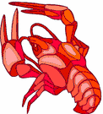
(they did the mash) They did the lobster mash
(they did the mash) It was a seaside smash
(they did the mash) It caught on in a flash
(they did the mash) They did the lobster mash
From my front-row seat at sandcastle west
To the briny deep, beyond the wave crests
The fish all came from their humble abodes
To share in the dance and twinkle their toes
(they did the mash) They did the lobster mash
(they did the mash) It was a seaside smash
(they did the mash) It caught on in a flash
(they did the mash) They did the lobster mash
The dolphins were having fun, the party had just begun
The guests included Marlin and Nemo, his only son.
The scene was rocking, all were digging the sound
Of the lobster claws clicking as all twirled around.
The whales and jellyfish were starting to scream
When a wave crashed loudly, and I awoke from my dream
(of the mash) It was the lobster mash
(oh yes the mash) It was a seaside smash
(you know the mash) It was gone in a flash
(it was the mash) My dream lobster mash.

Give Me A Pond Song
Baltimore Area Council
Tune: Home On The Range
Oh, give me a pond. on a hot summer's day.
Where the frogs and the crayfishies play.
I'll fish and I'11 swim: 'till it's time to go in;
Sopping wet. dripping all of the way.
Splish, splashing. I go.
All wet from my head to my toe.
Skipping stones 'cross the top;
Hope I never need stop;
I'm one happy-go-lucky. wet fellow!

Water Sports Song
Baltimore Area Council
Tune: Yankee Doodle
Water sports are what we like.
For summer, spring and fall.
When summer comes you now must know.
We'll have a great big ball.
Chorus:
Cub Scouts always having fun,
Cub Scouts in the water,
Swimming, diving, fishing, too.
Safely like we "otter".
Rivers and lakes, oceans and streams,
And even swimming pools.
Back stroke, breaststroke, and butterfly,
We'll follow safety rules.
Chorus

Shipwrecked Cub Scouts Song
Longhorn Council
Tune: Gilligan’s Island Theme
Our pack set sail on the sea one day,
In search of coins of gold.
A group of hearty Cub Scouts,
And leaders true and bold.
The weather started getting rough,
The tiny ship was tossed.
If not for the bravery of our Cubmaster,
The whole pack would be lost.
Our boat touched ground on a rocky isle
And up walked a tall old man.
He tossed a towel to dry us off,
And raised high his right hand.
He said, “You’re a sharp pack of Cub Scouts,
Your bravery brave and sure,
To sail out on a sea like this
On a Scouting adventure.”
He gave directions to get home.
We set sail with good cheer.
We reached home with the setting sun,
And tied up to the pier.
We looked in the bottom of the boat
And saw the old man’s towel.
His name was stitched along the hem,
The name was Baden-Powell.

Skin Diver’s Song
Longhorn Council
Tune: Sailing, Sailing
Diving, diving, into the deep blue sea,
And many a fish we’ve scared away
On that you will agree.
Diving, diving, into the ocean blue,
With flippers, and mask and oxygen gas
We’ll have adventures true!

Popeye the Sailor Man Song
Santa Clara County Council
I’m Popeye, the sailor man.
I’m doing the best I can.
I eat all my spinach,
I fight to the finish.
I’m Popeye, the sailor man.

Jaws Song
Tune: Do Re Mi
JAWS a mouth, a great big mouth
TEETH the things that make a crunch
BITE the friendly shark’s “Hello”
US his favorite juicy lunch
BLOOD that turns the ocean red
CHOMP oh what a tasty treat
GULP that means the shark’s been fed
That will bring us back to
JAWS! JAWS! JAWS! JAWS!

Singing in the Rain Song
Capital Area Council, TX
We're singing in the rain, just singing in the rain.
What a glorious feeling, we're happy again.
Thumbs up! [Group echoes.]
A-root-ta-ta, root-ta-ta. root-ta-ta-TA
Add each of the following, in turn
and keep doing all previous motions:
- Thumbs Up,  - Arms Out,  - Elbows In,  - Knees Bent,  - Knees together, | - Toes together,  - Butt out,  - Chest out,  - Head Back,  - Tongue out

Scout Wetspers Song
Capital Area Council, TX
Tune - Oh, Tannenbaum
Softly fall the rains today
As our campsite floats away
Silently, each Scout should ask
"Did I bring my SCUBA mask?
Have I tied my tent flaps down?
Learned to swim so I won't drown?
Have I done, and will I try
Everything to keep me dry?

Outdoor Fun Song
Capital Area Council, TX
Tune:- Camptown Races
Cub Scouts have their outdoor fun,
Doo-dah, doo-dah!
Play their games and sing and run,
Doo-dah, doo-dah!
Chorus:
Going to play their games,
Going to sing their songs,
Cub Scout boys have lots of fun,
‘Cause they all belong.
Cub Scout leaders have fun too,
Doo-dah, doo-dah!
Dressed up in their gold and blue,
Oh, doo-dah day!
Chorus:
Cook the food and eat it all,
Doo-dah, doo-dah!
In the outdoors, have a ball,
Oh doo-dah day!
Chorus:
Swim and splash in the swimming pool,
Doo-dah, doo-dah!
So glad there isn’t any school,
Oh, doo-dah day!
Chorus:

This Sand Is Your Sand Song
Capital Area Council, TX
Tune: This Land is Your Land
This sand is his sand,
This sand is our sand,
On a beach this crowded
We should bring some canned sand!
And all around us
Beach blankets crammed, jammed.
There’s not a sandy spot left free!
We begged our parents
To take us swimming,
Packed pails and shovels –
The car was brimming!
We piled the food in
We brought the dog too.
What fun the beach would be to see!
The heat was driving,
Was tough surviving,
Bumper to bumper
When at last arriving.
No one went swimming
Or felt like playing,
Back home is where we’d rather be!
This sand is my sand,
This sand is your sand,
Right in our backyard,
Aren’t sandboxes great?
No crowd of kids with
Their pails and shovels.
This sand is just for you and me!
STUNTS AND APPLAUSES
APPLAUSES & CHEERS
Baltimore Area Council
Buccaneer Applause: “Yo, ho, ho and a bottle of Coke”,
Deep Sea Diver Applause: “ Blubb, Blubb, Blubb”.
Water Cheer: “How, How, How, Water, Water, Water, Glug, Glug, Glug, Ah-hhh”
Clam Clap Applause: Ask everyone to roll up his sleeves in preparation for this strenuous applause. Double up your fists with your left arm in front of your face and right arm over-head. Then silently open and close your right fist.
Motorboat Applause: Flutter tongue on roof of mouth.
Seal Applause: Extend your arm straight out in front of you and clap with stiff arms while saying, “‘Arf, arf, arf, arf
Beach Cheer: Divide your audience into 3 groups. When you point to group 1, they yell “Sand.” When you point to group 2, they yell “Surf” And when you point to group 3, they yell “Sun.”
Southern NJ Council
Water Sprinkler Applause Make fist with the right hand with thumb sticking out. Place end of thumb on end of nose. Rapidly open and close fist while saying "Choo, choo, choo, choo," etc. sounding like a water sprinkler and turning around as you go. After a complete turn spin back around the opposite direction, again like a water sprinkler, saying "Wheeee."
Longhorn Council
Surfboarders Cheer: Pretend to be riding a surfboard, run it onto the beach, jump off, spread arms wide, say “Success!”
Diver’s Cheer: Same idea as Surfboarders Cheer, but jump off and say “Kersplash.” “Perfect!”
The Wave Cheer: Start with one side and let the wave go around the room twice.
Swimming Applause: Pretend to swim using the breaststroke, clap hands together as you put your arms forward.
Big Rain Applause: Start tapping one finger from each hand. Build quickly one finger at a time until you are clapping both hands. Then reverse and have storm fade away.
Beach Cheer: Divide the audience into three groups. When you point to group one, they yell "Sand!" When you point to group two, they yell, "Surf!" When you point to group three, they yell, "Sun!"
Clam Clap: Fold hands together, interlocking fingers. Make noise by pressing palms together.
Motor Boat: Pull on starter cord a few times while fluttering tongue on roof of mouth. Then start the sound of a motorboat.
Capital Area Council, TX
Water Cheer: “Wet, wet, wet, water, water, water, ah-hhh”
OCEAN APPLAUSE - Best done with a large group; have first row sway from side to side; second row swaying in opposite direction; third row same as first, etc. Then have them add sound effect: SWOOSH, SWOOSH, SWOOSH!!
RAINSTORM APPLAUSE - Start by gently patting knees alternately to simulate rain falling. Increase the noise by switching to hand clapping as the storm reaches its height. With a hand signal, have everyone shout “”BOOM” to represent thunder. Gradually decrease the hand clapping and then pat the knees as the storm subsides.
Backyard Pool Cheer - Don't stand up for this cheer. Lean back in your floating pool chair, take sip of your tall cool drink and say "Ahh, this is the life."

RUN-ONS
Longhorn Council
Cub 1: Why do fish have schools?
Cub 2: So the buoys and gulls can get an education.
Cub 1: Do they have Scouts too?
Cub 2: Sure Buoy Scouts and Gull Scouts.
Cub 1: What do buoy scouts do?
Cub 2: Make sure the coast is clear.
- Why do you keep doing the backstroke?
- I just had lunch and I don’t want to swim on a full stomach.
Cub 1: They say that swimming is one of the best
exercises for keeping the body slim and trim.
Cub 2: Yeah. Right!
Cub 1: Why do you say that?
Cub 2: Well, did you ever see a whale?
Cub 1: What is the first thing the fisherman caught after
running to the river?
Cub 2: His breath!
Cub 1: Do you know what sea monsters eat?
Cub 2: Sure. Submarine sandwiches!
Cub 1: What ship is always managed by more than one
person?
Cub 2: A partnership
Cub 1: What do you call a baby whale?
Cub 2: A little squirt.
Santa Clara County Council
Cub 1: I’ve eaten beef all my life and now I’m as strong as an ox.
Cub 2: That’s funny. I’ve eaten fish all my life and I can’t swim a stroke.
- What stays in bed most of the day and sometimes goes to the bank? A stream.
- Where can you find an ocean without water? On a map.
- What do sea monsters have for dinner? Fish and ships.
- What do you call a thing that sits on the bottom of the ocean and twitches? A nervous wreck.
- When is a ship like snow? When it’s a-drift.
- What gets wetter the more it dries? A towel.
- What kind of lights did Noah’s ark have? Floodlights.
- Where is the ocean the deepest? On the bottom.
- Did you hear about the pelican that switched from sardines to herring? The smaller fish just didn’t fill the bill.
Circle Ten Council
Boy: How many fish have you caught?
Fisherman: None yet. But I've only been fishing for an hour.
Boy: That's better than the man who was fishing here yesterday.
Fisherman: How's it better?
Boy: It took him five hours to do what you've done in just one!
Great Salt Lake Council
Scout 1: Where do rivers keep their money?
Scout 2: In their banks!
Father: How are your test scores, Son?
Son: Underwater, Dad.
Father: What do you mean, underwater?
Son: You know, below C level.
Scout 1: Why can’t you get two elephants into a pool at the same time?
Scout 2: They only have one pair of trunks.
Doctor: Take the green pill with a glass of water after getting up. Take the blue pill with a glass of water after lunch. Then just before going to bed take the red pill with another glass of water.
Patient: Exactly what is my problem, doctor?
Doctor: You’re not drinking enough water.
Web Ldr: Where did you take your bath?
Webelos: In the spring!
Web Ldr: I didn’t ask you when . . . I asked you where!!!
Capital Area Council, TX
Cub 1: Are there any athletes in your family?
Cub 2: My brother has been swimming for five years.
Cub 1: He must be pretty tired.
Cub 1: My mother does bird imitations.
Cub 2: Really? How does she do that?
Cub 1: She watches me like a hawk.

JOKES & RIDDLES
Baltimore Area Council
Why did the boy throw water out of the window?
He wanted to see a waterfall.
What does not get any wetter no matter how much it rains?
A lake.
Why didn’t the man swim on an empty stomach?
Because it is easier to swim in water.
Where do ships go when they are ill? To the “docks!”
What part of a fish weighs the most? The scales
What fish helps musicians? A tuna fish
Circle Ten Council
- What fish would an actor like to be? Starfish
- What fish should wear a crown? Kingfish
- What fish might say, 'Bow wow"? Dogfish
- What fish can play in a band? Drumfish
- What fish might chase a mouse? Catfish
- What fish may be found on a boat? Sailfish
- What fish is the best fish of all? Angelfish
- What do sharks like to eat with
peanut butter sandwiches? Jellyfish
- What kind of cat lives in the ocean? An octopus
Sam Houston Area Council

“H” TO “O”
Teacher: What is the formula for water?
Student: H, I, J, K, L, M, N, O
Teacher: Whoever told you that?
Student: You did! You said it was H to O

ALLERGIC
Cub #1: What do you call someone allergic to water?
Cub #2: I give up. What?
Cub #1: Dirty.

THE CANTALOUPE
Cub #1: Why did the cantaloupe jump into the water?
Cub #2: Why?
Cub #1: It wanted to be a watermelon.
SKITS

Waterways Skit
Baltimore Area Council
This could easily be adapted for an Opening CD
Props: A picture indicating each boy’s sentence. Text can be cut and pasted to back of picture.
- (holds up picture of a lake) A waterway is any navigable body of water. These include rivers, lakes, oceans, and canals. In order for a waterway to be navigable, it must meet several criteria:
- (holds up picture of a sailboat with a big keel) The waterway must be deep enough to allow the draft depth of the vessels using it;
- (picture of boat pushing barges on the Mississippi) The waterway must be wide enough to allow passage for the beam width of the vessels using it;
- (picture of Niagara Falls) The waterway must be free of barriers to navigation such as waterfalls and rapids, or have a way around them, such as canal locks;
- (picture of whitewater rapids) The current of the waterway must be mild enough to allow vessels to make headway.
- (picture of a cruise ship) Vessels using waterways vary from small animal-drawn barges to immense ocean tankers and ocean liners, such as cruise ships.
- (picture of barge on canal) At one time, canals were built mostly for small wooden barges drawn by horses or other draft animals. Today, major canals are built to allow passage of large ocean-going vessels. See Ship Canal.

How Did You Get Here? Skit
Circle Ten Council

The skit is introduced by saying, that “many different kinds of ships were used by the people that helped settle America. Any number of Cub Scouts can be used for this skit either by dividing the lines accordingly or creating new ones.
Cub 1: If the Pilgrims came over on the Mayflower how did the Cub Scouts get here?
Cub 2: I don’t know? How?
Cub 1: On handy crafts. (As he says this, a Scout comes on stage with a sample of the handicraft project and a sign identifying it)
Cub 1: If Pilgrims came on the Mayflower and the Cub Scouts came on handy crafts, how did the doctors get here?
Cub 2: I don’t know. How?
Cub 1: On blood vessels. (Boy dressed as a doctor enters)
Cub 1: How did the students get here?
Cub 2: On scholarships (Boy carrying books)
Cub 1: How did all the ordinary people get here?
Cub 2: On citizenship. (Boy carrying sign that says, “Don’t forget to vote”)
Cub 2: I know how the barbers got here.
Cub 1: How?
Cub 2: On clipper ships. (Boy dressed as a barber)
Cub 1: How did all the movie stars get here?
Cub 2: On a showboat. (Boy wearing fancy clothes and sun glasses)
Cub 2: I’ll bet you can’t guess how all the hot heads got here?
Cub 1: That’s easy, they all came over on a steam ship.
(Curtain closes the end)

Who Am I Skit
Baltimore Area Council
Set Up: This is a spin off from Family Feud. The teams play the game for real. Respond to answer for the MC means for him to say something witty about the response. The Master of Ceremonies (MC) enters first
MC: Welcome to our show. Tonight our two teams are back stage, ready and anxious to begin. So lets bring out the first team… The CUBBIES! (Cub Scouts run out and take their place on one side of stage. As they run out the Master of Ceremonies assistant holds up a sign that says “CHEER”; This sign is to be held up each time the audience is to participate with a cheer).
Now, let’s bring out the second team… The C. P.’s - The Cubbies Parents. (Cheer)
The captain of each team has a bell, if you know the answer to the question - ring the bell. The Team to get the most correct answers of course is the winner. Now, if you are ready we will begin. (Teams both answer “READY”) We have celebrities here to ask the questions. Do not ring your bell until the entire question has been asked. First Celebrity please step forward. By the way, just a little clue, each of the Celebrities has something to do with water.
FIRST CELEBRITY: (Wearing a hat to depicting Columbus) I sailed the ocean blue in 1492 . . . Who am I?
MC: (Respond to answer) Now for the second Celebrity.
SECOND CELEBRITY: (Wearing hat to depict John Paul Jones) On many ships I did sail, in battle I must not fail! I fought hard through the night. You can quote my words, “I’ve just begun to fight.”
MC: (Respond to answer) Will the third Celebrity please come out?
THIRD CELEBRITY: (Wearing hat to depict Popeye) I love to sail, it is true. To make me strong I eat my spinach too!…Who am I?
MC: (Respond to answer) As our next celebrity comes out, listen very carefully as he whistles a tune to tell you who he is.
FOURTH CELEBRITY: (Wearing hat to depict Gilligan from Gilligan’s Island) Enters whistling Gilligan’s theme song.
MC: (Respond to answer)
MC: Both teams have done your best, however, the winner is (name team). (Cheer) (To the losers) You have tried hard, and you are a winner, too. So here’s a refresher for you, (assistant runs out with a bucket and it looks like he is going to throw water on the losers. (Ham this up) But when he finally goes to throw the contents only some confetti (or another gag item) comes out..

A Ship Like This Skit
Baltimore Area Council
Characters: 3 boys
Scene: Aboard an ocean liner. A small table with a chair on each side. Mr. Niffy, who is very unhappy, sits in the right hand chair. He picks up a book, signs, puts down the book. Looks around. Taps the table with his finger tips. Tries to read again. Mr. Tiffy enters left.
Mr. Tiffy: Good Morning, Mr. Niffy. How are you, today?
Mr. Niffy: Oh, oh, I just don’t know.
Mr. Tiffy: May I sit down?
Mr. Nifty: Of course! Of course! Do whatever you wish. Anything you do is all right with me.
Mr. Tifty: Did you sleep well last night?
Mr. Niffy: No, no, not a wink!
Mr. Tiffy: Were you seasick?
Mr. Nifty: No, no, I wasn’t seasick.
Mr. Tiffy: Well, what’s your problem?
Mr. Nifty: I’m afraid.
Mr. Tiffy: Afraid of what?
Mr. Nifty: I’m afraid this ship will sink.
Mr. Tiffy: Oh, come on. That’s a silly fear. A ship this size doesn’t sink!
Mr. Nifty: Oh, I read about a ship that sank.
Mr. Tiffy: Here comes the Steward. Let’s talk to him.
Mr. Niffy: All right.
Mr. Tiffy: Pardon me, Steward.
Steward: Good Morning, gentlemen! May I help you?
Mr. Tiffy: I hope so. We have a question. Maybe you can answer it and put our minds to rest.
Steward: I’ll answer if I can.
Mr. Tiffy: Does a ship like this sink very often?
Steward: Oh, No! (Men smile happily.) A ship like this sinks only once!

Man Fishing Skit
Baltimore Area Council
A man was fishing and catching fish like crazy. Two men were watching him and wondering what his secret was. They asked him what his secret is and he, just mumbles. They keep watching him reel in the fish and they again ask him what his secret is and he just mumbles. They ask a third time. He spits something into his hand and answers "Keep the worms warm".
I’ve seen this done with a whole den/patrol asking the man one at a time. It is, also, good in the winter if they pretend they are ice fishing. CD

Facts of Water Skit
Baltimore Area Council
Cast: Six Cub Scouts
Equipment: Buckets of water the Scouts can hold while speaking.
- Did you know that watermelon isn't called that for nothing? It's 97% water.
- Did you know that during a lifetime, you will drink about 16,000 gallons of water?
- Did you know if all the valleys and mountains on land and on sea were leveled, water would cover the entire earth two miles deep?
- Did you know that waterpower is no idle phrase? Water flowing at 10 miles an hour can move a rock 10 feet thick. Cub 5: Did you know that water helps regulate climate: It absorbs heat in summer and releases it in the winter.
- Did you know that a birch tree releases about 70 gallons of water into the atmosphere each day, almost the amount person uses in his home each day?

The Fisherman Skit
Baltimore Area Council
Cast: 2 Cubs
Setting: A fish market, customer and merchant
Customer: I want you to do me a favor.
Merchant: What is it Mr. Bigwig?
Customer: I just got back from a fishing trip.
Merchant: Did you catch anything?
Customer: No, and that's the catch. My wife said I wouldn't and I'm in the doghouse. I said I would catch six fish. Merchant: Well, how can I help you.
Customer: Let me have 6 of those medium trout there.
Merchant: Wrap 'em up?
Customer: No, don't make a liar out of me. Pitch `em to me one at a time.
Merchant: Well, I don't understand but here goes. (Tosses the fish to the Customer) What was that for?
Customer: Very simple. I caught them, didn't 1?
Merchant: (Grinning) You're right Mr. Bigwig. Good Luck. (Customer leaves)

Fishing Skit
Baltimore Area Council
Cast: 2 Cubs
Setting: 'Two Cubs are rowing an imaginary boat
Cub #1: Whew! It sure is a long way out here.
Cub #2: Yep (Puts hand to eyes) I can't see the shore anymore. Ready to start fishing?
Cub #1: I think so. Looks like a good spot to me.
(Both ready imaginary rods, reels, hooks, worms, etc. and start fishing. Immediately they both start to catch fish, recast and catch more. Continue for several casts)
Cub #2: I told you this would be a good spot.
Cub #1: Sure is, the boat's full. Guess we have our limit, better get back.
Cub #2: OK. (Gets oars ready)
Cub #1: Did you use a map to get here?
Cub #2: How are we ever gonna find our way back'?
Cub #l: Oh. that's easy. I'll Just mark the spot with a big X right here on the side of the boat!
(Makes mark, both row away quickly)

THE FISHING TRIP Skit
Circle Ten Council
Set Up:
- Make a cardboard cutout of a boat and a sign that says “Boat Dock”.
- The scene starts with the boat about 10 feet away from the boat dock.
- The Cub Scouts and their Den Chief are on their way to go fishing.
Cub #1: Stops at the dock then walks out across the water and gets in the boat.
Cub #2: Hey wait for me! (He walks out to the boat.)
Den Chief: Oh well... (Steps into the water and pretends to fall in and drags himself out)
Cub #3: Hey wait up. Here I come. (Walks out to the boat.)
Den Chief: (Tries and fails again.)
The sequence continues until all the boys are in the boat and only the Den Chief remains on shore.
Cub #1: Should we tell him where the rocks are?

Water Water Skit
Capital Area Council, TX
- A man crawls out on the stage calling "Water, Water" as if he is very thirsty
- A Man walks by and says: "Sorry."
- He continues walking off stage.
- Another man walks by, the crawling man tugs on his pant leg: "Water, Water!"
- Man walking by: "All I've got is this beef jerky, sorry."
- He keeps walking.
- Another man walks by, the crawling man tugs on his pant leg: "Water, Water!"
- Man walking by: "No, I don't have any."
- He keeps walking.
- The crawling man sees a cup of water at the other end of the stage.
- "Water!!" He painfully crawls over there.
- "Water! Water!"
- When he reaches the water, he quickly stands up, dunks his comb in it, and uses it to comb his hair.
- And skips off stage.
CLOSING CEREMONIES

Beach Party Closing Ceremony
Voyageur Council
This can be done two ways –
- First - Cubmaster carries a water squirter and a beach towel. Now he lays them down after wringing out some imaginary drops of water from the towel and proceeds to talk.
- Second - Have Five cub Scouts dressed in beachwear and have each one say a part with appropriate pictures and actions.
Cubmaster - Well we've come to the end of another fun, fishy, delightful pack meeting. In planning a successful activity for Cub Scouts age boys, there are five essential ingredients to include:
  - First is ACTION. Boys find it impossible to sit and do nothing. Action makes everything much easier. Today we had ACTION!
  - Second is SOMETHING TO WATCH. Watching and helping celebrate another's accomplishments and hard work is one of the best ways to have fun watching
  - Third is having SOMETHING TO TALK ABOUT. It's fun for Scouts to hear adults telling stories and fun for them to do things that are worth talking about later. I think we accomplished that today.
  - Fourth is SOMETHING TO LAUGH AT. We all need to enjoy laughter, and sharing fun experiences is one of the best ways to do that. Did we succeed with laughter?
  - Fifth is SOMETHING TO HELP WITH. Parents, leaders and family members are involved in helping Cub Scouts move along on their trail toward Bobcat, Wolf, Bear, Webelos, and Arrow of Light. But just in case you missed out on helping this week, we have one more chance -- after the retiring of the colors, you can all HELP with the cleanup!

Transportation of Smiles Closing Ceremony
Baltimore Area Council
Set Up: 6 Cubs carrying posters of barges each with one of the following letters S-M-I-L-E-S and 2 Cubs carrying cartoon tug boats with smiles on both ends of the line.
- Something that should be transported every day, is a smile from one another as we hurry on our way,
- While carrying SMILES we’re transporting a valuable treasure
- For the value of transporting a smile to others we can’t even measure.
- That smile we give from the heart can lighten someone’s load,
- Making brighter his day as he travels down life’s road.
- So carry a smile with you wherever you go
- And transport to others a friendly glow.
- It only takes a mile with curves at beginning and end to give others smiles and win for us a friend.

NET CLOSING Ceremony
Santa Clara County Council
Form a net by clasping hands in any criss-cross design making sure everyone is caught in the net (part of the net). Boys shake each other’s hand that they are holding and say “Do Your Best.”

Conservation Closing Ceremony
Longhorn Council
Cubmaster (holding picture of large local waterway (or a small one or a famous one (e.g. Mississippi, Hudson, or Delaware River or one of the Great Lakes)): The Waterways of the USA are great and beautiful. The Waterways and the rest of America is ours to enjoy. Surely we want to preserve it for the thousands of boys who will come after us. Let us close our meeting by standing and repeating in unison a pledge that will remind us to conserve our H2Ohhh! And waterways and other wonderful parts of our country for those who follow us. (Repeat the Outdoor Code.)
OUTDOOR CODE:
As an American, I will do my best to:
Be clean in my outdoor manners,
Be careful with fire,
Be considerate in the outdoors,
And be conservation minded.
Nature And The Good Visitor
Longhorn Council
Committee Chairman: Our pack meeting tonight brought us all together to think about the waterways near our town and the outdoor opportunities they provide. We can enjoy the waterways and the great outdoors but we must think of others who will follow us. Wherever you go in the great wide world of nature, try to be a "good" visitor who will leave the plants and the creatures for others to enjoy after you leave.
- The only shots I took were snapshots.
- I tried to walk on pathways to keep off plants.
- When I see animals or birds, I try to remember that I am a guest in their living place and I don't do anything to them but look at them.
- The one big thing I always do when I am ready to go home is to look and see that all fires are out in nature's backyard.
Cubmaster: With Cubs and Webelos like you to help keep our friends on the ball, I'm sure that the beauties of nature will be around for years to come. Thanks Cubs, Good night.

Water Fun Closing Ceremony
Capital Area Council, TX
- Well, we sure had fun getting you wet.
- We had the best time ever yet.
- Thanks for helping in our little party,
- And joining us as
- The water fun was, oh, so grand,
- But now we change from sea to land
- Join us again next month
Cubmaster’s Minutes

Three Important Things Cubmaster Minute
Capital Area Council, TX
To the sailor, three things were essential - a compass, a sextant, and a flag. The compass to tell them where they were heading during the day. The sextant to tell them where they were at night, And the flag to tell them which way the wind is blowing
To Cub Scouts, these three things are important - (show items) a badge, a handbook, and a candle. The badge tells who you are and where you are going' the handbook tells how to get where you are going, and the candle is a symbol of the light of Scouting. It is a light that must be kept burning in the heart of every Scout.

Togetherness Closing Thought Cubmaster Minute
Capital Area Council, TX
Summer is a good time for the family to do many thing together and enjoy the beauty about them. A family that shares a lot of experiences is one that will always be a "together" family, even in later years when you are miles apart. Think about it! There's no better feeling than that of belonging. I am happy to see so many here tonight taking advantage of this summer Pack meeting. Good night and see you next month.

Captain Of All Scouts Cubmaster Minute
Capital Area Council, TX
Now may the great Captain of all Scouts
Who created the seas and all things that live therein
And Who gave us dominion over them
Be with us till we meet again.

Starfish Cubmaster’s Minute
Capital Area Council, TX
A friend of mine was walking on a beach one day when he saw a native bend down and throw a starfish back into the ocean. He asked the native why he was doing it. “You see, it’s low tide right now and all of these starfish have been washed up onto the shore. If I don’t throw them back into the sea, they’ll die up here from lack of oxygen.” “I understand,” my friend replied, “but there must be thousands of starfish on this beach. You can’t possibly get to all of them. There are simply too many. And don’t you realize this is probably happening on hundreds of beaches all up and down this coast? Can’t you see that you can’t possibly make a difference? “The local native smiled, bent down and picked up yet another starfish, and as he threw it back into the sea, he replied, “Made a difference to that one!”

Remember to be Grateful Cubmaster Minute
Baltimore Area Council
In this area, everything we do affects the Chesapeake Bay and its wildlife. We should remember that we have a lot to be grateful for. Not only Maryland's natural resources, but also our families, friends, and neighbors. Please remember this as we leave here tonight and we'll all be in a better world.
I am sure there most of us live near a body of water we could use in this minute. CD

LIFE IS LIKE A RIVER Cubmaster Minute
Santa Clara County Council
As we go through life, let us be ever reminded that life is like a river rushing to the sea, flowing sometimes slow, sometimes fast and yet able to go in different directions. As the water flows, it may stumble but yet continue to flow until it eventually finds its way again. The water may run clear and clean or dark and dirty. And so it is in life, except you are given the choice to choose which direction you will go. Choose wisely.

“WORK WHILE YOU WORK” Cubmaster Minute
Santa Clara County Council
Tonight we’ve had a lot of fun at our “Under the Sea!” pack meeting. Here’s a thought to take home with you.
Work while you work, play while you play;
One thing at a time, that is the way.
All that you do, do with all your might;
Things done halfway are not done right.
Now Cub Scouts, go out and do your best!

MAKE A FEW WAVES Cubmaster Minute
Santa Clara County Council
When fog prevents a small-boat sailor from seeing the buoy marking the course he wants, he turns his boat rapidly in small circles, knowing that the waves he makes will rock the buoy in the vicinity. Then he stops, listens and repeats the procedure until he hears the buoy clang. By making waves, he finds where his course lies. Often the price of finding these guides is a willingness to take a few risks, to “make a few waves.” A boat which always stays in the harbor never encounters danger, but it also never gets anywhere. I challenge each of you to make waves and diligently seek your goals in life. Set your sails for new and exciting horizons.

WATER Cubmaster Minute
Circle Ten Council
"We've had plenty of fun with water tonight, but as we leave, let's take a moment to remember what a precious resource water is, especially in the heat of the summer. We play in it, we bathe in it, and we drink it. We eat the fish that live in it. We use water to irrigate our crops and our lawns. Without water, our earth would be as lifeless as the moon. Let's all do our best this month to help conserve this great natural resource.

Candle Cubmaster Minute
Circle Ten Council
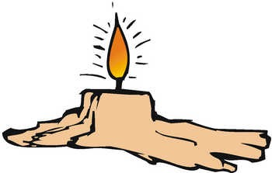
Throughout our meeting this evening, this candle, which represents the spirit of Cub Scouting, has burned. Look steadily at it for a moment. (Pause) Now close your eyes. The image remains with you. Now open your eyes. We will blow out the light. As the image of the light remained in our memory, so will the spirit of Cub Scouting stay with us. The evening of fun and good cub scouting will not soon be forgotten.

Mutiny Cubmaster Minute
Baltimore Area Council
Mutiny is a word we hear connected with pirates on the waterways. It is the act of insurrection or a refusal to obey the authority of the captain of the ship. It is often the cause of a disastrous end to all involved.
As Cub Scouts, our promise to obey The Law of the Pack and to live up to the Cub Scout Promise can only lead to a better life as a good citizen of this great country of ours. Let us not be mutineers, but strong supporters of the Boy Scouts of America.
THEME RELATED STUFF

Water Sayings:
Alice, Golden Empire Council
Here’s a list of some water sayings from around the world. See how many you have heard and how many you can explain.
- Even if you sit on the bottom of the sea, you cannot be a fish. (Africa)
- Have an umbrella ready before you get wet.
- A drop in the bucket
- Blood is thicker than water
- Break the ice
- Down the drain
- Finding your sea legs
- Having a ripple effect
- If a crocodile deserts the water, he will find himself on a spear (Africa)
- It’s all water under the bridge
- Like water off a duck’s back
- Make a big splash
- Somebody is all wet
- Steamed up..
- Still waters run deep
- The stone in the water knows nothing of the hill which lies parched in the sun (Africa)
- The well’s run dry
- Treading water
- Wet behind the ears
- When it rains it pours
- Watered down…
How many more can you think of?

Fun Facts About Water:
Alice, Golden Empire Council
- Water, either liquid or frozen, covers about 75% of the earth’s surface.
- About 30% of the earth’s fresh water is in groundwater and 70% is in ice (including ice caps, glaciers, permanent snow, ground ice, and permafrost)
- They don’t call it watermelon for nothing – its 97% water!
- The human body is 70% water!
- A birch tree can release about 70 gallons of water into the atmosphere each day.
- Water flowing at 10 miles an hour can move rocks 10 feet thick.
- In Northern Chile, years go by without a drop of rain.
- In parts of India, they get more than 400 inches a year of rain.
- If all the land on the earth and under the sea were leveled out, water would cover the entire earth two miles deep!
- Water has polar properties – a positive and a negative, while oil has no polar properties, which is why “Water & Oil don’t mix.”
- One third of the earth’s annual precipitation runs off into the ocean.
- It takes at least 600 gallons of water to make a hamburger – water for the cow to drink, water to grow what he eats, water to process the meat. Add to that the following things you eat with your burger:
Bag of hamburger buns – 150 gallons
Head of lettuce – 6 gallons
Tomatoes – 3 gallons
French Fries – 6 gallons
Here are some more products and the amazing amounts of water it takes to produce a serving:
Almonds: 12 gallons
Orange: 14 gallons
Milk: 65 gallons
Rice : 35 gallons
Watermelon: 100 gallons
1 Egg: 120 gallons
Loaf of bread: 150 gallons
1 Car: 39,000 gallons

Saving Water in the House:
Alice, Golden Empire Council
- Replace older toilets with high efficiency models – Check with local water utility for possible rebates.
- Toilet Devices are a less expensive alternative – They reduce the amount of water needed by filling up space in the tank.
- Showerheads - Install a water efficient showerhead that uses no more than 2.5 gallons of water per minute. (Half what a normal showerhead uses)
- Aerators - Low-flow aerators on your kitchen and bathroom faucets are easy to install and reduce water use and splashing . Your water company may provide them free!
- Clothes washers – Newer models typically use about 30% less water and between 40 to 70% less energy – and rebates may be available!

Water Waste Prevention:
Alice, Golden Empire Council
- Fix running toilets - A "running" toilet can waste two gallons of water per minute. A silent leak in a toilet can waste up to 7,000 gallons of water per month. To find silent leaks, put food coloring in the tank. Do not flush. Check the toilet bowl ten minutes later. If you see color in the bowl, the tank has a silent leak. Also, teach every member of your family where to shut off water at the toilet when making repairs or in case of a clog. Let your scout help fix the leak for credit in advancement or electives. Ask a home store or hardware store for instruction.
- Fix leaking faucets - a slow steady drip (100 drops per minute) - wastes 350 gallons per month. A small stream wastes 2,000 to 2,700 gallons of water per month. Replacing worn washers in your faucets will usually stop leaks.
- Look for hidden leaks. Turn off all running water in the house.. Don't use any water for 30 minutes, then read the water meter. If it shows water used, you have a hidden leak that needs repair.
- Save the water when running a faucet to get hot or cold temperature - put a gallon jug under the faucet. You can then use this water for other things around the house.
- Insulate hot water pipes and your water heater where possible to minimize water waste while waiting for hot water.
- While brushing your teeth, turn off the tap. Use a cup for water; run the tap only to rinse the toothbrush.
- When showering and washing hands, wet your body. Turn off the water, apply soap, and then turn on the water to rinse.
- When washing dishes by hand, instead of running water to rinse dishes, fill the kitchen sink and dip dishes in water to rinse. Automatic dishwashers are more efficient than hand washing dishes, but wash only full loads.
- Fill the sink or a bowl with water to wash fruits and vegetables.
- Keep a container of water in the refrigerator rather than running tap water for a cool drink.
- Operate the disposal only when necessary. Consider composting food waste in your garden.

Saving Water in the Yard
Alice, Golden Empire Council
- Water less frequently but more deeply. Think of your soil as a reservoir that holds water for your plants.
- Adjust your water controller according to the seasons.
- Reduce runoff caused by long water application times. Three five-minute applications with an hour in between will allow the soil to absorb more of the applied water that one 15-minute application, and prevent runoff.
- Exchange your irrigation controller for a Water-Smart Irrigation Controller. You may be eligible for a rebate from your local water district!
- Routinely check your irrigation system for leaks, broken or misdirected heads.
- Choose drip irrigation. Drip irrigation systems apply water at gallons per hour instead of minutes!
- Select plants that are adapted to your climate. Plants native to your area will need no water once established. Check with a local nursery or master gardener..
- Group plants according to their high, medium, or low water needs.
- Apply mulch to your garden – use at least 3 inches to maintain moisture, suppress weeds, protect the irrigation system and give a finished look to the garden. Never apply mulch right up against the main stem or trunk of a plant.

ONE LAST THING

Fifteen Steps to Building a Campfire
Baltimore Area Council
- Split dead limb into fragments and shave one fragment into slivers.
- Bandage left thumb.
- Chop other fragments into smaller fragments
- Bandage left foot.
- Make structure of slivers (include those embedded in hand)
- Light Match
- Light Match
- Repeat, “A Scout is cheerful” and light match.
- Apply match to slivers, add wood fragments, and blow gently into base of fire.
- Apply burn ointment to nose.
- When fire is burning, collect more wood.
- Upon discovering that fire has gone out while out searching for more wood, soak wood from can labeled “kerosene.”
- Treat face and arms for second-degree burns.
- Relabel can to read “gasoline.”
- When fire is burning well, add all remaining firewood.
- When thunderstorm passes, repeat steps 1 through 15.

DEN ADVENTURES


TIGER


Games Tigers Play
Tiger Adventure: Games Tigers Play
1. Do the following:
a. Play two initiative or team-building games with the members of your den.
b. Listen carefully to your leader while the rules are being explained, and follow directions when playing.
c. At the end of the game, talk with the leader about what you learned when you played the game. Tell how you helped the den by playing your part.
2. Make up a game with the members of your den.
3. Make up a new game, and play it with your family or members of your den or pack.
4. Find out how being active is part of being healthy. While at a sporting event, ask a player or coach why he or she thinks it is important to be active.
5. Bring a nutritious snack to a den meeting. Share why you picked it and what makes it a good snack choice.



Tigers – Safe & Smart
Tiger Elective Adventure: Tiger: Safe and Smart
1. Do the following:
a. Memorize your address, and say it to your den leader or adult partner.
b. Memorize an emergency contact’s phone number, and say it to your den leader or adult partner.
c. Take the 911 safety quiz.
2. Do the following:
a. Show you can “Stop, Drop, and Roll.”
b. Show you know how to safely roll someone else in a blanket to put out a fire.
3. Make a fire escape map with your adult partner.
4. Explain your fire escape map, and try a practice fire drill at home.
5. Find the smoke detectors in your home. With the help of your adult partner, check the batteries.
6. Visit an emergency responder station, or have an emergency responder visit you.


Tiger Theatre
Tiger Elective Adventures: Tiger Theater
1. With your den, discuss the following types of theater: puppet shows, reader’s theater, and pantomime.
2. As a den, play a game of one-word charades with your adult partners.
3. Make a puppet to show your den or display at a pack meeting.
4. Perform a simple reader’s theater. Make a mask afterward to show what your character looks like.
5. Watch a play or attend a story time at a library.


WOLF


Paws on the Path
Wolf Adventure: Paws on the Path
1. Show you are prepared to hike safely by putting together the Cub Scout Six Essentials to take along on your hike.
2. Tell what the buddy system is and why we always use it in Cub Scouts.
3. Describe what you should do if you get separated from your group while hiking.
4. Choose the appropriate clothing to wear on your hike based on the expected weather.
5. Before hiking, recite the Outdoor Code and the Leave No Trace Principles for Kids with your leader. After hiking, discuss how you showed respect for wildlife.
6. Go on a 1-mile hike with your den or family. Watch and record two interesting things that you’ve never seen before.
7. Name two birds, two bugs, and two animals that live in your area. Explain how you identified them.
8. Draw a map of an area near where you live using common map symbols. Show which direction is north on your map.


Hometown Heroes
Wolf Elective Adventures: Hometown Heroes
1. Talk with your family and den about what it means to you to be a hero. Share the name of someone you believe is a hero. Explain what it is that makes that person a hero.
2. Visit a community agency where you will find many heroes. While there, find out what they do.
Share what you learned with your den.
3. With the help of a family member, interview one of your heroes, and share what you learn with your den. Tell why you think this person is a hero.
4. As a den or family, honor a serviceman or servicewoman by sending a care package along with a note thanking them for their service.
5. With your family or den, find out about animals that are trained to help others in your community.
6. Participate in or create an event that celebrates your hometown hero(es).


BEAR


Paws for Action
Bear Adventure: Paws for Action
1. Do the following:
a. Find out about two famous Americans. Share what you learned.
b. Find out where places of historical interest are located in or near your community, town, or city. Go and visit one of them with your family or den.
c. Learn about our flag. Display it at home for one month. Say the Pledge of Allegiance and learn its meaning.
2. Do the following:
a. Visit a local sheriff’s office or police station, or talk with a law enforcement officer visiting your den. During the visit, take turns with your den members asking questions that will help you learn how to stay safe.
b. During or after your visit with a law enforcement officer, do at least two of the following:
i. Practice one way police gather evidence by taking fingerprints, taking a shoe print, or taking tire track casts.
ii. Make a list of emergency numbers to post in your home, and keep a copy with you in your backpack or wallet.
iii. With your family, develop a plan to follow in case of an emergency, and practice the plan at least three times. Your family can determine the emergency, or you can develop several plans.
iv. Discuss with your parent or another adult you trust any worries you have about your safety or a friend’s safety.
v. If you have younger brothers and sisters, make sure they know how to call for help in an emergency.
3. Do the following:
a. Learn about the energy your family uses and how you can help your family decrease its energy use.
b. Do a cleanup project that benefits your community.


Salmon Run
Bear Elective Adventures: Salmon Run
1. Explain the safety rules that you need to follow before participating in boating.
2. Identify the equipment needed when going boating.
3. Demonstrate correct rowing or paddling form. Explain how rowing and canoeing are good exercise.
4. Explain the importance of response personnel or lifeguards in a swimming area.
5. Show how to do both a reach rescue and a throw rescue.
6. Visit a local pool or swimming area with your den or family, and go swimming.
7. Demonstrate the front crawl swim stroke to your den or family.
8. Name the three swimming ability groups for the Boy Scouts of America.
9. Attempt to earn the BSA beginner swimmer classification.



WEBELOS CORE


First Responder
Webelos Adventure: First Responder
Do all of these:
1. Explain what first aid is. Tell what you should do after an accident.
2. Show what to do for the hurry cases of first aid:
a. Serious bleeding
b. Heart attack or sudden cardiac arrest
c. Stopped breathing
d. Stroke
e. Poisoning
3. Show how to help a choking victim.
4. Show how to treat for shock.
5. Demonstrate that you know how to treat the following:
a. Cuts and scratches
b. Burns and scalds
c. Sunburn
d. Blisters on the hand and foot
e. Tick bites
f. Bites and stings of other insects
g. Venomous snakebite
h. Nosebleed
i. Frostbite
6. Put together a simple home first-aid kit. Explain what you included and how to use each item correctly.
7. Create and practice an emergency readiness plan for your home or den meeting place.
8. Visit with a first responder.


Webelos Walkabout
Webelos Adventure: Webelos Walkabout
Do all of these:
1. Create a hike plan.
2. Assemble a hiking first-aid kit.
3. Describe and identify from photos any poisonous plants and dangerous animals and insects you might encounter on your hike.
4. Before your hike, plan and prepare a nutritious lunch. Enjoy it on your hike, and clean up afterward.
5. Recite the Outdoor Code and the Leave No Trace Principles for Kids from memory. Talk about how you can demonstrate them on your Webelos adventures.
6. With your Webelos den or with a family member, hike 3 miles (in the country if possible).
7. Complete a service project on or near the hike location.
8. Perform one of the following leadership roles during your hike: trail leader, first-aid leader, lunch leader, or service project leader.



ARROW OF LIGHT CORE
- None

WEBELOS & AOL ELECTIVES


Build My Own Hero
Do all of these:
1. Discover what it means to be a hero. Invite a local hero to meet with your den.
2. Identify how citizens can be heroes in their communities.
3. Recognize a hero in your community by presenting him or her with a “My Hero Award.”
4. Learn about a real-life hero from another part of the world who has helped the world be a better place.
5. Learn about a Scout hero.
6. Create your own superhero.

