http://www.USScouts.Org • http://www.MeritBadge.Org
Please submit errors, omissions, comments or suggestions about this workbook to: Workbooks@USScouts.Org
Comments or suggestions for changes to the requirements should be sent to: Advancement.Team@Scouting.Org
Cub Scout’s Name: Pack No. :
This adventure is an elective adventure which can be used to earn the Wolf Badge.
Complete Requirements 1-4 and any other(s) of your choice.
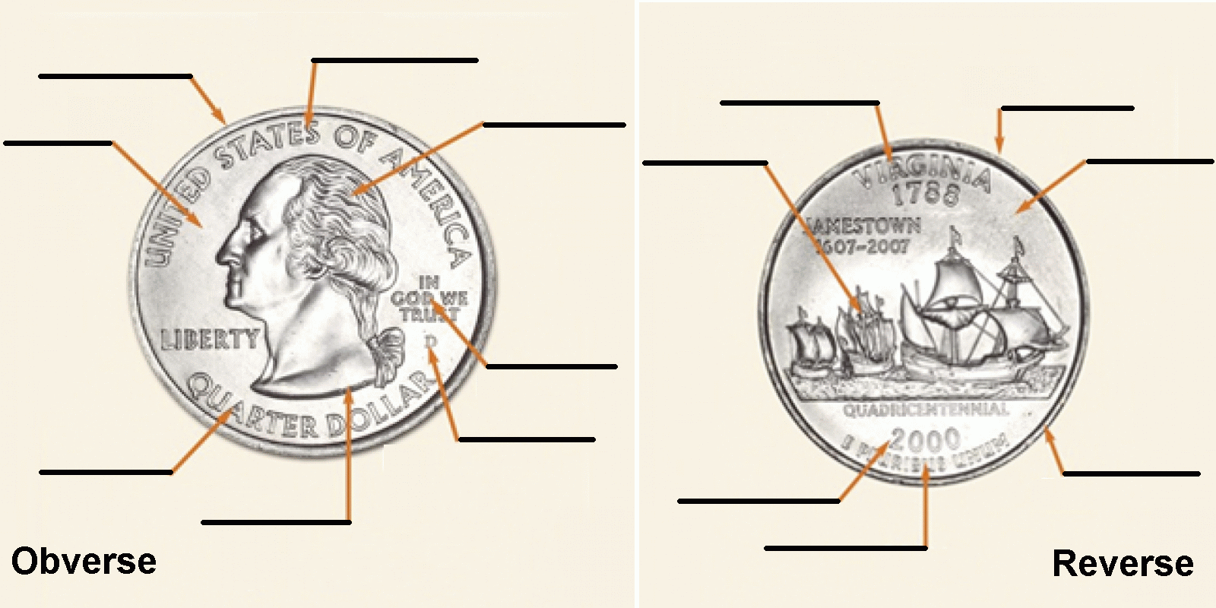
1. Identify different parts of a coin.
2. Find the mint mark on a coin.
Identify the mint where the coin was made,
and the year.
Note: The image on this page is a modified version of images of a 2000-D Virginia Statehood Quarter, found on the American Numismatic Association website at https://www.money.org/parts-of-a-coin with the legend erased.

3. Choose a coin that interests you, and make a coin rubbing. List information next to the coin detailing the pictures on it, the year it was made, and the mint where it was made.
Obverse |  | Reverse
Picture: |  | Picture:
Year: |  | Mint:
4. Play a game or create a game board with your den or family where you can practice adding and subtracting coins.
Describe the game:
When was this done?

5. Play a coin game.
Describe the game:
When was this done?
6. Create a balance scale.
When was this done?
7. Do a coin-weight investigation.
What was done?
When was this done?

[1.0.0.0] — Introduction
The current edition of the Guide to Advancement is the official source for administering advancement in all Boy Scouts of America programs: Cub Scouting, Boy Scouting, Varsity Scouting, Venturing, and Sea Scouts. It replaces any previous BSA advancement manuals and previous editions of the Guide to Advancement.
[Page 4, and 5.0.1.4] — Policy on Unauthorized Changes to Advancement Program
No council, committee, district, unit, or individual has the authority to add to, or subtract from, advancement requirements. There are limited exceptions relating only to youth members with special needs. For details see section 10, “Advancement for Members With Special Needs”.
[Page 4] — The “Guide to Safe Scouting” Applies
Policies and procedures outlined in the Guide to Safe Scouting apply to all BSA activities, including those related to advancement and Eagle Scout service projects.
[4.1.0.3] — Who Approves Cub Scout Advancement?
A key responsibility for den leaders is to implement the den meeting plans as outlined in the four den leader guides shown within this topic. For Tiger through Bear ranks, if the activity is completed outside of the den meeting, the parent, adult partner, or another trusted adult should sign in the boy’s handbook, indicating the Cub Scout has done his best to complete the requirement. The den leader then approves that requirement after consultation with the family or the boy to confirm completion. If the requirement is completed in a den meeting, the den leader signs in both places. Den leaders may, however, ask an assistant or parent who helps at meetings to play the role of “Akela” and assist with the approvals. For Webelos and Arrow of Light ranks, the den leader signs for approval of all requirements, unless the den leader delegates this responsibility.
[4.1.0.4] — “Do Your Best”
Cub Scouts—even those of the same age—may have very different developmental timetables. For this reason, advancement performance in Cub Scouting is centered on its motto: “Do Your Best.” When a boy has done this—his very best—then regardless of the requirements for any rank or award, it is enough; accomplishment is noted. This is why den leaders, assistants, and parents or guardians are involved in approvals. Generally they know if effort put forth is really the Cub Scout’s best.
When a boy completes advancement, he should be congratulated immediately and publicly. And though badges of rank should be reserved for the next pack meeting, it is best to present items such as belt loops and pins soon after they have been earned. If it is possible for the pack to report and purchase these awards quickly, they could be presented at a den meeting, rather than waiting for a pack meeting. If presented at den meetings, the accompanying pocket certificates can be used in a ceremony at a subsequent pack meeting—or vice versa with the pocket certificates at a den meeting. However this is done, it is important to note that advancement is an individual process, not dependent on the work or progress of others. Awards should not be withheld for group recognition. Likewise, a boy should not be presented with recognition he has not earned simply so that he will “not feel left out.”
In the same spirit as “Do Your Best,” if a boy is close to earning a badge of rank when the school year ends, the pack committee, in consultation with the den leader and the Cub Scout’s parent or guardian, may allow him a few weeks to complete the badge before going on to the next rank. Earning it will give him added incentive to continue in Scouting and carry on and tackle the next rank.

Additional notes of interest:
- Cub Scouts may complete requirements in a family, den, pack, school, or community environment.
- “Akela” (Pronounced “Ah-KAY-la”) — Akela (Ah-KAY-la) is a title of respect used in Cub Scouting—any good leader is Akela, who is also the leader and guide for Cub Scouts on the advancement trail.

